HPMF6005 – Assessment - 2
Client Project Report
Tom Smith – 2011731

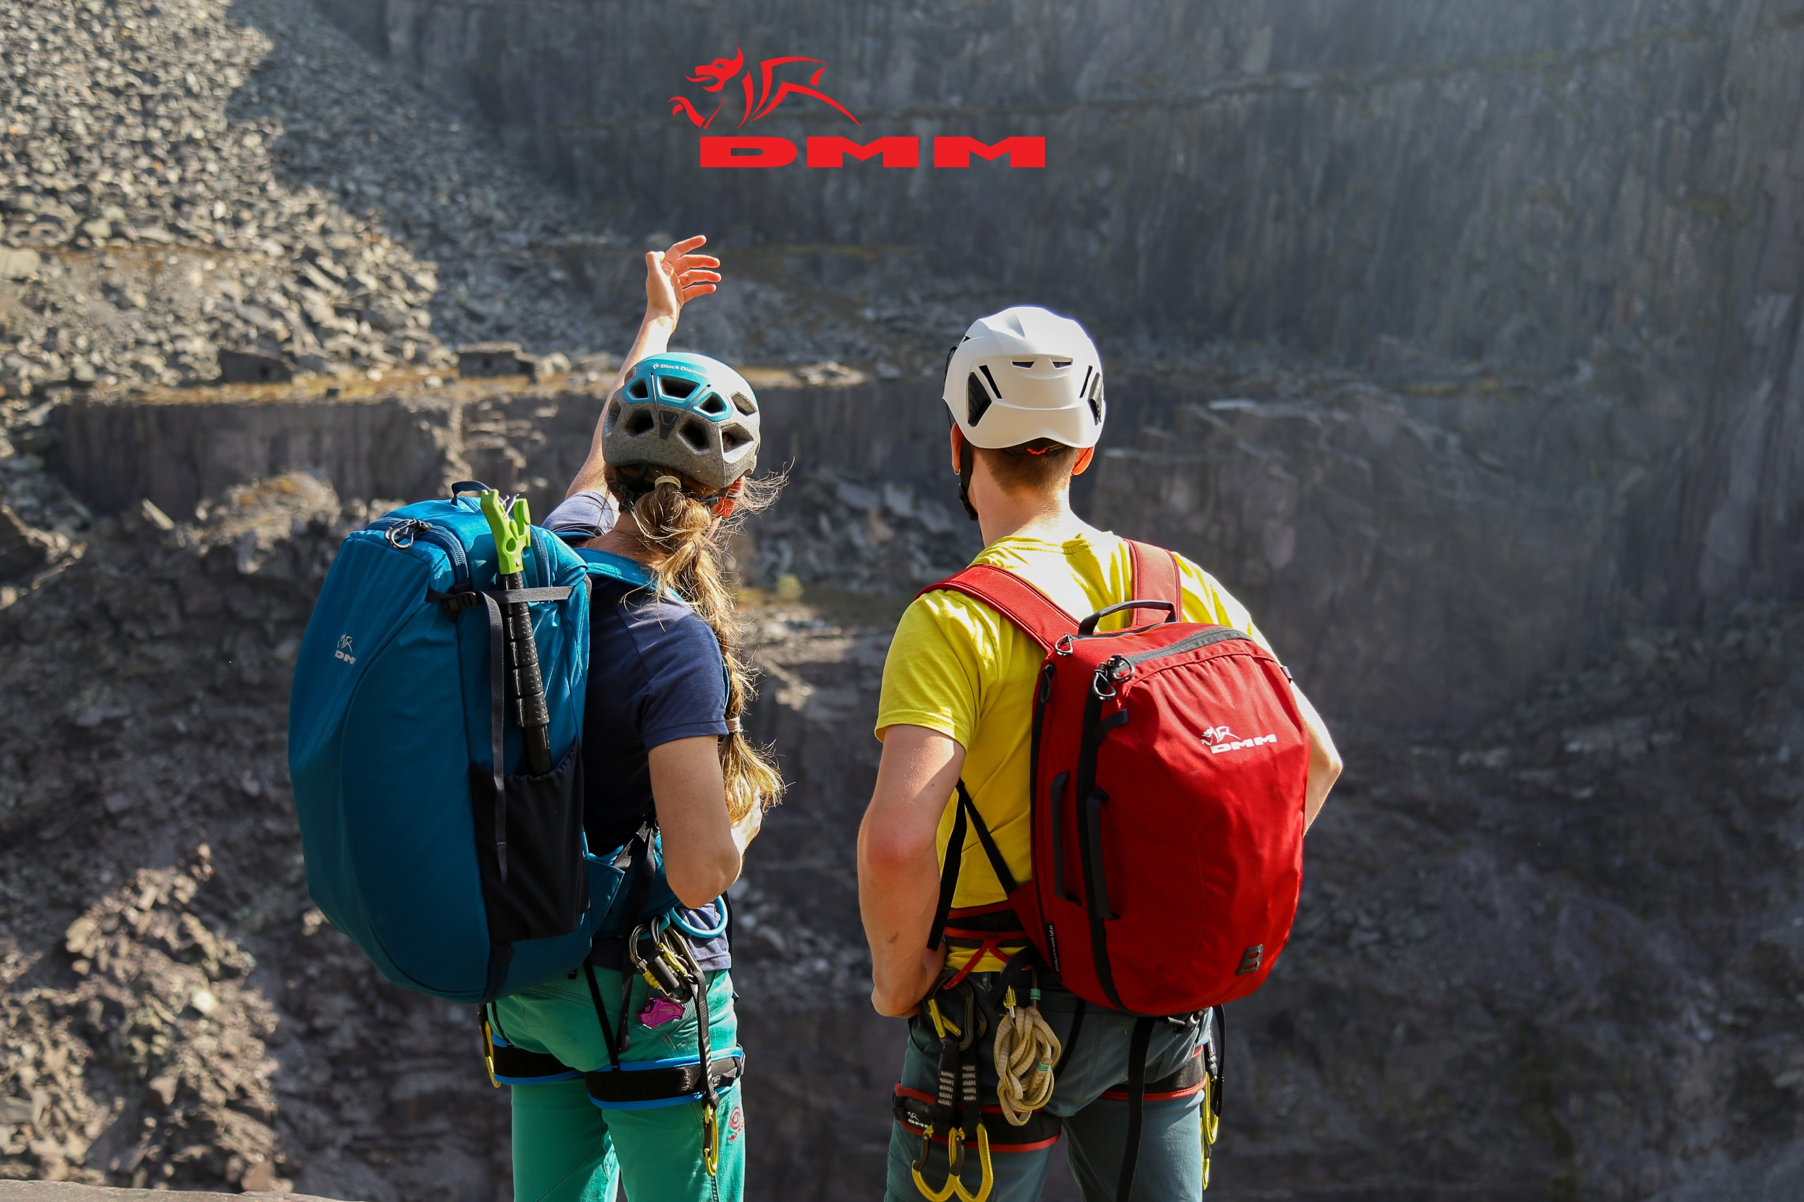

Introduction
For my client project I was fortunate enough to be able to work with DMM Wales on a project to promote their line of climbing bags and supporting equipment. The project gave me the opportunity to gain industry level experience working with a high-profile client and answer a set brief in a creative innovative way. Over the course of this report, I will critically reflect on my experienced gained on production, project outcome, client’s response, and feedback and how I would approach this project and upcoming projects differently in the future.

Experience Gained
The first aspect of the project was finding and engaging with a client to work with. Starting with no pre-arranged connections I sought to find a client to collaborate with which suited my style and interests. Approaching from this angle meant I could work on a project I wanted to make and be passionate about producing the content.

Having known of DMM for many years how understanding how personable they were as a company, I approached them directly by calling up the head office and introducing myself. This was an important experience. It enabled me to practice sounding confident and personable over the phone with a client and ultimately selling my capabilities. Further to this, picking a strategy to approach a client which is the most in line with said companies’ brand is the first and very important hurdle. It’s like the saying goes “you only have one chance to make a first impression” (Todorov, 2018). I am pleased to say that this approached worked well and after this Initial stage, we then met in person and the project could begin.
The second piece of experience I gained was organising, shooting, and directing a crew. Whilst I was the only person on the production side of the project, these films could not be made alone. Alongside formulating and developing the project I also had to arrange, locations, talent and shoot schedule for the project. This was very enjoyable elements and was only possible thanks to my connections and using reliable people. My key learning point here is that, building an existing network of reliable people in your space of work makes everything better. Prior to the project and being a climber myself, I am lucky enough to know both great climbers and great locations. This made pulling together the shoot schedule far more straight forward. It also meant when shooting at locations like the Beacon climbing centre, I could call upon my experience at the location and know how to ask for permission and work well in the space. As Gaz Banford says: “Experiences X 1000 = Experienced” (Banford, 2021). The experience of directing the climbers was also knew to me. My key focus of any direction was to always make sure they were comfortable and happy with the shoot. I did this through an opening briefing and continued checks through each shoot day. The methodology behind this was that if the climber were happy, they would be willing to do more and ultimately make the product on camera look its best.

The client’s response
Upon Completion of the project the client provided a range of very useful feedback. From this feedback I was pleased to find out that my professional conduct and delivering of the brief more than satisfied the client. DMM, when asked If I was engaged in the process stated: “Tom was very engaged and enthusiastic in all our meetings, brimming with ideas and eager to find out what I wanted from the project. Tom was very engaged and enthusiastic in all our meetings, brimming with ideas and eager to find out what I wanted from the project”. (Figure 2 – DMM Feedback, 2022) They also added that: “Tom is clearly a talented videographer and has a bright future ahead of him” (Figure 1 – DMM Feedback, 2022. I could not be happier with this feedback, overall, it was extremely positive.

However, I was also eager to receive any notes in my final product and how it could be improved for future projects. Whilst I was pleased to learn that DMM thought my “video skills, filming, editing skills are very good” (Figure 2 – DMM Feedback, 2022) The most useful note from the client was that: “the colour palette of the indoor climbing centre was very different to the outdoors setting.” (Figure 2 – DMM Feedback, 2022). Geraint Radford supported this note by stating: “Tom may benefit by using neutral density filters and polarizer filters to control sunlight…” (Figure 4 – Radford, 2022). This is something I had not previously considered on the production. Whilst filming in two very different location, I failed to plan for how different the colour contrast would be within sections. This could have been mitigated in one of two ways. Firstly, I could have shot some more transitional scenes, such as the bags in a car to lead the audience into the new a brighter location. Secondly, I could have spent more time colour grading my footage. Grading is one of my weaker areas and perhaps with more time given to it in post I could have made the colour tones of the films more even.

I was also pleased to have inspired and opened the client’s eyes to a new style of content and shooting methods DMM stated that they are “currently experimenting with different types of video mediums for marketing applications. I’m excited to use these videos as part of my marketing strategy, and I’m sure we will get a lot of value out of them” (Figure 3 – DMM Feedback, 2022). Geraint Radford also added: “Tom has exceptional drone filming skills; the compositions are epic, and the shorts are full of atmosphere.” (Figure 4 – Radford, 2022). I was very pleased to receive these added bits of feedback. Ultimately, inspiring the client and leaving a lasting impression is what I believe makes a good collaboration. My approach was always to strike the balance between answering the brief and delivering new and exciting content to the client and maybe even showing new techniques they have not considered.

Approaching work in the future
This process has taught me a lot about working with industry clients and I will carry a lot of this onto future work. My primary focus moving forward will be on the editing and postproduction phases of filming. I believe I am at my strongest practically, but I have learnt that the time spent after the production is equally as valuable as the production itself. Allowing more time in post-production, will give me greater opportunity to study edits and work on the colour grading that was missing from this project. I will also explore extra techniques to aid greater colour scape in my films, such as shooting in RAW and learning programs such as DaVinci Resolve 17.

Outcome of the project
Overall, I was very happy with the outcome of the project. The final films answered the brief well and as my feedback from the client states that: “The content matches the brand identity very well.” (Figure 4 – Radford, 2022). Further to this I am confident that I operated and conducted myself on a professional level and strived to always achieve industry standard work. Whilst I have some things to work on for future projects, I am spurred on by the fact that DMM themselves stated: “… Tom was great to work with, we may well be working again in the future” (Figure 3 – DMM Feedback, 2022).

Word Count - 1246
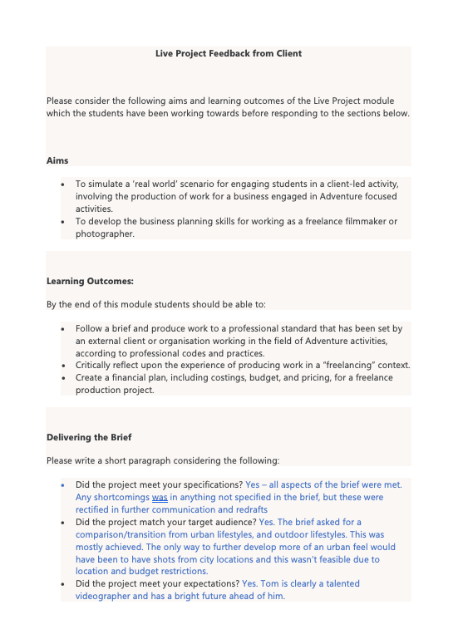
Bibliography & References
Figure 1 - DMM Feedback pt 1
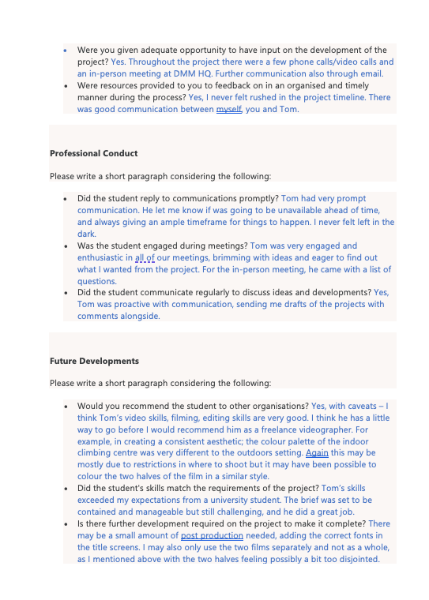
Figure 2 - DMM Feedback pt 2
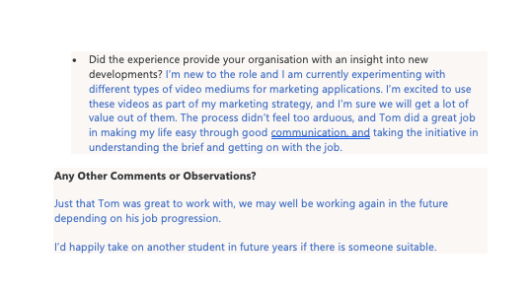
Figure 3 - DMM Feedback pt 3
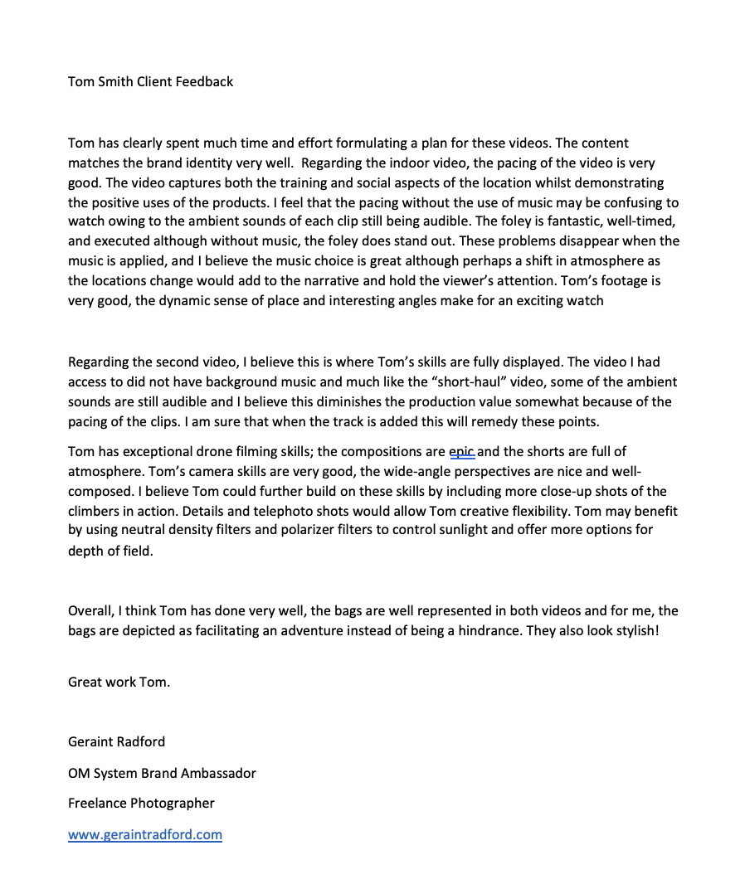
Figure 4 - Geraint Radford Feedback

References
Banford, G., 2021. Duratus Uk. [Online]
Available at: https://www.instagram.com/duratus_gaz/
[Accessed 5 May 2022].
Todorov, P. A., 2018. SURPRISING Science Of INFLUENTIAL First Impressions. [Online]
Available at: https://www.youtube.com/watch?v=6SAEVU3aKX4&t=3s
[Accessed May 5 2022].

