Hidden Disabilities:

Access to University for ALL
(Image 1: 501 Commons, 2018)
a,1977)
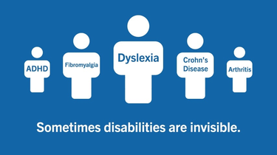
Attending University has become the societal norm. This leaflet will give guidance on the legislation, policy and examples of the help that is available to people with hidden disabilities. According to the UK Government (2010)
‘you are disabled under the Equality Act 2010 if you have a physical or mental impairment that has a ‘substantial’ and ‘long-term’ negative effect on your ability to do normal daily activities’ (UK Government 2010).
It has now become common practice that universities and places of higher or further education have a Student Services department that can provide a wide range of support, from assessments for learning difficulties, grants for equipment to assist the student to gain their education. They will also offer help in order to apply for such grants within the educational organisation (UWTSD,2019).
The University of Wales Trinity Carmarthen, Coleg Sir Gar and Coleg Ceredigion have created a combined Strategic Equality 2016-2020 document (UWTSD Group, 2016) which shows the need for inclusion across the divide that disabilities can create education. Their intent is to provide further and higher education which is available for all students regardless of disability, age or sex.

According to the Equality’s Act 2010 there is a ‘Duty to make adjustments’ (Equality’s Act 2010). This act further describes the requirement for all students to have the same level of attainment of study regardless of any disability. It has identified that a student can not be discriminated against due to their disability and that actions must be taken in order to have an even keel, as described below:
‘…….. puts a disabled person at a substantial disadvantage in relation to a relevant matter in comparison with persons who are not disabled, to take such steps as it is reasonable to have to take to avoid the disadvantage’ (Equality Act 2010, p22, Par 20)
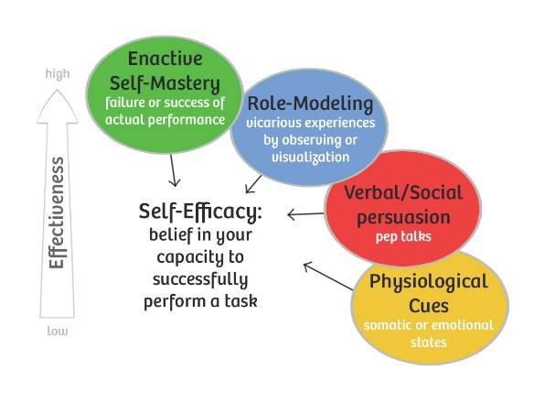
Education can begin once a student has enough ‘Self Efficacy’ (Bandura, 1977). According to Bandura’s model of Self Efficacy Theory, the main belief in a person’s ability to succeed the person needs to have the mental capacity to achieve one’s goals (Bandura, 1977).
(Image 2:Bandura,1977)

Arnstien’s Ladder of participation is one model that can be adapted in the engagement of students that lack confidence and self-belief.

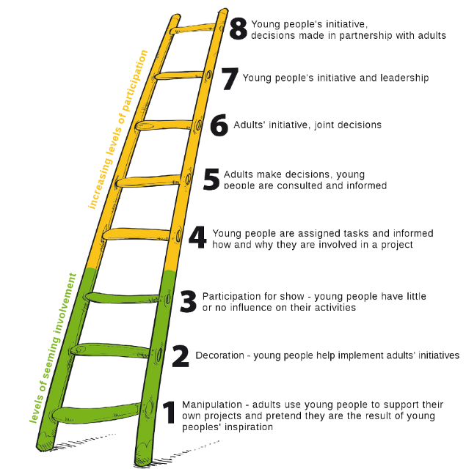
This is an example of how Hart has adapted Arnstien’s Ladder of participation in order to engage with youth education. This is a prime example of how young people can engage in their education in order to maximise their understanding

(Image 3:Macedonia D,2016)

According to the DWP in 2014 young adults of 19 years and older with a disability are more likely to have not obtained qualifications in comparison to non-disabled peers. Only 14.9% of disabled people, of working age, have obtained education to a degree level in comparison to 28.1% of non-disabled people (GOV,2014). But according to The Equality & Higher Education Students Statistical Report (Advance-he-ac.uk, 2018, p77) the percentage of students, in the UK, attending higher education that have disclosed a disability has risen from just over 5% in 2003/2004 to just over 12% in 2016/17 (Advance-he.ac.uk,2018 p 76). This shows that the figures have more than doubled. It could be argued that students have an increased confidence in disclosure of their disability due to the Student Services support that is now given, creating a more inclusive attitude towards students of different educational abilities in higher education (UWTSD,2019).

The availability of funding for equipment and individual help in higher education has been due to the Disability Student Allowance, DSA, which has the positive effect on their ability to learn with more support in the form of equipment and personalised support increasing the educational ability of students with disabilities (Student Finance Wales,2019).
Accessibility to campus, lecture rooms and even car parks have now become easier for a student with disabilities. With disabled parking bays, lifts and new buildings that have been created with the mindset of equality for all regardless of disability, are being built in Universities across the UK. UWTSD have recently opened their Teaching & Learning building, which is both open plan, user friendly and accessible regardless of their disability for all to all facilities (WRW, no date)
Giddins & Sutton describe disability from the perspective of the person with the disability, looking at how society have the issue. It is thought that society should create the change, stop the constant need to rehabilitate with the use of medication (Giddins and Sutton 2010: 163). It is shown that with the use of the Disabilities’ Act and the Equality’s Act people with disabilities now have the right to the same education. It shines a light on how every person is unique (UK Government,2010).

In summary this leaflet is a guide to the possibilities of every person regardless of physical and hidden disabilities. The support, financial and physical, is easily accessible with an open arms culture within universities across the UK. With the use of The Equality’s Act 2010, being a main factor for creating an inclusive higher educational route for students with disabilities (Equality’s Act 2010). Student services are there to provide every student attending their university the help and support to progress with their studies (UWTSD,2019). Information can be obtained from the University web sites as well as from the student services departments on campus.

Rational
This leaflet was created with the intent to widen the view of a person with hidden disabilities of the availability of higher/further education. With the help of legislation education is now open to all. People with disabilities have always felt that they do not belong or have the right to a better education and this leaflet was designed with the intent to show the help and support (financial and physical) that is available (Student Finance Wales,2019). A person going to university maybe scared and anxious about leaving home, embarking on a new social and educational adventure, but to have a disability that is unseen, having the unknown of their true ability has its own misgivings. This leaflet should highlight that higher education is available. Sign post the student to the correct people (Student Finance Wales,2019), legislation (Equality’s Act 2010) and polices (UWTSD Group, 2016) that will enable the student to succeed. It also highlights the empowerment through theory (Bandura,1977) that can ignite the flame of self-belief in a person who has always been held back by the disbelief they have in their own ability. With the help of theorists, such as Arnstien and Hart, students can gain belief once more, that they can be a student in higher education and have the same aspirations as all other students attending university. With the guidance of the Student services department in The University Wales Trinity Saint David a student, with a hidden disability, can find help and support needed to achieve academic success (UWTSD,2019).

Reference list
Equality Act 2010. Available at: https://www.gov.uk/definition-of-disability-under-equality-act-2010 (Accessed:24 October 2019)
Image 1: Available at: https://www.501commons.org/blog/helpful-resources-invisible-disabilities-in-the-workplace (Accessed: 7th November 2019)
Image 2: Available at: http://agilecoffee.com/toolkit/self-efficacy/ (Accessed: 7th November 2019)
UWTSD Group, 2016, Strategic Equality 2016-2020, Available at: https://www.uwtsd.ac.uk/media/uwtsd-website/content-assets/documents/strategies-policies/strategic-plan-equality-2016-2020.pdf (Accessed: 7th November 2019)
Image 3: Macedonia D, How to engage active participation of minority young people? Hart’s Ladder of participation (5th February 2016), Available at: https://minorityinclusion.wordpress.com/2016/02/05/how-to-engage-active-participation-of-minority-young-people-harts-ladder-of-participation/ (Accessed: 7th November 2019)

Department for Works and Pensions (2014), Disability Facts and Figures,Gov.uk: Available at: https://www.gov.uk/government/publications/disability-facts-and-figures/disability-facts-and-figures#post-19-education (Assessed on 7th November 2019)

University Of Wales Trinity Saint David, Student Services (2019) Available at : https://www.uwtsd.ac.uk/student-services/ , Accessed: 7th November 2019
Student Finance Wales, Disabled Student Allowance (2019), Available at : https://www.studentfinancewales.co.uk/practitioners/undergraduate-students/part-time/disabled-students-allowances.aspx , Accessed 7th November 2019
Giddens, A and Sutton, PW. (2010) Sociology: Introductory Readings,3rd edn, Cambridge :Polity
WRW.co.uk, Teaching and Learning Building (no date),Available at: http://wrw.co.uk/teaching-learning-building/ (Accessed 14th November 2019)

