
Applied Leadership and Management in the Workplace
Module Assignment Submission
Student Name: | Rebecca Forshaw
Student Number: | 2238205
Module No: | BMSK5014
Module Title: | Managing Projects

Statement of Confirmation of Authenticity
By the act of making this submission, the student declares that this is the work of the student named above. The work has not, in whole or in part, been knowingly presented elsewhere for assessment, or where assessment has been built on a previous assessment, this has been identified. Where materials have been used from other sources it has been properly acknowledged. If this statement is untrue, the student acknowledges that an assessment offence has been committed.
Attention is drawn to the plagiarism and unfair practice policies of both the University and of ILM.

Table of Contents
INTRODUCTION 3
TOOLS & TECHNIQUES 3
WATERFALL 3
ITERATIVE 3
V-MODEL 4
Project stages 5
INITIATE: 5
PLAN: 9
EXECUTE: 13
CONTROL: 14
CLOSE: 15
MY PROJECT 16
YOU AS A PM 16
CONCLUSION 19
REFERENCE LIST 20
APPENDICES 21

INTRODUCTION

This paper is written to establish the writers understanding of project management strategies for establishing and launching a children’s Nerf gun pay-per-play session business. The goal is to create a structured, safe, and engaging environment for children aged 6-12 to enjoy Nerf gun battles. The project will be managed using a combination of established project management methodologies, including the Waterfall, Iterative, and V-Model approaches, ensuring the project is delivered on time, within budget, and to the highest quality standards.

TOOLS & TECHNIQUES
Multiple project management approaches can be used for this project to handle the unique parts of the project lifecycle.

WATERFALL
The project will start using the Waterfall method, a simple approach often used when project requirements are clear (Sommerville, 2016). This method works well in the early stages, where the project’s scope, planning, and design are created. With the Waterfall model, each step must be finished before moving on to the next, helping to reduce the risk of changes and ensuring clear goals are met. Key activities in this phase include:
- Requirement Analysis: Collecting detailed customer needs, safety standards, and legal requirements (Kerzner, 2017).
- Design: Planning the layout for the venue, choosing the right equipment, and creating session formats.
- Planning: Developing a detailed project plan, including timelines, resources, and budget management (PMI, 2021).

ITERATIVE
The iterative technique in project management is a method that focuses on repeating and improving tasks throughout a project. This approach divides the project into smaller, manageable cycles or iterations. Each cycle includes planning, execution, and review of a part of the project, with the aim of gradually refining the final product until it reaches the desired outcome (Sommerville, 2016).
Agile is the most prominent example of an iterative technique. It emphasizes collaboration, collecting customer feedback, and implementing quick updates and changes. This approach allows for flexibility and responsiveness to evolving business needs, making it particularly useful in dynamic environments (Schwaber & Sutherland, 2020).

V-MODEL

The V-Model, or Verification and Validation model, is a project management method that improves on the traditional waterfall approach by linking each development step with a matching testing phase. It is called the "V" model because it visually represents the process stages, starting with requirements analysis, moving through design, and then progressing through different levels of testing (Sommerville, 2016).
The V-Model would support a project's launch by ensuring every stage of product development is thoroughly planned, executed, and tested. This structured approach minimizes risks, guarantees high quality, and ensures the final product meets both business goals and customer needs, resulting in a more successful and reliable launch (Kerzner, 2017).

When deciding between the V-Model, Iterative Technique, and Waterfall Methodology for a project, it's important to understand the pros and cons of each method. This comparison looks at the benefits and drawbacks of these approaches and explains which one is best suited based on a project's specific needs.
The V-Model builds on the Waterfall Methodology by putting more emphasis on testing and verification at every stage of development. Its main strength is its structured and well-organized approach, which focuses on thorough testing to catch potential problems early in the project's life cycle. However, it is less flexible for making changes after a phase is completed, which can significantly delay the project. This method is best suited for projects like product or prototype development with longer timelines (Sommerville, 2016).
Iterative techniques are ideal for projects where requirements are unclear at the beginning or when changes are needed based on user feedback. This method works well for software development, startups, and industries where the market evolves rapidly (Schwaber & Sutherland, 2020).
The Waterfall Methodology is most suitable for projects with clearly defined and stable requirements, such as construction projects or, in this case, launching an event where there is previous experience. It works well for projects with straightforward, step-by-step processes where each phase can be completed independently (Kerzner, 2017).

Project stages

INITIATE:

BUSINESS CASE
This business case aims to provide an overview of the operational, financial, and strategic factors involved in starting a pay-per-play Nerf gun business for children. The project aims to take advantage of the increasing need for interactive, family-oriented entertainment by providing a secure and organised setting where children may participate in imaginative and physically engaging play.

OBJECTIVES
Create and follow a session plan that meets all safety rules and provides an enjoyable experience for children. Set up daily operating procedures to keep everything running smoothly, including managing staff, scheduling, supervising sessions, using booking systems, and maintaining equipment. Develop a business strategy that ensures long-term success and profitability. Deliver great customer service to encourage repeat visits and build a loyal customer base through targeted marketing strategies. Ensure all necessary insurance and legal disclaimers are in place to operate legally. Hire, train, and retain skilled and motivated staff to run the sessions. Identify potential risks that could affect the project and take steps to address them. Engage with the local community to build connections and promote participation. Partner with nearby businesses and actively participate in community events.

Possible constraints that could impact the successful launch of this pay per play Nerf gun business are:
Budget. Limited financial resources can restrict various aspects of the project, including venue selection, marketing efforts, staffing levels, and equipment quality. Insufficient budget may lead to compromises in safety standards, customer experience, or the overall scale of the business, potentially affecting its viability and attractiveness to customers.
Time. A fixed deadline for launching the business can limit the time available for planning, design, and execution. Rushed planning and execution might result in incomplete or subpar implementations, such as inadequate staff training, insufficient marketing, or incomplete safety checks.
Resources. Availability of essential resources, including skilled staff, suitable venues, and high-quality equipment, might be limited. Difficulty in securing venues or adequately resourcing key products could lead to operational inefficiencies, reduced customer satisfaction, or delays in the project timeline.
Legal Constraints. Compliance with local laws, health and safety regulations, insurance requirements, and child protection policies can impose strict guidelines that must be followed. Failure to comply with legal and regulatory requirements can lead to fines, legal action, or closure, posing significant risks to the project’s success.
Technical Constraints. Limitations related to technology, such as the availability of suitable booking systems, payment processing tools, or safety monitoring systems. Inadequate or unreliable technology can lead to operational inefficiencies, poor customer experience, and potential safety risks.
Stakeholders. Customer may not buy into the idea of a pay-per-play sessions. This would result in a non-profitable and successful project.

Understanding and managing these constraints is crucial for ensuring the project remains feasible and aligned with its goals. Effective project management involves identifying these constraints early, planning accordingly, and making informed decisions to mitigate their impact.

COST BENEFIT ANALYSIS
As this is a pop-up pay-per-play business, the hiring of venues would be necessary.
Unlike leasing a permanent venue, hiring a venue per event involves recurring rental costs that vary depending on the location, size, and duration of the event. For example, renting a community hall or sports facility might cost between £50-£150 per event. This flexibility allows for cost savings during periods of lower demand but introduces variability in expenses.
Setup and Teardown Costs: Each event will require setup and teardown of equipment, which involves both time and potentially additional labour costs. These costs could range from £50-£100 per event, depending on the complexity and duration of the setup.
Equipment and Transportation Costs
Initial investment in Nerf guns, protective gear, and barriers remains, but the need for transportable and easy-to-setup equipment is higher. This may increase initial costs to £5,000. Additionally, ongoing maintenance and replenishment of consumables like Nerf darts are necessary, estimated at £20-£100 per event.
Transporting equipment to and from venues will incur costs, including fuel, and possibly additional staff for loading and unloading. These costs might range from £50-£150 per event, depending on the distance.
Marketing and Customer Acquisition
Marketing costs need to be strategically focused on promoting individual events. This includes digital marketing, local advertising, and partnerships with venue owners, potentially costing £50-£100 per event. These costs are critical for ensuring adequate attendance at each event.
Customer Relationship Management: To encourage repeat customers, investment in CRM tools and strategies, such as email campaigns or loyalty programs, may be necessary. This could cost an additional £50 per month.
Operational Costs
Staff will be needed to run each event, including session facilitators and customer service personnel. These costs could range from £100-£200 per event, depending on the number of staff required and event duration.
Insurance and Compliance: Event-specific insurance will be required for each event, potentially costing £500 per year.
Benefits
Revenue Generation
Pay-per-Play Fees: Charging £10-£15 per participant, with an expected attendance of 20-50 participants per event, could generate £200-£750 per event. If events are held weekly, this could translate to £800-£3,000 in revenue per month.
Merchandise and Refreshment Sales: Selling Nerf-related merchandise, snacks, and drinks at each event could provide an additional revenue stream of £50-£150 per event.
Special Event Premiums: Hosting themed events, birthday parties, or corporate team-building sessions could command higher fees, potentially adding £180-£300 per event.
Flexibility and Scalability
Scalable Operations: Hiring venues per event allows the business to scale operations based on demand, reducing the risk of underutilized assets. This flexibility helps manage costs and aligns expenditures with actual revenue-generating activities.
Targeted Market Reach: The ability to hold events in different locations allows the business to target various markets, potentially expanding the customer base and increasing brand awareness.
Reduced Fixed Costs
Lower Overhead: Without a permanent venue lease, fixed costs like rent, utilities, and full-time staff salaries are significantly reduced. This reduces financial risk, particularly in periods of low demand or economic downturns.
Event-Specific Expenditure: The pay-per-event model means that expenditures are directly tied to revenue-generating activities, improving cash flow management and financial predictability.
Community Engagement and Brand Visibility
Local Partnerships: Partnering with local venues and community centers can enhance brand visibility and community engagement. This can lead to increased word-of-mouth promotion and loyalty from local customers.
Offering Birthday Parties: The ability to tailor events to specific audiences or themes can differentiate the business from competitors and attract a wider range of customers.
Conclusion
Renting a venue for each event can mean costs vary, but it also offers great flexibility and the ability to grow by adjusting to market demand. The main benefits include lower fixed costs, the chance to earn more through targeted marketing and special events, and the ability to attract more customers by using different locations. With good management, this approach can create a profitable and sustainable business with less financial risk than using a fixed venue.

PLAN:

WORK/PRODUCT BREAKDOWN STRUCTURE

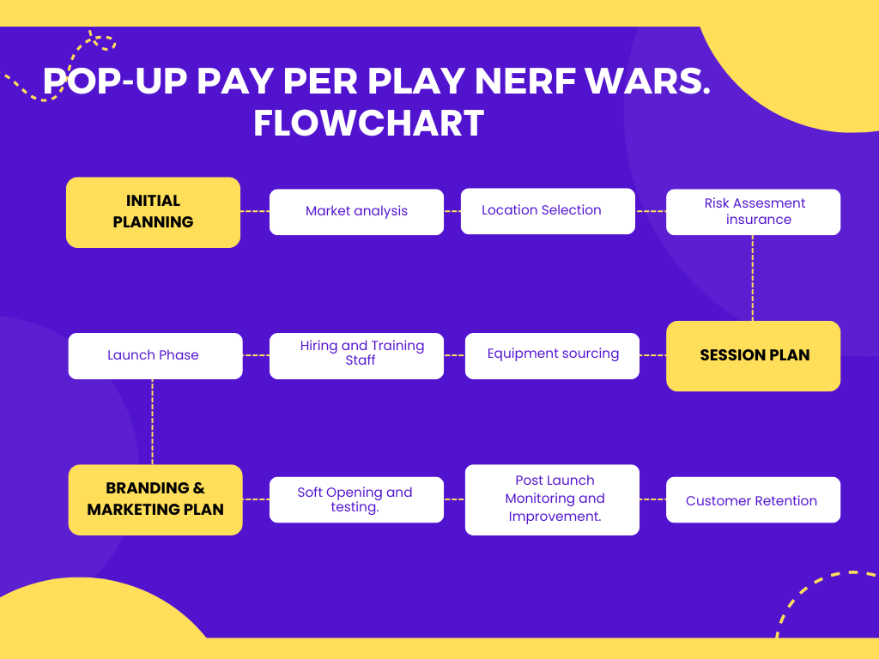

DURATION
When setting up a pay-per-play Nerf business, effective duration management is critical to ensure timely and efficient operations. The following outlines the key time frames required for various stages of setting up and managing the business, focusing on preparation, execution, and continuous improvement phases.

Market Analysis and Business plan (2-3 weeks):
Conduct market research to understand customer demand, preferences, and competition in the area.
Develop a business plan outlining the target audience, pricing strategy, and marketing approach.
Location Selection (2-4 weeks):
Identify and book suitable locations that offers sufficient space for safe Nerf play activities.
Consider factors such as visibility, accessibility, and safety regulations.
Risk assessment, insurance and Disclaimer. (3-4 weeks):
Produce a risk assessment that will be reused at each venue. Research and purchase the correct insurance and complete relevant disclaimers that limit the risk to the business.
Work with local authorities to ensure compliance with regulations.
Session Planning and Equipment sourcing (2-3 Months)
Session Planning (4-6 weeks):
Structure each session, plan games that are appropriate to the age range of the children attending the session.
Source Equipment and Supplies (3-4 weeks):
Purchase Nerf guns, safety gear, and other equipment required for gameplay.
Arrange for bulk buying to reduce costs and ensure a steady supply of ammunition and accessories.
.
Hiring and Training Staff (2-4 weeks):
Recruit staff members who will manage the games, handle customer service, and ensure safety.
Conduct training sessions on safety protocols, customer interaction, and game management.
Launch Phase (1 Month)
Marketing and Promotions (3-4 weeks):
Launch a marketing campaign to promote the business, using social media, local advertisements, and partnerships with schools or community centres.
Offer promotional discounts or special events to attract initial customers.
Soft Opening and Testing (1-2 weeks):
Conduct a soft opening to test the operations, offer these sessions free to gather customer feedback, and make necessary adjustments.
Ensure that all staff are familiar with the processes and can handle any issues that arise.
Post-Launch Phase (Ongoing)
Continuous Monitoring and Improvement (Ongoing):
Regularly monitor customer feedback, safety standards, and operational efficiency to make continuous improvements.
Conduct periodic training sessions for staff to maintain high service quality and safety standards.

Customer Retention and Engagement (Ongoing):
Develop loyalty programs, customer engagement strategies, and seasonal promotions to retain existing customers and attract new ones.

Managing the duration of each phase effectively is crucial for the successful launch and sustained growth of this business. By following a structured approach that includes thorough planning, timely execution, and continuous improvement, the business can ensure efficient operations and a positive customer experience.

NETWORK & DEPENDENCIES

CRITICAL PATH ANALYSIS
A network diagram would include tasks such as marketing, booking management, venue preparation, equipment setup, staffing, safety checks, and session execution. This helps identify the critical path — the sequence of tasks that must be completed on time to ensure the Nerf sessions are delivered successfully without delays.
Dependencies in a Nerf war business outline the relationships between these tasks and the order in which they need to be performed. There are several types of dependencies that apply:
- Finish-to-Start (FS): The most common type of dependency, where one task must be completed before another can start. For example, the venue must be prepared and equipment set up before players can enter the space.
- Start-to-Start (SS): Two tasks that must start simultaneously or one that can start only after another has started. For example, while one team sets up the game zone, another team can start preparing safety gear and briefing staff.
- Finish-to-Finish (FF): Two tasks that need to finish at the same time, such as ensuring all safety checks and staff briefings are completed before the session starts.
- Start-to-Finish (SF): Rare in this context but could involve a situation where equipment packing starts only when the last game session is about to finish.
Managing these dependencies is essential for the smooth execution of the Nerf war sessions. Understanding and planning these relationships helps prevent bottlenecks, ensures that all tasks are completed in the right order, and will minimise delays. For instance, ensuring that all marketing material are aligned with session scheduling helps manage customer expectations.

PLAN TOOLS:

GANTT
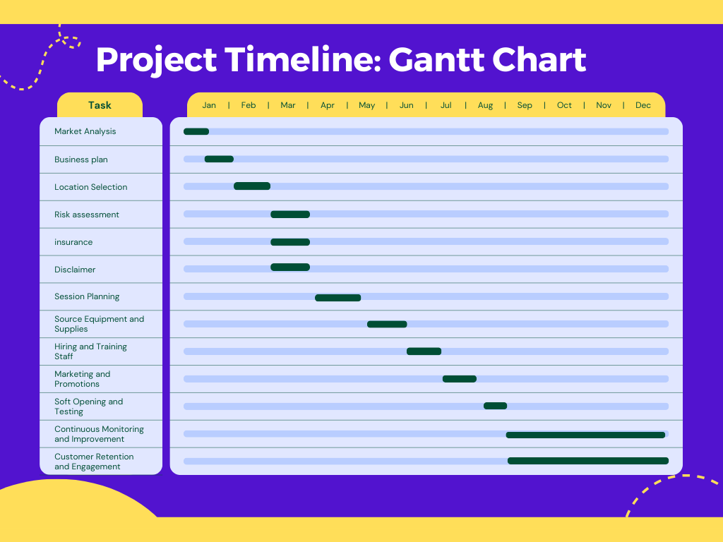

KANBAN
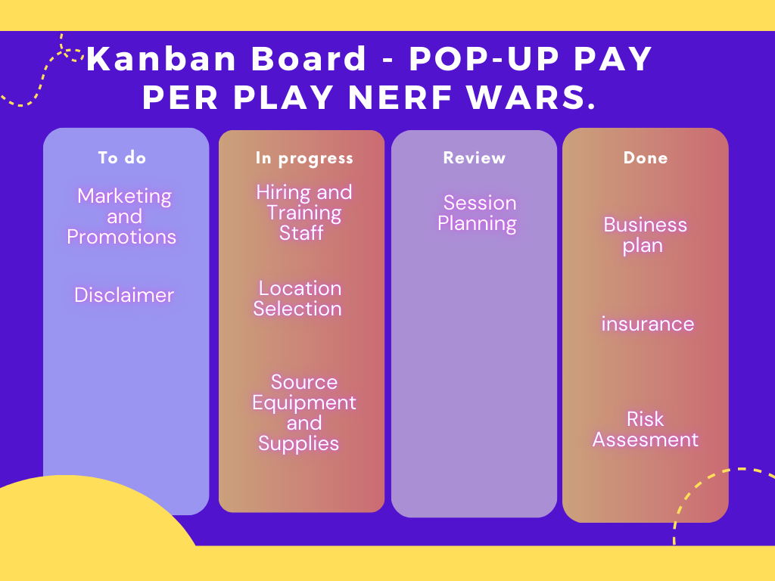

MILESTONES
Effectively managing milestones is crucial for launching any business. By defining clear milestones, using project management tools, assigning responsibilities, monitoring progress, maintaining flexibility, and communicating effectively, the business can stay on track, meet deadlines, and achieve its goals successfully.

EXECUTE:

ALLOCATED PERSONS/PROJECT TEAM ROLES & RESPONSIBILITIES
Executing the setup stage of a pay-per-play Nerf war business as a one-person operation requires careful planning, prioritization, and efficient use of time and resources. By breaking down tasks, leveraging tools and technology, outsourcing where feasible, and maintaining a focus on customer engagement and financial management, you can successfully launch your business while managing all aspects yourself then employing staff to run the sessions.

CONTROL:

MONITORING:

PROGRESS/TIME
Set a Project Timeline: Create a timeline for each phase of the business setup, including market research, venue selection, procurement, marketing launch, and the official launch.
Establish Key Milestones: Define milestones to track progress, such as completing market research, booking venues placing deposits to ensure booked, launching the website, and hosting a soft opening.

BUDGET
Estimate Startup Costs: Outline all initial costs, including venue rental or lease, equipment procurement (Nerf guns, safety gear), marketing, and insurance.
Create a Financial Plan: Develop a budget for ongoing expenses (utilities, supplies, staff wages, maintenance) and revenue projections to ensure profitability. Include a cash flow forecast to manage finances effectively.

QUALITY
Design Key Processes: Define processes for booking management, equipment setup and teardown, game supervision, safety checks, customer service, and post-event follow-up.
Standard Operating Procedures (SOPs): Develop SOPs for each process to ensure consistency, quality, and efficiency.

LOG REQUEST
A log request is a formal record-keeping tool used to document and track various types of requests that arise during a project's lifecycle. These requests can include changes, issues, risks, actions, or decisions that need to be addressed for the project to succeed. The log request ensures that all requests are systematically recorded, prioritized, assigned, and monitored to ensure timely resolution and proper communication among team members.

RISK MANAGEMENT
Identify Potential Risks: List potential risks, such as regulatory changes, weather conditions (for outdoor events), equipment failures, or low customer turnout.
Develop Mitigation Plans: Create strategies to mitigate these risks, having backup equipment, or offering indoor alternatives.

CLOSE:

SIGN-OFF/HAND OVER
The sign-off/hand-over process is a critical step in transitioning from the project phase to the operational phase of launching a pay-per-play Nerf war business. Signing off within this business project will be the formal acceptance by customers that they have received nerf war experience worthy of paying for, the business can smoothly transition to ongoing operations, setting the foundation for long-term success.

CHANGES & ISSUES AGREED
During the project management, certain changes and issues may arise that require agreement and resolution to ensure the project stays on track. These changes and issues are formally documented, evaluated, and approved to align with the project’s objectives, budget, and timeline.
Adjustment in Staffing Plan
Change: The original staffing plan needs adjustment to include additional staff for event setup and supervision during busier sessions of over 40 children.
Action: Hire two part-time staff members for weekend shifts and busy periods.
Impact: Increased operational costs, but this change is necessary to maintain service quality and ensure safety. The cost of this is covered due to additional revenue generated from the increase of session size so was approved after evaluating the impact on the budget.

LESSONS LEARNT
Start Marketing Earlier to Build Momentum
Lesson: Initial customer turnout was lower than anticipated, suggesting that marketing efforts should have begun sooner to build awareness and excitement.
Action for Future Launches: Begin marketing campaigns several weeks or months before the official launch. Utilize multiple channels, such as social media, local partnerships, community events, and targeted ads, to reach a broader audience.

EVALUATE PROJECT
This involves evaluating how well the project performed compared to its original goals and objectives. The evaluation looks at areas like planning, execution, outcomes, and overall effectiveness, highlighting both successes and areas that could be improved.
The main goals were to successfully launch the pay-per-play Nerf war business, create an initial market presence, attract customers, and generate revenue. The project met these goals by completing key tasks, including securing a venue, setting up equipment, training staff, launching the business, and hosting initial events. Marketing campaigns and promotions helped bring in customers during the first few sessions, though starting the marketing earlier could have attracted even more.
There were some minor delays, such as in getting equipment and finalizing risk assessments for different venues, which pushed the launch back by two weeks. However, flexible scheduling and contingency plans helped keep the overall timeline on track. The business launched within a reasonable timeframe, and key milestones were met, although some tasks needed quicker adjustments.

MY PROJECT

YOU AS A PM
As the Project Manager for launching the pay-per-play Nerf war business, my role encompasses planning, coordination, risk management, quality assurance, and team leadership. By fulfilling these responsibilities effectively, I aim to ensure that the project is completed successfully, meeting all its objectives and establishing a strong foundation for the business's ongoing operations (PMI, 2017; Kerzner, 2017; Schwalbe, 2015).

SKILLS OF A PM

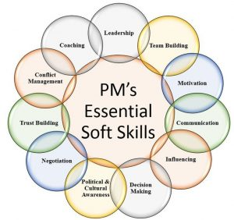

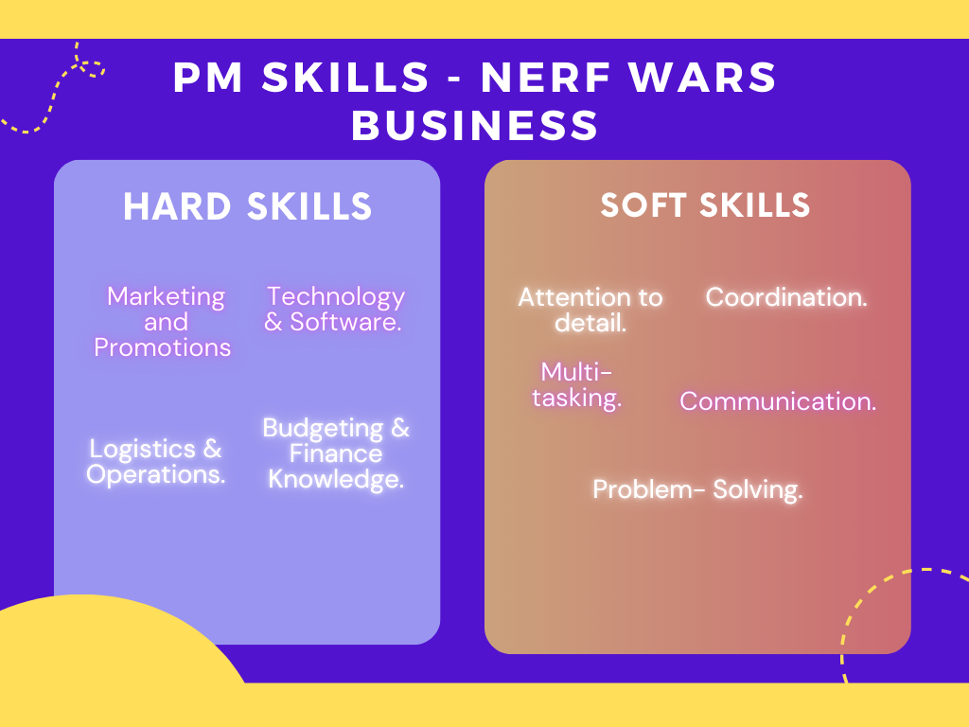

EVALUATE SELF AGAINST SKILLS
As the Project Manager responsible for the launch of a pay-per-play Nerf battle business, my success may be assessed via: Marketing & Promotions, Technology & Software, Logistics & Operations, and Budgeting & Finance. Below is an evaluation of my ability and areas that require development in each of these fields:
1. Marketing & Promotions Advantages:
I demonstrated strong skills in creating and executing a marketing strategy that built brand recognition and attracted bookings. By using a mix of online and offline tactics, such as social media campaigns and local events, I successfully generated excitement before the launch.
I engaged with early customers by offering discounts for early bookings, which increased initial bookings and helped build a positive reputation through word-of-mouth.
I used tools like Facebook Ads Manager to track and measure the effectiveness of marketing posts, adjusting strategies as needed and directing funds to the most impactful activities.
Areas need improvement:
I should have commenced marketing initiatives earlier in the project to generate more momentum prior to the launch. For optimal results.
2. Technology & Software Advantages:
I effectively managed the construction and integration of an online booking system called Eventbrite, guaranteeing its user-friendliness, security, and accessibility to consumers. This enhanced the efficiency of the booking process and enhanced the overall satisfaction of customers.
Areas need improvement:
While I managed the booking technology well, I could improve by learning more about technical areas like data analytics and CRM software. This would help me better analyse customer data and improve marketing and operations.
I could also explore more advanced software to automate repetitive tasks, like scheduling social media posts or sending follow-up emails, to save time and increase productivity

3. Logistics & Operations Advantages:
I efficiently oversaw the logistical aspects of preparing for the event, which involved successfully negotiating with suppliers to ensure timely delivery of equipment, organising the layout, and ensuring compliance with safety procedures. My meticulousness contributed to the establishment of a secure and captivating atmosphere for clients.
I effectively implemented standard operating procedures (SOPs) for daily operations, including equipment maintenance, staff scheduling, and customer service, resulting in the consistent maintenance of quality and standards.
My ability to promptly adjust to changes, such as finding alternate suppliers in the event of delays, guaranteed that the project remained on schedule and minimised any interruptions to the launch plan.
Areas need improvement:
To enhance my logistical preparation, I could have included more time in the timetable to accommodate possible delays, especially with supplier deliveries or unforeseen changes to the location.
There is a chance for me to improve my abilities in optimising resource allocation, namely in staffing and inventory management, in order to better match high demand periods and save expenses.
4. Budgeting and Finance Advantages:
I demonstrated strong financial management skills by creating a realistic budget, carefully tracking expenses, and making quick adjustments when needed to stay within the budget. This approach helped prevent overspending and ensured the project remained financially stable.
I kept a close eye on cash flow, making sure all payments to suppliers, venues, and other expenses were made on time. This helped maintain good relationships with stakeholders and avoided any financial problems.
Areas need improvement:
While I managed the budget well, I could improve by gaining a deeper understanding of financial forecasting and analysis. This would help me better estimate cash flow needs and spot potential financial risks early.

DEVELOP PDP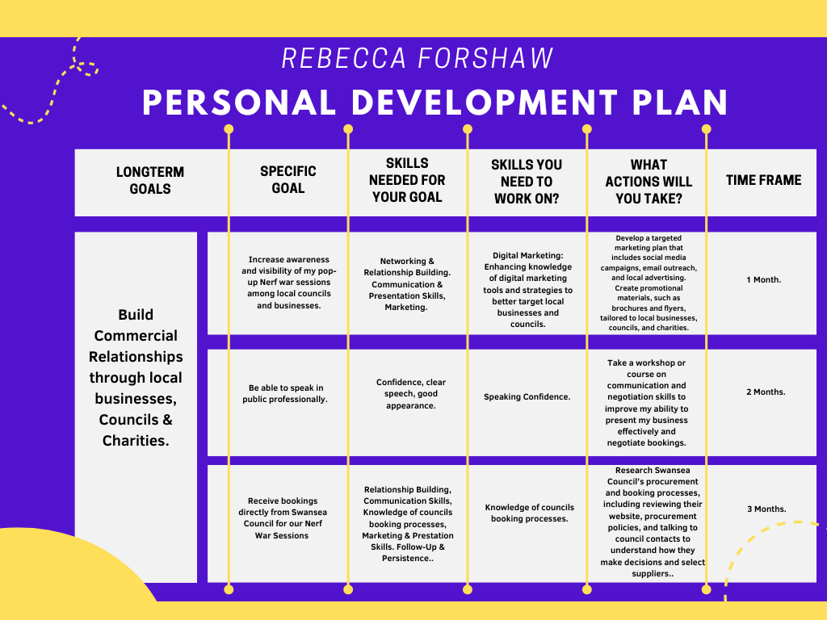

CONCLUSION
The project to launch the pay-per-play Nerf war business was successful in achieving its main goals of establishing a market presence, attracting customers, and generating revenue. Despite minor delays, I managed challenges through flexible planning and strong execution. Early customer engagement and effective marketing efforts contributed to a positive start, though starting promotions sooner could have increased customer turnout. Overall, the project met its key objectives, and the lessons learned will help improve future efforts.

REFERENCE LIST

Balaji, S., & Murugaiyan, M. S. (2012). "Waterfall vs. V-Model vs. Agile: A comparative study on SDLC." International Journal of Information Technology and Business Management, 2(1), 26-30
Boehm, B. W., & Turner, R. (2003). Balancing Agility and Discipline: A Guide for the Perplexed. Addison-Wesley.
Bowersox, D. J., Closs, D. J., & Cooper, M. B. (2013). Supply Chain Logistics Management (4th ed.). McGraw-Hill Education.
Burns, P. (2016). Entrepreneurship and Small Business (4th ed.). Palgrave Macmillan.
Deming, W. E. (1986). Out of the Crisis. MIT Press.
Dessler, G. (2020). Human Resource Management (16th ed.). Pearson.
Kerzner, H. (2017). Project Management: A Systems Approach to Planning, Scheduling, and Controlling (12th ed.). Wiley.
Kotler, P., & Keller, K. L. (2016). Marketing Management (15th ed.). Pearson.
Kumar, V., & Reinartz, W. (2018). Customer Relationship Management: Concept, Strategy, and Tools (3rd ed.). Springer.
Larman, C. (2004). Agile and Iterative Development: A Manager's Guide. Addison-Wesley Professional.
Levy, M., & Weitz, B. A. (2012). Retailing Management (9th ed.). McGraw-Hill Education.
Lock, D. (2020). Project Management (11th ed.). Routledge.
Longenecker, J. G., Petty, J. W., Palich, L. E., & Hoy, F. (2016). Small Business Management: Launching & Growing Entrepreneurial Ventures (18th ed.). Cengage Learning.
Meredith, J. R., Shafer, S. M., & Mantel, S. J. (2017). Project Management: A Strategic Managerial Approach (10th ed.). Wiley.
PMBOK® Guide (2017). A Guide to the Project Management Body of Knowledge (6th ed.). Project Management Institute.
PMI (2017). A Guide to the Project Management Body of Knowledge (PMBOK Guide) (6th ed.). Project Management Institute.
Pressman, R. S. (2014). Software Engineering: A Practitioner's Approach (8th ed.). McGraw-Hill Education.
Schwaber, K., & Sutherland, J. (2020). The Scrum Guide. Scrum.org.
Schwalbe, K. (2015). Information Technology Project Management (8th ed.). Cengage Learning.
Sommerville, I. (2011). Software Engineering (9th ed.). Pearson.
Thompson, J., & Martin, F. (2010). Strategic Management: Awareness & Change (6th ed.). Cengage Learning.
Zeithaml, V. A., Bitner, M. J., & Gremler, D. D. (2017). Services Marketing: Integrating Customer Focus Across the Firm (7th ed.). McGraw-Hill Education.

APPENDICES

