IMPACT OF ARTIFICIAL INTELLIGENCE (AI)-ENABLED CUSTOMER EXPERIENCE ON CONSUMER PURCHASE INTENTION: A SURVEY-BASED STUDY OF ASOS UK CUSTOMERS

STUDENT NAME: KAMRAN AKHTAR
STUDENT ID: 2433466
SUPERVISOR NAME: AMARE DESTA
YEAR OF STUDY:2025-2026
COURSE NAME: MBA IN INTERNATIONAL BUSINESS

CONTENTS
1. Introduction 2
1.1 Background of the Study 2
1.2 Problem Statement 3
1.3 Research Aim 3
1.4 Research Objectives 3
1.5 Research Questions 3
2. Literature Review 4
2.1 Artificial Intelligence (AI)-Enabled Customer Experience in Online Fashion Retail 4
2.2 Consumer Purchase Intention and the Role of AI 4
2.3 Research Gap 5
3. Methodology 5
3.1 Research Philosophy and Research Approach 5
3.2 Research Design, Sampling and Data Collection 6
3.3 Data Analysis and Ethical Considerations 6
4. Expected Findings 7
5. Timeframe 8
6. Limitations 8
7. Conclusion 9
REFERENCES 10

Introduction

1.1 Background of the Study
Throughout the retail sector, Artificial Intelligence (AI) has become a significant technology in transforming how businesses interact with customers and provide a tailored shopping experience. AI can refer to computational systems that can learn, reason, make decisions, and even predict, which are traditionally functions of human intelligence (Russell and Norvig, 2021). In the e-commerce industry, AI-powered tools like personalised recommendations, smart chatbots, virtual shopping assistants, image recognition systems, and predictive algorithms are now indispensable for creating a more engaging and compelling customer experience and gaining a competitive edge (Huang and Rust, 2021). AI offers significant promise in customer engagement, especially given the fast pace of retail digitalisation, enabled by changing consumer expectations and advancements in technology.
The United Kingdom is one of the oldest ecommerce markets, with online retail making up around 27% of overall retail sales in 2024 and the use of AI in retail organisations growing rapidly (Statista, 2024). Organisations that adopt AI personalisation techniques are likely to see revenue growth ranging from 5% to 15%, while also enjoying significant benefits for customer satisfaction and engagement, as outlined by McKinsey & Company (2023). These advancements mark a transition from AI's earlier role as a mere efficiency tool to a strategic asset that significantly shapes customer experiences and company results. Therefore, customer experience is a key differentiator, especially in the online fashion industry, where it has become essential for meeting customer expectations for easy, customized and responsive digital interaction.
In this context, ASOS is one of the top online fashion brands in the UK, which has embedded AI-powered technologies to enhance the consumer experience on their online platforms by providing a personalised product recommendation, intelligent search capabilities, a personalised marketing communication and automated customer service (Davenport et al., 2020). The technologies are meant to improve customer satisfaction, and reinforce purchase intention, but empirical studies on the efficiency of these technologies are inconsistent. Most studies on the use of AI are organisational or technological-centric and generally do not examine the perceived experience by consumers and the intended action of purchasing as the result of using AI (Davenport et al., 2020). Thus, this research aims to study the influence of AI-driven customer experience on customers' purchase intention of ASOS UK, adding fresh evidence to a vast amount of digital marketing and consumer behaviour literature.

1.2 Problem Statement
Artificial Intelligence (AI) has proven to be a crucial element in the online fashion retail sector, revolutionizing how businesses interact with customers through personalized and tech-driven solutions. While the use of AI for customer experience is prevalent, there has been limited empirical research that explores the direct impact of AI-driven customer experience on consumer purchasing intent, especially in the UK online fashion industry (Davenport et al., 2020). Previous studies have tended to focus on the operational and technological advantages of AI, with little attention paid to customer behavioural reactions to AI assisted buying experiences (Huang & Rust, 2021).
With the growth of these AI technologies, so has increased the expectations of the consumers in terms of personalisation, responsiveness, convenience etc. The interaction of these AI tools with users has raised the question of whether such engagement consistently leads to increased purchase intent in the context of a particular e-commerce platform like ASOS UK, however, academic research has not fully assessed this. This is important because it will give retailers useful insight into how to leverage AI to better meet customer expectations, improve relationships with customers, and create the right digital shopping experience that boosts satisfaction, trust, and sales (Verhoef et al., 2021; Huang & Rust, 2021).

1.3 Research Aim
The aim of this research is to examine the impact of AI-enabled customer experience on consumer purchase intention through a survey-based study of ASOS UK customers.

1.4 Research Objectives
- To investigate customers' perceptions of AI-enabled customer experience in the context of ASOS UK.
- To examine the influence of AI-enabled customer experience on consumers' purchase intention among ASOS UK customers.
- To develop practical recommendations that support the effective use of AI technologies for enhancing customer experience and encouraging purchase intention within the UK online fashion retail industry.

Research Questions
- How do ASOS UK customers perceive AI-enabled customer experience?
- What is the relationship between AI-enabled customer experience and consumer purchase intention?
- How can ASOS enhance its AI-driven customer experience to strengthen consumers' purchase intention?

Literature Review

2.1 Artificial Intelligence (AI)-Enabled Customer Experience in Online Fashion Retail
Customer experience has greatly been reshaped with the use of Artificial Intelligence (AI) that allows retailers to provide highly personalized, efficient, and data-driven interactions at every stage of the customer's journey. According to Lemon & Verhoef (2016), customer experience is the cognitive, emotional, behavioural, and sensory responses that occur as a result of customer interactions with a brand in multiple touch points. Specifically, AI technologies such as recommendation systems, chatbots and virtual assistants, predictive analytics and personalised marketing have been pivotal in boosting customer engagement and satisfaction in online fashion retail (Huang and Rust, 2021). AI can help enterprises analyze large amounts of consumer information, helping retailers make better decisions and offer personalised product recommendations, Davenport et al. (2020) wrote. AI can be beneficial for making operations more efficient, but over-automation may reduce the human element in service delivery and increase consumer concerns and worries regarding data privacy and security (Dwivedi et al., 2021). Thus, embracing AI-powered customer experience isn't just about efficiency, but also about ensuring it retains a sense of consumer trust.

2.2 Consumer Purchase Intention and the Role of AI
Consumer purchase intention is the consumer's desire to purchase a product after evaluating his/her alternatives and experiences while shopping (Ajzen, 1991). AI has emerged as a critical driver in this behavioural intent in the digital retail landscape, making shopping more convenient, relevant and perceived as high quality. Personalised recommendations and intelligent customer support have been found to have a positive effect on the attitude of customers towards online retailers, which helps to boost purchase intention (Pantano and Pizzi, 2020; Huang and Rust, 2021). Likewise, McKinsey & Company (2023) found that by using AI to personalized the shopping experience, customer engagement and sales can also be boosted by offering shoppers something relevant that matches their preferences. However, new research reveals that there's more to the equation than just going with the flow of AI: It isn't a surefire path to positive purchase action. Its effectiveness, on the contrary, relies on consumers' perception of transparency, trust, ease of use, and perceived usefulness (Venkatesh et al., 2003; Mariani et al., 2023). Therefore, the use of AI needs to be done in a way that builds trust among customers and beyond technology.

2.3 Research Gap
While prior literature has recognized the strategic role of AI in improving digital customer interactions, empirical research on AI adoption has tended to be either very general in terms of the retail sector or has largely relied on underlying technological aspects rather than consumer behaviour. There is limited research dedicated to understanding the relationship between customer experience powered by AI and purchase intent in the UK online fashion retail sector, specifically with regards to ASOS. Also, consumers' expectations have evolved since the early studies were conducted, given the fast pace of generative AI today. This study fills these gaps by offering new empirical evidence for the relationship between instant customer experiences and purchase intention on social media commerce platform ASOS UK, which is related to the theory of digital marketing and managerial practice.

Methodology
The methodology used in this study is quantitative to understand the correlation between AI-powered customer experience and the intention of purchase of ASOS UK customers. Methodological choices are informed by the Research Onion proposed by Saunders, Lewis and Thornhill (2023) to maintain a consistency between research aim, philosophical assumptions and analytical techniques.

3.1 Research Philosophy and Research Approach
This study is a positivist research with a philosophy of research because it aims to examine the relationship between variables that are measurable and measurable using objective methods. Positivism is suitable in research that is carried out to test theories that have been made by providing empirical evidence and quantitative analysis. This study aims to examine the relationship between an enhanced customer experience with AI technologies and consumer purchase intention, so numerical data will be gathered and analysed to determine the statistically significant relationships between the two (Saunders et al., 2023).
Deductive research approach is adopted, which starts with established concepts in the theories and proceeds to formulate hypotheses that can then be tested with empirical data. The relationships are supported theoretically based off of existing literature, and the collected evidence will be used to ascertain if these theoretical assumptions are supported in the context of the research. A deductive approach is commonly acknowledged as appropriate for quantitative research as it enables the researcher to test theory by systematically testing a hypothesis (Creswell & Creswell, 2023).

3.2 Research Design, Sampling and Data Collection
The quantitative cross sectional research design will be used as it allows data to be collected from a target population at one particular time. This layout is suitable for studies that are designed to start looking at associations between variables efficiently, and that ultimately results in data that can be analysed statistically. It is especially valuable for research applications that involve numerical answers to questions regarding behavioural intentions and consumer perceptions (Saunders et al., 2023).
Primary data will be gathered from an online questionnaire, which will be disseminated using Google Forms. It will be using non-probability convenience sampling technique as it is practical for the accessibility of the subjects of the study within the time and available resources. The target respondents will be those who frequently use AI-driven online shopping platforms and have some experience of using AI-based features in e-commerce like personal recommendations or virtual assistants (Bryman, 2021).
The questionnaire will have closed-ended statements with a 5-point Likert scale (Strongly Disagree to Strongly Agree. Measurement items will be modified based on previous studies that have tested the measurement to ensure the reliability and validity of the research instrument and consistency with previous empirical studies (Hair et al., 2022).

3.3 Data Analysis and Ethical Considerations
After data collection, responses will be coded and analyzed using IBM SPSS Statistics. Initial analysis will be descriptive including frequencies, percentages, means and standard deviations to summarize the demographic characteristics and overall responses of the respondents. To evaluate the reliability of the measurement scales, Cronbach's alpha will be used, where values of the internal consistency of the items of the questionnaire will be acceptable (Hair et al., 2022).
Pearson correlation and Multiple regression analysis will be used to explore the proposed relationships among variables. These techniques will measure the relationships in strength, direction and significance, and test the hypotheses (Pallant, 2020).
Ethical considerations will be adhered to during the whole research process. Participants will be given clear information regarding the purpose of the study before deciding whether or not to participate. Respondents will have the right to opt out at any time without giving a reason, participants will be optional. Personally identifiable information will not be collected and responses will be kept confidential. The data collected will be kept securely and in an ethical manner within the University guidelines and in line with the data protection policy and will only be used for academic purposes (Saunders et al., 2023).

Expected Findings
The research will likely show that the use of artificial intelligence technologies in the online fashion retail sector in the UK has a positive effect on consumers' purchase intentions. The integration of AI technologies, such as personalised product recommendations, intelligent chatbots, virtual shopping assistants, and predictive analytics, are expected to enhance the shopping experiences of online customers, making their journeys more efficient, relevant, and convenient. These technologies will be perceived as useful and responsive to consumers' needs, leading to increased confidence in online retailers, which will in turn increase their purchase intent. These anticipated findings are consistent with previous research highlighting the role of AI in enhancing customer satisfaction, trust, and shopping performance (Huang and Rust, 2021; Davenport et al., 2020).
Moreover, the outcomes will offer real-world solutions to online fashion companies aiming to enhance customer engagement with AI-based solutions. The research could also pinpoint areas where AI applications are best value to the consumer in decision-making and give businesses confidence that they are investing in digital technologies and customer experience strategies correctly. Academically, it is expected to build on current literature and empirical evidence regarding the adoption of AI in online retail, and draw on the UK fashion industry. As a result, the insights could be used in further research into customer experience and consumer behaviour in digital commerce contexts, leveraging technology (Verhoef et al., 2021; Lemon and Verhoef, 2016).

Timeframe
The research will be conducted over a 12-week period which is sufficient time for each phase of the study. It involves literature review, research methodology, getting approval from the ethical committee, data collection from the survey, data analysis with the SPSS software, interpretation of the results and the writing of the final dissertation. Defining the project phases is important for effective time management and for making sure that all research goals are met within the time frame.
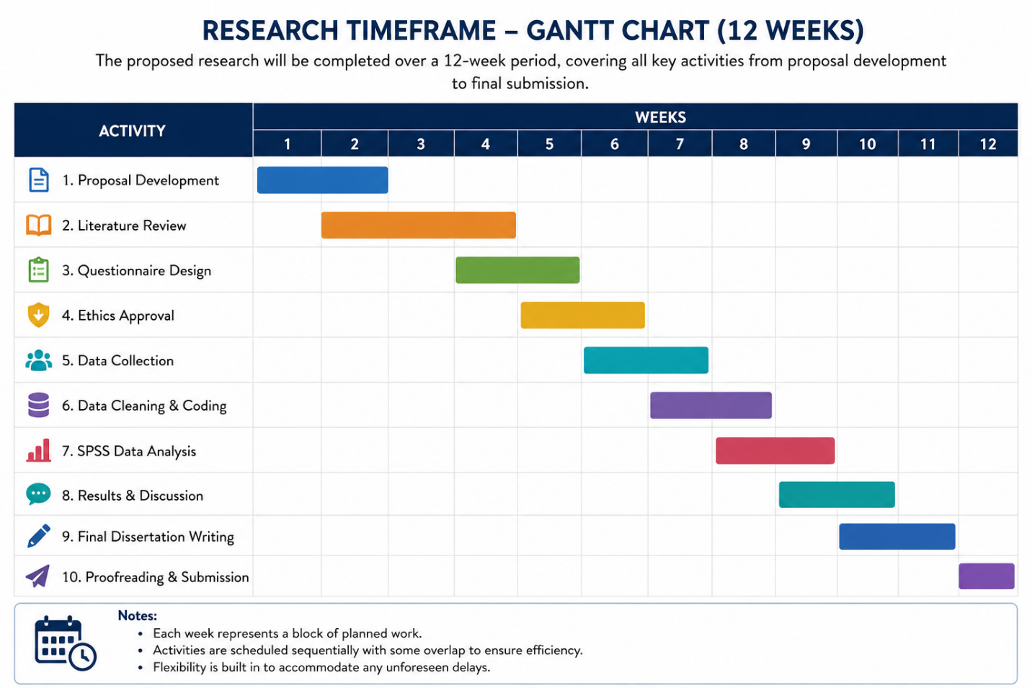
Figure 1 Timeframe: Gantt Chart

Limitations
The study is highly promising to yield important insights, but some limitations need to be noted. The study is limited to customers of ASOS UK, and findings might not apply to other online fashion retailers, or to other geographical areas. Additionally, participants will be recruited using convenience sampling, which might not be representative and could lead to selection bias. The research design utilized in the study is also a cross sectional survey design which means data will be gathered at one time. As a result, the research efforts refer to the relationships between variables, but do not make causal conclusions and do not explain the evolution of consumer behaviour over time. Moreover, the self-reported questionnaire data can also have response bias as the responses are governed by the perceptions and experience of the participant. However, use of existing measurement scales, pilot testing, and proper statistical analyses will enhance the reliability and credibility of the study's results.

Conclusion
Artificial Intelligence is transforming the Customer Experience in the Online Fashion Retail industry by providing the flexibility and efficiency to deliver personalized shopping experiences based on data. But, evidence about these AI-facilitated experiences and their effect on purchase intention among UK fashion retailers is far from widespread. This proposed research aims to fill this gap by using the quantitative survey methodology to explore the relationship between AI customer experience and purchase intent of the customers of ASOS UK. The results will help shape a broader digital marketing body of literature and offer actionable insights for retailers looking to maximize the value of their AI investments and improve customer interaction. The study's ultimate goal is to provide academics and decision-makers with valuable insights into the successful implementation of AI technologies to enhance consumer buying patterns in the fast-changing digital retail scene.

REFERENCES
Adam, M., Wessel, M. and Benlian, A. (2021) ‘AI-based chatbots in customer service and their effects on user compliance’, Electronic Markets, 31(2), pp. 427–445.
Ajzen, I. (1991) ‘The theory of planned behavior’, Organizational Behavior and Human Decision Processes, 50(2), pp. 179–211.
British Educational Research Association (BERA) (2024) Ethical Guidelines for Educational Research. 5th edn. London: BERA.
Bryman, A. (2021) Social Research Methods. 6th edn. Oxford: Oxford University Press.
Creswell, J.W. and Creswell, J.D. (2023) Research Design: Qualitative, Quantitative, and Mixed Methods Approaches. 6th edn. Thousand Oaks, CA: Sage.
Davenport, T.H., Guha, A., Grewal, D. and Bressgott, T. (2020) ‘How artificial intelligence will change the future of marketing’, Journal of the Academy of Marketing Science, 48(1), pp. 24–42.
Davis, F.D. (1989) ‘Perceived usefulness, perceived ease of use, and user acceptance of information technology’, MIS Quarterly, 13(3), pp. 319–340.
Dwivedi, Y.K., Hughes, L., Ismagilova, E., Aarts, G., Coombs, C., Crick, T., Duan, Y., Dwivedi, R., Edwards, J., Eirug, A., Galanos, V., Ilavarasan, P.V., Janssen, M., Jones, P., Kar, A.K., Kizgin, H., Kronemann, B., Lal, B., Lucini, B., Medaglia, R., Le Meunier-FitzHugh, K., Le Meunier-FitzHugh, L.C., Misra, S., Mogaji, E., Sharma, S.K., Singh, J.B., Raghavan, V., Raman, R. and Williams, M.D. (2021) ‘Artificial intelligence (AI): Multidisciplinary perspectives on emerging challenges, opportunities, and agenda for research, practice and policy’, International Journal of Information Management, 57, 101994.
Hair, J.F., Black, W.C., Babin, B.J. and Anderson, R.E. (2022) Multivariate Data Analysis. 9th edn. Andover: Cengage Learning.
Huang, M.-H. and Rust, R.T. (2021) ‘A strategic framework for artificial intelligence in marketing’, Journal of the Academy of Marketing Science, 49(1), pp. 30–50.
Lemon, K.N. and Verhoef, P.C. (2016) ‘Understanding customer experience throughout the customer journey’, Journal of Marketing, 80(6), pp. 69–96.
Mariani, M.M., Machado, I. and Magrelli, V. (2023) ‘Artificial intelligence in marketing: A systematic literature review and future research agenda’, Journal of Business Research, 161, 113824.
McKinsey & Company (2023) The State of AI in 2023: Generative AI’s Breakout Year. New York: McKinsey & Company.
Pantano, E. and Pizzi, G. (2020) ‘Forecasting artificial intelligence on online customer assistance: Evidence from retailing’, Journal of Retailing and Consumer Services, 55, 102091.
Russell, S. and Norvig, P. (2021) Artificial Intelligence: A Modern Approach. 4th edn. Harlow: Pearson.
Saunders, M., Lewis, P. and Thornhill, A. (2023) Research Methods for Business Students. 9th edn. Harlow: Pearson.
Statista (2024) Share of E-commerce in Total Retail Sales in the United Kingdom (UK) from 2019 to 2024. Hamburg: Statista.
Venkatesh, V., Morris, M.G., Davis, G.B. and Davis, F.D. (2003) ‘User acceptance of information technology: Toward a unified view’, MIS Quarterly, 27(3), pp. 425–478.
Verhoef, P.C., Kannan, P.K. and Inman, J.J. (2015) ‘From multi-channel retailing to omni-channel retailing: Introduction to the special issue on multi-channel retailing’, Journal of Retailing, 91(2), pp. 174–181.

