Assessment Component 1- Individual Essay
International Business Communications
Student Name: Radu Acris
Student Number:2239621
Lecturer Name: Dr Samson Oladejo
LCBB6001_BIRM
2025

,,Exploring cross-cultural communication challenges between UK and Japanese teams in the Global Combat Air Programme (GCAP), using cultural theories to understand, evaluate, and mitigate misunderstandings in multinational defence collaboration’’.
Contents
1.Introduction: 4
2. Background of GCAP and Geopolitical Context. 5
3. Communication and Culture - Theoretical Frameworks: 6
3.1. Hofstede’s Cultural Dimensions: 7
3.2. High-Context vs. Low-Context Communication: 8
3.3. Trompenaars’ Seven Dimensions of Culture: 9
4. Communication Styles in the UK and Japan: 11
5. Misunderstandings in Team Collaboration: 12
5.1. Impacts on Decision-Making and Project Implementation: 12
6.Conclusion: 13
References: 14

1.Introduction:

In today’s interconnected global economy, international partnerships have become more frequent. Successful collaboration in these multinational projects heavily relies on effective communication.
The Global Combat Air Programme (GCAP) is a joint defence initiative between the United Kingdom, Japan, and Italy, aiming to develop a sixth-generation fighter jet by 2035. This project represents more than just technological collaboration-it also brings together varied military, industrial, and cultural perspectives. GCAP brings together major defence firms-BAE Systems (UK), Mitsubishi Heavy Industries (Japan), and Leonardo (Italy)-to jointly design a highly advanced combat aircraft. The programme not only reflects shared security interests in the Indo-Pacific and Euro-Atlantic regions but also highlights complex communication challenges rooted in different national cultures.
The UK’s leadership in innovation and Japan’s high-precision engineering strengths make them complementary partners. However, differences in communication styles, corporate hierarchy, and decision-making can lead to friction if not properly managed.
This essay examines the communication differences between British and Japanese teams and evaluates how these differences influence cooperation in complex aerospace engineering projects. The discussion incorporates Hofstede’s cultural dimensions, Hall’s high- and low-context communication theory, and Trompenaars’ model to propose strategies for successful intercultural teamwork.

2. Background of GCAP and Geopolitical Context.

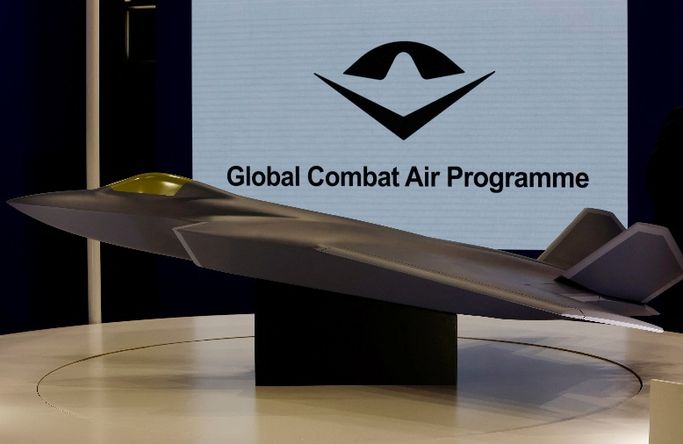
Launched in December 2022, the Global Combat Air Programme (GCAP) represents an ambitious three-nation collaboration aimed at advancing the future of air combat technology (Petrie, 2024). It brings together the UK’s Team Tempest initiative, Japan’s F-X programme, and Italy’s aerospace capabilities under a common strategic
Fig.1.
vision. Beyond shared defence goals Launched in December 2022, the Global Combat Air Programme (GCAP) represents an ambitious three-nation collaboration aimed at advancing the future of air combat technology. It brings together the UK’s Team Tempest initiative, Japan’s F-X programme, and Italy’s aerospace capabilities under a common strategic vision. Beyond shared defence goals, the partnership reflects a broader geopolitical alignment, particularly in addressing emerging security challenges and maintaining stability across the Indo-Pacific and Euro-Atlantic regions.
From an organisational standpoint, the UK’s involvement is led by BAE Systems, a company with extensive experience in combat aircraft development. In Japan, Mitsubishi Heavy Industries takes the lead, offering cutting-edge aerospace expertise and strong ties with the country’s Ministry of Defence. These key players operate within distinct national cultures, each influenced by unique views on hierarchy, communication, and collaboration.
The UK typically exhibits a business culture that is informal, individualistic, and focused on achieving results. In contrast, Japanese corporate and defence environments are marked by formality, collectivism, and a strong emphasis on consensus-building. Within the GCAP framework, these cultural contrasts are evident in how teams interact, make decisions, conduct meetings, and report progress (Ogbonna, 2011).
Given GCAP’s strategic significance and technical demands, recognising and addressing these communication differences is essential. This creates a foundation for a more in-depth analysis of the cultural dimensions that influence communication styles in each country.

3. Communication and Culture - Theoretical Frameworks:

To effectively understand cross-cultural communication within the Global Combat Air Programme (GCAP), it is essential to ground the analysis in established theoretical frameworks that reveal the underlying cultural values shaping professional behaviour (Saeed Askary, 2015).
Fig.2.
This section draws on Hofstede’s Cultural Dimensions, Hall’s High- and Low-Context Communication Theory, and Trompenaars’ Seven Dimensions of Culture to examine the contrasting communication styles between the UK and Japan. These theories offer valuable insight into how national cultures influence workplace dynamics, including decision-making processes, authority structures, attitudes toward time, and the flow of information (Kniewasser, 2017). For example, Hofstede’s model highlights differences in power distance and individualism, which help explain the UK’s preference for direct, task-oriented communication versus Japan’s group-focused and hierarchical approach. Similarly, Hall’s theory distinguishes between Japan’s high-context communication—where much is implied and dependent on shared understanding—and the UK’s more explicit, low-context style. Trompenaars adds further depth by exploring aspects such as universalism vs. particularism and achievement vs. ascription. Together, these frameworks provide a comprehensive lens through which the communication challenges and opportunities within this trilateral defence partnership can be better understood (Dong, 2024).

3.1. Hofstede’s Cultural Dimensions:
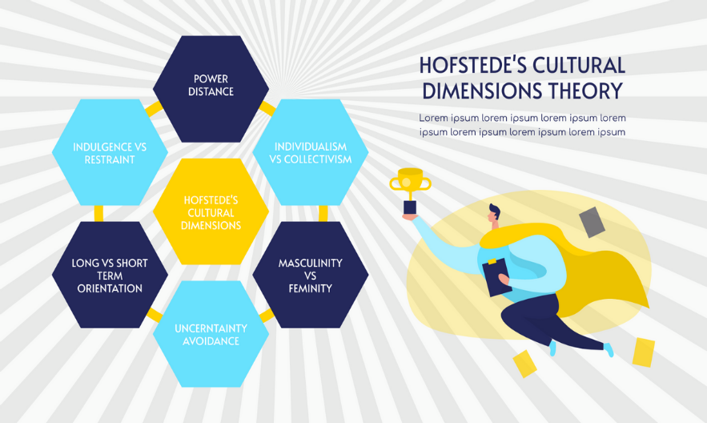
Geert Hofstede’s model identifies six cultural dimensions that explain how national values influence behaviour in organisational settings (Hofstede, 1983). The most relevant to UK-Japan communication within GCAP are:

Fig.3.
- Individualism vs. Collectivism:

- The UK scores highly on individualism, suggesting a culture that values autonomy, personal initiative, and direct communication. British professionals often feel comfortable speaking up and challenging ideas.
- Japan, on the other hand, is more collectivist. Team harmony, consensus, and group loyalty are central. In GCAP, Japanese engineers may avoid openly disagreeing with colleagues, especially in group settings, to preserve group cohesion.

- Power Distance:

- The UK has a relatively low power distance, meaning flatter hierarchies and informal communication between junior and senior staff.
- Japan has a moderate to high power distance, particularly in traditional sectors like defence. Formal titles, respect for seniority, and hierarchical communication are the norm. In joint meetings, Japanese participants may defer to senior leaders, while UK staff may express their views more freely.

- Uncertainty Avoidance:

- Japan scores very high on this dimension, reflecting a cultural preference for structure, planning, and risk avoidance. Japanese teams tend to be meticulous, requiring detailed documentation and multiple internal reviews before reaching a decision.
- The UK has a lower score, indicating greater comfort with ambiguity and faster decision-making. British teams may become frustrated by what they perceive as delays or indecisiveness on the Japanese side.

- Long-Term Orientation:

- Japan is strongly long-term oriented, favouring gradual progress, relationship-building, and sustainability.
- The UK, while also strategic, tends to be more short-term and result-driven. This can create tension in GCAP project planning and prioritisation.

3.2. High-Context vs. Low-Context Communication:

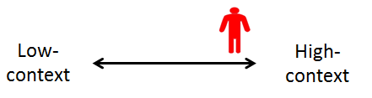
Fig.4.
Edward T. Hall’s theory of High- and Low-Context Communication is especially useful for analysing potential intercultural misunderstandings within the Global Combat Air Programme (GCAP). This model helps explain how deeply rooted communication habits, shaped by national culture, can lead to misinterpretation in collaborative settings (Bai, 2016).
- Japan represents a high-context culture, where communication tends to be subtle, indirect, and heavily reliant on non-verbal cues such as tone, facial expressions, and shared cultural norms. In such environments, silence is often used strategically, and responses may be intentionally vague to maintain group harmony and avoid confrontation. For instance, a Japanese engineer might respond to a proposal with a polite “We will consider it,” intending to defer or gently reject the idea without causing embarrassment.
- In contrast, the UK is characterised as a low-context culture. British communication is generally straightforward, transparent, and focused on verbal clarity. British professionals expect direct responses and may place less emphasis on reading between the lines. When Japanese team members do not offer a definitive “yes” or “no,” UK counterparts might misinterpret this ambiguity as reluctance, disinterest, or indecision.
Within the GCAP environment, such differences can cause confusion during discussions and meetings. A UK project leader may view a Japanese team’s measured or cautious responses as a lack of engagement, when in reality, the Japanese side may simply be exercising cultural norms of politeness, internal deliberation, or consensus-seeking (Mansour Javidan, 2006). Recognising and adapting to these divergent styles is crucial for building mutual understanding and ensuring effective multinational collaboration.

3.3. Trompenaars’ Seven Dimensions of Culture:
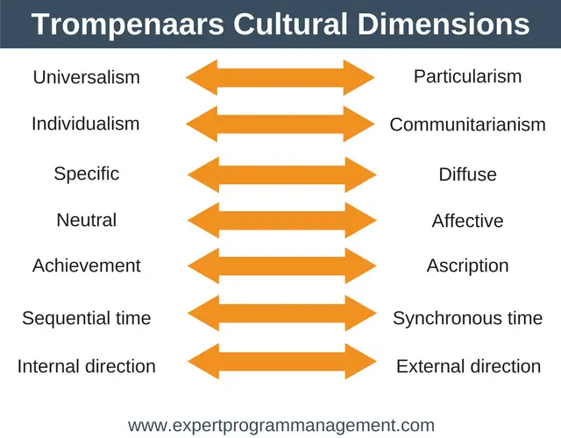
Fons Trompenaars' Seven Dimensions of Culture offer a nuanced framework for understanding how cultural values influence workplace behaviours, expectations, and interactions. In the context of the Global Combat Air Programme (GCAP), several of these dimensions are particularly relevant in highlighting communication and collaboration challenges between UK and Japanese teams (Bai, 2025). Fig.5.

- Universalism vs. Particularism:
British professionals typically operate within a universalist culture, where formal rules, procedures, and standards are applied uniformly, regardless of individual circumstances. This approach values fairness, consistency, and transparency. Conversely, Japan tends toward particularism, where context, relationships, and specific situations play a more prominent role in shaping decisions. For instance, when handling a technical issue or negotiation, a Japanese team may prioritise longstanding partnerships or seniority over strict adherence to established protocols. This can cause friction if UK teams perceive such actions as lacking objectivity or fairness.

- Achievement vs. Ascription:
The UK strongly favours achievement-based cultures, where individuals gain status through accomplishments, skills, and measurable contributions. Titles and authority are typically earned, not assumed. In Japan, however, cultural values reflect a blend of achievement and ascription. While competence is valued, greater importance is often placed on age, rank, and years of service. In GCAP, this can influence team dynamics and decision-making hierarchies. For example, British teams may naturally look to the most qualified engineer to lead a discussion, whereas Japanese teams might defer to the most senior person in the room, regardless of technical expertise.
- Neutral vs. Affective:
In the UK, emotional expression in the workplace is moderate—professionals are generally encouraged to communicate openly, while still maintaining decorum. Japan, on the other hand, is a distinctly neutral culture. Emotional control and restraint are seen as marks of professionalism and respect. Expressing strong feelings, especially in group settings, is often discouraged. As a result, British participants in GCAP may view Japanese colleagues as distant or difficult to read, while Japanese counterparts might interpret British directness or passionate debate as unprofessional or overly emotional. Misreading these cues can hinder trust and delay decision-making if not properly managed (Shinobu Kitayama, 2010).
Identifying these cultural dimensions and adapting accordingly is essential for fostering smoother cooperation, reducing miscommunication, and improving team synergy across the GCAP alliance. By building cultural awareness, teams can better navigate the complexities of international collaboration in a high-stakes defence environment.
- Internal vs. External Direction
Another valuable dimension from Trompenaars and Hampden-Turner's cultural framework is the contrast between Internal Direction (inner-directed) and External Direction (outer-directed) cultures. This dimension refers to how people relate to their environment and exercise control over outcomes.
- The UK is typically internally directed, meaning individuals believe they can control their environment, set clear goals, and shape outcomes through assertiveness and planning. In GCAP, UK teams often push forward with confidence in their decision-making and are action-oriented, especially when under pressure to meet deadlines or deliver progress updates.

- Japan, on the other hand, tends to be externally directed, emphasizing harmony with external circumstances, collective interests, and situational awareness. Japanese teams in GCAP may prioritise alignment with broader organisational goals, ministry-level approvals, or even geopolitical considerations. Rather than challenging obstacles directly, they seek to adapt around them through consensus, patience, and long-term strategy.
This difference can affect risk management and how each team responds to unexpected issues. For example, UK engineers might proactively push for immediate technical fixes, while Japanese counterparts may prefer to pause, consult internal stakeholders, and take a more holistic view of the consequences (Kızrak, 2023).
In a complex multinational programme like GCAP, recognising this dimension helps avoid misinterpretation. The UK’s forward-driving pace may be perceived by the Japanese as reckless, while the Japanese team’s measured caution could be seen by the UK as passive or resistant to progress. Bridging this gap requires mutual respect for differing decision-making rhythms.

4. Communication Styles in the UK and Japan:

- British Communication Style:
British professionals value clear, polite, and structured communication. Meetings are focused and emails are brief. Feedback is often indirect but understood, and assertiveness is acceptable within respectful limits. This reflects the UK’s low-context, individualistic culture, where directness and efficiency are appreciated.
- Japanese Communication Style:
Japanese communication prioritises harmony (wa), indirectness, and sensitivity to social context (kuuki wo yomu – reading the atmosphere). Silence is meaningful, and feedback is subtle to avoid embarrassment. Decisions are made through consensus, often following the ringi approval process. This aligns with Japan’s high-context and collectivist culture (Nixon & Bull, 2005).

5. Misunderstandings in Team Collaboration:

- Feedback styles: | - Silence: | - Meeting dynamics:
British professionals tend to give direct, constructive feedback, which may come across as overly blunt or critical to Japanese counterparts, who prefer more indirect and face-saving approaches. | In GCAP meetings, Japanese team members may remain silent as a sign of respect or reflection, but UK participants might misread this as hesitation, confusion, or lack of interest. | British members may speak more freely and assertively, aiming for quick progress, while Japanese colleagues might hold back, deferring to senior figures or awaiting internal alignment before contributing.

5.1. Impacts on Decision-Making and Project Implementation:

- Timelines: | - Email tone and structure:
The UK side often prioritises speed and efficiency, while the Japanese approach to decision-making—based on the ring process and group consensus—can extend timelines. This difference may lead to frustration or misaligned expectations within GCAP (G. & Martinsons, 2007). | British emails are typically brief and task-focused, while Japanese emails often include formal greetings, context, and a polite tone. UK partners may overlook these nuances, potentially causing unintended offence or appearing dismissive.

6.Conclusion:

Effective cross-cultural communication is crucial to the success of the Global Combat Air Programme (GCAP), a joint initiative between the United Kingdom and Japan. As explored through cultural theories such as Hofstede’s dimensions, Hall’s high- and low-context model, and Trompenaars’ framework, the UK and Japan differ significantly in their communication styles. While the UK values directness, clarity, and individual contribution, Japan emphasises indirectness, group harmony, and consensus-building. These contrasts can lead to misunderstandings, particularly in feedback, meeting dynamics, and decision-making processes.
If unmanaged, these differences risk creating delays and tension within the project. However, proactive strategies can bridge the communication gap and strengthen collaboration. Cultural training can raise awareness and sensitivity to each other’s working styles. Appointing bilingual coordinators or cultural mediators can improve clarity and reduce misinterpretation. Hybrid communication approaches—such as balancing direct feedback with culturally appropriate delivery—can also enhance mutual understanding. In addition, allowing flexible timelines and promoting psychological safety in meetings will support more open and respectful dialogue (Hurn, 2011).
In conclusion, recognising and adapting to cultural differences is not a barrier but an opportunity for building a more resilient and innovative partnership. By fostering intercultural competence, GCAP can benefit from the strengths of both nations and move forward with greater unity and effectiveness.

References:
Bai, H., 2016. A Cross-Cultural Analysis of Advertisements from High-Context Cultures and Low-Context Cultures. ERIC (Canadian Center of Science and Education.), 9(8), pp. 21-27.
Bai, X., 2025. A Critical Analysis of Fons Trompenaars’ Intercultural Research. In: Information Systems for Intelligent Systems. s.l.:Springer, Singapore, p. 155–165.
Dong, L., 2024. Philosophical Reflections and Value Reconstruction in International Communication from the Perspective of Intercultural Communication. Philosophy & Ideology Research, 4(1).
G., M. & Martinsons, 2007. Strategic decision making and support systems: Comparing American, Japanese and Chinese management. Decision Support Systems, 43(1), pp. 284-300.
Hofstede, G., 1983. National Cultures in Four Dimensions: A Research-Based Theory of Cultural Differences among Nations. International Studies of Management & Organization, Volume 13, pp. 46-74.
Hurn, B., 2011. Simulation training methods to develop cultural awareness. Industrial and Commercial Training, 43(4), pp. 199-205.
Kızrak, M., 2023. A Theoretical Exploration of the Nexus Between Performance Appraisal, Culture, and Impression Management. The Journal of Human and Work, 10(2), pp. 51-66.
Kniewasser, C., 2017. Intercultural Online Communication of International Companies in High-Context and Low-Context Cultures. Conference Proceedings Trends in Business Communication 2016, p. 141–147.
Mansour Javidan, P. W. D. M. S. d. L. a. R. J. H., 2006. In the Eye of the Beholder: Cross Cultural Lessons in Leadership from Project GLOBE. Academy of Management Perspectives, 20(1).
Nixon, Y. & Bull, P., 2005. Cultural communication styles and accuracy in cross-cultural perception: A British and Japanese study. Journal of Intercultural Communication, 6(2), pp. 1-20.
Ogbonna, E., 2011. Leadership style, organizational culture and performance: empirical evidence from UK companies. The International Journal of Human Resource Management, 11(4), pp. 766-788.
Petrie, L., 2024. What is the Global Combat Air, London: House of Commons Library.
Saeed Askary, N. Q. a. R. V. S., 2015. Culture, communication skills and intellectual capital: a theoretical framework. International Journal of Higher Education and Sustainability, 1(1), pp. 88-101.
Shinobu Kitayama, H. R. M. &. K., 2010. Culture, Emotion, and Well-being: Good Feelings in Japan and the United States. Cognition and Emotion, 14(1), pp. 93-124.

