

BMSW5104 MANAGING PROJECTS IN THE ORGANISATION
GYM 24/7 and Wellness Center
Lecturer: ALFRED MENSAH
Student: MARIANA GOLEMANOVA
ID: 2030688
FEBRUARY,2023

Contents
Task 2- EvaluaModelof Project Management Plan - GYM 24/7 3
1. Introduction 3
1.1 A basic project outline/description/scope based on our project: 3
2. Main body 4
2.1 Project Management Tools and Techniques 4
2.2 Project Life cycle Model 4
2.3 Relevant communication strategies used in project management. 5
2.3 Stakeholder Analysis 6
2.4 Work Breakdown Structure (WBS) 7
2.5 A decent draft of costs/resources uses. 7
2.6 Consideration of resources (i.e., including your own time, even if the ‘perceived cost to you is zero’) 8
2.7 An Outline Project Schedule / Gantt Chart 8
2.8 A Risk Assessment 9
2.9 Risk Management Plan 11
2.10 Communication Strategy 12
2.11 Network diagram……………………………………………………………………………12
3. Conclusion 13
References 14
4. Appendix ………………………………………………………………………………………….15

Task 2- Evaluation of Project Management Plan - GYM 24/7
Executive Summary
The report deals with the discussion of an effective project for a large factory organisation “GYM 24/7”. The report has highlighted the details and scope of the project. It has aligned the discussions with the PLC model and described the communication strategy that can be used in the project. The identification of stakeholders has been done with the help of a stakeholder matrix.

1. Introduction
The main aim is to plan and manage a specific development in-house project. The first part of our job was to create and plan the theoretical stage of the project and the second is to manage the completion of the GYM 24/7. The primary goal of the project is to deliver a luxury fitness and wellness center for customers. In this report, a description of the project will be provided. What are the project management tools and techniques used by GYM 24/7 in its project will be comprehensively discussed in this study. The stages of the project plan such as “project initiation, project planning, project execution, and project closure” will be discussed. The communication strategies which are going to be used by GYM 24/7 in its WELLBEING CENTRE project will be explained. Stakeholder analysis will be used in this study to analyse the role of key players in this project. A risk management plan of GYM 24/7 will also be comprehensively discussed.

1.1 A basic project outline/description/scope based on our project:
Outline: -
In this project, GYM 24/7 worked with the large factory administration to install a range of gym equipment for them.
Description: -
The vision of the Factory owners for our project is to be able to “Reduce the movement of staff from the premises during the lunch break which is currently creating congestion issues in the local area · Helping staff to develop a healthy lifestyle which the organisation believes is part of their CSR and will also reduce staff absenteeism”.). In our project, GYM 24/7 are manufacturing indoor gym equipment for them that would support them in fulfilling their vision.
Scope: -
During this project, GYM 24/7 is installing 29 pieces of gym equipment. The project plan is further extended to facilitate enough space in the users’ station as more than 50 people can work out at one time in.

2. Main body

2.1 Project Management Tools and Techniques
The project management tools that have been used in the GYM 24/7 project are described as follows: -
Work breakdown structure (WBS): -
As per the view of Jati and Latief (2020), the preparation of a WBS checklist in a project helps in assessing the level of accuracy and evaluating detailed activities that take place in each activity. Application of the WBS in our project would help in evaluating the total volume of work required in this project. Moreover, it would also help to identify the potential scope and major risks associated with the GYM 24/7 project.
Gantt Chart: -
As opined by Lee and Shvetsova (2019), the Gantt chart uses critical analysis to assess the planning process incorporated into a project. The implementation of the Gantt chart in the GYM 24/7 project, helps to measure the progress of the project and to identify the overlapping activities and task dependencies in the project.
The project management techniques that have been used in the current project have been discussed as follows: -
Project initiation: -
In this stage, GYM 24/7 identifies what are the recruitments of the manufacturing organization for its indoor gym and manufactures the requirements accordingly.
Project planning: -
In the project planning stage, GYM 24/7 evaluates the resources required in this project and determines the total cost of the project.
Project execution: -
In this stage, GYM 24/7 assesses the stakeholders’ expectations while procuring resources for this project.
Project Monitoring & Controlling:
In the last stage, GYM examines the installation process of indoor gym equipment in the manufacturing company.

2.2 Project Life cycle model
The project life cycle model or in other words PLC model can be described as the sequence of steps involved in the completion of the project. This model is divided into five distinct stages, namely, “initiation, planning, execution, monitoring/control, and closing” which helps in successfully managing the project from start to finish (Roman et al. 2022). The stages can be described as follows:
- Initiation phase: This is the first step of the PLC model that is concerned with the development of the project charter and identifying the stakeholders of the project. It is concerned with developing the goals and objectives of the project and sanctioning it from the stakeholders. The stakeholders for “manufacturing company” are owners, investors, the project manager, contractor, staff, workers, and administration". The project was initiated with the amalgamation of both the organisation and GYM 24/7 PROJECT TEAM for the development of an in-house gym for all the employees and staff and to help them fight obesity.
- Planning phase: This phase is concerned with the planning and delegation of tasks to the team members. In this phase determination of resources, cost estimation, and identification of risks are done [Provided]. Regarding the “manufactory organisation project,” this step has been related to working with GYM 24/7 and determining the work breakdown structure and identifying the required indoor gym equipment in the building.
- Execution phase: It is the third stage of the cycle that is concerned with procuring resources and managing the expectations of the stakeholders. Concerning “the manufactory company project” this stage is related to the deployment of big-size gym equipment [Provided ].
- Monitoring and control phase: This phase is simultaneously carried out with the execution phase. It is concerned with monitoring the quality, scope, cost, and time allocation of the project. In the context of the "manufactory company project," it has been observed that at least 50 people had been able to work out on the equipment at a time.
- Closing phase: It is the last stage of the PLC model and is concerned with the closure of the project. It has been identified that GYM 24/7 worked effectively with the contractor appointed by the company. Despite location hurdles, the installation process of the equipment has been successfully fulfilled.

2.3 Relevant communication strategies used in project management.
Clear and effective communication is of utmost importance in managing a project. It is necessary to avoid any misunderstanding and complete the project within the stipulated time. The communication strategies that can be used in project management can be described as:
Being clear and concise
In project management, it is significant to be clear about the goals and objectives of the project. In this regard, clear communication is necessary to promote team collaboration and get results (Ewing et al. 2019). Regarding the concerned project, explicit clear communication with the contractor appointed by the company helped in smoothly accomplishing the installation process.

Communicating with relevant tools
The use of relevant tools such as email helps in fostering better communication within the team [Provided]. It also helps in boosting team collaboration for better reviews and achieving milestones. Effective communication between the project manager and the company helped in the successful completion of the project.
Communicate with purpose.
Purposeful communication helps in delivering required information in a shorter time. Concerning “company”, the organisation contacted GYM 24/7 and clearly stated its desire. This explicit interaction helped in achieving the goals of this innovative project.

2.3 Stakeholder Analysis
The “stakeholder analysis” can be described as the project management tool which helps in identifying the stakeholders within the project and their impact on the project. It signifies the core requirements of the project and needs as well as expectations of the stakeholders with the concerned project. The graphical depiction of stakeholder analysis can be better illustrated with the help of the stakeholder matrix. It is the graphical representation that helps in determining the stakeholders of the projects (Bahadorestani et al. 2020). In the concerned project "manufacturing organisation project", the internal stakeholders are all the staff, the project manager, and the contractor. On the other hand, the external stakeholders are the community and investors, or anyone outside the factory, who will be able to use the equipment. The graphical representation highlighted in Figure 1 illustrates the impact of each stakeholder on the project.
Figure 1: Stakeholder matrix (Source: Self-developed)
LOW
POWER
HIGH
INTEREST
HIGH

2.4 Work Breakdown Structure (WBS)

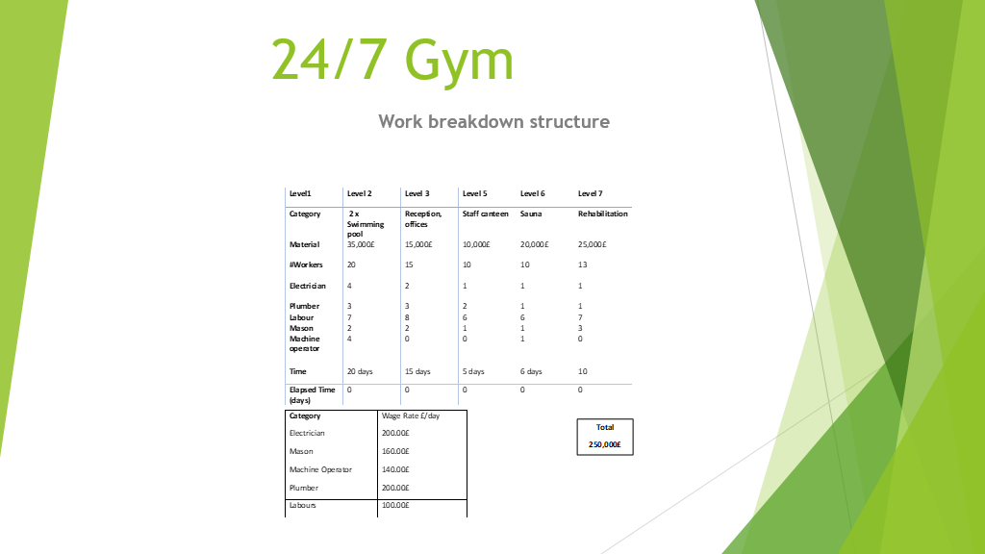

Figure 2: WBS (Source: Self-created)

2.5 A decent draft of costs/resources uses.
The estimated costs and the uses of resources play a huge role in the budgetary expectations of the project. However, not all expenses can be planned as some expenses occur in between the project. However, the expected cost and resources used by the gym are as follows:
Resources | Costs
Gym Equipment | 70000 £
Salary to interns | 45000 £
Equipment for workers | 22000 £
Salary for workers | 68000 £
Rent for Machinery supplies | 45000 £
Total | 250000 £
Table 1: Draft of cost and resources
(Source: Self-developed)

2.6 Consideration of resources (i.e., including your own time, even if the ‘perceived cost to you is zero’)
To complete the project “managing the project in the organisation”, the selected project is the "GYM 24/7 project ". It is a great initiative taken by the manufacturing company to open an in-house gym and wellness center. One of the main reasons for selecting it as a topic is to figure out the new trends observed in the gymming system. For the completion of this project, the team has concentrated on the vision of GYM 24/7 and how it acted to deliver indoor gym equipment to its clients.
It is a gym project in which the project management tools and techniques selected by GYM 24/7 have been developed. The online website and web articles have been used in this report to understand what project management methodologies are used by GYM 24/7. One of the visions of the “Manufacturing company” is to encourage, educate and inspire generations of its employees and families to participate in and enjoy sports together”. In this report, peer-reviewed journals are used to collect resources on how fitness gyms used project management tools for the betterment of the quality of indoor gym equipment.

2.7 An Outline Project Schedule / Gantt Chart
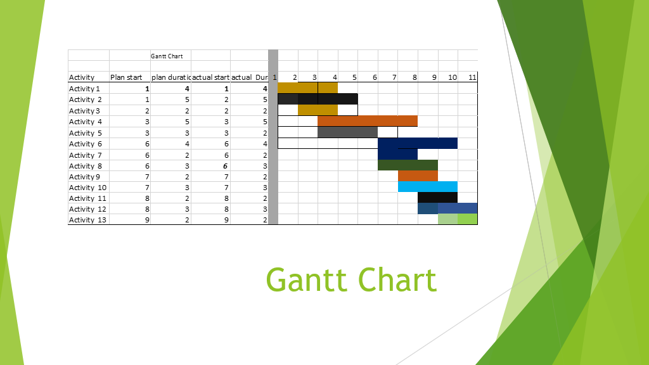

Figure 3: Gantt chart
(Source: Self-created)

2.8 A Risk Assessment

Project risk assessment is a process through which the potential hazards and risks involved in the project are identified and are taken into consideration while planning which helps in mitigating their impact on the completion as well as on the quality of the project (Kliem, and Ludin, 2019). The risks associated with the project of 24/7 Gym are depicted below:

Risks | Description of the risk | Probability | Impact | Mitigation Plan
Failure to deadline | The project needs to be completed within the deadline. Failure to deadlines means clients' | Low | High | Use the Gantt chart to ensure and monitor tasks in the project concerning the deadline.
Safety Hazards | Employees can get hurt while working on the project which can result in the disruption of the project. | High | High | Ensure that proper working equipment is provided to the people involved in the project.
Harm to the environment | Harm to environmental regulations during the project can result in financial fines and legal action against the project team | Low | Low | Ensure that environmental regulations of the UK are followed
Failure to adhere to budget limits | Failing to adhere to budget limits can result in the cancellation of the project midway due to a lack of financial resources | Low | Low | Effective planning and delegation of resources will ensure that the project is completed within budget limits.
Employee conflict | When different people with different background work together it is likely they develop a difference in opinion and hence conflict may arise. This may impact the operations of the project | High | Low | Clarity of goals and having a single common goal ensure that conflicts do not impact performance.
Table 2: Risk Assessment
(Source: Self-developed)

2.9 Risk Management Plan

Risk | Factors involved in the risk | Strategies to mitigate the risk | Severity
Failure to deadline | Failure of the deadline on the different tasks of a project negatively impacted client losses and loss of wages in the project team. | To eliminate the threat of deadline failure. It is required to use a Gantt chart to maintain the deadlines of each task. | Low
Safety Hazards | Disturbing in a project impacted the confidence level and will of the members in completing the task. | It is recommended to establish a good work culture in the team so that participants will get proper health and safety into the work. | High
Harm to the environment | For the completion of the tasks of a project, it is not legal to breach any environmental regulations. As it will be subject to financial fines charged to the project team/ | The whole project team should follow environmental laws and principles while participating in the project. | Medium
Failure to adhere to budget limits | Due to the lack of financial resources, a project can be canceled midway. | It is necessary to do effective planning before starting a project work as it will help in proving proper financial backup during the entire project. | Medium
Employee conflict | Inter-departmental conflict is considered a major issue in this project. As different employee comes from different background their options can be intercalated. | Before starting a particular project work, it is necessary to set a common goal for the project. As it will help the employees to understand how they set a plan to accomplish that goal throughout the project. | High
Table 3: Risk management plan
(Source: Self-developed)

2.10 Communication Strategy
For communication purposes in 24/7 GYM project management internet devices will be used. Internet devices equipped with Internet communication platforms like WhatsApp and Zoom will provide a platform for live and real-time information and insight sharing with the other groups involved in the project. Communication will also be used to manage clients and the stakeholders in the project. The communication medium to be used to manage clients and stakeholders will be E-mail. Through Email project, requirements and progress will be communicated. However, personal meetings will also be done with the clients and stakeholders of the project.

2.11 Network diagram

THE NETWORK DIAGRAM IS a graphical representation of our project, and it is composed of a series of connected arrows and boxes to describe the inter-relationship between the activities involved in the project. It allows a project manager to track each element and quickly share its status with others and establish project workflows.

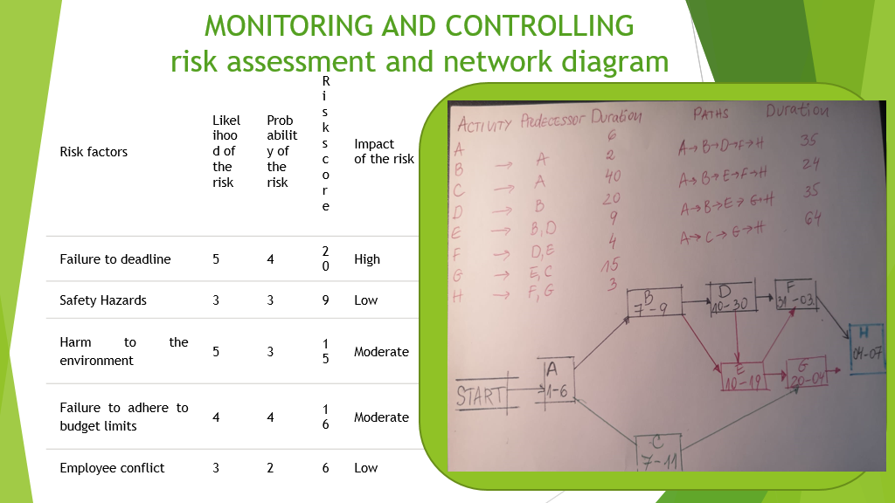
Figure 4: Network diagram
(Source: Self-created)

3. Conclusion
It can be concluded from the report that project management is of high importance to accomplish the project within the allocated time and budget. The discussion has been supported by the example of the GYM 24/7 special project of developing an indoor gym in the manufacturing company”. This innovative project has helped in providing an immersive indoor r family fitness, health, and sports experience. This report has outlined the scope and deliverables of the concerned project. The discussion has been supported with the help of the project life cycle model and its stages have been aligned with the project activities. Communication strategies such as “being clear and concise, communicating with relevant tools, communicating with purpose” have been explained in this report. This would help in facilitating better communication within the project and accomplishing it without any hurdles. The analysis of the stakeholders has been performed with the help of the stakeholder matrix. The report also illustrates the work breakdown structure that helps in explaining the activities involved in the project in a detailed manner. A Gantt chart has been illustrated here to define the timeline of each activity and completion of the project. A risk assessment has been done which highlighted that the project might have the risk of “failure to the deadline, safety hazards, harm to the environment, failure to adhere to budget limits and employee conflict”.

References
Asana 2023. Asana. Asana. Available at: https://asana.com/resources/project-constraints [Accessed 2nd. 2023].
Bahadorestani, A., Naderpajouh, N. and Sadiq, R., 2020. Planning for sustainable stakeholder engagement based on the assessment of conflicting interests in projects. Journal of Cleaner Production, 242, p.118402.
Ewing, M., Men, L.R. and O’Neil, J., 2019. Using social media to engage employees: Insights from internal communication managers. International Journal of Strategic Communication, 13(2), pp.110-132.
Ibisworld, 2022. Gyms & Fitness Centres in the UK - Market Size 2011–2029. Available at: https://www.ibisworld.com/united-kingdom/market-size/gyms-fitness-centres/ [Accessed on 3rd April 2023]
Ibisworld, 2022. Gyms & Fitness Centres in the UK - Market Size 2011–2029. Available at: https://www.ibisworld.com/united-kingdom/market-size/gyms-fitness-centres/ [Accessed on 3rd April 2023]
Indeed 2022a. 7 Project Success Criteria Examples (With Benefits). Indeed Career Guide. Available at: https://www.indeed.com/career-advice/career-development/project-success-criteria-exampl s [Accessed 4 Apr. 2023].
Indeed 2022b. Project Outcomes: Definition and Examples. Indeed Career Guide. Available at: https://www.indeed.com/career-advice/career-development/project-outcomes [Accessed 3 Apr. 2023].
Jati, D.B. and Latief, Y., 2020, September. Development of risk-based standardized Work Breakdown Structure (WBS) to improve time performance on high-speed railway construction projects. In IOP Conference Series: Materials Science and Engineering (Vol. 930, No. 1, p. 012065). IOP Publishing.
Kliem, R.L. and Ludin, I.S., 2019. Reducing project risk. Routledge.
‌‌Roman, A., Andrii, S., Galyna, R., Honcharenko, T., Iurii, C. and Hаnna, S., 2022. Integration of data flows of the construction project life cycle to create a digital enterprise based on building information modeling. International Journal of Emerging Technology and Advanced Engineering, 12(1), pp.40-50.
Statista. 2021. Gym sessions participation England 2016-21 | Statista. Available at: https://www.statista.com/statistics/934944/gym-sessions-participation-uk/#:~:text=Between%20November%202020%20and%20November,England%20%2D%20Public%20funding%20and%20participation. [Accessed 25 March 2023].
4. Appendix


