What do I know already / What have I learnt so far?

Have over 10 years’ experience in a Ks2 setting. Where I have attended many courses including: Safeguarding, First Aid, Dyslexia training, THRIVE, Behaviour support, ALN training, PECS training. I was also part of the improvement in reading and literacy scheme within cluster schools in Swansea, implementing programs to enhance children’s reading ages and understanding. I have attended RWI training, maths catch up and up to date with the new curriculum and policies.

What do I want to develop?

Improve confidence and knowledge in my ICT skills.
Improve my Harvard Referencing in assignments.
Gain knowledge in sensory Needs with ALN children.
Improve communication with non-verbal children using PECS and communication boards.

Objective | Actions (How will I achieve this objective/ what needs to be done?) | Resources (What support and resources are needed to achieve this objective?) | Target Date for achieving objective. | Success criteria (How will I know I have achieved this goal; how will I review this?)
Improve and become more confident in my ICT skills. | Watch helpful videos on you tube that explain step to step guides how to do something.  Get help from the university library. | Support from peers,  discussing problems and techniques.  Book an appointment with digital skills from the university library. | Within the month  01.11.2023 | Practice my skills independently that I have gained and use in future assignments and research.  Check I have fully understood and question any ongoing issues with others.
Complete Sensory needs Practitioner Training. | Discuss with my boss/ headteacher if I can go/complete the Sensory needs practitioner training course and book training day. | Liaise and talk with other staff members about the benefit of the course and knowledge for the children in our class and suggest a suitable time to complete course. | Within 3 months.  01.01.24 | Attended the course and be implementing new skills and strategies within the class, discuss with colleagues if skills are achieved and children gaining and progressing from new ideas.
Improve my Harvard referencing in assignments. | Ensure I follow the Harvard referencing handbook when referencing and check.  Use the online library and book an Academic and InfoSkills Appointment. | Use the website cite them right to gain a deeper understanding and check that my referencing is correct. | Within a month.  01.11.23 | Use knowledge gained in upcoming assignments and check the lecturers feedback to ensure my referencing is correct, or what improvements I still need to make.
Improve communication with non-verbal children in the classroom and school by improving my knowledge of PECS and communication boards. | Refresh my PECS (Picture Exchange Communication System) training by either attending more courses or working with the speech and language practitioner on new techniques and skills.  Watch videos on YouTube regarding PECS. | Liaise with Speech and language practitioner when she attends and discuss with her options of a refresh course or tips and advice on current children within the classroom.  Ensure I have the correct PECS available to help the children communicate effectively. | Within 3 months  01.01.24 | Implement these skills and techniques with colleagues and within the classroom and discuss improvements of communication between children and the use of PECS and alter accordingly.

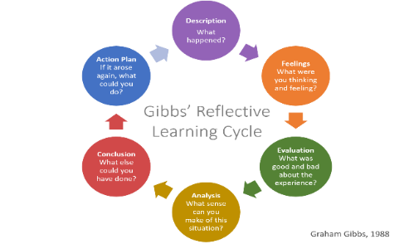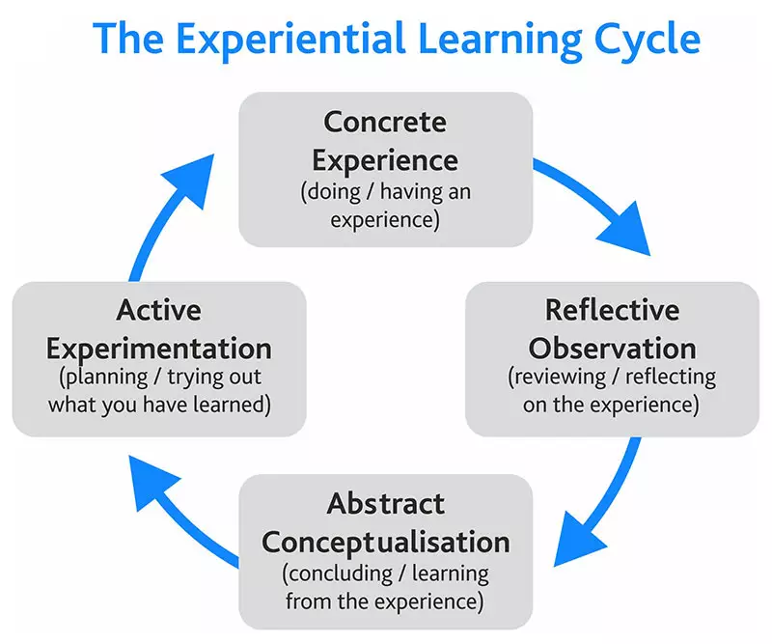
Both Gibbs and Kolbs reflective learning cycle allow structure to reflective practice, encouraging individuals to reflect on experiences, both reflective models enable practitioners to process, scrutinise and learn from situations, allowing areas of personal development and growth. However they contain key differences, Kolbs learning cycle focuses on experimental learning, the learning process, emphasising the importance of observing, reflecting and the development of new ideas and suggestions. Its an in depth analysis as well as a continuous learning cycle, it benefits from being flexible, to reflect and apply in many different situations, developing social awaerness and understanding. Although many practitioners claim this can be time consuming and requires practitioners to trail their new approach to see if sucessful and if not repeat the process. (Kolb 2015) Whereas Gibbs is focused on what went wrong and problem solving and what decisions were made. Gibbs is a more structured approach, analysing reflection in a systematic way, it includes how an individual was feeling, as feelings can sometimes be overlooked although they play a significant part in why a decision was made at the time. Gibbs’ cycle is more simplistic, allowing practitioners to write reflective practice in a journal or diary, its less detailed and more about finding a solution or goal. However, Gibbs’ cycle is critisised for not allowing deep reflection, therfore not ensuring reflection will result in change. (Open University 2014)
Reflective practice is important in early years as the Welsh Government want to raise the standard in schools, particularly in early years, to improve children’s outcomes in later years. To invest in good quality teaching and care providers, by ensuring they play an active role in their own professional development, reflecting on their skills and experience to enhance the standard of care within their role. (Social Care Wales 2017) Abiding by the National Minimum Standard and Early Years Framework to ensure all children learn and develop well by ensuring professionals working with children follow the framework. (EYFS 2023)
Reflection and reflective practice are essential for practitioners to reflect on their skills and understanding to continue to adapt and improve. Reflection is the ability to look upon a person’s own actions and evaluate what they did, why they did it and how they could improve it. Brookfield (1995): and Thiel (1999) explain that reflective practice is a continuous cycle of viewing what actions were taken, why and reflect on what they would do differently next time to refine and improve themselves as professionals and learners. Understanding that learning is a continuous cycle of adaptation and benefits not only the practitioner but those who they are working with.
“Reflective practice is the process of thinking about and analysing your practice, with the aim of challenging, changing, modifying, developing and improving it. This should be a continuous cycle of reflection and improvement. (Pacey, 2016)\
Reflective practice plays an essential part in personal development, whether a practitioner uses Kolbs or Gibbs learning cycle, the fundemental importance of reflecting on ones actions remain the same, as dewy explains that “we do not learn from experience, but reflecting on experience.”( Dewey 1933). It is essential that all practitioners working with children abide by the Legistlation and Standards and include reflective practice in their everyday roles.
Kolbs Model of reflection is another learning cycle used for reflective practice, he again believed in transferring experience into knowledge, his cycle however only consists of four stages, it begins with Concrete Experience, here Kolbs recognised that in order for an individual to acquire new knowledge, they have to actively have expereince and engage in a task not just read about it. Next is Reflective Observation, where a practitioner reflects upon the task or situation, allowing the practitioner to ask questions and discuss experiences with colleagues, communication is vital and it allows practitioners to have a detailed understanding of the situation. Following this Abstract Conceptulisation,- this step is where an individual draw conclusions reflecting on their knowledge and theories from colleauges, making comparisons on previous ideas and analysing the event. Lastly in the cycle is Active Experimentation,- here practitioners, return to a previous task or situation but with a modified goal or objective, this is to analyse if the appropriate changes that were made were a sucsess and if not repeat the cycle as with any learning cycle, it’s a continuous cycle of adaptation and learning. (Kolb 1984)
How to implement reflection in practice can be achieved by following Models of reflection, one of the most famous models of reflection was created by Gibbs in 1988, he created a cycle to give structure to learning from experiences, these include 6 stages: Description,- explaining what happened, Feelings,- what your thoughts are about the experience, here Gibbs wants a professional to understand what they were feeling and how that initiated a certain response, Evaluation,- allowing a practitioner to look at both the poor and the good decisions. Analysis, - why those decisions were made and making sense of a situation. Conclusion,- this allows professionals to look at what they have learned and what could be altered, Action Plan,- How to respond to similar experiences in the future better or make appropriate changes.
The theory of reflection and reflective models were created by Dewey and Schon over a century ago, Dewey states the importance of practitioners reflecting on their practice, Dewey explains that reflection is a way of processing events that have occurred, discussing with colleagues why particular events have led an individual to make a certain a decision. (Schon 1983)
Dewey explains that reflective practice is defined by two segments, Routine action and Reflective action. Routine action is followed by habit, adhering to policies or guidelines, this is a more static and unlikely to change model. However reflective action is contrast to this, it allows self-evaluation, to question whether you can control or change the outcome and a way of developing from experiences and growing as a practitioner. (Dewey 1933)
This is similar to Schon’s theory of reflective practice, he divides reflective practice into two parts: Reflection in action and Reflection on action, here he identifies that reflection in action is an instant response when something happens, conversely reflection in action is a more in-depth analysis of what happened and how a practitioner could change and improve situations for the future, enabling them to become better practitioners. (Schon 2016)
.
Professional Practice refers to the conduct, skills and ethnical values and standards that individuals in a spacific profession are expected to uphold in the early years sector in Wales, practitioners play a vital role in a childs development and the early years framework provides guidence to support childrens rights and wellbeing. EYF in wales (N.D) According to the ECEC (2015) it is essential to understand and instil collaborative working, working with a range of agencies, and aknowledging the fundermental role parents also play in their childs development as well as the child itself. Professionals should acquire theoretical knowledge of childrens interlectual, emotional, physical and spiritual development to aim to ensure high quality experiences and positive outcomes for children in early years. This combined with professional development, reflective practice attribute to a Professional practitioner in a child care setting. (Gasper, 2015) Professionals will need to follow the National Minumum Standard regulations, which states the legislative framework for regulated childcare in Wales designed to keep children safe but also support good quality teaching and working towards a high standard( Welsh Government, 2013). Professionals are expected to edhere to the Early Years outcomes document (Welsh Government,2015) as well as being up to date with the Safeguarding regulations, childs rights according to the UNCRC (1992) and National Curriculum for Wales (NCFW, 2020). The framework facilitates the delivery of high quality early years provision.
Good values are key for a professional practitioner working within an early years setting, as values serve as guiding principles that shape a practitioners behaviour, decisions and interactions. Practitioners are essentially role models for children within their care, individuals must have a genuine liking and interest in children and their development. Practitioners must have patience,- show an understanding and be compassionate, be respectful,- treating all individuals with dignity, valuing diversity and maintaining an inclusive approach. Be fair,- following policies and guidence, be caring and trustworthy, have integrity,- demonstrate honesty and ethnical behavior in all interactions and good ethnical principles, but most importantly,- want to make a difference. Values are significant in Early years practice as it helps practitioners to develop professional identity, by reflecting on their beliefs, commitments and attitudes. Values assist professionals in making ethnical decisions and solving complicated problems, Values also promote positive relationships and enable effective collaboration between colleagues and other professionals, they aid to a supportive and inclusive work environment. These are all highlighted in the code of ethics (General Teaching Council for Scotland, 2021) and (Childhood Education, 2011)
Communication and relationships are important to professional practice and meeting the needs of the children as it enables practitioners to understand the needs, interests, strengths and challenges of individual children and provide appropriate support and guidence, good communication between parents build trust and rapport with children and their families or carers. It is essential to have open honest communication, working collaboratively with proffessionals and other agencies to share information, expertise and resources. The Welsh Government recognises the importance of good communication and relationships in professional practice, these are included in the Curriculum for Wales guidence which sets out the principles and requirements designing a curriculum based on the Four Purposes of education that understands the needs and interests of each child, builds trust with children and families, share information, promote wellbeing and offer positive and inclusive learning (Curriculum of Wales Guidence 2020). According to EYFS (date), research highlights that involving parents/carers in their childs learning is very important in enabling children to achieve regardless of their background. Working together in partnership with parents/carers is centeral to the Early years foundation stage, good communication can include daily updates, phone calls home, open days where parents are welcome to enter the setting and overcome any concerns they have and ask questions in relation to their child. Practitioners also benefit from this, gaining a deeper and more alaborate picture of the child and their needs, interests and challenges, offering solutions to parent/teacher frustrations and collaboratively working together to aid the childs learning expereince.
Having an in-depth knowledge and understanding is important in professional practice for many reasons as practitioners are often involved in dealing with challenges and complex issues, having an in-depth knowledge and building good relationships with the children and parents/carers allows practitioners to be aware of signs and symptoms to look out for. To explore pattens of behaviour or suspected abuse and record appropriatly, act and implement applicable stratagies according to the (HM Government Safeguarding Policy.) Having extensive knowledge and understanding of the various policies and procedures are essential as practitioners have a duty of care to protect children and their wellbeing. According to the Working together to Safeguard policy (2018), safeguarding children refers to the actions taken to protect children in their care from harm, to look for signs of abuse, neglect to understand the procedures and take action. However this must be inline with the childs rights as according to the (Childrens Act 1989 and 2004) states anyone working with children should listen to what they say and take their views seriously, to work together in partnership with their families and other agencies as the welfare of children is paramount and having a child centred approach is fundermental in safegarding.
Partnership and multiagency collaboration are essential elements of professional practice as according to the government (date), agencies working with children should have a holistic approach, working together, bringing professionals expertise, advise and perspectives along with working with the child and their parents/carers to get the best outcomes for the children they work with to reach their full potential.
“Children and their families will access a range of services throughout a child's life. It's vital that practitioners work together to gain a full overview of a child's situation and have a co-ordinated approach to support” (NSPCC 2023)
According to Bronfenbrenner’s (1979) ecological systems theory, he emphasises the importance of multiagency and collaboration when supporting children, he states that a child’s development is influenced by many factors and systems, beginning with its immediate environments for example, family and school to broader social and cultural influences. Bronfenbrenner states that not one person or practitioner can meet all the needs of a child but instead a network of different agencies and professions working collaboratively together, communicating and exchanging information and knowledge can maximize a child’s potential.
The observation and planning cycle inform professional practice as it enables practitioners to identify the strengths, interests and needs of individual children, as well as plan their progress. The Welsh Assembly Government Observing Children document (2008) states that, all practitioners must understand child development and the needs of children. By observing children and looking at key points such as social development and wellbeing, cognitive development, personal development, physical development, language development and communication skills, practitioners can then plan a more appropriate and child centred curriculum that supports a child’s developmental needs. The observation and planning cycle is a process that helps practitioners to observe a child’s learning and development, plan appropriate activities, and evaluate their effectiveness. The four stages include: observation- observing a child’s learning and development, looking at strengths and areas for improvement. Assessment is next, where practitioners use their observations to assess a child’s progress against developmental milestones.
Planning is the third stage, where observations and assessments are used to plan activities tailored to the child’s needs. Evaluation is the final stage, where practitioners evaluate the effectiveness of the planned activities. (Birth to 5 matters 2023)
The Principles of the UNCRC inform professional practice as it provides a framework ensuring children’s rights are respected and upheld in all aspects of their lives. The UNCRC article 28 “that every child has a right to an education” and article 29 which states that “education should develop a child’s personalities, fascinations and abilities to the full.” In Wales, the Welsh Government has adopted a rights-based approach to policy making and decision making, ensuring children’s rights are at the heart of them. It is important to incorporate the principles in the UNCRC into professional practice as it ensures that children’s rights are acknowledged and being supported. (Gov Wales, 2022 )
In Summary incorporating these different aspects into practice whilst working with children is significant for professional practitioners so they can meet the individual needs of children in Wales effectively. This holistic approach prioritises the safety, rights and well-being of each child, enabling them to reach their full potential in a supportive and inclusive environment.

References

(HM Government Safeguarding Policy.)
Bronfenbrenner U. (1979). The ecology of human development: Experiments by design and nature. Harvard University Press

Brookfield (1995): and Thiel (1999)
Locating Article...
Care Wales (2017) Continuing Professional Development Principles for the early years and childcare workforce in Wales, Care Council for Wales Cardiff.
Early Education (2023) Observation, assessment and planning – Birth to 5 matters.

Early education 2011The British association of childhood education London
Early Education is a registered charity in England and Wales (no. 313082) and in Scotland (no. SC039472) and a company limited by guarantee.
Gibbs, G (1988). Learning by Doing: A guide to teaching and learning methods. Further Education Unit. Oxford Polytechnic: OxfordGibbs' Reflective Cycle | The University of Edinburgh.

GOV.UK (2023) Early years foundation stage (EYFS) statutory framework.

GOV.UK (N.D) Working in partnership with parents and carers – Help for early years providers.

GOV.WALES (2020) Curriculum for Wales.

GOV.WALES (2022) Children’s rights in Wales. The Childrens Act 1989 and 2004.
https://www.gov.wales/curriculum-wales-overview#:~:text=The%20Curriculum%20for%20Wales%20guidance% 2020

Kolb, D (2015) Experiential Learning: Experience as the Source of Learning and Development Hardcover
Kurt, S (2022) Kolb’s Experiential Learning Theory & Learning Styles - Educational Technology
Michael Gasper Book Title: A Critical Companion to Early Childhood Chapter Title: "Professional Practice and Early Childhood Today" Pub. Date: 2015 Access Date: September 25, 2021, Publishing Company: SAGE Publications, Inc
National Minimum Standards for regulated childcare | GOV.WALES

NSPCC Learning (2023) Multi-agency and interdisciplinary working.
PACEY (2016) Developing Self Reflective Practice. Available at: https://www.pacey.org.uk/Pacey/media/Website-files/PACEY%20member%20practice%20guides%20(PDFs)/PG04-self-reflective-practice.pdf

Schon, D (2020) Leontiev’s Theory of Activity and Donald Schön’s Reflective Professor: reflections on teacher education
Acta Scientiarum : Education
Vol. 43, p. e48355
Schön, D. (2016) The reflective practitioner : how professionals think in action. England: Routledge.
Third, S (2022) Reflective Practice in Early Years Education.

UNICEF UK (1992) UN Convention on the Rights of the Child.
University of Cambridge Libraries (No Date). Models of Reflection. Available at: Models of reflection - Reflective Practice Toolkit - LibGuides at University of Cambridge Subject Libraries,
Working in partnership with parents and carers - Help for early years providers - GOV.UK (education.gov.uk)

