BMHP5004
Lecture : DR Crisford Chogugudza
Student : Cherrelle Sutherland (2010942)

Module: Children, Young People and Families

Contents
Introduction………………………………………………………………………………………….2
Vulnerabilities……………………………………………………………………………………….3
Risk Factors…………………………………………………………………………………………4
Impacts/Domestic abuse………………………………………………………………………….4.1
Mental health………………………………………………………………………………………4.2
Dysfunctional Guide…………………………………………………………………………………5
Protective factors…………………………………………………………………………………….6
Multidisciplinary services…………………………………………………………………………….7
Health and Social care Assessments…………………………………………………………………………………………8
Critical analysis……………………………………………………………………………………….9
Recommendations………………………………………………………………………………….10
References………………………………………………………………………………………….11

Summary
This Supported document contains information about family A's dysfunctional/interventions. The research illustrates how growing up in a dysfunctional environment can be harmful to a child's health, as well as how a parent's dysfunction might affect a child's survival. Multi-agency involvement in the family's life should provide support and advice. The goal is to identify solutions to the family unit's dysfunctionalities.

2. Introduction

This Supported document will focus on the crucial risk/ protective factors in depth details of neglect and dysfunctions of family A, it includes interventions, and various multi-disciplinary agencies. Family is the most basic social institution in civilization. It is the essential unit that generates future generations and provides children with care, love, safety, and devotion. It is the responsibility of the family to address emotional and financial demands to ensure the family welfare needs are met correctly.

3. VUNERBILTIES

According to the data, both parents lack employable skills, leaving them with less, potentially leading to generational poverty. Living on a low income can cause a variety of problems, including debt, situational poverty, and limited social possibilities. Helen Bernard (2019) described What’s the best way to improve living standards?
These issues can leave the family exposed to mental health issues as well as emotional, mental, and physical problems. These issues have the potential to harm future generations. The lack of knowledge and understanding of the basic needs of children are harmful to the psychological needs of children this can potentially cause disruptive behaviour and can lead to mental health problems in the long run. Childhood trauma and the brain (Freud, 2020) describes ‘Laten Vulnerability’ where early abuse and neglect cause put children at risk of causing mental health problems
These concerns have a negative impact on the family unit the exposure to substance misuse and domestic violence, as well as neglect, does substantial harm to children. We must analyse the parent's behavioural habits if the family structure is failing.
Although many families have problems at home, these risk factors are less common in the ordinary family, whether it is a single parent or two parent homes with structure and routine, employability, understanding, and guidance.
The risk factors mentioned within this support document are the primary concerns in this family structure. The family need awareness and interventions in placed to help them build a strong foundation for the whole family to break any long-term generational damage. It is projected that 2.3 million children are at danger because of their family's vulnerability. (Childhood vulnerability in England 2019)

4. Risk factors

• Domestic violence abuse
• financial difficulties
• substance abuse
• disruptive behaviour/ School
• parenting issues
• Domestic cleanness
• anti-social behaviour
• mental health issues

Impacts

4.1 Domestic violence
In the year ending March 2020, an estimated 2.3 million adults aged 16 to 74 years experienced domestic abuse in the last year (1.6 million women and 757,000 men) Domestic Abuse Act 2021 overarching factsheet (GOV.UK, 2021).
Children who experience domestic abuse at an early age develop developmental disorders such as cognitive brain issues, depression, and PTSD. They may also have difficulty forming relationships with others, withdrawing, and becoming apprehensive. PTSD is characterized by the re-experiencing of traumatic events, avoidance of reminders of the trauma, hyper vigilance to threat and increased physiological arousal (Simmons et al. 2021, p.3)

4.2 Mental Health
Due to the lack of resources the parents have some complex mental health issues which are affecting the children mentally. How do mental health issues in parents effect the children? Mental health is a state of well-being which induvial recognize his or her state of abilities if I child is brough up in a volatile environment it can be detrimental to their mental state. This is known has neglect according to (Powell, 2012, p. 25) Neglect is the persistent failure to a child’s basic and physical and or/ and psychological needs likely to result in serious impairment of the child’s health or development.
They will grow up with difficulties in adulthood because the brain development needs where not met correctly in the early stages of life. Issues that may arise in early childhood development are behavioural issues, dysfunctional behaviours disturbance in learning and achieving Brain development is influenced by both biological and environmental factors. Current research suggests that the brain is a flexible organ which to react to experiences throughout life (Edmond and Price, 2012, p.84)

5. Dysfunctional guide

Dysfunctional parent guidance on how unhealthy patterns within the family unit can affect children to adulthood. Has sated by (Jones and Walker, 2011, p. 11) our memories and responses to our memories of our own childhoods and child – adult relationships.

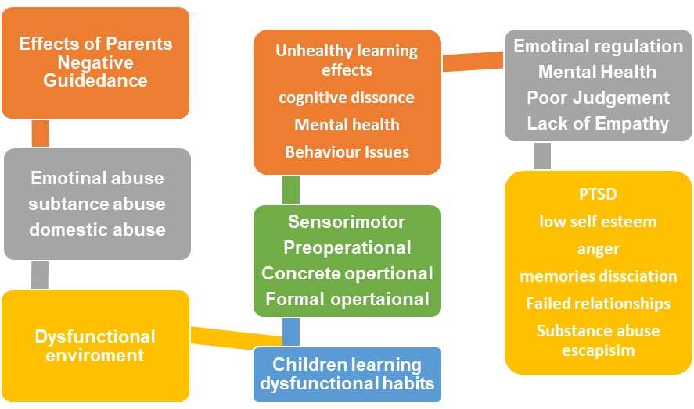

6. Protective factors

7.1 multi-disciplinary services

Multi-disciplinary organisations work to provide person-centred, coordinated care and support to those who require assistance. Providers in the health, social care, and volunteer and private sectors, for example, should redefine, refocus, and reframe their services. According to (Herbert and Bromfield, 2019, p.1) multi-disciplinary approaches aim to improve the response to abuse by setting a policy/practice structure to guide working across professional and organizational unit.

The family has already been selected as a priority for several key multi-disciplinary services.
- Job centre plus
- Connexions
- Probation services
- Métropolitain Police
- Neighborhood Services
- Education Services/ Children’s School
- Behaviour team
- Mental health Services (CAMHS)

8. Health and Social care Assessments

Issues considered during the evaluation:
Financial concerns were thought to be partly attributable to a lack of income, employment financial literature and training prospects for both caregivers. Advice about family relationships, including how to keep the house clean. Attitudes and hostility in the home/attendance at school issues considered in assessment: employment and training opportunities for both parents as financial issues are a concern. The adults in the household were given first action plans with recommendations such as rent payment monitoring, domestic cleaning assistance, parent counselling, and a parenting class involvement in extracurricular activities and connections, as well as support.

9. Critical Analysis

After carefully analysis the difficulties the family are facing It would be a priority for one of the several professional multi-disciplinary agencies to contact social services so they can safeguard the children in a professional manner. The parents also need a mental health assessment, counselling to get to the root cause of the substance abuse and domestic violence the parent need to be assessed correctly to see if they have the emotional capacity to be fulltime parents.

10. Recommendations
The following recommendations for needs and improvement within the family structure the family need support from their local social services team they need a dedicated social worker, support workers, safeguarding assessments for the children and the parents are failing the family needs. They need a lot of support and interventions such as respite, parenting classes. due to the lack of care and attention given to the children emotional, mentally, physically needs. The parents need to be assessed to see if long term parenting is option, it has been proven multi agencies such as social services delivery the right support for dysfunctional families.

Bernard, H. (2019) What’s the best way to improve living standards Helen Bernard today [blog]. 22 Nov. Available at: What’s the best way to improve living standards? | JRF (Accessed: 06 November 2021).
Children commissioner (2019) Childhood vulnerability in England 2019. Available at Childhood vulnerability in England 2019 | Children's Commissioner for England (childrenscommissioner.gov.uk) (Accessed 18 October 2021).
Edmond, N. and Price, M. (2012) Working with Children and Young People: Supporting development from birth to Nineteen. SAGE Publications, 2012. Available at ProQuest Ebook Central - Reader (Accessed 13 November 2012).
Freud, A. (2020) Childhood trauma and the brain: UK trauma [video]. Available at: Childhood Trauma and the Brain | UK Trauma Council - YouTube (Accessed: 02 November 2021).
GOV.UK (2021) Domestic Abuse Act 2021: overarching factsheet. Available at: https://www.gov.uk/government/publications/domestic-abuse-bill-2020-factsheets/domestic-abuse-bill-2020-overarching-factsheet (Accessed: 02 November 2021).
Herbert, J.L. and Bromfield, L. (2019) Multi-disciplinary teams responding to child abuse: Common features and assumptions. Australia: Available at Multi-disciplinary teams responding to child abuse_ Common features and assumptions (sciencedirectassets.com) (Accessed 13 November 2021)
Jones, P. and Gary, W. (2011) Children’s rights in practice. London: Sage publications Ltd. Available at https://web-a-ebscohost-com.ezproxy.uwtsd.ac.uk/ehost/ebookviewer/ebook/bmxlYmtfXzU5NTY5M19fQU41?sid=8fe8f450-bff2-4055-92aa-2a6897dc66ba%40sessionmgr4006&vid=0&format=EB&rid=1 (Accessed 18 October 2021).
Powell, J. (2012) Safeguarding babies and young children. Maidenhead, England: Open university press. Available at https://r4.vlereader.com/Reader?ean=9780335240296 (Accessed 18 October 2021).
Simmons, C. et al. (2021) A meta-analysis of dropout from evidence-based psychological treatment for post-traumatic stress disorder (PTSD) in children and young people. Available at A meta-analysis of dropout from evidence-based psychological treatment for post-traumatic stress dis (tandfonline.com) (Accessed 18 October 2021).

