

Module : Data Handling and Business Intelligence
Module Code: LCBB5000
Lecturer: Dr Sadeque Shaikh

Student: Florin Claudiu Visan
Student ID: 2247386

Contents
Introduction Page 3
Overview and Statistical Analysis Page 3
Results Interpretation Page 3
SPSS Analysis Page 4
Scatterplot Findings Page 5
Excel Visualization and Insights Page 6
Conclusion Page 6
Comparative Evaluation of Tools Page 7
Data Mining Cycle Page 8
Data Mining Cycle Page 9
References Page 10

Introduction
As part of my internship at a prominent research institute, I have been assigned the task of analyzing the "USA Housing Dataset" using Microsoft Excel and SPSS. This dataset contains valuable information on property attributes such as prices, bedroom counts, and square footage. The objective of this analysis is to uncover meaningful insights that could help stakeholders understand property trends and dynamics. By leveraging Excel for visualization and SPSS for statistical rigor, the analysis aims to provide robust conclusions about the dataset’s variables.
Overview and Statistical Analysis
The "USA Housing Dataset" includes detailed attributes related to residential properties. Below is a summary of the statistical analysis performed on key variables within the dataset:
- Mean Property Price: The dataset reveals an average property price of approximately $553,062. This value offers a central measure of the dataset’s price distribution. The mean provides insights into the typical property pricing trends but is sensitive to extreme values, which may inflate the average.
- Median Property Price: The median price of $460,000 indicates the midpoint of the dataset’s price values, offering a more robust central measure compared to the mean. This is particularly useful in skewed datasets where outliers significantly impact the mean.
- Mode of Property Prices: Interestingly, the mode of the price variable is $0, suggesting potential errors or anomalies within the dataset that require further cleaning. This highlights the importance of thorough data preparation before drawing conclusions.
- Standard Deviation for Bedrooms: The standard deviation for the number of bedrooms is calculated to be 0.90, reflecting minimal variability around the mean bedroom count. This suggests that most properties in the dataset have a similar number of bedrooms.
- Variable with Largest Variance: The price variable exhibits the largest variance, underscoring significant differences in property values within the dataset. High variance indicates a wide range of property prices, reflective of diverse market conditions.
- Variable with Largest Standard Deviation: Similar to variance, the price variable also has the largest standard deviation, further emphasizing its high variability. This reinforces the observation that property prices are highly dispersed compared to other variables.

Results Interpretation
The statistical measures calculated provide important insights into the dataset:
Skewed Distribution: The comparison of mean and median prices highlights a positively skewed price distribution, with higher-value properties pulling the mean upward.
Data Anomalies: The mode of $0 indicates the presence of unrealistic or erroneous data points that may distort further analysis. Cleaning the dataset to remove such anomalies is crucial.
Variability: The significant variability in property prices points to diverse market conditions or property characteristics, whereas the bedroom counts appear more consistent. This observation suggests that factors other than bedroom count play a significant role in determining property value.

SPSS Analysis:
Using SPSS, a weak positive correlation (0.189) was identified between price and bedrooms. This suggests that while properties with more bedrooms tend to have higher prices, other variables might play a more influential role. For example, location, square footage, or proximity to amenities could have a greater impact on property prices
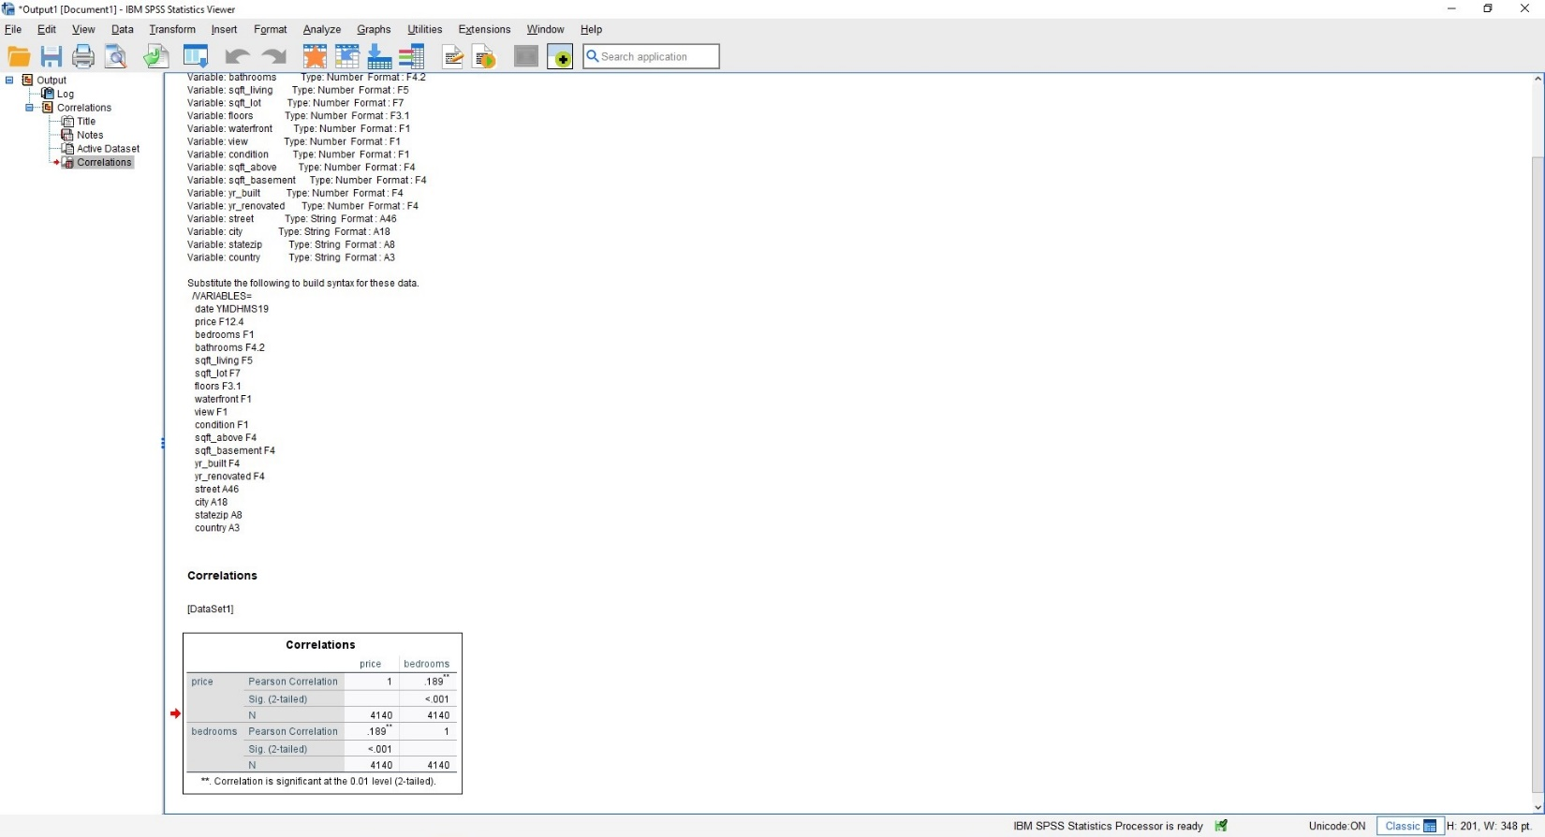
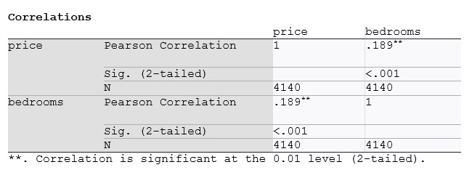

Scatterplot Findings:
A scatterplot plotting price on the horizontal axis and bedrooms on the vertical axis illustrates this weak correlation. A slight upward trend is visible, but the presence of outliers—such as extremely high-priced properties—hampers the clarity of this relationship. These outliers could represent luxury homes or properties in highly desirable locations.
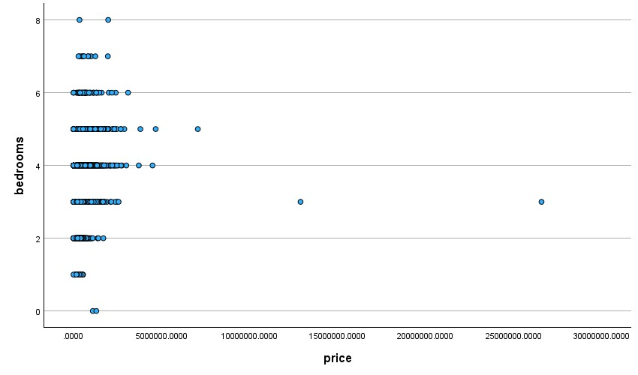
SPSS was further utilized to conduct a regression analysis, exploring the relationship between price and multiple variables, including bedrooms, bathrooms, and square footage. The analysis revealed that while bedrooms have a positive but weak correlation with price, square footage exhibited a much stronger relationship, indicating its greater influence on property value.

Results Summary
The analysis highlights the following key points:
Diverse Pricing Factors: While bedroom count plays a role in determining price, factors like square footage and waterfront access appear more significant.
Data Quality: The dataset requires cleaning to address anomalies like $0 property prices, ensuring more accurate results in future analyses.
Visualization Effectiveness: Excel’s visual tools proved invaluable in summarizing and communicating findings effectively.

Excel Visualization and Insights
To supplement the statistical analysis, Excel was used to create dynamic visualizations:
- Bar Chart: A bar chart was employed to showcase the average price distribution across different bedroom counts, highlighting noticeable trends. For instance, properties with more bedrooms generally exhibit higher average prices, but the increase is not uniform.
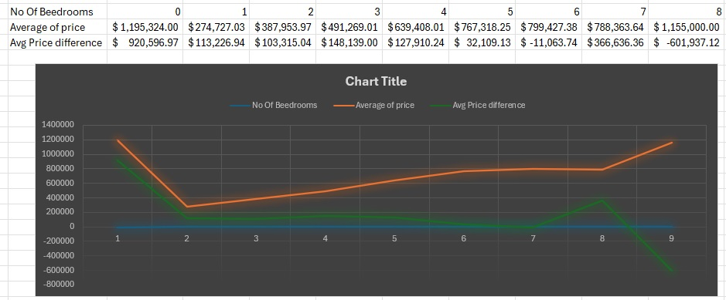
- Pivot Table: By aggregating average property prices by bedroom count, a pivot table provided a clear summary of how bedroom numbers influence pricing. This analysis revealed that while bedroom count impacts price, other factors such as lot size or building age may also contribute significantly.
Conclusion
The "USA Housing Dataset" offers valuable insights into property pricing trends. The combination of Excel’s visualization capabilities and SPSS’s statistical rigor provided a comprehensive understanding of the data. By addressing anomalies and incorporating additional variables into the analysis, future studies could further enhance these findings and support data-driven decision-making in the housing market.

Comparative Evaluation of Tools
Discussing the Advantages and Disadvantages of SPSS
When considering tools for statistical analysis, SPSS (Statistical Package for the Social Sciences) stands out as one of the most reliable and widely-used options, especially in research and academic environments. As I reflect on its use, the strengths of SPSS become immediately apparent, particularly for those seeking a balance between user-friendliness and robust statistical capabilities.
One of the most significant advantages of SPSS is its accessibility. The software is designed with a user-friendly interface, allowing even beginners to navigate complex statistical procedures with ease. For example, when performing a correlation or regression analysis, SPSS eliminates the need for coding or manual calculations, making these processes straightforward and time-efficient. In practical terms, this is invaluable when working with large datasets, as I experienced while analyzing housing data to understand price trends and their relationships with property attributes.
Another noteworthy strength of SPSS is its extensive range of statistical functions. The software excels in tasks like hypothesis testing, ANOVA, and multivariate regression. These tools are essential for drawing meaningful insights in projects where precision and depth are critical. For instance, in a study examining the impact of coffee consumption on health indices, SPSS could seamlessly handle the data to uncover relationships and test hypotheses. Moreover, SPSS’s ability to generate detailed charts and visual summaries, while not as dynamic as some visualization tools, provides clarity to the results.
However, while SPSS has its merits, it is not without limitations. One challenge that often arises is the cost. SPSS’s licensing fees can be prohibitive for smaller organizations or individual researchers. This makes it less accessible than alternatives like Excel or open-source tools such as R. Additionally, its visualization capabilities, though functional, fall short compared to tools like Tableau or Power BI. As someone who values engaging presentations, I find this limitation to be a drawback, as supplementary tools are often needed to enhance the visual appeal of SPSS outputs.
Furthermore, while the interface is user-friendly, mastering SPSS’s advanced features requires dedicated time and training. Beginners may struggle with complex statistical methods, which could slow down progress on more intricate projects. Lastly, SPSS is not particularly strong in data cleaning or transformation tasks. For instance, addressing anomalies like missing values or unrealistic entries, such as a property price of $0 in a dataset, is often more efficiently handled in tools like Excel before importing the data into SPSS for analysis.
Reflecting on these considerations, I would argue that the choice to use SPSS depends heavily on the project’s requirements. For example, in my analysis of housing prices, SPSS proved indispensable for identifying correlations and performing statistical tests. However, for initial data preparation or creating dynamic dashboards, I would complement SPSS with other tools like Excel or Tableau to achieve a comprehensive workflow.

Data Mining Cycle

The data mining cycle offers a structured and systematic approach to extracting meaningful insights from raw data. As I reflect on its importance, I am convinced that this cycle not only ensures thoroughness but also enhances the reliability of the results. Each stage of the cycle plays a critical role, and skipping or inadequately performing any step can compromise the entire analysis.
The first step, problem definition, is foundational. Without a clear understanding of the research objective, analysis can become directionless. For instance, in a study aimed at understanding property pricing trends, defining the goal—such as exploring how attributes like square footage and location influence price—ensures that every subsequent step aligns with this objective. In my own experience, starting with a well-defined question often helps streamline the process and saves time in later stages.
The next stage, data collection, involves gathering datasets relevant to the problem at hand. This can include primary sources, such as surveys, or secondary sources, like existing databases. In my analysis of the "USA Housing Dataset," the comprehensive data provided a solid foundation. However, this stage requires diligence to ensure data accuracy and relevance, as errors here can cascade into later stages.
Once data is collected, the data preparation stage begins. This step is arguably one of the most time-consuming but is absolutely vital. Cleaning and preprocessing the dataset involve addressing missing values, handling anomalies, and ensuring consistency in the data format. For example, during my housing data analysis, I had to address entries with $0 property prices, which clearly skewed the results. Using Excel for these tasks proved to be highly effective before transferring the cleaned dataset to SPSS for deeper analysis.
Following preparation, the data analysis phase is where patterns and relationships are uncovered. This is where tools like SPSS truly shine. For example, in my project, SPSS allowed me to calculate correlations and identify trends between variables, such as price and the number of bedrooms. These insights not only answered the research question but also laid the groundwork for more advanced analysis.

The model building phase comes next, focusing on creating predictive or descriptive models. While my housing analysis did not extend to predictive modeling, this stage could involve using regression techniques to forecast prices based on specific property attributes. This step is crucial for generating actionable insights that go beyond descriptive statistics.
Once models are built, they must be evaluated and interpreted. This stage ensures that the models are accurate and that their outputs make sense within the context of the research. For example, interpreting a model that predicts higher prices for properties with waterfront views requires cross-verifying with market trends to ensure validity.
Finally, the cycle concludes with deployment, where the insights are applied to real-world scenarios. In the case of my housing analysis, the findings could inform pricing strategies for developers or investment decisions for buyers. Deployment translates theoretical insights into practical applications, making this stage the most impactful.
Reflecting on this cycle, I find it indispensable for maintaining a systematic approach to data analysis. It not only provides a clear roadmap but also ensures that every aspect of the analysis, from problem definition to deployment, contributes to the overall objective. The structured nature of the cycle instills confidence in the results, making it an essential framework for any data-driven project.

References
- Field, A. (2018). Discovering Statistics Using IBM SPSS Statistics. Sage Publications.
- Kelleher, J. D., & Tierney, B. (2018). Data Science. MIT Press.
- Pallant, J. (2020). SPSS Survival Manual: A Step by Step Guide to Data Analysis Using IBM SPSS. Open University Press.
- Provost, F., & Fawcett, T. (2018). Data Science for Business: What You Need to Know about Data Mining and Data-Analytic Thinking. O'Reilly Media.
- Walkenbach, J. (2019). Excel 2019 Bible: The Comprehensive Tutorial Resource. Wiley.
- Wickham, H., & Grolemund, G. (2017). R for Data Science. O'Reilly Media.

