11th December 2018
Synchronous Motors
and
Power Factor Correction
P151664 Derek Lockhart
M6X00375 Power Electronics and Drives
Dr Steve Mosey

Table of Contents
Chapter | Title | Page
1. | Abstract | 2
2 | Literature Review | 2
3 | Power Factor Correction Exercise | 3
4 | Fault Finding Exercise | 7
5 | Conclusion | 8
6 | References | 9

Table of Figures
Figure | Title | Page
1 | Power factor 1 phasor diagram | 3
2 | Power factor in inductive circuit | 4
3 | Exercise Power Factor Configuration | 4
4 | 4 Redrawn circuit diagram | 5
5 | Phase angle an current amplitude | 6
6 | Phase and current comparisons | 7

Table of Tables
Table | Title | Page
1 | Phase and Current for various corrective capacitor values | 5
2 | Phase and Current for various corrective capacitor values in fault conditions | 7

1. Abstract
Lab exercise to examine power factor correction in a three-phase motor with a single-phase supply and the effects various correction capacitor sizes have on phase angle and current magnitude. Further investigating a fault scenario and the effects this will have on power factor.
2. Literature Review
This paper shall examine the operation of synchronous motors and the effects of power factor correction. Rashid et al [1], define synchronous motors as those motors using a polyphase winding on the stator and a DC carrying winding on the rotor. Wildi [2], explains that synchronous motors once started are locked into synchronisation with the rotating magnetic field produced by the stator windings. Wildi further explains that synchronous motors are designed to operate at unity power factor. This is advantageous as it reduces the reactive load on the supply, further, DC overexcitation of the rotor will give a capacitive like leading power factor. Hughes [3], explains that synchronous motors are not inherently self-starting, this is due to the rotating magnetic field having insufficient force to overcome the rotor inertia in a single pass, therefore as the rotating field passes the rotor an opposite force is applied, this results in the rotor effectively juddering and an average torque of zero. To overcome this a rotor cage is used, in effect starting the synchronous motor as an induction motor, this will continue until almost at synchronous speed whence the dc excitation is applied to the rotor and the rotational speed is locked. Chapman [4], seems to agree and refers to the rotor cage as amortissuer windings, literally damper windings[5], as they will have a damping effect on changes to system stability, e.g. load. Chapman further describes other methods of starting synchronous motors, from using smaller starting motors, generally induction motors, or alternatively by reducing the stator input frequency before increasing it as the rotor speed builds. However, in this case the equipment is a thee phase motor and a single-phase supply, therefore a different starting system shall be used. Lemau [6] explains the limitations of a single phase supply on a three phase motor such that the motor direction is dependent on the choice of star or delta configuration. Lemau and reduced starting torque. Malyar and Malyar[7], further explain that the use of a shunt capacitor creates a shift in the phase current sufficient to create a rotating magnetic field and start the motor in effectively the same way as an inductive motor.
3. Power Factor Correction Exercise
Power factor is a dimensionless measure, that is less than or equal to 1, and defines how well a load draws real power as opposed to apparent power[8]. A power factor of 1 will show as the voltage and current being in phase, as such then all reactive currents will be equal and in antiphase and therefore cancel each other out. This is shown in Figure 1.
Ic
I_{L}
I_{R}=I_{S}
V_{S}

Figure 1 Power factor 1 phasor diagram

To calculate the Power Factor if the supply (load) current lags the applied voltage by 25⁰.
Power factor = cos ф = cos 25⁰ = 0.906
ф
Ic
I_{S}
V_{S}
I_{L}

Figure 2 Power factor in inductive circuit
The circuit was configured in accordance with Figure 3
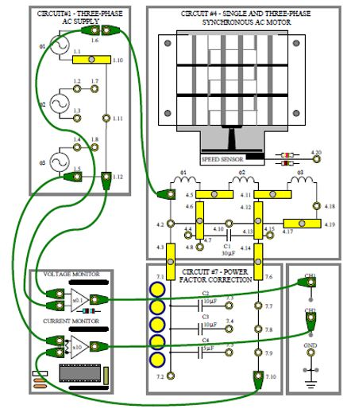
Figure 3 Exercise Power Factor Configuration
Redrawn this gives a circuit layout as shown in Figure 4

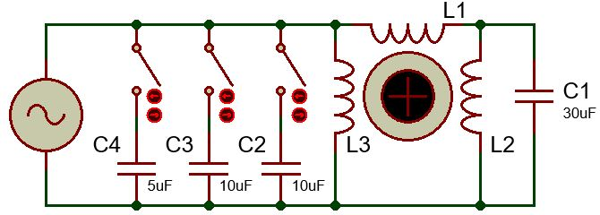
Figure 4 Redrawn circuit diagram
As motor inductive reactance increases with frequency this exercise shall show the effects off capacitive correction of the power factor. Therefore, the supply frequency was increased to maximum, this was measured to be 70Hz.
The phase angle and current amplitude was measured with different combinations of the corrective capacitors C2, C3 & C4.
Correction Capacitor | None | C2 – 10uF | C2 + C3 -20uF | C2 + C4 – 15uF
Phase Angle (Lead/Lag) | I Lag 30.5⁰ | I Lag 11.025⁰ | I Lead 20⁰ | I Lead 4.23⁰
Current Amplitude | 480mA p-p | 411mA p-p | 457mA p-p | 368mA p-p
Table 1 Phase and Current for various corrective capacitor values

Therefore, the shunt capacitance value that gives the nearest to complete correction of phase angle is 15uF.
It can be seen that with the best available value of power factor correction, the phase angle and current are both minimum. The power factor of this circuit with no correction capacitor in circuit is calculated thus
pf = Cos⁰ = Cos30.5⁰ = 0.86.
Similarly, the power factor of this circuit with the best correction capacitor available is
pf = Cos⁰ = Cos4.23⁰ = 0.997.
The supply voltage was measured at 52.3V p-p.
With no correction capacitor in circuit the power supplied was
$$\frac{52.3V x 480mA}{8} x Cos {30.5}^{0}=2.688W$$
With the best available correction capacitor in circuit the power supplied was
$$\frac{52.3V x 368mA}{8} x Cos {4.23}^{0}=2.399W$$
In can be seen that the decreased phase angle and Circuit current has produced a corresponding decreased in the power consumed. This can further be seen in Figure 5. Although only four data points have been recorded Figure 5 does show the dip synonymous with this graph, such that in a perfectly corrected system the current shall tend towards zero plus losses within the system[4] [9].

Figure 5 Phase angle an current amplitude

4 Fault Finding Exercise
With a fault switched into the circuit the phase angle and current amplitude measurements were repeated, the results are shown in Table 2.
Correction Capacitor | None | C2 – 10uF | C2 + C3 -20uF | C2 + C4 – 15uF
Phase Angle (Lead/Lag) | I Lag 31.2⁰ | I Lag 20.1⁰ | I Lead 2.1⁰ | I Lag 12.23⁰
Current Amplitude | 501mA p-p | 432mA p-p | 354mA p-p | 416mA p-p
Table 2 Phase and Current for various corrective capacitor values in fault conditions
The data from this fault series of readings has been plotted for comparison with the original data in Figure 6.
There appears to be a general decrease in the current demand through this series of readings, due to its consistency, this discrepancy could be assumed to be a consequence of the training rig implementation and shall be disregarded. It can also be seen that the readings for zero added capacitance are roughly comparable and show no significant change.

Figure 6 Phase and current comparisons
It is noted that the first series data point for C2 (10uF) and the fault series data point for C2 + C4 (15uF) are directly comparable. It is also be noted that the data points for series one C2 + C4 (15uF) and fault series C2 + C3 (20uF) are similarly comparable.
It would seem reasonable to surmise from this trend that the common denominator for this skewed series of data points would be C2, this would seem to be confirmed by the lone C2 data point in the second series.
From this observation it is proposed that the fault is the C2 capacitor that is not performing to specification. By these readings it would appear to be providing approximately half its rated 10uF.
5. Conclusion
Synchronous motors are devices that may be used for high accuracy devices, they may also be reconfigured to act to correct power factor. Synchronous motors are not self-starting, and various methods are available to achieve rotation at which point the dc excitation would lock the rotor into speed with the rotating magnetic field on the stator. Correct power factor correction can reduce the power consumption of the motor and can be used to correct the power factor on the supply voltage line.

6. References
[1] M. H. (Muhammad H. Rashid, N. (Professor of electrical engineering) Kumar, and A. R. (Ashish R. Kulkarni, Power electronics : devices, circuits and applications. .
[2] T. Wildi, Electrical machines, drives, and power systems. Prentice Hall International, 1997.
[3] A. Hughes, Electric motors and drives : fundamentals, types, and applications, 2nd ed. Oxford: Newnes, 1993.
[4] S. J. Chapman, Electric machinery fundamentals. McGraw-Hill, 2012.
[5] M.-H. Corréard, Compact Oxford-Hachette French dictionary : French-English, English-French. Oxford University Press, 2013.
[6] Lemau, “How to use three phase motor in single phase power supply,” Electric Neutron, 2014. [Online]. Available: https://www.electricneutron.com/electric-motor/use-three-phase-motor-single-phase-power-supply/. [Accessed: 10-Dec-2018].
[7] V. S. Malyar and A. V Malyar, Electrical engineering &amp; electromechanics., no. 3. Kharkiv Polytechnic Institute, 2016.
[8] N. Mohan, T. M. Undeland, and W. P. Robbins, Power electronics : converters, applications, and design. Wiley, 1995.
[9] S. N. Vukosavić, Electrical machines. Springer, 2013.

