
MSc Industry 4.0 Advanced Manufacturing
Introduction to Industry 4.0
Written by: Gareth Frost - Quality Compliance Manager
Safran Seats GB
Data Digitisation
Adoption for Efficiency and Regulatory compliance
Date: 25th March 2022
Contents

Abstract 2
Introduction 3
Aims 3
Objectives 3
Implementation Methodology 4
Process Updates 4
Systems 5
People 5
Implementation Planning 5
Project Plan overview 5
Background research 6
Conclusion 7
Recommendations 8
Appendix 1 9
Current system 9
Proposed System 10
Appendix 2 11
Efficiencies 11
Appendix 3 12
Sample QR Code 12
References 13

Abstract
Safran Seats GB is presently re-emerging in the marketplace as aviation awakens from the long winter of the global pandemic. Safran Seats GB has turned out to be a leaner and more agile business because of the pandemic and order downturn. However, it is still looking for further operational performance profits, a reduction in procurement costs, and to ensure that the performance profits do not drive behaviour away from the required regulations and legislation, to prove itself as the world leader in bespoke business and first-class seating solutions while ensuring a healthy return for its shareholders.
This research examines elements of digitised data to align businesses with Industry 4.0 principles, hypothesising that the higher volume of data and the simplified format for getting the data will reveal not only input efficiencies but also output efficiencies.

Introduction
As an aviation organisation, Safran Seats GB (SSGB) is governed by strict regulations.
- AS9100-Aerospace Quality Management System
- Part 21G and Part 145 are governed by the United Kingdom Civil Aviation Authority (UK CAA) along with, the European Union Aviation Safety Agency (EASA).
There are areas where we want to change the methodology that we as of now have. This report will zero in on one component, however, that component has two distinct requirements.
- Validation that consumables are within their manufacturer’s expiry dates.
- Consumables that are applied to products (seats, monuments, and closets).

Aims
This report intends to assess the digitisation of information and its use in the manufacturing environment and its guidelines and legislation.

Objectives
- To examine the use of QR Codes to control the expiry dates in manufacturing. Expected outcomes:
  - Efficiency increases in the validation of expiry dates (a daily task).
  - Increased data accuracy (reduction in human error)
  - Understand usage volumes as a cost-saving exercise.
- Use the QR code method to record where used.
  - Digital record generation
  - Traceability concerning an investigation (i.e., notification of escapes)
Points I. and II. are requirements set forth by regulation (maintain expiry dates and utilisation by-product).

Implementation Methodology
To facilitate the improvement, a few updates are expected to the current interior frameworks, the way of life, and the attitude to empower the movement to embed
- Process and procedure updates
- Forms
- Work instructions
- Guidelines
- Standard operating procedures
- Systems
- Software
- Hardware
- People
- Training

Process Updates
Several of the internal processes and procedures will require change, in conjunction with some document creation. This is to facilitate a new way of working.
The introduction of the QR code at the consumable stores will consider the batch number, expiry date, and date of product issue along with the position (COSSH cabinet) issued to (this positional data can then be taken to comprehend utilisation rates per area; however, this is not required by the regulation to meet the aims of this report). The current processes and procedures have the operational personnel confirm the contents of the COSSH cabinets daily. This is a visual inspection of the expiry dates only, which when signed, shows compliance.
The new process would just require the scanning of the QR code. This would cross-reference the information table for that cabinet to confirm that the product is within its expiry date and log the results centrally. As this is still a manual process, links into the digital factory will be made to ensure that manufacturing cannot begin until the cabinets needed within those manufacturing areas are confirmed.

During manufacture, when the consumable is required, it will have the QR code scanned before use. This will not only confirm the expiry as a safeguard, but the scanning of the QR code will create the computerised record within the digital factory. This digital record associates the information laid out in the code with the production order. The association enables future statistical analysis if needed from an investigation point of view and removes or reduces the human error that is currently in the system.

Systems
To enable these changes, several items of hardware and software will be needed. A prerequisite for the consumable store area will be QR code generation software, a handheld scanner, and a label printer. Each manufacturing area would require a minimum of two handheld scanners to confirm the cabinet, wirelessly linked to the system. Each station position already has scan capability, and therefore it is just the link configuration from the advanced manufacturing plant to the framework to apportion material used at this position. See Appendix 1 for system comparison and Appendix 2 for efficiency gains comparison.

People
As with updates to process, procedure, and innovation, there will be a requirement for training. This will in part follow the standard process Safran Seats currently uses on procedural updates. For process and hardware updates, this will be conducted by employing the training school and the train the trainer approach.

Implementation Planning
The approximate plan would show that the system would be up and running at around 10 weeks. No system would be switched until the system validation had proven successful.

Project Plan overview
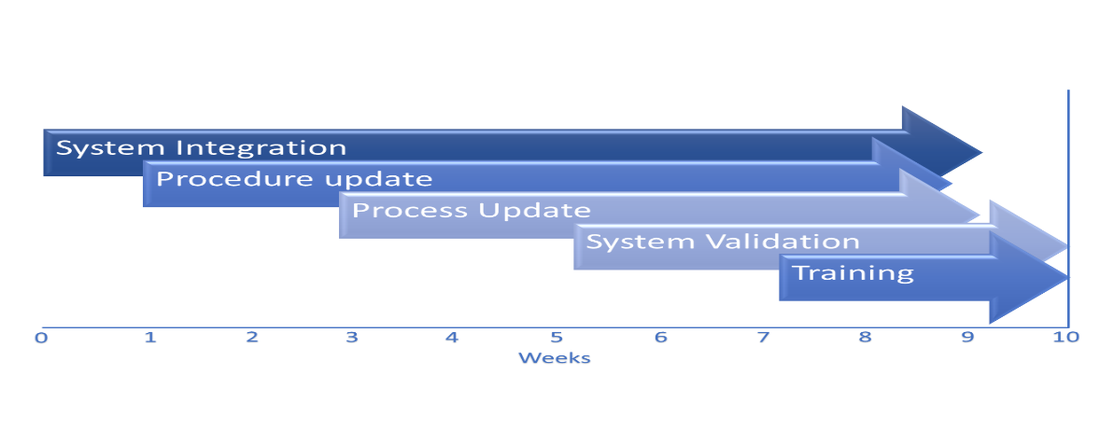

Background research
SAE International (2016) section 8.5.2, Identification and Traceability outlines the industry’s obligation to ensure where traceable data is received, it is to be part of the sequential record of production. SAE International (2016) section 8.6, Release of products and services outlines the aerospace community's requirements when the product is released. It is done under the condition that, when needed, we can show that the product meets the qualification.
EASA (2021) section 21.A.139 Quality System and EASA (2021) section AMC1, 145.A.42 Components, further reinforces the requirements of traceability by batch as a means of showing the origin of an article to supply evidence of conformity.
VIAR (2022) describes the QR code as a Quick Response code, also known as a two-dimensional barcode. It first came about in 1994 and was produced by a subsidiary company of Toyota by the name of Denso Wave. MRP Easy (2021) confirms the first belief that a QR code will have sufficient characters to meet the requirements laid out in the aims of this report. They say that a barcode, which is on most products we buy can only store up to twenty-five characters, while a QR code can store up to 1500 characters by reading horizontally and vertically. The code can also supply links to websites along with other data formats.
MRP Easy (2021) ratifies the belief in the reduction of paperwork, reduced human errors, improved traceability, increased productivity via increased efficiency, and data-driven decision-making.
Efficiency is “the ability to achieve an end goal with little to no waste, effort, or energy.” (Banton, November 2020). Banton (2020) also go on to say that efficiency can be expressed as a ratio or a percentage. Ratio-Efficiency = Output/Input, Percentage-Efficiency = Output/Input x 100. There are many distinct categories of efficiency, but operational efficiency is “how well profits are earned as a function of operating costs.” (Banton, November 2020). Further reading from Banton (2020) brings the idea of digitisation of data and Industry 4.0 together with factory processes and the Internet of things.

Conclusion
The digitisation of data is viewed as one of the foundations of the Industry 4.0 movement and the Quality 4.0 principles. Having the data promptly accessible allows the business to effectively use the data to enable considered decisions based on real-time information and material usage, and not summarised by historical order patterns and manufacturing models.
Using the information as a QR code enables the system to be arranged to extricate the information it expects at that point of usage, as various usage points will require potentially unique information, whilst keeping the full birth record within the QR code and the system. This level of traceability, albeit in place at present, is still a labour-intensive task and is subject to human error when translated onto paper. Thus, implementing these principles negates the potential issues around traceability and validity of the data when needed for an investigation.
The efficiency gained from the system will be seen post the first set-up of the data at the consumable store. This setup will be minimal due to the limited variety of consumable products used during the manufacturing process.
For the above reasons, the digitisation of data for consumables with expiry dates, and its use within the manufacturing environment is vital to aiding proficiency gains and the legitimacy of information for potential examination, alongside the related-use volumes to drive cost savings.

Recommendations
In addition to the birth record held within the QR code, a study of potential multi-formatted QR codes is to be conducted to see if the Material Safety Data Sheets (MSDS) can be embedded in the code. This would enable the end-user to have the most up-to-date version of the datasheet at the time of the scan of the code. This will end the holding of paper versions online or having to log onto a computer to find the data.
For the QR code itself, a trial is to be conducted to ensure the product does not have a detrimental effect on the ink. Also, a study will need to be conducted on where best to place the code to minimise the loss of code fidelity per product, albeit the QR code is more robust than, say, a barcode. (Lumi, n.d.) and (QR code Tiger , 2022) both discuss the best ways to ensure that the generated codes are effective and remain effective.
Before the system rolls out, there should be a dummy environment set up to help training, and based on this, a defined implementation date can be ensured to ease the changeover from one process to another.

Appendix 1

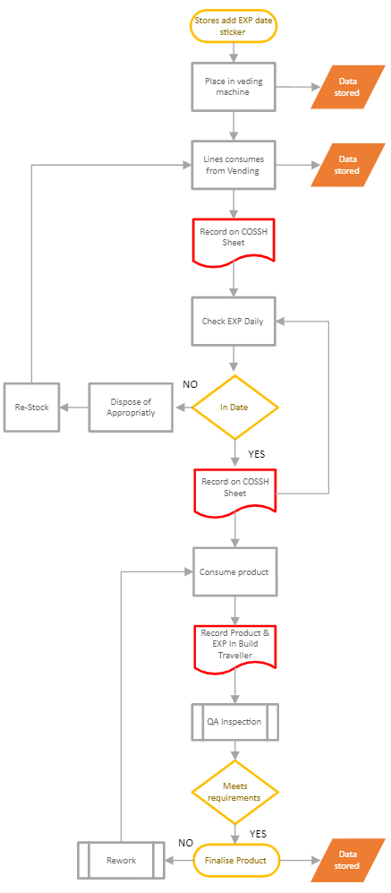
Current system
The flow shows the current system for the consumption of consumables within the production line. This is the flow for 1 line with only 1 COSSH cupboard utilised but can quickly become more complex and onerous depending on the quantity of COSSH cupboards per line.
The areas outlined in red show the manual tasks of reading the data from the item (consumable product) and recording the data on paperwork (COSSH cupboard inventory and production build traveller).
There is no fail-safe to ensure the data read is correct to the original, currently, at the COSSH cupboard check, only the expiry date is validated, and all other data is ignored. At consumption, currently, all that is required is the LOT number to trace its origin.
From this data, you can see there is no system failsafe to ensure COSSH cupboard validation has taken place and the correct information has been recorded before consumption. This is now reliant on people to correctly identify and record and to follow the system order correctly.
The efficiency of the line becomes affected when you start to consider the impact of reviewing and recording each item daily per COSSH cupboard, plus the recording at the consumption point of the appropriate information by the production operative along with the validation by the QA operative to ensure the information is correct.
From a rework point of view, it is difficult to analyse the effect as the consumption of an out-of-date product could lead to some very different scenarios from use as is in a form of a concession to a full set of flammability testing or full certification testing, therefore I will give a nominal figure that is realistic and is to analyse system gains.
The Data recorded at the start of the system is isolated and not utilised in any way to rationalise utilisation. Re-order is based on average consumption and trigger points. The data stored on the build traveller is paper-based and digitally scanned but does not comply with optical character recognition, therefore any data mining for an investigation can be onerous and time-consuming.

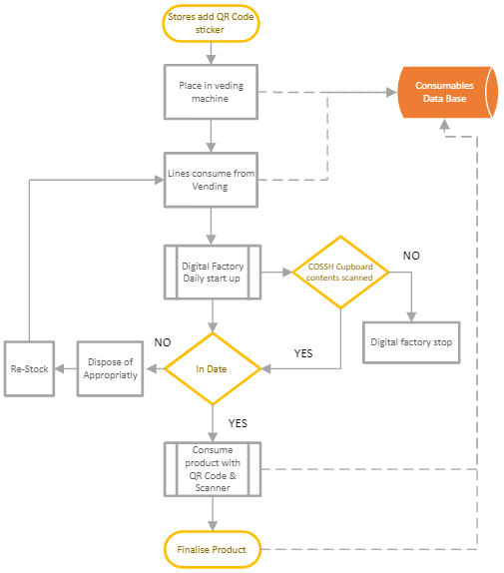
Proposed System
The flow shows the proposed system for the consumption of consumables within the production line. This is the flow for 1 line with only 1 COSSH cupboard utilised but the new system reduces the complexity and the task burden.
The system utilises the data that has been entered into the database for the QR code generation at the consumable stores. See Appendix 3 for a QR code sample.
Manual recording methods have been replaced by the scanning of the QR code. Dependent on the area (position in the digital factory) the relevant information is allocated within the database and the digital production traveller. A key point to note would be that the database would contain all the data required and acts as a backup to the digital traveller for the allocation.
The links with the digital factory ensure that the process of daily COSSH cupboard validation is a pre-requisite to enable production to start, this, in turn, reduces the risk of incorrect usage of out-of-date products and removes the requirement of Quality validating the details recorded are correct. The flow also removes the rework risk and thus the efficiency issue and cost concern.

Appendix 2

Efficiencies
The information below outlines the gained efficiencies and the potential associated costs and talks about the potential savings based on reworks

Current system efficiencies
COSSH Cupboards
1 consumable item = 15seconds to validate review expiry
1 consumable item = 15 seconds to find and validate on paperwork
1 Cupboard contains approx. 30 items therefore 30(15+15) = 15 mins/cupboard/Day
Therefore 1 Cupboard checked each day 15x5 = 1.25hrs /cupboard/week

Production Consumption
1 consumable item = 15seconds to validate review expiry
1 consumable item = 15seconds to check lot/batch is readable
1 consumable item = 30seconds to transfer data to production paperwork
1 consumable item = 60seconds for QA to validate
Therefore, each item consumed = 2 mins/item

*Costs associated with risks of data loss / poor fidelity and process failure that may lead to major campaigns could be from £5,000 - £100,000 (conservative estimates).

Proposed system efficiencies
COSSH Cupboards
1 consumable item = 5 seconds to find and validate on paperwork
1 Cupboard contains approx. 30 items therefore 30x5 = 1.5 mins/cupboard/Day
Therefore 1 Cupboard checked each day 1.5x5 = 7.5 mins /cupboard/week

Production Consumption
1 consumable item = 10seconds to transfer data to digital factory
Therefore, each item consumed = 10 secs/item

*Costs associated with risk cannot be fully removed but the risks are mitigated, and costs will be lowered.

Based on the scanning of the COSSH cupboards there is a 91% increase in efficiency per week
Based on the scanning of the product at consumption there is a 91.5% increase in efficiency per item.

Appendix 3

Sample QR Code
The following code contains the Data that is required to maintain the system database.


(Website Planet, n.d.)

References
Banton, C., November 2020. Efficiency. [Online]
Available at: https://www.investopedia.com/terms/e/efficiency.asp
[Accessed 13th march 2022].
EASA, July 2021. Easy Access Rules for Continuing Airworthiness (Regulation (EU) No 1321/2014). s.l.:s.n.
EASA, September 2021. Easy Access Rules for Airworthiness and Environmental Certification (Regulation (EU) No 748/2012). s.l.:s.n.
Lumi, n.d. Printing guidelines for QR codes and barcodes. [Online]
Available at: https://www.lumi.com/manual/printing-guidelines-for-qr-codes-and-barcodes?msclkid=2841c694a6b511ecac31e1abcf3f3ffb
[Accessed 18th March 2022].
MRP, Easy, June 2021. QR Codes vs. Barcodes in Inventory Tracking. [Online]
Available at: https://manufacturing-software-blog.mrpeasy.com/qr-codes-vs-barcodes/
[Accessed 13th march 2022].
QR code Tiger , 2022. Printing QR Codes: 10 Must-follow Tips in 2022. [Online]
Available at: https://www.qrcode-tiger.com/printing-qr-codes?msclkid=2841330ba6b511ec9d08b4ef8a0c40e8
[Accessed 18th March 2022].
SAE, International, 2016. AS9100 Rev. D. s.l.:s.n.
VIAR, 2022. REWO The Use of QR Codes in manufacturing. [Online]
Available at: https://www.rewo.io/the-use-of-qr-codes-in-manufacturing/
[Accessed 13th March 2022].
Website Planet, n.d. Free QR Code Generator – Custom High-Resolution QR Codes. [Online]
Available at: https://www.websiteplanet.com/webtools/free-qr-code-generator/#:~:text=Free%20QR%20Code%20Generator%20%E2%80%93%20Custom%20High-Resolution%20QR,QR%20code%2C%20hit%20the%20Generate%20QR%20button.%20?msclkid=f5610b22a6b611ec81e330591c9cae36
[Accessed 18th March 2022].

