Assignment
L4 - Computer Architecture and Operating Systems (ACCA4022)
Jon Morgan (2218940)
2024
Contents
Introduction 2
1. Key Functions of General Operating Systems 3
2. Use of Windows OS CLI commands 6
DIR 6
CD 6
MKDIR 7
REN 8
COPY 9
DEL 9
RMDIR 10
IPCONFIG 11
TYPE 12
CLS 12
3. Use of Linux OS CLI commands 14
PWD 14
LS 14
CD 15
CAT 16
HEAD 16
TAILS 17
SUDO 17
CHMOD 18
CHOWN 19
PASSWD 20
4. Use of Windows OS scripts 21
5. Use of Linux OS Scripts 24
TUTORIAL ACTIVITY – TYPES OF OPERATING SYSTEMS 26
Task: Research and define different types of OSs that are used today. 26
EVIDENCE OF ENGAGEMENT WITH ONLINE COURSE 27
References 29

Introduction
This document is my report submission for the assignment as given in L4 - Computer Architecture and Operating Systems (ACCA4022); specifically, for the ‘Operating Systems’ component of the module. This document aims to convey the appropriate response to the following tasks as given:
- Key functions of general Operating Systems
Briefly describe the key functions of popular general-purpose Operating Systems with several screenshots showing where some of the functions can be seen/monitored/managed. Approx. 500 words, cite several reference sources.
Note: If any commands are used to answer this task to create relevant screenshots, the commands can be re-used again in the tasks below.
- Use of Windows OS CLI commands
Document the use of approx. 10 Batch or PowerShell commands, with screenshots and accompanying narration. Approx. 350 words, cite several reference sources.
- Use of Linux OS CLI commands.
Document the use of approx. 10 Bash commands, with screenshots and accompanying narration. Approx. 350 words, cite several reference sources.
- Use of Windows OS scripts
Demonstrate key features of a Win. OS scripting language by documenting the use of Batch or PowerShell scripts, with screenshots and accompanying narration. Approx. 350 words, cite several reference sources.
- Use of Linux OS scripts.
Demonstrate key features of a Linux OS scripting language by documenting the use of Bash scripts, with screenshots and accompanying narration. Approx. 350 words, cite several reference sources.

1. Key Functions of General Operating Systems
An operating system (OS) is system software that acts as the co-ordinator of a computer’s hardware and software resources. An OS provides user interface capabilities such as command line and graphical interface command interpreters or ‘shells’ to facilitate interaction between computers and their users, usually by way of running applications (‘Apps’ in modern parlance). A key role of any OS is to provide a clean platform of structured functions and interfaces for those apps to run on, abstracting away all the underlying mess of multitudinous hardware possibilities [1].
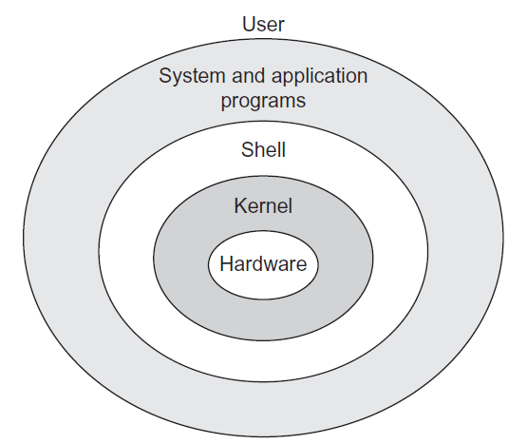
The hardware and software resources managed by an OS typically include I/O (Input/Output) devices such as keyboards and printers, RAM (Random Access Memory), processes for both the OS itself and user applications, and permanent storage filesystem functions. Modern OS’s also provide networking facilities, event logging and various security features, such as user login accounts and encryption services. The core component of any OS co-ordinating all these resources and managing the competing demands on them is called the Kernel. End user programs generally operate outside of the Kernel in what is termed ‘Userland’ space [2].
Figure 1 - Diagram showing the various layered parts of a computer system [2]
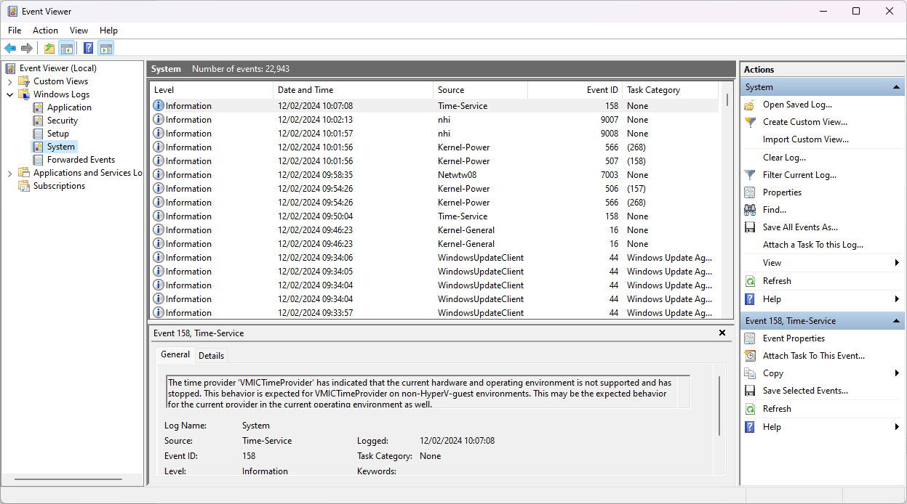
Figure 2 - A screenshot of the Event Viewer system utility in Windows 11, showing the 'System' log entries that the OS is creating, tracking informational and error events.
Hardware management typically relies on device drivers; files containing code that explicitly describe how a piece of hardware can be controlled and used by the OS. Hardware may use I/O interrupts to alert the CPU or OS when they need attention to deliver or receive data.
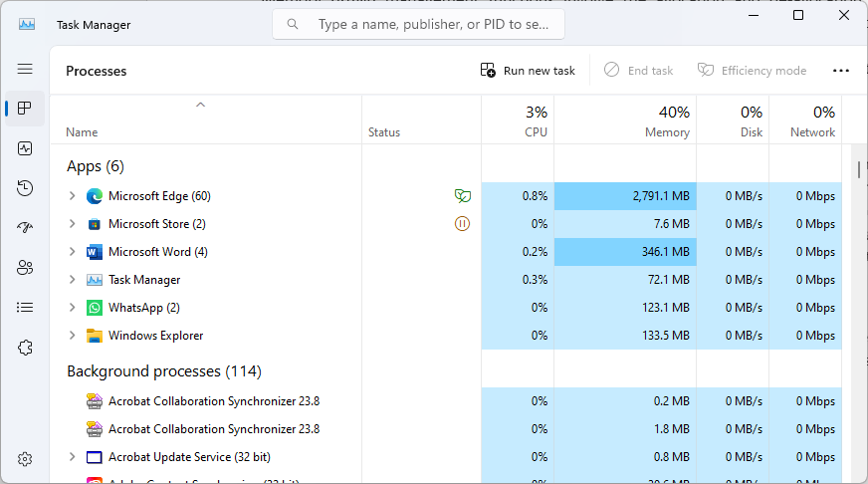
Figure 3 - A screenshot of the Task Manager system utility in Windows 11, showing several processes and their resource usage.

Memory (RAM) management functions involve the allocation and de-allocation of memory to processes; both Userland and Kernel, tracking these changes, providing memory protection so that Kernel processes and their memory contents cannot be tampered with and to ensure Userland processes don’t interfere with each other, and additionally creating and managing virtual memory on secondary storage to alleviate any low memory pressures encountered [3].

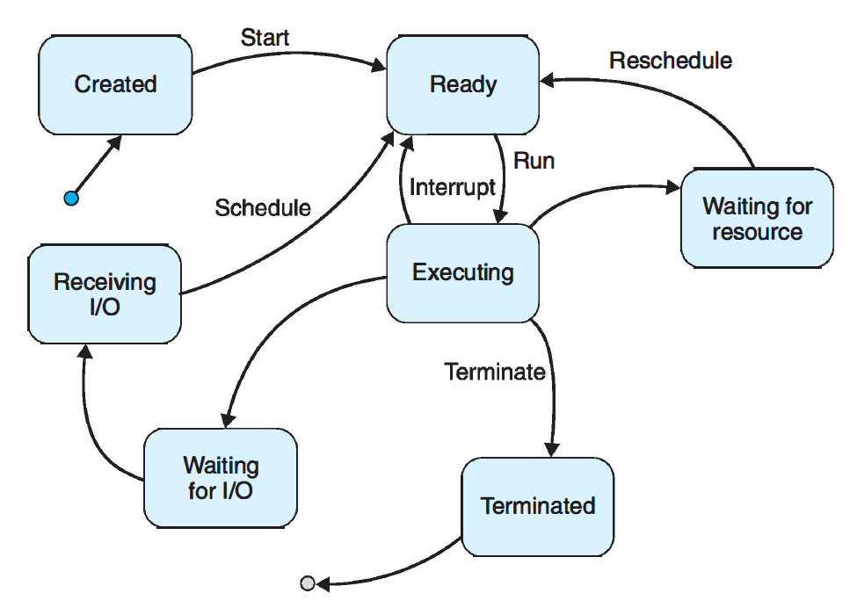
Figure 4 - A State Diagram of a typical process in a computer system [4].
Process management involves process creation, state and priority control, and termination [4], alongside any applicable memory allocation/de-allocations. Modern OS’s are often ‘multi-threaded’, allowing processes to be broken up into one or more (as needed by the process) smaller execution sub-units called threads; so additionally the OS tracks and directs the necessary context-switching between all threads, allocating or ‘scheduling’ CPU-time (‘runtime’) to them as it sees fit to, which is performed so fast by modern CPU’s as to give the illusion that everything is happening simultaneously.

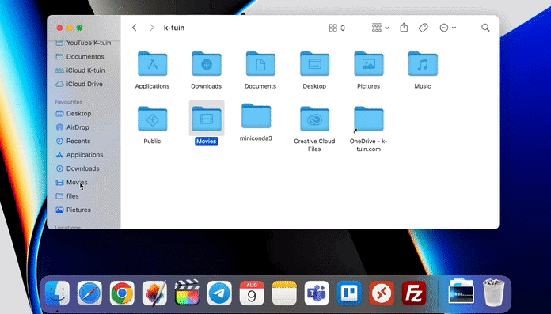
Figure 5 - A screenshot of the Finder system utility in MacOS, providing access to and management of files, folders, and storage devices or services.

Filesystem functions in operating systems provide the means to organise and manage data on permanent storage devices such as hard drives or external storage media. A tree-like hierarchical structure is typically presented, allowing files and folders to be nested and named as needed. Indexing and search functionality are often provided too, in addition to the fundamental basics of file and folder creation, renaming, moving, copying, deletion etc. Modern filesystems commonly offer security features too, such as file or whole volume encryption and Access Control Lists (ACL’s), which specify permissions against files or folders, either granting or denying differing types of access to users, apps or even the OS itself.

2. Use of Windows OS CLI commands
The basic command syntax of the Windows CMD cli (command-line interpreter or interface) terminal typically allows the user to first type the name of a command, and optionally, add further ‘options’ (sometimes referred to as ‘switches’) and/or ‘arguments’ to the command, usually in this order:
command [options…] [arguments…]
Commonly, commands can be given the switch option ’/?’ to display helpful guidance in that commands’ purpose and usage. The Windows command-line interface and file system is generally not case-sensitive. There are many built-in commands for everyday operation or automation [5].
Note that there is also another command-line interpreter shell available in Windows, which behaves different to the CMD interpreter with different commands available, called Windows PowerShell. That is not discussed here in Task 2 but will looked at below in Task 4.

DIR
The dir command shows the contents of directories or folders, and supports options to display additional information as needed.
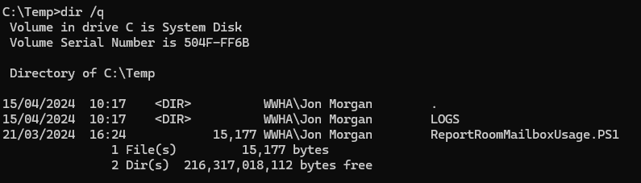
In the above example, the dir command was run inside the C:\Temp directory and did not specify another directory to list from, so the command listed the contents of that directory to the terminal. Additionally, the ‘/q’ switch option was given, also causing the dir command to show the ‘owner’ of the files and directories listed. Note that the ‘.’ entry represents the ‘current’ directory - the ‘Temp’ directory/folder itself in this instance.

CD
The cd command allows basic traversal around the filesystem (change directory) within the terminal. The ‘prompt’ generally shows the user their current location within the local filesystem, in front of the ‘>’ symbol. You specify the target location as an argument to the cd command for it to execute and take you there – depending on the context you may sometimes use relative path names, but full path names will always work.
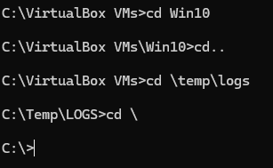
In the above example, the ‘prompt’ shows the ‘current location’ starting point as inside the ‘VirtualBox VMs’ directory/folder. The first ‘cd Win10’ command specifies a ‘relative path’ to the Win10 directory – one that exists inside the VirtualBox VM’s directory. The prompt then updates to show the new location inside the Win10 directory. The ‘cd..’ command instructs it to ‘go up one level’, back to the VirtualBox VMs folder. The ‘cd \temp\logs’ command specifies a ‘full path’ to the desired new location – the initial ‘\’ indicates the root of the current filesystem, where the temp folder exists with the logs folder inside of it also. The prompt again updates to show the new location. The ‘cd \’ command instructs it to traverse directly to the root level – again the prompt updates showing the new location.

MKDIR
The mkdir command allows the creation of new directories/folders – its usage is simple, as follows in the below example:
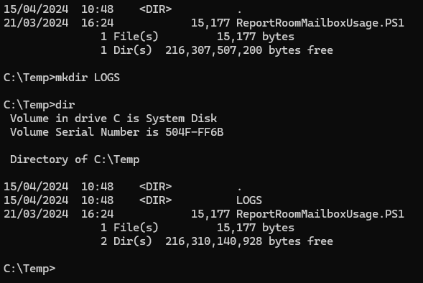

REN
The ren command allows the renaming of a file or files – it does not allow for specifying a new path whilst doing so, however.
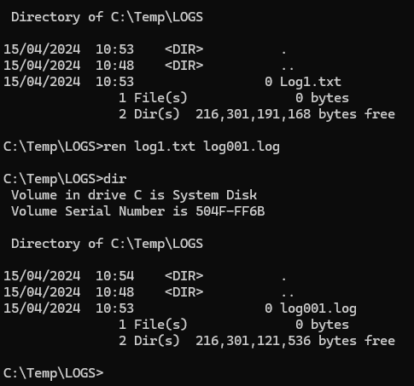
In the above example the file Log1.txt was renamed to log001.log. Note the case insensitivity in identifying the target file in the command used.

COPY
The copy command allows the copying of a file or files from one location to another. It follows the basic syntax structure of copy source.file destination.file, and supports several optional switches. See the following example:
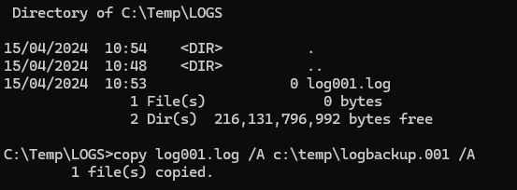
The relative path (current directory) to the log001.log file is implied as the source file to copy, and the full path to the new location and a new name is then given for the destination file. Both are given the /A switch option to specify them as ASCII type files, though this can be skipped, and copy will usually detect either ASCII or binary file types as needed. Note that there are two other copy related commands available which offer other features, capabilities, or benefits over copy – xcopy and robocopy.

DEL
The del command allows the deletion of one or more files (note, NOT directories).
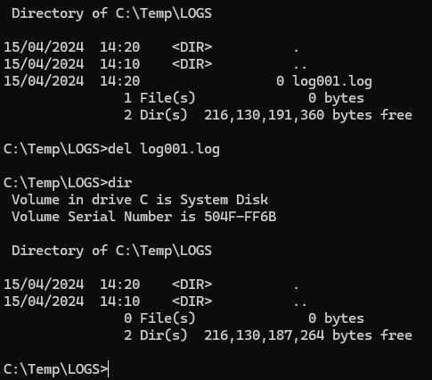
In this simple example, the del command is used to delete the log001.log file.

RMDIR
The rmdir command allows the deletion or removal of directories, simply by naming them as the target argument. The addition of the ‘/s’ option switch also enables the removal of all directories underneath the target directory – the entire ‘tree’.
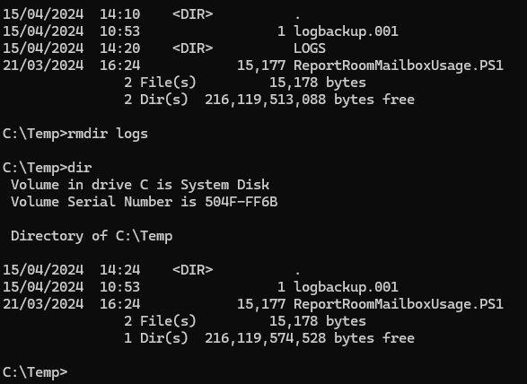

IPCONFIG
The ipconfig command [6] allows the retrieval of the TCP/IP configuration against any or all network interfaces. It also supports several additional switch options for other specific actions, such as purging the local DNS cache.
In this first example below, the ipconfig command is executed with no optional switches. It returns the basic IP configuration of every network interface adapter on the system.
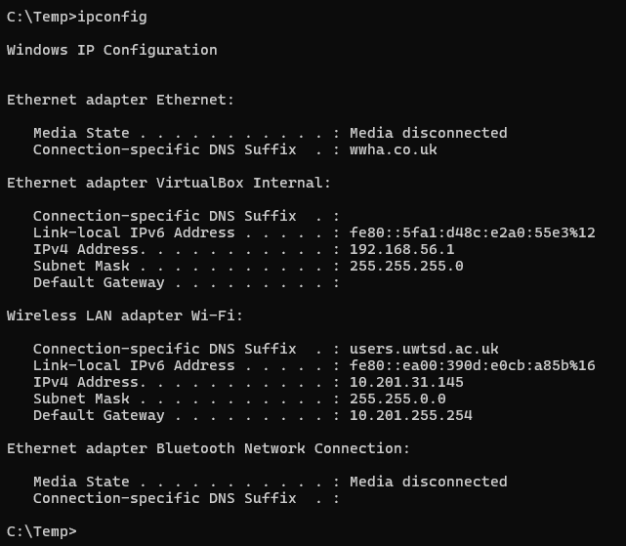
Adding the optional ‘/flushdns’ switch to the ipconfig command causes it to empty the local DNS client’s cache of resolved domains and inform the user of its success in doing so.
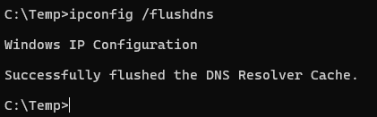

TYPE
The type command reads and displays the contents of a text file or files to the terminal/shell.
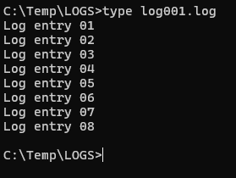
Simply pass the names of one or more text files as arguments, as in the above example. The type command does not offer any optional switches beyond the ‘/?’ help switch.

CLS
The cls command simply clears the terminal screen, useful when you want to ‘reset’ your view and clear your ‘working area’. Before issuing the cls command, your terminal is likely to be littered with the output of several previous commands, like so:
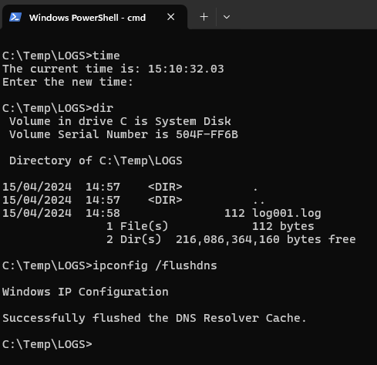
Then we issue the cls command and our terminal clears to a ‘clean slate’ – note that the cleared previous output cannot be recovered.
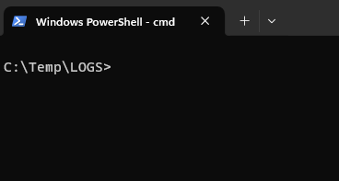

3. Use of Linux OS CLI commands
The basic command syntax of Linux command-line interface (CLI) terminals, which often default to the Bash [7] shell application, allow the user to first type the name of a command, and optionally, add further ‘options’ and/or ‘arguments’ to the command:
command [options…] [arguments…]
Typically, most commands can be given the option ’--help’ to display helpful guidance in that commands’ purpose and usage. Note that most things in the Linux terminal and file system ARE case-sensitive.

PWD
The pwd command displays the present working directory, informing the user of their current position within the local filesystem.
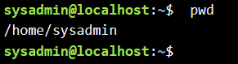

LS
The ls command lists directory contents of files and directories, and supports options to display further details as required.
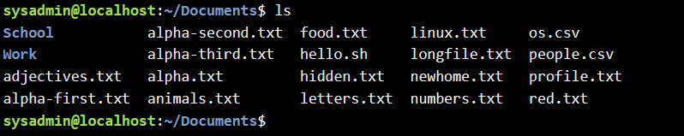
As an example, using the -lhS (case-sensitive) options will direct the ls command to list more detailed information for each item in ‘long format’ (the ‘l’ option), list the file or directory sizes in the 5th column in a more human-readable format (the ‘h’ option – without it all sizes are reported in Bytes) and sort the listed files and directories in order of size (the ‘S’ option – a lowercase ‘s’ is a different option with a different end result). You can also add the name of a directory as an argument – without it, it defaults to the present working directory.

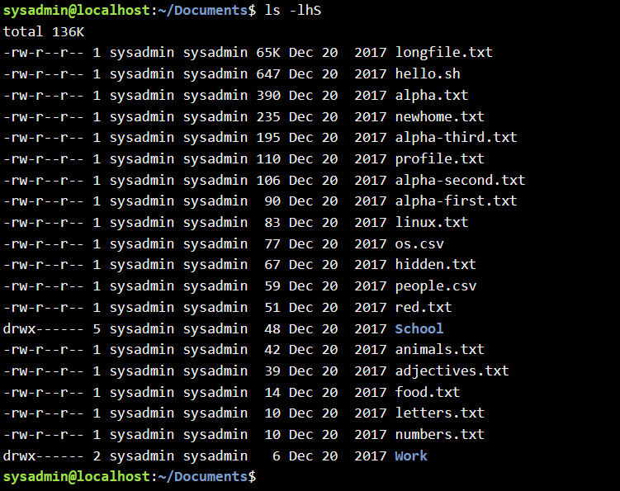

CD
The cd command allows the user to change their location (change directory) within the local filesystem. Typically used with an argument to specify the desired target location, however you can issue the command in isolation to quickly switch back to your ‘Home’ directory – the default directory assigned specifically and only to your user account/login. Specifying ‘..’ also allows you to traverse ‘up’ the directory structure one level only.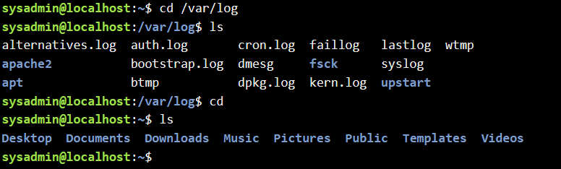

CAT
The cat command can concatenate files together – however, it’s typically used to concatenate one file with nothing else simply to print the given files contents to the terminal. A quick way to look at a short text-based file, for example.
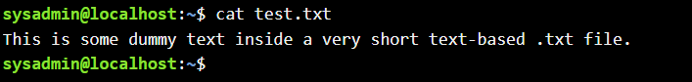

HEAD
The head command displays to the terminal the first n number lines of one or more files, or piped output from other commands. A method to quickly peek at the top or ‘head’ of a file. The default number for n if not specified as an option is 10 lines.
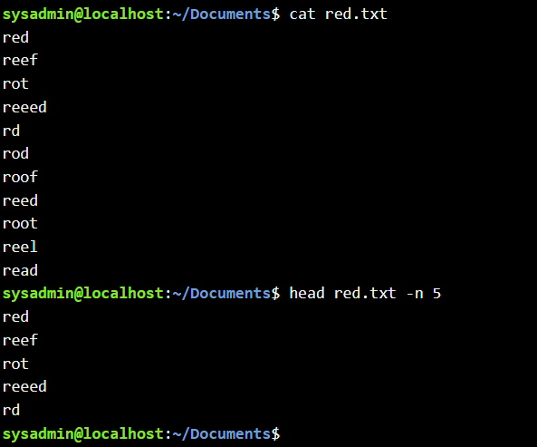

TAILS
The tails command is a mirrored opposite of a sort to the head command just described above – the tails command however reads from the bottom or ‘tail’ of a file or pipelined data instead. It too reads 10 lines by default. Can also be used to continually update a file being added too, say a log file of some type.
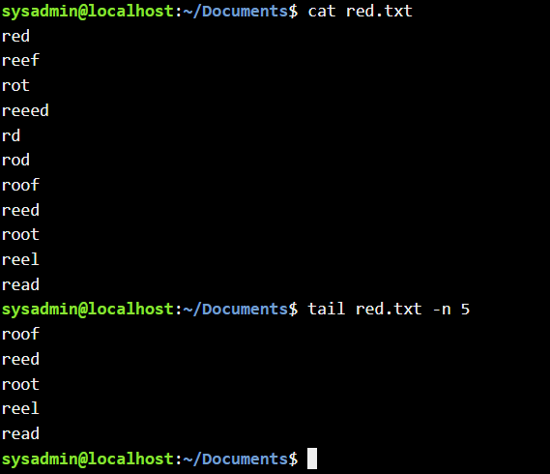

SUDO
The sudo command [8] allows a user to execute a command as another user – typically as a user with superuser or administrative privileges, such as the ‘root’ user (SUperuser DO). This helps maintain the security of a system, keeping users operating the system primarily without superuser privileges for most of the time, but allows temporary ‘elevation’ of their privileges only when absolutely necessary, without requiring them to log out and log in as another user with the needed privileges.
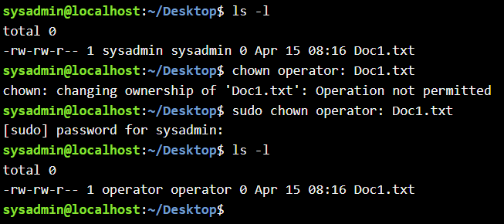
In the above example, the sudo command allowed the user to elevate to their permitted administrative level privileges within their current terminal (without logging out) in order to successfully use the chown command. Note also how the use of sudo required them to re-verify their identity with their password.

CHMOD
The chmod command [9] allows the changing of permissions (change the mode of access) on files and directories. Linux typically considers 3 types of permissions and 3 types of owners: Read, Write and eXecute permissions, applied to either the User, Group, or Other/public owner. There are two methods that chmod can interpret to alter permissions too – either the symbolic/named mode or the numeric/octal mode. The symbolic method may be easier for some to understand but can only alter one set of permissions at a time eg adding execute permissions to both the Group and Other owners. The octal method can set any combination of permissions to any owner group, but requires knowledge of the octal value of each permission and all 3 sets of octal permission values must be specified.
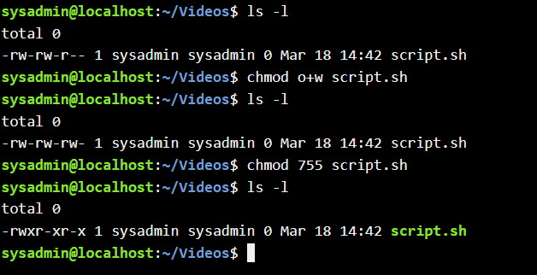
In the above screenshot example, chmod was first used via the symbolic method to add (+) Write permissions to the Other owner group. Then it was used via the octal method to explicitly set full (Read, Write and eXecute) permissions to the User group, and only Read and eXecute permissions to users that reside in either the Group or Other owners set.

CHOWN
The chown command allows the changing of ownership on files and directories. Linux typically considers 2 types of owners: User and Group. The chown command can interpret two methods to alter ownership - either by user or group name or by user or group numeric ID. For example, chown username:groupname filename would change the ownership of the file to the specified user and group. Similarly, chown userID:groupID filename would do the same using their numeric IDs. Only ‘root’ or superuser level users can change the ownership of files.
In the above example, chown was used to change the owner of the file Doc1.txt from ‘sysadmin’ to ‘operator’ – note that it needed to be elevated to ‘superuser’ privileges via the sudo command to successfully execute.

PASSWD
The passwd command allows a regular user to change their own user account password. A superuser may use it to change the passwords and alter other options for all local user accounts.
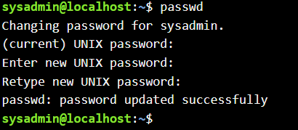
In the above example, a regular user issues the passwd command and steps through the process of changing their own password, entering their old password first to verify their identity. They are then directed to enter their new password twice, lessening the chance of a ‘typo’ causing a mistake in their intended password being saved.

4. Use of Windows OS scripts
To demonstrate some of the scripting abilities available in the Windows OS, we will examine several script files written in the modern Windows Powershell [10] [11] scripting language. Note that there is another legacy built-in scripting language to the Windows OS that uses the CMD command-line interpreter, called the Batch Scripting language.
The 7 basic principal features of Windows PowerShell scripting that will be demonstrated are as follows:

- Variables
- IF Statements
- Loops
- Arrays
- Functions
- User Input
- Switch Statements

Here follows a ‘real-world’ example PowerShell script I created many years ago, its purpose previously (it is no longer in use) being to remind staff who hadn’t changed their administrative user account password within the last 30 days to change it. This script relies upon the presence of an Active Directory Domain Services [12] environment, the Active Directory module [13] for Windows PowerShell and an available SMTP (E-mail) server to send e-mails. It is commented throughout to explain its operation, and the demonstrated scripting features matching 1 through 4 from the 7 listed above are picked out in the comments in CAPITALS.

# Script to check ICT user 'Admin' alter-ego accounts (excluding disabled accounts) to
# ensure their passwords are younger than 30 days of age and if not, e-mail the relevant
# ICT user with a gentle reminder. Also, list those who have been reminded in an e-mail
# to the ICT Infrastructure Mgr.

# Store today's date in a VARIABLE
$Today = Get-Date

# Get the AD User objects for all non-disabled ICT 'Admin' accounts, including a few
# extra properties needed
$Admins = Get-ADUser -Filter 'Enabled -eq "true"'`
-SearchBase "OU=Admins,OU=ICT,OU=Finance Directorate,DC=WWHA,DC=co,DC=uk"`
-Properties PasswordLastSet,Description,DisplayName

# Create an empty ARRAY object
$NaughtyList = @()

# Set a VARIABLE flag for deciding if a report e-mail is sent or not
$SendReport = 0

# LOOP through each retrieved 'Admin' user object, check the passwords age, and build
# a list of non-compliant real usernames by matching against the 'Admin' accounts
# 'Description' field.

ForEach ($admin in $Admins)
{ # Use an IF STATEMENT to do something based on a conditional check
If (($Today - $Admin.PasswordLastSet).Days -gt 30)
{
# Add items to the ARRAY where the accounts’ password is older than 30 days
$NaughtyList += Get-ADUser -Identity($Admin.Description)`
-Properties Mail,DisplayName
$SendReport = 1
# A report e-mail will now be generated as there are now
# items in the ARRAY object
}
else
{ } # Do nothing
}

# Send an e-mail to each non-compliant real ICT user, reminding them to update their
# 'Admin' alter-ego user account password asap.

# LOOP through each item now in the ARRAY collection, executing code for each
ForEach ($Naughty in $NaughtyList)
{
$UserToNotify = $Naughty.DisplayName
$NoticeBody = $UserToNotify + ", the password for your 'Admin' account is over `
30 days old and must be changed as per ICT security policy. Thank you."

Send-MailMessage -From "Server.Admins@wwha.co.uk"`
-To $Naughty.Mail `
-Priority High `
-Subject "URGENT - Immediate Action Required!" `
-smtpServer smtp.wwha.co.uk `
-port 2525 `
-body $NoticeBody

}

# If password reset reminder e-mails were sent out to staff, send an e-mail to the ICT
# Infrastructure Mgr listing those who have been reminded.

# Use an IF STATEMENT to check the value of a VARIABLE, execute code based on the result
If ($SendReport -eq 1)
{
$ReportBody = $NaughtyList.displayname | Out-String

Send-MailMessage -From "Server.Admins@wwha.co.uk" `
-To "InfraMgr@wwha.co.uk" `
-SmtpServer smtp.wwha.co.uk `
-port 2525 `
-subject "Reminders to reset Admin account passwords have just `
been sent to the following staff:" `
-body $ReportBody
}
Else
{ } # Do nothing

Here’s another ‘real-world’ example script, a part of a ‘PowerShell Profile’ – a script that is evaluated and run every time a new instance of a PowerShell host is loaded [14], barring any execution policy issues. Profiles can be used to customise your PowerShell environment to your preferences, adding commands, functions, aliases etc.
This is only a small specific section of the full profile script, which demonstrates the scripting features 5 and 6 (also 1 and 2) from the list above, again highlighted in the comments in CAPITALS.

# Declare GLOBAL VARIABLES, that can be accessed from any declared FUNCTION
$Global:Credential = $null
$Global:AdminUserName = $null
$Global:AdminPassword = $null

# A FUNCTION to gather USER INPUT to store both a username and
# a secure password

Function Update-SavedAdminCred {
# Wipe the terminal window clean, for ease of reading
Clear-Host
# Display some instruction text
Write-Host "Enter your Admin Account Username, in the format DOMAIN\USERNAME:"
# Prompt for USER INPUT, storing the result in a GLOBAL VARIABLE
$Global:AdminUserName = Read-Host

#Wipe the terminal window clean again for ease of reading
Clear-Host
# Display some instruction text
Write-Host "Carefully enter your Admin Account Password:"
# Prompt for USER INPUT, storing it securely in a GLOBAL VARIABLE
$Global:AdminPassword = Read-Host -AsSecureString | ConvertFrom-SecureString
Clear-Host
}

# A FUNCTION to create and save an authenticated Admin token, to use in other
# FUNCTIONS as needed

Function Load-AdminCred {
# Use an IF STATEMENT to check a condition and do something based on the result,
# in this case - check if the GLOBAL VARIABLE AdminUserName is empty
If ($Global:AdminUserName -eq $null) {
# IF it is empty, call another FUNCTION (the one above this one)
Update-SavedAdminCred
}
# IF it is NOT empty, construct and store a PSCredential object in the GLOBAL
# VARIABLE called Credential, which can be used as an authentication method
# for other commands or FUNCTIONS
$Global:Credential = New-Object -TypeName System.Management.Automation.PSCredential `
-ArgumentList $Global:AdminUserName, `
($Global:AdminPassword |
ConvertTo-SecureString)
}

The final scripting language feature to demonstrate is one I do not have a ‘real-world’ example for as I have never used it up to now – the Switch Statement. As per Microsoft’s own documentation [15], the Switch keyword in Windows PowerShell scripting allows for controlling the flow of execution within a script, similar to an IF Statement but with greater flexibility. Whilst IF statements perform condition checks and execute code based on the result, and that logic can be extended through multiple ELSEIF statements to check for a long list of different conditions, the Switch statement can accept a list of conditions and match an argument passed to it, greatly simplifying code. The Switch statement can even accept an Array, a list of values, and proceed to perform condition checks for every item in the array, acting as a loop too.
There are many examples of the Switch statements’ usage in the referenced documentation [15], but here is one of my own:
# A demonstration of an example use case for the Windows PowerShell Switch Statement, to
# drive the logic and execution of code for a simple menu system

# Clear the terminal shell for ease of readability
Clear-Host

# Display the script 'Menu' of choices
Write-Host "Welcome to the program - please choose from the following options:"
Write-Host
Write-Host "Option 1 - Do stuff"
Write-Host "Option 2 - Do some stuff"
Write-Host "Option 3 - Do this stuff"
Write-Host "Option 4 - Do that stuff"
Write-Host "Option 5 - Do any stuff"
Write-Host "Option 6 - Quit the program"
Write-Host

# Prompt the user for a selection from the menu displayed
Write-Host "Option Number: " -NoNewline
$Choice = Read-Host
Write-Host

# Instead of a long list of IF and ELSEIF statements and condition checks, use a simpler
# Switch statement to check the user input choice value against a list
Switch ($Choice) {
1 { Write-Host "You did 'STUFF'" }
2 { Write-Host "You did 'SOME STUFF'" }
3 { Write-Host "You did 'THIS STUFF'" }
4 { Write-Host "You did 'THAT STUFF'" }
5 { Write-Host "You did 'ANY STUFF'" }
6 { Write-Host "You QUIT" }

# If the user enters a value that doesn't match any of the 'allowed' choices
# being checked for in the Switch statement, the DEFAULT keyword allows for
# a 'no match' condition and resulting code execution.
default { Write-Host "Your entry did not match a menu choice" }
}

5. Use of Linux OS Scripts
To demonstrate some of the scripting abilities available in the Linux OS, we will examine a script file written in the Bash [7] scripting language. The 7 basic principal features of the Bash (Bourne Again SHell) scripting language that will be demonstrated are as follows:

- Variables
- If Statement
- Case Statement
- A loop
- Arrays
- Functions
- User Input

Here follows a basic script, fully commented throughout to explain its operation and structure, a simple exercise in asking the user for their name and some numbers as input, with the features matching from the list above highlighted again in CAPITALS:

#!/bin/bash

###################################
# DEFINE FUNCTIONS TO BE USED LATER
###################################

# A FUNCTION to list out the contents of an ARRAY using a FOR LOOP
display_array() {
local arr=("$@")
echo
echo "Your chosen numbers, sorted from smallest to largest are:"
echo
for i in "${arr[@]}"; do
echo "$i"
done
}

# A FUNCTION to display some text
display_youtubelink() {
echo
echo "Check out http://youtu.be/d6iQrh2TK98 for an interesting video on how"
echo "humans and random numbers don't gel together very well..."
echo
}

###########################
# MAIN SCRIPT BODY FOLLOWS
###########################
echo "Hi there. "

# Run an UNITL LOOP until any answer is given for a name
until [[ ! -z "$name" ]]; do

# Prompt for USER INPUT, storing the input in a new VARIABLE
echo
read -p "Please, tell me your name: " name
echo
# IF STATEMENT to check for a blank/NULL entry
if [[ -z "$name" ]]; then
echo "Aw, you didn't tell me your name."
fi
done

# Prompt for USER INPUT, saving input in VARIABLES to prepare to create an ARRAY
echo
echo "Please $name, can you give me three random whole numbers from 1-99:"
echo
read -p "First number: " integer1
read -p "Second number: " integer2
read -p "Third number: " integer3

# Create an ARRAY of the three numbers given by the user
userintegers=($integer1 $integer2 $integer3)

# Sort the numbers in the ARRAY from smallest to largest
userintegers=($(printf "%s\n" "${userintegers[@]}" | sort -n))

# Call a FUNCTION to list out the ARRAY contents
display_array "${userintegers[@]}"
echo

# Use VARIABLES as flags for tracking actions taken and condition checks
commonflag=0
ytflag=0

# Use a FOR LOOP to feed each item in the ARRAY into a CASE STATEMENT
# to execute specific code based on various condition checks
for integer in "${userintegers[@]}"; do
case $integer in
7)
echo "Ah, you chose the number 7!"
# Set a flag VARIABLE
commonflag=1
# IF STATEMENT to check a flag
if [[ ytflag -eq 0 ]]; then
# Call a FUNCTION
display_youtubelink
# Set a flag VARIABLE
ytflag=1
fi
;;
37)
echo "Ah, you chose the number 37!"
# Set a flag VARIABLE
commonflag=1
# IF STATEMENT to check a flag
if [[ ytflag -eq 0 ]]; then
# Call a FUNCTION
display_youtubelink
# Set a flag VARIABLE
ytflag=1
fi
;;
42)
echo "42 eh? Hmmm... Are you a hitchhiker?"
;;
*)
# IF STATEMENT to check a flag
if [[ $commonflag -eq 0 ]]; then
echo "You avoided the 'common' random numbers!"
# IF STATEMENT to check a flag
if [[ ytflag -eq 0 ]]; then
# Call a FUNCTION
display_youtubelink
# Set a flag VARIABLE
ytflag=1
fi
# Set a flag VARIABLE
commonflag=1
fi
;;
esac
done

echo
echo "Thanks for playing!!!"

APPENDIX - A

TUTORIAL ACTIVITY – TYPES OF OPERATING SYSTEMS

Task: Research and define different types of OSs that are used today.
The most prevalent type of operating system in use today ‘by the numbers [16]’ is the Mobile Operating System, with some estimates putting the percentage of the global population with access to a smartphone device running a Mobile OS (likely to be Android or iOS) as high as 68% in 2022 [17], or over 6 billion devices. Mobile operating systems can actually be considered as lightweight, specialised hybrids of General-purpose and Network operating systems – the Android OS core is derived from the Linux desktop operating system. Desktop computing operating systems such as MS-DOS, Windows and Linux largely began as General-purpose operating systems, but the rapid expansion of the internet and the commoditisation of networking equipment drove them to integrate the networking capabilities of Network operating systems. These networking capabilities are essential to the existence and purpose of Mobile operating systems, the devices they run on relying so heavily on mobile communications technology.
Another common operating system type already mentioned is the General-purpose operating system (with networking capabilities baked in), such as Windows 11 or the various versions of Linux running on countless desktop, laptop and tablet personal computers all over the world, enabling commerce, education and entertainment with many joining to the global internet. Less directly visible but nonetheless important today, are Cloud operating systems [18] – specialised extensions of Networking/Server operating systems, running the almost innumerable real and virtual workloads across thousands of datacentres around the globe, seamlessly working together for maximum uptime and responsiveness powering the ‘Cloud’ services that touch all our lives whether visibly or not – the shopping website you just purchased from was actually running in Amazon’s Web Services cloud datacentre; the spreadsheet you just created in the web app version of Excel, saved in your OneDrive and accessible from almost anywhere – all parts of the Microsoft 365 cloud service.
Perhaps the most discrete type, the Embedded operating system – often highly specialised ‘just for the job’, running inside all sorts of devices most people don’t give much thought to. Smart speakers, routers, payment card readers, IOT sensors, cars, or televisions – all sorts of electronic devices that need an operating system in order to perform their intended function.

APPENDIX - B

EVIDENCE OF ENGAGEMENT WITH ONLINE COURSE
I completed and passed the “Linux Unhatched” online course, as I felt I would benefit the most from it, with being relatively inexperienced using Linux operating systems. See below for screenshots of my completion and exam score:
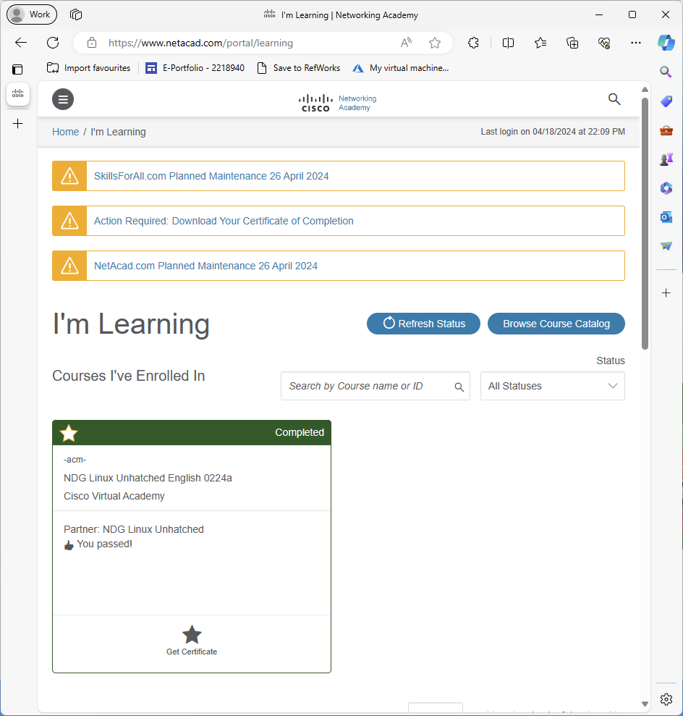
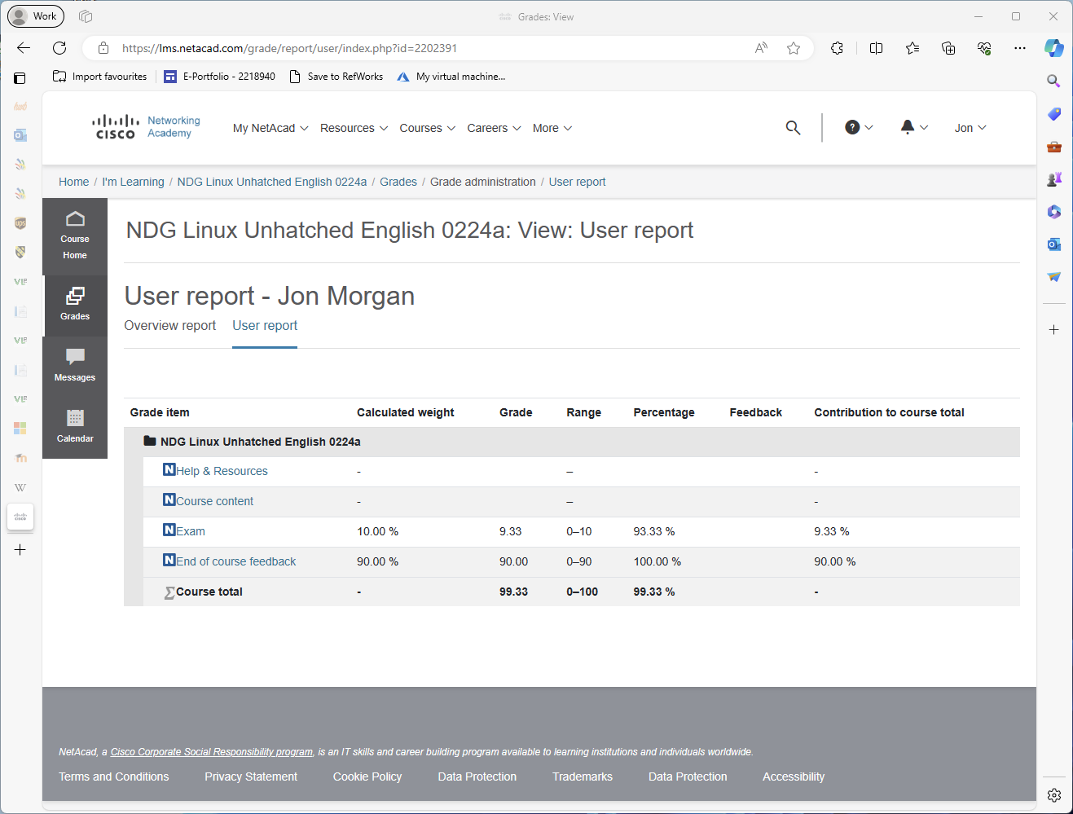

References
[1] A. S. Tanenbaum and H. Bos,Modern Operating Systems, 4th Ed. Harlow, England: Pearson, 2014.
[2] N. Chauhan, Principles of Operating Systems, India: Oxford University Press, 2014.
[3] J. Johnson. "Functions of Operating Systems: Fully Explained." History-Computer. https://history-computer.com/functions-of-operating-systems-fully-explained/ (accessed Feb 6,).
[4] J. M. Garrido, R. Schlesinger and K. Hoganson,Principles of Modern Operating Systems, 2nd Ed. Burlington, Mass: Jones & Bartlett Learning, 2013.
[5] "Windows Commands." Microsoft Learn. https://learn.microsoft.com/en-us/windows-server/administration/windows-commands/windows-commands (accessed 18/04/).
[6] "ipconfig." Microsoft Learn. https://learn.microsoft.com/en-us/windows-server/administration/windows-commands/ipconfig (accessed 18/04/).
[7] "What is Bash?" OpenSource.com. https://opensource.com/resources/what-bash (accessed 18/04/).
[8] J. Wallen. "Linux 101: Introduction to sudo." Linux.com. https://www.linux.com/training-tutorials/linux-101-introduction-sudo/ (accessed 18/04/).
[9] "Chmod Command in Linux (File Permissions)." Linuxize.com. https://linuxize.com/post/chmod-command-in-linux/ (accessed 18/04/).
[10] "What is PowerShell?" Microsoft Learn. https://learn.microsoft.com/en-us/powershell/scripting/overview?view=powershell-7.4 (accessed 18/04/).
[11] T. Dawson, "Introduction to the Windows Command Line with PowerShell," The programming historian, no. 5, 2016. doi: 10.46430/phen0054.
[12] "Active Directory Domain Services Overview." Microsoft Learn. https://learn.microsoft.com/en-us/windows-server/identity/ad-ds/get-started/virtual-dc/active-directory-domain-services-overview (accessed 18/04/).
[13] "about_Modules." Microsoft Learn. https://learn.microsoft.com/en-us/powershell/module/microsoft.powershell.core/about/about_modules?view=powershell-7.4 (accessed 18/04/).
[14] "about Profiles - PowerShell." Microsoft Learn. https://learn.microsoft.com/en-us/powershell/module/microsoft.powershell.core/about/about_profiles?view=powershell-7.4 (accessed Apr 15,).
[15] "Everything you ever wanted to know about the switch statement - PowerShell." https://learn.microsoft.com/en-us/powershell/scripting/learn/deep-dives/everything-about-switch?view=powershell-7.4 (accessed Apr 17,).
[16] "Operating System Market Share Worldwide." StatCounter.com. https://gs.statcounter.com/os-market-share (accessed 18/04/).
[17] F. Laricchia. "Global smartphone penetration rate as share of population from 2016 to 2022." Statista.com. https://www.statista.com/statistics/203734/global-smartphone-penetration-per-capita-since-2005/ (accessed 18/04/).
[18] Z. Chen, et al., "Evolution of Cloud Operating System： From Technology to Ecosystem," J.Comput.Sci.Technol, vol. 32, no. 2, pp.224-241, 2017. doi: 10.1007/s11390-017-1717-z.

