

The Teachers View of the Impact of Educational Web Based Games on Key Stage 2 (Year 6) Mathematics SATs Revision Through Implementation of a Prototype Solution.
by
Taylor Hodges

Supervisor: Tim Bashford

Project submitted as part of the requirements for the award of BSc (Hons) Computing (Software Engineering)

April 2023

Declaration form and form of consent
DECLARATION
I, Taylor Dawn Hodges declare that I am the sole author, writer, and developer of this Project; that all references cited have been consulted; that I have conducted all work of which this is a record, and that the finished work lies within the prescribed word limits.
This work has not previously been accepted as part of any other degree submission.

Signed: TDHodges
Date: ...............................................

FORM OF CONSENT
I, Taylor Dawn Hodges hereby consent that my Project, submitted in candidature for the B.Sc. Computing (Software Engineering) degree, if successful, may be made available for inter-library loan or photocopying (subject to the law of copyright), and that the title and abstract may be made available to outside organisations.

Signed: TDHodges
Date: ...............................................

Abstract
This project will investigate the concept of educational games use for primary school students, researching teacher’s views on educational games and student’s feedback on a developed prototype.
The main aim of this report is to investigate KS-2 maths curriculum, practical implementation of motivational maths games and activities to develop mathematical skills of users. This project hopes to aim at the young students that are not naturally a logical personality type and/or struggle more with Mathematics. This would enable more students to enjoy and uptake maths to help them get into a better university but give them the option to pursue a subject they enjoy alongside this desired STEM.
The prototype should be heavily maths based whilst tying in elements of fun to create motivation. The game will ideally be played as quick rounds with incrementing difficulty and track the player’s results to award points. Earning points would then be used to unlock more games with different maths skills such as: coordinates, algebra, geometry, statistics, etc.
The author selected the FFD methodology because as the sole developer on the prototype, FDD seems the most pragmatic option to meet the deadline, breaking requirements into smaller, more manageable chunks of tasks as features.
Teacher’s views will be collected about electronic educational games; teachers have been selected as the testers as they have first-hand experience teaching children.
The results from the secondary research showed that while some excel in maths and many go onto do it a A-level, many drop out after AS, and many struggle even more. Primary research found that many teachers agreed that educational games can be a good tool to create long lasting skills, they can create motivation and interest in a subject, as well as offer incremental difficulty and track a student’s progress.
The prototype showed to have some degree success on university students in improving player’s maths skills and could be a successful program if taken further. It would also be a supported by teachers as the game content holds lots of maths skills in the prototype game which was found to be liked by teachers, and any additional games would keep this same trend.
Overall, there are indications that the hypothesis could be true, but more investigation is needed to fully prove it.
Contents
Declaration form and form of consent 2
Abstract 3
1. Introduction 10
1.1. Aim 10
1.2. SMART Objectives 10
2. Research and Review of Literature 11
2.1. Brief Introduction into Research Problems 11
2.2. Review of their Existing Research 12
2.2.1. Gender Divide in STEM 12
2.2.2. Difficulties with Maths 16
2.2.3. Engaging Young People in Mathematics is Difficult 18
2.2.4. Traditional Studying is Ineffective for most Students. 19
2.2.5. Repetition Leads to Human Error 22
2.2.6. Paper impact on the environment 23
2.2.7. Progress is Hard to Measure with Past-Papers 24
2.2.8. Children have Short Attention Spans 25
2.2.9. KS-2 Curriculum 26
2.2.10. E-learning 28
2.2.11. Maths till 18-years-old 33
2.3. Competitor Analysis 35
2.3.1. Examples of Existing Games 35
2.3.2. Testing of Existing Maths Games 36
2.4. Development Tools 40
2.4.1. Mobile 40
2.4.2. Desktop 44
2.4.3. Web based. 47
3. Selected Approach 49
3.1. Materials needed. 49
3.2. Prototype description 49
3.3. Market analysis, design decision 50
3.4. Development tool selected. 50
4. Research and Development Methodology 51
4.1. Project plan 51
4.2. Research 51
4.3. Development 52
5. Design and Implementation 54
5.1. Design 54
5.1.1. Requirements 54
5.1.2. Flowcharts 55
5.1.3. Wireframes 57
5.1.4. Story board 61
5.1.5. ERD 62
5.2. Implementation 63
5.2.1. Structure 63
5.2.2. Code snippets 65
6. Results and Analysis 71
6.1. Results 71
6.1.1. Teacher’s survey 71
6.1.2. Unit and System Testing 76
6.1.3. Usability Testing 78
6.1.4. Usability Testing Observations 82
6.2. Analysis 83
6.2.1. Teachers wants in electronic games for their students. 83
6.2.2. Usability testing analysis 83
7. Conclusions and Recommendations 84
8. Reflection 87
Bibliography 88
Appendices 99
Appendix A – Full Year-6, Upper Key Stage 2 Curriculum 99
Appendix B – Existing board, card, and classic electronic games 101
Appendix C – Visual design choices 107
Appendix D – Flowchart for alt game 108
Appendix E – Papi’ Pizza Puzzle, possible answers 109
Appendix F – Detailed observations of usability testing 111

Table of Abbreviations
Abbreviation | Expansion
KS-2 | Key Stage 2
STEM | Science, Technology, Engineering, and Maths.
SMART | Specific, Measurable, Achievable, Relevant, and Time-bound
SDG | Sustainable Development Goal
VARK | Visual, Auditory, Reading/writing, and Kinaesthetic
SATs | Standard Assessment Tests
GCSE | General Certificate of Secondary Education
M | Million
OS | Operating System
HTTP | Hypertext Transfer Protocol
CSS | Cascading Style Sheet
JS | JavaScript
PHP | Hypertext Preprocessor
MS | Microsoft
FDD | Feature Driven Development
MoSCoW | Must have, Should have, Could have, Won’t have.
ERD | Entity Relationship Diagram
FK | Foreign Key
PK | Primary Key
OOP | Object-Oriented Programming
SQL | Structured Query Language

List of Figures
Figure 1: Statistics on AS level Maths uptake from Cambridge Assessment [9] formatted into a graph. 9
Figure 2: Statistics on AS level Maths uptake from Cambridge Assessment [9] formatted into a graph by gender. 10
Figure 3: Statistics on A-level Maths dropouts after AS from Cambridge Assessment [9] formatted into a graph. 11
Figure 4: [35]Results from Pew research centre study. 15
Figure 5: Steps students need to competently do for effective learning to take place [39] 16
Figure 6: [47] The Learning Pyramid developed by NTL Institute in the 60s [48]. 18
Figure 7: [59] Depiction and description of a bell curve graph. 21
Figure 8: [62] deviation groups of a bell graph. 21
Figure 9: Year-6 SATs Paper 2 & 3 Breakdown (post 2016.) 24
Figure 10: A View of UWTSD Moodle. 25
Figure 11: A View of Office 365. 26
Figure 12: A View of OneDrive. 26
Figure 13: A View of Google Classroom. 27
Figure 14: A View of Google Drive. 27
Figure 15: [94] A level of Run 3 on Coolmath Games. 33
Figure 16: [94] A level of Fireboy and Watergirl. 33
Figure 17: [96] 8-Ball pool match on Cool Math Games. 34
Figure 18: [97] Pre-game set up of Caterpillar Carnage asks the user to select a skill and difficulty level. 34
Figure 19: [97] Pre-game maths equations used to collect powerups before Caterpillar Carnage starts. 34
Figure 20: [97] A level of Caterpillar Carnage. 35
Figure 21: [98] Pre-game set up of Stone Age Stu asks the user to select a skill and difficulty level. 35
Figure 22: [98] A level of Stone Age Stu. 35
Figure 23: [99] Pre-game set up of Maths Mini Golf asks the user to select maths skill, and game length. 36
Figure 24: [99] Maths Mini Golf gives three maths equations used to increase the accuracy of a player’s shot. 36
Figure 25: [99] A hold on Maths Mini Golf. 36
Figure 26: [101] Structure of a Xamarin project. 37
Figure 27: [102] usage of mobile app development frameworks. 38
Figure 28: Gantt Chart plan of development throughout the year created on ‘Tom’s Planner’. 48
Figure 29: Five steps of FDD. 49
Figure 30: pseudo code explanation of flowchart. 52
Figure 31: Wireframe Home page, original mobile design. 54
Figure 32: ERD. 59
Figure 33: File structure for MMM site. 60
Figure 34: Database structure in PHPmyAdmin. 61
Figure 35: Alert that not all radio buttons have been selected from. 63
Figure 36: pseudo code of set_rawAnswers. 64
Figure 37: pseudo code of set_answers. 65
Figure 38: Final format of answers in a round of Papi’s Pizza Puzzle. 67
Figure 39: 74% of participating teachers have used electronic games. 68
Figure 40: 84% of participating teachers prefer question-based electronic games. 69
Figure 41: 77% of participating teachers set electronic games as both homework and classwork. 69
Figure 42: Likert responses of teacher’s views of electronic games. 71
Figure 43: 81% of participating teachers would recommend electronic games. 72
Figure 44: 54% of participating teachers like web-based games. 72
Figure 45: The textarea with its placeholder text in Chrome. 73
Figure 46: Edge line spacing. Figure 47: Chrome line spacing. 73
Figure 48: FireFox line spacing. 74
Figure 49: Min, max, and average of Likert responses for Alpha Testing. 76
Figure 50: Likert responses of beta testing, including anomalies. 77
Figure 51: [123]Monopoly board game, pieces, money, and property cards. 98
Figure 52: [124]Rubik’s cubes and variations. 98
Figure 53: [125] Rubik’s Race board and scrambler. 98
Figure 54: [127] Yahtzee score card showing upper and lower sections and boxes to be filled in. 99
Figure 55: [129] Dominoes laid out in a game fashion. 100
Figure 56: [131] Battleship game complete with two sets of ships, red ‘hit’ pins, and white ‘miss’ pins. 100
Figure 57: [133] Connect-4 vertical board and counters. 101
Figure 58: A Pontoon hand: equivalent to 21, an ace and picture card or ten is the highest-ranking hand, call a Pontoon [136]. 101
Figure 59: [138] Uno card with braille. 102
Figure 60: [139] A typical uno hand. 102
Figure 61: [141] Tetris gameplay, player is placing their piece on the right, this would clear 4 rows. 103
Figure 62: [144] A internet browser edition of snake. 103
Figure 63: [143] a view of snake on a classic Nokia. 103
Figure 64: colour set selected for the main site. 104
Figure 65: Grid of pizza values and possible answer values for addition. 106
Figure 66: Grid of pizza values and the 63 unique possible answer values for addition. 106
Figure 67: A section of table showing unique possible answers in their decimal, percent, and fraction forms. 107

List of Tables
Table 1: The Learning Pyramid in more detail. 18
Table 2: Number of pages in year-6 SATs Maths papers between 2003 and 2015. Data from Mr Barton maths [57]. 20
Table 3: [63] Attention spans by age. 22
Table 4: Percent of recruitment target of maths teachers met by year. 30
Table 5: Types of games and examples. 32
Table 6: MoSCoW table of requirements. 51
Table 7: Raw-answer array format and example. 64
Table 8: Unsorted-answer array format and example. 65
Table 9: answers array format and example. 66
Table 10: answer array example layout in game. 66
Table 11: float 0.1 as binary and decimal. 80

List of Wireframes
Wireframe 1: Home page, design. 54
Wireframe 2: Order Station, design 1. Wireframe 3: Order Station, design 2. 55
Wireframe 4: Kitchen, design 1. Wireframe 5: Kitchen, design 2. 56
Wireframe 6: Results, design 1. Wireframe 7: Results, design 2. 57

List of Flowcharts
Flowchart 2: Papi’s Pizza puzzle. 53
Flowchart 1: Maths game based on player lives. 105

List of Code Snippets
Code Snippet 1: PHP objects echoed to JS JSON encoded variables. 62
Code Snippet 2: Coninfo file. 62
Code Snippet 3: Responsive media implementation in CSS. 63
Code Snippet 7: Selecting answers validation function. 63
Code Snippet 4: Calculating possible answers, part 1 – getting raw values. 65
Code Snippet 5: Calculating possible answers, part 2 – formatting answers as Possible answers. 66
Code Snippet 6: Calculating possible answers, part 3 – organising answers into the required order for output. 67

Introduction
This project will look into the concept of educational games use for primary school students. The project will include the development of a prototype web-based solution. The report will research into secondary literature, and primary research conducted, and all will be analysed to prove or disprove the hypothesis.

Aim
The main aim of this report is to investigate KS-2 maths curriculum, practical implementation of fun maths games and activities to develop mathematical skills of users. The developed program will be used to analyse and evaluate the user's ability/skills tracking their progress.
This report will test the hypothesis:
“There is a positive correlation between academic progress of young user's ability and enjoyment of educational games and gamified quizzes for the use of exam revision.”

SMART Objectives
SMART objectives have the following criteria: Specific, Measurable, Achievable, Relevant, and Time-bound; these will break objectives down into smaller more realistic targets.
To support this aim, several SMART objectives have been created:
- Research the following. These must be completed by end of January:
  - Research into appropriate application development techniques and languages available for creating applications and decide on the technologies that will be used.
  - Research into relevant curriculum for KS-2(year-6) maths SATS exams.
  - Research into fun educational game styles and their teaching capacity and select various educational maths games to implement into the application.
- Develop a fun educational application that can be used by KS-2(year-6) maths students; it must be easy to use and include bright colours and buttons to attract interest. This must be completed by end of February.
- Collect, analyse, and evaluate feedback from users regarding game enjoyment and curriculum content, as well as the user progress accumulated. This must be completed by end of March. [1]

Research and Review of Literature

Brief Introduction into Research Problems
Mathematics is very important in life, and it is used every day. Unfortunately, many people find difficulty with mental maths and basic calculations. Mostly this stems from lack of interest in the subject as a child; this is a common occurrence with many adults now instinctively opting for a calculator for basic mathematical equations - this skill is harder to improve later in life.

Project Concept
This project hopes to aim at the young students that are not naturally a logical personality type and/or struggle more with Mathematics. This would enable more students to enjoy and uptake maths to help them get into a better university but give them the option to pursue a subject they enjoy alongside this desired STEM.
Preventing this mathematical roadblock for the next generation would be most effective by making academic subjects enjoyable much like more practical and creative subjects such as art or sports. These subjects are often seen as more enjoyable over STEM subjects leaving some students struggling to get into their first-choice university over their lack of academic subjects.
People can struggle with maths for many reasons, from not enjoying maths, to maths anxiety and dyscalculia – building a good maths foundation can help support people through these.
Mathematics can be complicated and convoluted to visualize why things work in certain ways, so it is important to use different learning styles to convey these solutions – else many people lose interest or struggle to learn anything at all.
Additionally, past papers are not good techniques for practicing, or measuring progress due to the bell curve grading system used to grade students compared to others. Not to mention the environmental impact of vast amounts of physical exam papers.
These topics will be critically reviewed in this paper:
- Gender divide in STEM.
- Difficulties with Maths.
- Engaging young people in STEM is difficult.
- Traditional study methods are ineffective for most students.
- Repetition leads to human error.
- Paper impact on the environment.
- Progress is hard to measure using past SATs/GCSE papers.
- Children have short attention spans.
- KS-2 Curriculum.
- E-Learning.
- Maths till 18-years-old.

Review of their Existing Research

Gender Divide in STEM
Less females than males have been studying STEM subjects, this has led to a lack of females in STEM careers [2] there are many reasons for this including:
“a lack of female role models, gender stereotyping, and less family-friendly flexibility in the STEM fields” [3].
Academic subjects such as Maths and Sciences are some of the most up-taken subjects at A-level in England. Most GCSE students in the UK see academic A-level subjects as more favourable to ivy league universities, and therefore subjects such as Maths, Science and English are very popular at A-level to guarantee their spot in their selected university and desired employer [4].
The most popular A-level subject by a mile is Mathematics, this has been consistent with its number of entries at 90,000 (give or take a few thousand) in the past decade, overtaking English [5] [6] [7] [8].
While it is the case that the most popular A-level subject for males was Mathematics, for women between 2006 and 2012 the most up taken subject was Psychology, followed by Biology, and then Mathematics [9].
There was a gradual rise in the uptake of mathematics at AS level between 2006 and 2013 [9].

Figure 1: Statistics on AS level Maths uptake from Cambridge Assessment [9] formatted into a graph.

Figure 2: Statistics on AS level Maths uptake from Cambridge Assessment [9] formatted into a graph by gender.

The graph shows a small gradual increase of people studying mathematics since 2006. The data also displays approximately only half as many females’ uptake maths A-level than male students.
The trend dips by 2015, when only 27.9% of all students took Maths at A-level in England, with 38.0% of males to only 19.8% of females [10]. A small rise in figures in 2017, this figure rose to 29.3%, with a 39.7% of males taking the subject to 20.9% of females [11]. This continues to show the trend of roughly only half as many females as males studying maths at A-level.
There is also a clear pattern that most students that take Maths A-level also take two science subjects and/or Further maths (as a fourth A-level or with Maths and one science). This suggests that a large portion of students taking maths at A-level are already mathematically minded and therefore select all STEM subjects for their A-levels [9].
Another interesting discovery found when analysing the most popular combinations of A-level subjects was that of Psychology (the most up taken subject by females between 2006-2012.) The most popular combinations of A-level subjects that contained Psychology were only in combinations of four A-level subjects; the most popular of these combinations was: Psychology, Mathematics, Chemistry, and Biology [9]– this combination of difficult subjects is also largely STEM based.

Despite these high levels of students going into maths, a fair number of them drop the subject after AS.

Figure 3: Statistics on A-level Maths dropouts after AS from Cambridge Assessment [9] formatted into a graph.

Almost 1 in 6 male maths students drop the course after the first year, compared to 1 in 4-5 female students. Directly comparing this to the previous gender graphs, less female’s uptake maths and more female’s dropout of maths [9].
Studies show that at younger ages females are as interested in STEM subjects as males but lose interest as they get older, and some opt for ‘more feminine’ subjects [12].
Additionally, a study showed that:
“How women are treated in a specific country has a direct correlation with how well girls perform on math tests” [12]
The report shows females in more gender equal countries, such as Iceland and Finland, had more level maths-skills with males, whereas in countries with more discrimination, such as Afghanistan and Yemen, females performed comparatively worse than males [12]. This can often be linked with the accessibility in education for women in these countries [13].
While the UK is ranked as ‘Good’ on the SDG Gender Index [14], it is still common for females of any age and group to experience a gender bias from their cohort, teachers, or lack of STEM female role models, often resulting in female’s progress and career choice being affected [12].
Nature published an article regarding how females in STEM are slowly increasing,
“But, for Saudi Arabia's knowledge economy to really thrive, the ranks of women working in science must increase.” [15]
The Journal of experimental child psychology writes:
“Gender gaps begin early—young girls report less interest and self-efficacy in technology compared to boys in elementary school.” [16]
Research suggests that the genders begin to take on biases of different genders being suited to different subjects at primary school [17], therefore, we want to inspire these children to do STEM at primary school before they begin to doubt their abilities.
Some universities offer a bursary to encourage female students to engage with STEM subjects to try to address this divide as can be seen on the UWTSD website [18].
It is important to provide these young females with female role models in STEM. In the future it would be beneficial to see more role models in the female STEM community, such as Neuroscientist Mayim Bialik. Mayim is not only a scientist, but also a public figure, an author, actress (known for her role on Big Bang Theory as Amy Farrah Fowler), host of Jeopardy, podcaster on Bialik Breakdown educating people on mental health, YouTuber, and is active on her social media platforms to find a way to reach as many audiences as possible [19].
While the gender divide in STEM is a long-term issue, we can attempt to mend the divide by inspiring our youth, especially females, to study what they are interested in because they enjoy it, rather than be affected by any kind of discrimination or discouragement to take a subject because it is heavily populated by another gender [20].

Difficulties with Maths

Maths anxiety
A study of rich countries showed that adults in England have average literacy skills, but poor mathematical skills [21], the article goes on to state:
“About 9m working-aged adults have difficulty with basic maths and literacy.” [21]
Math anxiety is present in many adults and leads to underperforming in maths [22] causing adults to use a calculator even for basic mathematics. This may stem from a lack of interest or a struggle with the subject as a child, leading to weaker skills in later life; therefore, the most effective way to prevent this is to find a way to encourage children to value their maths, implement and improve their skills at a younger age. [23]
A recent study on children’s attitude to maths reported a positive correlation between a student’s attitude and achievement [24]. Furthermore,
“Students with more-positive attitudes toward a learning domain are more interested in new learning; take better advantage of cognitive supports during learning and problem-solving; and persist in the face of difficulty.” [24] [25]
The findings show that if a student enjoys the topic more, they will try harder and persist to problem solve more than a student that does not take interest.

Jameson and Fusco found when studying adult learners to traditional undergraduate students, that adult self-reported greater maths anxiety and lower self-efficacy than traditional students [26].
Another study on math anxiety explains, there isn’t a direct correlation between the anxiety and low performance, rather the anxiety causes stress and worrying affecting the individual’s cognitive resources in working memory [27]; this affects the short-term memory and the individual’s ability to process relevant information, thus negatively impacting math performance.
Additionally, the study goes on to say maths anxiety is often present in adults that lack fundamental math skills and perform worse than their non-anxious peers [27]. However, identifying children lacking fundamental math skills a young age and rectifying these issues may help prevent math anxiety in the future [27]. Thus, it is so important for a strong foundation of maths skills to be set at a young age.

Dyscalculia
In addition to maths anxiety, dyscalculia is a specific learning difficulty that is just being acknowledged. It is sometimes referred to as maths/number dyslexia [28]. It is different from maths anxiety but people with dyscalculia will often have hesitation to do maths in a similar way due to the frustration involved [29].
“Dyscalculia is a specific and persistent difficulty in understanding numbers which can lead to a diverse range of difficulties with mathematics. It will be unexpected in relation to age, level of education and experience and occurs across all ages and abilities.” [30]
Dyscalculia affects maths ability, and specifically creates difficulty understanding numeracy [31]. Professor Brian Butterworth, the leading authority on dyscalculia in the UK states:
“It’s a problem understanding simple number concepts.” [31]
Butterworth’s research implies the parietal lobe in the brain (where number concepts are processed) is defective. Dyscalculic students find they cannot subitize (to recognise a number from a set of dots [32]) a small array of dots and must count dots individually [33].
Unfortunately, children with dyscalculia are often branded as stupid due to their low maths ability; dyscalculia is now being compared with dyslexia and how both disabilities affect the brain structure and activity [33].

Engaging Young People in Mathematics is Difficult
STEM subjects can be less popular due to their difficult or boring theory [34]. A report from the Pew Research Centre found, many American adults think STEM subjects are too hard, causing students to choose not to study them in higher education [35]
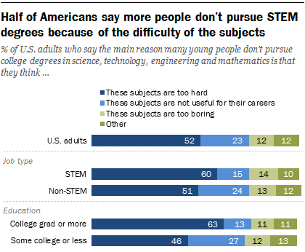
Figure 4: [35]Results from Pew research centre study.

While STEM subjects are often difficult, these views that they are difficult could be passed from adult to child, potentially leading to that child believing they could not do STEM, losing interest, and therefore not trying at all [35].
STEM can be a very rewarding career path, should students find their interest in it young and continue to develop these skills, STEM can be intellectually stimulating and financially plentiful [36]. As these subjects are largely logical and algorithmic based, a solid foundation of basic mathematical skill is beneficial to support further skill development. Making maths fun at a young age will help build this foundation early and encourage students to try their best [37]

As children get older, less females show interest in STEM subjects [see 2.2.1]; therefore, it is important to engage children, especially females in primary school, so they don’t lose an interest in these difficult subjects too soon. A study found that younger children thought their own gender to be better at both Maths and English, there was no presence of a gender bias in subjects until secondary school:
“Implicit attitudes are forming sometime between Grade 8 (13 years old) and young adulthood” [38]
These subjects need to be made fun to engage children to focus on them more and develop their skills; this effort needs to be focused on primary school students to help them to persevere on their goals despite any barriers they face. [37]

Traditional Studying is Ineffective for most Students.
Many students find traditional learning styles are ineffective for them, this is because each student has their own learning style much like a fingerprint, therefore find the ‘one-size-fits-all’ method of read-write conventional learning does not suit most [39].
In ‘Learning styles and inclusion’, Reid writes that students need to competently be able to:

Figure 5: Steps students need to competently do for effective learning to take place [39]
These skills should be strong for a student to understand the process of identifying and understanding a question before beginning solving it [39].

VARK
One way to reach more students with a subject is to use different teaching styles. Traditional studying consists of reading and writing; these only values one of the four learning styles. The four VARK learning styles are: visual, auditory, reading-and-writing, and kinaesthetic (touch) [40].
Visual learners find graphics such as charts/graphs, diagrams, and illustrations as the best learning tools [41]. Aural learners prefer hearing information such as podcasts, reading or songs. As the name suggest, reading-and-writing learners prefer to read information as words and texts. Finally, kinaesthetic learning is more than physical shapes and other physical materials, it requires:
“Engaging all your senses to feel or imagine what is happening” [42]
Many students find a combination of two or more learning styles to suit their needs, thus creating various exercises with multiple of these styles would enable them to personalise their experience. For example, visual, auditory, and kinaesthetic (VAK) can be used together to create a recallable experience of feeling, sight, and sound, much more memorable than reading and writing alone [42].
The writer of this report found through a VARK test that they scored highly on VAK styles, but rather lowly on read/write; this was supported by the writer’s experiences in school with difficulty to retain information through the read/write learning style, and personally found better results through any VAK or combination of VAK styles. There are many VARK questionnaires online (such as vark-learn.com [43]) that can give the user some idea of their own preferred learning styles and discover what best suits their needs.
Furner, Yahya, and Duffy also recommend VAK in their article (“Teach Mathematics: Strategies to Reach All Students”) to use different teaching styles to reach more students. Step 20 states:
“Using VAK teaching approaches for different learning styles enables teachers to reach more students than the traditional direct-instruction or paper and pencil drill and practice forms of instruction” [44]
They then go on to recommend methods such as using math software or computers, as well as more physical exercises including role play to act out the scenario.
While the writer of this report agrees with this, it is important to suit learning styles to the student, as students with anxiety or stage fright will not benefit from role play exercises as much as other learning styles and could find performing to be stressful and detrimental to their learning [45].
Moskowitz writes, unlocking a student’s full potential requires an environment that enables the student to relax, enjoy learning, improve self-esteem, and self-awareness [46]. Furthering this, Ried lists additional factors that condition learning includes the environment, mood, motivation, materials, support, teaching and learning styles [39]; these factors are all vital to aid a student’s performance. Many of these factors are influenced by their level of enjoyment in the task, in combination with a teachers support and the atmosphere they create [39].

The Learning Pyramid
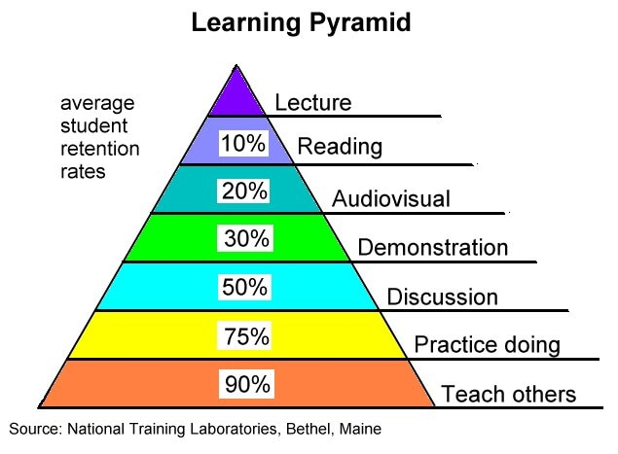
Figure 6: [47] The Learning Pyramid developed by NTL Institute in the 60s [48].
The concept of the learning pyramid is that:
“The lower down the cone they go, the more you learn and retain” [48].
This is supported by an article in ‘Teaching of psychology’: students found narrated lectures with screen captures to be more informative and interesting than learning from a manual [49].
The pyramid shows the following retention rates of learners per level and how they relate to VARK learning styles:
VARK? | Level | Retention (%)
A | Lecture | 5% of what they hear in a lecture
R | Reading | 10% of what they read
VA | Audio-visual | 20% of what they hear in a lecture
V | Demonstration | 30% of what they see: exhibits, mock-ups, diagrams, displays, graphs, etc.
VA | Discussion | 50% of what they see and hear during demonstrations, video/movie, etc.
A/R | Practice doing | 75% of what they say or write in worksheets
VAK | Teach others | 90% of what they say while doing the real thing
Table 1: The Learning Pyramid in more detail.
Going down the learning pyramid, the more learning is retained, the more VARK techniques are used in combination to address multiple senses and experience more [48]. Lalley and Miller go on to say, the original research for the Learning Pyramid is lost, but the results are believed to be accurate [48].
Additionally, there is a similar model by Edgar Dale, however, his work shows differing numbers, no use of the word ‘retention’ in his work, and no numbers referring to research, therefore concluding that his work is theory based:
“Thus, these numbers appear to be speculation.” [48]

Repetition Leads to Human Error
“It was found that human error is significantly affected by 4 major factors; A total of 48.8% of the variance in human error can be explained by stress, repetition, fatigue and work environment.” [50]
These factors (stress, repetition, fatigue, and work environment) can affect student’s ability, especially around exam periods [50]. Ineffective studying will take longer to learn skills, meaning more time is spent studying leading to fatigue. Stress from over studying can also lead to physical and mental health concerns, not to mention the increasing study-block making studying more ineffective. Shorter study sessions are shown to be more effective and reduce the impact of these four factors [51].
As an alternative, learning through game play shows students to be more motivated and find learning easier [52]. By making studying engaging, students will feel less stressed by the work and subconsciously absorb more content, meaning they require less study time; in turn, this leads to shorter, more effective study sessions and a well-rested brain to study more efficiently with [51].
Taking regular breaks in study sessions is also a healthy practice to let the brain rest:
“a positive association between study breaks and the odds of passing a course.” [51]
The article goes on to say that a significant number of passed students used study breaks to remain active during exam revision and assignment preparation, as compared to failed students who often exhibited a pattern to procrastinate [51].
The developer aims for the prototype to be learning heavy so that fewer game hours make up for more learning, and therefore more focused study sessions.

Paper impact on the environment
While paper is biodegradable, the paper production process produces Nitrogen and Sulphur Oxides, which leads to acid rain and releases carbon dioxide into the atmosphere [53]; Recycled-papers states:
“Manufacturing one tonne of 100% recycled paper emits 38% less CO₂ than paper produced from virgin fibres” [53]
Due to this remaining 62% of CO₂ emissions, the author recommends going paperless where possible, and will do so during this investigation [53].
Additionally, the impact of deforestation and chopping down trees to produce paper, less trees exist to photosynthesize and turn carbon dioxide into oxygen. An article in the journal of geographical research observed CO₂ production from tropical rainforests over 21 years. They found in this time that photosynthesis did not increase, but tree growth declined on hotter nights when it was over the optimal temperature for photosynthesis [54] 35-40°C [55]; this indicates that the rate of increase of CO₂ production speeds up as global warming intensifies [54].
Both these negative actions contribute to climate change and in 2022 we saw the effects of climate change first hand with the hottest ever recorded temperatures in the UK over serval heatwaves [56]; the met office had this to say:
“The UK's new record-high temperature of 40.3°C, on 19th July 2022, in Coningsby, Lincolnshire, has been confirmed by the Met Office.” [56]

Students use a lot of paper. An analysis of UK Year-6 SAT Math exams between 2003 and 2015 (the old exam scheme) shows three exams: Paper A, Paper B, and Mental maths papers. On average, papers A and B contain 24 double-side pages each (12 pieces of paper). Mental maths however contained six pages (4 pieces of paper) from 2003 through 2011, but now has reduced to one or two (1 piece of paper) [57]. Overall, with combined papers, each UK year-6 student (between 2003 and 2015) may use on average 26 double-sided pieces of paper for Maths SATs exams alone, not including revision materials or other subjects.
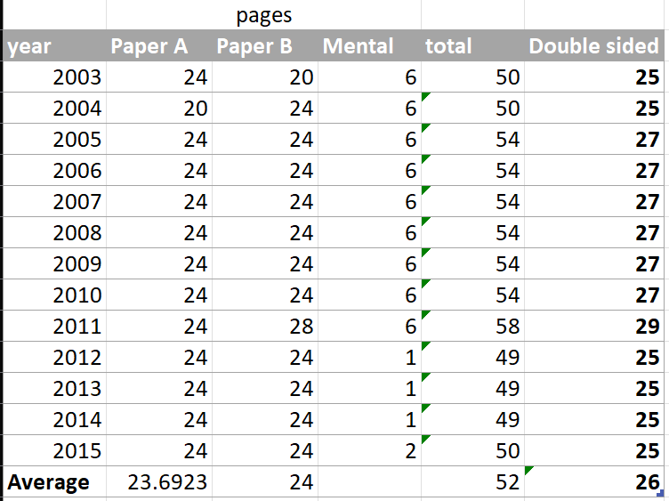
Table 2: Number of pages in year-6 SATs Maths papers between 2003 and 2015. Data from Mr Barton maths [57].
Furthermore, some students will complete several past exam papers as practice before the real exam; this works out as hundreds of pages of paper, per student, per subject, per year. This isn’t a sustainable future as it contributes many greenhouse gases to the atmosphere [53]. One of the easiest ways to reduce this impact is to go paperless where possible, such as digital studying with no printouts.

Progress is Hard to Measure with Past-Papers
Practice exam papers change their questions every year, therefore their grades are not compatible between years, this makes it difficult for students to assess if they have done better or worse on a practice paper, or if the grade boundaries are just higher for an easier exam, meaning they may do comparatively worse whilst getting a higher numerical mark. This can make it confusing to monitor progress when using practice papers; this occurs due to the Bell Curve used to displace students equally and calculate where grade boundaries should lie [58].
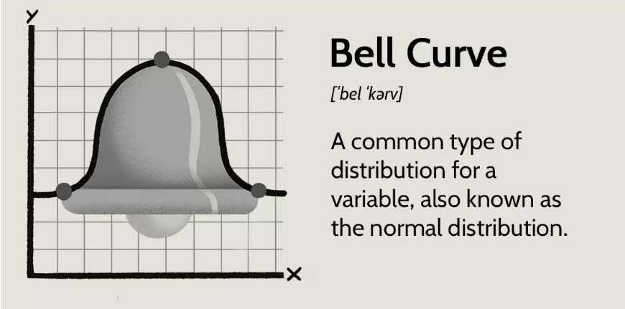
Figure 7: [59] Depiction and description of a bell curve graph.
A bell curve is a graphical representation on how the results from a large sample may fall, otherwise known as normal distribution; this graph is used with standard deviation to equally plot deviations, or grade boundaries in this scenario. This means that numerical grades are gathered before boundaries are set, then used to distribute grades ‘evenly’ between students [60]. However, this means marking students against each other, making them more about competition than about an individual’s ability [61].
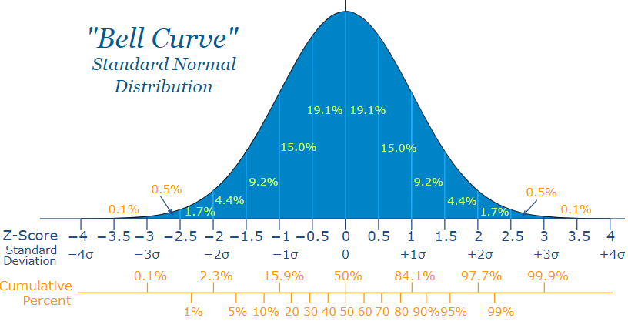
Figure 8: [62] deviation groups of a bell graph.
While some people may like this system, others may not. It’s the author’s opinion that students should not be competing for grades, and everyone should be granted an equal opportunity to achieve any grade, similarly to college or university’s approach with concrete grade boundaries (grading from criteria).

One potential way to measure progress in more detail, is to measure different skills individually. Such as practicing and measuring progress for fractions separately to practicing and measuring progress for angles; this can then return individual progress reports on these topics so that weaker skills can be targeted for more practice.

Children have Short Attention Spans
Children have much shorter attention spans than adults, approximately two to three times their age in years [63]. As children get older their attention spans develop; according to H. F. Neville, the following are the average attention spans by age [63]:
Age (years) | Average focus (mins)
3 | 6-15
4 | 8-20
5 | 10-25
6 | 12-30
7 | 14-35
8 | 16-40
9 | 18-40
10-12 | 20-45
Table 3: [63] Attention spans by age.
Outside of this attention span, studying will be less effective, as such these short periods should be optimised for effectiveness. While this is not something anyone has control over, it is important to consider it when developing a lesson plan, entertainment, or games [64], and spend more time engaging the target audience.
To best engage children, the product must be designed specifically with this target audience in mind. For example, young children may be attracted to bright colours, animation, music/sounds, characters, interaction, and a story element [65].
As mentioned previously, the developer aims for the prototype to be played in smaller, more focused study sessions.

There has been controversy in video games using loot boxes as a form of mystery prize when player spend real money in a game. Uddin writes about how developers use ‘mystery/loot boxes’ to attract attention from children and spend real money to open them [66]. They describe the techniques used to look appealing to young audiences [66]:
- Mystery of prize.
- Anticipation to open.
- Eye catching with a faint glow.
- Gentle noises to attract attention.
Uddin and Donaghy both go on to explain that the anticipation can lead to feelings of pleasure:
“Building anticipation in this way is related to surges of dopamine, a neurotransmitter responsible for feelings of pleasure, in the human body. This makes repeated engagement with loot boxes particularly attractive to adolescents, a group that lacks proper impulse control.” [66] [67]
Use of mystery boxes have been compared to gambling and has been compared to a ‘gambling gateway for children’ as the process hopes for a good prize when investing money [68]. The writer of this report frowns upon pay-to-win games as it creates disadvantages for users who do not wish to spend money in games.

KS-2 Curriculum
Changes were made to the curriculum in 2014 to help students with a more solid and focused mathematics foundation in preparation for secondary school [27]. According to the Gov.uk website, by the end of KS-2 pupils will now be coherent in written methods for [69]:
- All 4 operations ($+,-,×, ÷$).
- Including long multiplication, short and long division.
- Fractions, decimals, and percentages.
[See full curriculum in Appendix A]
Furthering this, an article from The Times Educational Supplement looks inside the new curriculum for KS-2 regarding the major changes [70]:
- The following have been moved to earlier in the curriculum:
  - Multiplication tables go up to 12x12.
  - Fractions and decimals (including counting beyond whole numbers.)
  - Large numbers.
  - Algebra.
  - Ratios.
  - Proportions.
  - Roman numerals.
- Use of formulae to calculate the area or volume of non-quadrilateral shapes.
- Extra focus on financial and percentage mathematics for real life use.
- Less data handling, more data interpreting.
Additionally, probability is no longer assessed, and calculators are not needed until higher primary school [70].
The author sees benefits in these changes: a more streamlined curriculum with a bigger focus on accuracy and foundational maths skills; this strengthens later maths skills and reduces the impact of maths anxiety [27] [as discussed in 2.2.2.]
The writer also sees the benefits in excluding probability and the use of a calculator from KS-2 examinations, as these high-level skills are more complicated and less useful at this stage. Restricting the use of a calculator in general will ensure students are building on their mental math capabilities.

The new revised KS-2 syllabus was first sat in 2016. the exams now have three papers as follows [71]:
- Paper 1 Arithmetic – 30 questions, 30 minutes.
  - Context free questions (in numbers.)
  - Most single mark questions apart form long division or long multiplication for two marks.
- Paper 2 and 3 Maths reasoning – each 40 marks, 40 minutes.
  - Contextual questions (in words.)
  - The papers will roughly follow this breakdown [71]:
    - 70% of the marks (28 marks per exam) are for –
      - Number, place value.
      - Approximation, estimation.
      - Four operations.
      - Fractions, decimals, percentages.
      - Ratios.
      - Proportions.
      - Algebra.
    - 30% of the marks (12 marks per exam) are for –
      - Measurement.
      - Properties of shapes.
      - Direction and position on graphs and maps.
      - Statistics.

Figure 9: Year-6 SATs Paper 2 & 3 Breakdown (post 2016.)

E-learning

What is E-learning?
E/Electronic/Online learning is the electronic use of web resources for learning, this usually occurs on the internet as online materials are accessible to everyone from anywhere [72].
On a global scale, recent demands presented themselves owing to the Covid-19 pandemic. During this time, existing technologies, such as MS Teams, Zoom, Discord, Google Classroom, and Moodle, provided a means for learners of all levels to engage with class materials and resources remotely, so that they did not fall behind in their studies [73].
Following the pandemic, much research has been conducted into the effectiveness of the use of these platforms, which has produced very mixed results. It is the belief of the author that a hybrid approach to e-learning and the technologies associated with it, is valuable in making course material and resources available and accessible to all learners [73] [74].
Some of the technologies provided by these platforms include the ability to provide pre-recorded resources, video calls for live lectures, file sharing, and online assessments. The fact that has been noted in the research is, that some learners feel a sense of disconnect when learning outside of the traditional classroom environment, while others thrive on it [74] [75]:
“The shift to the cyber environment requires a significant adjustment in the roles of both learners and instructors, in order to develop the necessary competencies to successfully employ technology in educational settings.” [76] [73]
E-learning usually comes in the form of online courses that could comprise of multiple of the following: Blackboard/Moodle/Online portals for schools and higher education, videos/podcasts, online educational games, etc [72] [77].
Many applications are already moving to online learning platforms such as Moodle, Google classrooms, Office 365, etc. These platforms are openly accessible online without the need to download an application. Furthermore, online software automatically saves files to a secure location, such as Google Drive or OneDrive, where they are saved in the cloud [77].

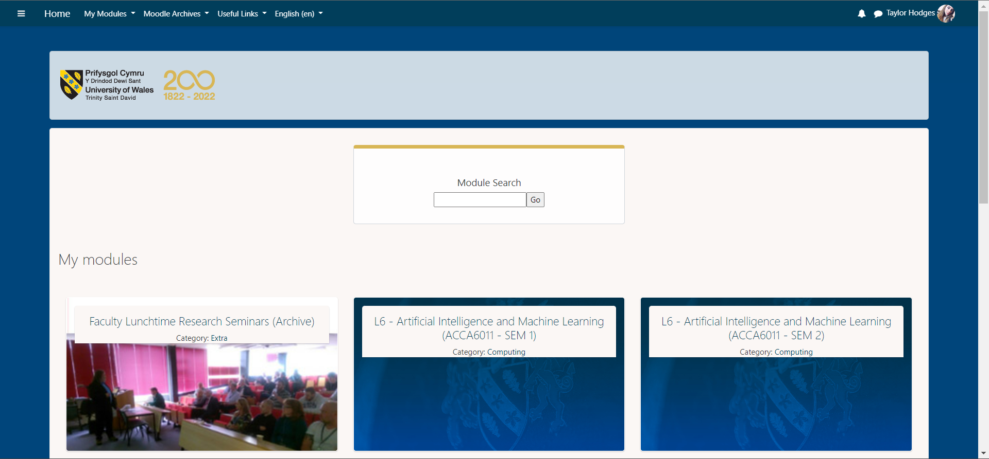
Figure 10: A View of UWTSD Moodle.
Moodle is an online resource for accessing class files, links, and uploading work for all units in one place. Other organisations may use similar resources such as Blackboard.

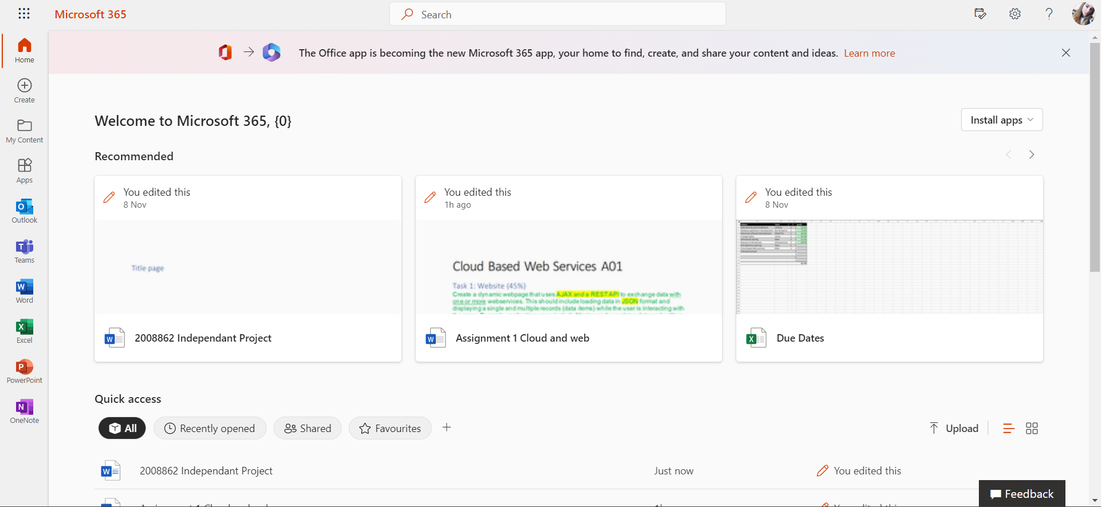
Figure 11: A View of Office 365.
Office 365 allows users to use an online version of all their MS products from anywhere, and securely save them all. Some of these online versions of MS products are scaled down in terms of size and functionality than their application counterparts.
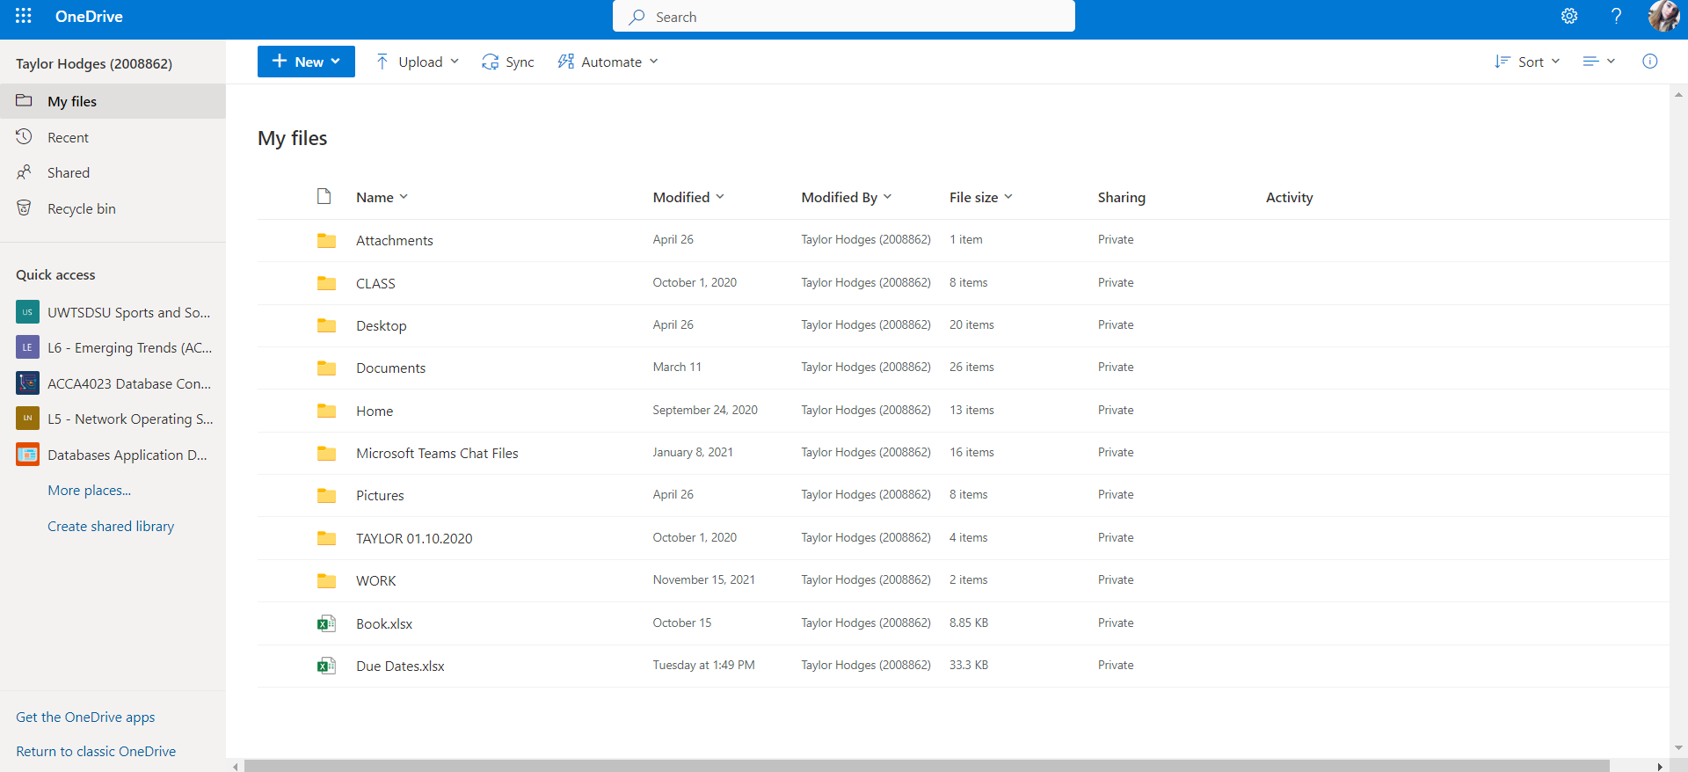
Figure 12: A View of OneDrive.
OneDrive is a cloud storage solution that keeps digital copies of files securely online, so they are accessible from anywhere.

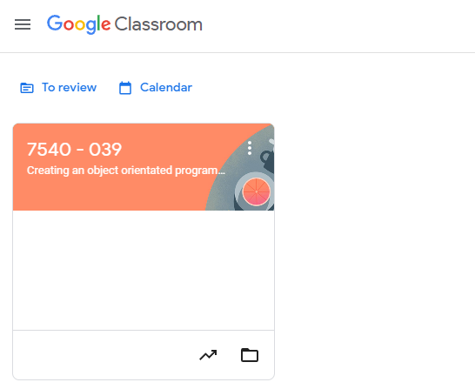
Figure 13: A View of Google Classroom.
Google Classroom is an online resource for accessing class files, links, and save files all units in one place.
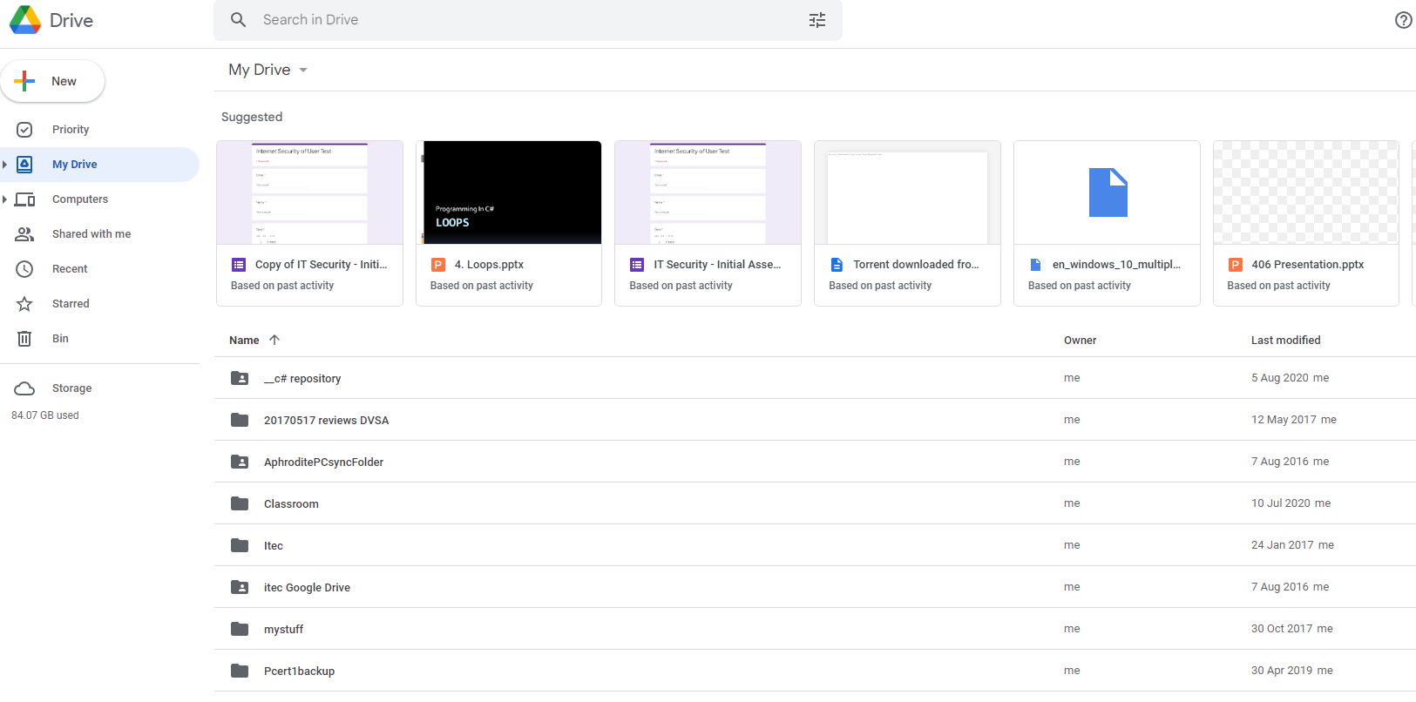
Figure 14: A View of Google Drive.
Google Drive is a cloud storage solution that keeps digital copies of files securely online, so they are accessible from anywhere. Google Drive also works with Google Docs, Google Sheets, Google Slides, etc (which can all be converted into MS products).

What is gamification?
Games are a form of amusement where the player uses their dice/cards/items to interact with objects, puzzles, or other players in the game, or to advance their own level [78] [79]. A player may be presented with increasingly difficult sections/levels of patterns of sequences for the player to master [80]. Koster describes the fun part of games being the process of learning the pattern and mastering the skill [80].
Gamification is the process of making learning motivational [81], by offering people an incentive to get past a certain point and therefore turning a process into a game; this is done by adding elements such as badges, leader boards, challenges, etc based on user’s behaviours, needs, and motivation [81]. It is believed by gamifying learning, that users will be more motivated, show higher performance, and overall better efficiency of learning [81] [82][see related in 2.2.8].
Digital games have infinite applications, one major use is in healthcare. A study into the uses of electronic games in a medical environment showed, by applying gamification to standard processes, patients found the use of the interactive software fun, and in turn helped improve their functioning in behavioural, physical, cognitive, and emotional performance [83]. There are many games on the market to promote a healthy lifestyle [83] [84]; another study analysed these games and found as well as effectively engaging users, significant positive benefits were seen in users in clinical outcomes [84].
While game based-learning is seen to some as a practical tool to aid student’s knowledge and motivation on a subject [85], others may see game-based learning as, simply:
“Computer video games with a wide variety of educational content” [86]

What is an electronic game?
A basic definition of an electronic game, is a game played on a machine, otherwise known as computer games or video games [87]. These machines can come in multiple forms, including not limited to [87]:
- PC/Laptop
- Games console such as XBOX ONE
- Arcade consoles
- Handheld consoles such as Nintendo Switch
- Mobile devices such as smart phones or tablets
Electronic games are a developing technology forever getting more advanced and used in new ways. The use of digital games is expected to grow in the future with new applications [88]; a major reason why, is down to their accessibility to everyone, entertainment, and socialisation value [88].

How can games help in learning?
As discussed in 2.2.10.2; games are fun and enjoyable, by using gamification, learning can be fun. By incorporating features such as badges, leader boards, challenges, etc into electronic learning, students will be more motivated to complete tasks to receive these rewards [80]. Depending on the subject and target audience, it may be necessary in some cases to do more than gamification, but rather better disguise the learning as a game.
Studies have shown, computer games are effective in positively impacting a student’s motivation, and successfully gaining knowledge [85], the author would consider this to be achieving the desired outcome of learning through fun.
Furthermore, this isn’t only appealing to students and ‘fitness fanatics’, employees are also motivated by gamified processes in the workplace; a recent study showed that:
“55% of people would be interested in working for a company that offered games as a way to increase productivity” [89]
On the other hand, some academics report scepticism about use of games in the classroom and their effectiveness, especially for the use of STEM subjects [85]; more research needs to be taken to understand if and why this may be the case.
Overall, through various research, there is a clear pattern emerging that game-based learning has a degree of positive impact on users including but not limited to the following ways [81] [82] [83] [84] [85] [88] [89]:

- Motivation
- Productivity
- Entertainment
- Socialisation
- Performance
- Efficacy
- Efficiency of leaning
- Cognitive skill
- Knowledge acquisition
- Physical and emotional behaviour
- Healthy lifestyle

Maths till 18-years-old
In 2023, the prime minister, Rishi Sunak, is looking at plans to ensure all school pupils in England study maths in some form until the age of 18, whether that be through A-level or another qualification [90]
Sunak stated:
" In a world where data is everywhere and statistics underpin every job, our children’s jobs will require more analytical skills than ever before, and letting our children out into the world without those skills is letting our children down," [90]
Furthermore, the OECD data shows below-average numeracy skills in the UK [91]. The UK-
“Is the only country where skills of 16–24-year-olds are no better than those of 55–65-year-olds” [91]

While the writer understands why Sunak’ wants children to have stronger maths, studying high level maths may not be the best solution. Firstly, some say his plan is ‘impossible’ due to a national lack of maths teachers as the recruitment rate of maths teachers has not been met in the last 7 out of 8 years [92]. The below table shows Percent of recruitment target of maths teachers [92]:
Year | Percent of target* met
2019/20 | 65%
2020/21 | 84%
2021/22 | 90%
Table 4: Percent of recruitment target of maths teachers met by year.
While the data looks to show a rise in recruitment of maths teachers, it must be noted that *the target have been reduced in the recent years, meaning the percent looks larger while the number of staff recruited may not be [92]. Despite this, the target has still not been met.
The writer of this report would comment that many adults with maths qualifications will find they can get a higher pay working in industry than in education which would cause a lack of maths and other STEM teachers. David Robinson, of the Think Tank, states that funding increase is needed for post 16 education [92]. Glyn Potts, of Newman RC College, in Oldham, agrees that maths teacher’s salaries have not been competitive with other jobs; he also comments that it isn’t only the pay, but also working conditions [93]

Another problem with Sunak’s plan is that it doesn’t align with students taking B-tecs nor students that simply do not wish to take Maths further.
“It is not clear what the plans will mean for students who wish to study humanities or creative arts qualifications, including BTecs.” [90]
The report goes on to say that no new qualification plans has been made nor is there plans to make A-level maths compulsory.
The writer of this report has strong opinions, from a first-hand experience, that currently most maths taught at AS-level is not applicable to real life scenarios so does not help people:
“feel confident when it comes to finances” [90]
-as commented to be the idea in Sunak’s first speech of 2023.
The writer feels a stronger foundational skill for maths would be far more beneficial to students. Mathematics is a cumulative subject, meaning new skills build on previous ones. Furthermore, other subjects are of numerate disciplines such as STEM subjects; overall a solid maths foundation is crucial to developing skills in many subjects, and as such should be of high importance in early life.

Competitor Analysis

Examples of Existing Games
Games come in many forms such as listed below [78] with examples:
Game Form | Description | Examples
Board | Games played on a physical board or flat on a table. | Chess  Monopoly  Battleship  Dominoes  Scrabble
Card | Played with a deck of cards, could be standard 52 pack of playing cards or their own deck. | Poker  Blackjack  Uno
Casino | Played in casinos for gambling. | Roulette  Slot machine
Puzzles | Games that test the player’s knowledge and problem-solving skills | Rubik’s cube  Jigsaws
Console/Computer  3-D or 2-D | Digital games played on PCs or consoles, can be classified into 2-D or 3-D categories. | Minecraft  Roblox  Grand Theft Auto  Terraria  Pac-man  Donkey Kong
Kids | Simple games with kids in mind, although other games outside this category can also be kids’ games. | Guess Who  Connect-4  Jenga  Operation  Checkers
Table 5: Types of games and examples.

Testing of Existing Maths Games
The following examples of games require some numeracy skills to play such as basic addition/subtraction, probability, coordinates, pattern finding, angles, and puzzles.
For an overview of existing board games, card games, and classic electronic games, see Appendix B.

CoolMathsGames.com
Coolmath Games is a popular website for children to play math related games. It is sometimes used in schools during maths or computing lessons as a fun alternative lesson or set as homework. These skills are often embedded in the game, so the users do not know they are subconsciously learning. There are an infinite number of games available, here are a few of their most popular:
- Run 3 – this game requires the user to approximate the character’s jump timing. Run 3 is a game where the player’s avatar runs through a tunnel in space, this tunnel contains holes and falling floors, should the player miss the real floor, they fall out into space and have to start that level again. Each side of the tunnel is playable as the tunnel rotates as the player moves left or right, offering infinite ways to complete levels [94].
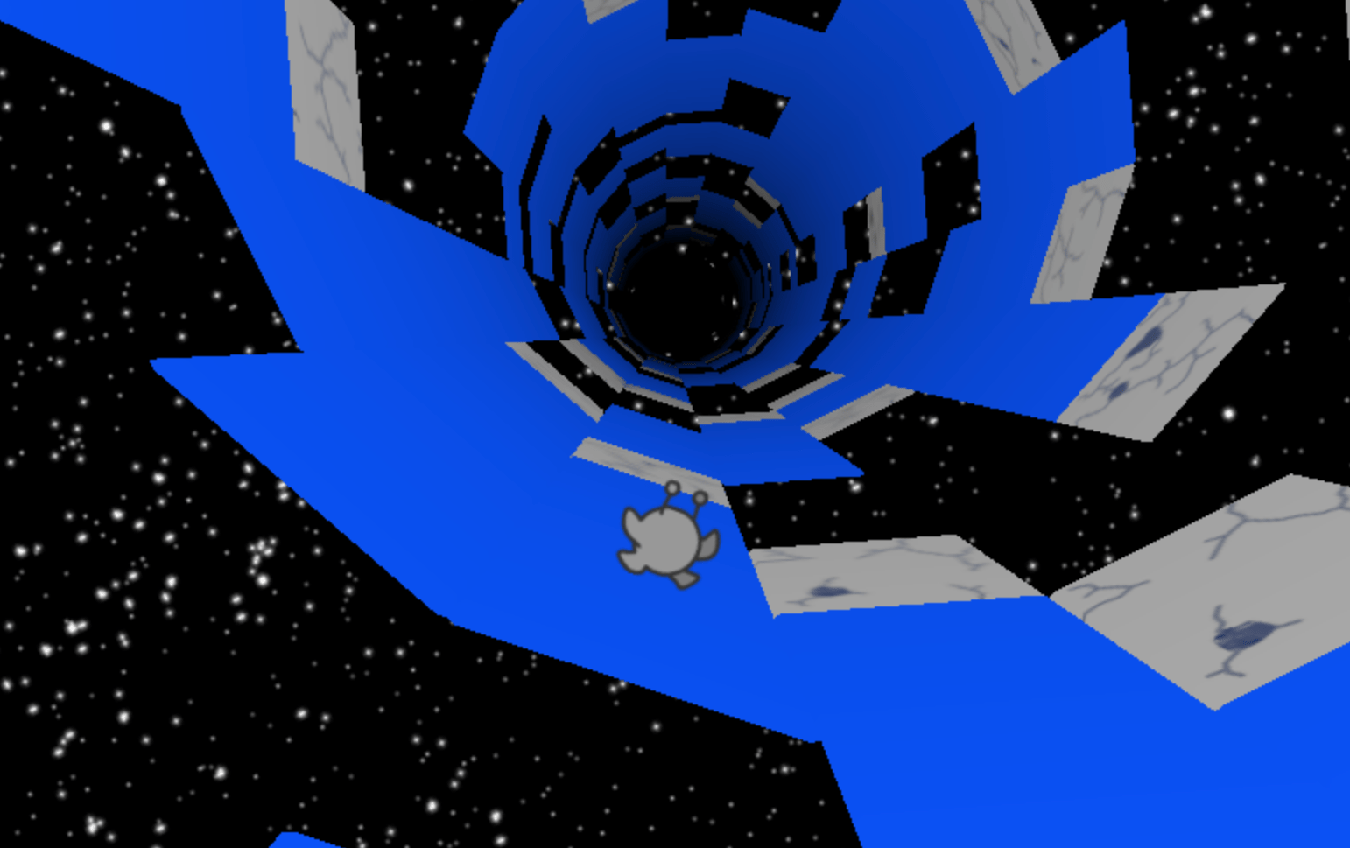
Figure 15: [94] A level of Run 3 on Coolmath Games.
- Fireboy and Watergirl in the forest temple (also available in the google play and app store) – is a 2-D puzzle game where the player uses the keyboard to control two characters, Fireboy and Watergirl; together they must maneuverer the maze collecting gems, avoiding danger, and triggering mechanisms as a team [94].
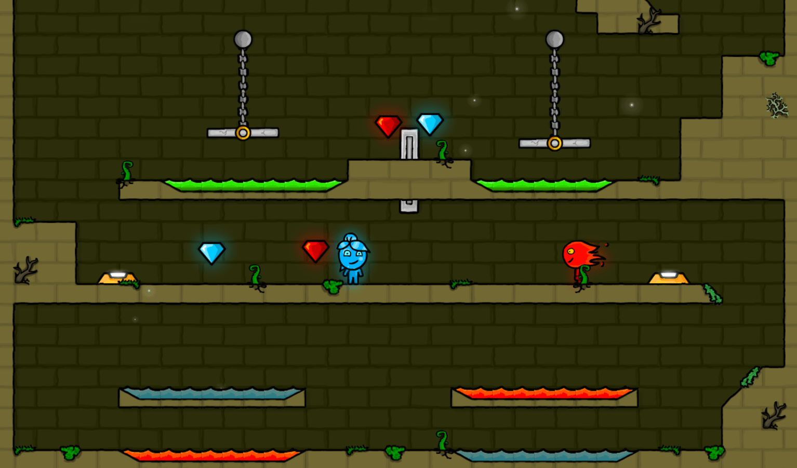
Figure 16: [94] A level of Fireboy and Watergirl.
- 8 Ball pool – the online version of 8 bool pool is easier to execute than in real life due to displaying the angles of a shot, possibly leading to its rise in popularity. This 2-D game involves the understanding of angles and how they are reflected when bouncing off the sides, and forward thinking of a player’s and opponent’s next shot. The rules are the same as in real life: taking turns, the aim of the game is for the player to pot all of their balls and the black ball (but not the white) before their opponent. If a player pots one of their balls, they get an additional turn; if the player misses all their balls, pots the opponent’s ball, or pots the white ball, their opponent gets an additional turn (unless they only have the black ball remaining.) [95].
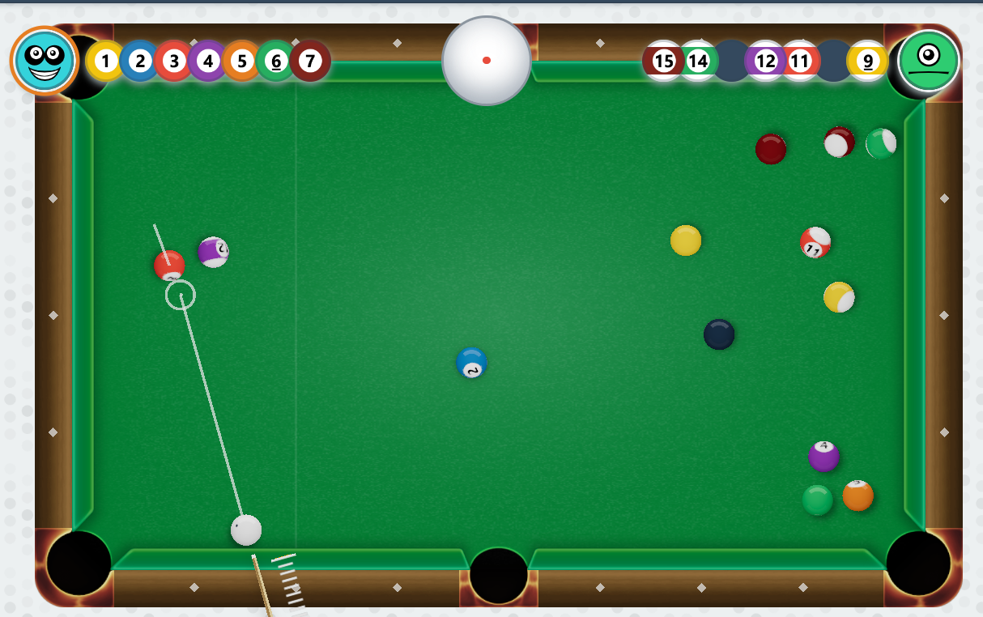
Figure 17: [96] 8-Ball pool match on Cool Math Games.

MathsFrame.co.uk
Maths Frame is another website for children to play maths games. Here, games are more focused on math questions, requiring players to solve a series of maths equations as part of the game process. These questions relate to the progress of a game; therefore, a player can get a higher score by getting the correct answers to these questions. There are many games available, here are a few of their popular games this week (December 2022):
- Caterpillar Carnage – a game where players collect fruit and powerups to extend their caterpillar, whilst avoiding hitting blocks that shorten their caterpillar. To start the game, players must answer maths questions for additional powerups. At some stages, the caterpillar must pass through a subtract block, so the player must aim for the least reducing block. The aim is to last as long as possible. If the player gets shortened more than the length of their caterpillar, the game is over [97].
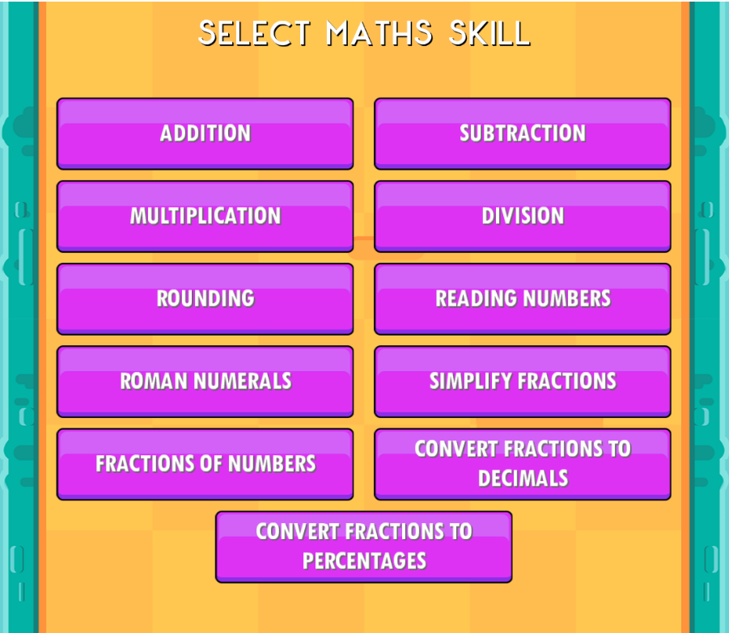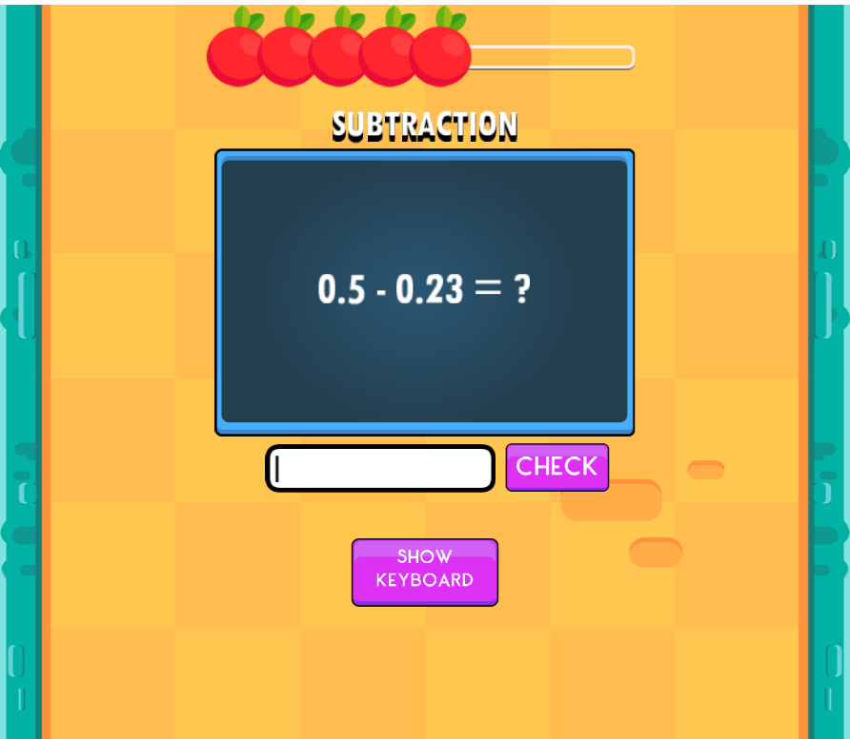
Figure 18: [97] Pre-game set up of Caterpillar Carnage asks the user to select a skill and difficulty level.
Figure 19: [97] Pre-game maths equations used to collect powerups before Caterpillar Carnage starts.
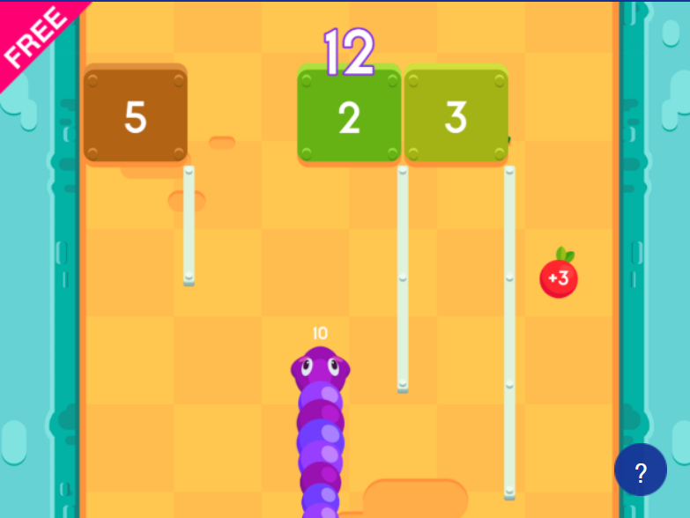
Figure 20: [97] A level of Caterpillar Carnage.
- Stone Age Stu – here players must navigate a course while solving the equation on screen and break the stone with the corresponding answer. If the player breaks the stones in the wrong order or take damage on the course, they lose a life, lose three and the game is over [98].
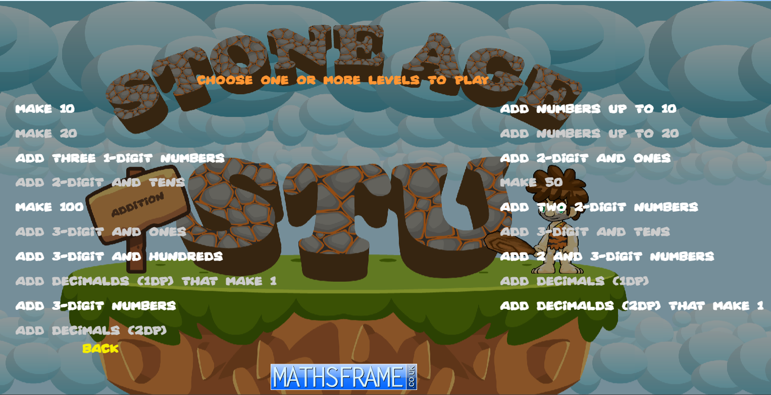
Figure 21: [98] Pre-game set up of Stone Age Stu asks the user to select a skill and difficulty level.

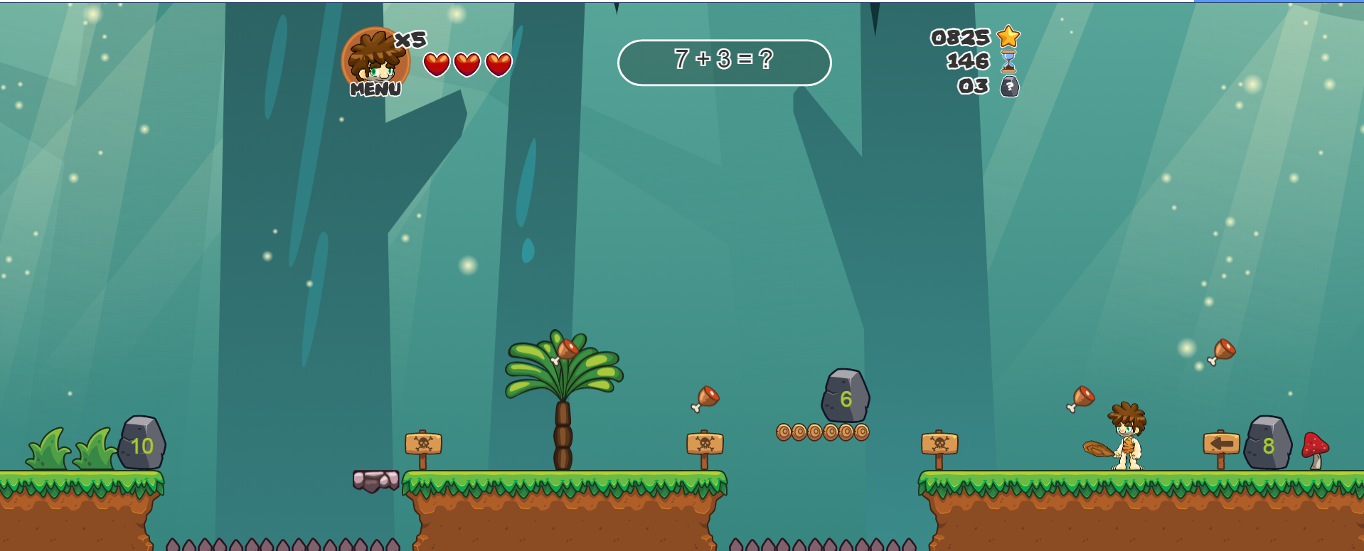
Figure 22: [98] A level of Stone Age Stu.
- Maths Mini Golf – a mini golf game where players drag their putter to hit their ball into the hole. players first answer three subtraction questions to increase the accuracy of their shots. Players get +1 score and +1 shot if they finish a hole, players get three shots per round. A game is five or ten rounds, and the player selects their skill level, and one or two players. The aim of the game is to get the highest score [99].
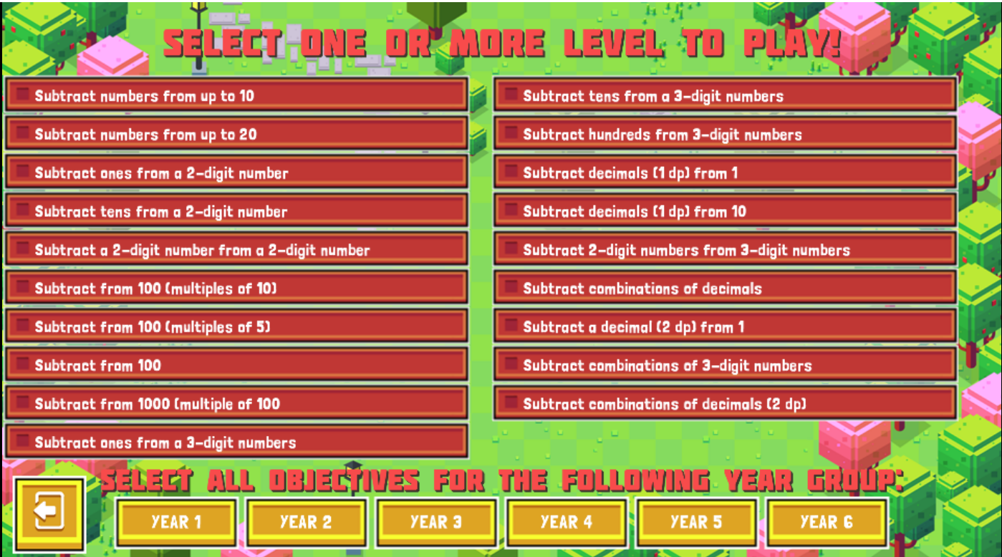
Figure 23: [99] Pre-game set up of Maths Mini Golf asks the user to select maths skill, and game length.
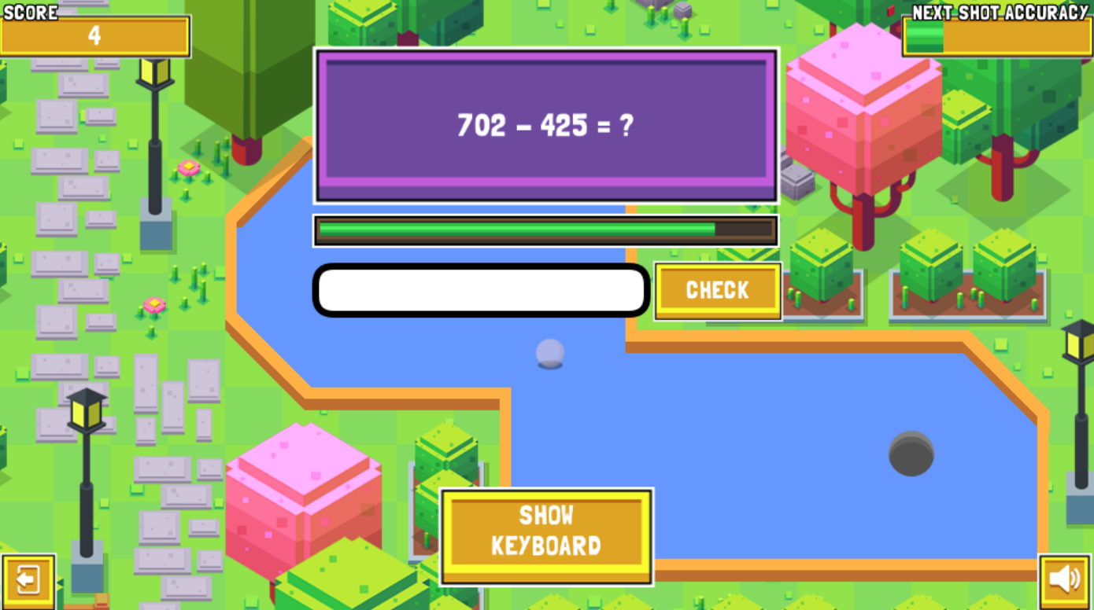
Figure 24: [99] Maths Mini Golf gives three maths equations used to increase the accuracy of a player’s shot.
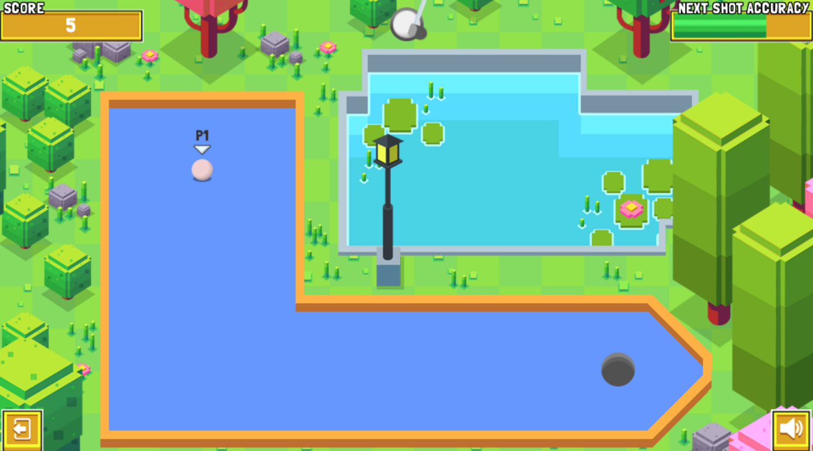
Figure 25: [99] A hold on Maths Mini Golf.

Development Tools

Mobile

Xamarin
Xamarin is -
“Xamarin is an open-source app platform from Microsoft for building modern & performant iOS and Android apps with C# and .NET.” [100]
Xamarin builds upon the .Net framework by providing additional specialised libraries and tools for development of applications for other platforms, including android and apple technologies. Some of the contributions that Xamarin can add to a .Net framework include [101]:
- A basis for utilising native capabilities and features of the destination or desired platform.
- Use of XML (Extensible Markup Language) for developing mobile application which are dynamic and as such are not model specific through use of the C# programming language.
- Xamarin incorporates libraries for common patterns, for example the Model View ViewModel (MVVM) pattern.
- Rich features may be added to the application through use of platform specific libraries, these can provide access to APIs hosted by Facebook, Apple, and Google (among others).
- Editor extensions can be incorporated to draw attention to syntax errors and to help with the mobile page development.
Xamarin is included as part of the open source .Net framework. Versions of the Visual Studio family can be installed and run-on multiple OSs and as such development and deployment are not platform specific.
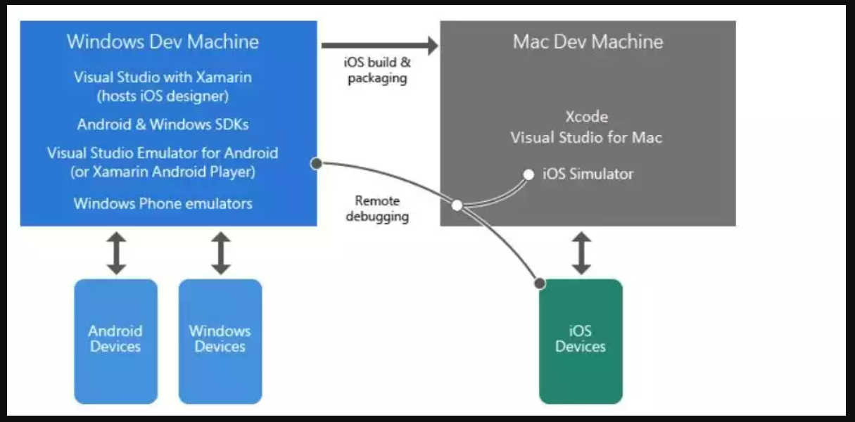
Figure 26: [101] Structure of a Xamarin project.
Developers have voiced some drawbacks to using Xamarin:
- There is sometimes a delay in Xamarin support for the latest update in mobile technologies as this may involve making changes to existing libraries or producing new plugins.
- Less access to open-source libraries and technologies than a developer may have when doing native development.
- The community of Xamarin developers is much smaller for those who develop in native android or IOS [see figure 40], this means that gaining any advice or finding an expert in this field could be difficult.
- It can be difficult to create an application for android or IOS with a truly native ‘look and feel’ without some knowledge of the native environment, as in order to achieve this the developer still must write a platform specific layer of code.
- Because of the extended elements required to create the platform non-specific version of a program and the libraries involved, apps created in Xamarin will be significantly larger.
- Some issues might be encountered when attempting to include resources produced from third party vendors within the Xamarin app (most native technologies will be supported but this is not the case for elements provided by third parties).
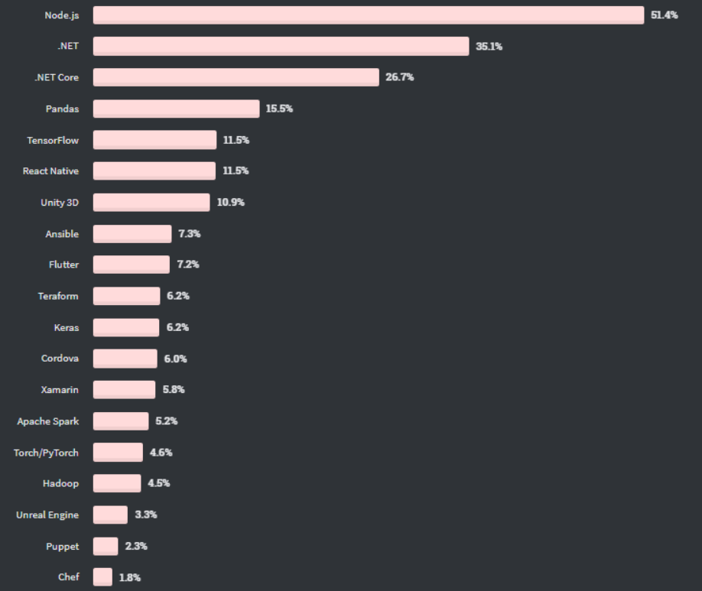
Figure 27: [102] usage of mobile app development frameworks.

Android
“An operating system for smartphones and tablets from the Google-sponsored Open Handset Alliance. With myriad models to choose from, Android is the leading mobile platform with approximately 75% of the worldwide smartphone market. More devices with Android are currently in operation than any other OS.” [103]
The advantages of android are [104]:
- It is easier to Customise Android, may alter nearly anything.
- Any new publishing can be made in Android quickly and without going through a review process.
- Switch to a different SMS app.
- Android Offers a Platform that Is open-source.
- simple and affordable access to the Android App Market
- Future releases will support saving RAW photos.
- Constructed beta testing and gradual rollout with native Google cloud storage integration. Free 15GB; 100GB for $2/month; and 1TB for $10. There are apps for Dropbox, OneDrive, and Amazon Photos.
On the other hand [105]:
- Not so versatile: The developers may have challenges when it comes to dealing with screens of varying sizes, resolutions, and aspect ratios.
- Cost: The overall cost of development rises due to the need of making investments in optimization and testing.
- Evaluating: Since Android offers a wide variety of endpoints, testing the functionality of the application on each of them may be expensive and time-consuming.

Apple
The first version of Apple's proprietary mobile operating system, iOS, was made available to the public in 2007. iOS was developed and is maintained by Apple Inc. iOS is the name of the operating system that is used for iPhones, while iPadOS and watchOS are the names of the operating systems that are used for iPads and iWatches. iOS is the second most popular mobile operating system behind Android, which is not surprising given that smartphones are the most popular kind of portable device [106].
Pros and cons of apple IOS [107] [104]:
- Massive app ecosystem: a definite benefit for tablet applications in comparison to those on smartphones. The most popular applications are almost always made accessible on both platforms.
- Because Facebook and Twitter are so well integrated with iOS, it is much simpler to share content and publish updates on social networking sites while using iOS than Android. This makes it the superior platform for social networking.
- applications that are exclusive to the iOS platform, such as Passbook, FaceTime, and the mobile payments app Square (available on iOS 3GS,4,4S,5 and up, not only for a limited Android phones)
- The interface is not accessible: There are few possibilities for modification of the home screens; the only choice is to arrange app icons in rows. The cellular provider does not come pre-loaded with any third-party applications. Apps may only be downloaded and installed by users via the Apple App Store.
- Upgrades to the software Apple makes available software updates for all of its devices that have the necessary hardware to run the newest version of the software. This ensures that devices remain up to date with the latest software features for a minimum of two to three years.
- iOS gives consumers a greater degree of control over the access that applications have to private information, such as contacts and location, which is a significant step forward in terms of protecting users' privacy.
- It has a review procedure; in order to publish an app, developers must submit it to Apple for evaluation, which typically takes 7 days but occasionally might take considerably longer.
- When compared to other mobile platforms, applications are quite huge.
- With iOS, there are expensive apps and no widget support.
- The 3G battery's performance is quite poor, and repairs are very expensive.
- Not versatile; only works with iOS devices.

Further Limitations to Native Mobile Development
Some further limitations to mobile development include:
- Not all learners will have access to either platform which would disadvantage learners (possibly from less affluent families.)
- Some schools have their own devices to use on school site only [108].
- Incompatibility issues between OS versions.

Desktop
Desktop software is installed on a home or office computer's desktop. Desktop programs are trustworthy and dependable. As long as your computer is nearby, you may use a desktop app. Most of the time, these programs don't require an Internet connection. An unpleasant limitation of a desktop program is that an individual cannot use it if they don't have access to a computer [109].
Web apps are starting to surpass desktop programs as of this writing. However, desktop programs unquestionably provide consumers with a more secure software environment. Although desktop apps are still used, most users prefer online applications [109].

Windows forms
Windows Forms is a UI framework for building Windows desktop applications. It provides one of the most efficient ways to create desktop apps based on the visual designer provided by Visual Studio. Desktop programme development is made simple by tools like drag-and-drop visual control placement [110].
With Windows Forms, a developer may produce visually stunning programmes that are easy to deploy, update, and use whether offline or connected to the internet. The hardware and local file system of the computer are accessible to Windows Forms applications [110].

Windows forms are limited to working off a PC with the software installed on it (suitable for a single player games). However, with use of webservices, several client machines over networks could communicate with each other in order to allow for a multiplayer solution [110].

Unity
Since 2005, developers have been able to use the Unity game engine to create both 2D and 3D video games. It was created by Unity Technologies with the intention of giving more developers access to game creation tools, which was a revolutionary endeavour back in those days. The engine has seen significant development and growth throughout the course of its lengthy existence, and it has successfully kept pace with the most recent industry standards and technological advances [111].
Even in this day and age, the primary goal of the game engine is to not only supply the game development industry with the most comprehensive collection of tools that are technically feasible, but also to make it as simple as is humanly possible for game developers of any level of expertise to use the engine (yes, including beginner developers). They have also extended its reach into other sectors in addition to placing a significant emphasis on the development of real-time 3D, which has resulted in it being one of the most powerful engines that are now accessible [111].
In spite of the fact that there is a tiny learning curve involved in comprehending the Unity UI, utilising Unity is simple once you get over that point. As was just discussed, the design of Unity is quite simple to comprehend, and the process of adding new items is as straightforward as right-clicking in the appropriate location. In addition, the Unity Inspector makes the majority of the game's attributes easily accessible, allowing them to be modified directly inside the engine without the requirement for the developer to start from fresh with the programming [112].
In addition, Unity provides kits and frameworks that may take away even more of the grunt work if the development team is not yet ready to master C#. As a result, the engine's ability to accommodate novice users is one of its primary selling points [112].
When compared to alternative options, Unity offers two primary benefits that stand out. A visual development environment and support for several platforms are provided here. The first consideration takes into account more than just visual modelling tools [112]. On the other hand, this location has an integrated environment as well as a construction chain. Its primary objective is to boost developer productivity, particularly in the prototype and testing phases of the development process. Whimsy's Unity game creation services include cross-platform compatibility, which not only supports deployment sites but also (installation on a personal computer, on a mobile device, console, etc.). However, another factor is the accessibility of various programming tools. Both the Windows and Mac operating systems support the usage of an integrated environment [112].
Because of its numerous advantages, Unity 3D is a fantastic tool for the creation of video games. In particular, the combination of a visual editor with complicated code is not conventional and might be challenging, despite the fact that it is successful within the context of the Unity component system. When dealing with complicated situations, it's easy to lose track of some of the components that are linked [112].

Unreal
Epic Games, a firm that develops both video games and software, is responsible for creating the video game creation tool known as Unreal Engine (often abbreviated as UE). Developers have the power to create simulations, modify films or music, and produce animations with the help of this tool. Developers have made use of it to construct some of the games that are now among the most popular ones available on the market [113].
The fact that it is both cost-free and simple to use makes it an attractive option for novices. Epic Games wants to guarantee that more individuals are able to get into the video game creation industry by promoting its software on a global scale in conjunction with the appropriate strategic partners. Epic Games is a firm that has been around for more than 25 years and has produced software that is regarded the AAA standard for the production of video games, which are a component of the industry that is expanding at the quickest rate in the globe [113].
Unreal Engine is a cross-platform game development tool that was developed in C++ and boasts a high degree of portability. Its users are able to run it on a variety of operating systems, including iOS, Android, Windows, PlayStation, and Xbox [113].
The Unreal Engine has a number of shortcomings, including unpredictable crashes and issues resulting from unresolved conflicts. Some users have complained about the slow performance, as well as the absence of tutorials and other forms of support [114]. Unreal Engine, on the other hand, is perfect for businesses with budgets in the six- or seven-figure range rather than the nine-figure range since it allows for the creation of games without the need for a degree in C++ or a warehouse full of programmers [114].

Web based.
Apps that run on the web are seen by some people as the natural next step in the progression of technology. After all, there is a solution to just about every problem on the internet! Therefore, there is no incentive for you to continue using them unless you are employed as a graphic designer, or you have a requirement for a specialised desktop application [115].
Despite this, web applications are not without their flaws. Even in this day and age of lightning-fast internet and advanced web browsers [115].

PHP
Open-source server-side scripting language PHP is widely used by developers to create websites. It is also a language that may be applied to a number of tasks and projects, including the creation of graphical user interfaces (GUIs). [116].
In its early days, Personal Homepage was what PHP stood for as an acronym. However, nowadays it is a recursive acronym that stands for Hypertext Pre-processor [116]. (It is recursive in the sense that the initial word itself is an abbreviation, which means that the complete meaning does not follow the abbreviation [117].)
It's been 26 years since the initial version of PHP was made available. Although it has moved on to version 8, which is scheduled for release in November 2020, version 7 is still the one that has the most users [116].
The creation of web servers is the primary focus of the bulk of PHP applications. In addition to being able to operate in a browser, it can also function on the command line. Therefore, if you'd prefer not to do so in the browser, you have the choice of viewing the output of your code in the terminal [116].

ASP
A web development platform called ASP.NET provides the programming model, extensive software infrastructure, and a range of services required to create robust web applications for desktop computers and mobile devices. These are the fundamental elements of an environment for web development [118].
Since ASP.NET is based on the HTTP protocol, it makes advantage of its directives and constraints to build collaboration and communication between browsers and servers. The HTTP protocol serves as the foundation for ASP.NET [118].
The ASP.NET application server is a part of the Microsoft.Net framework. Code that has been compiled and produced using the expandable and reusable components or objects that are supplied in the.Net framework makes up applications developed in ASP.NET. These scripts can make use of the entire class hierarchy offered by the.Net framework [118].
With ASP.NET, interactive and data-driven web applications can be built and distributed online. It is composed of a wide range of controls that may be used to put together, set up, and work with code to create HTML pages. Text boxes, buttons, and labels are a few instances of these elements [118].

Node.js
Node.js is a JavaScript runtime environment and library that is open-source and compatible with several platforms. It is used to execute web applications in a context other than the client's browser. It was first created by Ryan Dahl in 2009, and the most recent version of it, 15.14, was made available for download in April 2021. Node.js is a programming language used by developers to build server-side web applications. Due to the fact that it employs an asynchronous, event-driven approach, Node.js is well suited for data-intensive applications [119].

Selected Approach

Materials needed.
The writer will use their own PC in combination with the resources available at university campus. The developer will also need testers who can offer feedback and opinions on the solution.
The developer will also need some more knowledge in the selected technology and will compete this research alongside development.
The following software will be used for development:
- MS Word
- MS Excel
- MS Visio
- MS Forms
- MS Outlook
- MS Teams
- Visual Studio Code
- Wampserver32
- phpMyAdmin
- Tom’s planner

Prototype description
The prototype will show an early indication of what an implementation could do. Specifically, the prototype will include the following KS-2 maths skills:
- Conversion between fractions, decimals, and percentages
- Multiply and divide numbers by 100 (to compare between decimals and percentages)
- Fraction addition, including answers over one whole, with differing denominators.
- Simplifying fractions
- Mixed number fractions
- Interpreting Pie charts as fractions.
- Comparing, and elements of ordering fractions, decimals, and percents from smallest to largest
- Answering contextual/word questions
  - such as: Derek has two left-over pizzas, he wants to know how much pizza fills the boxes. Using the two pizza pies, add together for their total. Answer in the form of fraction, decimal, and percentage.
  - rather than number questions (such as: $0.2 + 0.5 = ?$)
- No calculator supplied.
- Using estimations
- Pattern finding
- Problem solving
The prototype should be heavily maths based whilst tying in elements of fun to create motivation.
The game will ideally be played as quick rounds with incrementing difficulty and track the player’s results to award points. Earning points would then be used to unlock more games with different maths skills such as: coordinates, algebra, geometry, statistics, etc.
The prototype would track the player’s results from each game to calculate which topics need more practice and suggest relevant games to the player.

Market analysis, design decision
The developer wishes to create a maths puzzle, to invoke problem-solving skills to find the answer.
The author also sees the value in both subconscious and conscious learning (hidden maths skills vs explicit maths questions as part of gameplay), however, believes the practicalities of practicing real maths questions in order to advance in the game are greater and will be preferred by teachers. Despite children preferring subconscious learning as this is more fun, the developer’s implementation hopes to make a fun gamified maths learning environment. The developer hopes to achieve this with layouts, colours, interactivity, and a character/story element.
The developer is a fan of puzzles and believes enjoyment from working out a puzzle will be satisfying to play, so hopes to incorporate this into the prototype.
Finally, games include a skill aspect, so the developer hopes to create a pattern in the game so users can use some skill to help them in their gameplay and motivate them.

Development tool selected.
The developer has decided to create a web-based/desktop prototype solution developing in raw HTML, CSS, PHP, and JavaScript because the developer has limited pre-existing foundational knowledge in these languages, and to meet time constraints by reducing the learning curve where possible. Ideally with future releases to roll out as a mobile and desktop application as well should this idea be developed further in the future.
Additionally, the author is of the opinion that a website is more widely accessible to all than an application that would require specific devises for each student to have access to; it is more common for schools to have a dedicated computer room than a set of tablets or students having their own devices due to social economic backgrounds.
Finally, testing would be more practical on a PC based solution than using apple or android OSs as the developer/tester does not have direct access to these devices themselves, and because testing will be done under observation, therefore can be conducted on the developer’s machine or the resources available on university site.

Research and Development Methodology

Project plan
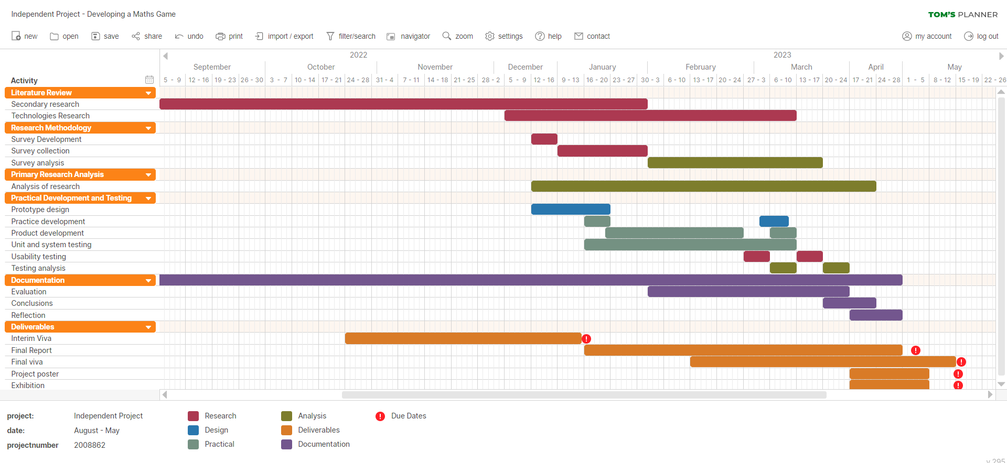
Figure 28: Gantt Chart plan of development throughout the year created on ‘Tom’s Planner’.

Research
Once conducting secondary research, the writer has gained a good idea of the important areas to focus on, and some idea of the content of the prototype. This information will be used a sort of primary research to see how much my testers agree or value important aspects of a solution.

Primary research will be conducted as MS Forms in two areas:
- Teacher’s/Lecturer’s views on electronic games for learning
- Student’s feedback on prototype development

Firstly, teacher’s views will be collected about electronic educational games in a MS Form sent out via email; teachers have been selected as the testers as they have first-hand experience teaching children, and potentially have assigned electronic games to their students themselves. The writer will gather information on:
- If teachers use electronic games.
  - What electronic education games they have used?
    - Did these games ask specific maths questions or if the maths skill was embedded in gameplay?
  - For what purposes/scenarios?
- If teachers like electronic games.
  - Why they feel this way?
  - What do they/do they not like about them?
- Their preferred format of educational games (desktop app, mobile app, web browser, etc)

Development
The author selected the FFD methodology because as the sole developer on the prototype, FDD seems the most pragmatic option to meet the deadline [120]. The developer will create a MoSCoW list of requirements and break these requirements into smaller, more manageable chunks of tasks as features [121], and use these features to plan short development cycles.
The key principles of FDD [120]:
- Each project is developed systematically.
- Simple and detailed process.
- Set value and consistency for all processes.
- Short iterative development cycles are prioritised [120]. This process means that functionality is increased quickly and therefore is also testable sooner, reducing errors.
FDD is beneficial to the development process because it works closely with the customer (in this case the customer is also the developer) to decide on the necessary features for the product [120].
FDD is a similar methodology to Agile, but has existed longer [120]; the difference being more focused on one feature at a time, and more detailed planning for each feature [120].
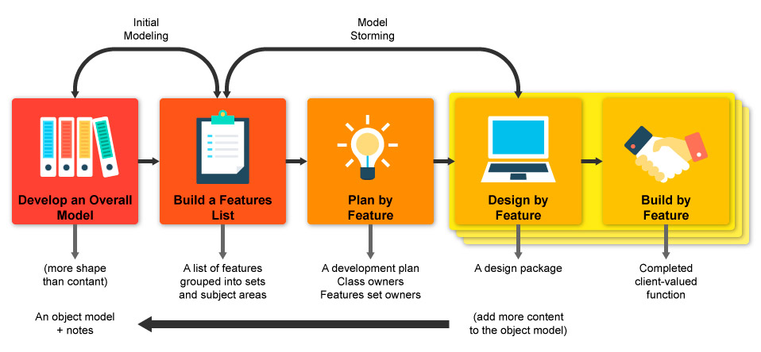
Figure 29: Five steps of FDD.

At this point, the developer will begin to create a prototype solution based on the feedback received from teachers. The development will be done on the writer’s local machine and will test functions and features as the development progresses. I intent to write this program in raw PHP, Javascript, and HTML and CSS; the program will also use mySQL with PHPmyAdmin to store and retrieve data.
The protype will be a reduced solution due to timeframe and so the solution will comprise of only one game. This game will be developed enough to be testable, and ideally demonstrate the desired characteristics: fun, motivational, replay able, incremental difficulty, etc.
Next, feedback on prototype will be conducted with University students as observed testing of the prototype and a MS Form to leave feedback. University students will be selected out of ease finding testers, the writer realises that this will produce less accurate data, however, will attempt to find testers who live with 10-year-olds at home to get their feedback from this experience. Feedback will collect data on:
- If the prototype functions correctly
  - Any bugs or errors found.
- If the prototype looks enticing
  - is the layout practical?
  - are the colours practical?
  - is the colour palette attractive?
- If the prototype is motivational
  - Why/why not?
- If the prototype difficulty is appropriate
- Would the testers play a game such as this in primary school?
  - Why/why not?
  - could the game be age appropriate to 10-year-olds?
- feedback/suggestions on future development
Should timeframe permit, the writer may complete two rounds of development and testing to observe for differences in responses between the solutions. This would then give more of an insight into people’s views on a skeletal code version, more focused on functionality, verses a more developed solution acting on feedback; the developer thinks this will be interesting with varying feedback as it is likely that most users will be less interested in answering questions, which will be what a first release development will mostly comprise of – therefore with constructive feedback, the final development will have users opinions more in mind.
After all data is collected, results will be analysed into graphs and charts to evaluate the quantitative data, and qualitative data will be analysed and discussed.

Design and Implementation

Design
For a bit about the visual design of the program, see Appendix C.

Requirements
Must have | Home page  1 maths-based game  Randomly generated questions  Multiple choice answers  Pizza  Toppings to choose from  Maths skills [stated in Prototype description]
Should have | Pizza order  Images of fractions for questions  Difficulty options
Could have | A character  A story  Animations  Sounds  Pizza size options (game length)  Different pizza options per round (base, sauce, toppings, cook, box, deliver)  Make-your-own-pizza mode.  Bad toppings to add if the player gets the question wrong (instead of missing the topping)
Won’t have (yet) | A user login  Multiple games  Collection sections of awards/medals won.  High scores per game  Total points per user  Highlight weaker skills and suggest relevant games.  Timed game  Timed difficulty levels  Open questions with type-in answers
Table 6: MoSCoW table of requirements.

Flowcharts
For first flow chart, see appendix D.
Flowchart 2 depicts the flow and process of Papi’s Pizza puzzle:
- The process begins with the start screen and options of a rules/how-to-play screen, difficulty options, and start game button.
- When the game begins, the program begins by retrieving the pizza order and four rounds of fraction questions; this includes the images of the pizza fractions for the question, and the potential answers to the questions.
- The player is then presented with the Order Station including Papi, the order, pizza, and toppings.
- The player selects a topping, and this is saved for later; the payer is then taken to the kitchen and presented with a fraction question and multiple-choice answers.
  - If the player gets all correct answers, the topping is added, and 20 points awarded.
  - If the player gets some correct answers, they get five points per correct answer.
  - Regardless of correct answers, the player is shown the value of the fractions and the correct answers.
- Steps 3-4 loops four times.
- Once the game is complete, the player is shown the maths results, pizza accuracy, points and a medal awarded based on their accumulated points; the pizza is delivered to finish gameplay.
- Play again?
Figure 30: pseudo code explanation of flowchart.
Flowchart 2: Papi’s Pizza puzzle.

Wireframes
The context for the prototype is a gamified maths quiz where players add the value of two pizza pie (fraction) images for an answer in decimal, percentage, and simplest fraction (mixed, not top heavy) forms. The game also gives the users the ability to make a pizza to order.
Multiple pages will be needed for this implementation, and the content for them is being collected and thus rough element sizes are being estimated.

Home page
Originally, the first wireframe for this prototype was conceived in mobile form. Since this is no longer the format of this prototype, web browser wireframes were developed.

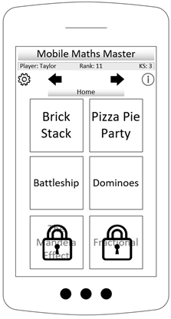
Figure 31: Wireframe Home page, original mobile design.
Wireframe 1 was deigned based on the mobile wireframe developed previously. Nav bar will include a link back to the home page. User score will state user’s details and their total score.
Game 1 will be Papi’s Pizza puzzle and will be developed for the testing purposed of this prototype. Other games will also be mathematics based such as battleship variation, dominoes variation, etc. In a final product, many games will exist, and the program will identify which games the user needs to spend more time studying, and there will be highlighted to the user.

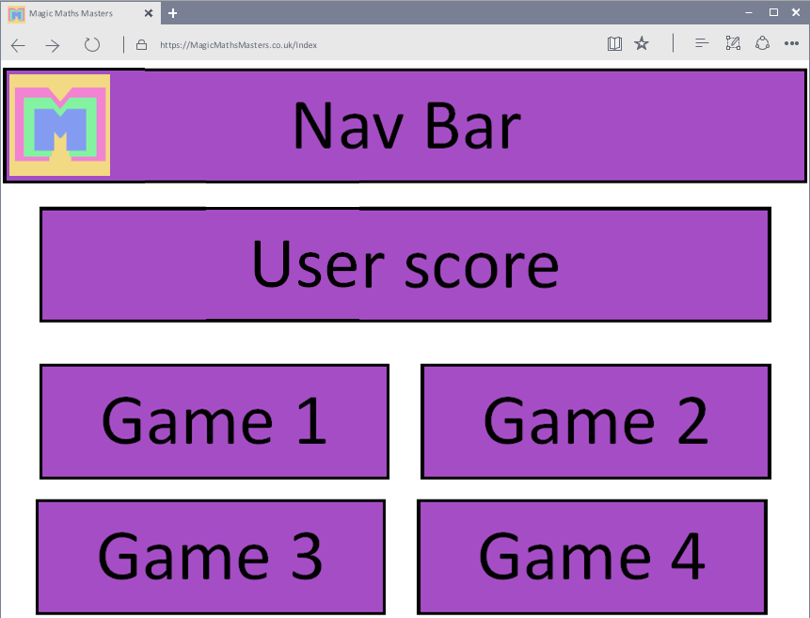
Wireframe 1: Home page, design.

Game section 1: Order Station
Order station is the first part of the game the player encounters after starting the game. Elements include: Papi (image), a welcome message detailing what the player should do, the order list the user will work towards, the pizza (image), and the toppings available to put on the pizza (images).
When considering Wireframes 2 and 3, both hold the same content. The topping bar is flexible and can be formatted differently, however, by formatting it to be tall and narrow made more space for a larger pizza, meaning larger toppings so users can see their successfully added toppings clearer; wireframe 3 was selected.
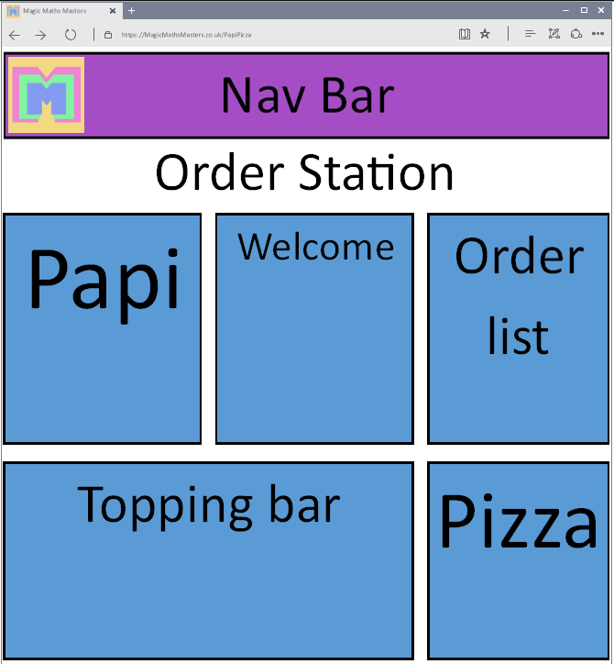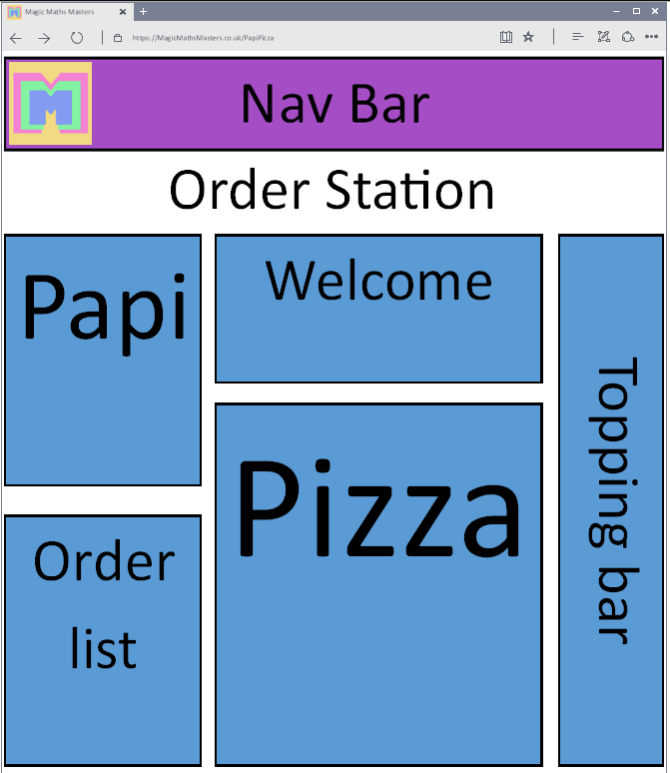
Wireframe 2: Order Station, design 1.
Wireframe 3: Order Station, design 2.

Game section 2: Kitchen
When the user clicks a topping, they will be taken to the kitchen; the kitchen includes: Papi again, an explanation from Papi about what the player should do, the fraction question (images), and the question-and-answer section (form).
Similarly, to the order station, image size was considered in this decision between wireframes 4 and 5. The fractions element contains the pizza pie images as a question; these images are clear to see even while smaller, so these images were selected to be in a narrower element. Wireframe 5 was selected.
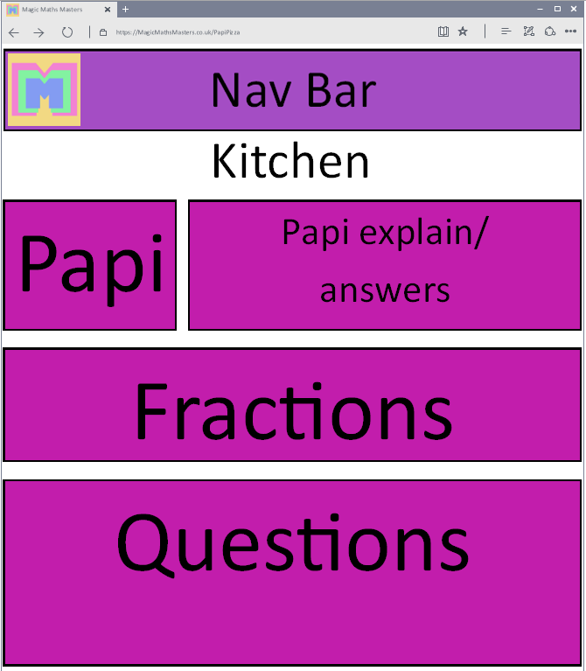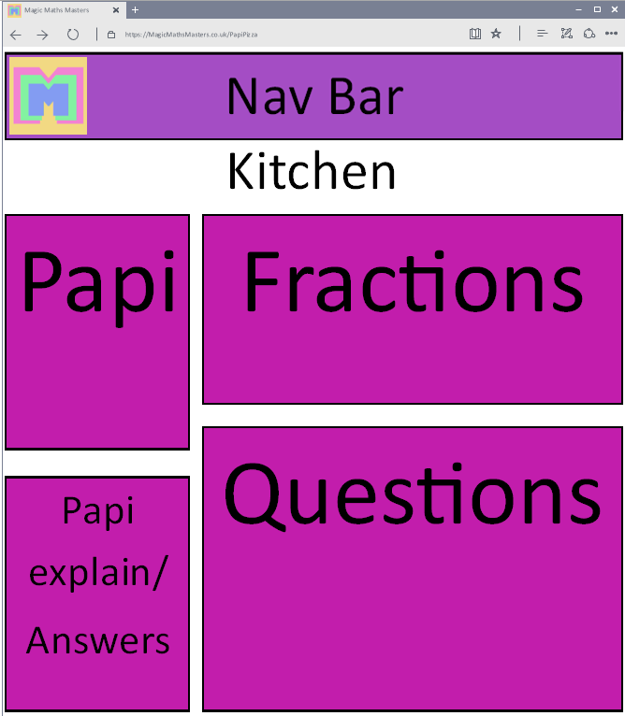
Wireframe 4: Kitchen, design 1.
Wireframe 5: Kitchen, design 2.

Game section 3: Results
After the player has completed the game, the player will see their results. The results page comprises of: Papi again, a congratulations for finishing the game with details on their gameplay results, order list, and the complete pizza. The toppings will not be visible here as they are not needed now the game is complete.
Two wireframes were created for the results page, however wireframe 6 differed to 7 as results and Papi conclusion are as one element. This is a reasonable design, however, based on the intended level of detail to be sent as results, these elements were separated, resulting in wireframe 7.
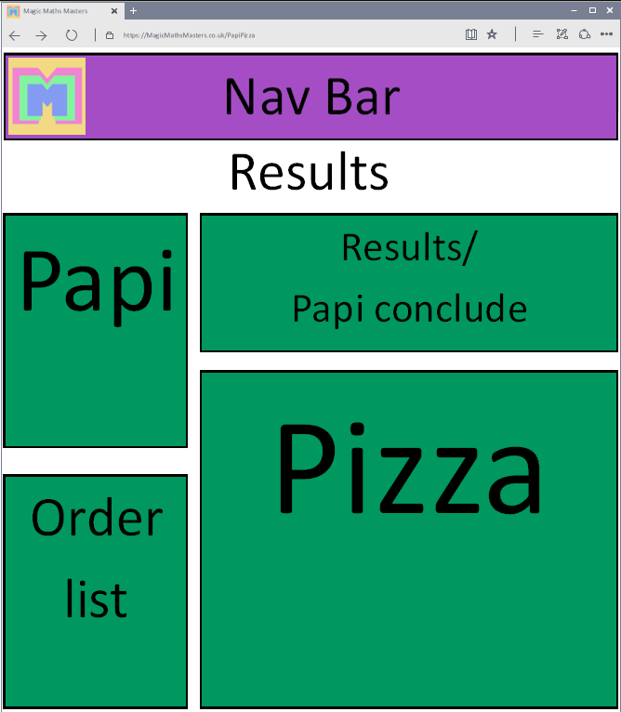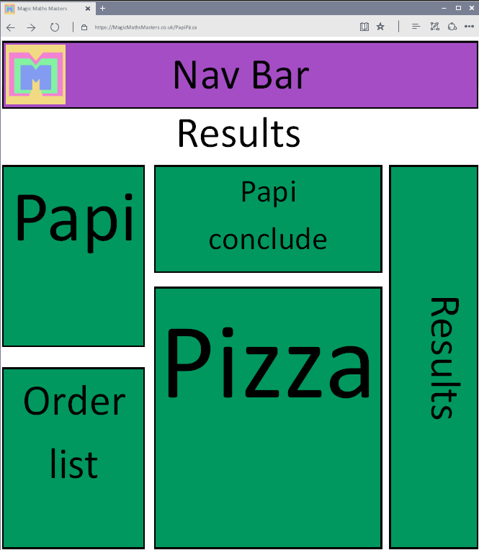
Wireframe 6: Results, design 1.
Wireframe 7: Results, design 2.

Story board
The prototype use is as follows:
1. Click game from home screen. | 2. In game, read the order, click a topping for pizza.
3. Answer the maths questions*, click submit.  *repeat screens 2-3 for four rounds. | 4. Show points, finished pizza, and results.
Table 7: Storyboard.

ERD
The following ERD shows how the games, users and scores will be saved. There are additional existing databased for the use of retrieving data for games.
The scores table will use FKs as the PKs from the games and users table, along with the date/time stamp of the game completion to create a composite key; the table will also track difficulty and scores achieved in all games by all users.
This relational table would then be used to get all from the scores table where Username matches the current player’s username. This can be used to retrieve high scores for individual games and create a rank of personal bests and calculate the sum of total points earned for the account.
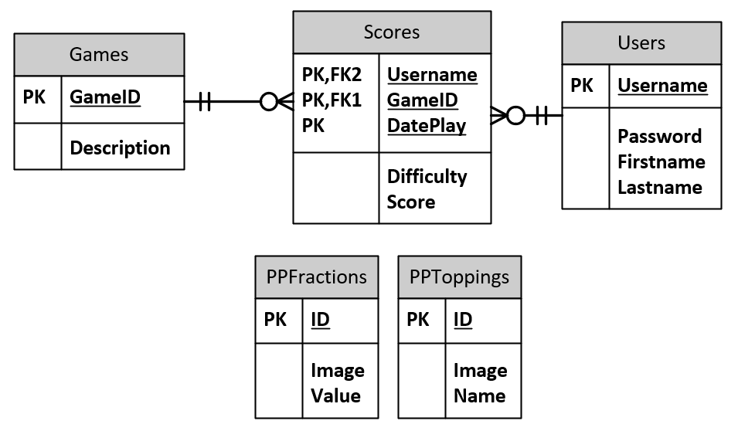
Figure 32: ERD.

Implementation
The program is modelled in an OOP fashion. This was selected to group related data into instances of objects and create a more organised structure to the system.
The following classes were created:
- Possible answers
- Answer choices*
- Fraction
- Array of fractions*
- Topping
- Array of toppings*
- Order details*
*These classes hold arrays of other classes for example, array of fractions holds fraction objects. These classes hold multiple arrays such as rawFractionID, holds randomly generated numbers used to get the fraction in an SQL statement, they also have an array for these returned results, and a formatted/sorted array ready for manipulation on the site.

Structure

Project structure
The project is structured with all the common files (such as coninfo) in the highest directory, accessible to other files. Below this, the image file and the Papi’ pizza files, with its relevant classes within, in their own directory.
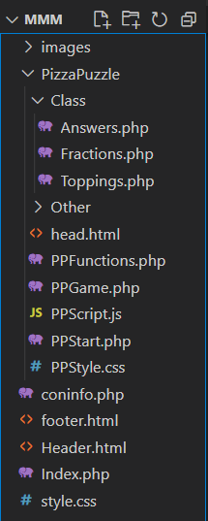
Figure 33: File structure for MMM site.

Database structure
The database structure mimics the ERD. For testing purposes, only the Topping and Fraction databases are functional.
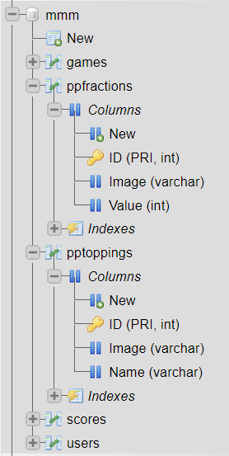
Figure 34: Database structure in PHPmyAdmin.

Code snippets

PHP objects to JS variables
The above code was found looking for solutions to send data between PHP server side, to JS client side. This solution was selected as it was the sleekest and simplest to understand whist also not needed to learn and use ajax or jQuery solutions. The method echoes variable from PHP directly into script tags so that they can be retrieved in the JS file.
While the developer is less certain about the security of this method, the author does not see this as a problem as if the target audience does have the knowledge to manipulate the data this way, they are likely to be too advanced for the purpose of the program.
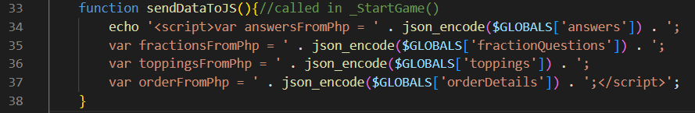
Code Snippet 1: PHP objects echoed to JS JSON encoded variables.

Coninfo
Coninfo files are used to create a connection between PHP files and PHPmyAdmin to connect and send SQL statements for data; this is included by the fractions and toppings classes and could also be used in other parts of the code such as accessing user data, getting high scores, or in other games.
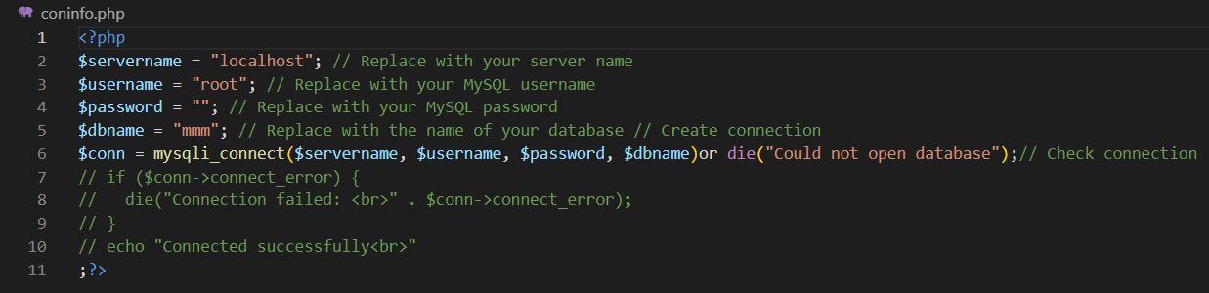
Code Snippet 2: Coninfo file.

Responsive media
By using ‘@media’ in the CSS file, it means when the window width is below the stated size, the elements within are adjust accordingly. This would give the screen a more integrated feel when using the site on other devices such as tablets and smart phones.
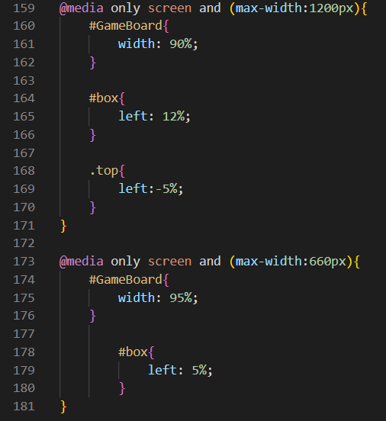
Code Snippet 3: Responsive media implementation in CSS.

Answer validation
The three-selected-radio function is used to check if the player has selected one radio button from each question by taking a tally of checked radio buttons from the array of element names, it returns true if 3 are found. This function is called as the condition for the while loop triggered by the ‘submit’ button; if the condition is false, the user gets an alert telling them to select 3 answers so they can proceed.
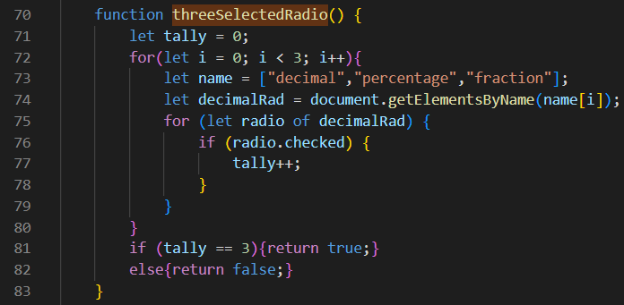
Code Snippet 7: Selecting answers validation function.
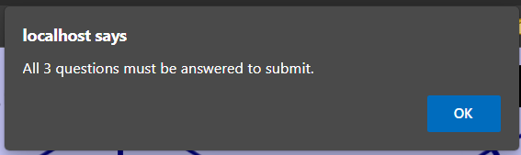
Figure 35: Alert that not all radio buttons have been selected from.

Possible answers.
The following set of functions are used to set the possible answers for questions in the rounds. This works by retrieving the fractions for the round, getting their values (set in the database), calculating the sum of these, and using this value to calculate the answer options.
It is also important to note, for example: the pizza pie for ½ has a set integer value of 500, rather than float of 0.5; this decision was made to eliminate inaccuracies when performing calculations on floats. This means we work with value 1000 = one whole.
Another noting factor is the value used to change the correct total value by when calculating the incorrect answer was decided to be kept rather simple, but in future development hopes to be more random. The constant value in this case ensure that all possible answers are greater than zero, and less than two.

Part 1
Part 1 takes the already calculated total of the fractions. This code also used brute force method to find the simplest form fraction for the value. The following pseudo code explains:
- Push value to raw answers.
- Calculate the denominator of the fraction:
  - Times the value by potential denominator = 2
  - If the answer is not divisible by 1000: Then increment potential denominator by 1.
  - If the answer is divisible by 1000: Then this is the lowest possible denominator.
  - If possible number is greater than 40: hit break point.
    - The program hits the break point if the denominator is not found by 40, as none of the possible answers to the combinations of fractions available use a denominator over 40 [Appendix E]. This break point was created as problems occurred during debugging. These problems were identified to be caused by inaccuracies when calculating with floats and is why the value is now an integer of 1000 equal to one whole.
- Push the numerator and denominator to raw answers.
- Repeat steps 1-3 with an incorrect value: calculated as value ± 100 [Appendix E].
Figure 36: pseudo code of set_rawAnswers.
This means the raw-answers array will hold data as follows:
Index | 0 | 1 | 2 | 3 | 4 | 5
Raw-answers | Correct value | Correct numerator | Correct denominator | Incorrect value | Incorrect numerator | Incorrect denominator
Example | 500 | 1 | 2 | 600 | 3 | 5
Table 8: Raw-answer array format and example.
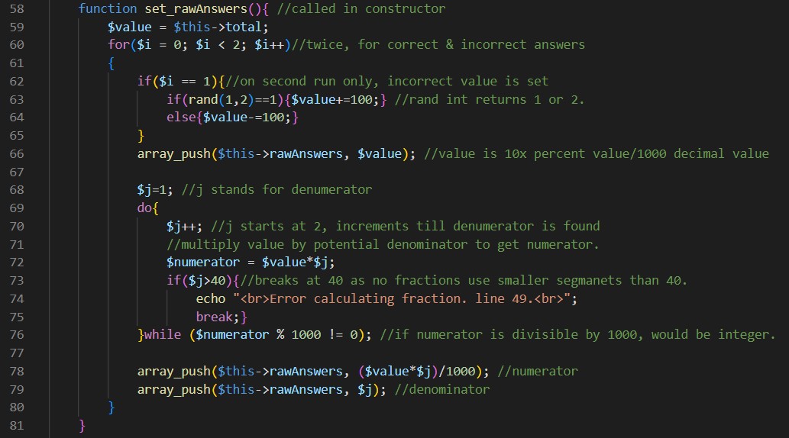
Code Snippet 4: Calculating possible answers, part 1 – getting raw values.

Part 2
Part 2 manipulates the raw-answers into an array of possible-answers. Possible answers hold an answer as a string, and the value as the same form previously mentioned. Function works as so:
- Retrieve the value (index 0 and 3)
- Push decimal as possible-answer = value/1000.
- Push percentage as possible-answer with answer = value/10 %.
- Calculate simplified version of fraction by calculating the difference between numerator and denominator:
  - If difference is 0: Then push possible-answer = 1.
  - If difference is positive: Then push mixed fraction possible-answer = 1 + (difference / denominator).
  - If difference is negative: Then push simplified fraction possible-answer = numerator / denominator.
- Repeat steps 1-4 for incorrect answers.
- Finally push possible-answers index 0-2 to the correct-answers array for purposes elsewhere.
Figure 37: pseudo code of set_answers.
This means the unsorted-answer array will hold data as follows:
index | 0 | 1 | 2 | 3 | 4 | 5
Unsorted-answers  (possible-answers) | Correct decimal | Correct percentage | Correct fraction | Incorrect decimal | Incorrect percentage | Incorrect fraction
Example answers | 0.5 | 50% | 1/2 | 0.6 | 60% | 3/5
Example values | 500 | 500 | 500 | 600 | 600 | 600
Table 9: Unsorted-answer array format and example.
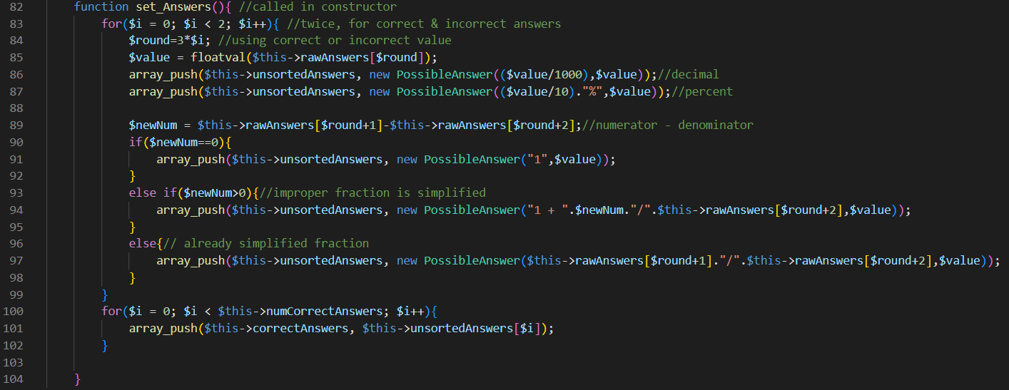
Code Snippet 5: Calculating possible answers, part 2 – formatting answers as Possible answers.

Part 3
Finally, in part 3 the data is ready, and the possible answers are mixed into the answers array. The above function randomly selects if answer 1 or 2 will be correct and pushes them to the answers array in the relevant order. The answers array will hold data as follows:
index | 0 | 1 | 2 | 3 | 4 | 5
answers  (possible-answers) | Decimal 1 | Decimal 2 | Percentage 1 | Percentage 2 | Fraction 1 | Fraction 2
Example answers | 0.5 | 0.6 | 60% | 50% | ½ | 3/5
Example values | 500 | 600 | 600 | 500 | 500 | 600
Table 10: answers array format and example.

Decimal 1 | Decimal 2
Percentage 1 | Percentage 2
Fraction 1 | Fraction 2
Table 11: answer array example layout in game.
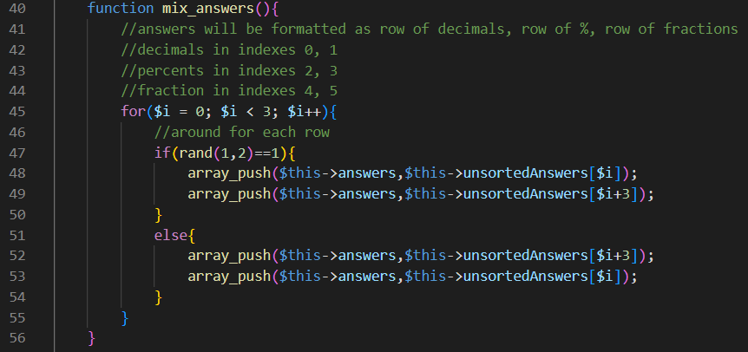
Code Snippet 6: Calculating possible answers, part 3 – organising answers into the required order for output.

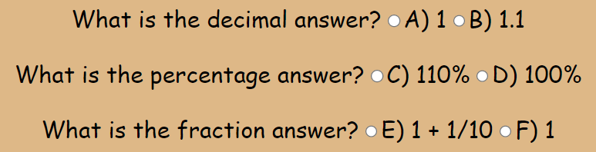
Figure 38: Final format of answers in a round of Papi’s Pizza Puzzle.

Results and Analysis

Results
This section will cover three rounds of primary research surveys conducted:
- Initial research – Teacher’s views on the use of web resources for learning
- Initial development feedback – University student’s views on the initial prototype.
- Final development feedback - University student’s views on the final prototype.

Teacher’s survey
The MS Form ‘The use of web resources for learning’ gathered information on the teachers/lecturers, and their use of and thoughts of web resources for learning, gathering over 40 responses.
This form was open to teachers and lecturers of different aged students, but the responses were mostly populated by primary school teachers teaching cross curriculum, with other responses mostly from computing and maths teachers/lecturers.

74% of participants said they have used an electronic game as a method of teaching, popular sites used include:
- Times Tables Rock Stars
- Topmarks – Daily 10
- Kahoot!
- Purple Mash
- Hit the Button
- ICT Games
- Scratch
- MathsFrame

84% of teachers agreed that their games asked questions as part of gameplay. Further supporting this idea, a participant says:
“The problem, in my opinion is that very often the game makers claim the game is educational when in fact the educational element is very small”. – anonymous teacher 6.
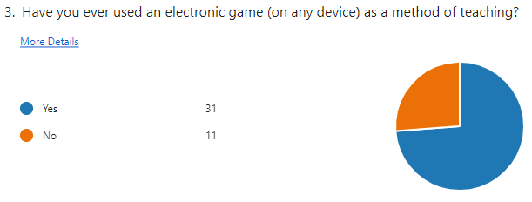
Figure 39: 74% of participating teachers have used electronic games.
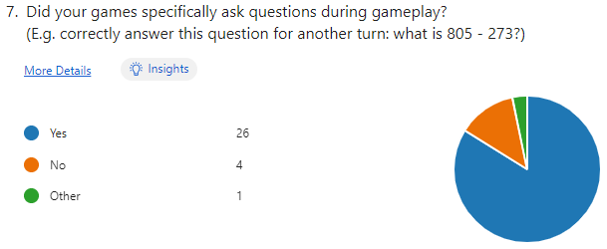
Figure 40: 84% of participating teachers prefer question-based electronic games.

When teachers were asked about their use of these games, their responses were that all used electronic games as supervised classwork, or in combination with homework.
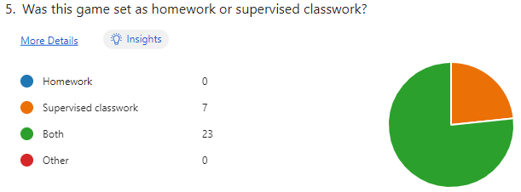
Figure 41: 77% of participating teachers set electronic games as both homework and classwork.

When teachers were asked about their uses of these games, many said that they were not introduced solely for teaching during COVID-19 restrictions and were used before this. Many teachers said that they were used in the classroom too as they were not limited to online study. However, some said that Kahoot and Purple Mash was introduced in some classrooms to aid with COVID distance study. Other teachers added that these online resources aided their student’s studying as they were able to access these resources more frequently and easily at their leisure.

The MS Form asked a range of Likert questions to gage teacher’s options. The results of these as follows from most to least agreeable. The majority agree:
- 92.9% agree to some degree that they believe educational games can be beneficial to the development of lasting skills.
- 92.8% agree to some degree that they like games that have incremental difficulty.
- 90.5% agree to some degree that they like games where you can track your skill progress.
- 90.4% agree to some degree that they believe creating motivation to play the game will promote interest in the required skills/subject.
- 88.1% agree to some degree that they would encourage children to play educational games as a form of revision.
- 83.3% agree to some degree that they believe classic board games are still relevant to primary school children in 2023.
- 78.6% agree to some degree that they believe setting children educational games as revision will get dedicated conscious efforts into getting a high score.
- 76.2% agree to some degree that they believe that children under the age of 12 would be interested in answering questions to gain rewards or advantages in game play.
- 73.8% agree to some degree that they like games to be visibly educational.
- 71.4% agree to some degree that they believe mystery prizes are a good reward due to their enigmatic value.
- 69.1% agree to some degree that they like games that have an obvious end point.
- 64.3% agree to some degree that they believe that games have to be active/animated to keep children’s attention.
The following had more of a split opinion and results were split between agree, disagree, and neither agree nor disagree:
- 40.5% agree to some degree that they believe that a band ranking system for percentiles is more motivational to children than ranking positions.
- 38.1% disagree to some degree that they believe that games have to be bright/flashy to gain children’s attention.
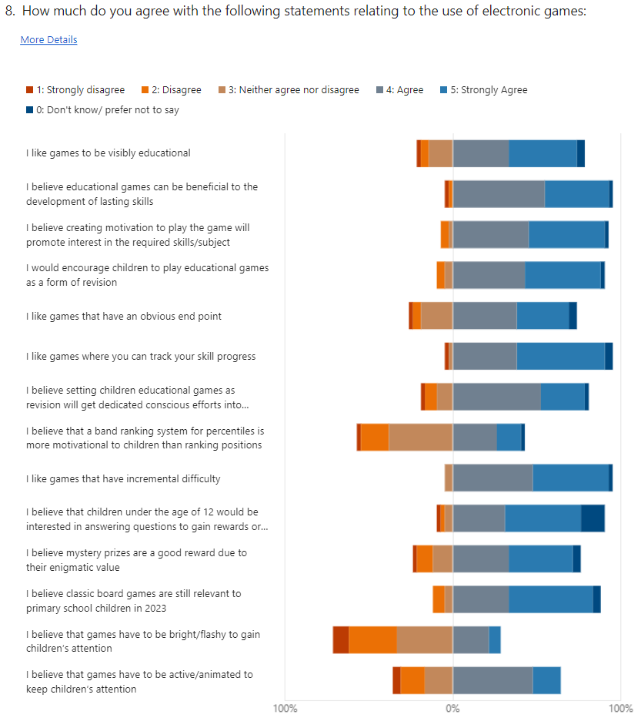
Figure 42: Likert responses of teacher’s views of electronic games.

The results show that most teachers would recommend educational games, while others are unsure. It is valuable to note that no-one would not recommend electronic games.
Those who said maybe seem to suggest it dependant on the game in question. One teacher stated:
“I would make my own judgement on the educational value of the game before recommending it to other” – anonymous teacher 12.
While some educational games may beneficial, some teachers have commented that it’s important not to rely too heavily on game-based learning:
“Educational games are often overused and don’t replace good teaching. They should be part of a well-balanced curriculum using a range of methods” – anonymous teacher 37.
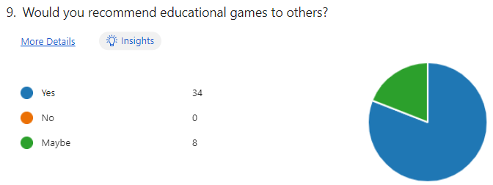
Figure 43: 81% of participating teachers would recommend electronic games.
When asking participants why they would/would not recommend electronic games, most commented on them being:
- Interactivity is enjoyable and motivational.
- Long lasting skill and knowledge acquisition. Often students learn without realising it.
- Creates interest in the subject.
- Tracks progress.
- It’s a good revision tool.
- Creating competition creates motivation.
- It offers different learning styles.
- It’s a good assessment tool.
- Creates a sense of achievement.

Participants were asked to select all of their preferred format for educational games; the results were split, but over half of results were for web browser games, likely due to its accessible nature.
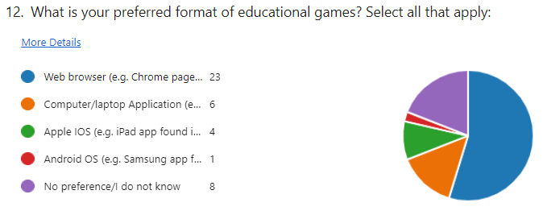
Figure 44: 54% of participating teachers like web-based games.

Finally, participants were asked to recommend other learning tools or teaching styles they like. Many responses included video or audio learning such as songs and rhyming or YouTube videos.

Unit and System Testing
Unit testing was used during the development process to test new features in the FDD iterations, once complete, system testing was focused on.
Testing occurred in multiple web browsers (MS Edge, Google Chrome, Mozilla FireFox), all browsers worked equally well, however a few differences were noted:
- MS Edge sometimes had difficulties understanding the placeholder of a textarea. The placeholder is intended to hold text in the box, when typed in this text disappears. This worked as intended in Chrome and FireFox, however did not disappear in Edge.
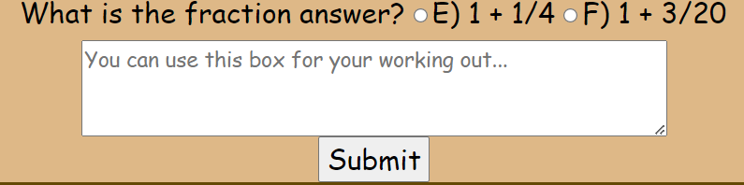
Figure 45: The textarea with its placeholder text in Chrome.
- Firefox had difficulties with linespacing and showed some text differently than Edge and Chrome.
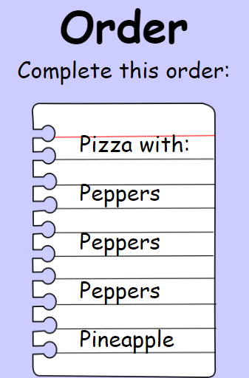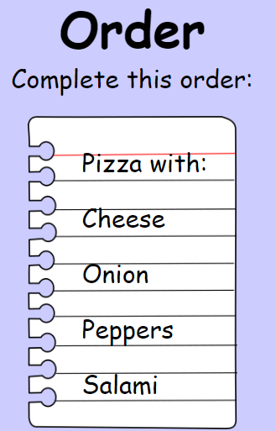
Figure 46: Edge line spacing.
Figure 47: Chrome line spacing.
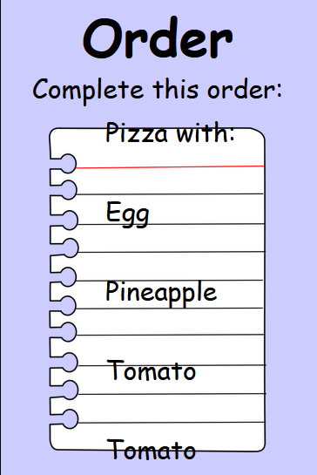
Figure 48: FireFox line spacing.
Due to these observed differences in browsers, the developer made sure that all testers used Chrome to ensure consistency between testers.
The developer also observed difficulties during the testing phase due to web browsers making a local copy of the CSS and JS files and these were not frequently updated. The developer found by using Ctrl + F5 would reload the page and the cache, resolving this issue.
Overall, unit and system testing ran smoothly and was ready for usability testing swiftly.

Usability Testing
The participants of the usability testing were students of UWTSD. While this means the responses are less relevant than testing on the actual target audience, this decision was made due to lack of new DBS check, timeframe, and ease of finding testers. Testers were given a summary of the purpose of the program and notified of the target audience.
Where possible, different groups of students were found to participate in testing including tech savvy students, not-tech savvy students, full-time students, apprentices/part-time students, 18-year-old students, mature students, mature students with kids, students with young siblings, neurodivergent students (such as with learning disabilities such as dyslexia, dyscalculia, etc.), etc.

Alpha Testing
The first round of testing was observation based and also gathered information from an informal Q&A; the questions consisted of a rate on a scale from 1-5, and an open response why they felt that way. Testing asked about the functionality, looks, use of design, difficulty, appeal to target audience, and how fun the tester thinks it is.

The results of these as follows shows the average Likert’s score, and the majority viewpoint:
- 3.8 - 70% agree to some degree that they liked the game.
- 4.1 - 70% agree to some degree that they like the design.
- 4.4 - 80% agree to some degree that they think the functionality is good.
- 3.0 - 60% neither agreed nor disagreed that the questions are clear.
- 3.5 - 50% agree to some degree that they think the difficulty is fair.
- 4.4 - 90% agree to some degree that they believed the material is good for revision.
- 3.8 - 80% agree to some degree that they believed the game was enjoyable.
- 4.3 - 80% agree to some degree that the game would appeal to the target audience.
- 3.9 - 80% agree to some degree that if they were in primary school, that they would be motivated to play the game.
While these numbers seem fairly middle of the road, the results for each question often ranged from 1 to 5, meaning divided opinions (these Means, Maxima and Minima are illustrated in the graph below).

Figure 49: Min, max, and average of Likert responses for Alpha Testing.

It was beneficial to identify the areas of weakness from this to aim development for the beta version of the protype. These areas in need are then developed using the open feedback part of the testing, this feedback mainly targeted:
- The layout of the design – Reorganising the game to fit 1 screen, increase font size, change font, make images smaller.
- Simplify terminology for kids.
- Clarifying how the game works with more instructions
- Create a story out of the game.
- Creating more difficulty options.
- Offer more feedback – a tick/cross when answers are marked and show correct answers.
- Ungroup the marking of questions (questions are currently marked in groups of 3)
The testing process produced vast opinions and ideas on how to improve the prototype, but very little in terms of identifying bugs. The developer thought this may happen as much testing of the functions occurred during the development stage.

Beta Testing
With development since alpha testing, the game has improved in layout, sizing, fonts, story, difficulty increments, question layout, and awards.
The MS Form ‘Beta MMM Feedback’ gathered from mostly students, and their feedback of the final development of the protype, gathering 28 responses. *
The result of these Likert’s as follows are of the majority viewpoint:
- 78.6% agree to some degree that they enjoyed the game.
- 85.7% agree to some degree that they liked the design and layout.
- 85.8% agree to some degree that they believe the usability is good.
- 89.2% agree to some degree that the questions are understandable.
- 75% agree to some degree that they believe the difficulty is appropriate for the target audience.
- 78.6% agree to some degree that they believe the game is a good revision material.
- 71.4% agree to some degree that they believe the game is appealing to the target audience.
- 64.3% agree to some degree that if they were in primary school, they would be motivated to play the game more.
*It should be noted that of the 28 participants, 3 selected ‘Strongly Disagree’ for 6 or 7 out of the 8 Likert’s while no other participants strongly disagreed with any statements; while there is no way to be sure that this 10.7% of participants were candid in their views, these outlying responses have impacted the results and remain as part of the data. These 3 participants also left some positive feedback in the open questions amongst some incomplete answers and results like “no feedback” and “NA” for possible improvements, further suggesting that their responses are unreliable and likely to be anomalies.
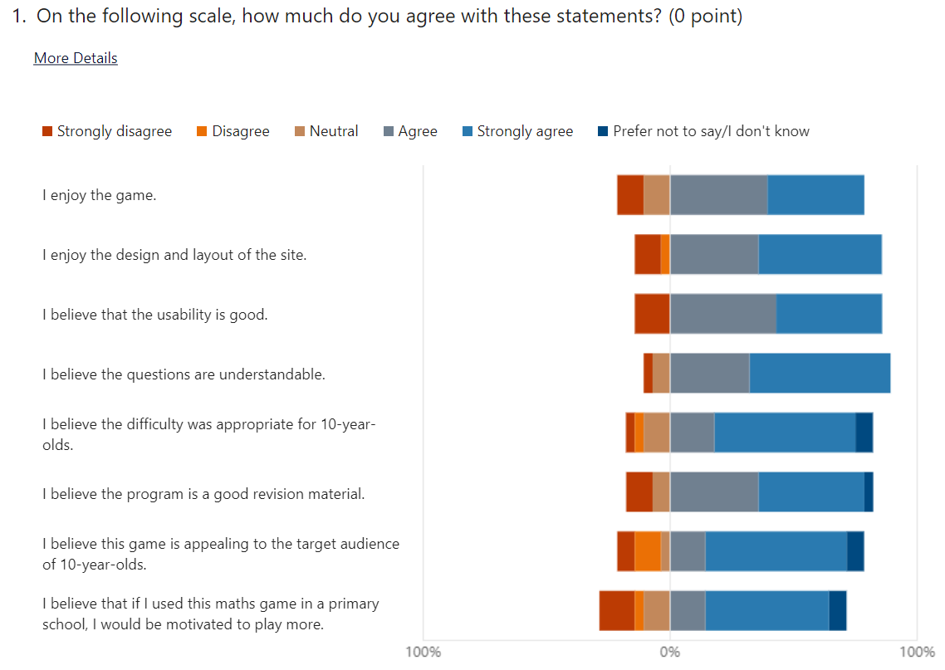
Figure 50: Likert responses of beta testing, including anomalies.
Participants liked the game and offered praise on:
- the interface.
- detailed results section.
- accessibility for all (font family and size.)
- appealing to the target audience.
- varying difficulty.
- use of images.
- colour scheme.
- puzzle element.
- Uses lots of maths skills.
- Offers real life examples.
- Most testers commented that pizza was a good motivational tool as everyone likes pizza regardless of age, gender, or background.
- Good revision material. Some testers also commented on how they felt their maths skill improving just from testing the prototype; this is great feedback to support the hypothesis.
They also offered recommendations for improvements including:
- more animations to interest kids.
- different question types for variation and keeping interest.
- not enough highlight to the order element to the game - was often missed by the testers.
- a timer to make the game more competitive.
- sounds to feel more interactive.
- add a progress bar so the players know how much they have left.
- deliver the pizza by animating it moving off the screen.
- add a score board for competition.
- offer a DIY pizza mode with no order.
- let the user drag the fractions into the same pizza to visualise the solution and add more interactivity.
- add more answer options to reduce the chance of guessing the answer correctly.
- add information on how to get points so the player can have these tips on how to get a high score.
- have more detailed backgrounds such as a kitchen to immerse the player more.

Testers commented on the difficulty increments being inclusive to all abilities, with a simple easy mode, up to a difficult hard mode; it was said that the hard mode:
“wasn't too hard but still challenging. Therefore it still made you think, so appropriate for the target audience.” – anonymous tester 15.
Another comment talked about how it was possible to get easy questions on normal mode, and easy and normal difficulty questions on hard mode.

When considering the appeal to the target audience, the testers commented that they liked the character of Papi, and the use of pizza, but also offered ideas to make it more appealing. Some said that Papi could offer more prompts to aid the player through the game and adding sound effects.
Testers found the game motivational as they competed to beat their high score and earn a medal, the end goal of completing the pizza order is fun, and achieving the medal is motivational to get a gold. On the other hand, some testers found the lack of competition boring and lost interest.

The testers who participated in both alpha and beta tested commented on how the improvements made the game more fun, offered more difficulty options, and more detailed results with awards made a more motivational environment making them want to play more.

Overall, the concept is great, the implementation is a good for a gamified maths quiz, it uses lots of maths skills, and has some motivational aspects. To make it more motivational, it would require more animation, sounds, interactivity, competition aspect, and more variation in gameplay.

Usability Testing Observations

Overall observations
The developer also observed that all testers chose to play the game as a full screen window and non-chose to make the window smaller; the final protype was then optimised for full screen use.
Another observation was that most users did not read the rules/how to play before starting, but those who did understood the game much better and quicker. The developer found generally, women spent more time understanding and playing the game more accurately than men, and most women read the rules, compared to only 1 man reading the rules.
Most importantly, the developer also witnessed users making progress with their maths skills as they played more of the game. While this still needs more investigation, seeing this progress supports the hypothesis.
More detailed comments on testing observations in Appendix F.

Analysis
In terms of unit and system testing, the developer found bugs and resolved them during the development. The only major bug found was when the value was calculated as floats, due to the inaccuracy of 0.1 as a float because they are represented as a binary decimal. The difference is very minor (approximately $3.8 ×{10}^{-7}$), but enough to cause errors within the program, therefore the values were changed to hold 1000 as 1 whole to eliminate this error.
binary | decimal | difference
0.0001100110011001101 | 0.1000003814697265625 | 0.0000003814697265625
Table 12: float 0.1 as binary and decimal.

Teachers wants in electronic games for their students.
The majority of the collected list of games that teachers set their students are question-based learning platforms, such as Kahoot. From this information, it is reasonable to deduce that many teachers prefer question-based learning games.
We can infer from the results that teachers all set electronic games for supervised classwork that students may not be motivated to do the work at home, and therefore teacher may select to do this work as supervised classwork so they can observe and support their students. Teacher may also recommend their students to continue to play educational games for homework at their own leisure.
When investigating the possibility for band ranking system, the results were mixed. This split suggests that some prefer a ranking system, some prefer not to and to focus more on self-improvement, and others may see the value in both.
It was also found that bright and flashy elements are not necessarily important for the target audience.
Finally, teacher’s preference between what format the games were in was not strong, but most preferred web-based solutions so that they are accessible to more students.

Usability testing analysis
It was gathered that some individuals that did not like maths, are not good at maths, and some of those who don’t appreciate gamification of a quiz over a typical game didn’t like the game. This is a common occurrence, and this is why this investigation works to find how to motivate a student to play maths.
Difficulty was reasonable, but easier questions still appeared in harder modes, this is due to how the program was developed and could use more complex algorithms to resolve this.
The program has some motivation to it in the design and choice of pizza, but the game is still lacking in motivation, and can possibly find this by incorporating a timer or competition with a leader board.
Generally, form the testers, women spent more time understanding and enjoying the program. While more investigation needs to take place on why this was the case, it was elating to see these females so involved in a mathematics game as the writer wishes the implementation to ensure inclusivity to females. The developer’s only loose theory to why this is, is perhaps due to it being developed by a female and so our alike brains are wired more similarly than to males.
All of the given feedback is achievable with enough time and skill to improve the prototype.

Conclusions and Recommendations
The results from the secondary research showed that while some excel in maths and many go onto do it a A-level, many drop out after AS, and many struggle even more. While the Prime Minister advocates for maths to be studies until the age of 18, this is not yet a realistic option due to lack of maths teachers in the country. More focus could be out into primary school maths in order to give children a better chance to grow their maths skills through secondary school.
Maths is a difficult subject and there are factors that make it harder for some people such as dyscalculia and maths anxiety - While dyscalculia affects the way the brain works, maths anxiety affects individuals differently, both can be helped with strengthening basic maths skills. Focusing more on maths at a young age can help build a solid foundation ready to cumulate more skills on top. The KS-2 maths curriculum has recently gone through some updates narrowing the range of maths skills to strengthen them before evolving them.
The traditional learning style of read-write doesn’t suit everyone, but there are lots of other options out there such as visual, auditory, and kinaesthetic, and other learning tools like role play, singing/rhyming, and games; many of these options are more interactive and more appealing to primary school children. Options such as e-learning are available online for students to study more from home, becoming a value tool during the COVID-19 pandemic.
Additionally, children have shorter attention spans than adults, therefore learning can be more effective in smaller sessions with breaks in between; this can also reduce human error and silly mistakes by taking breaks and learning in a supporting environment.
Revision using past papers are not effective enough, it is hard to measure progress and track ability through past papers due to varying content and grade boundaries, not to mention their paper impact – it is important to go paperless where possible to reduce the impact on the environment.

Primary research found that many teachers agreed that educational games can be a good tool to create long lasting skills, they can create motivation and interest in a subject, as well as offer incremental difficulty and track a student’s progress.
It was discovered that teachers prefer educational games with a significant educational element such as a quiz rather than a game with subliminal skills; adding they would recommend the right educational games and would test the game firs to see if they thought it educational enough to recommend. Teachers use these tools mostly as revision at the end of a class where they can observe and support their students through practicing their new skills.
Teachers also commented that a balanced curriculum is necessary to a student’s education and should include learning from many different styles including VARK styles, role play, singing/rhyming, YouTube, and educational games and sites.
Teachers believe that a game does not necessarily have to be bright and flashy in order to motivate them and keep their attention through a game.
Most of the testers preferred electronic games to be web based for accessibility to all, but don’t mind of they also come in application form.

When testing the prototype version, many testers strongly agreed that the pizza concept for an educational game is a good motivational topic, and as a primary school child they would have been motivated to play a game such as the developed prototype.
Testers had appreciation for the puzzle element to the game, incremental difficulty, the detailed results page, and award medals based on accumulated points.
Additionally, the visual depiction of pizza fractions as real-life examples was a hit, and the maths skill content was noted to be present and effective. Some testers commented that they felt their maths skill improving from testing the prototype.
Some testers highlighted weaknesses in the prototype as not motivational enough. Some of their feedback noted including sounds and animation and create more interactivity. While it is difficult to motivate children to learn, it can be harder to motivate children to do maths – more investigation is needed on the best ways to motivate children to learn.

Both teachers and students were fairly split on their views on if games should be competitive between other players or not. Some are not motivated without this competition, while some find more value in improving on one’s own skills – more investigation is needed on if competition is essential to make a game motivating to play.

The prototype showed to have some degree success on university students in improving player’s maths skills and could be a successful program if taken further.
It would also be a supported by teachers as the game content holds lots of maths skills in the prototype game which was found to be liked by teachers, and any additional games would keep this same trend.
The site would require additional games as variations on traditional games such as battleship, dominoes, Yatsee, Nerdle, etc – these games would be unlocked after a set many of points were accumulated form playing the previous game.
The site would be evolved to better track scores and use this information to identify where the user needs more practice and highlight a relevant game to the user.
The developer would also like the site to hold achievements, such as if the player earns 1000 points in a game, that they earn an item for their collection such as Papi or the pizza box. This would motivate users strive to earn all these achievements.
Finally, for this prototype to progress to a releasable version, it would require a login for users to begin and to save their progress affectively. This isn’t exactly necessary, but the full extent of the program would not be made use of without individual user accounts.

Overall, more investigation is needed to determine if there is a correlation between academic progress and enjoyment of an educational game for revision.
Some evidence was found that a motivational educational game is a good tool to revise skills and improve abilities. Generally, teachers and university students strongly agree that with a motivational game with heavy educational skill, the student will acquire long lasting skills.
The difficult is that enjoyment factor of something varies from person to person and therefore it is not possible to determine how motivational or enjoyable something may be as the individual will find satisfaction from different things. More investigation is needed on the best ways to motivate children to learn, and if creating competition is beneficial or detrimental to learning.
To investigate this hypothesis further, the writer would require a DBS check so that the test can be conducted on the target audience to investigate what children find motivational and fun and monitor their enjoyment and use of the prototype against their ability, to identify any patterns or correlations.

Reflection
During this investigation, the author learned a lot about the uptake and dropout rate of A-level maths between genders and found the ratio of men to women surprisingly unbalanced.
Also learned was how much paper can be used in schools, construction of recycled paper is only partly better on the environment, and that global warming is causing temperatures to surpass the optimum temperature for photosynthesis meaning even less CO₂ is being removed from the atmosphere over 40°C.
The writer found out about many different teaching and learning styles and how effective they can be when used in combination, and how valuable to a curriculum they can be when they are used in balance.
It was also discovered how difficult it is to make a game fun and motivational to different individuals and how it is not possible to satisfy everyone, this has made proving the hypothesis more subjective.
The use of a web-based solution was the best option to begin the prototype, and this could eventually be released in other formats too, but web-based is the most accessible to begin with.
The developer found a good idea for a motivational maths game with many different maths skills involved. By combining the visual fractions with pizza and maths skills, the prototype shows potential for a fun and educational game, but some work is needed. The prototype is likely to satisfy the needs of teachers when selecting an educational game for their students but is lacking some motivational aspect at this time amongst incomplete additional games and login functionality.
The testing approach was not bad, it found lots of valuable information as well as highlighting less important features and was helpful in the development stages. Some of the questions could have been more specific such as asking what the testers thought the most beneficial, motivational, and healthy way to create competition in the game could be.
The developer made mistakes in the testing section and should have done the following differently: create the same official form for both rounds of testing and ask the testers to test both versions of the prototype in order to better compare the outcomes of both and see a more concreate comparison of a maths quiz vs a better gamified version.
The developer also wished they had completed a DBS check in order to seek feedback directly from the target audience regarding their opinions and skill level to make a better prototype for the target audience.
The developer faced difficulties using Visual Studio Code to make this prototype and may have possible found the process easier in programs such as Adobe Dreamweaver due to its live site view, however this program requires a subscription that the developer did not have. There may have been a possibility to get access to this through UWTSD, but this avenue was not discovered until the end of the development process.
The developer believes that feature driven design worked well as a “team of one” being able to concentrate on one feature at a time and then repeat the cycle for further features. It was found to be highly appropriate to the chosen application.
Finally, the writer feels the scope of this project may have become too broad meaning work may have lost sight of the hypothesis at times leading to possibly less relevant results. Overall, there are indications that the hypothesis could be true, but more investigation is needed to fully prove it.

Bibliography

[1] | T. Hodges, “Change Makers Assignment 2,” UWTSD, Swansea, 2022.
[2] | V. Romei, “Lack of women ‘Stem’ students has led to gender ‘digital divide,” FT.Com, London, 2018.
[3] | T. J. D. L. G. M. B. K. M. D. D. N. Beede, “Women in STEM: A Gender Gap to Innovation,” Sexuality & Gender Studies eJournal, 2011.
[4] | Success at School, “What are A-levels?,” Success at School, [Online]. Available: https://successatschool.org/advicedetails/546/what-are-a-levels. [Accessed 10 August 2022].
[5] | R. Ratcliffe, “A-level maths overtakes English as most popular subject,” 14 August 2014. [Online]. Available: https://www.theguardian.com/education/2014/aug/14/a-level-maths-overtakes-english. [Accessed 9 August 2022].
[6] | GOV.UK, “Provisional Entries for GCSE, AS and A level: Summer 2020 exam series,” GOV.UK, 11 June 2022. [Online]. Available: https://www.gov.uk/government/statistics/provisional-entries-for-gcse-as-and-a-level-summer-2020-exam-series/provisional-entries-for-gcse-as-and-a-level-summer-2020-exam-series. [Accessed 9 August 2022].
[7] | N. Taylor, “These are the 11 most popular A-level subjects in 2019,” The Student Room, 15 August 2019. [Online]. Available: https://www.thestudentroom.co.uk/news/these-are-the-11-most-popular-a-level-subjects-in-2019#:~:text=%20These%20are%20the%2011%20most%20popular%20A-level,at%20A-level%2C%20with%20the%20numbers%20of...%20More%20. [Accessed 9 August 2022].
[8] | Think Student, “The 10 Most Popular A-Level Subjects – Ranked for 2022,” Think Student, 2 February 2021. [Online]. Available: https://thinkstudent.co.uk/most-popular-a-level-subjects/. [Accessed 9 August 2022].
[9] | T. Sutch, “Uptake of GCE AS level subjects 2007–2013,” Cambridge Assessment, June 2014. [Online]. Available: https://www.cambridgeassessment.org.uk/Images/173577-uptake-of-gce-as-level-subjects-2007-2013.pdf. [Accessed 9 August 2022].
[10] | J. W. T. Gill, “Uptake of GCE A level subjects 2015,” Cambridge Assessment, June 2016. [Online]. Available: https://www.cambridgeassessment.org.uk/Images/323211-uptake-of-gce-a-level-subjects-2015.pdf. [Accessed 9 August 2022].
[11] | T. Gill, “Uptake of GCE A level subjects 2017,” Cambridge Assessment, December 2018. [Online]. Available: https://www.cambridgeassessment.org.uk/Images/518880-uptake-of-gce-a-level-subjects-2017.pdf. [Accessed 9 August 2022].
[12] | V. Silva, “4 Main Reasons Why There Is a Lack of Women in STEM,” Built By Me ® – STEM Learning, 29 April 2019. [Online]. Available: https://www.builtbyme.com/lack-of-women-in-stem-reasons/. [Accessed 9 August 2022].
[13] | e. a. L. Guiso, “Culture, gender, and math.,” Science , vol. 320, no. 5880, pp. 1164-1165, 2008.
[14] | World Population Review, “Gender Equality by Country 2023,” World Population Review, 2023. [Online]. Available: https://worldpopulationreview.com/country-rankings/gender-equality-by-country. [Accessed 12 December 2022].
[15] | L. Sarant, “THE GENDER DIVIDE: AGENTS OF CHANGE,” Nature, vol. 549, pp. 70-74, 2017.
[16] | S. C. A. M. a. A. N. M. A. Master, “Programming experience promotes higher STEM motivation among first-grade girls,” Journal of experimental child psychology, vol. 160, pp. 92-106, 2017.
[17] | Anonymous, “RUNNING HEAD: LACK OF WOMEN IN STEM: COMPETENCE OR CONFIDENCE UNIVERSITY OF EDINBURGH Lack of Women in STEM: Competence or Confidence? An Examination into Gender Differences in Ability and Attitudes at Primary School Level.,” 2017.
[18] | UWTSD, “Undergraduate Bursaries,” UWTSD, 2022. [Online]. Available: https://www.uwtsd.ac.uk/bursaries/undergraduate/. [Accessed 17 October 2022].
[19] | V. REICH-SHACKELFORD, “Depictions of Women in STEM: Amy Farrah Fowler,” Simon Fraser University, 25 May 2017. [Online]. Available: https://www.sfu.ca/wwest/WWEST_blog/depictions-of-women-in-stem--amy-farrah-fowler.html. [Accessed 7 November 2022].
[20] | L. B. a. L. Sara, “Women don't ask: Negotiation and the gender divide,” Princeton University Press, 2003.
[21] | G. Vina, “English adults struggle with basic maths,” FT.Com, London, 2016.
[22] | J. B. Herts, “Adult Math Anxiety: Relation to Math Performance and Adult/Child Math Interactions,” Chicago , 2020.
[23] | D. S. a. D. M. Iver, “Developmental change in children's assessment of intellectual competence,” Child development, pp. 521-538, 1989.
[24] | P. G. S. M. W. A. J. L. Cooper, “Who Benefits from Diagrams and Illustrations in Math Problems? Ability and Attitudes Matter,” Applied Cognitive Psychology, vol. 32, no. 1, pp. 24-38, 2017.
[25] | C. A. T. C. F. a. J. M. T. P. G. Sidney, “Children’s and Adults’ Math Attitudes Are Differentiated by Number Type,” The Journal of experimental education, vol. 89, no. 1, pp. 1-32, 2021.
[26] | B. R. F. M. M. Jameson, “Math Anxiety, Math Self-Concept, and Math Self-Efficacy in Adult Learners Compared to Traditional Undergraduate Students,” Adult Education Quarterly, vol. 64, no. 4, pp. 306-322, 2014.
[27] | S. L. B. E. A. Maloney, “Math anxiety: who has it, why it develops, and how to,” Trends in Cognitive Sciences, vol. 16, no. 8, pp. 404-406, 2012.
[28] | D. Frye, “What Is Dyscalculia? Math Learning Disability Overview,” ADDitude, 20 Jan 2023. [Online]. Available: https://www.additudemag.com/what-is-dyscalculia-overview-and-symptom-breakdown/. [Accessed 30 March 2023].
[29] | The Dyslexia Association, “The signs of Dyscalculia - The Dyslexia Association - The Dyslexia Association,” Dyslexia.uk.net, 22 August 2017. [Online]. Available: https://www.dyslexia.uk.net/specific-learning-difficulties/dyscalculia/the-signs-of-dyscalculia/. [Accessed 30 March 2023].
[30] | The British Dyslexia Association, “Dyscalculia,” The British Dyslexia Association, 2021. [Online]. Available: https://www.bdadyslexia.org.uk/dyscalculia#:~:text=What%20is%20Dyscalculia%3F,across%20all%20ages%20and%20abilities.. [Accessed 17 October 2022].
[31] | S. V. D. L. B. Butterworth, “Dyscalculia: from brain to education,” Science, vol. 332, no. 6033, pp. 1049-1053, 2011.
[32] | Dictionary.com, “Definition of subitize,” Dictionary.com, [Online]. Available: www.dictionary.com. [Accessed 30 March 2023].
[33] | Anonymous Teachers TV/UK Department of Education, “About "Dyscalculia",” Anonymous Teachers TV/UK Department of Education, 2007. [Online]. Available: https://video.alexanderstreet.com/watch/Dyscalculia.. [Accessed 30 March 2023].
[34] | S. S. a. B. G. S. S. Stodolsky, “Student views about learning math and social studies,” American educational research journal, vol. 28, no. 1, pp. 89-116, 1991.
[35] | M. H. C. F. B. Kennedy, “Half of Americans think young people don’t pursue STEM because it is too hard,” Pew Research Centre, 2018.
[36] | S. E. Bryant, “The role of transformational and transactional leadership in creating, sharing and exploiting organizational knowledge.,” Journal of Leadership & Organizational Studies, vol. 9, no. 4, pp. 32-44, 2003.
[37] | 2. D. H. Clements and J. Sarama.., Learning and teaching early math: The learning trajectories approach, Routledge, 2020.
[38] | D. H. A. B. C. F. K. Morrissey, “Implicit math-gender stereotype present in adults but not in 8th,” Journal of Adolescence, pp. 173-182, 2019.
[39] | G. Reid, Learning styles and inclusion, London: Paul Chapman, 2005.
[40] | M. D. S. Y. S. W. L. Leite, “Attempted Validation of the Scores of the VARK: Learning Styles Inventory With Multitrait–Multimethod Confirmatory Factor Analysis Models,” Educational and Psychological Measurement, pp. 323-339, 2010.
[41] | K. Cherry, “Overview of VARK Learning Styles,” Very well mind, 27 Novemeber 2019. [Online]. Available: https://www.verywellmind.com/vark-learning-styles-2795156#:~:text=The%20VARK%20model%20of%20learning,in%20the%201970s%20and%201980s.. [Accessed 12 April 2022].
[42] | T. Clausen-May, Teaching maths to pupils with different learning styles., London: Paul Chapman, 2005.
[43] | VARK Learn, “VARK Learning Styles,” VARK Learn, [Online]. Available: https://vark-learn.com/. [Accessed 3 November 2022].
[44] | N. Y. M. L. D. J. M. Furner, “Teach Mathematics: Strategies to Reach All Students,” Intervention in School and Clinic, vol. 41, no. 1, pp. 16-23, 2005.
[45] | B. Q. J. C. Yang, “Effects of Prior Knowledge on Learning Performance and Anxiety in an English Learning Online Role-Playing Game.,” Journal of Educational Technology & Science, vol. 21, no. 3, pp. 174-185, 2018.
[46] | G. Moskowitz, Moskowitz, Gertrude. Caring and sharing in the foreign language class: A sourcebook on humanistic techniques, Rowley: Newbury house, 1978.
[47] | V. Strauss, “Why the ‘learning pyramid’ is wrong,” Washington Post, 2013.
[48] | J. P. L. a. R. H. Miller, “The learning pyramid: does it point teachers in the right direction?,” Education, vol. 128, no. 1, p. 64, 2007.
[49] | M. A. M. a. M. C. M. Fallon, “Watching Screencasts Help Students Learn APA Format Better Than Reading the Manual,” Teaching of psychology, vol. 45, no. 4, pp. 324-332, 2018.
[50] | P. K. N. K. S. T. T. S. C. a. W. Y. L. J. A. Yeow, “Effects of Stress, Repetition, Fatigue and Work Environment on Human Error in Manufacturing Industries,” Journal of Applied Sciences, vol. 14, pp. 3464-3471, 2014.
[51] | S. T. B. R. Q. Nguyen, “How do students engage with computer-based assessments: impact of study breaks on intertemporal engagement and pass rates,” Behaviormetrika, vol. 45, no. 2, pp. 597-614, 2018.
[52] | K. M. a. P. S. Selvam, “Learning through Play - Improving Academic Performance through Play,” Education in Childhood , 2021.
[53] | Recycled Papers, “CO2 and Greenhouse Gases,” Recycled Papers, [Online]. Available: https://recycled-papers.co.uk/green-matters/why-use-recycled-papers/co2-and-greenhouse-gases#:~:text=Manufacturing%20recycled%20paper%20produces%20less,in%20the%20average%20European%20car.. [Accessed 19 October 2022].
[54] | D. B. C. S. F. O. D. A. clark, “Annual Tropical‐Rainforest Productivity Through Two Decades: Complex Responses to Climatic Factors, [CO2] and Storm Damage,” Journal of geophysical research, vol. 126, no. 12, 2021.
[55] | E. C. M. R. F. d. O. R. V. Ribeiro, “Temperature response of photosynthesis and its interaction with light intensity in sweet orange leaf discs under non-photorespiratory condition,” Ciência e Agrotecnologia, vol. 30, pp. 670-678, 2006.
[56] | Press Office, “Record high temperatures verified,” Met Office, 28 July 2022. [Online]. Available: https://www.metoffice.gov.uk/about-us/press-office/news/weather-and-climate/2022/record-high-temperatures-verified#:~:text=The%20UK%27s%20new%20record%2Dhigh,of%20analysis%20and%20quality%20control.. [Accessed 26 October 2022].
[57] | mr barton maths, “Year 6 SATs Maths Past Papers and Solutions on mrbartonmaths,” mr barton maths, 2016. [Online]. Available: http://www.mrbartonmaths.com/students/year6-maths-sats-past-papers.html#2015. [Accessed 26 October 2022].
[58] | L. Mead, “The SAT Bell Curve Explained,” Enhanced Prep, 5 June 2019. [Online]. Available: https://enhancedprep.com/the-sat-bell-curve-explained/. [Accessed 19 October 2022].
[59] | A. Bloomenthal, “Bell Curve Definition: Normal Distribution Meaning Example in Finance,” Investopedia, 7 March 2022. [Online]. Available: https://www.investopedia.com/terms/b/bell-curve.asp. [Accessed 19 October 2022].
[60] | B. Y. W. L. L. C. P. M. G. L. T. Y. Ling, “Students’ Conceptions of Bell Curve Grading Fairness in Relation to Goal Orientation and Motivation,” International journal for the scholarship of teaching and learning, vol. 14, no. 1, 2020.
[61] | A. S. S. R. L. M. S.-J. M. H. C. S. F. K. Voss, Inequality by Design Cracking the Bell Curve Myth, Princeton: Princeton University Press, 2006.
[62] | Maths is fun, “Normal Distribution,” Maths is fun, [Online]. Available: https://www.mathsisfun.com/data/standard-normal-distribution.html. [Accessed 24 December 2022].
[63] | H. F. Neville, “How Long Can Your Child Stay Focused and How Can You Help,” Lingo Bus, 15 May 2018. [Online]. Available: https://blog.lingobus.com/chinese-learning-resources/how-long-can-your-child-stay-focused-and-how-can-you-help/. [Accessed 19 October 2022].
[64] | K. E. Moyer, “The Concept of Attention Spans in Children,” The Elementary school journal, vol. 54, no. 8, pp. 464-466, 1954.
[65] | S. Thomas, “Marketing to Children: The Good, The Bad and The Ugly,” AVADA Commerce Blog, 14 March 2022. [Online]. Available: https://blog.avada.io/resources/marketing-to-children.html. [Accessed 26 October 2022].
[66] | S. Uddin, “Loot the children: The need to regulate predatory loot box mechanics in video games that target young audiences,” Family court review, vol. 59, no. 4, pp. 870-885, 2021.
[67] | K. Donaghy, “How ‘Loot Boxes’ Are Luring Your Young Kids into Gambling Online,” Independent, 2018.
[68] | A. Whitmer, “Are in-game ‘loot boxes’ a gambling gateway for children?,” Deseret News, 07 December 2022. [Online]. Available: https://www.deseret.com/entertainment/2022/12/6/23467178/are-in-game-loot-boxes-a-gambling-gateway-for-children. [Accessed 27 March 2023].
[69] | GOV.UK, “National curriculum in England: mathematics programmes of study,” GOV.UK, [Online]. Available: https://www.gov.uk/government/publications/national-curriculum-in-england-mathematics-programmes-of-study/national-curriculum-in-england-mathematics-programmes-of-study. [Accessed 8 November 2022].
[70] | C. B. a. R. Thomas, “How to tackle the new maths curriculum,” The Times Educational Supplement, no. 5102, p. 44, 2014.
[71] | SATs Papers Guide, “Content of KS2 Maths SATs Papers,” SATs Papers Guide, 2016. [Online]. Available: https://www.satspapersguide.co.uk/ks2-year-6-sats/contents-ks2-maths-sats-papers/. [Accessed 26 October 2022].
[72] | S. Tamm, “What is the Definition of E-Learning?,” E-Student, 21 December 2020. [Online]. Available: https://e-student.org/what-is-e-learning/. [Accessed 16 November 2022].
[73] | C. Petrie, “Spotlight: Quality education for all during COVID-19 crisis (hundrED Research Report #01),” United Nations, 2020.
[74] | I. G. C. &. H. A. &. A. N. A. &. J. H. Jabbar, “Education During COVID-19 Era: Readiness of Students in a Less-Economically Developed Country for E-Learning.,” IMCC Journal of Science, vol. 1, no. 2, pp. 94-101, 2021.
[75] | S. Murgatrotd, “COVID-19 and Online learning,” University of Alberta, Alberta, Canada, 2020.
[76] | K. S. R. a. N. Amira, “Learners’ engagement assessment in e-learning during the COVID-19 pandemic: nation-wide exploration,” Education and information technologies, vol. 27, no. 8, pp. 10647-10663, 2022.
[77] | E. Wilson, “5 Examples of e-Learning That Showcase its Power,” E-Student, 30 December 2020. [Online]. Available: https://e-student.org/examples-of-e-learning/. [Accessed 17 November 2022].
[78] | J. Gregory, Game Engine Architecture : Second Edition, Boca Raton: CRC Press, 2015.
[79] | R. v. d. Spuy, Foundation Game Design with Flash, 1st ed, Berkeley: CA: Apress, 2009.
[80] | R. Koster, A theory of fun for game design, Scottsdale: Ariz: Paraglyph, 2005.
[81] | V. A. a. A. C. M. O. Bernardes, Handbook of Research on the Influence and Effectiveness of Gamification in Education, Hershey: IGI Global, 2022.
[82] | V. A. a. A. C. M. O. Bernardes, Handbook of research on cross-disciplinary uses of gamification in organizations, Hershey, Pennsylvania: IGI Global, 2022.
[83] | M. G. a. A. G. R. Safdari, “Sweet care against sugar bitterness, designing health-based electronic game,,” Health informatics journal, vol. 25, no. 4, pp. 1825-1845, 2019.
[84] | C. H. e. al., “Development of a Mobile Game to Influence Behavior Determinants of HIV Service Uptake Among Key Populations in the Philippines: User-Centered Design Process,” JMIR serious games, vol. 7, no. 4, p. e13695, 2019.
[85] | S. M. a. J. C. O. Y. S. Chee, “Authentic game-based learning and teachers’ dilemmas in reconstructing professional practice,” Learning, media and technology, vol. 40, no. 4, pp. 514-535, 2015.
[86] | M. Prensky, “Digital game-based learning,” Computers in Entertainment (CIE), vol. 1, no. 1, p. 21, 2003.
[87] | H. E. Lowood, “Electronic game | Definition, History, Systems, & Facts | Britannica,” Britannica, 1 November 2021. [Online]. Available: https://www.britannica.com/topic/electronic-game. [Accessed 21 November 2022].
[88] | N.-A. T. V. G. A. F. a. P. K. G. Giannakopoulos, “Accessible electronic games for blind children and young people: Accessible electronic games for blind children,” British journal of educational technology, vol. 49, no. 4, pp. 608-619, 2018.
[89] | K. M. Kapp, The Gamification of Learning and Instruction: Game-based Methods and Strategies for training and education, John Wiley & Sons, 2012.
[90] | B. J. &. H. S. S. Francis, “Rishi Sunak wants all pupils to study maths to age 18,” BBC, 4 January 2023. [Online]. Available: https://www.bbc.co.uk/news/uk-politics-64158179. [Accessed 12 January 2023].
[91] | The Essentials of Numeracy Skills, “A new approach to the UK numerate,” national numeracy. [Online]. [Accessed 12 January 2023].
[92] | J. Dalton, “Chronic teacher shortage makes Rishi Sunak’s maths plan impossible, experts warn,” Independant, 11 January 2023. [Online]. Available: https://www.independent.co.uk/news/education/education-news/rishi-sunak-maths-plan-teachers-b2256104.html. [Accessed 12 January 2023].
[93] | B. Abbit, “Headteacher says Rishi Sunak's maths plan is 'unrealistic' when staff have to prioritise feeding children,” Manchester Evening News, 6 January 2023. [Online]. Available: https://www.manchestereveningnews.co.uk/news/greater-manchester-news/headteacher-says-rishi-sunaks-maths-25906917. [Accessed 12 January 2023].
[94] | Coolmath Games, “What are the Top 10 Coolmath Games? - Read Here,” Coolmath Games, 5 May 2022. [Online]. Available: https://www.coolmathgames.com/blog/top-10-most-popular-games-on-coolmath-games. [Accessed 24 November 2022].
[95] | colorado, “8-Ball Rules,” colorado, [Online]. Available: https://www.colorado.edu/umc/sites/default/files/attached-files/8-ball_rules_bca.pdf. [Accessed 24 November 2022].
[96] | Coolmath Games, “Play 8 Ball Pool Online: Multiplayer pool | Coolmath Games,” Coolmath Games, [Online]. Available: https://www.coolmathgames.com/0-8-ball-pool. [Accessed 24 November 2022].
[97] | Mathsframe, “Caterpillar Carnage - Mathsframe,” Mathsframe, [Online]. Available: https://mathsframe.co.uk/en/resources/resource/592/Caterpillar-Carnage. [Accessed 25 November 2022].
[98] | Mathsframe, “Stone Age Stu - Addition - Mathsframe,” Mathsframe, [Online]. Available: https://mathsframe.co.uk/en/resources/resource/570/Stone-Age-Stu-Addition. [Accessed 25 November 2022].
[99] | Mathsframe, “Subtraction - Mini Maths Golf - Mathsframe,” Mathsframe, [Online]. Available: https://mathsframe.co.uk/en/resources/resource/555/Subtraction-Mini-Maths-Golf. [Accessed 25 November 2022].
[100] | Microsoft, “Xamarin | Open-source mobile app platform for .NET,” Microsoft, 2022. [Online]. Available: https://dotnet.microsoft.com/en-us/apps/xamarin. [Accessed 24 November 2022].
[101] | AltexSoft, “What is Xamarin? Xamarin vs Native App Development | AltexSoft,” AltexSoft, 13 November 2020. [Online]. Available: https://www.altexsoft.com/blog/mobile/pros-and-cons-of-xamarin-vs-native/. [Accessed 24 November 2022].
[102] | Stack Overflow, “Stack Overflow Developer Survey 2020,” Stack Overflow, February 2020. [Online]. Available: https://insights.stackoverflow.com/survey/2020#technology. [Accessed 24 November 2022].
[103] | PCMag, “Definition of Android | PCMag,” PCMag, 2022. [Online]. Available: https://www.pcmag.com/encyclopedia/term/android. [Accessed 28 November 2022].
[104] | N. Saranya, “Advantages and Disadvantages of Android & iOS | by Saranya N | Medium,” Medium, 5 April 2017. [Online]. Available: https://medium.com/@saranyaan2710/advantages-and-disadvantages-of-android-ios-aa76e2b8f41. [Accessed 28 November 2022].
[105] | Goodwork, “iOS vs Android App Development: The Pros & Cons,” Goodwork, 24 June 2020. [Online]. Available: https://www.goodworklabs.com/ios-vs-android-app-development-the-pros-cons/. [Accessed 28 November 2022].
[106] | digital aptech, “Advantages and Disadvantages of iOS | IOS App Development Service,” digital aptech, [Online]. Available: https://www.digitalaptech.com/advantages-and-disadvantages-of-ios/. [Accessed 28 November 2022].
[107] | Diffen, “Android vs iOS - Difference and Comparison | Diffen,” Diffen, [Online]. Available: https://www.diffen.com/difference/Android_vs_iOS. [Accessed 28 November 2022].
[108] | Education Business, “How mobile tech is transforming education | Education Business,” 2021.
[109] | r-tools technology, “The Difference Between a Web Application and a Desktop Application,” r-tools technology, [Online]. Available: https://www.r-tt.com/technology-articles/web-desktop-application.html. [Accessed 5 December 2022].
[110] | Microsoft, “What is Windows Forms - Windows Forms .NET | Microsoft Learn,” Microsoft, 9 September 2022. [Online]. Available: https://learn.microsoft.com/en-us/dotnet/desktop/winforms/overview/?view=netdesktop-6.0. [Accessed 5 December 2022].
[111] | L. Schardon, “What is Unity? – A Guide for One of the Top Game Engines – GameDev Academy,” GameDev Academy, 22 February 2022. [Online]. Available: https://gamedevacademy.org/what-is-unity/#What_is_Unity. [Accessed 8 December 2022].
[112] | Entrepreneurs Box, “Disadvantages of Unity Game Development - Entrepreneurs Box,” Entrepreneurs Box, [Online]. Available: https://www.entrepreneurshipinabox.com/25226/disadvantages-of-unity-game-development/. [Accessed 8 December 2022].
[113] | E. Moss, “What Is Unreal Engine? - BairesDev,” BairesDev, 25 August 2022. [Online]. Available: https://www.bairesdev.com/blog/what-is-unreal-engine/. [Accessed 8 December 2022].
[114] | The UK2 Blog, “The Merits and Drawbacks of the Unreal Engine – The UK2 Blog,” The UK2 Blog, 23 October 2017. [Online]. Available: https://www.uk2.net/blog/the-merits-and-drawbacks-of-the-unreal-engine/. [Accessed 8 December 2022].
[115] | Outsource, “Pros and Cons of Web Apps and Desktop Apps - Outsource,” Outsource, [Online]. Available: https://outsourcenz.com/pros-and-cons-of-web-apps-and-desktop-apps/. [Accessed 8 December 2022].
[116] | K. Chris, “What is PHP? The PHP Programming Language Meaning Explained,” freecodecamp, 30 August 2021. [Online]. Available: https://www.freecodecamp.org/news/what-is-php-the-php-programming-language-meaning-explained/. [Accessed 8 December 2022].
[117] | K. Chris, “What is PHP? The PHP Programming Language Meaning Explained,” freeCodeCamp.org, 30 August 2021. [Online]. Available: https://www.freecodecamp.org/news/what-is-php-the-php-programming-language-meaning-explained/#:~:text=The%20abbreviation%20PHP%20initially%20stood,was%20launched%2026%20years%20ago.. [Accessed 24 April 2023].
[118] | tutorialspoint, “ASP.NET - Introduction,” tutorialspoint, [Online]. Available: https://www.tutorialspoint.com/asp.net/asp.net_introduction.htm. [Accessed 8 December 2022].
[119] | T. Sufiyan, “What is Node.js: A Comprehensive Guide,” Simplilearn, 24 November 2022. [Online]. Available: https://www.simplilearn.com/tutorials/nodejs-tutorial/what-is-nodejs#what_is_nodejs. [Accessed 8 December 2022].
[120] | Lvivity, “7 Things You Need to Know About Feature Driven Development,” Lvivity, 12 June 2020. [Online]. Available: https://lvivity.com/7-things-about-feature-driven-development. [Accessed 11 April 2023].
[121] | Product Plan, “MoSCoW Prioritization,” Product Plan, [Online]. Available: https://www.productplan.com/glossary/moscow-prioritization/. [Accessed 11 April 2023].
[122] | Hasbro, “MONOPOLY,” Hasbro, [Online]. Available: https://www.hasbro.com/common/instruct/00009.pdf. [Accessed 23 November 2022].
[123] | Argos, “Buy Monopoly Classic Board Game from Hasbro Gaming | Board games | Argos,” Argos, [Online]. Available: https://www.argos.co.uk/product/3900468. [Accessed 23 November 2022].
[124] | D. Linkletter, “Rubik’s Cube Algorithms Explained: How to Solve a Rubik’s Cube,” Popular Mechanics, 24 October 2022. [Online]. Available: https://www.popularmechanics.com/science/math/a30244043/solve-rubiks-cube/. [Accessed 23 November 2022].
[125] | Toysntech, “Rubiks Race Game - Toysntech,” Toysntech, [Online]. Available: https://www.toysntech.co.uk/rubiks-race-game/. [Accessed 23 November 2022].
[126] | Hasbro, “YAHTZEE,” Hasbro, [Online]. Available: https://www.hasbro.com/common/instruct/yahtzee.pdf. [Accessed 23 November 2022].
[127] | Paper Trail Design, “Free Printable Yahtzee Score Card - Paper Trail Design,” Paper Trail Design, [Online]. Available: https://www.papertraildesign.com/yahtzee-score-card/. [Accessed 23 November 2022].
[128] | Masters of games, “The Rules/ Instructions for Dominoes | How to Play Dominoes,” Masters of games, [Online]. Available: https://www.mastersofgames.com/rules/dominoes-rules.htm. [Accessed 23 November 2022].
[129] | Board Games Galore Wiki, “Dominos | Board Games Galore Wiki | Fandom,” Board Games Galore Wiki | Fandom, [Online]. Available: https://board-games-galore.fandom.com/wiki/Dominos. [Accessed 23 November 2022].
[130] | Hasbro, “BATTLESHIP,” Hasbro, [Online]. Available: https://www.hasbro.com/common/instruct/battleship.pdf. [Accessed 23 November 2022].
[131] | John Lewis, “John Lewis Battleship Game,” John Lewis, [Online]. Available: https://www.johnlewis.com/john-lewis-battleship-game/p4351540. [Accessed 23 November 2022].
[132] | Bradley, “CONNECT-4,” Bradleys, [Online]. Available: https://www.google.com/url?sa=t&rct=j&q=&esrc=s&source=web&cd=&cad=rja&uact=8&ved=2ahUKEwjV8errmsT7AhU-SkEAHQdKCR4QFnoECC4QAQ&url=https%3A%2F%2Fwww.fgbradleys.com%2Frules%2FConnect%2520Four.pdf&usg=AOvVaw1Tr4184h-OPd8-fEU2M4wz. [Accessed 23 November 2022].
[133] | John Lewis, “Connect 4 Game,” John Lewis, [Online]. Available: https://www.johnlewis.com/connect-4-game/p6336478. [Accessed 23 November 2022].
[134] | Game Rules, “Pontoon Card Game Rules - How to play the card game Pontoon,” Game Rules, [Online]. Available: https://gamerules.com/rules/pontoon-card-game/. [Accessed 23 November 2022].
[135] | ThePOGG, “Pontoon Strategies, Rules, House Edge & Calculator | ThePOGG,” ThePOGG, [Online]. Available: https://thepogg.com/guides/pontoon/. [Accessed 23 November 2022].
[136] | J. Mcleod, “Pontoon - card game rules,” Pagat, 29 May 2017. [Online]. Available: https://www.pagat.com/banking/pontoon.html. [Accessed 24 November 2022].
[137] | Uno Rules, “The Full Rules for Uno Card Game Plus Other Versions,” Uno Rules, [Online]. Available: https://www.unorules.com/. [Accessed 24 November 2022].
[138] | C. Vargas, “Uno Official Braille Card Deck at Target | Photos | POPSUGAR UK Parenting,” popSugar, 2 Ocober 2019. [Online]. Available: https://www.popsugar.co.uk/parenting/uno-official-braille-card-deck-at-target-photos-46709029. [Accessed 24 November 2022].
[139] | Gamesver, “UNO (Game): The Rules & How To Play - According to Mattel - Gamesver,” Gamesver, [Online]. Available: https://www.gamesver.com/uno-game-the-rules-how-to-play-according-to-mattel/. [Accessed 24 November 2022].
[140] | M. K. e. a. J, “A Game Explained (an example of a single game and how it meets the rules of fun),” Interaction design, 2020. [Online]. Available: https://www.interaction-design.org/literature/article/a-game-explained-an-example-of-a-single-game-and-how-it-meets-the-rules-of-fun#:~:text=Tetris%20has%20very%20simple%20rules,blank%20space%20in%20a%20line.. [Accessed 24 November 2022].
[141] | M. Shaver, “Tetris - New Ways to Challenge Yourself and Test Your Skills,” Tetris, 26 July 2017. [Online]. Available: https://tetris.com/article/65/tetris-new-ways-to-challenge-yourself-and-test-your-skills. [Accessed 24 November 2022].
[142] | kosbie, “Snake Tutorial,” kosbie, [Online]. Available: https://www.kosbie.net/cmu/fall-10/15-110/handouts/snake/snake.html. [Accessed 24 November 2022].
[143] | A. Angelos, “The history of Snake: How the Nokia game defined a new era for the mobile industry,” its nice that, 23 February 2021. [Online]. Available: https://www.itsnicethat.com/features/taneli-armanto-the-history-of-snake-design-legacies-230221. [Accessed 24 November 2022].
[144] | Cool Math Games, “Snake,” Cool Math Games, [Online]. Available: https://www.coolmathgames.com/0-snake. [Accessed 24 November 2022].
[145] | S. S. C. R. F. d. A. S. Rondon, “Computer game-based and traditional learning method: a comparison regarding students’ knowledge retention,” BMC Med Educ, vol. 30, p. 13, 2013.
[146] | D. G. Stephens, arget audience children: An analysis of U.S. propaganda through the comic book medium, ProQuest Dissertations Publishing, 2011.
[147] | Cool Maths Games, “Hangman - Play the Word Game Online at Coolmath Games,” Cool Maths Games, [Online]. Available: https://www.coolmathgames.com/0-hangman#immersiveModal. [Accessed 24 November 2022].
[148] | WikiHow, “How to Play Hangman: 11 Steps (with Pictures) - wikiHow,” WikiHow, 16 February 2022. [Online]. Available: https://www.wikihow.com/Play-Hangman. [Accessed 24 November 2022].

Appendices

Appendix A – Full Year-6, Upper Key Stage 2 Curriculum
The Gov.uk website states the year 6 programme of study includes [69]:
- Understand numbers (in numbers and contextual/word questions):
  - Read, write, order, and compare numbers up to 10M.
    - Determine the value of each digit.
  - Round any number with some accuracy.
  - Use negative numbers.
  - Calculate intervals across 0.
- All 4 operations:
  - Use formal written long division and multiplication methods between a number up to four-digits by a whole two-digit number.
  - Use formal written short division methods between a number up to four-digits by a two-digit number.
    - Interpret remainders as fractions or rounding to whole numbers.
  - Mental mathematics on mixed operations and large numbers. Solve problems with a combination of operations.
  - Identify:
    - Common factors.
    - Common multiples.
    - Prime numbers.
  - Use BODMAS.
  - Solve multi-step contextual problems involving addition and subtraction, explaining why decisions were made and how used.
  - Use estimation to check answers to contextual problems with some accuracy.
- Fractions:
  - Simplify fractions using common factors.
  - Compare and order fractions and improper fractions.
  - Use equivalent fractions to add and subtract fractions (differing denominators) and mixed numbers.
  - Multiply fractions.
  - Write fractions in their simplest form.
  - Divide fractions by whole numbers.
  - Convert between decimals, fractions, and percentages.
  - Multiply and divide numbers by 10, 100, and 1000 with 3 decimal places.
  - Multiply one-digit numbers with two decimal places by whole numbers.
  - Written division where the answer has two decimal places.
  - Rounding with some accuracy.
- Ratio and proportion:
  - Using enlargement between two entities, solve missing values with integer multiplication and division.
  - Use percentages of numbers and make comparisons.
  - Solve problems with similar shapes with a scale factor.
- Algebra:
  - Use simple algebra formulae.
  - Linear number sequences.
  - Use algebra to express missing number problems.
  - Solve an equation with two unknowns with pairs of numbers.
- Measurement:
  - Calculate and convert units of measure using decimal notation up to three digits.
  - Convert from smaller to larger standard units up to three decimal places for: mass, length, volume, and time.
  - Convert between miles and kilometres.
  - Recognize shapes with different perimeters can have the same areas and vice versa.
  - Use of area and volume formulae.
  - Calculate the area of triangles and parallelograms.
  - Use correct units when calculating volumes of cubes and cuboids (mm³, cm³, m³, km³.)
- Geometry – properties of shapes:
  - Draw 2-D shapes with given dimensions and angles.
  - Identify and create 3-D shapes and make nets.
  - Find unknown angles of regular polygons, quadrilaterals and triangles using known properties of shapes.
  - Name parts of a circle: radius, diameter, and circumference.
    - know diameter equals twice the radius.
  - recognise and find angles where:
    - they meet at a point.
    - they on a straight line.
    - they are vertically opposite.
- Geometry – position and direction:
  - Describe position on a full coordinate grid with all 4 quadrants.
  - Plot, translate, and reflect simple shapes on the coordinate plane and over axis.
- Statistics:
  - Solve problems by interpreting and constructing:
    - Pie charts.
    - Line graphs.
  - Calculate and interpret the mean as an average.

Appendix B – Existing board, card, and classic electronic games

Classic board games
- Monopoly – a dice-based game using basic addition and subtraction with currency. Players move around a board and buy available properties when they land on them, however if a player lands on a taken property, the player must pay the owner of that property. The winner is the last player with remaining money [122].
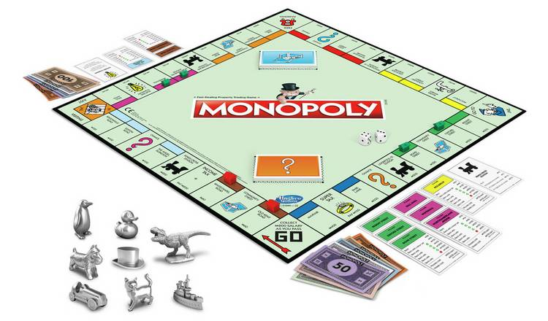
Figure 51: [123]Monopoly board game, pieces, money, and property cards.

- Rubik’s cube – a puzzle where the player has to resolve the cube into six solid faces of only one colour by rotating the faces on their three axels. The Rubik’s puzzle now comes in an array of 3-D shapes a swell as Rubik’s race. In Rubik’s race, the players race to slide their tiles to match the pattern on the scrambler.
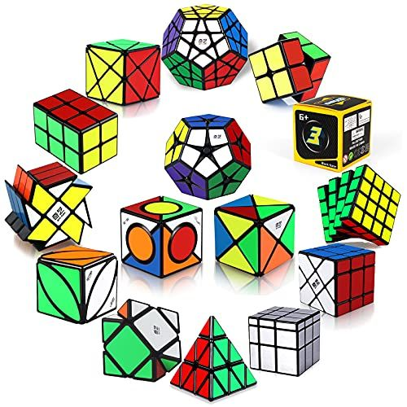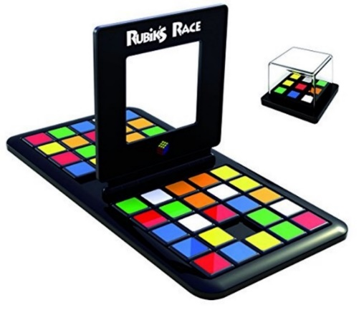
Figure 52: [124]Rubik’s cubes and variations.
Figure 53: [125] Rubik’s Race board and scrambler.

- Yahtzee – a dice-based game including addition and probability. Players roll five dice up to three times (re-rolling any or all dice desired on second and third roll) and scoring results. Players have a score sheet where they must fill in each of the boxes only once, if no boxes apply, player scores a zero in a box of their choice. The winner is the person with the highest total score once all boxes have been filled [126].
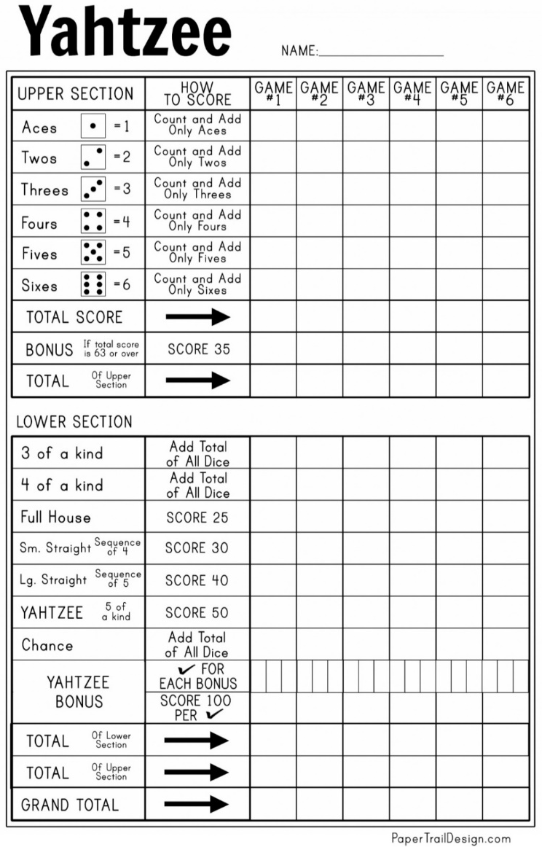
Figure 54: [127] Yahtzee score card showing upper and lower sections and boxes to be filled in.

- Dominoes – a tile game where players match sides of their dominoes with the same number (counting the pips/dots on a side of the tile) on the board in a line, double tiles lay perpendicular to the line. If a player can’t go, they must draw another tile from the pile. The winner is the first person to use all their tiles [128]. Tiles usually come in the range of zero to six but can also come in the range of zero to 12, zero to 18, and zero to 24.
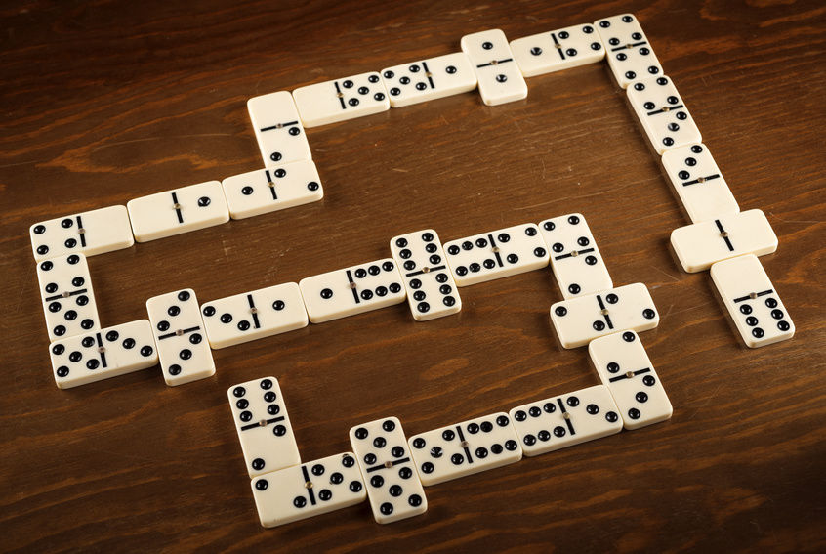
Figure 55: [129] Dominoes laid out in a game fashion.

- Battleship – a coordinate-based game involving reasonable deduction. Players try to sink opponent’s ships by working out their hidden formation on the board. Both players get the same play area size, and the same set of ships to locate (five ships of length two to five). Taking turns, the player will read out a coordinate (from A1 to J10) to bomb; if your opponent hits your ship, it gets a red 'hit’ pin, once your ship is full of red pins, your ship has sunk. The winner is the player who sinks all their opponents’ ships [130].
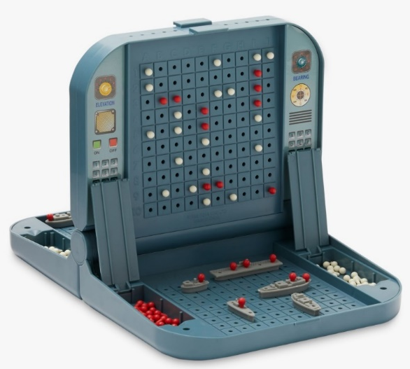
Figure 56: [131] Battleship game complete with two sets of ships, red ‘hit’ pins, and white ‘miss’ pins.

- Connect-4 – a pattern finding game where the players must take turns putting their counter in the vertical board, to gain themselves 4-in-a-row. Players also have to prevent their opponent from doing the same [132].
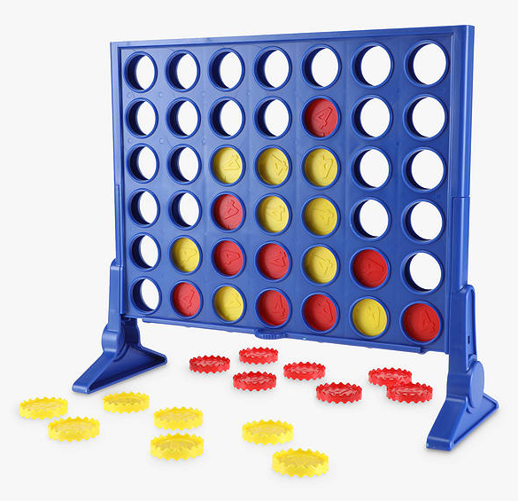
Figure 57: [133] Connect-4 vertical board and counters.

Card games
- Pontoon/21 – a card game involving addition and probability. Players are delt two cards and must add their value together (picture cards are worth ten, ace is worth one or 11 players choice) players must decide if they want to stick (stay) or twist (be delt another card) and aim to get as close as they can to 21 without busting (going over 21) [134].
  - While Pontoon isn’t instinctively a gambling game, gambling can be involved. Therefore parents should monitor their children if playing casino games under the legal gambling age [135].

Figure 58: A Pontoon hand: equivalent to 21, an ace and picture card or ten is the highest-ranking hand, call a Pontoon [136].

- Uno – a card game with a non-standard, 108 card deck, consisting of four colours (red, yellow, green, blue) with cards zero to nine, action cards, and wild cards. Players a delt seven cards, taking turns, the players can stack a card face up onto the discard pile, this card must be the same colour or value as the last card on this pile, or they can choose a wild card. If the player cannot go, they must draw a card from the main deck. The winner is the first to get rid of all their cards but remember to announce “uno” when on one card. If a player fails to announce uno and someone notices, they must draw two cards and miss a turn [137]. Other rules vary based on game version.
  - Action cards include:
    - Draw two – the next player must draw two cards and skip their turn.
    - Reverse – changes the direction of game play.
    - Skip – skips the next player’s turn.
  - Wild cards (can be played on any card):
    - Wild card – player gets to select the next colour.
    - Wild draw four – player gets to select the next colour; the next player must draw four and skip their turn. Can only be used if the player cannot play anything else.
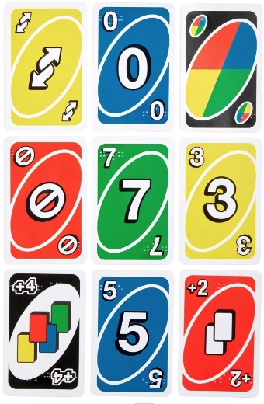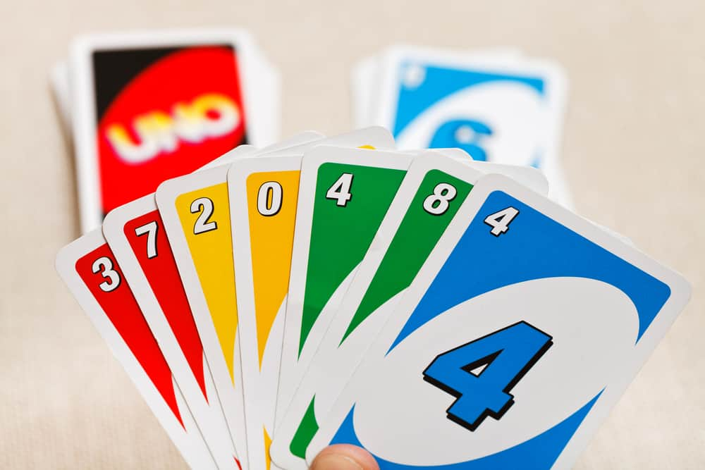
Figure 59: [138] Uno card with braille.
Figure 60: [139] A typical uno hand.

Classic electronic games
- Tetris – a single player puzzle game where pieces fall from the top of the screen towards the board. The player can move the falling piece left, right, or rotate 90° a time. The player attempts to use pieces to complete rows, so they disappear, and everything above it falls into its position; this is how the player gains points. The game is over when the pieces stacked reach the top of the board. [140].
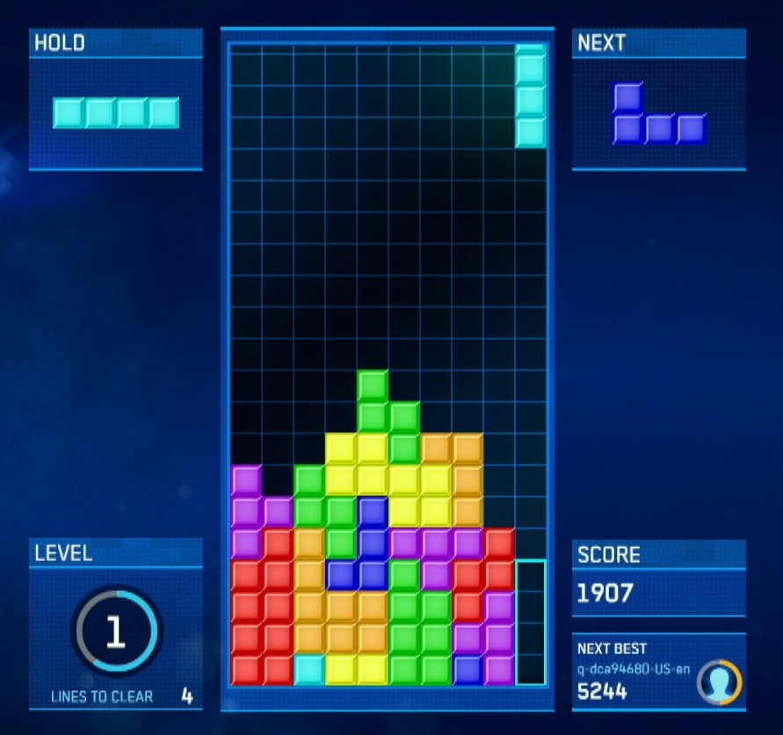
Figure 61: [141] Tetris gameplay, player is placing their piece on the right, this would clear 4 rows.

- Snake – a single player puzzle game where the player directs the snake on a 2-D playing field. The aim of the game is to collect the fruit without ‘crashing’; as the player advances, the snake gets longer, turning itself into an obstacle too. The aim is to last as long as possible [142].
  - This game is a classic and was found on many early 2000’s Nokia phones [143].
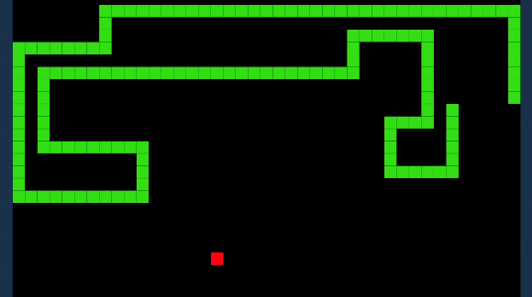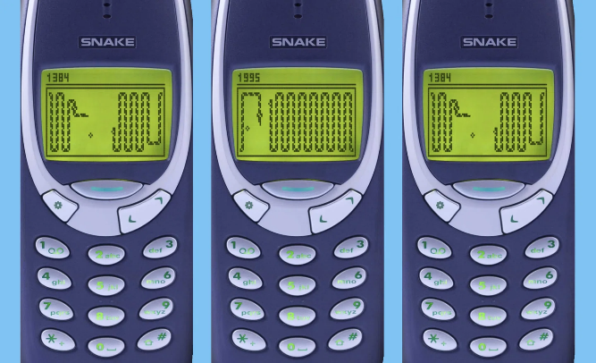
Figure 62: [144] A internet browser edition of snake.
Figure 63: [143] a view of snake on a classic Nokia.

Appendix C – Visual design choices
My site will be called ‘Magic Maths Masters’, for fun through alliteration purposes. The one game that the writer will develop for the purposes of the prototype will be called ‘Papi’s Pizza Puzzle’ again for alliteration purposes.
Colours are also important in this development, the writer has selected dark mode along with a lighter, soft set of colours that are easy on the eyes; these colours are intended to be more attractive to the target audience (10-year-olds) and girls in particular, whilst appealing to all genders. The site uses blue/aqua, red/pink, green, and yellow, seen as attractive colours especially to young children; an almost pastel variation of the set is used alongside a darker variation. These will be set as variables for ease in use:
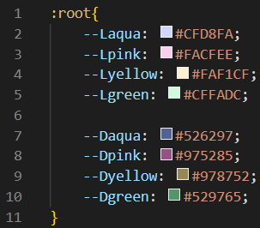
Figure 64: colour set selected for the main site.

Appendix D – Flowchart for alt game
A rough flowchart was made [flowchart 1] for a vague maths game requiring lives. This initial design was created before a game plan was created and show one of the early options considered for development. This flow chart shows a game where the player has a set number of lives and aims to get as many right answers as possible to get more rounds and a higher score before they run out of lives.
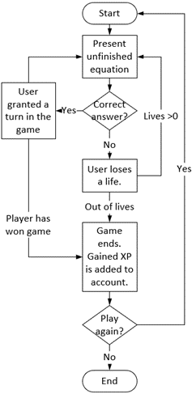
Flowchart 1: Maths game based on player lives.

Appendix E – Papi’ Pizza Puzzle, possible answers
When planning the maths for the prototype, the developer found it valuable to know all the possible answers from the existing 19 pizzas added to any of the 19 pizzas and found the following facts.
- Of the 19 pizzas, 15 different values exist.
- The pizza decimal value ranges from 0.1 – 0.9.
- 63 unique answer values are possible.
- Possible answers decimal value ranges from 0.2 – 1.8.
- The smallest answer increment is 0.025 = 1/40
This information was used to determine where to stop the fraction calculating function ‘set_rawAnswers’. It was also used to determine how much to vary the total value when calculating incorrect values for answer options whilst answers remain greater than zero, and less than two: varying the decimal value by 0.1 will do this successfully.
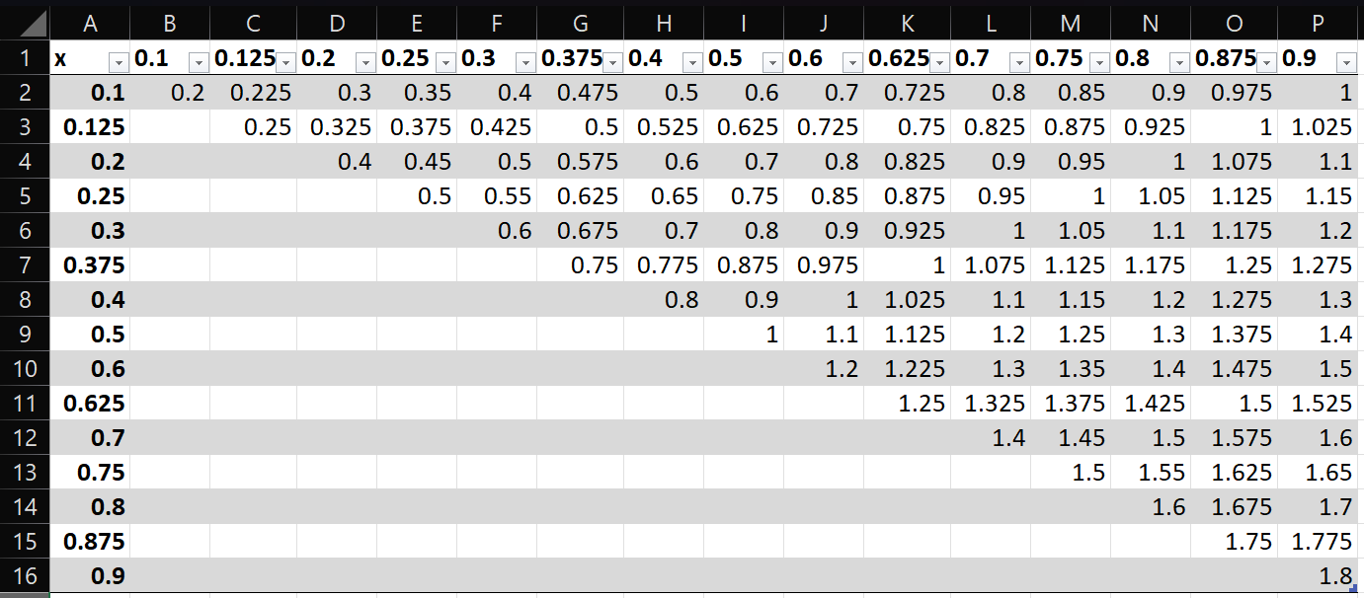
Figure 65: Grid of pizza values and possible answer values for addition.
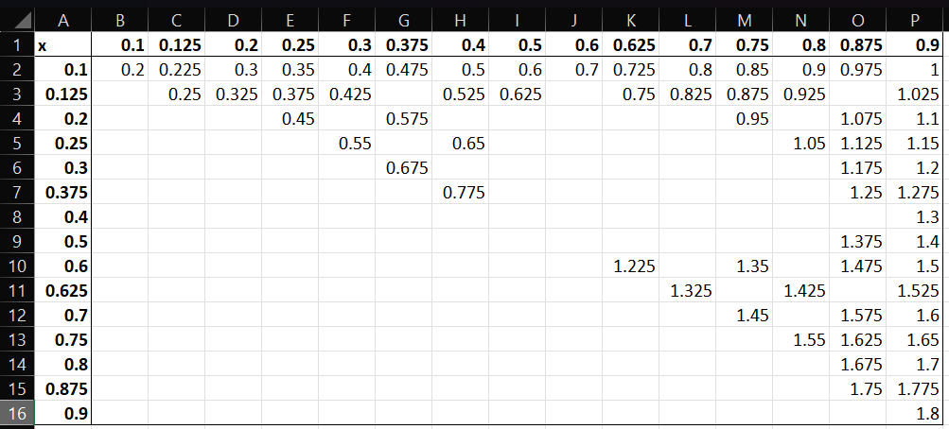
Figure 66: Grid of pizza values and the 63 unique possible answer values for addition.
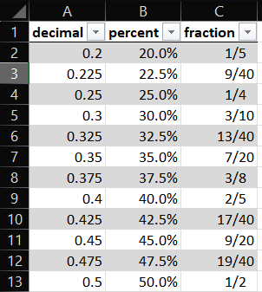
Figure 67: A section of table showing unique possible answers in their decimal, percent, and fraction forms.

Appendix F – Detailed observations of usability testing

Observation of Tester-A
The developer would like to comment on observation of one anonymous tester in particular, tester-A. Tester-A gave feedback on both the first and second round of testing, offering insight of 10-year-old’s opinions as they have a 10-year-old in their household. This tester’s insight was very detailed and incredibly helpful to the development process.
The developer observed this student to struggle with the mathematics involved and was made aware they are diagnosed with dyslexia with symptoms of dyscalculia. During the final round of testing, this tester played the pizza puzzle game three times on easy, normal, and hard mode. The tester was observed to make some mistake in the begging but didn’t get discouraged, they wanted to figure out the puzzle. They used the tool to understand their mistakes and improve. Tester-A was then able to complete the hard mode to achieve a gold medal. Tester-A was observed to be thrilled with completing the hard mode and achieving a gold medal.
The developer found this result to be very promising as it directly showed someone with maths difficulty to learn and improve from just a few rounds of game play – this is exactly what the developer wanted with implementation of the prototype and helps to support the hypothesis.

Discussion with Tester-B
The developer would also like to comment on an interaction with anonymous Tester-B, whom has many children themselves. Tester-B offered insight to 10-year-old’s lack of motivation to study and the difficulties with finding fun in mathematics especially with question-based maths games. During the first testing phase, tester-B offered some suggestions for features to help motivate young children to play maths games and feedback on creating more clarity in the questions and layout to prevent discouragement from the players.
A discussion with Tester-B and another tester also found making the game more story based with a character could help explain the game and keep the game proceeding and reduce confusion for the player.

Technical feedback from Tester-C
The developer received more technical feedback from tester-C who works in an embedded electronic profession so has some skills in developing. Tester-C suggested feedback in terms of the use of the prototype, in particular that the toppings may not be clear what they depict from an image alone, and suggested the name of the topping to be displayed when the user hovers over the element. Tester-C also suggested that the game elements should be arranged to fit all on one screen without scrolling.

