Student name: Iustina Oanea
Student number: 1909889
Tutor name: Lloyd Beharry and Barbara Chinyani
Module title: Academic and employability skills
Module code: BMSW4001

Table of contents:
1- Introduction ………………………………………………………. 3
2- Gibbs’ reflective cycle …………………………………………….3
2.1- Description………………………………………………………..3
2.2- Feelings…………………………………………………………..4
2.3- Evaluation…………………………………………………...……4
2.4- Analysis……………………………………………………..…….4
2.5- Conclusion ……………………………………………………….4
2.6- Action plan ………………………………………………………..4
3-Resolution……………………………………………………………5
4-Reference ……………………………………………………………6
5-Appendix……………………………………………………………...7

1 Introduction:
This report plans to analyse the exercises performed in the first year of the Academic and employability course at the University of Wales Saint Trinity David. During the classes in the second term we were asked to focus on reflecting about the set of skills developed during the two terms we attended at the University , we also had to consider the impact they had on the students professional and academic career through the use of Gibbs’ reflective cycle. The set of skills that are going to be analysed in this report are, Time management, CV writing, Cover letter, team working and critical thinking.

2 Gibbs’ reflective cycle
Gibbs reflective cycle, that was developed in 1988, is used as a way of helping students give a structure to learning from experience. This study was also called “learn by doing” as it promoted students to be able to think systematically about their own leaning in terms of education and employment, it covers six stages that can be effectively used in order to come to a clear judgement.

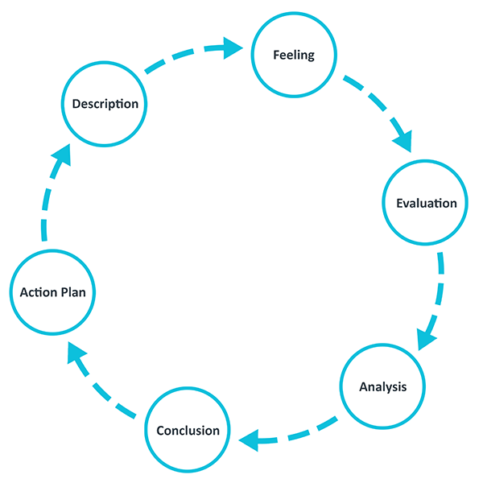
(2020) Gibbs’ reflective cycle, (University of Edinburgh)

2.1 Description
The first step of this cycle is to describe the learning process in detail, for example:
- What happened?
- When and where did it happen?
- Who was present?
- What was the outcome of the situation?
- Why were you there?
- What did you want to happen?

2.2 Feelings
This stage is based on reflecting upon what was thought and felt during the process
- How did you feel before the process?
- What did you feel while it was taking place?
- How were you feeling afterwards?
- How do you think other participants felt?
- Has your view of the process changed afterwards?

2.3 Evaluation
This stage gives the student a chance to evaluate what was effective and what wasn’t in the situation, it focused both on the negative and the positive aspects.
- What was good and bad about the experience?
- What went well?
- What did not go well?
- What did you contribute?
- What did others contribute?

2.4 Analysis
This stage gives a chance to the student to make sense of what happened, it creates a meaning from the situation, this allows the same success to be repeated in the future.
- Why didn’t things go well?
- Why did things go well?
- What sense can I make of the situation?
- What knowledge can help me understand the situation?

2.5 Conclusions
This stage aims to summarise the learning and it shows what changed done to your actions could be used to improve the outcome in the future.
- What did I learn from this situation?
- How could this have been a more positive situation for everyone involved?
- What skills do I need to develop for me to handle a situation like this better?
- What else could I have done?

2.6 Action plan
This stage allows you to plan what you would do differently in a similar situation in the future.
- If I had to do the same thing again, what would I do differently?
- How will I develop the required skills I need?
- How can I make sure that I act differently next time?

3 Reflection:
Time management
I find a lot of difficulty when it comes to managing my time , this problem has a big impact on my academic life as I’m not always able to finish my work on the required deadlines and I struggle to keep myself organized in terms of keeping my tasks evenly separated to give myself enough time to focus on everything. I struggle with failing to avoid distractions and I cannot successfully prioritise my work, I often find myself being overly stressed over what I have to get completed as I do not create an effective structure to help me deal with the problem. Whilst I was in college studying for my A levels, I had a problem with being able to hand in all the pieces of homework given to me as I was taking three subjects and it felt overwhelming to me. After realizing that time management was a crucial part of why I was not able to complete all my work I then started to research ways to help me deal with this. During this process I found out some easy steps I could take that would improve by time management over time, for example one way was creating a timetable that included both school work and after school activities, however an obstacle I had to overcome was sticking to the programme strictly , I noticed that if I would cancel a plan on my timetable or I would leave it for later it would give me less motivation to carry on doing the rest of the tasks on the specific day and also the next. After observing this I was able to decide that I should follow the timetable very strictly, this ended up providing me with a lot of free time in which I wasn’t stressing over not meeting specific deadlines.

CV Writing
When I first applied for job I didn’t have the correct format of a CV, meaning that it contained a broad overview of what I have studied and had very little detail about myself because of this I was not able to obtain the part time job, however I was very lucky to receive feedback from my interviewer on how to improve my CV and other skills required for an interview. The first tip I received was to ensure that I have all my skills clearly listed as employers often look for different sets of skills depending on each job , for example some could want someone with leadership skills whereas others might consider having a team player. Another piece of advice was to include a little bit about myself for example past experiences instead of using meaningless clichés as they show a big lack of professionalism. After receiving this feedback and also studying about employability skills during my course at the University of Saint Trinity David, I was then able to rewrite my CV in the best format, I then presented it to a few more job interviews and managed to receive a job within a short period of time after managing to improve my CV. This showed me the importance of presented a well-organized CV that stands out to employers as soon as they begin to read it, I was taken a lot more seriously despite being young of age.
Team working
During my studies at the University , when working on Academic and employability skills, I discovered the significance of team working as we were given tasks such as creating presentations with groups based on different subjects and we all had to find a method of working well together, one big example we were given that helped me understand team working in depth was Belbin’s Team Roles , we were taught each role step by step, this was a huge help as I was able to see how everyone that is part of a team has an equally important role. Before studying about this I considered myself to possess a lot more qualities of a team member than I originally do. For example I knew I was good at communicating , problem solving and having good persuasion skills, however I was shown that I lacked in being able to solve conflicts and decision making luckily my other team mates had these attributes making it easier for us all to work together. Whilst part of a team after recognising that I lacked in some skills required for a team, I was able to reflect on what I could do to improve, when I took into consideration my what I also learnt in the previous lectures I came to the realisation that I should focus on improving what I have already such as being able to solve conflicts and effectively communicate with the rest of the team.
Critical thinking
I was not aware of how important critical thinking is to have as a skill as I did not consider myself to have this skill, whilst studying for my Academic and employability skills module I was able to give a bigger focus to this and through in class research I discovered that in this day and age it is essential to try to improve and have this skill in order to understand the logical connections between ideas and implementing them either to coursework or job tasks, I learnt that having critical thinking as a skill is useful when it comes to doing research on a certain topic as you are able to only gather relevant sources when informing yourself. An obstacle that occurred for me when I was trying to put critical thinking into use was that I was not successfully able to differentiate between relevant sources and those less relevant so when we were given a project some of the information I gathered could not be put into use as it wasn’t a clear enough to improve my theory and strengthen the argument I was trying to make.in light of this after I received feedback from my lecturer and tried a few more examples I was able to conduct research in a better way as I was now only seeking the correct pieces of information.
Conclusion
To conclude this report I would like to say that by taking this University course I was finally able to work on key skills that will take a part in not only improving my future career but also the way I go about my studies , I was able to evaluate myself in more detail allowing me to see what areas I have been lacking on , without taking this course I do not think I would have been able to realize myself certain obstacles that have been holding me back from becoming my best self , I knowledge the fact that there is always space for more improvement however I really appreciate how much I have been able to progress in terms of understanding all the technicalities behind self-improvement. I am looking forward to gaining more experience as I go along with help from my class mates and also my teachers, I am now able to reflect a lot more on what else I can improve such as my presentation skills and referencing , hopefully by the end of this academic year I will be able to look back and seen a clear pattern in improvement on all the skills I have learnt about.

4 References
- Maud, Schriek and Tinkler (2017) Certificate in higher education: Skills for the workplace, sage publications Inc,London
- Learning performance (2019) Gibbs’ reflective cycle [online] Available at https://learningperformance.com/gibbs-reflective-cycle-and-learning/ (Accessed on 29/04/2020)
- University of Edinburgh (2019) Gibb’s reflective cycle [online] Available at https://www.ed.ac.uk/reflection/reflectors-toolkit/reflecting-on-experience/gibbs-reflective-cycle ( accessed on 2/05/2020)



