Module : Digital Skills and Research Methods
Module code : BMSW4003_BIRM
Title: How do we use technology to collaborate at UWTSD?
Component 2 - Research Report
Student Name & ID : Alexandra Felicia Merauta 2121306
Lecturer : Abdi Rahman

Contents
Abstract 3
Introduction 3
Literature review 4
Research Design 4
Research Question 4
Method 5
Ethical Considerations 6
Results 7
Discussion 8
Conclusion 10
Reference List 11
Appendix A – A blank copy questionnaire. 12

Abstract

The expanding quantity of instructional technology options available to schools today is putting a pressure on their resources. Computing devices (computers and software), internet connections (including projectors), and other high-tech gadgets are now considered vital in the modern classroom. School systems will soon be equipped with cutting-edge technology and software, but if instructors are not appropriately trained, children will be unable to make good use of it. The effectiveness of technology integration in the classroom is reliant on the level of training provided to educators. For educators to be effective in the digital era, they must be technologically proficient as well as knowledgeable about how to use instructional technology in the classroom. The research is developed to know the level of confident while using technology in the classroom or educational purposes by the teachers and students.

Introduction

The everyday activities of the University of Wales Trinity Saint David are highly affected by information and communication technologies. When it comes to technology and services, the university is committed to ensuring that they are utilized in ways that serve the institution's purpose and the services it provides. This article describes the information technologies and systems associated with the University of Wales Trinity Saint David. A well-informed workforce and effective management systems are important to the successful implementation of this Policy by the University. Before accessing the university's information and communication systems, you must read this policy if you are a university employee or student. If you get into problems at work or school, you can't cite the fact that you didn't cooperate as a justification. Teachers are drawn to technology because it meets the requirements of pupils with visual styles and those with special needs. Furthermore, technology brings up a whole new world of information to pupils.

Literature review

According to Palupi et al. (2020), when incorporating technology into academic subjects, teachers should stress metacognitive skill development, skill application, and learning inquiry. Park and Son (2020) investigated how computer-assisted language learning (CALL) helps primary school kids acquire English as a second language (EFL). The study's results indicate that CALL has a favorable influence on the learning of English as a second language. It was discovered that the students had a positive attitude about CALL and a strong willingness to use it in the future to help them learn English as a second language. According to Borup and Evmenova (2019), by using technology as a tool for learning, students in a community of learners may build on their prior knowledge, feel accomplished, and grow to their full potential. Constructivist learning environments seem to be appropriate for students that want to incorporate technology into their education. However, research warns us that technology alone cannot bring about the required changes in today's classrooms. It won't be possible to teach or learn in the twenty-first century without using technology in the classroom. As long as teachers and students use technology regularly and make it easy for them to do their work and help them reach their goals, they have successfully integrated technology into the classroom (Kopcha et al., 2020). We need to figure out how to use technology in the classroom the right way because it is now so common in education. Technology has changed how kids in grades K-12 have grown up (Kerres, 2020). This is what these kids say: The digital world has been woven into every part of their lives. According to Kidd and Murray (2020), Technology has become an important part of students' lives, so it makes sense to look into how it affects the classroom. Prensky is an expert in education and learning, a thought leader in the field of education, and a game designer (Kalolo, 2019). He wants to close the digital gap in education. Since digital technology has become so common in K-12 schools, he says that today's kids think and learn very differently from their predecessors. Those who were born in a world where digital technology was their first language are called "Digital Natives," or people who were born in that world.

Research Design

Research Question
- what is the expertise level of teachers and students in terms of technological familiarity?
- How frequently teachers and students use technology in their daily activity?
- How much they are confident while using technology?

Method
The research strategy:
Qualitative, quantitative, or a mix of these are some of the many methods that scientists use to study things (Taguchi, 2018). People who do both qualitative and quantitative research use numbers to find out things. When you use the mixed method, you can use both types of data at the same time in this study, we will use a quantitative method of research to find out more (Taguchi, 2018). Because the researcher will be able to see how people think about online shopping, as well as how they think about it, by taking a questionnaire and getting feedback from other people in the study.
Random sampling:
The only thing that could make it less accurate is a bad run of luck. Samples that aren't typical have a lot of random variation in them, which is called sampling error. An appropriate sample and population must be used to evaluate the results of a study. Research is based on the ability to make generalizations about a large group from a small group of people (Levitt, 2021). In order to use simple random sampling, you must have a complete list of the people in the group. There must always be a list of people on this page that is up to date and correct. Most people can't see this list because it's so long. New sampling methods need to be used in these situations.
The method used to get the data:
The researcher will get the data from the original sources and put it together. A survey will be used by the researcher to get information about what people want to know. Closed-ended questionnaires will be given to the person who is going to answer the question. It is because of COVID-19 that the researcher will use social media to get data from people. You have already been asked to stay at home and be safe. The reason for this is that it's very important to keep one's social walls up. As a result, social networking is the best way to get in touch with the person you want to talk to. It took about five minutes for students to fill out a Google form with seven open-ended questions, which they did in about five minutes.

Ethical Considerations

Ethics in research is defined as the principles and morals that are followed throughout the process of gathering data and disseminating results, according to the concept of ethics (Pietilä et al., 2020). An excessive amount of participation on the part of the researcher, the need to maintain participant confidentiality, and misinterpretation of data are just a few of the ethical considerations to consider while doing research. It is the researcher's final responsibility to ensure that all applicable rules and regulations are followed during the course of their research. Individuals' well-being, confidentiality, privacy, and safety must always take precedence over any long-term study of their behavior and interactions (Lazarus et al., 2021). The code of ethics of the British Sociological Association is as follows: Unless there are strong and overwhelming reasons to do otherwise, confidentiality and anonymity guarantees must be honored.
It's critical that students learn how to collaborate in an ethical manner. Educators have a responsibility to serve as role models for students in terms of ethical behavior by including lessons that encourage students to think about, debate, and behave ethically. In order for students to develop and maintain an ethical community, educators must provide them with the skills they need. One approach to do this is by the establishment of clear rules and regulations, which may assist students convince their classmates that cheating serves no one's interests. When required, honor codes or behavior regulations should be revised with input from students, who should have a say in developing and amending them. Ethical questions that don't have a clear correct solution should be argued in a “common” - a place where assumptions may be questioned (Lazarus et al., 2021). Parents, teachers, students, and administrators should all be included in these discussions. With this project, we want every member of our community to learn how to work together ethically and face problems that are now in the gray area.

Results
If not already legislated in most schools, technology integration into the curriculum is a top goal. Educators have had a difficult time figuring out how to effectively include and use technology in the classroom to further their educational objectives. To yet, this has not occurred because of a lack of personal experience, confidence, and training. The goal of this research was to see whether teachers' confidence in using technology in their classrooms was affected by training.
The findings of this research show that teachers' confidence in their ability to use technology in the classroom is influenced by training. Respondents are generally comfortable and confident with the technology they use. Their confidence is based on their training, and they want to keep up the good work. Despite the fact that a single respondent said that he or she did not use technology at home, the remaining 91% did. Using this data, we may conclude that technology is being utilized, but not always in the classroom. According to this survey, personal technology usage was the most confidently utilized. As a result, we need to find measures to boost students' self-confidence in the classroom. The solution to this problem is to provide our instructors with technological training. A survey of instructors indicated that many felt underprepared. According to their response, training was either not delivered often or did not relate to classroom activities. In other words, this demonstrates how crucial it is for technology to be included in the classroom and work with the educators. Training might be delivered more often and tailored to the specific requirements of a classroom with increased cooperation from the technology department. Teachers' confidence would also be bolstered as a result of this. In educational settings, technology takes on a variety of shapes. It's difficult to put faith in all of the technological gadgets accessible because of the sheer number of options. A person should be assigned to each school to learn and teach others about the technology they utilize. Confidence in the usage of certain gadgets in schools would increase if a designated person was assigned to each of them.

Discussion
- Gender: Male or Female?
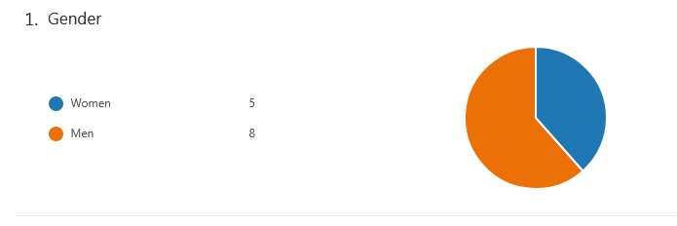
In the survey, there are 13 participants where 8 were men and the rest were women. This question is formed to know the ration of men and women, and there is a balance of both to find a neutral result.
- What is your age group?
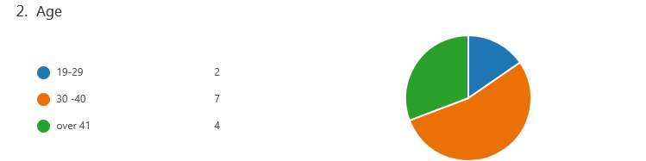
The average age group of the participants was 30 to 40 years old. But there are some participants whose age are over 40 and below 30.
- When you communicate with colleges (students) and staff (lecturers) for collaborating?
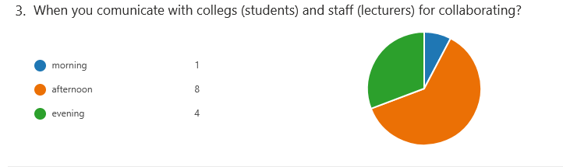
This question formed to know the time to communicate with the students and staff. Participants fill the survey form in the afternoon(8) mainly but some participants also active in the morning and night.
- Which platform did you use for collaborate(communicate)?
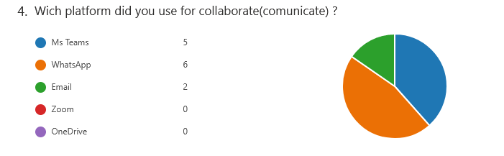
Social communication channel WhatsApp is the most used media to communicate with the participants and receive their responses. Some responses were collected through MS Teams and Email.
- How satisfied you are when you use OneDrive to collaborate with colleagues?
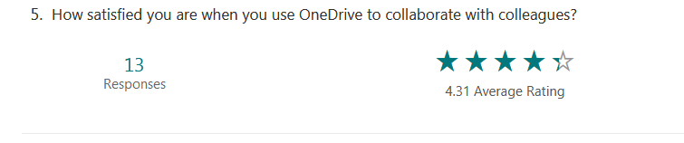
Participants are satisfied with the usage of OneDrive with their colleagues and the satisfaction rating is 4.3 which is given by the participants. That means technological usage make their task easy and comfortable.

- Collaborating online to create a group task feels very challenging for me
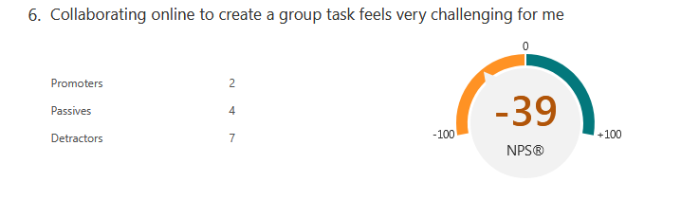
The participants do not feel challenging to collaborate in the group task via online. Only 2 participants out of 13 feel challenging to collaborate their group task online.
- In your opinion "Are staff and students confident in using technology to collaborate?"
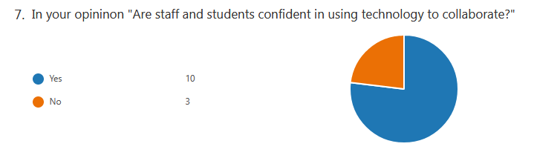

The participant feels confident in using technology. 10 participants out of 13 feel confident while using technology and the other 3 does not feel confident yet.

Conclusion
To understand how teachers become more confident and move from hesitancy and resistance to full integration of technology in the classroom, it's important to know what makes them do this. This study backs up the idea that teachers who get training feel more confident when they use technology in the classroom. So, in order for classroom technology integration to become the norm, teachers need to get a lot of different types of training, skill levels, and applications. Instructors will need to learn more about how to use technology in the classroom in order to make it better

Reference List

Borup, J. and Evmenova, A.S., 2019. The effectiveness of professional development in overcoming obstacles to effective online instruction in a College of Education. Online Learning, 23(2), pp.1-20.
Kalolo, J.F., 2019. Digital revolution and its impact on education systems in developing countries. Education and Information Technologies, 24(1), pp.345-358.
Kopcha, T.J., Neumann, K.L., Ottenbreit-Leftwich, A. and Pitman, E., 2020. Process over product: The next evolution of our quest for technology integration. Educational Technology Research and Development, 68(2), pp.729-749.
Kidd, W. and Murray, J., 2020. The Covid-19 pandemic and its effects on teacher education in England: how teacher educators moved practicum learning online. European Journal of Teacher Education, 43(4), pp.542-558.
Kerres, M., 2020. Against all odds: Education in Germany coping with Covid-19. Postdigital Science and Education, 2(3), pp.690-694
Levitt, H.M., 2021. Qualitative generalization, not to the population but to the phenomenon: Reconceptualizing variation in qualitative research. Qualitative Psychology, 8(1), p.95.
Lazarus, J.V., Safreed-Harmon, K., Kamarulzaman, A., Anderson, J., Leite, R.B., Behrens, G., Bekker, L.G., Bhagani, S., Brown, D., Brown, G. and Buchbinder, S., 2021. Consensus statement on the role of health systems in advancing the long-term well-being of people living with HIV. Nature communications, 12(1), pp.1-14.
Pietilä, A.M., Nurmi, S.M., Halkoaho, A. and Kyngäs, H., 2020. Qualitative research: Ethical considerations. In The application of content analysis in nursing science research (pp. 49-69). Springer, Cham.
Palupi, B., Subiyantoro, S., Triyanto, T. and Rukayah, R., 2020. Creative-thinking skills in explanatory writing skills viewed from learning behaviour: A mixed method case study. International Journal of Emerging Technologies in Learning (IJET), 15(1), pp.200-212.
Park, M. and Son, J.B., 2020. Pre-service EFL teachers’ readiness in computer-assisted language learning and teaching. Asia Pacific Journal of Education, pp.1-15.
Taguchi, N., 2018. Description and explanation of pragmatic development: Quantitative, qualitative, and mixed methods research. System, 75, pp.23-32.

Appendix A – A blank copy questionnaire.

- Gender: Male or Female?
- What is your age group?
- When you communicate with colleges (students) and staff (lecturers) for collaborating?
- Which platform did you use for collaborate(communicate)?
- How satisfied you are when you use OneDrive to collaborate with colleagues?
- Collaborating online to create a group task feels very challenging for me
- In your opinion "Are staff and students confident in using technology to collaborate?"

