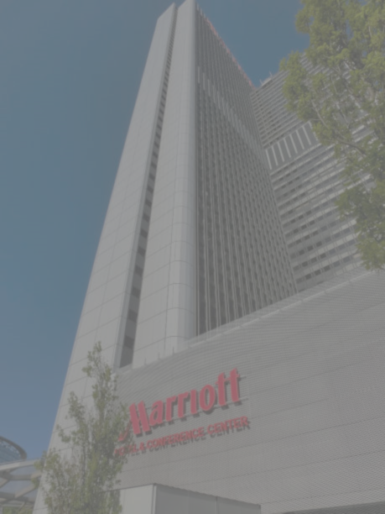
Consultancy Report on
Frankfurt Marriott Hotel, Frankfurt, Germany
Prepared by:
3T Consulting Group

BMIH6006 Organisational Consultancy
Student Name: Md Arif Uddin Khan
Student ID: 2107274
Module Leader: Jaliya De Silva
Word Count: 6489

Table of Contents
Executive Summary 4
Introduction 8
Analysis 9
Essential Services and Amenities of Frankfurt Marriott Hotel 9
Problem Analysis 9
Unprofessional Staff & Check-in System 9
Infrastructural Issues 10
Hygiene and Comfort Issues: 10
Miscellaneous Services and Other Issues: 10
Key Findings 11
PESTLE Analysis 12
Discussion: 13
SWOT Analysis 13
TOWS Matrix Analysis 15
Recommendations 17
Recommendation 1: Enhance Customer Service and Staff Training 18
Recommendation 2: Strengthen Security Measures and Privacy Protocols 19
Recommendation 3: Infrastructure Upgrade and Maintenance 19
Recommendation 4: Implement Advanced Technology Solutions 20
Recommendation 5: Sustainable Practices Implementation 21
Recommendation 6: Crowd Management and Service Optimisation 22
Action plan 23
Conclusion 25
References 27
Appendices: 34
Appendix 1: Complaint about Check-in 34
Appendix 2: Complain About Staff: 34
Appendix 3: Complaint about Security 34
Appendix 4: Complaint about Room: 35
Appendix 5: Complaint about Elevator 35
Appendix 6: Complaint about Washroom: 35
Appendix 7: Complaint about Bedding: 36
Appendix 8: Complaint about elite Member service 36
Appendix 9: Complaint about Breakfast 36

List of Tables:
Table 1: PESTLE Analysis 13
Table 2: SWOT Analysis 14
Table 3: TWOS Matrix 17
Table 4: Action Plan 24

Executive Summary
The Frankfurt Marriott Hotel, nestled in the heart of Frankfurt and founded in 1976, has a storied history of providing luxury and a wide range of hospitality services. However, it currently grapples with a pressing issue—increasing customer dissatisfaction. Despite its strong reputation, the hotel faces many guest complaints spanning check-in processes, room quality, services, and overall visitor experience. To address this challenge, the hotel has engaged 3T Consulting Group, a management consulting firm in Germany known for its extensive industry expertise. This report, employing PESTEL, SWOT, and TOWS analyses, delves into the hotel's challenges, offering strategic solutions. It provides actionable recommendations and an implementation plan to restore the hotel's market standing competitive edge and prioritise guest satisfaction, ultimately ensuring enduring positive guest experiences.
The critical services section of the report entails that Europe's tallest landmark, the Frankfurt Marriott Hotel, offers 587 rooms, modernised in 2013, catering to business and leisure travellers. Services include a Concierge/Club Floor, currency exchange, multi-lingual staff, and 25 conference rooms. Security features encompass electronic key/lock systems, well-lit parking, and surveillance cameras for guest safety.
The problem analysis section reveals that the Frankfurt Marriott Hotel faces substantial issues, as evidenced by customer reviews:
- Unprofessional Staff & Check-in System: Customer service and the check-in process have raised concerns. Reviews point out unprofessional behaviour, a need for more information, and disagreements about extra fees or payment policies. Staff members' unhelpfulness and rudeness negatively affect the guest experience.
- Security and Privacy Concerns: Substantial criticism regarding security breaches, particularly in room access and personal data management. Instances of unauthorised access due to room information being disclosed without adequate verification pose significant safety and privacy risks.
- Infrastructural Issues: Guests report problems with room conditions, including weak air conditioning during summer, noise issues, and outdated room amenities. Elevator and infrastructure maintenance problems further impact guest comfort and satisfaction.
- Hygiene and Comfort Issues: Substandard washroom conditions and maintenance have led to guest dissatisfaction. Complaints regarding toiletries and cleanliness suggest inadequate hygiene practices. Bedding, soundproofing, and room comfort issues affect the overall guest experience.
- Miscellaneous Services and Other Issues: Elite members' expectations must be consistently met, raising questions about service parity and loyalty program compliance. Breakfast crowding and service accessibility challenges are negatively affecting the guest experience.
The PESTLE analysis reveals external factors affecting the Frankfurt Marriott Hotel: evolving political regulations, economic fluctuations impacting visitor spending, socio-cultural shifts in guest preferences and eco-conscious trends, essential technological innovations, legal considerations like liability and labour regulations, and a critical need for sustainability practices to meet guest expectations.
The SWOT analysis reveals that Frankfurt Marriott Hotel's strengths lie in the Marriott brand and prime location. Weaknesses include staff issues, security breaches, and sustainability limitations. Opportunities include enhancing experiences through sustainability and technology adoption. Threats encompass intense competition, economic fluctuations, changing preferences, strict regulations, COVID-19 uncertainties, and security concerns.
The TWOS analysis shows that SO strategies leverage Marriott's brand and prime location for eco-conscious tourists, incorporating advanced technology and sustainability. ST strategies focus on security and staff training, improving rooms, and managing congestion while complying with environmental regulations. WO strategies invest in staff training, security, and infrastructure to enhance visitor comfort. WT strategies prioritise security, infrastructure, congestion, and sustainability to reduce accessibility risks and safeguard the hotel's reputation.
The key findings of the report indicate that the Frankfurt Marriott Hotel's core problems stem from operational deficiencies in procedures, staff training, and infrastructure upkeep. Staff training should prioritise communication, conflict resolution, and customer service standards to rectify inadequate service and unprofessional behaviour: inconsistent check-in procedures and unclear fee communication demand policy reviews and enhanced employee training. Security breaches reveal the need for strict regulations and identity verification. Privacy breaches require updated security protocols and staff education. Infrastructure issues point to inadequate maintenance and call for a comprehensive strategy. These issues affect guest satisfaction, reputation, and profitability. Restructured training, robust security, and maintenance funding are essential to improve the visitor experience and financial viability.
The comprehensive recommendations for the Frankfurt Marriott Hotel encompass an initial investment of €100,000 for staff training to enhance professionalism and customer service. Strengthening security requires a €50,000 budget, focusing on surveillance and keyless access systems. Approximately €300,000 is suggested for infrastructure upgrades, including room renovations, air conditioning, and soundproofing. Allocating around €150,000 for advanced technology solutions, like keyless entry and mobile check-in, is advised. An estimated €75,000 is proposed for sustainable practices, including energy-saving initiatives and recycling programs. To improve service during peak hours, a €50,000 budget is recommended for crowd management and service optimisation, involving changes to the breakfast area, a reservation system, and staff training. The action plan formulated is as follows:
Problem | Solution | Desired Outcome | Time Scale | Completion Date | Planned Budget
Unprofessional Staff & Check-in System | Enhance Customer Service and Staff Training | Improved guest satisfaction reduced complaints | 12 months | November 2024 | €100,000
Security and Privacy Concerns | Strengthen Security Measures and Privacy Protocols | Enhanced guest trust, minimised security risks | Ten months | September 2024 | €50,000
Infrastructure Issues | Infrastructure Upgrade and Maintenance | Higher guest satisfaction, improved room occupancy | 14 months | January 2025 | €300,000
Hygiene and Comfort Issues | Improve Hygiene Standards and Room Comfort | Enhanced cleanliness and guest comfort | 14 months | January 2025 | €200,000
Miscellaneous Services and Other Issues | Enhance Miscellaneous Guest Services and Amenities | Improved quality of miscellaneous services and amenities | 16 months | March 2025 | €80,000
In conclusion, the report identified critical issues impacting guest satisfaction and proposed comprehensive solutions to enhance operations at the Frankfurt Marriott Hotel. We thank the hotel for the opportunity to collaborate and look forward to future partnerships.

Introduction
Located in the centre of Frankfurt, Germany, the Frankfurt Marriott Hotel has a rich history of providing guests luxury and convenience. The hotel was founded in 1976 and provides a wide array of services and amenities that are consistent with Marriott International's well-known dedication to providing outstanding hospitality (Marriott, 2022). The Frankfurt Marriott Hotel occupies a significant place in the hospitality sector. It has 587 guest rooms of various sizes and types and several noteworthy amenities and services, including dining, sightseeing, business conference centres, and ballrooms, among others (Marriott, 2022).
However, the hotel is currently dealing with a critical challenge – a discernible level of customer dissatisfaction. Despite maintaining a solid reputation, the hotel has to address the growing number of visitor complaints, as seen by the abovementioned customer reviews (Moliner et al., 2019). These worries cover anything from difficulties encountered during the check-in procedure to issues with the standard of the rooms, facilities, services, invoicing, and general visitor experience. Such complaints are common, which poses a severe problem for the hotel as it may impact its standing, ability to retain guests, and future commercial opportunities (Kuhzady and Ghasemi, 2019).
Dealing with dissatisfied consumers is a problem that the Frankfurt Marriott Hotel has asked 3T Consulting Group to help with. 3T Consulting Group was established in Germany in 2018. 3T Consulting Group is a management consulting firm that aspires to be internationally renowned and widely recognised for its proficient counsel to organisations spanning diverse industries. By leveraging extensive industry expertise, analytical methodologies, and consulting frameworks, the consulting firm is exceptionally equipped to assist the Frankfurt Marriott Hotel in rectifying these challenges and re-establishing its dedication to providing outstanding visitor experiences.
Utilising established analytic frameworks, including PESTEL, SWOT and TOWS, this report will examine the challenges encountered by the Frankfurt Marriott Hotel. By providing an all-encompassing comprehension of the current issues, these frameworks will facilitate the development of effective strategies for the hotel's enhancement.
Furthermore, this report shall provide a comprehensive examination of the issues and discoveries that have been identified, along with pragmatic suggestions for effectively resolving these issues. Furthermore, the implementation of the suggested adjustments at the Frankfurt Marriott Hotel will be facilitated by the inclusion of an action plan (Cate Gable, 2018). Through a methodical approach to tackling these challenges, the hotel can strategically restore its competitive advantage, fortify its market standing, and prioritise visitor satisfaction above all else; consequently, it will be capable of generating lasting positive guest experiences.

Analysis

Essential Services and Amenities of Frankfurt Marriott Hotel
The Frankfurt Marriott Hotel, Europe's tallest, is an iconic landmark located opposite the exhibition grounds, offering proximity to the Congress Centre and the central train station. Established in 1976, it underwent modern renovations in 2013. With 587 rooms across 44 floors, it caters to business and leisure travellers. Guest services include a Concierge/Club Floor, currency exchange, and multi-lingual staff. Security features electronic key/lock systems, well-lit parking lots, and surveillance cameras. The hotel offers 25 conference rooms covering 21,721 square feet and various amenities, including air conditioning, minibars, and entertainment options in rooms (Marriott, 2023).

Problem Analysis
Several issues at the Frankfurt Marriott Hotel were reported from the customer reviews. The following issues resulted in massive customer dissatisfaction that is hampering the reputation and profitability of this hotel.

Unprofessional Staff & Check-in System
1. Customer Service and Check-in Process: Many things could be improved at the hotel with customer service and the check-in process. Several reviews point out unprofessional behaviour (Ekiz, Khoo‐Lattimore and Memarzadeh, 2022), a lack of information, and disagreements about extra fees or payment policies. When staff members were useless, rude, or did not give guests the information they needed about their stay, extra charges, or accommodations, their experience was terrible (Xu et al., 2020). This includes not being transparent about extra costs, misunderstandings about stay details, and a general lack of respect for customers' needs. (See appendix 1 and 2 in the appendices)
2. Security and Privacy Concerns: The hotel has faced substantial criticism regarding security breaches, particularly with room access and the management of personal data (Magalhães et al., 2016). Instances in which room information was divulged via telephone without adequate verification, thereby granting unauthorised access to rooms, present significant hazards to the safety and privacy of visitors (Anichiti et al., 2021). A significant concern is the absence of stringent security measures and proper identity verification procedures. (See appendix 3 in the appendices)

Infrastructural Issues
1. Room Conditions and Amenities: There are numerous complaints about room conditions, particularly during the summer. Guests had trouble sleeping because the air conditioning in their rooms was too weak, making them too hot (Torres et al., 2020). Some also said that noise problems from insufficient insulation and being close to lifts made sleeping hard. There is also a problem with the old infrastructure, including room amenities like air conditioners, TVs, and room care (Hu et al., 2019). (See figure 4 in the appendices)
2. Elevator and Infrastructure Maintenance: Guests had to walk up and down many floors because the lifts were not working (Alassafi et al., 2022), and there were ongoing problems with the building's infrastructure, such as broken lifts, the HVAC system (Smitt, Tolstorebrov and Hafner, 2021), and soundproofing that was not good enough. (See figure 5 in the appendices)

Hygiene and Comfort Issues:
1. Washroom Hygiene and Maintenance: Guests complained about substandard washroom conditions and maintenance (Yu, Seo and Hyun, 2021). Dissatisfaction is increased in bathrooms that are dirty or badly managed, including problems with toiletries and difficulties keeping them clean (OA, 2017). Grievances regarding partially utilised or insufficient toiletries indicate a disregard for proper hygiene practices. (See figure 6 in the appendices)
2. Bedding and Room Comfort: Complaints about uncomfortable pillows, subpar soundproofing, and substandard bedding that caused disruptions at night also add to the unpleasant experience. (See appendix 7 in the appendices)

Miscellaneous Services and Other Issues:
1. Unmet Expectations for Elite Members: The hotel's inability to provide select visitors with the perks of elite membership programs raises questions about service parity and loyalty program compliance (Sayin and Karaman, 2019). (See appendix 8 in the appendices)
2. Breakfast Crowding and Service Accessibility: When people swarm a buffet at breakfast and find it difficult to get food, there may be problems with crowd control and service delivery (Xu, 2018). The overall guest experience is positively impacted when many guests' demands are met at peak hours. (See appendix 9 in the appendices)
To improve the guest experience and uphold its reputation in the hospitality sector, the Frankfurt Marriott Hotel must address these complex issues, which centre around service quality, infrastructure upkeep, staff professionalism, and overall guest satisfaction (Radde, 2017).

Key Findings
The fundamental causes of the various problems at the Frankfurt Marriott Hotel are systemic deficiencies in operational procedures, staff training, and infrastructure upkeep (Kim, Kim and Heo, 2017). Inadequate service delivery and unprofessional behaviour indicate that staff members require extensive training programmes that emphasise communication, conflict resolution, and customer service standards (Hu, Zhang et al., 2019). The operational shortcomings that are exposed by inconsistent, ineffective check-in procedures and the opaque communication of extra fees necessitate a review of internal policies and increased employee training programmes in order to guarantee smooth, customer-focused service delivery.
Inadequate room access procedures have resulted in security breaches, highlighting the necessity for strict security regulations and the lack of reliable identity verification mechanisms (Chittiprolu, Samala and Bellamkonda, 2021). Concerns about safety and privacy are increased by the unapproved release of guest room information, which calls for quick correction through updated security protocols and employee education to protect visitor data and respect privacy laws.
Infrastructure issues suggest inadequate property maintenance and enhancement funding (Padma and Ahn, 2020). To improve guest comfort and satisfaction, a thorough property maintenance strategy is needed due to outdated room amenities, malfunctioning elevators, and continuous infrastructure difficulties. Concerns about lavatory comfort and sanitation emphasise the importance of strict hygiene measures and maintenance checks to protect patrons' health (Chanwisitkul, Shahgholian and Mehandjiev, 2018).
These core issues affect many hotel elements. A drop in staff professionalism and service quality may lower occupancy rates, word-of-mouth, and long-term profitability by diminishing visitor loyalty and trust (Bravo, Martinez and Pina, 2019). Security and privacy breaches imperil guests and damage the hotel's reputation, which may lead to legal issues and customer distrust. Infrastructure and maintenance issues may hurt the visiting experience, lowering customer satisfaction and possibly costing money and lowering patronage (Nobar and Rostamzadeh, 2018).
To lessen these significant impacts, the hotel must restructure its employee training initiatives, put strong security measures in place, and set aside funds for the thorough upkeep of the facility (Noordzy, 2014). Improving the visitor experience and maintaining the hotel's financial viability in the cutthroat hospitality sector are two additional benefits of addressing these fundamental problems (Bharwani and Jauhari, 2013).

PESTLE Analysis
PESTEL analysis is a strategic framework for assessing external macroenvironmental elements that can influence an organisation's operations and decision-making. Political, Economic, Social, Technological, Environmental, and Legal issues are all included in the acronym. With this tool, organisations can recognise possible risks and opportunities in their working environment and take appropriate action (Kampanje, 2020). PESTLE Analysis of Frankfurt Marriott Hotel:
P | E | S | T | L | E
Compliance with local and national regulations, including health and safety standards. | Economic fluctuations and their impact on tourism and travel. | Socio-cultural shifts influencing guest preferences. | Adoption of advanced reservation systems and mobile check-in. | Compliance with labour laws and regulations, including working conditions and wages. | Sustainability initiatives and green practices to reduce the hotel's carbon footprint.
Impacts of government policies and regulations on the hospitality industry. | Exchange rate fluctuations affecting international guests. | Diversity and multiculturalism in Frankfurt impacting guest demographics. | Digital marketing and online presence to reach a broader audience. | Liability issues and insurance requirements. | Impact of environmental regulations on hotel operations (Yusof et al., 2017).
Taxation policies affecting hotel operations  (Nunkoo and Gursoy, 2016). | Business trends in Frankfurt and their influence on corporate bookings. | Changing travel patterns, such as choosing eco-friendly accommodations (Zhuang, Yao and Li, 2019). | Integration of intelligent room technologies (Buhalis et al., 2019) | Intellectual property protection for the hotel's branding (Safaeva et al., 2019). | Addressing climate change-related risks, such as extreme weather events.
Stability of the political environment in Frankfurt. | Economic recovery post-pandemic  (Altinay and Taheri, 2019). | Guest expectations regarding safety and hygiene. | Data security and guest privacy in a digital age. | Legal implications of guest contracts and disputes. | Implementing energy-efficient technologies to reduce resource consumption.
Table 1: PESTLE Analysis
(Source: Self-made)

Discussion:
The Frankfurt Marriott Hotel faces diverse elements in its PESTLE analysis. Politically, it must navigate evolving regulations and consider the impact of political stability on business and tourism in Frankfurt (Nunkoo and Gursoy, 2016). Economically, it is susceptible to changes affecting visitor spending, exchange rates, and the post-pandemic recovery's influence on the travel and tourism sector (Altinay and Taheri, 2019). Socio-culturally, the hotel needs to adapt to evolving guest preferences and embrace eco-friendly trends to enhance the guest experience (Zhuang, Yao and Li, 2019). In terms of technology, the focus is on innovation, integrating digital solutions, and prioritising robust security measures for visitor privacy and data protection (Buhalis et al., 2019). Legally, it must handle liability concerns, labour regulations, and reputation management (Safaeva et al., 2019). Sustainability is imperative, necessitating eco-friendly practices and reduced energy consumption to comply with environmental standards and meet evolving guest expectations (Yusof et al., 2017).

SWOT Analysis
A strategic planning tool known as a SWOT analysis assesses the opportunities, threats, weaknesses, and strengths of a business. It helps in making strategic decisions by pointing out opportunities and dangers from the outside as well as internal strengths and weaknesses. Opportunities and threats are external environmental elements, whereas strengths and weaknesses are internal characteristics (Benzaghta et al., 2021). Following is the SWOT analysis of the hotel:
Strengths  1. Marriott International affiliation.  2. Prime location near exhibition grounds and the central train station.  3. Europe's tallest hotel with a tall tower structure.  4. Extensive guest services and amenities.  5. Diverse portfolio of 587 rooms and ample event spaces (Barreto and Mayya, 2022).  6. Multi-lingual staff and Marriott Bonvoy loyalty program participation. | Weakness  1. Unprofessional staff behaviour and service issues.  2. Security lapses, including guest information disclosure.  3. Infrastructure problems, notably room conditions and maintenance.  4. Issues with peak-hour overcrowding.  5. Sustainability practices needing improvement. (Natasha and Are, 2019)
Opportunities  1. Enhance guest experience with technology like mobile check-in.  2. Invest in staff training to improve service quality.  3. Attract eco-conscious travellers through sustainability practices.  4. Expand corporate partnerships and business event services (Ntalakos et al., 2022).  5. Offer unique local experiences and benefit from post-pandemic travel recovery. | Threats  1. Intense competition in the Frankfurt hospitality market.  2. Economic fluctuations affecting business and leisure travel.  3. Ongoing challenges from COVID-19 and changing travel trends (Afshan et al., 2021).  4. Adapt to evolving guest expectations and preferences.  5. Address environmental regulations and carbon footprint pressure.  6. Mitigate potential security breaches and data privacy concerns.
Table 2: SWOT Analysis
(Source: Self-Made)
Strengths: The Frankfurt Marriott Hotel benefits from the trusted Marriott International brand, a prime location near the main rail station and exhibition grounds, and its distinction as Europe's tallest tower building (Barreto and Mayya, 2022).
Weaknesses: Challenges include staff professionalism issues, security breaches, infrastructure difficulties, and limitations in adopting sustainable practices (Natasha and Are 2019).
Opportunities: The hotel can enhance guest experiences through sustainability initiatives, staff training, and technology adoption. It can expand corporate partnerships, offer unique local experiences, and tap into the post-pandemic travel industry rebound (Ntalakos et al., 2022).
Threats: Threats involve intense competition, economic fluctuations, changing visitor preferences, strict environmental regulations, COVID-19 uncertainties, and the need to maintain security and data privacy to safeguard its reputation and guest trust (Afshan et al., 2021).

TOWS Matrix Analysis
From the TWOS analysis, the Frankfurt Marriott Hotel will gain insights into its strategic position and potential future directions. By leveraging strengths and opportunities, it can enhance guest experiences and attract eco-conscious travellers. Addressing strengths against potential threats will mitigate risks while safeguarding its reputation. Investing in staff training and infrastructure improvements to improve service quality is vital when addressing weaknesses and seizing opportunities. To tackle weaknesses facing potential threats, implementing robust security measures, maintaining infrastructure, and managing congestion and sustainability will reduce risks and protect the hotel's reputation (Asadpourian, Rahimian and Gholamrezai, 2020). Following is the TOWS analysis for the hotel:
 | Strength  1. Marriott International affiliation.  2. Prime location near exhibition grounds and the central train station.  3. Europe's tallest hotel with a tall tower structure.  4. Extensive guest services and amenities.  5. Diverse portfolio of 587 rooms and ample event spaces.  6. Multi-lingual staff and Marriott Bonvoy loyalty program participation. | Weakness  1. Unprofessional staff behaviour and service issues.  2. Security lapses, including guest information disclosure.  3. Infrastructure problems, notably room conditions and maintenance.  4. Issues with peak-hour overcrowding.  5. Sustainability practices needing improvement.
Opportunity  1. Enhance guest experience with technology like mobile check-in.  2. Invest in staff training to improve service quality.  3. Attract eco-conscious travellers through sustainability practices.  4. Expand corporate partnerships and business event services.  5. Offer unique local experiences and benefit from post-pandemic travel recovery. | SO  - S1, O4: Marriott affiliation for business expansion.  - S2, O5: Prime location for unique experiences.  - S3, O1: Tower structure for tech enhancements.  - S4, O2: Guest services for staff training.  - S5, O3: Diverse portfolio for eco-conscious guests. | WO  - W1, O1: Service quality with tech.  - W2, O2: Trust with security improvements.  - W3, O5: Infrastructure issues and local experiences.  - W4, O4: Overcrowding via corporate partnerships.  - W5, O3: Sustainability and eco-conscious guests.
Threat  1. Intense competition in the Frankfurt hospitality market.  2. Economic fluctuations affecting business and leisure travel.  3. Ongoing challenges from COVID-19 and changing travel trends.  4. Adapt to evolving guest expectations and preferences.  5. Address environmental regulations and carbon footprint pressure.  6. Mitigate potential security breaches and data privacy concerns. | ST  - S1, T3: Security measures for data privacy.  - S2, T1: Location to counter competition.  - S3, T6: Tech for changing travel trends.  - S4, T2: Training for evolving expectations.  - S5, T5: Sustainability for regulations.  - S6, T4: Data privacy with training. | WT  - W1, T1: Competition and data privacy.  - W2, T6: Reputation and evolving trends.  - W3, T3: Infrastructure and data privacy.  - W4, T2: Crowd management for fluctuations.  - W5, T5: Sustainability, regulations, and data privacy.
Table 3: TWOS Matrix
(Source: Self-Made)
SO, Strategies (Strengths-Opportunities): Leveraging the Marriott brand in post-pandemic travel trends, utilising the prime location for business attendees, and embracing sustainability cater to eco-conscious tourists while adopting advanced technology for enhanced guest experiences (Asadpourian, Rahimian and Gholamrezai, 2020).
ST Strategies (Strengths-Threats): Strengthening security measures and employee training mitigates evolving risks. Improving room conditions and managing peak-hour congestion safeguards the hotel's reputation and service quality while addressing environmental regulations (Szeliga-Duchnowska and Goranczewski, 2017).
WO Strategies (Weaknesses-Opportunities): Investing in employee training improves service quality. Enhancing security and addressing infrastructure issues bolster visitor trust and comfort. Improving rooms aligns with changing travel trends while offering unique local experiences counters congestion issues (Whittington et al., 2020a).
WT Strategies (Weaknesses-Threats): Implementing strong security measures addresses data privacy issues. Infrastructure improvements maintain the hotel's reputation. Managing congestion and sustainability initiatives reduces service accessibility risks and reputational hazards (Singjai, Winata and Kummer, 2018).

Recommendations
Following are some recommended strategies for the hotel to address and solve the issues keeping change management in consideration:

Recommendation 1: Enhance Customer Service and Staff Training
Strategy Description: The first suggestion addresses the urgent requirement to improve staff professionalism and customer service (Piccoli, Lui and Grün, 2017). This means investing in employee training initiatives that prioritise soft skills. The goal of these programmes is to improve the hotel's image by emphasising crucial skills like problem-solving, communication, and conflict resolution (Salem and Abdien, 2017).
Implementation: The hotel will set aside an estimated €100,000 for extensive training programmes as the initial investment to carry out this approach. To guarantee the most outstanding calibre, these programmes will be painstakingly created in association with prestigious service training organisations (Li et al., 2021). The training programme will be implemented progressively, starting with soft skills training that will mainly target communication enhancements and work it up to more specialised training modules (Waqanimaravu and Arasanmi, 2020). Staff training is expected to require an initial investment of €100,000.
Success Measurement: The success of this initiative will be assessed through various key performance indicators (Jahangirian et al., 2019). These include higher ratings for guest satisfaction, a discernible decline in complaints from visitors, and an increase in favourable web reviews. Mystery shopper assessments and ongoing guest input will be essential components of the measurement process to guarantee staff competency.
Reaction to Change: Although employees could show some reluctance at first to modifications in their daily schedules, the advantages of improved skills will eventually become clear. These advantages—better job satisfaction, a happier workplace, and more significant opportunities for professional advancement—should encourage employees to support the change (Jamal Ali and Anwar, 2021).
Change Management Strategy: Soft skills training will be the first step in introducing the change gradually to ensure a seamless transition. Furthermore, a comprehensive feedback loop will enable employees to express their worries and recommendations, facilitating a cooperative approach to change management (Burnes, 2014, pp. 14–27).
Potential Benefits: This recommendation has numerous potential advantages. They include a discernible rise in patronage, the development of a more polished and politer hotel image, increased employee contentment, and improved overall business success (Salem and Abdien, 2017).

Recommendation 2: Strengthen Security Measures and Privacy Protocols
Strategy Description: Strengthening security and privacy policies at the Frankfurt Marriott Hotel is the second important proposal. This plan calls for a significant investment in state-of-the-art surveillance and keyless access systems, among other security technologies. Regular staff training sessions regarding data privacy and strict security standards are highly prioritised (Dammak et al., 2020).
Implementation: To purchase cutting-edge security equipment and identity verification systems, the hotel will first budget an estimated €50,000. Modern surveillance equipment will be purchased, and keyless entry systems will be installed thanks to this funding (Dammak et al., 2020). Simultaneously, it will be planned to perform frequent staff training sessions emphasising educating employees about data privacy and maintaining strict security procedures. The initial outlay for putting these cutting-edge security measures in place is projected to be €50,000.
Success Measurement: Success will be assessed by quantifiable metrics, such as declining security incidents and data breaches. Positive comments from visitors will also be used to assess how adequate these safeguards are, especially about how safe and private they feel.
Reaction to Change: Initially, staff members can be worried about possible privacy violations. Ensuring acceptance and compliance among the personnel can be achieved by educating them about the procedures in place to protect both visitors and the hotel.
Change Management Strategy: To gain support and guarantee a seamless transition, staff involvement will be crucial in the development and selection of these security measures. Gaining their support will mostly depend on highlighting how important visitor safety is and how strict data privacy laws must be followed (Kotter, 2012).
Potential Benefits: It is anticipated that these improved security measures will significantly increase visitor trust and reduce any security threats. Furthermore, it will be essential in guaranteeing the protection of visitor data and accomplishing adherence to strict data privacy laws. Ultimately, this will improve the hotel's standing and increase visitors' trust in their privacy and safety while visiting.

Recommendation 3: Infrastructure Upgrade and Maintenance
Strategy Description: The third important suggestion focuses on the thorough renovation and regular upkeep of the hotel's infrastructure. This means giving guest rooms much attention throughout renovations and updates, paying particular attention to important things like air conditioning, soundproofing, and general room condition (Mandić, Mrnjavac and Kordić, 2018).
Implementation: The hotel is willing to set aside an approximate expenditure of €300,000 for the sole purpose of remodelling rooms (Mandić, Mrnjavac and Kordić, 2018). In order to guarantee peak efficiency and visitor comfort, air conditioning system renovations will take precedence. Improvements to soundproofing will be made concurrently to reduce noise disruptions. In order to minimise any potential disturbance to the visitors' experience, these restoration and maintenance works will be carried out in phases that have been meticulously planned. An estimated €300,000 has been set aside for these infrastructure repair and upgrading projects.
Success Measurement: Metrics that can be measured, such as a clear drop in guest complaints about maintenance issues, an apparent rise in guest satisfaction scores, and a significant rise in room occupancy rates, will be used to judge success.
Reaction to Change: Owing to current renovations, guests may encounter brief inconveniences, which may result in some complaints. However, aggressive announcements of the upgrades and a dedication to reducing inconvenience ought to allay visitor worries.
Change Management Strategy: To minimise any disruptions to the visitor experience, renovation works will be carefully scheduled during times of lower occupancy. Throughout the process, keeping visitors informed about the ongoing modifications will be of utmost importance through clear and constant communication. Long-term development of a significantly enhanced visitor experience will be the main goal (Jamal Ali and Anwar, 2021).
Potential Benefits: Some potential benefits could arise, including higher guest satisfaction, higher room occupancy rates, a better-than-expected brand image, and, over time, significant cost savings due to the upgraded infrastructure's increased durability and efficiency. In addition to addressing current problems, this approach establishes the hotel as the premier option for visitors looking for a contemporary and comfortable stay.

Recommendation 4: Implement Advanced Technology Solutions
Strategy Description: This suggestion suggests utilising cutting-edge technological solutions to improve the hotel's overall guest experience. Keyless entry, mobile check-in, and intelligent room amenities are all included in these systems (Kansakar, Munir and Shabani, 2019). The hotel may improve operational efficiency, simplify guest interactions, and provide a more enjoyable and convenient stay by implementing this cutting-edge technology.
Implementation: The hotel will set aside around €150,000 to implement this plan. This investment will cover several essential elements, such as the creation and integration of a guest-only mobile app, the installation of keyless entry systems, and the addition of intelligent features for the rooms. Initial technology implementation costs are projected to be €150,000.
Success Measurement: Several things will be used to determine success, such as higher guest satisfaction scores with check-in and room experiences, higher operational efficiency, and a rise in the number of guests who use technology. These metrics will be useful in determining how well the technology is being implemented.
Reaction to Change: The hotel will offer committed support and direction to guarantee a smooth transition, acknowledging that visitors might need time to get used to these new technologies. This customer-focused strategy will assist in reducing any possible obstacles or change resistance.
Change Management Strategy: A thorough training programme aimed at hotel employees and visitors alike will be created to ensure a seamless transition. Throughout the process, there will be effective communication about the benefits of adopting technology, focusing on the increased convenience, effectiveness, and quality of experience these advancements provide (Kirrane et al., 2017).
Potential Benefits: There are numerous advantages to using cutting-edge technological solutions. They include increased visitor happiness, a competitive edge in the hospitality sector, and the potential for long-term cost savings through streamlined operations and less manual processes. These are all markedly enhanced operational efficiency. These advantages are in line with the overarching goal of providing an exceptional visitor experience while also streamlining internal procedures.

Recommendation 5: Sustainable Practices Implementation
Strategy Description: The hotel should aggressively adopt eco-friendly procedures, emphasising waste reduction, energy efficiency, and responsible sourcing, in response to the growing concerns about sustainability (Sakshi et al., 2019). This plan includes energy-saving projects, recycling programmes, and buying goods from suppliers who practise environmental responsibility. Using sustainable practices, the hotel can mitigate its ecological impact and conform to the growing demands of environmentally concerned patrons.
Implementation: The hotel will set aside an estimated €75,000 to carry out this plan. This funding will go towards several projects, such as installing energy-efficient appliances and lights, setting up recycling bins, and forming alliances with environmentally conscious vendors (Sakshi et al., 2019). Employees will be trained in sustainable practices, and progress will be tracked through recurring sustainability evaluations. Initial expenditure for sustainability initiatives is projected to be €75,000.
Success Measurement: Several essential indicators, such as decreased energy use, rates of waste diversion, and favourable comments from environmentally concerned visitors, will be used to evaluate the level of success. These criteria will assess the hotel's sustainability efforts.
Reaction to Change: For staff to adopt sustainable practices in reaction to these changes, training and education may be necessary. Communication is critical because guests will likely favour these changes if they understand the environmental benefits.
Change Management Strategy: To ease the transition, staff will undergo thorough sustainability training. Guests will learn about the hotel's eco-friendly efforts and be encouraged to practise sustainability.
Potential Benefits: Numerous advantages arise from adopting sustainable practices. These include attracting environmentally conscious customers who actively seek eco-friendly housing, progressively reducing operational costs through garbage reduction and energy conservation, and increasing the hotel's reputation as a sustainable, ethical corporate citizen (Abdou, Hassan and El Dief, 2020). These benefits align with contemporary environmental concerns and make the hotel a leader in eco-friendly hospitality.

Recommendation 6: Crowd Management and Service Optimisation
Strategy Description: The hotel should proactively deploy crowd control methods and optimise service during peak hours to address issues around breakfast overcrowding and waiting times (Özdemir, Çolak and Shmilli, 2018). This plan calls for rearranging the breakfast area's layout, implementing a reservation system for patrons during high demand, and expediting the food service procedure (Kambli, Sinha and Srinivas, 2020). The purpose of these adjustments is to improve the visitor experience while reducing traffic during breakfast service.
Implementation: The hotel will set aside an estimated €50,000 for service optimisation and crowd control as part of this approach. This budget will go towards several essential projects, such as revamping the arrangement of the breakfast area, implementing a reservation system to control visitor flow, and providing staff training to boost productivity at busy times (Kambli, Sinha and Srinivas, 2020). An estimated €50,000 will be needed to deploy measures for crowd management and service optimisation.
Success Measurement: Wait times, table turnover, and guest feedback during prime breakfast hours will be used to measure success. This will show how well the hotel handles crowds and provides exceptional service.
Reaction to Change: Staff may need training and direction to improve service, and guests may have to change their breakfast routines. Though initially painful, better service and reduced wait times will improve the overall experience.
Change Management Strategy: Staff will be coached and advised on providing efficient service during busy times to ease the shift. Guests will be told how vital these changes are. Guests will be informed of these changes and asked for their input during the changeover to ensure their needs are met.
Potential Benefits: There are many advantages to crowd management and service optimisation. Happier visitors, more tables turned over, and better service during hectic periods are examples. These adjustments will reduce crowds and wait times and make visitors' meals more pleasurable and speedier, improving their stay.

Action plan
Problem | Solution | Desired Outcome | Time Scale | Completion Date | Planned Budget
Unprofessional Staff & Check-in System | Enhance Customer Service and Staff Training | Improved guest satisfaction reduced complaints | 12 months | November 2024 | €100,000
Security and Privacy Concerns | Strengthen Security Measures and Privacy Protocols | Enhanced guest trust, minimised security risks | Ten months | September 2024 | €50,000
Infrastructure Issues | Infrastructure Upgrade and Maintenance | Higher guest satisfaction, improved room occupancy | 14 months | January 2025 | €300,000
Hygiene and Comfort Issues | Improve Hygiene Standards and Room Comfort | Enhanced cleanliness and guest comfort | 14 months | January 2025 | €200,000
Miscellaneous Services and Other Issues | Enhance Miscellaneous Guest Services and Amenities | Improved quality of miscellaneous services and amenities | 16 months | March 2025 | €80,000
Table 4: Action Plan
(Source: Self-Made)
The Frankfurt Marriott Hotel's action plan tackles the main problems found during the research. It consists of four main issue areas with matching fixes, all aimed at improving the overall hotel operations and visitor experience (Buttrick, 2009).
First, investing in thorough staff training programmes solves the issue of unprofessional staff and the check-in system. This will contribute to the hotel projecting a more polished and politer image. Improved guest satisfaction and fewer complaints are the intended results. The project is expected to be completed by November 2024 and cost €100,000.
Concerns about security and privacy are the subject of the second issue. The best course of action is to bolster privacy and security procedures. Improved visitor confidence and reduced security threats are anticipated outcomes of this €50,000 project, which is expected to be completed in September 2024.
Infrastructure issues are the subject of the third issue. The hotel's infrastructure will be maintained and upgraded as part of the suggested solution. With an estimated completion date of January 2025 and a budget of €300,000, this will increase guest satisfaction and enhance room occupancy.
The last set of problems includes challenges with comfort and hygiene in addition to other problems and other services. The goal of the solution is to raise the standard of cleanliness, comfort in the rooms, and general quality of other services and facilities. Improved cleanliness, visitor comfort, and service quality are the intended results. The project is expected to be completed in January 2025 and will cost €200,000.
The Frankfurt Marriott Hotel hopes to systematically address these critical concerns by implementing this action plan, resulting in an improved visitor experience, enhanced reputation, and sustained company growth.

Conclusion
The consultancy report conducted for the Frankfurt Marriott Hotel comprehensively examined the prevailing issues impacting the guest experience and overall operations. An analysis spanning unprofessional staff behaviours and check-in procedures, infrastructure deficiencies, hygiene and comfort issues, and various service obstacles yielded essential conclusions.
The study revealed many issues, including employee unprofessional behaviour, improper check-in procedures, subpar room conditions, privacy issues, and inconsistent service. The importance of these problems was discussed, focusing on how they affect overall business performance, reputation, and guest pleasure. These results highlighted severe issues that, if ignored, may negatively impact the hotel's reputation in the cutthroat hospitality sector.
The report put out comprehensive suggestions meant to address the identified concerns. Plans were created to improve personnel professionalism, strengthen security protocols, modernise facilities, and improve other services. Every suggestion was painstakingly prepared to provide thorough solutions for specific issues. The action plan was designed to give the hotel a clear route for implementing these modifications within predetermined timeframes. It emphasised the goals, deadlines, and budgets allotted to each effort.
Simplifying the guest experience, boosting operational effectiveness, and strengthening the hotel's competitive edge have been the primary goals throughout. These suggestions were developed considering both the industry's prospective future obstacles and its present difficulties.
Finally, I would like to thank the Frankfurt Marriott Hotel for entrusting our consulting team with this project. Offering my expertise to improve the hotel's operations and visitor pleasure has been a rewarding experience. Putting these suggestions into practice will bring a new age of better guest happiness, enhanced operational effectiveness, and heightened service standards, making the hotel stand out in the cutthroat hospitality industry. We are still up for possible future partnerships, and we are excited to see what good comes from putting the suggested recommendations into practice.

References
Abdou, A. H., Hassan, T. H. and El Dief, M. M. (2020) ‘A Description of Green Hotel Practices and Their Role in Achieving Sustainable Development’, sustainability, 12(22), p. 9624. doi: https://doi.org/10.3390/su12229624.
Afshan, G. et al. (2021) ‘CSR actions and post-COVID-19 consequences in the hotel industry: a conceptual framework’, International Journal of Strategic Change Management, 7(4), p. 275. doi: https://doi.org/10.1504/ijscm.2021.122845.
Alassafi, H. et al. (2022) ‘The Causal Factors of Elevator Maintenance: A Perspective from Saudi Arabia Healthcare Facility Management’, Buildings, 12(5), p. 532. doi: https://doi.org/10.3390/buildings12050532.
Altinay, L. and Taheri, B. (2019) ‘Emerging themes and theories in the sharing economy: a critical note for hospitality and tourism’, International Journal of Contemporary Hospitality Management, 31(1), pp. 180–193. doi https://doi.org/10.1108/ijchm-02-2018-0171.
Anichiti, A. et al. (2021) ‘Aspects Regarding Safety and Security in Hotels: Romanian Experience’, Information, 12(1), p. 44. doi: https://doi.org/10.3390/info12010044.
Asadpourian, Z., Rahimian, M. and Gholamrezai, S. (2020) ‘SWOT-AHP-TOWS Analysis for Sustainable Ecotourism Development in the Best Area in Lorestan Province, Iran’, Social Indicators Research, 152(1), pp. 289–315. doi: https://doi.org/10.1007/s11205-020-02438-0.
Barreto, N. and Mayya, S. (2022) ‘SWOC Analysis of Marriott International- A Case Study’, International Journal of Case Studies in Business, IT, and Education, 6(2), pp. 877–889. doi https://doi.org/10.47992/ijcsbe.2581.6942.0238.
Benzaghta, M. A. et al. (2021) 'SWOT Analysis Applications: An Integrative Literature Review', Journal of Global Business Insights, 6(1), pp. 54–72. doi: https://doi.org/10.5038/2640-6489.6.1.1148.
Bharwani, S. and Jauhari, V. (2013) ‘An exploratory study of competencies required to co‐create memorable customer experiences in the hospitality industry’, International Journal of Contemporary Hospitality Management, 25(6), pp. 823–843. doi: https://doi.org/10.1108/ijchm-05-2012-0065.
Bravo, R., Martinez, E. and Pina, J. M. (2019) ‘Effects of service experience on customer responses to a hotel chain’, International Journal of Contemporary Hospitality Management, 31(1), pp. 389–405. doi: https://doi.org/10.1108/ijchm-09-2017-0569.
Buhalis, D. et al. (2019) ‘Technological disruptions in services: lessons from tourism and hospitality’, Journal of Service Management, 30(4), pp. 484–506. doi: https://doi.org/10.1108/josm-12-2018-0398.
Burnes, B. (2014) Managing Change, Great Britain, Prentice Hall. 4th ed. Great Britain: Prentice Hall, pp. 14–27.
Buttrick, R. (2009) The project workout. Harlow: Financial Times Prentice Hall.
Chanwisitkul, P., Shahgholian, A. and Mehandjiev, N. (2018) ‘The Reason Behind the Rating: Text Mining of Online Hotel Reviews’, 2018 IEEE 20th Conference on Business Informatics (CBI), 1. doi: https://doi.org/10.1109/cbi.2018.00025.
Chittiprolu, V., Samala, N. and Bellamkonda, R. S. (2021) ‘Heritage hotels and customer experience: a text mining analysis of online reviews’, International Journal of Culture, Tourism and Hospitality Research, 15(2), pp. 131–156. doi: https://doi.org/10.1108/ijcthr-02-2020-0050.
Dammak, M. et al. (2020) A Secure and Interoperable Platform for Privacy Protection in the Smart Hotel Context, IEEE Xplore. Doi: https://doi.org/10.1109/GIIS50753.2020.9248483.
Dandage, R. V., Mantha, S. S. and Rane, S. B. (2019) 'Strategy development using TOWS matrix for international project risk management based on prioritisation of risk categories', International Journal of Managing Projects in Business, 12(4), pp. 1003–1029. doi https://doi.org/10.1108/ijmpb-07-2018-0128.
Ekiz, E., Khoo‐Lattimore, C. and Memarzadeh, F. (2022) ‘Air the anger: investigating online complaints on luxury hotels’, Journal of Hospitality and Tourism Technology, 3(2), pp. 96–106. doi: https://doi.org/10.1108/17579881211248817.
Herold, D. M., Fedor, D. B. and Caldwell, S. D. (2007) ‘Beyond change management: A multilevel investigation of contextual and personal influences on employees’ commitment to change.’, Journal of Applied Psychology, 92(4), pp. 942–951. doi: https://doi.org/10.1037/0021-9010.92.4.942.
Hu, F. et al. (2019) ‘Evolving customer expectations of hospitality services: Differences in attribute effects on satisfaction and Re-Patronage’, Tourism Management, 74, pp. 345–357. doi https://doi.org/10.1016/j.tourman.2019.04.010.
Hu, N. et al. (2019) ‘What do hotel customers complain about? Text analysis using structural topic model’, Tourism Management, 72, pp. 417–426. doi: https://doi.org/10.1016/j.tourman.2019.01.002.
Jahangirian, M. et al. (2019) ‘Key performance indicators for successful simulation projects’, Journal of the Operational Research Society, 68(7), pp. 747–765. doi: https://doi.org/10.1057/jors.2016.1.
Jamal Ali, B. and Anwar, G. (2021) ‘The mediation role of change management in employee development’, Vol-6, Issue-2, March - April 2021, 6(2), pp. 361–374. doi: https://doi.org/10.22161/ijels.62.52.
Jung, H. S. and Yoon, H. H. (2018) ‘Improving frontline service employees’ innovative behaviour using conflict management in the hospitality industry: The mediating role of engagement’, Tourism Management, 69, pp. 498–507. doi https://doi.org/10.1016/j.tourman.2018.06.035.
Kambli, A., Sinha, A. A. and Srinivas, S. (2020) ‘Improving campus dining operations using capacity and queue management: A simulation-based case study’, Journal of Hospitality and Tourism Management, 43, pp. 62–70. doi: https://doi.org/10.1016/j.jhtm.2020.02.008.
Kampanje, B. P. (2020) ‘Pestel Analysis’, SSRN Electronic Journal, 3(2).
Kansakar, P., Munir, A. and Shabani, N. (2019) ‘Technology in the Hospitality Industry: Prospects and Challenges’, IEEE Consumer Electronics Magazine, 8(3), pp. 60–65. doi: https://doi.org/10.1109/mce.2019.2892245.
Kim, B., Kim, S. (Sam) and Heo, C. Y. (2017) ‘Consequences of Customer Dissatisfaction in Upscale and Budget Hotels: Focusing on Dissatisfied Customers’ Attitude Toward a Hotel’, International Journal of Hospitality & Tourism Administration, 20(1), pp. 15–46. doi https://doi.org/10.1080/15256480.2017.1359728.
Kirrane, M. et al. (2017) ‘Linking perceived management support with employees’ readiness for change: the mediating role of psychological capital’, Journal of Change Management, 17(1), pp. 47–66. doi https://doi.org/10.1080/14697017.2016.1214615.
Kotter, J. P. (2012) Leading Change. Boston, Mass.: Harvard Business School Press.
Kuhzady, S. and Ghasemi, V. (2019) ‘Factors Influencing Customers’ Satisfaction and Dissatisfaction with Hotels: A Text-Mining Approach’, Tourism Analysis, 24(1), pp. 69–79. doi https://doi.org/10.3727/108354219x15458295631972.
Li, M. et al. (2021) ‘A systematic review of AI technology-based service encounters: Implications for hospitality and tourism operations’, International Journal of Hospitality Management, 95, p. 102930. doi: https://doi.org/10.1016/j.ijhm.2021.102930.
Magalhães, M. J. et al. (2016) ‘A Review on Privacy Issues in Hotels: A Contribution to the Definition of Information Security Policies and Marketing Strategies’, Global Security, Safety and Sustainability - The Security Challenges of the Connected World, pp. 205–217. doi: https://doi.org/10.1007/978-3-319-51064-4_17.
Mandić, A., Mrnjavac, Ž. and Kordić, L. (2018) ‘TOURISM INFRASTRUCTURE, RECREATIONAL FACILITIES AND TOURISM DEVELOPMENT’, Tourism and hospitality management, 24(1), pp. 1–22. doi: https://doi.org/10.20867/thm.24.1.12.
Marriott (2022) Modern Hotel in Frankfurt City Center | Frankfurt Marriott Hotel, www.marriott.com. Available at: https://www.marriott.com/en-us/hotels/fradt-frankfurt-marriott-hotel/overview/ (Accessed: 30 October 2023).
Marriott (2023) Modern Hotel Rooms & Junior Suites | Frankfurt Marriott Hotel, www.marriott.com. Available at: https://www.marriott.com/en-us/hotels/fradt-frankfurt-marriott-hotel/rooms/ (Accessed: 30 October 2023).
Moliner et al. (2019) ‘Environmental Sustainability and the Hospitality Customer Experience: A Study in Tourist Accommodation’, Sustainability, 11(19), p. 5279. doi: https://doi.org/10.3390/su11195279.
Natasha, I. and Are, R. L. (2019) ‘The Impact of Online Reviews and Ratings on Customer Hotel Preferences, Case Study: Tripadvisor’, ICONIET PROCEEDING, 2(4), pp. 302–311. doi: https://doi.org/10.33555/iconiet.v2i4.48.
Nobar, H. B. K. and Rostamzadeh, R. (2018) ‘The impact of customer satisfaction, customer experience and customer loyalty on brand power: empirical evidence from hotel industry’, Journal of Business Economics and Management, 19(2), pp. 417–430. doi: https://doi.org/10.3846/jbem.2018.5678.
Noordzy, G. (2014) Project management of hotel opening processes: Exploring better ways to manage new hotel openings. CreateSpace.
Ntalakos, A. et al. (2022) ‘Effect of Covid-19 on the Tourism Industry: Opportunities and Threats in Covid-19 Era’, Proceedings of the 4th International Conference on Finance, Economics, Management and IT Business. Doi: https://doi.org/10.5220/0011065200003206.
Nunkoo, R. and Gursoy, D. (2016) ‘Political trust and residents’ support for alternative and mass tourism: an improved structural model’, Tourism Geographies, 19(3), pp. 318–339. doi https://doi.org/10.1080/14616688.2016.1196239.
OA, A. (2017) ‘Impact of Safety Issues and Hygiene Perceptions on Customer Satisfaction: A Case Study of Four and Five Star Hotels in Aqaba, Jordan’, Journal of Tourism Research & Hospitality, 06(01). doi: https://doi.org/10.4172/2324-8807.1000161.
Özdemir, A. İ., Çolak, A. and Shmilli, J. (2018) 'Business process management in hotels: focusing on delivering quality guest service', Quality & Quantity, 53(5). doi: https://doi.org/10.1007/s11135-018-0727-4.
Padma, P. and Ahn, J. (2020) ‘Guest satisfaction & dissatisfaction in luxury hotels: An application of big data’, International Journal of Hospitality Management, 84, p. 102318. doi: https://doi.org/10.1016/j.ijhm.2019.102318.
Piccoli, G., Lui, T.-W. and Grün, B. (2017) 'The impact of IT-enabled customer service systems on service personalisation, customer service perceptions, and hotel performance', Tourism Management, 59, pp. 349–362. doi https://doi.org/10.1016/j.tourman.2016.08.015.
RaddeB. (2017) Digital Guest Experience: Tools to help hotels manage and optimise the digital guest experience. Hamburg: Tredition Gmbh.
Safaeva, S. R. et al. (2019) ‘Economic and Legal Aspects of Tourism Regulation in the New Economy: International Practice’, Journal of Environmental Management and Tourism, 10(2), pp. 459–463. doi: https://doi.org/10.14505//jemt.v10.2(34).24.
Sakshi et al. (2019) ‘Measuring the impact of sustainability policy and practices in tourism and hospitality industry’, Business Strategy and the environment, 29(3). doi: https://doi.org/10.1002/bse.2420.
Salem, I. E.-B. and Abdien, M. K. (2017) 'Implementation of employee cross-training during perilous hotel conditions', Tourism Management Perspectives, 23, pp. 68–74. doi: https://doi.org/10.1016/j.tmp.2017.05.005.
Sayin and Karaman (2019) 'Communication and productivity with guests at the front office; A qualitative study on hotels', Journal of International Management and Social Researches, 6(11), pp. 186–196.
Singjai, K., Winata, L. and Kummer, Tyge-F. (2018) ‘Green initiatives and their competitive advantage for the hotel industry in developing countries’, International Journal of Hospitality Management, 75, pp. 131–143. doi: https://doi.org/10.1016/j.ijhm.2018.03.007.
Smitt, S., Tolstorebrov, I. and Hafner, A. (2021) ‘Performance improvement of integrated CO2 systems with HVAC and hot water for hotels’, Thermal Science and Engineering Progress, 23, p. 100869. doi: https://doi.org/10.1016/j.tsep.2021.100869.
Subramaniam, N. et al. (2011) ‘The effects of perceived business uncertainty, external consultants and risk management on organisational outcomes’, Journal of Accounting & Organizational Change, 7(2), pp. 132–157. doi: https://doi.org/10.1108/18325911111139671.
Szeliga-Duchnowska, A. and Goranczewski, B. (2017) ‘Use of tows analysis in tourism and recreation strategy planning by a commune governing the hosting area’, Ekonomiczne Problemy Turystyki, 40(4), pp. 103–114.
Torres, Y. D. et al. (2020) ‘Heating ventilation and air-conditioned configurations for hotel san approach review for the design and exploitation’, Energy Reports, 6, pp. 487–497. doi: https://doi.org/10.1016/j.egyr.2020.09.026.
Waqanimaravu, M. and Arasanmi, C. N. (2020) ‘Employee training and service quality in the hospitality industry’, Journal of Foodservice Business Research, 23(3), pp. 216–227. doi https://doi.org/10.1080/15378020.2020.1724850.
Weihrich, H. (1982) ‘The TOWS Matrix - a Tool for Situational Analysis’, Long Range Planning, 15(2), pp. 54–66. doi: https://doi.org/10.1016/0024-6301(82)90120-0.
Whittington, R. et al. (2020) Exploring strategy. 12th ed. Harlow, England Pearson.
Wu, S.-H. and Gao, Y. (2019) ‘Understanding emotional customer experience and co-creation behaviours in luxury hotels’, International Journal of Contemporary Hospitality Management, 31(11), pp. 4247–4275. doi: https://doi.org/10.1108/ijchm-04-2018-0302.
Xu, F. Z. et al. (2020) 'Facial Recognition Check-in Services at Hotels', Journal of Hospitality Marketing & Management, 30(3), pp. 1–21. doi https://doi.org/10.1080/19368623.2020.1813670.
Xu, X. (2018) ‘Examining the Relevance of Online Customer Textual Reviews on Hotels’ Product and Service Attributes’, Journal of Hospitality & Tourism Research, 43(1), pp. 141–163. doi: https://doi.org/10.1177/1096348018764573.
Yu, J., Seo, J. and Hyun, S. S. (2021) ‘Perceived hygiene attributes in the hotel industry: customer retention amid the COVID-19 crisis’, International Journal of Hospitality Management, 93, p. 102768. doi: https://doi.org/10.1016/j.ijhm.2020.102768.
Yusof, Y. et al. (2017) ‘The influence of green practices by non-green hotels on customer satisfaction and loyalty in hotel and tourism industry’, International Journal of Green Economics, 11(1), p. 1. doi: https://doi.org/10.1504/ijge.2017.082716.
Zhuang, X., Yao, Y. and Li, J. (Justin) (2019) 'Socio-cultural Impacts of Tourism on Residents of World Cultural Heritage Sites in China', Sustainability, 11(3), p. 840. doi: https://doi.org/10.3390/su11030840.

Appendices:

Appendix 1: Complaint about Check-in
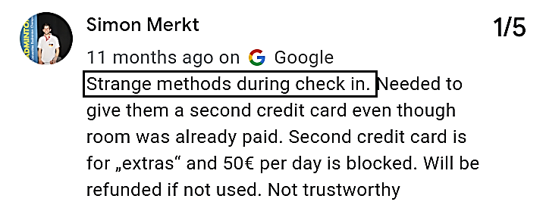

Available at: https://tinyurl.com/yt4tpdt7

Appendix 2: Complain About Staff:
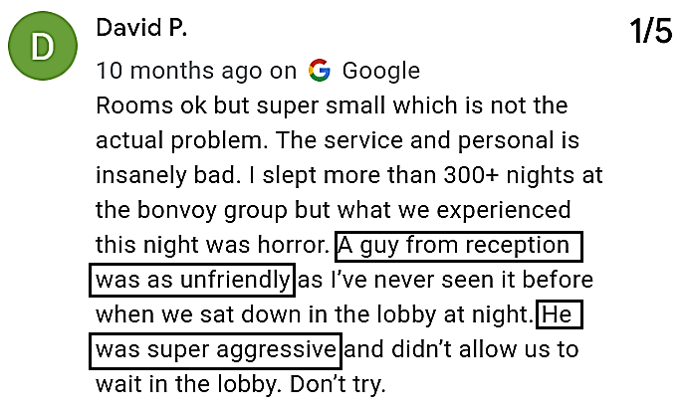

Available at: https://tinyurl.com/yt4tpdt7

Appendix 3: Complaint about security
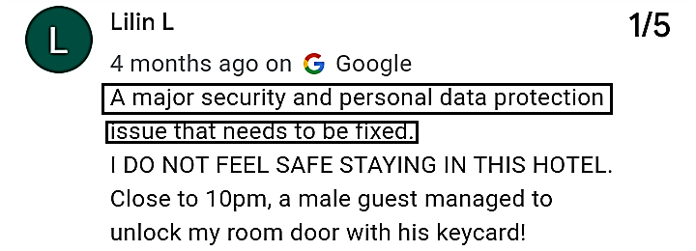

Available at: https://tinyurl.com/yt4tpdt7

Appendix 4: Complain about Room:
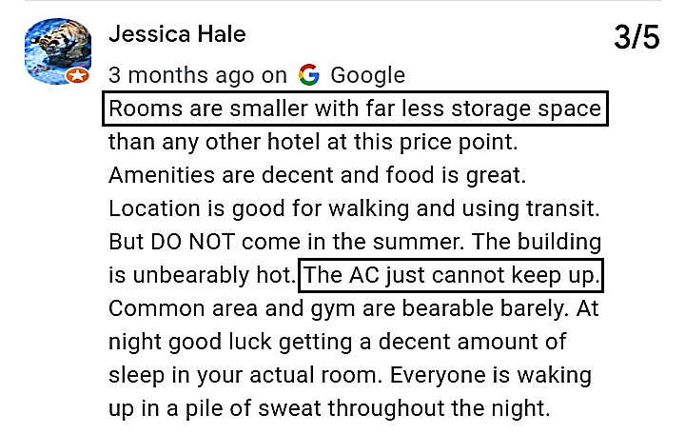

Available at: https://tinyurl.com/yt4tpdt7

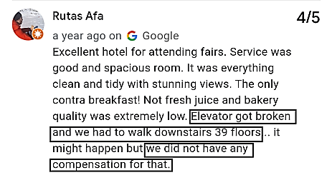
Appendix 5: Complaint about elevator

Available at: https://tinyurl.com/yt4tpdt7

Appendix 6: Complaint about Washroom:
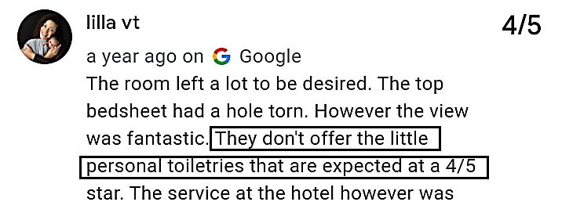

Available at: https://tinyurl.com/yt4tpdt7

Appendix 7: Complaint about Bedding:
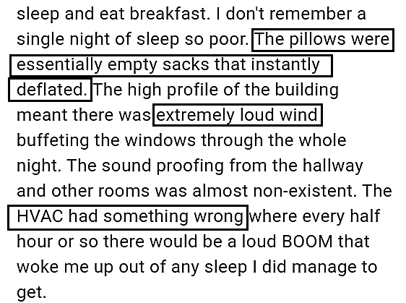

Available at: https://tinyurl.com/yt4tpdt7

Appendix 8: Complaint about Elite member service
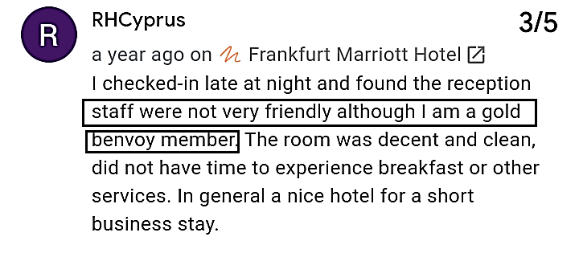

Available at: https://tinyurl.com/yt4tpdt7

Appendix 9: Complaint about Breakfast
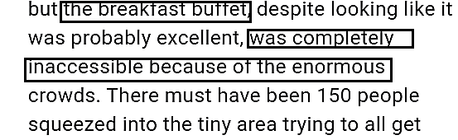

Available at: https://tinyurl.com/yt4tpdt7

