Worksheet 3: Network Policy & Security Practices

Network Operating Systems and Services (ACCA5023)
April 2021

Abstract
This report will firstly narrate the practical tasks set out in the Network Operating Systems and Services (NOSS) Worksheet 3. Namely, creating and testing NTFS and network share permissions. The second section of the report will discuss group policy management and implement five different policies and test them. Finally, there is a discussion of the main differences between network shares and NTFS permissions, group policy management, and the implementation of password policy in an enterprise network.

Table of Contents
1 Abstract 1
2 Table of Contents 2
3 Table of Figures 3
4 Task 1: NTFS & Share Permissions 5
4.1 NTFS permissions 5
4.2 Network shares 20
5 Task 2: Group Policy Management 24
5.1 GPO 1: Removing access to the control panel 24
5.2 GPO 2: Removing access to the command prompt 27
5.3 GPO 3: Restricting access to removable media drives 30
5.4 GPO 4: Restricting software installs 32
5.5 GPO 5: Enforcing Password policy in the ‘nwtraders.msft’ domain 36
6 Task 3: Observational Tasks 40
6.1 Local permissions and file shares 40
6.2 Group policy management 40
6.3 Password principles 41
6.3.1 Password complexity 41
6.3.2 Password expiry 41
6.3.3 Password blacklists 42
6.3.4 Elevated accounts 42
6.3.5 Multi-factor authentication 42
7 References 44

Table of Figures
Figure 1 - Domain Admin Users 5
Figure 2 - Client 1 logged in as domain admin 6
Figure 3 - Dept_Important_Docs folder 7
Figure 4 - Important_File text document 7
Figure 5 - Default permissions for Dept_Important_Docs 8
Figure 6 - Dept_Important_Docs permssions error 8
Figure 7 - Disabling permission inheritance 9
Figure 8 - Disabling permission inheritance 10
Figure 9 - Blank folder permissions 10
Figure 10 - NWT-JB full control permissions 11
Figure 11 - NWT-JB full control permissions 11
Figure 12 - User 1 folder permissions 12
Figure 13 - User 2 folder permissions 13
Figure 14 - User 3 folder permissions 13
Figure 15 - NWT-JB file edit 14
Figure 16 - User 1 file edit error 15
Figure 17 - User 1 file overwrite error 15
Figure 18 - User 2 overwrite 16
Figure 19 - User 2 re-name error 16
Figure 20 - User 2 folder re-name error 17
Figure 21 - User 3 file edit 18
Figure 22 - User 3 folder re-name 18
Figure 23 - User 3 folder deletion 19
Figure 24 - New network share 20
Figure 25 - New share network path 20
Figure 26 - Access-based enumeration 21
Figure 27 - Network share permissions 22
Figure 28 - Network share mapping 23
Figure 29 - Files in the network share 23
Figure 30 - Non Admin Users OU 24
Figure 31 - NoCtrlPanAccess GPO 25
Figure 32 - NoCtrlPanAccess GPO enabled 25
Figure 33 - Group policy force update 26
Figure 34 - Control panel access denied 27
Figure 35 - NoCmdPrmptAccess GPO 28
Figure 36 – Command prompt working 28
Figure 37 - Command prompt access denied 29
Figure 38 - NoRemDriveAccess GPO 30
Figure 39 - GPO force update 31
Figure 40 - USB access denied 32
Figure 41 - NWClient Computers 33
Figure 42 - NoUnauthSoftInstalls GPO 33
Figure 43 - 7-zip installation file 34
Figure 44 - Installation denied 35
Figure 45 - Installation successful 35
Figure 46 - Default domain policy 36
Figure 47 - Password policy 37
Figure 48 - New user account 37
Figure 49 - Password change denied 38
Figure 50 - Password change successful 39

Task 1: NTFS & Share Permissions

NTFS permissions
Client 1 was logged in with NWT-JB as they are a domain admin, this ensures that the account will have sufficient permissions to create and edit shares.
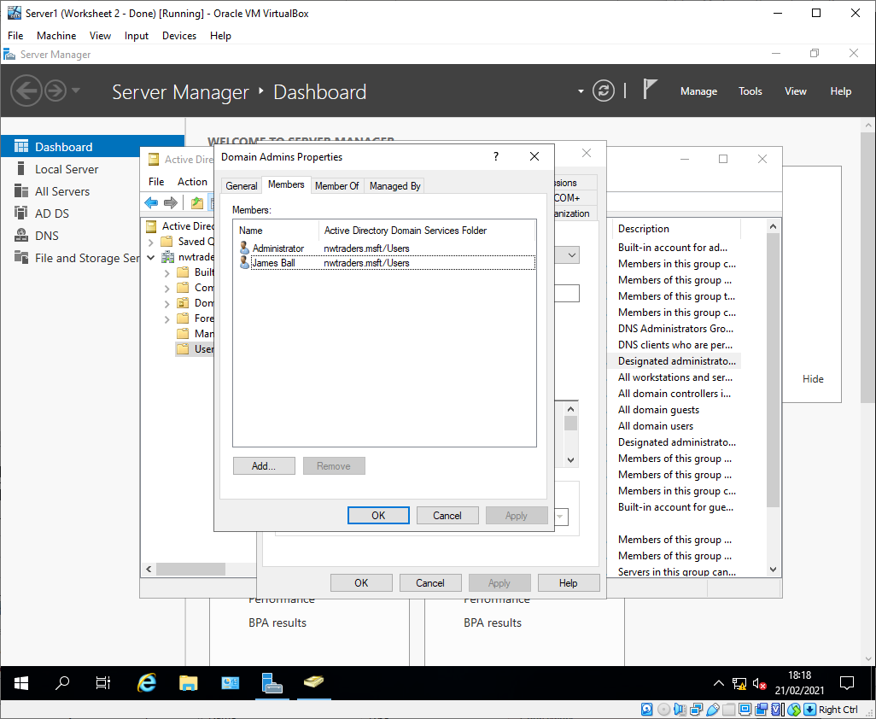
Figure 1 - Domain Admin Users
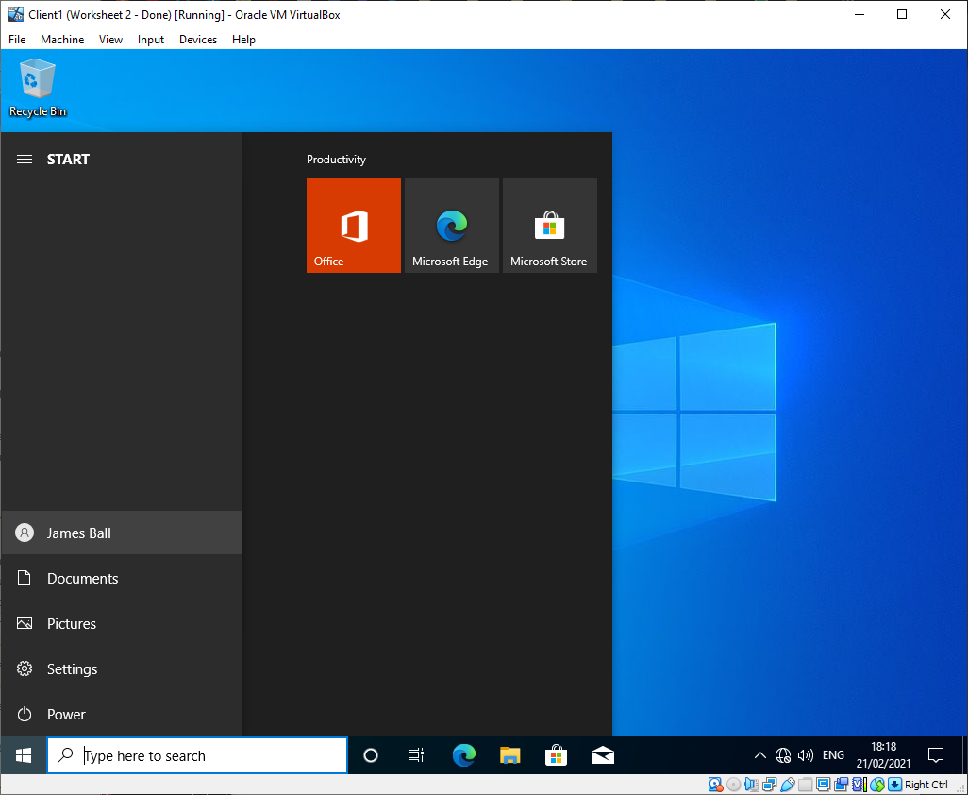
Figure 2 - Client 1 logged in as domain admin
A folder “Dept_Important_Docs” was created in the root C: directory on client 1
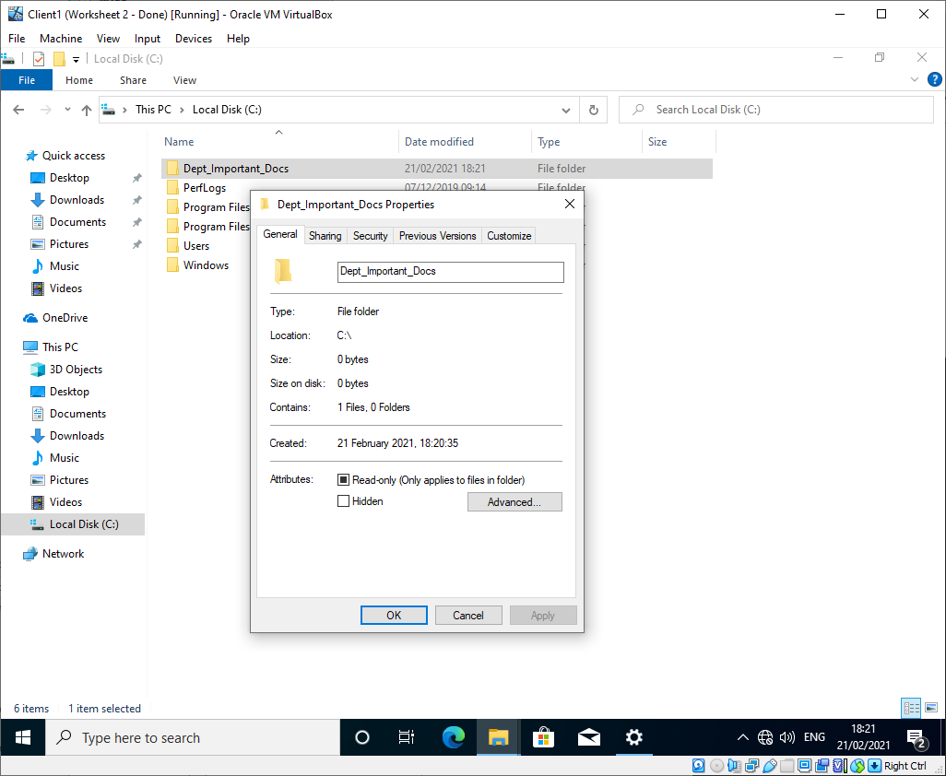
Figure 3 - Dept_Important_Docs folder
A text file “Important_File” was created in this new folder.
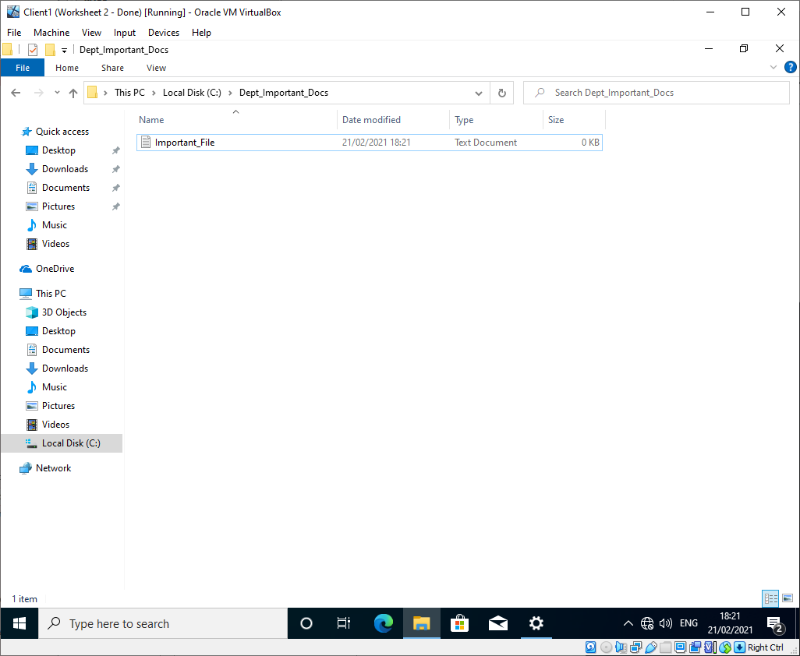
Figure 4 - Important_File text document

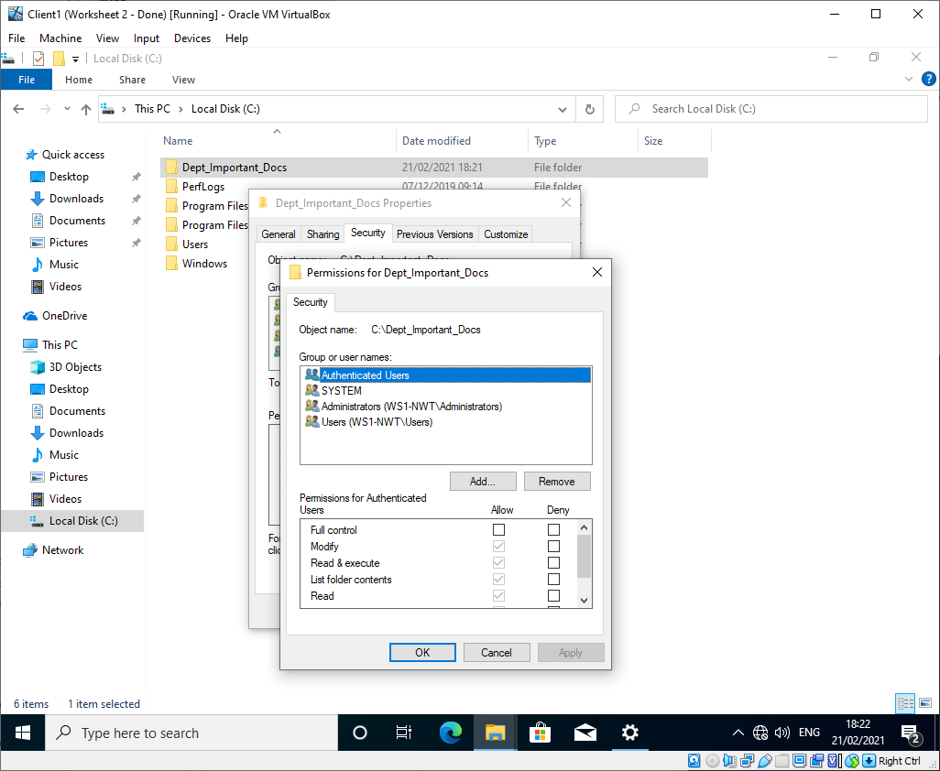
Figure 5 - Default permissions for Dept_Important_Docs
An error occurred when attempting to remove “Authenticated Users” from having access to the folder. This was due to the folder inheriting permissions from the root C: directory.
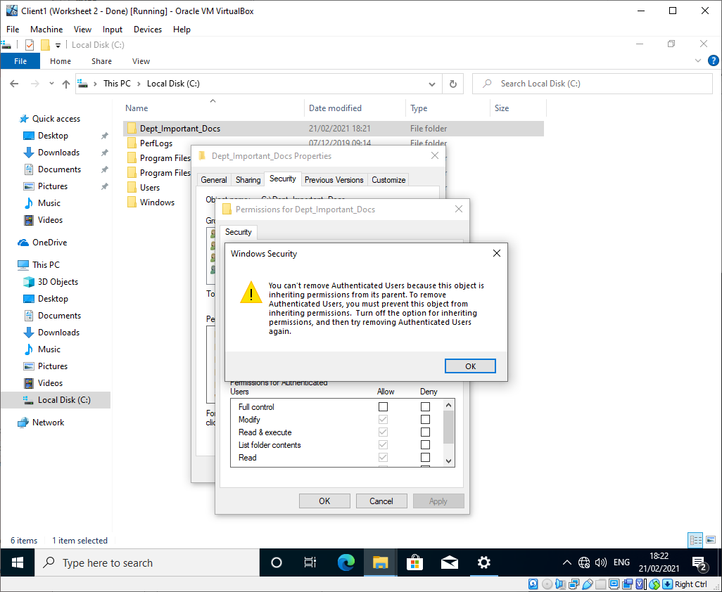
Figure 6 - Dept_Important_Docs permssions error

To resolve this, permission inheritance was disabled on the folder.
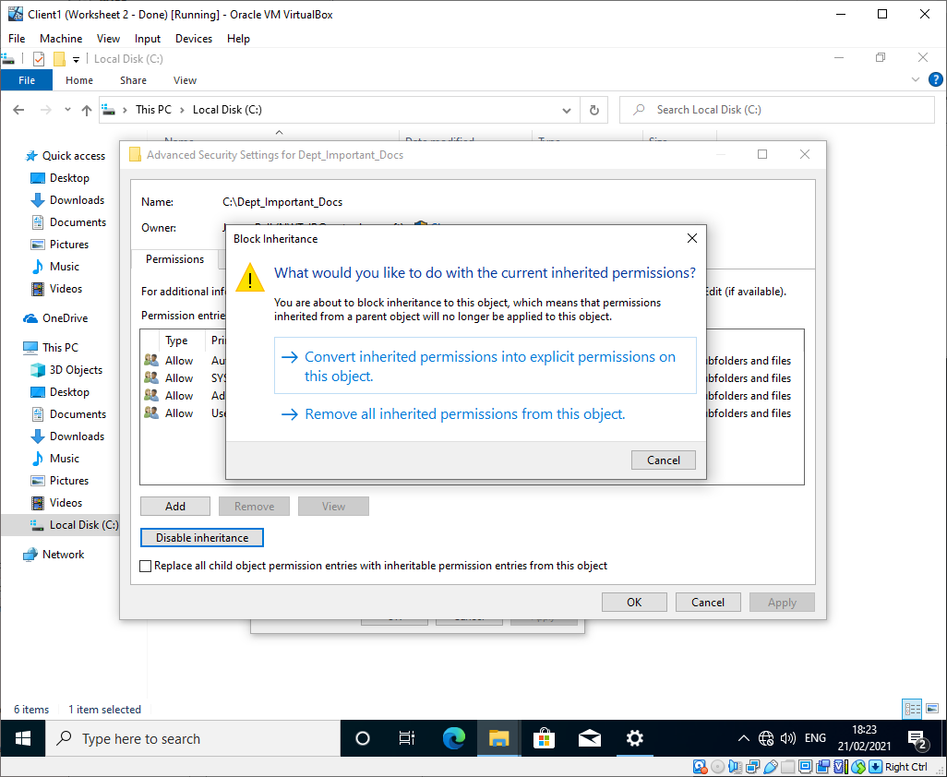
Figure 7 - Disabling permission inheritance
This disables all permissions on the folder and only the folder owner (NWT-JB in this case) will be able to add new permissions.
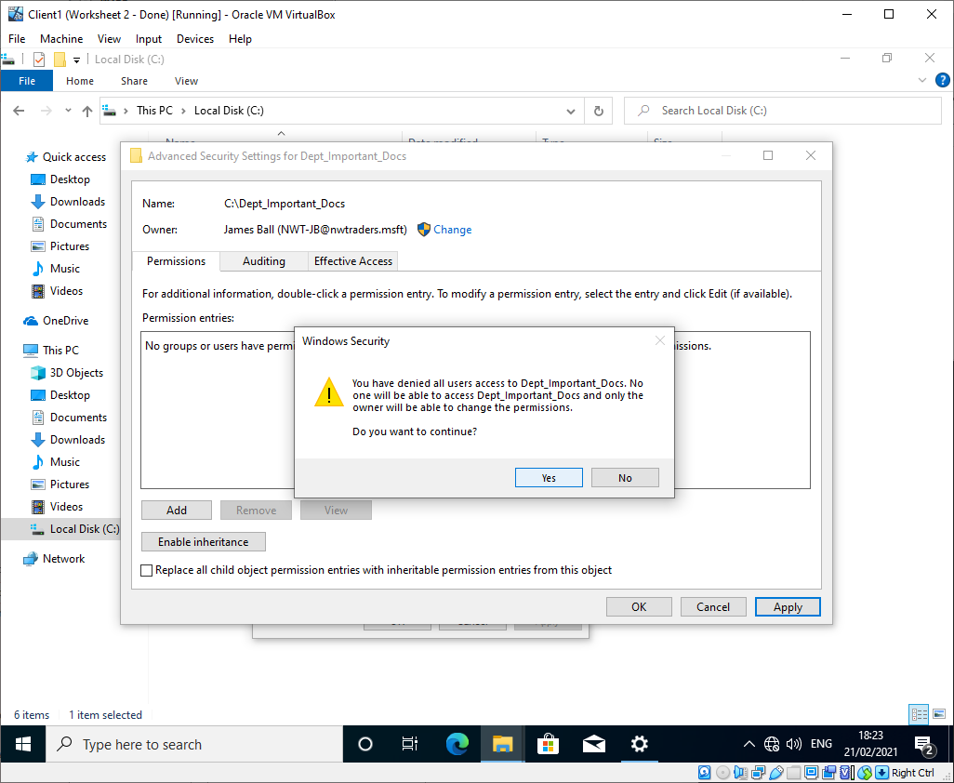
Figure 8 - Disabling permission inheritance

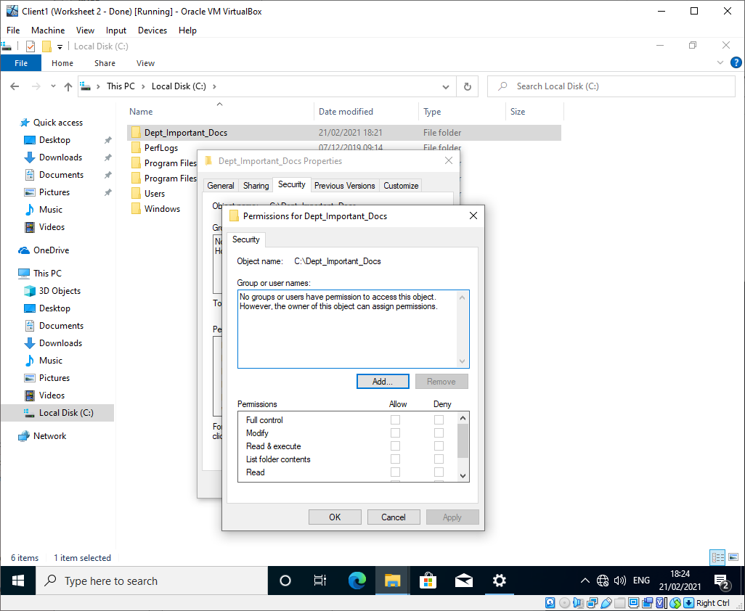
Figure 9 - Blank folder permissions
The admin account NWT-JB was given full control permissions to the folder.
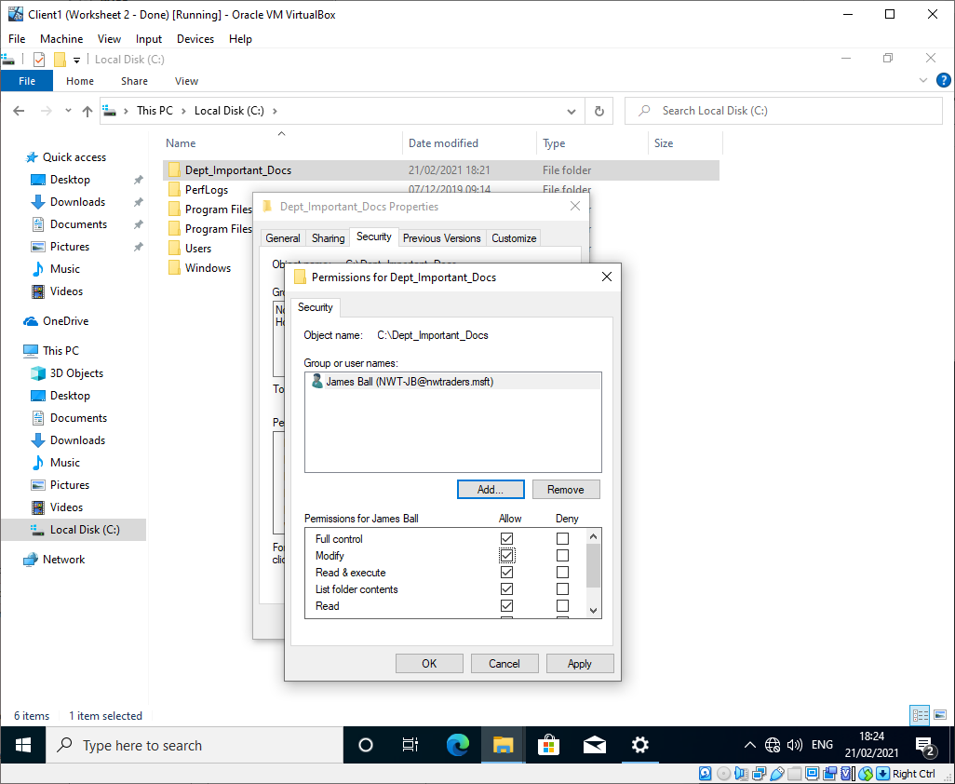
Figure 10 - NWT-JB full control permissions

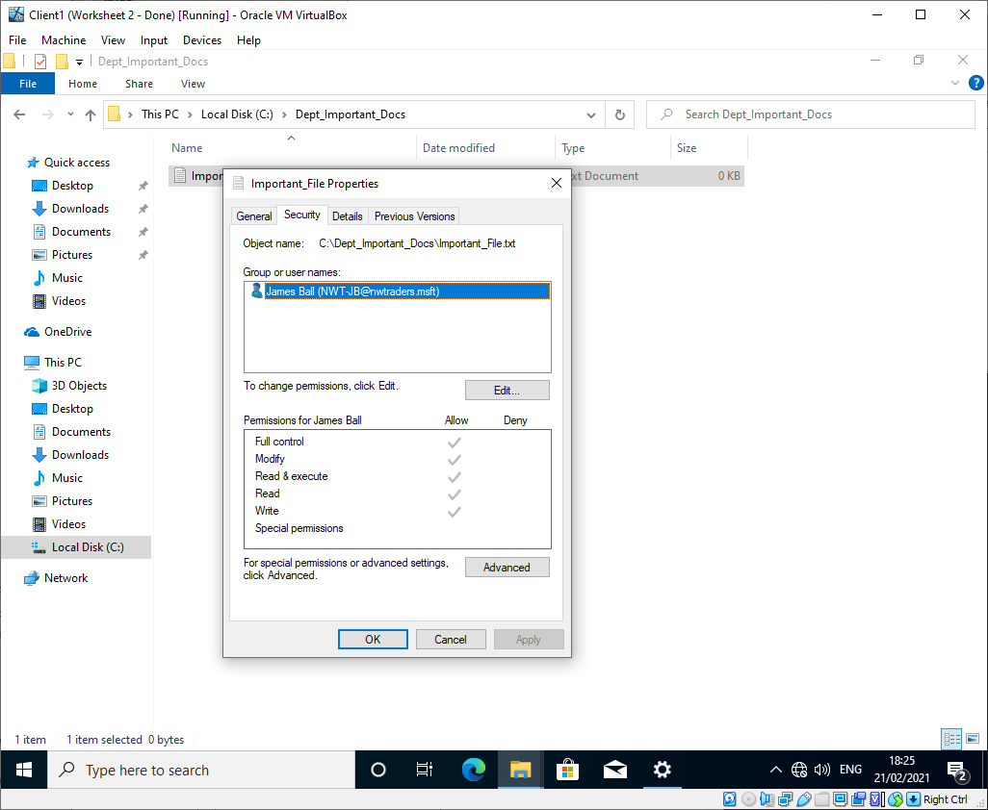
Figure 11 - NWT-JB full control permissions
After this, three additional users were given permissions to the folder:
- User 1 had read, list
- User 2 had read, list, write
- User 3 had read, list, write, and modify

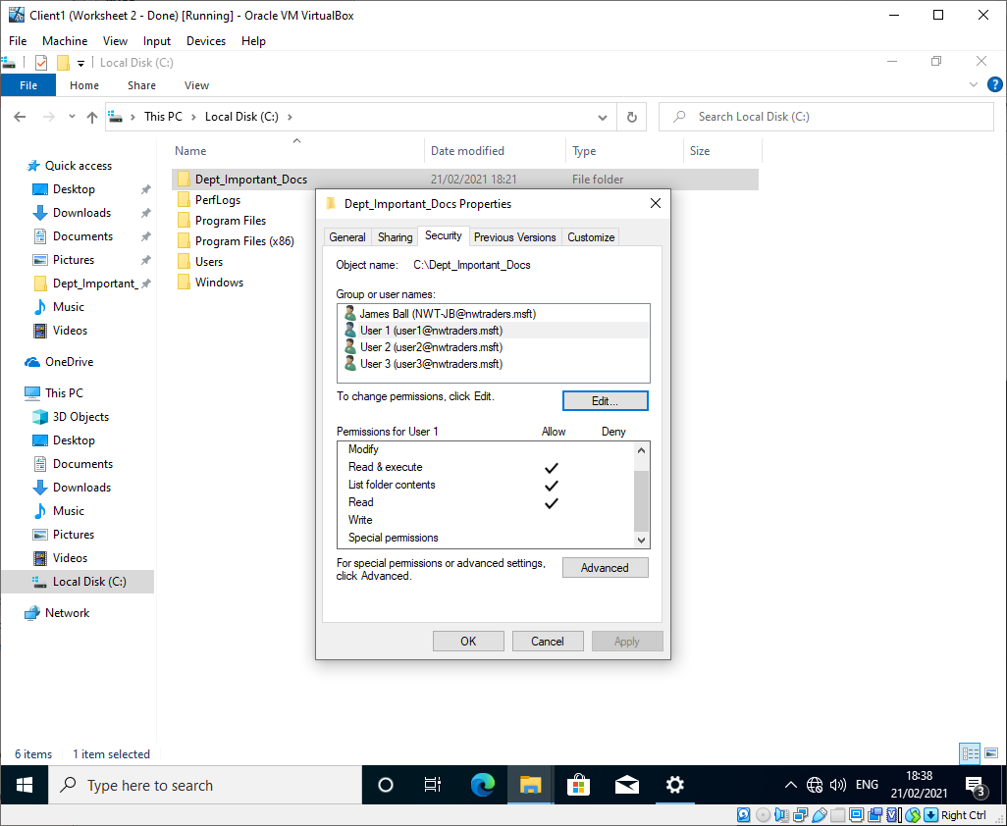
Figure 12 - User 1 folder permissions
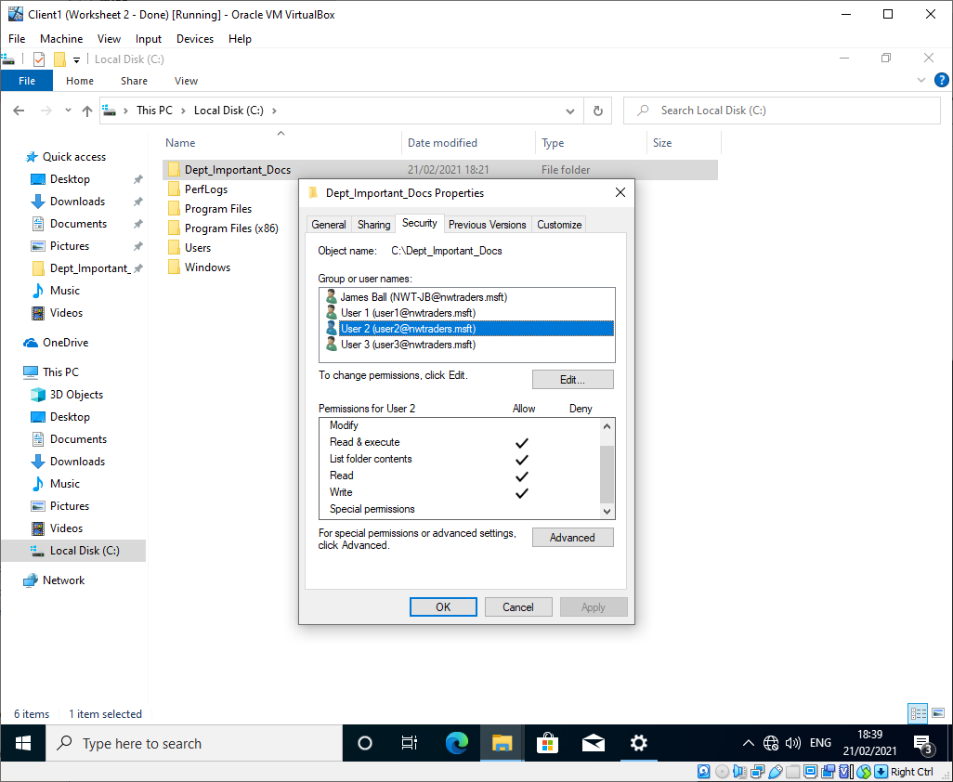
Figure 13 - User 2 folder permissions

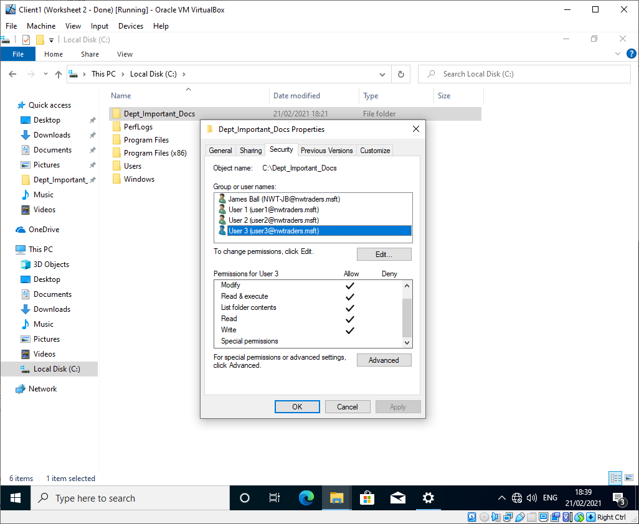
Figure 14 - User 3 folder permissions
As expected, NWT-JB was able to save an edit to the file as they have full control permissions.
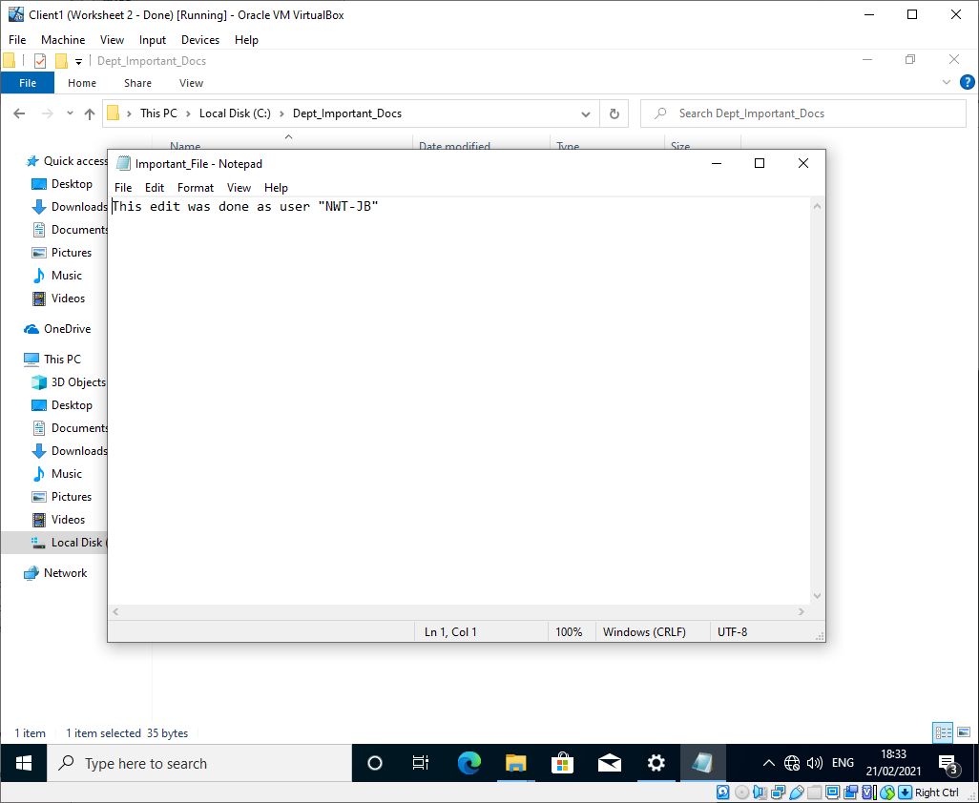
Figure 15 - NWT-JB file edit
NWT-JB was logged out and User 1 was logged into client 1. User 1 was able to open the file, but were unable to overwrite the current file or save a new version with modified content.
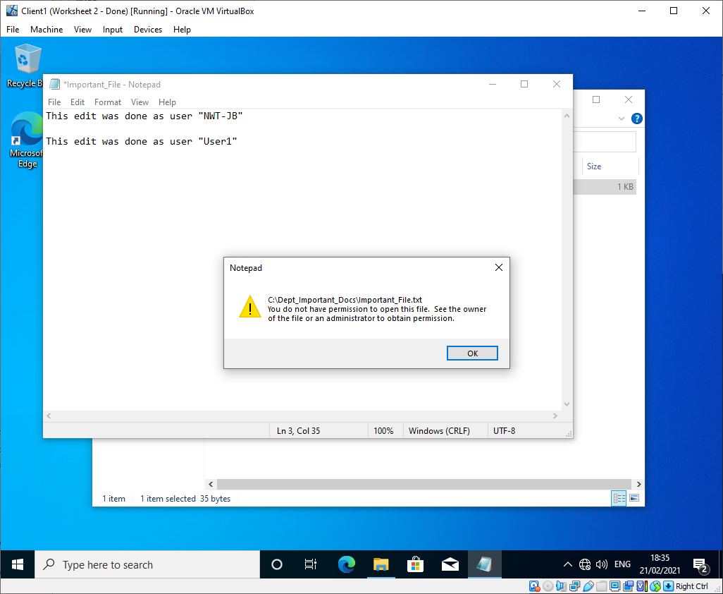
Figure 16 - User 1 file edit error
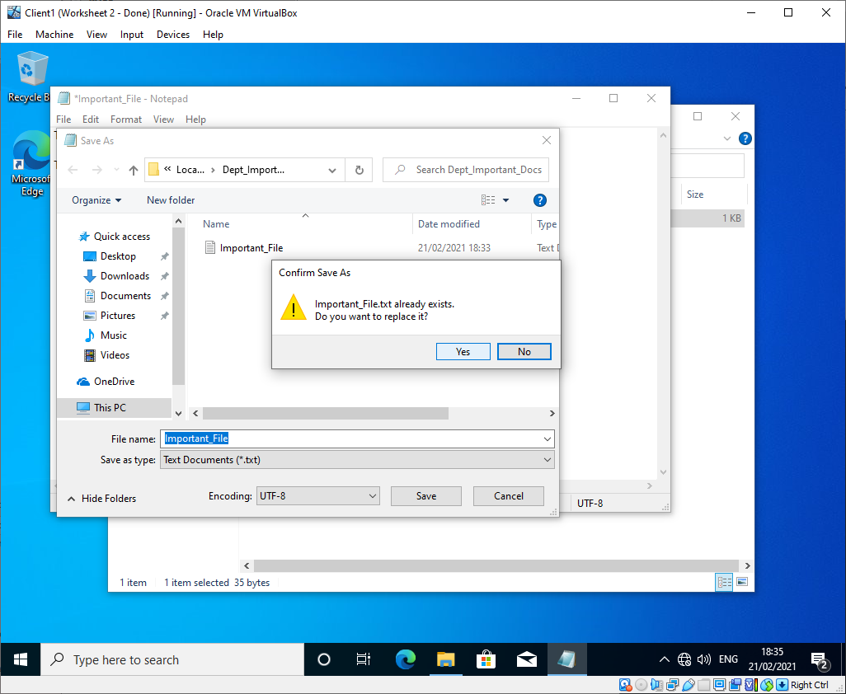
Figure 17 - User 1 file overwrite error

User 2 was able to overwrite the current version of the file and create a new folder, but was unable to re-name the file or folder.
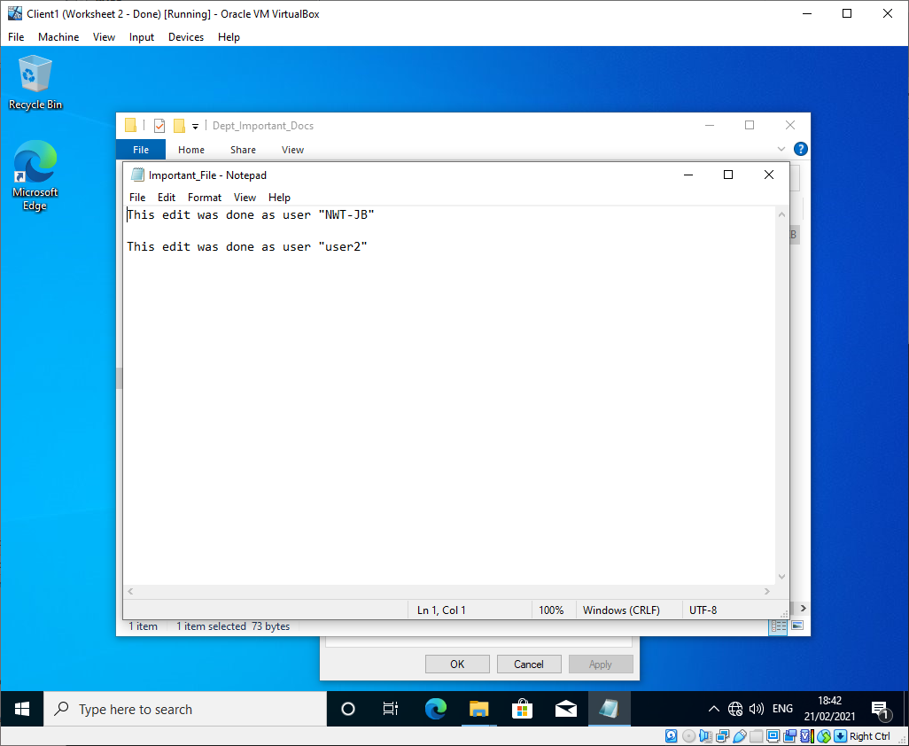
Figure 18 - User 2 overwrite
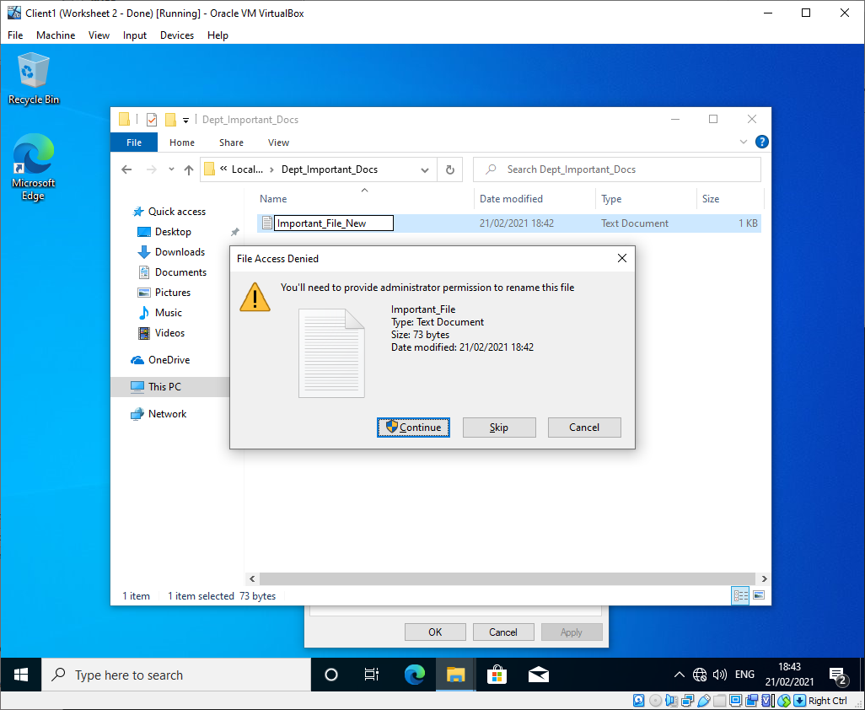
Figure 19 - User 2 re-name error
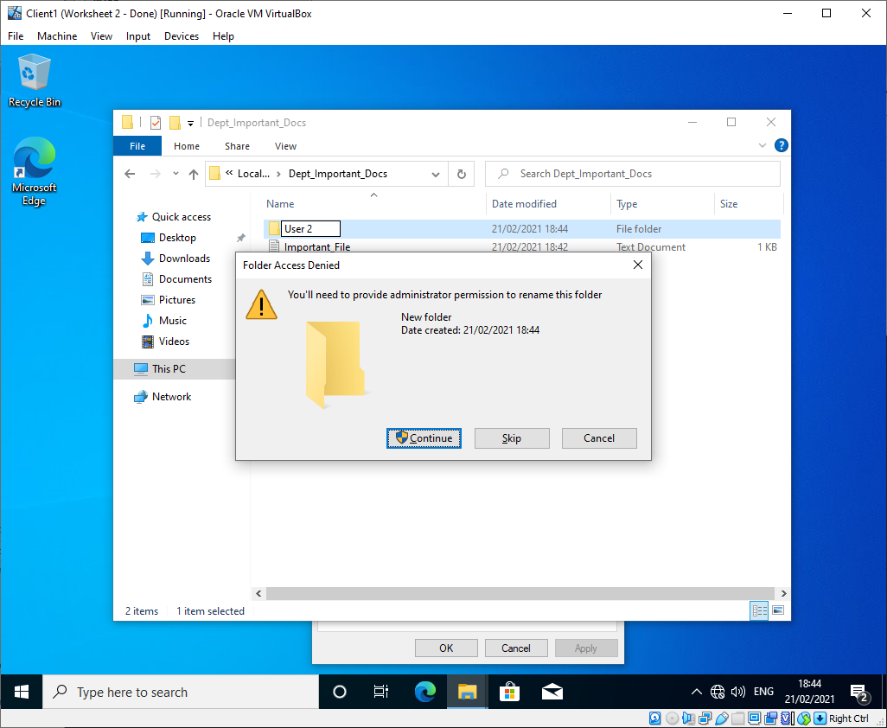
Figure 20 - User 2 folder re-name error
User three was able to do all the tasks users 1 and 2 were able to, with the addition of renaming and deleting objects. The difference between having read & write and having modify access is that having modify access grants the ability to delete and rename files/folders
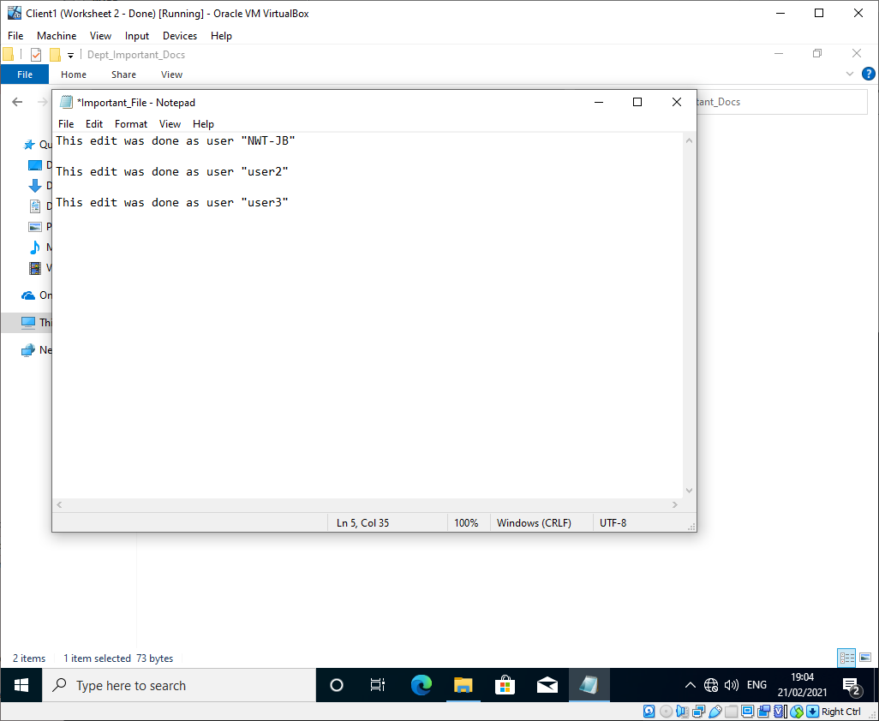
Figure 21 - User 3 file edit

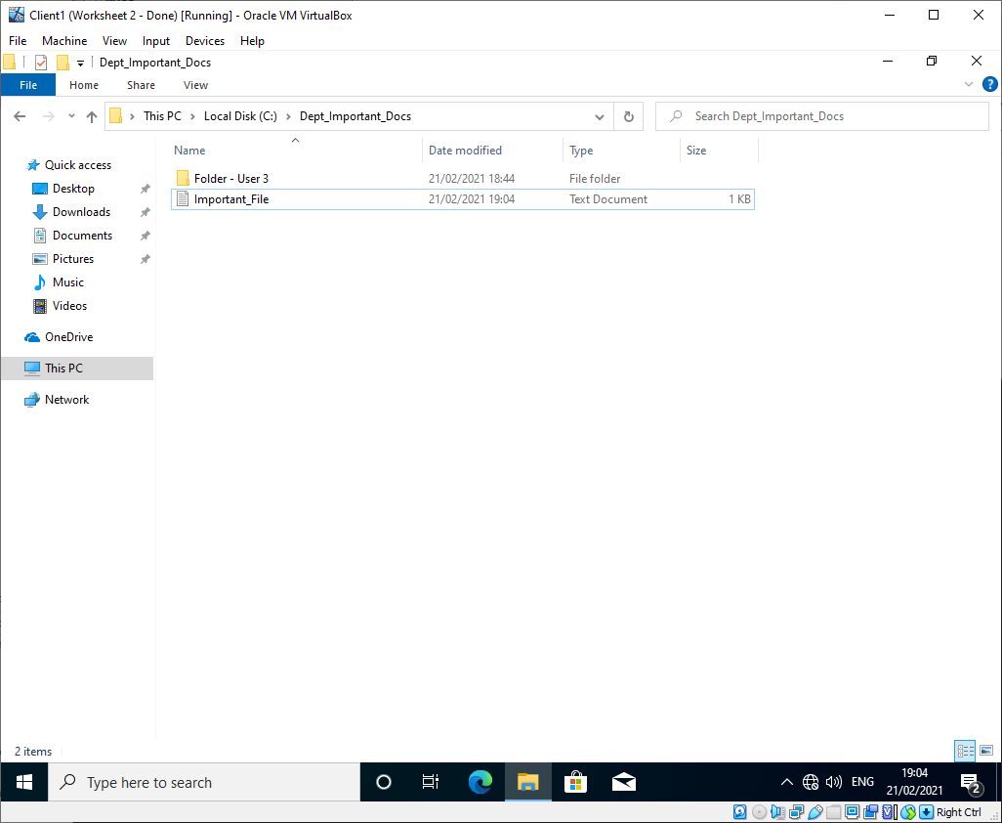
Figure 22 - User 3 folder re-name
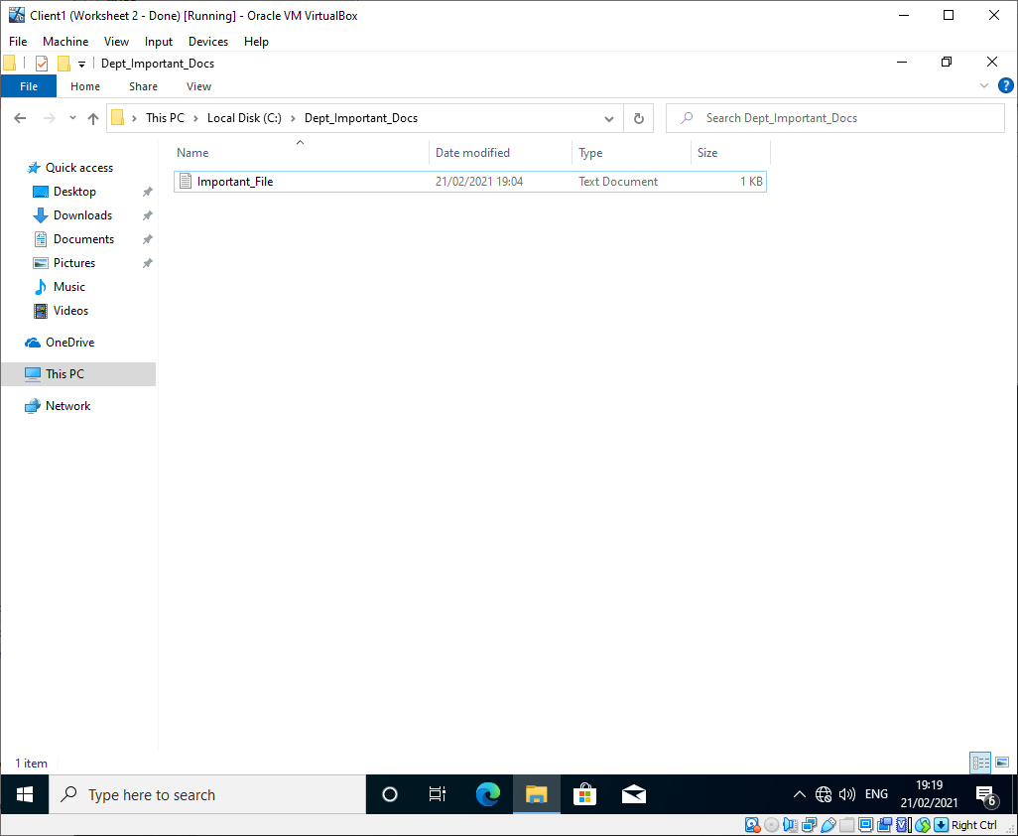
Figure 23 - User 3 folder deletion

Network shares
A new network share was created on Server 1 with the path “\\YourServerName\DeptNetShare$”.
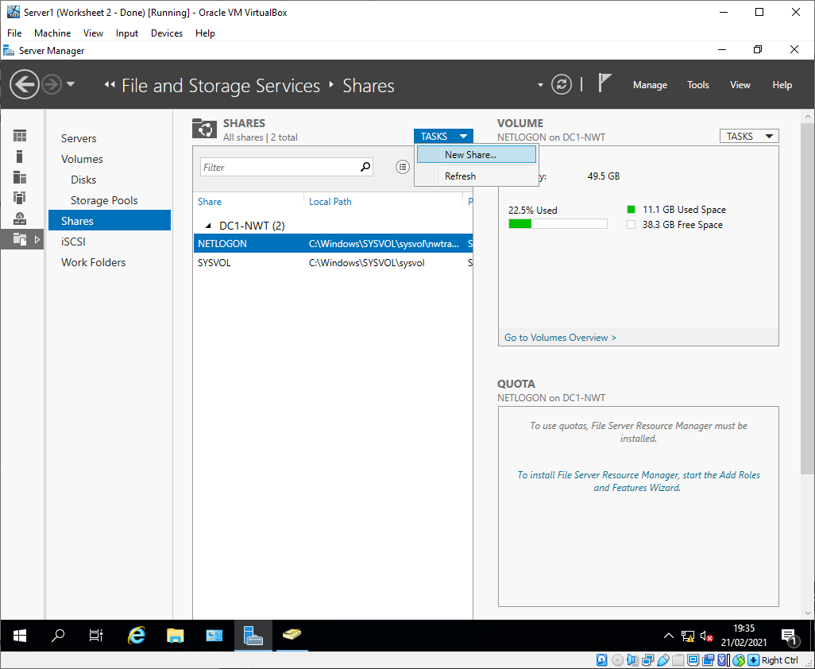
Figure 24 - New network share
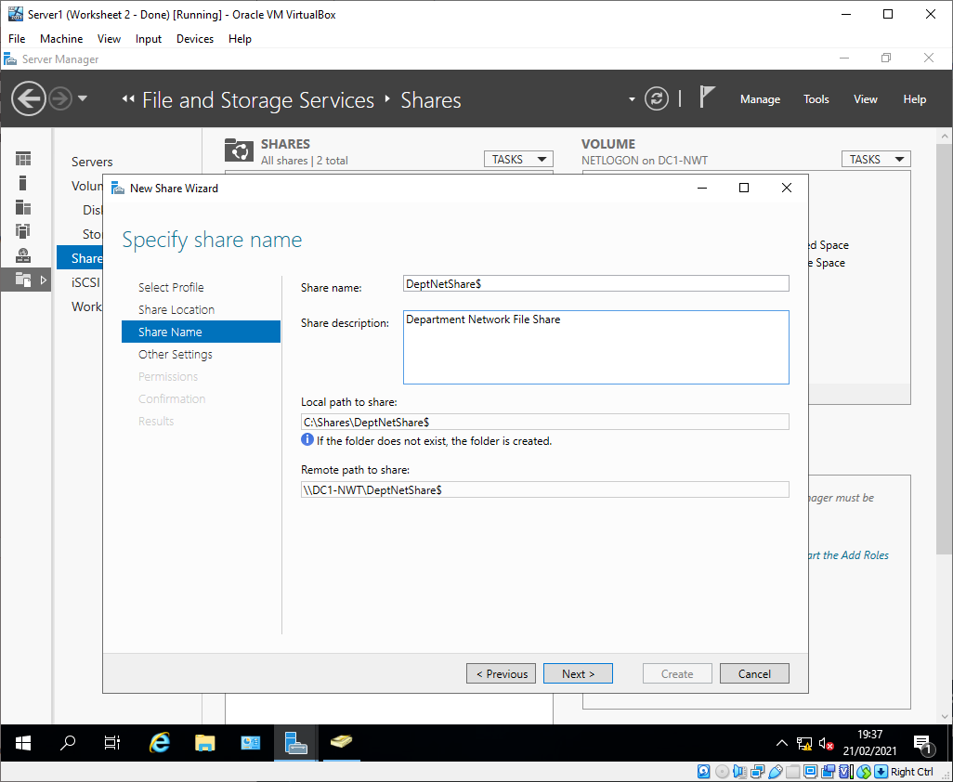
Figure 25 - New share network path

Access-based enumeration was enabled on the share to ensure that only users who have access to the files will be able to see them.
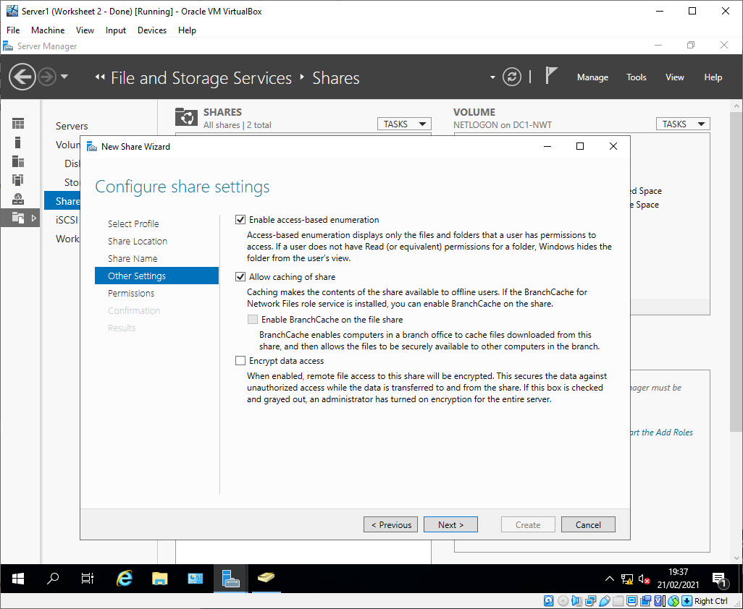
Figure 26 - Access-based enumeration
Admin users were given full control of the share, and users 1, 2, and 3 were given read and execute permissions.
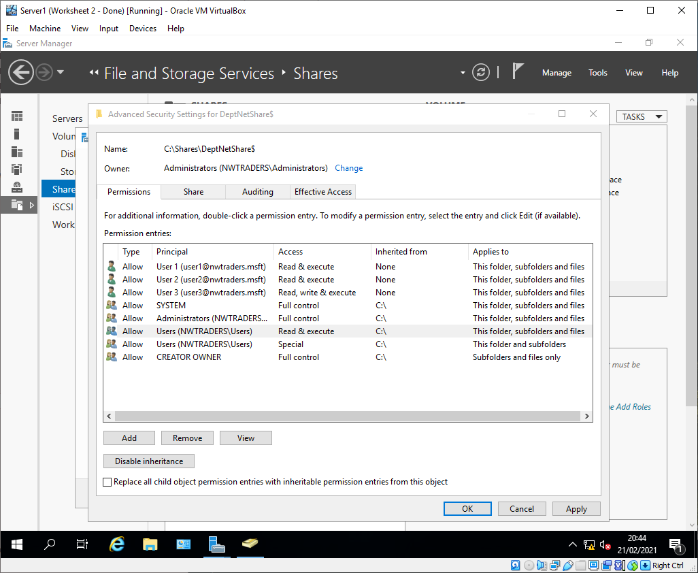
Figure 27 - Network share permissions
To test the share, it was mapped on Client 1 using the drive letter z.
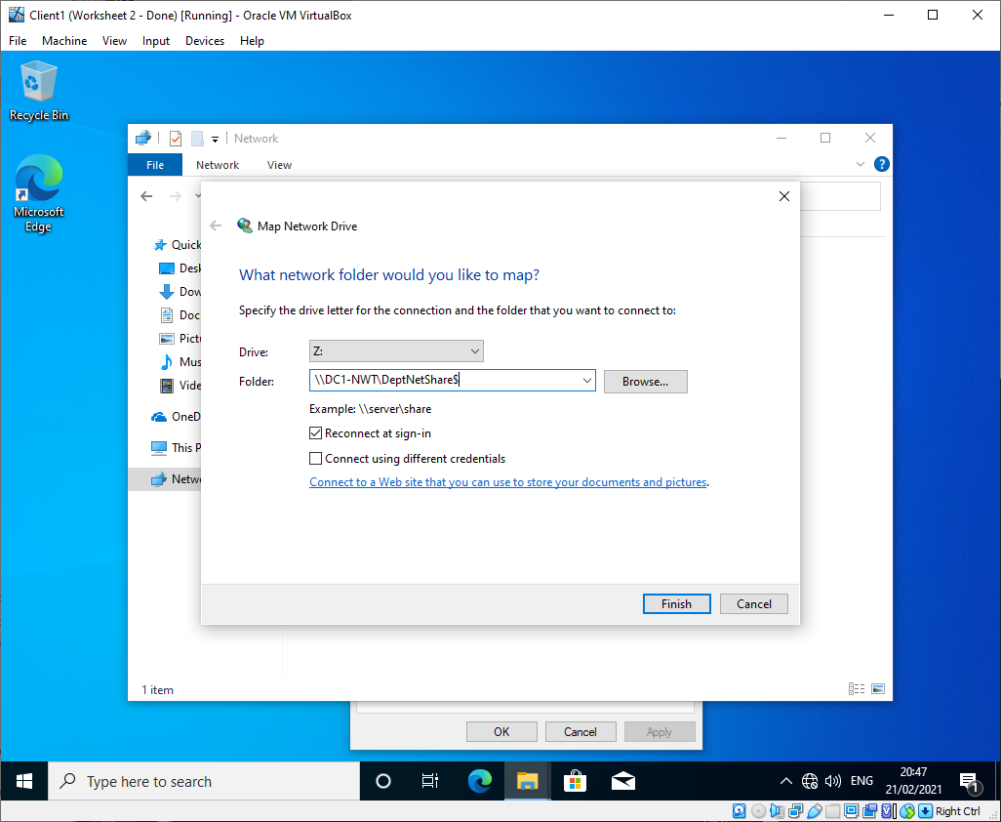
Figure 28 - Network share mapping
As expected, the admin users were able to create new sub-folders etc., whilst the normal users were only able to read the files.
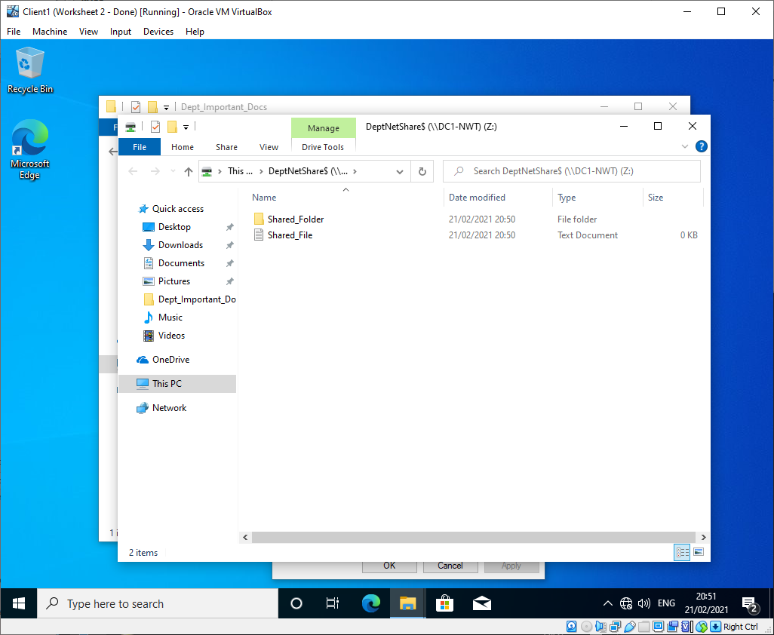
Figure 29 - Files in the network share

Task 2: Group Policy Management

GPO 1: Removing access to the control panel
A new Organisational Unit (OU) was created, “Non Admin Users” in the root of the nwtraders domain and several users were added to it. This OU was created so that GPOs could be applied to specifically non-admin users.
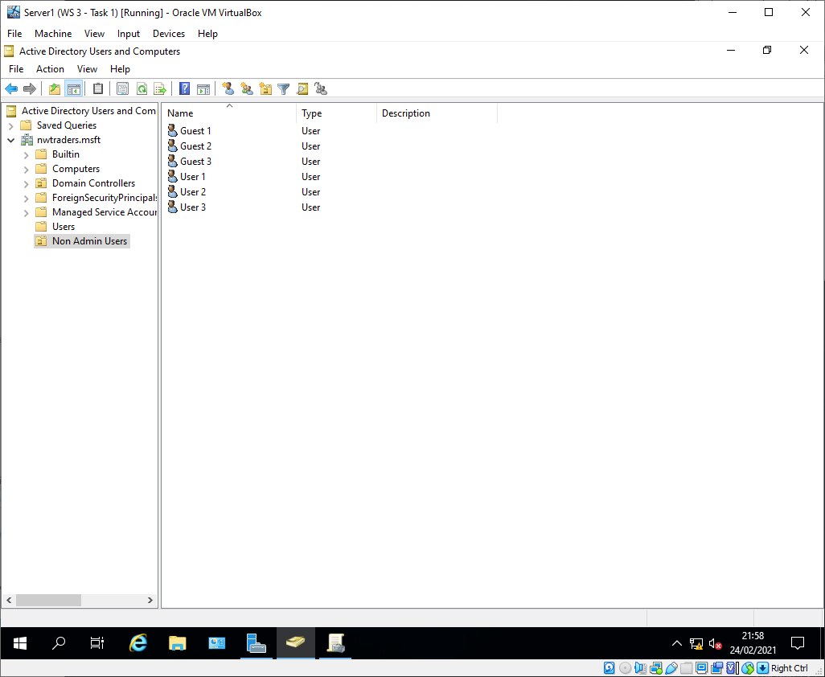
Figure 30 - Non Admin Users OU

A Group Policy Object (GPO) was created and linked to this OU called “NoCtrlPanAccess” which disabled users access to the control panel.
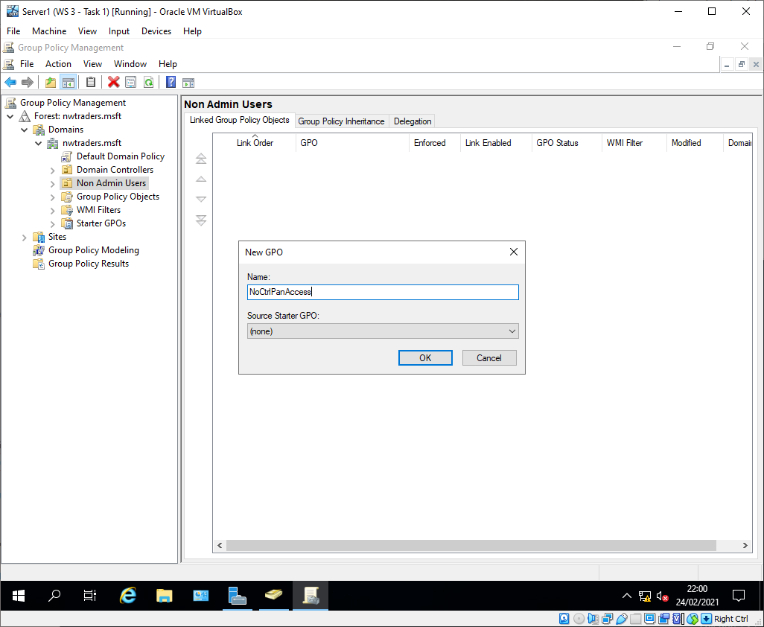
Figure 31 - NoCtrlPanAccess GPO
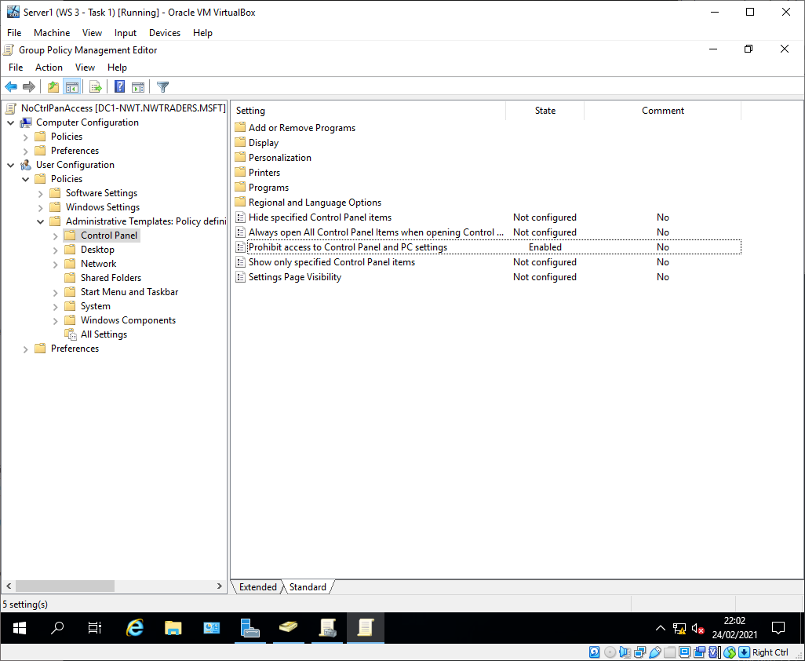
Figure 32 - NoCtrlPanAccess GPO enabled

The group policy update was forced, which overwrites the normal 30-minute timer for clients to check for group policy.
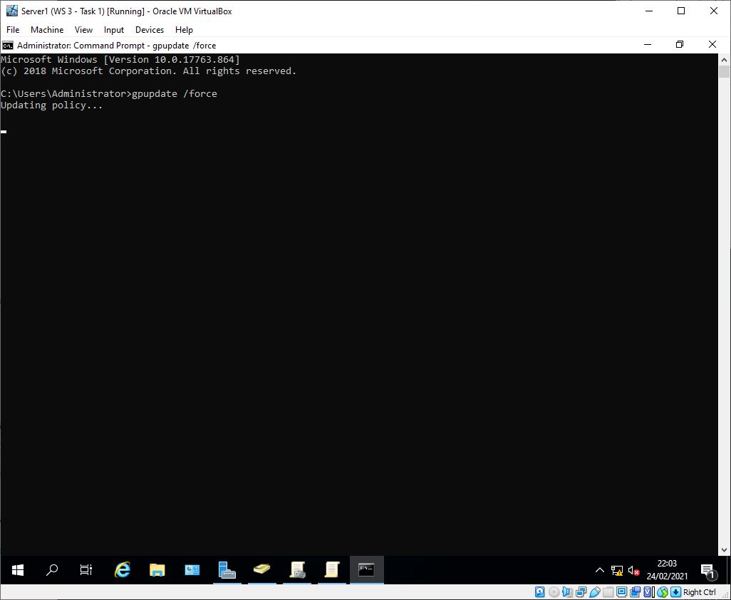
Figure 33 - Group policy force update
The group policy was tested and the users in that OU were unable to open the control panel as expected.
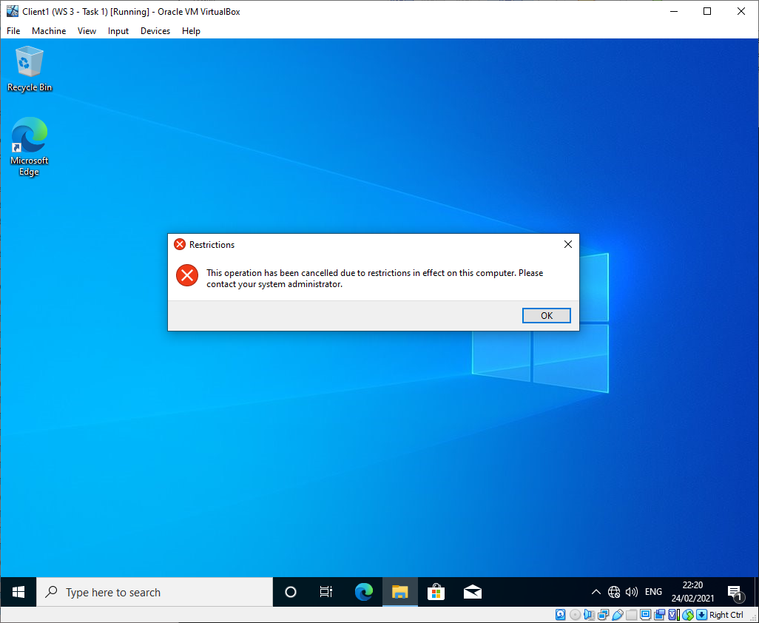
Figure 34 - Control panel access denied

GPO 2: Removing access to the command prompt
A second GPO was created and linked to the non-admin OU. This GPO removed the access for users to run command prompt, this can reduce the effect of account compromise or malware attacks that rely on the command prompt.
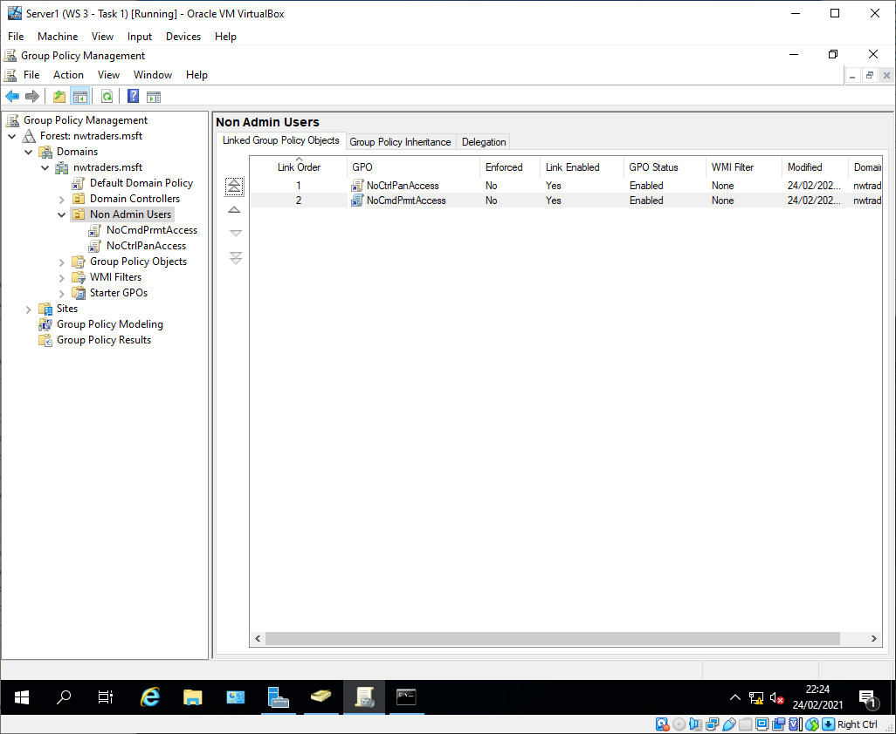
Figure 35 - NoCmdPrmptAccess GPO

Whilst the policy was updated again, because user2 was still logged in the GPO hadn't applied. Once the user logged out and back in and the GPO was applied correctly, and the user could no longer access the command prompt.
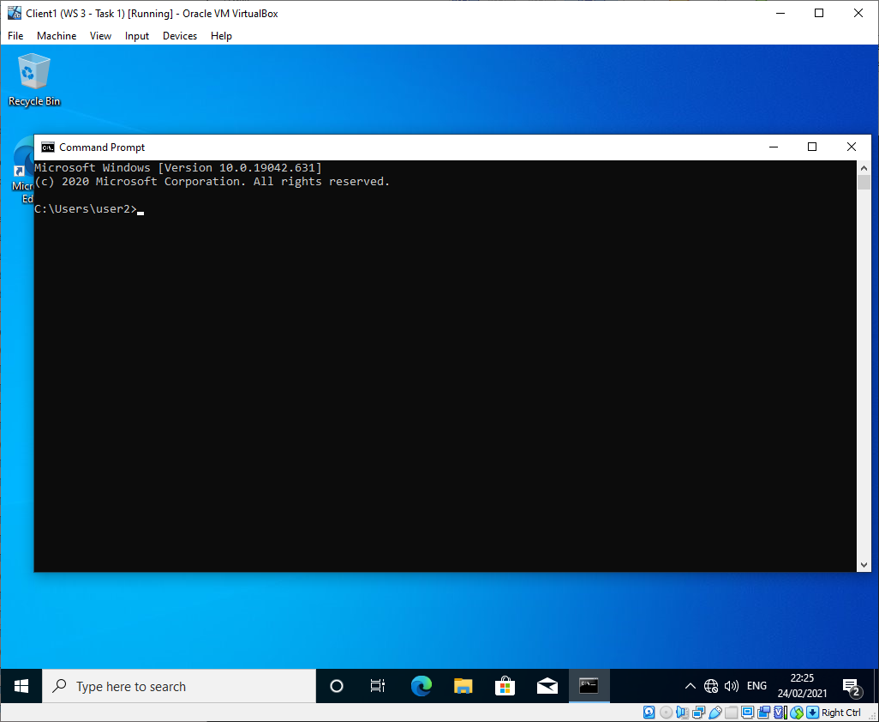
Figure 36 – Command prompt working
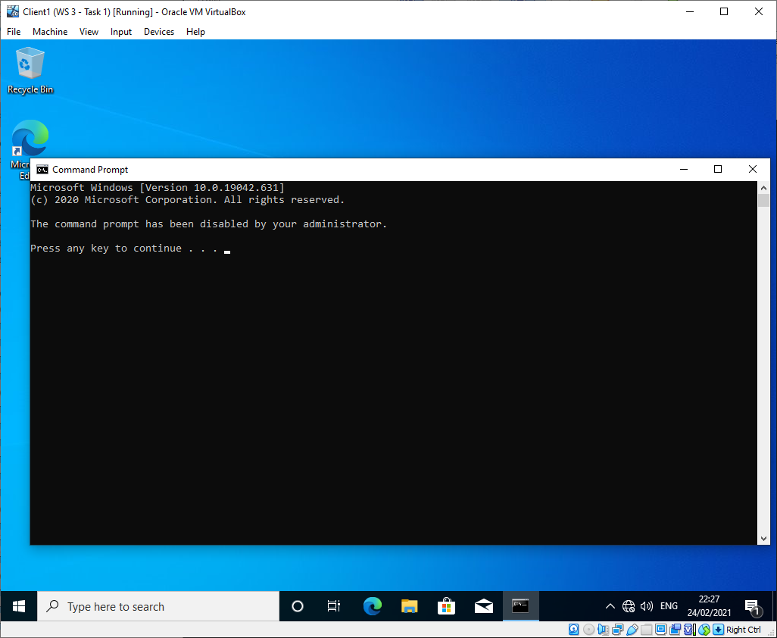
Figure 37 - Command prompt access denied

GPO 3: Restricting access to removable media drives
A third GPO was created and linked to the OU, this one restricts access to removable storage such as USB flash drives. This can prevent the unintentional spread of malware through a network via USB drives.
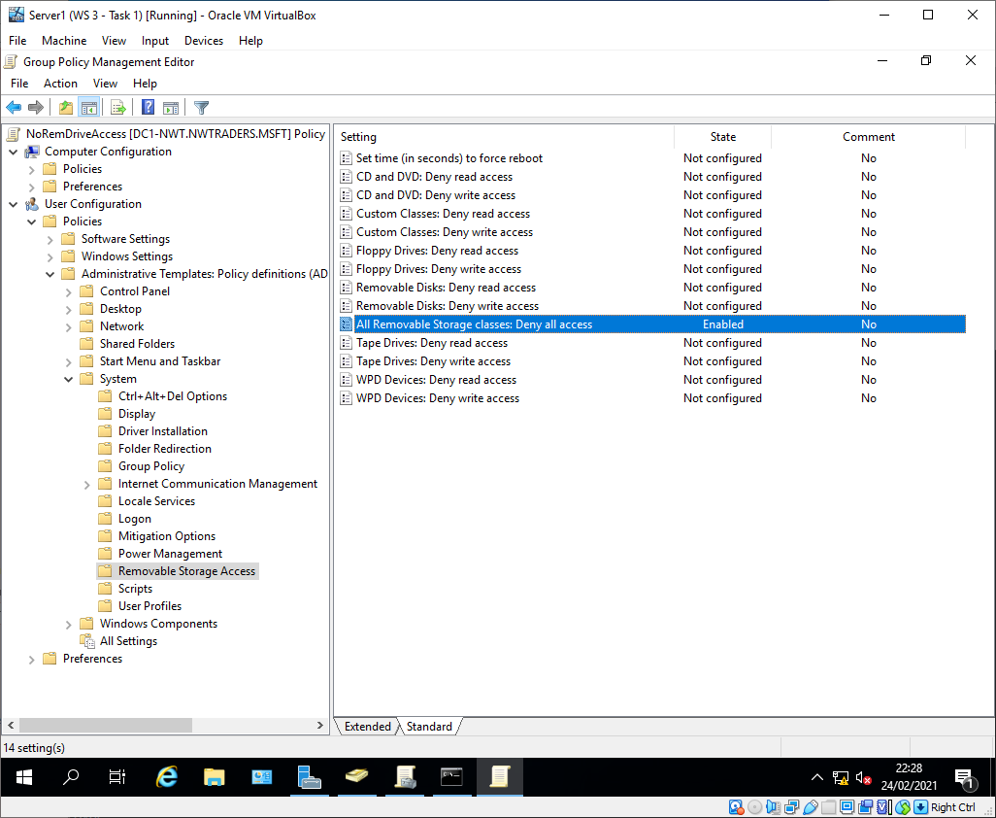
Figure 38 - NoRemDriveAccess GPO
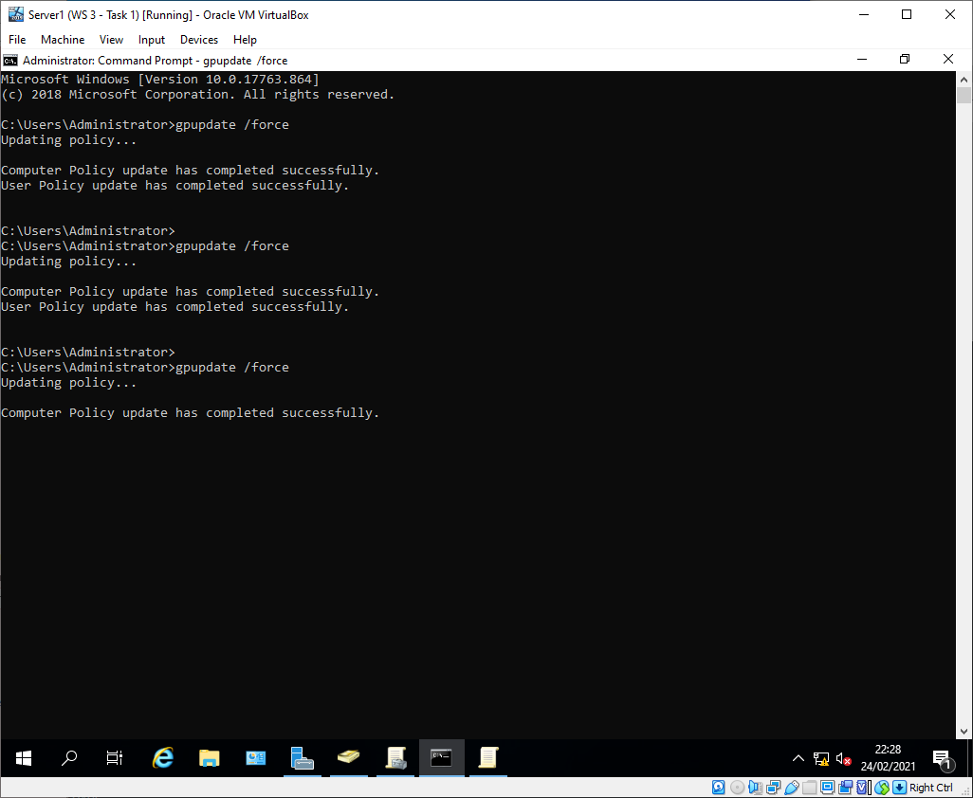
Figure 39 - GPO force update

Again, the GPO wasn't applied until the user signed out and back in again, then it was enforced as expected and the USB stick access was denied
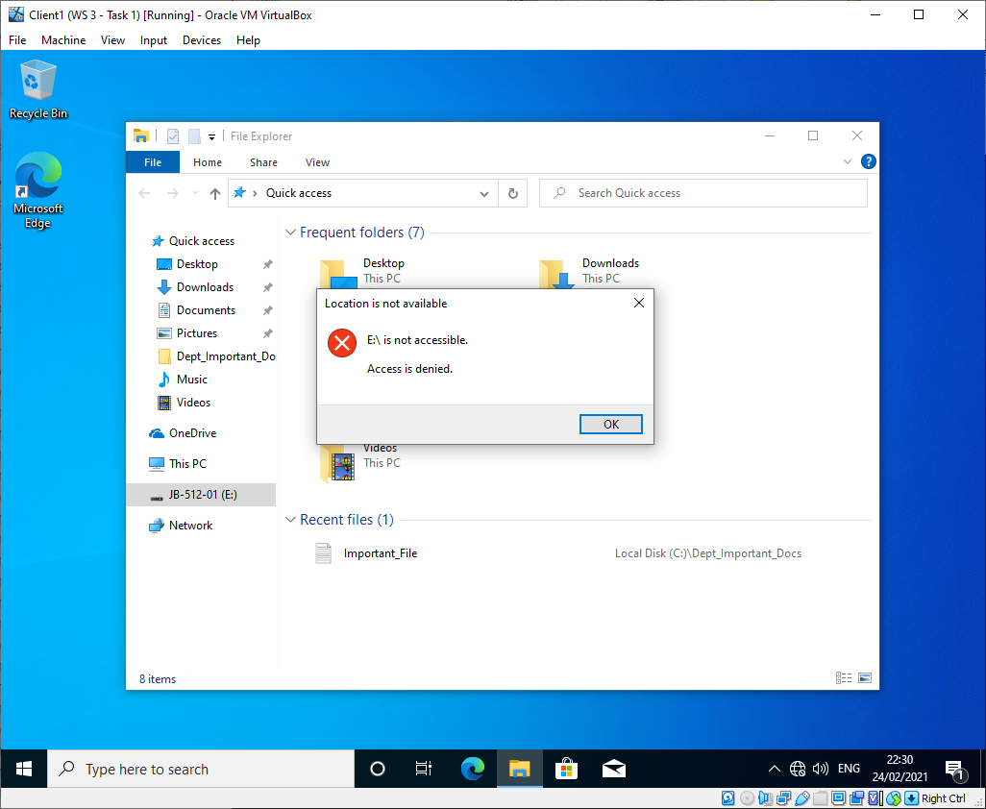
Figure 40 - USB access denied

GPO 4: Restricting software installs
A new OU was created “NWClient Computers” in the root of the nwtraders domain, and client 1 was added to the OU. This is because the GPO that will be linked with it applies to computers.
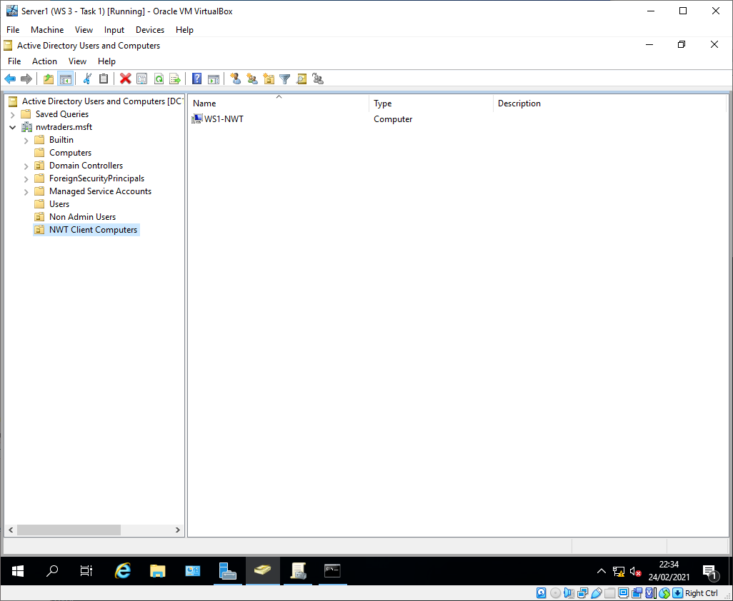
Figure 41 - NWClient Computers

A GPO was created and linked to the OU with the policy to prohibit software installations.
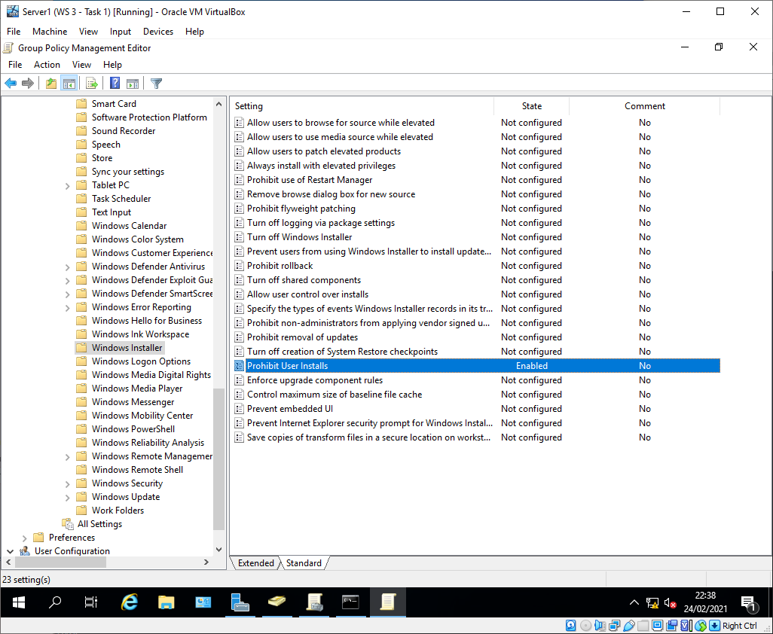
Figure 42 - NoUnauthSoftInstalls GPO
The GPO was tested on client 1 with a 7zip installation file[1]. When the installation was attempted using the non-admin credentials it was denied.
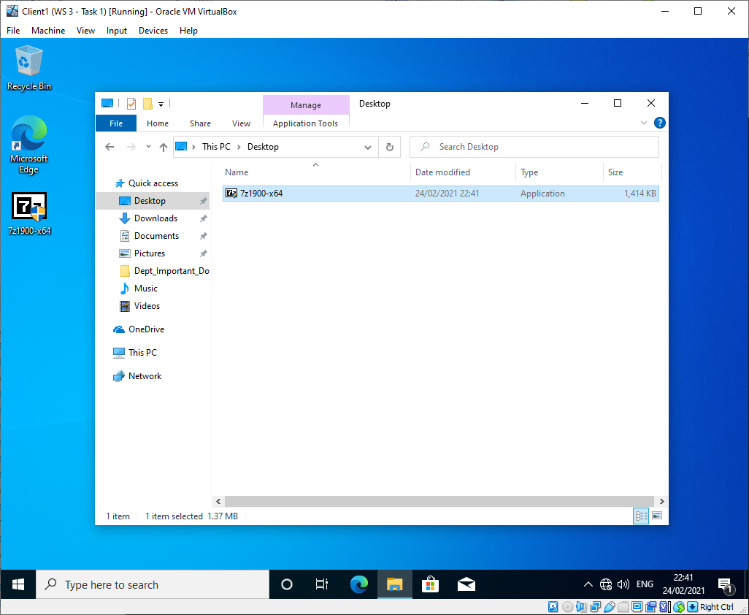
Figure 43 - 7-zip installation file

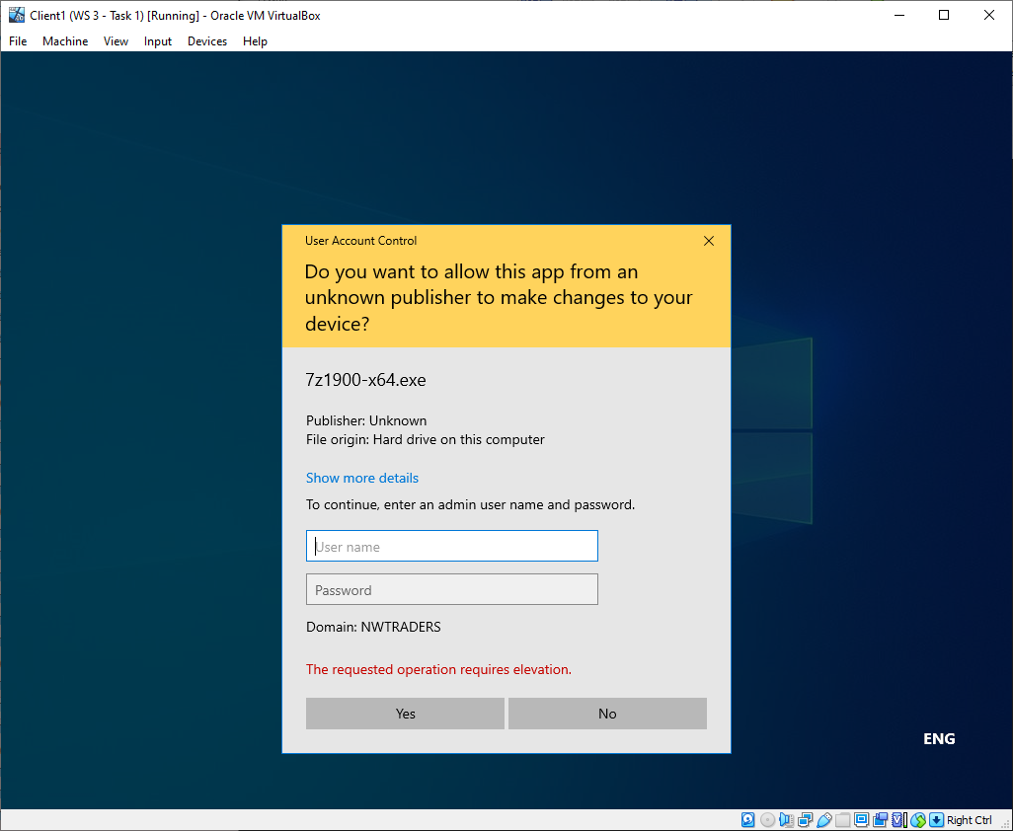
Figure 44 - Installation denied

When the login prompt was re-tried with admin credentials 7-Zip was able to be installed.
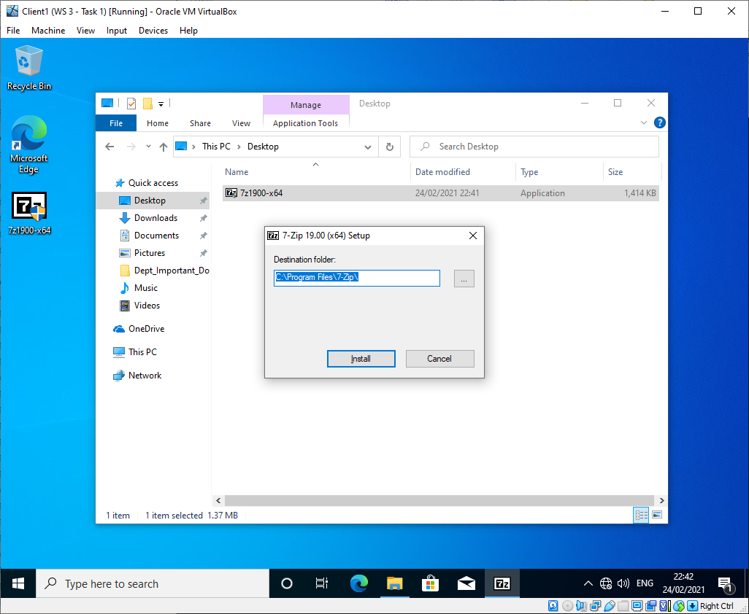
Figure 45 - Installation successful

GPO 5: Enforcing Password policy in the ‘nwtraders.msft’ domain
The default domain policy was updated to change the password policy, this is one of the few times editing the default domain policy is recommended as it is something that should be applied to the entire domain.
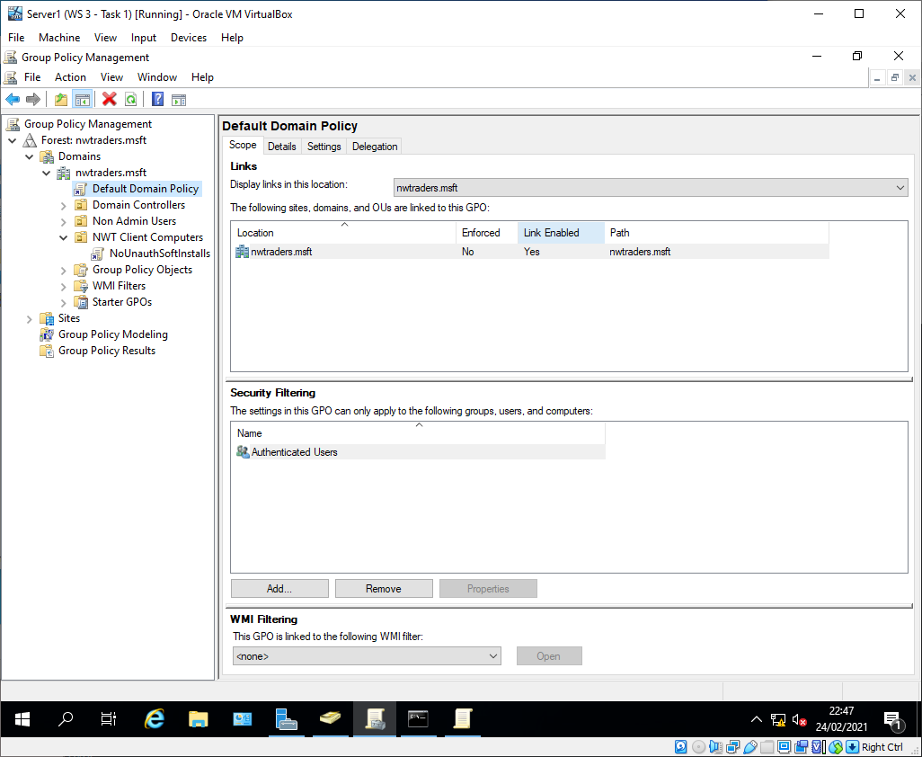
Figure 46 - Default domain policy
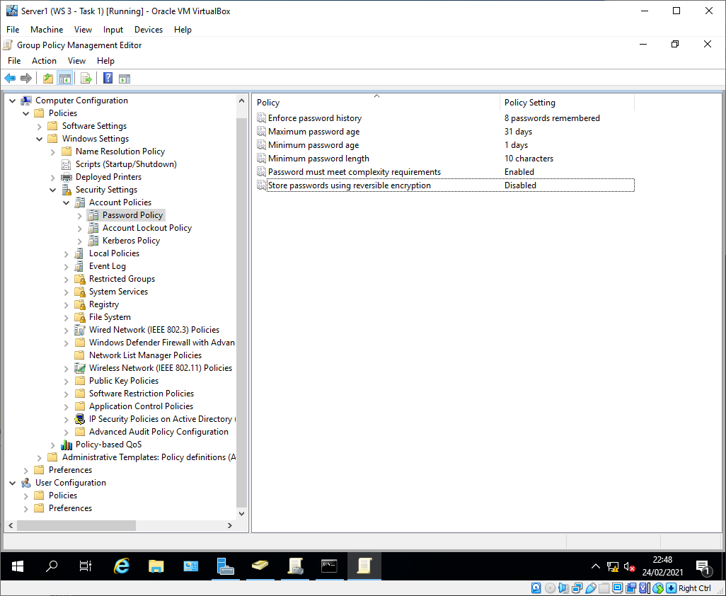
Figure 47 - Password policy
The GPO was tested by creating a new user account and trying to set the password to something that didn’t meet the new standards. As expected this failed.
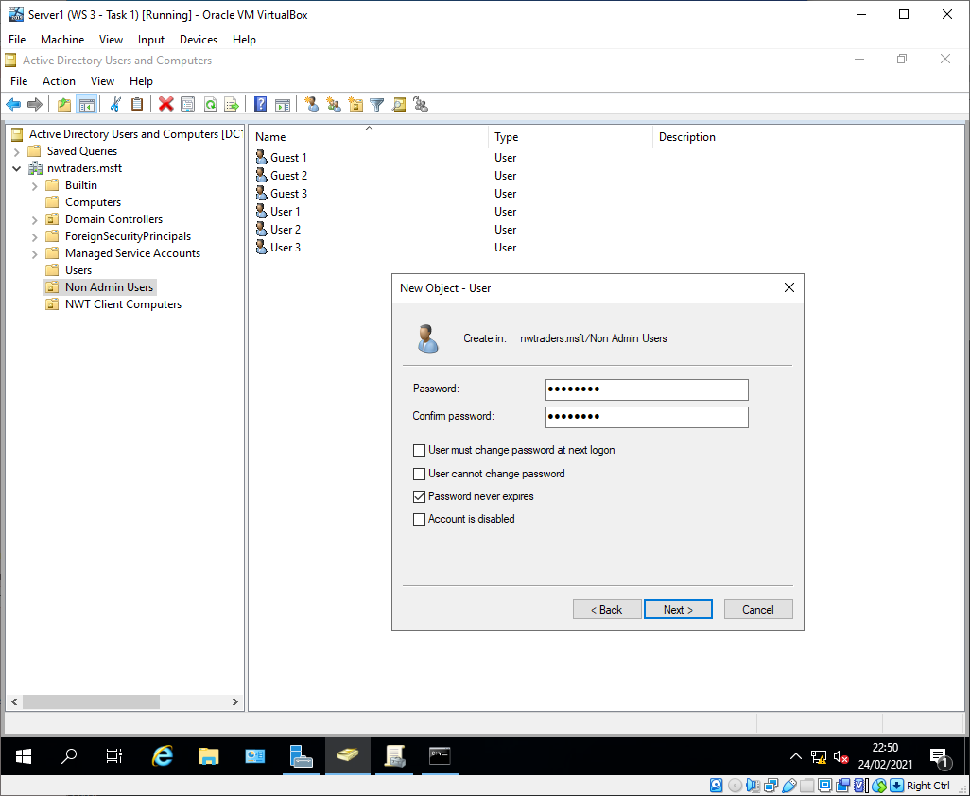
Figure 48 - New user account

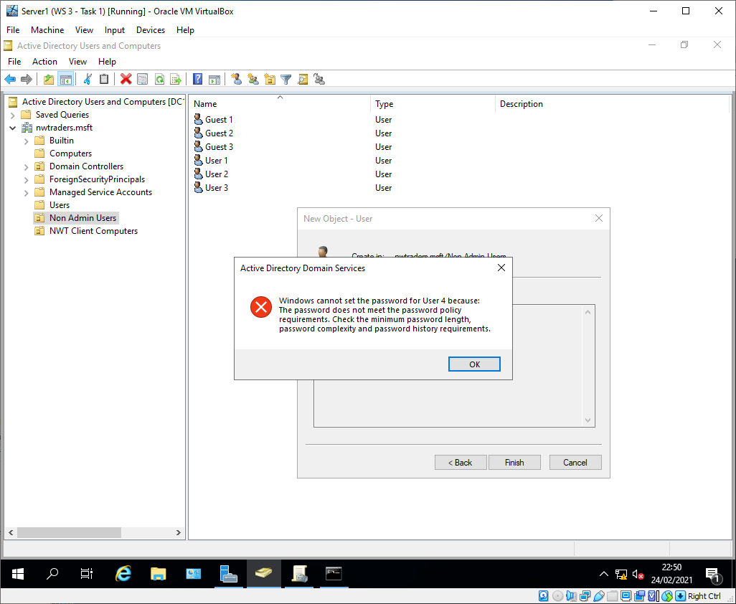
Figure 49 - Password change denied
A different password that met the new standards (CorrectHorseBatteryStaple1) was chosen and was applied successfully.
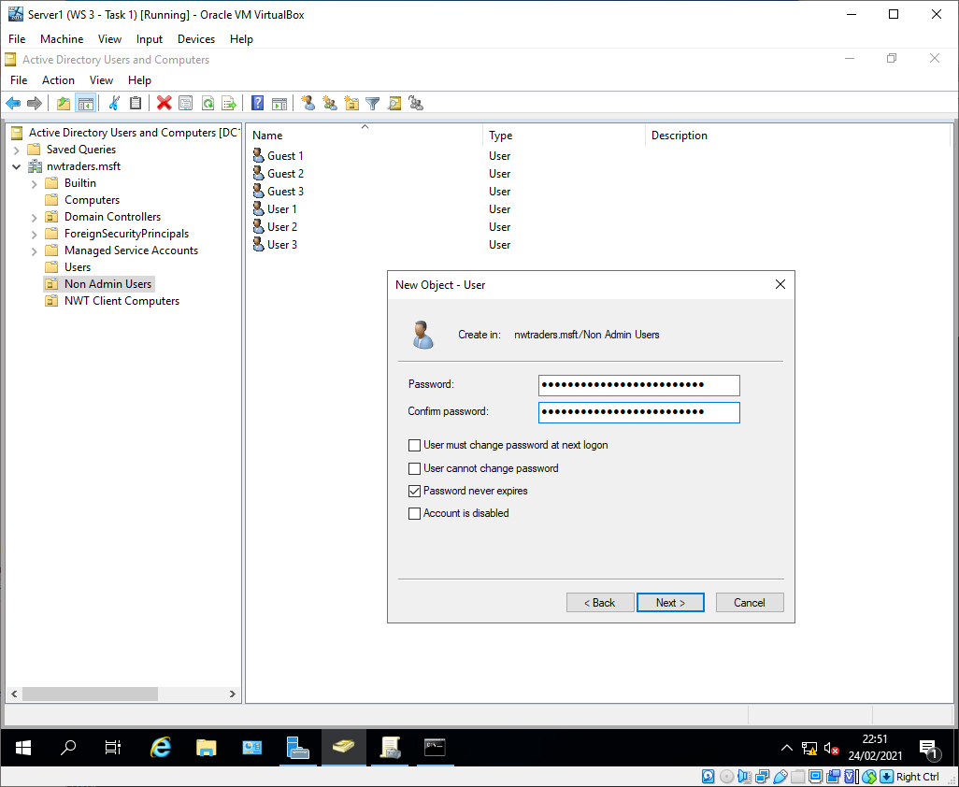
Figure 50 - Password change successful

Task 3: Observational Tasks

Local permissions and file shares
The major difference between NTFS permissions and share permissions is that NTFS permissions apply both when the resource is accessed locally and over the network, whilst share permissions only apply when the resource is accessed via the network[2]. This means that it is possible to have separate NTFS and share permissions on the same directory structure. This can become very confusing for IT administrators and users in determining which permissions apply in each scenario. It can also cause accidental data disclosure if a user is given more access via NTFS than share, or visa versa. As such it is recommended to have a predefined policy for giving users permission to network resources. For instance administrators may decide to use share permissions to give all standard users read access to the network share, and then use NTFS permissions to restrict access further[2][3]. This would mean that if a user is unable to access a resource they are meant to, the administrators will always know that NTFS permissions will be the cause.

Group policy management
Group Policy is a management technology for Windows in an active directory environment[4]. The point of group policy management is to allow the centralised management of devices and users settings. These settings can vary from setting the desktop background to a corporate branded image to blocking command prompt. Group policy is not the only method for managing network environments, with System Centre Configuration Manager (SCCM), and Mobile Device Management (MDM)[5] being other tools used in enterprise networks. MDM is often used in the context of Bring Your Own Device (BYOD) which allows for organisations to set minimum standards for personal devices used to access organisational data.
Some of the most important group policies from a security point of view in an enterprise network are those that prohibit regular users from accessing administrative functions. These policies enforce a system on least privilege on a network. Such policies include preventing access to the control panel and command prompt, or prevent users from installing software[5]. Other policies may remove legacy support features that are vulnerable to attack like SMBv1 and v2[6], or disabling default local accounts.
One important group policy to apply is to prevent Windows from storing user account passwords as LAN Manager Hashes, and to instead use Windows NT Hash[7]. This is because LM hashes are vulnerable to cracking by attackers which could then be used to impersonate users and pivot to different systems[8].

Password principles
There are several different elements to best practice with regards to password policies in a modern enterprise network. The following are some examples.

Password complexity
Password complexity refers to the standards that a password must meet. Historically best practice required passwords to include upper and lowercase letters, numbers, and special characters. This however resulted in “unhappy users and an over-worked Help Desk”[9], this is because whilst the inclusion of additional possible symbols does increase per character entropy, it also makes passwords significantly harder for users to remember. This, along with the fact that many users will use predictable patterns for replacing letters with other characters is why current best practice as provided by NCSC recommends against complexity requirements.

Password expiry
Historically the guidance on password expiry was to have enforced password changes periodically. The rationale for this was that it limits the risk posed by a compromised password by limiting the amount of time it is useful to an attacker[10]. The issue that was presented by this line of thinking was that when a user is forced to change their password often, they tend to use passwords that are similar to the previous one (e.g. from “Password3” to “Password4”), making guessing the new password trivial for the attacker. This problem is exacerbated when the user has dozens of different passwords that each need to be updated every 3-6 months, which can cause some users to resort to writing them down, presenting even more avenues of attack. This is why in 2015 NCSC published guidance which “explicitly advised against” regular password expiration[11], and in 2019 SANS did the same[12]. They instead recommend only requiring password changes “if they have reason to believe it has been compromised”[12].

Password blacklists
It is recommended by both the National Cyber Security Centre (NCSC) and the National Institute of Standards and Technology (NIST) in their respective guidance documents[13][14] that certain passwords are blacklisted from use. This prevents users from choosing passwords that are commonly used or have been previously exposed in data breaches. This can protect organisations from attack methods such as password stuffing, where attackers use previously compromised credentials on other services in the hopes that the password was re-used[15]. It can also be combined with password attempt throttling to severely limit the effectiveness of brute force password attacks where attackers used known usernames with common passwords. This is where the system enforces a time delay between unsuccessful login attempts and locking accounts after a certain number of failures[14].

Elevated accounts
It is very important to ensure that accounts with elevated privileges are not used for general work duties such as email or web browsing. They should instead only be used for tasks that require the privileges such as installing software or performing administrative tasks like creating user accounts[16]. This is because the less often an account is used, the less likely it is that the account is compromised. Elevated accounts should also be closely monitored for suspicious activity, such as a domain admin logging into a regular client machine, or an admin account accessing systems outside of normal working hours or from a non-standard location[17].

Multi-factor authentication
It is generally agreed that there are four factors that can be used to authenticate a user[18]:
- Knowledge (i.e. what the user knows)
- Possession (i.e. what the user has)
- Inherent (i.e. who the user is)
- Location (where the user is)
Passwords represent the knowledge factor, one of the most effective methods of limiting the impact of a compromised password is to make it so the password is not the only thing required for a user to access a system.
Examples of Multi-Factor Authentication (MFA) include smart-cards, hardware or software tokens, and SMS messages with One Time Passwords (OTP). The thing that all of these solutions have in common is that they require the user to possess something. Inherent examples include biometric authentication. Location authentication might involve geofencing logins to the country an organisation is based in, or having alarms set up such as Microsoft Azure’s “impossible travel” detection which triggers when two login events from different locations are within a timeframe that is too short to have been reasonably travelled[19].

References
[1] “7-Zip.” [Online]. Available: https://www.7-zip.org/. [Accessed: 29-Apr-2021].
[2] H. Semmelmayer, “NTFS Permissions and Share Permissions – What’s the difference?,” TenFold, 28-Sep-2020. [Online]. Available: https://www.tenfold-security.com/en/ntfs-permissions-and-share-permissions-whats-the-difference/. [Accessed: 29-Apr-2021].
[3] “File and Folder Basic NTFS Permissions - NTFS.com,” NTFS. [Online]. Available: http://www.ntfs.com/ntfs-permissions-file-folder.htm. [Accessed: 21-Feb-2021].
[4] “[MS-GPOD]: Glossary | Microsoft Docs,” Microsoft. [Online]. Available: https://docs.microsoft.com/en-us/openspecs/windows_protocols/ms-gpod/a4ce9803-71e7-4e20-988b-167a4e13f660#gt_defe8c22-1365-4e5e-abf7-46ad112d3bda. [Accessed: 28-Apr-2021].
[5] M. Wilson, “Group Policy Management - Guide & Tutorial along with Defintions! - PC & Network Downloads - PCWDLD.com,” PCWDLD, 19-Nov-2020. [Online]. Available: https://www.pcwdld.com/group-policy-management. [Accessed: 28-Apr-2021].
[6] “6 Group Policy Settings You Need to Get Right,” https://blog.netwrix.com/.
[7] “Top 10 Most Important Group Policy Settings for Preventing Security Breaches,” Lepide, 2020. [Online]. Available: https://www.lepide.com/blog/top-10-most-important-group-policy-settings-for-preventing-security-breaches/. [Accessed: 29-Apr-2021].
[8] “Network security Do not store LAN Manager hash value on next password change (Windows 10) - Windows security | Microsoft Docs.” [Online]. Available: https://docs.microsoft.com/en-us/windows/security/threat-protection/security-policy-settings/network-security-do-not-store-lan-manager-hash-value-on-next-password-change. [Accessed: 29-Apr-2021].
[9] “Password must meet complexity requirements (Windows 10) - Windows security | Microsoft Docs,” Microsoft. [Online]. Available: https://docs.microsoft.com/en-us/windows/security/threat-protection/security-policy-settings/password-must-meet-complexity-requirements. [Accessed: 28-Apr-2021].
[10] “The problems with forcing regular password expiry - NCSC.GOV.UK,” NCSC. [Online]. Available: https://www.ncsc.gov.uk/blog-post/problems-forcing-regular-password-expiry. [Accessed: 28-Apr-2021].
[11] “Password administration for system owners - NCSC.GOV.UK,” NCSC. [Online]. Available: https://www.ncsc.gov.uk/collection/passwords. [Accessed: 28-Apr-2021].
[12] L. Spitzner, “Time for Password Expiration to Die,” SANS, 27-May-2019. [Online]. Available: https://www.sans.org/blog/time-for-password-expiration-to-die/. [Accessed: 28-Apr-2021].
[13] P. A. Grassi, M. E. Garcia, and J. L. Fenton, “Digital identity guidelines: revision 3,” Gaithersburg, MD, Jun. 2017.
[14] “Password policy: updating your approach - NCSC.GOV.UK,” NCSC. [Online]. Available: https://www.ncsc.gov.uk/collection/passwords/updating-your-approach. [Accessed: 28-Apr-2021].
[15] “Credential stuffing Software Attack | OWASP Foundation,” OWASP. [Online]. Available: https://owasp.org/www-community/attacks/Credential_stuffing. [Accessed: 13-Jan-2021].
[16] “Managing user privileges - NCSC.GOV.UK,” NCSC. [Online]. Available: https://www.ncsc.gov.uk/collection/10-steps-to-cyber-security/the-10-steps/managing-user-privileges. [Accessed: 28-Apr-2021].
[17] “Privileged Account Management Best Practices.” [Online]. Available: https://www.netwrix.com/privileged_account_management_best_practices.html. [Accessed: 28-Apr-2021].
[18] “What Is Multi-Factor Authentication? 4 Examples of MFA in Action,” SugarShot, 17-Sep-2020. [Online]. Available: https://www.sugarshot.io/what-is-multi-factor-authentication/. [Accessed: 29-Apr-2021].
[19] “Create anomaly detection policies in Cloud App Security | Microsoft Docs,” Microsoft, 01-May-2021. [Online]. Available: https://docs.microsoft.com/en-us/cloud-app-security/anomaly-detection-policy. [Accessed: 29-Apr-2021].

