
Computer Architecture and Operating Systems
Operating Systems Assignment
Jessica De Schoolmeester (2503086)

Table of Contents
Introduction 2
Key Functions of General Operating Systems 2
Process Management 2
Memory Management 3
System and Performance Management 4
Device and Driver Management 5
Reliability monitor 5
Windows Recovery Environment (WinRE) 6
Event Viewer 7
System Security Management 7
Windows Defender Firewall 7
Windows Security 8
Use of Windows OS CLI commands . 9
Process Management (PowerShell) 9
File & Directory management 10
New-Item (PowerShell) 10
Remove-Item (PoweShell) 11
Network testing/monitoring 11
Test-Connection (PowerShell) 11
Get-NetTCPConnection (PowerShell) 12
User Management 12
Get-LocalUser (PowerShell) 12
New-LocalUser (PoweShell) 12
Task scheduling 13
Register-ScheduledTask (PoweShell) 13
Use of Linux OS CLI commands 13
Process management 13
Ps aux (Bash) 13
Sudo Kill Command (Bash) 14
File & Directory Management 15
MKDIR (Bash) 15
RMDIR (BASH) 16
Network testing/ monitoring 16
Ping (Bash) 16
Ifconfig (Bash) 16
User Management 17
Sudo Adduser Command (Bash) 17
Su – username (Bash) 17
Task Scheduling 18
Use of Windows OS scripts 18
Variables 19
Goto command 19
If Statement & User inputs 20
For Loop 20
Arrays 21
Functions 22
Use of Linux OS Scripts 22
Number Guessing Game (Bash Script) 22
Variables 23
Arithmetic operations 23
Loops 23
If and else statements 23
Full script and output 24
Conclusion 25
References 25
Appendices 26

Introduction
Operating systems (OSs) are a core part of modern computing, controlling how hardware and software interact. They play an important role in modern technology and are used in devices such as smartphones, tablets and desktop computers. Their main purpose is to ensure devices operate efficiently, reliably, and securely. [1]
This report examines the key functions of operating systems, focusing on hardware management, software processes, and user interaction. It also explores the use of command-line interfaces (CLI) in Windows and Linux, showing how commands can be used to manage processes, files, users, and system performance

Key Functions of General Operating Systems
Operating systems perform several essential functions to ensure computers operate efficiently and reliably. [1]

Process Management
Process management involves controlling how programs run. The OS creates processes, allocates CPU time, and switches between tasks to support multitasking. This allows multiple applications to run simultaneously without slowing the system. [2].

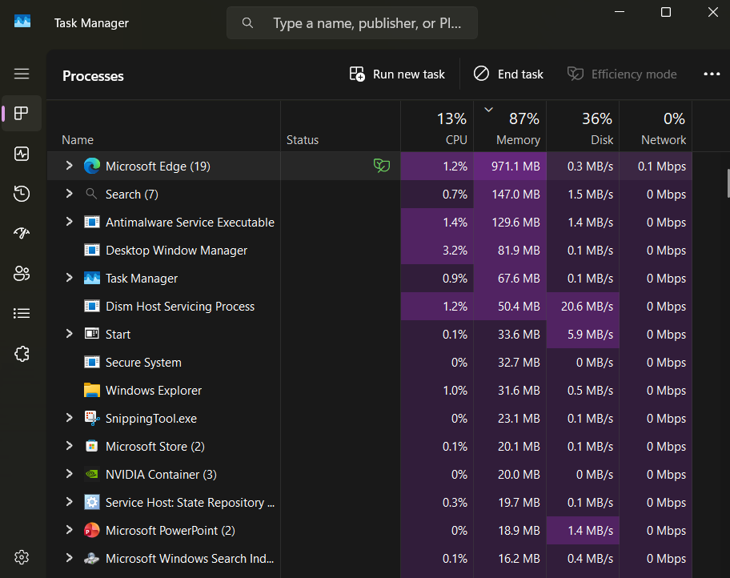

Memory Management
Memory management controls how RAM is allocated. It ensures that each process receives enough memory while preventing conflicts between applications. Virtual memory is used when physical memory is limited, improving system stability and allowing larger programs to run smoothly. [3] In Windows, memory usage can be monitored using Task Manager.
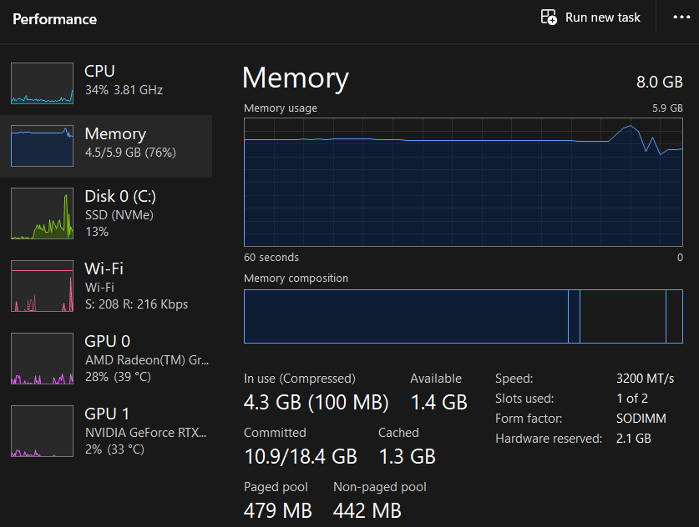

System and Performance Management
Performance management is a tool that ensures the system runs efficiently [4] Tools such as Task Manager and Resource Monitor help identify processes that may be affecting performance
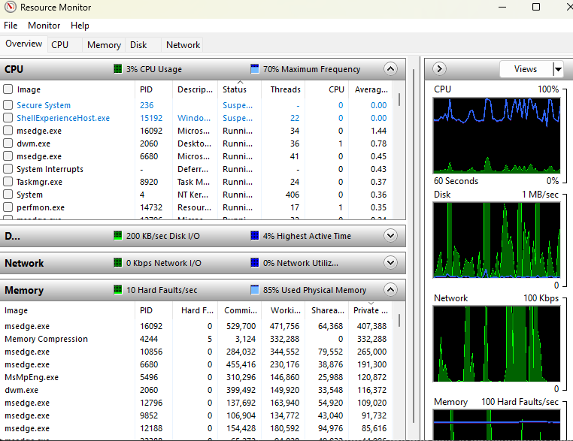
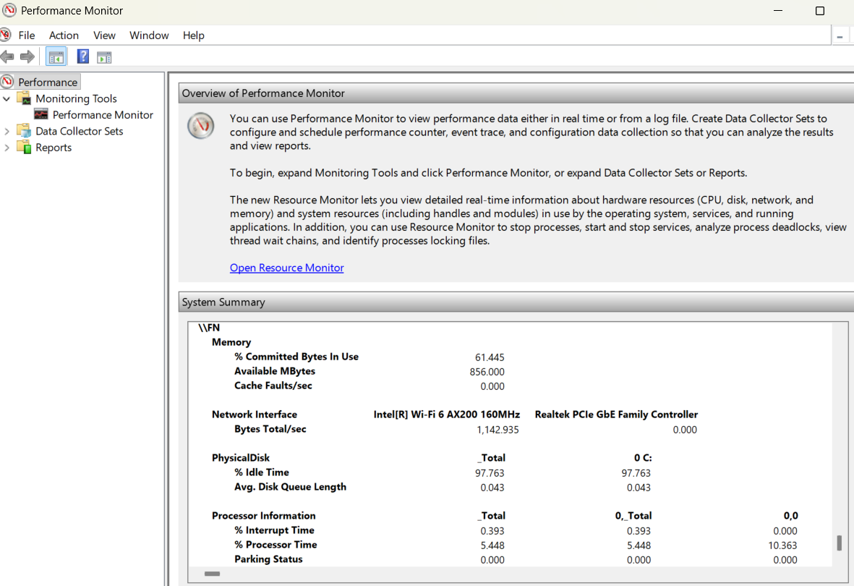

Device and Driver Management
Device and driver management allows the operating system to control hardware components. Drivers act as communication software between hardware and the OS. Device Manager in Windows allows users to update, enable, or troubleshoot devices. [5]
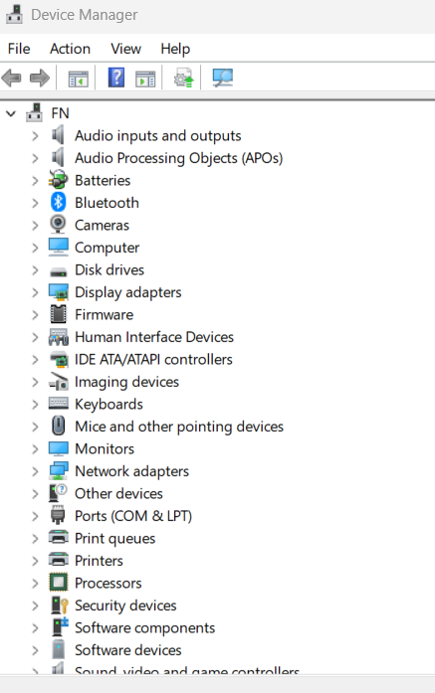

Reliability monitor
Reliability Monitor is a Windows tool that provides a visual timeline of system stability and reliability. It tracks application crashes, hardware failures, Windows update issues, and other critical events over time. The tool helps users identify patterns of problems and determine what may be causing system instability, making troubleshooting easier and more efficient. [6]

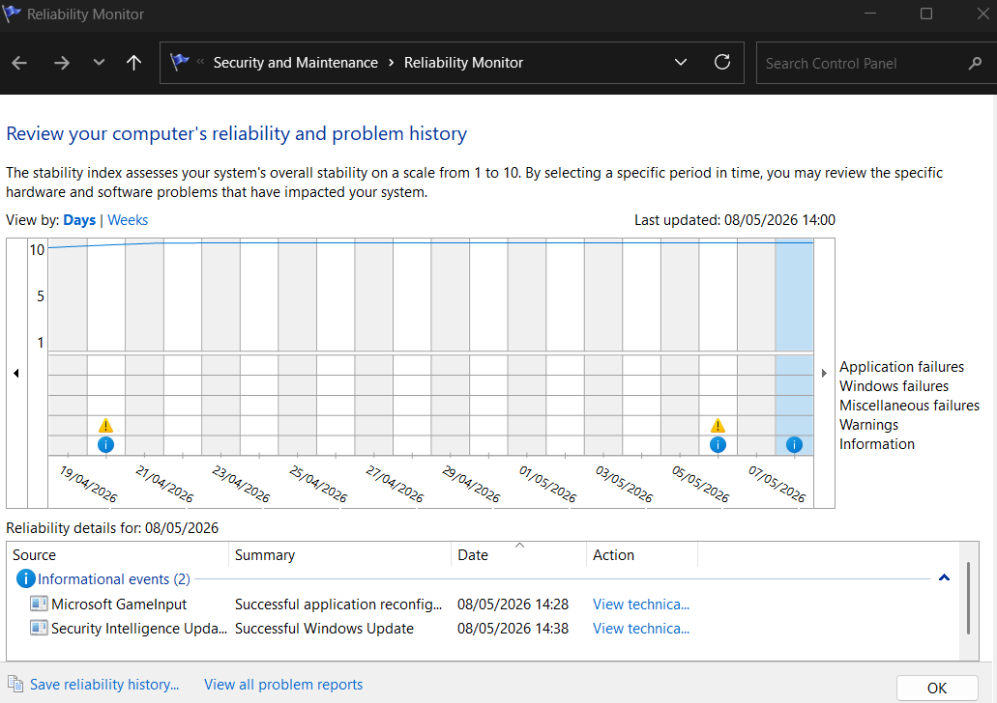

Windows Recovery Environment (WinRE)
Windows Recovery Environment is a recovery platform built into Windows that helps users repair and restore the operating system when serious problems occur. It includes recovery tools such as Startup Repair, System Restore, Safe Mode, and Reset this PC. WinRE is used to troubleshoot boot failures, recover from corrupted system files, and restore the system to a working state after crashes or major errors. [7]

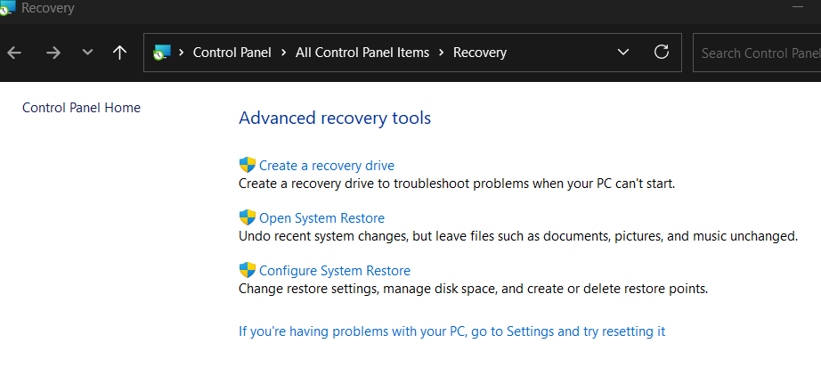

Event Viewer
Event Viewer is a Windows administrative tool used to view detailed logs of system, application, and security events. It records information about errors, warnings, software crashes, hardware failures, and system activities, helping users and administrators diagnose and troubleshoot problems. Event Viewer is commonly used to investigate system issues and monitor the health and stability of the operating system. [7]

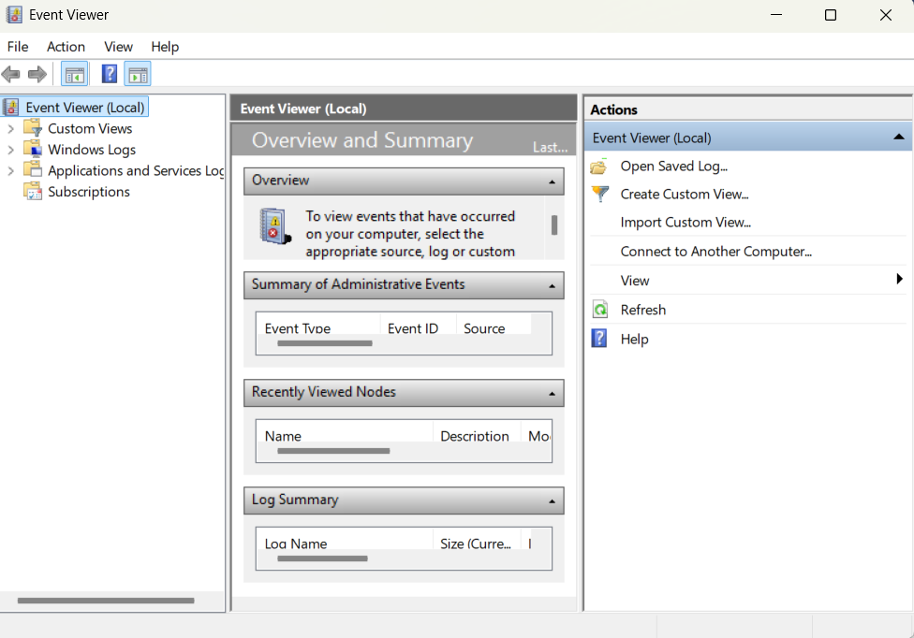

System Security Management

System Security Management is a key function of a general operating system that focuses on protecting the computer system, data, and users from unauthorized access, malware, and security threats. It involves managing user accounts, passwords, permissions, firewalls, antivirus protection, and security updates to ensure the system remains secure and reliable. The operating system controls access to files, applications, and network resources so that only authorized users can perform specific actions.[7]

Windows Defender Firewall
Windows Defender Firewall is a security feature that monitors and controls incoming and outgoing network traffic on a computer. Its main purpose is to block unauthorized access while allowing safe and trusted communication between the computer and networks or the internet. The firewall helps protect the system from hackers, malicious software, and unauthorized connections by applying security rules to network traffic. Users and administrators can customize firewall settings to allow or restrict specific applications and services.[7]

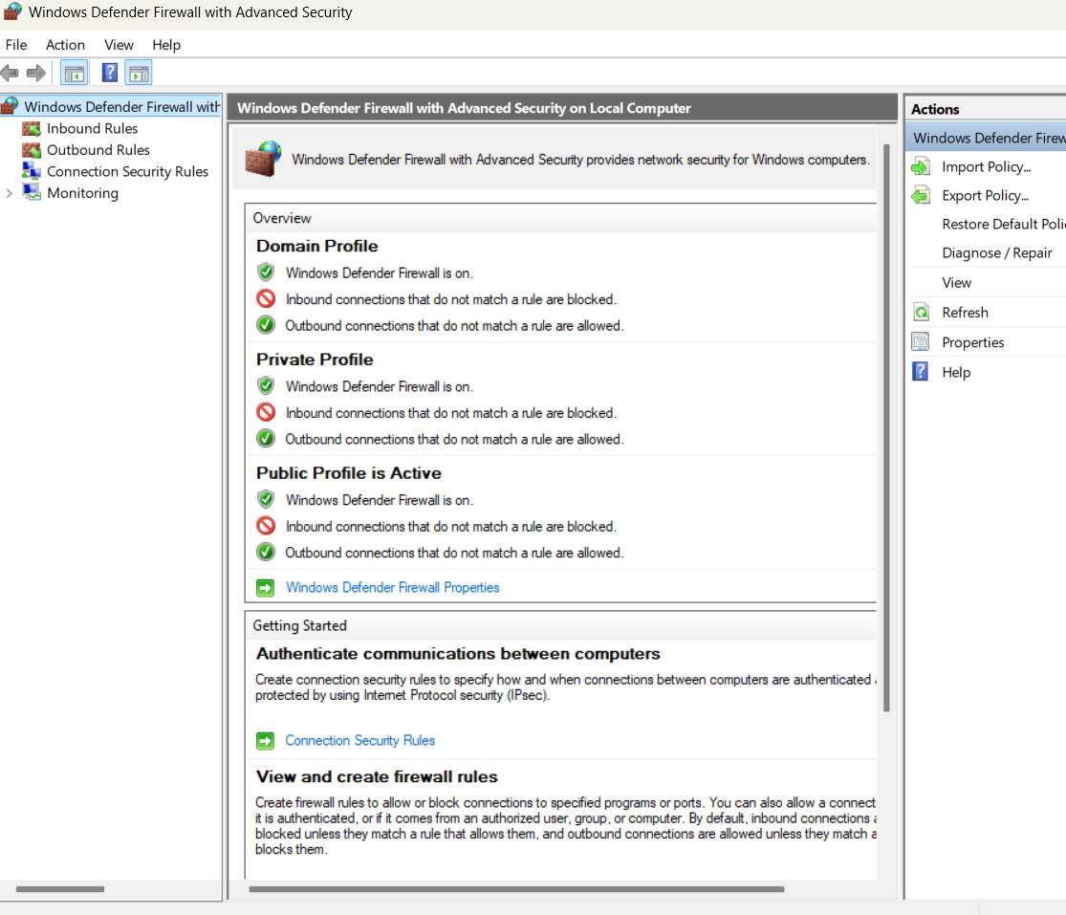

Windows Security
Windows Security is the built-in security application in Windows that helps protect the computer from viruses, malware, ransomware, and other security threats. It provides access to security features such as virus and threat protection, firewall and network protection, device security, account protection, and security updates. Windows Security continuously monitors the system and alerts users if any risks or suspicious activities are detected, helping maintain the overall safety and integrity of the operating system.[7]

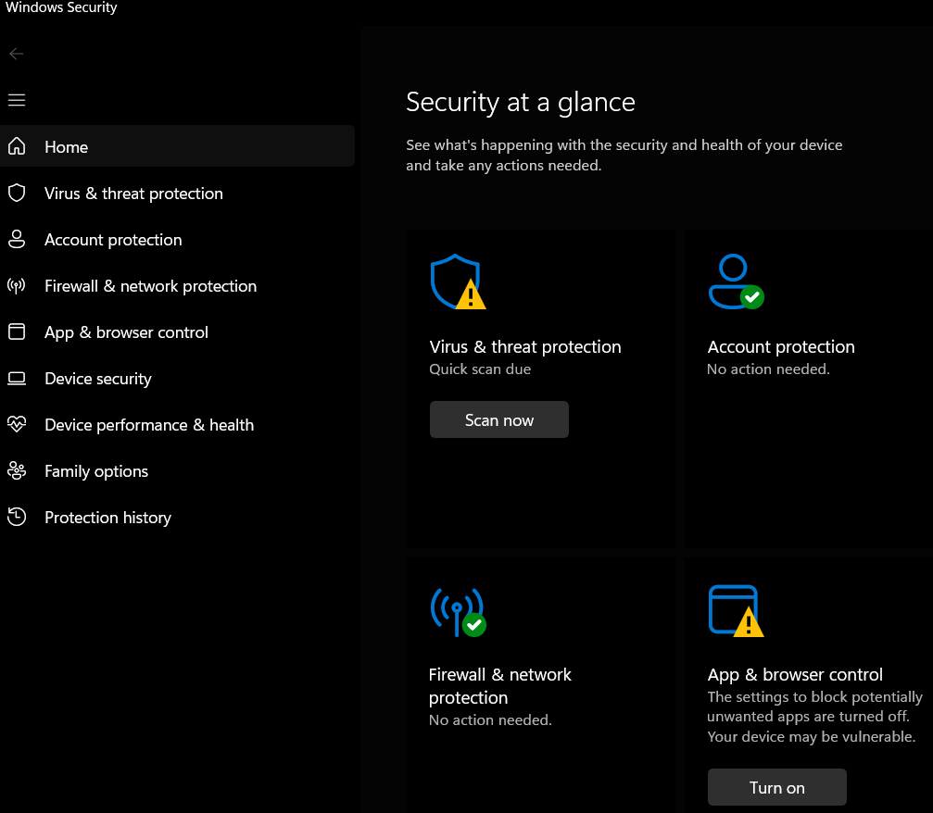

Use of Windows OS CLI commands .

Process Management (PowerShell)
The command Get-Process shown below displays all active processes along with CPU and memory usage. This helps identify resource-heavy applications.[8]
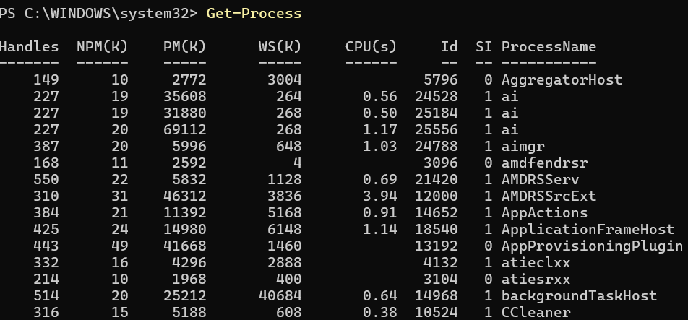
Stop-Process -Name notepad -Force is used to terminate a specific process if it becomes unresponsive or needs to be closed immediately in this instance the application snippingtool was successfully closed.[8]

File & Directory management

New-Item (PowerShell)
As seen below, the command is used in PowerShell to create a new item at the specified location. In this case, it creates a file named test.txt inside the OneDrive folder for the user jessi.
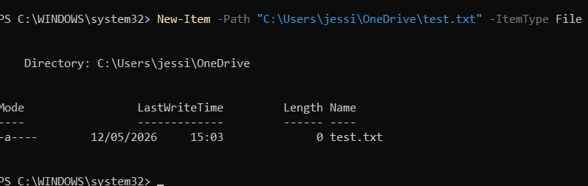
This is the result of the command being executed. As shown, a file named test.txt has been successfully created.

Remove-Item (PoweShell)
Remove-Item command is used to remove test.txt stored in the OneDrive folder for the user jessi and deletes it from the system location, effectively clearing it from that directory
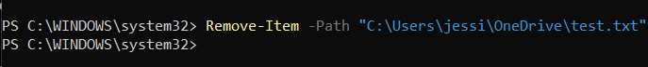

Network testing/monitoring

Test-Connection (PowerShell)
As shown below, Test-Connection is a PowerShell command similar to the ping command used in other operating systems to test connectivity to a host. In this example, it was used to connect to google.com and verify network communication. [8]
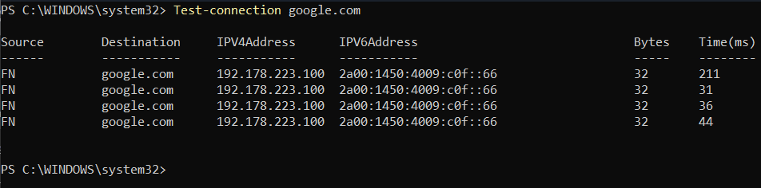

Get-NetTCPConnection (PowerShell)

Get-NetTCPConnection is used to display active TCP network connections on the system. [8]
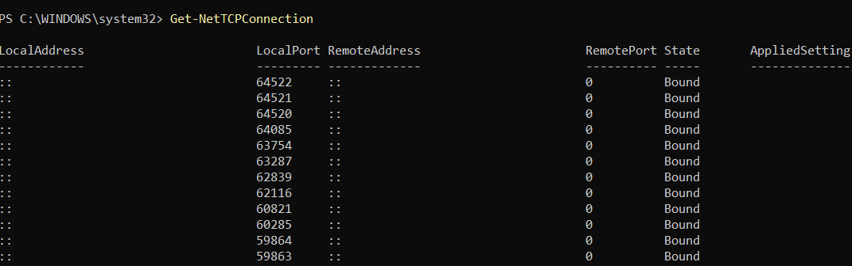

User Management

Get-LocalUser (PowerShell)
Get-LocalUser is used in PowerShell to display a list of all current local user accounts on the system. It shows details such as usernames and account status, allowing administrators to review and manage existing users. [8]
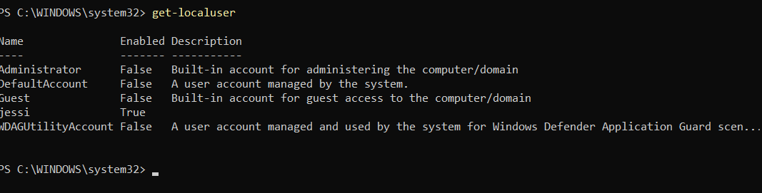

New-LocalUser (PoweShell)
New-LocalUser is used in PowerShell to create a new local user account on the system. It allows administrators to define a username, password, and account settings, making it possible to add and manage users directly through the command line. [8]
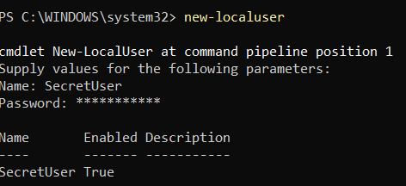

Task scheduling

Register-ScheduledTask (PoweShell)

Register-ScheduledTask was used to create a scheduled task that triggers an action to open Notepad each time the user logs on. This allows tasks to be automated running specific applications without manual input.

Use of Linux OS CLI commands

Process management

Ps aux (Bash)

The ps aux command is a commonly used Linux tool for inspecting all active processes running on a system. Each application or service operates its own process, and Linux relies on these processes to coordinate how the CPU and memory are used. Running ps aux provides a snapshot of the system’s current activity, showing details such as process IDs and resource consumption. [9]

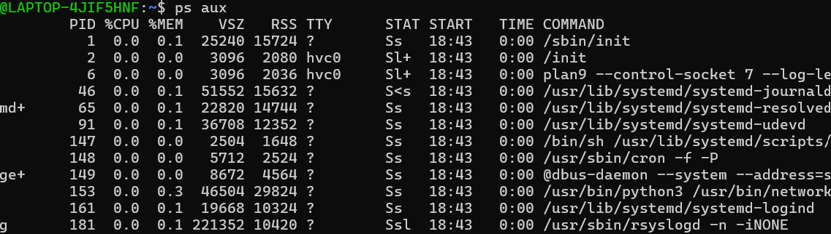

Sudo Kill Command (Bash)
Once processes have been identified using ps aux, any unwanted processes can be terminated using the sudo kill command, which immediately forces the task to end.[10] For example, an unwanted process was identified and killed; when ps aux was run again, that process no longer appeared, confirming it had been successfully terminated.
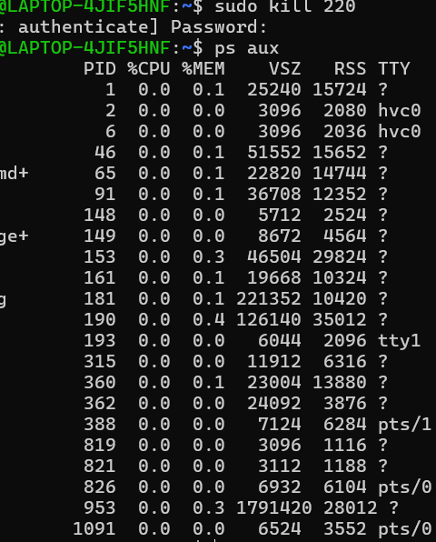

File & Directory Management

MKDIR (Bash)

The mkdir command can be used to create a new directory, which helps in arranging files. [10] In the example below, mkdir is used to create a directory called myfolder. The directory is then confirmed using the pwd command to display the current working location, and the ls command to list the contents and verify that the new directory has been created.
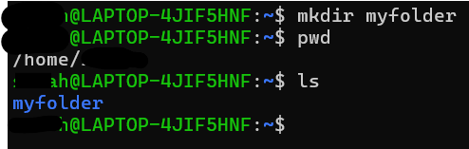

RMDIR (BASH)

Below, the RMDIR command is used to remove the recently created directory. This is confirmed by running the LS command again, where the directory no longer appears in the current location.
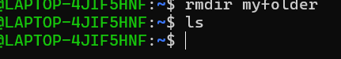

Network testing/ monitoring

Ping (Bash)
Ping is a widely used command that is used to test the network connectivity to a host.[11] Below, the ping command was used to connect to google.com, and the output measures the time it takes for packets to travel to and from google.com.
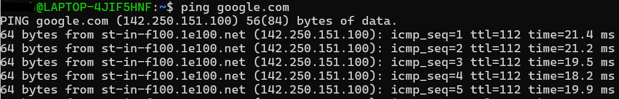

Ifconfig (Bash)
The ifconfig command is used to display network interface details, including IP addresses, network status, and configuration information. It helps users view and manage network connections on a system for troubleshooting and checking network settings. [11]
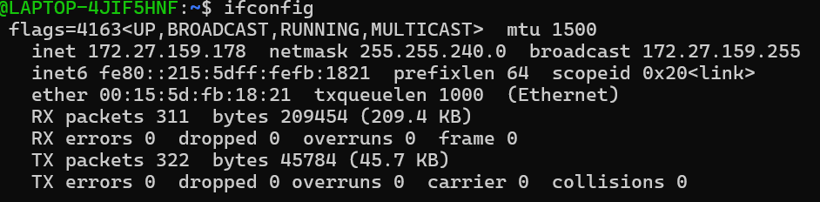

User Management

Sudo Adduser Command (Bash)
Below is an example of the sudo adduser command being used to set up a user named username it is then presented with a box to input a password and presents with filling out information for the new user
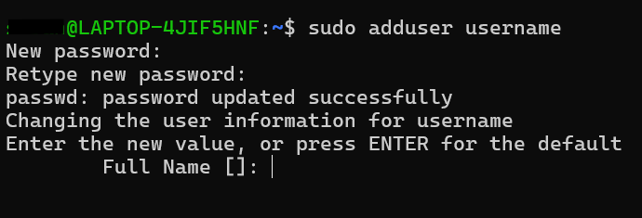
Below cat /etc/passwd is used to view a list of all system users, where each username represents a user account. The previous execution was successful because the command correctly displayed the user entry username

Su – username (Bash)
The command su - username is used to switch the current session to a different user after password verification as shown below. [8]
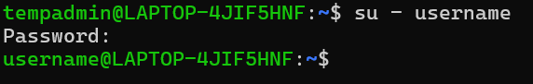

Task Scheduling
Crontab is used for task scheduling, allowing users to automate commands and processes at specific times.[8] Below is an example of a task scheduled to open Notepad at 20:15.
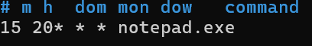

Once executed using crontab –l the scheduled tasks for the current user are displayed allowing verification that the job has been correctly added to the list.

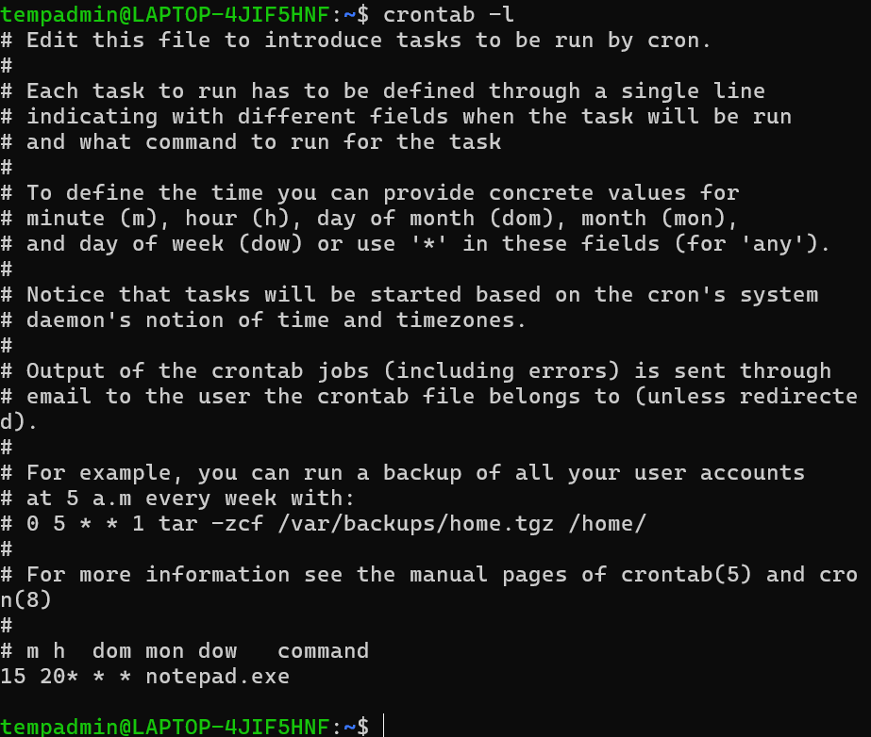

Use of Windows OS scripts

Variables
Variables store values for later use in scripts. They can hold text or numbers and are defined using the SET command in Batch scripting. [12] The example below shows variables being created using the SET command and then displayed as output using the ECHO command.
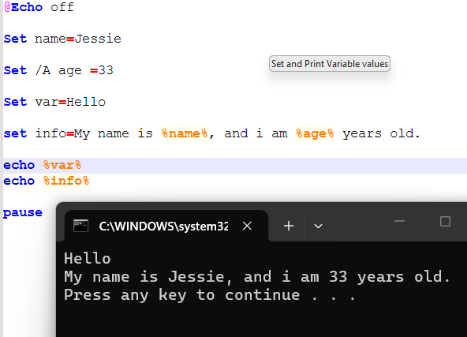

Goto command

The GOTO command changes the flow of execution by jumping to a labeled section of a script. This allows scripts to skip sections or repeat specific parts of code.[13] In the example shown, the GOTO instruction caused the script to bypass the printed line and move straight to the :SkipCode label, where execution picked up again.

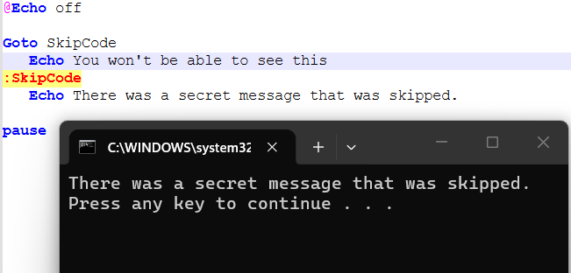

If Statement & User inputs
IF statements allow decision-making in scripts. They evaluate conditions and execute different actions depending on user input or system values.[8] Scripts can also accept input from users using the SET /P command

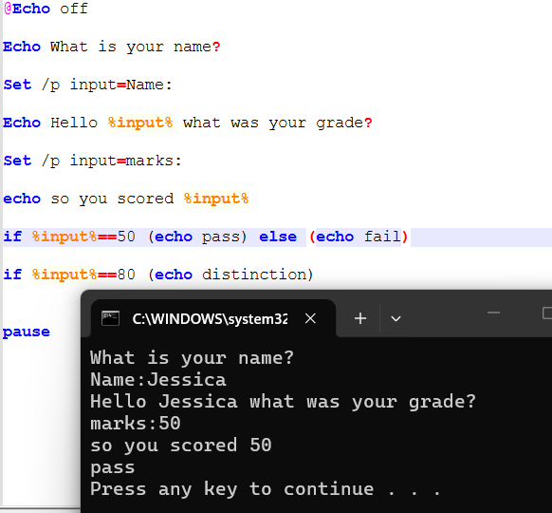

For Loop
FOR loops are used to repeat actions multiple times. For example, they can be used to iterate through numbers or files in a directory as shown below. [8]

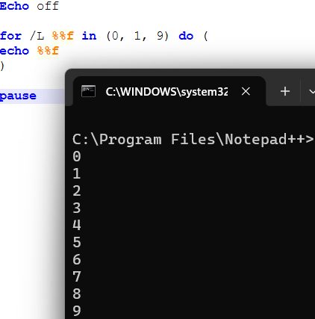

Arrays

Arrays store multiple values under a single variable name using indexed positions. This allows scripts to manage collections of related data efficiently.[8]

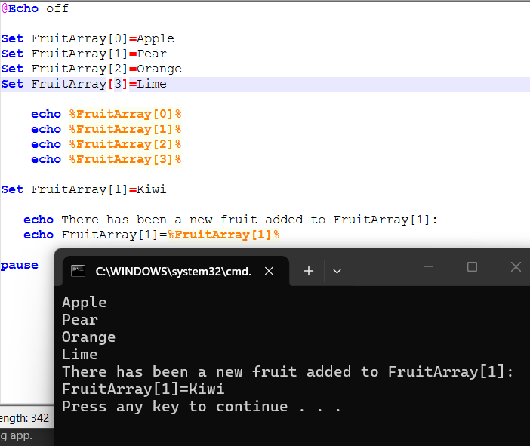

Functions
Functions are reusable blocks of code that perform specific tasks. They help reduce repetition and improve script organisation. [8] The script below shows a number guessing game where a function called “:checkGuess” is executed after the user inputs their guess. Once the input is compared with the secret number, the code continues through an IF statement. If the user guesses correctly, the game ends using the exit command. If the guess is incorrect, the script outputs “Wrong guess”. and allows the user to retry guessing a number.

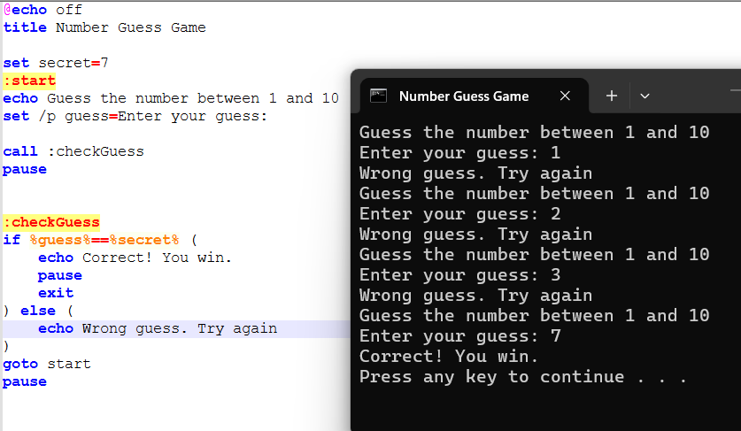

Use of Linux OS Scripts

Number Guessing Game (Bash Script)
A number guessing game was created using a Bash script to demonstrate the use of variables, arithmetic operations, loops, functions, and conditional statements. The script generates a random number within a defined range and allows the user to repeatedly guess the number until they are correct.

Variables
Variables store values used in the game. secret holds a random number between 1 and 10 using $RANDOM % 10 + 1, and guess stores the user’s input. These allow comparison between values during the game.
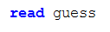

Arithmetic operations
Arithmetic is used to generate the secret number within a range. $(( RANDOM % 10 + 1 )) limits the random value to 1–10 for consistent gameplay.

Loops
A while loop repeatedly asks the user for input until the correct number is guessed. It only stops when a break is executed after a correct guess.
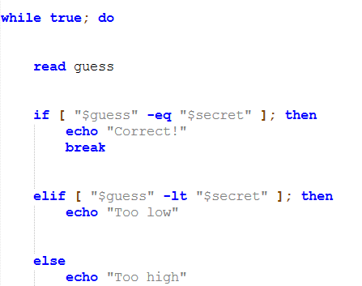

If and else statements
If and else statements compare guess with secret. If equal, the program prints “correct” and ends. If lower, it prints “too low”, otherwise “too high”.
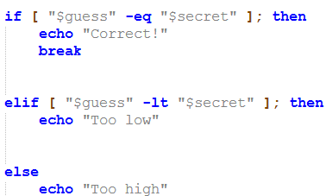

Full script and output
The complete number guessing game script and its output can be seen below, demonstrating how variables, arithmetic operations, loops, and conditional statements work together within the Bash program.

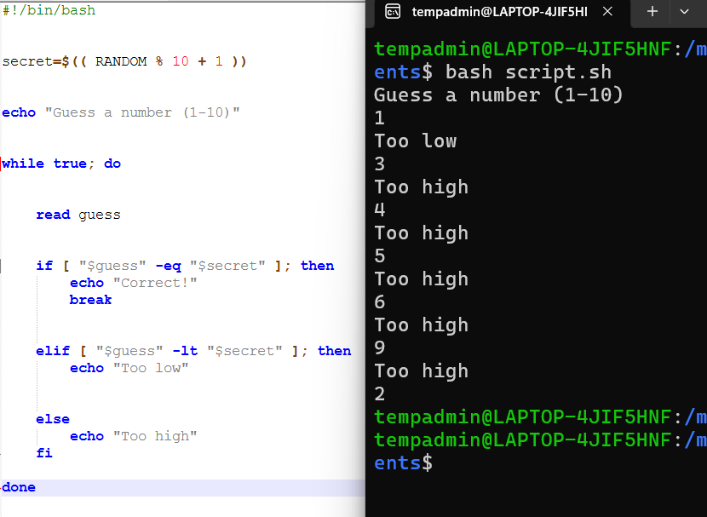

Conclusion
Operating systems are essential for managing hardware, software, security, and system performance across modern computing devices. This report explored key operating system functions and demonstrated how command-line tools and scripting can be used in both Windows and Linux environments. Through the use of CLI commands and scripts, tasks such as process management, networking, file handling, and automation can be performed efficiently. Overall, both Windows and Linux provide powerful administrative and scripting tools that support effective system management.

References
[1] Jiasheng. Hao, Yindong. Xiao, W. Zhou, and Peicheng. Wang, Operating System Basics and Practice : A Hands-on Approach with openEuler, 1st ed. Singapore: Springer Nature Singapore, 2026. doi: 10.1007/978-981-95-2185-2

[2] “Introduction of Process Management,” June 14, 2015. Available: https://www.geeksforgeeks.org/operating-systems/introduction-of-process-management/. [Accessed: May, 2026]

[3] “Memory Management in Operating System,” Aug. 18, 2021. Available: https://www.geeksforgeeks.org/operating-systems/memory-management-in-operating-system/. [Accessed: May, 2026]

[4]“How to use Perfmon or Performance Monitor in Windows 11,” Nov. 24, 2025. Available: https://www.thewindowsclub.com/how-to-use-perfmon-performance-monitor-windows. [Accessed: May 13, 2026]

[5] Dell, “Access Device Manager in Windows 10 and 11 using shortcuts and CMD commands,” Dell US, Apr. 19, 2026. https://www.dell.com/support/kbdoc/en-us/000123570/how-to-access-device-manager?msockid=37599cb669a261a6249b8a7268426023

[6] Dell, “How to use Windows Reliability Monitor to identify software issues,” Dell US, May 06, 2026. https://www.dell.com/support/kbdoc/en-us/000178177/how-to-use-windows-reliability-monitor-to-identify-software-issues?msockid=37599cb669a261a6249b8a7268426023

[8] J. Williams, OS 5, Lecture – Intro to Bat Scripting (1), PowerPoint, University of Wales Trinity Saint David, 2026

[7] “Windows-Driver-Content, “Windows Recovery Environment (Windows RE),” Microsoft Learn. https://learn.microsoft.com/en-us/windows-hardware/manufacture/desktop/windows-recovery-environment--windows-re--technical-reference?view=windows-11

[9] “How to Use the ps aux Command in Linux,” Jan. 25, 2021. Available: https://www.linode.com/docs/guides/use-the-ps-aux-command-in-linux/. [Accessed: May 12, 2026]
[10] “D. Panovski, “How to Use the kill Command in Linux,” Dec. 02, 2019. Available: https://linuxize.com/post/kill-command-in-linux/. [Accessed: May 12, 2026]

[11]“Ping Command in Linux,” June 04, 2018. Available: https://www.geeksforgeeks.org/linux-unix/ping-command-in-linux-with-examples/. [Accessed: May 12, 2026]

[12]“What is a variable?,” https://www.w3schools.com/programming/prog_variables.php

[13]“How to use GOTO for jumps and simple loops in batch script,” Tutorial Reference. https://tutorialreference.com/batch-scripting/examples/faq/batch-script-how-to-use-goto-for-jumps-and-simple-loops

Appendices




