
Nojus Liubinas
Lecturer: Rhys Hutton
HNC Process Operations Engineering
Process Engineering Practices
PCPO4007
Student Number – 2320127

Table of Contents
Table of Figures 2
Introduction 3
Task 1 4
Task 2 11
Evaluation 17
References 18
Bibliography 21
Abstract 23

Table of Figures

Figure 1.0 - Centrifugal Pump
Figure 1.1 - Compressor
Figure 1.2 - Steam Turbine
Figure 1.3 - Heat Exchanger
Figure 1.4 - Fired Heater
Figure 1.5 - 1.8 - Certifications

Introduction

Within this assignment the demonstration of operational and maintenance activities within a process engineering environment is explained including specific key process equipment such as pumps. Also, a CV with a current job description and my current development action plan, while providing evidence of technical competence using training records and certification, while showing recognition of results.

Task 1

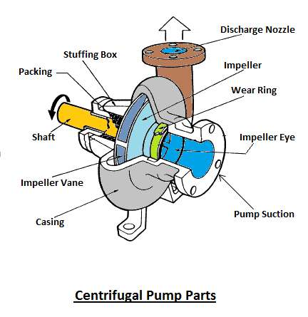
Figure 1.0 - Centrifugal Pump
Within Valero, pumps are essential for the movement of liquids and gases throughout the process. They convert mechanical energy into fluid flow, which is dependent on the type of pump for example, Centrifugal (Figure 1.0) or a positive displacement pump, they convert it in a different way. As for example a centrifugal pump uses a motor to rotate an impeller which will transfer rotational energy to the fluid moving it out of the discharge. In a process, pumps are selected dependant on the pressure, flow and specific properties of the fluid (Rook, 2023). Must ensure that the proper design and operation of the pump is safe and efficient at transporting the materials throughout the plant. Important operational principles are priming the pump to avoid cavitation and using selecting the correct pump based on the process is vital for continuous flow. Regular maintenance is important to keep pumps running effectively. This is done by checking seals, impellers, and bearings, this is done to ensure that the pump is running within its operating parameters. Issues such as cavitation and overheating can occur if maintenance is neglected, which makes the pump less effective and can cause failure (Joffe and Stenger, 2022.) An important way to avoid unexpected breakdowns can be done by vibration checks and regular lubrication (Baxter et al., 2021). Often failures such as leaks, cavitation and high vibration are due to lack of maintenance, poor installation or using the pumps in the incorrect way outside of their operating parameters (Wright and Hull, 2023).
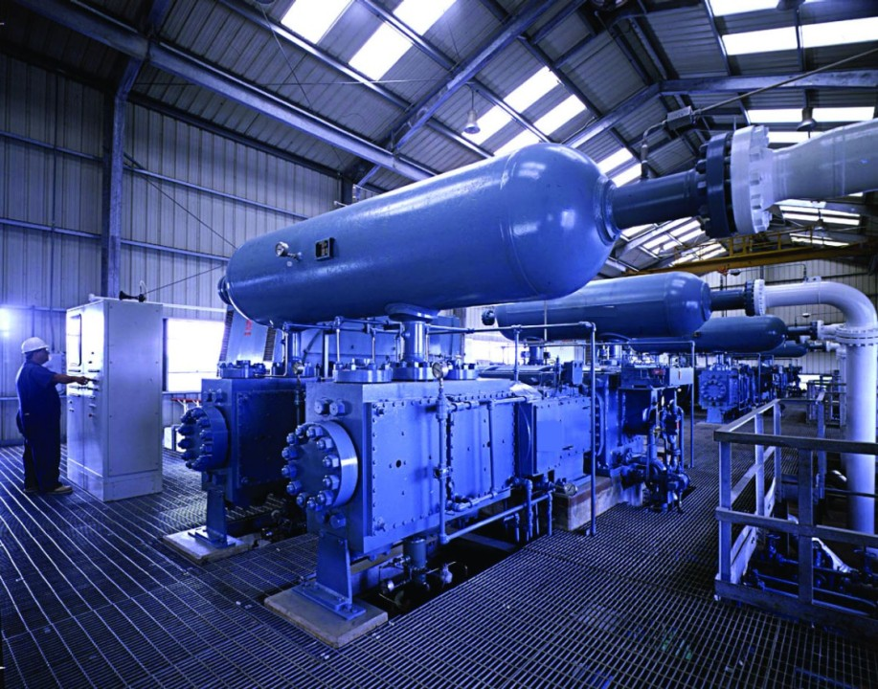Figure 1.1 - Compressor
Compressors operate by increasing the pressure of gas for various applications such as chemical processes, and gas transport. Compressors operate by reducing the volume of gas which will increase the pressure (Jones, 2022). Maintaing proper Suction and discharge is vital for the performance of the compressor as any fluctuations can limit the compressor and could lead to damage. Important operational activities within a compressor are to ensure it is running at optimum temperatures and is not over pressure limits which helps prevent internal damage of the compressor, like the seals, pistons, or valves. Within Valero we often must adjust the load of our compressor to ensure it is efficient and reduces wear on the compressor and to ensure we do not trip on high amps. Proper filtration of intake air or gas is essential to protect the compressor components from particulate damage (Shan and Song, 2024). Compressor maintenance is important to ensure longevity of the equipment. This can be done by ensuring adequate lubrication, leak checking and the monitoring of discharge pressures. The seals and bearings are one of the most vital parts of the compressor so proper maintenance must be completed (Shan and Song, 2024). Vibration monitoring and routine inspection of the compressor can identify early causes of failure. Compressors often fail due to seal degradation, valve damage, or overheating. These can lead to the compressor becoming less efficient or system failure (Liu and Zhang, 2023). These issues can be mitigated by using the correct maintenance strategies.
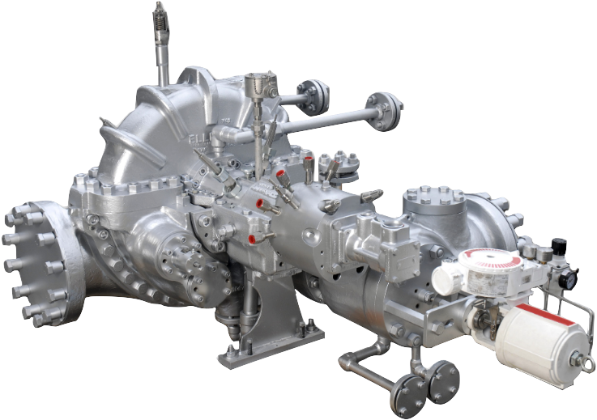Figure 1.2 - Steam Turbine
Turbines convert energy from steam, gas or fluids into rotational mechanical energy. They are commonly used in power generation or for driving industrial equipment (Lau, 2023). A key factor for turbine operation is to ensure the rotational speed is at an optimal level. Turbines should be operated within a narrow range of rotational speeds to avoid mechanical stress on the equipment. Also to ensure that the power is generated efficiently. The efficiency of turbines will depend on the flow of steam/gas through the blades of the turbine. To ensure effective operation it is important to balance the shaft correctly to avoid misalignment and high vibrations as it can lead to long term damage (Zhang et al., 2023). Within Valero maintenance of turbines is vital, and includes vibration monitoring, checking for misalignment and inspecting the blades and the bearings. Proper lubrication of the internals is important to extend the longevity of the turbine (Zhang et al., 2023). Often these turbines will fail on bearing wear, blade damage or misalignment which can cause loss of production or a major failure. Proactive maintenance such as vibration monitoring and thermal monitoring can allow the company to find early warning signs (Kumar et al., 2024).
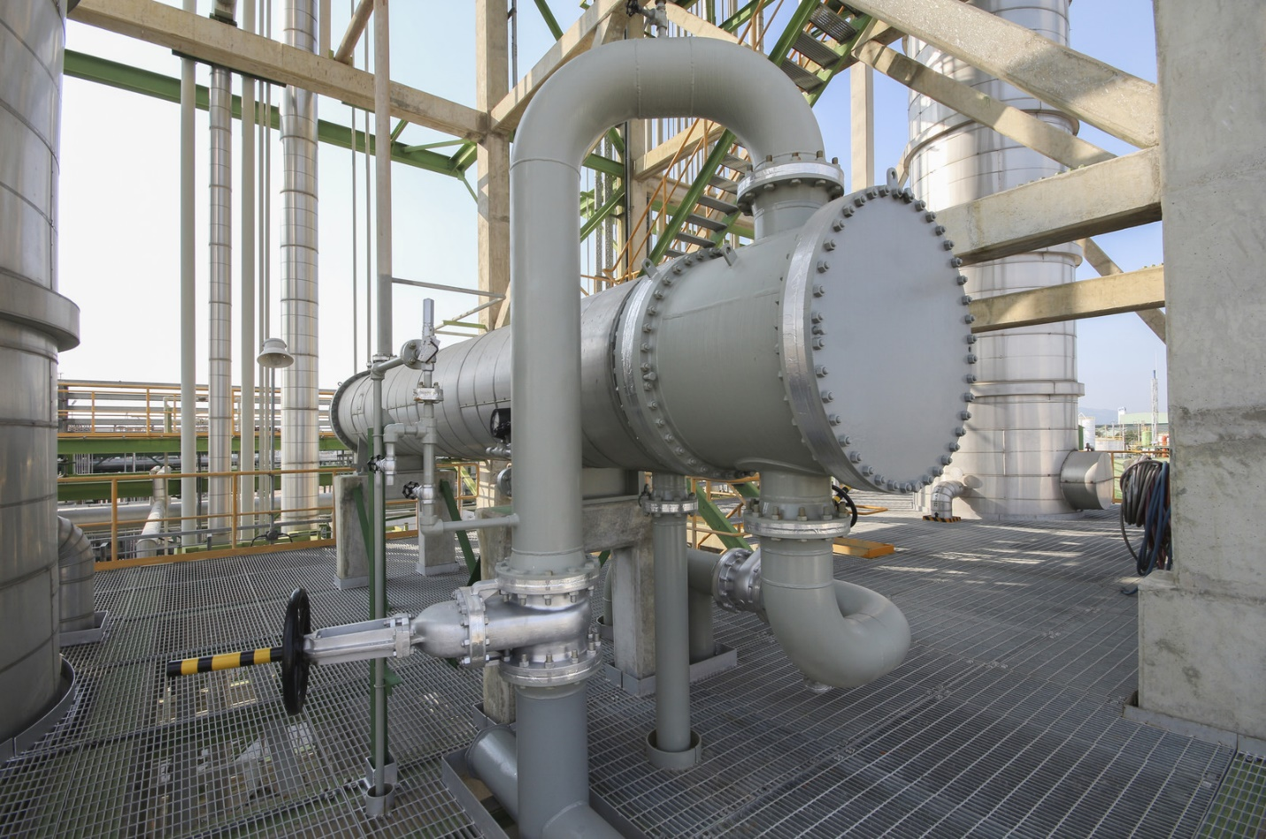Figure 1.3 - Heat exchanger
Heat exchangers transfer heat between two or more fluids/gases without mixing them. These are essential in maintaining temperature control in specific chemical processes. The design of heat exchangers will depend on heat load, the flow rate and thermal conductivity (Li and Wang, 2023). To ensure proper heat transfer, exchangers must operate at design temperature and specific pressure limits. A key operating practice is to ensure the surfaces are clear and clean with a lack of fouling which reduces the efficiency of them. In exchangers it is important to monitor the flow and temperature gradients between the separate streams to maintain proper efficiency (Wilson, 2022). Regular maintenance is vital to keep exchangers operating efficiently, done by cleaning, and removing fouling and inspecting corrosion. A pressure test when maintenance activities are completed is done to ensure the system is intact and operating safely (Nelson, 2024). Routine inspection is also done to see any tube leaks before they affect the operation of the exchanger. Corrosion, tube leaks and fouling are the most common areas where exchangers fail (Wilson, 2022). These issues are due to lack of cleaning and negligence of replacing worn components.
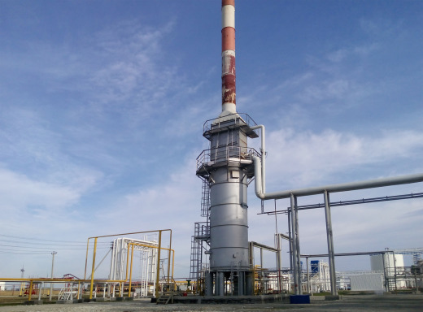
Figure 1.4 - Fired Heater
Fired heaters provide heat to process fluid by combustion. It is important to have proper control of the flame temperature and how efficient the combustion is in the firebox, fuel to air ratio is also vital for safe operation (Bajpai, 2024). Key principles of heaters are to ensure a correct balance between fuel and air to ensure complete combustion, which in turn minimises emissions and avoids overheating any of the surfaces in the firebox. Continuous monitoring of the flame stability, fuel flow rate and temperature allow optimisation of fuel efficiency and will reduce the risk of incomplete combustion. Combustion air and exhaust gases must be managed properly due to their high thermal efficiency (Norris, 2022). Regular maintenance of fired heaters would be burner inspection, cleaning the firebox, and checking the refractory within the heater. Flame monitoring systems are important to ensure combustion efficiency and allows the control operator to see if they proper calibration of fuel and air supply is complete (Norris, 2022). Some of the major failures within heaters are combustion being incomplete which produces high emissions. Overheating and burners failing are common issues within fired heaters (Wang Et al., 2023). These issues can be removed by proper operating conditions and routine checks on the equipment.

Task 2

For CV – Abstract 0.1

My current development action plan is mainly focused on improvement of my technical skills, leadership abilities, safety knowledge and improvement to help career progression. Within the next 6 months, I will be undergoing training a second unit, which will increase my responsibility within my workplace. I also aim to undertake more training on process control system to help improve my understanding of automated systems and the process. I will take part in equipment specific training to gain more Indepth knowledge of the plant.
I plan to shadow lead operators to learn more advanced techniques and become more effective at troubleshooting. I will focus on improving my safety within work, by attending training courses for safe working. Additionally, I plan on completing the next Turnaround in 2025 as a runner which will give me vital experience within the unit. Regular check ins with my supervisor to help ensure I'm on track with these objectives.
Within the next 5 years I want to be training a panel, which will help me further my role within the company as I strive to climb the ladder as far as I can. To do this I will need to develop both my technical skills and leadership skills to become a Panel or Senior Operator.
To improve my competency within my apprenticeship I had to go to college to complete courses linked to my future career.

Figure 1.5 - 1.8 - Certifications

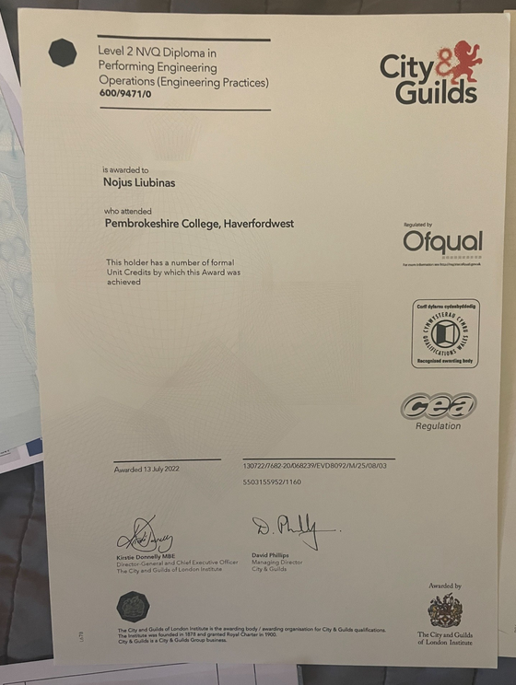
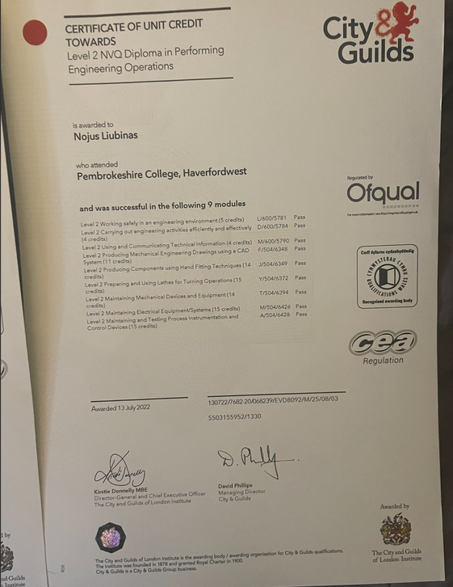
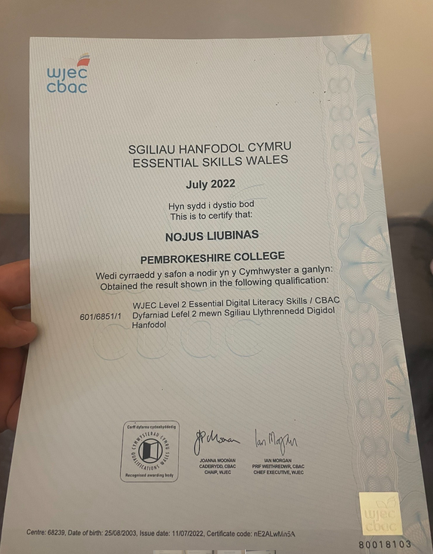
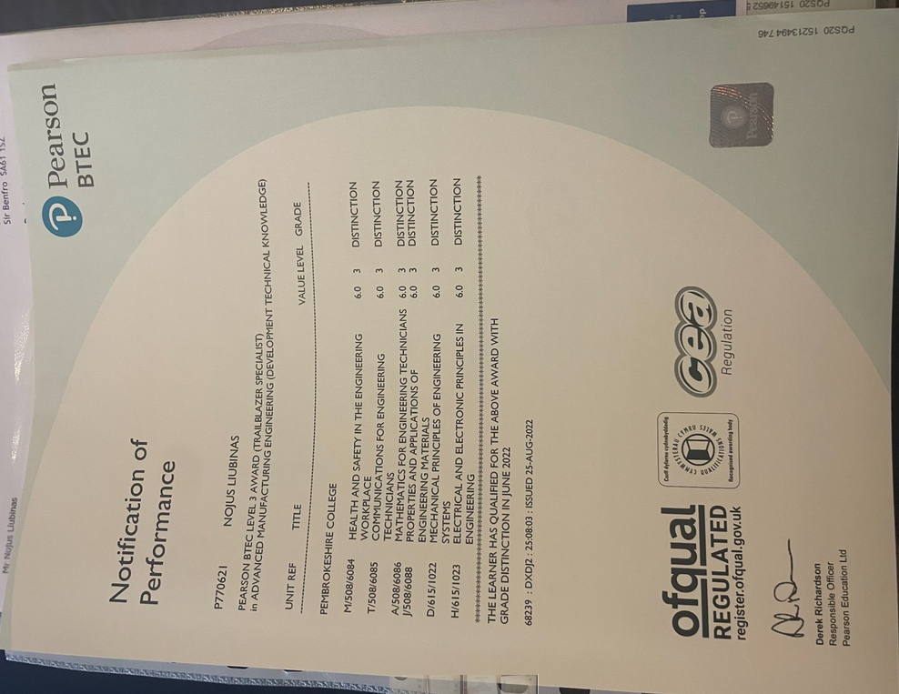

These Certifications show the work that was completed throughout my apprenticeship to ensure I'm at the correct level of knowledge for my career. This improved my level to knowledge drastically and currently I am undergoing a Level 4 Operations course to greater improve this knowledge.

Within Work I had to complete job write ups to prove the technical competency that I have, which is attached in Appendix 0.2. These job write ups in the workplace are crucial on improvement as they helped me get hands on. These job write ups showed records of the tasks I completed. This allows to me go back to these in the future to reflect and improve on the mistakes I made. These write ups also allow me to track my progress over time and with knowledge it will help improve me in my workplace. They also enable continuous improvement due to constant checks on them from assessors ensures I understand the job and task in hand. This has helped me in operations due to the hands-on nature it has given me vital experience in the job.
Over my course as an operator, I have received recognition within my job, I recently received a VPP Star Award for safety due to firefighting activities. Within my monthly checkups with my supervisor, I have been praised for resilience to harsh environments as within the turnaround we had long working weeks but my commitment to the job and to those around me stayed which was massively appreciated by supervisors. Also, a written thank you from supervisors due to response of a leak, which was done following the correct procedures even in high stress situations I was able to stay calm and helped fix the situation which I was commended for.
When carrying out work activities I have consistently used my technical knowledge of my unit and operations skills to ensure safe operations of the unit. This has been shown by numerous shutdowns and startups. I was able to help improve the efficiency of our splitter column as I was able to troubleshoot a steam trap issue which was dropping over 30 degrees from the column over the past few years. Even though I have limited experience being an apprentice I was able to shadow excellent operators and picked up their best traits and know what not to do as an operator. Within the next few years, I want to continue shadowing those above to improve my abilities as an operator.

Evaluation
Within this report key equipment has been explained and how the safe operation and correct maintenance of the equipment is required and how vital it can be to the refinery. Within this report my own knowledge as an operator has been shown as I have been part of numerous shutdowns and startups which has boosted my knowledge in my role. Recognition of a VPP Star award for safety for fighting a fire while I was training my unit. With constant supervisor reports and talks, I've been able to know where I'm doing well at my job and how to improve to the next level.
1936 Words

References
American Society of Mechanical Engineers (ASME) (2023) Process Safety Management: Guidelines and Best Practices. Available at: https://www.asme.org (Accessed: 09 January 2025).
Chemical Engineering Journal (2024) Process Optimization and Control in the Chemical Industry, 35(7), pp. 512-530. Available at: https://www.journals.elsevier.com/chemical-engineering-journal (Accessed: 09 January 2025).
Health and Safety Executive (HSE) (2023) Managing Process Safety in the Process Industry. Available at: https://www.hse.gov.uk/process/index.htm (Accessed: 09 January 2025).
Institute of Chemical Engineers (IChemE) (2024) Safety and Operational Principles for Process Engineers. Available at: https://www.icheme.org (Accessed: 09 January 2025).
International Journal of Chemical Reactor Engineering (2024) Advancements in Reactor Design and Maintenance Practices, 22(3), pp. 122-138. Available at: https://www.degruyter.com (Accessed: 09 January 2025).
International Journal of Pressure Vessels and Piping (2024) Piping System Maintenance and Integrity: Challenges and Strategies, 179, pp. 104-118. Available at: https://www.journals.elsevier.com/international-journal-of-pressure-vessels-and-piping (Accessed: 09 January 2025).
Mann, J., and Lee, S. (2023) Fundamentals of Process Equipment and Maintenance. 2nd ed. London: Wiley-Blackwell.
Pumps and Systems (2024) Operational Principles and Maintenance of Industrial Pumps. Available at: https://www.pumpsandsystems.com (Accessed: 09 January 2025).
Schneider, E., and Patel, K. (2023) Turbine and Compressor Operations in the Process Industry: Maintenance and Optimization Techniques. Journal of Industrial Maintenance, 27(5), pp. 44-58.
Society of Petroleum Engineers (SPE) (2024) Pumps, Compressors, and Heat Exchangers in the Oil & Gas Industry. Available at: https://www.spe.org (Accessed: 09 January 2025).
Valero Energy Corporation (2024) Process Safety Management at Valero: Operational Excellence and Risk Mitigation. Available at: https://www.valero.com (Accessed: 09 January 2025).
U.S. Occupational Safety and Health Administration (OSHA) (2024) Process Safety Management and Hazard Analysis. Available at: https://www.osha.gov/safety-management (Accessed: 09 January 2025).
Whittingham, M., and Robbins, L. (2024) Process Maintenance and Safety: Bridging the Gap Between Engineering Design and Daily Operations. Chemical Engineering & Technology, 47(6), pp. 860-872.
World Health Organization (WHO) (2024) Safety Management in the Chemical Process Industry. Available at: https://www.who.int (Accessed: 09 January 2025).
Zhang, Q., and Wu, Y. (2023) Safety Management in Process Engineering: Best Practices for Equipment and System Maintenance. Journal of Safety Research, 72, pp. 66-78. Available at: https://www.journals.elsevier.com/journal-of-safety-research (Accessed: 09 January 2025).

Bibliography

Anderson, R., Grant, K. and Jones, T. (2022) Practical Distillation: Design and Operation. New York: Wiley-Interscience.
Baker, M., Green, H. and Peterson, B. (2022) 'Valves in Chemical Processing: Types, Functions, and Applications', Chemical Engineering Journal, 43(2), pp. 145-158.
Bajpai, P. (2024) Fired Heaters: Technology and Applications. Elsevier: Oxford.
Chen, L. and Li, Q. (2023) 'Reactor Maintenance and Safety: Approaches to Maximizing Efficiency', Process Safety and Environmental Protection, 109, pp. 59-70.
Haddad, A., Khan, S. and Wang, L. (2022) 'Piping and Valve Maintenance for Chemical Plants', Journal of Process Engineering, 50(3), pp. 89-99.
He, Y. and Liu, J. (2024) Fundamentals of Process Control and Reactor Design. Cambridge: Cambridge University Press.
Huang, H. and Xu, X. (2023) Catalytic Reactors: Design, Control, and Operation. London: Springer.
Jones, D. (2022) Compressors in Process Plants: Selection, Operation, and Maintenance. McGraw-Hill.
Joffe, D. and Stenger, P. (2022) Industrial Pumping Systems: Maintenance and Troubleshooting. New York: McGraw-Hill.
Kumar, R., Sharma, V. and Patel, A. (2024) 'Turbine Operations and Maintenance in Chemical Processing', International Journal of Mechanical Engineering, 12(1), pp. 78-91.
Lau, S. (2023) Turbines for Process Industry. London: Elsevier.
Li, H. and Wang, Z. (2023) 'Heat Exchanger Design and Maintenance in Process Industries', *Journal

Abstract

0.1 - CV
Nojus Liubinas
11 St Davids Close
Milford Haven, Pembrokeshire, SA73 3BR,
07534222430
Nojusliubinas@Gmail.com

Professional Summary
A highly motivated and hard worker. Currently improving my skill set as a Refinery Operator, which was done through a comprehensive apprenticeship program with lots of hand on experience. Highly skilled in operating and maintaining refinery equipment, ensuring safety protocols and proficient in optimising production processes. Proven ability to adapt and perform under dynamic conditions. Strong Foundation in customer service from previous retail roles, demonstrating excellent communication and problem solving. Committed to continuous learning and looking to leverage technical and interpersonal skills to keep climbing in the energy sector.

Key Skills
Refinery Equipment Operation & Maintenance
Safety Protocols & Compliance
Equipment Troubleshooting & Diagnostics
Strong Communication skills
Team Collaboration & Coordination
Problem Solving Abilities
Attention To Detail
Time Management
Adaptability & Flexibility

Work Experience
Refinery Operator
Valero — [Pembroke]
[August 2024] – [Present]
Monitored and controlled refinery process
Ensured following of safety regulations adhering to the HSE
Proactive coordination with maintenance for preventative maintenance
Performing regular quality checks
Operations Apprentice
Valero — [Pembroke]
[September 2021] – [August 2024]
Learning and assisting with daily operations
Adhering to safety standards
Assisting with routine inspections
Participating in equipment start up

Education
A Levels
Haverfordwest High VC School — [Haverfordwest]
[September 2020]
Physics A
Biology A
Business A*
Welsh Baccalaureate A*

GCSE’S
Sir Thomas Picton — [Haverfordwest]
[June, 2018]
13 GCSE’S A-C
Maths B
English B

Certifications & Training
Hydrotreater/Unifiner Operator (Valero) – [August 2024]
VPP Safety Star Award (Valero) – [June 2024]

Projects
Unifiner Turnaround 2024
Assisted in Safely shutting down the Unit, and ensuring proper LOTO in place
Working alongside maintenance to ensure work is completed on time
Assisting in safe and gradual startup of the unit.

Languages
English [Fluent]
Lithuanian: [Native]

References
Available upon request.

Appendix 0.2
Snapshots of my job write up, that I had completed. Some photos attached
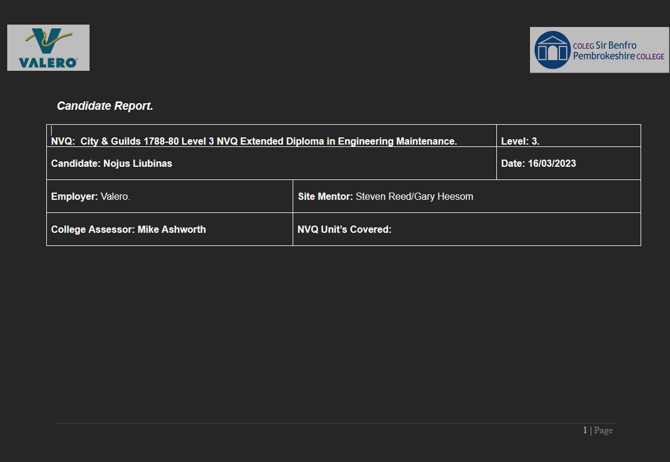
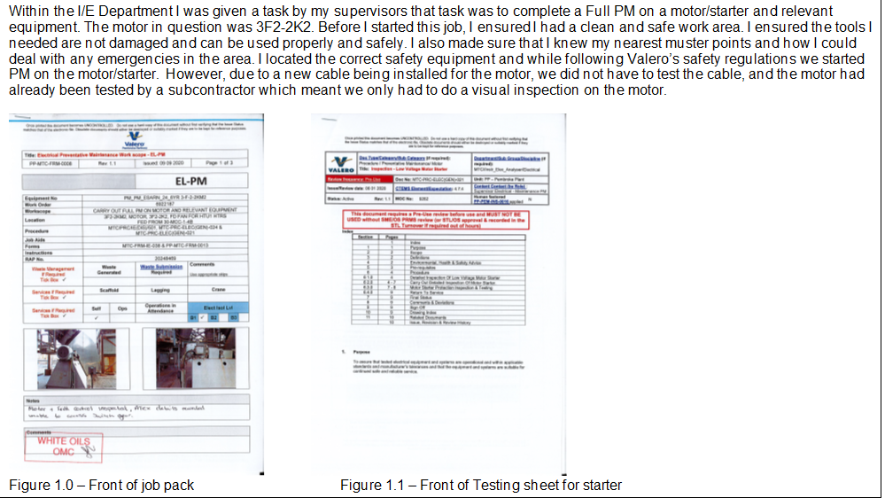
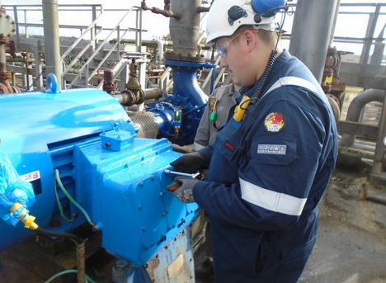

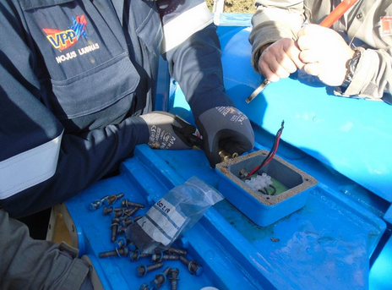
Within the Main job write up you would include photos of you completing the job just to prove that you did complete the job, then you write about the task you have just completed using the report format above. Then my assessor would go over this job with me after I submitted it just to double check that I did not forge anything and did complete the task.
Job write ups helped me gain hands on experience as an apprentice to ensure I felt more comfortable when finally, I was qualified and able to work alone.

