Marketing Plan and individual presentation
Student name : Catalin Leva
Student id : 2244690
Table of Contents
Component A: Marketing Plan Report 3
Introduction 3
Situational Analysis 3
Objectives 5
Strategy 6
Tactics 7
Action 8
Control 9
Conclusions 9
Component B: Presentation 9
References 12

Component A: Marketing Plan Report

Introduction
Marketing is a significant strategy followed by business organisations. It is a strategy of advertising and promoting the products and services of a business organisation to the global market. It is a relevant process that helps a business company to create a positive and strong brand image and at the same time enhances customer satisfaction. The study analyses the significant factors related to the marketing plan of a company. To analyse the several relevant elements related to the marketing and promotion of an organisation the case study of Hilton Hotel has been chosen and analysed. For the purposes of marketing the SOSTAC marketing method has been chosen. Sostac is a general marketing strategy that contains six elements related to the marketing process of a company such as situation, objective, strategy, tactics, action and control.

Situational Analysis
5 C's Situation Analysis
5 C’s is a significant situation analysis framework that refers to the environment in which a company conducts its business. As opined by Chaffey and Smith (2022), situation analysis is a significant factor of a marketing plan that helps an organisation identify the relevant factors affecting their business.
Company
SWOT analysis has been done to analyse the competitive factors of the company existing in the market. As opined by Benzaghta et al. (2021), SWOT Analysis is a significant method of analysing the future scopes and relevant factors of a business organisation.
- Strengths
High-recognised brand image
Skilled and trained employees (Hilton Hotel, 2023)
Innovative ideas
- Weakness
Technical faults
Data breaches (BBC, 2017)
The dissatisfaction of the employees
- Opportunities
Digital marketing strategy
Technological innovation
Business expansion
- Threat
Covid impact
Political issues
High competition in the market
Customers
The organisation is following the demographic method of market segmentation. Hilton Hotel is targeting customers who are willing to explore new places with several innovative plans (Hilton Hotel, 2023). The organisation is mainly expanding their businesses in the geographic regions that have been very popular with their consumers.
Competitors
Hilton Hotel is highly required to implement an innovative strategy in their business as the market competitiveness for Hilton Hotel is significantly high. There are several competitors existing in the business market like Grand, Marriott, Hyatt and many others. Bowman's Strategy Clock is a significant tool of marketing that helps an organisation to analyse its pricing strategy and the value of its services. It is a significant tool the organisation can analyse the competitive factors existing in the global market.
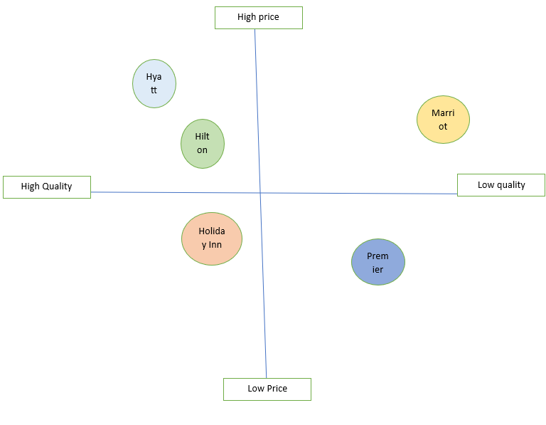
Figure 1: Perceptual Positioning Map
(Created by the learner)
Collaborators
There are several significant internal and external collaborators and stakeholders existing in the business process of Hilton Hotel. The organisation engages several stakeholders in their business to enhance their productivity and at the same time ensure their Corporate Social Responsibility needs (Hilton, 2023).
Climate
PESTLE Analysis
Hulton Hite is a famous and renowned hotel chain existing in the Tourism and leisure market. The political stability of a country helps the organisation to expand their business in different regions of the world. The political stability of the UK is 0.54 in 2021 (The Global Economy, 2021). The UK has left the European Union and as a result, it created some political turmoil initially but now the condition is quite stable for the hotel to expand their business. Covid -19 has a significant impact on the economic and social life of the people living all over the world therefore to mitigate the challenges the organisation has to incorporate the relevant strategies. On the other hand climate change has been a huge threat for the hotel industries and they are mainly focussing on environmental sustainability.

Objectives
 | Specific | Measurable | Attainable | Relevant | Time duration
Sales Increase | Calculating the net profit value the organisation can measure the sale growth rate. | Innovative strategies help an organisation increase their sales rate. | Implementing the marketing strategy helps to achieve profit. | Increases in the revenue and sales rate help an organisation to sustain its business. | 8-9 months
Brand value | Brand value of a company helps to increase the sales and profit rate. | Promotion and effective marketing strategy helps an organisation to create a positive brand value. | Advertising, digital marketing and promotion helps in the process of creating a strong brand value. | Brand value is a relevant factor as it is related to the customer satisfaction. | 7-8 months
Table 1: SMART Objectives
(Created by the learner)

Strategy
Value proposition is a significant strategic framework that a business organisation uses to implement new strategies in their business and also targeting the consumers for their business. As opined by Kaur et al. (2021), value proposition helps an organisation to analyse the customer behaviour, consumer’s demand and market segmentation of a company. The new strategy to be devised by Hilton Hotel will be to improve the customer's experience with more focus on the health and safety of the customers after the outbreak of the pandemic in 2020. The new strategy when linked with Ansoff Matrix, it can be stated will be to Product Development. Hilton Hotel will take aim to innovate and invent a new app service through digital collaboration which will help in creating awareness among the customers. According to Hussain et al. (2013), product development does boost the enhancement of the experience of the customers since it is for the users that the new products are launched knowing the necessity. Hence, for the Hilton Hotel, a digitally tailored app will be designed and introduced which will create an awareness about what the hotel will facilitate and how the hotel will be dealing with the customers in concern with the health and safety protocols.
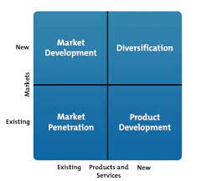
Figure 1: Ansoff Growth Matrix
(Source: Clarissia, 2020)

Tactics
With the idea of introducing a new market or even entering a new market, it is important to communicate with the audience (Jacobson et al., 2020). If the companies do fail to communicate the innovative plans, the actual performance or purpose will be a failure. Hence, the Communication Mix is considered one of the truest means of understanding what appropriate communication technology could be used that will help in fostering better and more advanced performances and positioning of the brand too. In the communication Mix for Hilton Hotel, the aim will be creating an awareness of how the company is taking proper care and incorporating advanced mechanisms through the introduction of the digital app focusing on the health and safety of the customers. Communication Mixes are regarded to be different in nature and the decision lies with the management on which mix to be chosen (Patricio et al., 2020). Here, for Hilton Hotel the communication mix to be used will be social media advertising through Facebook which will help in reaching out to millions of users at a time and with images and videos have a broader awareness of the new product.
Through social media advertisements, it is idealized that millions of users can be attracted at one means with a cost-effective means (Dolega et al., 2021). Therefore, the management and the marketing team in collaboration will decide on undertaking a Facebook campaign where the broader discussion on the product can be done and informed to the users.

Action
Activities | Week 1 | Week 1-2 | Week 2-3 | Week 3-4 | Week 4
Identify the current issue of company
Conduct the SWOT analysis
Develop the new product line
Plan on the objectives
Frame the communication marketing tool to be used
Identify on how the tool will be used
Decide on the kind of advertisements
Make up the plans on the advertisements
Implement it
Evaluation of the implementation

Control
The two significant KPI s chosen to measure the growth of the business is the customer retention and the measurement of business and sales profit rate. As opined by Khan et al. (2022), customer retention helps the organisation to increase their productivity and business operation.

Conclusions
From the conclusion, it can be gathered that for the introduction of a new plan and new marketing activity, it is identified that every company needs to develop plans. The current scenario is that Hilton Hotel will be planning after the SWOT analysis to understand how the issues can be overcome. The communication mix like social media advertisements will be used to create awareness of the new product lines and develop the market position. From the application of the Ansoff Growth Matrix, the company will go by Product Development which will help in creating a strong market position and ensure that good revenues are earned through it.

Component B: Presentation
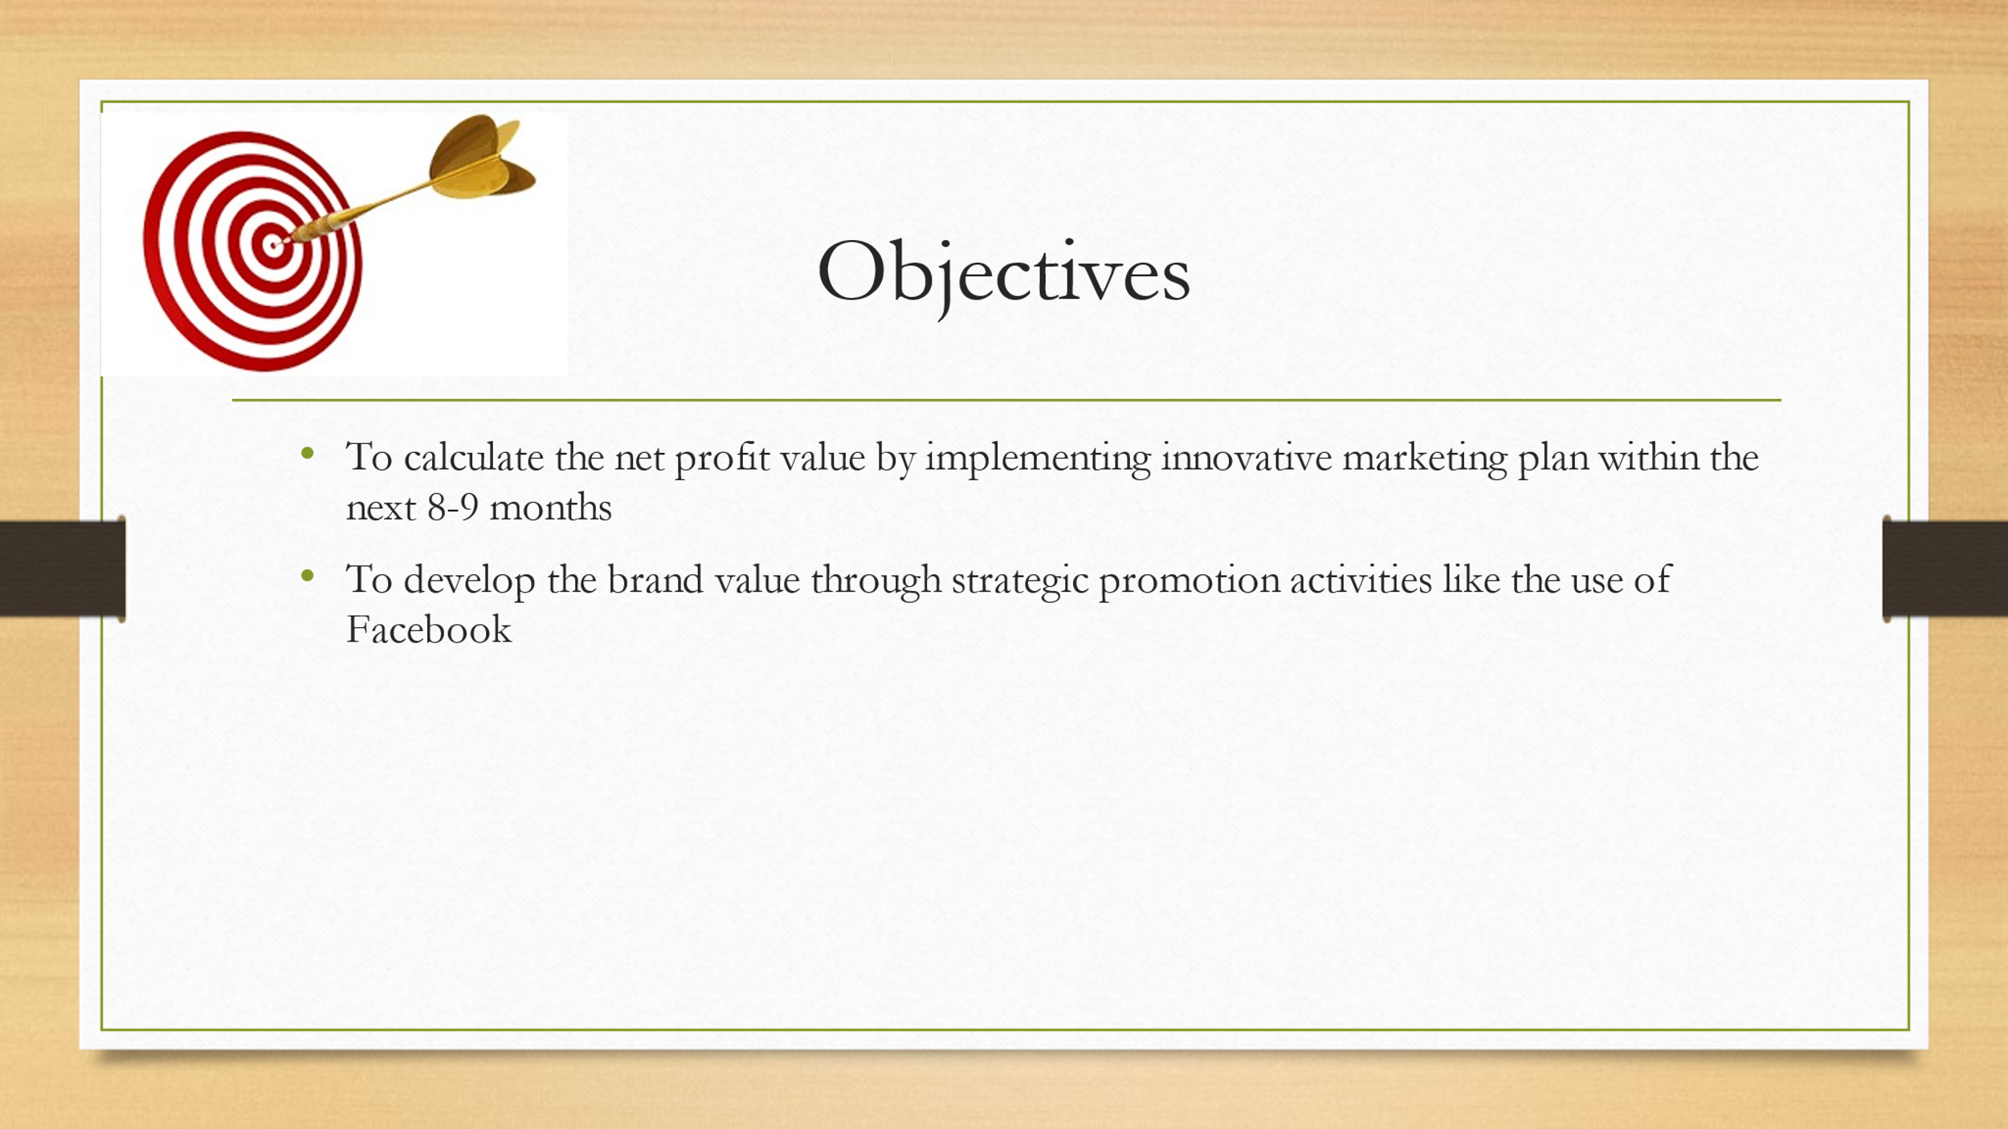
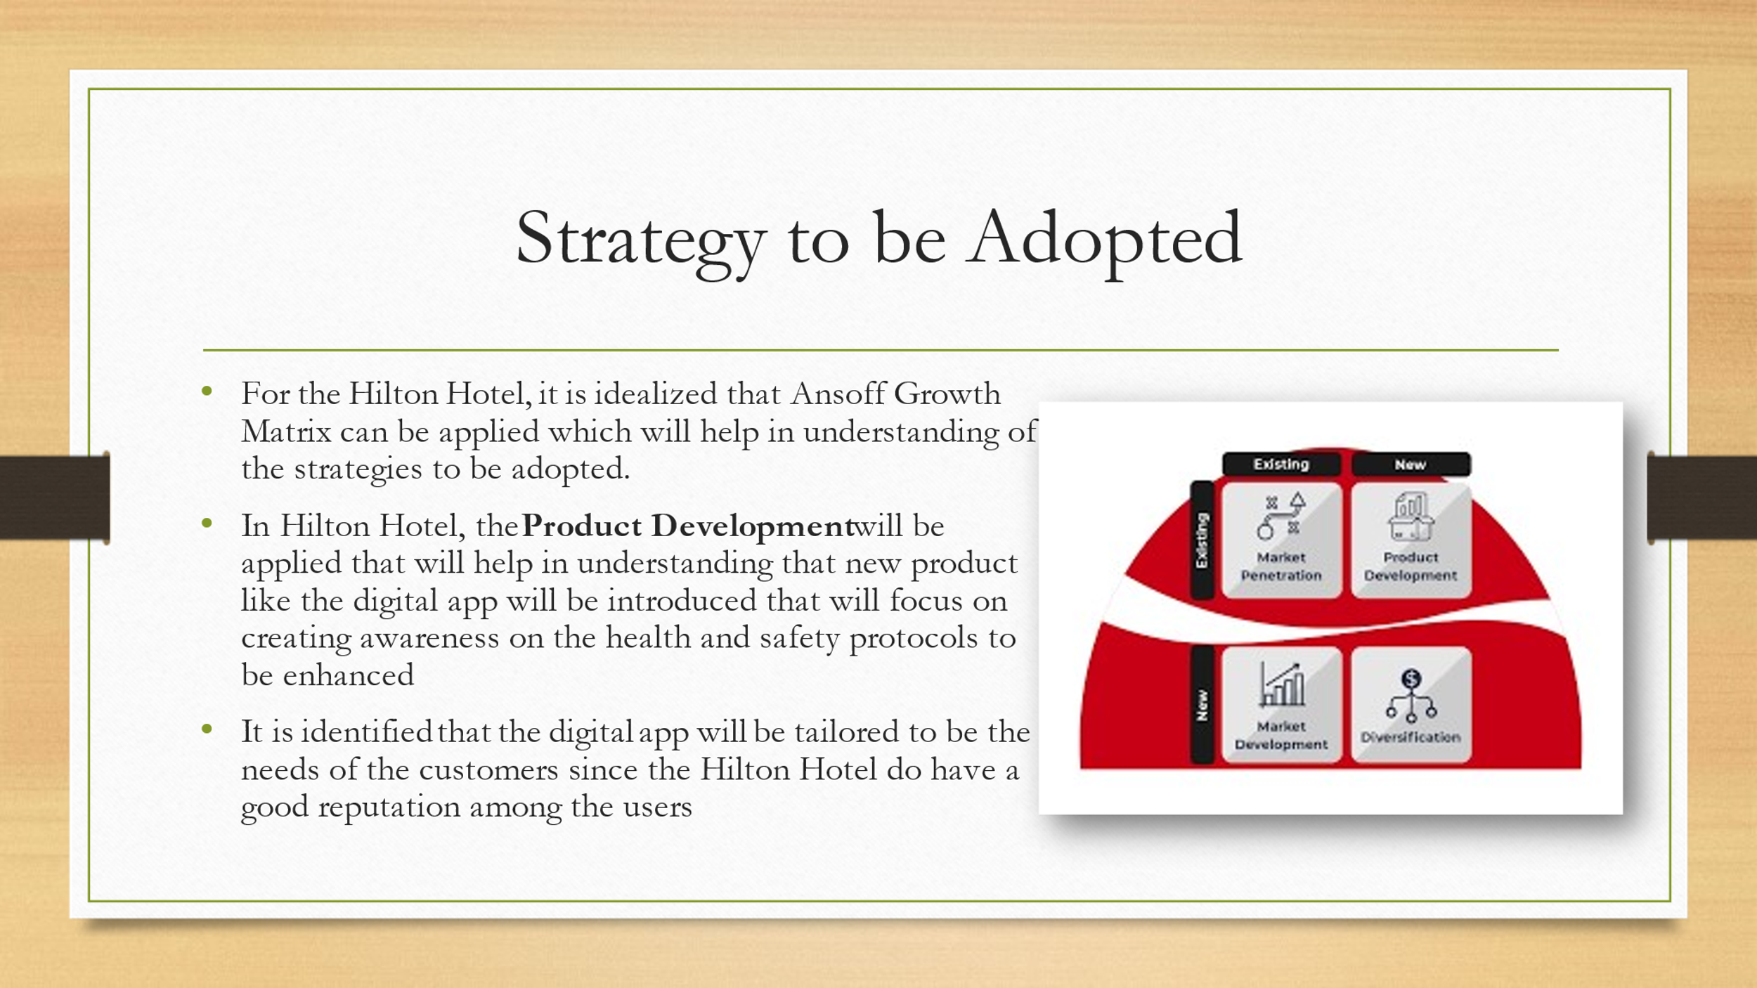
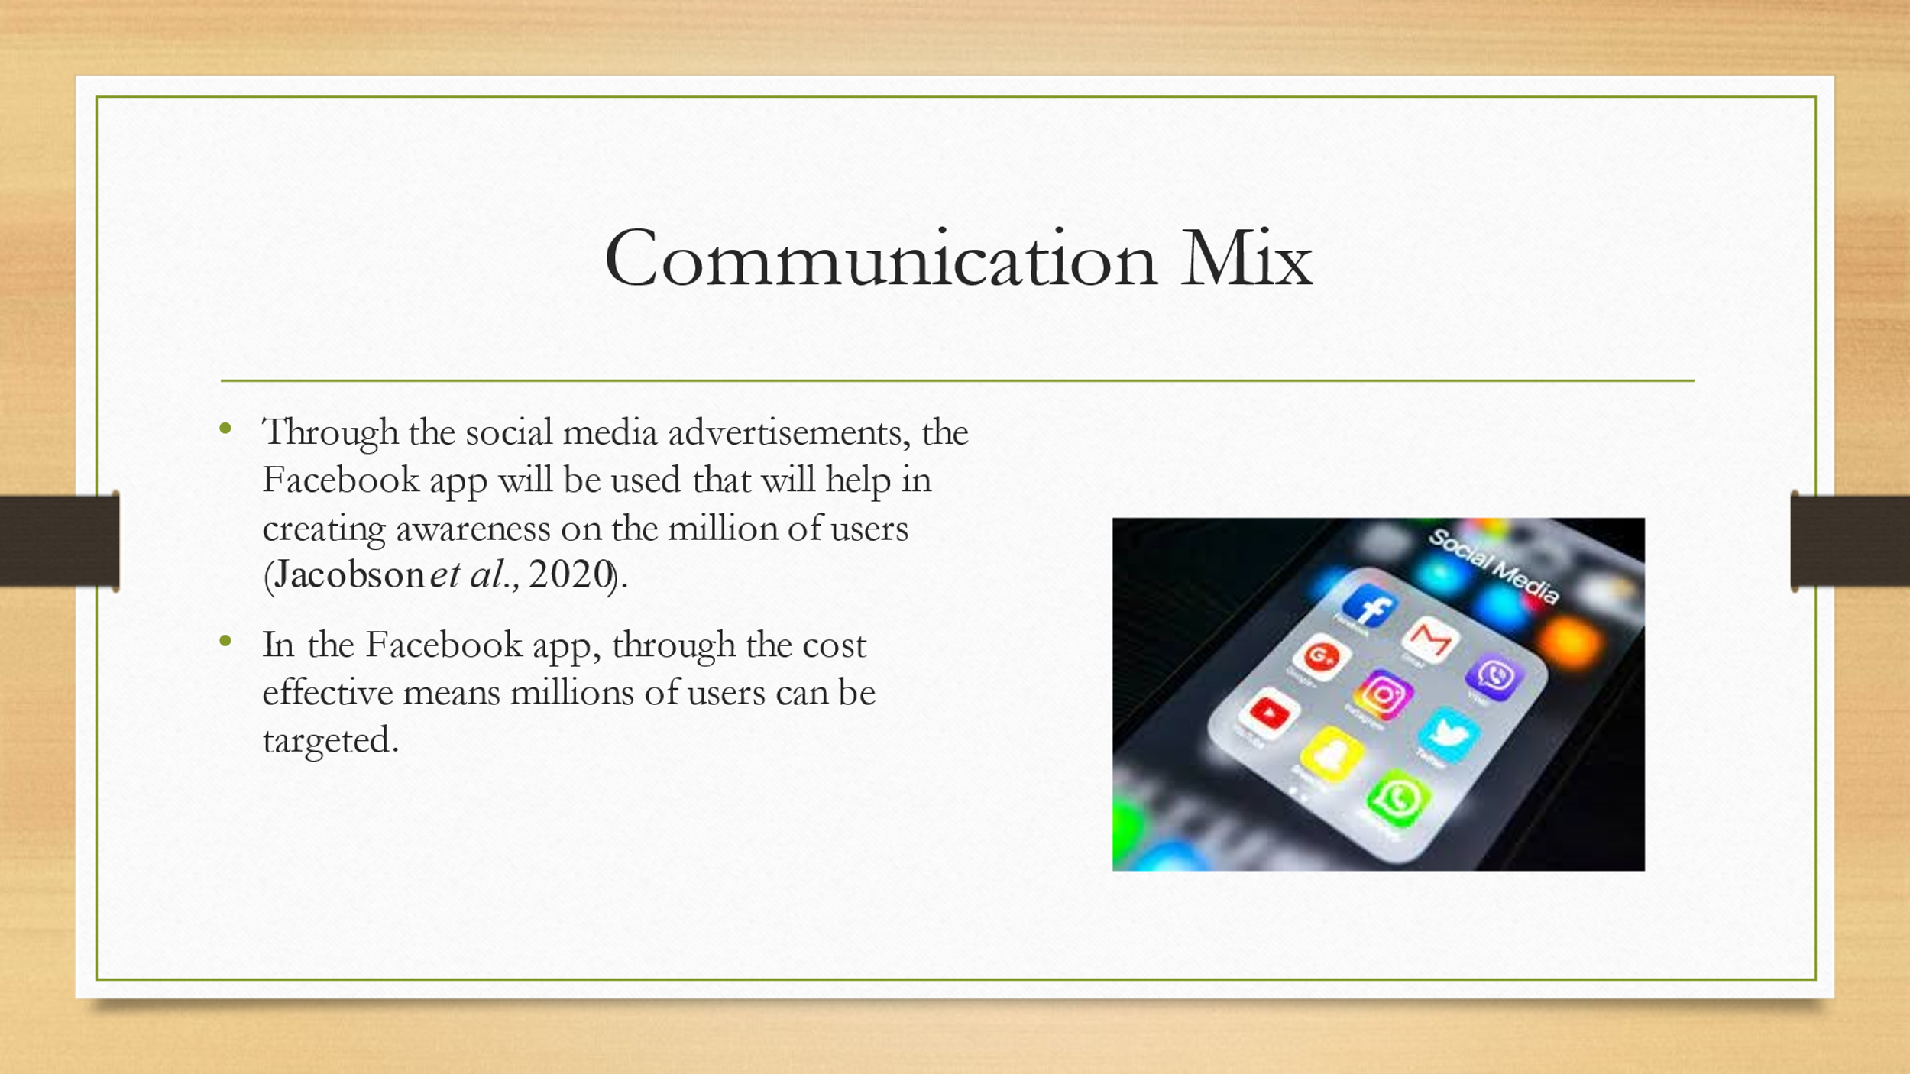

References
BBC, 2017. Hilton Hotels fined for credit card data breaches [Online] Available at:<https://www.bbc.com/news/technology-41834679> [Accessed on 9 June 2023]
Benzaghta, M.A., Elwalda, A., Mousa, M.M., Erkan, I. and Rahman, M., 2021. SWOT analysis applications: An integrative literature review. Journal of Global Business Insights, 6(1), pp.55-73.
Chaffey, D. and Smith, P.R., 2022. Digital marketing excellence: planning, optimizing and integrating online marketing. Taylor & Francis.
Clarissia, S.M.S., 2020. A study on Ansoff Matrix Technique: As a growth strategy and an adaptive learning technique adopted in the leading brand of products. BIMS Journal of Management, p.18.
Dolega, L., Rowe, F. and Branagan, E., 2021. Going digital? The impact of social media marketing on retail website traffic, orders and sales. Journal of Retailing and Consumer Services, 60, p.102501.
Hilton Hotel, 2023. HILTON GLOBAL [Online] Available at:<https://jobs.hilton.com/apac/en/apprenticeship> [Accessed on 9 June 2023]
Hilton Hotel, 2023. STAKEHOLDERS ENGAGEMENT [Online] Available at:<https://cr.hilton.com/wp-content/uploads/2018/05/Hilton_2018_Stakeholder_Engagement.pdf> [Accessed on 9 June 2023]
Hussain, S., Khattak, J., Rizwan, A. and Latif, M.A., 2013. ANSOFF matrix, environment, and growth-an interactive triangle. Management and Administrative Sciences Review, 2(2), pp.196-206.
Jacobson, J., Gruzd, A. and Hernández-García, Á., 2020. Social media marketing: Who is watching the watchers?. Journal of retailing and consumer services, 53, p.101774.
Kaur, P., Dhir, A., Talwar, S. and Ghuman, K., 2021. The value proposition of food delivery apps from the perspective of theory of consumption value. International Journal of Contemporary Hospitality Management, 33(4), pp.1129-1159.
Khan, R.U., Salamzadeh, Y., Iqbal, Q. and Yang, S., 2022. The impact of customer relationship management and company reputation on customer loyalty: The mediating role of customer satisfaction. Journal of Relationship Marketing, 21(1), pp.1-26.
Patricio, R., Moreira, A., Zurlo, F. and Melazzini, M., 2020. Co‐creation of new solutions through gamification: A collaborative innovation practice. Creativity and Innovation Management, 29(1), pp.146-160.

