  'How have shifting public perceptions of marine mammal welfare impacted on seaworld and other entertainment parks?' | Abstract  Georgia Passmore (1802108)

Contents Page

1.0 - Background of Subject Area

2.0 - Context of Study

3.0 - Organisation Background

4.0 - Research Methods

5.0 - Resources and Planning

6.0 - Gantt Chart

7.0 - Reference List

Background of Subject Area

The topic chosen for the dissertation involves the welfare of marine mammals, this topic was hugely discussed at one point during the year 2010 (Lavender and Holland, 2020). The literature used throughout the dissertation will differ from newspaper articles, online website articles, TV documentaries, TV interviews and legal documents describing events and deaths that took place due to marine animals or the entertainment parks. The majority of this topic is not only information and statistics but also continuous arguments and legal battles between two opposing sides, one being the entertainment parks (Seaworld) and one being the activists and organisations that fight for the rights of marine mammals. A huge portion of the dissertation research will be referring to the TV and later Netflix documentary 'Blackfish'. A documentary based on the death of Dawn Brancheau and her life and death at Seaworld. Dawn died whilst performing an entertainment act with Killer Whale Tikkilum, she was pulled under the water by her hair by the mammal, and for years on after is the unsettled debate of whether Dawn died because the Whale's captivity or because of a fault of her own (Lavender, 2020).

Context of Study

The field in which I've chosen to study has a huge variety of perspectives, it has so much depth to discover and reference it has become very interesting to people. The research itself is very controversial and causes many discussions when brought up, as the research differs from informal documents to formal documents it is hard to establish the real truth and facts behind this topic and to really answer or at least try to answer the dissertation title correctly. As mentioned, there are many opinions and arguments around the title, and it will be very interesting to find out more about it. The question we are researching into is one that has positives and negatives for each argument given, the main question asked in relation to this topic is "should marine animals be used as entertainment, is it damaging to them?". It is a controversial topic in the sense of each perspective is weighed out, there is not one with more information than the other, there is plenty of reliable and accurate sources to use but also the more unreliable ones are an advantage to use as it will suggest what public writers and readers really thought about the situation. PETA will be a heavily used source in this dissertation as they were the instigators of the opposing argument (About PETA's Campaign Against SeaWorld | PETA, 2020). Whereas the main source on the opposite side is obviously Seaworld and its attorneys, who's argument is that the Orca's are perfectly safe in their tanks and the trainers were at fault for any disruptions (The Case Forever Known as Tilikum v. SeaWorld | PETA, 2020).

Organisation Background

The organisations being investigated in relation to this topic are Seaworld and PETA. PETA is an organisation based on establishing and defending the rights of all animals, their motto is that animals are not our property to test on, eat, wear, use for entertainment or abuse in any way. It is a non-profit charity based in Norfolk, Virginia, but have affiliates worldwide.
Since the 1980s, it has been enforced that animal rights have been upkept. PETA focuses its mission in four different areas, the entertainment industry, in laboratories, factory farms and in the clothing trade (All About PETA | PETA, 2020). PETA's roles in the fight against Seaworld is obvious to any reader, their argument included that Seaworld were technically abusing their Orca's sexually, physically and mentally by holding them captive and using them to reproduce over and over again. Seaworld are an entertainment/theme park that use marine mammals and animals as their product. The first Seaworld was built in San DIego but its most famous park is in Orlando, Florida. Seaworld opened many parks up in America and the empire kept growing and the numbers became unstoppable. Seaworld got greedy and started to capture marine life in unethical ways, whilst keeping the Orca's in tanks meant for one now holds 2-3 it became apparent that Seaworld was abusing their animals in many different ways (SeaWorld Parks & Entertainment Company History | SeaWorld Entertainment, 2020). The aim of my dissertation is to really see in what way did the TV documentary 'Blackfish' and the opinions and criticisms following it affect the way marine mammals, specifically Orcas, were treated at Seaworld and how the public helped change the way for the better. To find the answers the plan is to ensure all relevant sources and information are used to the best of their ability, to see the topic from both points of view and don't go into the research with a closed mind and also to use sources other than Seaworld and PETA. The reason question is very similar to the dissertation question overall but includes use of the specific sources. "How does the publication and the showing of Blackfish and the public opinions and criticisms that follow affect the welfare argument of Orcas at Seaworld?". This question is more specific to what the exact mission is and it includes sources that will be used continuously throughout the dissertation.

Research Methods

The research methods that will be used through the dissertation are mainly qualitative and not quantitative data, as the topic that I will be researching is very deep and meaningful to people, a lot of the data and sources are in written form instead of statistics. And even though probably already known, all of the data except for a small minority will be secondary data carried out by other people such as PETA, newspapers, bloggers etc. The benefits of secondary data are that it is easier and faster to access, and it can range across any time period and any geographical location. Although a small amount of primary data will be used when conducting questionnaires, online surveys and potentially observations, this will help answer the research question more specifically (Base, 2020). To gain some personal primary data and knowledge throughout the dissertation, it will be beneficial to conduct a questionnaire to the general public to see what their opinion is on the matter and what argument they would side with. The reliability will differ from source to source, as mentioned although a lot of sources used will be reliable and come from a trustworthy origin, it will be beneficial to use and identify the inaccurate sources to evidently show the miscommunication and affects that fake news has on the public and its opinions. The risks this topic carries include it being a very emotional subject to particular people and the views and articles shown throughout may contain some disturbing information and images to those who think very highly of animals and respect their wellbeing. The data will be analysed by using content analysis, it means that by using qualitative data it can be broken down into patterns and categories and potentially then turned into quantitative data and that can be easier to read and analyse furthermore (Content Analysis, 2020).

Resources and Planning

To carry out the research I will always need a compute device such as my Macbook as it stores a lot of information in the files and throughout particular documents, I can search a word or phrase and it will highlight it every time it is found. I will also need access to an individual and space to observe an experiment as part of my research (although this will be done using a family member within my household due to the Covid-19 pandemic). I will need access to specific legal documents which I will more than likely have to use an email address for and potentially show a virtual ID to gain access. The most important resource needed is access to Microsoft word software, all software packages from Microsoft will be used throughout the dissertation to analyse data, write down the data, showcase the data and potentially use it to convert the qualitative data into the quantitative data, meaning it would be simplified into numbers rather than large paragraphs of words.

Gantt Chart

Below is a Gantt Chart created to keep on track and stay organised with tasks when conducting and analysing the research and finally writing up the dissertation. It includes many tasks all throughout the month of December as draft dates until certain dates can be confirmed, providing the process will be smooth going and reach no limitations or issues in the process.

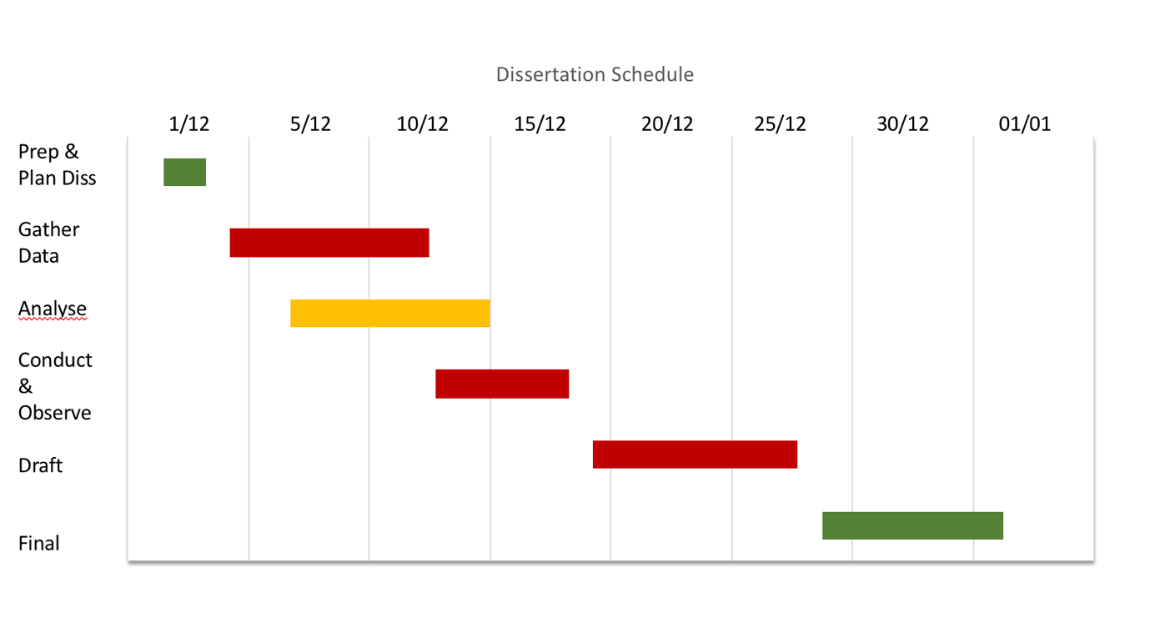
The above Gantt Chart was inspired and was built on from Microsoft examples, it is a very straight forward chart that will allow me to mark my tasks off easily and efficiently jsut by the click of a button (Chart, 2020).

Reference List

SeaWorld of Hurt. 2020. About PETA's Campaign Against Seaworld | PETA. [online] Available at: <https://www.seaworldofhurt.com/about/> [Accessed 30 November 2020].

PETA. 2020. All About PETA | PETA. [online] Available at: <https://www.peta.org/about-peta/learn-about-peta/> [Accessed 30 November 2020].

Base, K., 2020. Research Methods | Definitions, Types, Examples. [online] Scribbr. Available at: <https://www.scribbr.com/category/methodology/> [Accessed 30 November 2020].

Chart, M., 2020. Excel Gantt Chart Tutorial +Free Template + Export To PPT. [online] Office Timeline. Available at: <https://www.officetimeline.com/make-gantt-chart/excel#download-excel-file> [Accessed 30 November 2020].

Terry.uga.edu. 2020. Content Analysis. [online] Available at: <https://www.terry.uga.edu/contentanalysis/index.php> [Accessed 30 November 2020].

Lavender, J., 2020. Trainer's Horrific Death As Seaworld Killer Whale 'Tore His Organs And Bit Him'. [online] mirror. Available at: <https://www.dailyrecord.co.uk/trainers-horrific-death-seaworld-killer-21983642> [Accessed 30 November 2020].

Lavender, J. and Holland, P., 2020. Horrific Injuries Of Seaworld Trainer Killed By Orca Confirmed. [online] mirror. Available at: <https://www.mirror.co.uk/news/us-news/horrific-injuries-seaworld-trainer-killed-21564725> [Accessed 30 November 2020].

Seaworldentertainment.com. 2020. Seaworld Parks & Entertainment Company History | Seaworld Entertainment. [online] Available at: <https://seaworldentertainment.com/about-us/history/> [Accessed 30 November 2020].

PETA. 2020. The Case Forever Known As Tilikum V. Seaworld | PETA. [online] Available at: <https://www.peta.org/blog/case-forever-known-tilikum-v-seaworld/> [Accessed 30 November 2020].

