Report for Strategic Management Assignment 1 2019 - Lidl - German Discounter Gaining Market Share
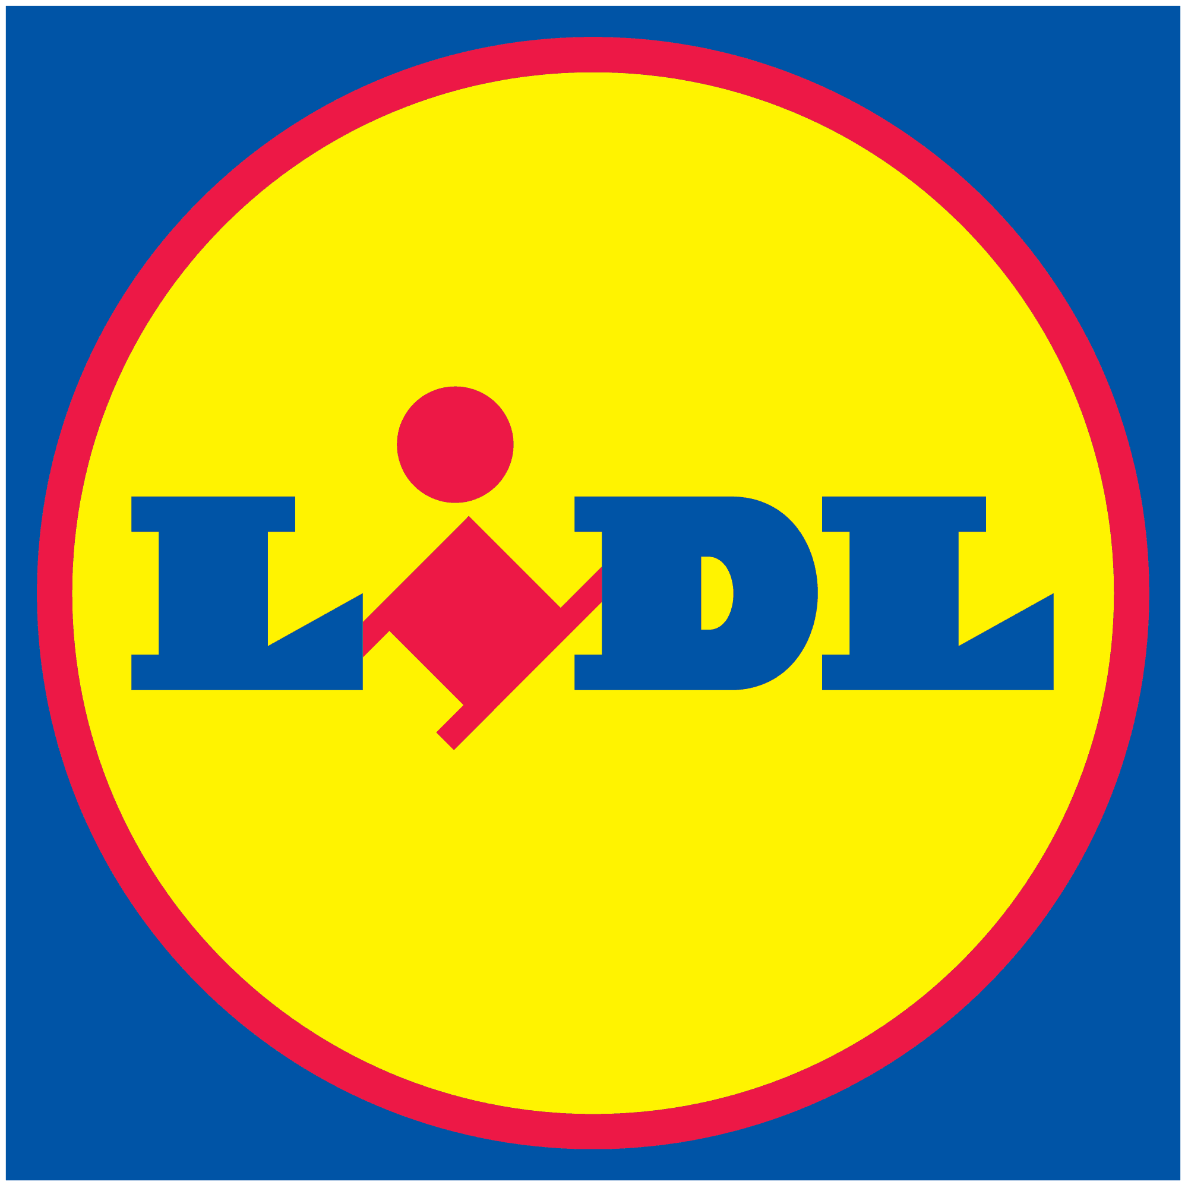

MODULE NAME: STRATEGIC MANAGEMENT AND SUSTAINABILITY
NAME: FARA ALISHA ZULKIFLI
STUDENT NUMBER: 1903960

TABLE OF CONTENTS

1. EXECUTIVE SUMMARY 1
2.0 INTRODUCTION 2
2.1 REPORT REMIT 2
2.2 BACKGROUND OF THE ORGANISATION 2
2.3 DEFINITIONS OF MAJOR CONCEPTS 3
2.3.1 DEFINITION OF STRATEGY 3
2.3.2 DEFINITION OF BUSINESS LEVEL STRATEGY 3
2.3.3. DEFINITION OF COMPETITIVE ADVANTAGE 3
2.3.4 PORTER’S GENERIC STRATEGIES 4
3. MAIN BODY 6
3.1 IMPLEMENTATION OF THE STRATEGY 7
3.2 ADVANTAGES AND DISADVANTAGES OF THE STRATEGY 8
4. CONCLUSION 9
4.1 RECOMMENDATIONS 9
5. REFERENCES 10

LIST OF FIGURES

FIGURE 2-1 PORTER GENERIC STRATEGIES ……………………………………....... 4

1. EXECUTIVE SUMMARY
The purpose of this report is to identify Lidl’s competitive strategy, examples that Lidl has taken and critically evaluate Lidl’s development. Lidl was established in the 1930s in Germany and became a discounter in the 1970s. Lidl entered the UK in 1994 and now has around 450 UK stores. Lidl competes with four big retailers such as Tesco, Asda, Sainsbury’s and Morrisons. Lidl has around 10,00 stores worldwide, 210,000 employees and 135 warehouses.

Lidl’s strategic choice is the Cost Leadership strategy from Porter’s Generic Strategies. Cost leadership’s aim is to gain a competitive advantage by reducing costs. The way that Lidl has implemented the cost leadership is by selling private label brands. Lidl gets to cut out the middleman, which eliminates any additional costs from a supplier. Moreover, Lidl as well keeps its labour costs low. Lidl stores are thinly staffed to keep labour costs down. Lastly, Lidl stocks fast-moving items. Lidl favours everyday items that shoppers often buy.

The advantages of the cost leadership are higher profitability and increased market shares. While the disadvantages are lack of innovation or new products and as well less recognition due to less marketing, market research and R&D can be expensive in the long run. Recommendations for Lidl should reposition its brand. In the future, customers are going to expect better quality. Lidl should also impose home delivery services in order to compete with the bigger supermarkets.

2.0 INTRODUCTION

2.1 REPORT REMIT
The purpose of this report is to identify the competitive strategy that Lidl has utilized in order to develop their current competitive positions. This report will also show examples of actions that Lidl has taken to accomplish this strategy. This report will also show the critical evaluation of the competitive strategy that Lidl has utilized in the development of its competitive position.

2.2 BACKGROUND OF THE ORGANISATION

Lidl is a German chain of discount supermarkets that operate worldwide, including the UK. Lidl was established in the 1930s in Germany and became a discounter in the 1970s. Lidl entered the UK in 1994 and now has around 450 UK stores. Lidl competes with four big retailers such as Tesco, Asda, Sainsbury’s and Morrisons. Lidl has around 10,00 stores worldwide, 210,000 employees and 135 warehouses that ship some 1,600 products to nearly every European country (Lidl, 2019).

Their mission is to deliver outstanding customer satisfaction, to ensure market leading quality and value by constantly innovating and optimising our efficient processes, driven by technology and people, to work with business partners in sustainable relationships, contributing positively to local communities and to achieve long term success by investing in the recruitment, training and development of our people (Lidl, 2019).

In 1994, Lidl entered the UK market and now has approximately 450 UK stores. The country, however, is not as engaged in discounters as Germany. This is because of the successful marketing of the big four retailers such as Tesco, Asda, Sainsbury’s and Morrisons. They present satisfying retail experiences that convinced the customers.

Thus the domination of larger supermarket chains in the UK in 2007, Lidl’s market was approximately 1.5% compared to Tesco, the market leader of 27.6% market share (Dyer, 2018). In 2007, Schwarz had an approximate market share of 18.4% in Germany, encouraged by ownership of the hypermarket chain Kaufland, putting it ahead of its discount competitor, Aldi. Lidl had attained its biggest UK grocery market shares at 5.9% in 2019 (Makortoff, 2019).

2.3 DEFINITIONS OF MAJOR CONCEPTS

2.3.1 DEFINITION OF STRATEGY

According to Johnson et al (2011), a strategy is the direction and scope of an organisation over the long term, which achieves advantage in a changing environment through its configuration of resources and competences with the aim of fulfilling stakeholder expectations. Business strategy is a comprehensive collection of decision rules and guidelines that define the scope and direction of a business (Ansoff, 1965).

2.3.2 DEFINITION OF BUSINESS LEVEL STRATEGY

An organisation's strategy outlines how it will achieve its objectives despite the environmental challenges and opportunities and its resources and capabilities (Rue and Holland, 1989). Business-level strategy is a strong indicator of other organisational phenomena and by the most important element for practitioners’ study, which is the empirical analysis of their relationship with organisational success (Hambrick, 1980). The business-level strategy is to deliver value to consumers and achieve a competitive advantage by leveraging core competencies in particular product or service markets. Business-level strategy deals with the position of a company in an industry relative to competitors and the five competitive forces (Starr, 1999).

2.3.3. DEFINITION OF COMPETITIVE ADVANTAGE

Competitive advantage is achieved when a company creates or acquires a set of attributes that enable it to perform better than its competitors (Wang, 2014). Competitive advantage is to aim for a favourable competitive advantage in the market, which is the fundamental arena in which rivalry takes place. To aim of the competitive advantage is to initiate a competitive and sustainable position against the industry that decides competition in the industry (Porter, 1985)

3.4 PORTER’S GENERIC STRATEGIES

Michael Porter outlined a classification scheme consisting of three general forms of strategies typically used by businesses to achieve and maintain a competitive advantage. Michael Porter particularly identified two of his most important competencies, which are product differentiation and product cost (Tanwar, 2013)

The three generic strategies to achieve above-average performance in an industry are cost leadership, differentiation and focus. The two of Porter’s most important competencies are combined with a variety of activities for which an organisation seeks to achieve them (Porter, 1985). The generic strategies are shown in Figure 2-1.
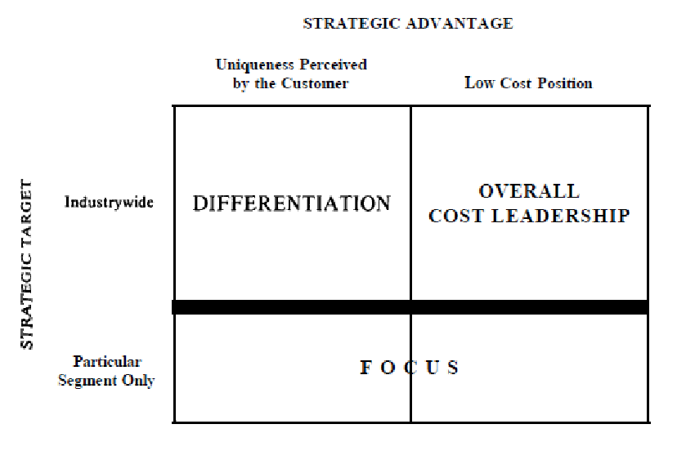
Figure 2-1 - Three Generic Strategies (Porter, 1990)

Cost leadership strategy is described as a cost advantage that represents lower-cost sales of goods and services than rivals in terms of design and development (Wheelen and Hunger, 2002). This strategy aims to gain a competitive advantage by reducing the costs of R&D, operations, sales, and marketing activities (Rugman and Hodgetts, 2000). Companies can achieve a competitive advantage in the scale of economies through the use of efficient systems in order to reduce human capital costs, reduce costs with cheaper raw materials, mass production and distribution (Eraslan, 2008).

The second generic strategy is differentiation. A Company strives to be unique in its sector in a differentiation strategy along with some feature that is widely appreciated by customers. This selects one or more qualities that many purchasers in the industry find to be significant and special in meeting these needs (Porter, 1985). Differentiation methods can be made up of factors such as brand name, software, customer services, distribution network, and other dimensions. The ideal approach is to distinguish the company into multiple dimensions (Porter and Victor, 1985).

Lastly, the third generic strategy is focus. This approach is quite different from the others as it focuses on choosing within the market narrow competitive context. The focuser selects and tailors a segment, or group of segments in the industry to fit them to the exclusion of others (Porter, 1985). There are two variants in the focus strategy, which are Focus Cost Leadership and Focus Differentiation. Both variants of the strategy are focused on the differences between the target market of a focuser and other industry segments. Cost focus exploits price behavior discrepancies in some segments, while differentiation focus takes advantage of buyers’ special needs in some segments (Tanwar, 2013).

According to Datta (2009), he critiqued Porter’s strategy by stating that the flaw is not in Porter’s logic but in his basic premise that associates differentiation with uniqueness and premium prices: a situation generally incompatible with high market share.

A company that is engaged in such generic strategy but does not achieve any of them is “stuck in the middle”. It does not have any competitive advantage. Usually, this strategic position is an instruction for below-average performance (Porter, 1985). A “stuck in the middle” firm will compete at a disadvantage it will be better positioned to compete in any segment for the cost leader, differentiators, or focusers. If a “stuck in the middle” firm is lucky enough to find a profitable product or customer, the spoils will be quickly eliminated by rivals with a sustainable competitive advantage (Porter, 1985).

3. MAIN BODY

Lidl has chosen Cost Leadership as their company’s strategy based on Porter’s Generic Strategies. This strategy highlighted efficiency. Companies are able to produce their goods at a lower cost than their rivals (Marangu et al, 2007). The company aims to take advantage of economies of scale and experience curve effects by producing high quantities of standardized goods. This product is often a simple commodity that is manufactured at a relatively low cost and made available to a very large base of customers (Tanwar, 2013).

Maintaining this policy includes ongoing research in all aspects of the business to reduce costs. The related distribution method is to obtain the widest possible distribution. The marketing approach also involves trying to use low-cost product features to build a virtue (Tanwar, 2013).

According to Porter (1980) being a cost leader is able to lead the market in the cost of production. Cost control is a technique that contains a number of processes that are designed to manufacture goods with certain characteristics in order to satisfy the needs of consumers in terms of quality and value but delivered at the same time at the lowest cost than the rivals of the company.

The purpose of strategy according to Ramaswamy and Namakumari (1996) is taking advantage of the unique advantages of the company facing environmental challenges. A plan begins with a concern and a responsibility on how best to use the organisation’s limited resources. Successful companies are putting their strategic focus on developing their core competencies and long-term competitive advantages to provide the real back-up for the business-level strategies of the corporate units.

3.1 IMPLEMENTATION OF THE STRATEGY

Lidl is committed to selling quality products at the lowest possible cost. This would suggest that they are using and implementing a cost leadership strategy with incredible efficiency (Morschett, et al., 2006).

Lidl is pursuing the cost leadership strategy with a no-frill approach, price minimization, and effective processes. Most of the products that can be found in Lidl are private label brands. Approximately 90% of Lidl’s items in the store are private-label brands. The products are produced exclusively for Lidl (Hanbury, 2017). The benefits of selling the private-label brands are twice as great. Lidl eliminates the source, removing any additional costs from a distributor. Lidl also has more leverage over production costs and is able to set its own prices. Consecutively, it means that goods can be marketed at higher margins than national brands, as initial costs are significantly lower (Hanbury, 2017). Lidl also displays products from brands that are less familiar. Most of their store area is allocated to the sale of non-food items, such as electronics or household products. Departments of the in-store bakery are a point of difference when it comes to the product range of Lidl.

Lidl also keeps the cost of their labour low. Lidl shops are poorly staffed in order to reduce labour costs. Lidl has efficient technology and automation in the backroom to limit the amount of human interaction (Hanbury, 2017). Customers must weigh their items in the store and pack their own grocery items. According to Lidl’s managing director Ronny Gottschlich to The Daily Mail, with the use of the motion sensor energy, Lidl keeps the costs down. Employees don’t move fast enough, so they don’t spend money on anything that the consumer can’t see or taste. It seems like the philosophy is working (Steiner, 2014). The employees are as well cross-trained in order to be able to work in any zone. Therefore, the employees are more versatile and productive (Hanbury, 2017).

Lastly, Lidl only stocks products that move fast. Lidl prefer everyday items mostly bought by shoppers (Hanbury, 2017). According to Kantar Retail, the collection is limited to the fastest-moving products that generate gross profit. Higher-speed products mean less inventory-bound cash. Meat, dairy, eggs, fresh fruits and vegetables, baked goods, beer, and wine are among the product in Lidl’s stocks. Such products are known as lines in the food industry and produce more than 80% of sales in a typical grocery store (Ladd, 2018).

3.2 ADVANTAGES AND DISADVANTAGES OF THE STRATEGY

Each generic strategy offers advantages that companies can exploit to improve their success as well as disadvantages that can undermine their success. High productivity is one of the benefits of the cost leadership. One of the benefits available to low-cost management in the industry is even a high-profit margin. If they are able to sell low-cost and competitive pricing products and services, their margins are greater than companies that invest more than producing products of similar quality (Hassan, 2015).

Other than that, an increased market share is also known as one of the benefits of Cost Leadership. Cost leadership leads to higher profits and uses it to increase demand and market share of customers. Companies that can offer products at a lower price than the usual market price will attract more business from budget-conscious buyers (Hassan, 2015).

Cost leaders tend to keep their costs low by minimizing advertising, market research, and research and development. This approach, however, proved to be costly in the long run.
However, this approach can prove to be expensive in the long run. A relative lack of market research can result in cost leaders being less skilled than other firms detecting significant changes in the environment.

Moreover, downplaying research and development can slow down the ability of cost leaders to respond to changes when identified. A relative lack of market research can lead cost leaders to be less skilled than other firms detecting important environmental changes. Meanwhile, downplaying research and development can slow cost leaders’ ability to respond to changes once they are detected. Detecting and reacting to external changes can prove to be a deadly combination that leaves cost leaders out of contact with the market and out of responses (Ketchen and Short, 2016).

In addition, cost leadership is lacking in innovation or new products. Research and development costs are needed for a company to introduce new products or new features in products. Nonetheless, these additional costs should be removed for the low-cost strategist. The lag in innovation, therefore, has a negative impact on consumers who want technology in the products (Hassan, 2015). Therefore, in the end, it has fewer market shares equals fewer sales, which is less turnover, therefore less profit for the company.

4. CONCLUSION

In conclusion, Lidl that was established in the 1930s has been applying one of the Porter’s Generic Strategic by using the Cost Leadership Strategy in order to develop its current competitive positions and to compete with other supermarkets. The cost leadership strategy aims to gain a competitive advantage. Therefore, in order to keep their business going with the strategy, Lidl applied it through selling private label brands, lowering its labour costs, and stocking fast-moving items. Although there are a few advantages and disadvantages of the cost leadership strategy, Lidl is known as a successful discount supermarket and their business is still doing well.

4.1 RECOMMENDATIONS

Although Lidl is successful, it is also important to note some recommendations in order to improve its business in the future. One of the recommendations is that Lidl should reposition its brand. This is to ensure that Lidl will always make substantial market gains. Even Lidl can make significant gains, but in order to be successful in the long run for the long term, Lidl must improve their brand’s image. Improving their brand image would gain them more consumers in the long run. If Lidl repositions its brand, it might become the store where consumers purchase all their groceries at.

Furthermore, Lidl can upgrade their online shopping with home delivery on online shopping. Customers would order the products through the website and would get it to send at their doorsteps. Lidl could also apply the “click and collect” services. Where a customer would click on the website the products of their choice, and collect it at the stores. This would save up so much of the consumer’s time. As technology is very important in this era, Lidl should develop these services in order to compete with larger supermarkets. This is an opportunity for Lidl to gain more recognition as Lidl have less marketing.

5. REFERENCES
- Ansoff, H. (1965). Corporate Strategy. New York: McGraw-Hill.
- Datta, Y. (2006). A critique of Porter’s cost leadership and differentiation strategies, Chinese Business Review, 9 (4), pp. 37-51. Available at: http://www.davidpublisher.org/Public/uploads/Contribute/5563f0411247b.pdf (Accessed: 19 November 2019)
- Dyer, R., 2018. 'Big Four' grocers continue to lose market share to Aldi and Lidl; Morrisons rises on Amazon bid talk. Proactiveinvestors UK. Available at: https://www.proactiveinvestors.co.uk/companies/news/210953/-big-four--grocers-continue-to-lose-market-share-to-aldi-and-lidl-morrisons-rises-on-amazon-bid-talk-210953.html [Accessed November 24, 2019].
- Eraslan, I.H. (2008). The effects of competitive strategies on firm performance: a study in Turkish textile and apparel industry considering the mediating role of value chain activities. [ebook] Istanbul, p.100. Available at: https://www.researchgate.net/publication/324900274_The_Relationship_between_Cost_Leadership_Strategy_Total_Quality_Management_Applications_and_Financial_Performance [Accessed 20 Nov. 2019].
- Hambrick, D.C. (1980). “Operationalising the concept of business-level strategy in research”, Academy of Management Review, 5(4), pp. 567.
- Hanbury, M. (2017). A German grocery chain that's coming to America is already dominating Walmart on prices — here's why it's so cheap. Business Insider. [online] Availablat: https://www.businessinsider.com/how-lidl-keeps-its-prices-down-2017-6?r=US&IR=T#5-it-keeps-labor-costs-low-5 [Accessed 24 Nov. 2019].
- Hassan, Y. (2015). Differentiation and cost leadership. Choose of one puts constraints on using the second. [online] Linkedin.com. Available at: https://www.linkedin.com/pulse/differentiation-cost-leadership-choose-one-puts-using-yasser [Accessed 20 Nov. 2019].
- Ketchen, D. & Short, J. (2016). Mastering Strategic Management. Available at: http://www.opentextbooks.org.hk/ditatopic/17225 [Accessed 20 November 2019].
- Ladd, B. (2018). Lidl USA: What Went Wrong And What It Can Do To Recover. Forbes. [online] Available at: https://www.forbes.com/sites/brittainladd/2018/07/08/lidl-usa-what-went-wrong-and-what-it-can-do-to-recover/#1ee60e9429c8 [Accessed 24 Nov. 2019].
- Makortoff, K. (2019). This article is more than 3 months old Lidl attains its biggest UK grocery market share at 5.9%. The Guardian. [online] Available at: https://www.theguardian.com/business/2019/aug/20/lidl-attains-biggest-uk-market-share [Accessed 24 Nov. 2019].
- Marangu, W., Mwiti, E., and Thoronjo, E. (2017). Analysis of Cost Leadership Strategy Influence on Organizations’ Competitiveness of Sugar Firms in Kenya. 9th ed. [ebook] European Journal of Business and Management, p.39. Available at: https://pdfs.semanticscholar.org/21aa/b21a3064614178e3cd2d934ed97303ba24e6.pdf [Accessed 19 Nov. 2019].
- Morschett, D., Swoboda, B. and Schramm-Klein, H. (2006). Competitive strategies in retailing—an investigation of the applicability of Porter's framework for food retailers. Journal of Retailing and Consumer Services, 13(4), pp.275-287.
- Porter, M. E. (1980). Competitive Strategy. New York: The Free Press
- Porter, M. E. (1985). Competitive advantage. London [New York]: Free Press, p.1.
- Porter, M. E. (1985). Competitive advantage. London [New York]: Free Press, p.14.
- Porter, M. E., and Victor, M. (1985). "How Information Gives You Competitive Advantage." Harvard Business Review 63, no. 4 (July–August 1985): 149–160.
- Ramaswamy, V. and Namakumari, S. (1996). Strategic planning for corporate success. [ebook] New Delhi: Macmillan India Ltd, p.
- Rue, L.W. and Holland, P.G. (1989), Strategic Management: Concepts and Experiences. McGraw-Hill, New York, NY
- Rugman, A. and Hodgetts, R. (2019). International business: a strategic management approach International. [ebook] New York, p.100. Available at: https://www.researchgate.net/publication/324900274_The_Relationship_between_Cost_Leadership_Strategy_Total_Quality_Management_Applications_and_Financial_Performance [Accessed 20 Nov. 2019]

- Rupert, S. (2014). LIDL BOSS: We're expanding from Lidl to large - soon we'll have an empire of 1,500 stores. The Daily Mail. [online] Available at: https://www.thisismoney.co.uk/money/markets/article-2735948/German-grocer-Lidl-plans-open-hundreds-UK-stores.html [Accessed 24 Nov. 2019].
- Starr, E., Business Level Strategy. Business Level Strategy. Available at: https://www.albany.edu/faculty/es8949/bmgt481/lecture4.html [Accessed November 24, 2019].
- Tanwar, R. (2013). Porter’s Generic Competitive Strategies. IOSR Journal of Business and Management, [online] 15(1), pp.11-17. Available at: https://sswm.info/sites/default/files/reference_attachments/TANWAR%202013%20Porter%E2%80%99s%20Generic%20Competitive%20Strategies.pdf [Accessed 20 Nov. 2019].
- Wang, H.L. (2014), “Theories for competitive advantage”, in: Hasan, H. (Ed.), Being Practical with Theory: A Window into Business Research, Wollongong, Australia: THEORI, Australia, pp. 33 – 43
- Wheelen, T. and Hunger, J. (2002). Strategic management and business policy. 8th ed. [ebook] p.100. Available at: https://www.researchgate.net/publication/324900274_The_Relationship_between_Cost_Leadership_Strategy_Total_Quality_Management_Applications_and_Financial_Performance [Accessed 20 Nov. 2019].

