Running Head: Collaboration Tools

Student Name: STEFANIA FLORENTINA ENOAICA
Student Number:2124107
Lecturer Name: SAYEN NASIRPOUROSGOEI
MODULE CODE :BMSW4003_BIRM
Digital Skills and Research Methods.

Table of Contents
Introduction 3
Research Design 4
Research Questions 4
Method 5
Ethical Consideration 6
Results 7
Discussion 8
Conclusion 10
References 11

Introduction
Digital collaboration is the practise of working together while using digital technologies. When working in a group this way, rather than working alone, you can do far more than you could if you worked in a traditional way, and as a consequence, you obtain better outcomes (Blau et al., 2020). Standardizing the inventive process and increasing productivity and efficiency are just a few of the advantages of online conferencing, which include applications, computer programs, and platforms that enable businesses and their employees to achieve a good performance as a result of the Internet (Schönbrodt et al., 2012). Communication and collaboration tools are usually referred to as such because they enable employers and superintendents to assign tasks and track performance while also reporting on outcomes and growing workflows and communication services both within and outside of their respective organisations, as well as between their respective organisations.
Distance education has become more accessible as a result of rapid technological advancements. "Most of the terms (for example, online learning, open learning, web-based learning, computer-mediated learning, blended learning, and m-learning) have in common the ability to use a computer connected to a network, which provides the possibility to learn from anywhere, at any time, in any rhythm, and with any means" (source). It is described as "learning experiences that take place in synchronous or asynchronous contexts using a variety of devices (such as mobile phones, laptops, and other similar devices) that have internet connection." "In these environments, students may study and communicate with teachers and other students from any location (independent of the instructor)". Although online teaching–learning strategies may give high-quality education, the key concern during this challenging moment is how colleges and universities will be able to integrate distance classes on such a big scale.

Research Design

Research Questions
Which digital tools are most used for collaboration at UWTSD?
- An online mode of instruction was required by educational institutions because of the Corona Virus. Some formerly hesitant organisations will be more open to adopting new technology in the wake of this disaster. Because there were no other options, the university decided to move from traditional classes to virtual ones.
- MICROSOFT TEAM was the most widely utilised digital platform for workplace and education throughout the pandemic (Covid -19), and it continues to be so now.
- What is Microsoft Teams and how does it work? In addition to chat and video meetings, Microsoft Teams also provides file storage (and collaboration) as well as application integration capabilities. Because of the University's Microsoft Office 365 subscription, it is accessible to all employees and students on the web, through desktop applications, and through mobile applications.
In addition, we employ the following for collaboration with UWTSD:
- SKYPE is a software programme that allows users to make one-on-one and group calls, send messages, make international calls to mobile and landlines, have immediate online meetings, and share files. Skype is an instant messaging service that allows you to communicate with anybody in the globe in real time and provides real-time translation.
- If you want to collaborate, email is perhaps the most popular tool you can use. It can be used for everything from exchanging notes and papers to organising meetings and sharing links. Many people believe that email is a poor tool for cooperation and that it will eventually be phased out. I believe it is simply meant for a slightly different application case.
- GOOGLE DRIVE works on multimedia projects, files are shared, and papers are worked on together

Method
This study, like most others in the world of e, used a combination of quantitative and qualitative methodologies to gather information. The phenomena kind of survey was used, which places a strong emphasis on the opinions, actions, and experiences of those who take part in the survey. Closed and open items were used in the online questionnaire, which was administered through the internet. The quantitative investigation was carried out utilising an e-questionnaire (Survey Monkey), which could then be evaluated in Excel using the results (Schonbrodt et al., 2022). The link to the surveys was sent out over WhatsApp to anybody who wanted to participate. In order to make the survey as convenient as possible, it was delivered in this manner.
Twelve undergraduates from the University of Wales Trinity Saint David London Campus were asked to complete the questionnaire. Individual completion of the review was promoted throughout group instructional activities, and understudy were urged to complete it. An example size estimate was carried out in order to assess the size of a basic delegate test (Blau et al., 2020). It was necessary to have a reaction speed of 37 percent and a base example size of 10 in order to obtain agent findings. Each and every one of the review outcomes was kept a secret, and understudy were made aware of this prior to the conclusion of the evaluation. The completion of the survey was regarded as explicit consent for the original study data to be utilised in any way (Schneider and Fuller, 2018).
Certain reminder emails were given out before to the final data collection, which will take place in one and a half weeks. For the most part, the analysis is purely descriptive in character. There are just a few unanswered questions therefore descriptive statistics are provided for the problem questions. However, replies to the questions to be answered are left in their natural shape so that they may be described.

Ethical Consideration
Prior to initiating any research study, the researcher must obtain the agreement of the participants from the participants. The respondents owe it to themselves and the research to respect their right to remain anonymous and confidential throughout the process (Schneider and Fuller, 2018). However, even if the responses are unsuitable for the study's objectives, researchers should respect the respondents' viewpoints and refrain from engaging in any sort of wrongdoing on their own behalf. It is also critical that the study objectives are reasonable and that they do not contain any misleading data (Tawafak et al., 2018). It is critical for all interviewees to maintain their composure and politeness during the whole procedure. Statistical significance requires that the results of the study be impartial, intelligible, and statistically significant. In order for the interaction to be productive, the researcher must complete the interview within the time range that has been set aside for the interaction. In addition, the researcher should abstain from harassing the subjects after the session has concluded.

Results

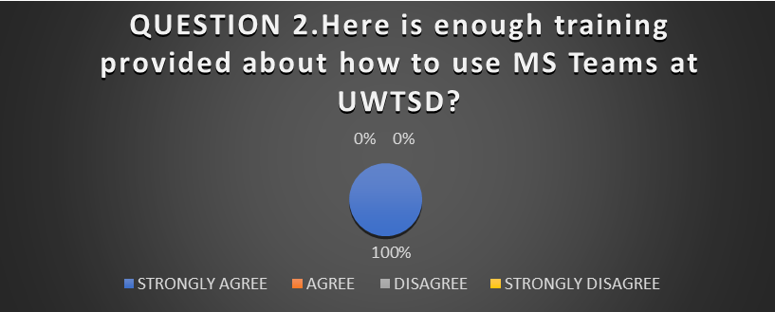

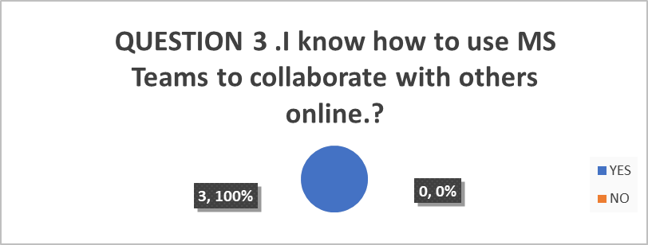

Discussion
In the first instance, the tools should be designed to assist you in achieving your scholastic or engagement objectives. Second, you must've been able to access and use the tool alongside your population of learners in order for them to be successful. To get you started, the following list contains a selection of several popular collaboration tools that you may use. This list is not fully elucidated, but rather to provide resources to assist you in the initial stages of planning your class (Blight, 2016). In addition to face-to-face classroom settings, these solutions are also effective in entirely remote settings. Ideally, each student should have access to a device in order for these tools to be most successful and to elevate all students' voices. If this is not practicable, students could work in pairs, for each companion taking turns acting as the pilot and copilot for the course of the course. In this arrangement, the pilot is in charge of the keyboard or gadget, while the copilot gives input and suggestions. After a predetermined period of time has passed, the partners trade places.
Take into consideration technology that may be utilised in a variety of ways as you look for the best solution to fulfil your learning goals. The use of a few "workhorse" technologies will allow students to feel less overwhelmed by computers, and they'll have more cognitive resources available for the academic tasks that they will encounter. With a thorough recruitment process for tools, you can strike a balance between the requirement to minimise student cognitive load and the goal to give students with the novelty and variety that will keep them engaged and interested throughout the course (Ali, 2019).
Teachers want to see gains in their pupils' performance, and technology may help them do so. Administrators should support instructors in developing the essential skills and expertise to effectively employ technology to enhance student learning. This would assist in resolving the issues. Additionally, educational technology should simplify teachers' work without adding time to their day (Schonbrodt et al., 2022). Technological advances assist students in that they make information more readily available so that they may learn at a faster rate and provide them more opportunity to apply what they've learned in meaningful ways. For students in STEM areas, it provides a way to learn about new subjects while also enhancing their understanding of difficult concepts. The use of technology in and outside of the classroom can help students acquire 21st-century technical abilities that will be crucial in their future employment (Sharp, 2018).
Collaboration may be made simpler via the use of educational technology. Throughout the course of a class, students are permitted to converse with one another as well as with their professors. Students learn how to collaborate to solve problems through online classes and pedagogical techniques, which can be accessible at any time of day or night. Collaborative activities allow students to express themselves and provide support to one another via the exchange of ideas (Novara et al., 2018). Technology also makes it possible for students and lecturers to communicate one-on-one with one another. Students have the opportunity to ask a question about what is actually taking place and request more support with tough topic matter by contacting their teachers. Using computers provided by the school, students may submit their assignments from home, and teachers may access and examine completed projects through the usage of these laptops. Teachers may use technology to increase their productivity, add important digital tools to expand learning opportunities for kids, and increase student support and engagement, all of which will be beneficial to students. Furthermore, it affords teachers the option to refine their educational techniques and personalise learning experiences for their students. By using technology, schools can cut costs by not having to buy physical educational materials. They can also make more efficient training materials and use all of the time allocated to them (Tawafak et al., 2018).
What collaborative learning is all about is having people work together to solve a problem, build a product, or derive meaning from a large amount of knowledge; this is what it is all about. It is necessary to identify and define a key issue or problem in order to organise and direct operations. This question or challenge should encourage students to apply, analyse, and synthesise what they have learned in class (Kallio et al., 2016). When it comes to enabling collaborative learning activities, there is a vast and diverse range of technological options available to choose from. Although many of the tools available are categorised under a single title, "collaboration tools," many of them are really grouped together under this name.

Conclusion
It is the empirical examination of the literature that provides support for the research questions, which leads to the creation of hypotheses. In this study, it was shown that adopting collaboration promotes self-governed learning by allowing students to adjust casually at their own pace and in their own time, space, and location, allowing them to accommodate project assignment around their hectic schedules (Blight, 2016). Using a collaborative tool improves students' capacity to learn, fosters communication and synergy learning, and provides highly motivating immediate critique, according to the writing concentration. While this investigation demonstrates that the use of Moodle has a positive impact on understudy learning, it would be interesting to investigate whether different fields of knowledge have an impact on learning. Furthermore, it would be intriguing to look into which features in the collaborative tools have the greatest impact on student education, such as discussion forums, quizzes, and course handouts, for example. However, despite the fact that the analysis of the data has provided significant results, it has been limited in its ability to provide depth due to the limited time available and also the positive technique employed (Blau et al., 2020).

References
Ali, W., 2019. The Efficacy of Evolving Technology in Conceptualizing Pedagogy and Practice in Higher Education. Higher Education Studies, 9(2), pp.81-95. ​
Blau, I., Shamir-Inbal, T. and Avdiel, O., 2020. How does the pedagogical design of a technology-enhanced collaborative academic course promote digital literacies, self-regulation, and perceived learning of students?. The internet and higher education, 45, p.100722.
Blight, K.B.J., 2016. Can asylum be managed ethically?. In Public Health Ethics: Cases Spanning the Globe (pp. 230-233). Springer.
Kallio, H., Pietilä, A.M., Johnson, M. and Kangasniemi, M., 2016. Systematic methodological review: developing a framework for a qualitative semi‐structured interview guide. Journal of advanced nursing, 72(12), pp.2954-2965. ​
Novara, C., Lavanco, G., Mannino, G. and Serio, C., 2018. Management and human factors: exploratory research with focus groups. World Futures, 74(5), pp.343-354. ​
Schneider, Z. and Fuller, J., 2018. Writing Research Proposals in the Health Sciences: A Step-by-step Guide. SAGE.
Schönbrodt, S., Wohak, K. and Frank, M., 2022. Digital tools to enable collaborative mathematical modeling online. Modeling in Science Education and Learning , 15 (1), pp.151-174.
Sharp, L.A., 2018. Collaborative Digital Literacy Practices among Adult Learners: Levels of Confidence and Perceptions of Importance. International Journal of Instruction, 11(1), pp.153-166.​
Tawafak, R.M., Romli, A.B., bin Abdullah Arshah, R. and Almaroof, R.A.S., 2018. Assessing the impact of technology learning and assessment method on academic performance. EURASIA Journal of Mathematics, Science and Technology Education, 14(6), pp.2241-2254. ​

