
Module Name: Computer Architecture and Operating Systems
Module Code: ACCA4022
Student Name: Umar khitab abidi
Student ID: 2510352
Lecturer Name: Md Shantanu Islam

Contents
ACCA4022 Computer Architecture and Operating Systems 2
Introduction 2
Key functions of general Operating Systems 2
Task Management 2
Application and Program Management 2
File and Directory Management 3
Device Management 3
Security Management 3
Use of Windows OS CLI commands 4
Use of Linux OS CLI commands 7
Use of Windows OS scripts 9
Use of Linux OS scripts 10
Conclusion 11
References 11

ACCA4022 Computer Architecture and Operating Systems

Introduction
This report examines the operation of general purpose operating systems and the ability to control those systems from the command line. It covers the main functions that an operating system carries out, such as managing tasks, programs, files, devices and security. It then demonstrates a series of commands for Windows and Linux, and explains what each command returns and what it does. Finally, there are a few short Batch and Bash scripts to illustrate the basic automation of both systems..

Key functions of general Operating Systems
An operating system is the kind of software that resides between the computer hardware and the user, controlling resources like memory, processes and storage. This is the same fundamental concept that evolved into the Windows and Linux operating systems, but in different ways [1].

Task Management
Task management is the way an operating system keeps track of all the tasks that are running and allocates the processor's time among these tasks. All running programs are considered processes and the operating system determines which program gets the CPU to process the programs at a particular instant. This is the process by which a computer can seem to execute several programs simultaneously, when its central processing unit (CPU) can generally only execute one program at a time. On Windows, a user may be able to view this and identify which processes are consuming resources, for example with the Task Manager; on Unix, the equivalent command is tasklist.
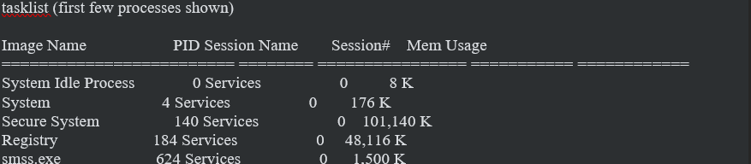

Application and Program Management
This function includes starting, running and closing programs, and maintaining independence of each program, so that one crashing program does not crash the whole system. The operating system loads the program into memory, allocates a process to it, and coordinates access to the CPU and memory with other programs that are open. It also can close a program correctly and free up any memory or files used by the program [2].
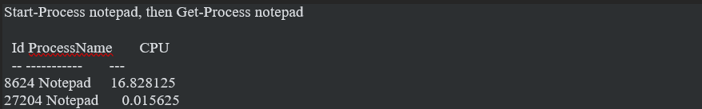

File and Directory Management
File and directory management is how the operating system organises data into files and folders, and keeps track of where everything is stored on the disk. It can do things such as create, open, rename, move and delete files, and can manage who has access to them. Otherwise, there would be no real way to save or load anything, as it's the operating system that communicates with the hardware that holds the data [3].
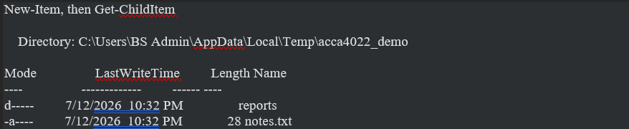

Device Management
Device management - communications between the operating system and devices like printers, USB drives, graphics cards & network adapters. It relies on the presence of little programmes called drivers to act as a translator between the instructions issued by the program and the way the hardware works. This implies that the application does not have to have any knowledge of the exact hardware that it is utilizing; the operating system will take care of this layer between the application and the hardware [3].
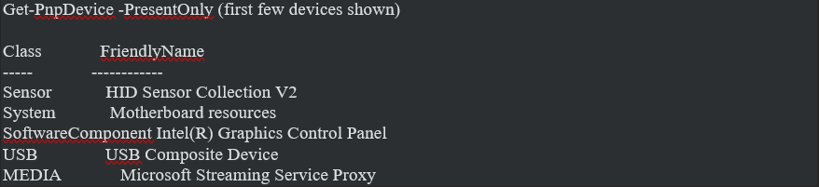

Security Management
Security management involves the protection of the computer and the data on the computer. That consists of determining who may log in, their own permissions, and preventing one user's applications from accessing other users' files without their consent. Each user account could be a member of several groups, and it is these groups that determine what a user can do on the system [1].

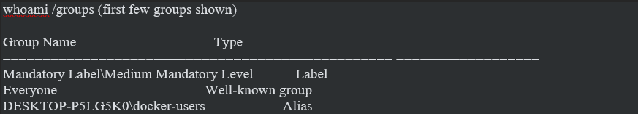

Use of Windows OS CLI commands
There are two ways of controlling Windows using Command Prompt: with the help of Batch style commands, or with the newer PowerShell that has a better understanding of more modern commands and returns proper objects instead of plain text [2].
Example 1: tasklist
Displays all currently running processes, their process ID and memory consumption. Helpful for determining what's doing what or consuming resources.
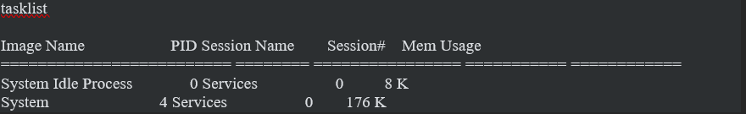
Example 2: Get-Process
A PowerShell script that displays the information regarding a running process, in this case, Notepad was opened and then queried, providing the process ID and CPU time for the program which had been used by this program so far.
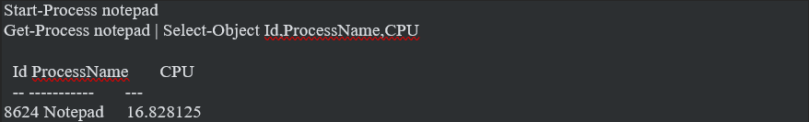
Example 3: Stop-Process
Ends a program that is running from the command line rather than by clicking the Close button. Here it is used to shut down the Notepad process that was just opened.
Example 4: New-Item and Get-ChildItem
Makes a new folder/file, lists the contents of a directory as does File Explorer, but from the command line.
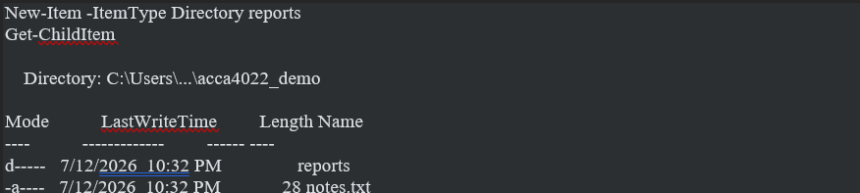
Example 5: dir
The older, Batch style command to list files and folders, display file sizes and available disk space.
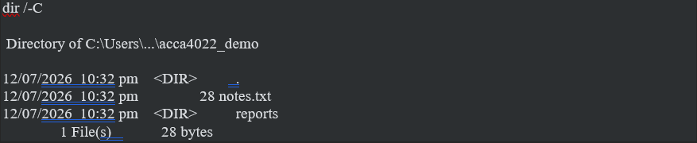
Example 6: ipconfig
Displays network configuration for the machine (eg, what networks are available and if they are connected).
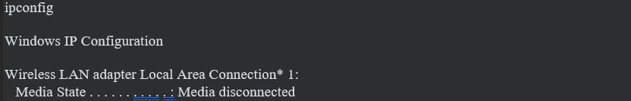
Example 7: Test-NetConnection
Tests if a connection or service is reachable by the machine, useful to know if the machine can reach another address on a given port.
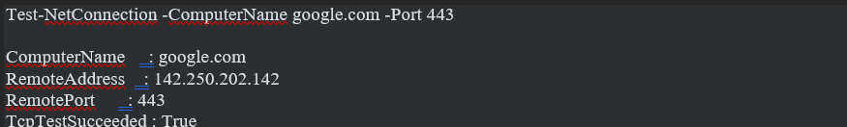
Example 8: net user
Lists all the local user accounts that are present on the machine.

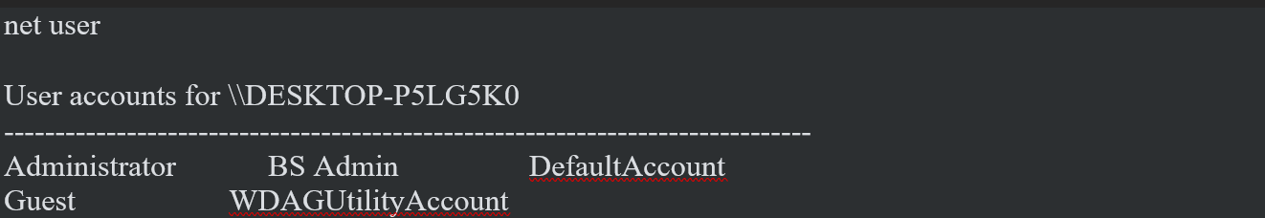
Example 9: Get-LocalUser
PowerShell version of the same idea but also displays if each account is either enabled or disabled.
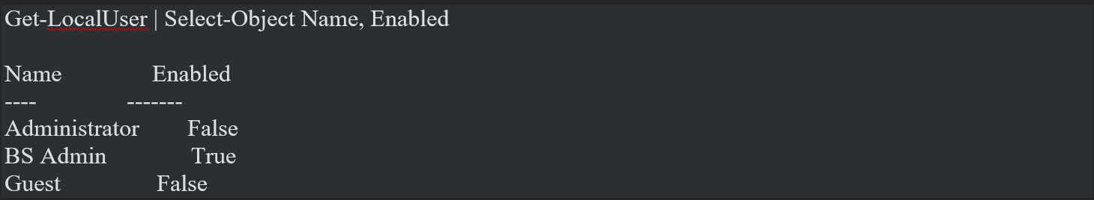
Example 10: schtasks
Displays the tasks that Windows will run automatically, and when they will next run.
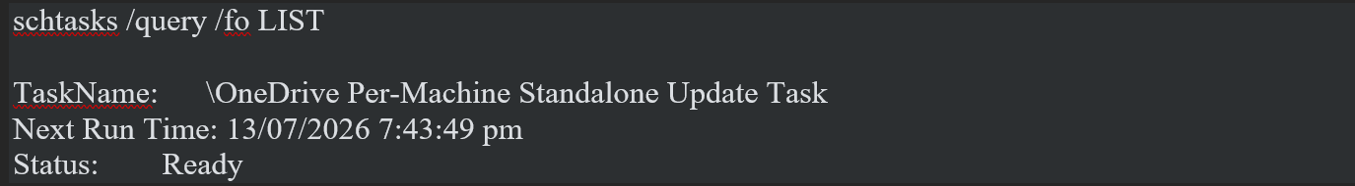

Use of Linux OS CLI commands
The Bash shell provides virtually complete control of Linux. The following line of commands are executed in Ubuntu via WSL and address the same five areas as the Windows commands above [4].
Example 1: ps aux
Displays all processes running in the system along with their owner and memory and CPU consumption.
ps aux | head

USER PID %CPU %MEM COMMAND
root 1 0.1 0.0 /sbin/init
root 43 0.0 0.0 /usr/lib/systemd/systemd-journald
Example 2: kill
Sends a signal to a process, normally used to stop it. Here signal 0 was sent to process 1 just to make sure it's there, and Linux refused as a normal user cannot send a signal to the initial process.
kill -0 1

bash: line 1: kill: (1) - Operation not permitted
Example 3: ls -la
Prints every file that is in a folder, its permissions, owner and size, including hidden files.
ls -la ~

drwxr-x--- 5 bs_admin bs_admin 4096 Apr 27 00:01 .
-rw-r--r-- 1 bs_admin bs_admin 220 Apr 8 01:07 .bash_logout
-rw-r--r-- 1 bs_admin bs_admin 3771 Apr 8 01:07 .bashrc
Example 4: mkdir, touch and ls -R
Makes new folder and file, and prints the files in a folder and all its contents.
mkdir -p ~/acca4022_demo/reports
touch ~/acca4022_demo/notes.txt
ls -R ~/acca4022_demo

/home/bs_admin/acca4022_demo:
notes.txt
reports
Example 5: ip addr
Displays network settings for a specific interface, such as its IP address.
ip addr show eth0

inet 172.25.151.143/20 brd 172.25.159.255 scope global eth0
link/ether 00:15:5d:c1:ef:ce brd ff:ff:ff:ff:ff:ff
Example 6: ping
Sends test packets to another address for testing if it's reachable and how long it takes to get there and back.
ping -c 3 8.8.8.8

64 bytes from 8.8.8.8: icmp_seq=1 ttl=60 time=4.65 ms
64 bytes from 8.8.8.8: icmp_seq=2 ttl=60 time=213 ms
3 packets transmitted, 2 received, 33.3% packet loss
Example 7: ss
Displays which ports are open and listening on the host.
ss -tulnp

Netid State Local Address:Port
udp UNCONN 127.0.0.54:53
tcp LISTEN 127.0.0.53%lo:53
Example 8: whoami and id
Displays the currently logged on user, user id and groups they are in.
whoami
id

bs_admin
uid=1000(bs_admin) gid=1000(bs_admin) groups=1000(bs_admin),27(sudo),1001(docker)
Example 9: cat /etc/passwd
Reads the file containing all of the files for each user account, including system accounts and normal accounts.
cat /etc/passwd | tail -5

polkitd:x:990:990:User for polkitd:/:/usr/sbin/nologin
bs_admin:x:1000:1000:,,,:/home/bs_admin:/bin/bash
Example 10: crontab
Shows any scheduled jobs set up for the current user. In this instance, there have been no preparations made.
crontab -l

no crontab for bs_admin

Use of Windows OS scripts
Example 1: multiplication table script
This report first demonstrated the primary functions of an operating system, and then included some actual real-life Windows and Linux commands for processes, files, networking, users and scheduling. It also covered the use of basic automation with variables, loops and conditionals using Batch and Bash scripts. It is easy to see that Windows and Linux address the same issues, albeit with very different syntaxes, and knowing both is a handy thing to know.
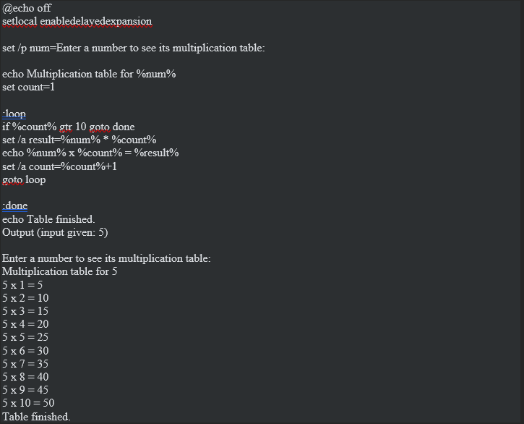
Example 2: even or odd checker script
The script accepts inputs of whole numbers from the user, and then determines two characteristics about the input. The first characteristic is whether the input is an even or odd number. The script achieves this through set /a and the modulo operator to divide the input by 2, and then using an if else construct to display even or odd, respectively. Then, the input is checked to determine its positivity by an if else block, displaying the outcome. This is how Batch processes a conditional logic block that involves an arithmetic operation against a user defined variable.

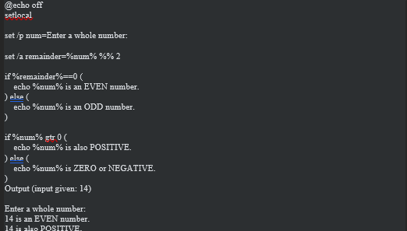

Use of Linux OS scripts
Example 1: multiplication table script
It is similar to the Windows script above, but in Bash. Firstly, it asks for a number using read -p, then stores it in a variable and then a proper for loop constructed with seq 1 10 to repeat 10 times. The number is multiplied by the loop counter (i) with $((num * i)) within parentheses, and this is how Bash does the arithmetic. This is typically regarded as being a cleaner approach to looping than the label and goto approach in Batch.
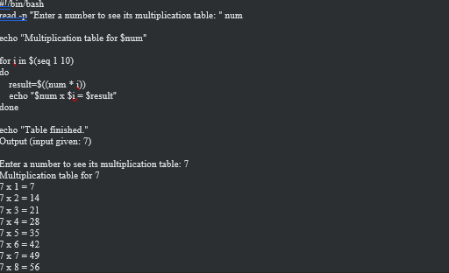
Example 2: exam grade script
This bash script reads a score from 100, then computes a grade from the score, using an if, elif, else statement to sequentially test multiple conditions. Also does a second check after that to determine if that number entered was actually a sensible score (0-100) with an or condition ||. This demonstrates the use of multi way conditionals and simple range checking for a number entered by the user using the bash shell.
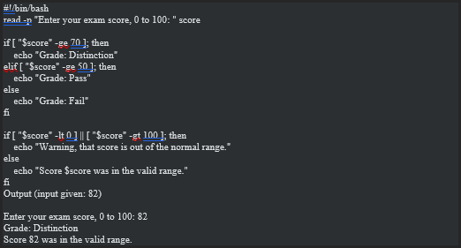

Conclusion
This report first demonstrated the primary functions of an operating system, and then included some actual real-life Windows and Linux commands for processes, files, networking, users and scheduling. It also covered the use of basic automation with variables, loops and conditionals using Batch and Bash scripts. It is easy to see that Windows and Linux address the same issues, albeit with very different syntaxes, and knowing both is a handy thing to know.

References
[1] A. Silberschatz, P. B. Galvin, and G. Gagne, Operating System Concepts, 10th ed. Hoboken, NJ, USA: Wiley, 2018.
[2] Microsoft, "Windows commands," Microsoft Learn, 2024. [Online]. Available: https://learn.microsoft.com/windows-server/administration/windows-commands/windows-commands
[3] W. Stallings, Operating Systems: Internals and Design Principles, 9th ed. Boston, MA, USA: Pearson, 2018.
[4] Free Software Foundation, "Bash Reference Manual," GNU Project, 2024. [Online]. Available: https://www.gnu.org/software/bash/manual/

