Development Appraisal: Lace House, Brighton
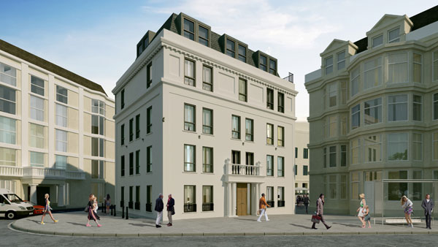

Written By: Shalom Joseph (2113608)
Module: ACBA6010 Advanced Project Management
Prepared For: Ian Brown
Table of Contents
1 Executive Summary 1
2 Introduction 1
3 History and Background 2
4 Location Analysis 3
5 Proposed Development Brief 4
6 Financial Analysis 5
7 Risks and Opportunities Analysis 6
8 Review of Similar Developments 7
9 Return on Investment (ROI) Analysis 8
10 Summary and Conclusion 9
11 References 9

Executive Summary
The Lace House project entails the renovation and reconstruction of a historic structure situated at 39-40 Old Steine, Brighton. The project seeks to transform the deteriorated commercial building into nine residential units, consisting of one and two-bedroom apartments, while maintaining significant architectural features. This analysis evaluates the financial feasibility of the proposed development, analyses related risks, and offers recommendations to enhance the return on investment (ROI) and the project's sustainability profile.

Introduction
This development appraisal report aims to assess the financial sustainability and potential hazards related to the redevelopment of Lace House, Brighton. The property, a historic edifice situated in the centre of Brighton’s Old Steine, is presently converted into a nine residential unit, consisting of seven one-bedroom and two two-bedroom apartments. The project saw the installation of new aluminium double-glazed windows, underfloor heating, and contemporary fixtures and fittings.
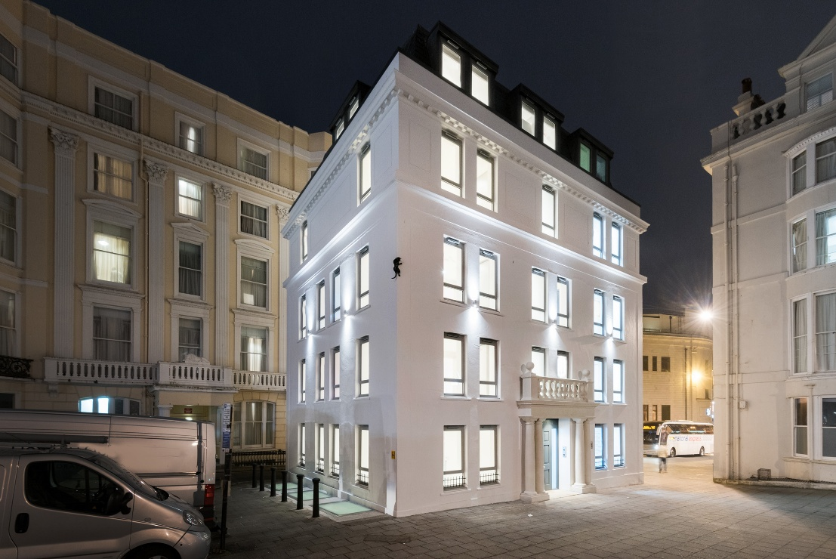
Figure 1 Shows Lace House Currently (HAPA Architects, 2023)

This report will methodically analyse the property's historical context, location assessment, planned development strategy, financial analysis, risk evaluation, and ROI forecasts. An evaluation of analogous exemplary developments will establish a standard for the proposed endeavour. The analysis will culminate with suggestions to augment the development's market attractiveness and financial feasibility.

History and Background
Lace House, situated at 39-40 Old Steine, Brighton, is a historic edifice with a significant architectural legacy originating from the late 18th century (HAPA Architects, 2023). Initially built in the 1760s as a two-storey timber edifice called Woodgate’s Library, the facility evolved into a cultural centre where patrons could engage in reading, music, and gambling. In 1784, it was subsequently acquired by Andrew Crawford, who extended it to incorporate a post office (HAPA Architects, 2023).
During the 19th century, Lace House was rented to George Phillips, the confectioner for King George IV, and later divided into a confectionary and millinery establishment (Oakley Properties, 2025). By 1925, the site was converted into a vehicle showroom managed by J. Carlish & Co., which subsequently became Newmans & Co., responsible for the installation of the renowned black cat sculpture, a landmark still visible on the building’s façade (Oakley Properties, 2025).
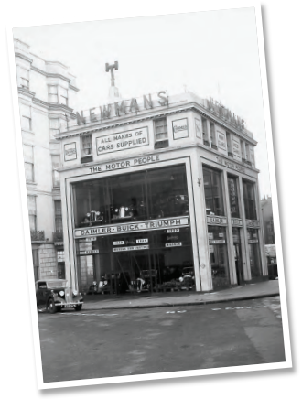
Figure 2 Shows what once was J. Carlish & Co. Vehicle Showroom (Oakley Properties, 2025).
In 1973, the property was repurposed as offices, maintaining that function until the present proposal for conversion into residential units (Oakley Properties, 2025). The building's historical importance and architectural distinctiveness render it a notable element within the Valley Gardens conservation area. The reconstruction seeks to preserve essential architectural elements, such as the cat sculpture, portico roof, and column detailing.
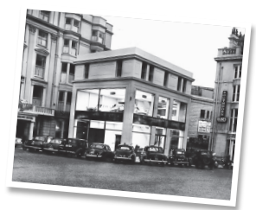
Figure 3 Shows what once was an office building on the lot of Lace House (Oakley Properties, 2025).

Location Analysis
Lace House is situated at 39-40 Old Steine, Brighton, a central location renowned for its historical and commercial importance. The Old Steine is a prominent cultural and social centre, with major events like the Brighton Festival and Pride, which attract significant visitor numbers to the locale (Brighton and Hove City Council, 2023).

Figure 4 Shows Old Stein Brighton (Oakley Properties, 2025).
The property is next to significant attractions, such as the Victoria Fountain, Brighton Palace Pier, the Sea Life Centre, and the lively Lanes shopping district. This site offers superior access to public transportation, encompassing Brighton railway station, bus routes, and the adjacent beachfront promenade (Brighton and Hove City Council, 2023).
The area features a combination of Regency architecture and modern structures, rendering it appealing to investors and prospective inhabitants (Office for National Statistics, 2024). The closeness to educational institutions, retail centres, and entertainment facilities increases the property's attractiveness for residential transformation (Office for National Statistics, 2024). The rising demand for residential apartments in downtown Brighton, along with the city's continuous reconstruction efforts, establishes Lace House as a potentially profitable investment opportunity (Office for National Statistics, 2024).

Proposed Development Brief
The proposed reconstruction of Lace House entails transforming the current commercial building into nine residential flats, comprising seven one-bedroom units and two two-bedroom ones. The design emphasizes the creation of high-specification apartments that integrate modern amenities with retained antique aspects, such as the cat sculpture and the portico roof.
The projected development's salient features comprise:
- Structural Modifications: Enhancement of current walls and floors to comply with residential standards while preserving the building's architectural character.
- Interior Layouts: Contemporary designs that optimize natural illumination and spatial efficiency, especially in the basement and penthouse flats.
- Energy Efficiency: Implementation of aluminium double-glazed windows, underfloor heating, and LED lighting to diminish energy consumption.
- Finishes & Fixtures: Premium finishes, with engineered wood floors, ceramic tiles, and integrated Bosch appliances in kitchens.
- External Works: Restoration of the building's façade, encompassing re-rendering and repainting, along with the replacement of the portico roof and window guards.
- Sustainability Initiatives: Integration of water-conserving fixtures, energy-efficient appliances, and sustainably sourced building materials, preferably from local suppliers.
The initiative seeks to augment the property's market attractiveness by integrating contemporary residential features with the historical allure of the current edifice. The project is anticipated to conclude within a 12-month construction period, emphasizing the reduction of disturbances to adjacent businesses and people.

Financial Analysis
The financial study of the Lace House development encompasses a detailed examination of purchase costs, design phase expenditures, building expenses, and additional capital outlays.
- Property Acquisition Costs: The property's purchasing price is stated as £1,316,500.
- Design and Planning Expenses: According to the SPONS guidance, design expenses, encompassing architectural and engineering services, are approximated at 10% of the overall building value, yielding expected costs of £100,168 (AECOM, 2023).
- Construction Costs: The projected construction expense per square meter for refurbishing is £1,900, as detailed in the key information document, culminating in a total contract value of £1,001,680.
- Supplementary Infrastructure Expenses: This encompasses site clearance, demolition, external works, and infrastructure enhancements. Projected costs are estimated at £150,000, depending on regular SPONS rates (AECOM, 2023).
- A contingency allowance of 10% of the overall project cost is advised, totalling £126,184.
- Aggregate Projected Expenditures: The comprehensive cost analysis is as follows:
  - Acquisition cost: £1,316,500
  - Design and Planning: £100,168
  - Construction cost: £1,001,680
  - Infrastructure and External Works: £150,000
  - Contingency amount: £126,184
  - Estimated Total Project Expenditure: £2,694,532

Risks and Opportunities Analysis
The Lace House rehabilitation project entails several risks and possibilities that require meticulous management to guarantee successful completion and optimize rewards.
- Risks:
  - Structural Deterioration: The building's historical significance may introduce unexpected structural problems, hence escalating restoration expenses.
  - Planning Delays: Postponements in planning approval resulting from the property's status as a conservation area.
  - Cost Overruns: Increasing expenses for materials and labour, especially for specialized restoration projects, may affect the budget.
  - Market Fluctuations: Variations in the property market in Brighton may influence the expected sale or rental values.
  - Access Constraints: The site’s position in a congested business zone may pose logistical difficulties for construction activities.
- Opportunities:
  - Enhanced Property Valuation: Tactical placement in a high-demand locale with robust rental and sales prospects.
  - Implementing sustainable building principles may decrease operational expenses and appeal to environmentally conscientious purchasers.
  - Augmented Market Appeal: Retaining historical elements while incorporating contemporary amenities may increase marketability.
  - The property's closeness to significant attractions in Brighton may provide short-term rental prospects.
Effective risk management tactics will encompass consistent oversight of project expenditures, contingency planning, and the engagement of seasoned contractors for specialized restoration tasks. Further exploration of opportunities to augment sustainability and commercial appeal will occur in following sections.

Review of Similar Developments
To establish a baseline for the proposed redevelopment of Lace House, two comparable projects of similar scale and specifications in Brighton were examined:
- Royal Pavilion Townhouses, Brighton: This project entailed the transformation of a Grade II listed Regency townhouse into several residential units. The renovation preserved historical architectural features while integrating contemporary conveniences. The property attained a substantial ROI owing to its advantageous location and effective marketing as premium apartments. The incorporation of sustainable materials and energy-efficient technology augmented the development's market attractiveness.
- The Lanes Residences, Brighton: This initiative transformed a historic commercial edifice in The Lanes into modern residential apartments. Notwithstanding the problems posed by structural deterioration, the project was effectively finalized by the incorporation of premium finishes and opulent fixtures. The development drew affluent purchasers and short-term rental investors owing to its prominent location and fusion of historic and contemporary design elements.
Both proposals emphasize the necessity of preserving the building's historic character while upgrading contemporary facilities. The success of these developments indicates that a comparable strategy for Lace House might provide significant returns, especially considering its position in the Old Steine district, a high-demand residential market.

Return on Investment (ROI) Analysis
The ROI study evaluates the financial returns of the Lace House project by considering anticipated rental income, sales revenue, and overall development expenses.
- Projected Sales Revenue:
  - Seven one-bedroom units: £350,000 each, totalling £2,450,000.
  - Two two-bedroom units: £450,000 each, totalling £900,000.
  - Total Sales Revenue: £3,350,000
- Total Development Expenditure: £2,694,532
- Return on Investment Calculation:
  - Net Profit = Total Sales Revenue - Total Development Expenditures
  - Net Profit equals £3,350,000 - £2,694,532, resulting in £655,468.
  - Return on Investment (ROI) = (Net Profit / Total Development Costs) x 100
  - Return on Investment (ROI) = (655,468 / 2,694,532) x 100 = 24.32%
The anticipated ROI of 24.32% indicates that the Lace House project is economically feasible, with significant profit potential following completion. Additional sensitivity analysis may be performed to evaluate the effects of variations in sales prices and construction expenses on the anticipated ROI.

Summary and Conclusion
The development analysis of Lace House has identified the possible financial returns and related hazards of converting a historic commercial structure into nine residential flats. The property's strategic location in central Brighton, along with its historical importance and architectural distinctiveness, renders the project a potentially profitable investment.
The financial study forecasts a return on investment of 24.32%, propelled by expected sales revenues and efficient cost management. Nonetheless, hazards like possible structural deficiencies, planning setbacks, and market volatility must be meticulously observed and addressed.
Strategies for optimizing returns encompass adopting sustainable construction methods, utilizing the building's historical appeal to entice high-end purchasers, and investigating short-term rental prospects to take advantage of Brighton's dynamic tourism industry. Moreover, effective marketing emphasizing the property's outstanding location and historical attributes might augment its market appeal.
In summary, the Lace House project offers a feasible development opportunity with considerable potential for financial rewards, contingent upon the proper management of identified risks and the full exploitation of market positioning opportunities.

References
- AECOM (2023). Spon’s Architects’ and Builders’ Price Book 2023. CRC Press.
- Brighton and Hove City Council (2023). Strategic Housing Market Assessment - August 2023. [online] Brighton & Hove City Council. Available at: https://www.brighton-hove.gov.uk/planning/planning-policy/strategic-housing-market-assessment-august-2023 [Accessed 16 May 2025].
- HAPA Architects (2023). Lace House - HAPA Architects. [online] HAPA Architects. Available at: https://hapa-architects.co.uk/portfolio/lace-house/ [Accessed 16 May 2025].
- Housemetric (2023). House prices in Old Steine (Brighton BN1 1) £ per square metre & square foot. [online] Housemetric.co.uk. Available at: https://housemetric.co.uk/house-prices/Old-Steine/BN1-1N/ [Accessed 16 May 2025].
- Oakley Properties (2025). Lace House – Oakley Property - Brighton, Hove, Lewes, Shoreham Estate Agents. [online] Oakleyproperty.com. Available at: https://oakleyproperty.com/residential-properties/lace-house-19126?section=commercial&isLet=1&isUnavailableSale=0&isUnavailableLet=1&branch=&location=&typeResidentialSale=&typeResidentialLet=&typeCommercial=&minimumBedrooms=&maximumPrice=&maximumLetPrice= [Accessed 16 May 2025].
- Office For National Statistics (2024). Housing prices in Brighton and Hove. [online] www.ons.gov.uk. Available at: https://www.ons.gov.uk/visualisations/housingpriceslocal/E06000043/ [Accessed 16 May 2025].

