For this project, I initially wanted to continue expanding my skills within the effects area, so I was considering mainly doing the effect sequences for our short film. However since this was something that i previously did, i wanted to try out something new and this was creating aswell as texturing a 3D environment. I realised the level 7 module was the perfect way to explore and expand my skills when it came to environment designing. Other than just modelling this would also enable me to expand my skills when it came to texturing and sculpturing. Before we began I wanted the environment designing to be my top priority because I thought the look of our desired environment was very important before stepping into the effect shots. The reason behind this was because without the ideal environment the characters won’t suit the story. I initially did want to try and challenge myself by trying to create a photorealistic environment, however after going over the final story as a group we realised the photorealistic environment may not suit the story. This doesn’t mean we will be steering away from realism because i will still try to make the desert look somewhat like a realistic desert environment using relevant references.
The initial step before designing the environment was understanding it, for this as said earlier required relevant reference sources that met the criteria of our desired environment. This was a large empty desert with either some vegetation or small patches of gradually dying grass. Through the research stage I was able to use the Sahara Desert as my first reference source. The Sahara was a vast empty desert filled with only dunes and rocks, this was a perfect reference. Through this initial research strategy I was able to also acquire other relevant stats regarding the Sahara for example. One was the area/scale, so the Sahara covers around 9,200,000 square kilometres. This was relevant because i was able to use this to come to an idea as well as come to a conclusion on how big our environment would have to be. Another reference piece that I acquired during the research stage was the Kalahari desert. This was another good as well as accurate reference to use when designing because this desert was similar to the Sahara but this also contained patches of dying grass/vegetation. The research stage was very useful as well as important because it allowed me to gather various crucial information that would help me obtain knowledge on how to hopefully design and texture a realistic looking environment.
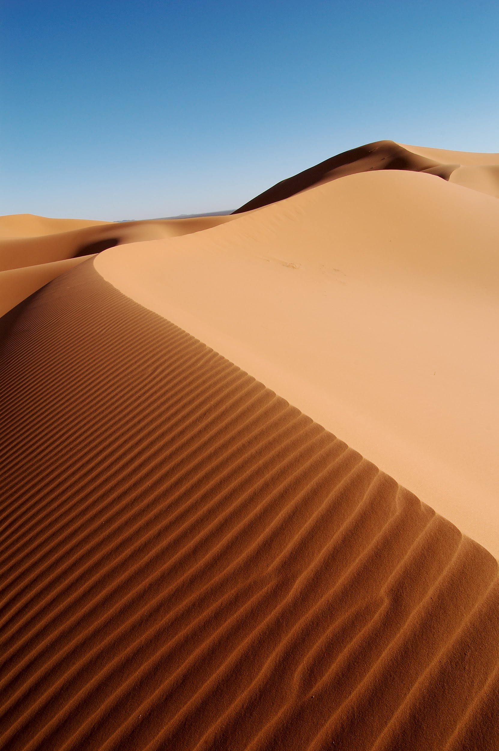
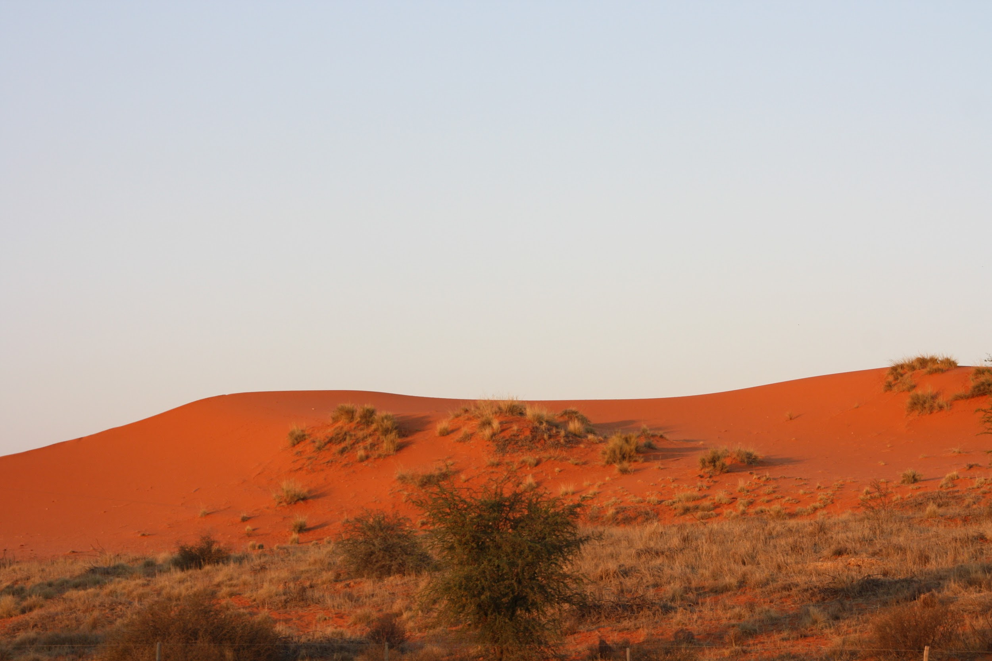
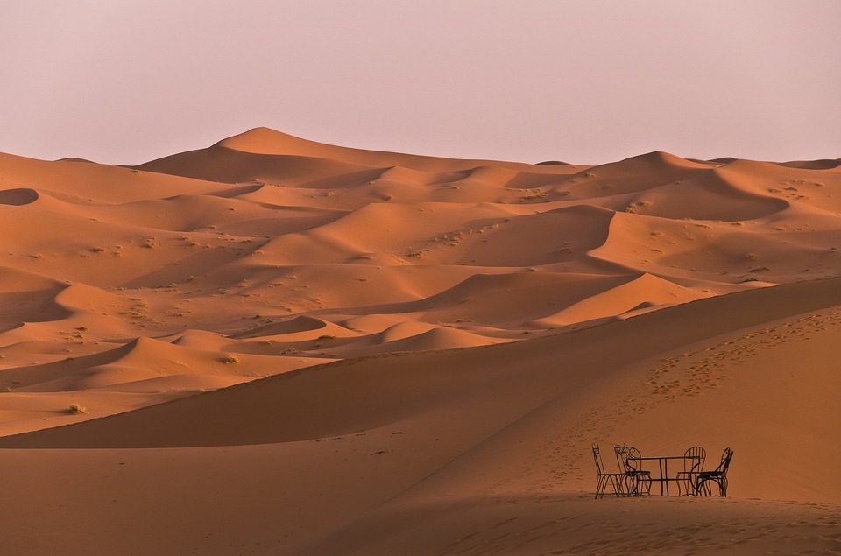

When it came to designing/modelling, I decided to stick to Blender because this was finalised as the software to animate our short film. My initial protocol was occurring the correct shapes of the sand dunes. To create the dunes, I was able to use one of the blender addons that provided basic landscapes. Then using this i was able to play around with the shape until i was satisfied. While going through each shape of the dune, I did refer back to the various reference images of the sand dunes in both Sahara and the Kalahari. The next stage was adding the mountains in the background, this was created using the same addon produced by Blender. The addon allowed me to acquire a basic mountain shape and then using references of the Kalahari mountains I was able to shape the mountains further making them more detailed, such as rough rocky edges, cliff edges etc. I felt working on the mountains was very difficult because sculpting the rocks to look rough aswell as getting an idea on how big the mountains surrounding the vast desert was difficult. Even though the references were useful , they didn’t provide relevant information regarding the size and layout, so for this a lot of trial and errors were carried out. I even placed the robot model in the environment to see if the size of the dunes and mountains were working. This approach also gave me an idea on the depth of field.
The next step for creating the environment was texturing. This was the most complex as well as time consuming part for me. This was complex and time consuming because my texturing skills were very limited so this was something I wanted to expand on, so a lot of research regarding texturing on Blender was needed. Even though my experiences with texturing was very limited, I still didn't want to create a basic texture for my environment so I challenged myself to keep with a realistic approach by creating textures that would make the environment look very much like a realistic desert. One of the ways I tried to make the sand dunes look realistic was by including visible sand grains to the textures I had created beforehand. Creating the basic colour of the sand was quite straightforward because I could refer back to both the Sahara and Kalahari desert for colour inspiration. To apply the grainy look to the texture, I added a bump node and then a noise node, this allowed the initial flat yellow texture look like it's made from lots of little sand grains. Once the nodes were added the values of both nodes were tested so that i could see which value produced the texture i desired. Several versions/drafts of the textures were created so as a group we could discuss which texture suited the environment more. While texturing I noticed some of the sahara dunes contained lines/patterns along the dunes, this was something I wanted to add to my texture to add further realism to my dunes. To apply these patterns to my texture, I added a mapping node and then a noise node to the sand texture. Once again I had to play around with the values of the mapping node, so this was basically seeing all the directions of the patterns and choosing which suited the sand dunes aswell as matching up with the reference. I thought adding the patterns to my sand dunes were ideal because these patterns are caused when wind/sandstorms are pushing the sand grains. Adding this shows the harsh weathers within this environment, furthermore, as said earlier adding the patterns to the texture gave the environment and the sand dunes the realistic style i initially wanted. The Dune textures will still be an ongoing task.
Before I began texturing the mountains, I wanted to see if adding small patches of dying grass or vegetation etc would suit the current look of the environment. Grass was the first asset I wanted to add within the environment. Using the reference images of the Kalahari desert I was able to apply the small patches of dying grass easily using the hair emitter. Once I was happy with the shape of the grass, I began adding small patches along the dune. For the texture, I used a simple colour node because since this was still a draft stage and we hadn’t completely finalised whether we wanted them in the final film. The values for a light green with a hint of dark orange was added to the colour node, showing the patches of grass were in their dying state. Grass wasn’t the only object added to the sand dunes because while referring to the Kalahari desert, I noticed certain parts of the Kalahari desert were scattered with rocks and boulders. This is another great way to give my environment that further realistic look, scattering rocks all around the dunes. Since I only wanted to get an idea of what my desert dunes would look like with rocks and boulders around, I only created 2 rocks and duplicated them to scatter around the area. For the final version i will not be doing this, but i only did this now for time management. The rocks were sculptured using a sphere and for reference i used google images of rocks. Finally for texture, i decided to use a 3d image texture from the website; CC0 Textures. After seeing the final version with the rocks scattered around the desert, I was happy with what I saw and this is something that will definitely be implemented onto the final version of the environment. For the final version, I will not be using the image textures but instead creating the rock textures manually.
The final object that needed texturing was for the mountains surrounding the desert, once again the image reference of the Kalahari mountains were used to help texture. My initial approach was to use the technique I carried out to obtain the sand dune texture, this meant using the bump and the noise node once again. The final results I gained from playing around with the values was the image below on the left. However after the second inception i realised the texture looked very sandy. Even though the sandy texture on the mountain looked good as well as suit the nature of the environments surrounding, I personally wasn’t completely happy because I wanted the texture to look more rough and rocky. Since it was very important to get the mountain texture to how I desired, I decided to carry out further research into texturings mountains, specifically desert mountains. After watching a few youtube tutorials on how to texture mountains correctly using blender, I began playing with the values of the texture node further. I also decided to include another noise and a mapping node to the texture. The final outcome is the image below on the right. After seeing the before and after renders, the mountains definitely look a lot better, especially with the fact it doesn't look too sandy now and some areas have rough spots like a mountain should do. I’m still planning to play around with the mountain texture right up until we start animating because i still want to try and add other small touches such as making parts of the mountain rocks shiny when sunlight hits etc. This will definitely be an ongoing individual task.

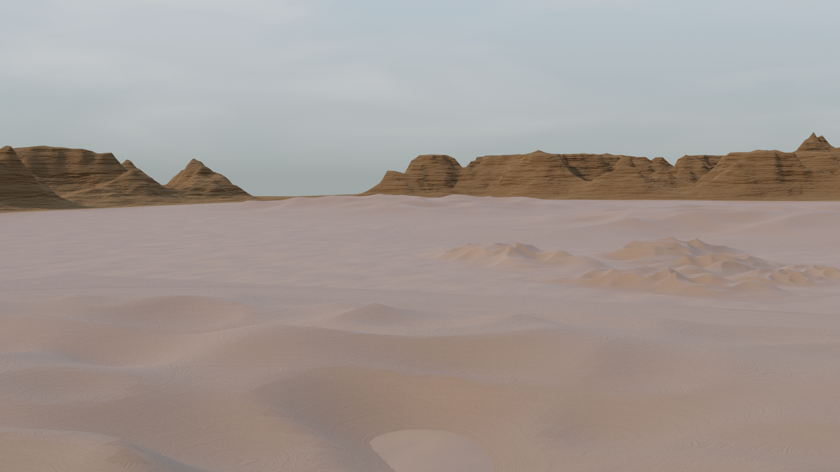
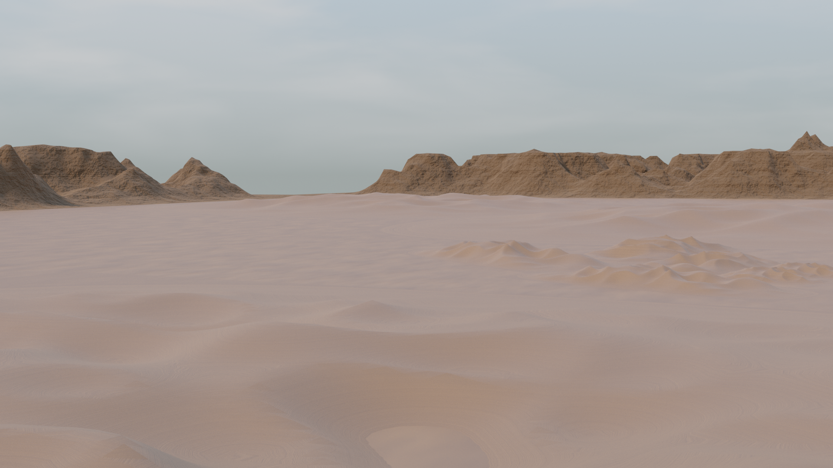
Besides the desert, the coastline for the desert was another environment I designed. The coastline was another pivotal location because this would be the starting point for when our character goes into the desert. Creating the dunes and texturing the dunes was straightforward because I was able to implement my actions from earlier to this environment. So for example, I was able to easily get another sand dune shape and then for texturing, I was able to easily refer back to the texture data from the desert environment. Once the dunes were textured and added, I played around with how the coastline would be layed out. My initial idea was to have the ocean on one side and the dunes on the other, however after viewing various reference images I realised the desert would need to look like it's curving around the ocean. Using various coastline images as reference, I decided to add the ocean in first and then once textured, I can play around with positioning the dunes and the ocean itself. The ocean was created using the ocean modifier tool provided by Blender, this was a plane that would behave like water. This was used rather than using a vast water simulator because when i looked into creating a small ocean simulator on Houdini the biggest drawback was the render time. Due to this I thought using the ocean modifier was easier because rendering would be easy and it was easier to work with. Since i had no previous experience with creating an ocean texture and i didn’t want it to be a simple shade of blue, i used youtube tutorials as my reference. The tutorials were very straightforward and went over various ocean textures, some including with and without displacements. To get the texture i created i used the following nodes; mapping, colour ramps, noise textures and displacements.
Just like the level 6 project, effect was the other area i got involved in. Even though these were just tests, I still used all of my existing aswell as new skills to create certain effects elements for our short film. The first effect was creating a trail of dust as the robot goes through the desert. The second effect was creating ripples, waves and water sprays caused by the robot as it goes through the ocean. Both effects are complex in their very own way, however i found out both are easy to create using some easy solutions. For example rather than creating a large ocean simulator that would use a lot of data aswell as time to render, the easy solution I found was that in blender you can manipulate the ripple effect easily on a simple plane using the weight paint tool. Since the effects are still an ongoing task, I'm hoping to find more easy solutions like those that could aid me with creating some flawless effects.

Bibliography

Sahara Desert: https://www.globaladventurechallenges.com/journal/facts-about-sahara-desert

Kalahari Desert: https://www.britannica.com/place/Kalahari-Desert/Climate

Ocean texture: https://www.youtube.com/watch?v=acYCOogWjD8&t=62s

Rock texture: https://cc0textures.com/view?id=Rock020

