University of wales trinity saint david
Adriana’s Photography
A business plan
Student: Adriana Elena Dascalu (2011303)

Module: Managing Enterprise in the 21th Century

Contents

About the business 1
Mission statement 3
Aims and objectives 4
SMART goal 5
Introduction 6
Products & Services 7
Unique selling point 8
Marketing Activities and Strategies 9
Demanding of Adriana’s Photography 10
Resources 11
Physical resources 11
Financial resources 12
Human resources 12
SWOT Analysis 13
Future of the business 14
Appendice 15
Cash Flow 16
Reference list 17

About the business



Motto: Embracing beauty in a frame

Adriana's Photography is a small business owned by one person, Adriana Elena Dascalu, as a Sole Trader. As unique owner of the business, I have total independence in running it, so all decisions, changes, profits, and losses will belong to me (Rye, 2020). Being an art-oriented person, through this business I have the opportunity to combine one of my passions, photography, with the plan to open a small personal business. Through it, I can contribute significantly to my personal development in terms of intellectual, social, economic and skills. The activity will take place mainly in Swansea and around the city.

Mission statement

Adriana’s Photography is committed to keep the art of photography at hand for people who want to capture moments in their lives, by offering quality services, in professional conditions.

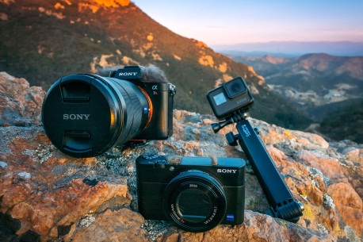

Aims and objectives

- Offering photo sessions in the studio or in locations proposed by the client.
- Having a consistent profit.
- Growing in popularity year after year.
- Adherence to the latest technologies and techniques in the field of professional photography.
- Promoting aesthetics and beauty in various forms.
- Contributing to the emotional well-being of customers and online visitors



SMART goal

The purpose of creating a SMART goal is to maintain the focus on achieving the business goal, in a practical, active way and with high chances of success. It stands for the following elements:

S - Specific: to offer regularly photo sessions to clients from the Swansea area.
M- Measurable: to keep track of how many clients asked for business’ services.
A – Achievable: to update regularly the work portfolio of the business.
R- Realistic: to offer services at a good price.
T – Time: to be flexible in terms of adapting the work hours according to clients’ possibilities.

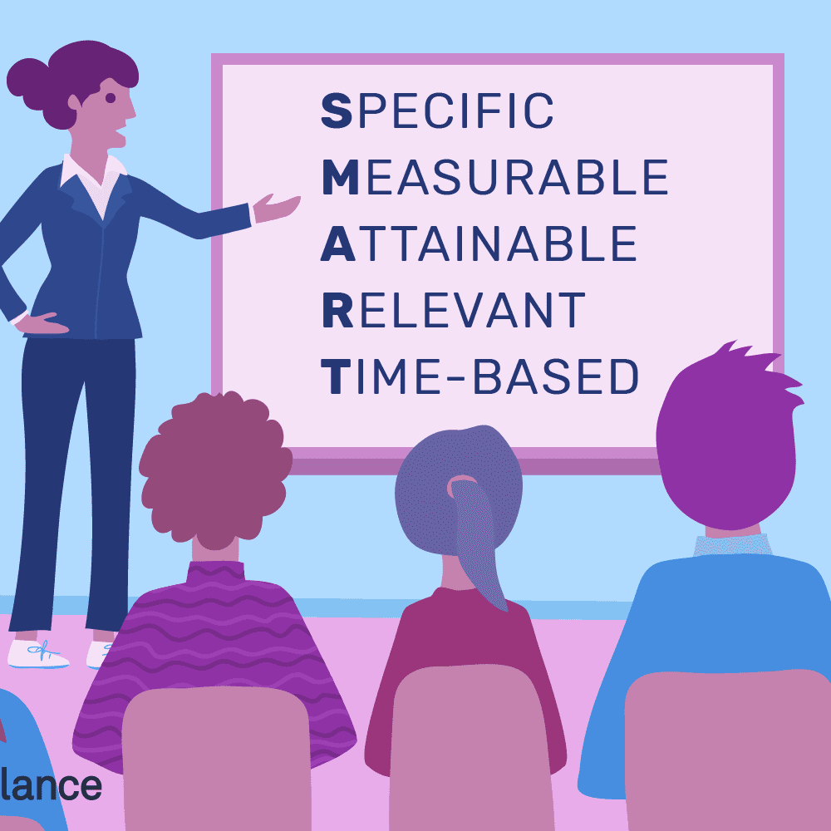

Introduction

Social media is one of the main interests of smartphone owners in their internet browsing, especially people aged between 12 and 40 (Giunchiglia et al., 2018). In recent years, several social networks have developed in which photos are the main attraction. People are attracted to look at other people's albums, and the better they are aesthetically and technically, the more they will be appreciated. Both in the form of a "selfie", but also captured by an observer, the photos captivate the viewers and even keep them attentive for hours in the scrolling of the pages.

Thus, those who like to include moments in photos, choose the best performing devices (depending on their budget) to achieve their goal whenever they want. Dozens of mobile photo editing applications have also appeared, which can create stunning images, using from the simplest functions to the most complex tricks (PhotoShop, PhotoScape, Pixlr, etc.).

Given this modern trend, Adriana's Photography aims to meet the desires of clients to have high quality photos, which are the answer to the emotional need to return to tangible memories, the need to share and appreciate, socialize and information. It was found that “reflecting on happy memories are common techniques that have shown positive results in improving overall mood and feelings of happiness “(Lee et al., 2021). Therefore, the business is not only based on offering a paid service, but a way to contribute to improving the mood and increasing the client's well-being.

This principle highlights Adriana's Photography compared to other businesses in the field.



Products & Services

Products
- Photoshoot albums
- Frames with photographies

Services

- Baby photography - 150 £
- Commercial photography - 700 £
- Couple photography - 100 £
- Event photography - 500 £
- Headshot photography - 15 £
- Product photography - 100 £
- Wedding photography - 600 £

Depending on the client's requirements and needs, other services can be provided. The displayed prices are negotiable, however some costs can be added depending on details such as travel to certain locations, the duration of the event, but all these are discussed and established prior to the provision of services.

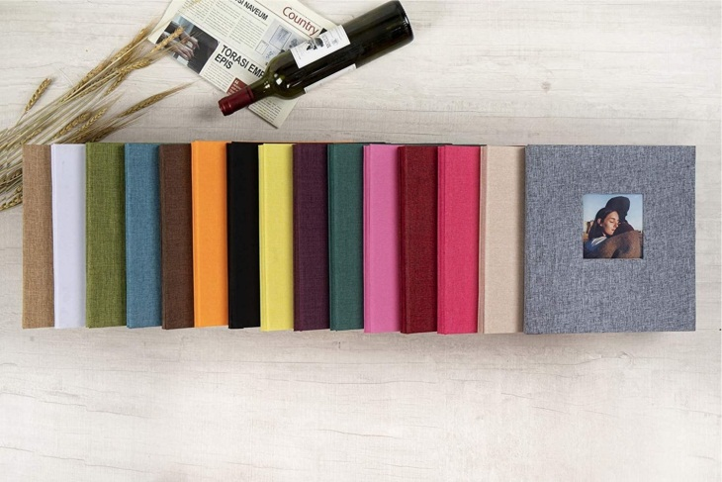

Unique selling point

What makes Adriana's Photography stand out from other businesses is professionalism combined with personal passion for photography. Clients' ideas and suggestions are considered, and their wishes are materialized in stunning photos that will keep their memories alive over the years. The business will also be involved in advertising, offering services that capture products from the best angle. Flexibility and negotiability will also be the core features of the business. Life is busy and demanding for everyone, so Adriana's Photography will do its best to be a pleasant part of the program in the clients' agenda. Also, the photographer will regularly invest in her education to be up to date with the latest technologies and techniques and will seek to add an unique imprint to her works and collaborations.





Marketing Activities and Strategies

Marketing is the field where all the products and services offered by a business, or an enterprising person, are made available to the customer. It has the possibility to choose according to needs, tastes, and budget (Sharp, 2017). To ensure a good start for Adriana's Photography, the main marketing approach strategy will be based on 4 P's: Product, Promotion, Place and Price. The mix of these elements will highlight how Adriana's Photography can make its customers satisfied to the highest standards, paying attention to professionalism, current offers of competitors and the introduction of new, creative things to attract attention (Osiri, 2013). Therefore, regarding the Product, the focus will be on the quality and on meeting the client's expectations regarding the photo sessions and the final products, which will usually be printed or digital photo albums. The Promotion will consist of a balanced and intelligent investment in advertising to increase the popularity of the business. The more people hear about Adriana's Photography, the more likely I am to have new clients. The place will always be accessible to customers, the main location being the studio in Swansea. Also, the services will be flexible in the sense of the possibility to hold photo sessions in nearby locations, depending on the case and request. Directions to free and legal parking spaces will be provided so that customers do not waste time or enthusiasm, especially if they are unfamiliar with the area. Prices will be calculated based on factors such as the average market offer for the photographer's job, location, number of overtime hours and, if applicable, the consideration of offers or discounts. Considering these aspects, customer satisfaction will be a focus, being flexible to remain a reliable, professional business that offers services equivalent to their investment.
I thought about what I would do to figure out how I could personally find a photographer in the situation where I do not know anyone in the field, and I would need photography services. Thus, this strategy would help me to put myself in the place of a potential client and how I could prepare a solution in advance so that my business can be easily found.
On an internet search, the Bidvine.com (2021) platform is the first online register of photographers where a client could select a professional in the field for the desired photo session. Therefore, registering on this website could facilitate clients' access to Adriana's Photography profile and thus there are greater chances of using business services.
Given that photos are popular products on the Internet, as presented in the introduction, business promotion will be done predominantly online. Pages dedicated to the business will be created on social media networks such as Facebook, Instagram, Twitter, LinkedIn, which will load samples of photos from photo shoots and albums made especially for virtual visitors. A website will be dedicated to the entire plan which will include the business description, price list of services, customer feedback, contact details, trunk links to related social media pages and the portfolio of photo albums. There will also be a budget for regular ads on Facebook, Instagram and Google with a redirect link on the website. Business cards and leaflets will be created to be distributed to interested personnel, respectively in the mailboxes (Pritchard, 2020).

Demanding of Adriana’s Photography

To anticipate the impact that Adriana's Photography would have on the market, a questionnaire was conducted to investigate the perspective of a sample of subjects regarding professional photography services, 80% with ages between 26-35 years, and 20% with ages between 45-55 years, 80% with domicile in Swansea, and 20% with domicile in other rounded locations. The questionnaire was completed and distributed online, consisting of ten questions with subjective answers. Knowing the experiences of the public can be a strategy to create higher quality services in the future and to ensure an advantage over other competitors in the field.

Thus, it was shown that all subjects resorted to professional photography services, 40% for weddings, 60% for family photo sessions. It follows that in general, customers use these services at special events, even some unique in life. All the subjects said that they chose the professional photographer following the recommendation of others, which proves that the classic method of word of mouth is of great impact for a business. To make themselves known in public, some photographers ask clients to leave feedback on their business page. Thus, people who happen to get there to observe how other collaborations have gone. All subjects stated that before choosing the photographer they wanted to see other works from his portfolio, which means that it is especially important to create a consistent and quality portfolio to win clients. It is important that the work done for the client is of the same standard as the portfolio in order not to tarnish the image and credibility of the business.

For 60% the most relevant aspects in choosing a photographer were the professionalism, for 20% the price for services counted, while for 20% the openness to their wishes and suggestions mattered the most. All subjects agreed with the photo sessions in a thematic studio. A percentage of 60% said they regularly post pictures on social media. Only a percentage of 60% stated that they would like to subscribe to the newsletter with offers and deals which means that not all clients agree to be always up to date with promotional offers of services that they probably rarely request.

Resources

Physical resources

The main headquarters where Adriana's Photography will carry out its activity will be a studio bought in Swansea, equipped with all the accessories and utilities necessary to carry out the activity. This will include the IT workspace, a computer that will be used to promote and monitor the business, printer, paper, ink, licensed photo editing programs, website hosting fee, office supplies (diaries, writing instruments), wireless internet. Hot drinks (coffee, tea) will be provided to offer a pleasant and welcoming atmosphere in the studio, to which the provision of sanitary services is added. There will be themed sets for photo sessions, panels, costumes, to bring diversity and creativity to photo shoots depending on the client's preferences. Moreover, photo frames and albums will be exhibited for making personalized orders with the photos taken.




Financial resources

The financial part is vital when it comes to starting and maintaining a business. No enterprise can be launched without investment. Thus, adding to the above-mentioned resources, costs will also include the advertising, both printed and digital. Also, finances are needed for personal support, and even for employees if the company is supported by more people, until there is a profit.
In the case of Adriana's Photography, the total amount allocated is 100,000 £, of which 50,000 £ represent personal savings, and the remaining 50,000 £ represents a profit from investing in cryptocurrencies.

Human resources

In addition to the advantages that the position of Sole Trader implies over the business, another advantage is that the owner will also be "employed". Basically, the owner will have the role of administrator, social media manager, photographer, cashier, accountant, studio maintainer, creative director. Thus, there will be no obligation to pay other salaries, all profit remaining to the owner.
However, the owner is aware of the legal requirements regarding the hiring of staff, because in the future there may be a change that will produce the need to hire someone. The vacancies will be integrated in an announcement that will be published on the business social networks, but also on recruitment sites such as Uk.indeed.com (2021). Once individuals are selected, follow the sequence of steps on Gov.uk (2021) on staffing:
- Check the recruited individuals’ right to work in UK
- Perform a DBS check if necessary
- Check about workplace pension
- Agree about contract, salary and holiday
- Register the employee on HMRC (for paying taxes, insurance and for legal evidence)
Being a freelancing business, there is not always a fixed schedule, which remains the agreement between the employer and the employee on the number of working hours, without exceeding the maximum number of working hours per week - 40, legally. At least the minimum payment on the economy will be ensured, depending on the employee's responsibilities.

SWOT Analysis

The SWOT Analysis is a popular tool used for identifying the strengths and the weaknesses of a subject, then the opportunities and threats that the subject may face. It can help to recognize potential things that may help or affect it (White, 2013).
For Adriana’s Photography SWOT Analysis (appendice), the main strengths rely on a wide services and products offer, firstly. The customer is free to choose according to his/her desires and wherever is chosen, it is a benefit for business. Then professionalism is a core part of the business, followed by qualitative devices which are important for the process of taking photographies. Another strength is the creative thematic studio where the customers can have many photoshoots, bringing an unique design and charm to the photographies. Experience in working with people, taking pics, and coordinating all activities with patience and responsibility are an important part of the business. Working with various computer software like Photoshop or Lightroom can be added to these advantages. These programs can help edit the photographies and create stunning results.
The weaknesses are represented by the pandemic which means less events, skepticism from people about going outside of their home and all the safe measures can be real impediments in the process. Also, there is no guarantee that the wave of customers will be constant. Sometimes, my agenda can be full, other times I can barely have any customers. These can lead to serious income fluctuations.
The opportunities are reflected in occasions to meet new people and increase the number of photoshoots. It is also possible to enter competitions to become more popular and sell photos on stock websites to increase the income.
On the other side, the threats are represented by competition (many photographers in the area), changes in technology which may compel me to invest in new devices to be up to date with the last trends. Also, the bad or slightly negative feedback from clients can affect the image of the business. Although the business aims to meet the desires and needs of customers as best as possible, realistically there is still a possibility that the customer cannot be happy about the services.

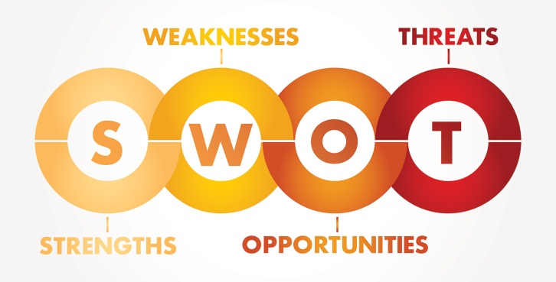

Future of the business

Adriana’s Phtography aims to be a known business for its professionalism and passion for photography, making happy as many customers as possible and win a good reputation on the photography market. The business’ portfolio will include a wide range of projects, leaving a beautiful trail in the practiced art.



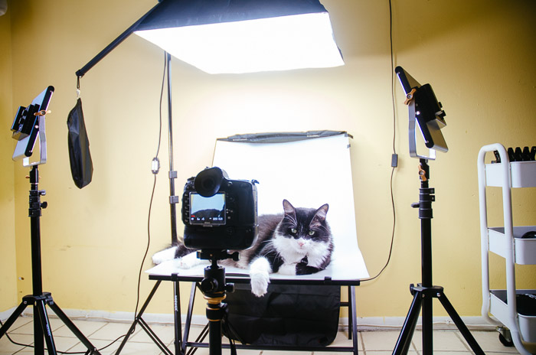

Appendice

SWOT Analysis

Strengths:

- Wide services and products offer
- Professionalism, qualitative devices, creative thematic studio,
- photo experience
- Work with various computer software (Photoshop, Lightroom)
Weaknesses:
- Pandemic
- The wave of customers is not constant

Opportunities:
- Occasions to meet new people and increase number of photoshoots
- Sell n stock photography websites
- Enter competitions

Threats:
- Many competitors on market
- Bad feedback from customers
- Change in technology

Cash Flow

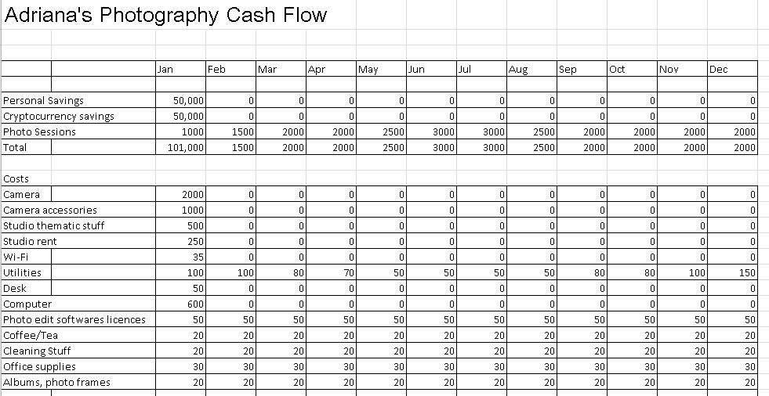

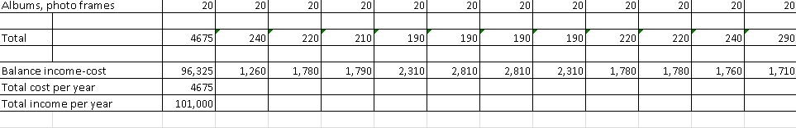

Reference list

Bidvine. 2021. Bidvine - hire trusted local service professionals. [online] Available at: <https://www.bidvine.com/> [Accessed 25 May 2021].

Giunchiglia, F., Zeni, M., Gobbi, E., Bignotti, E. and Bison, I., 2018. Mobile social media usage and academic performance. Computers in Human Behavior, 82, pp.177-185.

Gov.uk. 2021. Employ someone: step by step - GOV.UK. [online] Available at: <https://www.gov.uk/employ-someone> [Accessed 7 June 2021]

Lee, J., Efstratiou, C., Siriaraya, P., Sharma, D. and Ang, C., 2021. SnapAppy: A positive psychology intervention using smartphone photography to improve emotional well-being. Pervasive and Mobile Computing, 73, p.101369.

Osiri, J. K. (2013). Entrepreneurial marketing: Activating the four P's of marketing strategy in entrepreneurship. The Entrepreneurial Executive, 18, 1.

Pritchard, L., 2020. Setting up a successful photography business. 2nd ed. New York: Routledge.

Rye, J., 2020. Setting up and running a therapy business. 2nd ed. Routledge.

Sharp, B., 2017. Marketing: Theory, Evidence, Practice. 2nd ed. Oxford University Press.

Uk.indeed.com. 2021. Job Search | Indeed. [online] Available at: <https://uk.indeed.com/> [Accessed 7 June 2021].

White, L., 2013. Photography Business Secrets. New York: Wiley.

