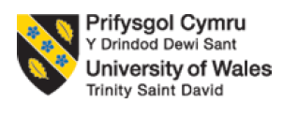

Module name: International Business Concepts
Module code: LCMB7034

Title: International Business management of the tourism industry in Vietnam
Student name : Chetnaben Anilbhai Fadke
Student ID : 2430959
Word Count: 5201
Table of Content

Section 1: 2
1. Introduction to the report 2
2. Industry and Country Overview 2
a. Introducing the tourism industry within the context of Vietnam 2
b. Size, scope, and economic importance of tourism industry of Vietnam 4
c. Major domestic and multinational firms operating within the tourism of Vietnam 5
3. Application of Michael Porter’s ‘Diamond Model of National Advantage’ to analyse the global competitiveness of the tourism sector of Vietnam 6
4. Identifying one of the major foreign MNCs/TNCs operating in the country-industry pair 9
One foreign MNC tourism operating in Vietnam: Marriott 9
Evaluation of the company’s operations in Vietnam 10
PESTLE: External tourism factors on Vietnam’s market attractiveness 10
CAGE analysis 13
Porter’s five focus on competitiveness analysis 15
BCG Matrix on tourism market profit analysis 17
5. Conclusion 19
Section 2: 20
Introducing reflective model: Gibbs reflective cycle 20
Gibbs' reflection on reflective process of my researching, analysing and preparing the above section of the assignment 20
Description: 20
Feelings: 21
Evaluation: 22
Analysis: 22
Conclusion: 23
Action plan 23
References 24

Section 1:

1. Introduction to the report
As of Vietnamtourism.gov.vn (2026), Vietnam recorded nearly 21.2 million international visitors in 2025 which accounted for an increase of over 20.4% compared to 2024. The surge in international tourists to Vietnam reflects Vietnam’s global appeal as a popular travel and tourism destination, reaching over approximately 4.68 million tourists only within the first two months of 2026 which shows an year-on-year growth of around 18.1% overall (Bách, 2026). The appeal of Vietnam’s tourism industry would be because of its diverse natural landscapes, cultural heritage sites and Vietnam’s expanding tourism infrastructure. This is what has allowed Vietnam to become one of Asia's fastest-growing tourism markets where major foreign visits to Vietnam are reported to come from China, followed by South Korea (Sering and Sering, 2026).

2. Industry and Country Overview

a. Introducing the tourism industry within the context of Vietnam
Vietnam’s tourism industry has experienced exponential recovery following the crisis of Covid-19 pandemic as Vietnamtourism.gov.vn (2026) reports a growth of international tourist visits exceeding pre-pandemic level of 2019 by a margin of 17.8% (Refer to Figure 1).
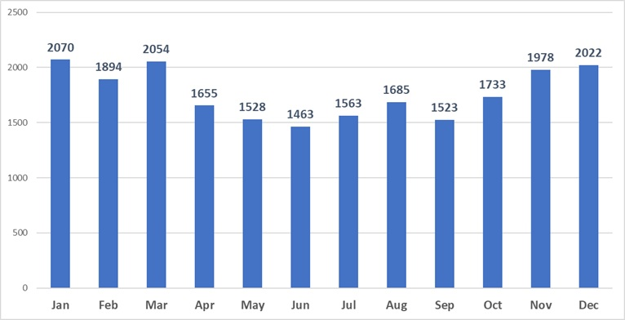
Figure 1: National Statistics Office's data on international visitors by month to Vietnam
Source: (Vietnamtourism.gov.vn, 2026)
ASEAN Briefing (2025) reports Vietnam’s tourism sector in 2024 contributed around 6.6% to Vietnam’s nominal GDP. Such a number not only reflects the integral role of tourism in the national development of Vietnam as a country but also it is important to understand how tourism creates new job roles and employment in Vietnam has been estimated to reach over 5.96 millions jobs (representing one in every nine jobs in Vietnam) (ASEAN Briefing, 2025).
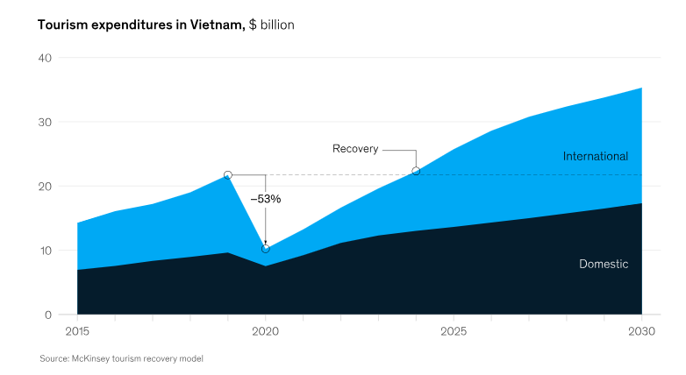
Figure 2: Tourism expenditure in Vietnam continue to rise
Source: (Constantin, Francois and Le, 2021)
Referring to Figure 2, the tourism expenditure to Vietnam's tourism sector shows rapid growth of international tourist spending over domestic tourist spending, a massive growth in numbers against a -53% fall recorded in 2020. All of these numbers illustrate the strategic importance of the tourism sector for Vietnam’s economy which could stimulate overall infrastructure development by increasing foreign investment and potentially contributing significantly to regional economic growth of Vietnam.

b. Size, scope, and economic importance of tourism industry of Vietnam
The scalability of Vietnam’s recent success in the tourism industry can not only be limited to growth in recent one or two years, instead, cumulative growth results in generating substantial revenue, employment opportunities and overall regional development. For instance, Vietnam registered international arrivals of over 17.5 million which accounted for 38.9% growth compared to 2023, whereas domestic tourists reached over 110 million the same year which also increased by 1.6% overall (Vietnam News, 2024). With the growing number of both international and domestic tourists, the biggest beneficiaries to Vietnam’s tourism boom would include hotels, restaurants and resorts, transportation services, and local tour operators across the country. The thriving tourism sector in Vietnam was reported to reach over VND840 trillion (equivalent to US$32.96 billion) in 2024, which recorded a growth of 23.8% year-on-year surge in tourism boost in recent years (Vov.gov.vn, 2024).

c. Major domestic and multinational firms operating within the tourism of Vietnam
Domestic tourism companies: There could be leading examples of domestic tourism firms playing a dominant role in shaping Vietnam’s tourism infrastructure particularly in travel services and resort development to support excellence in tourist customer services. Companies such as Vinpearl, Muong Thanh Hospitality, and Vietravel play a major role influencing Vietnam’s tourism boom in recent years. For example, Vinpearl is considered the leading hospitality brand in Vietnam, operating with 42 facilities across 17 major cities in Vietnam with its 30 hotels and resorts (that is reported to have a capacity of over 15,900 hotel rooms) (Initiation Report, 2024). All of these mentioned firms target both domestic and international tourists by offering them integrated resort complexes, tour packages and entertainment parks so that wider mass tourism and tourist demands could be addressed.
MNC tourism firms: Vietnam’s expanding tourism market is also appealing to several international hospitality brands such as Marriott International, InterContinental Hotels Group (IHG), Hilton Worldwide Holdings, Accor Group etc. to come to Vietnam. All of these multinational corporations offer premium and luxury hospitality services as the wider global brand recognition and international service standards help Vietnam’s tourism cater to the high-level of expectation visiting Vietnam, particularly for international tourists. These MNCs even have been reported to collaborate with domestic firms so that maximum benefit could be registered. For instance, Vinpearl (2022) reports of Vinpearl’s strategic cooperation with Marriott International that was intended to leverage Marriott’s network of over 8,000 hotels and resorts worldwide to use the global standard of excellence in Vietnam’s case to target more international and domestic tourists.
Relative positioning of key tourism companies in Vietnam by comparing strategies, market segments, performance, positioning
While domestic Vietnamese companies have been seen to typically pursue scale-driven growth strategies as Tufft et al. (2024) finds consolidation driving economies of scale could allow domestic firms reclaim their relations with guests by offering integrated services catering to emerging diverse tourist demands. To put into comparison with the approach of domestic companies with MNCs, it can be said that international firms such as Marriott and Accor (Vietnam) focus on premium branding by leveraging global distribution systems and international service standards.
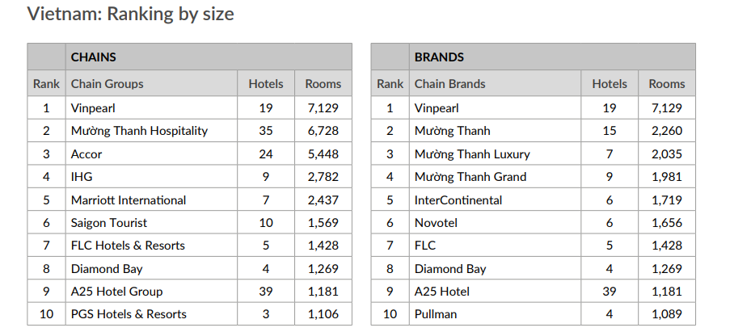
Figure 3: Domestic and International firms dominate Vietnam’s tourism industry
Source: (Horwathhtl.com, 2022)
This is important in particular to encapsulate high-value international visitor segments coming to Vietnam. However, Referring to Figure 3, domestic firms are also improving the standards as Horwathhtl.com (2022) claims Vinpearl and Muong Thanh Hospitality lead the domestic hotel markets in terms of number of properties and rooms, whereas Accor and IHG maintain a strong hold within luxury travel segment in the country.

3. Application of Michael Porter’s ‘Diamond Model of National Advantage’ to analyse the global competitiveness of the tourism sector of Vietnam
In the case of Vietnam, each of these four determinants in Porter’s Diamong Model collectively could explain the reasoning behind the rapid growth of the tourism sector that has been successful in attracting international tourists to Vietnam in recent years.
Factor Conditions: Factor conditions would refer to the resources that are available to the industry of the case country that could support overall development. For Vietnam’s tourism industry, evaluating tourism expenditure, critical factor quality and specialisation of appealing international tourists through cultural heritage sites and beautiful landscapes can be labelled attracting millions to visit the country. For example, Marriott aimed to capitalise on the opportunity to blend its hospitality experience with deep Vietnamese traditions and prioritise natural beauty. For example, the “JW Marriott Phu Quoc Emerald Bay” resort ranked first position in Southeast Asia (including Vietnam) (Vietnamtourism.gov.vn, 2026a). On the other hand, Accor Hotel blended its staying experience by immersing the Vietnamese culture and natural landscape. Apart from the resources, the hotel Group also specialises in boasting diving sites, offshore islands and preserving beaches with its Nha Trang initiative (Accor, 2025).
With a record number of being the second-highest number of World Heritage Sites in Southeast Asia, just behind Indonesia with ten sites, Vietnam has an added advantage to itself which is leveraged by the country's expanding investment on improving its tourism infrastructure to attract more visitors to the country (Makeyourasia.com, 2025). The seriousness of the country's leadership to continue improving its tourism sector can be understood by initiatives such as when Vietnam hosted the UN Tourism's first Global Conference on Tourism for Rural Development in Hoi An in December 2025 (Vov.gov.vn, 2024).
Demand Conditions: The demand conditions reflect the nature and sophistication of domestic and international tourism demand within Vietnam. With a backing of strong tourism demand for both domestic and international tourists, Vietnam naturally gets significant benefit with its strong tourism infrastructure to captivate the rising demand year-on-year. Vov.gov.vn (2024) reports a significant milestone for the tourism industry in Vietnam should be given credit to the country's adoption of an e-Visa policy for citizens of all countries. For example, JW Marriott e-visa policy offers 90-days to the guests to enjoy the scenic beauty in Vietnam and stay in the Deluxe, Premier, Executive and Presidential risk Suite (Hdfcergo, 2026). Apart from the revised Visa Policy, unlike JW Marriott, IHG is an integral part of the 7000-room hospitality ecosystem under the Vietnam ‘megacity’ project. For example, Crowne Plaza Saigon and InterContinental Saigon Can Gio are evidence of IHG’s strategic expansion in Vietnam (Shepherd, 2026).
Related & Supporting Industries: The competitiveness in the tourism industry would strongly be influenced by presence of good local suppliers and presence of supporting industries such as aviation, hospitality, transportation and overall digital travel services. JW Marriott partnered with Vinpearl and Sun Group for its strategic expansion in Vietnam. Under this partnership, 10 new resorts and hotels will be opened in the time period, 2026-2030 (Theinvestor.vn, 2026). Thus, the supporting and related industries played an instrumental role for JW Marriott to target all segments in Vietnam, from traditional to lifestyle, midscale youths and families to premium MICE guests. On the other hand, the VINPEARL Hotel preferred to partner with Airlines for shared use of resources and exclusive design of the holiday package. For example, Vinpearl, VinWonders and Xanh SM are able to order 50% discounts with the contribution of the airline support industry (Vietnamtourism.gov.vn, 2026b).

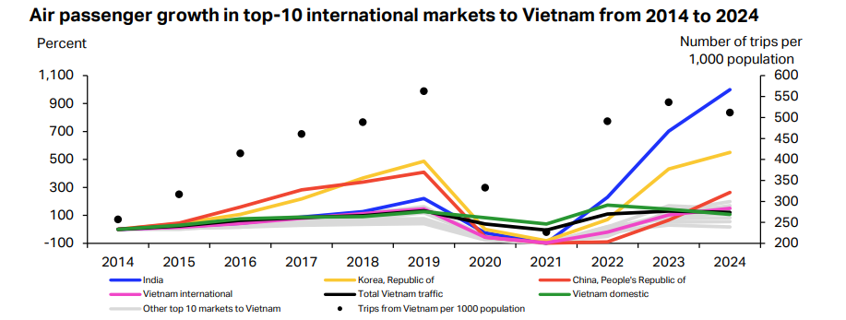
Figure 4: Air passenger growth in Vietnam (2014-2024)
Source: (IATA, 2025)
A report by the Civil Aviation Administration of Viet Nam reports that the aviation sector in Vietnam registered the highest growth rate among top-10 performing markets in the neighbouring region, showcasing a growth of over 121% from 2014 to 2024 (Refer to Figure 5). Among the regional competitors, Vietnam also recorded the highest hotel performance growth in the first half of 2025, accumulating 21% year-on-year growth (Global Expat Recruiting, 2025).
Firm Strategy & Rivalry: The competitive structure of Vietnam's tourism industry includes popular multinational companies with wider global networks of hotels and infrastructure that encourage foreign direct investment (FDI) and upgrading the existing infrastructure alongside vigorous competition from domestic tourism firms as well. For example, Muong Thanh upgraded its Infrastructure to cover more than 60 regional areas in Vietnam. Under the leadership of Yen, the hotel Group established a centralised management office in Vietnam and monitored the local activities within the supply chain. Now, Moung Thanh has a significant presence from three-star hotels to five stars, within an asset of 11,500 rooms (Hoang, 2020). On the other hand, the international brands such as Marriott faced challenges from the trade protectionist policies in Vietnam, in terms of safeguarding its domestic tourism ecosystem. However, competition is high among the rival companies, for example, Marriott plans to extend its key portfolio beyond 1900 by partnering with Masterise Group (Van, 2026); hence, followed a similar approach of Moung Thanh to infrastructure upgrade in Vietnam.

4. Identifying one of the major foreign MNCs/TNCs operating in the country-industry pair

One foreign MNC tourism operating in Vietnam: Marriott
One of the most prominent multinational corporations operating within Vietnam’s tourism and hospitality industry would be Marriott International, an American multinational company with over 30 leading brands and over 9,700 properties across 143 countries and territories (Marriott International, 2026). As of February 2026, Marriott has 29 properties across Vietnam, spanning 12 of its extraordinary brands and a wide range of destinations that include key gateway cities and beautiful beach resorts (Marriott, 2026).

Evaluation of the company’s operations in Vietnam

PESTLE: External tourism factors on Vietnam’s market attractiveness
Factors | Description | Threat or Opportunity
Political | - The “2025 Tourism Development Stimulus Program” was introduced by the “Ministry of Culture” of Vietnam to promote tourism by offering 50% discounts on different travel services, such as tax incentives and fee exemptions (Vietnam Tourism, 2026).  - The government of Vietnam has e-Visas and lenient visa policies in the country to enhance visitor numbers and tourist accessibility (KPMG, 2025).  - The political stability index score of Vietnam was 0.13 in 2020, which also became 0.01 in 2024, indicating the political stability in the country (The Global Economy, 2025).  - The government support and political stability in Vietnam can create opportunities for Marriott in developing its operations in the country. | Opportunity
Economic | - The GDP (Gross Domestic Product) of Vietnam has increased by 4.73% in 2023, reaching 429.72 billion USD in 2023 from 410.32 billion USD in 2022 (Macrotrends, 2025).  - A stable inflation rate between 3.16% and 3.4% can be noticed in Vietnam between 2022 and 2025, which is also projected to reduce to 3.3% by 2030 (Clark, 2026).  - The interest rate in Vietnam has reduced to 4.78% in 2023 from 13.99% in 2011 (Nguyen, 2025).  - The decreased inflation and interest rate of Vietnam, along with increased GDP, can bring opportunities for Marriott to strengthen its performance in the market. | Opportunity
Social | - The total population in Vietnam has increased to 102.16 million in 2025 from 97.58 million in 2020, which is also forecasted to become 105.43 million in 2030 (O’Neill, 2025).  - The literacy rate in Vietnam from 2019 to 2022 was 96.0%, indicating the presence of educated people in the country (Macrotrends, 2024).  - From the report of VNAT (Vietnam National Administration of Tourism), it can be noticed that the total number of workers in the tourism sector of Vietnam was around 1.3 million (Le, 2025).  - The increased population and the presence of a huge workforce with a high literacy rate can help Marriott to improve its performance. | Opportunity
Technological | - The companies in Vietnam invested 5.82% of their total revenue in their R&D areas (Ngo, Le and Tran, 2022).  - The digital transformation of the tourism sector of Vietnam has improved the performance of businesses by improving their operational efficiency.  - 3D mapping of Vietnam’s historical sites, contactless payments, and AI chatbots are the latest digital technologies improving the tourist experiences in Vietnam (Hue and Mai, 2025).  - The high R&D expenditure and rapid digitalisation of Vietnam’s tourism industry can enable Marriott to increase its performance. | Opportunity
Legal | - The “Hiến Pháp” policy and the “Đổi Mới Policy” were incorporated in the tourism industry of Vietnam to create a favourable environment in the country (Hoang, 2023).  - The “Labour Code 2019” was introduced in Vietnam to protect employee rights and empower workers in the workplace (ASEAN, 2025).  - The PDPL (Personal Data Protection Law) was enacted in the UK to protect the personal data of people.  - The inability to follow the legal regulations in Vietnam can create threats to Marriott.  - For example, Marriott was alleged by the FTC (Federal Trade Commission) due to its security failures, which led the business to face 3 separate data breach issues (Federal Trade Commission, 2024). | Threat
Environmental | - The “Law on Environmental Protection (LEP) 2020” was enacted by the government of Vietnam to reduce environmental effects across industries (Winrock, 2020).  - The “Solid Waste Management up to 2025” regulation was adopted in Vietnam to reduce waste from businesses in the tourism sector (GIZ, 2026).  - Non-compliance with the environmental laws by Marriott in Vietnam can create issues for the company.  - For instance, Marriott has failed to achieve its 30% carbon emission reduction goal in 2025 based on its 2016 baseline, which was reached by only 24.6% in the financial year (Marriott International, 2025) | Threat
Table 1: PESTLE analysis
Source: (Self-created)

CAGE analysis
The CAGE framework, abbreviated as Culture, Administrative, Geographic and Economic Distance, was developed by Pankaj Khemawat in 2001. The framework is used in this section to examine the market opportunities and threats in the tourism market in Vietnam by comparing home country factors with the host country.
Cultural Distance: Based on the evidence of The White House (2025); Translators Without Borders (2022), it can be said that English (spoken by 78% in 2018) is the official language in the United States. On the other hand, Vietnamese is the official language in Vietnam and it is spoken by the majority (approximately 85%) of the population (Hana, 2024). Only 4% of the Vietnamese speak English; thus, hospitality businesses needed to hire local Vietnamese staff to bridge the above cultural distance (communication gap and cultural misalignment). For example, Marriott Bonvoy mandated the use of hotel key cards in six languages, such as English, French, Spanish, German, Japanese and Mandarin Chinese (Marriott Bonvoy, 2024). However, the brand had yet to launch the hotel key card in the Vietnamese language. Mobility, Equality, Individualism and Community are the cornerstones of the value system in the United States (Kohls, 2026). Simultaneously, the Vietnamese share similar values of harmony, community and hierarchical orders (Minh and Anh, 2024), which will help in narrowing the cultural distance between the US and Vietnam in the tourism and hospitality industry.
Administrative Distance: The evidence of the International Trade Administration (ITA) revealed that the bilateral trade between Vietnam and the US increased to USD 139 billion in 2024, nearly a growth of 360% (International Trade Administration, 2024). The development of regional blocks, the US contribution to FDI in Vietnam and the signing of bilateral trade agreements help to minimise the administrative distance between the hospitality and tourism industry in the US and Vietnam. The wide acceptance of USD in Vietnam (TransIndus, 2026) strengthens the opportunity for the tourism and hospitality business to sell goods and services using the same currency. For example, a multi-property agreement was developed between Marriott and Masterise Group to capitalise on the bilateral trade opportunities between the US and Vietnam (Van, 2026).
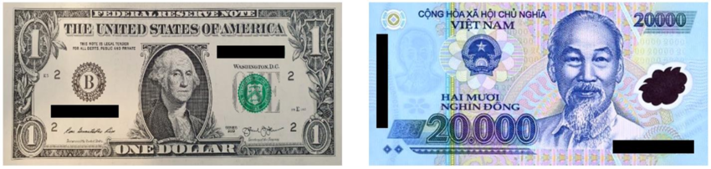
Figure 5: Common Currency in the US and Vietnam
Sorce: (Amaral, Gibson and Morgan, 2022)
Geographic Distance: The home country (US) and host country (Vietnam) share similar climate and weather patterns. For example, the humid tropical climate in South Florida has a strong resemblance to the Southern parts of Vietnam (Thinksmart, 2025). The common climate conditions help the foreign businesses to adapt to the foreign climatic conditions, especially in the tourism and hospitality sector. On the other hand, the airline distance between Vietnam and the United States is approximately 8,574 miles (13,798 kilometres) (Distance Calculator, 2026). Further, the timezone difference between Vietnam and the US might also disrupt the collaboration of the onsite team (Vietnam) and the remote team (US) in hospitality and tourism businesses. For example, Marriott Bonvoy introduced a flexible hybrid working model to address the collaboration challenges caused by time zone differences (Yingling, 2023).
Economic Distance:
Trading Economics reported that the GDP in Vietnam increased by 8.46% in Q4 of 2025 (see Figure 6), despite the additional imposition of 20% tariffs by the Trump Administration (Trading Economics, 2025b). On the other hand, GDP growth in the U.S. was only 1.80% (Trading Economics, 2025a). Thus, the foreign U.S.-headquartered business will have the opportunity to seize the economic opportunity and penetrate the Vietnamese tourism and hospitality market.
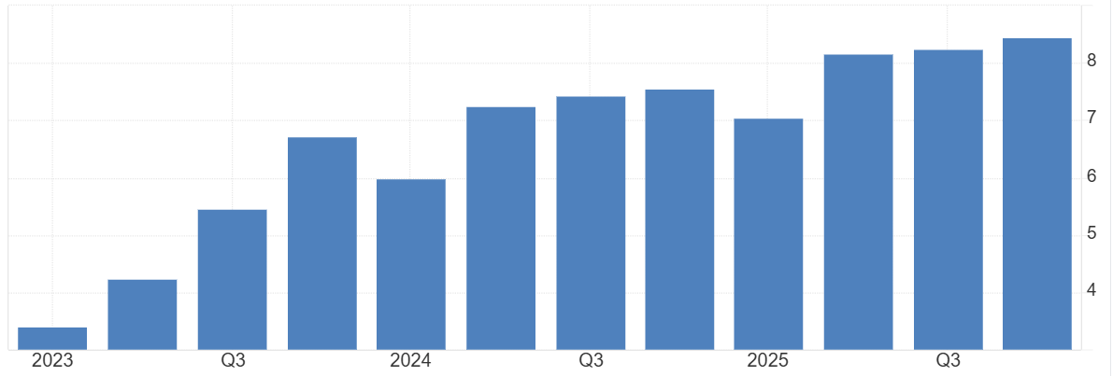
Figure 6: GDP Growth rate in Vietnam (2023-2025)
Source: (Trading Economics, 2025b)

Porter’s five focus on competitiveness analysis
Threat of New Entrants: The threat of New Entrants in the Vietnam hospitality market is low to moderate because the Vietnam Government eliminated numerous non-tariff barriers from the US-Vietnam BTA (“Bilateral Trade Agreements”) (ITA, 2024). For example, the relaxation of quantitative bans, quotas and import permits increased the opportunity for the new entrants to an extent; however, high capital requirements and low brand awareness still acted as barriers. The open-market stance will give equal opportunity to the domestic as well as international hospitality business to set up new entrepreneurial ventures in Vietnam.
Threat of Substitute Products: The threat is moderate because personalisation, R&D infrastructure and technology innovation and creative ecosystem help in fostering a strong product resonance with the customers. On the contrary, the limited differentiation in the hospitality service on the grounds of service quality, brand reputation and guest relations can raise the threat posed by the substitute products.
Bargaining Power of Suppliers: The primary suppliers and supporting industries to the hospitality sector are the food and accommodation industry, hotel amenities manufacturers, and the logistics sector. The higher number of suppliers in comparison to hospitality businesses can minimise the bargaining power of suppliers for the hospitality businesses. Thus, the bargaining power of suppliers for the hotel and hospitality businesses is low to moderate.
Bargaining Power of Buyers:
The bargaining power of buyers for the hospitality and tourism businesses in Vietnam is high because the market is highly competitive (Mordor Intelligence, 2026). The above argument is made from the Mordor Intelligence report on Market Concentration in the Vietnamese Tourism and Hospitality Sector (See Figure 7). The presence of multiple alternatives gives ample choices to the customer to select travel companies and hotels based on their preferences.
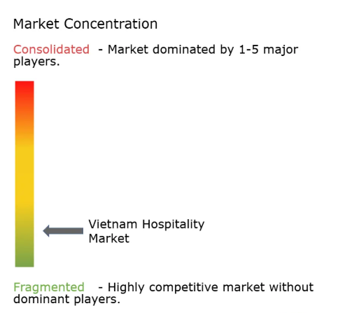
Figure 7: Market Concentration in the Vietnamese Hospitality Market
Source: (Mordor Intelligence, 2026)
Competitive Rivalry:
The presence of reputed international hotels and hospitality businesses in Vietnam, for example, IHG, Marriott, Accor Hotels, Vinpearl and others intensify the market competition (Mordor Intelligence, 2026). The changing customer preferences, pricing pressure and imitating the marketing strategies made the competitive rivalry very high for the new as well as existing businesses in Vietnam.
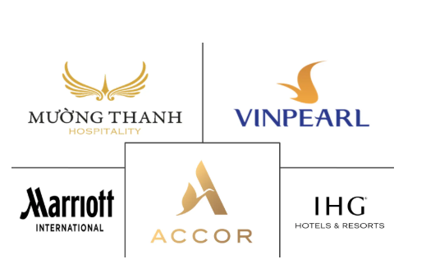
Figure 8: Top Companies operating in the Vietnam Hospitality Market
Source: (Mordor Intelligence, 2026)

BCG Matrix on tourism market profit analysis
BCG matrix is used in this section to examine the market profits and product portfolio in the hospitality and tourism businesses in Vietnam. The BCG Matrix for the Vietnam Tourism Market is demonstrated below:
Cash Cows: According to Mordor Intelligence, the upper mid-scale hotels have the highest market share (48.79% in 2025) in Vietnam (Mordor Intelligence, 2024). However, their market growth is comparatively less than that of luxury hotels. As a result, international hospitality companies initiate regional package tours to capitalise on the local growing hospitality market in Vietnam.
Stars: The market share of the Luxury Hotels in Vietnam increased by 30% in the last three years (Marketresearch.com, 2025). For example, Marriott International provides premium accommodation and travel experience to its travelers through AI personalisation and targeted marketing content.
Question Mark and Dogs: The older hotels with outdated infrastructure are considered as Dogs in the Vietnamese Hospitality Market due to a negligible market growth rate and low market share. On the other hand, e-commerce hospitality businesses with mobile technology have comparatively low market share and high market growth potential; hence, they are considered a question mark in the market.
Porter’s value chain on tourism operations of the MNC in Vietnam
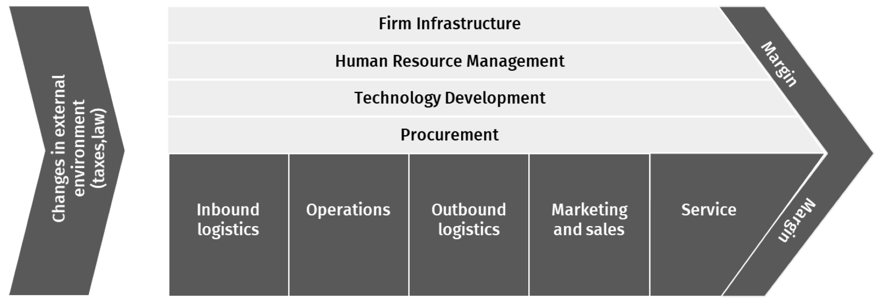
Figure 9: Porter’s value chain analysis
Source: (Kohnová and Salajová, 2023)
The value chain framework of Porter helps to assess the primary and secondary activities of businesses that help them in improving their performance and creating competitive advantages in the market (Kohnová and Salajová, 2023). The value chain analysis of Marriott is illustrated below:
Primary activities:
Inbound Logistics: The inbound logistics of Marriott are based on revolving its sourcing quality information in order to provide exceptional experiences to guests (Pereira, 2025).
Operations: Marriott has focused on maintaining its operations with the help of its more than 9700 properties and over 30 leading brands across 143 countries, giving its customers seamless experiences (Marriott International, 2025).
Outbound Logistics: The outbound logistics of Marriott are focused on property-level service offerings and a centralised and digital reservation system promoting its growth in the market (Jin et al., 2025).
Marketing and Sales: Marriott has adopted e-commerce services and digital-driven sales and marketing practices to boost its performance (Guo, 2025).
Service: Marriott provides world-class facilities and services to its customers to maintain its wonderful legacy in the global market (Marriott Hotels, 2024).
Support Activities:
Firm Infrastructure: The digital-first “built to change” focused infrastructure of Marriott Hotels sustains its business operations in the international market.
Human Resource Management: The collaboration of Marriott with Accenture helped the firm in creating an international HR hub to improve its top-level talent management and acquisition in the global market (Hesse et al., 2026).
Technology Development: Cloud computing, data platforms, AI, IoT, and Smart Rooms are the latest technologies developed by Marriott.
Procurement: The practices of Marriott regarding procurement involve the delivery of efficient and high-quality products and services at competitive prices to its consumers.

5. Conclusion
Based on the above discussion, it can be inferred that the tourism expenditure in the context of both domestic and international tourism in Vietnam is projected to rise in the future. The tourism industry of Vietnam significantly contributed to the economic growth of the nation. Marriott, Vinpearl, Accor, and IHG are major hotel chains in the country. Porter’s Diamond Model showed that resource availability, high investment, and cultural & natural assets are the factor conditions in the market, whereas the demand conditions include strong tourism demand and e-Visa policy. These conditions have increased the number of tourists in the country.

Section 2:

Introducing reflective model: Gibbs reflective cycle
Adeani, Febriani and Syafryadin, (2020), provided a detailed overview of a 6 stage framework utilised for systematically elaborating learning from experience through “Gibbs reflective cycle”. Gibbs serves as a suitable model for showing the pattern of reflective practice. It includes description of the situation, feeling, centres on exploring emotions during the situation, an evaluation of experiences, analysis about the situation, a conclusion, including a summary of learning, along with an action plan for detailing actions for future similar situations.
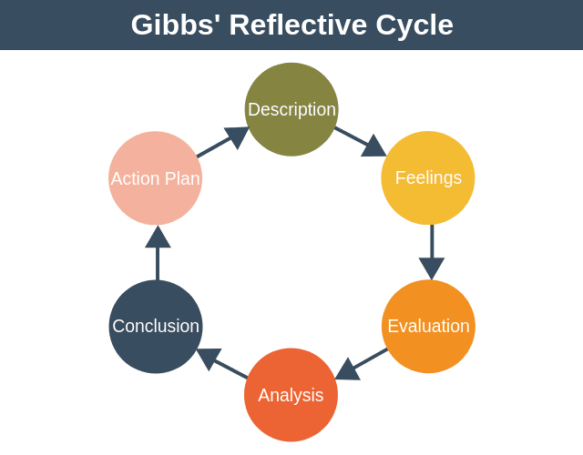
Figure 10: Gibbs reflective cycle
Source: (Denis, 2020)

Gibbs' reflection on reflective process of my researching, analysing and preparing the above section of the assignment

Description:
The above section has explored the tourism industry of Vietnam by employing different strategic frameworks, such as “Michael Porter’s Diamond model”, “PESTLE analysis”, depending on the prominent MNC Marriott International, along with CAGE analysis, “Porter's five forces, BCG matrix and Porter's value chain”. The underlying goal is centred on the assessment of recognising the tourism competition and complex operation of Vietnam within the multinational hospitality industry in the country. Through investigating the industry development factors, market structure and external environment driver this report demonstrated the way Vietnam has become an emerging hotspot in Southeast Asia. The significance of multinational corporations with an emphasis on Marriott International in assisting tourism development over transnational services, the above evaluation presented the technology incorporation and investment in hospitality framework, highlighting the potential of the structural analytical model while examining the industry's competitive nature and Business expansion within the international tourism sector.

Feelings:
While compiling this report, I primarily faced challenges while integrating a broader range of strategic frameworks into a single hospitality industry evaluation (Aladag et al., 2020). I felt interested and slightly saturated regarding the complexity of the topic as the tourism industry in Vietnam is a broader subject, and I was also concerned about organising information coherently. Although I have spontaneously researched the tourism complications and sector of Vietnam and reviewing broader ranges of academic literature, I have moderately created a better understanding of how the approach and frameworks complement each other. I have located the procedure as mainly interesting when evaluating Porter’s diamond model, as it helps in describing the reason behind obtaining robust revenue of Vietnam in the tourism sector. The assessment of the operational factor of Marriott International has improved my knowledge about the approach of a global hospitality organisation to expand into emerging markets. Working depending on the case study Mariott International was also involving part of this report as it has helped me to locate detailed company-oriented information, which results in satisfying with the progress I made in evaluating companies' operations using different strategic frameworks. Upon finishing the report, I felt more confident about my research and analytical skill which helped me to create in depth recognition of the International tourism sector while using a strategic convenient tool.

Evaluation:
Comprehensively, the task has offered precious chances to use theoretical focus with practical industry as the strength lies in the report, which was the unification of different strategic frameworks while evaluating the tourism sector of Vietnam as employing model including Porter’s Diamond Model, PESTLE analysis, and Porter’s Five Forces enable me to investigate industry from different view with focus on competitive and strategic prospect. Another positive side was the utilisation of credible academic and industry reports while assisting evaluation, government reports, tourism statistics and international research publication allow me to improve information relevance, enhancing academic quality through the utilisation of relevant information. I have faced challenges in accessing recent company-oriented operational information of Marriott in Vietnam, as many sources delivered general information but did not provide detailed information on strategies. Moreover, managing word count and structuring report as per the assignment has needed proper planning, which provided a challenge to maintain in depth evaluation with concise writing. In spite of the issue, this assignment was successful in providing a way to implement strategic frameworks for the international tourism industry.

Analysis:
While reflecting on the learning procedure, it became transparent that the employment of a strategic management framework while evaluating a multinational organisation. Porter's diamond model enlightens the factors such as natural resources, factor conditions, demand conditions of international tourists, related and supported industry such as aviation, transportation and digital travel, along with firm strategy of using FDI, infrastructure and government policy of the country's competitive gains. PESTLE evaluation offered insights into the way political stability, economic development, technology growth and environmental regulation impact Vietnam tourism's key attractiveness, which allow in evaluating external environment factors of business while expanding internationally. The CAGE framework delivered information about cultural and economic differences between the US and Vietnam; this knowledge of differences is significant for MNCs as they impact communication and management strategy. Marriott International's exploration presented how the global brand uses resources while expanding demonstrated the significance of flexibility while maintaining Global relation. This assignment has provided a robust understanding of integrating theoretical frameworks in practical business and industry data within strategic models for improving analytical thinking. I could have used SWOT, Ansoff Matrix for recognising relevant resources and strategies enable Marriott to recognise emerging markets.

Conclusion:
Considering all this, previous assignment was a valuable experience which improved my knowledge about the international hospitality sector and business technique under the lens of researching the Vietnam tourism sector and evaluating the operation of Marriott International allowed me to integrate prominent theoretical framework with real-world situation. Using frameworks as “Porter’s Diamond Model, PESTLE analysis, CAGE framework, BCG, Porter value chain and Porter’s Five Forces” offered a systemic plan to evaluate industry determination, which improved my research, critical thinking and academic writing skill and identified weaknesses in time management, problem solving skill and stress management.

Action plan
I have organised to enhance my research on analytical skills through involvement with a wider range of academical journal, industry report and authentic databases to improve my argument for evidence oriented prospect. Another area for improvement is time management, as I realised I spent too much time on certain parts of the task, which can be improved through initiating the research procedure earlier and creating a structured outline at the beginning to organise ideas more efficiently and mitigate pressure within a limited time. I will improve my academic-writing skills through practising critical evaluation and my problem-solving skills through segmenting tasks into steps and managing time effectively to improve stress management (Hanim, Aripin and Lin, 2020). Lastly, I will focus on improving my ability to recognise strategic management frameworks through integrating with different industries, which can improve my analytical potential and help to navigate future academic and professional business oriented context.

References
Accor (2025). Hotel Vietnam: book online at all.accor.com. [online] all.accor.com. Available at: https://all.accor.com/a/en/destination/country/hotels-vietnam-pvn.html.
Adeani, I.S., Febriani, R.B. and Syafryadin, S., 2020. Using GIBBS’reflective cycle in making reflections of literary analysis. Indonesian EFL Journal, 6(2), pp.139-148.https://journal.uniku.ac.id/index.php/IEFLJ/article/download/3382/2034/0
Aladag, O.F., Köseoglu, M.A., King, B. and Mehraliyev, F., 2020. Strategy implementation research in hospitality and tourism: Current status and future potential. International Journal of Hospitality Management, 88, p.102556.https://pmc.ncbi.nlm.nih.gov/articles/PMC7205733/pdf/main.pdf
Amaral, M.A., Gibson, A.P. and Morgan, R.M. (2022). Trace evidence dynamics of cocaine on banknotes: A comparison study of paper and polymer banknotes. Science & Justice, 62(2), pp.221–228. doi:https://doi.org/10.1016/j.scijus.2022.02.008.
ASEAN (2025). NATIONAL ASSEMBLY SOCIALIST REPUBLIC OF VIETNAM Independence -Freedom -Happiness. [online] asean.org. Available at: https://asean.org/wp-content/uploads/2016/08/Doc-9_Vietnam60.pdf.
ASEAN Briefing. (2025). Vietnam Tourism Drives Growth and Investment in 2025. [online] ASEAN Business News. Available at: https://www.aseanbriefing.com/news/tourism-boosts-vietnams-economic-outlook-in-2025/.
Bách, T. (2026). Vietnam welcomes 4.68mln foreign tourists in 2M. [online] VnEconomy. Available at: https://en.vneconomy.vn/vietnam-welcomes-468mln-foreign-tourists-in-2m.htm [Accessed 9 Mar. 2026].
Clark, D. (2026). Vietnam: inflation rate 2030| Statista. [online] Statista. Available at: https://www.statista.com/statistics/444749/inflation-rate-in-vietnam/?srsltid=AfmBOoqiPGPOUVf5KZFvXmdTas_URQTTWBZ-5BQTcGI829b4XpsLRi78.
Constantin, M., Francois, M. and Le, T. (2021). Reimagining tourism: How Vietnam can accelerate travel recovery. [online] McKinsey & Company. Available at: https://www.mckinsey.com/featured-insights/asia-pacific/reimagining-tourism-how-vietnam-can-accelerate-travel-recovery#/.
Denis, G. (2020). Gibbs’ Reflective Cycle. [online] Expert Program Management. Available at: https://expertprogrammanagement.com/2019/05/gibbs-reflective-cycle/.
Distance Calculator. (2026). United States» Vietnam : Distance, Miles and Kilometer. [online] Available at: https://www.entfernungsrechner.net/en/distance/country/us/country/vn
Federal Trade Commission (2024). FTC Takes Action Against Marriott and Starwood Over Multiple Data Breaches. [online] Federal Trade Commission. Available at: https://www.ftc.gov/news-events/news/press-releases/2024/10/ftc-takes-action-against-marriott-starwood-over-multiple-data-breaches.
GIZ (2026). Enhancing solid waste management in tourist cities in Viet Nam. [online] www.giz.de. Available at: https://www.giz.de/en/downloads/giz2023-en-factsheet-ASEAN-municipal-solid-waste-management-enhancement-AMUSE-viet-nam.pdf.
Global Expat Recruiting. (2025). Vietnam’s hotel sector growth surges ahead of regional peers - Global Expat Recruiting. [online] Available at: https://globalexpatrecruiting.com/vietnams-hotel-sector-growth-surges-ahead-of-regional-peers/.
Guo, X. (2025). Case analysis of e-commerce marketing strategy in hotel industry: taking Marriott as an example. Journal of Applied Economics and Policy Studies, 18(5), pp.81–85. doi:https://doi.org/10.54254/2977-5701/2025.24623.
Hana (2024). Language in Vietnam: Essential Guide for Indian Travellers | Vietnamese & Minority Tongues. [online] Vietnam Story. Available at: https://vietnamstory.in/language-in-vietnam/.
Hanim, N., Aripin, N. and Lin, N.M., 2020. Exploring the connection between critical thinking skills and academic writing. International Journal of Asian Social Science, 10(2), pp.118-128.https://www.researchgate.net/profile/Zulaikha-Khairuddin-2/publication/360313535_Exploring_the_Connection_between_Critical_Thinking_Skills_and_Academic_Writing/links/631c96e970cc936cd3f9bbd0/Exploring-the-Connection-between-Critical-Thinking-Skills-and-Academic-Writing.pdf
Hdfcergo (2026). Explore JW Marriott Resort in Vietnam. [online] https://www.hdfcergo.com/. Available at: https://www.hdfcergo.com/travel-insurance/travel-o-guide/vietnam/explore-jw-marriott-resort-in-vietnam [Accessed 27 Apr. 2026].
Hesse, D., Craig, S., Manchanda, N. and Young, B. (2026). Global HR Hub | Marriott Case Study. [online] Accenture.com. Available at: https://www.accenture.com/ma-en/case-studies/travel/marriott-hr-transformation.
Hoang (2020). Muong Thanh continues to fly high. [online] Vietnam Investment Review - VIR. Available at: https://vir.com.vn/muong-thanh-continues-to-fly-high-75173.html [Accessed 27 Apr. 2026].
Hoang, T.P.T. (2023). Tourism policy in Vietnam: an evaluation using the difference-in-differences model. Journal of Policy Research in Tourism, Leisure and Events, 17(3), pp.1–24. doi:https://doi.org/10.1080/19407963.2023.2273558.
Horwathhtl.com. (2022). Asia Pacific Chains & Hotels Report 2018. Available at: https://horwathhtl.com/wp-content/uploads/2024/09/2018_ASIA-PACIFIC_CHAINS-REPORT-1.pdf [Accessed 9 Mar. 2026].
Hue, N.T. and Mai, T. (2025). Digital Transformation in Tourism and Hospitality Management in Vietnam: Opportunities, Challenges, and Solutions. International Journal of Scientific Research and Management (IJSRM), 13(08), pp.9538–9545. doi:https://doi.org/10.18535/ijsrm/v13i08.em05.
IATA. (2025). Chart of the Week Growth in Vietnam’s Air Passenger Market. Available at: https://www.iata.org/en/iata-repository/publications/economic-reports/growth-in-vietnams-air-passenger-market/.
Initiation Report. (2024). Available at: https://www.vndirect.com.vn/cmsupload/beta/VIC_-Initiation_20240816.pdf [Accessed 9 Mar. 2026].
International Trade Administration (2024). Vietnam - Market Overview. [online] www.trade.gov. Available at: https://www.trade.gov/knowledge-product/exporting-vietnam-market-overview.
ITA (2024). Vietnam - Trade Barriers. [online] www.trade.gov. Available at: https://www.trade.gov/country-commercial-guides/vietnam-trade-barriers.
Jin, Y., Yin, L., Wu, X. and Mei, L. (2025). Analyze the relationship between the corporation’s management systems and operation capacity: A case study of Marriott Hotel and H World Hotel. International Theory and Practice in Humanities and Social Sciences, 2(4), pp.137–165. doi:https://doi.org/10.70693/itphss.v2i4.313.
Kohls, R. (2026). VALUES IN AMERICAN CULTURE. [online] Available at: https://www.bu.edu/isso/files/pdf/AmericanValues.pdf.
Kohnová, L. and Salajová, N. (2023). Impact of industry 4.0 on companies: Value chain model analysis. Administrative Sciences, 13(2), p.35. doi:https://doi.org/10.3390/admsci13020035.
KPMG (2025). GMS Flash Alert Immigration Vietnam -Facilitating Entry for Citizens of Certain Countries. [online] assets.kpmg.com. Available at: https://assets.kpmg.com/content/dam/kpmgsites/xx/pdf/2025/04/fa25-081.pdf.coredownload.pdf.
Le, T. (2025). Vietnam’s tourism boom calls for quality human resources. [online] www.rmit.edu.vn. Available at: https://www.rmit.edu.vn/news/all-news/2019/jan/vietnams-tourism-boom-calls-for-quality-human-resources.
Macrotrends (2024). Vietnam Literacy Rate 1979-2024. [online] www.macrotrends.net. Available at: https://www.macrotrends.net/global-metrics/countries/VNM/vietnam/literacy-rate.
Macrotrends (2025). Vietnam GDP 1985-2024. [online] www.macrotrends.net. Available at: https://www.macrotrends.net/global-metrics/countries/VNM/vietnam/gdp-gross-domestic-product.
Makeyourasia.com. (2025). 26 UNESCO World Heritage Sites in Southeast Asia. [online] Makeyourasia.com. Available at: https://makeyourasia.com/blog/unesco-world-heritage-sites-in-southeast-asia.html [Accessed 9 Mar. 2026].
Marketresearch.com. (2025). Vietnam Luxury Hotels & Resorts Market. [online] Available at: https://www.marketresearch.com/Ken-Research-v3771/Vietnam-Luxury-Hotels-Resorts-42957298/.
Marriott Bonvoy (2024). How Hospitality Translation Services Transformed Marriott Bonvoy. [online] Language Connections. Available at: https://www.languageconnections.com/blog/how-hospitality-translation-services-transformed-marriott-bonvoy/.
Marriott Hotels (2024). Experience | Services & Facilities. [online] Marriott Hotels. Available at: https://marriott-hotels.marriott.com/experience/.
Marriott International (2025). 2023 SERVE 360 REPORT: ENVIRONMENTAL, SOCIAL, AND GOVERNANCE PROGRESS. [online] Marriott International. Available at: https://serve360.marriott.com/wp-content/uploads/2023/06/Marriott-2023-Serve-360-ESG-Report-accessible.pdf.
Marriott International (2025). About Marriott International | Corporate Information. [online] marriott. Available at: https://www.marriott.com/marriott/aboutmarriott.mi.
Marriott International. (2026). About Marriott International | Corporate Information. [online] marriott. Available at: https://www.marriott.com/marriott/aboutmarriott.mi.
Marriott. (2026). Marriott International Signs Multi-Property Agreement with Masterise Group, Accelerating Expansion in Vietnam. [online] Marriott.com. Available at: https://news.marriott.com/news/2026/02/03/marriott-international-signs-multi-property-agreement-with-masterise-group-accelerating-expansion-in-vietnam [Accessed 9 Mar. 2026].
Minh and Anh, C.N. (2024). Specific cultural values affect basic political activities in Vietnam. Cogent Social Sciences, 10(1). doi:https://doi.org/10.1080/23311886.2024.2404622.
Mordor Intelligence (2024). Hospitality Industry in Vietnam - Growth, Trends and Forecast (2020 - 2025). [online] Mordor Intelligence. Available at: https://www.mordorintelligence.com/industry-reports/hospitality-industry-in-vietnam.
Mordor Intelligence (2026). Hospitality Industry in Vietnam Companies - Top Company List. [online] www.mordorintelligence.com. Available at: https://www.mordorintelligence.com/industry-reports/hospitality-industry-in-vietnam/companies.
Ngo, T.M., Le, T.H.T. and Tran, Y.T.B. (2022). Innovation and firm performance: Is R&D worth it? An empirical case of Vietnam enterprises. Science & Technology Development Journal - Economics - Law and Management, 6(1), pp.2039–2050. doi:https://doi.org/10.32508/stdjelm.v6i1.790.
Nguyen, M.-N. (2025). Deposit interest rate Vietnam| Statista. [online] Statista. Available at: https://www.statista.com/statistics/738672/vietnam-deposit-interest-rates/?srsltid=AfmBOop_FB2ePgu6Yeczd0fX4edeIvlLLtTa_g8uoKVNjNPX1zEk9LZq.
O’Neill, A. (2025). Total population Vietnam| Statista. [online] Statista. Available at: https://www.statista.com/statistics/444597/total-population-of-vietnam/?srsltid=AfmBOooi8lyVX-g6iddvdScBWWuygU1yjEZOgOTVc_eIi9WwmZe6PQ2k.
Pereira, D. (2025). Marriott Value Chain Analysis. [online] Business Model Analyst. Available at: https://businessmodelanalyst.com/marriott-value-chain-analysis/?srsltid=AfmBOorD4tOg4m85jbaWd0EJRIEXdwnRSQj1MG1Th1yuuT0Wfbeu88La.
Sering, T. and Sering, T. (2026). Vietnam’s tourism boom shows no sign of slowing. [online] Travelweekly-asia.com. Available at: https://www.travelweekly-asia.com/Destination-Travel/Vietnam-s-tourism-boom-shows-no-sign-of-slowing [Accessed 9 Mar. 2026].
Shepherd, A. (2026). Vietnamese ‘megacity’ project signs new hotel partnership. [online] Cit-world.com. Available at: https://www.cit-world.com/vietnamese-megacity-project-signs-new-hotel-partnership/article/1955873 [Accessed 27 Apr. 2026].
The Global Economy (2025). Vietnam Political stability - data, chart | TheGlobalEconomy.com. [online] TheGlobalEconomy.com. Available at: https://www.theglobaleconomy.com/Vietnam/wb_political_stability/. .
The White House (2025). Designating English as the Official Language of The United States. [online] The White House. Available at: https://www.whitehouse.gov/presidential-actions/2025/03/designating-english-as-the-official-language-of-the-united-states/.
Theinvestor.vn. (2026). Sun Group, Marriott International elevate strategic partnership with 10 planned hotels, resorts. [online] Available at: https://theinvestor.vn/sun-group-marriott-international-elevate-strategic-partnership-with-10-planned-hotels-resorts-d18678.html [Accessed 27 Apr. 2026].
Thinksmart. (2025). 5 U.S. states with the most similar climate to Vietnam. [online] Available at: https://thinksmartinsurance.com/en/states-with-the-most-similar-climate-to-vietnam.html
Trading Economics (2025a). United States GDP Growth Rate. [online] Tradingeconomics.com. Available at: https://tradingeconomics.com/united-states/gdp-growth.
Trading Economics (2025b). Vietnam GDP Annual Growth Rate. [online] Trading Economics. Available at: https://tradingeconomics.com/vietnam/gdp-growth-annual.
TransIndus. (2026). Before you go to Vietnam: Essential Travel Guide. [online] Available at: https://transindus.co.uk/blog/travel-to-vietnam
Translators without Borders. (2022). Language data for the United States of America - Translators without Borders. [online] Available at: https://translatorswithoutborders.org/language-data-for-the-united-states-of-america/.
Tufft, C., Constantin, M., Pacca, M. and Mann, R. (2024). Six trends shaping new business models in tourism and hospitality. [online] McKinsey & Company. Available at: https://www.mckinsey.com/industries/travel/our-insights/six-trends-shaping-new-business-models-in-tourism-and-hospitality.
Van, T. (2026). Marriott signs major deal to expand luxury hotel footprint in Vietnam. [online] Vietnam Investment Review - VIR. Available at: https://vir.com.vn/marriott-signs-major-deal-to-expand-luxury-hotel-footprint-in-vietnam-146184.html.
Vietnam News. (2024). Tourism sector thriving in 2024. [online] vietnamnews.vn. Available at: https://vietnamnews.vn/life-style/1690000/tourism-sector-thriving-in-2024.html.
Vietnam Tourism (2026). Visa exemption in the Tourism Development Stimulus Program Vietnam - Timeless Journey, Endless Love. [online] 2025.vietnam.travel. Available at: https://2025.vietnam.travel/en/home/.
Vietnamtourism.gov.vn. (2026). Vietnam’s tourism sets a new record, ranking among the world’s fastest-growing. [online] Available at: https://vietnamtourism.gov.vn/en/post/21493.
Vietnamtourism.gov.vn. (2026a). JW Marriott Phu Quoc named best resort in Southeast Asia. [online] Available at: https://vietnamtourism.gov.vn/en/post/14052 [Accessed 27 Apr. 2026].
Vietnamtourism.gov.vn. (2026b). Vietnam Airlines and Vinpearl signed a cooperation agreement to develop aviation products - safe tourism. [online] Available at: https://vietnamtourism.gov.vn/en/post/16603 [Accessed 27 Apr. 2026].
Vinpearl. (2022). Vinpearl announces strategic cooperation with Marriott International, Inc. [online] vinpearl.com. Available at: https://vinpearl.com/en/vinpearl-announces-strategic-cooperation-with-marriott-international-inc.
Vov.gov.vn. (2024). Tourism sector thriving in 2024. [online] Available at: https://vov.gov.vn/tourism-sector-thriving-in-2024-dtnew-1053547?
Winrock (2020). Law on Environmental Protection (2020). [online] winrock.org. Available at: https://winrock.org/wp-content/uploads/2023/02/LuatBVMT-Eng_20230203.pdf.
Yingling, J. (2023). What It’s Really Like to Work Hybrid at Marriott. [online] Life at Marriott Blog. Available at: https://life.marriott.com/blog/christie-shared-services/.

