Student Name: Gheorghe Plescan  Student ID: 2234901  Module Title: Foreign Languages and Cultural Awareness  Module Code: BMIH5003  Lecturer: Lisa-Marie Bassler  Date: 09.02.2024 | 
ASSIGNMENT 1:
Component 4: Presentation

Component 4: Training Presentation (6 Slides)

Weighting: 25%
Slide: Introduction
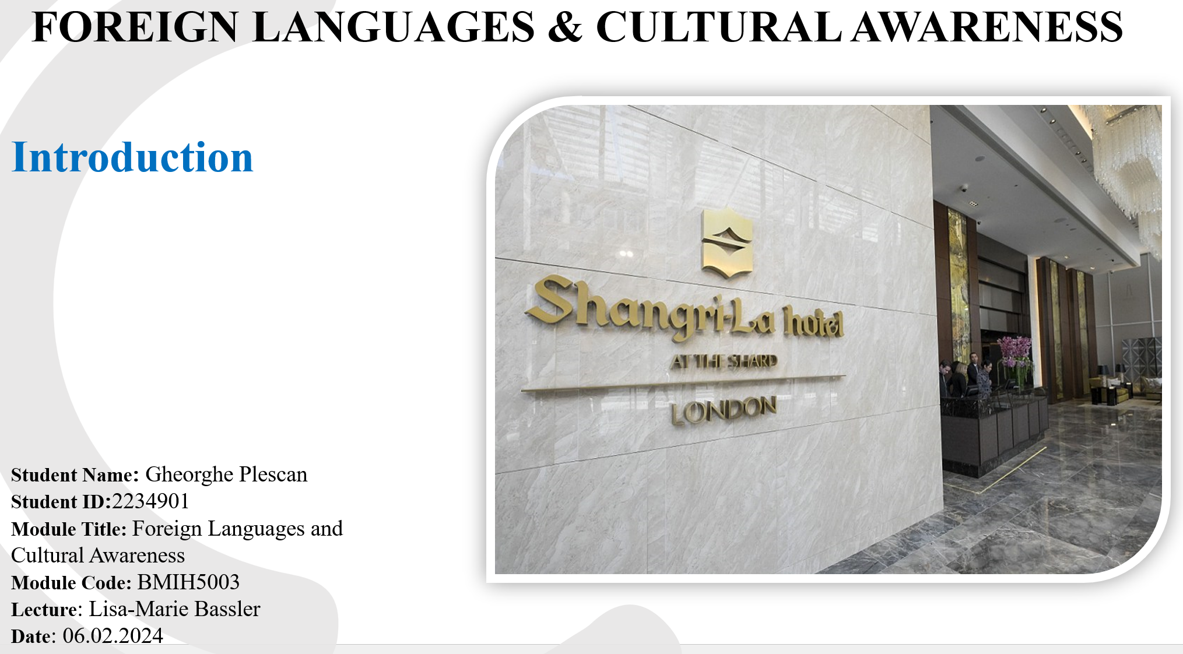
Good morning, everyone. My name is Gheorghe Plescan, and today, I will guide you through why mastering English is vital in the hospitality sector. Let me begin with a story from my time at Shangri-La Hotel in London. I once helped a guest navigate a dietary need that could have been misunderstood due to the language barrier. This incident highlighted the importance of English for communication and as a crucial tool for ensuring guests' needs are met and enhancing their experience. Our discussion will focus on the importance of English for those of us in hospitality, especially coming from non-English speaking countries, and how it can improve guest satisfaction and our career journey.
Slide: English in Hospitality
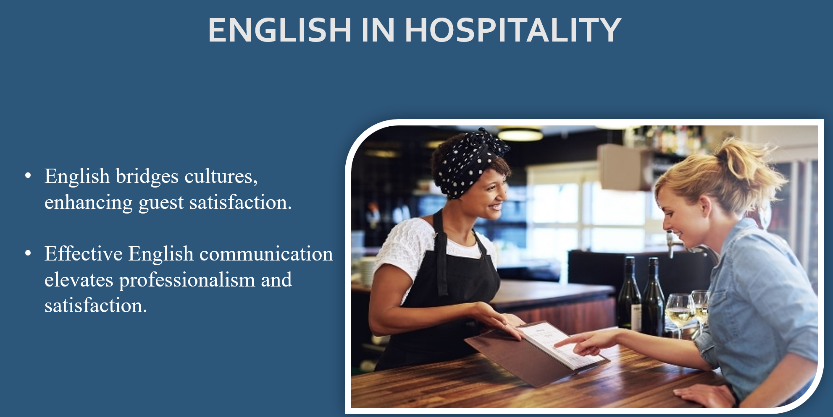
In the hospitality sector, English is the key language connecting guests from different cultures. Wierzbicka’s (1997) research, involving a survey of over 500 international hotel guests, uncovered that effective communication in English is highly valued, linking it with increased guest satisfaction and perceived professionalism. This research shows a clear link between the ability to communicate in English and positive guest experiences and highlights the essential role English plays in the global hospitality environment, serving as a critical tool for fostering guest satisfaction. Now, let's explore this further.

Slide: Learning English: Hard but Worth It

Mastering English can be challenging due to its complex sounds and diverse expressions, but it's incredibly rewarding. Hill and Miller (2013) ) highlights that the effort to learn English is valuable despite these obstacles. It enhances our career prospects in the competitive hospitality industry and significantly improves guest experiences. By learning English, we can communicate more effectively with guests worldwide, understand their needs better, and provide them with memorable service, thereby enriching their stay and our professional growth.

Slide: Enhancing English Skills with Practical Tools
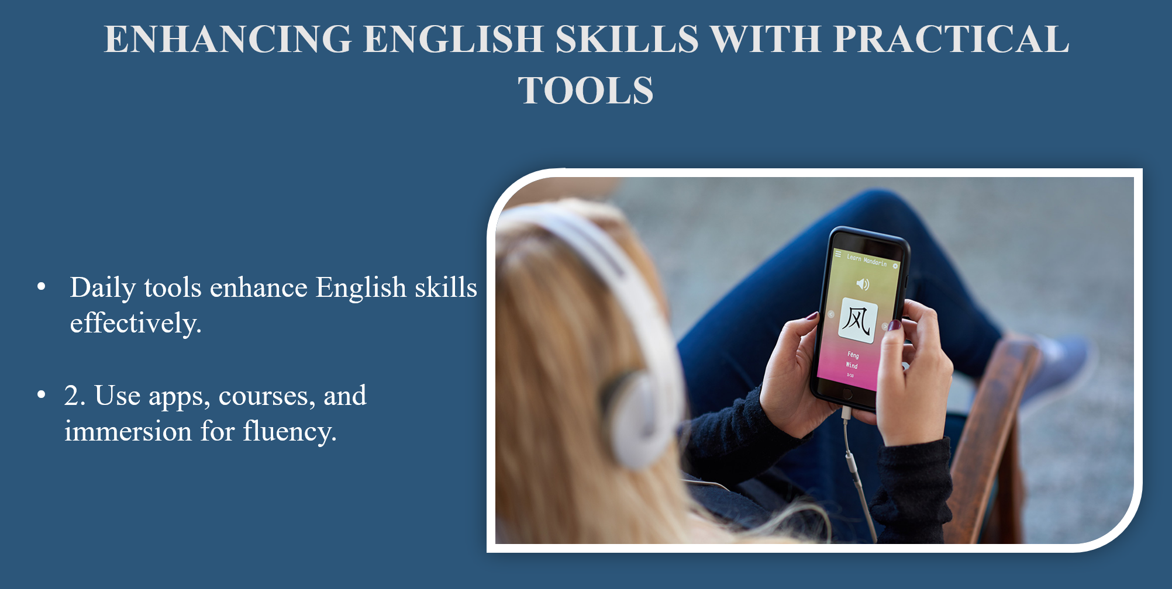Integrating practical tools into our daily routines has greatly improved our English. Utilizing language learning apps like Duolingo or Babbel, which Powers (2019) recommends for their ease of use and effectiveness, can significantly aid our learning process. Lee also suggests enrolling in English courses specifically designed for hospitality workers, as they focus on relevant vocabulary and scenarios. Moreover, immersing ourselves in English by engaging with media and practising in real-life situations can boost our confidence and fluency.

Slide: Success Story at Shangri-La Hotel
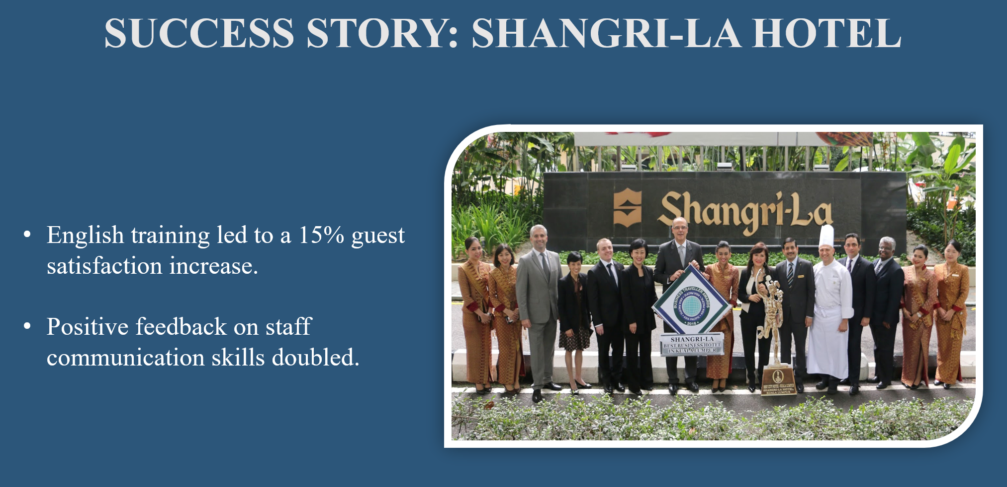
Now, let's turn our attention to a real success story. We saw a significant positive impact after introducing an English training program at Shangri-La, The Shard. Our guest satisfaction scores increased by 15% within six months, and positive feedback about staff communication skills doubled. This reflects broader findings in the hospitality industry about the benefits of language training, similar to those discussed in academic studies. For example, research in the field, such as by Hennig-Thurau (2000), has shown that language proficiency is closely linked to improved guest satisfaction and staff confidence across various settings. Our experience at Shangri-La, The Shard, serves as a concrete example of these broader benefits, demonstrating the effectiveness of focused language education.

Slide: Conclusion
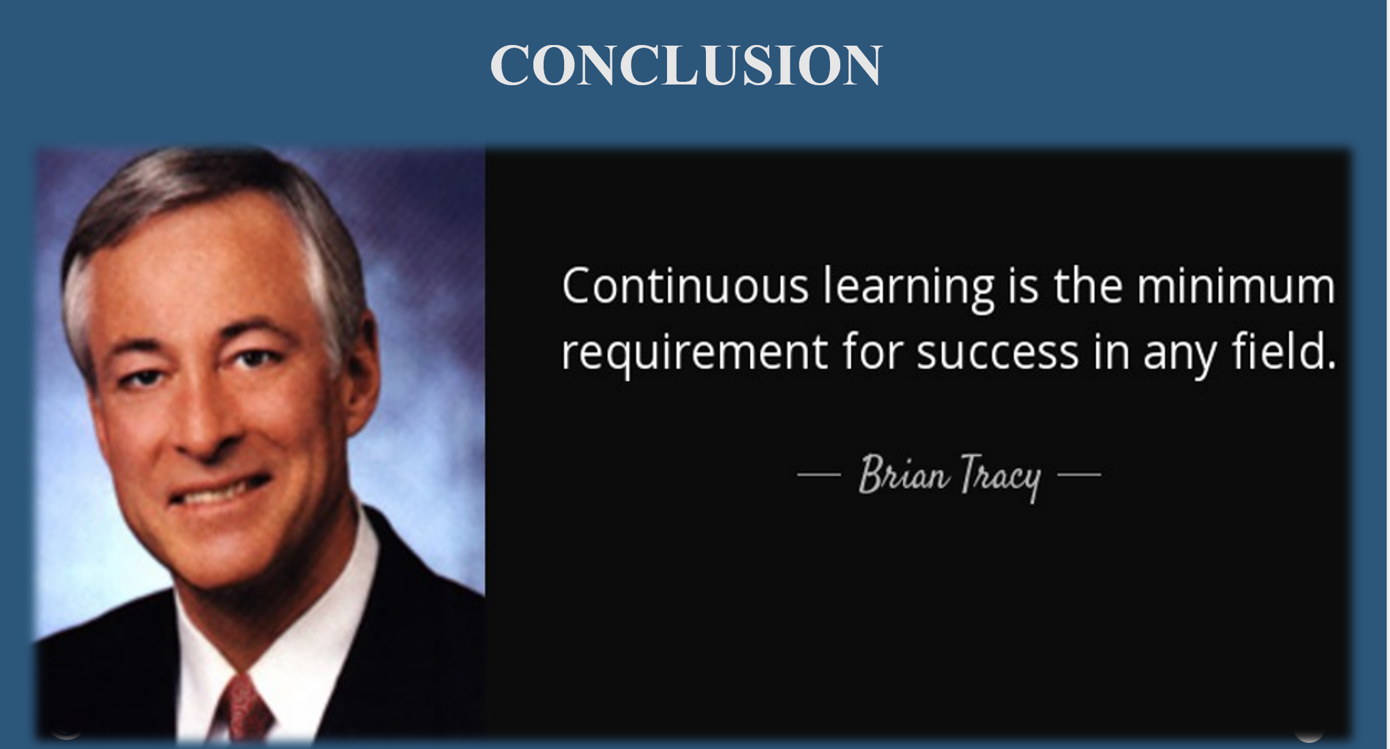
In conclusion, it's clear that mastering English is crucial for excellence in hospitality. Let's not stop here. I encourage you to set personal goals for improving your English and take advantage of any language training sessions. Committing to this journey will elevate our service quality and enrich our professional and personal lives. Let's aim high and make continuous learning a part of our daily routine, ensuring we provide the best.
Thank you!

References:
Hennig-Thurau, T. (2000) Relationship marketing: Gaining competitive advantage through customer satisfaction and customer retention. London, UK: Springer Science & Business Media.
Hill, J.D. and Miller, K.B. (2013) Classroom instruction that works with English language learners. Virginia, USA: ASCD.
Powers, C. (2019) The use of apps in foreign language education: A survey-driven study. North Texas Journal of Undergraduate Research, 1(1). Available at: https://doi.org/10.12794/journals.ntjur.v1i1.78.
Wierzbicka, A. (1997) Understanding cultures through their key words: English, Russian, Polish, German, and Japanese (Vol. 8). Oxford University Press operates in the city of Oxford, UK: Oxford University Press.

