Jenson Davies
2316793
Network operating systems & services
Coursework 1

Contents
Task 1 2
Research on Hypervisor 2
Research on IP Addressing 2
Research on Routing 3
Research on Network Services 3
Task 2 4
2.1 Choice of Hypervisor 4
2.2 Download and Setup 4
2.3 IP Configuration 4
2.4 Testing 4
Task 3 5
Technical Reflection 5
References: 6

Task 1

Research on Hypervisor
A hypervisor is a software that enables multiple virtual machines to be run on a single host machine [1]. There are two distinct types of hypervisors, type 1 hypervisors and type 2 hypervisors, each with differing architectures and performance. The type 1 hypervisor runs directly on the host machine’s physical hardware and is usually referred to as a bare-metal hypervisor. This type of hypervisor is considered to be more secure, as there is a reduced risk of instability [1]. Whereas the type 2 hypervisor is a program that is installed on a host machine’s operating system and is usually referred to as a hosted hypervisor. This means the hypervisor does not have complete control over the computer [1].
For the SWANSEA.ACCA domain topology, a type 1 hypervisor would be more suitable for hosting Windows Server 2022 and Debain Server. This is due to the fact that it has direct access to the host machine’s hardware, the performance of the hypervisor will be improved, as well as isolating the virtual machines from each other [1]. This allows means the management of multiple virtual machines will be more efficient, as the isolation prevents unnecessary strain on the host’s hardware, even if there are limited hardware resources. In addition to this, type 1 hypervisors are more scalable, which means additional virtual machines can be implemented without affecting the overall system stability within the domain environment significantly.

Research on IP Addressing
The internet is an interconnected network of computer users on a global scale. It is considered the largest international system, in which users on any device or network can exchange data with other networks that are connected to the internet [2]. For data to be transmitted across networks, it is converted into small pieces called data packets. A data packet is made up of several components: a header, which contains the routing information such as the IP addresses for the source and destination; a payload, which contains the data to be transmitted and a footer, which contains the error checking methods, for example, checksums [3]. Within a network routers will select paths for data packets, with the assistance of IP addresses. Whereas, switches connect devices within local networks, using MAC addresses [5].
An IP address is a unique numerical value that is assigned to each device connected to a network that uses Internet Protocol for communication. IP addresses are essential because they allow devices to find and communicate with each other within a network, enabling the transfer of data [4]. IPv4 address are 32-bit addresses that are written in a dotted format; this type of IP address is widely used but has a limited number of available addresses. However, IPv6 addresses are 128-bit addresses, that are written as eight groups of hexadecimal number separated by colons, allowing for a larger address space [4]. Additionally, subnetting is the process of dividing a larger network into multiple smaller networks, this helps to improve the utilization of IP addresses as address ranges can be allocated more accurately [5].

Research on Routing
Routing is the process of selecting the best paths for data packets to travel across, within an interconnected network [6]. It does this through the use of routing tables, that store information on the networks established paths, that is then used to locate the most efficient paths that the packet can take. Routing helps to minimise failures within a network by managing data traffic, in a way that optimises network capacity usage, without creating congestion [6].
There are two main types of routing, which are based on how routing tables are generated. Static routing requires a network administrator to manually configure and select routes; this is useful for networks where the design or parameters remain constant [6]. On the contrary, with dynamic routing, routing tables are created and updated based on network conditions, where a dynamic routing protocol is used to locate the fastest path from the source to the destination [6]. This allows it to adapt to changing conditions, such as traffic volume, bandwidth and failures within the network.
Within the SWANSEA.ACCA topology, since the Debian Server is a DHCP Relay that forwards requests from a subnet to another within Windows Server, static routing would be the best option. This is due to the fact that the topology is smaller and would remain consistent, meaning the static routing would be able to form fixed paths between subnets, forming a reliable communication stream.

Research on Network Services
A Virtual Private Network (VPN) establishes a secure connection between a user’s device and a remote network owned by a VPN provider. It creates an encrypted tunnel that protects your personal data, masks IP addresses and allowing secure communication across networks [8].According to the UK’s National Cyber Security Centre (NCSC), some of the best practices for VPNs include, using certificate authentication, avoid split tunnelling to minimise the risk of data being exposed outside of the VPN and regularly updating VPN to adhere to new security patches [7].
A Dynamic Host Configuration Protocol (DHCP) is used to automatically assign IP addresses to each host on a network [9]. It is also known to assign Domain Name System (DNS) addresses, subnets mask and default gateways, reducing the amount of manual configuration needed within a network [9]. Some best practices for using DHCP include, avoid putting DHCP on a domain controller to avoid overwhelming it, incorporating a DHCP failover and avoid using static IP addresses when possible.
Active Directory Domain Services (AD DS) is a hierarchical directory service that stores information about objects on a network, including user accounts and network devices, as well providing authentication and authorisation for Windows domains. AD DS gives authorised users on a network a centralised location to access and use this information, allowing administrators to manage users and resources more efficiently [10].
Certificate Authorities (CAs) are trusted third-party entities that issue certificates that verify and enable encrypted communications when you open a network connection [11]. A certificate is a small file that contains a key, which is used to confirm the identity of the people or services communicating over the network [11].

Task 2

2.1 Choice of Hypervisor
For the implementation of the SWANSEA.ACCA network, VMware Workstation was selected as the network’s hypervisor. VMware Workstation is defined as a type 2 hypervisor; this means that it runs as an application on a standard operating system rather than directly on a device’s hardware [12]. This allows multiple virtual machines (VMs) to be created and managed simultaneously within their own isolated environments [12]. This is essential for the SWANSEA.ACCA network, due to the fact that both Windows Server and Debian systems are required to operate concurrently.
In addition to this, VMware Workstation encapsulates the state of each VM, supporting snapshotting functionality [12]. Snapshotting allows the current state of the VM to be saved and quickly restored when required; this will subsequently help to facilitate safe testing and analysis of network clients [12], as well as fast recoveries from errors within the network. Furthermore, VMware Workstation offers an appropriate level of scalability for the SWANSEA.ACCA network, as it adheres to smaller scale environments, where multiple VMs can be supported with efficient resource allocation [13]. This also means that for future expansion of the topology in Coursework, expansion can effectively occur, where the needed resources can be allocated and managed.

2.2 Download and Setup

2.2.1 Software Installation
To maintain system integrity and security, all software components were sourced from official and authenticated vendor repositories. The VMware installation was directly acquired from the official VMware website, so that the network would be built using an authenticated and reliable hypervisor.
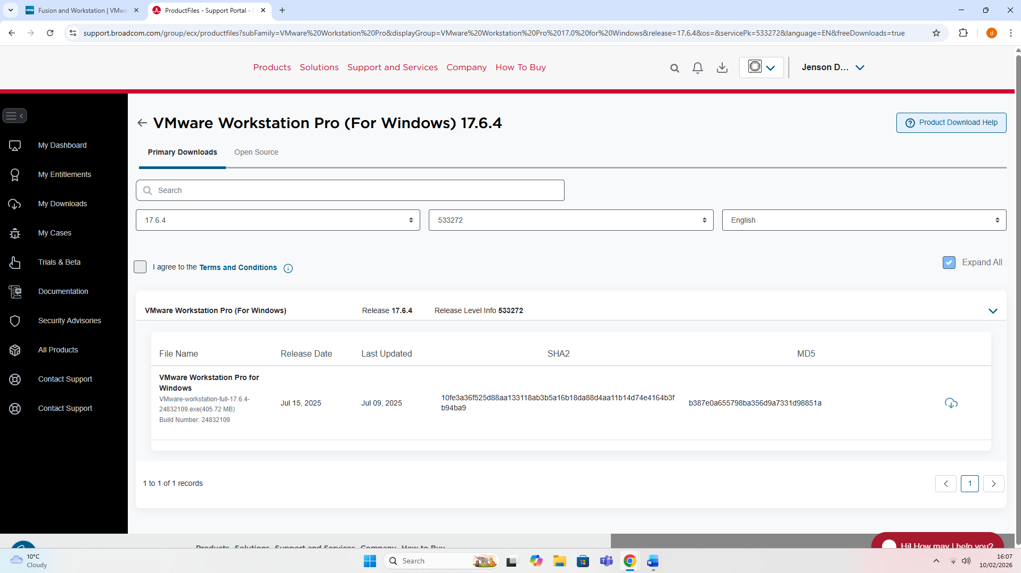
Additionally, the Windows Server 2022 ISO was installed from the Microsoft’s Evaluation Centre, in order to ensure that the windows version is compliant with the requirements for the topology. Moreover, the Debian ISO was also downloaded from the Debian official website, which is a reliable and validated Linux distribution.
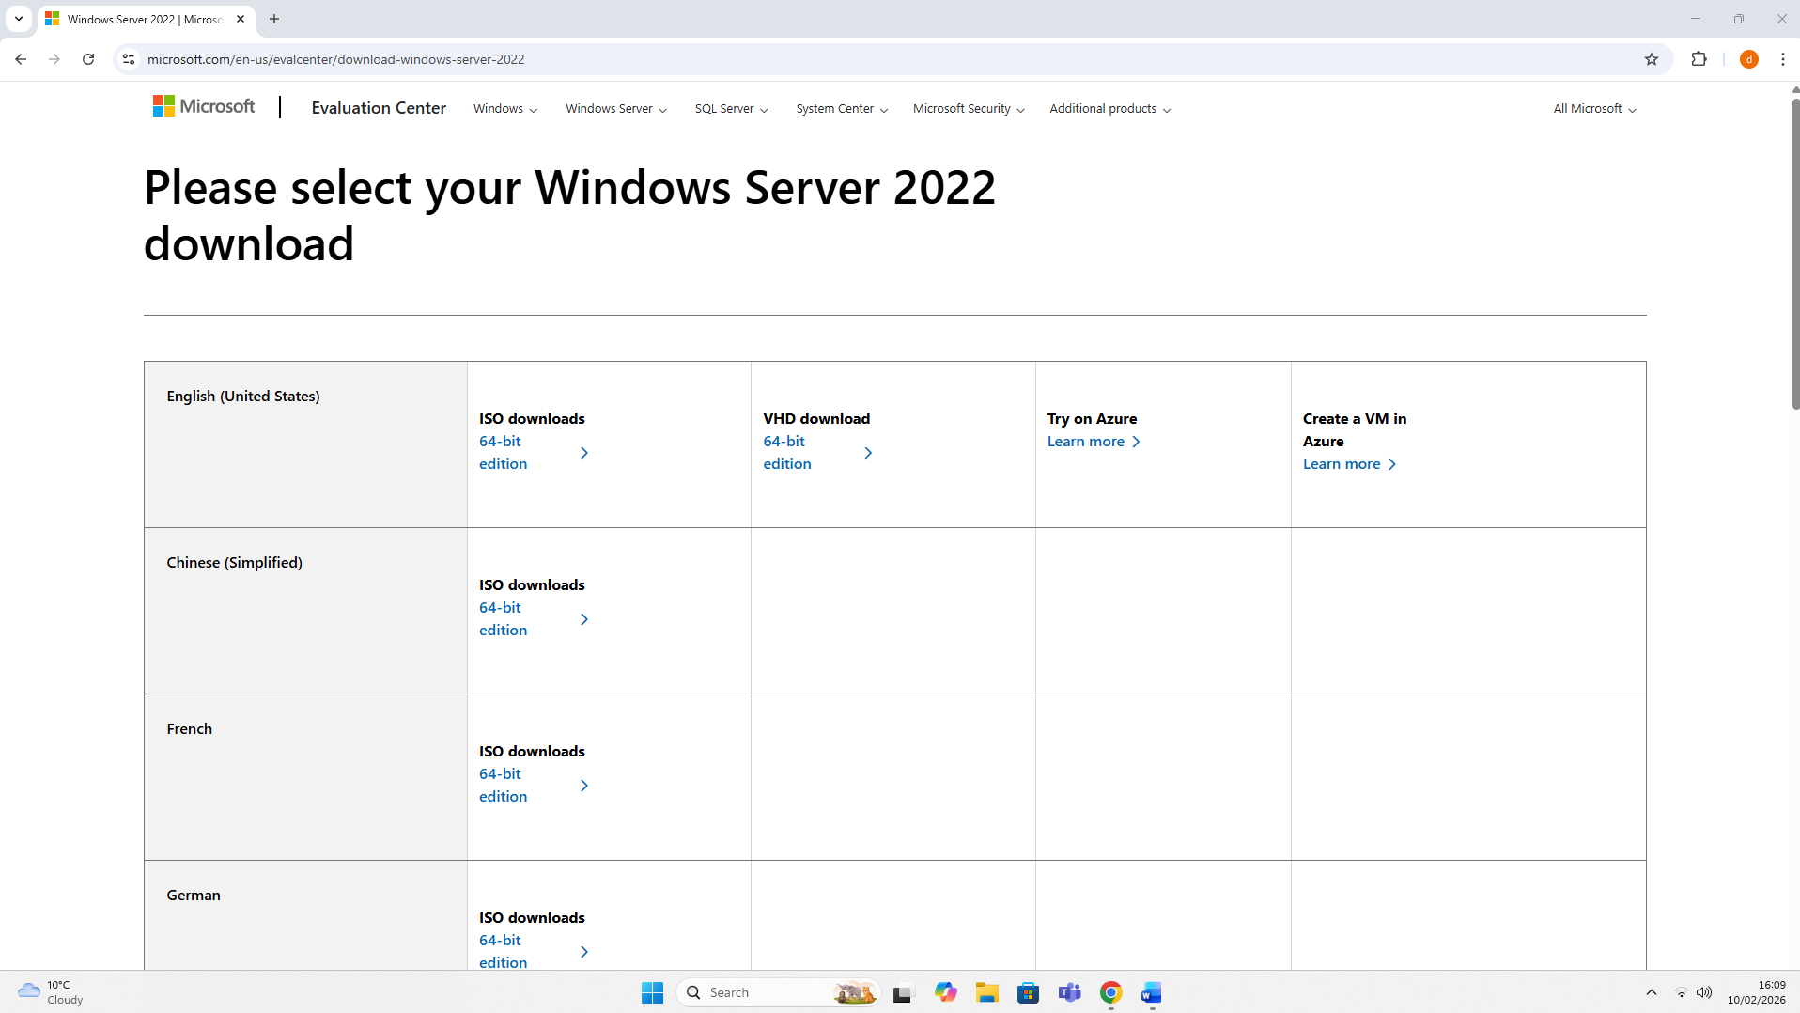
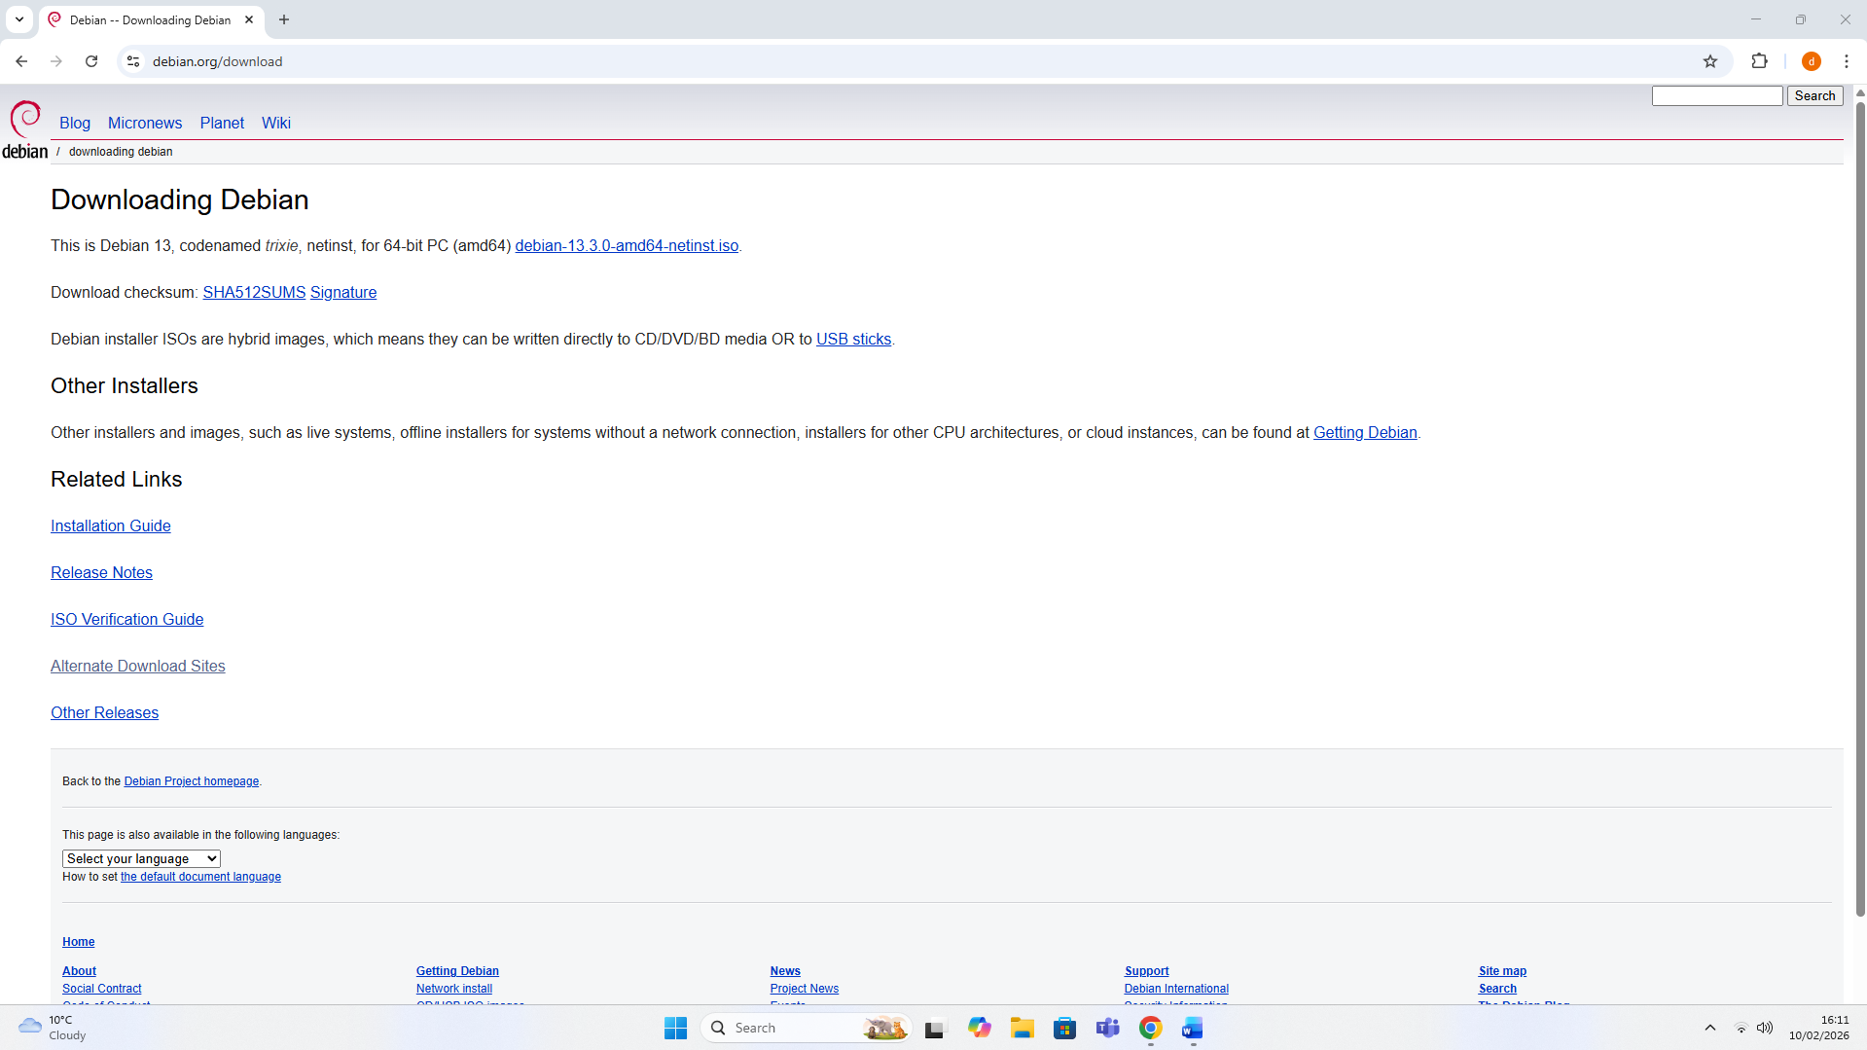
Furthermore, since all software has been downloaded directly from reliable sources, the risk of malware infiltration, out of date software versions and incorrectly configured downloads is significantly reduced.

2.2.2 Deployment of the Topology
In accordance with the proposed SWANSEA.ACCA topology, three virtual machines were created within VMware Workstation. These virtual machines consisted of one Debian Client Server VM, one Windows Server 2022 VM and one Windows Client Server VM. Both client VMs were allocated 4GB of RAM and 40GB of virtual hard disk space. This is due to the fact that it was deemed appropriate for the required resources within the VMs, such as, client to server IP address pings.
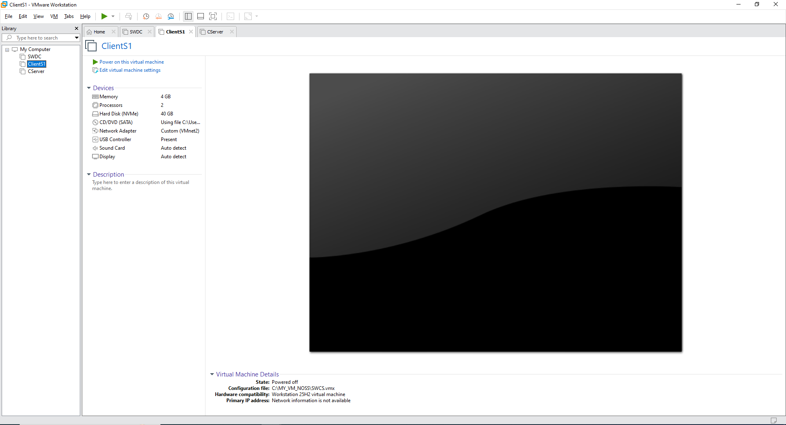
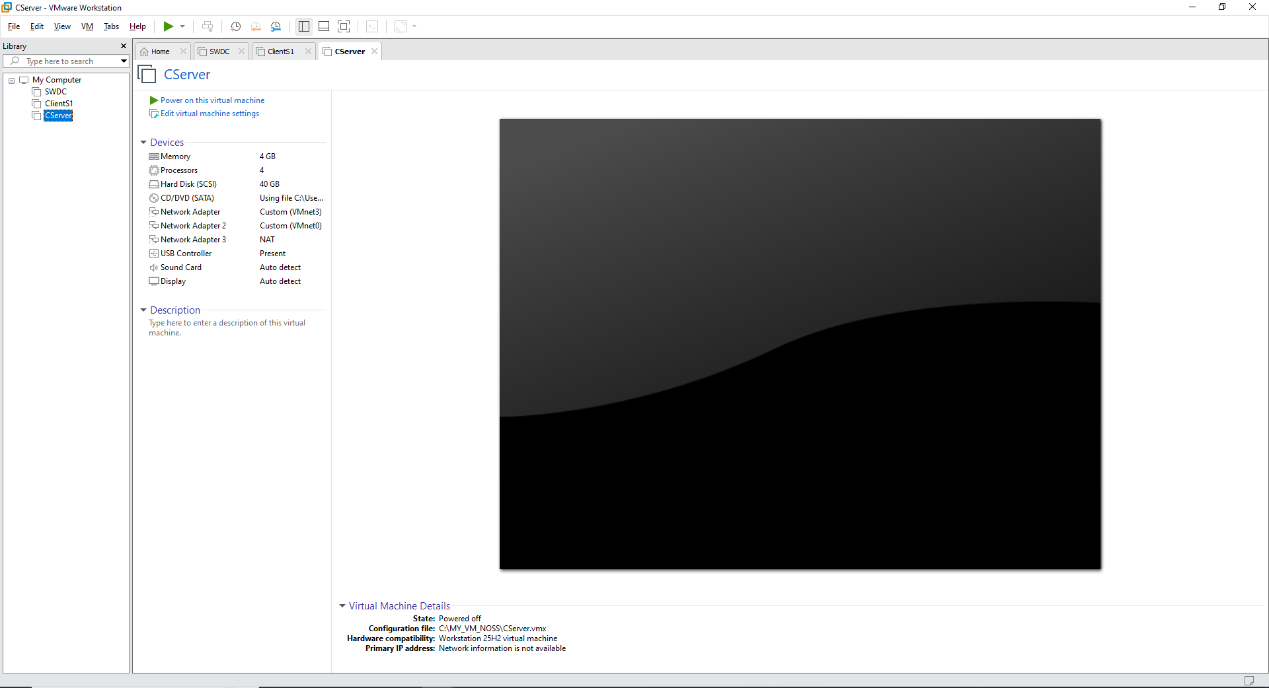
Here are the VMs for the Windows Server Client and the Debian Client, where both devices allocated resources can be found.

On the contrary, the Windows Server virtual machine was allocated 8GB of RAM and 80GB of virtual hard disk space. The change in allocated space is as a result of the increased demand in resources for the VM, to host the topology’s S-DC, Domain controller, DHCP server and much more, in an efficient manner.
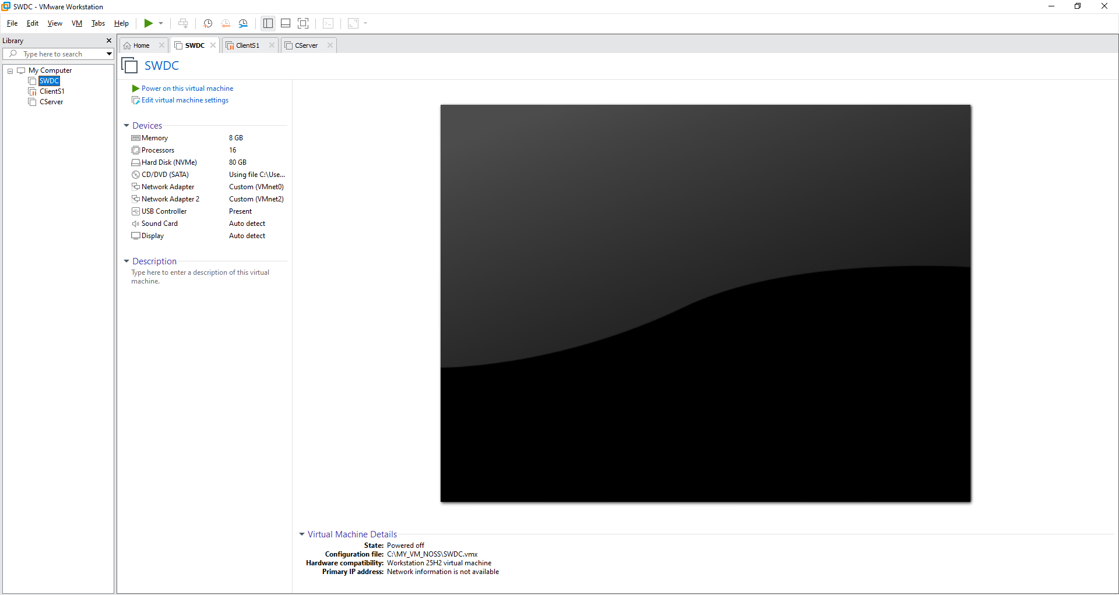

2.3 IP Configuration
In order to ensure communication within the internal subnet was correct, the virtual machines within the SWANSEA.ACCA network required manual IPv4 configuration.
Within the ClientS1 virtual machine, the IP address was configured to 192.168.1.10 with a subnet mask of 255.255.255.0. Furthermore, the default gateway was configured to 192.168.1.1, to allow the client to forward traffic beyond the local subnet and to the Windows Server. Additionally, in order to ensure the DNS server address was properly routed to the Windows Server that contain the DNS and Active Directory services, the preferred DNS server was also configured to 192.168.1.1. This ensured that the SWDC (Windows Server) network configuration was operating within the same network topology as the ClientS1, and enables successful connectivity testing.
The following screenshot highlights the IPv4 Properties for the ClientS1 VM: 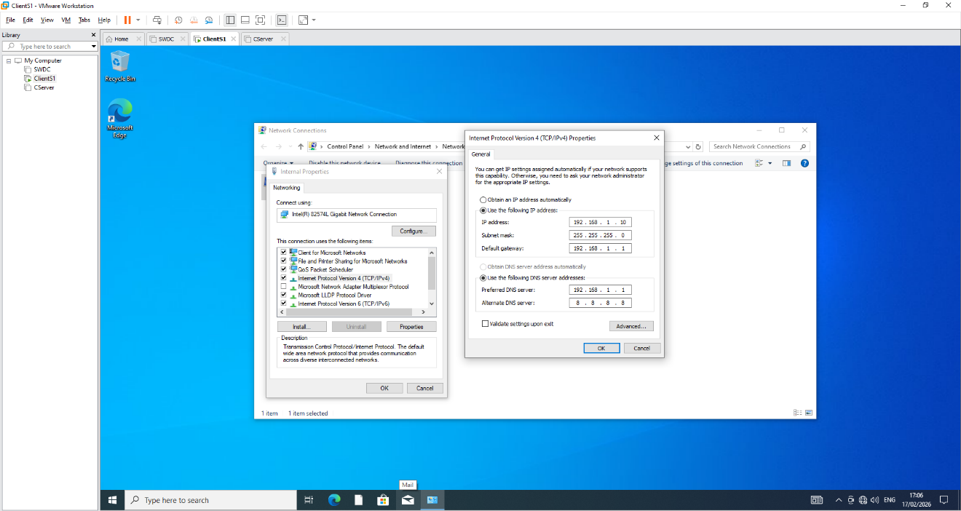
The following screenshot highlights the external network IPv4 Properties for the SWDC VM:
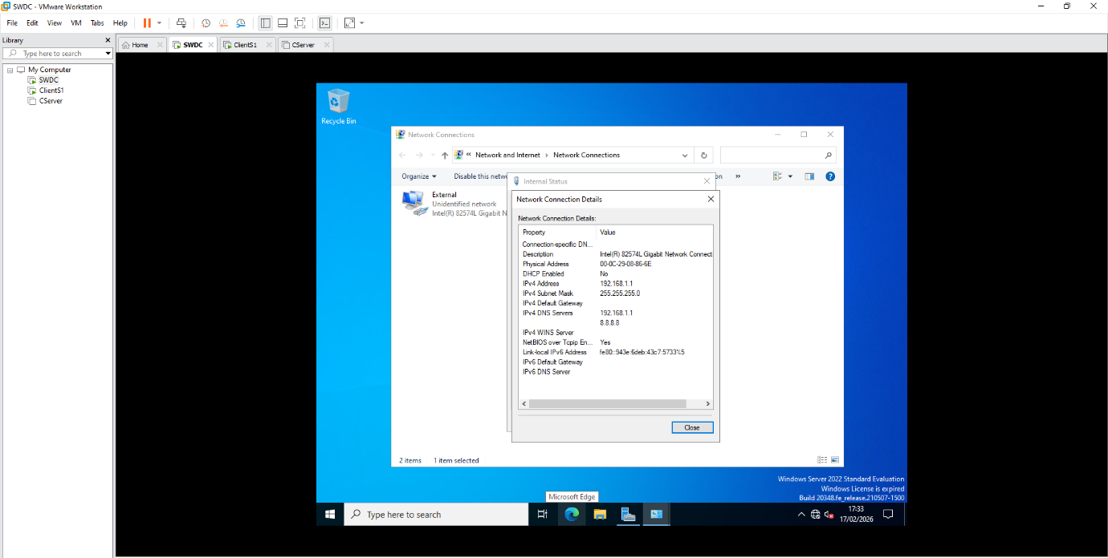

2.4 Testing and Troubleshooting
After the manual configuration was completed, connectivity testing was conducted using pings in the command line interface, within the ClientS1 virtual machine. The ping was initiated to the Windows Server, using the following command: ping 192.168.1.1, to verify if the network communication was successful. The result of this command was 4 out of the 4 packets sent were received, confirming the IP configuration along with the gateway alignment were correctly implemented.
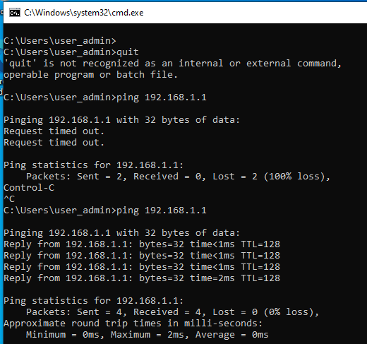
This was also evidenced in the Windows Server domain when the following command was run: ping 192.168.1.10.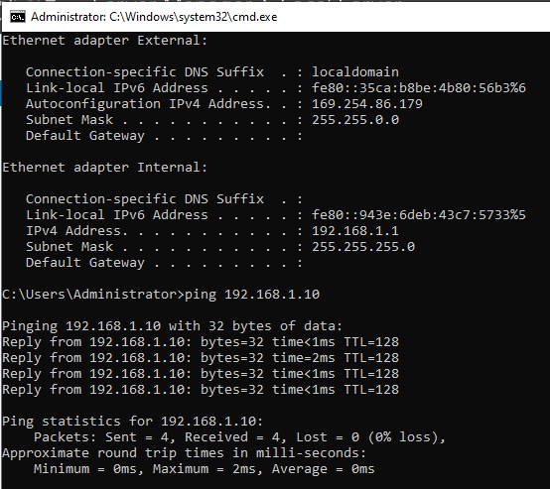
However, during the initial testing, ping requests from the client repeatedly outputted “Request time out”. This highlighted that there was a possible IP configuration issue present.
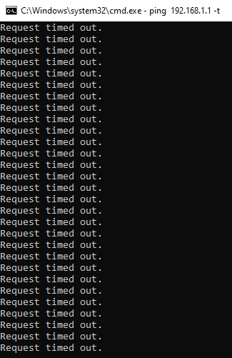
In order to identify the root of the issue, various troubleshooting methods were conducted. Initially, the IP configuration settings were verified using the command ‘ipconfig’ in the windows command line interface. Since configurations were as desired the possibility of it being a routing issue was ruled out. As a result of this, further investigations were conducted, where it was identified that the Firewall & Network Protection settings within the Client VM were preventing the client from reaching the Windows Server subnet. After turning off the appropriate firewalls, the client was able to successfully ping the server.
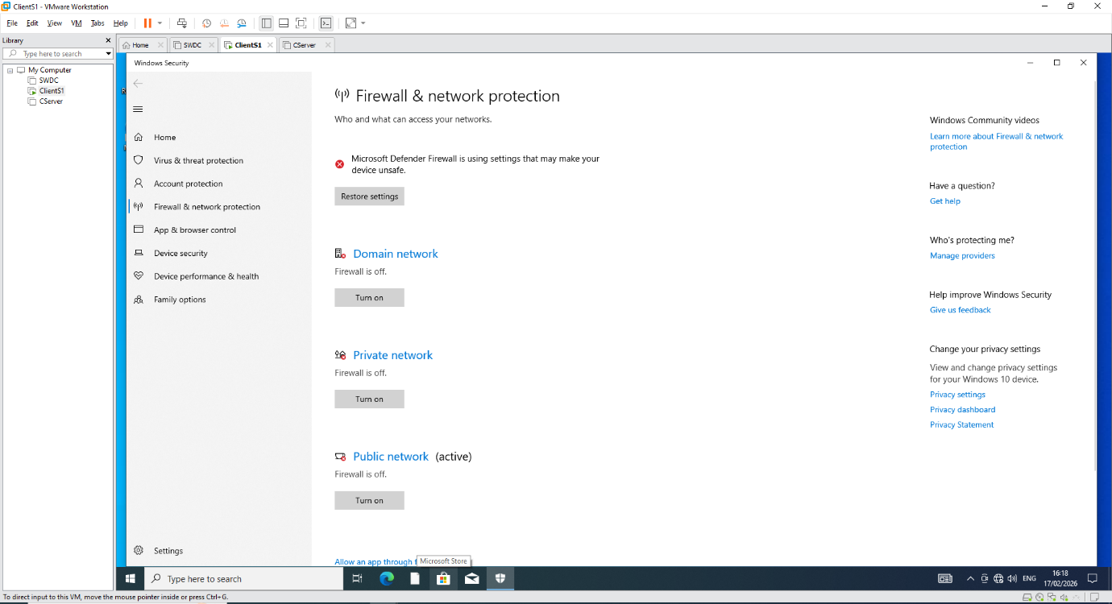

Task 3

3.1.1 Technical Reflection
When conducting the deployment of the SWANSEA.ACCA network, the primary issue that was encountered was during the connectivity testing between the ClientS1 virtual machine and the SWDC’s server. When an attempt was made to ping the server’s IP address, the requests repeatedly returned “Request timed out”, without successfully sending over any packets. Initially, it was believed that the issue stemmed from a misconfiguration with the IP addresses, but after troubleshooting this with the command ‘ipconfig’, the IP addresses were confirmed to be correct. This meant that the issue was related to the Windows Firewall settings within the virtual machine, so to amend this issue, the settings appropriately configured.
The situation allowed me to become confident with troubleshooting methodologies. Identifying and testing all areas of potential failure meant that I was verify the actual cause of the failure, instead of attempting to reconfigure the IP addresses and potentially reinforcing the ongoing issue.
3.1.2 Personal Reflection
This task assisted me in building my knowledge and confidence when deploying and testing structured networks, as it was something that I have had a small amount of experience with previously. It also helped in building my knowledge with establishing connections between subnets, and how to conduct connectivity test to verify if these connections are correct.

References:
[1] Amazon Web Services, “What is a Hypervisor?,” Amazon Web Services, Inc., Feb. 12, 2026. https://aws.amazon.com/what-is/hypervisor/#what-are-the-types-of-hypervisors--79utcr (accessed Mar. 02, 2026).
[2] J. W. Allen, “What Is the Internet?,” Jan. 2002, doi: https://doi.org/10.1007/978-3-642-88424-5_1.
[3] “A Technical Look At How Data Is Transmitted On The Internet - ComputerCity,” ComputerCity, Mar. 18, 2025. https://computercity.com/hardware/networking/how-is-data-is-transmitted-on-the-internet
[4] “What is an IP address, and why is it important? - Tencent Cloud,” Tencentcloud.com, 2025. https://www.tencentcloud.com/techpedia/131015
[5] Cloudflare, “What is a network switch? | Switch vs. router | Cloudflare UK,” Cloudflare, 2023. Available: https://www.cloudflare.com/en-gb/learning/network-layer/what-is-a-network-switch/
[6] Amazon Web Services, “What is Routing?,” Amazon Web Services, Inc., Feb. 12, 2026. https://aws.amazon.com/what-is/routing/#what-are-the-types-of-routing--mbga6x
[7] NCSC, “Virtual Private Networks (VPNs),” www.ncsc.gov.uk, Jun. 29, 2021. https://www.ncsc.gov.uk/collection/device-security-guidance/infrastructure/virtual-private-networks
[8] Microsoft Azure, “What is a VPN? Why Should I Use a VPN?,” azure.microsoft.com, 2024. https://azure.microsoft.com/en-us/resources/cloud-computing-dictionary/what-is-vpn [9] https://www.fortinet.com/uk/resources/cyberglossary/dynamic-host-configuration-protocol-dhcp
[10] Microsoft, “Active directory domain services overview,” Microsoft, Mar. 11, 2025. https://learn.microsoft.com/en-us/windows-server/identity/ad-ds/get-started/virtual-dc/active-directory-domain-services-overview
[11] “What is a certificate,” The University of Edinburgh, Oct. 08, 2024. https://information-services.ed.ac.uk/computing/computing-infrastructure/network/certificates/introduction
[12] “Vmware Workstation - an overview | ScienceDirect Topics,” www.sciencedirect.com. https://www.sciencedirect.com/topics/computer-science/vmware-workstation
[13] “What to Choose: VMware Workstation or Hyper-V?,” Backupchain.net, 2026. https://backupchain.net/what-to-choose-vmware-workstation-or-hyper-v/

