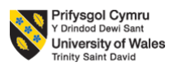

PROGRAMME: BA BUSINESS MANAGEMENT
MODULE: STRATEGIC MANAGEMENT AND SUSTAINABILITY
MODULE CODE: LCBB6004
MODULE COORDINATOR: DR HOSSEIN SHOKRI

ASSIGNMENT TITLE: WRITTEN REPORT

STUDENT NAME AND NUMBER: PAVEL BODUSHKI (2023711)
WORD COUNT: 2,657
SUBMISSION DATE: 21.08.2023
Table of Contents
Introduction 3
Business strategies of VW 3
Resources and capabilities 6
How VW tries to become more competitive while taking into consideration sustainability and the environment 11
Recommendations for further sustainability policies that can help the organisation develop competitive advantages in the future 13
Conclusion 14
References 15
Appendix 17
SWOT analysis 17
Porter’s five forces analysis 18

Introduction
Volkswagen has experienced reputational damages and a loss of competitiveness after the release of Dieselgate scandal in the middle of the previous decade. The company was found to use devices aiming to manipulate the results on tests for environmental compatibility and CO2 emissions (BBC, 2022). The outburst of the scandal has damaged the brand image and reputation of the brand and led to a wave of court trials and litigation cases against it. In the beginning of this year, Volkswagen announced that it opted for court settlements, amounting at approximately £193 million that are supposed to be distributed among 90,000 drivers in England and Wales (BBC, 2022). Since 2015, the brand has paid more than €30 billion in settlements and fines across the world (BBC, 2022). The company is now focused on rebuilding trust among consumers and other stakeholders. In the past five years, it has emphasised on policies that can achieve this goal, such as increased priority of sustainability practices.
The current strategic report aims to explore these in greater detail and assess the strategic management pillars of the brand during the last five years. Based on findings, recommendations are also developed and provided regarding further sustainability policies that can help the organisation to develop and maintain strong competitive advantages in the future.

Business strategies of VW
The development and implementation of corporate strategy is crucial for the creation and maintaining of competitive advantage, especially in rival industries, such as the one Volkswagen operates in. As also illustrated on the next figure, strategy development is based on an in-depth analysis of internal and external environment (Barney, 2019; Lynch, 2018).

Figure 1 – Strategic management process
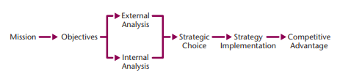
Source: Barney (2019)
Competitive advantage is based on creating a higher economic value for consumers than rivals (Barney, 2019; Whittington et al., 2020). Before the emissions scandal, Volkswagen was developing its competitive advantage mainly on product differentiation, claiming that it had some of the most innovative vehicles on the market with minimum negative footprint on environment (BBC, 2022). The whistleblowing scandal changed this, and the brand could no longer use this as a main unique selling point, as it was found guilty in purposefully manipulating tests on CO2 emissions. The last five years, the company has developed and launched a new strategy aiming to both rebuild trust in the brand and further differentiate its products from rivals. The main emphasis, which is used as a unique selling point and a tool to regain credibility, stems from the brand’s commitment to sustainability and environmentally friendly practices.
The ‘Transform 2025+’ strategy of the company is mainly built upon Volkswagen’s dedication to e-drive vehicles, CO2-neutral mobility and enhancing product range to address newly evolving needs of consumers (Volkswagen, 2023a). The strategy also reflects the external challenges faced by the company, including increasing pace of innovation in the industry, continuously evolving and changing needs of consumers ad increasing rivalry on the market (Volkswagen, 2023a). The company has set a goal to increase the share of all-electric cars in Europe up to 70% of its sales in Europe and up to 50% in US and China, exceeding EU regulation and recommendations (Volkswagen, 2023a). Implementing this strategic objective and working towards achieving it is considered to become a good foundation for the company to develop into a global leader regarding climate-neutral e-mobility (Volkswagen, 2023a).
To achieve these corporate objectives and rebuild its credibility through attracting and retaining customers’ trust, the brand is focused on prioritising digitalisation and innovation in terms of electrification, software-defined products, autonomous driving and new business model developed based on digital renovation (Volkswagen, 2023a). The company has been heavily investing into transforming digitalisation into a core competence of the organisation that can address both customer requirements and market changes. This is used as a tool for generating new revenue streams, tapping into new market segments and differentiating the brand from rivals, so that it can regain the trust of consumers. Another core milestone for the company transformed into main corporate objective is achieving making autonomous driving more widespread until 2030 (Volkswagen, 2023a). The brand is dedicating more than €18 billion in e-mobility, hybridization and digitalisation by 2026 (Volkswagen, 2023a). To justify these investments without compromising its liquidity position, the brand is expecting and aiming to reach a minimum of 6% of operating margin for 2023 (Volkswagen, 2023a).
Based on findings revealed by assessing Volkswagen’s current strategy, it can be suggested that the company is entirely changing its business model and unique selling points, leading to new sources of competitive advantage. The company uses these innovations and changed approaches to further develop its differentiation strategy and regain its credibility, mitigating the negative impacts of Dieselgate scandal on its reputation and brand image. The company is currently aiming to position itself as one of the most innovative and climate-friendly brands on the market, so that it can compensate for its past unethical policies and regain trust of stakeholders.
This approach is also justified by scholars as one of the most successful when rival industries are considered. Differentiation is one of the main generic strategies according to Porter’s model, illustrated below (Porter, 1985). It is associated on basing competitive advantage on the uniqueness of the product and the higher value offered as when compared to competitors in the industry (Mind Tools, 2023). In the case of Volkswagen, this is based on higher degree of innovation and greater value offered through provision of more sustainable vehicles.

Figure 2 – Porter's generic strategies
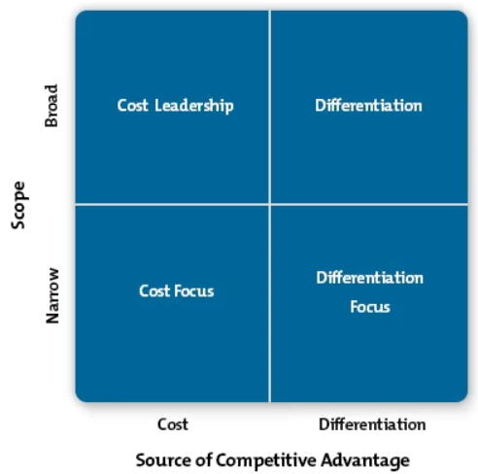
Source: Mind Tools (2023)
It is assumed that the development of this strategy is very appropriate for Volkswagen, considering its corporate objectives and aims, its strengths and weaknesses, as well as external opportunities and threats. These have been identified and assessed and an overview is presented in appendix section.

Resources and capabilities
To assess the viability of current strategic approach of Volkswagen, its resources and capabilities must be evaluated in a direct relation to applied strategic course of action. Resources are defined as the tangible and intangible assets a company has that can be utilised for achieving its strategic objectives (Barney, 2019). Resources can be mainly divided into financial, physical and human. Capabilities, on the other hand, are defined as the tangible and intangible assets that enable a firm to take full advantage of the other resources in control (Barney, 2019).
In terms of financial resources, it can be suggested that the company has substantial funds to support its currently applied business strategy. As evident from the extract below, although sales slightly decreased in terms of volume and amount in 2022 compared to 2021, earnings after tax of the company have increased with 2.6% and the operating return is 7.9% (Volkswagen, 2023b). Furthermore, as indicated on the following extract, the net income for the fiscal year increased significantly in 2022 compared to 2021 (Volkswagen, 2023b).
This leads to the assumption that the brand would fulfil its corporate objectives and would also achieve the 6% operating profit margin in 2023, ensuring alignment with its current strategy.
Table 1 – Volkswagen financial performance overview
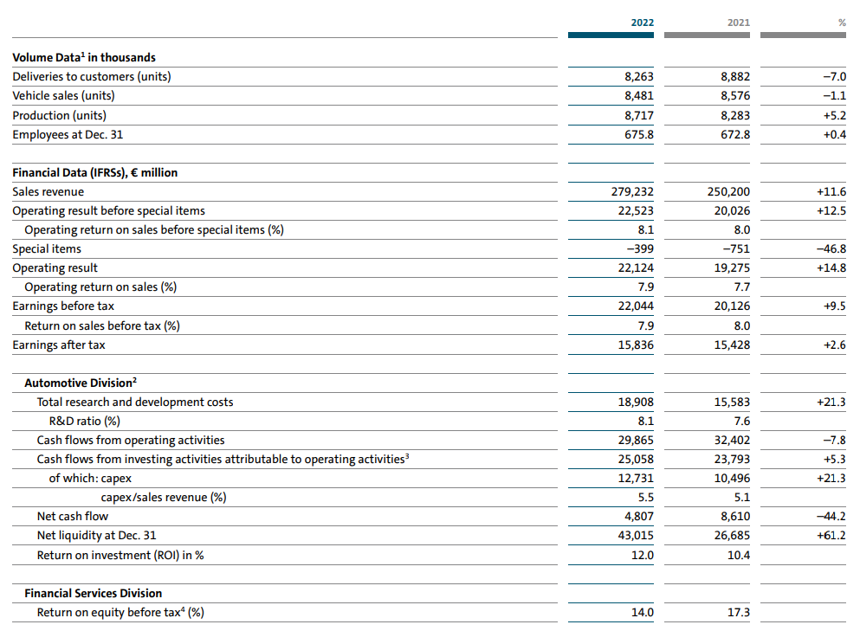
Source: Volkswagen (2023b)
In terms of human resource, the company has less employees in 2022 as when compared to 2021. On the first sight, it can be assumed that this decreases its capacity and capability to meet expectations set by the newly developed strategy and the needs of the new business model adopted. However, for the purposes of objective critical evaluation, more information should be obtained in terms of training and development of workforce, as decreased number does not necessarily mean lower productivity or skills. This has been researched in greater depth through analysing Volkswagen’s sustainability report. According to it, every employee of the company has received on average 19.9 hours of training in 2022, lower than the 20.9 hours reported in 2021 (Volkswagen, 2023c). This can mean that the brand has placed a lower priority on workforce training or that skills of employees have improved in a way that they require less development schemes. Considering the fact that the organisation has spent €398.6 million in training costs in 2022, it can be assumed that it has skilled and developed workforce that can support the implementation of the new strategy.
Table 2 – Employees and additional financial data
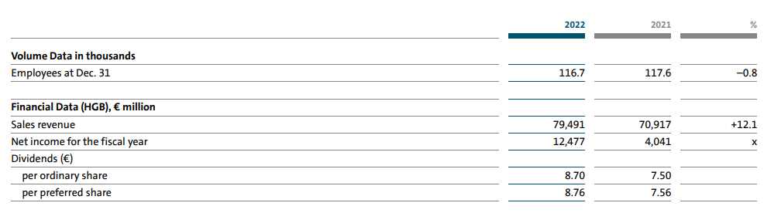
Source: Volkswagen (2023b)
In terms of physical resources, the company has significantly increased its tangible and intangible assets in 2022 compared to 2021, as illustrated on the extract below. It can be suggested that the brand has the required physical resources to comply with pre-set strategic goals of the new business model applied. It is noted from the data that the intangible assets of the company have increased at a higher pace during 2022 than physical resources like property, plant and equipment. This can be assumed to be driven by the new strategy and its associated innovations, which further supports the claim that the organisation has the capability of supporting its strategic actions and new goals.

Table 3 – Volkswagen assets
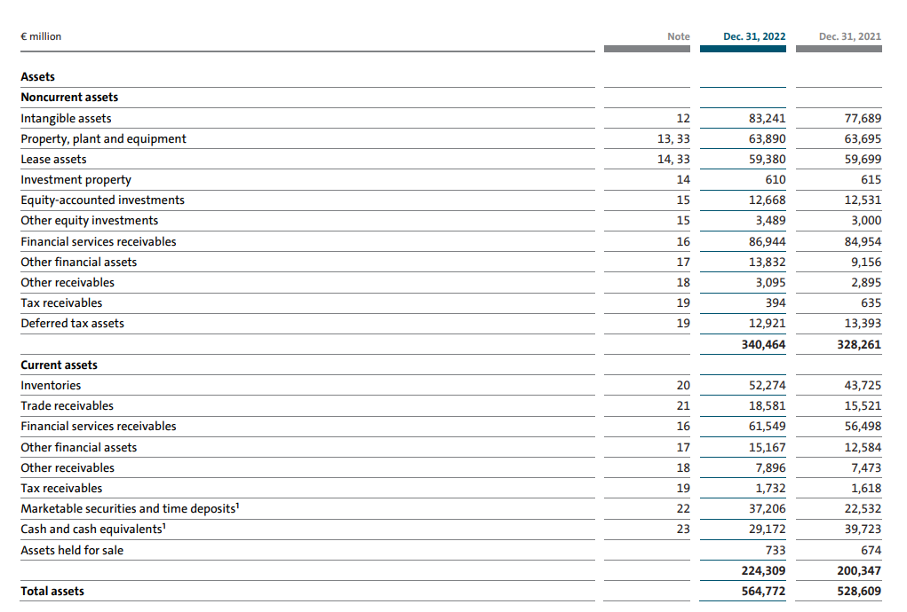
Source: Volkswagen (2023b)
According to the annual report of the company, it can be assumed that the company also has the required capabilities to develop and implement its new strategy. One of the examples supporting this statement is the initiatives regarding the new auto strategy. As shown on the next extract, the company has the required technological platforms in terms of mechatronics, software, battery & charging, as well as mobility solutions to maintain the planned strategic actions and transform them into a source of solid competitive advantage.

Figure 3 – Auto strategy
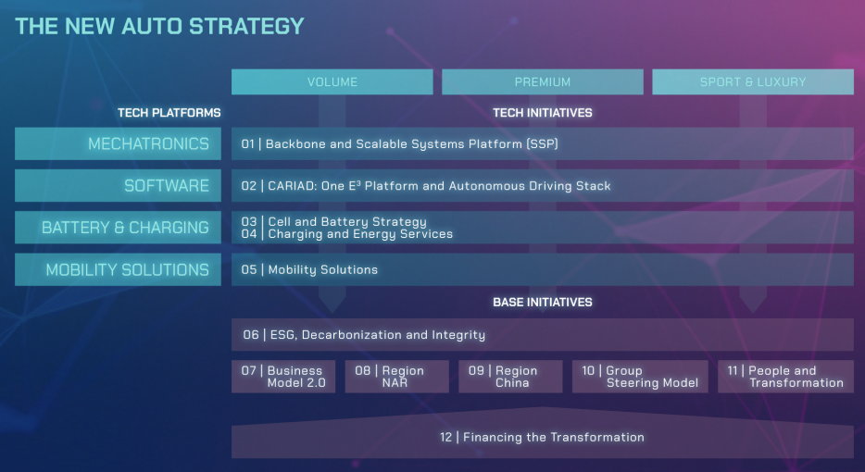
Source: Volkswagen (2023b)
It should also be noted that, regardless of what resources and capabilities the company has, they must be compliant with VRIO framework to serve as a foundation for achieving corporate goals and a source of competitive advantage (Jurevicius, 2023). The VRIO framework stands for value, rarity, imitability and organisation (Jurevicius, 2023). It can be stated that, as the current strategy of Volkswagen is based on differentiation achieved through innovation, the organisation has adequate capacity to fulfil strategic goals and targets. The analysis shows that Volkswagen has considerable financial, fixed assets and human resources – tangible resources – while its brand serves as a key intangible resource. Economics of scale and the wide distribution network are also key resources. The unique organisational culture, innovativeness and ability to change are capabilities. While resources can be replicated by competitors over time, which means that they are imitable – the overall competitiveness of Volkswagen mainly depends on its ability to develop unique capabilities.

How VW tries to become more competitive while taking into consideration sustainability and the environment
It is already shown that Volkswagen significantly increased its focus on sustainability and the production of climate-friendly vehicles. These are some of the main sources of its competitive advantage. After the emission scandal, the organisation faced the challenge of rebuilding its credibility and regaining trust by customers, as it has been perceived as an entity which is not ethical and sustainable.
Currently, the whole new strategy of Volkswagen is developed on gaining competitiveness based on innovative and unique climate-friendly production methods and operations. This is also supported by the information provided in its annual report. The results of adopting a strategy which prioritises sustainability more are evident. As shown below, the ESG rating of the company significantly improved across different rankings during the last three years (Volkswagen, 2023c). It is expected that this trend would be preserved.
Table 4 – Volkswagen ESG rankings
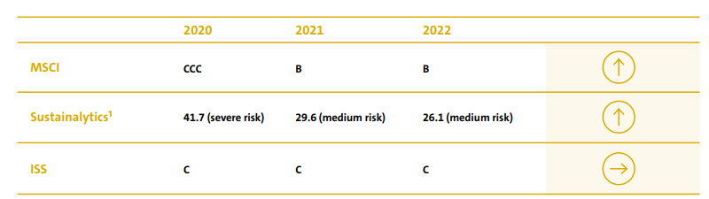
Source: Volkswagen (2023c)
The company has set several important objectives in four main areas of operation, including protecting the climate, conserving resources, conserving ecosystems and ensuring environmental compliance, as shown below (Volkswagen, 2023c). Activities and strategies adopted in all these areas not only help the company to rebuild its image of a sustainable brand, but also support organisation’s sources of competitive advantage by creating a higher value for buyers.

Table 5 – Mission statement action areas
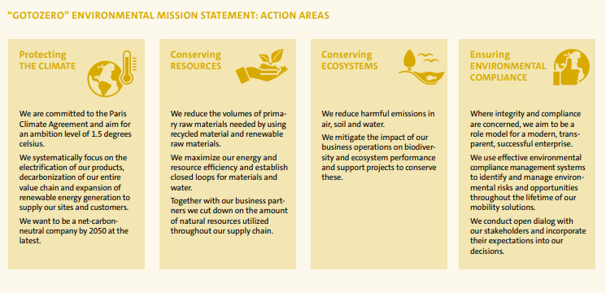
Source: Volkswagen (2023c)
The company also set a priority of having more sustainable production by developing the Zero Impact Factory plan, having the aim of reaching zero environmental impact from production processes by 2050 (Volkswagen, 2023c). As evident from the following extract, the progress of the brand during the last five years is significantly high and expected to increase even further during the next decade.
Figure 4 – Zero impact factory plan
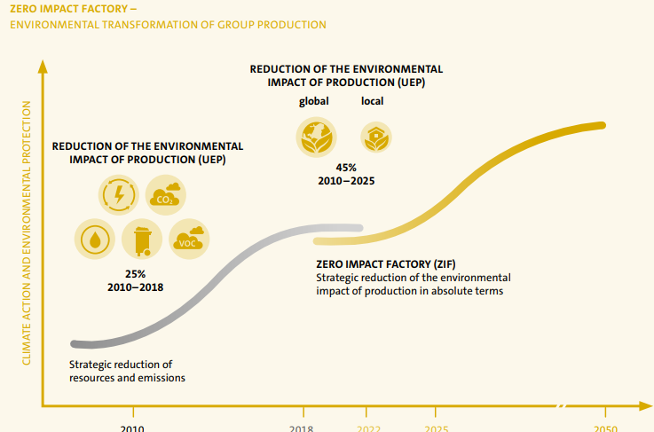
Source: Volkswagen (2023c)
As evident from the sustainability report of the company, the change in environmental impact of production in 2022 is a reduction of 37.4% which is sufficiently better than a decrease of 29.1% reported in 2021 (Volkswagen, 2023c). This has been the result of decreasing specific energy requirements, specific CO2 emissions, specific VOC emissions, water consumption and waste disposal (Volkswagen, 2023c). All this serves as a solid foundation for developing a sustainable and climate-friendly strategy, production process framework and overall business model. This is considered as the most effective way for the company to recover from the scandal and try to restore and maintain its leadership positions on the market.
This is essential for the future development of the brand not only because of the recent scandal which has deteriorated its image and reputation, but also due to the current market trends. A recent report developed by Moller (2022) reveals that sustainability increases significantly in importance for current vehicle buyers. This is partly due to new regulations, such as the voted ban on production of non-electric cars after 2035 (Moller, 2022). However, this trend is also driven by the significant shift towards greater sustainability post-pandemic. According to research, sales of low-emission cars would increase from 5% in 2020 to 60% in 2030 and this should be addressed by car manufacturers like Volkswagen (Moller, 2022). It can be suggested that, currently, the company has developed an effective strategy to address internal and external factors of influence on business operations and this would serve as a long-term source of competitive advantage.

Recommendations for further sustainability policies that can help the organisation develop competitive advantages in the future
According to the analysis of internal and external factors of influence on business operations, Volkswagen is advised to continue developing currently adopted strategy based on sustainable solutions and climate-friendly processes. Specific recommendations for the company include:
- Use resources and capabilities to create and develop more innovative solutions which are climate friendly.
- Promote sustainable practices of the company more, so that awareness increases and thus, affects positively sales in terms of both units and value, since current sales are decreasing.
- Invest more in training employees, as upskilling them would provide the company with a wide variety of long-term benefits.
- Invest in research and development on improving electric vehicles performance, such as longer range or battery life, as this is considered the segment with highest prospects for development during the next decade.
- Develop sustainability strategy pillars and increase range of activities beyond sustainable manufacturing and employee diversity, including sponsor green events, adopt a variety of philanthropic initiatives and others.
These are just a few examples of activities that can be conducted by the company to increase its competitiveness, while it also better addresses the topic of sustainability along with expectations of stakeholder groups in this regard. The recommendations clearly show the importance of developing capabilities, such as innovativeness, flexible organisational culture supporting change, as well as strong relationships with key stakeholders. The transformation plan largely depends on Volkswagen’s ability to detect and respond to external changes.

Conclusion
Research findings indicated the negative impact of the emission scandal and its role as a trigger for positive change. As a result of the scandal, the company has lost its credibility, reputation and competitiveness on the market, while it also had to pay significant amount of money on court settlements. Currently, the company has developed and implemented a new strategy based on climate-friendly and sustainable solutions which seems to be a good foundation for its competitive advantages against rivals and unique selling points. Therefore, research findings clearly suggest the value of pursuing the strategy and adapting it accordingly to various external trends and developments.

References
Armstrong, M. 2023. UK Inflation Rate Rises Again. [online] Available at: <https://www.statista.com/chart/26208/uk-cpih-cpi-inflation-timeline/> [Accessed 11 August 2023].
Barney, J. 2019. Strategic Management and Competitive Advantage: Concepts and Cases. 6th global edition, Pearson.
BBC 2022. Volkswagen Too Pay Out £193m In ‘Dieselgate’ Settlement. [online] Available at: <https://www.bbc.com/news/business-61581251> [Accessed 14 July 2023].
Fastmarkets 2022. Lithium Supply & Battery Raw Materials 2022 – what we learned. [online] Available at: <https://www.fastmarkets.com/insights/lithium-supply-battery-raw-materials-2022-what-we-learned> [Accessed 11 August 2023].
Globe Newswire 2023. Automotive Market Is Expected To Reach USD 28.7 Billion by 2030, Grow at a CAGR Of 4.5% during Forecast Period 2023 To 2030 | Data By Contrive Datum Insights Pvt Ltd. [online] Available at: <https://www.globenewswire.com/news-release/2023/03/22/2632656/0/en/Automotive-Market-Is-Expected-To-Reach-USD-28-7-Billion-by-2030-Grow-at-a-CAGR-Of-4-5-during-Forecast-Period-2023-To-2030-Data-By-Contrive-Datum-Insights-Pvt-Ltd.html#:~:text=Farmington%2C%20March%2022%2C%202023%20(,cars%2C%20trucks%2C%20and%20motorcycles> [Accessed 11 August 2023].
Jurevicius, O. 2023. VRIO Framework Explained. [online] Available at: <https://strategicmanagementinsight.com/tools/vrio/> [Accessed 24 July 2023].
Kallstrom, H. 2015. What makes the auto industry highly concentrated? [online] Available at: <https://finance.yahoo.com/news/makes-auto-industry-highly-concentrated-140540290.html> [Accessed 11 August 2023].
Lynch, R. 2018. Strategic Management. 8th edition, Pearson.
Mind Tools. 2023. Porter’s Generic Strategies. [online] Available at: <https://www.mindtools.com/azb8kpl/porters-generic-strategies> [Accessed: 10 August 2023].
Moller, T. 2022. Road Mobility, [online] Available at: <https://www.mckinsey.com/capabilities/sustainability/our-insights/spotting-green-business-opportunities-in-a-surging-net-zero-world/transition-to-net-zero/road-mobility> [Accessed 14 July 2023].
Porter, M. 1985. Competitive Advantage. Creating and Sustaining Superior Performance. Free Press, New York.
Volkswagen 2023a. Strategy. [online] Available at: <https://www.volkswagen-newsroom.com/en/strategy-3912> [Accessed 14 July 2023].
Volkswagen 2023b. Annual Report 2022. [online] Available at: <https://annualreport2022.volkswagenag.com/_assets/downloads/entire-vw-ar22.pdf>[Accessed 14 July 2023].
Volkswagen 2023c. Sustainability Report 2023. [online] Available at: <https://www.volkswagen-group.com/en/publications/more/group-sustainability-report-2022-1644> [Accessed 14 July 2023].
Whittington, R., Regner, P., Angwin, D., Johnson, G. and Scholes, K. 2020. Exploring Strategy: Text and Cases. 12th edition, Pearson.

Appendix

SWOT analysis
Strengths  - New strategy developed.  - Increase focus on sustainability.  - Strong brand image and popularity.  - Solid resources and capabilities. | Weaknesses  - Severely deteriorated reputation  - Some indicators of performance are deteriorating, such as sales and workforce.
Opportunities  - Growing demand for e-vehicles  - Increased importance of sustainability and innovation  - Digitalisation  - Increased importance of sustainability | Threats  - Increasing competition  - Evolving customer needs  - Increasing pace of innovation in industry  - Climate change

Porter’s five forces analysis
Competition in the industry: Extremely high; main rivals are Toyota, Ford, Nissan, Mazda and others. The market is mature and expected to grow at just 4.5% per annum in the foreseeable future (Globe Newswire, 2023). The lack of solid growth additionally intensifies existing competition.
Bargaining power of buyers: High due to high price sensitivity, as well as high availability of substitutes on the market and low switching costs. The considerably high inflation rate in the last two years – up to 11% per annum in the UK – has made consumers more sensitive and preferring low-cost alternatives; thereby, putting price pressure on car brands (Armstrong, 2023).
Bargaining power of suppliers: Relatively high due to innovative production methods, requiring more sophisticated supplies with less available alternatives when compared to traditional manufacturing. Especially considering rare suppliers, such as lithium and other rare inputs, suppliers have a considerable bargaining power due to production shortages; thereby, pressuring producers to pay more for some types of supplies (Fastmarkets, 2022).
Threat of new entrants: Relatively low due to high initial investment and established players on the market. New entrants must invest considerable capital in production capacity, global distribution network, considerable sunk costs, requirements for economies for scale, brand development, licensing regimes – key barriers discouraging new competitors (Kallstrom, 2015).
Threat of substitutes: Relatively high due to the large variety of vehicles available on the market and easy access to dealerships.
Results indicate the highly competitive nature of the industry which depresses profit margins. Being innovative and competitive are keys to prospering in such a rival industry.

