Analysis Focussing On:

Analysis of Structures

Module Code – ACBA5027

Word Count Required – 2000 (+/- 10%
Word Count: Calculations

Prepared for:
- Bitar

Created By:
E. Evans (2211009)

Submission Deadline – 29th April 2025

Table of Contents
1. Task 2: Analysis of Structures 4
3.1 Q1 Hand Calculations 4
3.2 Q1 Robot Structural Analysis 7
3.3 Q2 Hand Calculations 9
3.4 Q2 Robot Structural Analysis 11
3.5 Q3 Hand Calculations 12
3.6 Q3 Robot Structural Analysis 15
3.7 Q4 Hand Calculations 16
3.8 Q4 Robot Structural Analysis 19
3.9 Q5 Hand Calculations 20
3.10 Q5 Robot Structural Analysis 24
2. Hand Calculations & Robot Analysis Comparison Comments 25

Table of Equations
Equation 1: Q1.1 Beam Analysis using Moment Distribution (Ethan Evans 2025) 4
Equation 2: Q1.2 Beam Analysis using Moment Distribution (Ethan Evans 2025) 5
Equation 3: Q1.3 Beam Analysis using Moment Distribution (Ethan Evans 2025) 6
Equation 4: Q2.1 Beam Analysis using Moment Distribution (Ethan Evans 2025) 9
Equation 5: Q2.2 Beam Analysis using Moment Distribution (Ethan Evans 2025) 10
Equation 6: Q3.1 Frame Analysis using Moment Distribution (Ethan Evans 2025) 12
Equation 7: Q3.2 Frame Analysis using Moment Distribution (Ethan Evans 2025) 13
Equation 8: Q3.3 Frame Analysis using Moment Distribution (Ethan Evans 2025) 14
Equation 9: Q4.1 Frame Analysis using Moment Distribution (Ethan Evans 2025) 16
Equation 10: Q4.2 Frame Analysis using Moment Distribution (Ethan Evans 2025) 17
Equation 11: Q4.3 Frame Analysis using Moment Distribution (Ethan Evans 2025) 18
Equation 12: Q5.1 Truss Analysis using Matrix Stiffness Method (Ethan Evans 2025) 20
Equation 13: Q5.2 Truss Analysis using Matrix Stiffness Method (Ethan Evans 2025) 21
Equation 14: Q5.3 Truss Analysis using Matrix Stiffness Method (Ethan Evans 2025) 22
Equation 15: Q5.4 Truss Analysis using Matrix Stiffness Method (Ethan Evans 2025) 23

Robot Analysis Equations
Robot Analysis 1: Q1.1 Continuous Beam with dead load (Ethan Evans 2025) 7
Robot Analysis 2: Q1.2 Reactions with dead load (Ethan Evans 2025) 7
Robot Analysis 3: Q1.3 Bending Moment diagram with dead load (Ethan Evans 2025) 8
Robot Analysis 4: Q1.4 Bending Moment diagram without dead load (Ethan Evans 2025) 8
Robot Analysis 5: Q2.1 Reactions - No dead load (Ethan Evans 2025) 11
Robot Analysis 6: Q2.1 Bending Moment Diagram - No dead load (Ethan Evans 2025) 11
Robot Analysis 7: Q3.1 Frame Analysis Reactions - No dead load (Ethan Evans 2025) 15
Robot Analysis 8: Q3.2 Bending Moment diagram - No dead load (Ethan Evans 2025) 15
Robot Analysis 9: Q4.1 Frame Analysis & Reactions - No dead load (Ethan Evans 2025) 19
Robot Analysis 10: Q4.2 Bending Moment Diagram - No dead load (Ethan Evans 2025) 19
Robot Analysis 11: Q5.1 Truss Analysis & Reactions - No dead load (Ethan Evans 2025) 24
Robot Analysis 12: Q5.2 Truss Displacements - No dead load (Ethan Evans 2025) 24

Task 2: Analysis of Structures

3.1 Q1 Hand Calculations
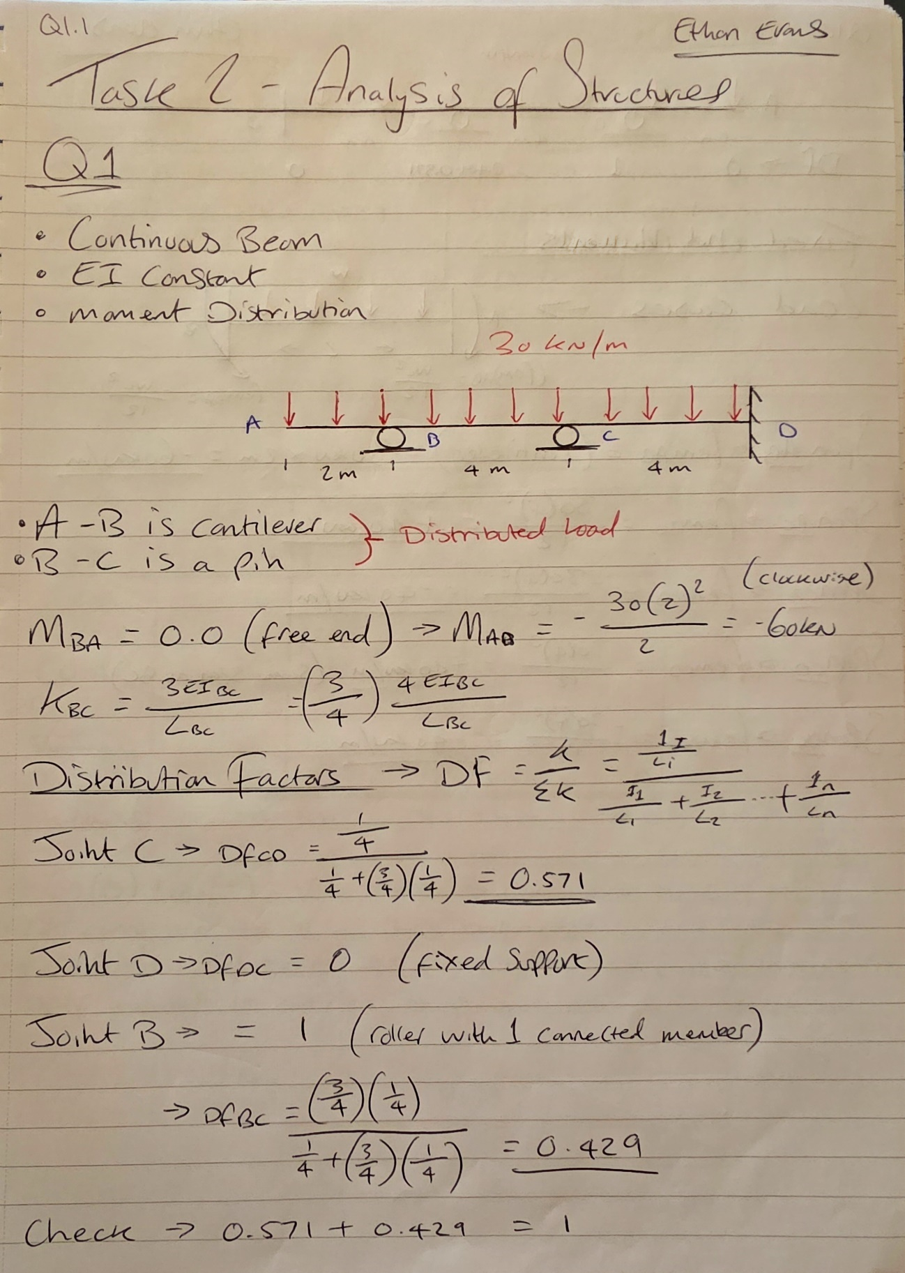

Equation 1: Q1.1 Beam Analysis using Moment Distribution (Ethan Evans 2025)
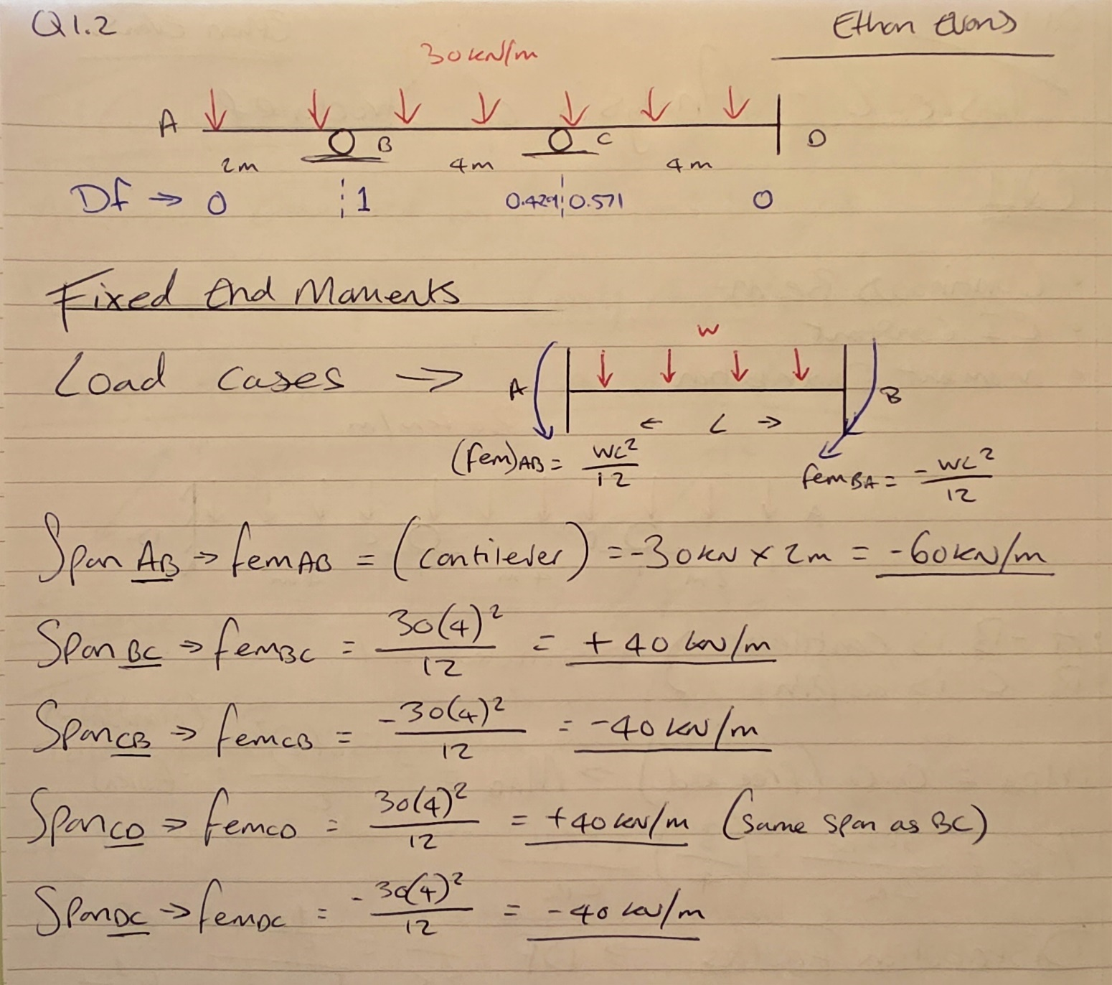
Equation 2: Q1.2 Beam Analysis using Moment Distribution (Ethan Evans 2025)
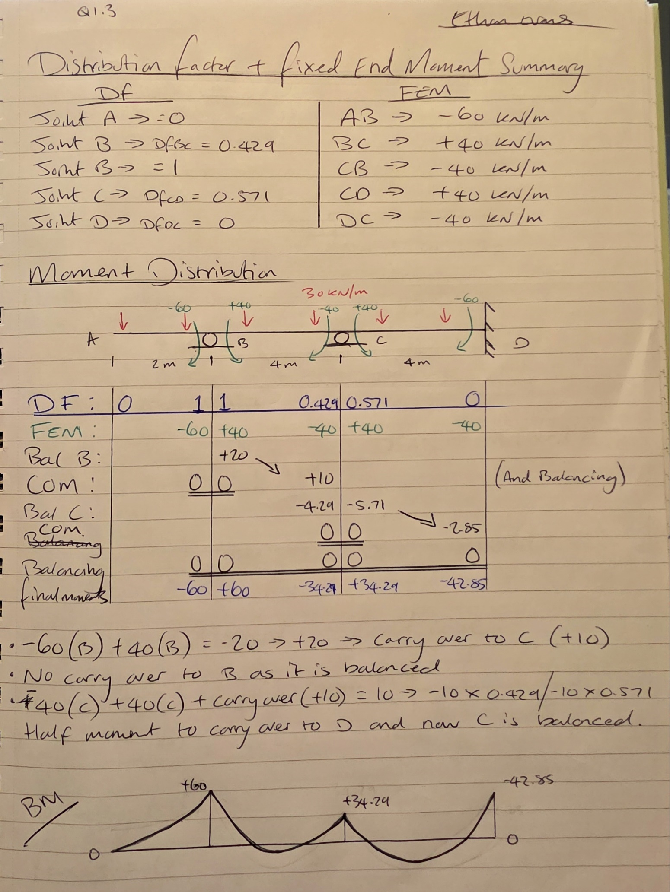
Equation 3: Q1.3 Beam Analysis using Moment Distribution (Ethan Evans 2025)

3.2 Q1 Robot Structural Analysis
Robot Analysis 1: Q1.1 Continuous Beam with dead load (Ethan Evans 2025)

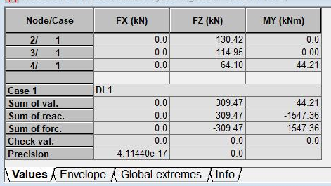
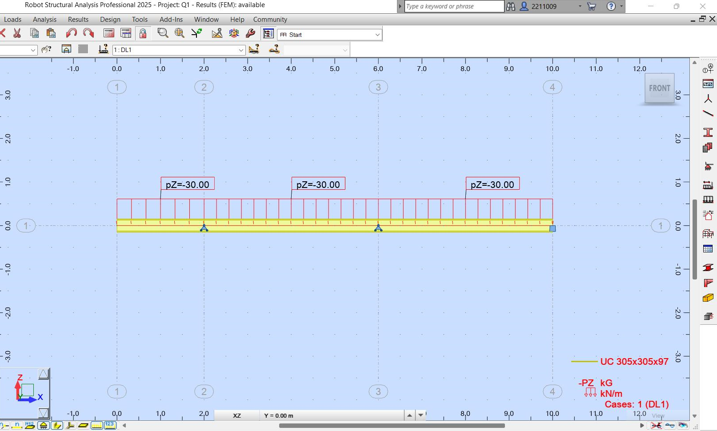
Robot Analysis 2: Q1.2 Reactions with dead load (Ethan Evans 2025)
Robot Analysis 3: Q1.3 Bending Moment diagram with dead load (Ethan Evans 2025)

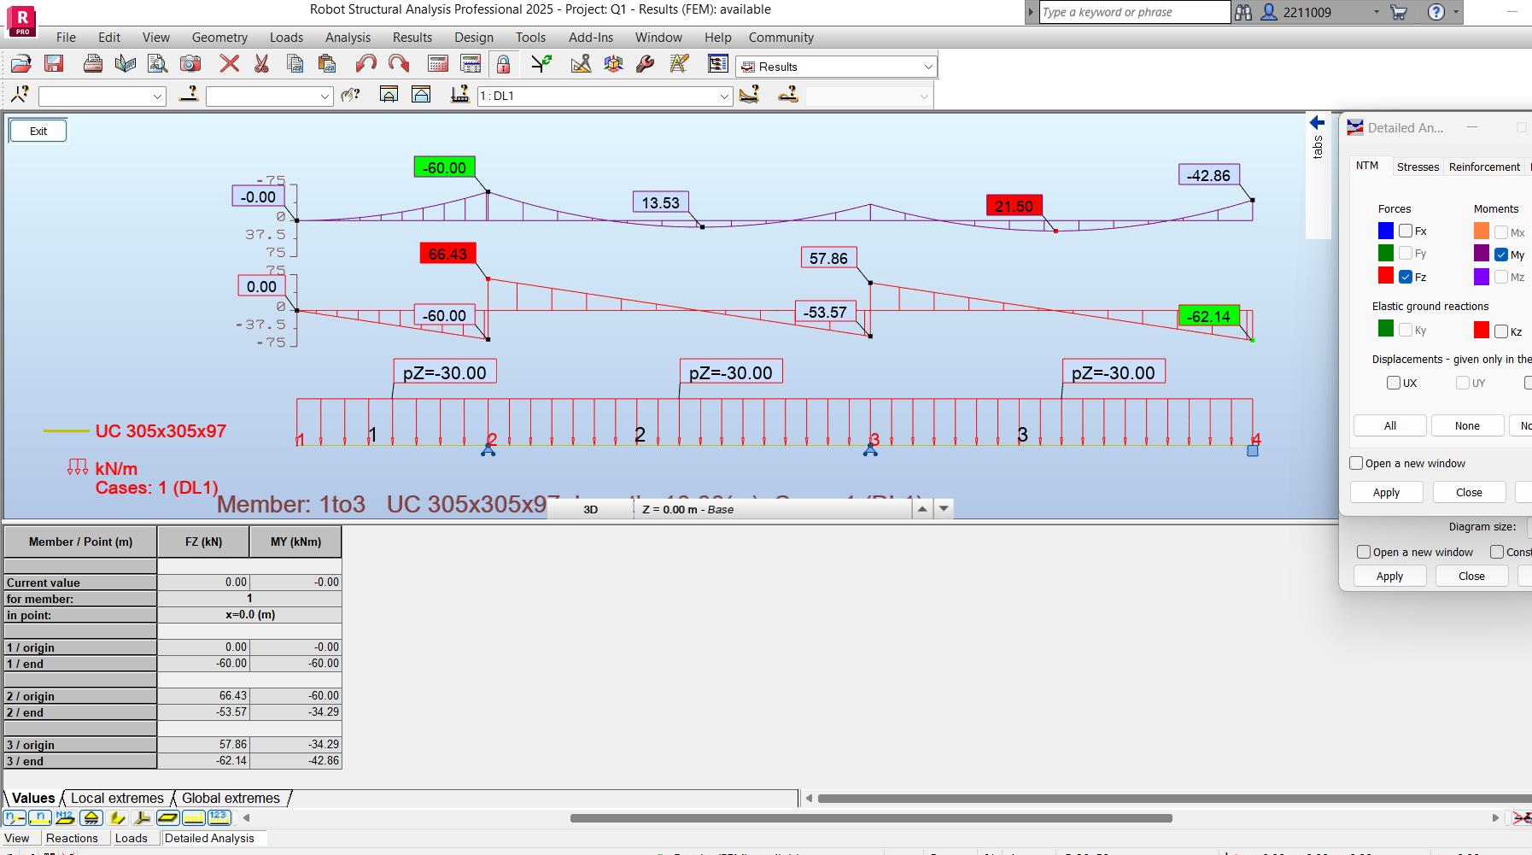
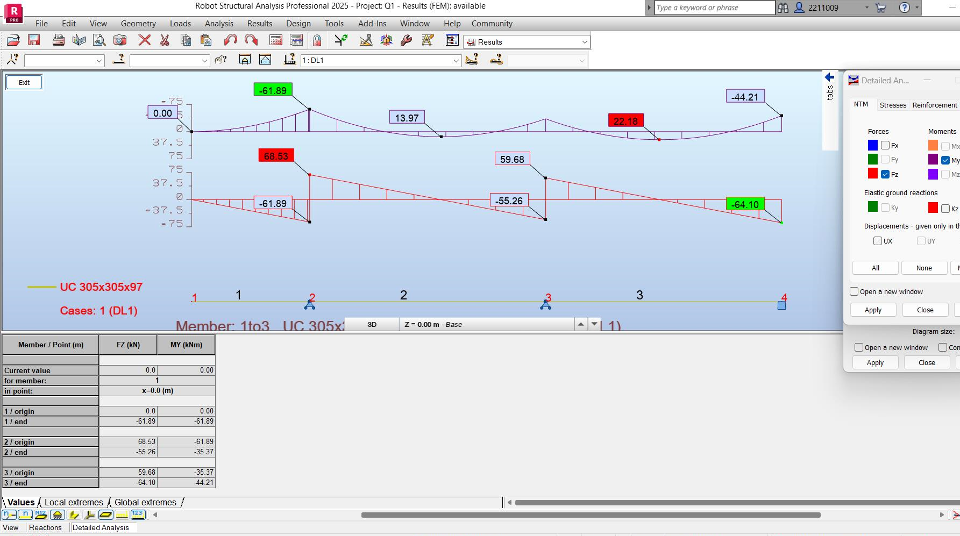
Robot Analysis 4: Q1.4 Bending Moment diagram without dead load (Ethan Evans 2025)

3.3 Q2 Hand Calculations
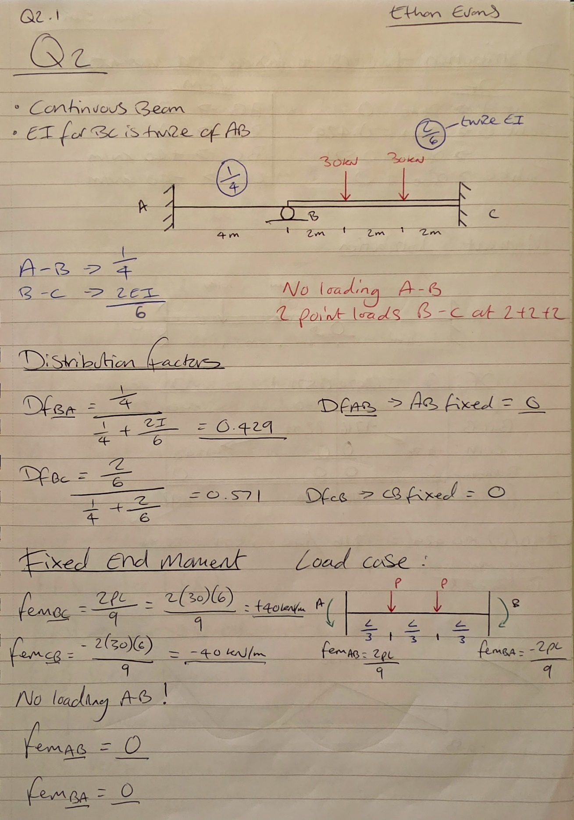
Equation 4: Q2.1 Beam Analysis using Moment Distribution (Ethan Evans 2025)
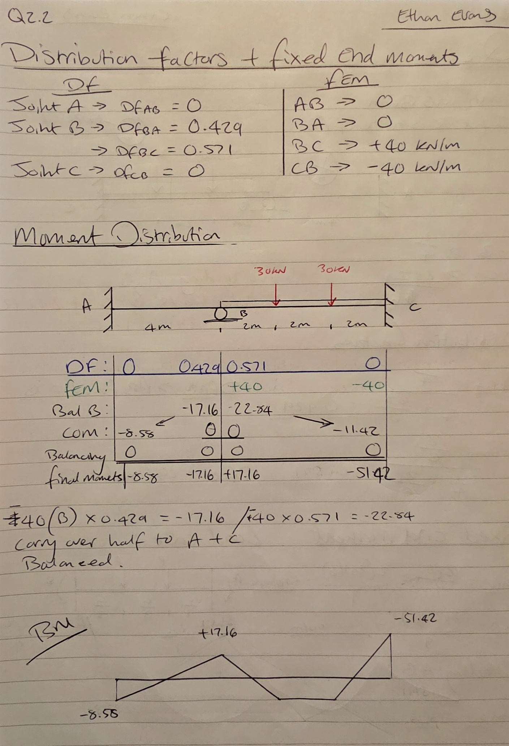
Equation 5: Q2.2 Beam Analysis using Moment Distribution (Ethan Evans 2025)

3.4 Q2 Robot Structural Analysis
Robot Analysis 5: Q2.1 Reactions - No dead load (Ethan Evans 2025)
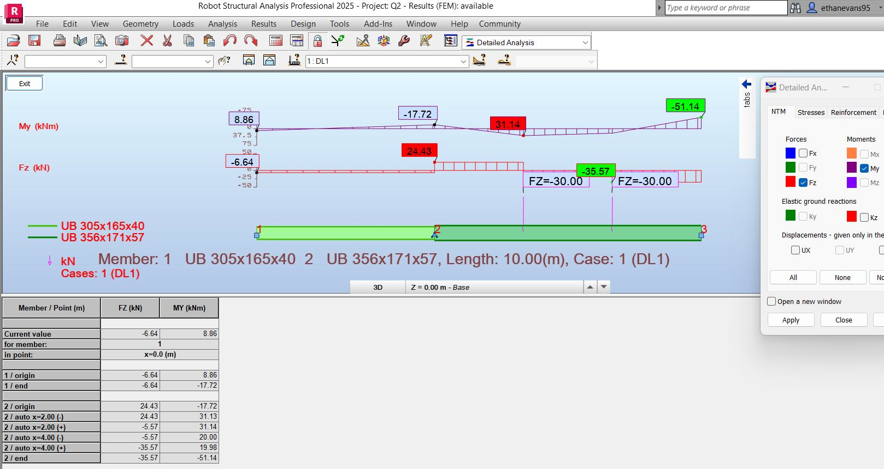
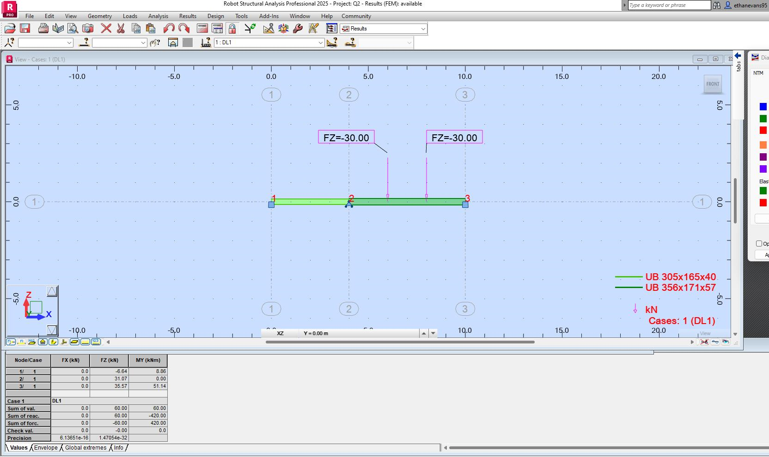
Robot Analysis 6: Q2.1 Bending Moment Diagram - No dead load (Ethan Evans 2025)

3.5 Q3 Hand Calculations

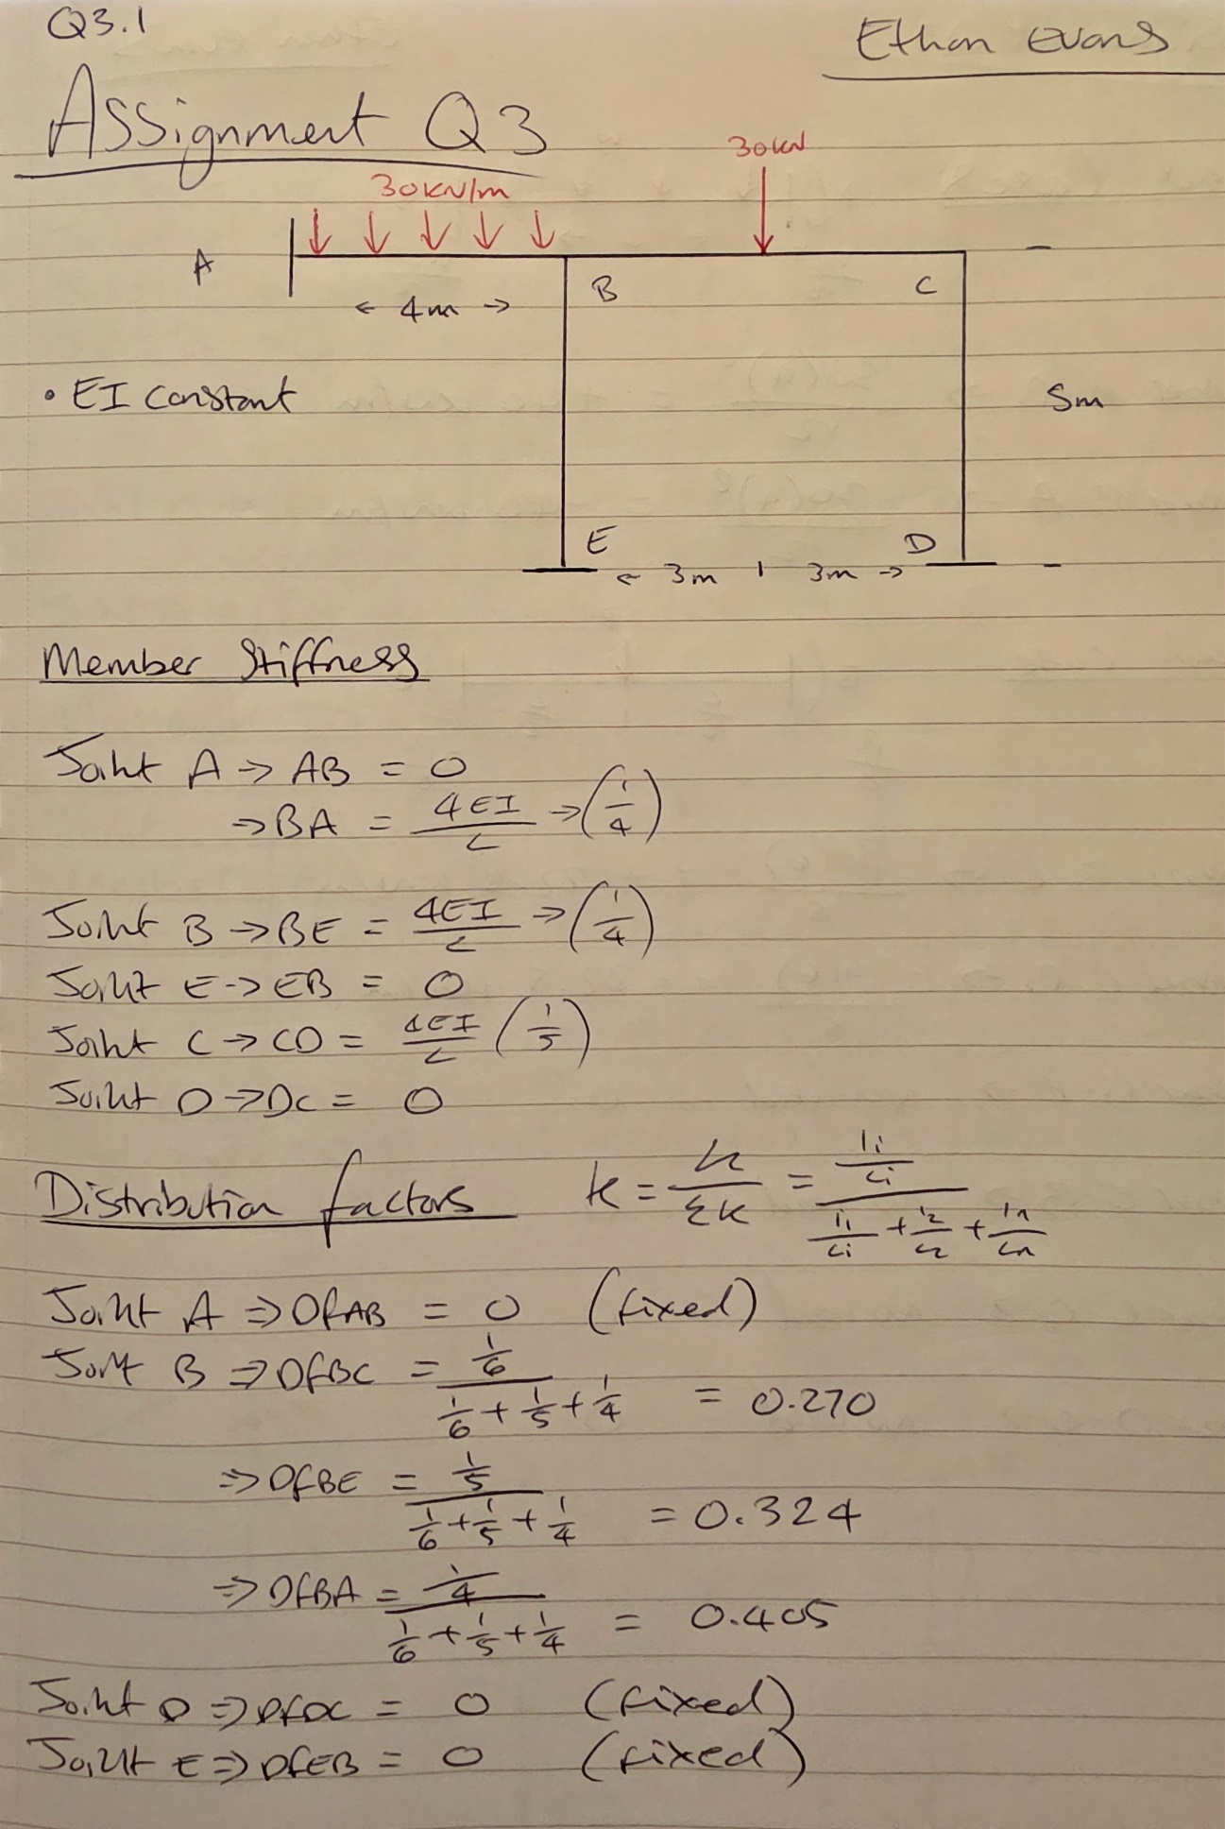

Equation 6: Q3.1 Frame Analysis using Moment Distribution (Ethan Evans 2025)
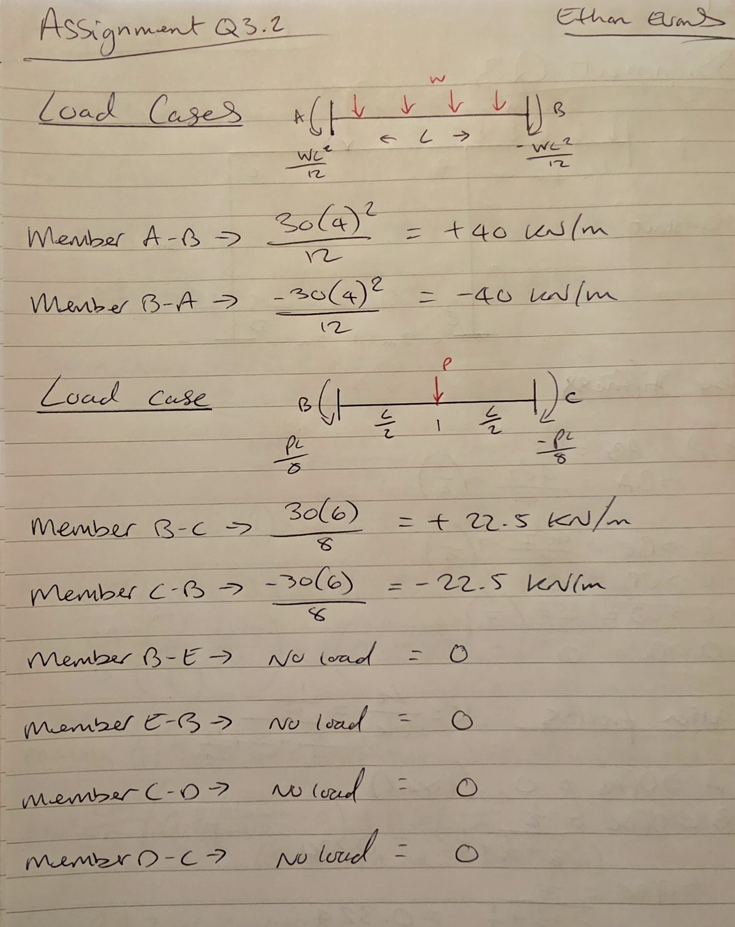
Equation 7: Q3.2 Frame Analysis using Moment Distribution (Ethan Evans 2025)
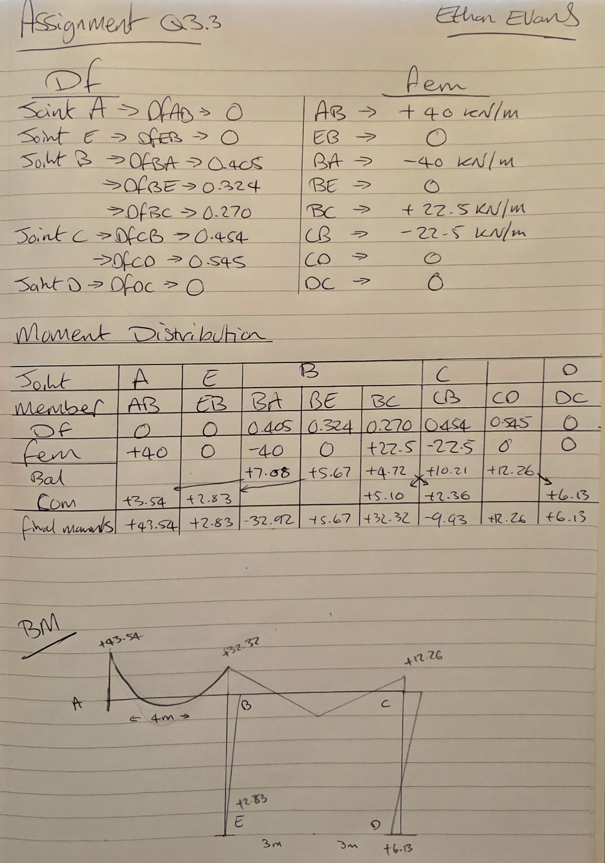
Equation 8: Q3.3 Frame Analysis using Moment Distribution (Ethan Evans 2025)

3.6 Q3 Robot Structural Analysis
Robot Analysis 7: Q3.1 Frame Analysis Reactions - No dead load (Ethan Evans 2025)
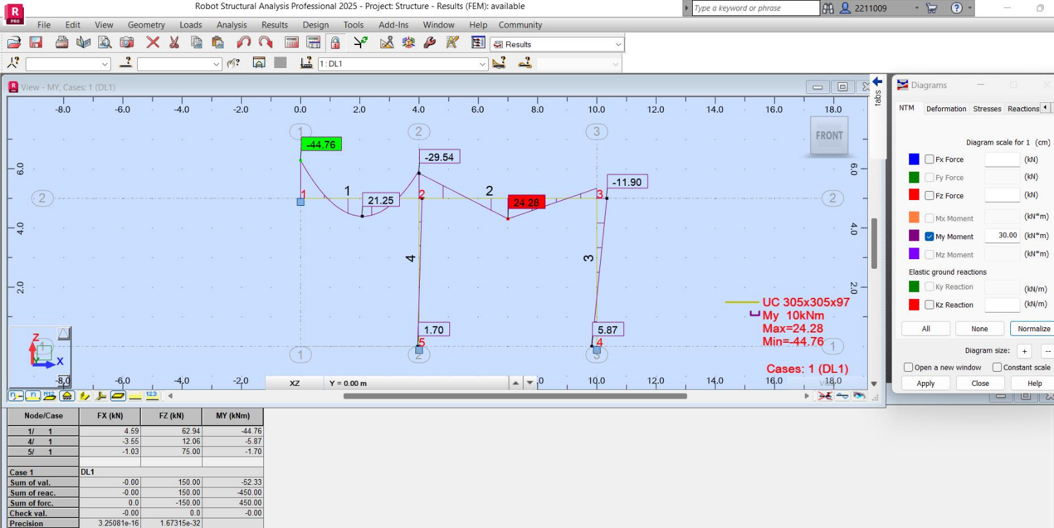
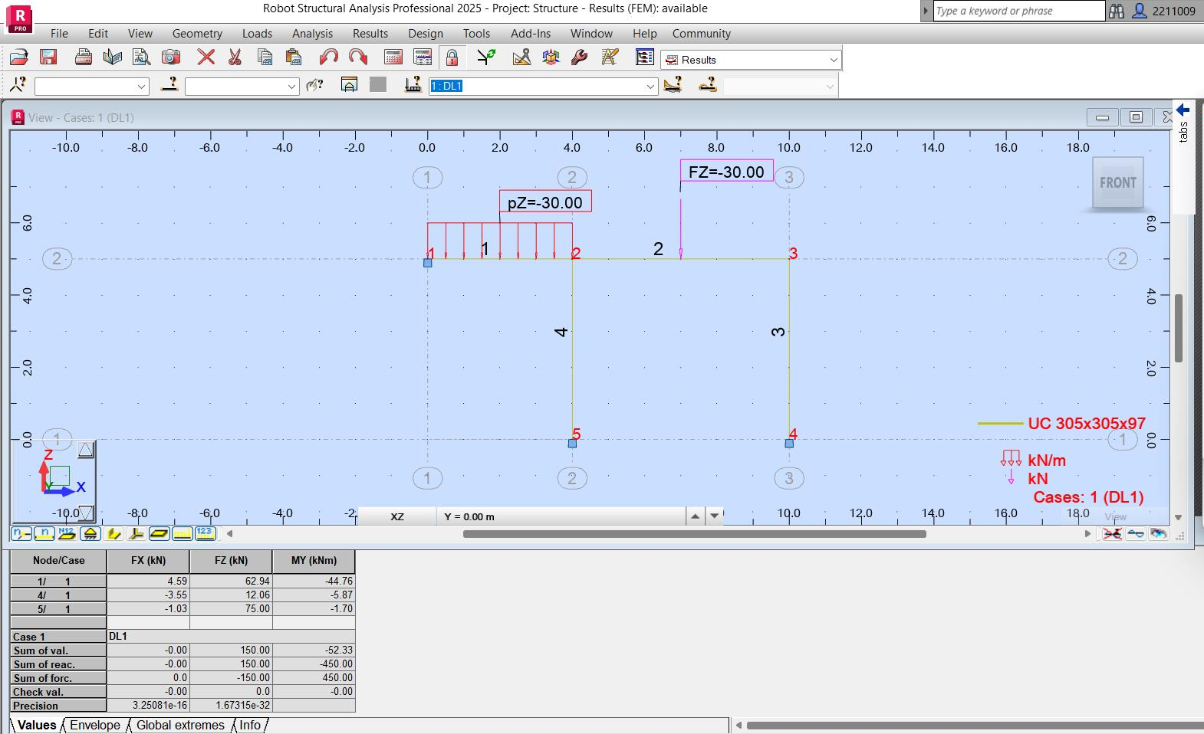
Robot Analysis 8: Q3.2 Bending Moment diagram - No dead load (Ethan Evans 2025)

3.7 Q4 Hand Calculations
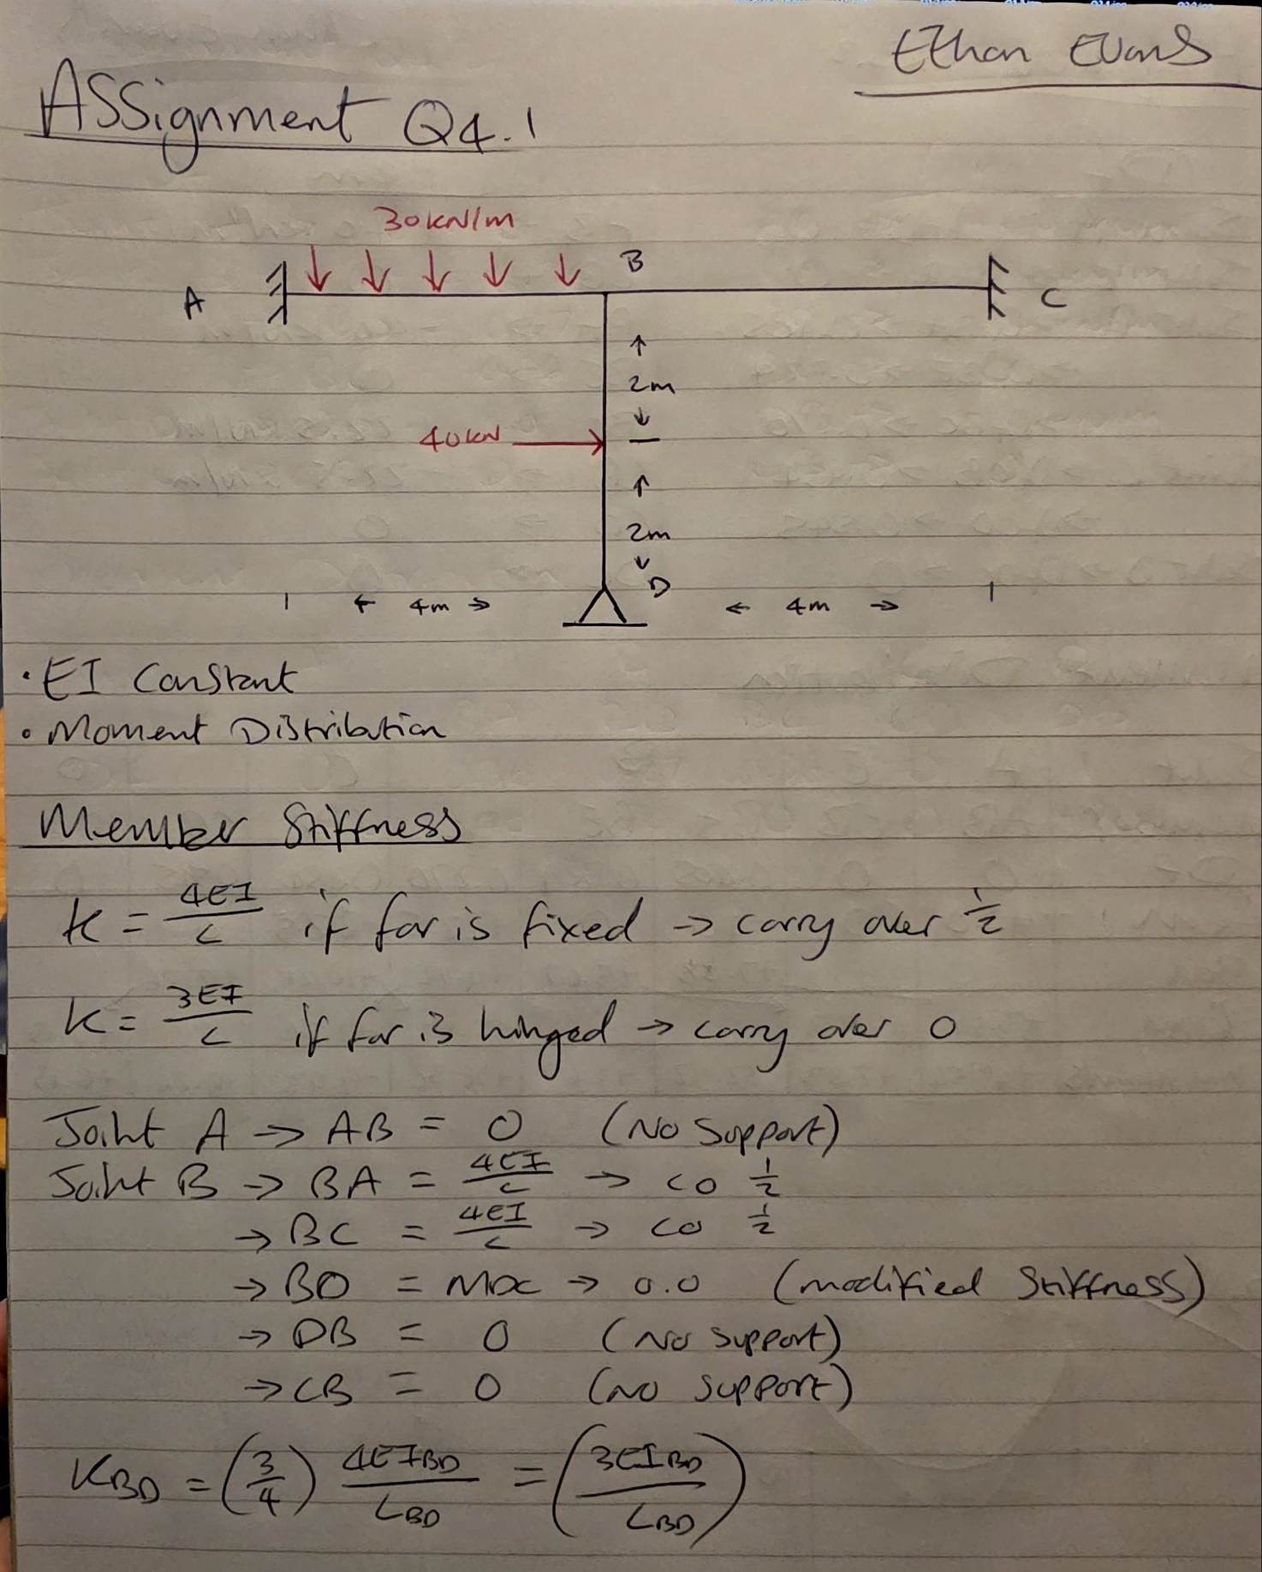
Equation 9: Q4.1 Frame Analysis using Moment Distribution (Ethan Evans 2025)
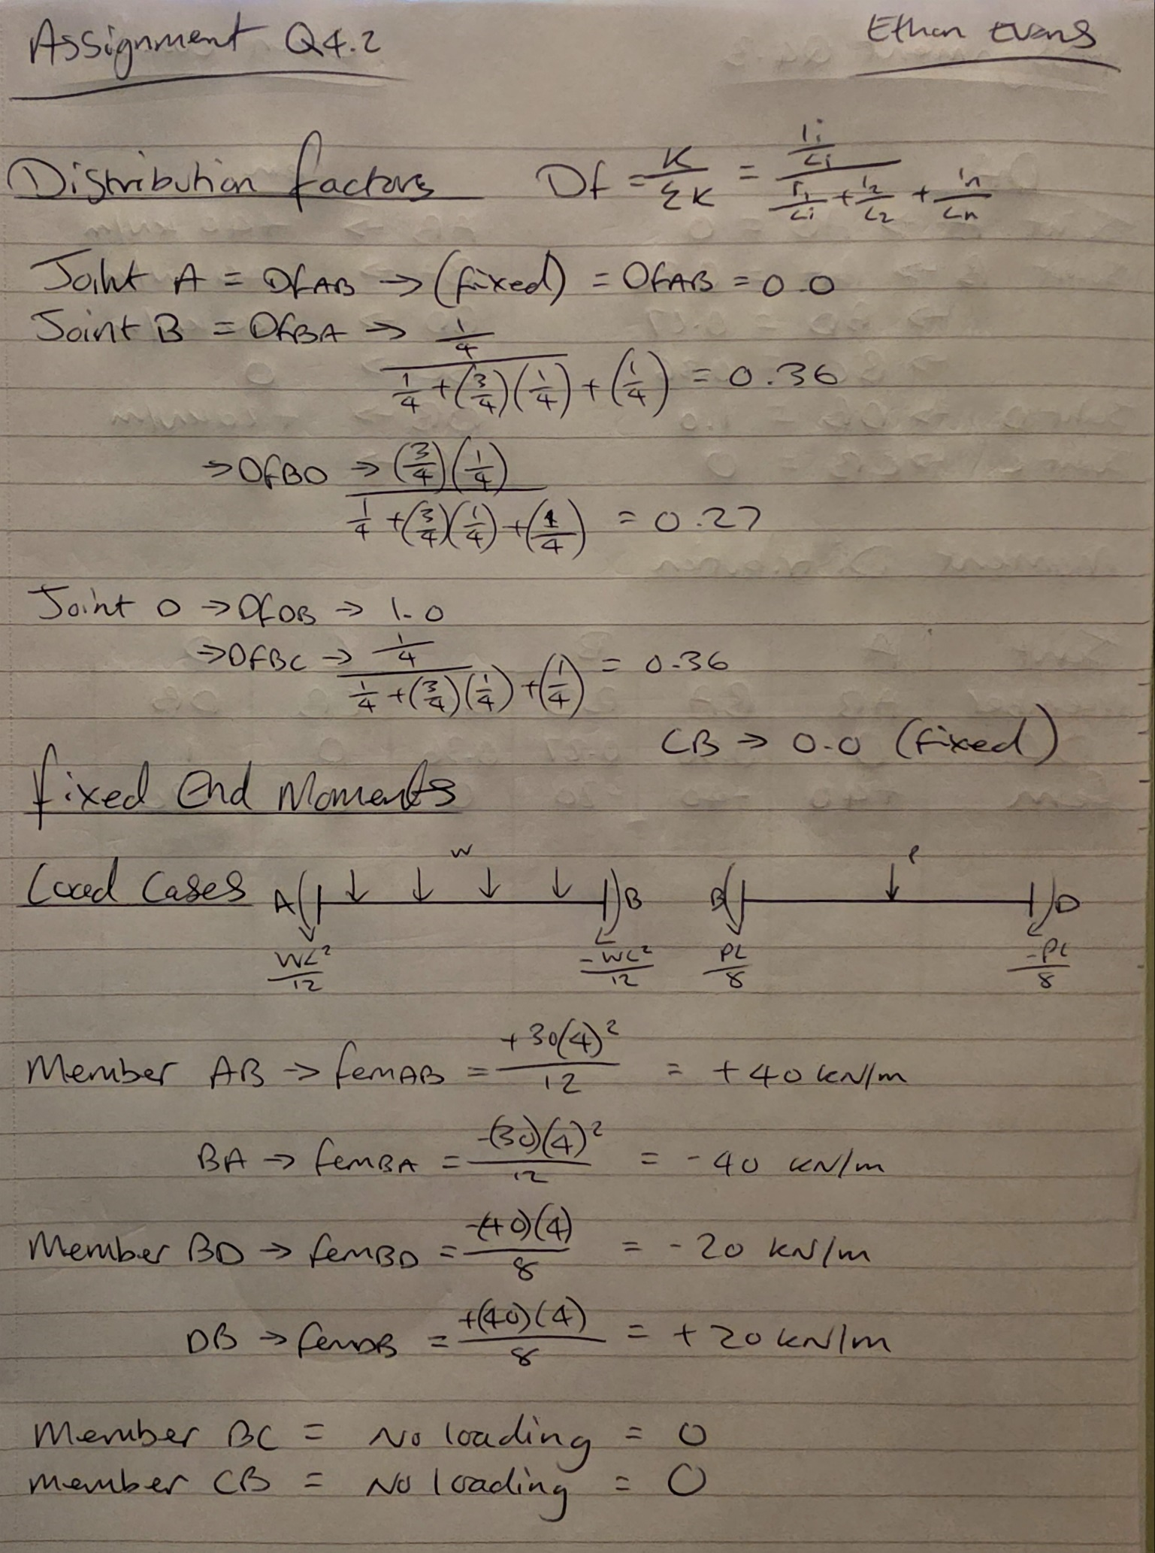
Equation 10: Q4.2 Frame Analysis using Moment Distribution (Ethan Evans 2025)
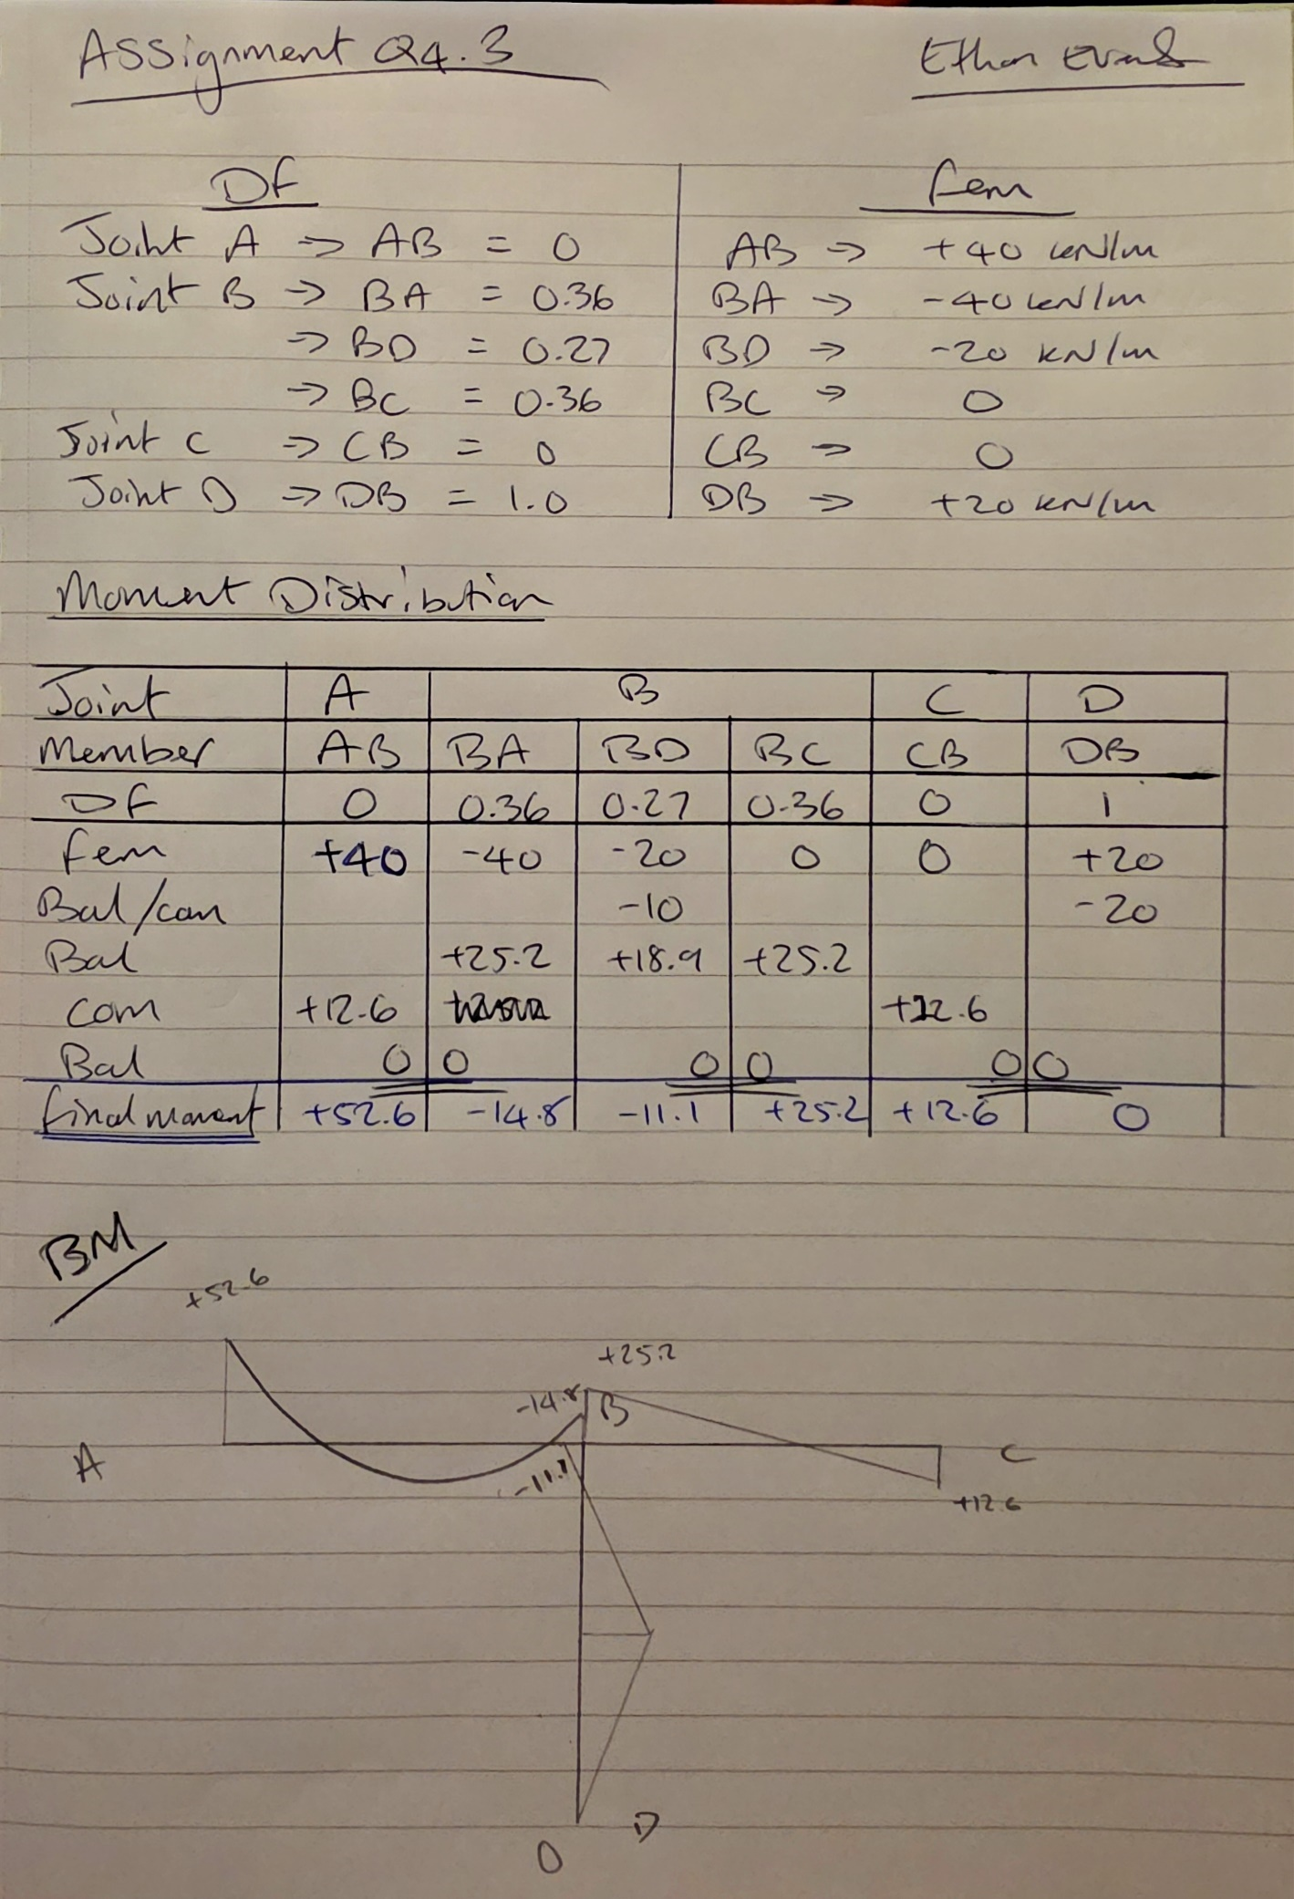
Equation 11: Q4.3 Frame Analysis using Moment Distribution (Ethan Evans 2025)

3.8 Q4 Robot Structural Analysis
Robot Analysis 9: Q4.1 Frame Analysis & Reactions - No dead load (Ethan Evans 2025)
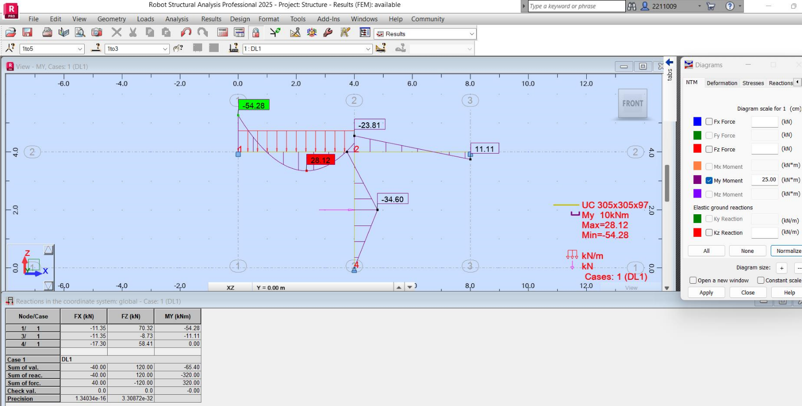
Robot Analysis 10: Q4.2 Bending Moment Diagram - No dead load (Ethan Evans 2025)
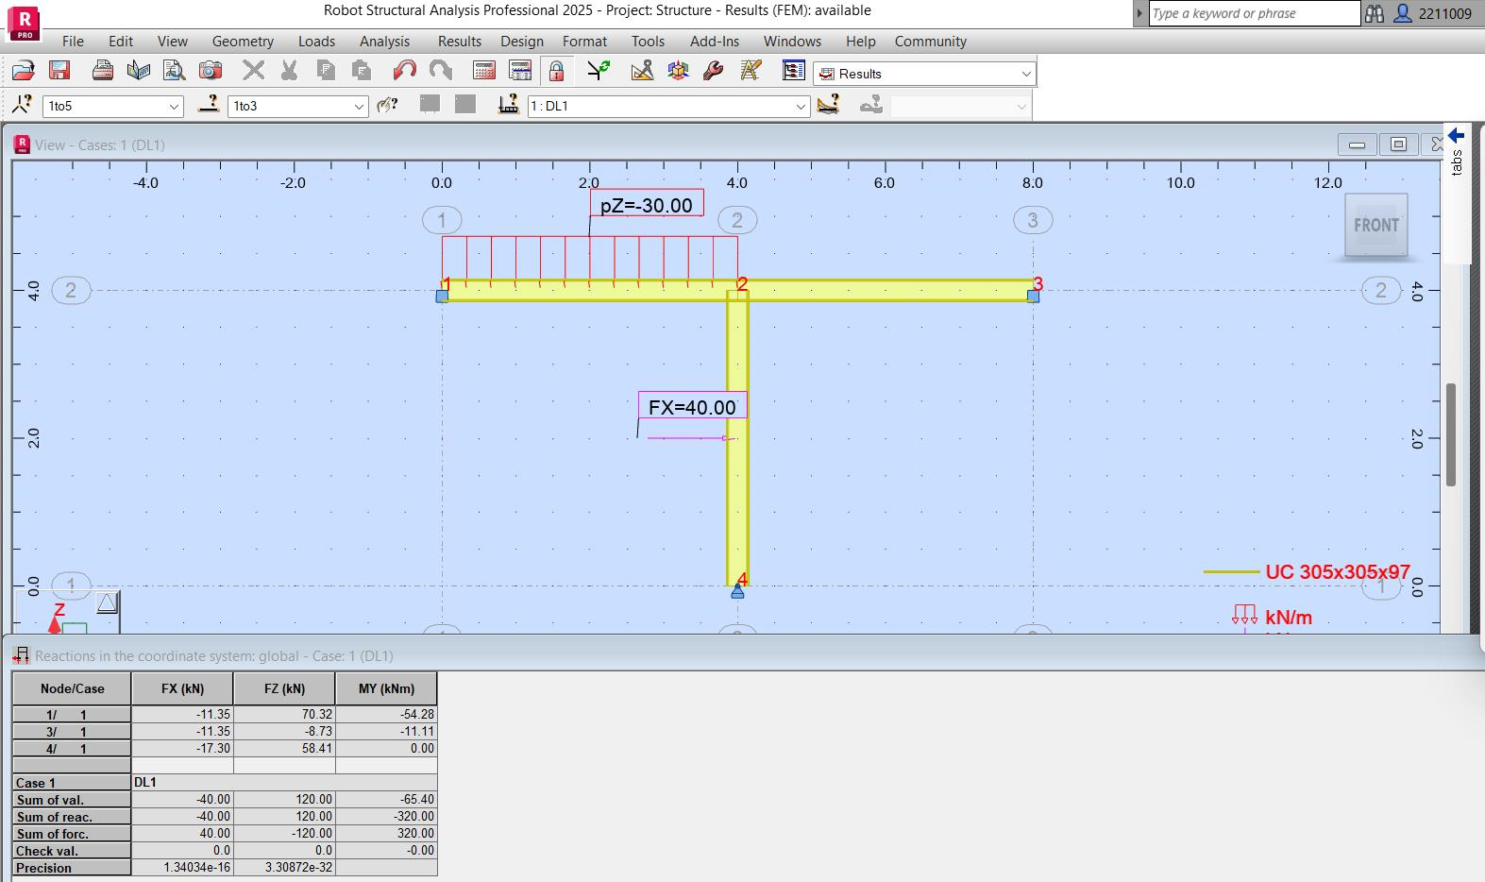

3.9 Q5 Hand Calculations
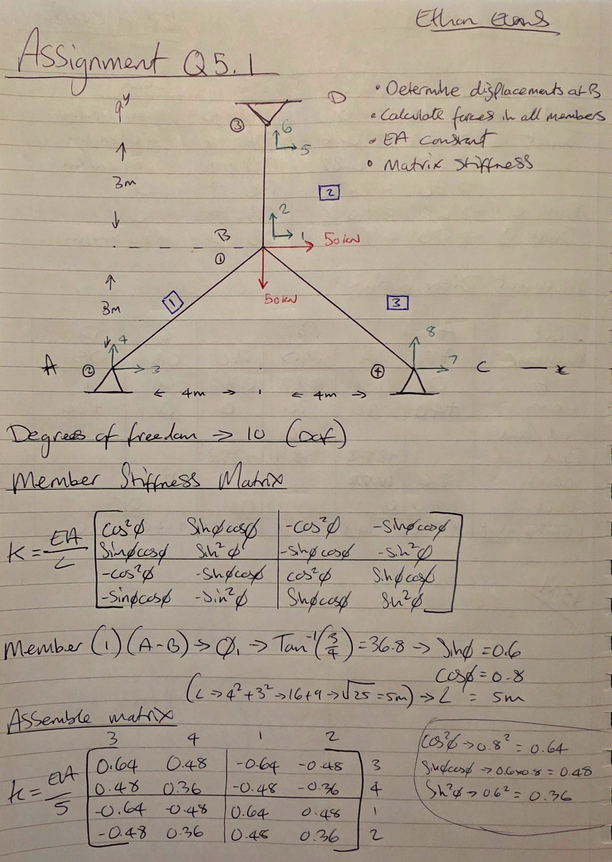
Equation 12: Q5.1 Truss Analysis using Matrix Stiffness Method (Ethan Evans 2025)
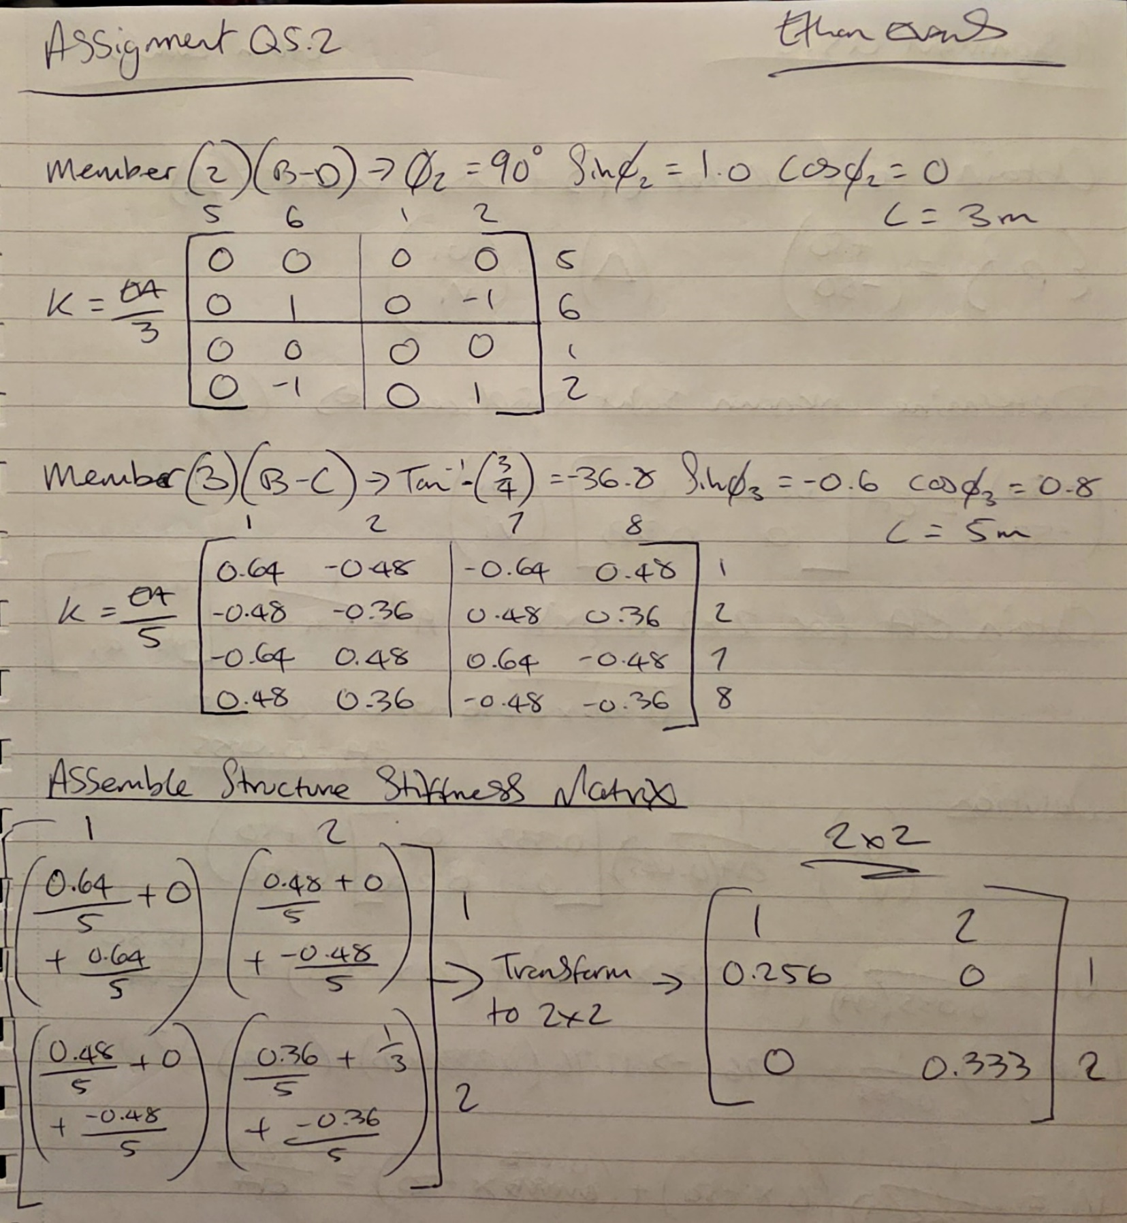
Equation 13: Q5.2 Truss Analysis using Matrix Stiffness Method (Ethan Evans 2025)
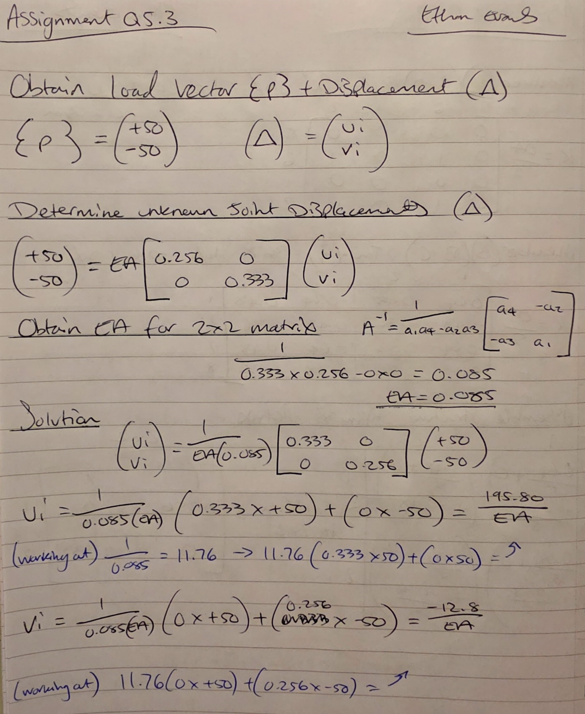
Equation 14: Q5.3 Truss Analysis using Matrix Stiffness Method (Ethan Evans 2025)
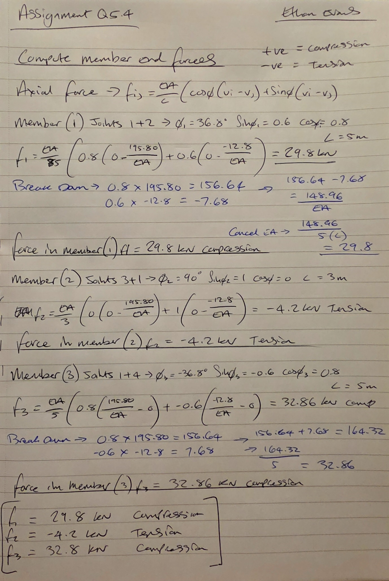
Equation 15: Q5.4 Truss Analysis using Matrix Stiffness Method (Ethan Evans 2025)

3.10 Q5 Robot Structural Analysis
Robot Analysis 11: Q5.1 Truss Analysis & Reactions - No dead load (Ethan Evans 2025)

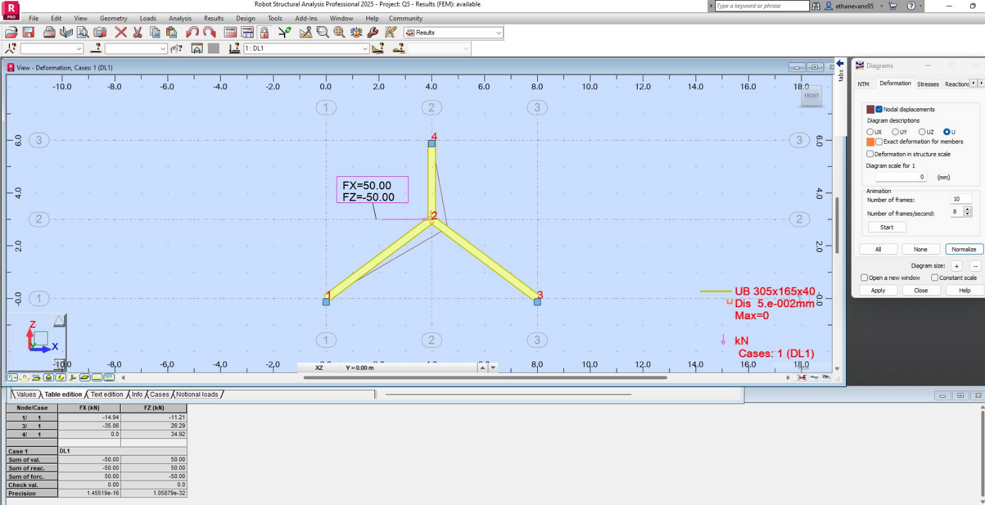
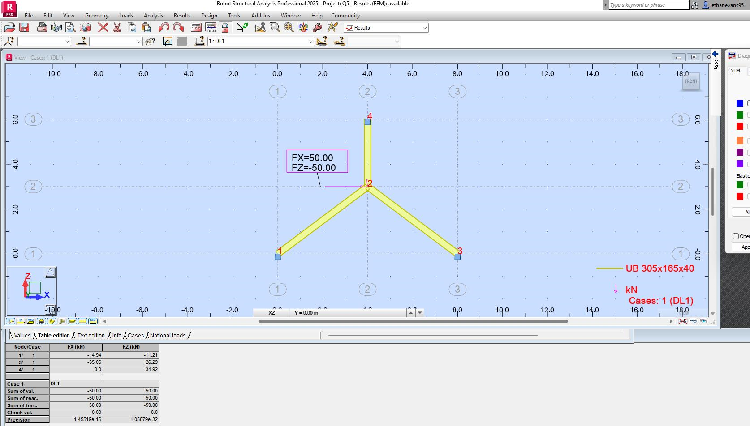
Robot Analysis 12: Q5.2 Truss Displacements - No dead load (Ethan Evans 2025)

Hand Calculations & Robot Analysis Comparison Comments
To check the hand calculation accuracy the researcher used Autodesk Robot Structural Analysis 2025, this software produces its figures and diagrams on the tension side so the researcher notes that the figures and drawings in comparison will be as accurate as possible. Robot Analysis is a great piece of software to design and implement different materials and codes, in two of the equations there are different values in comparison such as Q2 features twice EI which is determined by using a member with different moment of inertia, for example in this case the original member as seen in the screenshot is node 1-2 is Universal Beam 305x165x40 and the second member 2-3 is Universal Beam 356x171x57 which is twice EI. All models are produced in 2D beam/frame apart from Q5 which is produced in a 2D truss model to simulate no moment reaction. The first question for the continuous beam is both calculated with and without the dead load to see the difference of dead load reactions.

