

A Study into Accident Reporting within Small to Medium Enterprises in the Repair and Maintenance Sector in South Wales

Simon Paul David Williams

April 2020

Submitted in partial fulfilment of the requirements for the degree of Master of Science - Property and Facilities Management

Title:
A Study into Accident Reporting within Small to Medium Enterprises in the Repair and Maintenance Sector in South Wales

This research was undertaken under the auspices of the University of Wales: Trinity Saint David and Submitted in partial fulfilment of the requirements for the degree of
M.Sc. in Property and Facilities Management, April 2020

Researcher: Simon P. D. Williams
Researcher Student Number: 1502958

Dissertation Tutor: Dr Juan A. Ferriz-Papi

Word Count: 15,000 +/- 10%
Dissertation Word Count: 16,490

I declare that the work in this dissertation was carried out in accordance with the regulations of the University of Wales, Trinity Saint David. The work is original except where indicated by special references in the text and no part of the dissertation has been submitted for any other degree.

Any views expressed in the dissertation are those of the researcher and in no way represent those of the University of Wales, Trinity Saint David.

The dissertation has not been presented to any other University for examination either in the United Kingdom or overseas.

I hereby give permission for my work, if accepted, to be available for photocopying and inter-library loan, and for the title and summary to be made available to outside organisations.



This work has not previously been accepted in substance for any degree and is not being concurrently submitted in candidature for any degree.

STATEMENT 1
This dissertation is the result of my own investigations, except where otherwise stated. Where correction services have been used, the extent and nature of the correction is clearly marked in a footnote(s).
Other sources are acknowledged by footnotes giving explicit references. A bibliography is appended.

STATEMENT 2
I hereby give consent for my dissertation, if accepted, to be available for photocopying and for inter-library loan, and for the title and summary to be made available to outside organisations.

NB: Candidates on whose behalf a bar on access has been approved by the University, should use the following version of Statement 2:

I hereby give consent for my dissertation, if accepted, to be available for photocopying and for inter-library loans after expiry of a bar on access approved by the University of Wales on the special recommendation of the Member Institution concerned.

ABSTRACT
The UK construction industry is not only of great importance in terms of the financial contribution it makes to the UK economy, but also in terms of its role in the advancement of health and safety in the workplace. However, the under-reporting of accidents and injuries sustained in the workplace by employees is injurious to that valuable secondary role. The scope of this study was to: examine the reasons for under-reporting accidents; investigate whether management attitudes influenced the reporting accidents; and identify whether the use of technology could potentially influence employee reporting of workplace accidents.

The previous research in this field is examined through a review of the current literature. The literature review critically analyses previous academic work and identifies a lacuna in the research. It reveals the contribution this study makes to the field by building on existing research. Following the development of the literature review, the researcher formulated several hypotheses. These hypotheses were tested to satisfy the aims and objectives of the research through the approaches, methods and tools set out by the research methodology. The researcher developed three questionnaires that would aid the study. Each questionnaire used quantitative methods to collect nominal, ordinal and ratio data that was analysed with descriptive and inferential statistics. Both parametric and non-parametric tests were conducted to test the hypotheses.

The main findings of the research identified that forty-seven per cent of the sample of repair and maintenance operatives, (N = 211) indicated that, in the past 5 years, they have failed to report one or more workplace accidents while working in the repair and maintenance sector. The main reason given by operatives for not reporting accidents is that ‘operatives believed they were working unsafely and felt that the accident was their fault’. Eighty-seven per cent of all operatives believed this factor to be a moderate to major influence on the decision not to report the accident. Seventy-one per cent of operatives indicated that management attitude did influence their decision to report accidents with forty-six per cent of all respondents indicating the management influence was negative to some degree. Ninety-six per cent of the presentation sample (N = 26) indicated that technology, in the form of the presented software application, would impact positively on their decision to report an accident.

ACKNOWLEDGEMENTS

Throughout the writing of this dissertation I have received a great deal of support, assistance and encouragement.

I would like to thank Dr Juan A. Ferriz-Papi for his help, guidance and encouragement and past lecturers who have offered support and guidance along my academic journey.

I would like to thank all of the organisations and individuals who have assisted in making this dissertation possible. Several South Wales based sub-contracting companies responded to the researchers requests for participation and for that the researcher is enormously grateful.

I would finally like to thank my wife Rhian Williams for her many years of continuous support and encouragement and for her diligent proof-reading.

TABLE OF CONTENTS

ABSTRACT V
ACKNOWLEDGEMENTS VI
TABLE OF CONTENTS VII
LIST OF TABLES X
LIST OF FIGURES XII
LIST OF ABBREVIATIONS XV
1. INTRODUCTION 1
1.1 RESEARCH PROBLEM 1
1.2 JUSTIFICATION AND RATIONALE FOR THE RESEARCH 2
1.3 RESEARCH AIM AND OBJECTIVES 3
1.3.1 RESEARCH AIM 3
1.3.2 RESEARCH OBJECTIVES 3
1.4 SYNOPSIS OF THE DISSERTATION 4
1.5 SUMMARY AND LINK 5
2. LITERATURE REVIEW 6
2.1 INTRODUCTION 6
2.2 ORIGINS AND DEVELOPMENT OF HEALTH AND SAFETY IN THE UK 8
2.3 THE UNDER-REPORTING OF ACCIDENTS AND INJURIES 11
2.4 ORGANISATIONAL AND MANAGEMENT CULTURE AND ITS EFFECT ON THE UNDER-REPORTING OF ACCIDENTS 18
2.5 REASONS FOR NOT REPORTING WORK RELATED ACCIDENTS AND INJURIES 20
2.6 USING TECHNOLOGY TO IMPROVE HEALTH AND SAFETY 22
2.7 SUMMARY AND LINK 23
3. RESEARCH METHODOLOGY 24
3.1 INTRODUCTION 24
3.2 FORMULATION OF HYPOTHESIS 24
3.3 NATURE OF THE RESEARCH 26
3.4 RESEARCH PHILOSOPHY 26
3.5 RESEARCH APPROACH 28
3.6 RESEARCH STRATEGIES AND INSTRUMENTS 29
3.7 METHODS 30
3.7.1 PILOT STUDY 30
3.7.2 SAMPLE SIZE AND SELECTION 31
3.7.3 RESEARCH INSTRUMENTS AND IMPLEMENTATION 33
3.8 FRAMEWORK FOR DATA ANALYSIS 37
3.9 ETHICAL CONSIDERATIONS 39
3.10 LIMITATIONS AND POTENTIAL PROBLEMS 41
3.11 SUMMARY AND LINK 42
4. DISCUSSION 43
4.1 INTRODUCTION 43
4.2 THE CAUSATIONAL FACTORS AND THE REASONS FOR UNREPORTED ACCIDENTS AND INCIDENTS IN THE REPAIR AND MAINTENANCE SECTOR IN SOUTH WALES. 43
4.2.1 HYPOTHESIS ONE DISCUSSION 43
4.2.2 HYPOTHESIS TWO DISCUSSION 44
4.2.3 HYPOTHESIS THREE DISCUSSION 46
4.2.4 HYPOTHESIS FOUR DISCUSSION 46
4.3 ORGANISATIONAL FACTORS AND MANAGEMENT ATTITUDES AND HOW THEY INFLUENCE THE REPORTING OF ACCIDENTS AND INCIDENTS IN THE REPAIR AND MAINTENANCE SECTOR IN SOUTH WALES. 47
4.3.1 HYPOTHESIS FIVE DISCUSSION 47
4.3.2 HYPOTHESIS SIX DISCUSSION 49
4.3.3 HYPOTHESIS SEVEN DISCUSSION 50
4.4 CAN THE USE OF TECHNOLOGY CAN INFLUENCE EMPLOYEE REPORTING OF WORKPLACE ACCIDENTS WITHIN AN SME. 51
4.4.1 HYPOTHESIS EIGHT DISCUSSION 51
4.5 LIMITATIONS OF THE STUDY AND FURTHER RESEARCH 52
5. REFERENCES 56

APPENDICES 1
LIST OF APPENDICES 1
APPENDIX A: TRADE OPERATIVE SURVEY QUESTIONNAIRE 2
APPENDIX B: MANAGEMENT SURVEY QUESTIONNAIRE 8
APPENDIX C: FOCUS GROUP SURVEY QUESTIONNAIRE 12
APPENDIX D: FOCUS GROUP PRESENTATION SLIDES 15
APPENDIX E: OPERATIVE QUANTITATIVE DATA ANALYSIS 23
APPENDIX F: MANAGEMENT QUANTITATIVE DATA ANALYSIS 32
APPENDIX G: DISCRIPTIVE AND INFERENTIAL ANALYSIS 41
APPENDIX G 1: HYPOTHESIS ONE DATA ANALYSIS 41
APPENDIX G 2: HYPOTHESIS TWO DATA ANALYSIS 43
APPENDIX G 3: HYPOTHESIS THREE DATA ANALYSIS 45
APPENDIX G 4: HYPOTHESIS FOUR DATA ANALYSIS 47
APPENDIX G 5: HYPOTHESIS FIVE DATA ANALYSIS 48
APPENDIX G 6: HYPOTHESIS SIX DATA ANALYSIS 49
APPENDIX G 7: HYPOTHESIS SEVEN DATA ANALYSIS 50
APPENDIX G 8: HYPOTHESIS EIGHT DATA ANALYSIS 55

LIST OF TABLES
Table 1: Metatheoretical Assumptions (Webber, 2004) 27
Table 2: Construction employment levels by area (Welsh Government, 2018) 32
Table 3: Statistical techniques for quantitative research (Biggam, 2017) 38
Table 4: Levels of Data - Adapted from (Kostelis & Matthews, 2013) 39
Table 5: Descriptive Statistics for operative response option 1 23
Table 6: Descriptive Statistics for operative response option 2 23
Table 7: Descriptive Statistics for operative response option 3 24
Table 8: Descriptive Statistics for operative response option 4 24
Table 9: Descriptive Statistics for operative response option 5 25
Table 10: Descriptive Statistics for operative response option 6 25
Table 11: Descriptive Statistics for operative response option 7 26
Table 12: Descriptive Statistics for operative response option 8 26
Table 13: Descriptive Statistics for operative response option 9 27
Table 14: Descriptive Statistics for operative response option 10 27
Table 15: Descriptive Statistics for operative response option 11 28
Table 16: Descriptive Statistics for operative response option 12 28
Table 17: Descriptive Statistics for operative response option 13 29
Table 18: Descriptive Statistics for operative response option 14 29
Table 19: Descriptive Statistics for operative response option 15 30
Table 20: Descriptive Statistics for operative response option 16 30
Table 21: Descriptive Statistics for operative response option 17 31
Table 22: Operative descriptive Statistics 31
Table 23: Descriptive Statistics for management response option 1 32
Table 24: Descriptive Statistics for management response option 2 32
Table 25: Descriptive Statistics for management response option 3 33
Table 26: Descriptive Statistics for management response option 4 33
Table 27: Descriptive Statistics for management response option 5 34
Table 28: Descriptive Statistics for management response option 6 34
Table 29: Descriptive Statistics for management response option 7 35
Table 30: Descriptive Statistics for management response option 8 35
Table 31: Descriptive Statistics for management response option 9 36
Table 32: Descriptive Statistics for management response option 10 36
Table 33: Descriptive Statistics for management response option 11 37
Table 34: Descriptive Statistics for management response option 12 37
Table 35: Descriptive Statistics for management response option 13 38
Table 36: Descriptive Statistics for management response option 14 38
Table 37: Descriptive Statistics for management response option 15 39
Table 38: Descriptive Statistics for management response option 16 39
Table 39: Descriptive Statistics for management response option 1 40
Table 40: One sample t-Test to test hypothesised mean 41
Table 41: Frequency and Percentage for the under-reporting of accidents 42
Table 42: Frequency of Reasons for Not Reporting Workplace Accidents and Injuries 44
Table 43: Injuries that are not reported 45
Table 44: Fisher’s and Chi-Square 2x2 Contingency Table 46
Table 45: Management Influence on Accident Reporting 47
Table 46: Management Influence on Accident Reporting 47
Table 47: Management influence of Accident Reporting 49
Table 48: Mann Whitney U Test response option 1 50
Table 49: Mann Whitney U Test response option 2 50
Table 50: Mann Whitney U Test response option 3 50
Table 51: Mann Whitney U Test response option 4 50
Table 52: Mann Whitney U Test response option 5 50
Table 53: Mann Whitney U Test response option 6 50
Table 54: Mann Whitney U Test response option 7 51
Table 55: Mann Whitney U Test response option 8 51
Table 56: Mann Whitney U Test response option 9 51
Table 57: Mann Whitney U Test response option 10 51
Table 58: Mann Whitney U Test response option 11 51
Table 59: Mann Whitney U Test response option 12 51
Table 60: Mann Whitney U Test response option 13 52
Table 61: Mann Whitney U Test response option 14 52
Table 62: Mann Whitney U Test response option 15 52
Table 63: Mann Whitney U Test response option 16 52
Table 64: Mann Whitney U Test response option 17 52
Table 65: Mann Whitney U Test Results – Comparison of Operative and Management Responses 53
Table 66: Descriptive Statistics for Focus Group Questionnaires 54
Table 67: Focus Group questionnaire results 54
Table 68: Focus Group questionnaire results cont. 55

LIST OF FIGURES
Figure 1: Literature Review Pyramid Adapted From (Mahmutaj & Shrestha, 2011) 7
Figure 2: Inductive and Deductive reasoning - Adapted from (Trochim & Donnelly, 2008) 29
Figure 3: Sample Size Formula (Casa, et al., 2018) 33
Figure 4: Product Feasibility (Maksimavicius, 2017) 36
Figure 5: Software Application Model 37
Figure 6: Frequency of answers for operative response option 1 23
Figure 7: Percentages of answers for operative response option 1 23
Figure 8: Frequency of answers for operative response option 2 23
Figure 9: Percentages of answers for operative response option 2 23
Figure 10: Frequency of answers for operative response option 3 24
Figure 11: Percentages of answers for operative response option 3 24
Figure 12: Frequency of answers for operative response option 4 24
Figure 13: Percentages of answers for operative response option 4 24
Figure 14: Frequency of answers for operative response option 5 25
Figure 15: Percentages of answers for operative response option 5 25
Figure 16: Frequency of answers for operative response option 6 25
Figure 17: Percentages of answers for operative response option 6 25
Figure 18: Frequency of answers for operative response option 7 26
Figure 19: Percentages of answers for operative response option 7 26
Figure 20: Frequency of answers for operative response option 8 26
Figure 21: Percentages of answers for operative response option 8 26
Figure 22: Frequency of answers for operative response option 9 27
Figure 23: Percentages of answers for operative response option 9 27
Figure 24: Frequency of answers for operative response option 10 27
Figure 25: Percentages of answers for operative response option 10 27
Figure 26: Frequency of answers for operative response option 11 28
Figure 27: Percentages of answers for operative response option 11 28
Figure 28: Frequency of answers for operative response option 12 28
Figure 29: Percentages of answers for operative response option 12 28
Figure 30: Frequency of answers for operative response option 13 29
Figure 31: Percentages of answers for operative response option 13 29
Figure 32: Frequency of answers for operative response option 14 29
Figure 33: Percentages of answers for operative response option 14 29
Figure 34: Frequency of answers for operative response option 15 30
Figure 35: Percentages of answers for operative response option 15 30
Figure 36: Frequency of answers for operative response option 16 30
Figure 37: Percentages of answers for operative response option 16 30
Figure 38: Frequency of answers for operative response option 17 31
Figure 39: Percentages of answers for operative response option 17 31
Figure 40: Frequency of answers for management response option 1 32
Figure 41: Percentages of answers for management response option 1 32
Figure 42: Frequency of answers for management response option 2 32
Figure 43: Percentages of answers for management response option 2 32
Figure 44: Frequency of answers for management response option 3 33
Figure 45: Percentages of answers for management response option 3 33
Figure 46: Frequency of answers for management response option 4 33
Figure 47: Percentages of answers for management response option 4 33
Figure 48: Frequency of answers for management response option 5 34
Figure 49: Percentages of answers for management response option 5 34
Figure 50: Frequency of answers for management response option 6 34
Figure 51: Percentages of answers for management response option 6 34
Figure 52: Frequency of answers for management response option 7 35
Figure 53: Percentages of answers for management response option 7 35
Figure 54: Frequency of answers for management response option 8 35
Figure 55: Percentages of answers for management response option 8 35
Figure 56: Frequency of answers for management response option 9 36
Figure 57: Percentages of answers for management response option 9 36
Figure 58: Frequency of answers for management response option 10 36
Figure 59: Percentages of answers for management response option 10 36
Figure 60: Frequency of answers for management response option 11 37
Figure 61: Percentages of answers for management response option 11 37
Figure 62: Frequency of answers for management response option 12 37
Figure 63: Percentages of answers for management response option 12 37
Figure 64: Frequency of answers for management response option 13 38
Figure 65: Percentages of answers for management response option 13 38
Figure 66: Frequency of answers for management response option 14 38
Figure 67: Percentages of answers for management response option 14 38
Figure 68: Frequency of answers for management response option 15 39
Figure 69: Percentages of answers for management response option 15 39
Figure 70: Frequency of answers for management response option 16 39
Figure 71: Percentages of answers for management response option 16 39
Figure 72: Frequency of answers for management response option 1 40
Figure 73: Percentages of answers for management response option 1 40
Figure 74: Un-reported an Accident Frequency 42
Figure 75: Un-reported an Accident Percentage 42
Figure 76: Male Under-reporting 42
Figure 77: Female Under-reporting 42
Figure 78: The Frequency of Operatives Reasons for not Reporting Accidents 44
Figure 79: Percentage of Injuries considered reportable that have been un-reported. 46
Figure 80: Frequency of Injuries considered reportable that have been un-reported. 46
Figure 81: Under-reporting level - Males and Females 47
Figure 82: Males that have not reported an Accident 47
Figure 83: Females that have not reported an Accident 47
Figure 84: Management influence Bar Chart 49

LIST OF ABBREVIATIONS

HSWA The Health and safety and Work Act 1974
RIDDOR The Reporting of Injuries disease and dangerous occurrences regulations 1985
NADOR The Notification of Accidents and Dangerous Occurrences Regulations 1980
HSE The Health and Safety Executive
GDP Gross Domestic Product
DIA Denver International Airport
BLS Bureau of Labour Statistics
PDA Personal Digital Assistant
POC Proof of Concept
SME Small to Medium Enterprise
KPI Key Performance Indicator

1. INTRODUCTION

1.1 RESEARCH PROBLEM

The construction industry is considered to be one of the United Kingdom's most dangerous environments to work within. The labelling of the industry as "dangerous" is linked to not only the frequency of accidents but also the potential severity of the injuries which workers sustain. The desire to quell the frequency and severity of injuries in the industry has forged a web of health and safety measures. Successful health and safety measures in the construction industry seek to avoid accidents and injuries to the workforce, failing to achieve this will result in unfit employees, lost working days and the risk of litigation. There is significant financial incentive, if nothing else, to achieve safe working practices. Following the introduction of the Health and Safety and Work Act 1974 (HSWA 1974) and the Reporting of Injuries Diseases and Dangerous Occurrences Regulations 1985 (RIDDOR), figures for accidents in the UK construction industry appear to be successfully falling year on year. However, a considerable body of evidence (discussed in chapter 2) indicates that accidents and injuries are far more common in the workplace than official figures suggest. That poses a problem because it creates a false sense of security; it creates a false impression that the measures in place are achieving the objectives. That breeds complacency. It is only by accurately understanding the frequency and nature of accidents that one can gain an appreciation of the risks and how to mitigate them.

According to official reports from the Health and Safety Executive (HSE), (2019), fatal and non-fatal accidents at work have seen a dramatic reduction since the introduction of the above legislation. However, according to Probst et al. (2019), workplace accidents and workplace fatalities increased globally in 2018. In 2018 there were an estimated 374 million non-fatal work-related injuries worldwide with the resultant cost to the economy estimated to be 3.94% of global GDP (International Labour Organisation, 2019). These figures are substantial; however, the research tells us that these figures are just a proportion of the actual numbers of workplace accidents.
This research aims to identify several objectives that will contribute to current knowledge in this research area.

1.2 JUSTIFICATION AND RATIONALE FOR THE RESEARCH

When health and safety research is undertaken into the construction industry, it tends to be conducted into sectors such as 'new build’ or ‘infrastructure'. In order to widen the pool of information, this research focuses primarily on the repair and maintenance sector. The repair and maintenance sector is financially, the single most significant element of the UK construction industry. Total repair and maintenance orders in 2017, comprised 34% of all construction orders (Rhodes, 2019). Despite the economic significance, this sector of the industry has received little attention from a research perspective. Health and safety research with this sector is an almost unchartered topic. It is of rising importance internationally and has long been overlooked (Chan & Hon, 2016). Given the substantial financial contribution which the repair and maintenance sector makes to the UK economy and the volume of people which it employs, there is justification for undertaking research in this field.

There have been limited studies into the under-reporting of accidents in the workplace on the whole. Of those the researcher identified only a handful of studies concerning the construction industry and the studies identified had been predominately undertaken by many of the same researchers. This strongly suggests that more diverse research into this area is required.

This research will specifically focus on small to medium enterprises (SME's) in the repair and maintenance sector as they are a significant force in the UK economy. This study will build upon the existing research and will focus exclusively on the repair and maintenance sector, in respect of which Chan and Hon, (2016) identified there to be a significant lacuna in the research landscape.

In the limited research which does exist, some studies have found that in areas where job insecurity and high unemployment are prevalent, the rate at which accidents are under-reported increases. This research is conducted in South Wales, which holds the lowest GDP per Capita in the UK (Eurostat, 2018). Therefore, this allows for further comparative studies with other areas of the UK.

1.3 RESEARCH AIM AND OBJECTIVES

1.3.1 RESEARCH AIM

This research aims to investigate the under-reporting of accidents within SME's operating in the repair and maintenance sector in South Wales. Using the ‘Proof of Concept’, the research will endeavour to test whether technology can contribute to the advancement of accident reporting within SME's in the repair and maintenance sector in South Wales.

1.3.2 RESEARCH OBJECTIVES

- Identify and examine causational factors and the reasons for unreported accidents and incidents in the repair and maintenance sector in South Wales.

- Evaluate organisational behaviours and identify and examine whether management attitudes influence the reporting and non-reporting of accidents and incidents in the repair and maintenance sector in South Wales.

- Investigate whether the use of technology influences employee reporting of workplace accidents and incidents in the repair and maintenance sector in South Wales.

1.4 SYNOPSIS OF THE DISSERTATION

Chapter 1: Introduction
Chapter 1 of this dissertation introduces the research problem and discusses the justification and rationale for the research. This chapter sets the route of the research and provides the course which the reader will follow.

Chapter 2: Literature Review
This chapter presents and discusses the substance of the research. This chapter uses the principle of the ‘literature review triangle’. It begins broadly considering health and safety in the UK before narrowing the focuses more specifically on the critical point of the research, i.e. the under-reporting of accidents in the workplace and the reasons given by workers for not reporting accidents. The literature review evaluates the current understanding of the phenomena and assists in the formation of hypotheses.

Chapter 3: Research Methodology
Chapter 3 sets out the methodology used in the study and discusses the research design. This chapter begins with the formation of hypotheses, developed from reviewing the literature in chapter 2. It then presents the research approach, methods, strategies, and tools utilised to test the hypothesis.

Chapter 4: Discussion
This chapter discusses the main findings of the research by using the research methodology set out in chapter 3 to test the eight hypotheses developed in chapter 2. This chapter also provides details of the limitations the researcher encountered in this study and the recommendations for future and further research. This chapter concludes by summarising the study and accumulates the research findings to present the implications of the under-reporting of accidents in the repair and maintenance sector in South Wales.

1.5 SUMMARY AND LINK

This chapter has introduced the research problem, justified the research and provided a synopsis of the following chapters of this study. The next chapter in this study will review the existing literature.

2. LITERATURE REVIEW

2.1 INTRODUCTION

In this chapter, the researcher will identify, review and analyse existing research. The research undertaken by the researcher was exploratory in nature. Therefore, the first tier of research conducted was broad. That tier explored the available information regarding the origins and development of health and safety in the UK construction industry and the reporting of accidents in that sector generally. The researcher then sought to narrow the research to focus on the under-reporting of accidents and injuries in the UK construction industry before further attempting to contract the topic specifically to the under-reporting of accidents and injuries in the repair and maintenance sector. By this process, the researcher identified that there was no existing research into the under-reporting of accidents and injuries in the repair and maintenance sector. Therefore, the researcher reverted to investigating the under-reporting of accidents and injuries in the construction industry but sought to expand that research more laterally. This was undertaken by examining the available research into the factors influencing the underreporting of accidents and injuries in the construction industry, focusing mainly on the impact of organisation and management cultures. Having reached this stage, the researcher then sought to explore whether there was existing research into solutions to resolve this specific issue, in particular, the use of technology. This process led the researcher to identify that there is minimal research into the use of technology as a potential solution to the issue of under-reporting of accidents in the construction industry. Indeed, there is no existing research into this issue in the South Wales geographic region in respect of SMEs. Figure 1. provides a visual representation of the development of the exploratory research.
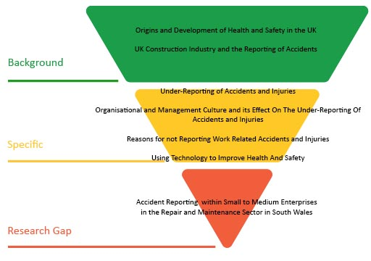
Figure 1: Literature Review Pyramid Adapted From (Mahmutaj & Shrestha, 2011)

It was this process which led the researcher to conclude that there was a gap in the research. Not only in terms of the reporting of accidents and injuries in the maintenance sector but also in terms of the use of technology as a solution to resolve the under-reporting of accidents. Therefore, a study examining these issues could contribute to the existing knowledge in the field. The research, developed organically and focussed the objectives of this study.

This study will seek to use and develop several past studies which were identified as part of the research. This study will expand upon the results from those studies to address the objectives. To this end, the researcher has sought to draw upon the approaches used in past studies in developing the research design. This is to ensure not only the validity of this study but to also ensure that the study contributes to the research gap. This feature of the study along with the process of analysing and evaluating the existing research in this field contributes to the researcher's aim of filling a gap in the research, contextualising the current knowledge and potentially identifying areas for others to build upon in the future. Following a review of the literature, this research will provide several hypotheses which the data collection and data analysis will subsequently seek to test.

2.2 ORIGINS AND DEVELOPMENT OF HEALTH AND SAFETY IN THE UK

In order to explore the under-reporting of accidents and injuries in the construction industry and the factors influencing under-reporting, it is first necessary to understand; the health and safety framework underpinning the industry, the development of that framework, and its requirements.

HSE, (2019) identifies that the origin of official health and safety monitoring in the United Kingdom can be traced back to the formation of Her Majesty's Factory Inspectorate which was established pursuant to the Factories Act in 1833. However, Parliament's first attempt at improving conditions for workers had, in fact, occurred some 30 years earlier with the Health and Morals of Apprentices Act 1802 (also known as the Factories Act 1802). That piece of legislation was of limited effect however, as it lacked any mechanism to enforce its attempts at regulation. It was not until the Factories Act 1833 that an inspectorate body was established to oversee and enforce the legislation. The primary duty of HM Factory Inspectorate, established under the 1833 Act, was to prevent injury and overworking of child textile workers. The factory inspectors were empowered to formulate regulations and laws to ensure the enforcement of the ethos of the Factories Act 1833. This led to legislation regarding machinery guarding and accident reporting. Over the next 26 years, the Mines Inspectorate was formed in 1843 followed by the Quarry Inspectorate in 1895. By 1956 the agricultural industry had followed suit by introducing legislation to regulate health and safety in that industry and in 1959 the Nuclear Industry followed. This influx of regulation and legislation was prompted by the Industrial Revolution which by the mid-1800s had resulted in a myriad of new manufacturing methods across Europe and the United States and with those new methods came higher risk of workplace injury. What became apparent from the 30 years between the 1802 Act and the 1833 Act is that health and safety legislation was only effective with an inspectorate body which was empowered to enter, investigate and sanction those who failed to comply.

The 1970s saw the significant development of the workplace legislative landscape. Attempts were made in the early 1970s to introduce Health and Safety legislation in the UK with the Employed Persons (Health and Safety) Bill. However, that Bill floundered despite the passage of the Occupational Safety and Health Act in the USA. As a result of the 1970 Bill floundering a Committee of Enquiry was established to report on workplace health and safety. The Robens Report was published in 1972. It paved the way for the revolutionary Health and Safety at Work Act 1974 (HSWA 1974) and the consequential establishment of the Health and Safety Commission and the Health and Safety Executive in 1975 which were created to regulate and enforce the legislation. The HSWA 1974 was revolutionary for the UK as for the first time it merged the health and safety of all industries into one piece of primary governing legislation which enabled the creation of a battery of pieces of secondary legislation in the form of Regulations and Codes of Practice. Crucially the 1974 Act learned from the mistakes of the first Factories Act and established not only principles and standards in terms of health and safety in the workplace but also made provision for the inspection and auditing of workplaces across all industries to ensure that the Act had 'teeth'. In 2019, 45 years after the HSWA 1974 received Royal Assent, it remains the core piece of primary legislation in the UK for health and safety.

The durability of the HSWA 1974 is in part due to its battery of supportive secondary legislation. For the purposes of this study, a particularly significant directive was The Notification of Accidents and Dangerous Occurrences Regulations 1980 (NADOR). NADOR’s significance was that it went beyond mere regulation and inspection by external monitoring agencies; it transferred responsibility to require employers and the self-employed to record and report accidents and dangerous occurrences. This allowed the HSE to monitor the rate of reported accidents and dangerous occurrences in the workplace across all industries.

However, NADOR was relatively short-lived and was replaced by The Reporting of Injuries, Diseases and Dangerous Occurrences Regulations 1985 (RIDDOR). According to the HSE (2019), RIDDOR was introduced, in order to legally "require a 'responsible person' to notify the enforcing authority where a person dies or sustains any injuries or specific medical conditions or where a dangerous occurrence takes place in connection with a work activity". From this date, the Regulations have been changed and have evolved several times to ensure that the controls are fit for purpose.

Today, health and safety in the workplace is well-established throughout every sector of industry in the UK. However, accidents and injuries sustained whilst at work still present a serious issue. In 2016/17 alone, workplace accidents and injuries cost the UK economy an estimated £5.2 Billion. This expense was the result of 581,000 non-fatal injuries sustained by employees, those incidents resulted in 4.7 million lost working days. These figures may seem exorbitantly high; however, the Health and Safety Executive, (2019) suggests that since the introduction of the HSWA 1974 the rate of self-reported workplace non-fatal injuries have reduced by an estimated 50% and employer reported non-fatal injuries have also decreased by an estimated 58% since 1986 (Health and Safety Executive, 2018).

It is apparent therefore that whilst there has been a significant reduction in self-reported workplace accidents in the UK which is perhaps demonstrative of the efficacy of the 1974 Act, workplace accidents continue to be a dogged issue which can cause significant losses to businesses and industries across the UK. It must be the objective of all industries and workplaces to reduce workplace accidents. The reporting of accidents when they occur is crucial to achieving that objective as without knowing and understanding where unsafe, risky or dangerous practices exist it is incredibly difficult to seek to prevent and mitigate those risks with a view to reducing accidents and injuries. Failing to report accidents; therefore, not only risks placing a business in breach of the statute and regulations but also impedes the objective of reducing workplace accidents and injuries and thus unnecessary expenditure or loss of profits.

In the UK, the construction industry is a particularly important employment sector which accounts for approximately 6.5% of the UK workforce. During the second quarter of 2019, the sector directly employed 2.4 million (6.6%) people and contributed approximately 6% of gross domestic product (GDP) to the UK economy (Rhodes, 2019). These figures account for around £113billion per annum (Health and Safety Executive, 2018). However, despite its financial prominence and the extraordinary and rigorous endeavours to impose health and safety legislation to prevent and mitigate risks, the construction industry is still regarded, both in the UK and throughout the world, as one of the most dangerous industries to work within (Wanberg, et al., 2013; Mohseni, et al., 2015).

In 2017/2018, the UK construction industry had the second-highest number of reported work-related accidents in the UK; only the UK agricultural industry had more work-related accidents (Health and Safety Executive, 2019). During 2016 there were 2,940 work-related accidents per 100,000 workers, and in 2017-18 according to the HSE, there were 58,000 non- fatal injuries reported, of which 30% were 3-day injuries, and 24% were over 7-day injuries. This resulted in 400,000 lost working days and an economic cost of £490 million (Health and Safety Executive, 2018). These figures, however, only represent reported accidents. The actual number of work-related injuries in the construction industry is likely to be far higher.

2.3 THE UNDER-REPORTING OF ACCIDENTS AND INJURIES

According to Hosseinian & Torghabeh (2012) 'accidents' are an unplanned and unwanted occurrence, involving the movement of persons, objects or materials which may result in injury, damage or loss to property or people. The majority of accidents sustained at work; however, would not require an employer notify the HSE through RIDDOR. There is a difference between the requirements for a reportable injury under RIDDOR and what accidents a company would expect an employee to report. Most employers would expect all accidents which result in personal injury to be reported and recorded in the organisations' accident book. At a bare minimum, an employer is required to record any injury that results in lost workdays pursuant to The Social Security (Claims and Payments) Regulations 1979 which states: “Every employed earner who suffers personal injury by accident in respect of which benefit may be payable shall give notice of such accident either in writing or orally as soon as is practicable after the happening thereof”.

As set out above, the HSE reports that since the introduction of the HSWA 1974 the rate of self-reported workplace non-fatal injuries have actually reduced by an estimated 50% and employer reported non-fatal injuries have also decreased by an estimated 58% since 1986 (Health and Safety Executive, 2018). Therefore, it would appear that there has been a significant reduction in both self-reported and employer reported non-fatal injuries since the introduction of the HSWA 1974. The figures are undeniably impressive and could be said to be superficially demonstrative of the efficacy of the HSWA 1974, i.e. there has been a reduction in accidents and injuries in the workplace due to the introduction of more rigorous and stringent health and safety regulations and legislation. However, many researchers would argue that the figures provided by the HSE are misleading and misrepresentative. Much research has been undertaken, as far back as two decades, which contradicts the official figures for the rate of self-reported workplace non-fatal injuries. Existing research offers a number of examples whereby work-related accidents in the construction industry go unreported, and there are considerably more incidents than the official figures indicate (Pransky, et al., 1999; Probst & Estrada, 2010; Taylor- Moore, et al., 2013; Tucker, et al., 2014; Wuellner, et al., 2016; De Silva, et al., 2018).

A significant amount of academic and organisation-led research has been conducted into many areas within the construction industry to explore the reasons accidents and models for improving health and safety. However, over the past two decades, only a small number of studies have investigated the under-reporting of accidents and injuries in the industry. This is despite the fact there is evidence which demonstrates that the construction industry is experiencing one of the highest rates of accidents in any sector worldwide. The research that has been undertaken in this area has indicated that the actual number of accidents that occur in the construction industry is unclear. Whilst there is limited research into the issue, all of the significant research undertaken has identified some element of under-reporting. The research that has been conducted suggests that the under-reporting of accidents could be anywhere between 29% and 80% depending on variables such as organisational culture, job insecurity and the type of work activities (Tucker, et al., 2014). Therefore, depending on which study is used, the figures for under-reporting can vary greatly.

For many researchers, the reported figures are always likely to be inaccurate due to the self-governing methods used for reporting, i.e. the figures are entirely dependent upon either those who sustain the accident or injury or the employer reporting the matter. That is of significance in the circumstances where almost all of the available research undertaken has found that there is a significant trend of under-reporting accidents and injuries across all industries. (Glazner, et al., 1998; Pransky, et al., 1999; Probst & Estrada, 2010; Dong, et al., 2011; Taylor- Moore, et al., 2013; Tucker, et al., 2014; Wuellner, et al., 2016; De Silva, et al., 2018).

In 2007 the HSE commissioned research that investigated this very issue. The study conducted by Davis, et al. (2007) aimed to examine the under-reporting of accidents, which were reportable pursuant to RIDDOR, to the HSE. It reviewed accident reports that were made to the HSE and compared those accident reports with patients attending the Royal Liverpool University Hospital as a result of workplace accidents. The study revealed that only 30% of the research's identified reportable accidents were reported to the HSE. The study also determined that the self-employed sector was particularly poor at reporting workplace accidents, with a woeful reporting rate of just 12% as compared with 32% for employed workers (Davies, et al., 2007). This study had a sample group of 488, it was able to provide primary sensitive data, and therefore, the findings of the study could be considered to be reliable and valid. This study's findings are regarded as reliable as the study only aimed to apply to the study sample and did not aim to use its results to the wider population.

However, there are some limitations to the study. Firstly, the study aimed to investigate the ‘under-reporting’ of workplace accidents and incidents. It would be reasonable to expect that a study investigating the under-reporting of accidents would seek to investigate the reasons why employees/employers ‘did not’ report accidents. However, the study only recorded information on the reasons why people did report accidents. The reasons why employers and employees report accidents should be perhaps less of an enigma in reality as there is a legal requirement to report. The crucial and more illuminating question is why employers and employees are breaching the statutory requirement to report. In order to remedy the issue of non-reporting, it is necessary to understand the reasons for non-reporting, which this study did not address. Secondly, whilst the concept of quantifying those who suffered work-based accidents via hospital attendances and comparing those figures with the reported figures was valuable and informative, the mechanism used meant that the study missed all under-reporting of individuals who had suffered injuries but had not sought medical attention. In this regard, the research fell into the very trap which other researchers had criticised the HSE for, i.e. it is challenging to identify how many accidents are going unreported if there is no objective way to quantify them in circumstances where the regulatory framework is almost entirely dependent upon self-reporting. What this study does show, however, is that the under-reporting of accidents in the workplace is significant, and the figures are undoubtedly worse in reality than this study was able to reveal. This is because if employers/employees are regularly failing to report accidents for which hospital treatment was required (thus indicating the incident involved an injury must have been beyond the superficial) which are absolutely reportable, then how regularly are more minor incidents which do not require meaningful medical treatment being under-reported? The study also found that the most significant number of reportable accidents came from occupations connected with the construction industry (both labouring and trades).

Probst, Brubaker, and Barsotti (2008) followed on from the HSE commissioned research and directed research that explicitly sought to identify the issue of under-reporting of workplace accidents within the construction industry. The study looked at a sample of 1,390 employees working for 38 companies that were contracted to work at a large construction site. The study investigated the number of accidents and injuries reported in the accident book and compared the data and figures identified with the owner-controlled insurance policies. The results of the research found that the annual rate of injuries reported was 3.11 per 100 workers. However, the rate of insurance eligible injuries not reported was 10.90 per 100 workers. The research showed a clear case of under-reporting of accidents within this large construction project. The research further identified that companies that had poor health and safety principles had significantly higher rates of under-reporting. It was documented that these companies did not report up to 81% of eligible injuries. Whereas, organisations with a good health and safety approach did not report 47% of eligible injuries. The researchers were able to obtain a high level of participation which give validity to the findings. The results of the study confirmed the findings of previous research indicating that the rate of accidents and injuries occurring within organisations often vastly surpasses the injuries that are reported. A shortcoming of the study, however, was that the study addressed the under-reporting from an organisational level and not from an individual level. Therefore, similarly to the HSE commissioned research by Davis et al. (2007), this study did not explore the reasons why people do not report accidents, it only aimed to confirm the hypothesis that under-reporting was occurring. Furthermore, whilst the study focused on investigating under-reporting at an organisational level, it did not progress to assess the extent to which the organisational culture of the companies influenced employee under-reporting of injuries to supervisors. What the study did confirm, however, was that there was clear evidence to support the theory that there was significant under-reporting of accidents within the construction industry.

If one accepts that the objective and ethos of the Health and Safety legislation and regulatory framework is to make working practices safer and reduce workplace accidents, then it must follow that understanding the nature and frequency of accidents is crucial to make practices safer. Therefore, statistics which are not representative of accident rates and working practices creates a false impression of the efficacy of the health and safety measures. This can combat the objectives and ethos of the Act as it implies that working practices are improving and accidents are reducing when, in reality, it may simply be that reporting is reducing. In order to give effect to the ethos and objective of the Act, it is vital that accurate reporting occurs and under-reporting is reduced. In order to reduce under-reporting, it is crucial as a first stay to understand why it is that employers and employees are breaching their statutory duties to report accidents in order that strategies to address these reasons can be considered and implemented. The goal of everyone must surely be the same: 'to make working practices safer'. Employers need to avoid workplace accidents as they are costly and inconvenient, workers need to avoid workplace accidents as they can cause severe injury and even death. Yet something is preventing the reporting of such incidents despite the reporting being part of the process by which working practices will ultimately be improved. Whilst the above referenced well-known research studies both demonstrated the high level of under-reporting of accidents; there appears to little evidence to suggest any significant steps have been taken over the last decade to combat this phenomenon. Indeed, there has been very little in terms of follow up research by the HSE on this discernible issue. The research which is available has been conducted by individual academics and groups of scholars.

Is this issue of under-reporting of accidents in the workplace and in particular in the construction industry, therefore unique to the UK? The answer appears to be: no. This is demonstrated by examining a more ‘international’ piece of research by Glazner et al. (1998) which evaluated the under-reporting of accidents during the construction of Denver International Airport (DIA). This significant piece of research obtained safety and accident data on 32,000 employees employed by 433 construction companies. The research identified that the injury rates incurring during the construction of DIA were twice that reported in the published data by the Bureau of Labour Statistics (BLS). The analysis within this research of injuries as compared to company size was different to the records of the BLS's. The research showed that small firms had injury rates that were less or akin to many other larger organisations. However, BLS's records showed that injuries in small firms were lower than those for all but the largest companies which had over 250 employees.

Dong et al. (2011) examined injury under-reporting among small establishments in the construction industry in the United States. This particular research divided the sample based on ethnicity; however, when measured, the calculated rate showed that approximately 57.5% of construction accidents go unreported. This figure is fairly consistent with the levels identified by (Glazner, et al., 1998). However, Dong et al. (2011) found that workers in smaller construction companies were less likely to report accidents when compared to larger, more established companies. These findings directly contradict the research finding of Glazner et al. (1998).

There are limitations to both of these studies; both relied on secondary data to form large parts of their research. This made the research one dimensional and limited the research to formulating questions based on the available data. Both studies were similarly unable to give insight into the valid reasons why under-reporting was occurring and like the 2007 and 2008 UK studies referred to above, could not present any credible solution to the problem. However, due to the sample sizes of both studies, it could be argued that the validity of the research findings is credible and reliable.

Therefore, the researcher can conclude at this stage that there is evidence and research to confirm that there is significant under-reporting of accidents in the construction industry and therefore the statistics indicating reducing workplace accidents and efficacy of the HSWA 1974 are not necessarily as positive as they first appear. There is, however, limited research thus far to investigate the reasons why accidents are unreported and the factors that could explain or influence the under-reporting of accidents. Adams and Hartwell, (1977) in a study conducted shortly after the implementation of the HSWA 1974, suggest that in organisations where a blame culture exists, workers may be reluctant to report accidents. This is due to a fear that employers would apportion blame to the individual. The implication from this research is, therefore, that organisational behaviours and cultures may influence the under-reporting of accidents. However, other studies suggest that workers do not report accidents due to psychosocial, economic and cultural factors which are wholly independent from organisational influences (Pransky, et al., 1999; Schnieder, 2001; Rosecrance, et al., 2002; Probst, et al., 2008).

It has also been suggested that organisational failings in terms of conveying and emphasising the importance and purpose of reporting accidents has led to the significant levels of under-reporting shown in previous research. Pransky et al. (1999) suggests that the accurate reporting of work-related accidents and injuries is necessary to monitor workplace health and safety and to identify the interventions when they are most needed. This is a prominent statement which likely be endorsed by many professionals within the construction industry yet how that is conveyed may influence how workers interpret their obligations.

According to Probst, Petitta and Barbaranelli (2017) the under-reporting of workplace injuries ultimately occurs at one of two points within the chain of reporting. Firstly, when an injury occurs, and the employee decides to report it or fails to report it to their employer. Secondly, when an organisation decides whether to include an employee injury in the official accident book. Therefore, the first potential break of the chain is the individual employee; this is the person who has actually suffered the accident and who should arguably be most motivated to report it to their employer who after all owes them a duty of care. This first break in the chain is crucial; the second chain break by the employer is not even engaged if the accident is not reported in the first place. Therefore, in order for any further or future research to examine to what extent under-reporting is due to chain break two, one must first explore and resolve the first chain break one in order to identify to what extent the under-reporting is down to the employee failure or the employer failure.

This research will investigate under-reporting from an individual perspective and not from an organisational perspective and will seek to identify and explore the reasons why accident go unreported and whether organisational and management cultures influence such decisions.

2.4 ORGANISATIONAL AND MANAGEMENT CULTURE AND ITS EFFECT ON THE UNDER-REPORTING OF ACCIDENTS

There is existing research which has indirectly investigated organisational and management cultures and its effect on the under-reporting of accidents. The research expresses the issue as "the effect of job insecurity on employee safety”. One of the most prominent researchers to investigate both the under-reporting accidents in the workplace and the effect of job insecurity on employee safety is Tahira M. Probst. The research undertaken by Probst and Brubaker, (2001) and Probst, (2002) were essentially unique in terms of their focus directly on employee job insecurity and the effect this has on employee safety. The studies identified that job insecurity has detrimental effects on employee safety attitudes, behaviours, and outcomes.
In more recent research, it was identified that job insecurity related to more workplace accidents. The same research recognised job insecurity correlated with a higher propensity to not report such accidents (Probst, et al., 2017; Jiang, et al., 2018). Therefore, one could reasonably conclude that one of the reasons that workers who sustain workplace accidents may not report them, is due to a fear of losing their jobs. This is a factor which is connected to organisational and management attitudes which appear to intentionally or unintentionally, directly or indirectly influence operative decisions when deliberating whether or not to report accidents. This influence may, of course, not be the case or indeed the intention from the managers perspective, this may only be the subjective perception of the operative. Nonetheless, this reason even if an inaccurately perceived notion, could still could influence the under-reporting of accidents in the workplace. It is crucial for a manager or organisation to understand if incorrect or unintentional operative perceptions are influencing reporting of accidents as whilst the manager or organisation may not have actively taken steps to create that impression they may need to take active steps to dispel the impression to ensure compliance with their statutory duties.

Research by Palali and Van Ours (2017) would seem to support the research conducted by Probst (2017). The research by Palali and Van Ours (2017) purports that workplace accidents do not always reflect workplace safety because workers under-report accidents for fear of reprisal. The workers in their study would not report accidents through the fear of losing their job if they did report having had an accident. The research conducted by Palali, and Van Ours (2017) investigated accident reporting across 15 European countries and found evidence that workers were less likely to report a workplace accident when unemployment was high. The research also found that workers in temporary employment posts were also less likely to report accidents. This research gives further credibility to the theory that organisational culture and management attitude has an effect on the under-reporting of accidents in the workplace. An interesting and relevant observation of this piece research is the correlation between under-reporting and high unemployment. This is relevant to the current study as South Wales is ranked lowest in the UK by GDP per capita and also has above average unemployment when compared to the UK average (Eurostat, 2018).

These studies follow the theme of identifying that there was evidence of under-reporting of accidents as a matter of principle. They go further in identifying an evidence-based connection between under-reporting and employee perception of job security which may or may not be the result of management or organisational cultures.

2.5 REASONS FOR NOT REPORTING WORK RELATED ACCIDENTS AND INJURIES

As set out above, the existing research has identified that there is an issue in terms of under-reporting of accidents as a matter of principle but has primarily focused on organisational or individual circumstances to explain the rate of accidents which go unreported. There is minimal research into the actual reasons why individuals chose not to report accidents and injuries sustained in the workplace.

One of the few studies which did investigate individual worker perspectives was conducted by (Pransky, et al., 1999). The format of the study consisted of a questionnaire that was given to a small sample of 110 workers and several managers. The questionnaire revealed that less than 5% of the workers had officially reported a work-related injury. Despite that low reporting figure, 85% of the respondents stated they had, in fact, sustained some form of work-related accident. Of the sample group, 50% also reported persistent work-related issues as a result of injuries suffered at work, 30% of the sample reported lost time or working light duties as a result of their injury or ailment. This evidenced a significant disparity between injuries and accidents sustained and reporting and thus followed the same theme of other research. This study, however, also demonstrated that not only were injuries being sustained, but those injuries were impacting on worker productivity on an ongoing basis and yet were still not reported. The study sought to go further by endeavouring to identify some of the reasons why workers in the same group may not report injuries. One of the reasons offered by the individuals was that they feared reprisals, including a loss of bonuses and workplace incentives. Some workers also approached the issue from the mindset that some risks came with the nature of their work and therefore, they viewed accidents as 'part of the job'. This piece of research by Pransky et al., (1999) was one of the first studies of its kind which investigated from the workers perspective the rationale for non-reporting of work-based injuries. The research did, however, have some limitations; the sample size was quite small and therefore the reliability and validity of the study may be questionable. However, the principles of the study and the approaches used provided a solid bedrock for further research to build upon. Despite the limitations which accompany the sample size issue, this study is still an important piece of research. This is in part due to the lack of other meaningful studies exploring the rationale for under-reporting. As a result, the (Pransky, et al., 1999) study continues to provide a credible foundation for the current research two decades after it was undertaken.

A more recent study which followed the work of Pransky et al. (1999) was research conducted by (Taylor- Moore, et al., 2013). This study also specifically sought to investigate the reasons why workers fail to report accidents in the construction industry. For this research, a sample of construction workers were surveyed, the intention was first to identify the rate at which accidents went unreported and secondly to attempt to identify the reasons why the workers did not report the accidents. A sample of 135 workers was used, of that sample, 27% indicated that they had failed to report a workplace accident. The most frequent reasons given by the 27% were that the injury sustained was considered by them to be "too small” or their mindset was that injuries were “just part of the job”, they also reported fear of negative consequences which may follow injury reporting. The findings derived from this research made it possible for the researchers to propose specific recommendations to overcome some of the reasons provided for the non-reporting of accidents. Therefore, uniquely, this research actually aimed to establish the reasons underpinning the problem of non-reporting in order actually to address it. This study supported the findings of (Pransky, et al., 1999) in terms of confirming that there was an issue regarding non-reporting of accidents and the reasons offered by the sample group were similar in both studies. However, like the (Pransky, et al., 1999) study, there were limitations. The sample size used for the (Taylor- Moore, et al.) study was also small in number, and the findings are therefore less robust to scrutiny, the limitations of the sample size calls into question whether the study could be repeated with a degree of confidence that the same results would be obtained. Furthermore, within the research narrative, an assertion was made by the researchers That assertion was that ‘if the (unreported) injuries are truly small, minor ones, then under-reporting is not important’. This assertion is clearly incorrect, part of what the research revealed was that the severity of an injury is often subjective to the person affected by the injury. Indeed, a reason given by a number of the sample was that injuries were not reported as they were regarded as too minor. This also fails to have regard to the requirements of the statutory or regulatory requirements which seek to remove the option of discretion for reportable accidents and create a framework for required reporting.

A notable study was undertaken by Tucker et al. (2014). That research aim was to establish, and then provide explanations for, the under-reporting of accidents and injuries amongst young workers. The study obtained data on 4554 part-time workers who had experienced at least one lost-time injury. Of the 4554 part-time workers, 61% were male, and 39% female. The study identified the total number that did not report to their employer or a doctor was 1216, of which 65% were male. Like the research undertaken by (Taylor- Moore, et al., 2013), the main reason which participants in the study gave for not reporting accidents was that the injured worker did not consider the injury significant enough to report to an employer or a doctor. The sample for this study was quite significant in terms of its size, and therefore, the findings of the study could command credibility and validity. However, an issue encountered by this study was that there was no clear definition of what constituted a reportable injury or accident. As a result, injuries such as paper cuts were included in the data, thus reducing its value in terms of evaluating the non-reporting of otherwise reportable injuries.

It is accepted by the researcher that small cuts, grazes, bumps and knocks sustained in the course of employment in the construction industry are unlikely to be reported as they are regarded as intrinsic hazards to the nature of the work. Therefore, replies relating to these sorts of minor injuries will not be used in the data in order to endeavour to obtain credible data. For this research, therefore, the term "injury" will be limited to circumstances where “the person affected has had to seek medical attention or take time off work as a result of the specific injury”.

2.6 USING TECHNOLOGY TO IMPROVE HEALTH AND SAFETY

This chapter has shown that there are many barriers and reasons why workers do not report accidents. A number of the existing studies revealed that some of the reasons given by employees for failing to report an accident or injury, related to the time and effort required to report the accident or injury, i.e. ‘there are too many steps to reporting the injury’ (Scherzer, et al., 2005); ‘The time that it takes to report the injury makes the worker fall behind on their work’ (Taylor- Moore, et al., 2013); There is too much effort involved in reporting the injury (Tucker, et al., 2014). Therefore, should the reporting of accidents be made more accessible and less time consuming, this could potentially assist the reporting of accidents.

There are a number of studies which have focused on improving health and safety through technology. However, the researcher has been unable to locate any research or any proposal for using technology to assist in reducing the under-reporting of accidents and injuries. In a modern world where technology is constantly advancing and indeed already contributing to improving and driving health and safety standards, it is unusual that the use of technology has not appeared to filter into this problematic field. The academic research which has investigated whether technology can improve health and safety in the construction industry has focussed on reducing the risk of accidents as opposed to utilising technology to improve reporting of accidents and thus gathering data to inform risk reduction (Guo, et al., 2012; Yu, et al., 2015).

Guo et al. (2012), for example, sought to identify whether health and safety could be improved by operatives practising high-risk work through the use of gaming technologies. The result of this research showed that the software allowed trainees to study and practice the operating methods or sequences of construction plant operations in a virtual environment. The environment closely resembled the real environment they would encounter on-site. This allowed the operative to become well trained in the operation without ever being at risk and therefore increasing health and safety.

2.7 SUMMARY AND LINK

This study will build upon the existing research and will focus exclusively on the repair and maintenance sector, where there is currently a lacuna in the research landscape (Chan & Hon, 2016). This study will explore what issues impact on individual workers reporting accidents. This study will compare those findings to the reasons proffered by managers who can guide organisational influence regarding health and safety.

3. RESEARCH METHODOLOGY

3.1 INTRODUCTION

This chapter justifies the chosen methods of the research. It describes the reasons these methods are the most appropriate to achieve the research aims and objectives. The research methodology chapter begins by outlining the nature of the study and the philosophical approach of the research. The research methodology chapter defines the research approach adopted for the study and rationalises the means used for data collection. The chapter discusses the processes used for analysing the data and provides information on the sample of participants use for the research. The section also discusses the ethical considerations applied as part of the study.

3.2 FORMULATION OF HYPOTHESIS

Following a review of the literature in chapter 2, the researcher formulated several hypotheses which are as follows:

Hypothesis 1: This research will find that the under-reporting of accidents and injuries in the repair and maintenance sector in South Wales will not exceed the levels found in the research undertaken by Taylor-Moore et al. (2013)

Hypothesis 2: This research will follow the findings of Taylor-Moore et al. (2013) and the foremost reason for not reporting an accident will be that operatives feel the injuries sustained are too small to report.

Hypothesis 3: This research will find that the most common unreported accident or injury is significant cuts and lacerations. This hypothesis aims to identify the Taylor-Moore et al. (2013) problem of ‘what do operative perceive as reportable injuries.

Hypothesis 4: This study will not follow the findings of the Tucker et al. (2014) study and will find that male operatives are no more likely to under-report accidents than female operatives.

Hypothesis 5: This study will not be consistent with the findings of the (Pransky, et al., 1999; Probst, et al., 2017; Palali & Van Ours, 2017) studies and will show that management influence does not affect the reporting of accidents and injuries.

Hypothesis 6: The research will show that management influence will not have a positive or negative effect on the reporting of accidents.

Hypothesis 7: This research ill show that there is no difference between the reasons operatives give for not reporting accidents and management perception of the reasons operatives do not report accidents.

Hypothesis 8: The research will show that technology that allows remote accident reporting will have no influence on accident reporting within the building maintenance sector and will not reflect the findings of Guo et al. (2012) who found that technology can assist in the advancements of health and safety in the workplace. Furthermore, the technology will not overcome the time and effort related barriers identified by (Scherzer, et al., 2005; Taylor- Moore, et al., 2013; Tucker, et al., 2014).

3.3 NATURE OF THE RESEARCH

The nature of the empirical research undertaken for this study was exploratory. The research aim was to explore and investigate the under-reporting of accidents within SME’s operating in the repair and maintenance sector in South Wales. According to Robson (2002), an exploratory study is a valuable measure used to identify ‘what is happening; to seek new insights; to ask questions and to evaluate phenomena in a new light’. The exploratory direction of this research was a natural progression. This was as a result of there being a limited amount of previous research into the subject area. However, the prior research available has also followed an exploratory approach. This approach was therefore deemed the most appropriate as it would firstly, determine the general nature of the potential problems; secondly, the theories and hypothesis generated in this research can be tested by researchers using the exploratory approach in future research studies (Reid & Bojanic, 2010).

3.4 RESEARCH PHILOSOPHY

Research philosophy relates to the development of knowledge. When choosing a research philosophy, it is not a matter of which one is better but rather which one is better suited for the task (Saunders, et al., 2012). According to Venkateswaran and Ojha (2019), research philosophies aim to capture an accurate representation of the phenomena they examine. There are three main research philosophies; positivism, interpretivism and critical theory (Orlikowski & Baroudi, 1991). The two methods considered for this research were positivism and interpretivism. The positivism philosophy has a long history of being established in science and mathematics. It is objective and advocates that what one experiences as reality, is objectively real. The ontology of this philosophy is that person and reality are separate. Theories can be tested and verified through observation, experiments and mathematical measurement. Positivism also looks to build on the knowledge that already exists and does not endeavour to establish new understanding. Interpretivism philosophy advocates that reality is multiple and relative, and that person and reality are the same. The philosophy is subjective and proposes that the knowledge one acquires is socially constructed. Table 1 shows the metatheoretical assumptions of the positivism and interpretivism philosophies.

Table 1: Metatheoretical Assumptions (Webber, 2004)

A review of the research philosophies is necessary to give the researcher an understanding of what possibilities are available. By using the correct research philosophy, the researcher can have confidence that the rest of the research methodology will almost be predetermined.

The philosophical approach this research adopted was the positivist approach. This approach is objective and independent in its application and relies upon scientific evidence such as experiment and statistical data to reveal how a social group operates. According to Levin (1988), it is the positivist belief that reality is stable and objectively described and viewed. Saunders et al. (2012), suggests that positivists research in a value-free way; the researcher is independent of the data and maintains an objective stance. The research approach for this study was completely unbiased, and the researcher was wholly independent of the data. The main aim was to investigate why accidents go unreported and identify the laws that govern human behaviour. Therefore, this philosophy was more befitting of the research and met all the requirements of the study. It also provided the researcher with a clear direction for the remaining choices of the research methodology.

3.5 RESEARCH APPROACH

Following the selection of the research philosophy, the next logical component of the research design for selection was the research approach. There are two conventional methods of research approach, these being: deductive and inductive. According to Nola and Sankey, (2014), deductive research begins with the general and moves to the specific. The deductive research approach originates with a theory, and from the theory comes a hypothesis. The hypothesis is subsequently tested in an action to prove or disprove a theory. Within inductive research, the opposite occurs, the research starts with the specific and moves to the general. The inductive research approach begins with observations to finalise a theory (Locke, 2007). Deductive research often requires quantitative research methods such as experimental and survey research, while inductive research usually relies on qualitative research methods such as case studies and ethnography (Erikson & Kovalainen, 2016). Figure 2 shows the reasoning of the inductive and deductive approaches.
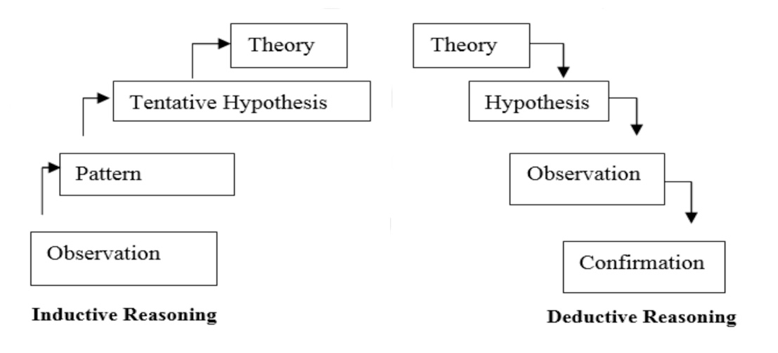
Figure 2: Inductive and Deductive reasoning - Adapted from (Trochim & Donnelly, 2008)

The research approach used for this study followed the deductive approach. The researcher chose this approach due to the logical order of deductive research being a requirement for the positivism philosophy. Furthermore, this research intended to follow on from past research where known theory and phenomenon was already present and stated as fact. Therefore, it seemed logical that the study followed the methods used by previous research should a comparative assessment be pursued following the research findings.

3.6 RESEARCH STRATEGIES AND INSTRUMENTS

Within research, there are two standard methods of data collection; those are quantitative and qualitative. The research strategies chosen for this research were selected based on the requirements of the exploratory research design, the positivism research philosophy and the deductive research approach. The requirements for these three principles advocate a quantitative research strategy. Yilmaz, (2013), describes quantitative research as empirical research into a human conundrum or social phenomenon. Quantitative research tests a theory consisting of variables which are measured with numbers and analysed with statistics to determine if the theory explains or predicts phenomena. Therefore, the qualitative research method could not be used as each part of the phenomenon needed to be measured.

Furthermore, Liu, (2016) explains that the inductive approach is qualitative, which means its research nature is also subjective and interpretive. Therefore, a qualitative research method would contradict the entire existing research design of this study.

The methods and instruments used in this research were survey questionnaires and focus groups. These research instruments were implemented and exercised to gather large quantities of primary quantitative data from the sample. By using survey questionnaires, the researcher was able to direct the research to follow the methods utilised in previous research as identified in the literature review. The questionnaire instrument also evidenced the validity and reliability of the data collection. By utilising the questionnaire instrument method, the researcher was able to remain uninvolved, objective and independent of the results and provide anonymity to the respondents.

Once the researcher had established the instrument for data collection, the researcher then considered the time horizon for the research. According to Saunders et al. (2012), time horizons are required by the research design independent of the research methodology used. There are two methods for the time horizon. These are: cross-sectional, which can be akin to a moment in time or present time; and longitudinal, which is akin to a diary or several moments in time. For this research, the cross-sectional method of time horizon was applied. The basis for this decision was due to the research being the subject of a time constraint; therefore, the longitudinal method was not appropriate.

3.7 METHODS

This section of the research methodology chapter explains the research techniques, tools, and instruments used to collect the data and how each method was applied.

3.7.1 PILOT STUDY

The research began with the formulation and distribution of a pilot survey. Pilot surveys represent a fundamental phase of the research process. The purpose of conducting a pilot survey is to examine the feasibility of the approach the researcher intends to use in the main study. The pilot survey was designed to carefully follow, and to a degree replicate, the components of research methods used in published works by (Pransky, et al., 1999) and (Taylor- Moore, et al., 2013).

The rationale for using existing survey structures was to ensure a degree of reliability and validity for the pilot questionnaire. By reprocessing past questionnaires, the ethical consideration for the pilot would also be satisfied. Furthermore, due to the environment in which the respondents work, it was felt this method would be the most appropriate tool to use.

Questionnaires offer an objective means of collecting information about people's knowledge, beliefs, attitudes, and behaviour (Boyton & Greenhalgh, 2004). Questionnaires also allow the researcher to provide a reasonable level of confidentiality and anonymity to the respondents.

Thirty-one participants completed the pilot survey for this research. Those participants were selected by the researcher on the basis that they met the criterion of working within the repair and maintenance sector. Unlike the previous study by Taylor-Moore et al. (2013), the participants selected were not required to have had any self-reported accidents in the past. The pilot survey worked well and generated several concerns and additional ideas. The concerns and ideas identified needed to be addressed before compiling and distributing the main larger scale operative questionnaire to the target population. Following the pilot study, the researcher developed the main study questionnaires. In total, the researcher produced three different questionnaires: the operative questionnaire; the management questionnaire; and the focus group questionnaire.

3.7.2 SAMPLE SIZE AND SELECTION

For the main worker questionnaire, the researcher aimed to gather a sample of participants who would act as an actual representative sample of the South Wales repair and maintenance sector. There is no recorded number for the quantity of repair and maintenance workers in South Wales. Therefore, the researcher had to use a figure to encompass all construction workers for South Wales. According to the Welsh Assembly Government (2018), that figure is 63700.

Table 2: Construction employment levels by area (Welsh Government, 2018)

In order to establish an appropriate sample size, the researcher first had to determine the appropriate levels of confidence in the reliability of the results that would be acceptable for this research. The researcher was able to determine the appropriate sample size of the operative questionnaire by accepting a satisfactory confidence interval and confidence level.

The confidence interval is the margin for error that a researcher is willing to accept in the data. For example, if the confidence interval is six in a survey where 60% of the sample selected the same answer, probability states that should the same question be given to another sample, between 54% and 66% of that entire target population would choose the same response.

Figure 3, Shows the formula for calculating sample size, which is representative of a target population.

Figure 3: Sample Size Formula (Casa, et al., 2018)
By applying a confidence level of 95% and a confidence interval of seven, the sample size required to be representative of South Wales repair and maintenance sector (calculated using the formula in Figure 3) was 196. As the management questionnaire is only used as a comparative for the operative survey (and the limitation of ability to gather a substantial number of managers to take part in the study), the management population will not be subject to the sample size formula calculation.

3.7.3 RESEARCH INSTRUMENTS AND IMPLEMENTATION

The first questionnaire developed for this study was the operative questionnaire. The research focused on the repair and maintenance sector, and the participants were required to represent the target population. The participants were therefore made up of different tradespeople working in the repair and maintenance sector in South Wales and were part of a quota sample. The distinguishing feature of a quota sample is that quotas are set to ensure that the sample represents specific characteristics in proportion to their prevalence in the population (Schutt, 2006). The operative questionnaire was created with the improvements identified following results of the pilot study. To assure a diverse result, several randomly selected contractors who operate within the repair and maintenance sector in South Wales were asked to participate. Sixteen contractors and their employees indicated that they would participate in the research and the sample size for the final operative survey was N= 211. The questionnaires were completed by the operatives at various locations including; contractors offices, worksites, and during health and safety briefings. The completed questionnaires were placed into a sealed box provided by the researcher.

The operative questionnaire (template located in Appendix A) consisted of 7 main questions. The first question was used to establish whether the respondent would be suitable to undertake the whole questionnaire. If the first question was answered in the affirmative (i.e. that the operative had experienced a work-based accident in the last five years which they had not reported), the operative was then asked to answer 17 questions. Those 17 questions posed different rationales which might influence a decision not to report a workplace accident. Those 17 questions invited responses on a 7-point linear ordinal scale based on the extent to which the particular rationale influenced the respondent’s decision not to report an accident. These questions were designed to answer several different research hypotheses developed in the literature review section.

Question 3 of the operative survey then sought to identify the types of injury that are unreported due to being perceived by the operative as too minor. This question was identified by Taylor-Moore et al. (2013) as an area that needed further research. This aspect of the survey sought to establish which injuries construction workers perceive to be ‘reportable injuries’ and which injuries they considered too small or minor to report.

Question 5 of the operative questionnaire was specifically constructed to identify whether management attitude influenced the reporting of accidents. The question also investigated whether management influence had a positive or negative effect on the operative’s decision to report accidents. Section B, question 7 of the operative questionnaire replicated question 5, however this was only to be answered by operatives who had always reported or who had never sustained an accident in the repair and maintenance sector. The survey also included some catch and filler questions which allowed the respondents to answer the questions freely without encouragement from the researcher.

The second survey was the management questionnaire (template located in Appendix B). This questionnaire also consisted of a quota sample. The management questionnaire was produced to reflect and replicate several components of the worker's questionnaire. However, the questions were adapted and fashioned to gain an understanding of management attitudes towards the non-reporting of accidents and incidents in the repair and maintenance sector. The management questionnaire consisted of 4 questions. The first question of the management questionnaire reflected exactly the options provided in the second question of the operative questionnaire. The second and third questions were filler questions that sought to identify if the organisation and the respondent encouraged operatives to report all work-related accidents and injuries. The final question of the management questionnaire again reflected exactly question 5 of the operative survey. This was arranged so that a comparative evaluation could be made between operative and manager perceptions of the influential factors regarding the reporting of accidents and whether such factors had a positive or negative effect on reporting.

Participants for the management survey were chosen from the same 16 contractors used in the operative questionnaire. The number of respondents for this survey was 43.

The third survey (template located in Appendix C) which was given to participants following the focus group presentation (presentation slides located in Appendix D) was classified as a convenience sample and formed part of a more extensive section of the research. The study for objective three began with a presentation introducing a new software application. The software application aimed to encourage health and safety reporting. The researcher presented the application to two focus groups of 13. Those groups consisted of employees from a repair and maintenance company based in South Wales. The participants were randomly selected trade operatives who would ultimately use the application should it be implemented. The presentation displayed the new software which allowed the user to report accidents and injuries directly from their Personal Digital Assistant (PDA). This allowed the operative to report accidents and injuries while working remotely, removing the need to attend head office and meet with a manager.

The software application was a 'conceptual idea' and therefore, was presented in an attempt to confirm or refute the ‘proof of concept’. The proof of concept (POC) in the field of technology is described as a small exercise to test a design, idea or assumption. The primary purpose of developing a POC is to demonstrate the functionality of the technology and to verify a particular concept or theory that can be achieved in development (Maksimavicius, 2017; Singaram & Jainthu , 2018). The POC is the very first stage of a product’s inception, and its ultimate goal is to determine the viability of the product.

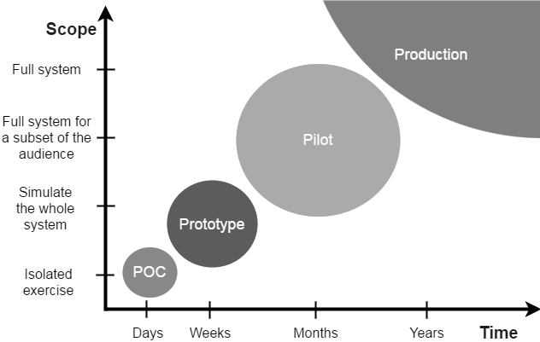

Figure 4: Product Feasibility (Maksimavicius, 2017)

Following the presentation, a small survey consisting of five questions was given to the participants. The first question had two parts. The first part looked at organisational influence on management to reduce accidents at work. The second part reflected question 5 of the operative survey and question 4 of the management survey. Question 2, of the focus group questionnaire was designed to establish whether the respondents, if given access to the application, would be more or less likely to report an accident. Questions 3, 4 and 5 sought to identify whether the software application could have a positive effect on reporting and could remove some of the issues which past research identified as being reasons operatives did not report accidents. The answers provided in the final four questions would enable the researcher to achieve objective three.

The objective of the software application is shown in figure 5. Following the collection of data, the data was analysed.

Figure 5: Software Application Model

3.8 FRAMEWORK FOR DATA ANALYSIS

The purpose of conducting data analysis is to make the information gathered in research legible to the reader. This was completed by performing statistical analysis on the data collected. Statistics are concerned with; the collection of data, its subsequent description, and its analysis which often leads to the drawing of a conclusion (Ross, 2004). For many researchers, statistics are considered as the art of learning from data. There are two categories of statistics: descriptive statistics and inferential statistics. Descriptive statistics are used in the organising and presenting of data. They describe the characteristics of the sample population and do not apply the finding(s) to a wider target population. Inferential statistics look to draw a conclusion about a population based on the sample. Table 3: shows the different statistical techniques that can be used for quantitative research.

Table 3: Statistical techniques for quantitative research (Biggam, 2017)

Before the statistical analysis of the data began, the data was categorised into levels. Table 4 provides a summary of the four levels of data, namely: nominal, ordinal, interval, and ratio. The data collected was mainly ordinal however did include nominal and ratio data. This data was screened, cleaned and coded with the appropriate variables being assigned to the data. For example, binary data (data with only two response options such as yes or no, male or female) were awarded the numerical value of 0 or 1. Whereas variables that had more than two options, such as the occupation and education level, were assigned a numerical value consistent with the number of possible outcomes. Once the coding of variables had concluded the statistical analysis began.

Table 4: Levels of Data - Adapted from (Kostelis & Matthews, 2013)

The data analysis section (Appendix E-G) of this research shows commentary of descriptive statistics and inferential statistics. Descriptive statistics present information such as the ‘percentage of workers who have not reported accidents’ or the ‘percentage of workers who feel management influence has prevented them from reporting accidents’. By using descriptive statistics, information such as ‘what groups are most and least probable to report accidents’ and ‘which trades are affected by this issue the most’ are identifiable (these results are located in the Appendix E, Table 22). This ordinal data is presented in the form of charts and graphs and summarised through median and variance. According to Manikandan, (2011), mean is generally considered the best measure of central tendency and the most frequently used one. However, there are some situations where the other measures of central tendency such as median are preferred i.e. when the data is measured on an ordinal scale. Appendix G, also displays the inferential statistic data analysis. The inferential statistic section includes parametric and non-parametric tests. The tests include one-sample t-tests that were used to identify and examine the difference between data sets such as demographics and hypothesised data. Further tests such as a Fisher’s Exact Test were conducted to identify if there was any difference in proportions between two variables; Mann Whitney U tests were carried out to identify whether two sample data sets could be considered significantly different.

3.9 ETHICAL CONSIDERATIONS

The research techniques used to complete objectives one and two followed and expanded upon previous methods used in published works. These methods began with a quota sample that aimed to identify and examine the attitudes and practices of the respondents. The questionnaire for objective one collected nominal, ordinal and ratio data to identify the reasons why operatives did not report accidents which resulted in personal injury. The questionnaire for objective two followed the questioning of the survey for objective one closely and again collected nominal, ordinal and ratio data. This was to understand management attitudes towards the reporting of accidents and whether managers felt any responsibility should under-reporting be identified.

In planning this research, the researcher evaluated similar studies which had previously been undertaken by the leaders in this area. In compiling the questions for the questionnaire, the researcher had endeavoured to use and adapt the questions used in previous studies and sought to adopt a similar approach in terms of the information gathering process. The adaptations to the questions were made to add to current knowledge. By using established research methods as a framework, the researcher was able to ensure the integrity and the quality of the research to allow comparability in the future.

Final questionnaires were sealed and no questionnaire was opened until all questionnaires were received and gathered. Every effort was made to give complete anonymity to all respondents. Individuals involved with the research were informed of: the purpose of the study, the methods and possible uses of the data collected, and what the data collection aimed to achieve. The researcher maintained integrity in all aspects of the research. The questionnaires had been designed to obviate harm or distress to the respondents.

All participant contributions were entirely voluntary, and no individual was coerced to participate. Everyone involved in the research was informed that they were able to withdraw their participation at any time and that the information gathered in this research would be treated with full confidentiality. Furthermore, if published the research would not identify any individual. All respondents were informed that they had the right not to answer questions within the questionnaire.

The information that the respondents provided would inevitably contain some sensitive information. Such information may include information regarding their employment and their attitude and practical approach to health and safety. However, due to the anonymity afforded to the respondents, no individual respondent or SME can be identified, thus protecting the position of the respondent and hopefully generating credible, honest and reliable responses. As a result of the measures taken, it is highly unlikely that harm (physical, emotional or reputational damage) could be caused to any participant. There was no debriefing after the surveys had been completed. However, a copy of the research has been made available to all participants.

The researcher maintained complete independence throughout the research and did not encounter any conflict of interest with any participant.

3.10 LIMITATIONS AND POTENTIAL PROBLEMS

The samples for questionnaires 1 & 2 were quota samples. Therefore, they are not random samples. However, this was necessary due to the research requiring a specific area of the population. The limitation of quota samples is that there is potential for selection bias. This can lead to the sample being unrepresentative of the population it is meant to represent. A further issue that was identified through the course of this research was the sample size and corresponding confidence interval when applying the findings to the target population. Although the researcher has presented true and accurate findings, a limitation is that the lower the sample, the more full the spread of the confidence interval. By increasing the sample to N = 382, the confidence interval could be reduced to 5 points. Therefore, increasing the validity of the research.

The validity of the research findings refer to the extent to which the results are an accurate representation of the phenomena they are intended to represent (Anderson, 2010). The validation of the research can be safeguarded in several ways; according to Sexton (2000), one way of showing validation is by showing the generalisability of research findings. This refers to "the probability that patterns observed in the sample will also be present in the wider population from which the sample is drawn." This research has shown that it is generalised to a broader target population. Even though the margin for error is 7 points, this still provides a measurable degree of certainty that can be tested further and applied to the broader population.

The reliability of a study refers to the reproducibility of the findings (Lachin, 2004; Anderson, 2010). The methods used in this research have followed past published research and also incorporated best practice for the data collection and analysis. Therefore, the researcher considers that the methods used in the research are correct and appropriate for the research aims and objectives.

3.11 SUMMARY AND LINK

This chapter has discussed in depth the methodology used for this research. This research methodology has explained the exploratory nature and the positivist philosophy underpinning the research. This chapter also discussed the deductive approach, quantitative strategy and the techniques and instruments used for the research. The following chapter presents the discussion of the results, the limitations of the study and puts forward a conclusion and recommendations of the research.

4. DISCUSSION

4.1 INTRODUCTION

The discussion chapter of this dissertation will look to expand upon the meaning, importance and relevance of the results which are located in the appendices (Appendix E - G). It will, where appropriate, compare the findings of this research to the findings identified through previous works reviewed in chapter 2. This section of the research will evaluate and analyse the results and consider whether they achieve the research objectives.

4.2 THE CAUSATIONAL FACTORS AND THE REASONS FOR UNREPORTED ACCIDENTS AND INCIDENTS IN THE REPAIR AND MAINTENANCE SECTOR IN SOUTH WALES.

4.2.1 HYPOTHESIS ONE DISCUSSION

The results for hypothesis one show that 100 (47%) respondents reported that they had failed to notify their employer of a workplace accident or injury. These results imply that there is a significant level of under-reporting of accidents and injuries within this sample. There is at least some potential that this trend towards under-reporting is reflected across the broader repair and maintenance sector in South Wales. These results are also consistent with the findings of previous research highlighted in chapter 2; i.e. that there is empirical evidence to support a contention that accidents are unreported. The findings of this study provide further evidence to validate past research; (Pransky, et al., 1999; Probst, et al., 2008; Lipscomb, et al., 2012; Taylor- Moore, et al., 2013) similarly found the existence of the under-reporting of accidents in their samples from the construction industry. The results of this study build upon existing evidence that the under-reporting of accidents is commonplace in the construction industry. This research has shown that the levels of under-reporting recorded in this study considerably exceed the levels from the previous studies of Pransky, (1999) and Taylor-Moore (2013) which found levels of under-reporting to be 30% and 27% respectively. Therefore, the results do not support the null hypothesis that “the under-reporting of accidents and injuries in the repair and
maintenance sector in South Wales would not exceed the levels found in the research undertaken by Taylor-Moore et al. (2013)”.

It was anticipated by the researcher that the results of this study would yield evidence in support of the premise that there was under-reporting of accidents in the repair and maintenance sector. The researcher's forecast in this regard was informed firstly by the existing research evidence, which indicated a likelihood of under-reporting of accidents across the construction industry; and secondly by an understanding of the nature of the work undertaken in the repair and maintenance sector and the consequent risks. Whilst the principle of there being under-reporting of accidents was anticipated, what was not anticipated was the volume of unreported accidents amongst operatives. Most operatives indicated that they had not reported at least three to four accidents during their time of working as an operative in the repair and maintenance sector. This was followed very closely by operatives who had failed to report accidents on at least five to six occasions. The researcher’s expectation was that the majority of operatives would have failed to report one or maybe two accidents. This was not the case however and the category of failing to report one or two accidents was only the third most common selection.

4.2.2 HYPOTHESIS TWO DISCUSSION

One of the most significant objectives of this study from the researcher’s perspective was to identify the reasons why operatives choose not to report accidents. This issue had been explored in previous research; however, as this research applied to the repair and maintenance sector in South Wales, it was an important question that would add to existing knowledge. Therefore, as set out in the research methods chapter, this study aimed to identify the ‘main’ reasons why operatives elected not to report workplace accidents and injuries. In an attempt to achieve this objective, the researcher analysed the 'significance' of the reasons given by operatives, by 'influential level'. This was achieved by calculating the percentage of moderate to major influence levels, which allowed the researcher to differentiate between minor influences and more significant or major influences.

The findings and implications for this hypothesis were not entirely consistent with the findings of previous research. For example, in the Taylor-Moore (2013) study, it was identified that the most common reason for not reporting an accident was that 'the operative believed the injury was small, so they did not report it'. In this research, this option was the second-highest influential reason expressed by operatives for not reporting an accident or injuries. Pransky (1999), meanwhile, found that the most common reason for not reporting an accident was that 'the pain and discomfort were an inevitable consequence of the job’. This influence was the eighth in the list of potential influences in this study, with 56% of respondents indicating it as a moderate influence or higher.

It was anticipated by the researcher that the results of this study would accord those obtained by the Taylor-Moore (2013) and that the main reason for not reporting accidents would be 'the operative believed the injury was small, so they did not report it'. However, this research showed that the main reason given by operatives for not reporting accidents was that ‘operatives believed they were working unsafely and felt that the accident was their fault’ with 87% of all operatives believing that factor to be a moderate to major influence.

This result was unexpected because the operatives were communicating a sense of responsibility for the accident in terms of their practices; despite acknowledging that they did not feel a responsibility to report it. The results do not therefore support the hypothesis that ‘this research would follow the findings of Taylor-Moore et al. (2013) and the principal reason for not reporting an accident would be that operatives felt the injuries sustained were too small to report’. These results make progress towards achieving objective one, which was to identify the causational factors and the reasons for unreported accidents and incidents in the repair and maintenance sector in South Wales.

There was also a clear anomaly in the data whereby the reason ‘I could not afford to take time off work without pay’ had a median influence rating of (M=7). It was discovered that the reason for this anomaly was as a result of some operatives being in receipt of full sick pay and other operatives were not.

4.2.3 HYPOTHESIS THREE DISCUSSION

To understand the causational factors regarding why operatives do not report accidents, the researcher sought to examine and overcome the limitations of past research. Several questions presented in the operative questionnaire aimed to address some of these limitations. The results gathered in the operative questionnaire were able to answer a limitation posed by Taylor-Moore et al. (2013). This limitation of Taylor-Moore et al. (2013) was to establish 'what workers feel are small injuries that they have not reported'.

As expected by the researcher, the results show that the primary reportable injury that is not reported by operatives was significant cuts and lacerations. This section was not overly complicated in terms of hypothesis testing; however it does provide more information to support objective one. These findings also support the hypothesis “that the most common unreported accident or injury not reported would be significant cuts and lacerations”. The results of this hypothesis provide new insight and a clear understanding of ‘what workers perceive as reportable injuries that they do not report’.

4.2.4 HYPOTHESIS FOUR DISCUSSION

This study found that 52% of males and 38% of females who completed the questionnaire had previously failed to report an accident while working in the repair and maintenance sector. The findings for hypothesis four are not wholly consistent with the previous research that also compared the under-reporting of accidents as between males and females. In the works of Tucker et al. (2014), it was identified that the under-reporting of accidents for male subjects was approximately 25% compared to 16% for female subjects. There are many potential reasons to explain why the results of this research are so different from that of Tucker et al. (2014). However, there are two key factors which stand out when the two studies are compared. The first being that Tucker et al. (2014) took a sample from a pool of 15-25 year old part-time workers. The nature of the works being undertaken by part-time workers is unlikely to be a good comparison with the high-risk activity of working in the repair and maintenance sector. However, Tucker et al. (2014) was able to obtain a sample size of 21,345; the sample size gives far more reliability to their results when compared to the results of this study.

The results of the Fisher's exact test supports the null hypothesis that 'male operatives are no more likely to under-report accidents than female operatives’. However, it is also clear from the findings that the reliability of these results could be considered misleading due to the low sample size and the proportion of males and females in the study. Therefore, the generalisability of these results should not be considered reliable due to the low numbers of female representatives working as operatives in the repair and maintenance sector.

In the researcher’s view, over the three hypotheses, this study has been able to achieve the objective of identifying causational factors and the reasons for unreported accidents and incidents in the repair and maintenance sector in South Wales.

4.3 ORGANISATIONAL FACTORS AND MANAGEMENT ATTITUDES AND HOW THEY INFLUENCE THE REPORTING OF ACCIDENTS AND INCIDENTS IN THE REPAIR AND MAINTENANCE SECTOR IN SOUTH WALES.

4.3.1 HYPOTHESIS FIVE DISCUSSION

The results for hypothesis five (Appendix G5) show that of the 211 respondents that completed the operative questionnaire, 150 (71%) indicated that they believed that management influence had an effect on the reporting of accidents. It is clear from the results that operatives who have previously not reported accidents were influenced far more than operative who had always reported accidents or had not had an accident. These responses however, are subjective to the operative. What is not apparent from the answers and indeed from the study, is whether the rationale proffered by the operative for failing to report an accident is evidentially well-founded, or whether it is in the unconscious bias/presumption of the operative; i.e. Is there, in fact, a management culture/influence which dissuades the reporting of accidents which the operative is aware of and which influences their decision not to report. Alternatively, is it the perception of the operative that there would be a negative response by management to the reporting of an accident which is not based in fact but rather is based upon the operative’s own perceptions of how the reporting of an accident may be received by management.

The results did reveal that many of the operatives (53%) felt that being reprimanded by management was a moderately influential reason for not reporting accidents., Being labelled by management was less of a concern to operatives with only (42%) believing this to be a moderate influence reason. These particular results are consistent with the finding of the works by (Pransky, et al., 1999; Probst, et al., 2017; Palali & Van Ours, 2017); all of those studies identified that workers would not report accidents as they were afraid of being reprimanded by management and feared reprisals. Furthermore, these results also support the works of (Probst, et al., 2017) that also found job insecurity to be a factor in the under-reporting of accidents. These results show that for at least 30% of respondents, the fear of losing their job was a moderate to major influence for not reporting.

Based on the data gathered and analysed, it is reasonable to conclude that the data does not support the null hypothesis that ‘management influence does not affect the reporting of accidents and injuries’. These results are significant and support the alternative hypothesis that ‘management influence does affect the reporting of accidents and injuries’ and are consistent with the findings of (Pransky, et al., 1999; Probst, et al., 2017; Palali & Van Ours, 2017). However, the implications of these results are not entirely clear at this point. This is due to the researcher not having a clear understanding of whether the influence that managers have over the reporting of accidents is a negative influence or a positive influence or whether there is in fact any influence on the part of management at all or merely a perceived influence by the operative. Hypothesis six aims to investigate and address this problem.

4.3.2 HYPOTHESIS SIX DISCUSSION

Hypothesis five clearly shows that for many operatives, management attitude influences their decision to report accidents. However, hypothesis five did not establish whether that influence was negative or positive.

To identify whether the management influence was 'negative or positive', descriptive statistics were performed on specific data from the questionnaires. The questionnaire asked operatives who indicated that they did think management attitude influenced an operative’s decision to report accidents at work, whether the influence was negative, positive or neither. The results (Appendix G6) show that in total 61 (29%) of the respondent’s answers (by selecting that management influence has neither a positive or negative impact on reporting) support the null hypothesis that “management influence has no overall effect on the reporting of accidents”. The remaining 71% of respondents believe that management influence does have an effect on an operative’s decision to report accidents. Table 47, shows that for 94 (45%) respondents, management influence has some level a negative effect on the reporting of accidents. For the remaining 56 (26%) respondents, management influence has, to some degree, a positive effect. Therefore, the results taken from the survey do not support the null hypothesis ‘management influence would not have a positive or negative effect on the reporting of accidents’.

Interestingly, the results show that the rate at which operatives feel that management has a negative effect on accident reporting is considerably higher amongst those operatives that have not previously reported accidents.

4.3.3 HYPOTHESIS SEVEN DISCUSSION

This section of the research focussed on organisational factors and management attitudes and investigating how they influence the reporting of accidents and incidents in the repair and maintenance sector in South Wales. Thus far, the research has shown that management attitude does influence the majority of operatives and their decision making when they are considering whether or not to report an accident. The research has also shown that overall the influence which management attitude has on operatives has a slight negative effect.

The aim of hypothesis seven was to identify if there was a significant difference between the answers given by operatives and the answers given by the managers in the questionnaires. The results of this hypothesis show that of the 17 reason options given to both the operatives and management, 6 (35%) of the management responses were not statistically different from the answers given by the operatives. What these results reveal is that managers do not appear to have a clear understanding of the subjective reasons why operatives do not report accidents. The difficulty that this poses in terms of increasing accident reporting is that any measures that these organisations implement to combat this phenomenon are likely to fail as they do not address the actual reasons for non-reporting in the first instance.

Therefore, the results of Mann Whitney U Tests do not support the hypothesis that ‘there is no difference between the reasons operatives give for not reporting accidents and what management perceive are the reasons operatives do not report accidents’.

It is the view of the researcher that this study has been able to achieve its objective of evaluating organisational behaviours and identifying whether management attitudes influence the reporting of accidents and incidents in the repair and maintenance sector in South Wales.

4.4 CAN THE USE OF TECHNOLOGY CAN INFLUENCE EMPLOYEE REPORTING OF WORKPLACE ACCIDENTS WITHIN AN SME.

4.4.1 HYPOTHESIS EIGHT DISCUSSION

The final hypothesis of this research aimed to identify and examine whether the use of technology could influence employee reporting of workplace accidents within an SME.

For this part of the research two focus groups, each consisting of 13 operatives, were given a presentation which invited their views on how a new software application would influence their decision to report accidents. The results of both focus groups reveal that with access to the new software application the respondents were 'much more likely to report an accident.’

These results imply that there is a measure that should be implemented that could improve accident reporting. In the focus group presentation, 96% of both groups reacted positively to the software with only one operative expressing that the software application would have no bearing on their decision to report an accident. These results exceed the expectations of the researcher particularly in light of the evidence gathered regarding the influence of management on the decision not to report; this is because the use of technology does not necessarily impact on a perception of management influence whether factual or perceived. The researcher interprets from this that the use of technology would remove elements of bureaucracy from the process of accident reporting which would make the process less policy and procedure intensive and less time consuming; this in turn would be met with positive connotations from the majority of operatives. This hypothesis has been far more positively supported than the researcher envisaged.

The implementation of a streamlined process utilising software would also address some of the issues found in past research. For example, Scherzer et al. (2005) found that workers considered ‘there were too many steps to reporting the injury’. Taylor-Moore et al. (2013) found that workers felt ‘The time that it takes to report the injury makes the worker fall behind on their work’. And the Tucker et al. (2014) study found that workers believed ‘There is too much effort involved in reporting the injury’.

This research addressed each of those issues individually. For each of the issues, the respondents who completed the focus group survey overwhelmingly indicated that the introduction of the software application would have a positive effect on the reporting of accidents in the repair and maintenance sector. Therefore, the evidence gathered from the focus group study does not support the null hypothesis that ‘technology that allows remote accident reporting will have no influence on accident reporting within the building maintenance sector for the majority of operatives’. Furthermore, the research does not support the hypothesis that the technology will not overcome the time and effort related barriers identified by (Scherzer, et al., 2005; Taylor- Moore, et al., 2013; Tucker, et al., 2014)

It is the researcher’s view that this study has achieved the objective of identifying whether the use of technology can influence employee reporting of workplace accidents within an SME.

4.5 LIMITATIONS OF THE STUDY AND FURTHER RESEARCH

This research was based on data obtained from operatives employed within the repair and maintenance sector in South Wales. Therefore, this research should only be considered representative of the sample from which it was taken. However, should the methods of this study be repeated with a comparative study the results obtained could support or discredit the results of this research.

The researcher believes the sample size of this research was small and not diverse enough. Further research should aim to vastly increase the sample population to improve the reliability of the results. For example, hypothesis four theorised that male operatives were not more likely to under-report accidents than female operatives. However, due to the sample size of females in the operative questionnaire, the results could not objectively be considered reliable.

Due to the limitations and restrictions of time, the development and testing of the proposed software application was not achievable in practice; therefore its impact could not be thoroughly tested within this particular research study. This limitation should be considered by practitioners who intend to conduct longitudinal research into this subject area. This type of research would allow the researcher to obtain the necessary measurements needed to test the hypothesis across a far greater expanse of time and therefore, collect creditable data.

4.6 CONCLUSION AND RECOMMENDATIONS

This research aimed to investigate the under-reporting of accidents within SME's operating in the repair and maintenance sector in South Wales. The research also endeavoured to test, using the “Proof of Concept”, whether technology can contribute to the advancement of accident reporting within SME’s in the repair and maintenance sector in South Wales.

The objectives of the research were to firstly identify and examine causational factors and the reasons for unreported accidents and incidents in the repair and maintenance sector in South Wales. The research has achieved this objective. Based on the quantitative analysis of data recorded in questionnaires from operatives working within the repair and maintenance sector, it is concluded that the under-reporting of accidents is widespread in the repair and maintenance sector in South Wales. This research was also able to identify through hypothesis two; the main reasons why operatives do not report accidents. The main reason being ‘that operatives believed they were working unsafely and felt that the accident was their fault’. It is the researcher’s opinion that identifying the reasons why operatives do not report accidents is the most crucial part of the study. From the researcher’s perspective, it is a critical first step in seeking to formulate a strategy to counter this phenomenon.

The second objective of this research was to evaluate organisational behaviours by identifying and examining whether management attitude influences the reporting and non-reporting of accidents and incidents in the repair and maintenance sector in South Wales. Through analysing the data recorded from the management and operative questionnaire, this study has shown that management attitude does influence the reporting of accidents in the repair and maintenance sector in South Wales.

The final objective aimed to identify whether the use of technology could influence employee reporting of workplace accidents and incidents in the repair and maintenance sector in South Wales. Through hypothesis two, it was identified that the time and effort it takes to report accidents is a significant factor for operatives when deciding whether or not to report an accident. It was shown in hypothesis eight that the introduction of a software application that allows remote accident reporting could have a positive impact on accident reporting. The software application would be unlikely to affect reporting by those who chose not to report due to issues such as management influence but where issues around time and effort are a reason then it would appear the software application could be far more influential.

The research conducted in the UK on these subject areas was minimal, and no research had been conducted on this issue in the repair and maintenance sector of South Wales. As a result, there has been a vast void in the research on the subject. This research has made intuitive observations that contribute to the understanding of the under-reporting of accidents, particularly into the area of the repair and maintenance sector in South Wales. These observations need not be limited to just the repair and maintenance sector but could also be used for comparative study in other industries in future research.

This research has provided several hypotheses and delivered results that could be comparatively tested for validity. For future studies, the researcher recommends that far greater sample sizes are used to increase the reliability of the research findings. Depending on the sample size and demography of respondents i.e. trades, age, education; comparative testing could be conducted. This type of research could identify which groups are more likely not to report accidents or whether a particular trade is more likely to not report accidents than others. Future research could therefore avoid the limitations identified in this research.

To better understand the implications of these results, further research undertaken in this area should aim to identify the effects that the under-reporting of accidents has on SME's, i.e. the financial impacts and the impact on performance such as key performance indicators (KPI). This type of research would be more achievable through qualitative methods, such as interviews and focus groups. Through implementing a mixed-methods study, many different hypotheses could be supported by informally interviewing operatives.

5. REFERENCES

Adams, N. & Hartwell, N., 1977. Accident-Reporting Systems: a basic problem area in industrial society’. Journal of Occupational Psychology, Volume 50, pp. 285-298.

Anderson, C., 2010. Presenting and Evaluating Qualitative Research. American Journal of Pharmaceutical Education, 74(8), p. 141.

Biggam, J., 2017. Succeeding With Your Master's Dissertation: AStep-by-step Handbook. 4th Edition ed. London: Open University.

Boyton, P. & Greenhalgh, T., 2004. Selecting, designing and developing your questionnaire. British Medical Journal, Volume 328, pp. 1312-1315.

Casa, M. et al., 2018. Developing a New Product Design for an ID Case. Manila, Philippines: De La Salle University, Innovation and Technology Fair.

Chan, A. P. C. & Hon, C. K. H., 2016. Safety of Repair, Maintenance, Minor Alteration, and Addition (RMAA) Works: A New Focus of Construction Safety. London: Routledge.

Channels, N., 1985. Social science mehods in the legal process. Totowa, New Jersey: Rowman & Allanheld.

Creswell, J. & Plano Clark, V., 2010. Designing and conducting mixed methods research. 2nd Edition ed. Thousand Oaks, United States: Sage Publications.

Davies, J., Kemp, G. & Frostick, S., 2007. An investigation of reporting of workplace accidents under RIDDOR using the Merseyside Accident Information Model, Online: Health and Safety Executive.

De Silva, N., Rathnayake, U. & Kulasekera, K., 2018. Under-reporting of construction accidents in Sri Lanka. Journal of Engineering , Design and Technology, 16(6), pp. 850-868.

Dong, X. et al., 2011. Injury underreporting among small establishments in the construction industry.. American Journal of Indurial Medicines, 54(5), pp. 339-349.

Erikson, P. & Kovalainen, A., 2016. Qualitative methods in business research. 2nd Edition ed. London: Sage Publications.
Eurostat, 2018. Regional GDP per Capita ranged from 29% to 611% of the EU average 2016. [Online]
Available at: https://ec.europa.eu/eurostat/documents/2995521/8700651/1-28022018-BP-EN/15f5fd90-ce8b-4927-9a3b-07dc255dc42a
[Accessed 10 November 2019].

Facke, C. & Plonsky, G., 2014. Manual of Language Acquistion. Berlin: De Gruyter Mouton.

Glazner, J. et al., 1998. Construction injury rates may exceed national estimates: Evidence from the construction industry of Denver International Airport. American Journal of industrial Medicine, 34(2), pp. 105-122.

Guo, H., Li, H., Chan , G. & Skitmore, M., 2012. Using game technologies to improve the safety of construction plant operations.. Accident Analysis and Prevention, 48(1), pp. 204-213.

Health and Safety Exceutive , 2019. History of the HSE. [Online]
Available at: http://www.hse.gov.uk/aboutus/timeline/index.htm#a2000
[Accessed 13 October 2019].

Health and Safety Executive, 2018. Construction Statistics in Great Britian 2018. Annual Statistics. [Online]
Available at: http://www.hse.gov.uk/statistics/industry/construction.pdf
[Accessed 24 October 2019].

Health and Safety Executive, 2018. Health and Safety and Work. Summary statistics for Great Britian 2017. [Online]
Available at: http://www.hse.gov.uk/statistics/overall/hssh1617.pdf
[Accessed 2019 September 2019].

Health and Safety Executive, 2019. Historical Picture: Statistics in Great Britian 2018. [Online]
Available at: https://hse.gov.uk/statistics/history/historical-picture.pdf
[Accessed 26 October 2019].

Hosseinian, S. & Torghabeh, J., 2012. Major theories of construction accident causation models - A literature review. International Journal of Advances in Engineering and Technology, 4(2), pp. 53-66.

International Labour Organsation , 2019. Safety and Health at Work. [Online]
Available at: https://www.ilo.org/global/topics/safety-and-health-at-work/lang--en/index.htm
[Accessed 2019 November 12].

Jiang, L., Probst, T. M., Benson, W. & Byrd, J., 2018. Voices carry: Effects of verbal and physical aggression on injuries and accident reporting. Journal of Accident Analysis and Prevention, Volume 118, pp. 190-199.

Kostelis, K. & Matthews, T., 2013. Designing and conducting researchin health and human performance. San Francisco, California, United States: Jossey-Bass.

Lachin, J., 2004. The role of measurement reliability in clinical trials. Journal of the Society for Clinical Trials, 1(6), pp. 533-566.

Leon , A., Davis, L. & Kraemer, H., 2011. The role and interpretation of pilot studies in clinical research. Journal of Psychiatric Research, 45(5), pp. 626-629.

Leon, A., Davis, L. & Kraemer, H., 2011. The role and interpretation of pilot studies in research. Journal of Psychiatric Research, 45(5), pp. 626-629.

Levin, D., 1988. The opening of Vision: Nihilism and teh postmodern situation. London: Routledge.

Lipscomb, H. et al., 2012. Safety, incentives, and the reporting of work-related injuries among union carpenters: “You're pretty much screwed if you get hurt at work”. American Journal of Industrial Medicine, 56(4), pp. 389-399.

Liu, L., 2016. Using generic inductive approch in qualitative educational research: A case study analysis. Journal of Education and Learning, 5(2), pp. 129-135.

Locke, E., 2007. The case for inductive theory building. Journal of Management, 33(6), pp. 867-890.

Mahmutaj, L. & Shrestha, P., 2011. A Case study conducted in “University Clinical Centre of Kosovo, Rheumatology department". [Online]
Available at: https://www.researchgate.net/publication/277839621_Lean_Service_Implementation_in_Hospital_A_Case_study_conducted_in_University_Clinical_Centre_of_Kosovo_Rheumatology_department
[Accessed 19 January 2020].

Maksimavicius, V., 2017. Proof of Concept vs. Prototype vs. Pilot. [Online]
Available at: https://www.valdas.blog/2017/05/29/proof-of-concept-vs-prototype-vs-pilot/
[Accessed 2019 August 29].

Manikandan, S., 2011. Measures of central tendency: Median and mode. Journal of Pharmacology & Pharmacoterpeutics, 2(3), pp. 214-215.

Mohseni, P., Farshad, A., Mirkazemi, R. & Orak, R., 2015. Assessment of the living and workplace health and safety conditions of site-resident construction workers in Tehran, Iran. International Journal of Occupational Safety and Ergonomics, 21(4), pp. 568-573.

Nardi, P., 2018. Doing survey research. 4th Edition ed. New York: Routledge.

Niza, C., Silva, S. & Lima, M. L., 2008. Occuational accident experience association with workers accident explanation and definition. Safety Science, 46(4), pp. 959-971.

Nola, R. & Sankey, H., 2014. Theories of Scientific Method. London: Routledge .

Orlikowski, W. & Baroudi, J., 1991. Studying Information Technology in Organizations: Research Approaches and Assumptions.. 2(1), pp. 1-28.

Palali, A. & Van Ours, J. C., 2017. Workplace accidents and workplace safety: On under-reporting and temporary jobs.. Labour, 31(1), pp. 1-14.

Polonsky, M. & Waller, D., 2005. Designing and implementing a research project. Thousand Oaks, United States: Sage Publications.

Pransky, G., Snyder, T., Dembe, A. & Himmelstain, J., 1999. Under-reporting of work-related disorders in the workplace: a case study and review of the literature. Ergonomics, 42(1), pp. 171-182.
Probst, T. M., 2002. Layoffs and tradeoffs: production, quality, and safety demands under the threat of job loss. Occupational Health Psychology, 7(3), pp. 211-220.

Probst, T. M., Bettac, E. & Austin , C., 2019. Accident underreporting in the workplace.. In: R. Burke & A. Richardsen, eds. Increasing Occupational Health and Safety in Workplaces. Cheltenham: Edward Elger, pp. 30-47.

Probst, T. M., Brubaker, T. & Barsotti, A., 2008. Organizational injury rate underreporting: The moderating effect of organizational safety climate.. Journal of Applied Psychology, 93(5), pp. 1147-1154.

Probst, T. M. & Brubaker, T. M., 2001. The effects of job insecurity on employee safety outcomes: cross-sectional and longitudinal explorations. Occupational Health Psychology, 6(2), pp. 139-159.

Probst, T. M. & Estrada, A., 2010. Accident under-reporting among employees: Testing the moderating influence of psychological safety climate and supervisor enforcement of safety practices.. Accident Analysis and Prevention, 42(5), pp. 1438-1444.

Probst, T. M., Petitta, L. & Barbaranelli, C., 2017. Comparing recall vs. recognition measures of accident under-reporting: A two-country examination.. Accident Aanlysis and Prevention, 16(1), pp. 1-9.

Reid, R. & Bojanic, D., 2010. Hospitality marketing management. Hoboken, New Jersey, United States: John Wiley & Sons.

Rhodes, C., 2018. Construction Industry: Statistics and Policy, London: House of Commons Library.

Rhodes, C., 2019. Construction industry: statistics and policy, London: House of Commons Library.

Robson, C., 2002. Real World Research. 2nd Edition ed. Oxford: Blackwell.

Rosecrance, J., Cook, T., Anton , D. & Merlino, L., 2002. Carpal tunnel syndrome among apprentice construction workers.. American Journal of Industrial Medicine, 42(2), pp. 107-116.

Ross, S., 2004. Introduction to probability and statistics for engineers and scientists. 3rd Edition ed. Amsterdam: Acadmic Press.

Saunders, M., Lewis, P. & Thornhill, A., 2012. Research methods for business students. 7th Edition ed. Harlow: Financial Times Prentive Hall.

Scherzer, T., Rugulies, R. & Krause, N., 2005. Work-Related Pain and Injury and Barriers to Workers’ Compensation Among Las Vegas Hotel Room Cleaners. American Journal of Public Health, 95(3), pp. 483-488.

Schnieder, S., 2001. Musculoskeletal Injuries in Construction: A Review of the Literature.. Applied Occupational and Environmental Hygine, 16(11), pp. 1056-1065.

Schutt, R., 2006. Investigating the social world. 5th Edition ed. Thousand Oaks, United States: Pine Forge Press.

Sexton, M., 2000. Sustainable Built Environments and Construction Activity Through Dynamic Research Agendas. PhD Thesis, Uiversity of Salford.

Singaram, M. & Jainthu , P., 2018. What is the Difference between Proof of Concept and Prototype?. [Online]
Available at: https://www.entrepreneur.com/article/307454
[Accessed 24 August 2019].

Sokas, R. K. et al., 2009. An intervention effectiveness study of hazard awareness training in the construction building trades.. Public Health Reports, 124(1), pp. 161-168.

Taylor- Moore, J. et al., 2013. Construction Workers’ Reasons for Not Reporting Work-Related Injuries: An Exploratory Study.. International Journal of Occupational Safety and Ergonomics, 19(1), pp. 97-105.

Trochim, W. & Donnelly, J., 2008. The research methods knowledge base. 3rd Edition ed. Mason, Ohio, United States: Cenage Learning.

Tucker, S., Diekrager, D., Turner, N. & Kelloway, E., 2014. Work-related injury underreporting among young workers: Prevalence, gender differences, and explanations for underreporting. Journal of Safety Research, 50(1), pp. 67-73.

Venkateswaran, R. & Ojha, A., 2019. Abandon Hofstede-based research? Not yet! A perspective from the philosophy of the social sciences. Asia Pacific Business Review, 25(3), pp. 413-434.

Wanberg, J., Harper, C., Hallowell, M. & Rajendran, S., 2013. Relationship between Construction Safety and Quality Performance. Journal of Construction Engineering and Mangement, 139(10), pp. 1-10.

Webber, R., 2004. The Rhetoric of Positivism versus Interpretivism: A Personal View.. Management Information Systems Quarterly, 28(1), pp. 3-12.

Welsh Government, 2018. Workplace employment by broad industry by Welsh local authority.. [Online]
Available at: https://statswales.gov.wales/Catalogue/Business-Economy-and-Labour-Market/People-and-Work/Employment/Jobs/Whole-Workforce/WorkplaceEmployment-by-Industry-Area
[Accessed 2 October 2019].

Wuellner, S., Adams, D. & Bonauto, D., 2016. Unreported workers’ compensation claims to the BLS Survey of Occupational Injuries and Illnesses: Establishment factors. American Journal of Industrial Medicine, 59(4), pp. 274-289.

Yannis, G., Papadimitriou, E., Chaziris, A. & Broughton , J., 2014. Modelling road accident injury under-reporting in Europe. European Transport Research Review, 6(4), pp. 425-438.

Yilmaz, K., 2013. Comparison of Quantitative and Qualitative Research Traditions: epistemological, theoretical, and methodological differences. European Journal of Education, 48(2), pp. 311-325.

Yu, Y., Sun, S. & Ni , X., 2015. Advanced Technologies Abroad are Used to Improve Highway Construction Safety. Applied Machanics and Materials, Volume 737, pp. 399-403.

Zhang, M., Cao, T. & Zhao, X., 2017. Applying Sensor-Based Technology to Improve Construction Safety Management. Sensors, 17(8), p. 1841.



APPENDICES

Simon Paul David Williams

Master of Science – Property and Facilities Management

April 2020

LIST OF APPENDICES

APPENDIX A: TRADE OPERATIVE SURVEY QUESTIONNAIRE 2
APPENDIX B: MANAGEMENT SURVEY QUESTIONNAIRE 8
APPENDIX C: FOCUS GROUP SURVEY QUESTIONNAIRE 12
APPENDIX D: FOCUS GROUP PRESENTATION SLIDES 15
APPENDIX E: OPERATIVE QUANTITATIVE DATA ANALYSIS 23
APPENDIX F: MANAGEMENT QUANTITATIVE DATA ANALYSIS 32
APPENDIX G: DISCRIPTIVE AND INFERENTIAL ANALYSIS 41

APPENDIX G 1: HYPOTHESIS ONE DATA ANALYSIS 42
APPENDIX G 2: HYPOTHESIS TWO DATA ANALYSIS 44
APPENDIX G 3: HYPOTHESIS THREE DATA ANALYSIS 45
APPENDIX G 4: HYPOTHESIS FOUR DATA ANALYSIS 47
APPENDIX G 5: HYPOTHESIS FIVE DATA ANALYSIS 48
APPENDIX G 6: HYPOTHESIS SIX DATA ANALYSIS 49
APPENDIX G 7: HYPOTHESIS SEVEN DATA ANALYSIS 50
APPENDIX G 8: HYPOTHESIS EIGHT DATA ANALYSIS 55

APPENDIX A: TRADE OPERATIVE SURVEY QUESTIONNAIRE

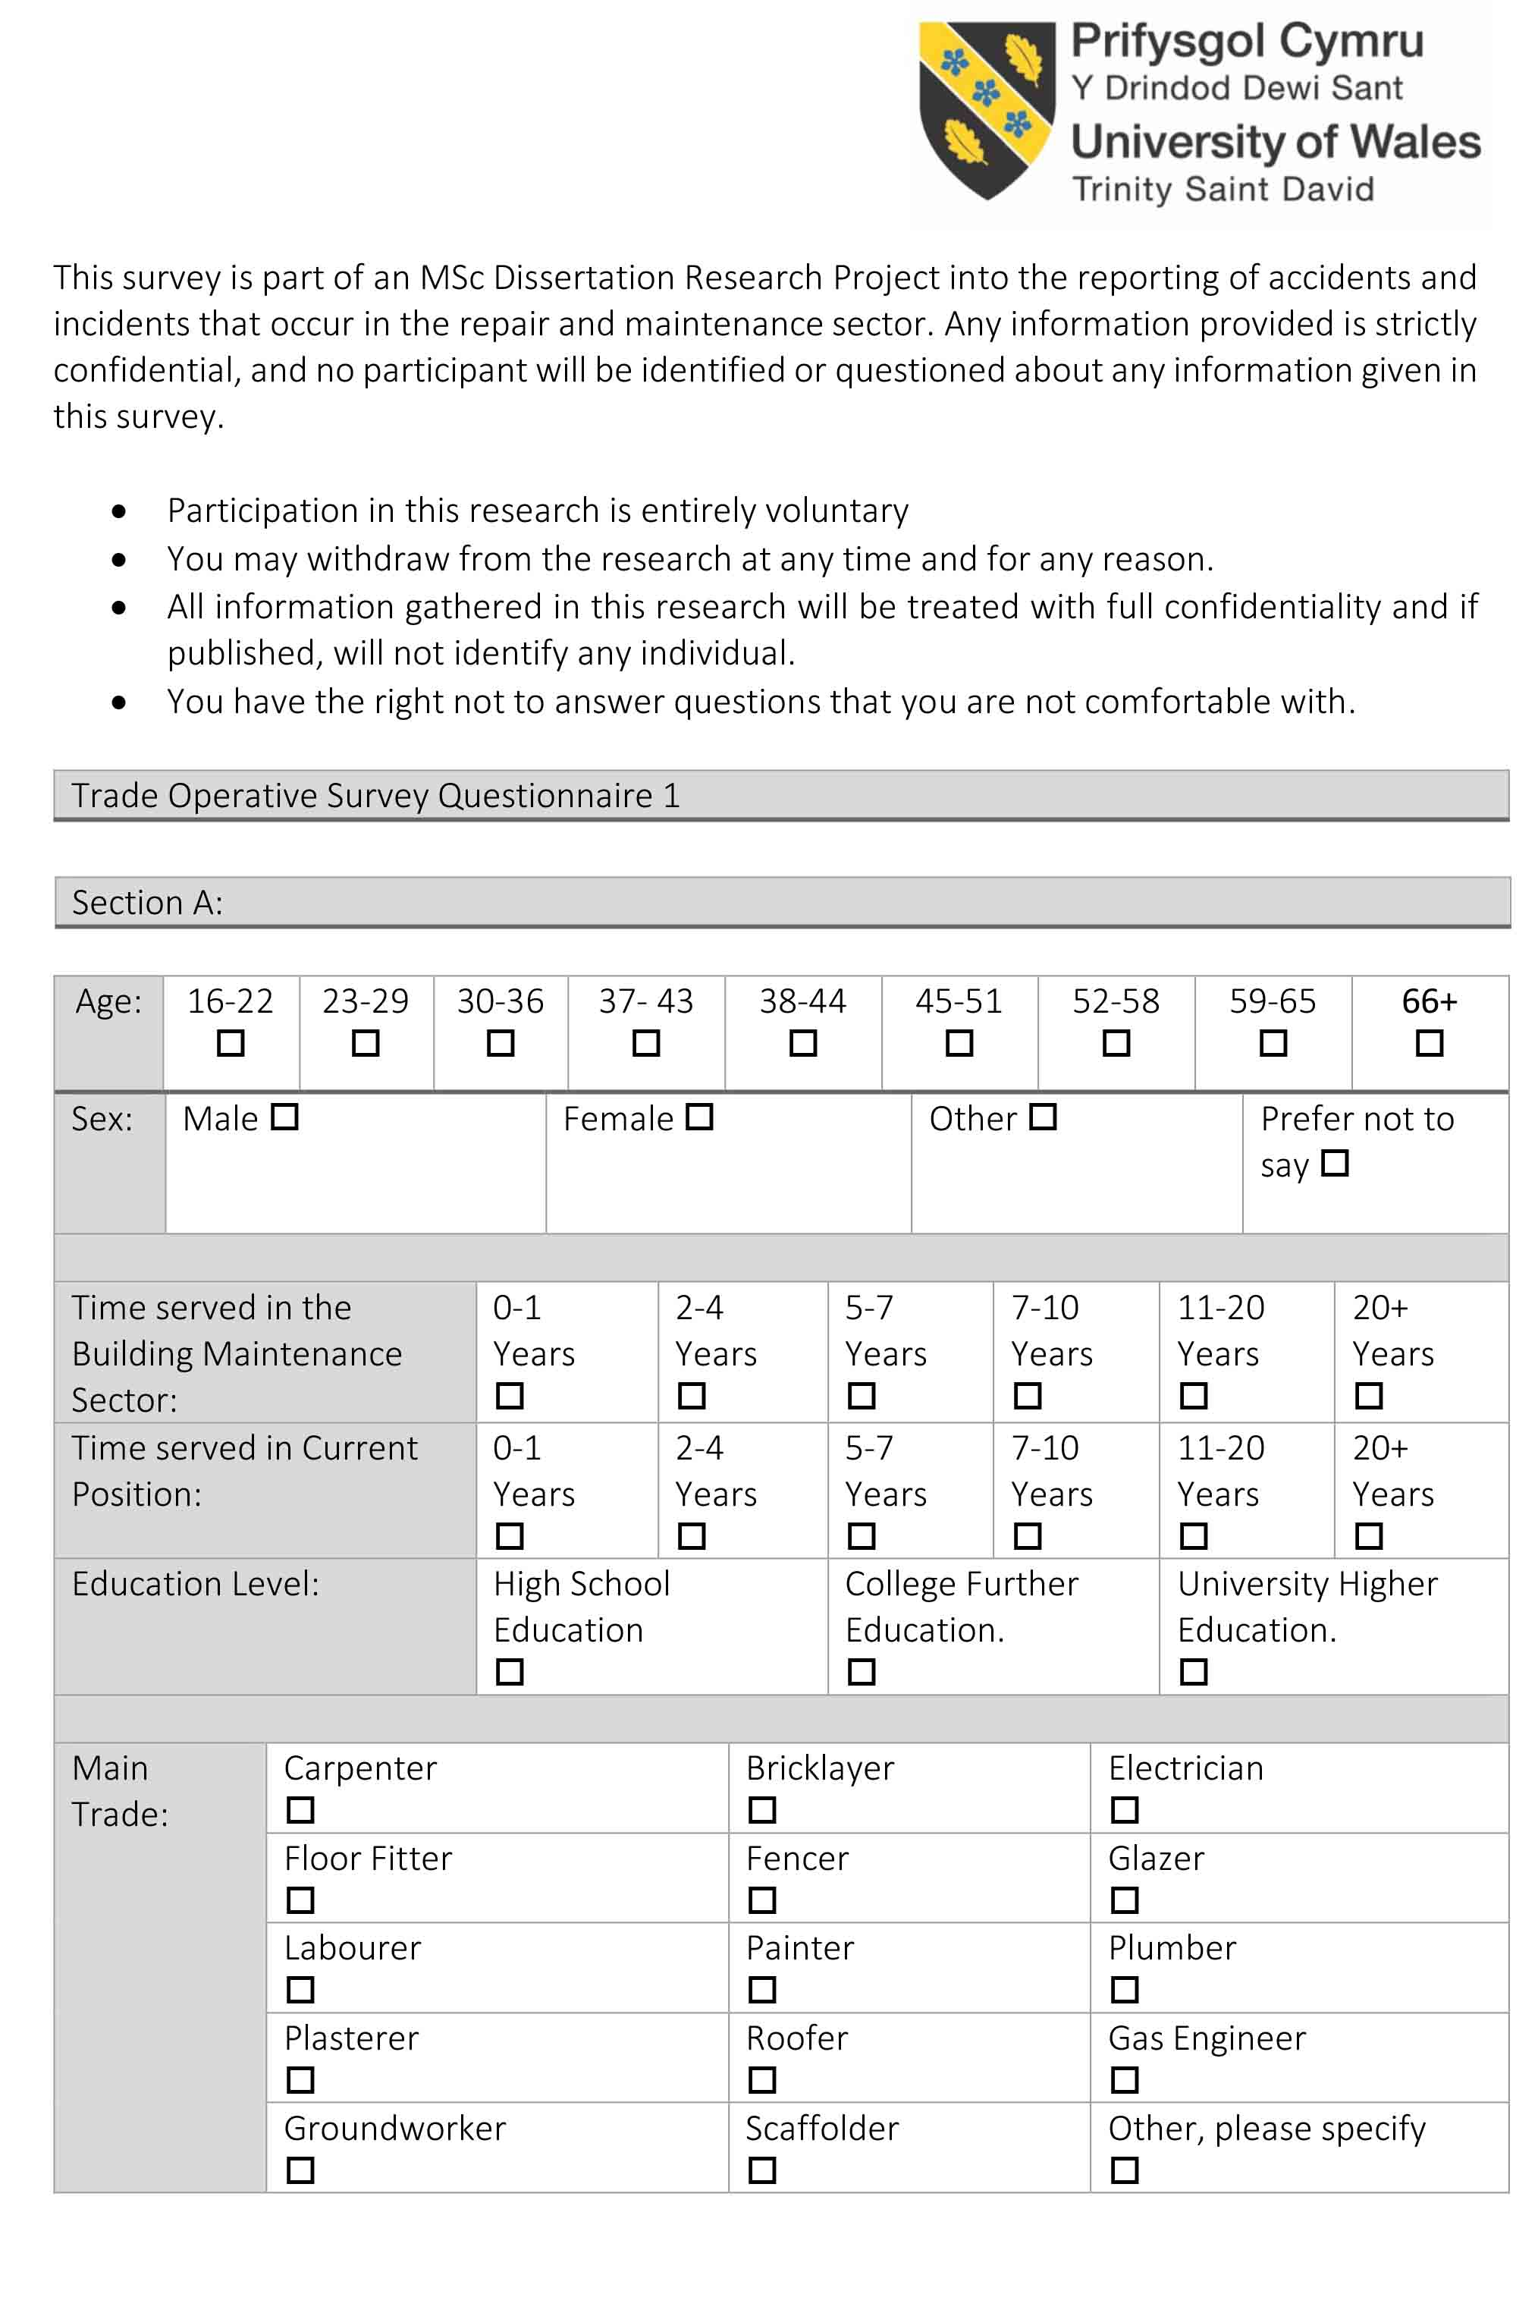
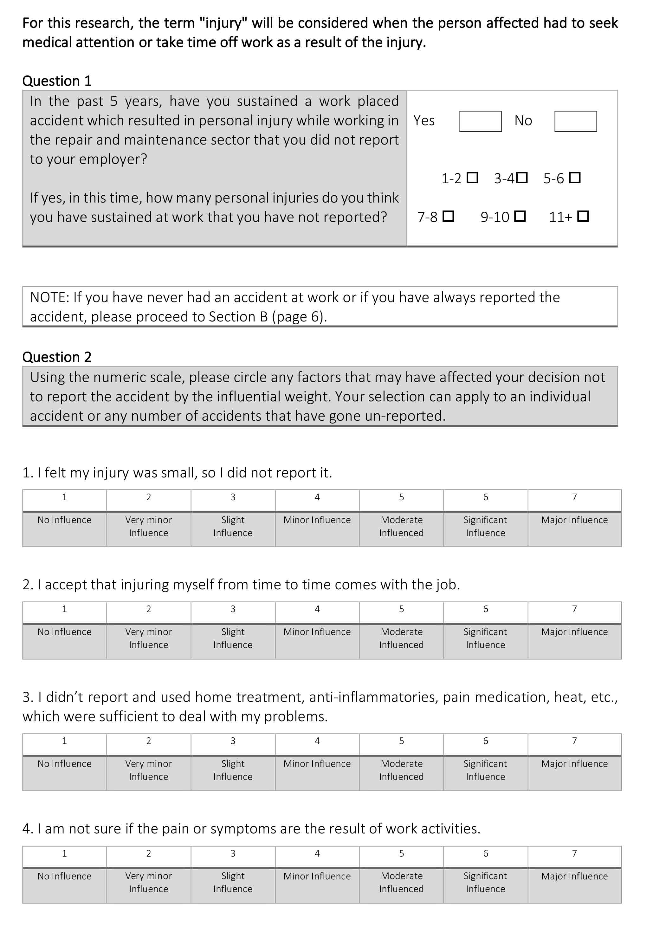
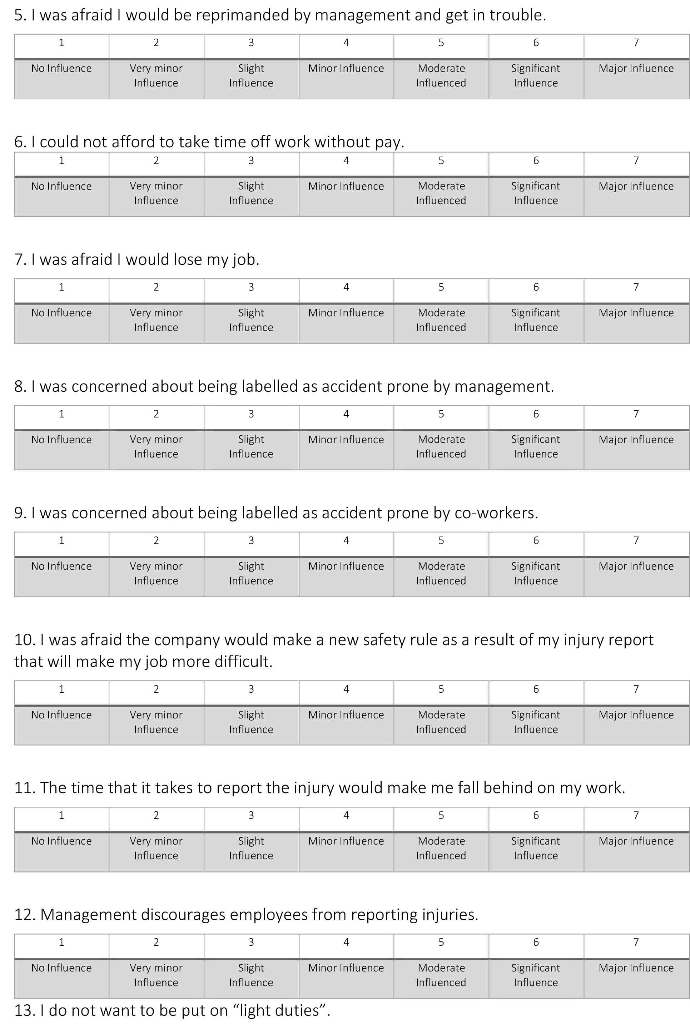
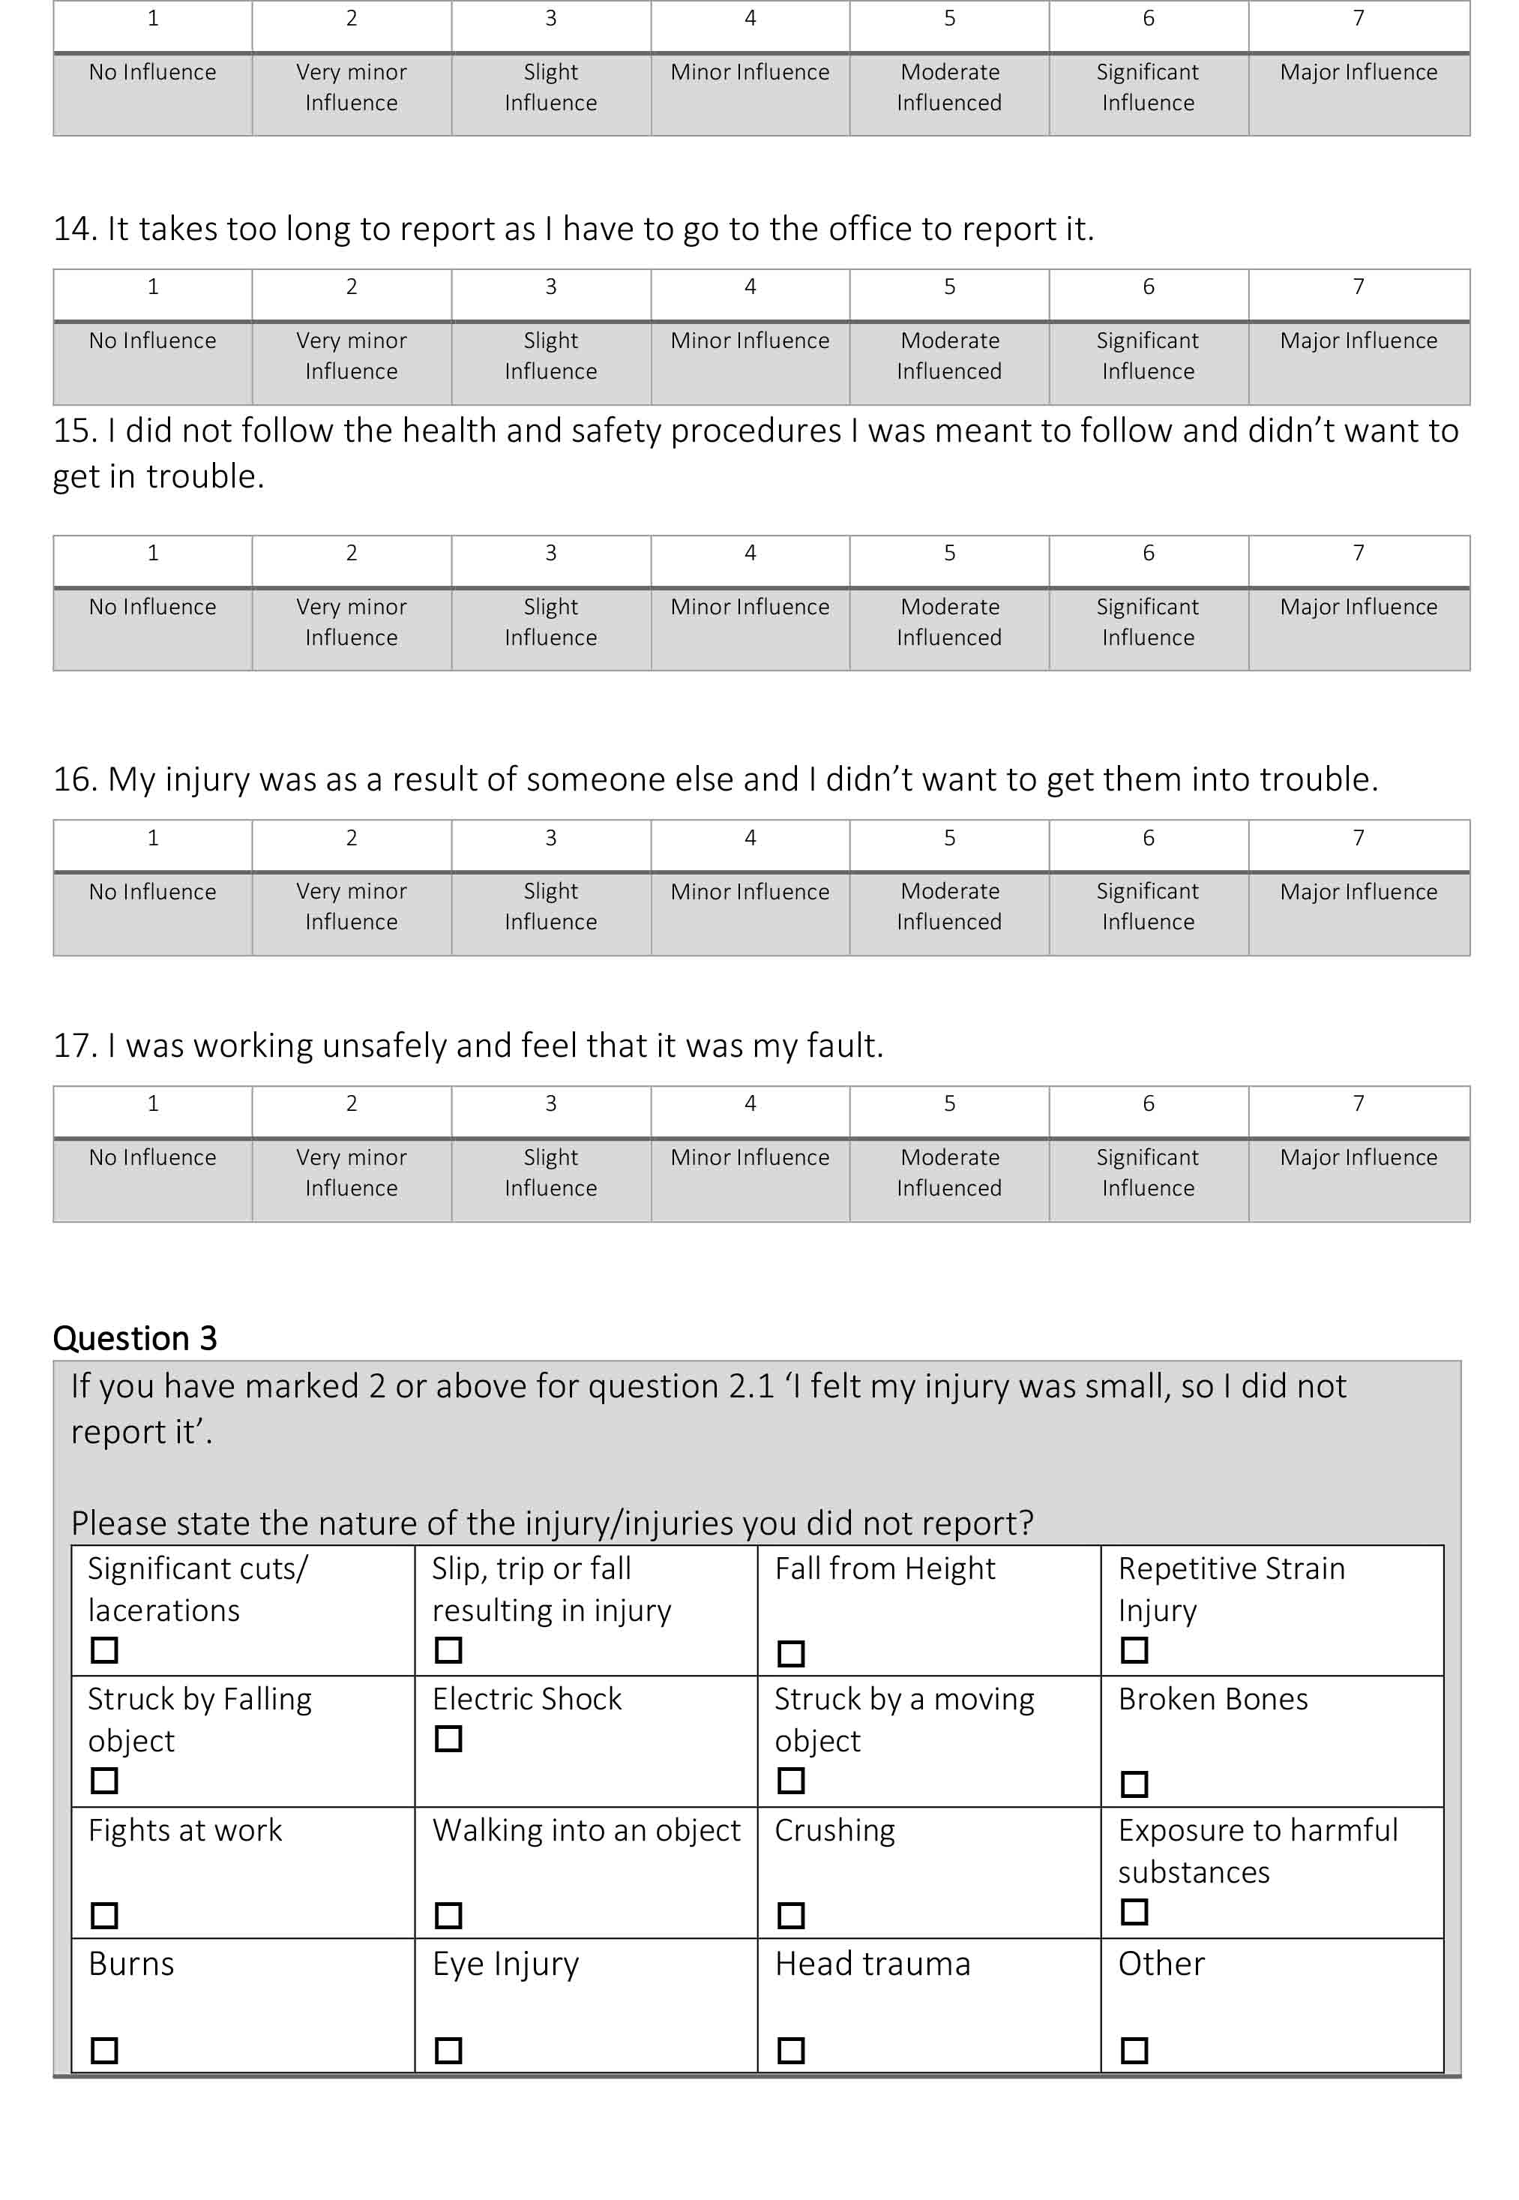
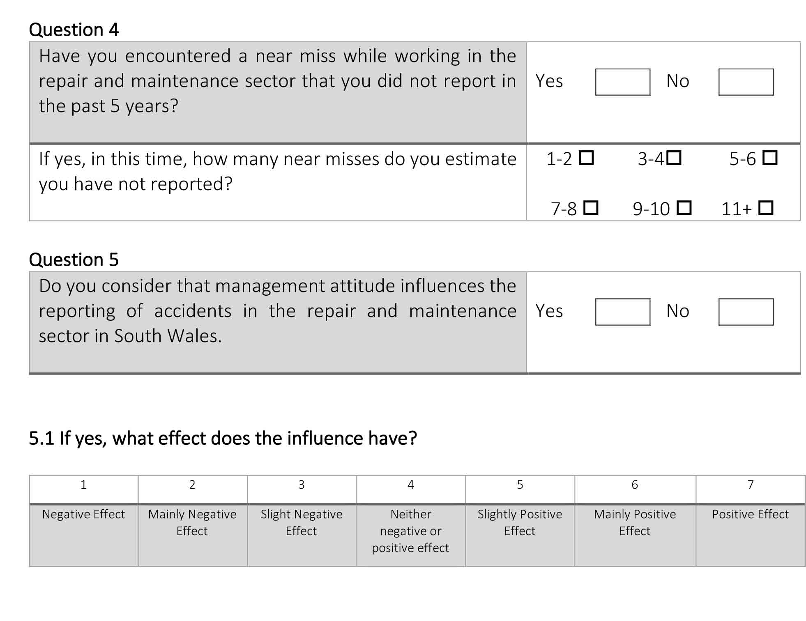
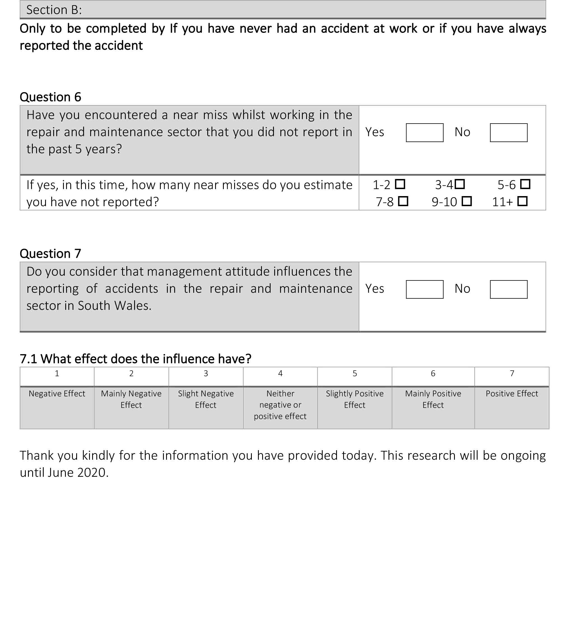

APPENDIX B: MANAGEMENT SURVEY QUESTIONNAIRE
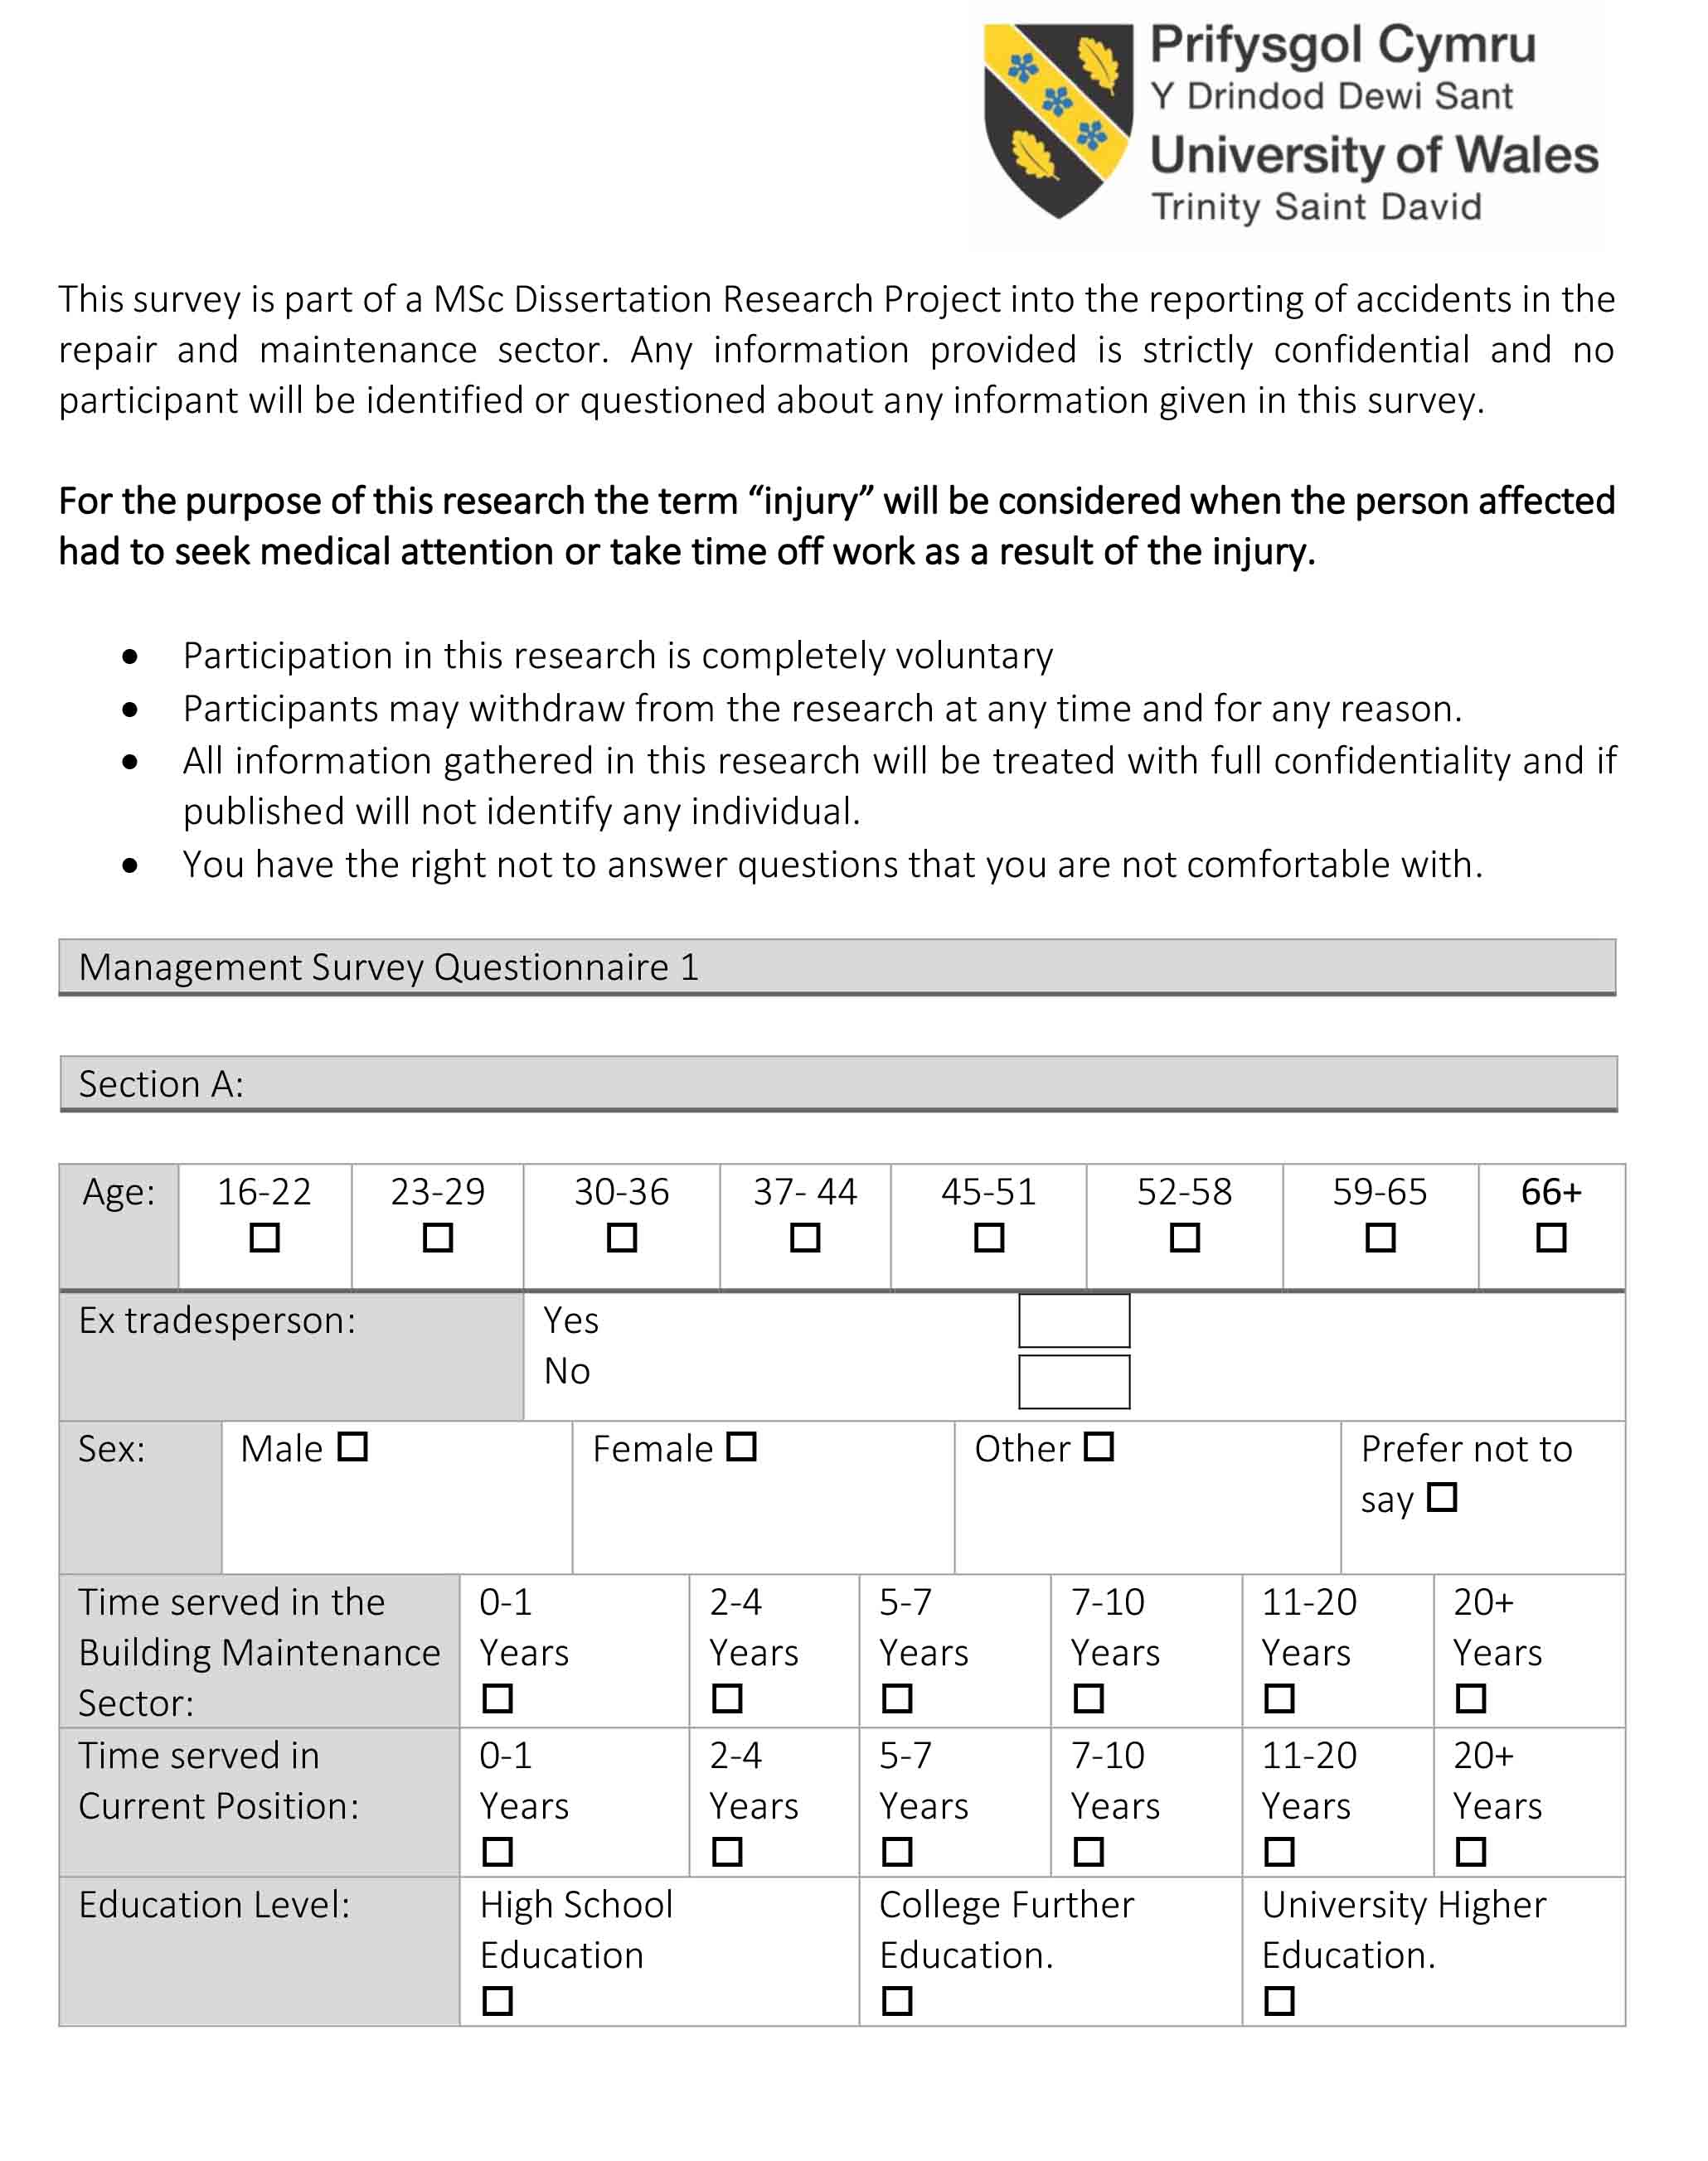
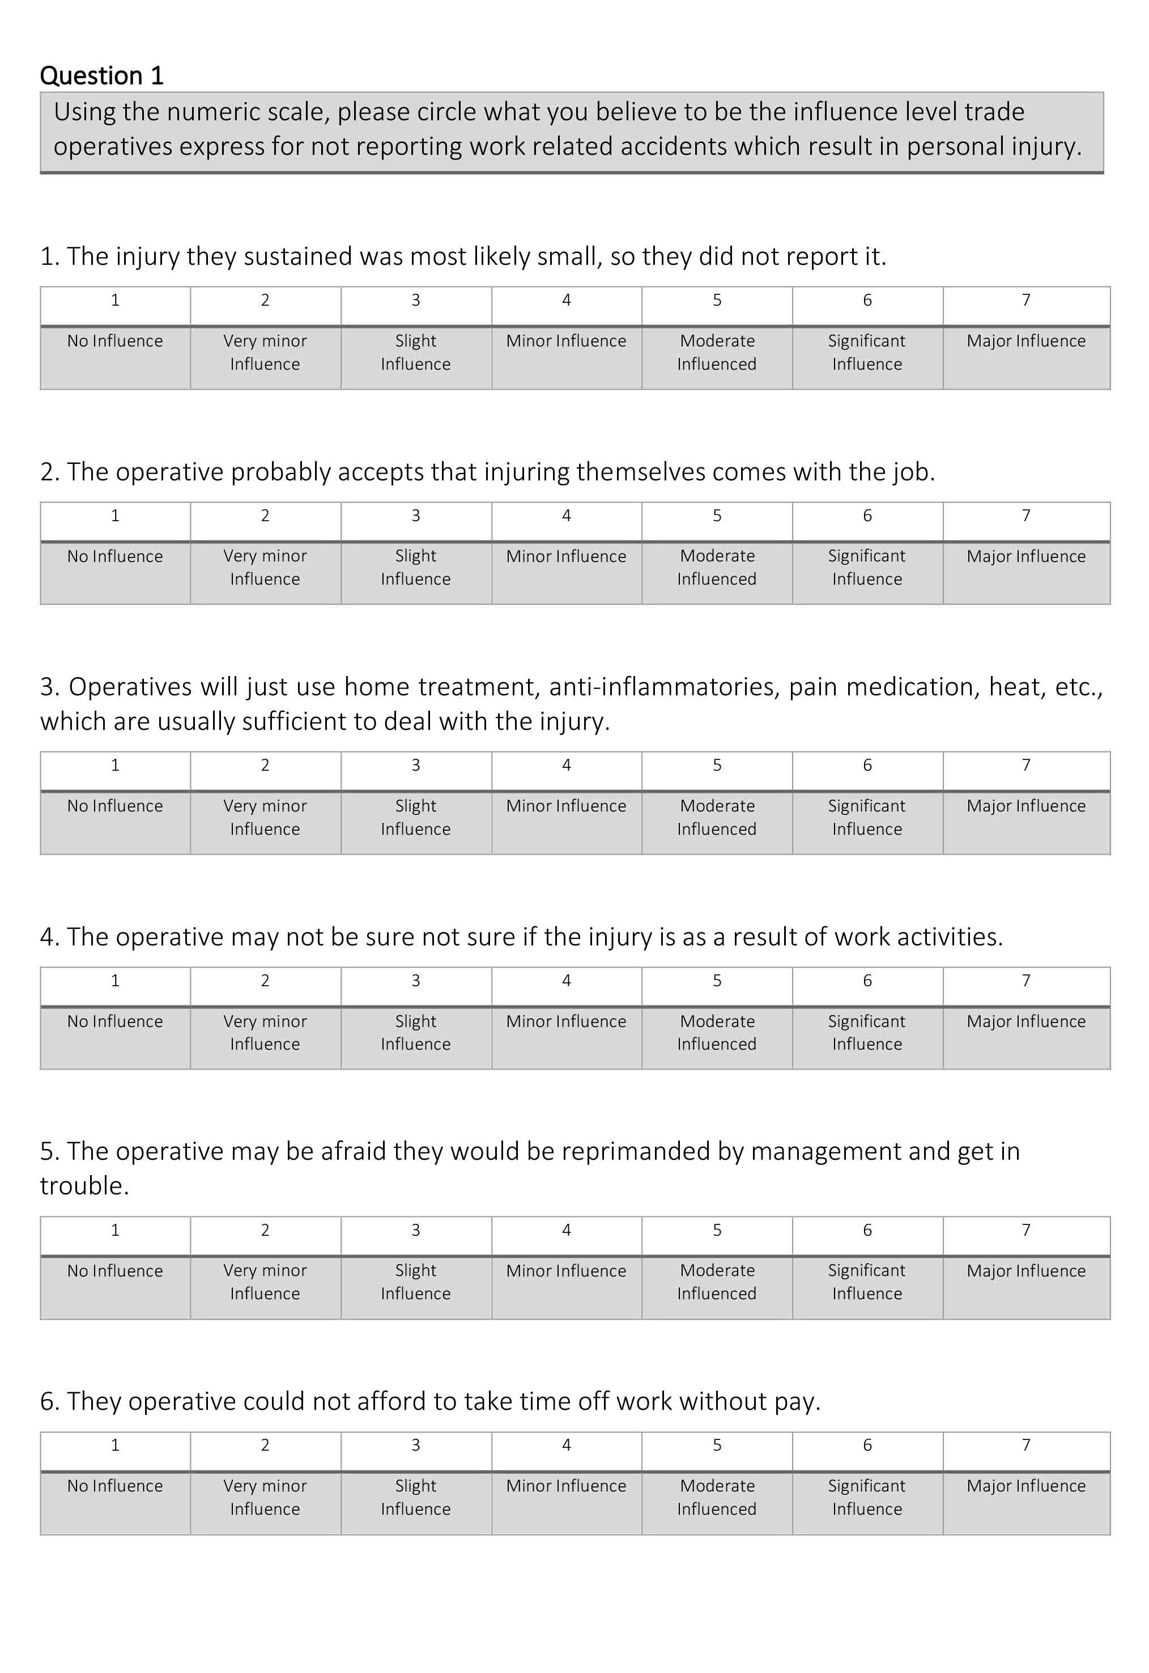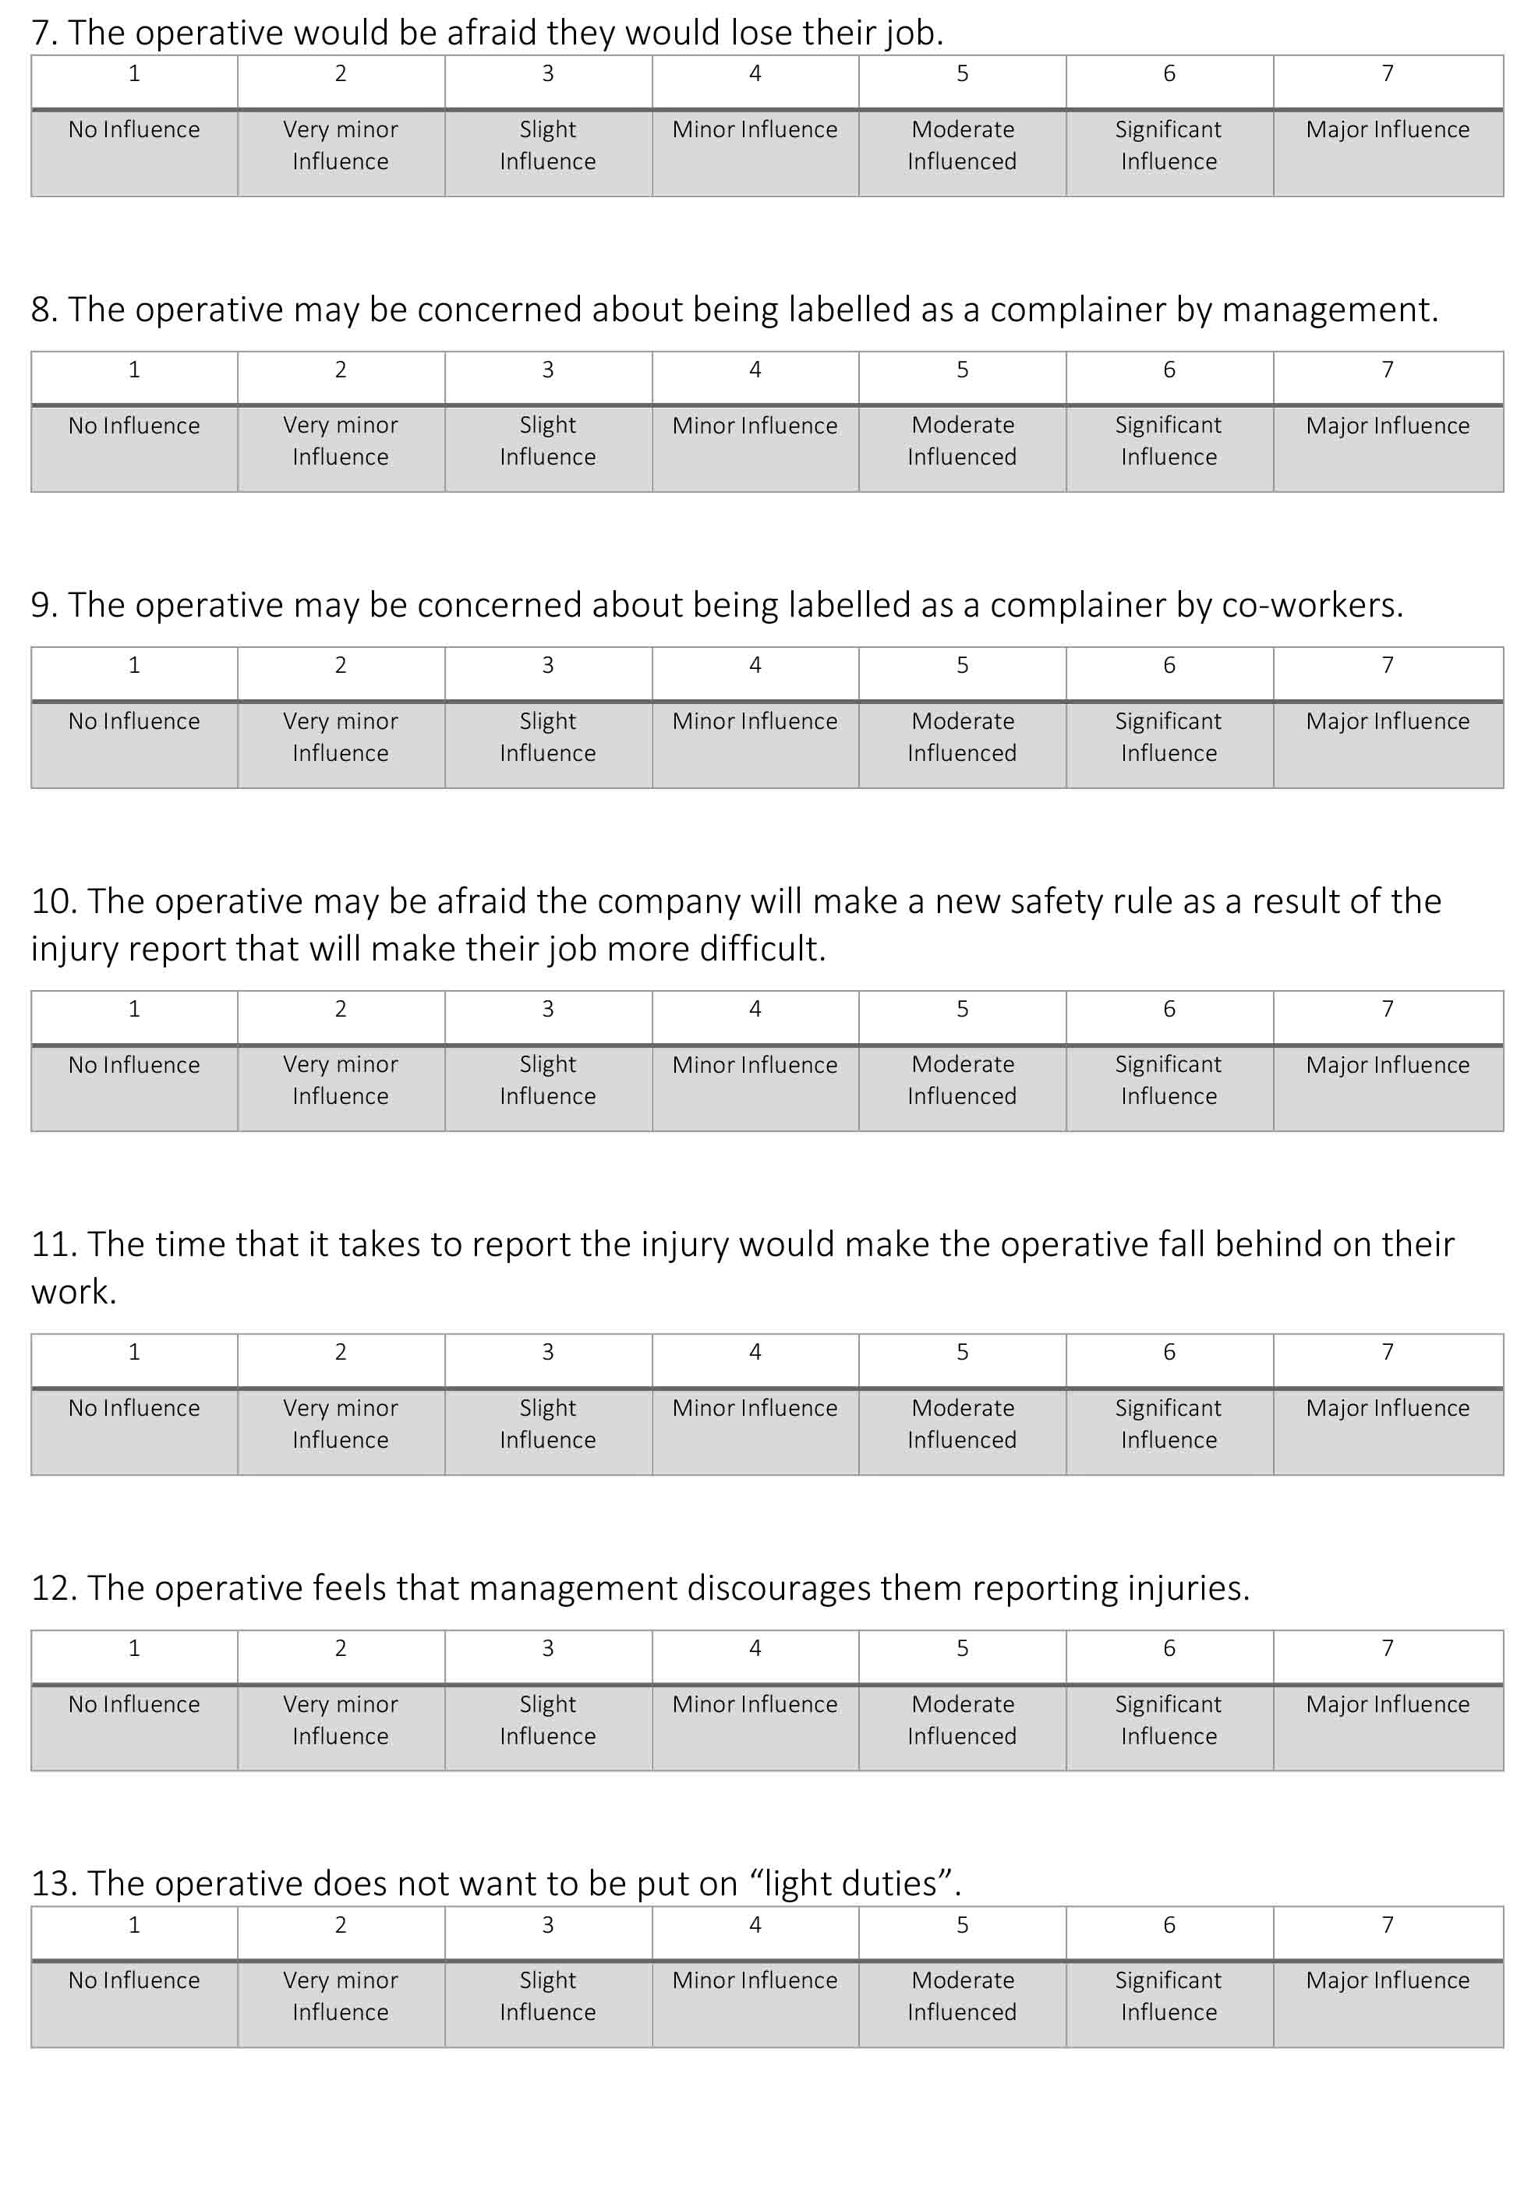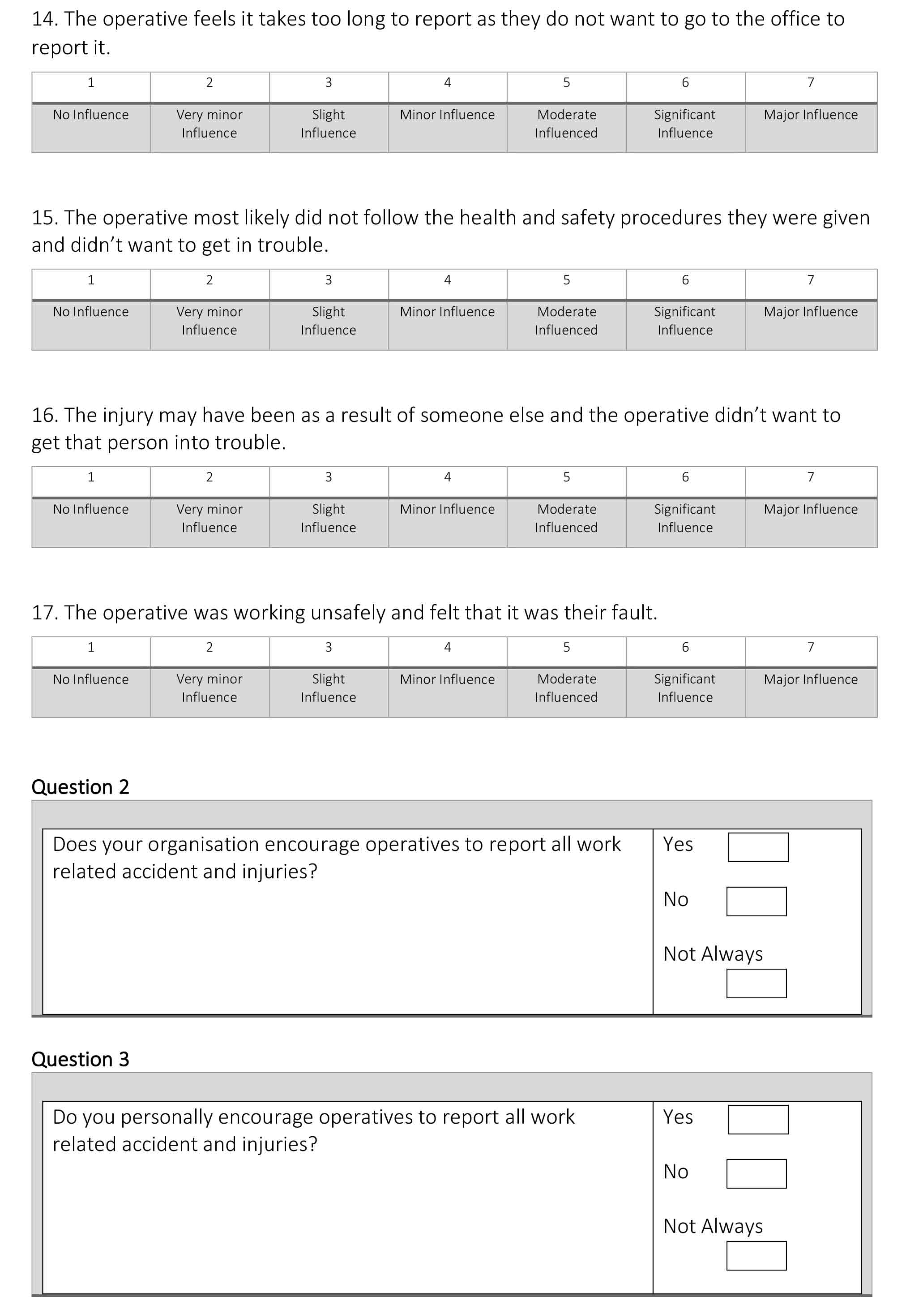

APPENDIX C: FOCUS GROUP SURVEY QUESTIONNAIRE
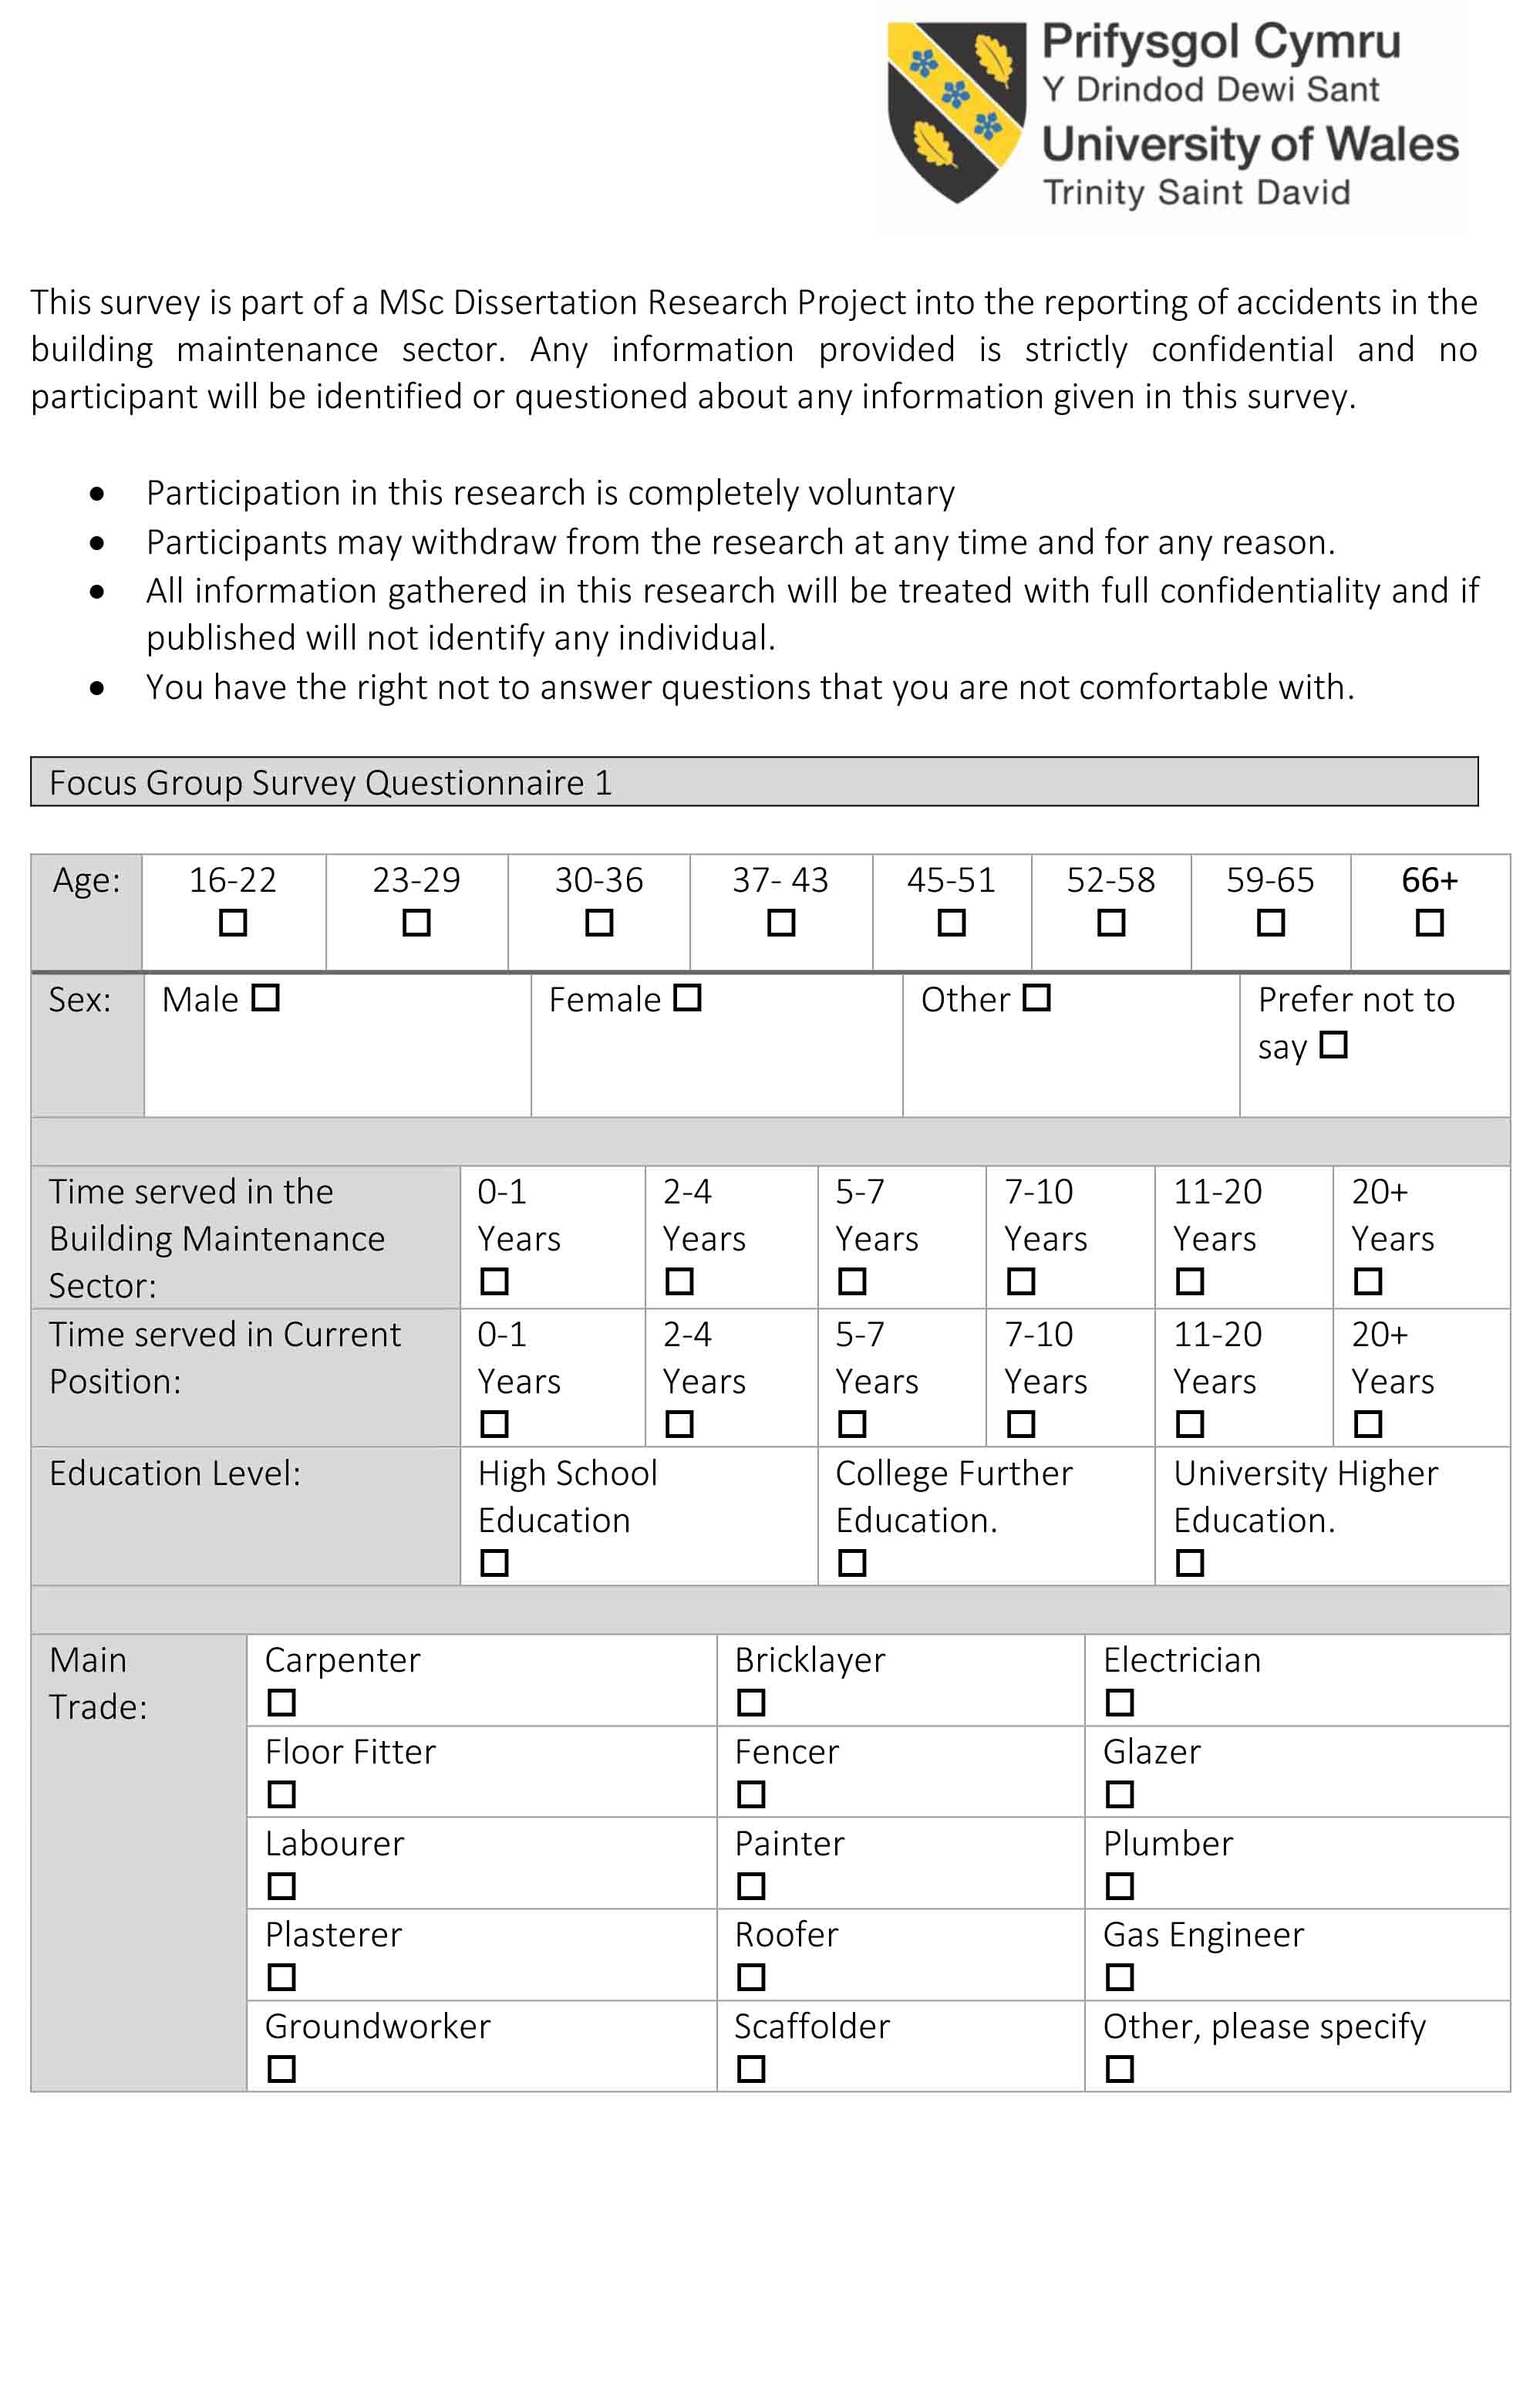
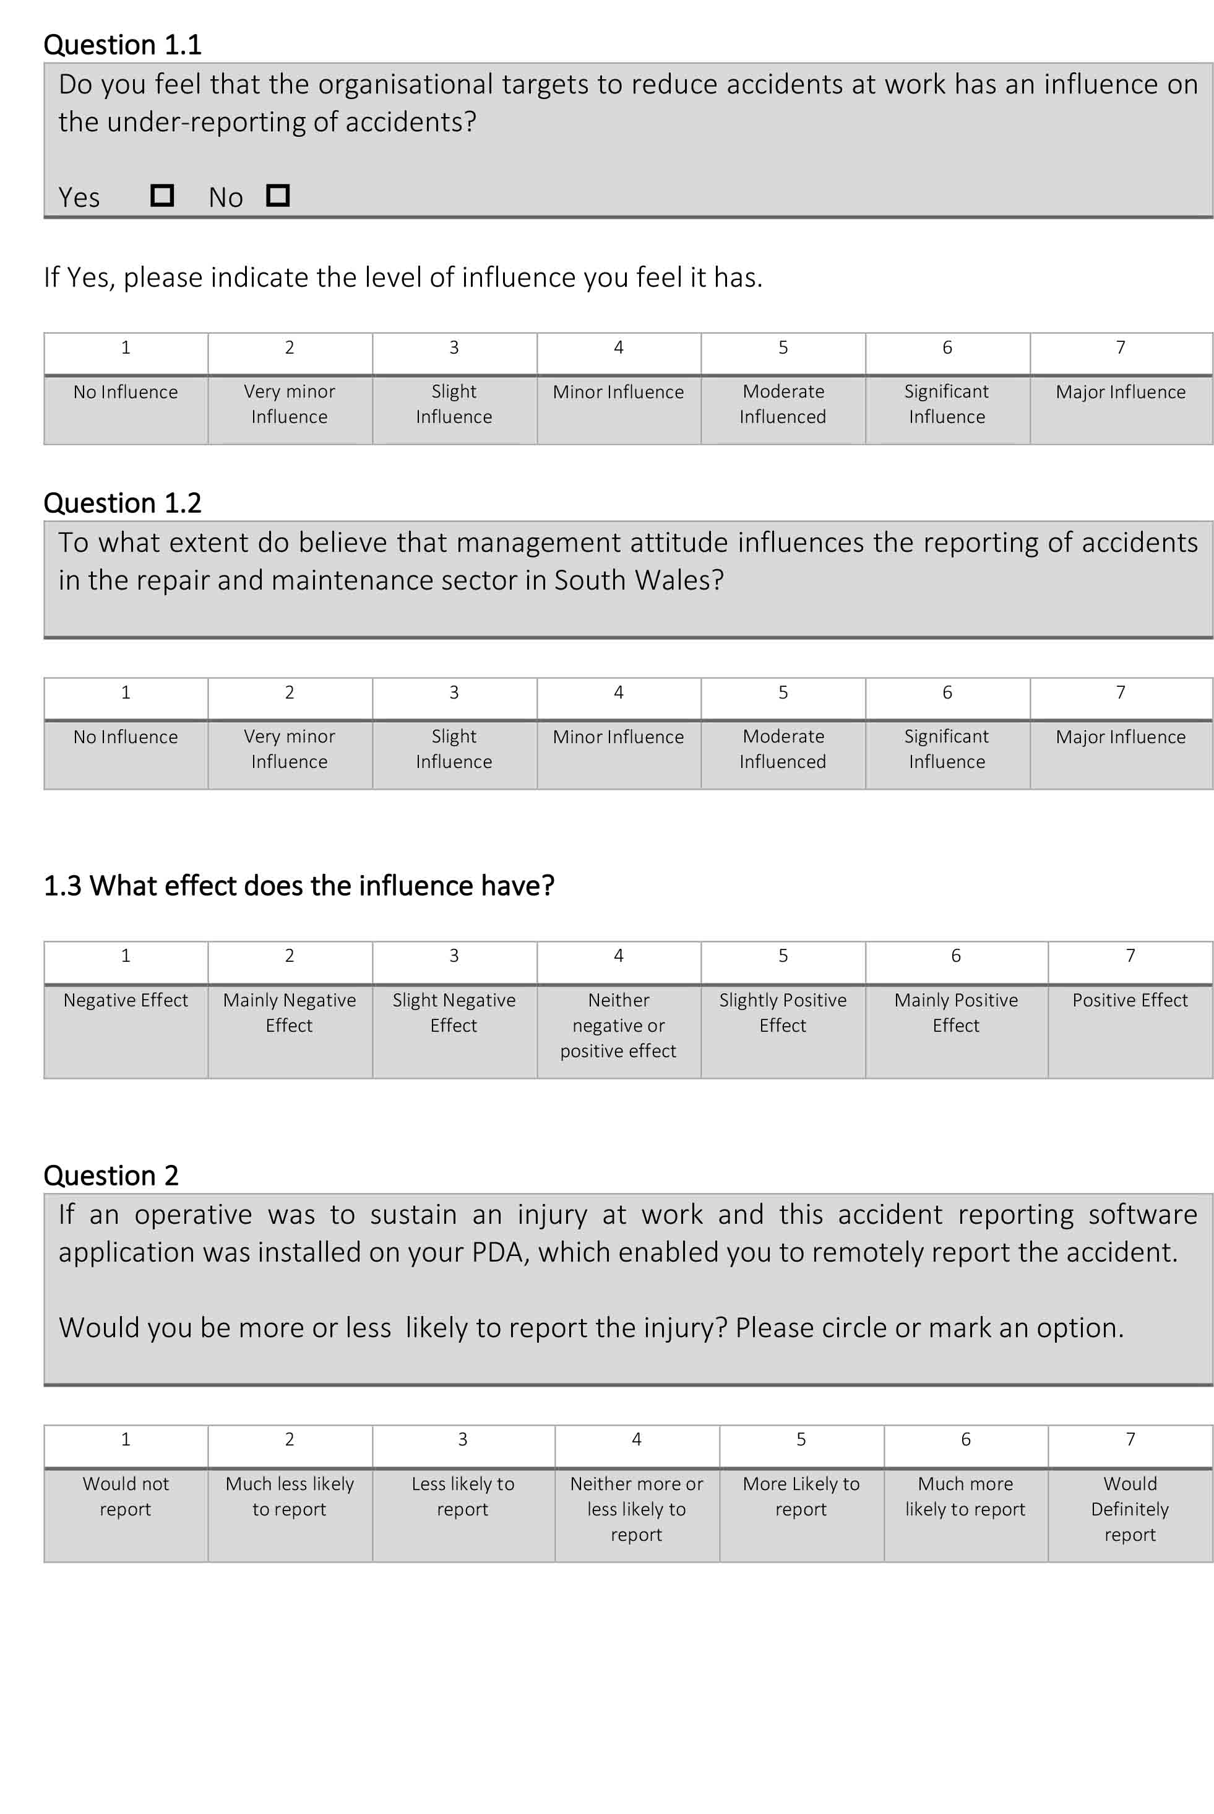
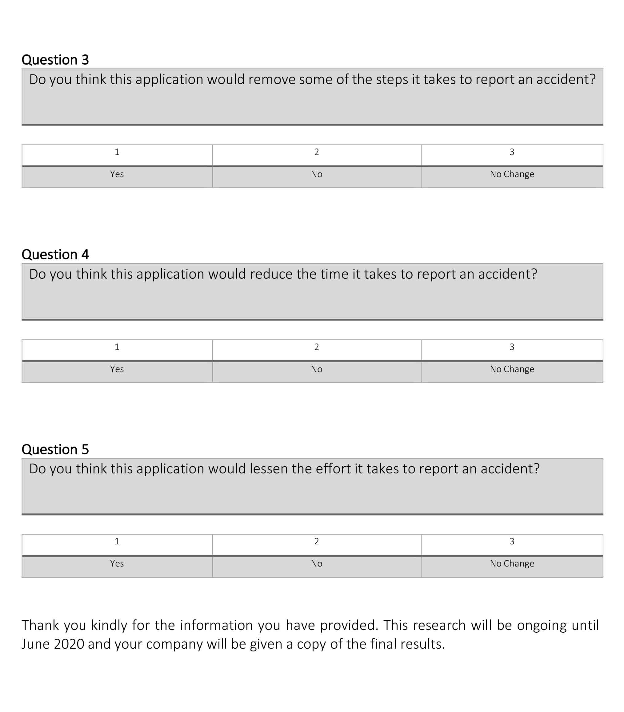

APPENDIX D: FOCUS GROUP PRESENTATION SLIDES







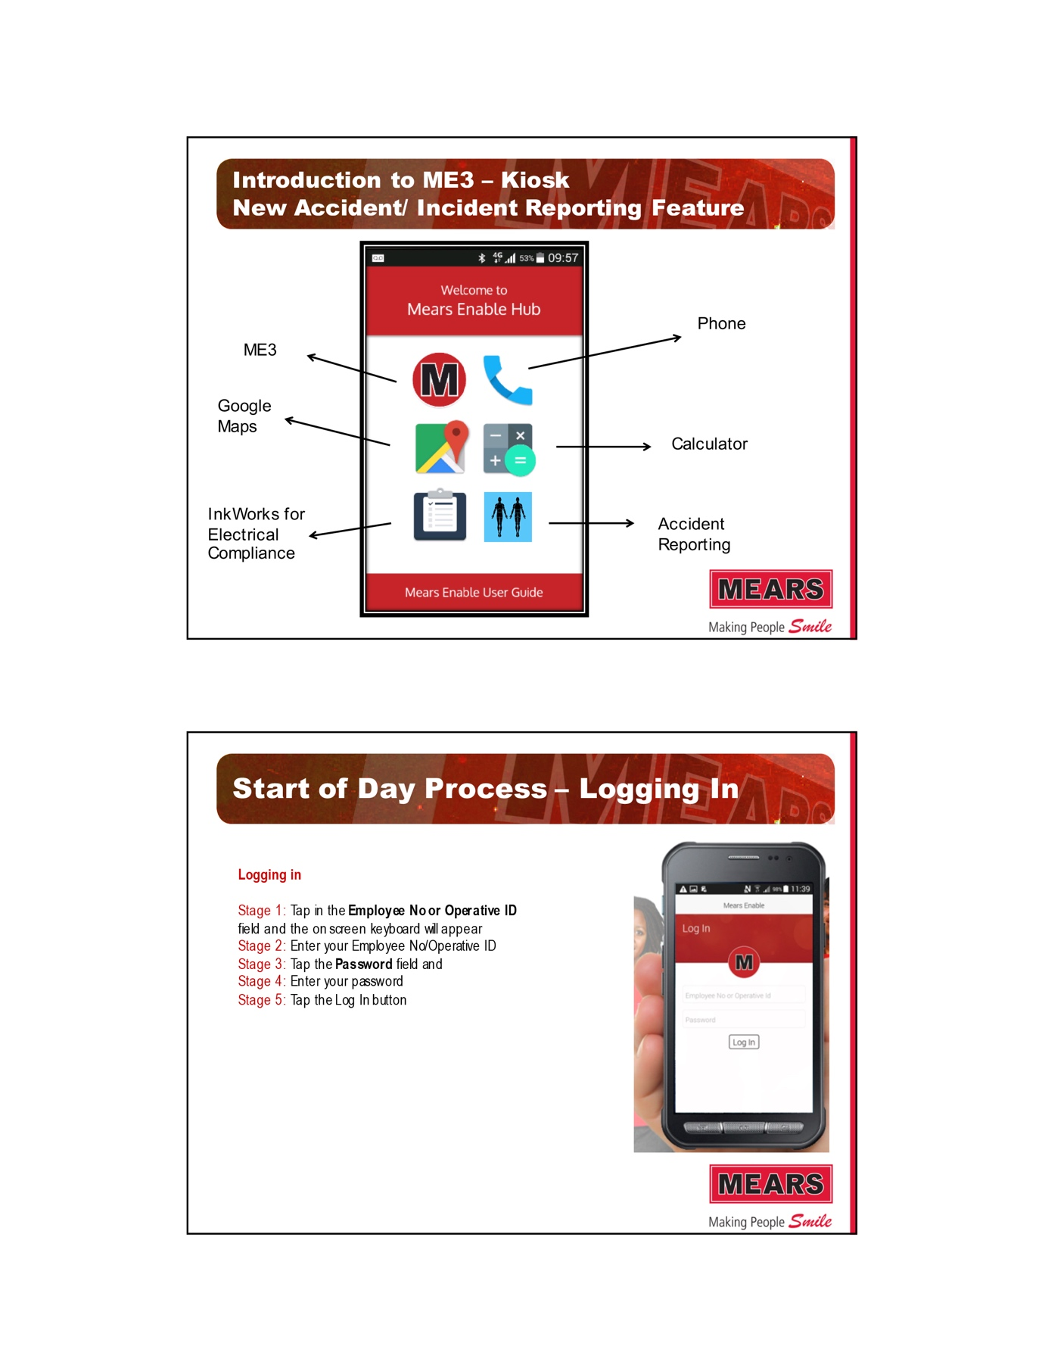

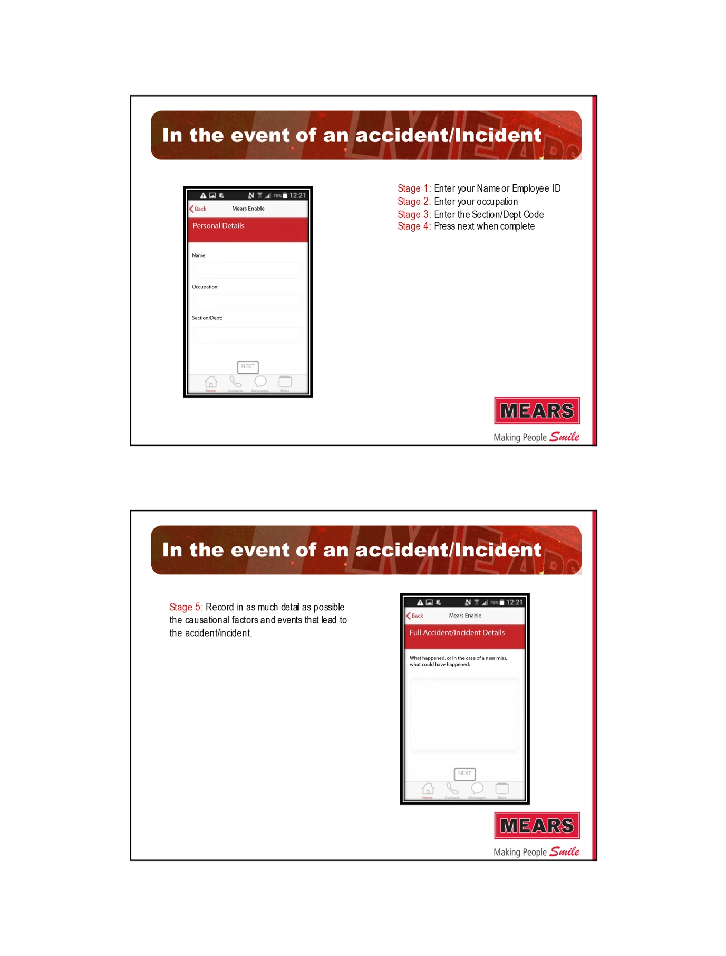

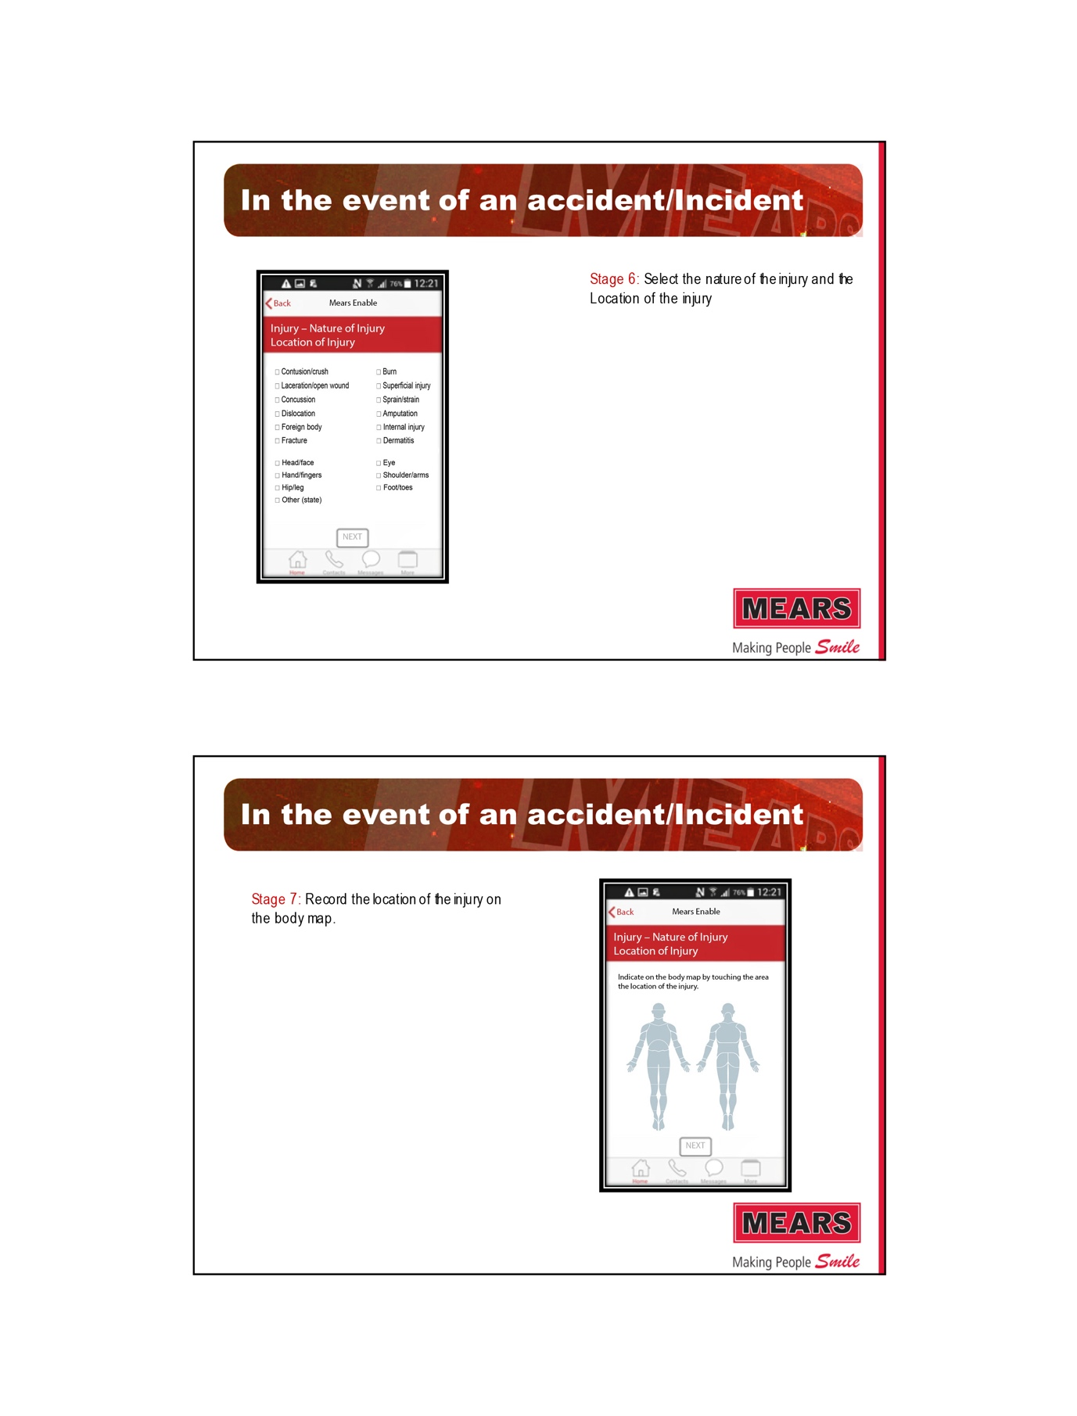

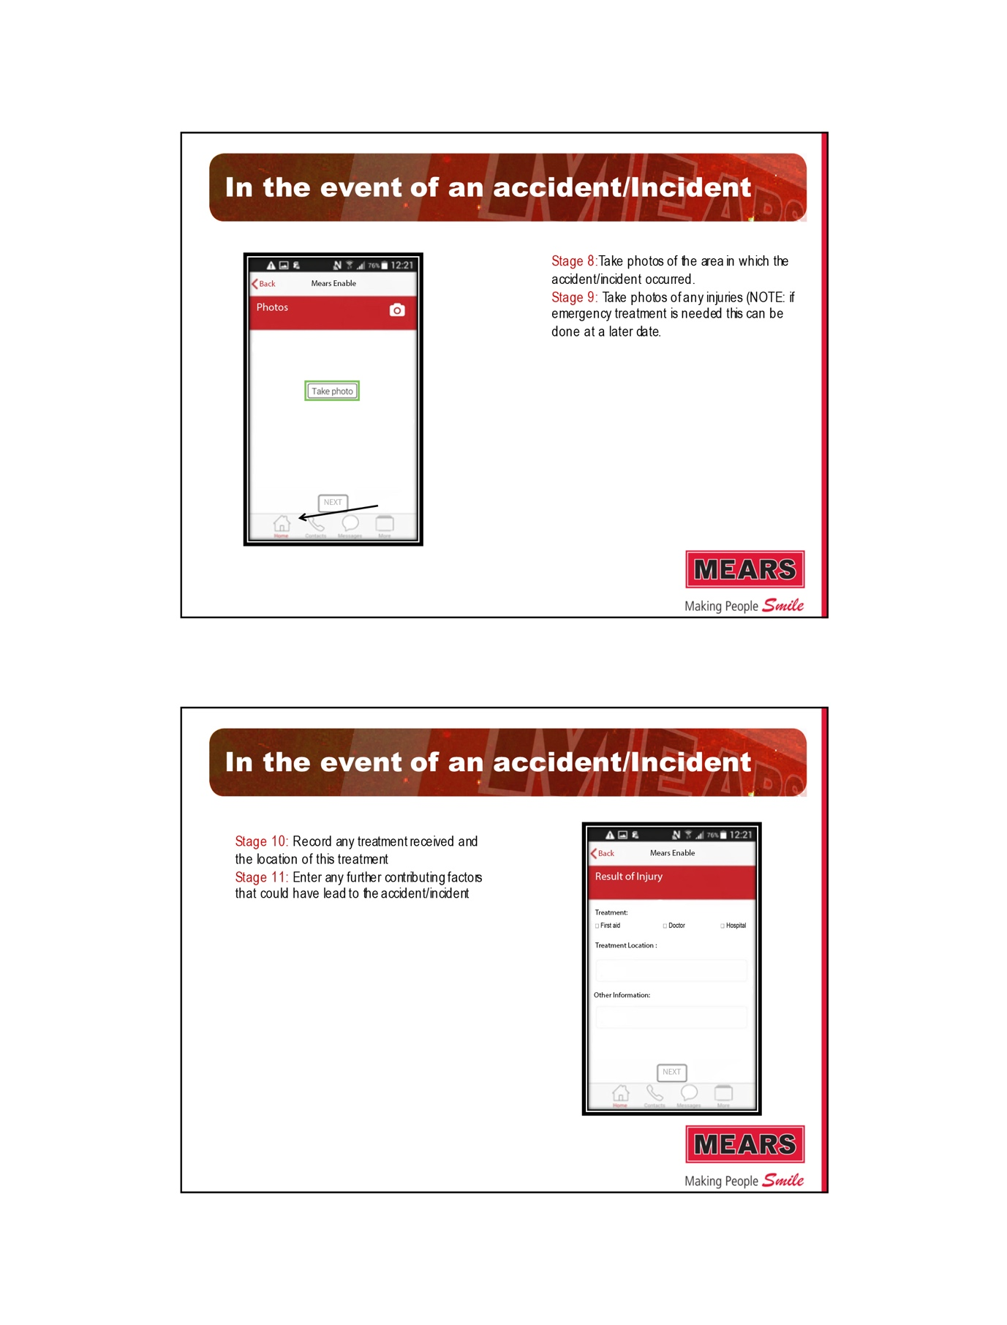
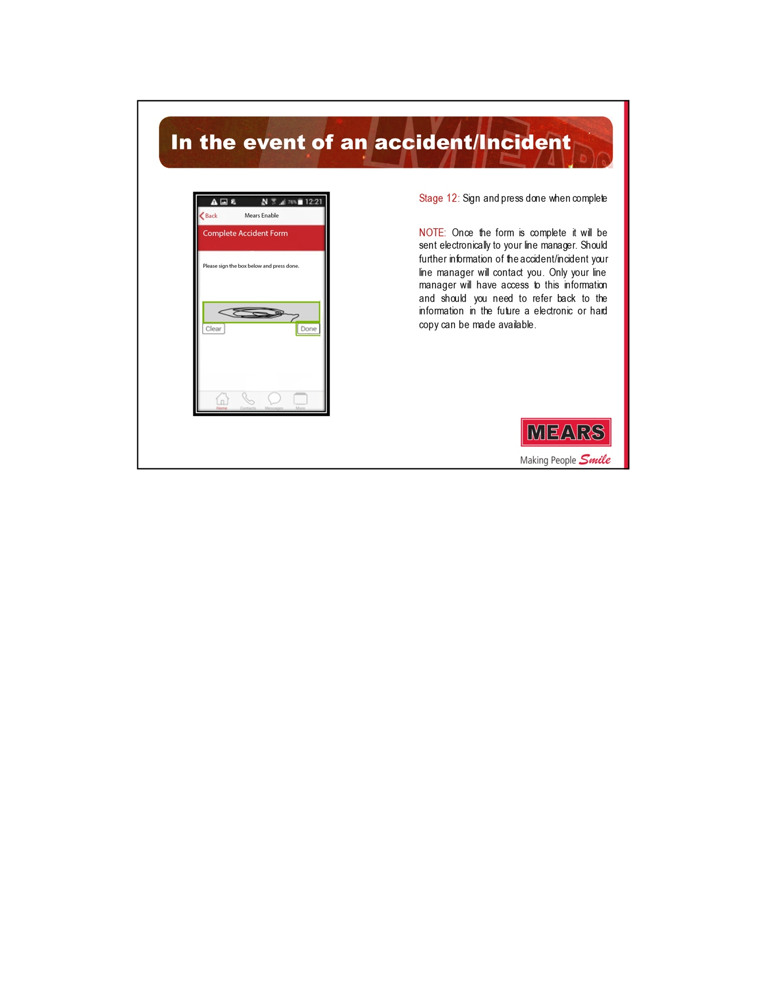

APPENDIX E: OPERATIVE QUANTITATIVE DATA ANALYSIS

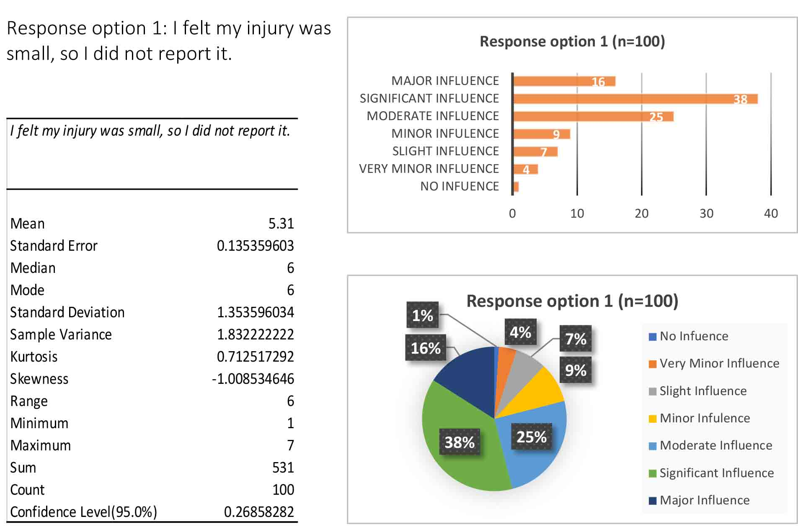

Table 5: Descriptive Statistics for operative response option 1
Figure 6: Frequency of answers for operative response option 1
Figure 7: Percentages of answers for operative response option 1

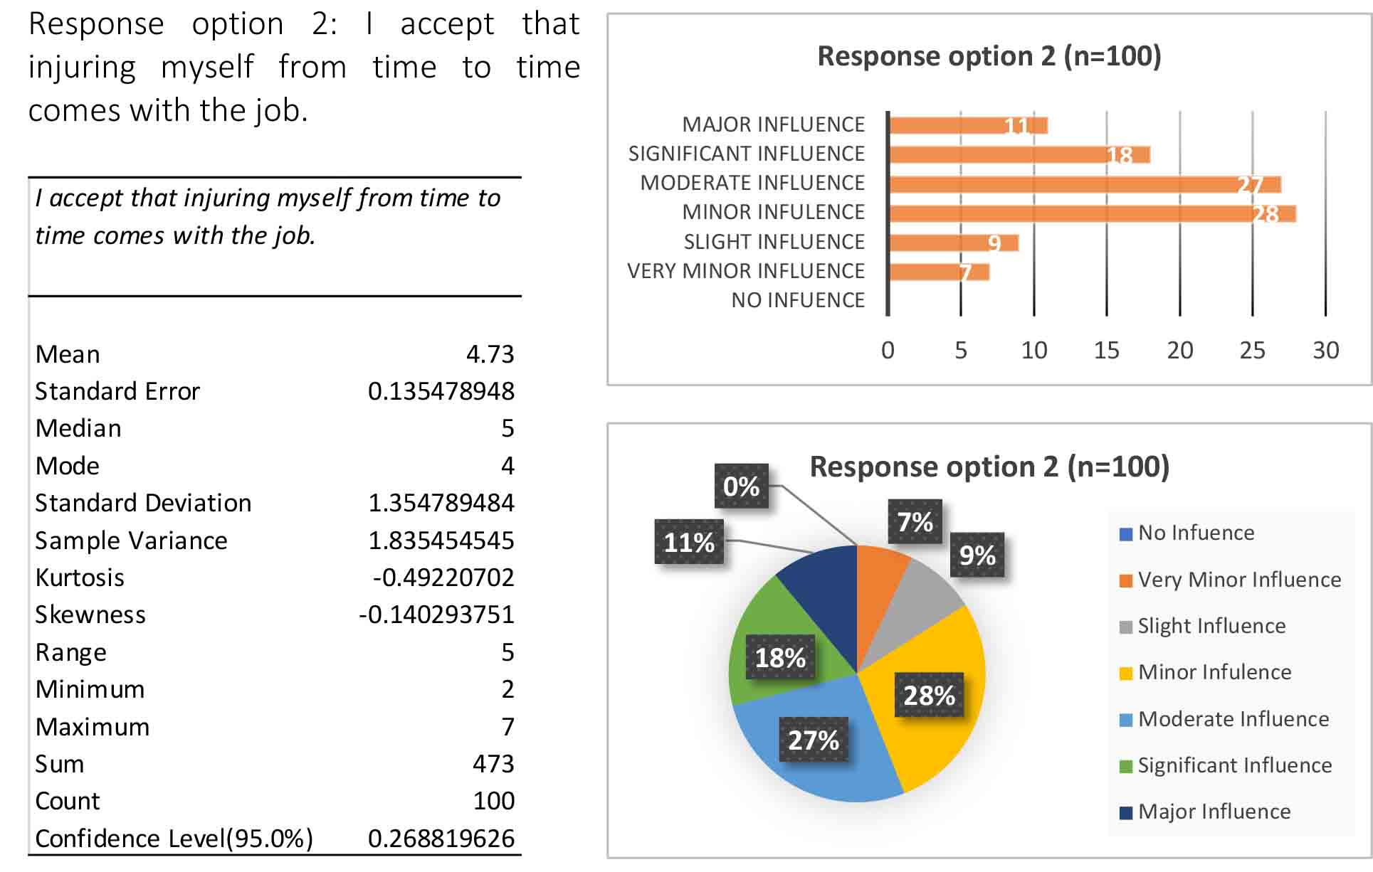

Table 6: Descriptive Statistics for operative response option 2
Figure 8: Frequency of answers for operative response option 2
Figure 9: Percentages of answers for operative response option 2
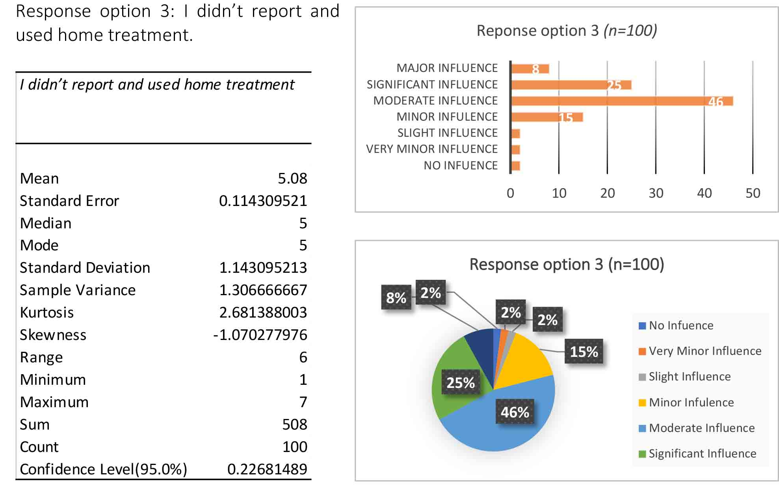

Table 7: Descriptive Statistics for operative response option 3
Figure 10: Frequency of answers for operative response option 3
Figure 11: Percentages of answers for operative response option 3

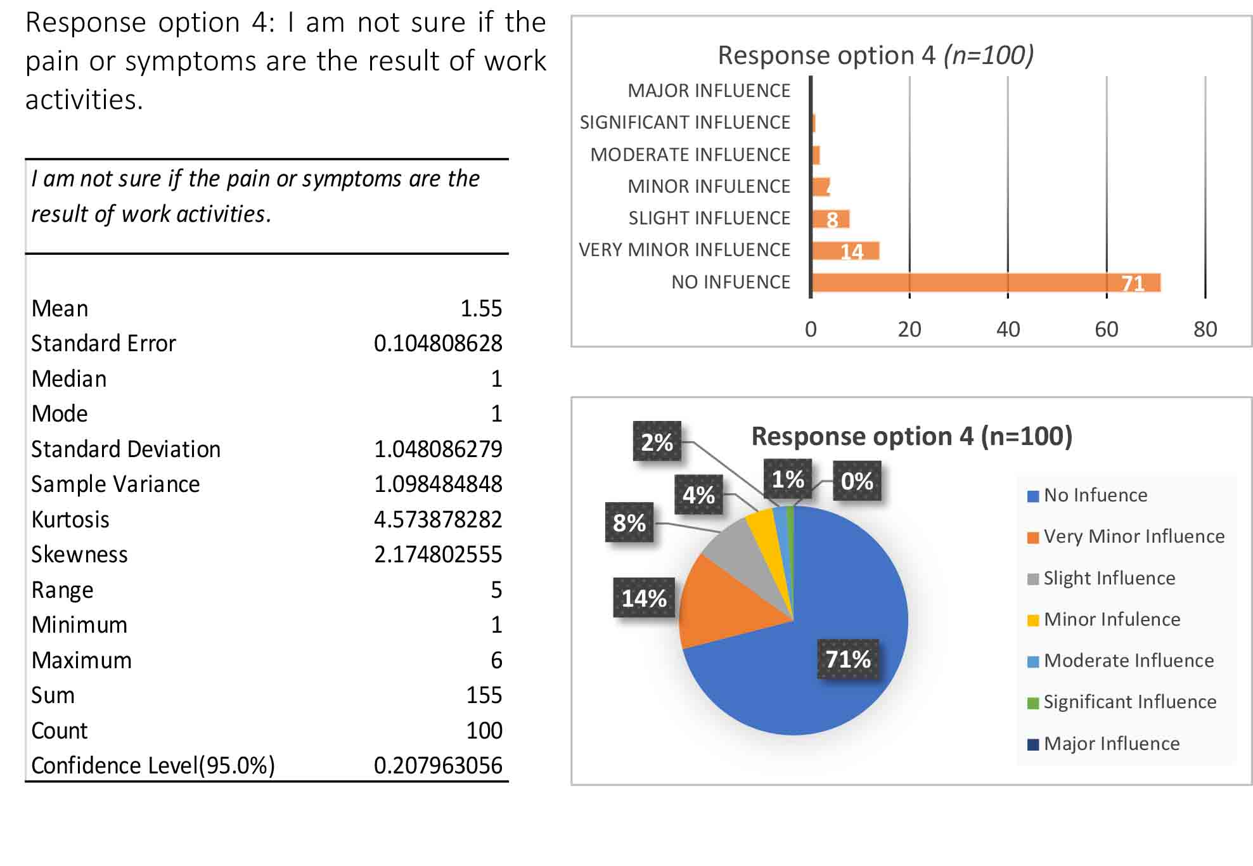
Table 8: Descriptive Statistics for operative response option 4
Figure 12: Frequency of answers for operative response option 4
Figure 13: Percentages of answers for operative response option 4
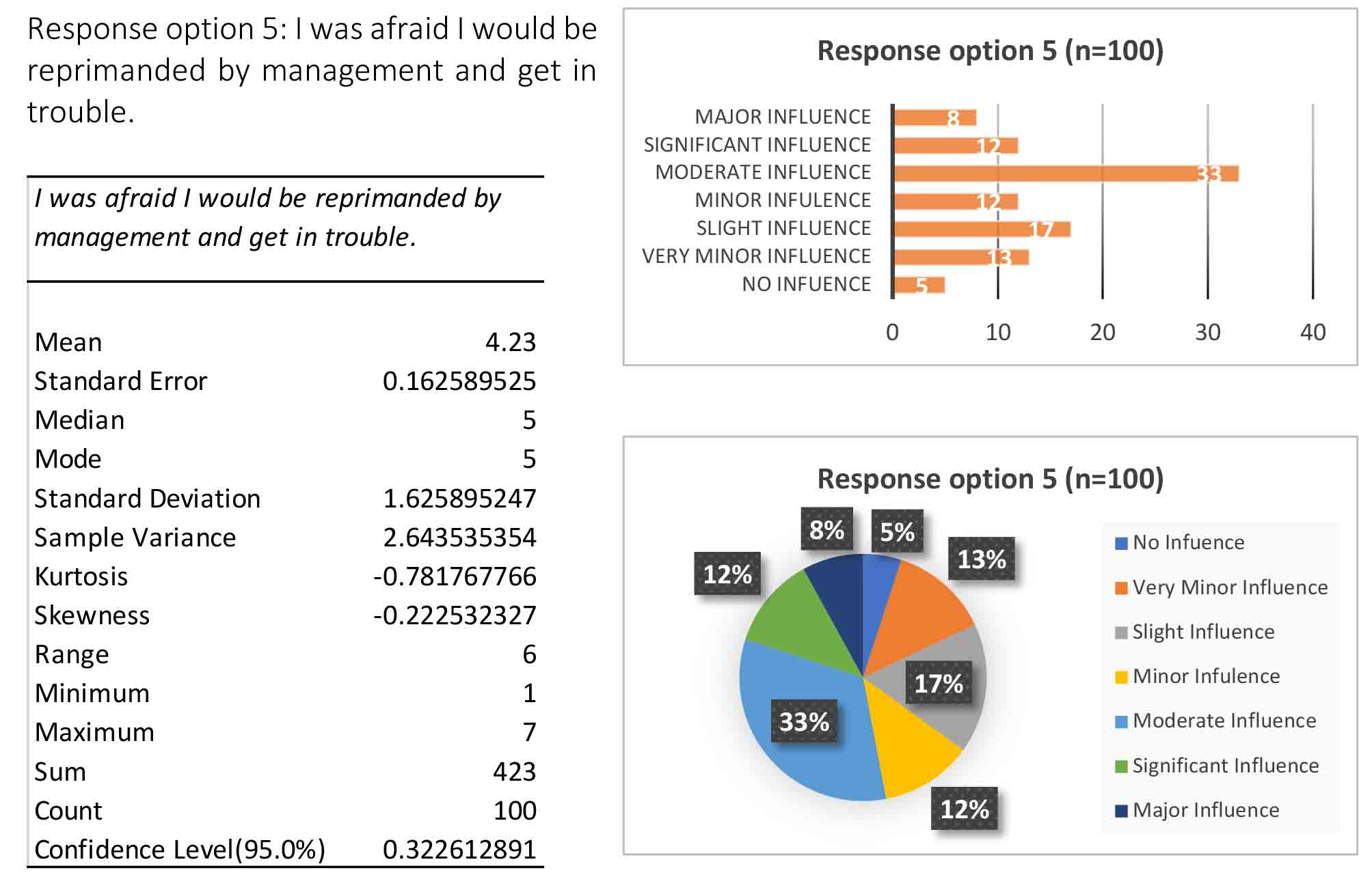

Table 9: Descriptive Statistics for operative response option 5
Figure 14: Frequency of answers for operative response option 5
Figure 15: Percentages of answers for operative response option 5

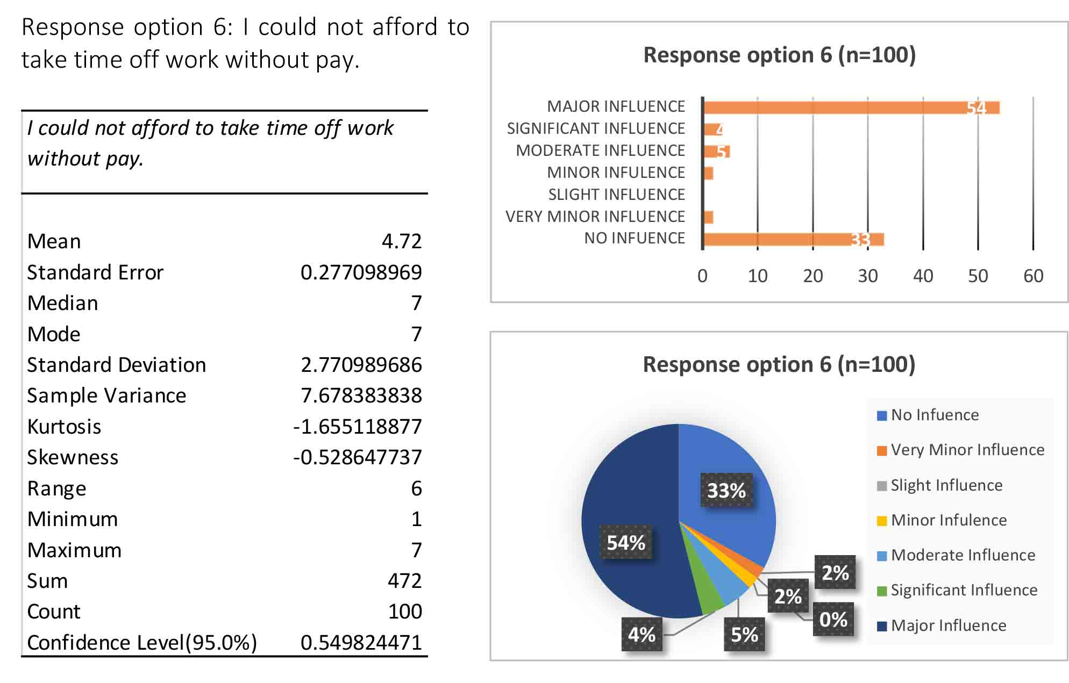

Table 10: Descriptive Statistics for operative response option 6
Figure 16: Frequency of answers for operative response option 6
Figure 17: Percentages of answers for operative response option 6

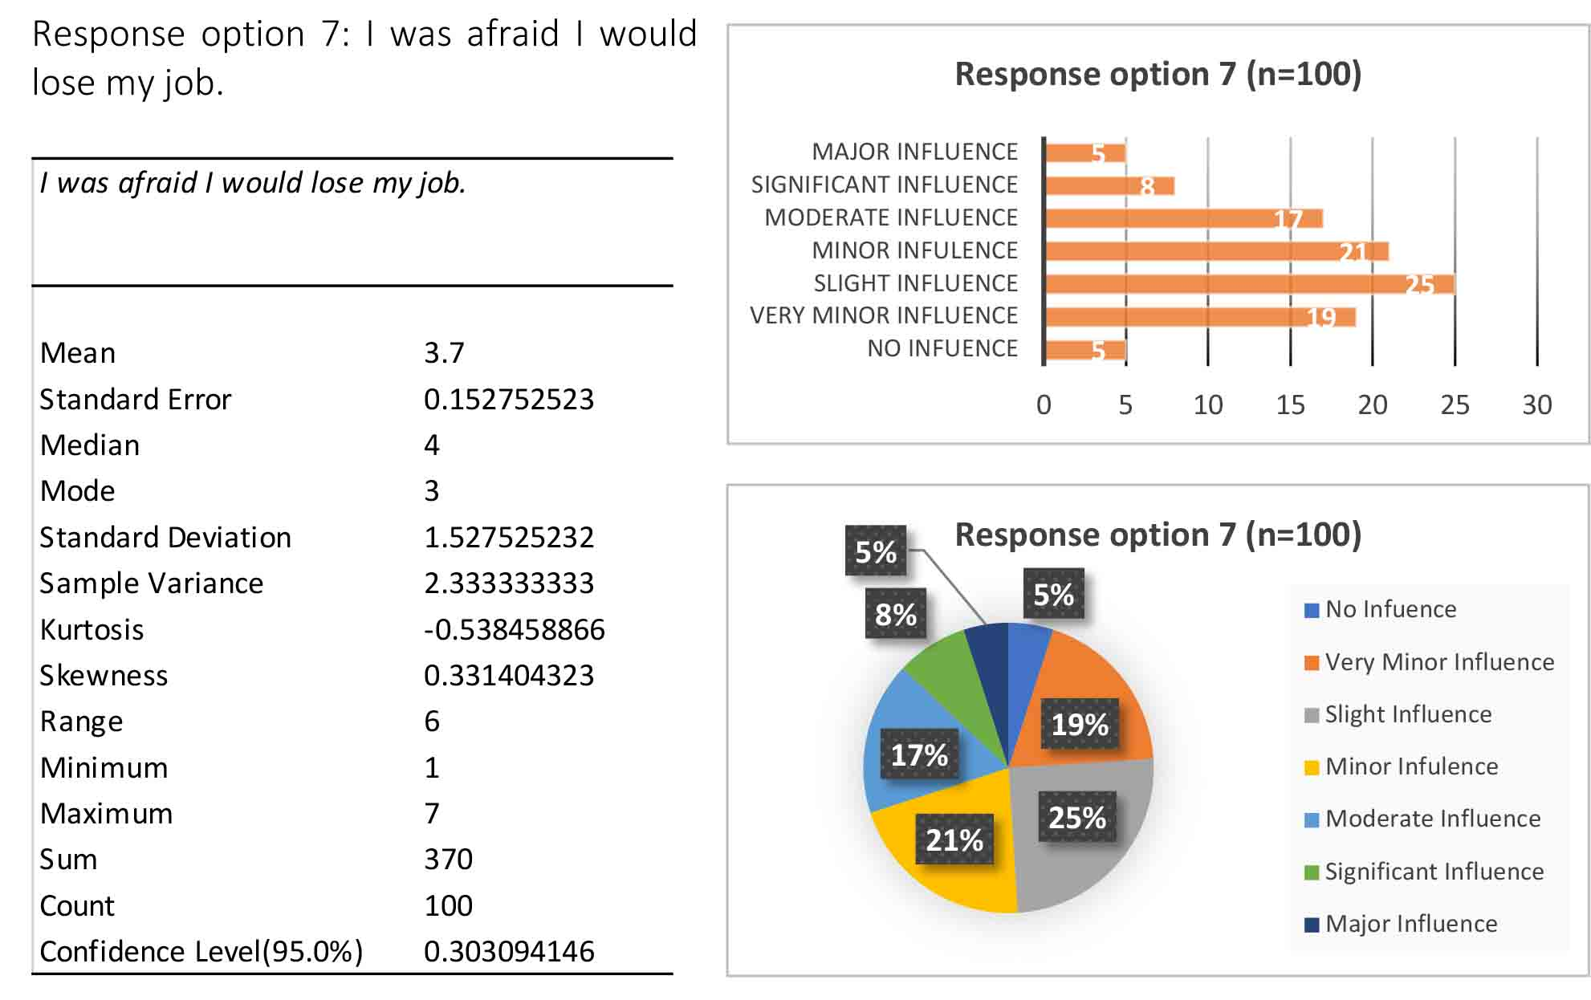
Table 11: Descriptive Statistics for operative response option 7
Figure 18: Frequency of answers for operative response option 7
Figure 19: Percentages of answers for operative response option 7

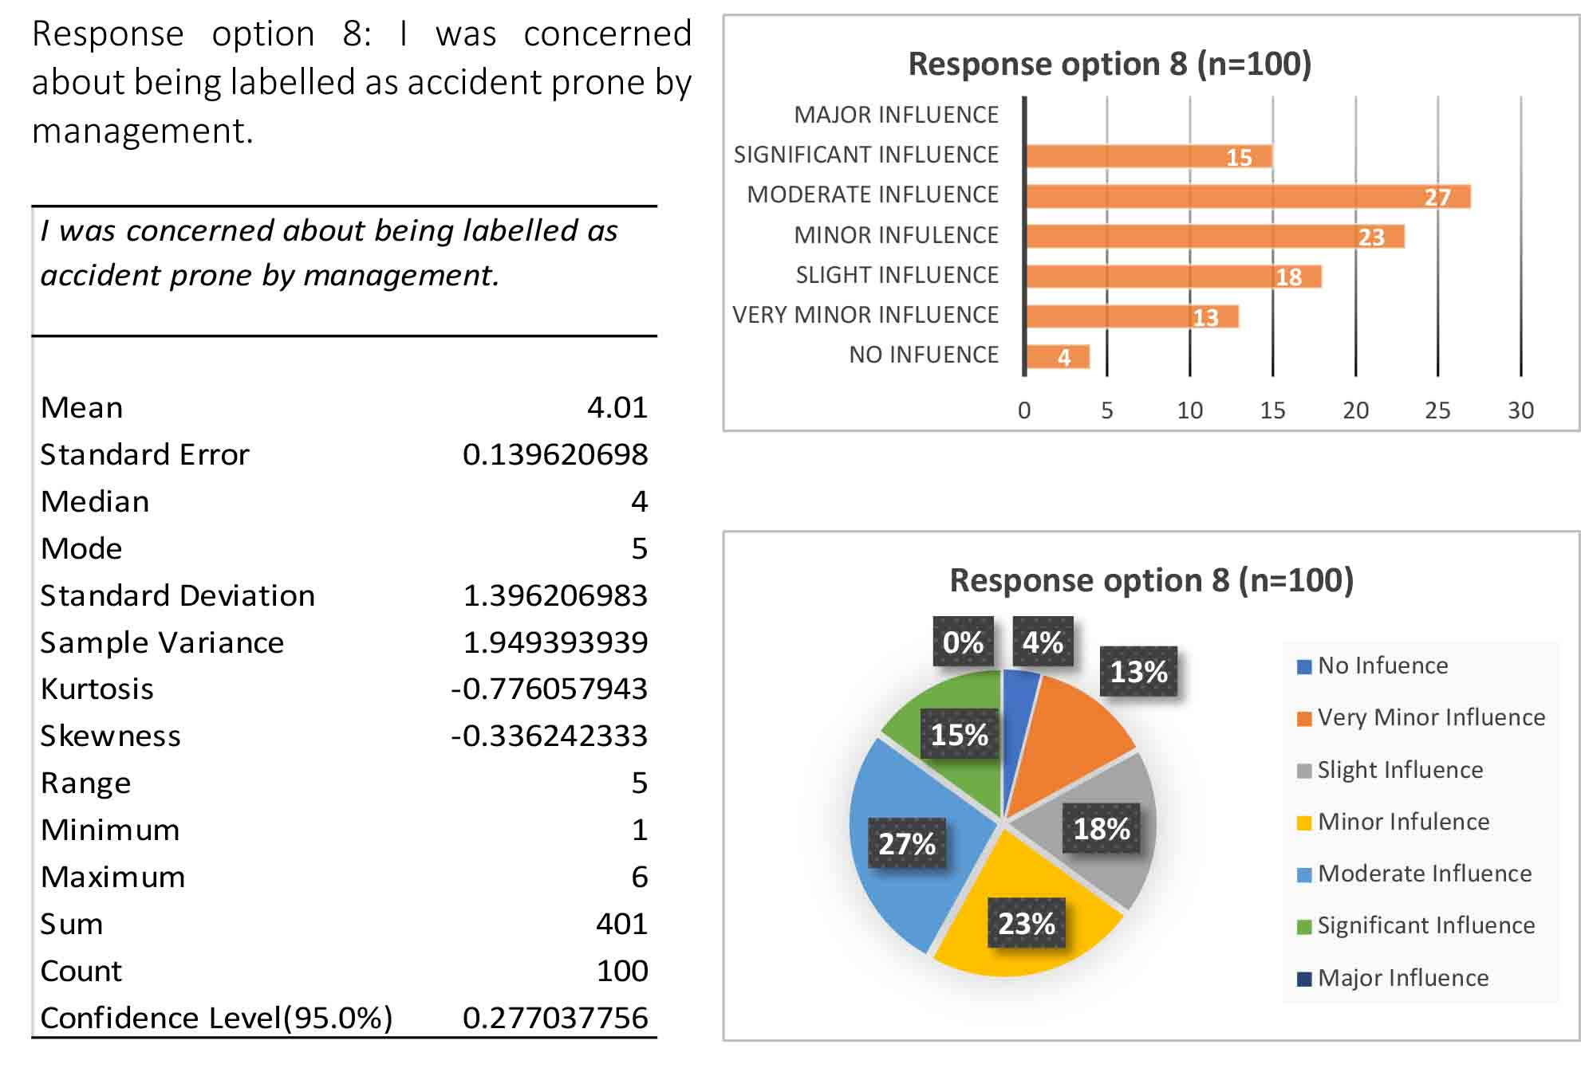
Table 12: Descriptive Statistics for operative response option 8
Figure 20: Frequency of answers for operative response option 8
Figure 21: Percentages of answers for operative response option 8

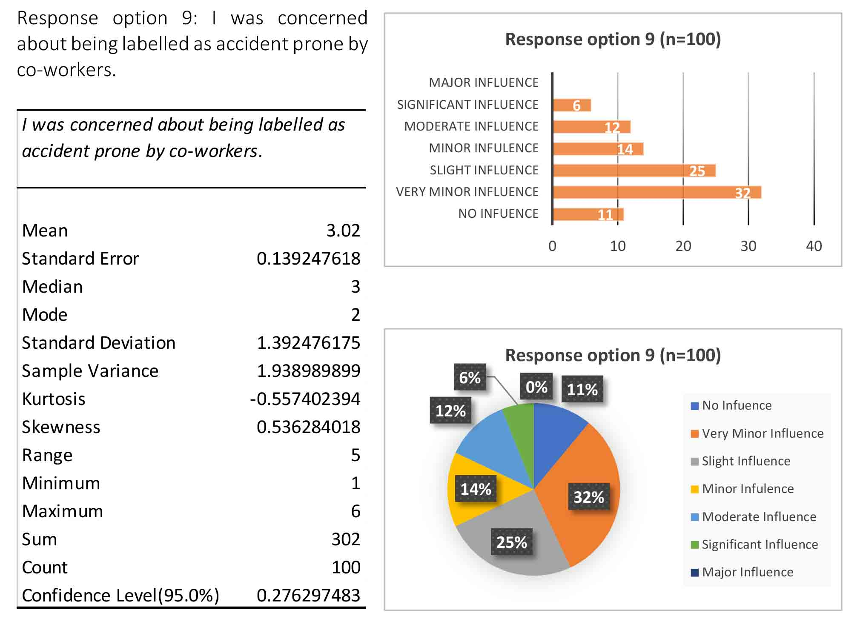
Table 13: Descriptive Statistics for operative response option 9
Figure 22: Frequency of answers for operative response option 9
Figure 23: Percentages of answers for operative response option 9

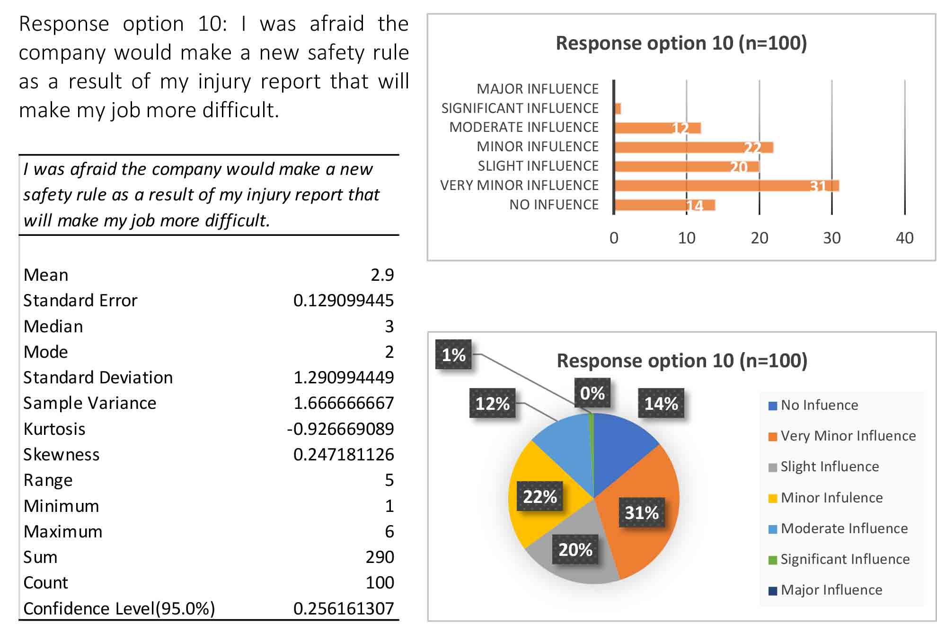
Table 14: Descriptive Statistics for operative response option 10
Figure 24: Frequency of answers for operative response option 10
Figure 25: Percentages of answers for operative response option 10
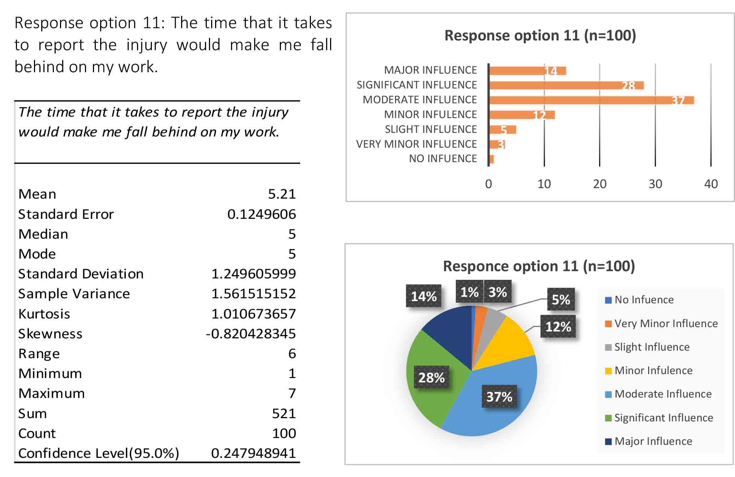
Table 15: Descriptive Statistics for operative response option 11
Figure 26: Frequency of answers for operative response option 11
Figure 27: Percentages of answers for operative response option 11

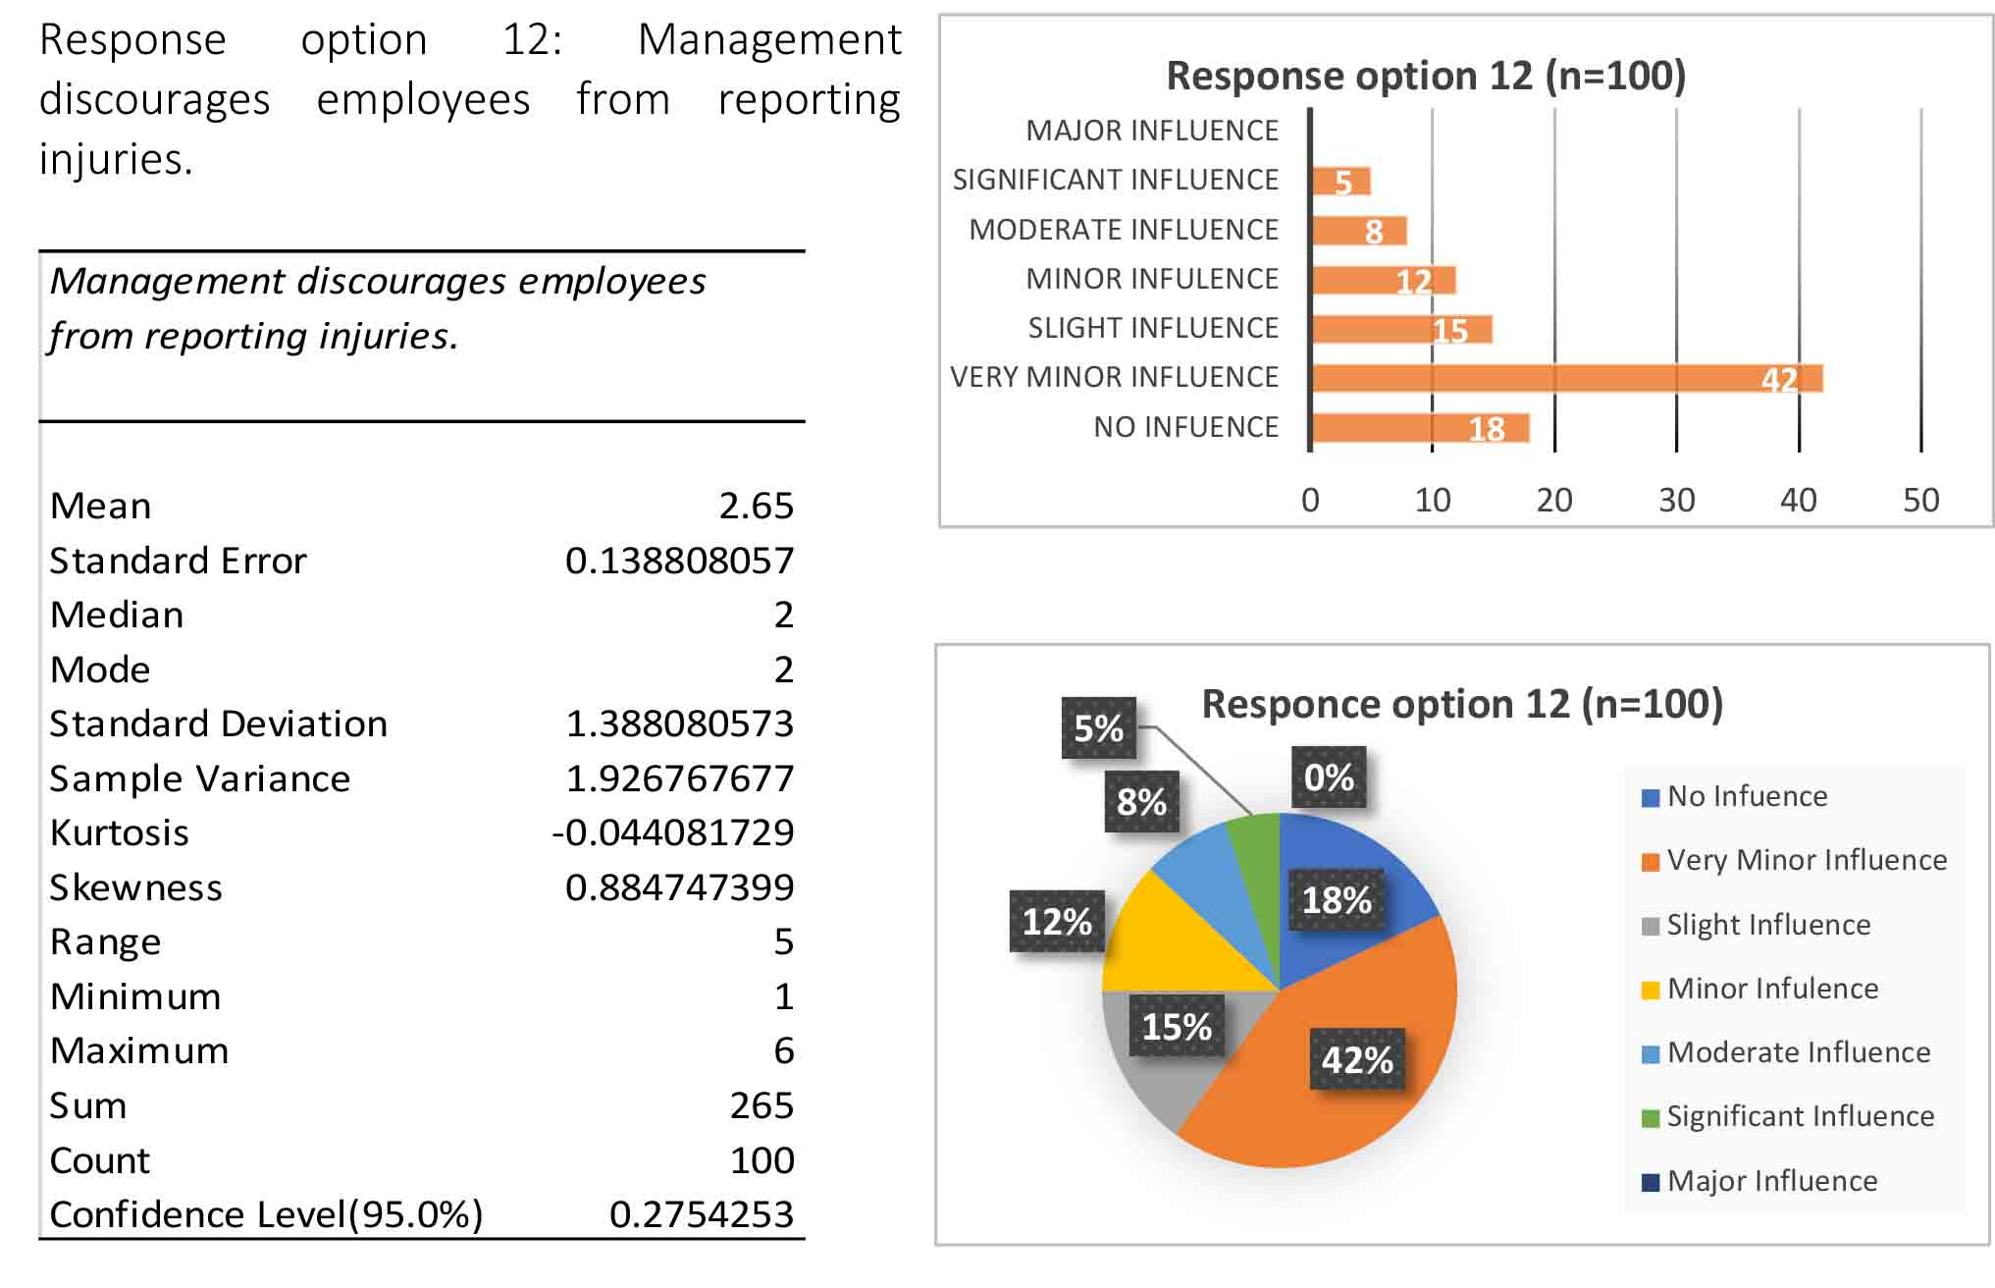
Table 16: Descriptive Statistics for operative response option 12
Figure 28: Frequency of answers for operative response option 12
Figure 29: Percentages of answers for operative response option 12

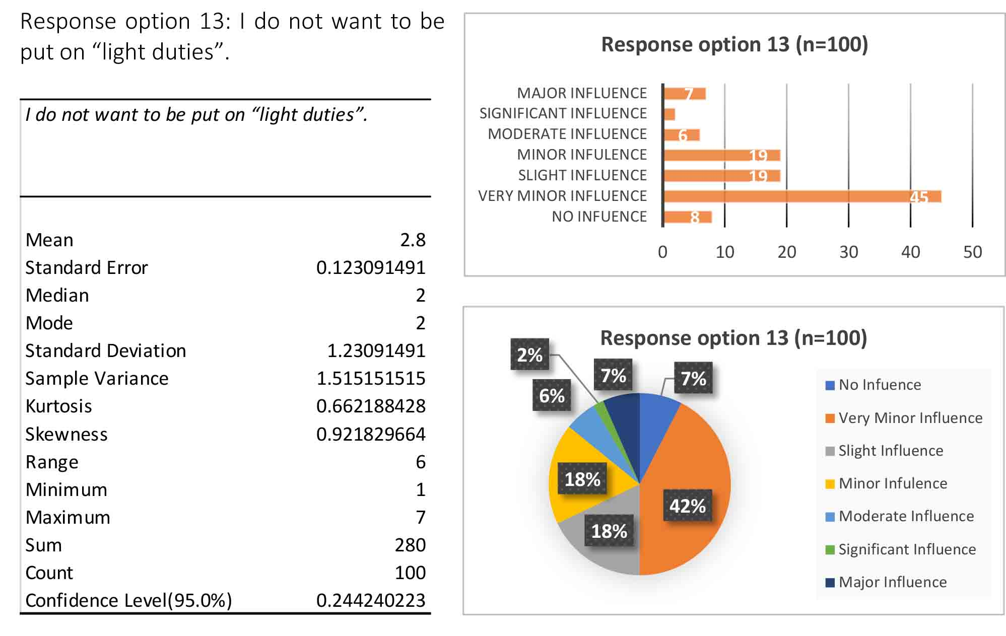
Table 17: Descriptive Statistics for operative response option 13
Figure 30: Frequency of answers for operative response option 13
Figure 31: Percentages of answers for operative response option 13

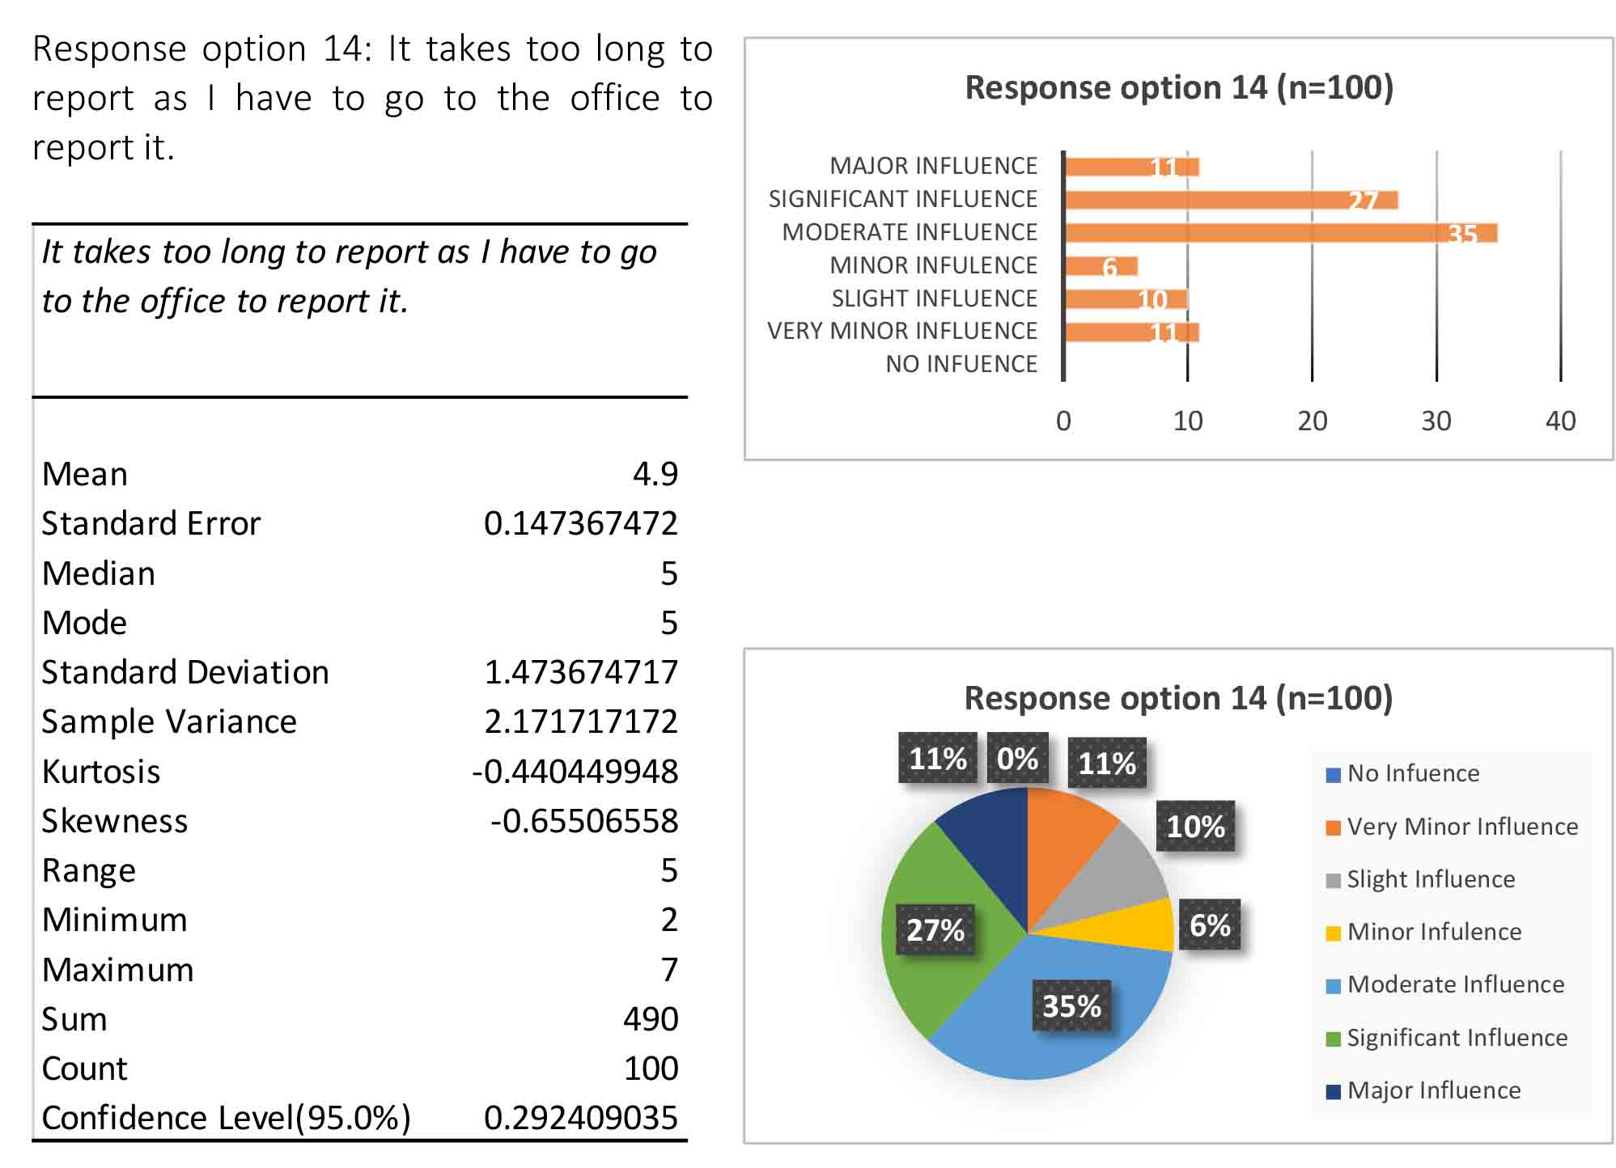

Table 18: Descriptive Statistics for operative response option 14
Figure 32: Frequency of answers for operative response option 14
Figure 33: Percentages of answers for operative response option 14

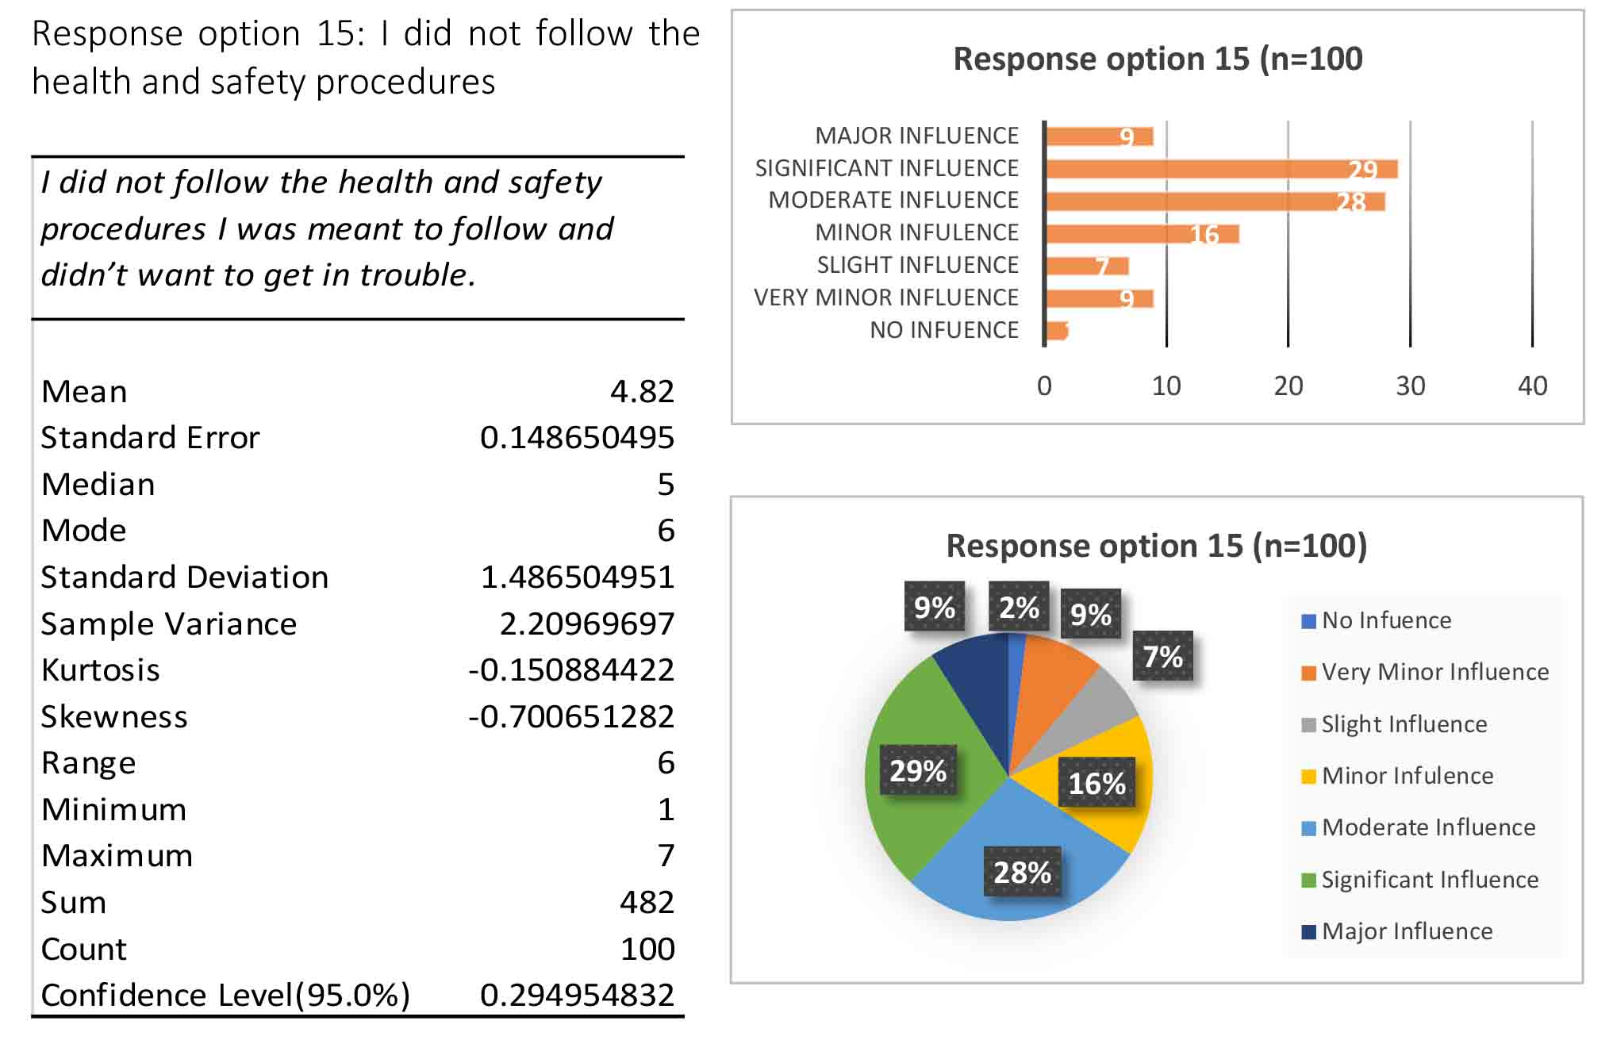
Table 19: Descriptive Statistics for operative response option 15
Figure 34: Frequency of answers for operative response option 15
Figure 35: Percentages of answers for operative response option 15

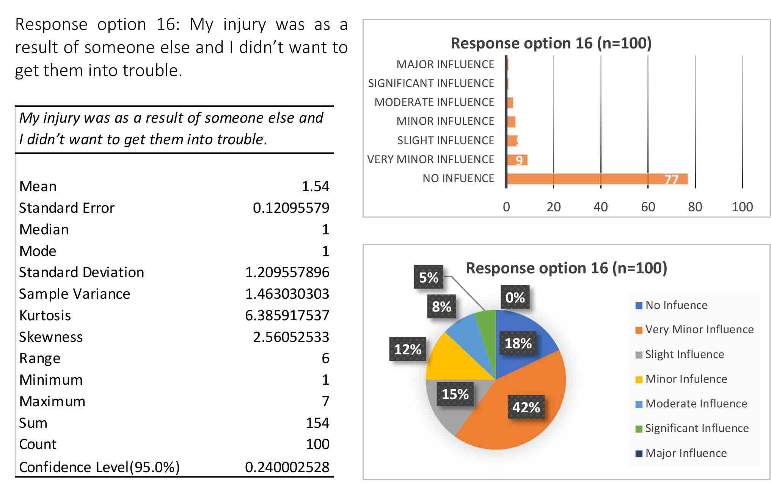

Table 20: Descriptive Statistics for operative response option 16
Figure 36: Frequency of answers for operative response option 16
Figure 37: Percentages of answers for operative response option 16

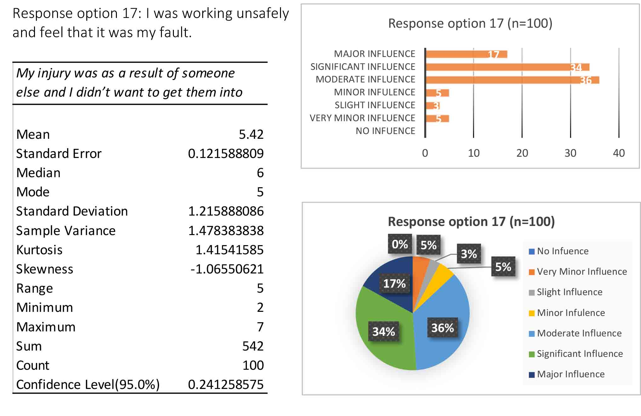
Table 21: Descriptive Statistics for operative response option 17
Figure 38: Frequency of answers for operative response option 17
Figure 39: Percentages of answers for operative response option 17

Table 22: Operative Descriptive Statistics

APPENDIX F: MANAGEMENT QUANTITATIVE DATA ANALYSIS

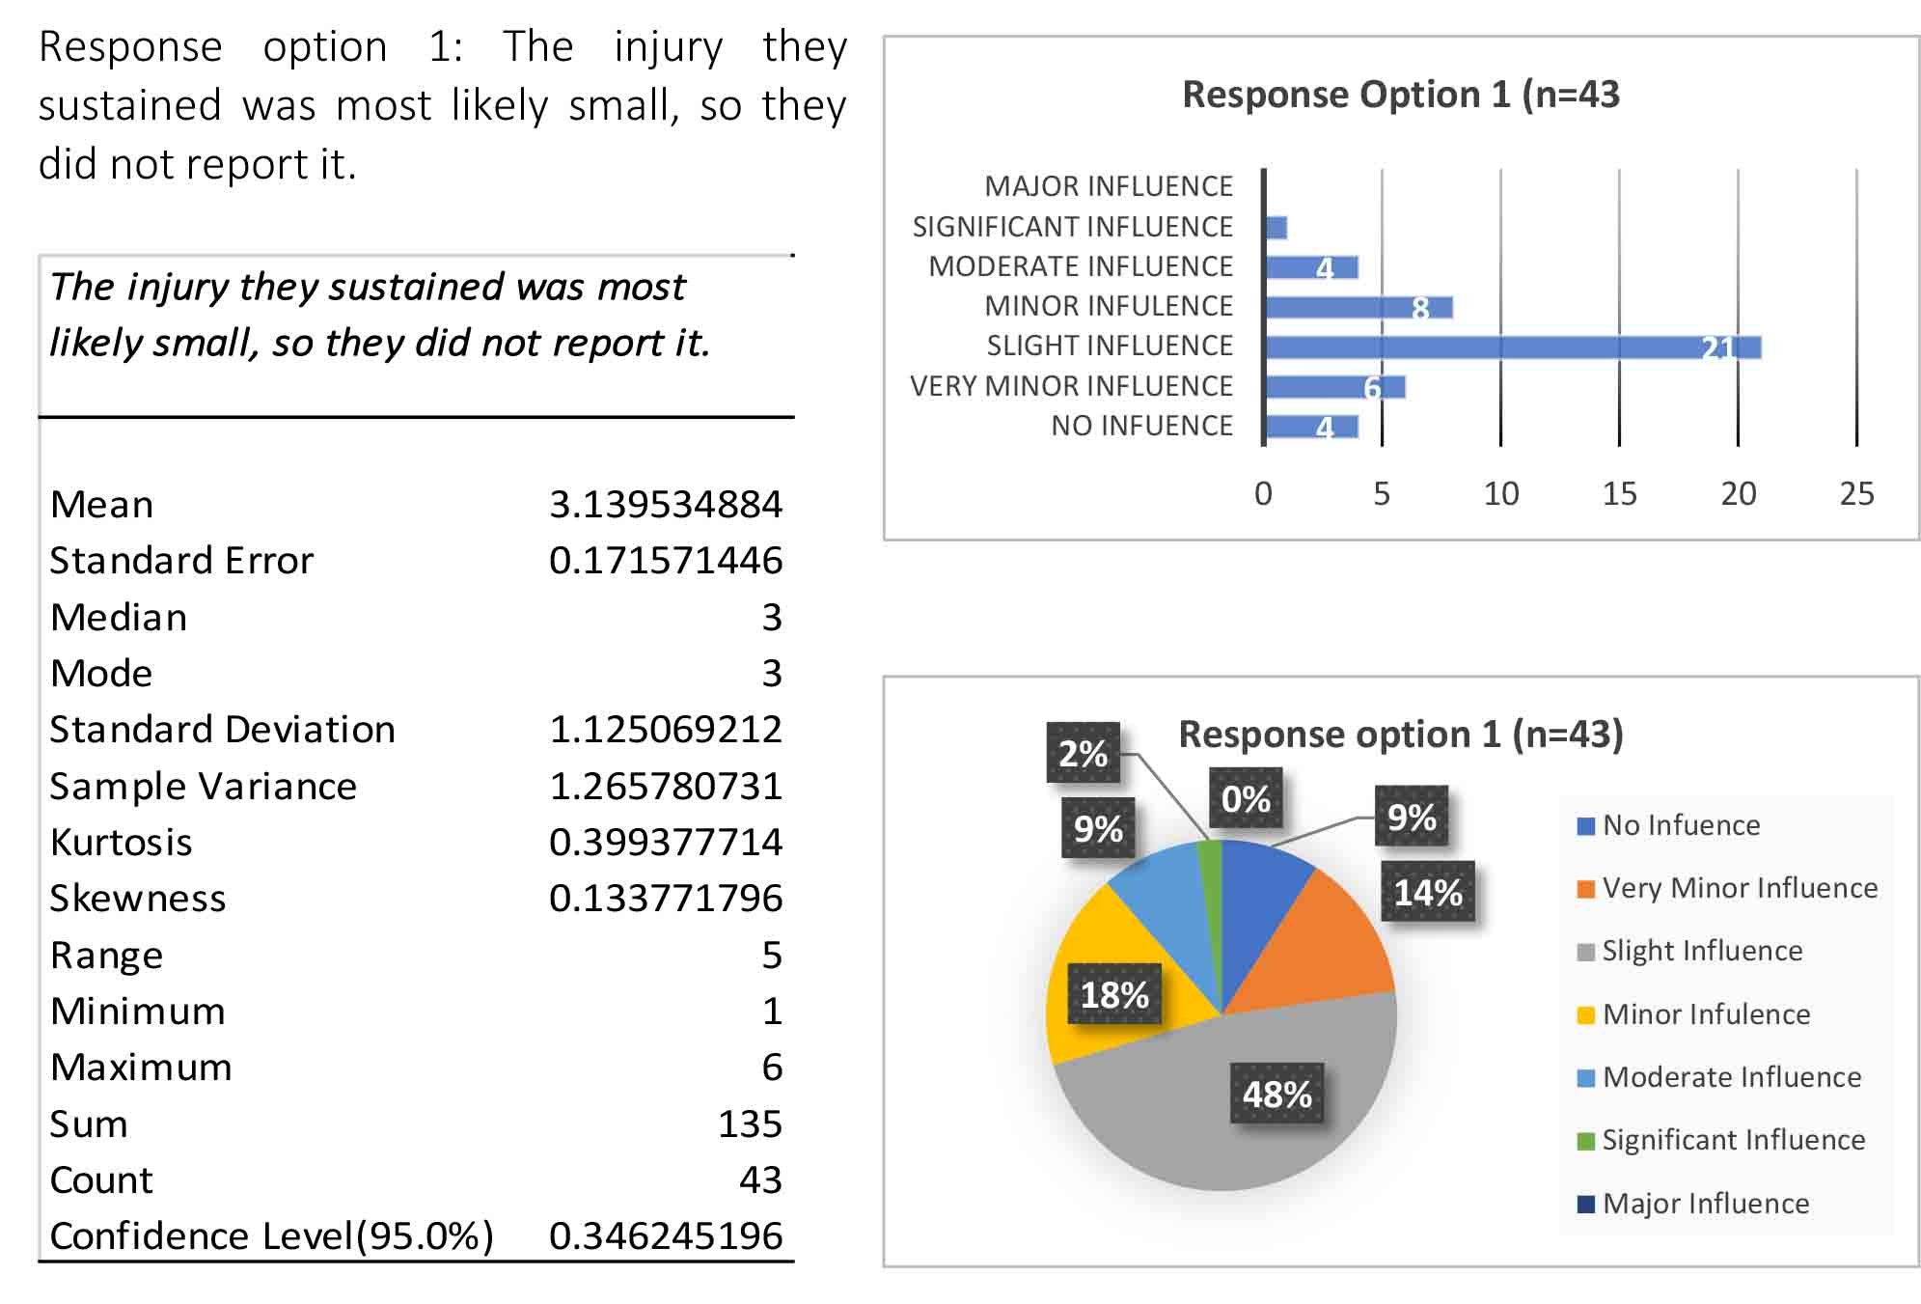
Table 23: Descriptive Statistics for management response option 1
Figure 40: Frequency of answers for management response option 1
Figure 41: Percentages of answers for management response option 1

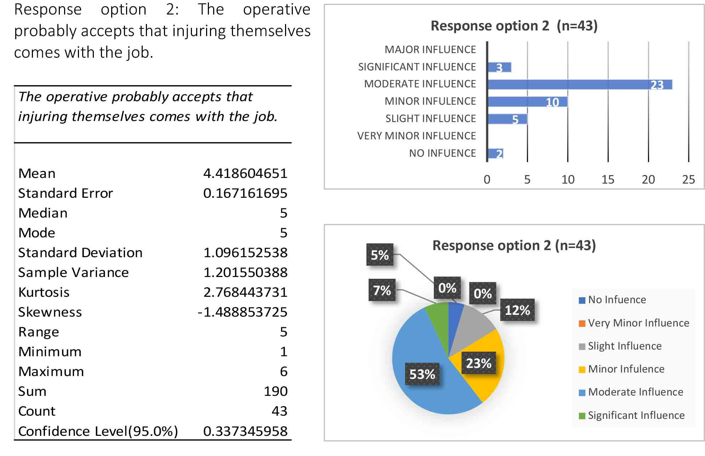
Table 24: Descriptive Statistics for management response option 2
Figure 42: Frequency of answers for management response option 2
Figure 43: Percentages of answers for management response option 2
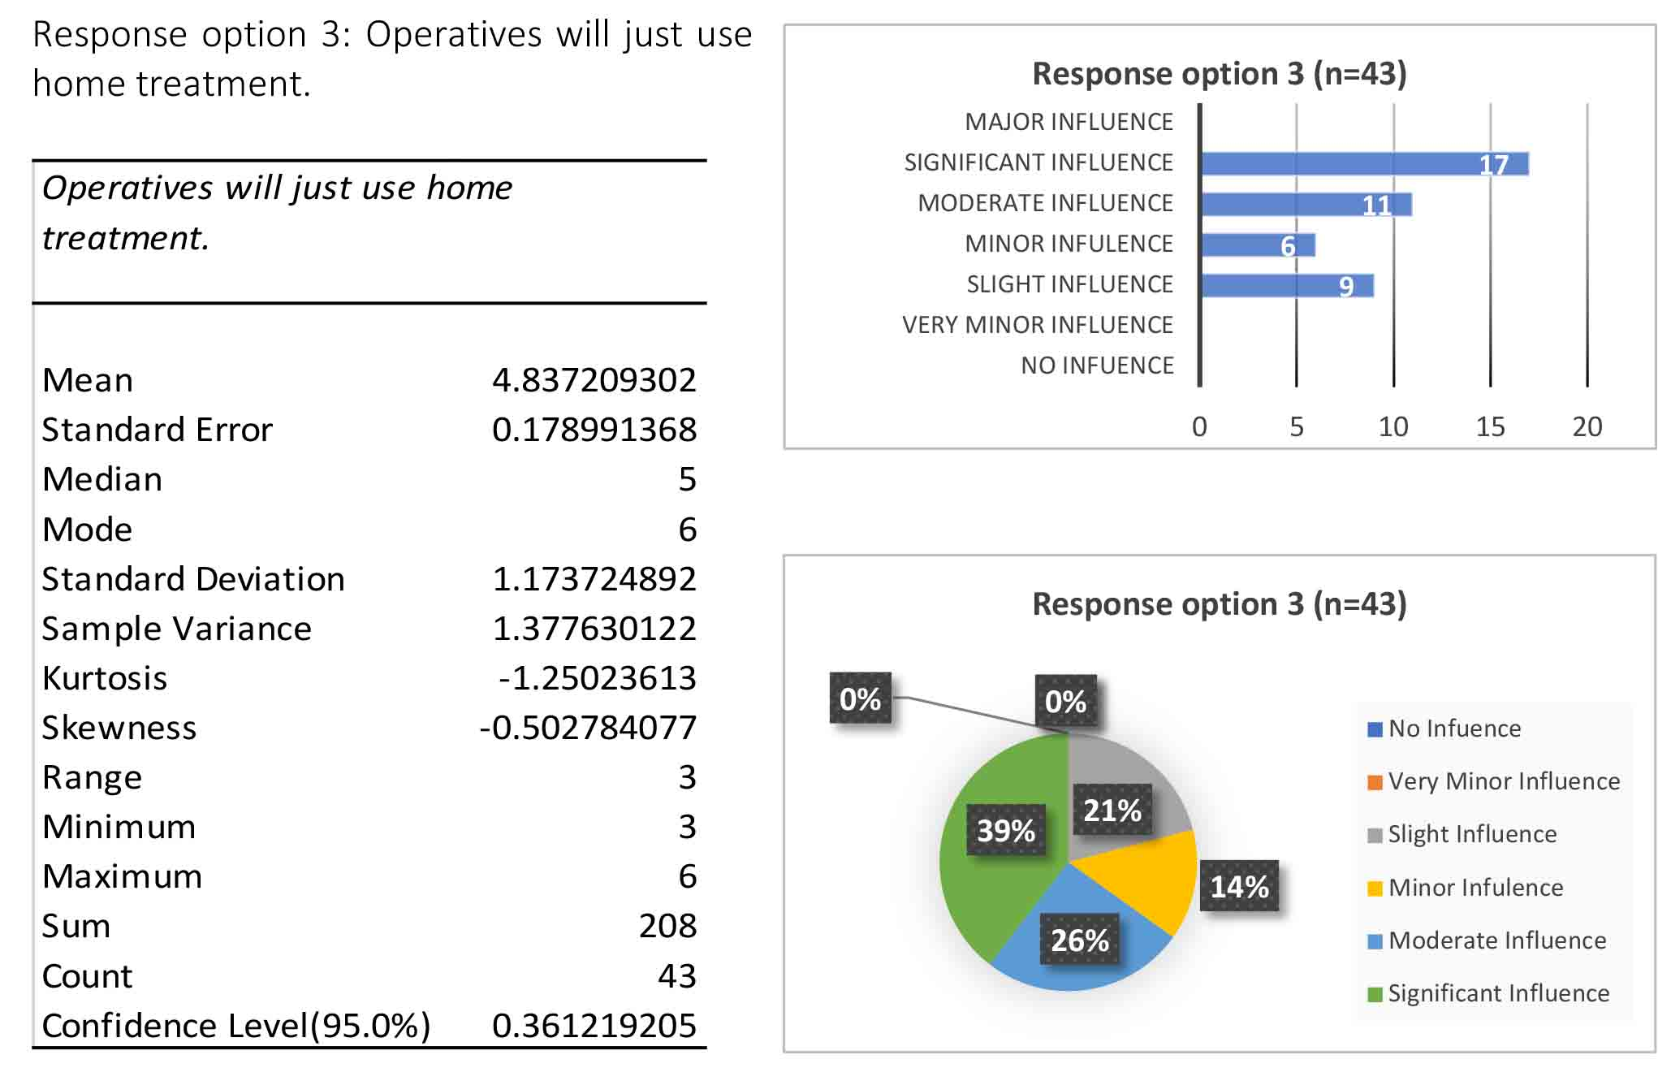
Table 25: Descriptive Statistics for management response option 3
Figure 44: Frequency of answers for management response option 3
Figure 45: Percentages of answers for management response option 3

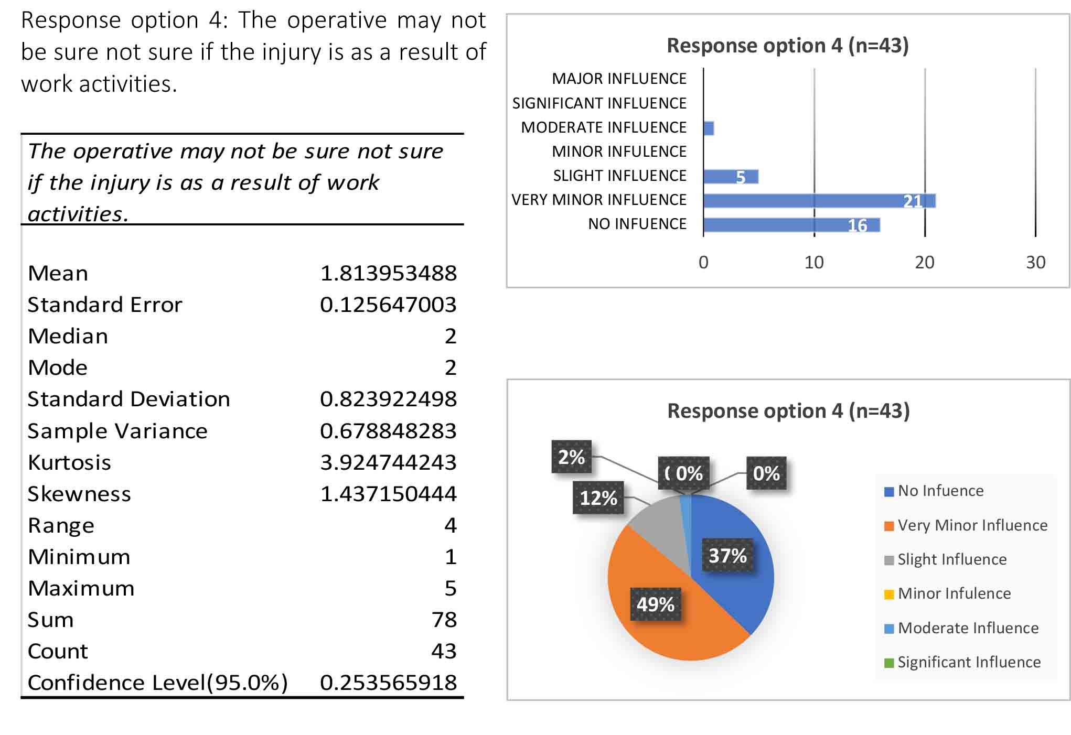
Table 26: Descriptive Statistics for management response option 4
Figure 46: Frequency of answers for management response option 4
Figure 47: Percentages of answers for management response option 4

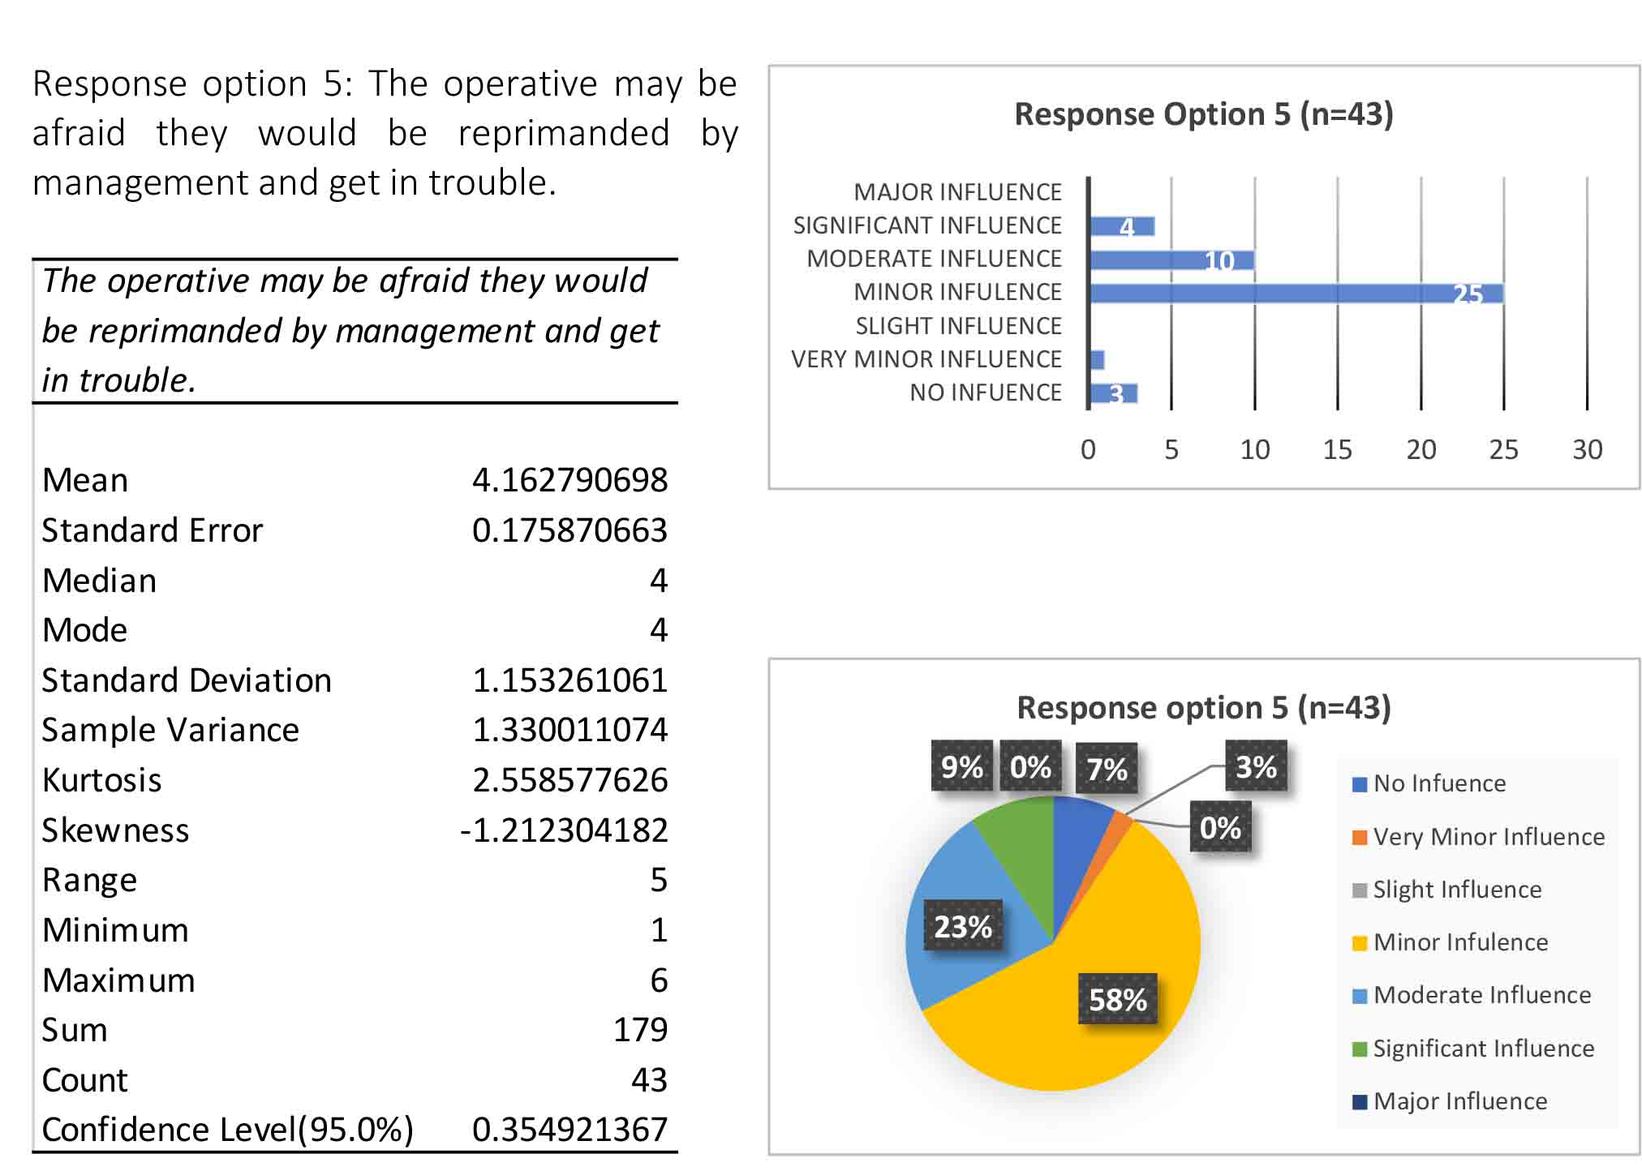

Table 27: Descriptive Statistics for management response option 5
Figure 48: Frequency of answers for management response option 5
Figure 49: Percentages of answers for management response option 5

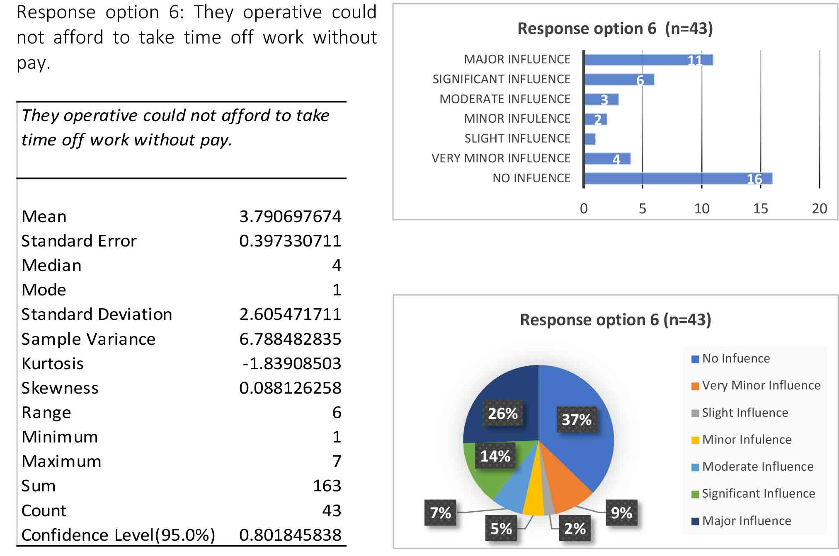

Table 28: Descriptive Statistics for management response option 6
Figure 50: Frequency of answers for management response option 6
Figure 51: Percentages of answers for management response option 6

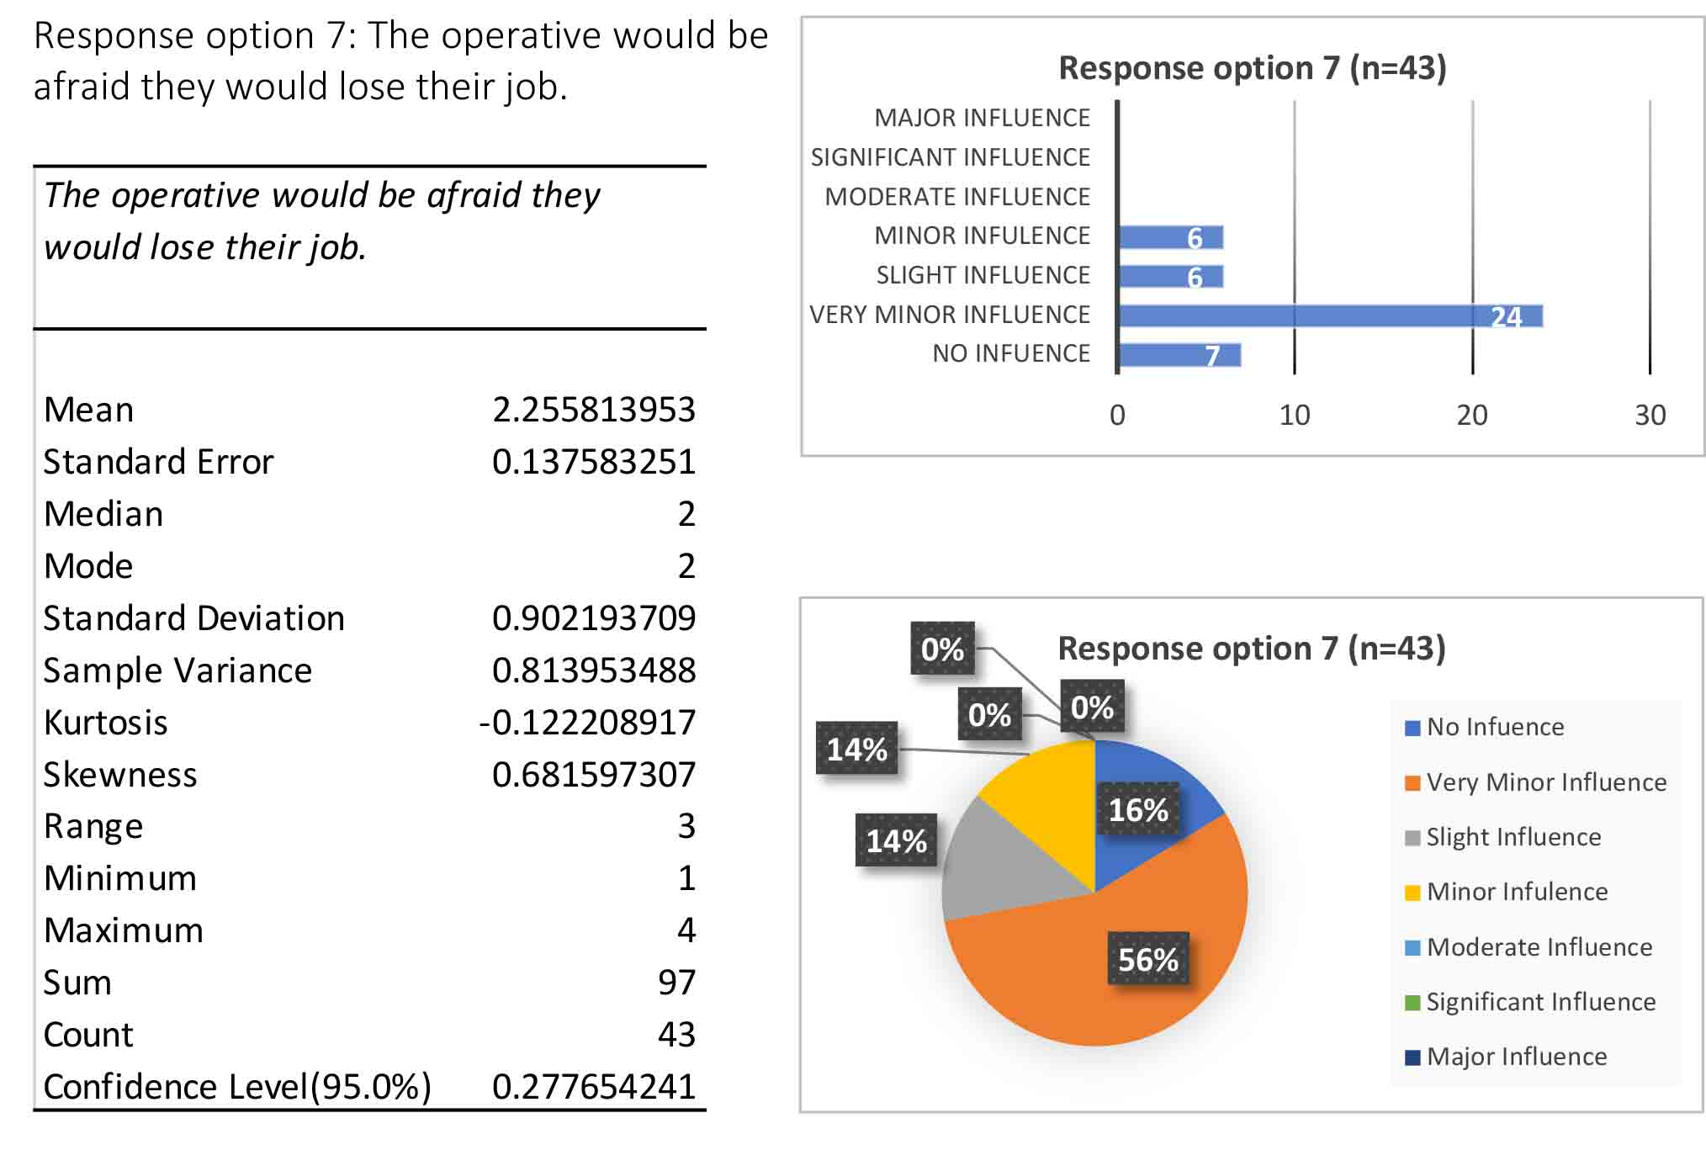
Table 29: Descriptive Statistics for management response option 7
Figure 52: Frequency of answers for management response option 7
Figure 53: Percentages of answers for management response option 7

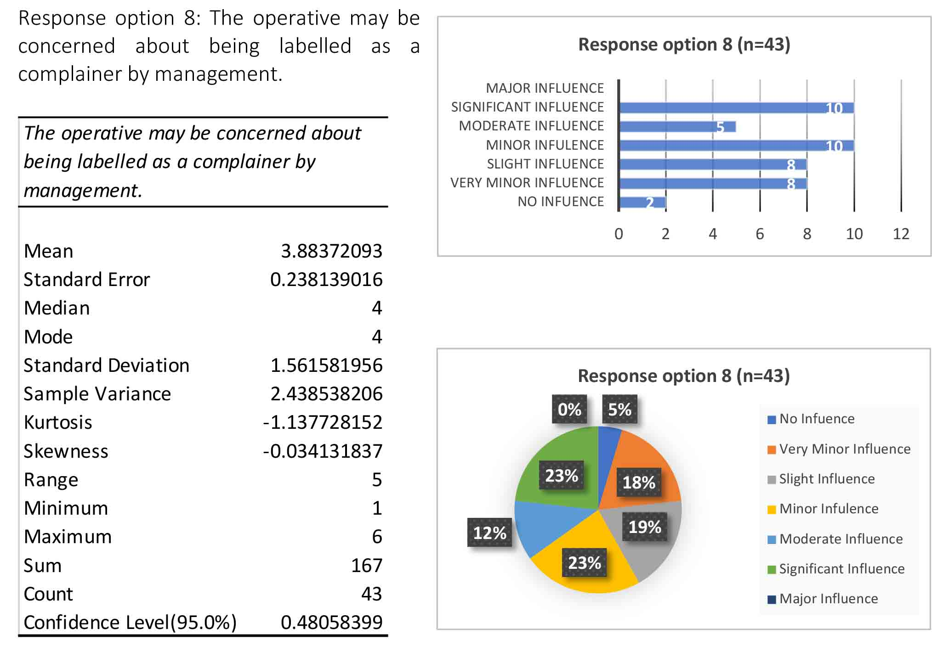
Table 30: Descriptive Statistics for management response option 8
Figure 54: Frequency of answers for management response option 8
Figure 55: Percentages of answers for management response option 8

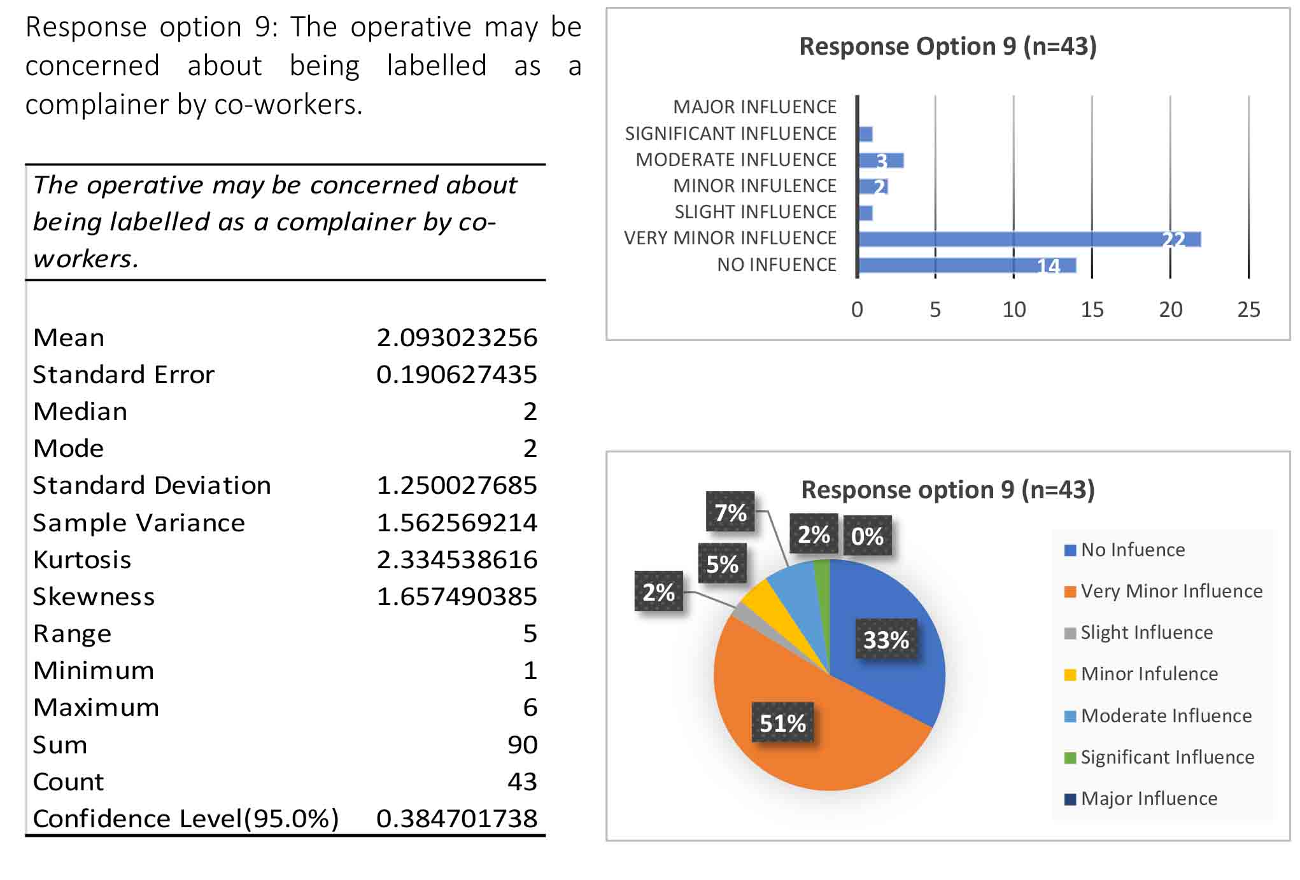
Table 31: Descriptive Statistics for management response option 9
Figure 56: Frequency of answers for management response option 9
Figure 57: Percentages of answers for management response option 9

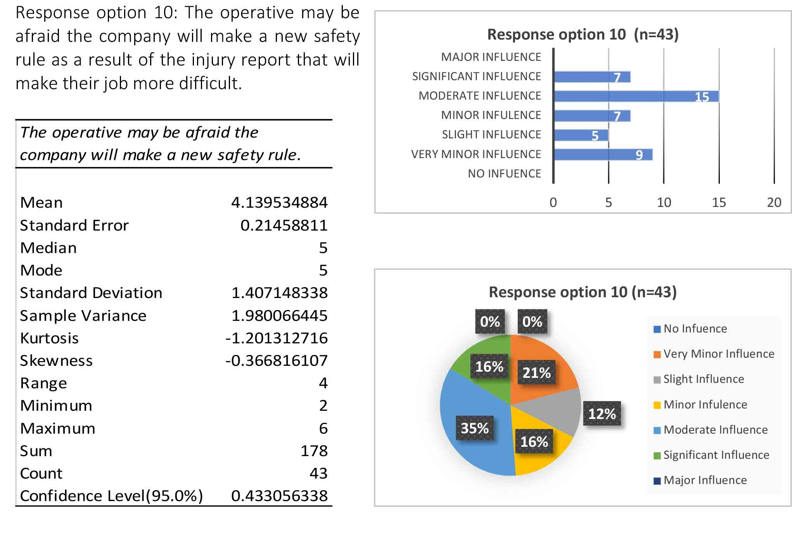
Table 32: Descriptive Statistics for management response option 10
Figure 58: Frequency of answers for management response option 10
Figure 59: Percentages of answers for management response option 10

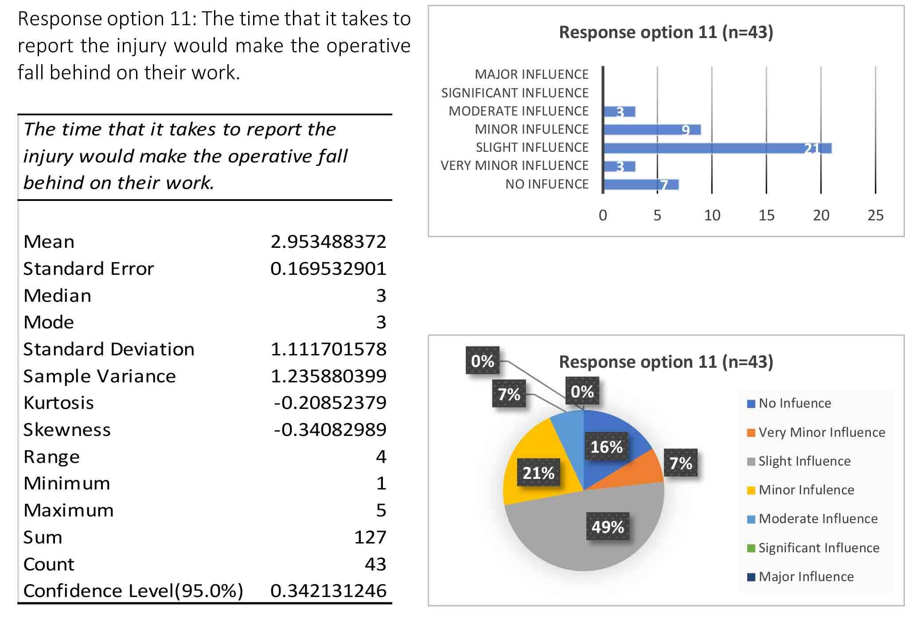
Table 33: Descriptive Statistics for management response option 11
Figure 60: Frequency of answers for management response option 11
Figure 61: Percentages of answers for management response option 11

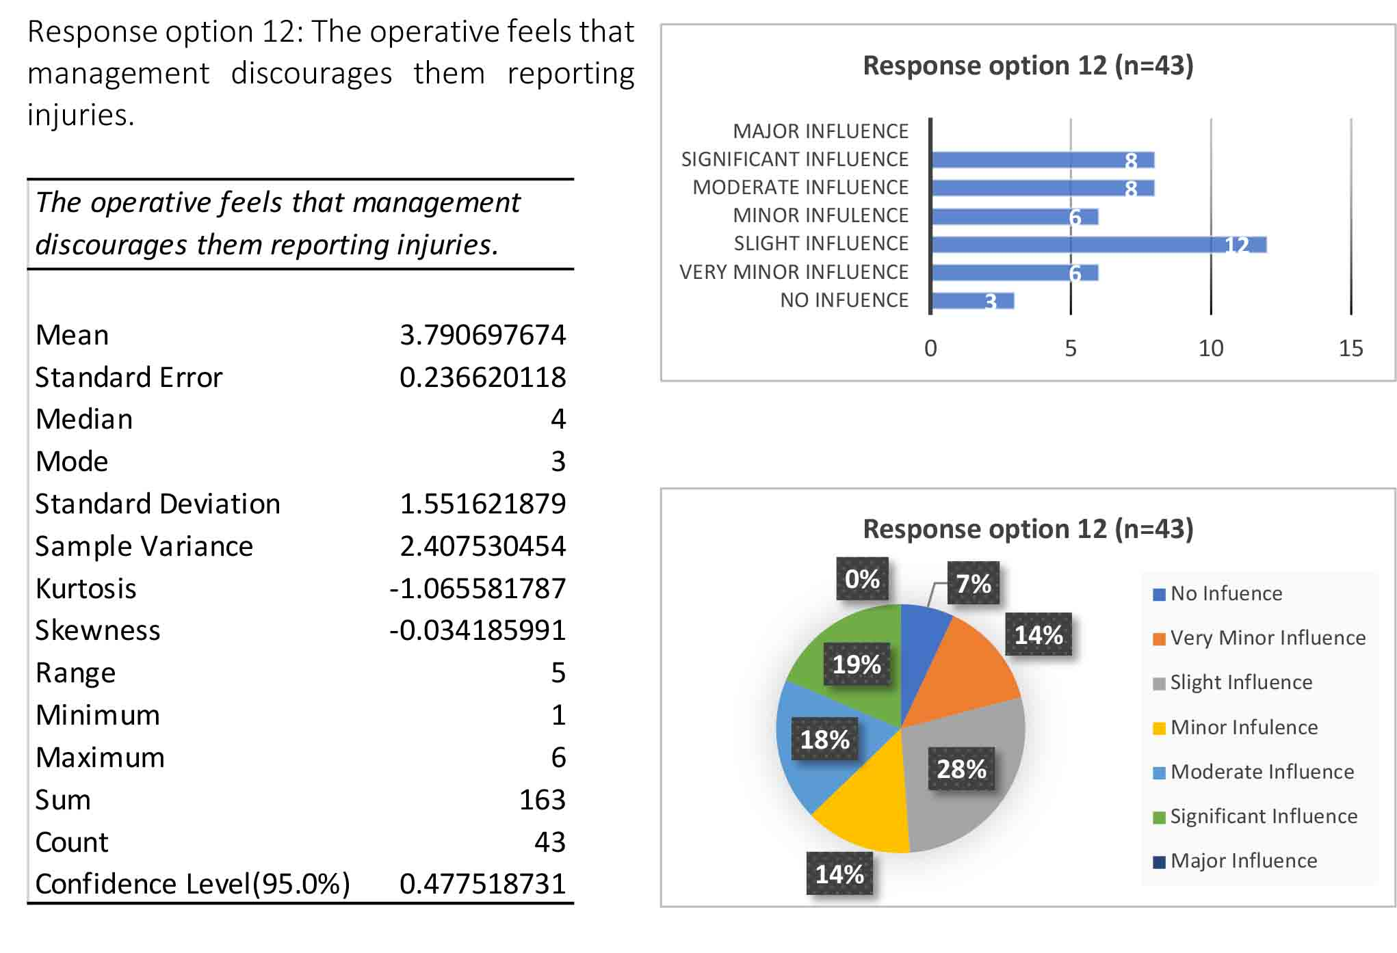
Table 34: Descriptive Statistics for management response option 12
Figure 62: Frequency of answers for management response option 12
Figure 63: Percentages of answers for management response option 12

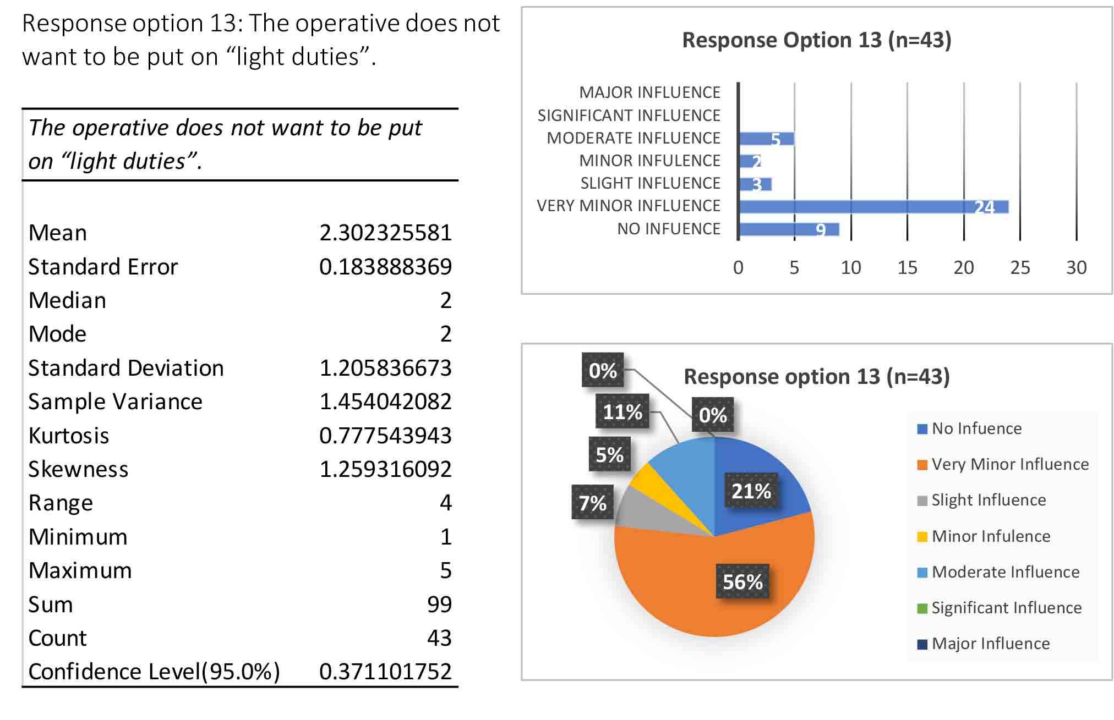
Table 35: Descriptive Statistics for management response option 13
Figure 64: Frequency of answers for management response option 13
Figure 65: Percentages of answers for management response option 13

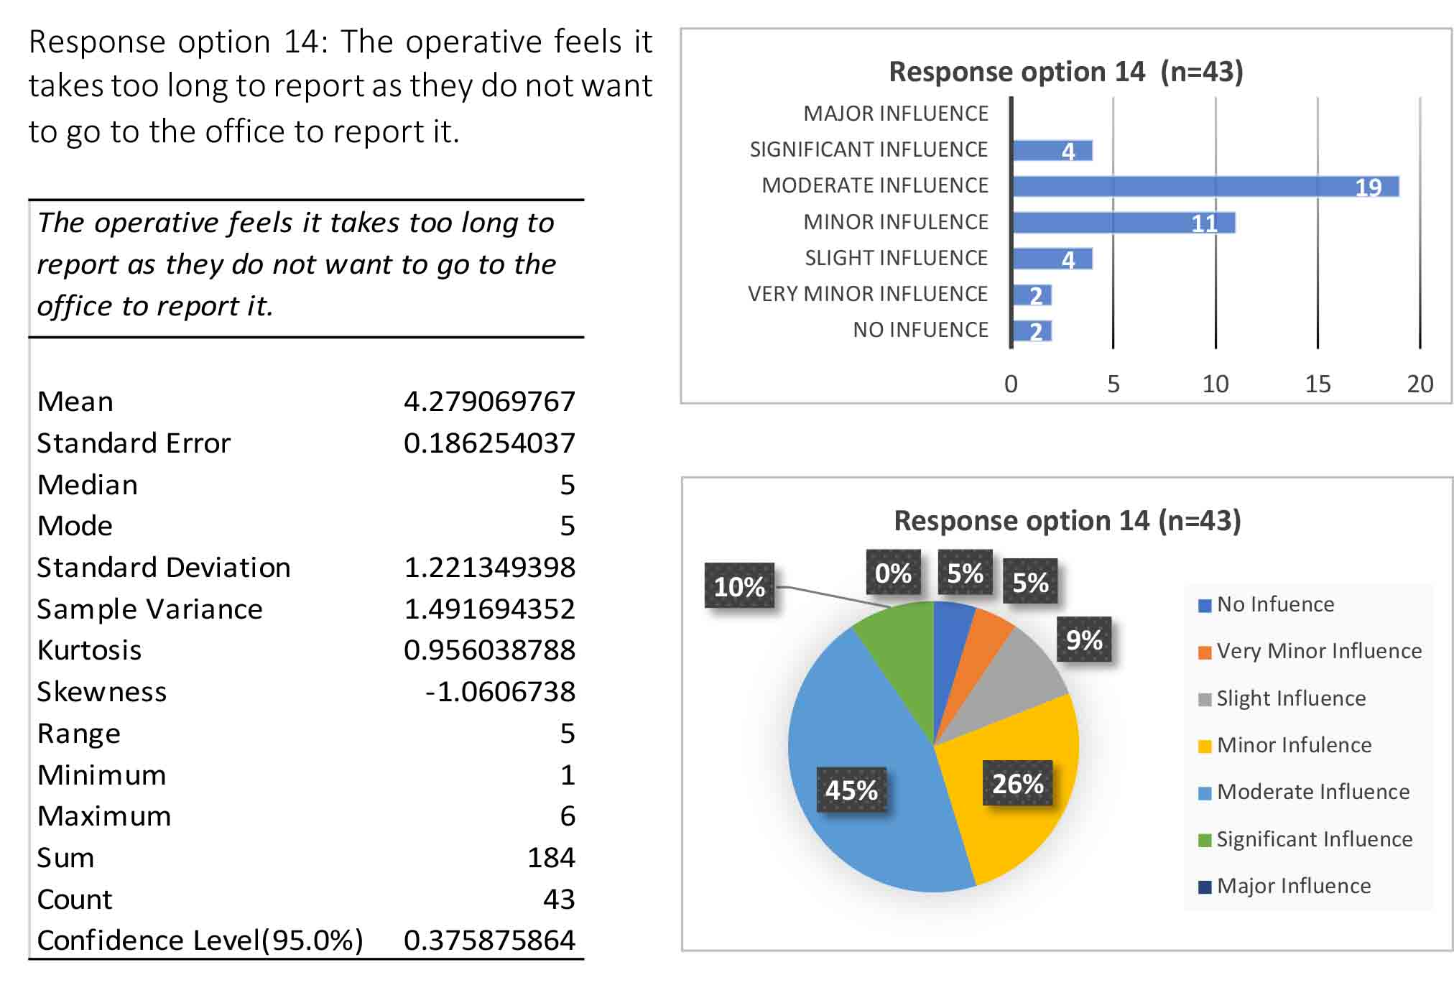
Table 36: Descriptive Statistics for management response option 14
Figure 66: Frequency of answers for management response option 14
Figure 67: Percentages of answers for management response option 14

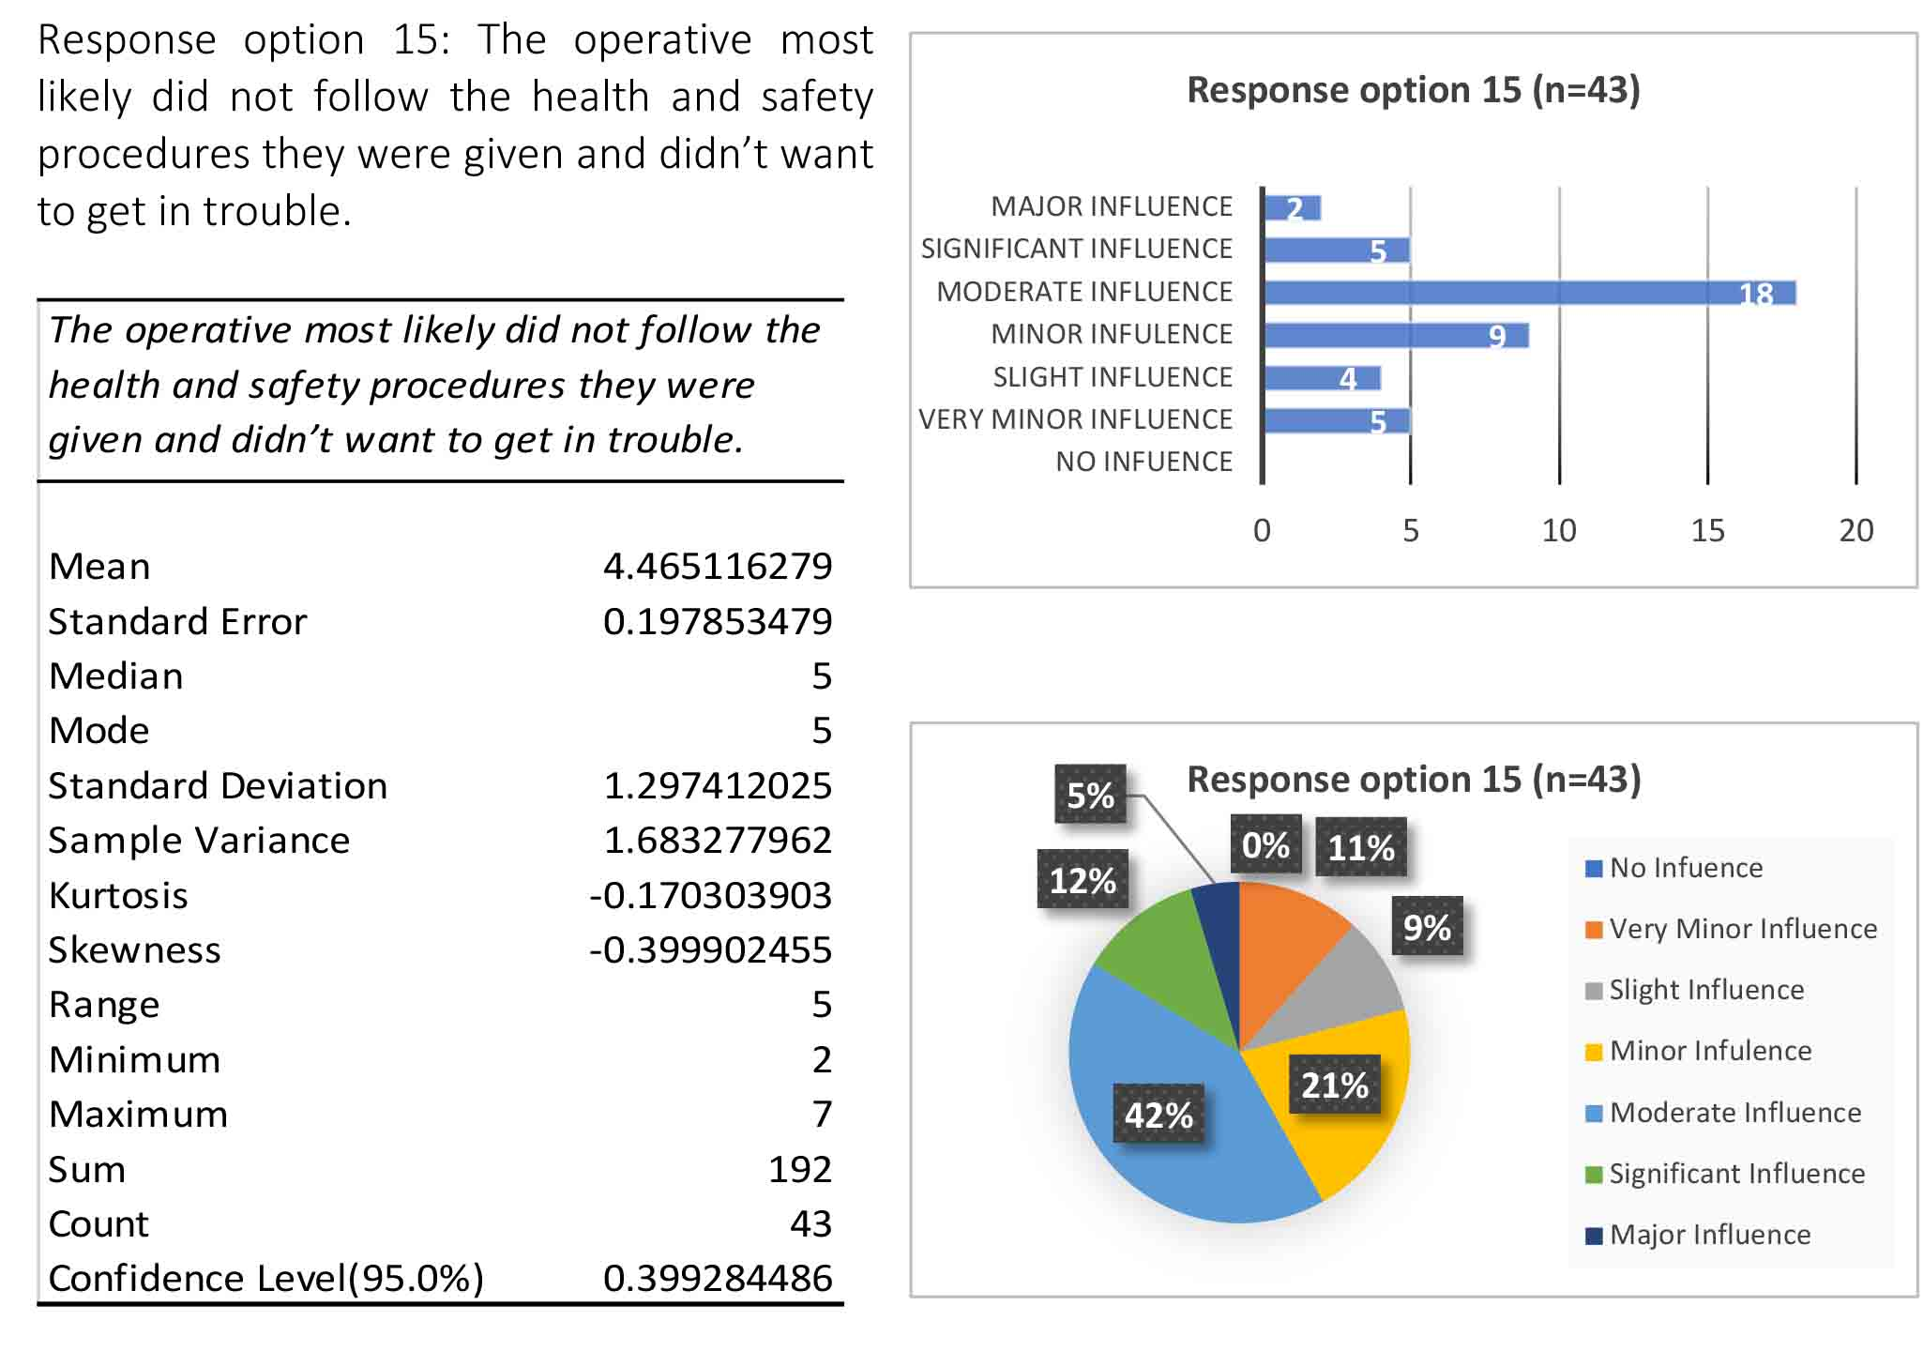
Table 37: Descriptive Statistics for management response option 15
Figure 68: Frequency of answers for management response option 15
Figure 69: Percentages of answers for management response option 15

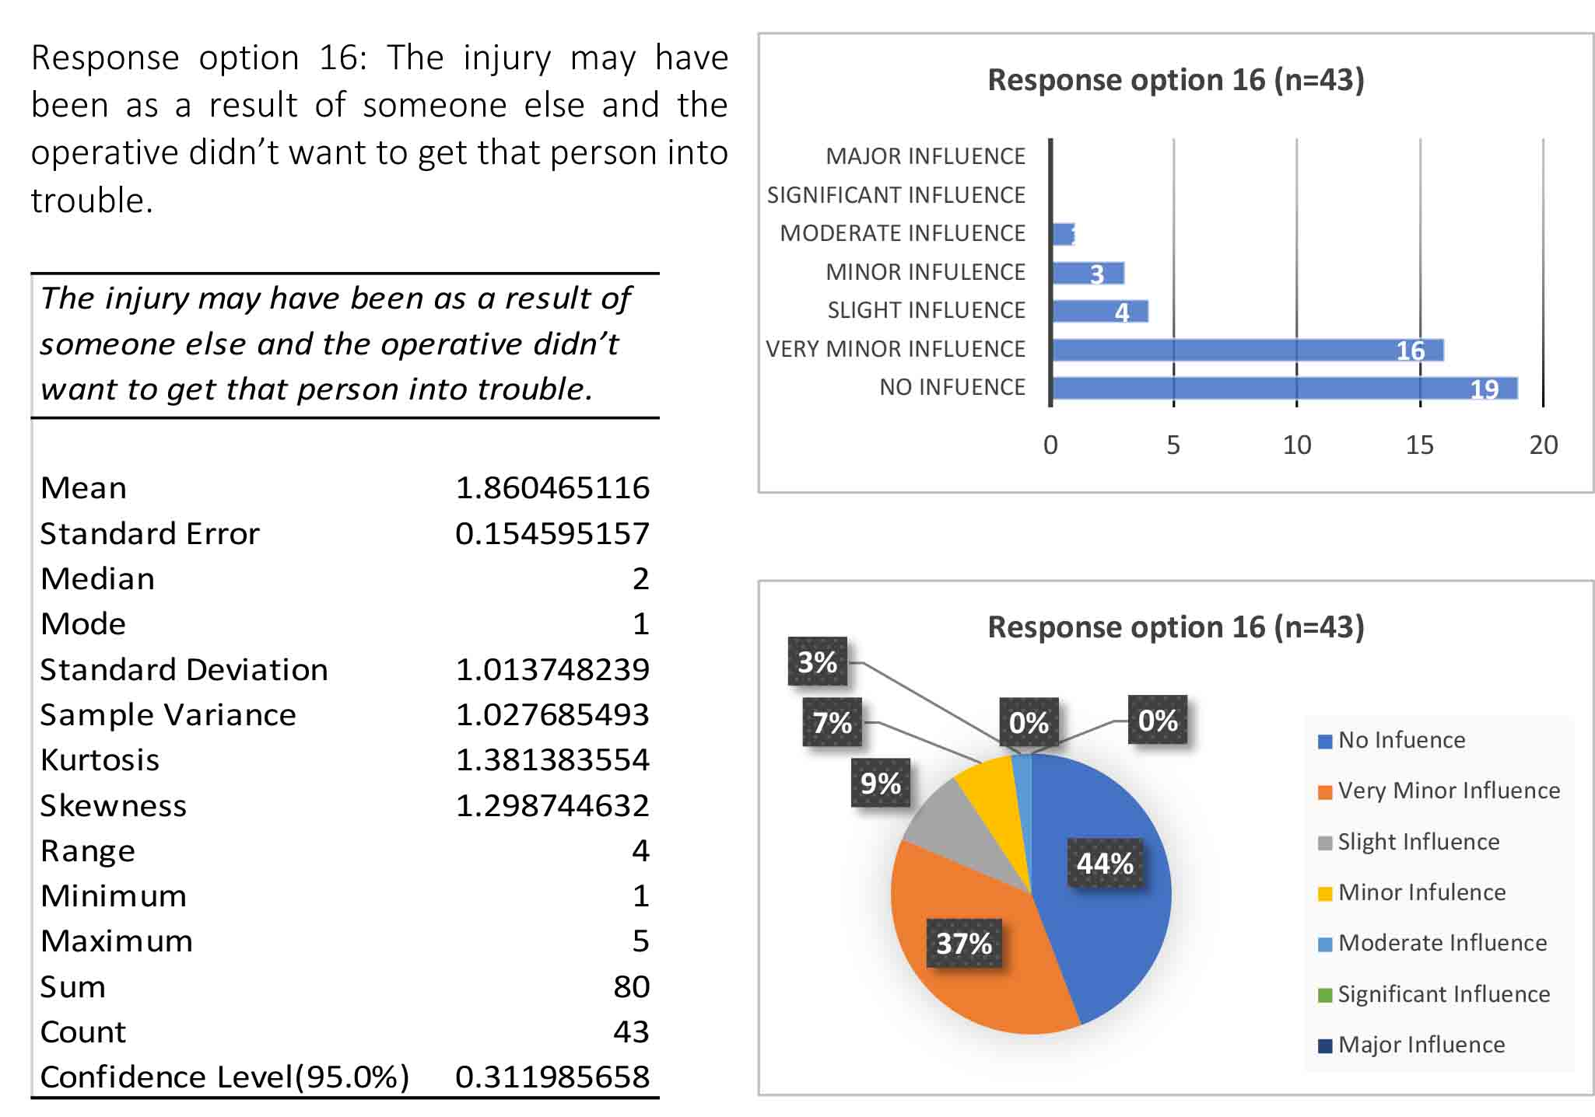
Table 38: Descriptive Statistics for management response option 16
Figure 70: Frequency of answers for management response option 16
Figure 71: Percentages of answers for management response option 16
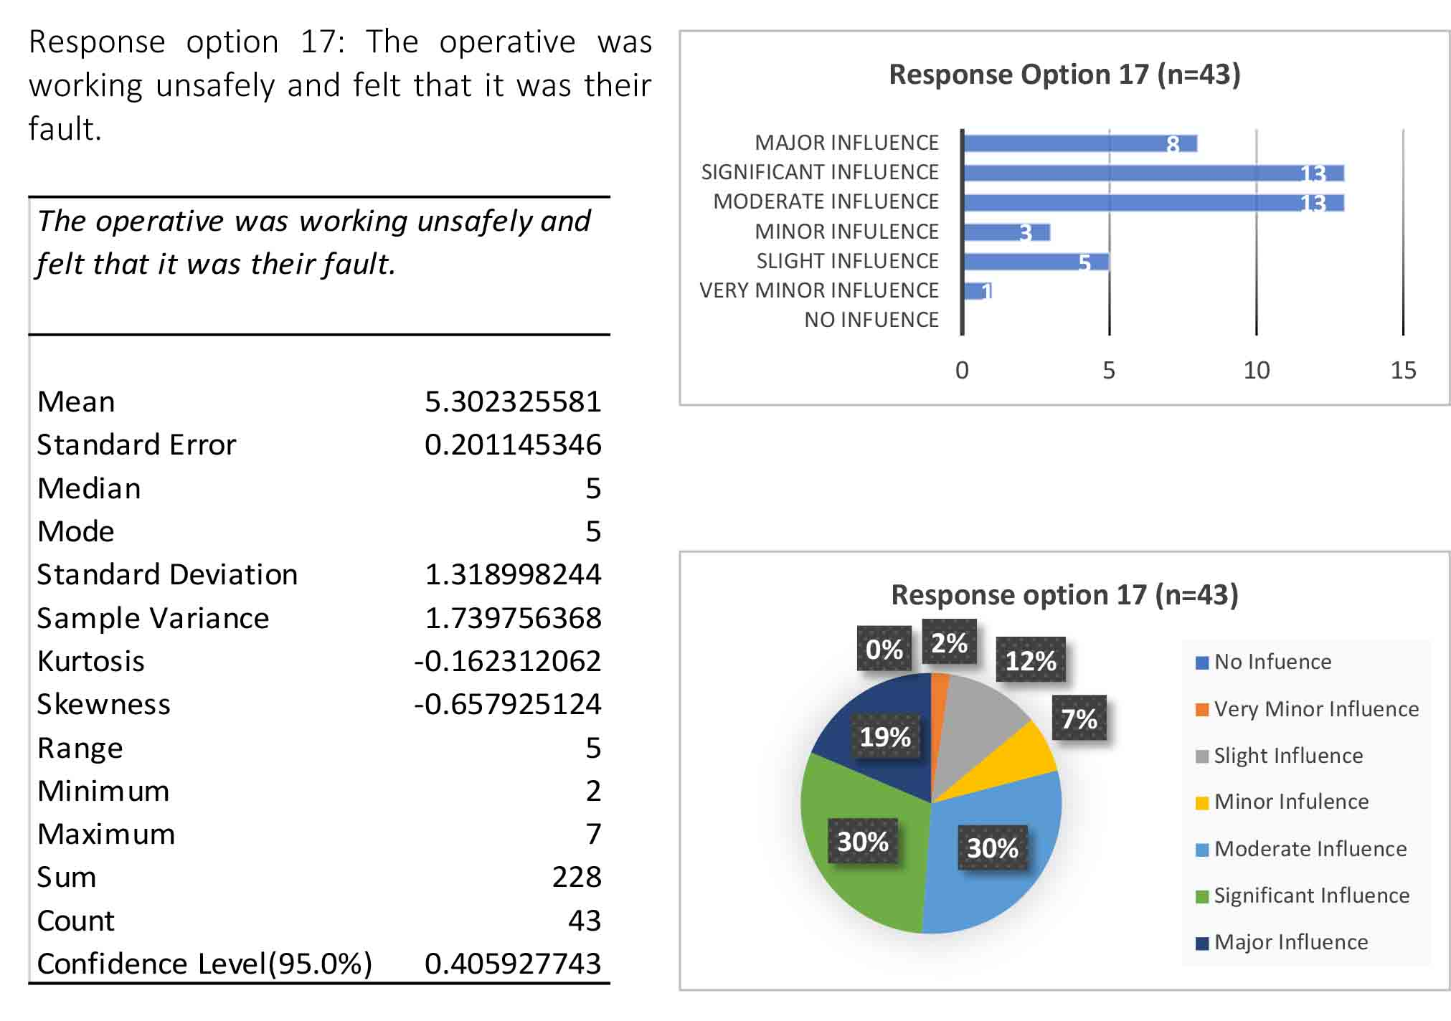
Table 39: Descriptive Statistics for management response option 1
Figure 72: Frequency of answers for management response option 1
Figure 73: Percentages of answers for management response option 1

APPENDIX G: DISCRIPTIVE AND INFERENTIAL ANALYSIS

APPENDIX G 1: HYPOTHESIS ONE DATA ANALYSIS

The first null hypothesis theorised that the under-reporting of accidents and injuries in the repair and maintenance sector in South Wales would not exceed the levels found in the research undertaken by Taylor-Moore et al. (2013). This hypothesis was tested via a one-sample t-test (right tail) which determined whether the sample mean (μ) was statistically different from the hypothesised population mean (μ0). The results of this analysis (Table 40) show that under-reporting of accidents and injuries in the repair and maintenance sector in South Wales did exceed the levels found in the research undertaken by Taylor-Moore et al.

Table 40: One sample t-Test to test hypothesised mean

Since it is observed that t = -4.151282 is not in the 95% range of the TC = 1.9713, it is concluded that this test does not support the null hypothesis. Using the P-value approach: The P-value is p = 6.53E-09 and since P = 6.53E-09 < 0.05, therefore, it is concluded that this test does not support the null hypothesis.

The following tables and figures show the frequency and percentages for the under- reporting of accidents
Table 41: Frequency and Percentage for the under-reporting of accidents

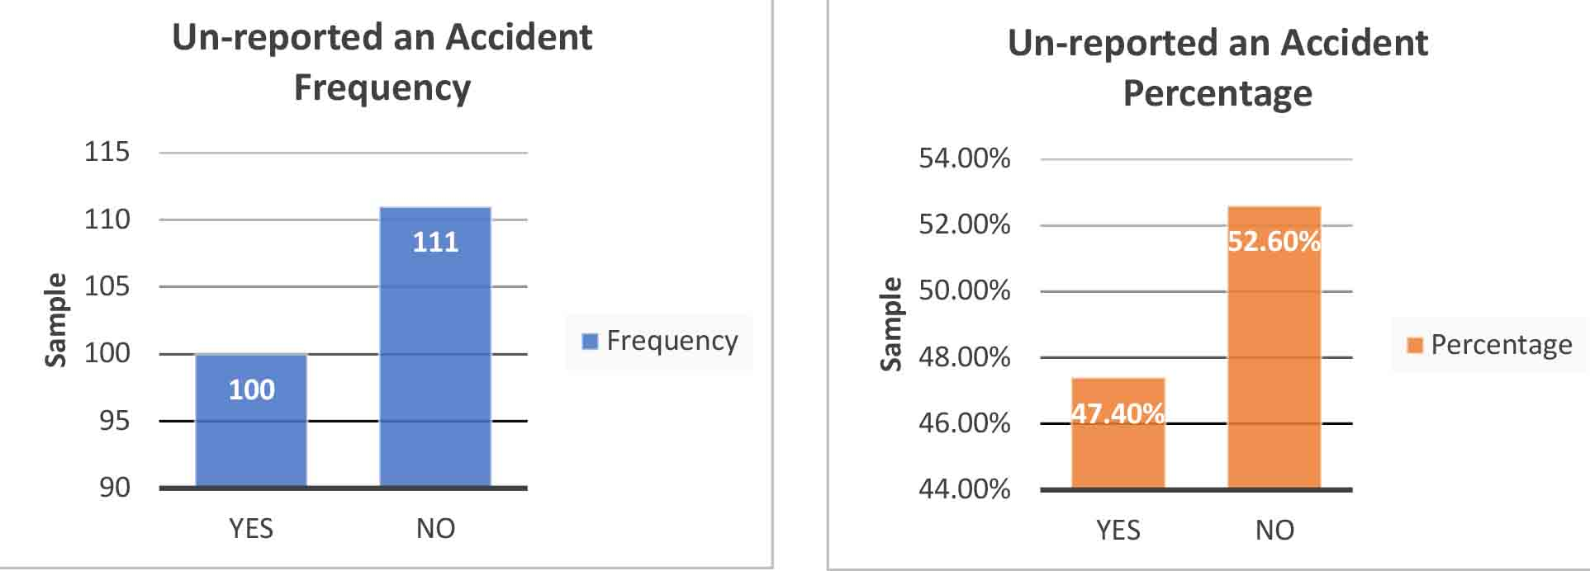
Figure 74: Un-reported an Accident Frequency
Figure 75: Un-reported an Accident Percentage

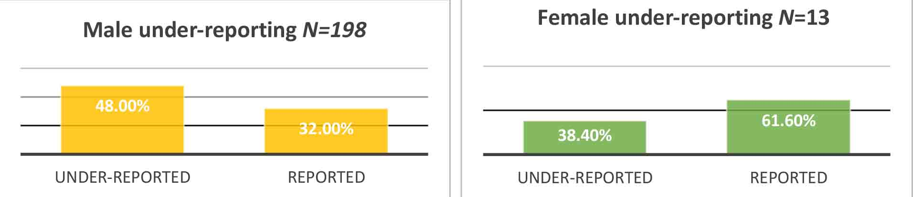
Figure 76: Male Under-reporting
Figure 77: Female Under-reporting

APPENDIX G 2: HYPOTHESIS TWO DATA ANALYSIS

The second null hypothesis theorised that this research would follow the findings of Taylor-Moore et al. (2013), and that the primary reason for not reporting an accident would be that operatives would feel ‘the injuries sustained are too small to report’. To test this hypothesis, descriptive statistics for many numeric variables were performed. The analysis aimed to firstly establish the greatest median influence before then seeking to establish a clear ranking system of the most to the least influential reasons. The results of this analysis (Table 42) show that of the 100 eligible respondents, 79% expressed that reason ‘the injuries sustained are too small to report’ was a moderate to major influence in their decision not to report an accident or injury. This study found however that the most influential reason that operatives do not report accidents was that the operative felt they were working unsafely and the accident was their fault. This was expressed by 87% of operatives as a moderate to major reason for not reporting accidents. The dataset also shows median influence level for this response was (M=6).

The greatest median influence was given for the reason ‘I could not afford to take time off work without pay’. However, this reason was the seventh in the percentage of respondents who felt that this reason was moderate or higher and this was due to some operatives receiving full sick pay and other operatives not receiving this benefit. Of the seventeen options provided in the questionnaire stating the reasons why an operative would not report an accident, eleven were deemed to have a moderate influence level or higher. Therefore, it is concluded that this test does not support the null hypothesis.

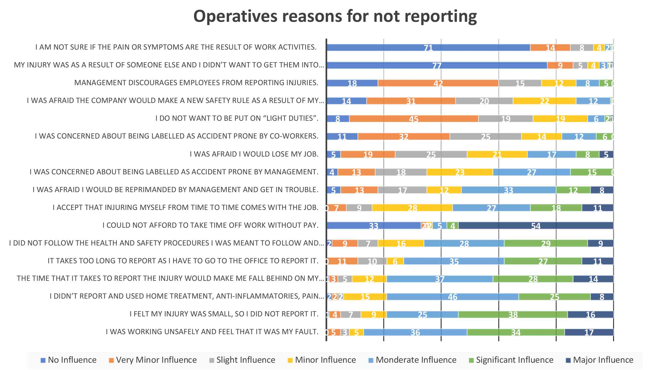
Figure 78: The Frequency of Operatives Reasons for not Reporting Accidents

Table 42: Frequency of Reasons for Not Reporting Workplace Accidents and Injuries

APPENDIX G 3: HYPOTHESIS THREE DATA ANALYSIS

The third null hypothesis theorised that the most common category of unreported accident or injury is significant cuts and lacerations. To test this hypothesis, descriptive statistics for many numeric variables were once again performed. The descriptive statistics aimed to establish the most frequent injuries that are reportable which the operative did not report. The results of this analysis (Table 43) show that the most common category of reportable injury that goes un-reported is that of ‘significant cuts and lacerations’. This was the most collectively un-reported injury with 46% of respondents indicating this as their primary un-reported injury. This was followed by electric shock at 20% and slips, trips and falls, resulting in injury at 13%. No inferential statistical tests were undertaken on this data. Therefore, it is concluded that this test does support the null hypothesis.

Table 43: Injuries that are not reported
Figure 79: Percentage of Injuries considered reportable that have been un-reported.
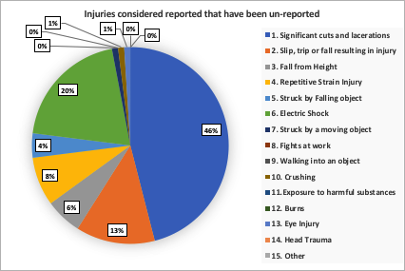
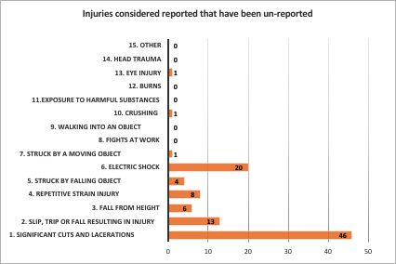

Figure 80: Frequency of Injuries considered reportable that have been un-reported.

APPENDIX G 4: HYPOTHESIS FOUR DATA ANALYSIS

The fourth null hypothesis theorised that this study will not follow the findings of the Tucker et al. (2014) study and would find that male operatives are no more likely to under-report accidents than female operatives. To test this hypothesis, descriptive statistics for many numeric variables were once again performed. This was followed by a Fisher’s Exact Test, which was carried out to test if there was any difference in proportions that could be considered significant. The results of the descriptive statistics analysis (Table 44) shows that 52% of males and 38% of females who completed the questionnaire had previously not reported an accident while working in the repair and maintenance sector. The results of the Fisher’s Exact Test (Table 44) show a p-value of 0.5760. Due to the p-value being higher than the accepted significance level of 0.05, the analysis shows that the association between the groups (male/female) and the outcomes (reported/unreported) is considered to be statistically significant. Therefore, it is concluded that this test does support the null hypothesis.

Table 44: Fisher’s and Chi-Square 2x2 Contingency Table

Figure 81: Under-reporting level - Males and Females
Figure 82: Males that have not reported an Accident
Figure 83: Females that have not reported an Accident

APPENDIX G 5: HYPOTHESIS FIVE DATA ANALYSIS

The fifth null hypothesis theorised that this study would not be consistent with the (Pransky, et al., 1999; Probst, et al., 2017; Palali & Van Ours, 2017) studies and would show that management influence does not affect the reporting of accidents and injuries. To test this hypothesis, descriptive statistics were performed on specific data from the questionnaires. The results of the descriptive statistics analysis (Table 45) show that of the 211 respondents who participated and completed the operative questionnaire, 150 (71%) indicated that they believed that management influence had an effect on the reporting of accidents in the repair and maintenance sector in South Wales. Of the 150 respondents, 85 (56%) had experience of not reporting an accident, with 65 (44%) having always reported accidents or never having an accident at work.

Table 45: Management Influence on Accident Reporting

Within the operative questionnaires, four out of the seventeen response options were directly related to management influence. These reasons included options such as ‘I was afraid I would be reprimanded by management and get in trouble’ and ‘I was concerned about being labelled as accident-prone by management'. The results of how the operatives responded to these questions are shown in tables 45 & 46 and figure 84 ).

Table 46: Management Influence on Accident Reporting

Figure 84: Management influence Bar Chart

Table 46 shows that the majority of respondents do not feel that management discourages them from reporting injuries, with only 13% stating otherwise. By contrast, 42% of operatives were concerned about being labelled as accident-prone by management. This reason provides a median influential level of (M=4) which table 43 shows to hold a moderate influence for under-reporting. Therefore, it is concluded that this test does not support the null hypothesis.

APPENDIX G 6: HYPOTHESIS SIX DATA ANALYSIS

The sixth null hypothesis theorised that this research would show that management influence would not have a positive or negative effect on the reporting of accidents. Descriptive statistics were performed on specific data from the questionnaires. The following table shows what type of influence management attitude has on operatives decision to report accidents. Table 47 shows that 61 (29%) respondents support the null hypothesis that management influence has no overall effect on the reporting of accidents by selecting that management influence has neither a positive or negative effect on reporting. The remaining 71% of respondents believe that management influence does have an effect on an operative’s decision to report accidents. The table shows that for 94 (45%) respondents, management influence has some level of negative effect on the reporting of accidents. Whereas for the remaining 56 (26%) respondents, management influence has some level of positive effect. Therefore, the results taken from the survey do not support the null hypothesis.

Table 47: Management influence of Accident Reporting

APPENDIX G 7: HYPOTHESIS SEVEN DATA ANALYSIS

The seventh null hypothesis theorised that there is no difference between the reasons operatives give for not reporting accidents and management’s perception of the reasons operatives do not report accidents. To test the hypothesis, two-sample Mann Whitney U tests were carried out on the seventeen response options for both operatives and management. A full breakdown of the results of the tests are show in tables 48 - 64. A condensed summary of the results is shown in table 65. The tests show that of the 17 influential reasons offered in the questionnaires, 6 (35%) of the options chosen by the operatives were significantly different when compared to the option chosen by the managers. The test also showed that 11 (65%) of the options chosen by the operatives were not significantly different when compared to the option chosen by the managers. Therefore, overall the figures show that the majority of answers given by operatives are significantly different when compared to the answers given by the managers. It is concluded that there was a large enough significant difference in the two sets of data to state that the tests do not support the null hypothesis.

Table 48: Mann Whitney U Test response option 1
Table 49: Mann Whitney U Test response option 2

Table 50: Mann Whitney U Test response option 3
Table 51: Mann Whitney U Test response option 4

Table 52: Mann Whitney U Test response option 5
Table 53: Mann Whitney U Test response option 6

Table 54: Mann Whitney U Test response option 7
Table 55: Mann Whitney U Test response option 8

Table 56: Mann Whitney U Test response option 9
Table 57: Mann Whitney U Test response option 10

Table 58: Mann Whitney U Test response option 11
Table 59: Mann Whitney U Test response option 12

Table 60: Mann Whitney U Test response option 13
Table 61: Mann Whitney U Test response option 14

Table 62: Mann Whitney U Test response option 15
Table 63: Mann Whitney U Test response option 16

Table 64: Mann Whitney U Test response option 17

Table 65: Mann Whitney U Test Results – Comparison of Operative and Management Responses

APPENDIX G 8: HYPOTHESIS EIGHT DATA ANALYSIS

The eighth and final null hypothesis theorised that technology that allowed remote accident reporting would have no influence on accident reporting within the building maintenance sector and would not reflect the findings of Guo et al. (2012) who found that technology can assist in the advancements of health and safety in the workplace. Furthermore, it was theorised that the technology would not overcome the time and effort related barriers identified by (Scherzer, et al., 2005; Taylor- Moore, et al., 2013; Tucker, et al., 2014). Descriptive statistics were performed on specific data from the questionnaires.

Table 66: Descriptive Statistics for Focus Group Questionnaires

Table 67: Focus Group questionnaire results

The descriptive statistics in (table 66), show for group 1, a median score of (M=6) and for group 2, a median score of (M=6). Both of these scores are in the ‘much more likely to report’ range. These figures show that 96% of respondents indicated that the software application would have a positive effect on their decision to report an accident. The results in (table 68) show that 23 (88%) of the sample (n=26) indicated that the software application would remove some of the steps it takes to report an accident. 24 (92%) of the sample (n=26) indicated that the software application would reduce the time it takes for them to report an accident. Finally, 25 (96%) of the sample (n=26) indicated the software application would lessen the effort required to report an accident.

The final table (table 68) shows the results of the questions that investigate how the software application would affect the barriers identified in past research.

Table 68: Focus Group questionnaire results cont.

