

William Young
2113840
Word Count: 2750

Analysis of Electromagnetic Wave Propagation

UWTSD
ACDC5009 Electromagnetic Radiation

BEng
Academic Year: 2024 - 2025

Supervisor: Stalin Jacob
Associate Supervisor: Jennifer Prince
April 2025

Academic integrity declaration
I declare that:
- the thesis submitted has been written by me alone.
- the thesis submitted has not been previously submitted to this university or any other.
- that all content, including primary and/or secondary data, is true to the best of my knowledge.
- that all quotations and references have been duly acknowledged according to the requirements of academic research.
I understand that to knowingly submit work in violation of the above statement will be considered by examiners as academic misconduct.

Abstract
Two rectangular waveguides were designed with vacuum and Teflon fills, as well as one half-wave dipole antenna. Theoretical calculations were completed and compared to the simulated results, with similar values being obtained. A discussion was provided on the reasons for these results. The Teflon waveguide produced lower cutoff frequencies due to its larger permittivity compared to a vacuum, resulting in a reduced propagation of electromagnetic waves due to a lower speed of light in the material. The half-wave dipole antenna produced an expected operating frequency and an omnidirectional radiation pattern due to its vertical alignment.

Table of Contents
Academic Integrity Declaration…………………………………………………………… 2
Abstract……………………………………………………………………………………… 3
List of Figures………………………………………………………………………………. 5
List of Equations……………………………………………………………………………. 9
1 Introduction…………………………………………………………………..………….. 10
2 Method………………………………………….........………………………….……… 12
2.1 Rectangular Waveguide Simulations………………………………….…… 12
2.11 Task 1a………….……………………………………………….…… 12
2.12 Task 1b…………………………………………………….……….… 21
2.2 Half-Wave Dipole Antenna Simulation..………………………………….… 21
3 Results………….………………..……………………………………………………… 33
3.1 Task 1a – Vacuum Rectangular Waveguide……..………………….…….. 33
3.2 Task 1b – Teflon Rectangular Waveguide……….………………………… 45
3.3 Task 2 – Half-Wave Dipole Antenna…………………….………………..… 62
4 Discussion……………………………………………………………………….……… 65
4.1 Rectangular Waveguides……..…………………………………….……….. 65
4.2 Half-Wave Dipole Antennas…….…….…………………………..………… 65
5 Conclusion………………………………………………………………………………. 66
6 References.……………………………………………………………………………... 67
7 Appendices.……………………………………………………………………...……… 68

List of Figures
Figure 1 Initial Cuboid Dimensions ………………………..…………………………….. 12
Figure 2 New Dimensions for Rectangular Waveguide …………………………..…… 13
Figure 3 Vacuum Fill ………………………..…………………………………………….. 13
Figure 4 Rectangular Waveguide with New Dimensions ………………………..….… 14
Figure 5 Perfect Electric Region Verification …………………………..……………..… 15
Figure 6 Assigning a Wave Port to the Waveguide Opening ……………………….... 15
Figure 7 Wave Port 1 Verification ………………………………………………...……… 16
Figure 8 Wave Port 2 Verification …………………………..……………………..…..… 16
Figure 9 Driven Solution Setup …………………………..……………………………… 17
Figure 10 Frequency Sweep Setup ………………………………………………...…… 18
Figure 11 Project Verification …………………………..………………………………… 19
Figure 12 Field Plot Settings for Magnitude of Electric Field …………….…………... 20
Figure 13 Rectangular Plot Settings for Gamma Plot …………………….……..….… 20
Figure 14 Teflon Fill …………………………..…………………………………………… 21
Figure 15 Initial Cylinder …………………………..………………………………...…… 22
Figure 16 Updated Cylinder Dimensions …………………………..…………………... 23
Figure 17 Updated Cylinder …………………………………………………….…..…… 24
Figure 18 PEC Fill …………………………..…………………………………………..… 25
Figure 19 Gap Cylinder Dimensions …………………………..……………………...… 25
Figure 20 Gap Cylinder …………………………..…………………………………….… 26
Figure 21 Gap Cylinder Material ………………………………………………………… 26
Figure 22 Dipole Antenna Legs …………………………..……………………………… 27
Figure 23 Rectangular Plane …………………………..………………………………… 27
Figure 24 Lumped Port Integration Line ………………………………………………… 28
Figure 25 Rectangular Radiating Surface …………………………..………………..… 29
Figure 26 Lumped Port Excitation Verification …………………………..……………... 30
Figure 27 Open Region Radiation Verification (1 of 6 sides) …………………………. 30
Figure 28 Driven Solution Setup …………………………………..………………..…… 31
Figure 29 Frequency Sweep Setup ……………………………….………………..…… 32
Figure 30 Project Validation ………………………………………………….……..…… 32
Figure 31 Port Field Display Mode 1 …………………………..……………………...… 33
Figure 32 Port Field Display Mode 2 …………………………..……………………...… 33
Figure 33 Port Field Display Mode 3 …………………………..………………………... 34
Figure 34 Mode 1 Electric Field Magnitude Plot …………………………………..…… 34
Figure 35 Mode 1 Electric Field Vector Plot …………………………..……………...… 35
Figure 36 Mode 1 Electric Field Vector Plot (without arrow tails) ……………….…… 35
Figure 37 Mode 1 Magnetic Field Magnitude Plot …………………………..……….… 36
Figure 38 Mode 1 Magnetic Field Vector Plot …………………………..……………… 36
Figure 39 Mode 1 Magnetic Field Vector Plot (without arrow tails) …………..……… 37
Figure 40 Mode 2 Electric Field Magnitude Plot …………………………..…………… 37
Figure 41 Mode 2 Electric Field Vector Plot…………………………………………..… 38
Figure 42 Mode 2 Electric Field Vector Plot (without arrow tails) ……………….…… 38
Figure 43 Mode 2 Magnetic Field Magnitude Plot …………………………..……….… 39
Figure 44 Mode 2 Magnetic Field Vector Plot …………………………..……………… 39
Figure 45 Mode 2 Magnetic Field Vector Plot (without arrow tails) ………..………… 40
Figure 46 Mode 3 Electric Field Magnitude Plot …………………………………..…… 41
Figure 47 Mode 3 Electric Field Vector Plot ………………………………………….… 41
Figure 48 Mode 3 Electric Field Vector Plot (without arrow tails) ………………….… 42
Figure 49 Mode 3 Magnetic Field Magnitude Plot ……………………..…………….… 43
Figure 50 Mode 3 Magnetic Field Vector Plot ………………………………………….. 43
Figure 51 Mode 3 Magnetic Field Vector Plot (without arrow tails) ………………..… 44
Figure 52 Plot of Cutoff Frequencies ………………………………………………….… 44
Figure 53 Port Field Display Mode 1 ……………………………………………………. 46
Figure 54 Port Field Display Mode 2 ……………………………………………….…… 46
Figure 55 Port Field Display Mode 3 ……………………………………………….…… 47
Figure 56 Mode 1 Electric Field Magnitude Plot ……………………………………..… 47
Figure 57 Mode 1 Electric Field Vector Plot ………………………………………….… 48
Figure 58 Mode 1 Electric Field Vector Plot (without arrow tails) ……………….…… 49
Figure 59 Mode 1 Magnetic Field Magnitude Plot ………………………………...…… 50
Figure 60 Mode 1 Magnetic Field Vector Plot ………………………………………..… 51
Figure 61 Mode 1 Magnetic Field Vector Plot (without arrow tails) …..……………… 52
Figure 62 Mode 2 Electric Field Magnitude Plot …………………………..…………… 53
Figure 63 Mode 2 Electric Field Vector Plot …………………………………….……… 54
Figure 64 Mode 2 Electric Field Vector Plot (without arrow tails) ………….………… 55
Figure 65 Mode 2 Magnetic Field Magnitude Plot …………………………...………… 56
Figure 66 Mode 2 Magnetic Field Vector Plot ………………………………………..… 57
Figure 67 Mode 2 Magnetic Field Vector Plot (without arrow tails) …………..……… 58
Figure 68 Mode 3 Electric Field Magnitude Plot …………………………………..…… 58
Figure 69 Mode 3 Electric Field Vector Plot …………………………………….……… 59
Figure 70 Mode 3 Electric Field Vector Plot (without arrow tails) ………………….… 59
Figure 71 Mode 3 Magnetic Field Magnitude Plot ……………………………...……… 60
Figure 72 Mode 3 Magnetic Field Vector Plot ………………………………………..… 60
Figure 73 Mode 3 Magnetic Field Vector Plot (without arrow tails) …………..……… 61
Figure 74 Plot of Cutoff Frequencies ……………………………………….…………… 61
Figure 75 S Parameter Plot ……………………………………………………………… 63
Figure 76 Antenna Radiation Pattern …………………………………………………… 63

List of Equations
Equation 1 Cutoff Frequency …………………………………………………………… 16
Equation 2 Speed of Light through a material ………………………………………… 21
Equation 3 Dipole Length …………………………………………………………..…… 22
Equation 4 Operating Frequency ……………………………………………….……… 31

1 Introduction
1.1 Assignment
The aim of this body of work was to design two rectangular waveguides filled with vacuum and then Teflon, Tasks 1a and 1b respectively, and one halfwave dipole antenna, Task 2, using Ansys Electronics and the HFSS capability provided by the tool.
The outcome of Task 1a and 1b was to identify the dominant mode and modes propagating through the waveguides, record the port field displays, obtain the magnitude and vectors of electric and magnetic fields for the modes, calculate cutoff frequencies for the first three modes, and to produce a rectangular plot to visualise the cutoff frequencies. These results would then be compared between each waveguide.
The outcome of Task 2 was to calculate the length of the dipole antenna and the operating frequency, plot the S-Parameter to identify the simulation’s cutoff frequency, and to produce a visualisation of the antenna’s radiation pattern.
1.2 Ansys Electronics and HFSS
Ansys Electronics is a software suite specialising in electromagnetic, signal integrity, thermal and electro-mechanical simulation solutions. [1] The suite integrates multiple tools and solvers to simulate complex electronic systems such as antennas and waveguides. [1]
High Frequency Structured Simulation Software (HFSS) is a finite element electromagnetic simulation tool used to model and simulate high-frequency electromagnetic fields, capable of completing S-Parameter extraction and Far-Field or Near-Field radiation patterns. [2] HFSS can be particularly useful for antenna designers, providing solved 3-D Maxwell’s Equations, accuracy with adaptive meshing, cost-effective methods of changing and designing antenna components, as well as 3-D visualisations of antenna performance. [3]
1.3 Rectangular Waveguides
Waveguides are hollow metal tubes that guide electromagnetic waves along a specific path with minimal energy loss. [4] Rectangular waveguides have a rectangular cross-section and are typically filled with air or a dielectric material, with walls made from metals such as copper or aluminium. [4] Rectangular waveguides only function in Transverse Electric (TE) or Transverse Magnetic (TM) modes as there is no centre conductor supporting Transverse Electromagnetic (TEM) waves. [4]
Advantages of rectangular waveguides include low energy loss with high energy signals, no dielectric breakdown, and the function of a high-pass filter. [5] They are frequently used in RADAR and satellite communication systems. [6]
1.4 Dipole Antennas
A dipole antenna consists of two identical conductive components aligned end-to-end and fed through a port in the centre of the antenna, whereby the current flows through a positive and negative pole. Typically, such as with the antenna used in this simulation, a dipole antenna arm is a quarter of the wavelength. A half-wave dipole antenna is an antenna in which the total length of the antenna is half the wavelength of the frequency. [4]
Halfwave dipole antennas are frequently used in communication systems such as radio and television transmissions, military communications and RADAR, and Wi-Fi. [7] Advantages include an omnidirectional radiation pattern to provide uniform coverage in the horizontal plane, relatively good bandwidth, and simple design that makes it easy to use in a variety of applications. [8] [9]

2 Method
2.1 Rectangular Waveguide Simulations
2.11 Task 1a
Task 1a, the vacuum-filled rectangular waveguide, was started by creating a modal HFSS design in Ansys Electronics and drawing a cuboid of any dimensions in mm.
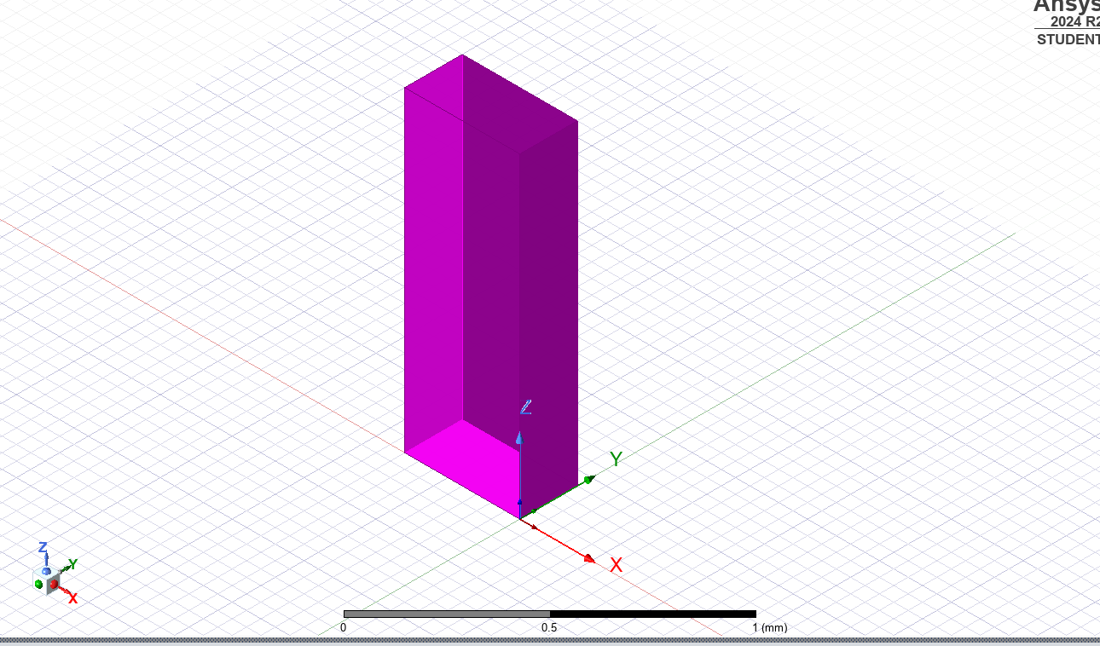
Figure 1 – Initial Cuboid Dimensions
The dimensions were then modified to the parameters in the brief, namely that the waveguide would have a width (a) of the Student’s first two numbers in their Student ID, height (b) of the third and fourth numbers of their ID divided by two, and length of 50mm. With a Student ID of 2113840, a and b were calculated as follows.
a = 21mm
b = 13/2 = 6.5 = 7mm (rounded to the nearest integer as per the brief)
Figure 2 shows the dimensions used for the revised rectangular waveguide. Figure 3 shows the vacuum material used for Task 1a, while Figure 4 shows the completed cuboid.
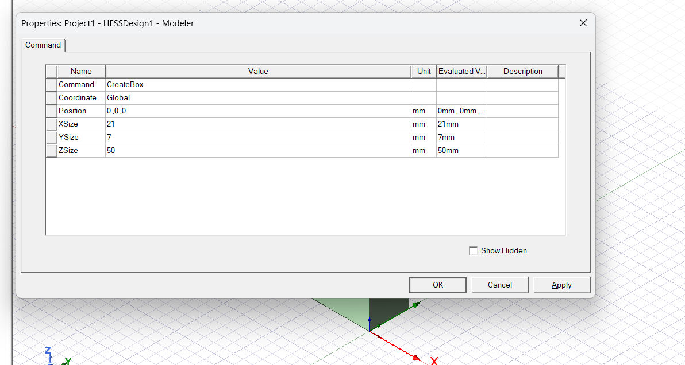
Figure 2 – New Dimensions for Rectangular Waveguide
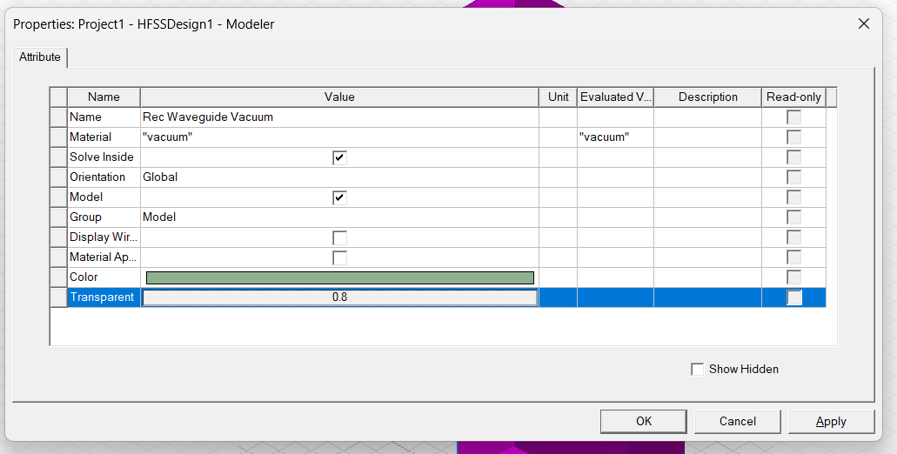
Figure 3 – Vacuum Fill
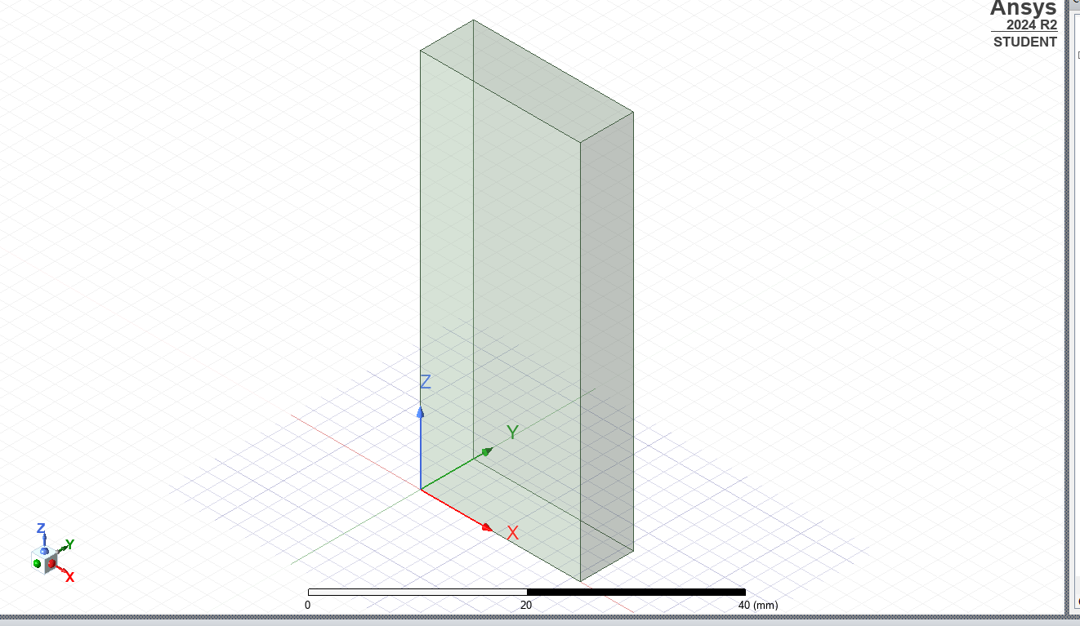
Figure 4 – Rectangular Waveguide with New Dimensions
Four sides, excluding the future ports of the waveguide, were then selected and a perfect electric region was applied to them using the Assign Boundary function. This boundary was verified, shown in Figure 5, to ensure it had been applied to the correct walls.
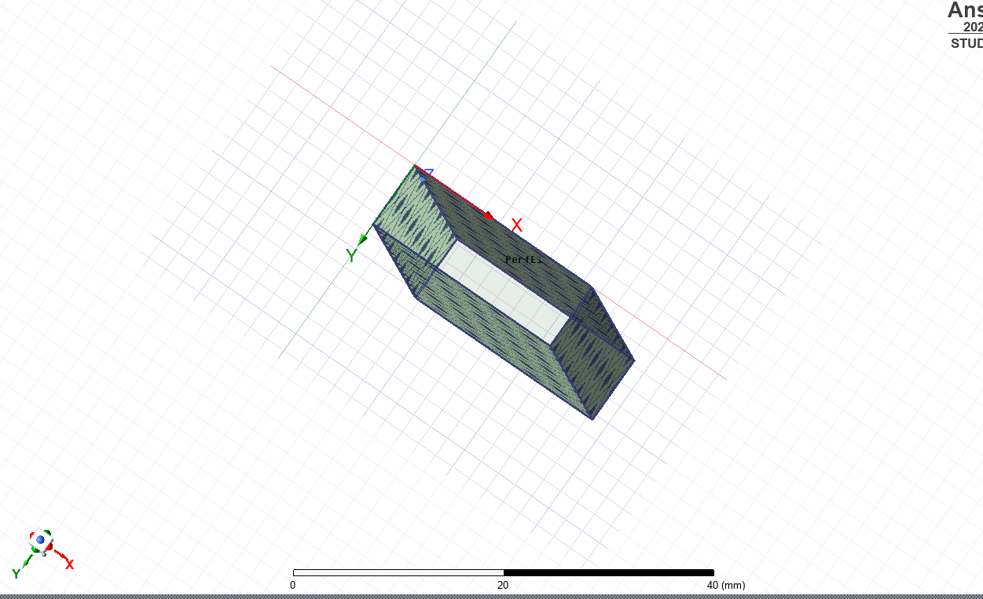
Figure 5 – Perfect Electric Region Verification
The two remaining faces not highlighted in Figure 5 were then selected to act as the ports of the waveguide. One of these faces was highlighted and the Wave Port function was used to assign an excitation with three modes and a full port impedance of 50 Ohms to the waveguide opening.
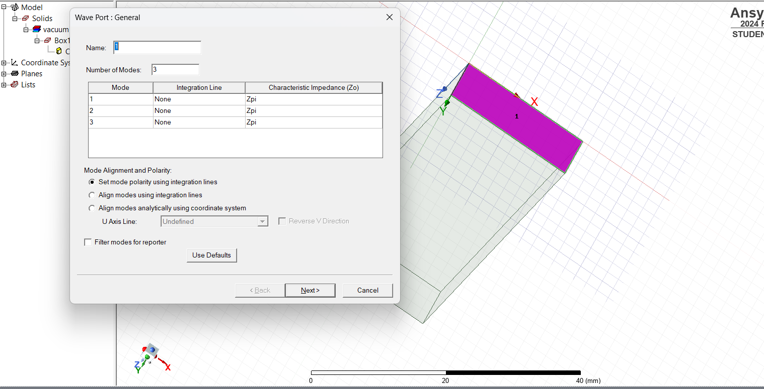
Figure 6 – Assigning a Wave Port to the Waveguide Opening
The wave port was then verified to ensure correctness, and the steps were repeated for the second wave port on the opposite side of the waveguide, shown in Figures 7 and 8.
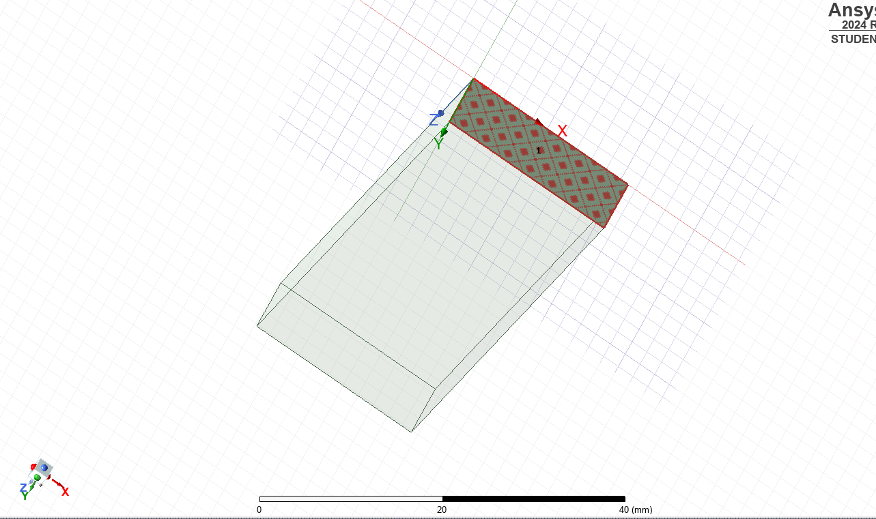
Figure 7 – Wave Port 1 Verification
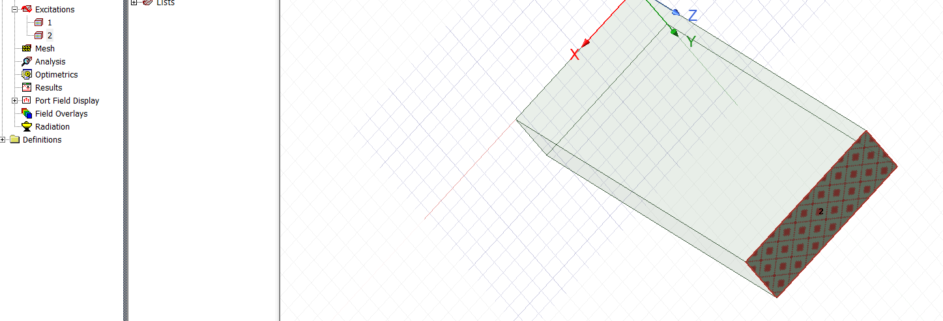
Figure 8 – Wave Port 2 Verification
With the rectangular waveguide now completed, an Advanced Solution Setup was added to the project. The Driven Solution used a frequency of 7GHz, based on the expected cutoff frequency calculated in the Results Section and shown in Equation 1 below, with the number of passes selected as 99 to maximise the accuracy of the solution by increasing the frequency with which the adaptive mesh is refined. [3] The frequency sweep range, from 2GHz to 30GHz, was provided by the assignment brief.
$f_{c }= \frac{c}{2} \sqrt{{\left(\frac{m}{a}\right)}^{2}+ {\left(\frac{n}{b}\right)}^{2}}$ Equation 1
c = speed of light (in vacuum)
m = number of half wavelengths in width of waveguide
n = number of half wavelengths in height of waveguide
a = wavelength width
b = wavelength height
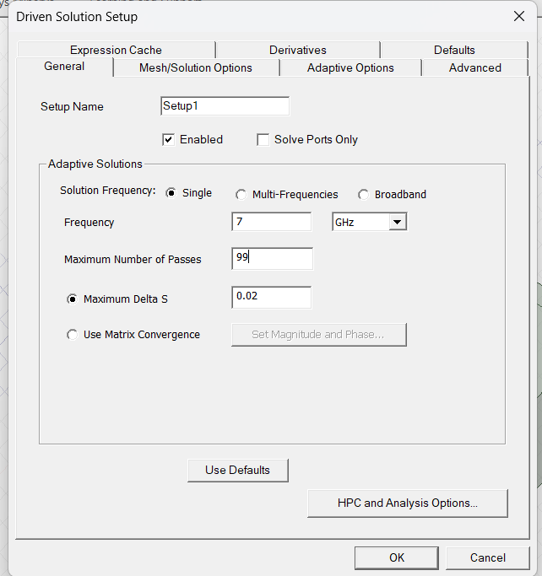
Figure 9 – Driven Solution Setup
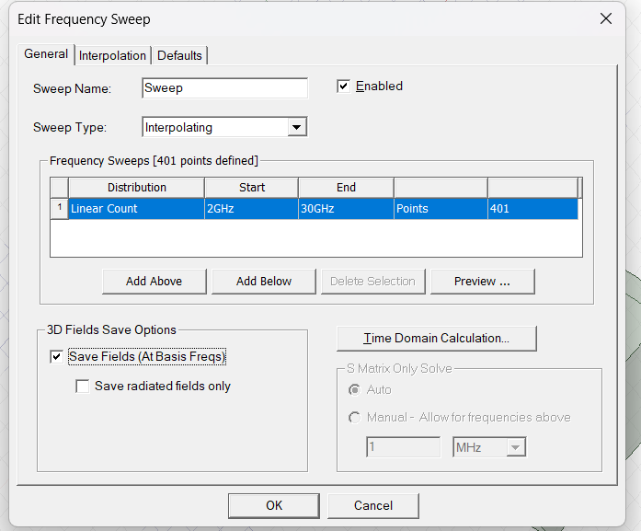
Figure 10 – Frequency Sweep Setup
The project was then validated to ensure the waveguide was correctly setup, before beginning the analysis with the Analyze All function. A rectangular plot was created to visualise cutoff frequencies of the three modes, followed by port field displays as well as magnitudes and vectors of the electric and magnetic fields, shown in Results.

Figure 11 – Project Verification
The port field displays were created by clicking on each mode individually and screenshotting the modes propagating. The magnitudes of the electric and magnetic fields were generated by creating field plots of each, with a Sweep solution and 30GHz maximum frequency as shown in Figure 12. The Quantity parameter was changed from Mag_E to Mag_H, or from Vector_E to Vector_H, for electric and magnetic fields respectively. The rectangular plot was created with parameters shown in Figure 13.
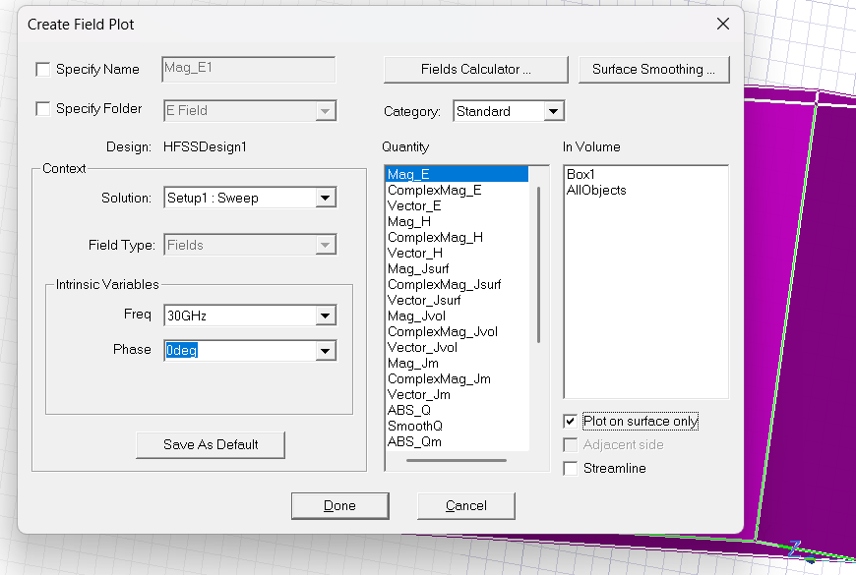
Figure 12 – Field Plot Settings for Magnitude of Electric Field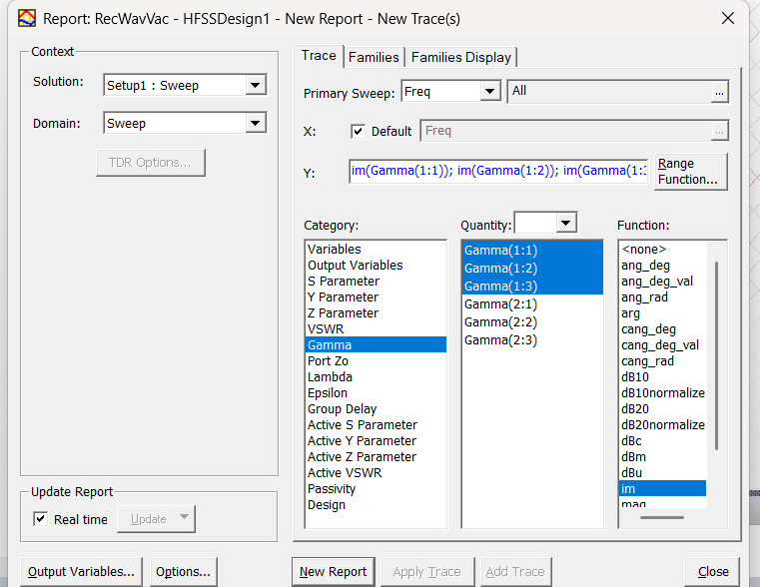
Figure 13 – Rectangular Plot Settings for Gamma Plot
2.12 Task 1b
Task 1b, the Teflon-filled rectangular waveguide, was almost identical to Task 1a with two exceptions: the material fill and cutoff frequency equation. Figure 14 shows the updated waveguide material, while Equation 2 shows a new value for c, based on values for permittivity and permeability of the Teflon medium., to be substituted back into Equation 1.
$c=\frac{{3x10}^{8}}{\sqrt{εμ}}$ Equation 2
c = speed of light in Teflon medium
Ɛ = permittivity of medium
µ = permeability of medium

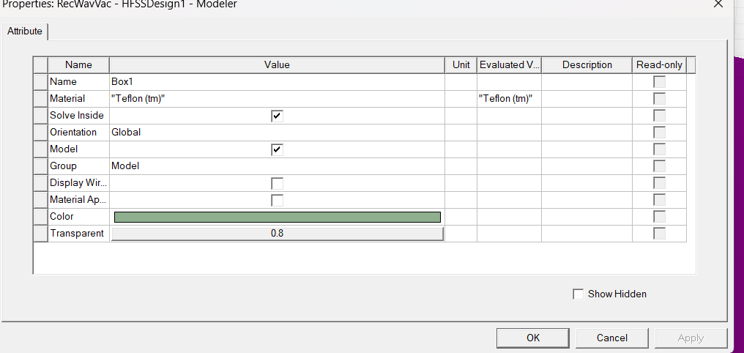
Figure 14 – Teflon Fill
2.2 Half-Wave Dipole Antenna Simulation
Task 2, the half-wave dipole antenna, was started by creating a modal HFSS design in Ansys Electronics and drawing a cylinder of any dimensions in mm, shown in Figure 15.
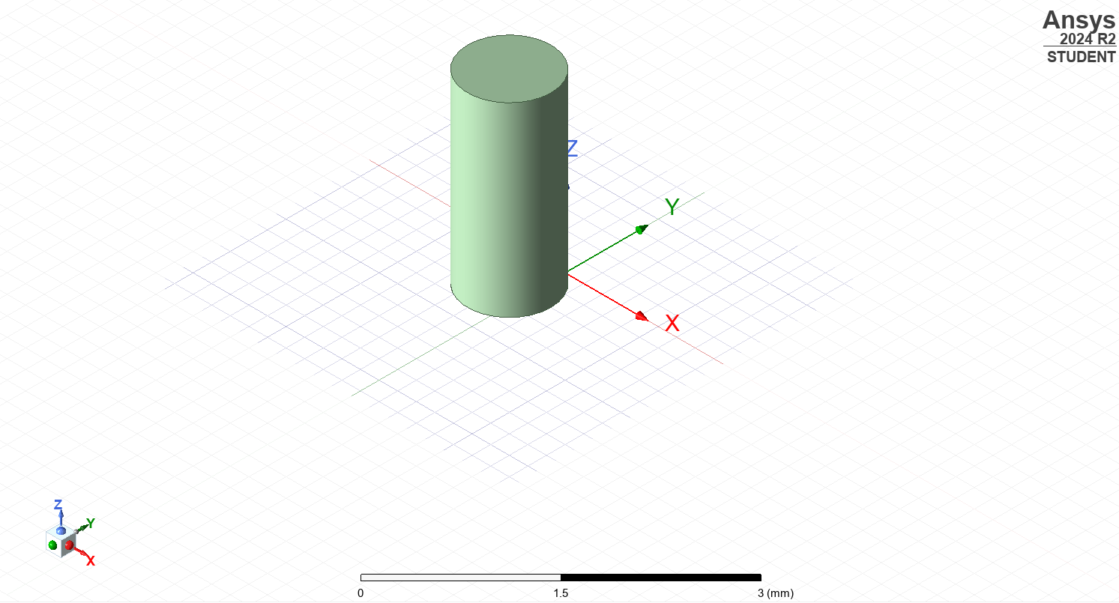
Figure 15 – Initial Cylinder
The cylinder was then updated with dimensions from the assignment brief, namely that the antenna have a radius of 1mm and a wavelength of the first three numbers from the Student ID (211mm). Equation 3 shows the calculation for the height of the antenna.
$Dipole Length= \frac{λ}{2}$ Equation 3
Where $λ=211$
The length of the antenna was calculated as 106mm, rounded to the nearest integer. These dimensions are shown in Figure 16. To ensure ease of use when creating the feed gap later in the project, the antenna was placed along the z axis with its mid-point centred on the origin. PEC was selected as the antenna material as per the brief.
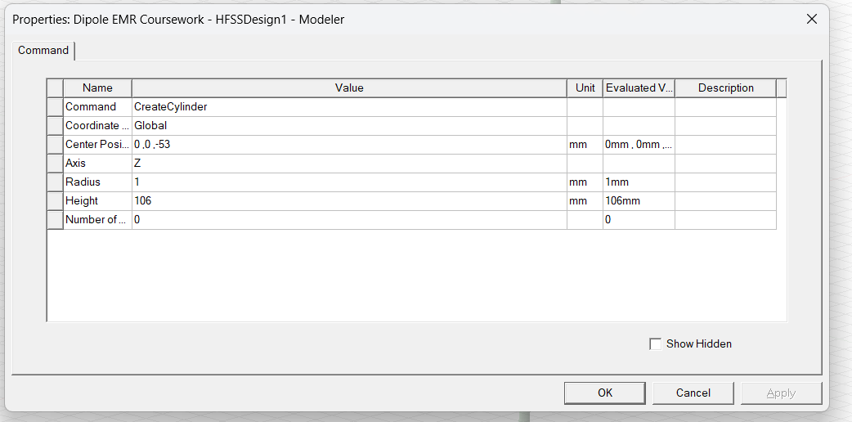
Figure 16 – Updated Cylinder Dimensions
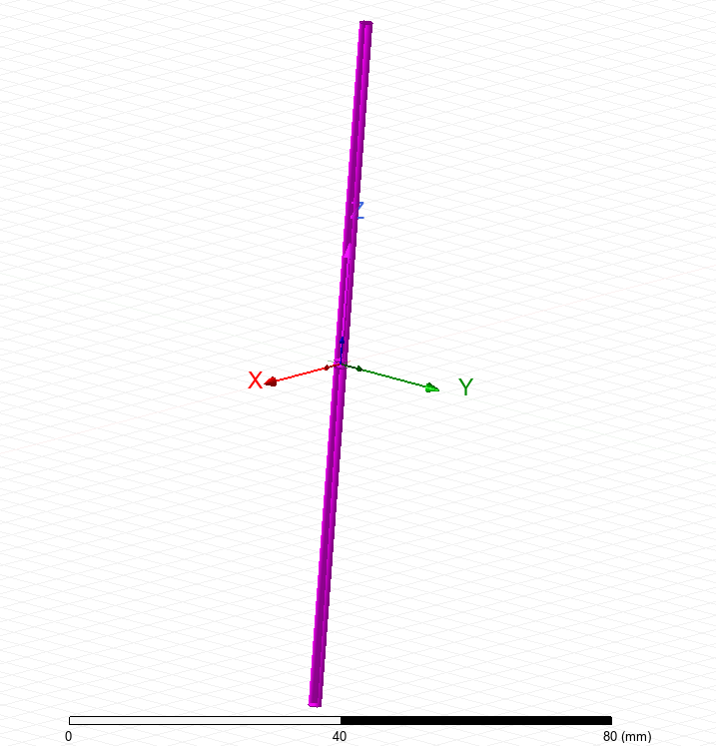
Figure 17 – Updated Cylinder
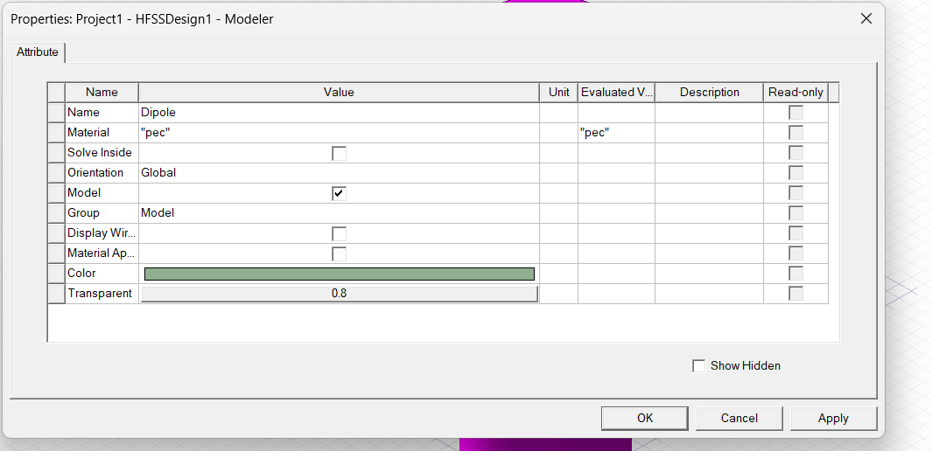
Figure 18 – PEC Fill
A gap was then created in the middle of the cylinder for the lumped port to be added. A second cylinder was added as shown in Figures 19-21. This was then removed from the original cylinder with the Boolean Subtract function to create the two dipole legs shown in Figure 22.
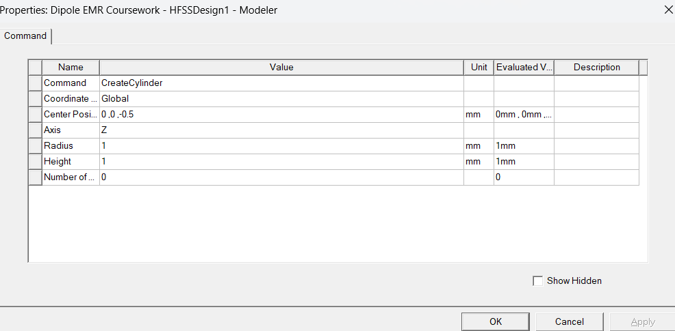
Figure 19 – Gap Cylinder Dimensions
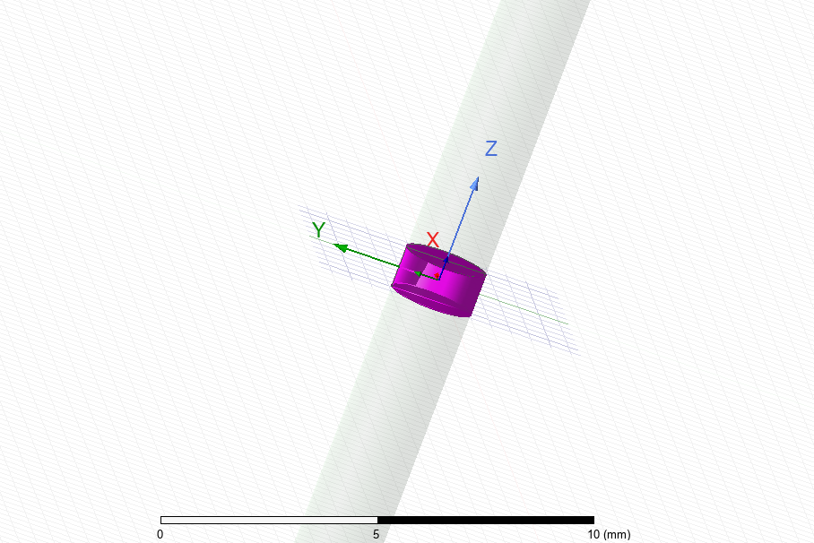
Figure 20 – Gap Cylinder
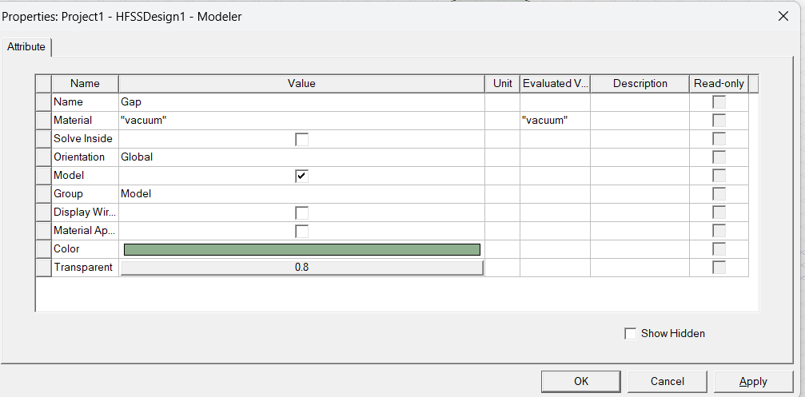
Figure 21 – Gap Cylinder Material
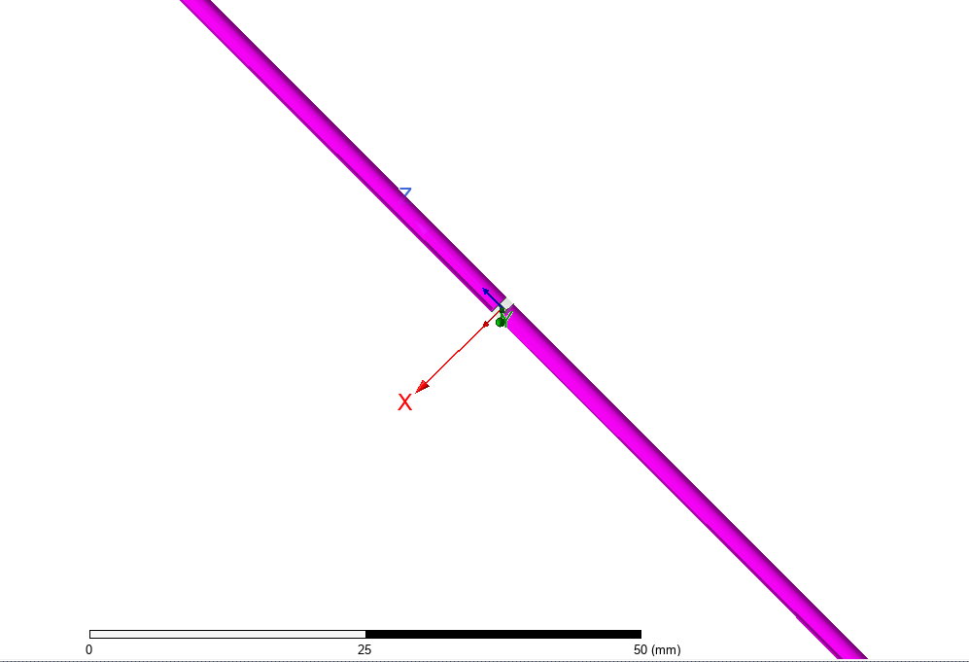
Figure 22 – Dipole Antenna Legs
To create the lumped port, the gap was selected and a Surface Section was added in the YZ plane, ensuring the lumped port was parallel to the Z axis.
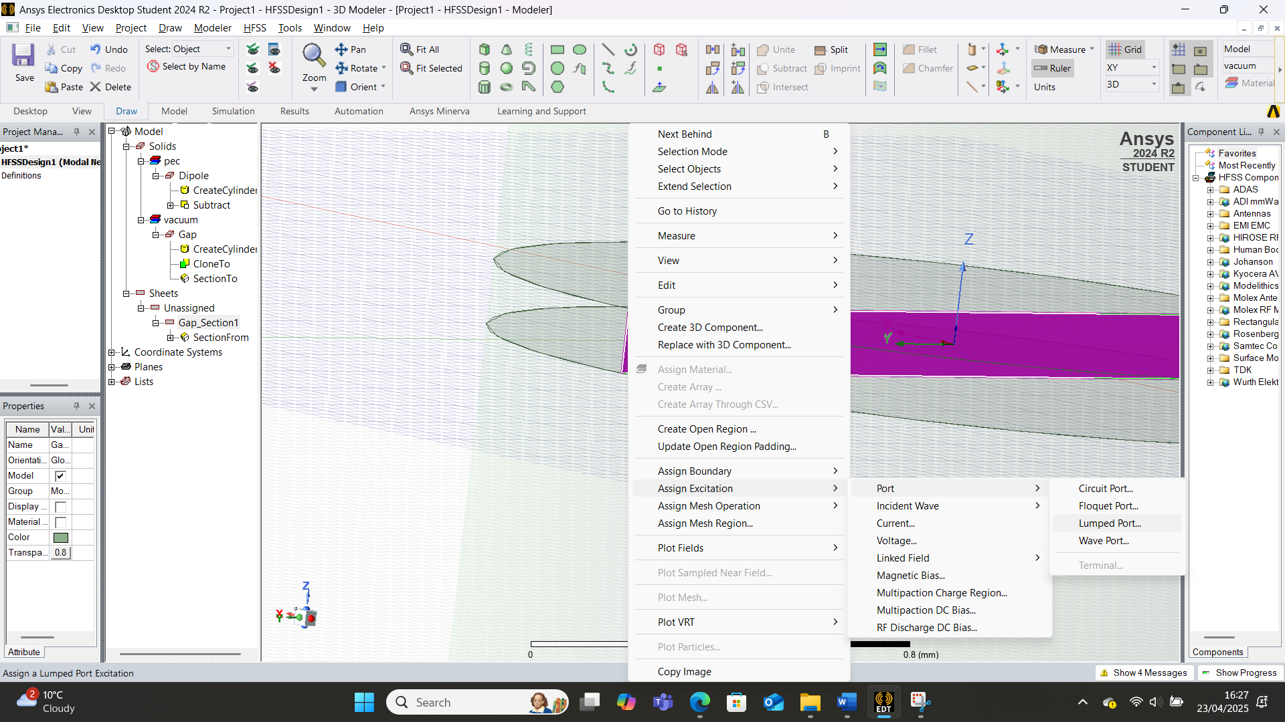
Figure 23 – Rectangular Plane
A lumped port was then added to the rectangular plane with one mode and an impedance of 50 Ohms, as per the assignment brief. An integration line was then drawn to define the path along which the electric and magnetic fields are integrated. [3]
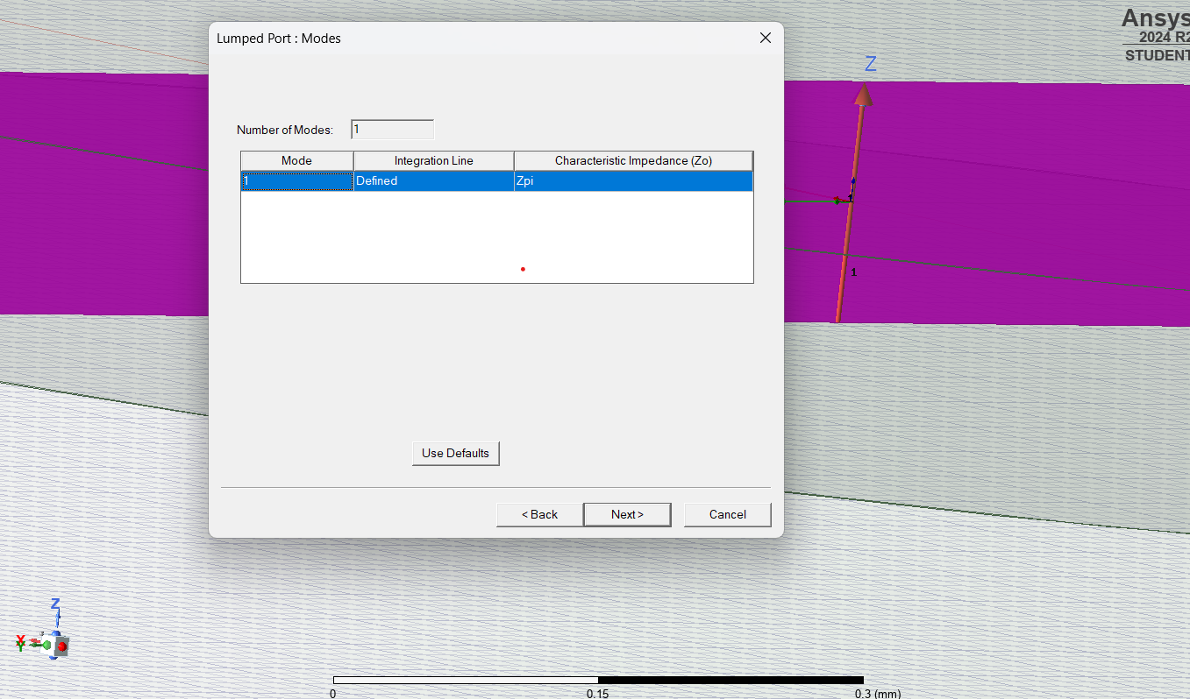
Figure 24 – Lumped Port Integration Line
A rectangular radiating surface was then added by creating an open region with a 1GHz frequency and a Perfectly Matched Layer (PML) boundary, simulating the antenna radiating within an open space.
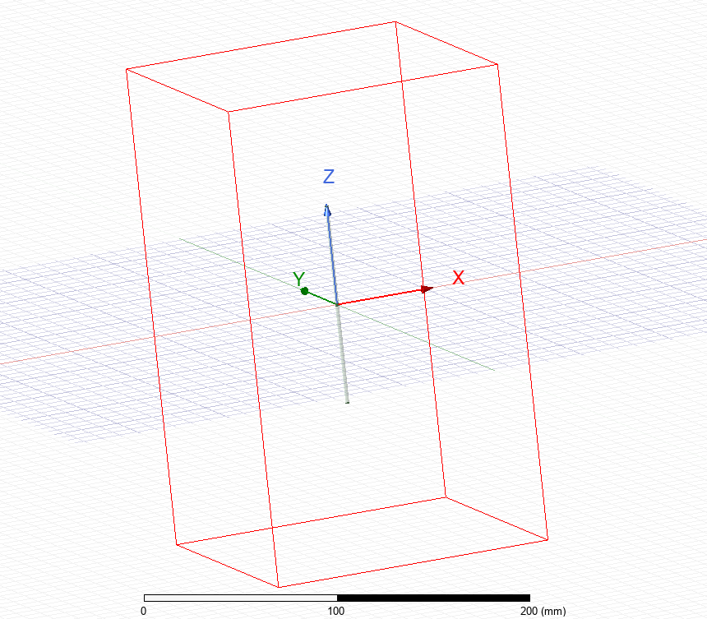
Figure 25 – Rectangular Radiating Surface
Figures 26 and 27 show verification of the lumped port excitation and open region radiation respectively.
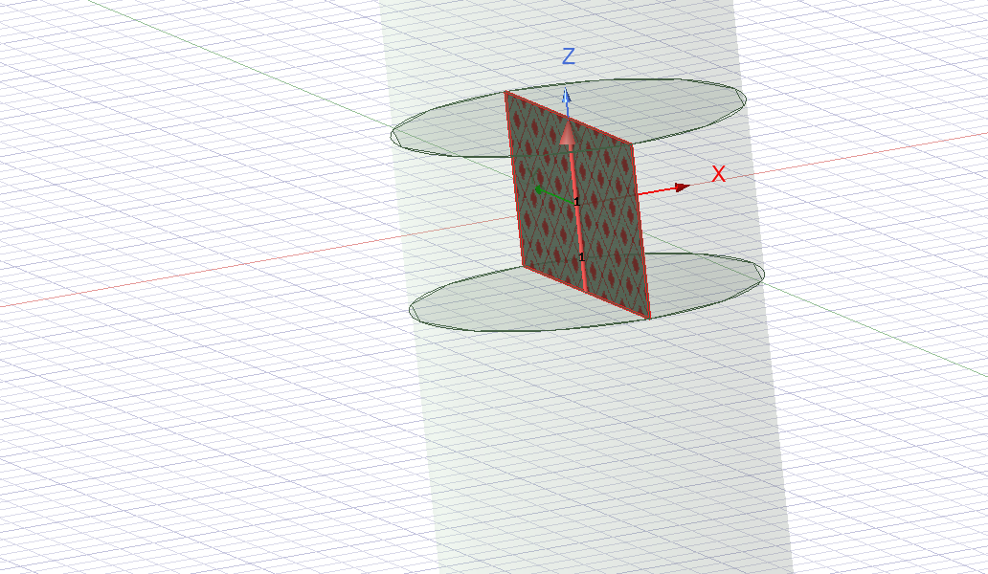
Figure 26 – Lumped Port Excitation Verification
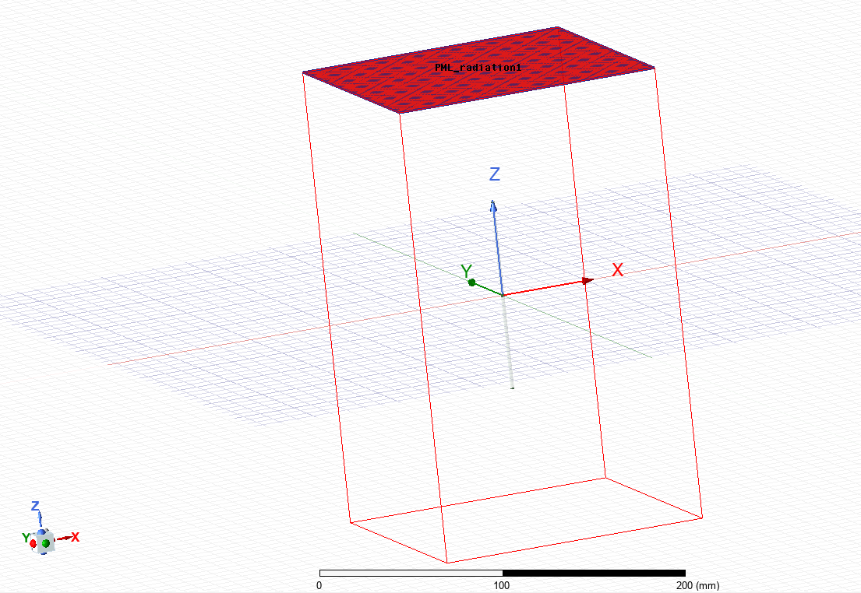
Figure 27 – Open Region Radiation Verification (1 of 6 sides)
A solution setup was then added, shown in Figures 28 and 29. 5GHz was chosen for the frequency, staying close to the operating frequency calculated with Equation 4. The frequency sweep was also chosen to ensure the operating frequency fell within its range.
$f=\frac{c}{λ}$ Equation 4
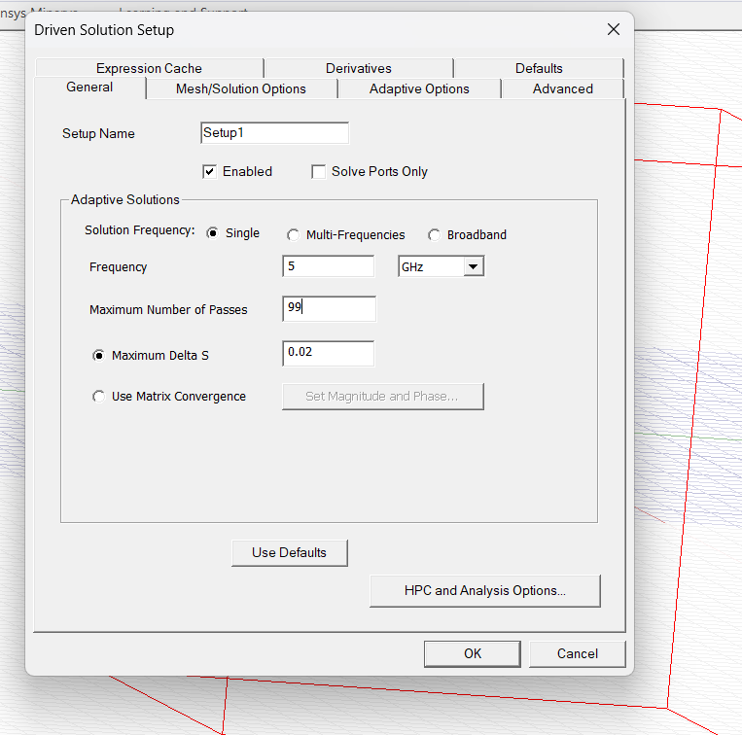
Figure 28 – Driven Solution Setup
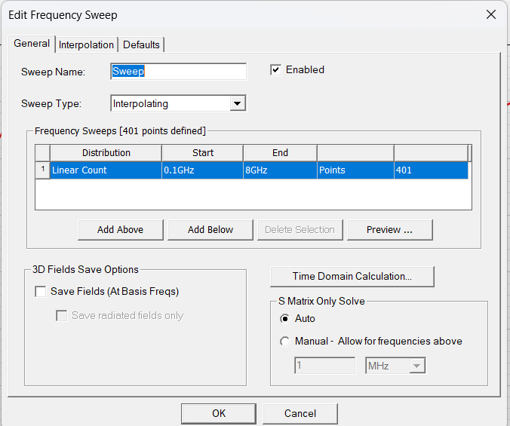
Figure 29 - Frequency Sweep Setup
The project was then validated and the analysis was run. An S Parameter Plot and Gain Plot were generated, shown in Results.
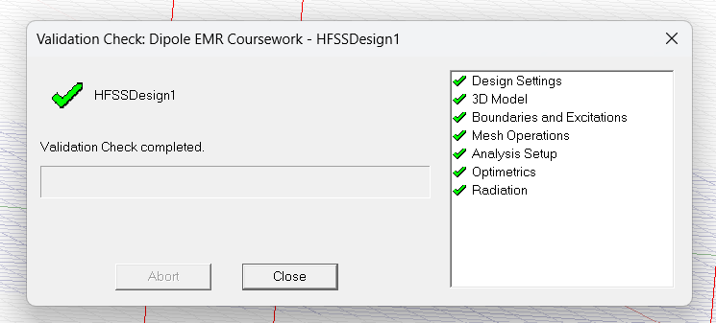
Figure 30 – Project Validation
3 Results
2.1 Task 1a - Vacuum Rectangular Waveguide
Figures 31-33 show the Port Field Displays for the vacuum-filled rectangular waveguide.
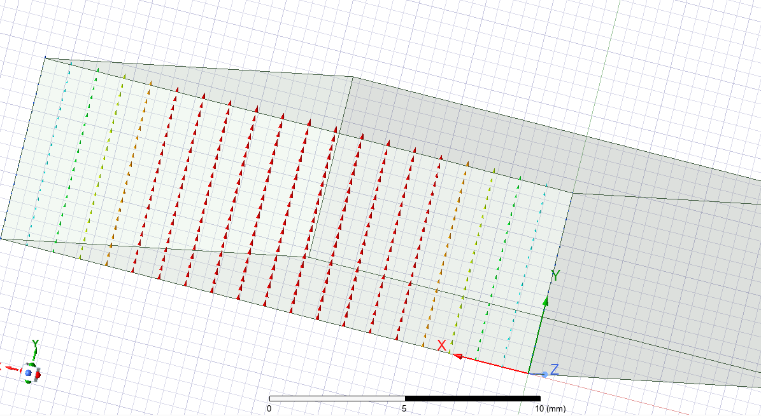
Figure 31 – Port Field Display Mode 1
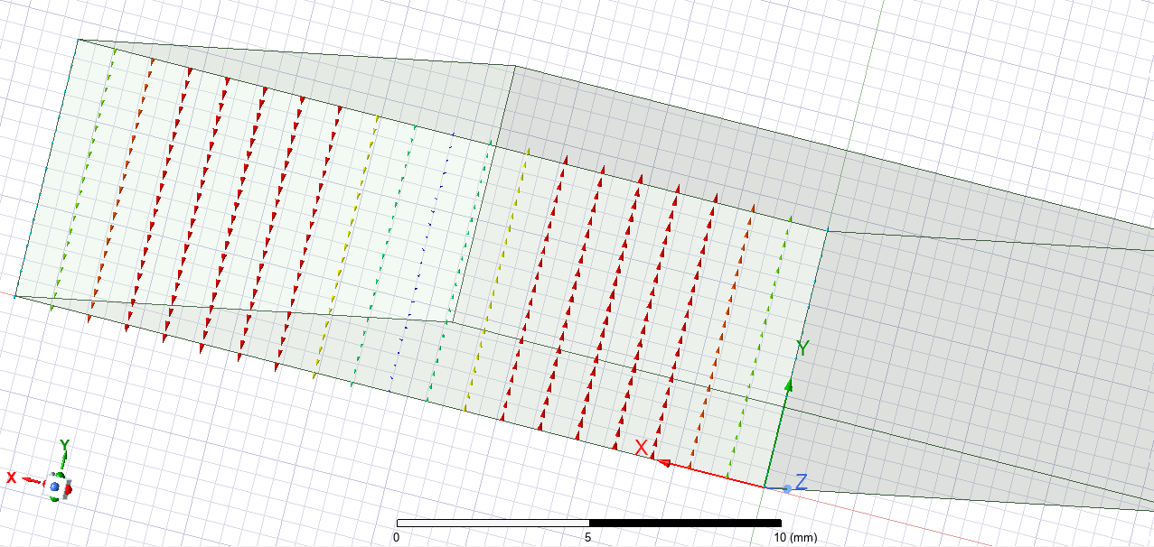
Figure 32 – Port Field Display Mode 2
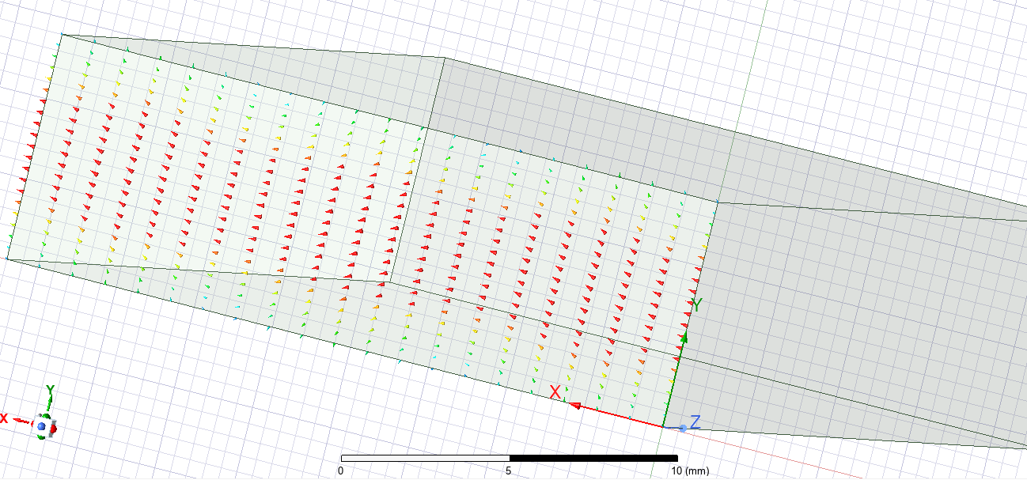
Figure 33 – Port Field Display Mode 3
Figures 34-36 show the magnitude and vectors of the electric field through Mode 1.
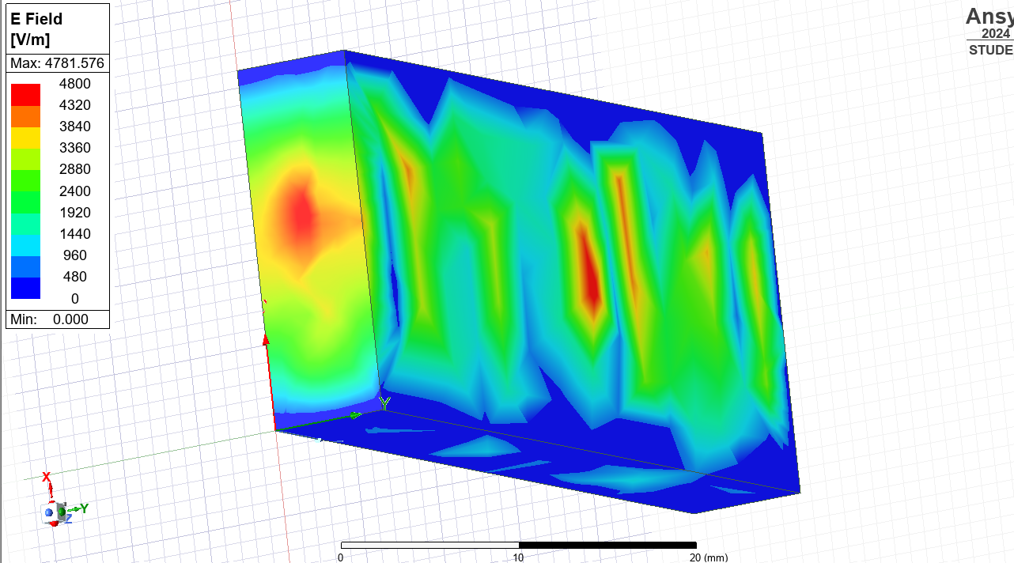
Figure 34 – Mode 1 Electric Field Magnitude Plot
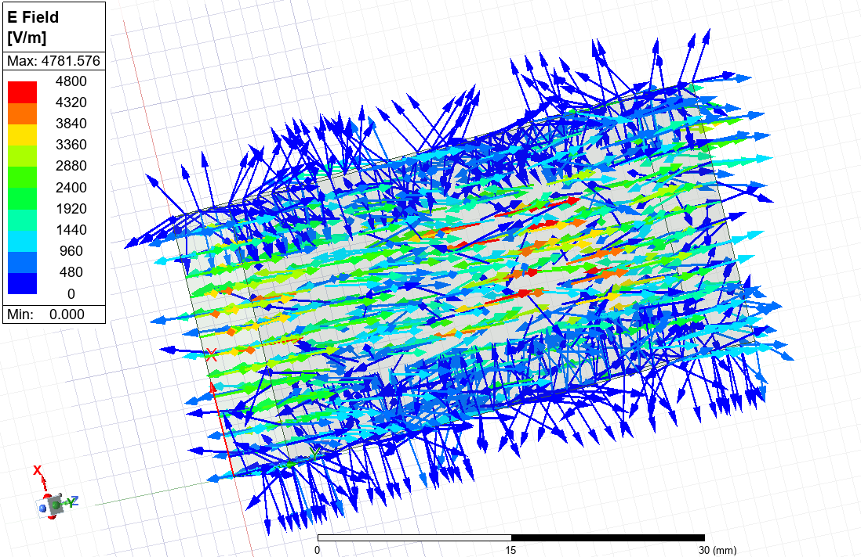
Figure 35 – Mode 1 Electric Field Vector Plot
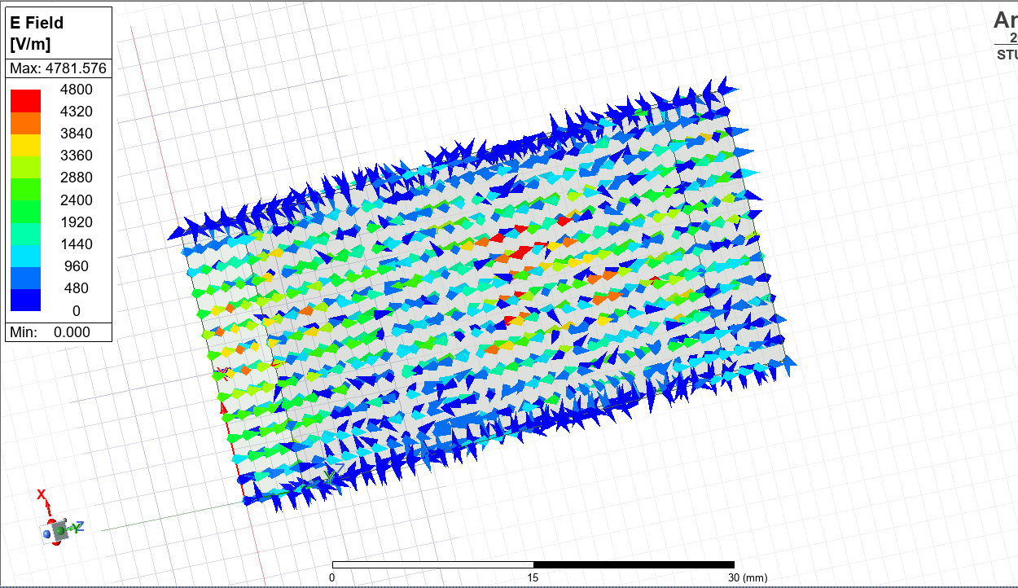
Figure 36 – Mode 1 Electric Field Vector Plot (without arrow tails)
Figures 37-39 show the magnitude and vectors of the magnetic field through Mode 1.
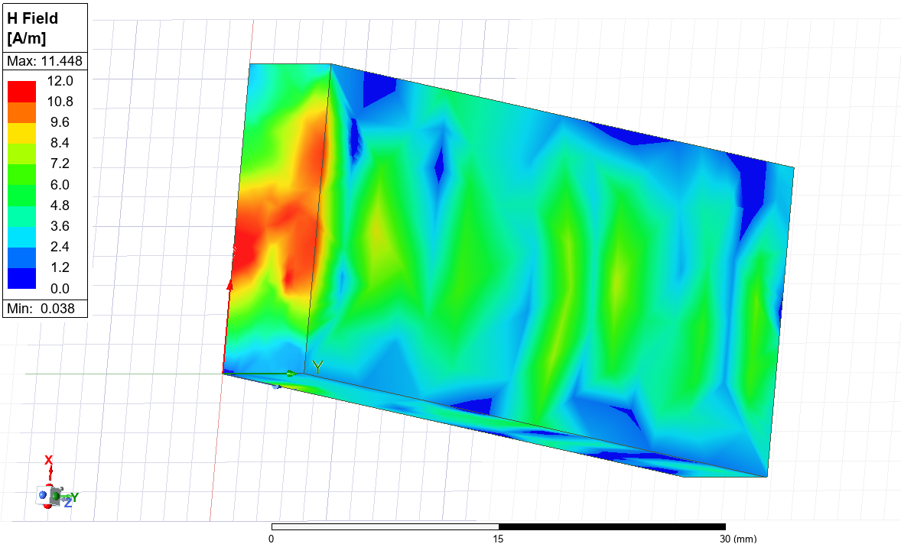
Figure 37 – Mode 1 Magnetic Field Magnitude Plot
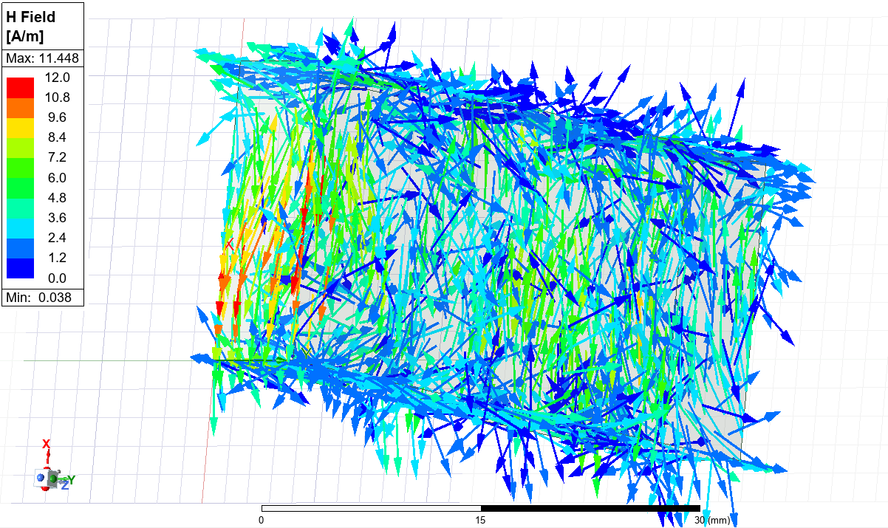
Figure 38 – Mode 1 Magnetic Field Vector Plot
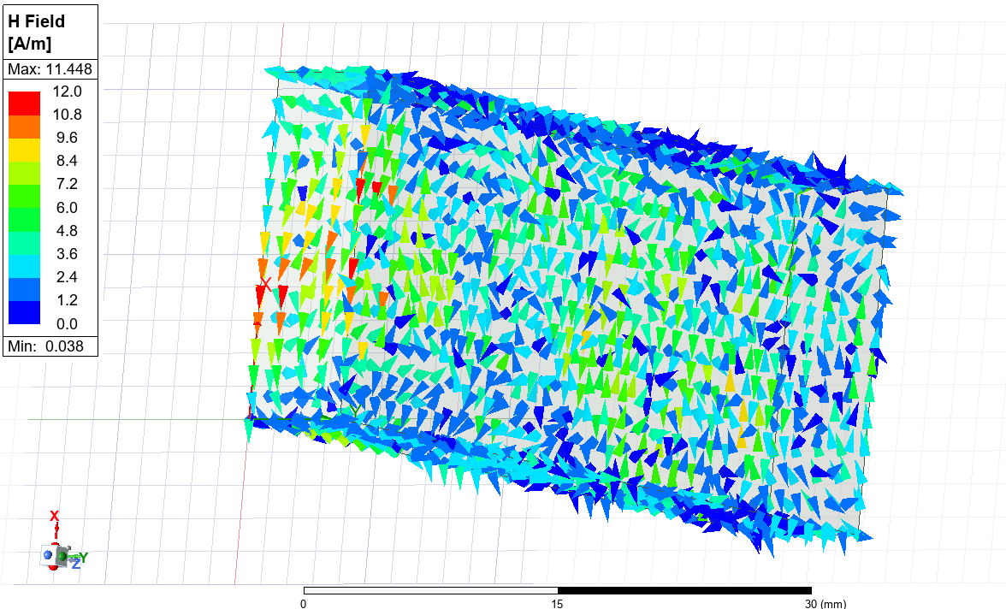
Figure 39 – Mode 1 Magnetic Field Vector Plot (without arrow tails)
Figures 40-42 show the magnitude and vectors of the electric field through Mode 2.
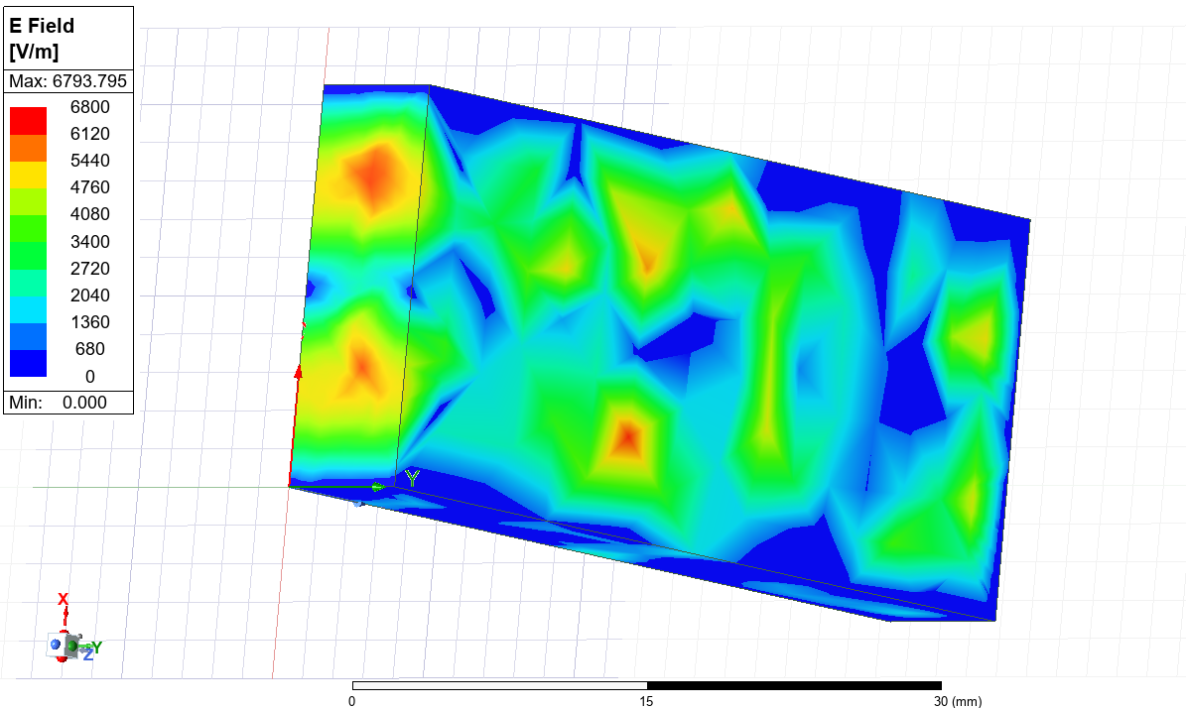
Figure 40 – Mode 2 Electric Field Magnitude Plot
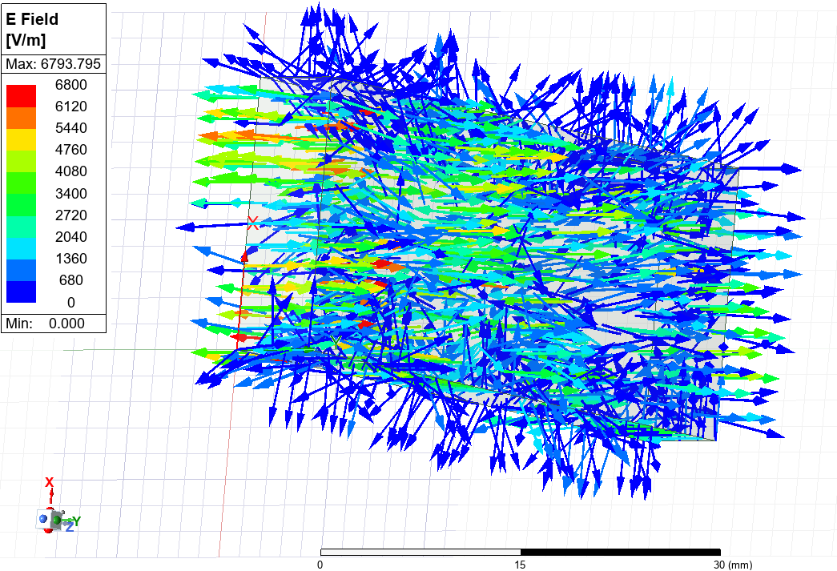
Figure 41 – Mode 2 Electric Field Vector Plot
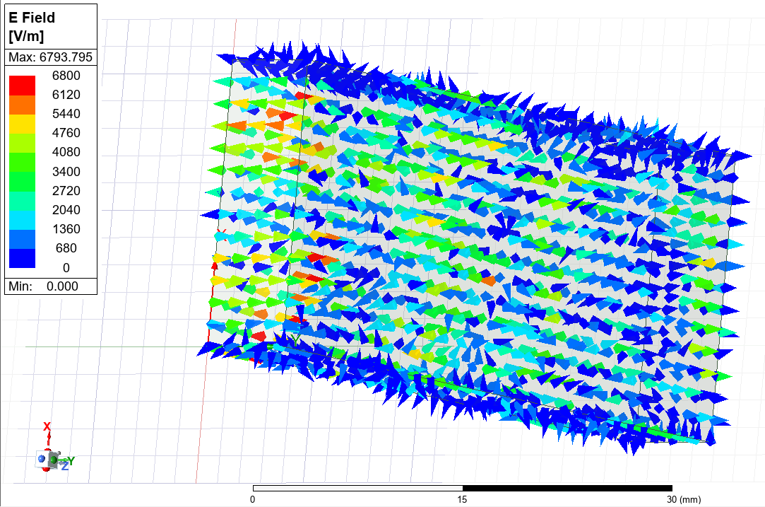
Figure 42 – Mode 2 Electric Field Vector Plot (without arrow tails)
Figures 43-45 show the magnitude and vectors of the magnetic field through Mode 2.
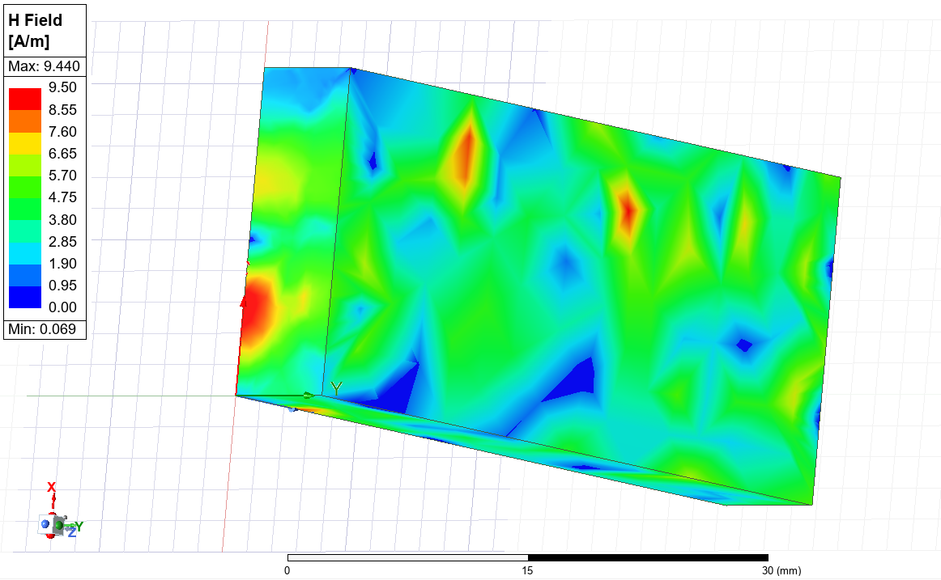
Figure 43 – Mode 2 Magnetic Field Magnitude Plot
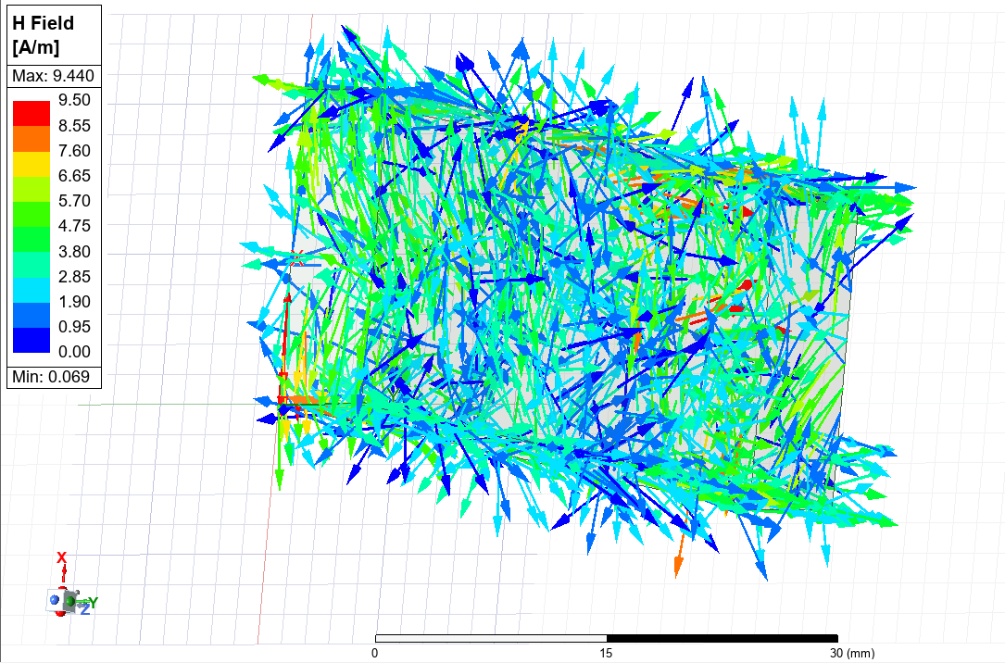
Figure 44 – Mode 2 Magnetic Field Vector Plot

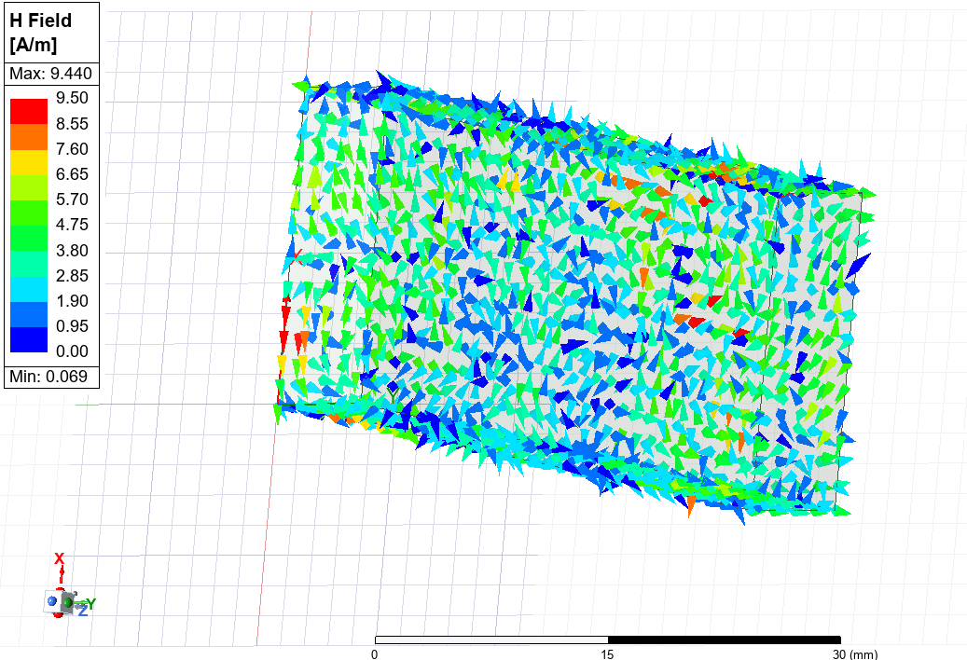
Figure 45 – Mode 2 Magnetic Field Vector Plot (without arrow tails)
Figures 46-48 show the magnitude and vectors of the electric field through Mode 3.
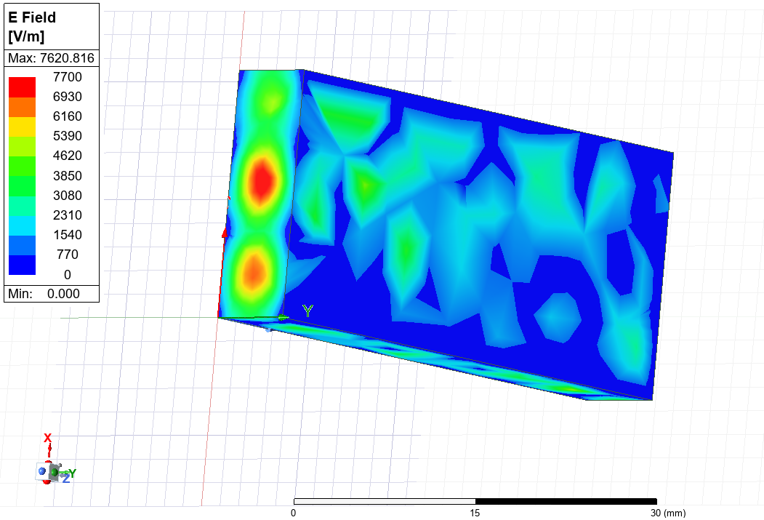
Figure 46 – Mode 3 Electric Field Magnitude Plot
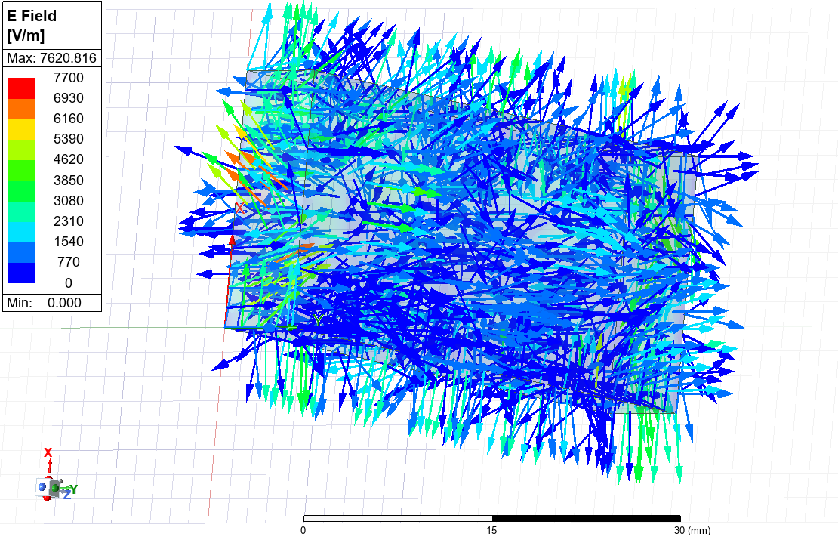
Figure 47 – Mode 3 Electric Field Vector Plot
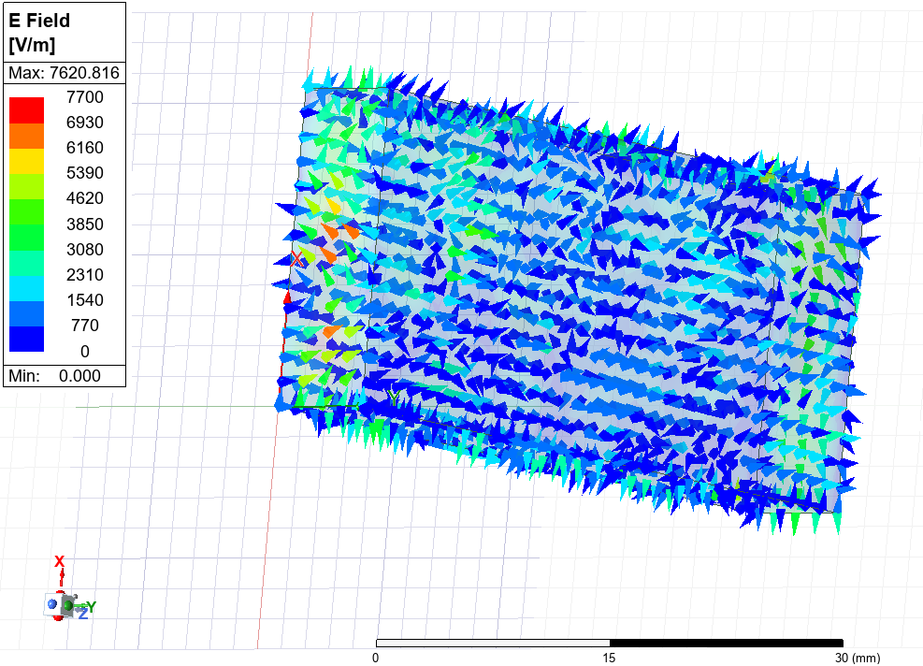
Figure 48 – Mode 3 Electric Field Vector Plot (without arrow tails)
Figures 49-51 show the magnitude and vectors of the magnetic field through Mode 3.
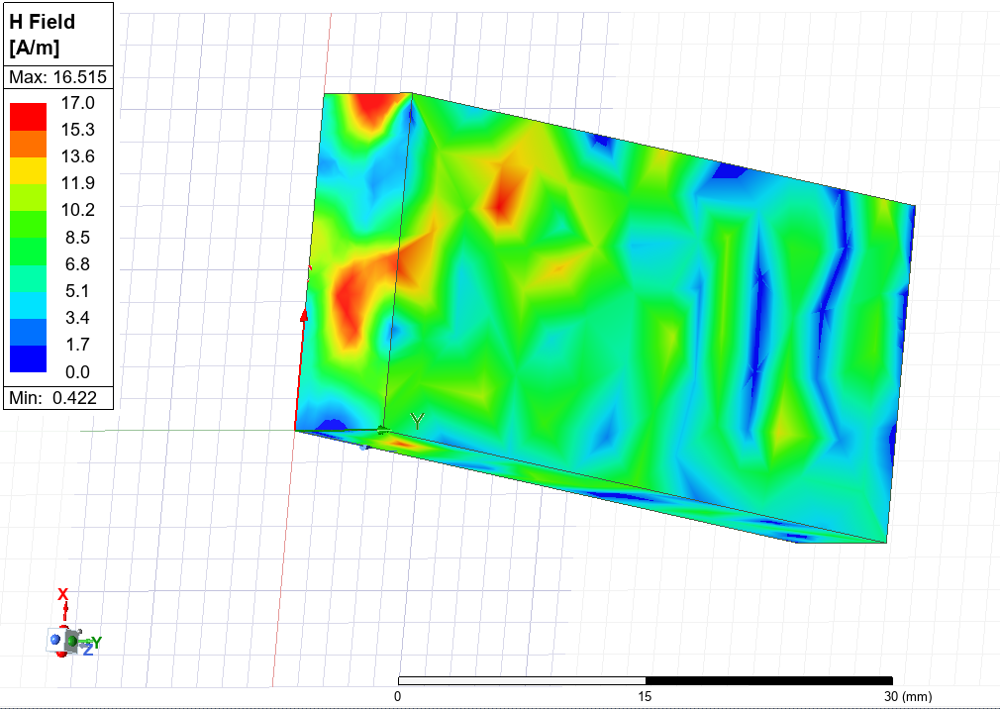
Figure 49 – Mode 3 Magnetic Field Magnitude Plot
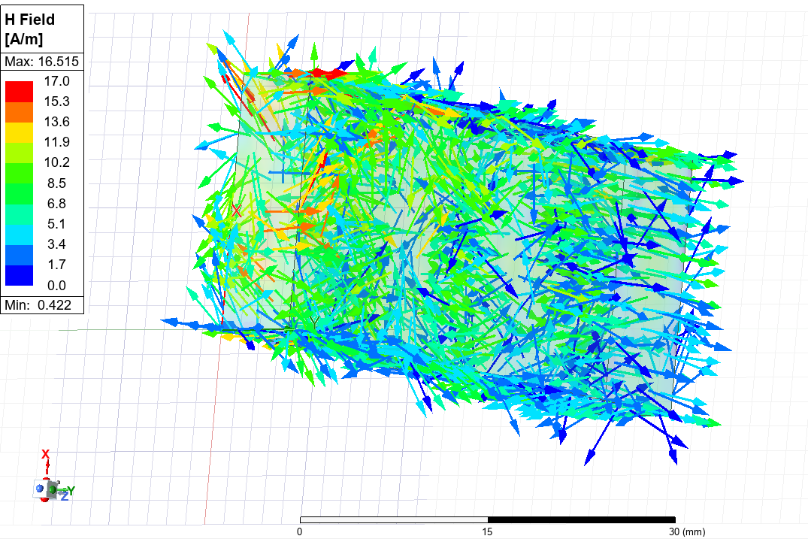
Figure 50 – Mode 3 Magnetic Field Vector Plot
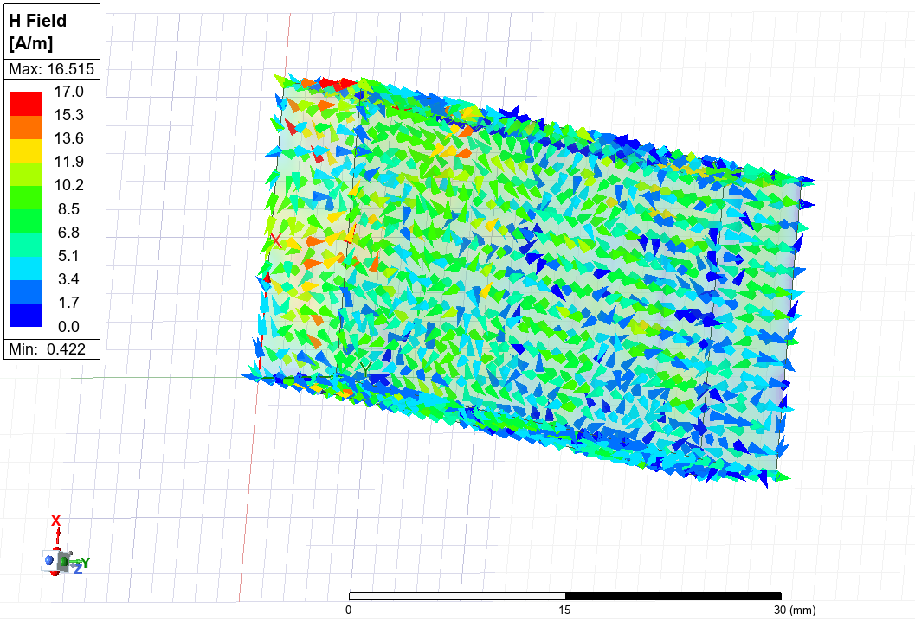
Figure 51 – Mode 3 Magnetic Field Vector Plot (without arrow tails)
Figure 52 shows the rectangular plot to visualise cutoff frequencies.
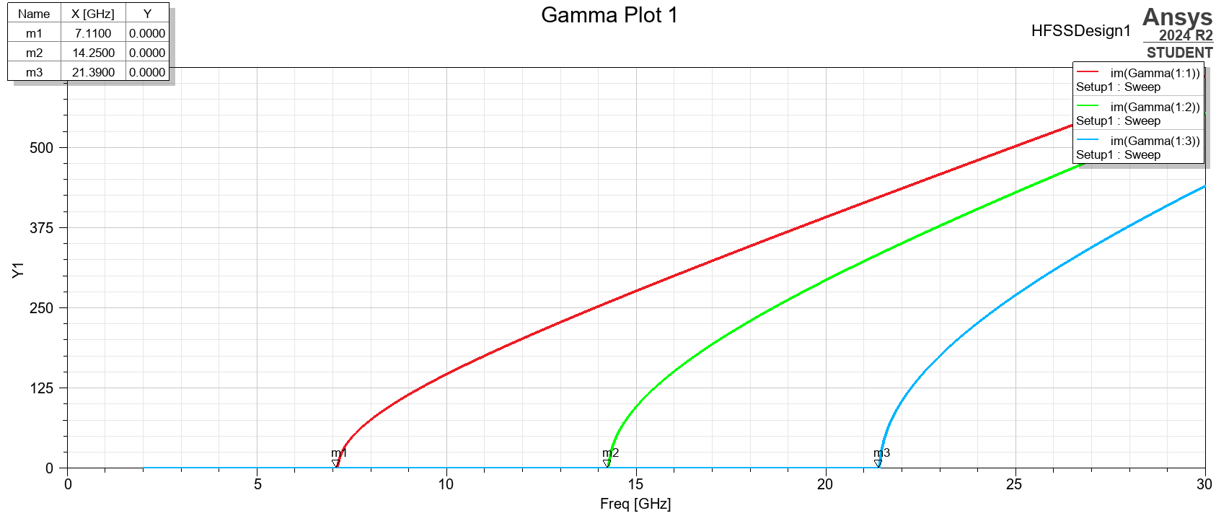
Figure 52 – Plot of Cutoff Frequencies
Mode 1 can be identified as the dominant mode as it has the lowest cutoff frequency.
The cutoff frequency, from Equation 1, can be calculated as follows:
Mode 1:
$$f_{c }= \frac{{3x10}^{8}}{2} \sqrt{{\left(\frac{1}{0.021}\right)}^{2}+ {\left(\frac{0}{0.007}\right)}^{2}}$$
Mode 1 Cutoff Frequency = 7.14GHz
Mode 2:
$$f_{c }= \frac{{3x10}^{8}}{2} \sqrt{{\left(\frac{2}{0.021}\right)}^{2}+ {\left(\frac{0}{0.007}\right)}^{2}}$$
Mode 2 Cutoff Frequency = 14.29GHz
Mode 3:
$$f_{c }= \frac{{3x10}^{8}}{2} \sqrt{{\left(\frac{3}{0.021}\right)}^{2}+ {\left(\frac{0}{0.007}\right)}^{2}}$$
Mode 3 Cutoff Frequency = 21.43GHz
2.2 Task 1b - Teflon Rectangular Waveguide
Figures 53-55 show the Port Field Displays for the Teflon-filled rectangular waveguide.
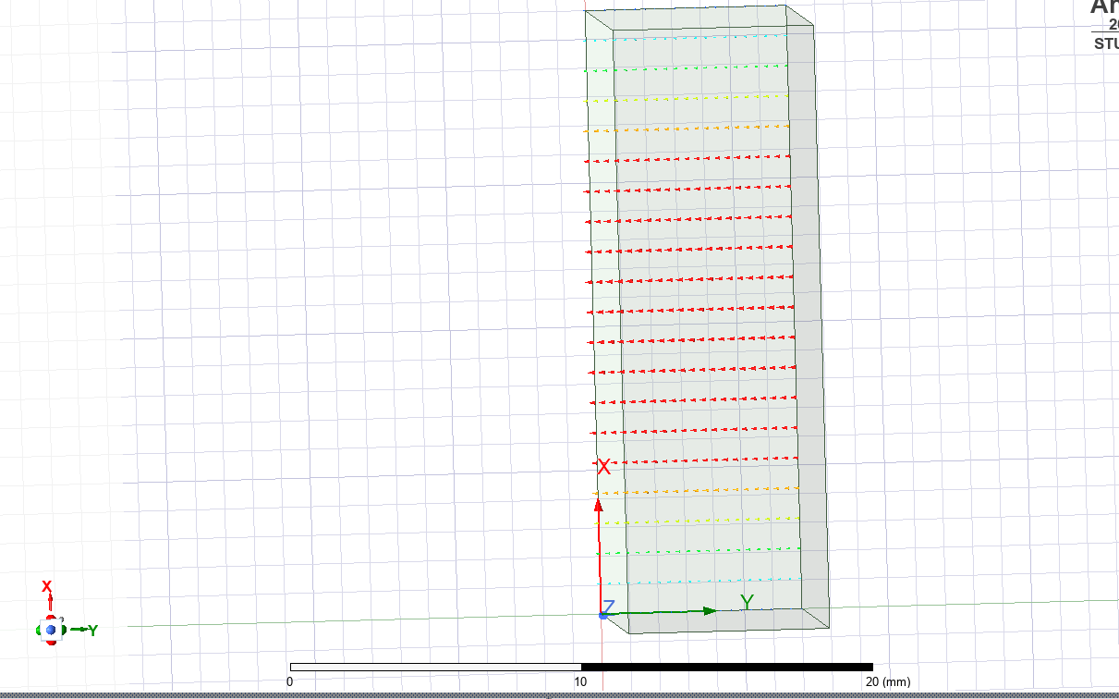
Figure 53 – Port Field Display Mode 1
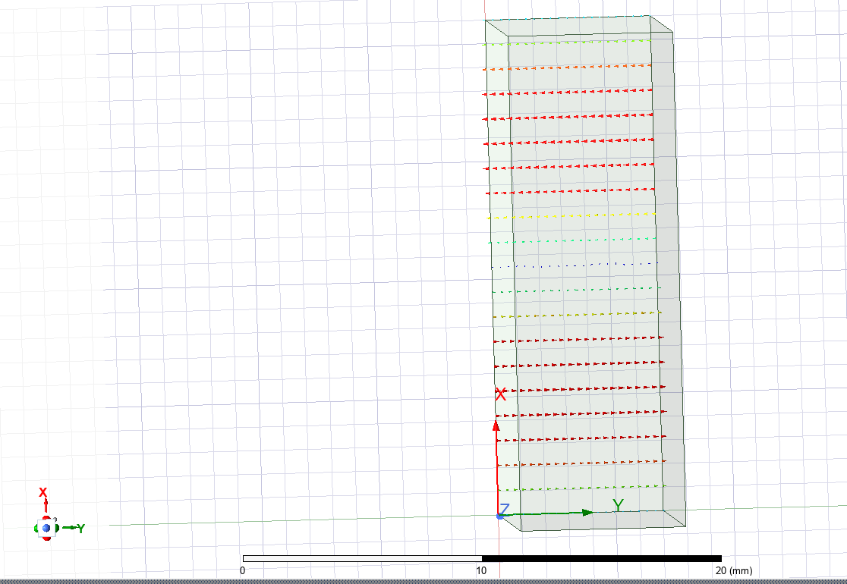
Figure 54 – Port Field Display Mode 2
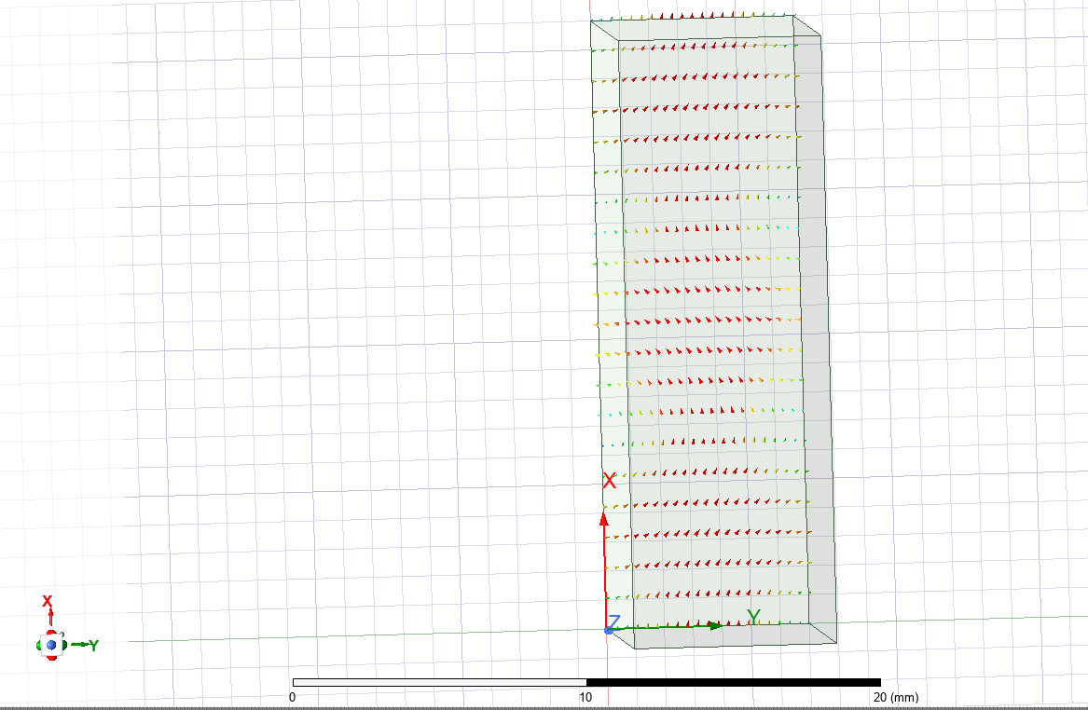
Figure 55 – Port Field Display Mode 3
Figures 56-58 show the magnitude and vectors of the electric field through Mode 1.
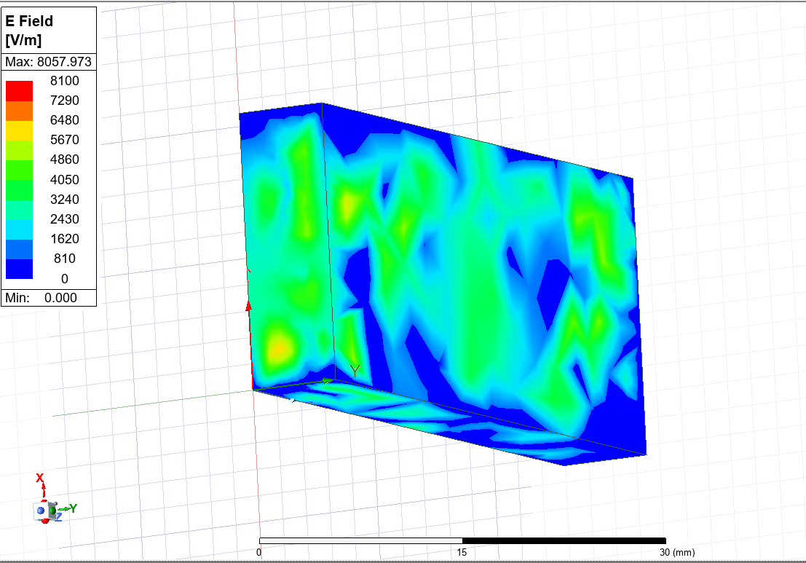
Figure 56 – Mode 1 Electric Field Magnitude Plot
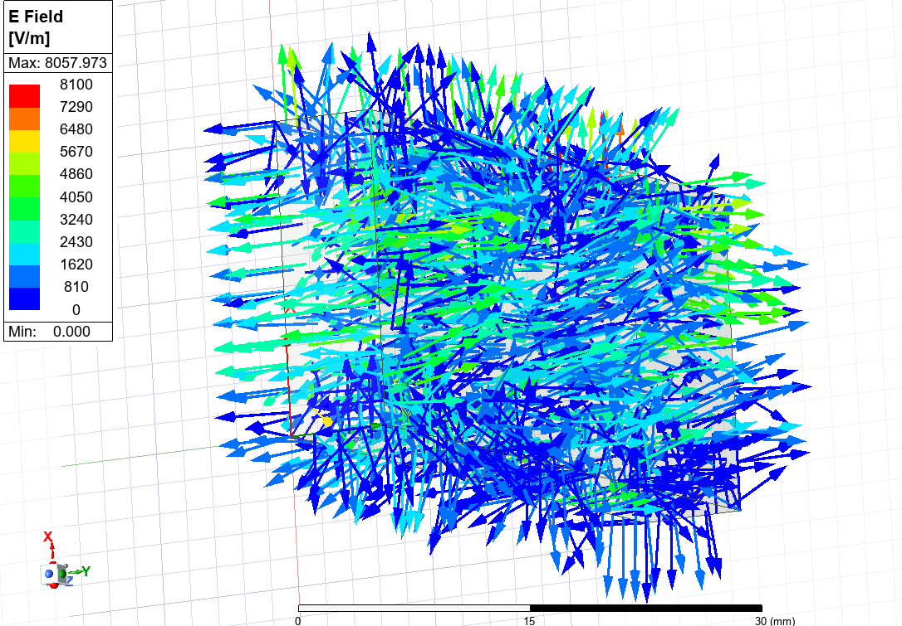
Figure 57 – Mode 1 Electric Field Vector Plot
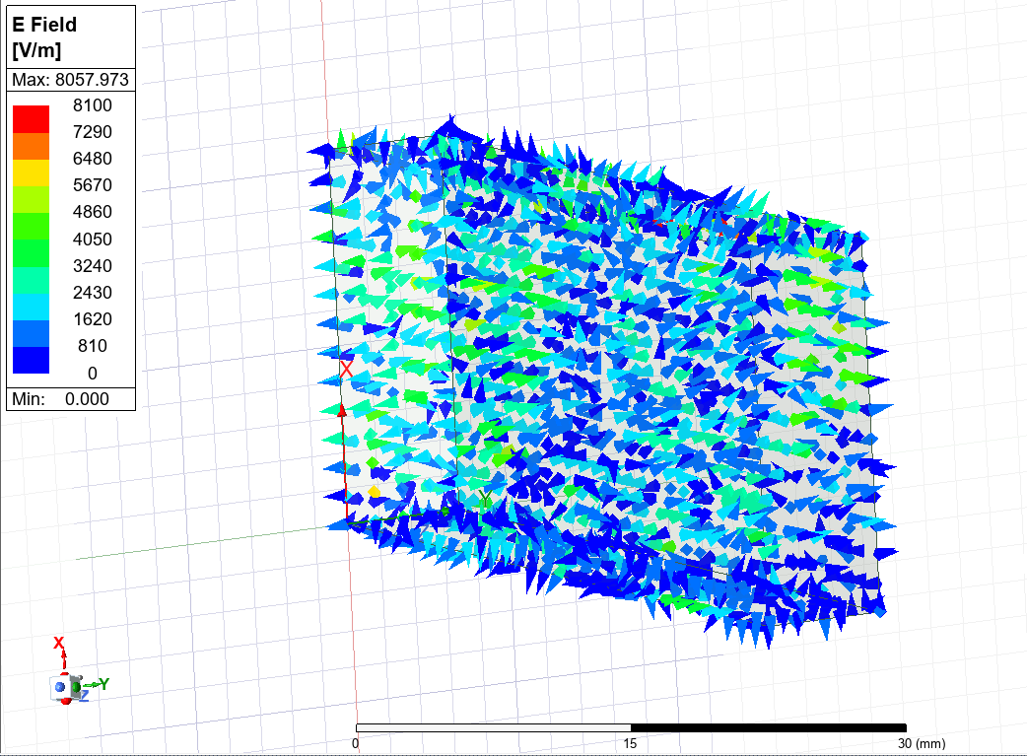
Figure 58 – Mode 1 Electric Field Vector Plot (without arrow tails)
Figures 59-61 show the magnitude and vectors of the magnetic field through Mode 1.
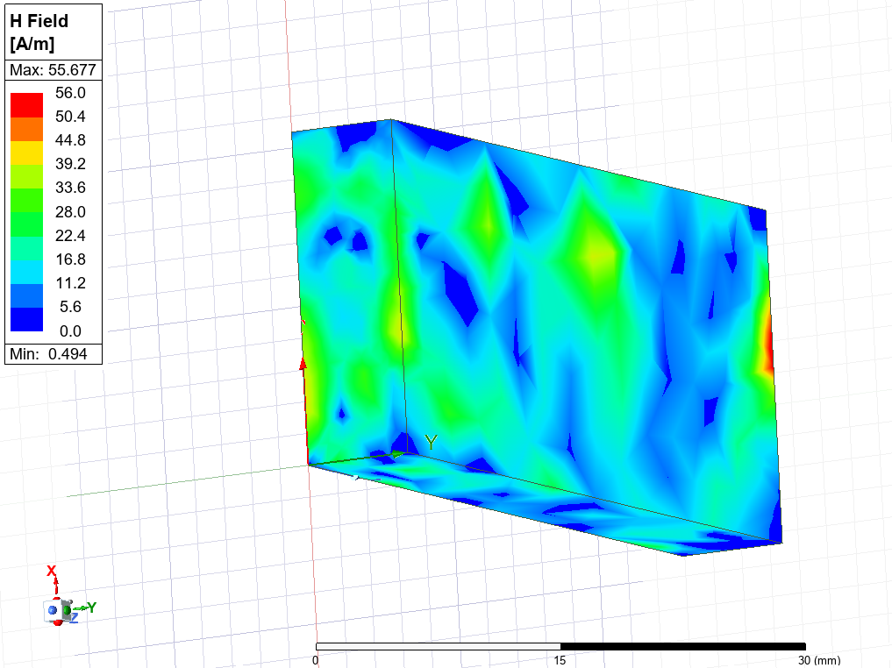
Figure 59 – Mode 1 Magnetic Field Magnitude Plot
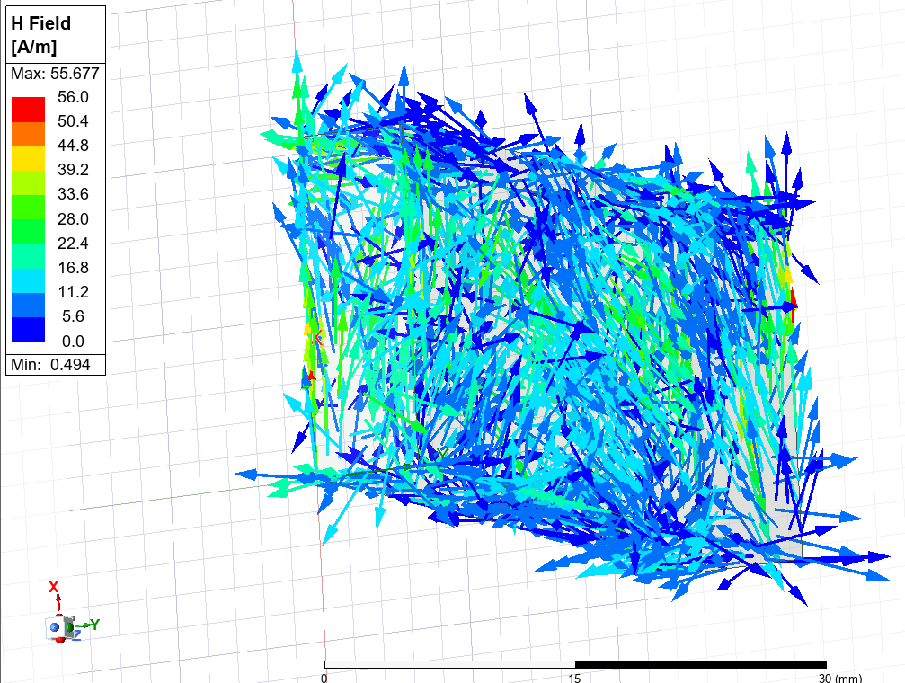
Figure 60 – Mode 1 Magnetic Field Vector Plot
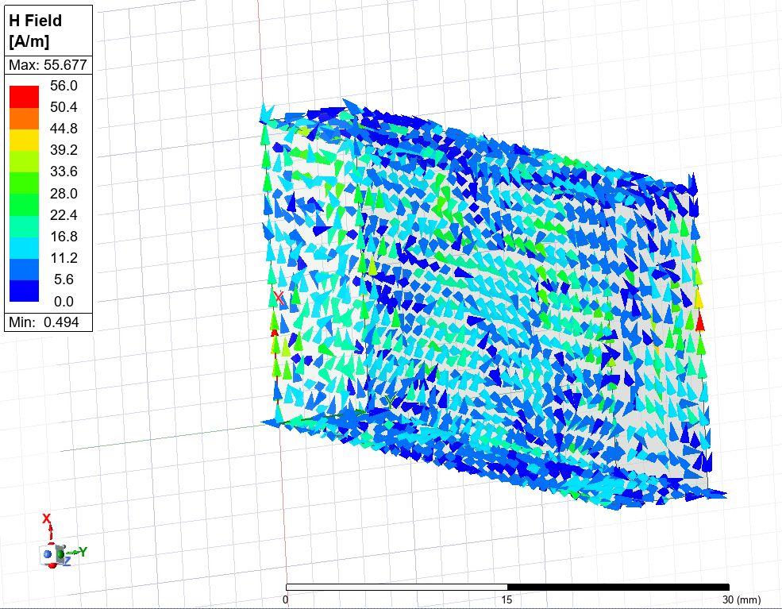
Figure 61 – Mode 1 Magnetic Field Vector Plot (without arrow tails)
Figures 62-64 show the magnitude and vectors of the electric field through Mode 2.
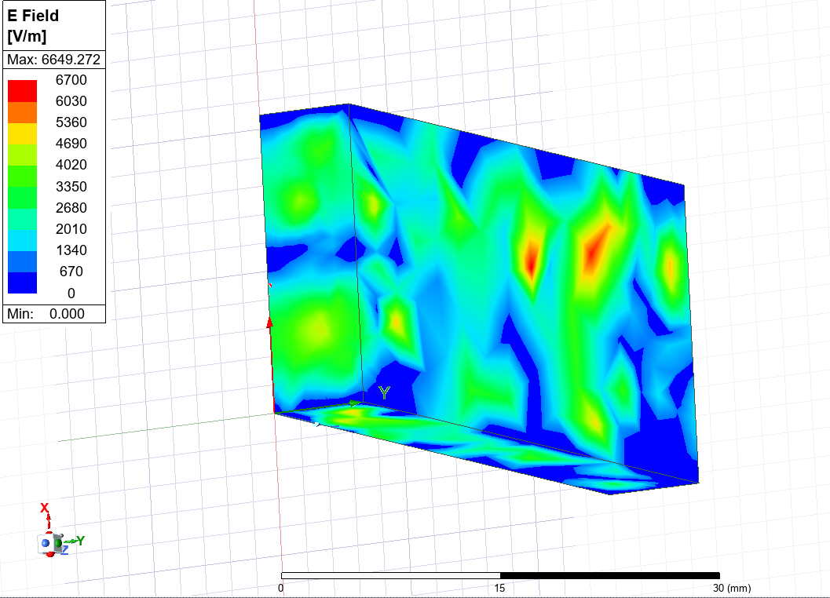
Figure 62 – Mode 2 Electric Field Magnitude Plot
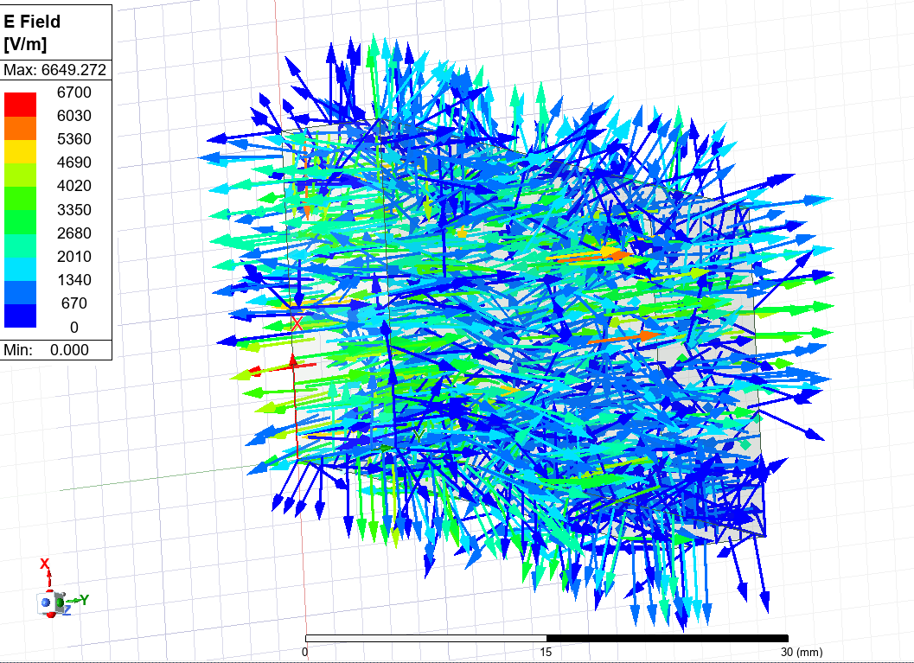
Figure 63 – Mode 2 Electric Field Vector Plot
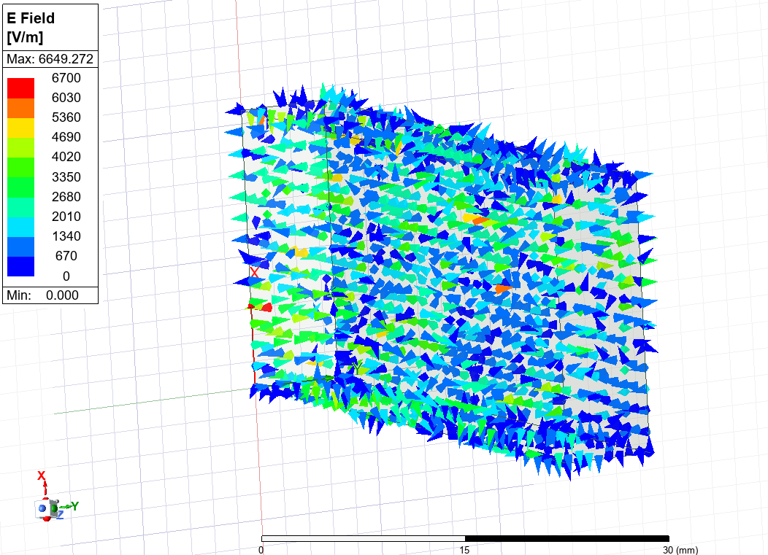
Figure 64 – Mode 2 Electric Field Vector Plot (without arrow tails)
Figures 65-67 show the magnitude and vectors of the magnetic field through Mode 2.
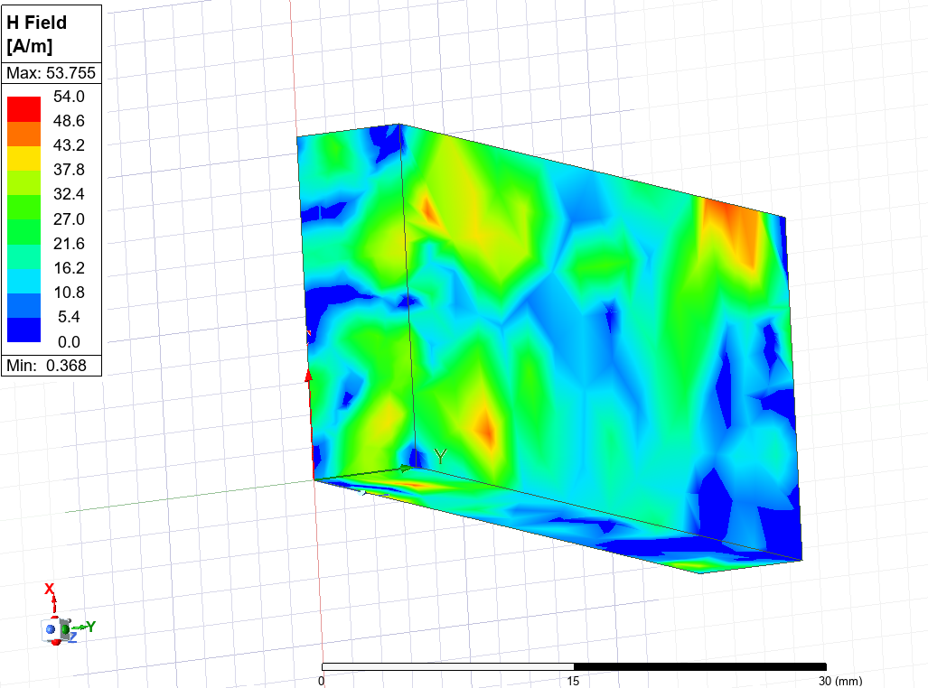
Figure 65 – Mode 2 Magnetic Field Magnitude Plot
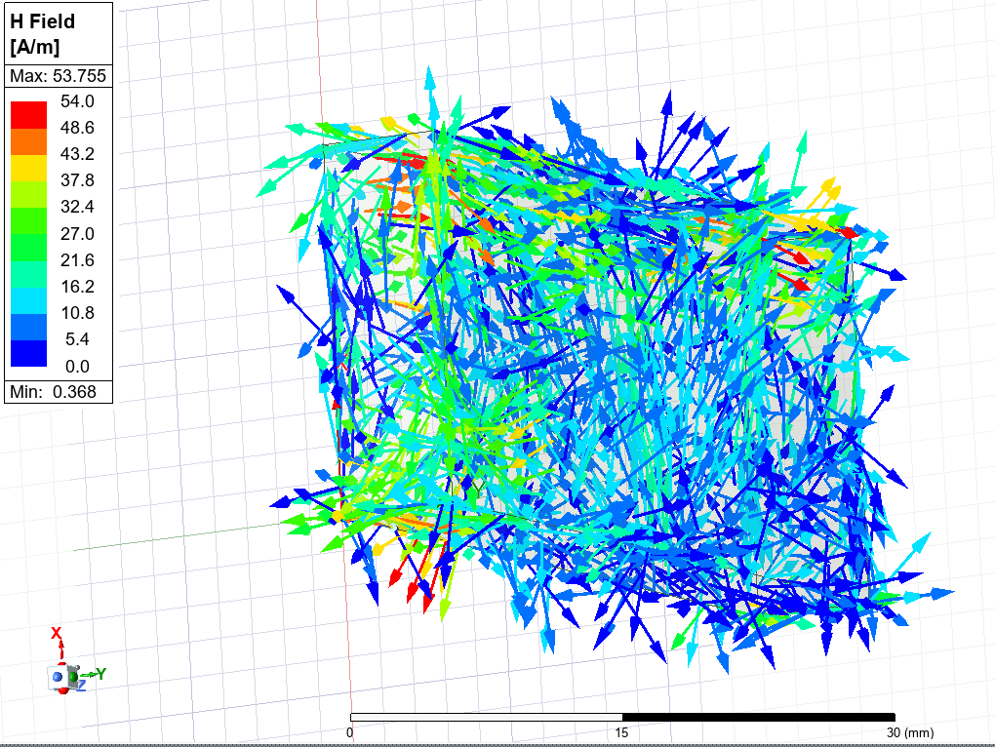
Figure 66 – Mode 2 Magnetic Field Vector Plot
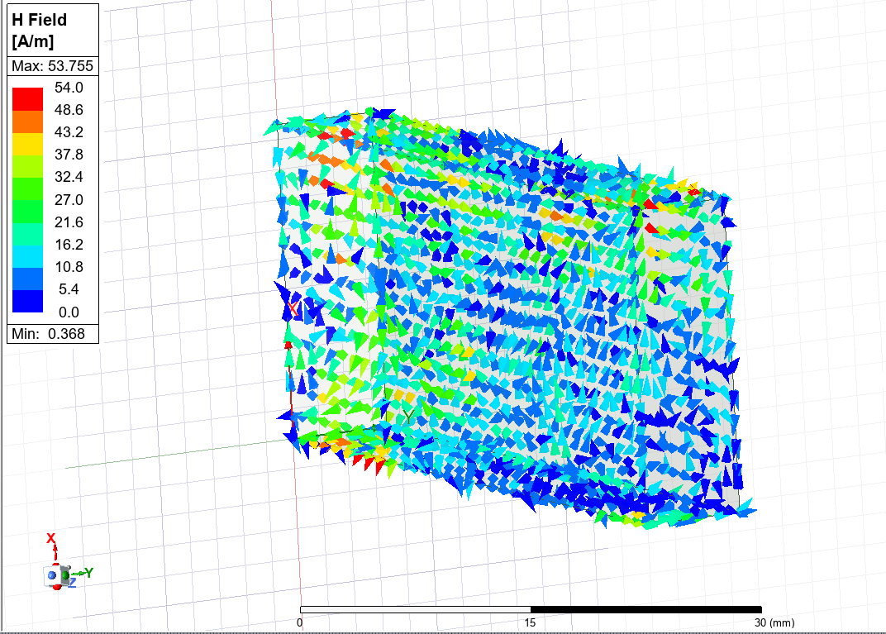
Figure 67 – Mode 2 Magnetic Field Vector Plot (without arrow tails)
Figures 68-70 show the magnitude and vectors of the electric field through Mode 3.
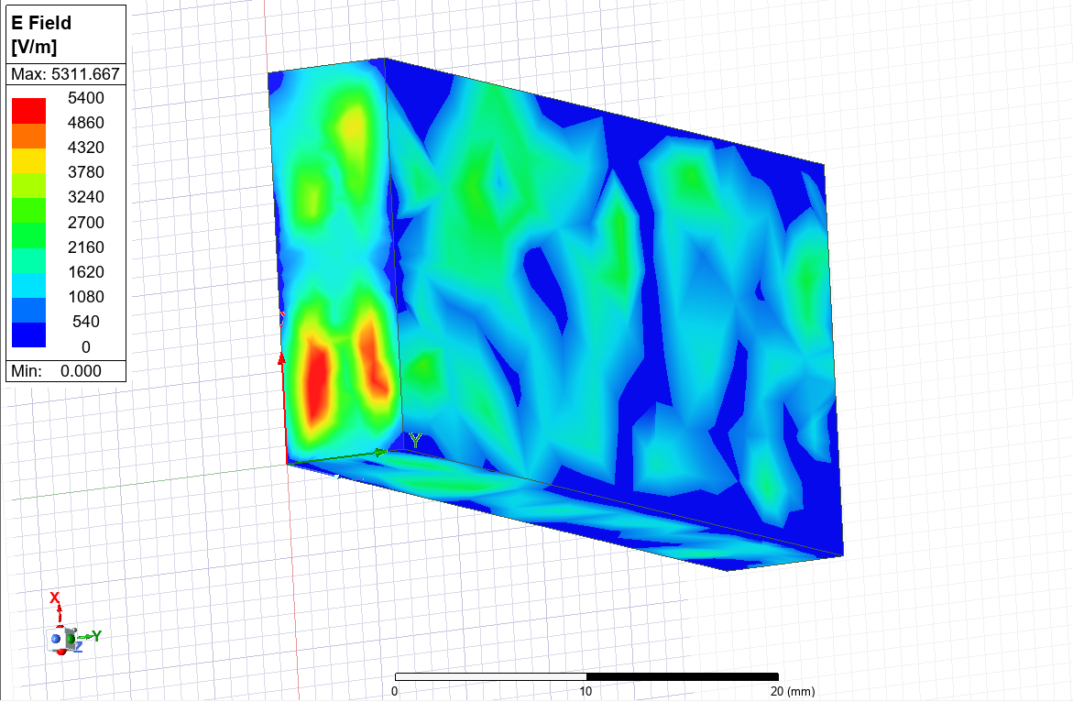
Figure 68 – Mode 3 Electric Field Magnitude Plot
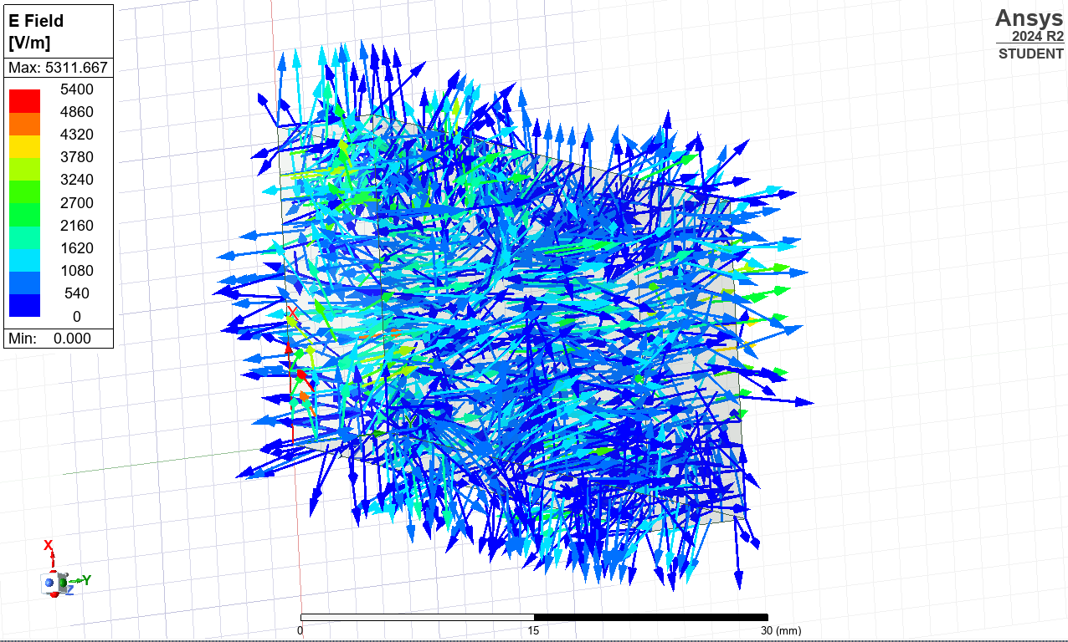
Figure 69 – Mode 3 Electric Field Vector Plot
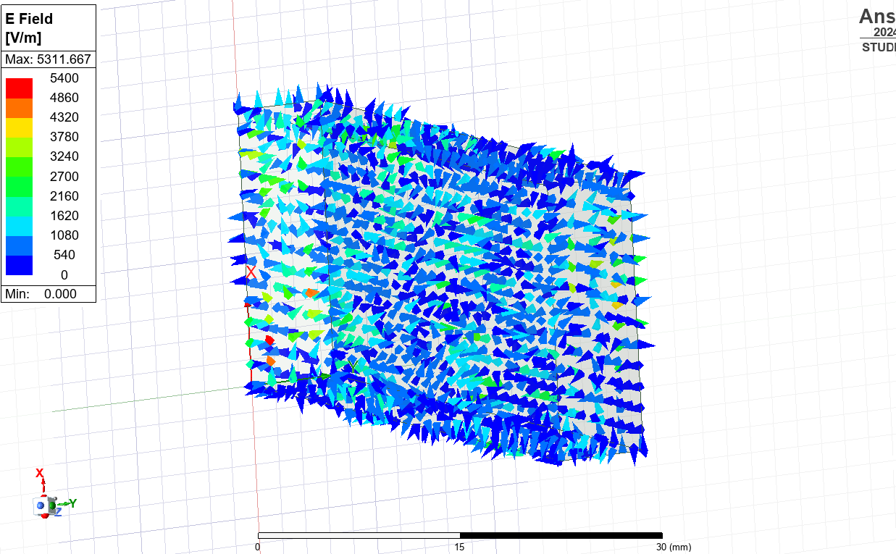
Figure 70 – Mode 3 Electric Field Vector Plot (without arrow tails)
Figures 71-73 show the magnitude and vectors of the magnetic field through Mode 3.
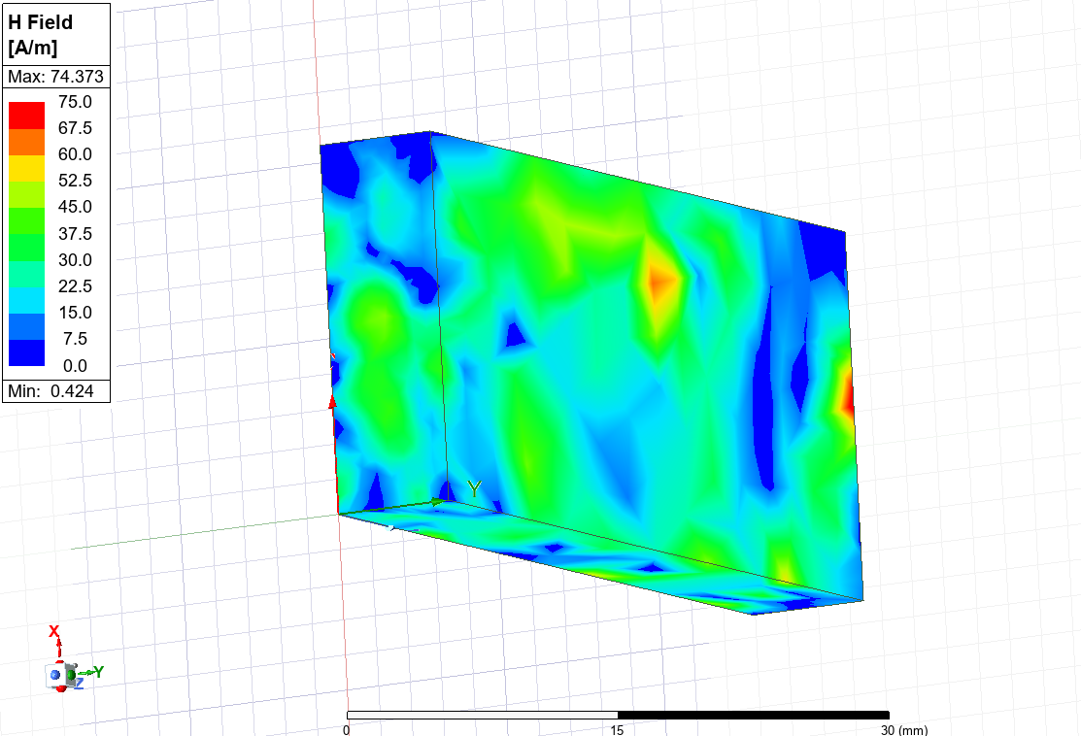
Figure 71 – Mode 3 Magnetic Field Magnitude Plot
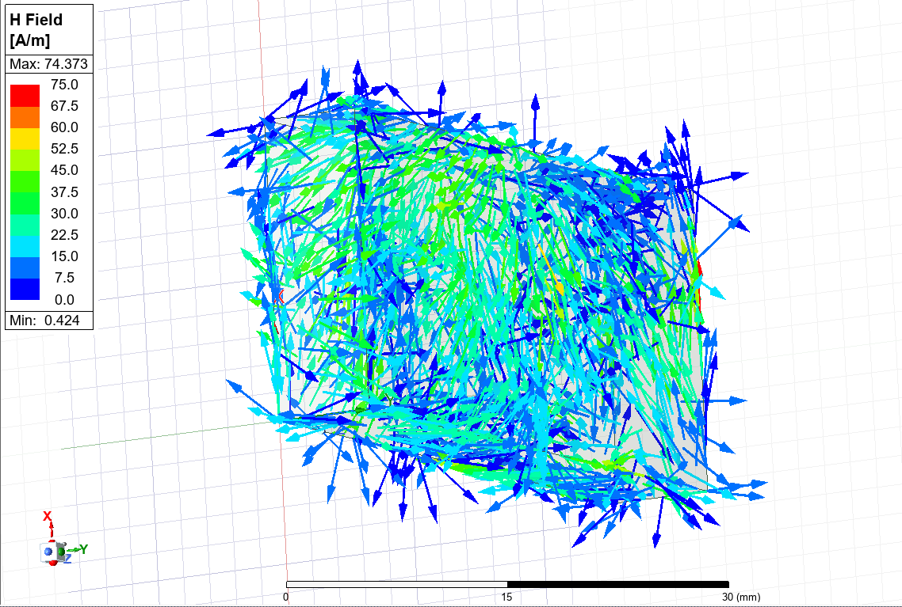
Figure 72 – Mode 3 Magnetic Field Vector Plot
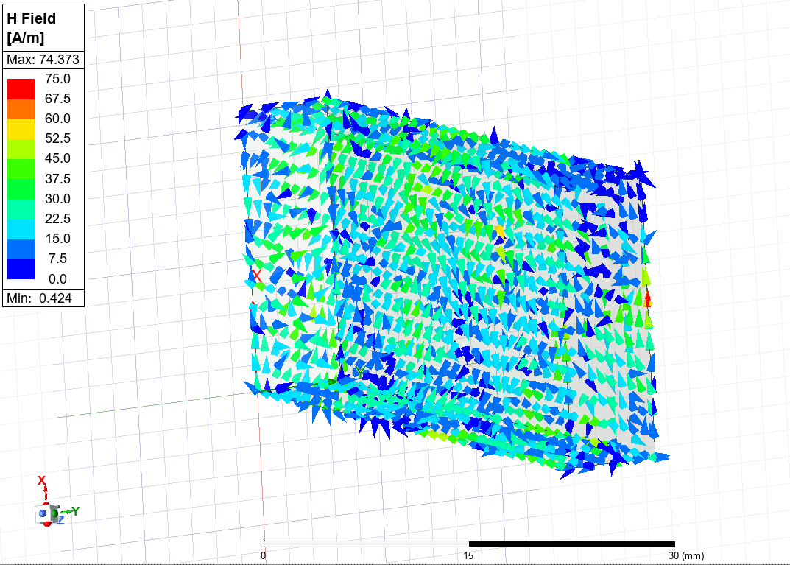
Figure 73 – Mode 3 Magnetic Field Vector Plot (without arrow tails)
Figure 74 shows the rectangular plot to visualise cutoff frequencies.
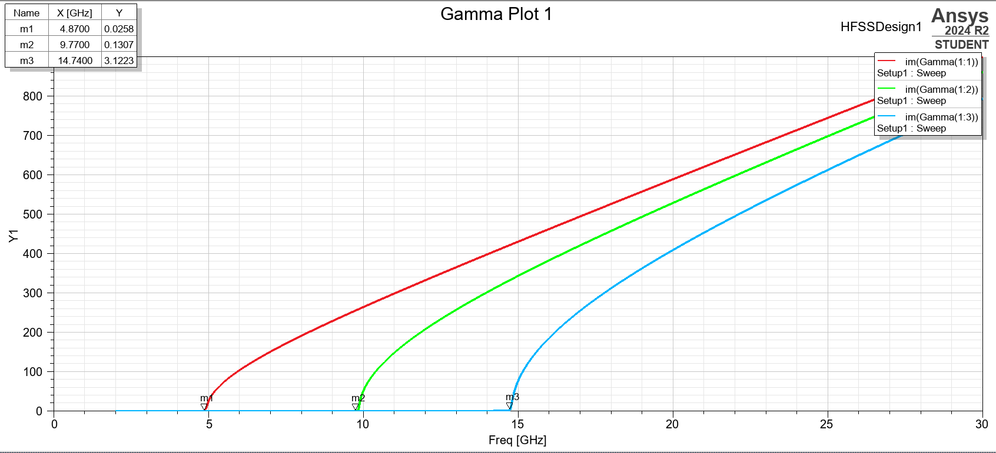
Figure 74 – Plot of Cutoff Frequencies
Mode 1 can be identified as the dominant mode as it has the lowest cutoff frequency.
The cutoff frequency, from Equations 1 and 2, can be calculated as follows:
$$Teflon c=\frac{{3×10}^{8}}{\sqrt{2.1×1}}$$
Teflon c = 2.07 x 10⁸ ms⁻¹
Mode 1:
$$f_{c }= \frac{{2.07×10}^{8}}{2} \sqrt{{\left(\frac{1}{0.021}\right)}^{2}+ {\left(\frac{0}{0.007}\right)}^{2}}$$
Mode 1 Cutoff Frequency = 4.93GHz
Mode 2:
$$f_{c }= \frac{{2.07×10}^{8}}{2} \sqrt{{\left(\frac{2}{0.021}\right)}^{2}+ {\left(\frac{0}{0.007}\right)}^{2}}$$
Mode 2 Cutoff Frequency = 9.86GHz
Mode 3:
$$f_{c }= \frac{{2.07×10}^{8}}{2} \sqrt{{\left(\frac{3}{0.021}\right)}^{2}+ {\left(\frac{0}{0.007}\right)}^{2}}$$
Mode 3 Cutoff Frequency = 14.79GHz
2.3 Task 2 - Halfwave Dipole Antenna
Figure 75 shows the S-Parameter Plot with the operating frequency marked.
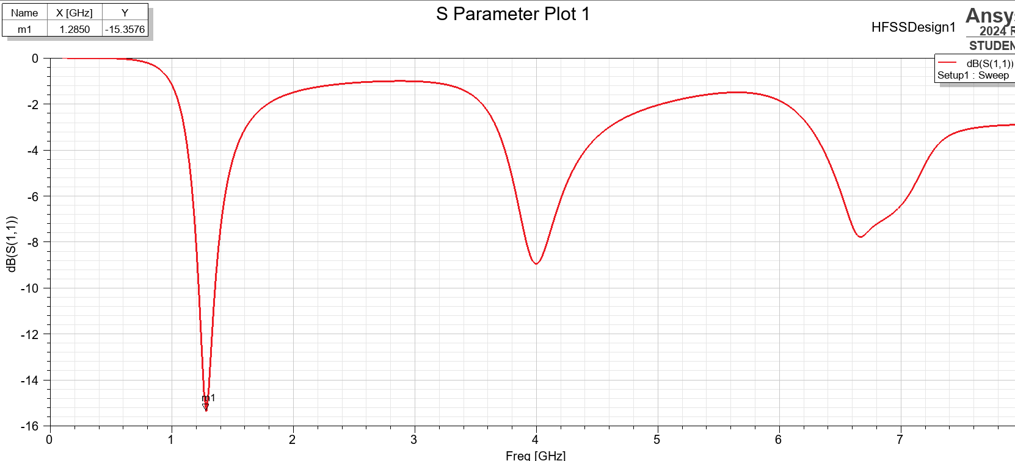
Figure 75 – S Parameter Plot
Figure 76 shows the radiation pattern of the antenna.
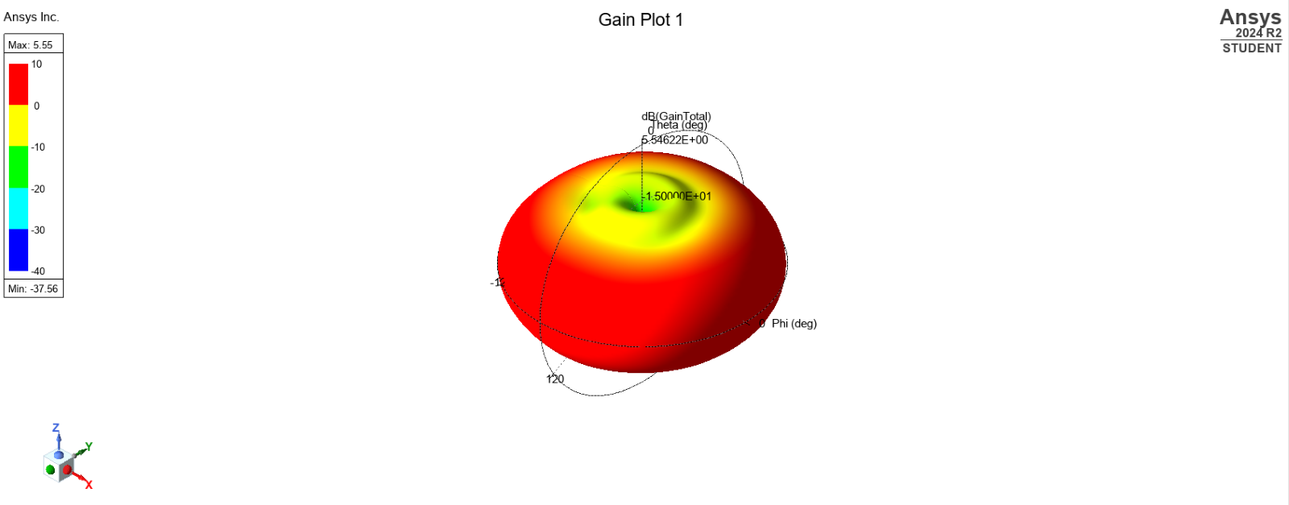
Figure 76 – Antenna Radiation Pattern
Using Equation 3, where $λ$ = 211mm, the length of the halfwave dipole can be calculated as follows:
$$Dipole Length= \frac{211}{2}$$
Halfwave Dipole Length = 106mm (rounded to the nearest integer)
The operating frequency, from Equation 4, can be calculated as follows:
$$f=\frac{{3x10}^{8}}{0.211}$$
Operating Frequency = 1.4GHz

4 Discussion
2.1 Rectangular Waveguides
Appendix A shows the combined Maximum Electric and Magnetic Field values, theoretical cutoff frequencies and plotted cutoff frequencies for the vacuum and Teflon waveguides.
The theoretical cutoff frequencies were similar to the plotted values given by Ansys Electronics, which is to be expected given the perfect conditions used in the simulation, such as with the perfect electric conductor walls. These conditions are difficult to reproduce in real life and are an idealised version of the design. [8] The cutoff frequencies increased with each Mode. The vacuum waveguide produced larger cutoff frequencies than the Teflon waveguide due to Teflon’s higher permittivity, resulting in reduced propagation of electromagnetic waves and therefore lower cutoff frequencies as evidenced by Equations 1 and 2, where Teflon has a lower speed of light than a vacuum (which is directly proportional to its cutoff frequency). [4]
2.2 Half-Wave Dipole Antenna
The S Parameter Plot shows an operating frequency of 1.2850GHz, similar to the theoretical value of 1.4GHz. The radiation pattern obtained in Figure 76 shows an omni-directional shape, with stronger radiation perpendicular to the antenna due to its linear polarisation. [4]

5 Conclusion
In conclusion, cutoff frequencies calculated and plotted for the waveguides produced similar values, as did the operating frequency of the dipole antenna. The vacuum waveguide produced larger cutoff frequencies than the Teflon waveguide, while the electric field magnitudes had inverse relationships due to vacuum’s permittivity of 1 and Teflon’s ability to polarise in an electric field. [4] The antenna’s theoretical and plotted results were also similar, with an omnidirectional radiation pattern.

6 References

[1] | Ansys, “Ansys Electronics,” Ansys, 12 04 2025. [Online]. Available: https://www.ansys.com/en-gb/products/electronics#tab1-1. [Accessed 12 04 2025].
[2] | Ansys, “Ansys HFSS,” Ansys, 12 04 2025. [Online]. Available: https://www.ansys.com/products/electronics/ansys-hfss. [Accessed 12 04 2025].
[3] | Ansys, An Introduction to HFSS: Fundamental Principles, Concepts, and Use, Canonsburg: Ansys, Inc., 2013.
[4] | K. J, Electromagnetics: with applications, Boston: WCB McGraw-Hill, 1999.
[5] | S. e. al, “A Novel Modeling Technique to Solve a Class of Rectangular Waveguide Based Circuits and Radiators,” Progress In Electromagnetics Research, vol. 61, pp. 231-252, 2006.
[6] | H. e. al, “Artificially integrated synthetic rectangular waveguide,” IEEE Transactions on Antennas and Propagation, vol. 53, no. 9, pp. 2872-2881, 2005.
[7] | X. T. e. al, “Crossed Dipole Antennas: A Review,” IEEE Antennas and Propagation Magazine, vol. 57, no. 5, pp. 107-122, 2015.
[8] | R. e. al, “The fractioned dipole antenna: A new antenna for body imaging at 7 Tesla,” Magnetic Resonance in Medicine, vol. 75, no. 3, pp. 1366-1374, 2015.
[9] | S. J.E., “The dipole antenna problem in surface physics: A new approach,” Surface Science, vol. 105, no. 2-3, pp. 489-504, 1981.

7 Appendices
Appendix A
Waveguide | Mode 1 E Max (V/m) | Mode 2 E Mag Max (V/m) | Mode 3 E Mag Max (V/m) | Mode 1 H Mag Max (A/m) | Mode 2 A Mag Max (A/m) | Mode 3 A Mag Max (A/m) | Theoretical Mode 1 F (GHz) | Theoretical Mode 2 F (GHz) | Theoretical Mode 3 F (GHz) | Plotted Mode 1 F (GHz) | Plotted Mode 2 F (GHz) | Plotted Mode 3 F (GHz)
Vacuum | 4782 | 6794 | 7621 | 11 | 9.44 | 16.51 | 7.14 | 14.3 | 21.43 | 7.11 | 14.25 | 21.39
Teflon | 8058 | 6649 | 5312 | 56 | 53.76 | 74.37 | 4.93 | 9.86 | 14.79 | 4.87 | 9.77 | 14.74

