

Course Title: MBA - International Business
Term 1

Student Name: VISHAL BHALALA
Student ID: 2509170

Module Name: Marketing Management
Module Code: LCMB7024

Lecturer’s Name: Dr Laila Maazouz (London)

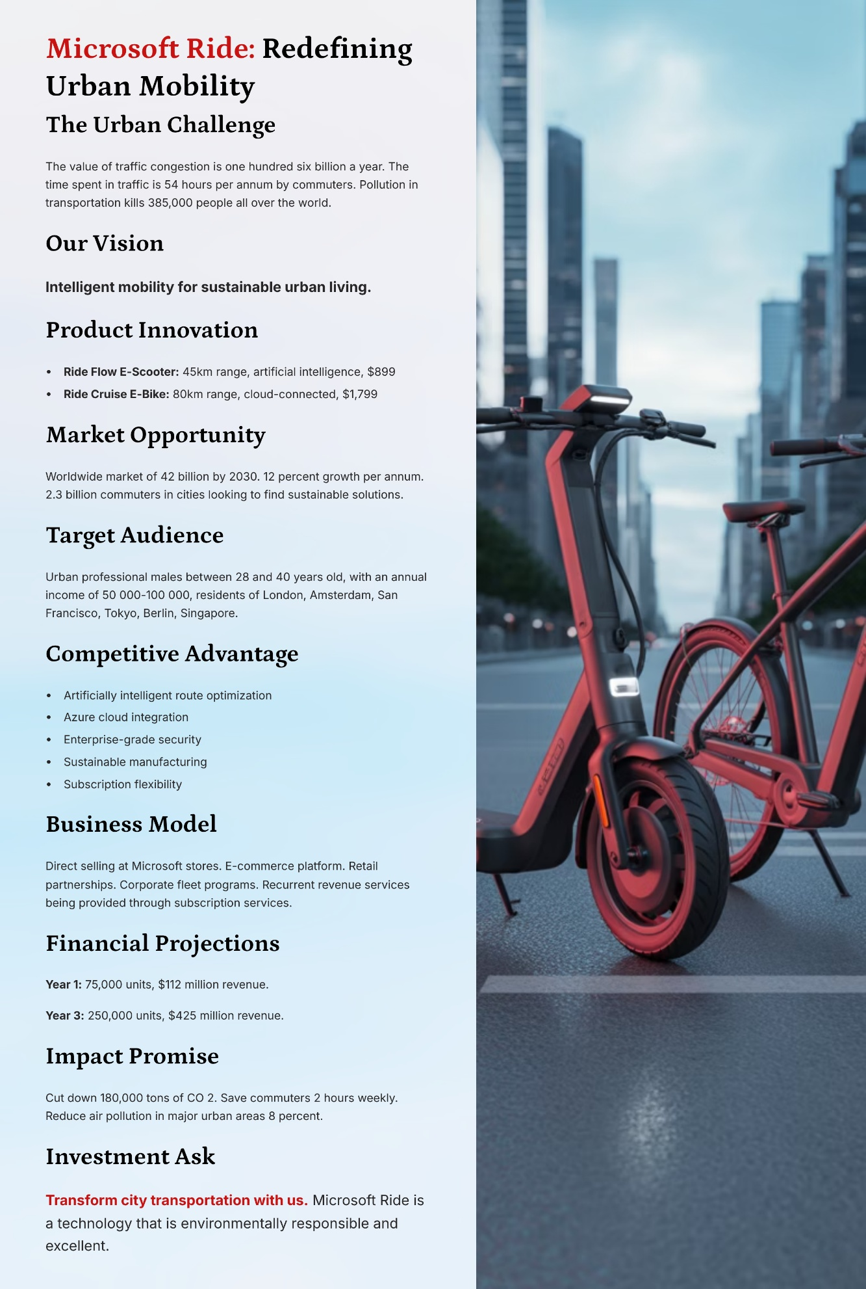
References
Balaji, Pratyusha D, Sravanthi B and Jayakiran Reddy E (2024). Recent AI Applications in Electrical Vehicles for Sustainability. SSRG international journal of mechanical engineering, 11(3), pp.50–64. doi: https://doi.org/10.14445/23488360/ijme-v11i3p106.
Grand View Research (2023). Electric Scooters Market Size & Share | Industry Report, 2019-2030. [online] Grandviewresearch.com. doi: https://www.grandviewresearch.com/industry-analysis/electric-scooters-market.

