Responsive Web Design and Development
  - Lecture 7 Lab Tutorial Exercise

Cross-Platform Mobile Development with Apache Cordova and AngularJS

Objectives
The aim of this lab exercise is to introduce you to some more Angular concepts, specifically Filters and Services.
Note: This lab exercise is a continuation from the previous exercise.

Exercise 1: Fixing the Scroll Problem
- Open up your exercise from last week.
- You may wish to take a backup copy of the app.js file as you will be replacing some of this content with more advanced concepts.
- Some of you may have noticed that the content area listing the notes was not scrollable and one/two notes were missing from the view. The fix is simple – just add the highlighted class to the content area.
- Save your changes and you can test to see if it fixed the problem.
- Challenge Exercise: it’s not a difficult challenge
  - How about changing the checkboxes. Try using the iconic checkbox class for the checkboxes indicating if the item is done or not as follows.
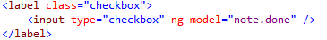
  - Alternatively, you may want to use a toggle: http://ionicframework.com/docs/components/#toggle
  - See if you can replace the checkboxes with toggles instead.
  - Keep the format you prefer of course.

Exercise 2: Updating your Controller to use Dependency Injection
- Recall from the lecture that the better approach to adding dependencies to your components is to use Inline Array Notation.
- At the moment, your controller has one dependency – the $scope.
- Open up your app.js file and locate the controller component method.
- Make the following highlighted changes to inject the $scope dependency into the controller using the inline array notation – please be careful with the commas and the opening square bracket “[“.
- Now, make sure you can correctly identify the closing bracket/curly brace combination for the controller – you can ask me if you are unsure. You need to insert a closing square bracket “]” as shown.
- Save your changes and test to make sure everything still works okay.

Exercise 3: Using a Service
- At the moment, your JSON data is loaded from the global notes variable. You will change this so that the data is loaded from an external JSON file instead using Angular’s $http service.
- Right-click on the www folder and create a new folder called data.
- Download the notes.json file from Moodle and add it to the folder created in the last step.
- Inject the $http dependency into your controller – remember the order of the dependency parameters to the function must match the same order of the inline array string names and be careful with those commas.
- Delete or comment out the block of code to initialise the notes variable (var notes = […];).
- In your controller, you previously initialised $scope.notes to the variable called notes. This time you will use the $http service to retrieve the notes. Make the following changes and feel free to use your own messages.
// Set a default message for no notes
// Initialise notes to empty array object first
// Initalise notes model for view using $http service to load JSON file
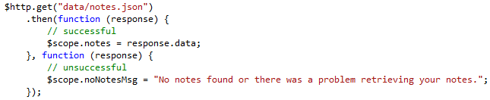
- Now, go to your HTML document and add a <p> element bound to the no notes message to display when there are no notes (number of notes is zero) as follows:
- Save your changes and test your app.
- Hopefully, your notes displayed.
- Hmmm, if you looked carefully, you will probably discover that you have broken the code for showDetails. This function used the old notes variable – change it to use $scope.notes instead to retrieve the current note.
- Now test the case for when the $http service cannot correctly retrieve the notes.json file. (Just use a bad file name).
Does it correctly display the no notes message?
- Change it back to the proper file name.

Exercise 4: Creating Filters
- Create a new folder in the www\scripts folder called filters.
- Add a new file to this folder called notesFilter.js or whatever you prefer.
- Go to your index.html file and link the newly created JavaScript file – make sure you add the reference after the link to app.js as the new file depends on app.js.

Filter Notes by ID

Creating the Filter Function
- The first filter you will create will filter the notes array object to find a note with the specified ID. Thus two parameters are needed:
  - The notes array to search
  - The notes ID to perform a match against
- Return to the new notes filter JavaScript file and register the new filter as follows. The name of the shown filter is findNoteById – you are free to change this, but just make sure you remember the name.
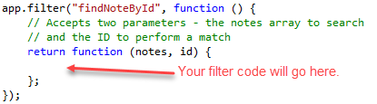
- To conduct the search you will use the array.forEach() method to loop through each of the note items and check if the specified id matches.
If you need the comments, I have pasted these below.
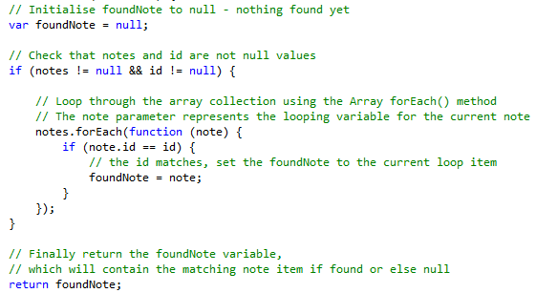
Comments
// Initialise foundNote to null - nothing found yet
// Check that notes and id are not null values
// Loop through the array collection using the Array forEach() method
// The note parameter represents the looping variable for the current note
// the id matches, set the foundNote to the current loop item
// Finally return the foundNote variable,
// which will contain the matching note item if found or else null
- Save your changes.

Updating the Controller to Use the Filter
- Return to your notes controller.
- First, you need to inject Angular’s $filter into the controller. Look at what you did for the $http service if you have forgotten.
- Next, locate the showDetails function in the controller. Now you are going to use the new filter function to find the note item with the passed in noteId parameter. Make the following changes (if you have used a different name for your filter, make sure you use the correct name).
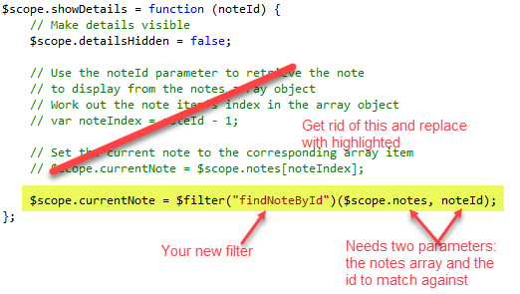

Find Note
- Next, you will create another filter to use with a search input field.
- The Angular default filter method, searches all fields. If your array objects contain a lot of fields/properties, this could be an expensive operation. Instead you may want to limit the search to just a few fields/properties.
- For your app, you will create a filter that searches the title, details and category fields.
- Return to the notes filter JavaScript file and create a new filter function called findNote. The function needs to accept two parameters:
  - The notes array to search
  - The search text
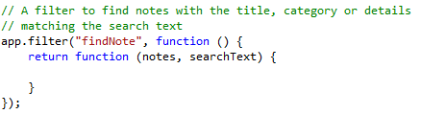
- This time around, the find function may return zero or more results, so you will use the array filter() method, which returns an array of all items in the array that match some criteria.
You will also use a regular expression to set up a case-insensitive pattern to match.
Comments below as before.
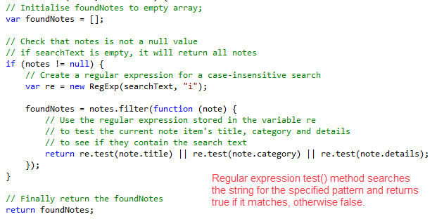
Comments
// Initialise foundNotes to empty array;
// Check that notes is not a null value
// if searchText is empty, it will return all notes
// Create a regular expression for a case-insensitive search based on the search text
// Use the regular expression stored in the variable re
// to test the current note item's title, category and details
// to see if they contain the search text
// Finally return the foundNotes

- Save your changes.

Adding a Search Form to the HTML
- Return to your HTML content and add the following (use the Ionic CSS components to help you). Note: you may have to move your ng-app and ng-controller to a higher level parent element e.g. the <body> element.
  - Search Input Form – check out the Forms Input Icons/ Header Icons section. The form should contain:
    - A search text input field
    - A close/cancel button
  - Tabs – containing a search button to bring up the search form

Implementing the Click Events for the Search Form Buttons
- Go back to your controller and create a new function in the controller to display the Search Form when displays when the Search button is clicked and close it when the close/cancel button is clicked. Try using just one function. For example:
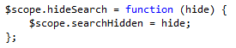
- Now go back to the HTML and add the appropriate ng-click attributes on the two buttons.

Implementing the Search
- You need to create a new method in the controller to handle the filtering of note items when the search text changes. Add the following:
// represents the search term specified by the user
// Filters the notes matching the user's search text
// using the custom filter, findNote
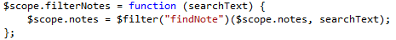
- Save your changes.
- Return to your view. You need to:
  - Bind the search input field to the searchText model item initialised in the last step.
  - Add an Angular change event to the search input field that calls the filterNotes function defined in the last step, passing in the searchText.
- Save your changes and test your app.
- Hmm, I can just guess what type of testing you did .
- There is a small problem. Test your app again, this time:
  - Type something into the search box e.g. “rwdd” – should find something
  - Then clear the search box – you want all items back.
  - Hmmm, it doesn’t work.
- The problem is, you have modified and overwritten the $scope.notes model, so your code has no way of going back to the original notes array. This is where Custom Services come in handy. For now, you will fix this problem by using a global variable.
- Return to the controller.
- Add a new global variable – outside the controller as shown.
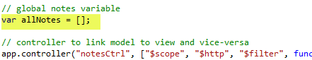
- Then modify the $http.get() method to store the retrieved notes JSON object in the new global variable too.
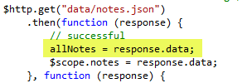
- Then look for the two uses of the $filter() function and make them use the new global variable instead.
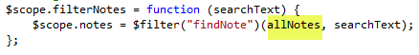
- Save your changes and test. Did it fix the problem?

Exercise 5: Challenge Exercise
- Do you think you can implement a feature for the user to change the search order of the notes items e.g. by title, done, due date, modified date.
  - You will need to find a way to display the search options to the user.
  - Use Angular’s filter orderBy function – see the slides (slide 12).
- That’s all for today.

