Hotel Organisational Audit

Hilton Hotels

*Report*

Student Name: Laura Popescu
Student ID: 2110392
Module name:
Management & Organisational Behaviour
Module code: BMIH5004
Tutor: Julia Ault

Executive Summary
The aim of this report was to discuss the relationship between organisational structure, culture and goals with organisational performance, the essential nature of managerial work in recent change initiatives, impacts and their management by leadership and behavioural approach to management for the organisation’s strategic direction and business performance. The selected organisation was the Hilton Hotel group. In the discussion, it was found that the group has a hierarchal structure, due to which it has centralised control with a top-down approach. At the same time, situational theory supports the organisation in the utilisation of its resources. Moreover, the role of management is important in reducing the impacts of change, for which the utilisation of the situational theory of leadership provides flexibility and support to the leaders, especially in the events of change. Further, the behaviour of management and employees determines the strategic direction of a company. For which the behavioural management theory is used for solving conflicts and resolving issues. Thus, it was observed that the Hilton hotel group is effectively utilising these resources, evident from its financial performance and assets growth, in comparison to its competitor.
Table of Contents
Introduction 3
Hilton Overview 3
Organisation Structure, Culture and Goals 3
Change Initiatives and Their Impacts 5
Hilton’s Strategic Direction and Business Performance 6
Recommendations 11
References 12

Introduction
The aim of this report is to discuss the relationship between organisational structure, culture and goals with organisational performance. Followed by the discussion on the essential nature of managerial work in recent change initiatives, impacts and their management by leadership. Lastly, the discussion will be made on the behavioural approach to management for the organisation’s strategic direction and business performance. Therefore, for the said purpose, the selected organisation for this report is the Hilton Hotel Group.

Hilton Overview
Hilton hotel group is one of the largest and leading hospitality global groups that started its official operations in 1925 from Dallas, Texas, but the foundation of the hotel was laid in 1919. The group has developed 19 well-known brands spread across 122 countries with nearly 7200 properties. Moreover, Hilton is the first hotel chain that is listed on New York Stock Exchange (Hilton.com. 2023). The Hilton hotel group has earned its name in giving world-class hospitality services to customers, and it is amongst the most preferred service providers in the hospitality industry. In its recent statement, Hilton Hotel Group has a market capitalisation of $37.748 billion (macrotrends.net, 2023).

Organisation Structure, Culture and Goals
According to Pratama et al. (2022, p.74-82), organisation structure represents the procedure by which the working of an organisation is observed. Therefore, it is a hierarchy by which roles and responsibilities are distributed among the departments and individuals. Thus, organisational structure determines the direction of the flow of decisions taken for the growth and development of an organisation. Hilton Hotel Group's global presence and massive business require a hierarchical structure for decision-making, establishing authority and centralized control. Decisions flow top-down, resulting in centralized command and control. According to Andersson et al. (2019, p.36-45), the organisational structure has a strong relationship with the performance of employees and the organisation. Since structure allows for setting roles and responsibilities, it also supports the organisation in achieving its goals. In this regard, the System Theory of organisation can be used to understand how the organisational structure of Hilton is associated and linked with its culture, goals and performance. According to Plaza-ubeda et al. (2020, p.68-81), systems theory believes that organisations are made up of complex systems and subsystems, either working together or in departments to achieve common goals. As a result, through systems theory, it can be determined that the hierarchy structure of Hilton Hotel Group has supported the organisation, developed its culture and achieved its goals. In addition, due to centralised command, the Hilton hotel group has been able to develop the best hospitality services for the global consumer bases.
Similarly, the culture of an organisation also impacts its performance and organisational goals. In this regard, Lubis and Hanum (2020, p.88-91) stated that organisational culture is based on shared values, beliefs and attitudes of the people. Similarly, Park et al. (2021, p.2334) identified that organisational culture is based on four types of cultures such as adhocracy, hierarchy, market and clan culture. In addition, organisational culture plays a vital role in shaping the behaviour of employees, it has a significant impact on overall organisational performance (Roscoe et al., 2019, p.737-749).
According to Runtu et al. (2019, p.785-802), clan culture promotes teamwork and collaboration within the organisation to achieve its common goal. In addition, collaboration and team working are directly associated with organisational performance. On the other hand, an adhocracy culture promotes innovation and risk-taking in the employees in order to enhance organisational performance (Hung et al., 2022, p.6897). At the same time, market culture is focused on competition while achieving goals. At the same time, hierarchy culture promotes process orientation and structured working by following predefined sets of rules and regulations to achieve organisational excellence. However, when the success of Hilton Hotel group’s global performance is evaluated, it is found that Hilton has applied a mixture of hierarchy, market and clan culture to achieve its goals and enhance its performance. However, the culture and structure of the organisation are not effective unless people are completely involved. As people of an organisation like Hilton support its growth and global expansion, they provide their services in achieving the goals of the organisation. In this regard, Leitão et al. (2019, p.3803) stated that people are an important aspect of organisational success and performance as they contribute to the completion of different tasks and objectives of the organisation. Therefore, the people of Hilton are playing their role in supporting the organisation in maintaining its standards, quality and services while supporting the company to enhance its performance and achieve its goals.

Change Initiatives and Their Impacts
According to Azeem et al. (2021), change becomes important within the organisational context, especially when it is for the upgradation of services or enhancement in the processes. Therefore, it is a two process by which the whole process is communicated between teams and leaders. Since Hilton has applied a hierarchy system due to which, change decisions move in a top-down positions where each individual in the hierarchy plays a role in spreading the information about the change in Hilton. According to Cortellazzo et al. (2019, p. 1938), to manage the change process, the roles of leadership and management are crucial. At the same, the managerial role is to plan, lead, organise and control, and leadership play its role in setting the direction of the employees and set vision for them, both functions are crucial for the organisational success and processes. In addition, people are the only aspect of organisational change that is actively engaged in the change initiatives. As a result, the managers and leaders of the Hilton hotel group pay close attention to people in order to manage change initiatives. Therefore, in order to evaluate the effectiveness of management and leadership in managing change initiatives and reducing the impacts, the Situational theory can be applied. According to Mulyana et al. (2022), situational leadership is based on the concept that the effectiveness of leadership increases when they are flexible and adaptive to adjust in any situation. As a result, their effectiveness and efficiency increase, and they are likely to mitigate the impacts of change initiatives. Thus, situational leadership fits well in the change initiatives of the Hilton hotel group due to its nature and business model. For instance, recently, the Hilton hotel group took the initiative of implementing artificial intelligence to enhance and smoothening the flow of its procedures. Thus, this change initiative was likely to increase resistance from the side of employees. According to Shamsuddin (2020), when a change is implemented in an organisation, it increases the risk of resistance from the people who are going to face the impact. As a result, the change initiative of Hilton in which AI was going to be implemented in order to increase the effectiveness of operations, the employees resisted. However, it is natural to face resistance as change initiatives increase insecurity. At the same time, AI is perceived as a job eater as it is believed that the implementation of AI will reduce the input from humans, due to which thousands of jobs will become obsolete (Kreutzer et al., 2020, 1-57). Therefore, the role of management and leadership was important in this situation. Since the implementation of AI was going to change many operations and procedures from check-ins to check-outs. Thus, the situational theory of leadership is adequately applied here as the situational theory of leadership emphasises that whenever the management is taking a decision, it is important for them to consider situations and their possible outcomes. According to Escortell et al. (2020), variables of effective management and leadership are influence, motivation, stimulation and consideration. Therefore, through the utilisation of these variables, leadership and management of the Hilton hotel group mitigated the possible risk of resistance. At the same time, the support of situational theory of leadership supported, increasing the effectiveness of leadership and management in this situation.

Hilton’s Strategic Direction and Business Performance
According to Kabeyi (2019, p. 27-32), every business needs strategic direction to ensure that they are utilising its resources in an effective and efficient manner. In addition, businesses that are in tough competition are more likely to be affected if their strategic direction is not identified or determined, due to which competitive advantage is lost. However, it is important to understand that in terms of setting strategic direction, the behavioural approach of management plays an important role. The performance and growth of the Hilton hotel group are achieved by the behaviour and motivation of its employees. Therefore, to understand the behavioural approach to management, the behavioural management theory can be utilised. In this regard, Yin et al. (2019, p.564-584) claimed that behavioural management theory deals with the belief that organisations perform well when their employees are highly motivated. As a result, the behavioural management theory supported the management of the Hilton hotel group to understand the factors that contribute to motivating their employees so that standards of services and quality remain consistent. Since the behaviour and motivation of employees are important to support the growth of the organisation and retain its competitive advantage. According to Klasmeier and Rowold (2020, p. 915-930), it is important for leaders to understand the behaviours of their followers so that they are influenced to reach shared goals.
The management of Hilton is keen to sustain and retain its brand image and reputation in the market, for which it proposed a Travel with Purpose strategy for reducing the environmental impacts of its operations by 2030. However, for the success of this strategy, the support of employees and other stakeholders is important for the business since every stakeholder has their own interest, which and there is a risk of conflicts which has the potential to impact the performance of the organisation. Due to this, understanding of factors is important for reducing the risk of conflicts. Thus, with the Travel with Purpose strategy, the management of the Hilton hotel group focused on those customers who were part of environmental protection movements.
However, understanding behaviour is important for defining the strategic direction of the business. Since the management and leadership of Hilton has focused on the implementation of technology, global expansion and establishing partnerships to reduce environmental impact, it has to understand how these strategies are going to impact on the motivation of individuals. For instance, the adoption of AI for streamlining processes had a negative impact on the motivation of employees and increased insecurity in the employees. Thus, behavioural management theory is utilised to identify the root causes of impacts so that healthy relationships are developed with the employees while reducing the impacts. Therefore, the leadership of Hilton focused on inclusion and equity so that reasons for declining motivation are controlled, and the fear of insecurity is mitigated. As a result, it was observed that Hilton observed a growth of 33.24% in its revenues in the first quarter of 2023. At the same time, Hilton observed growth in revenues from 2022-2023 of 40.84%, as demonstrated in Figure 1.
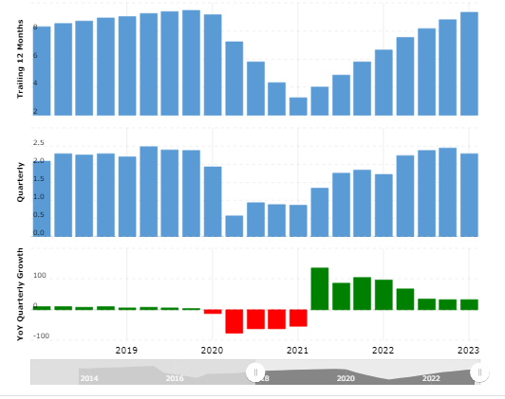
Figure 1 Revenues and Profits of Hilton Hotel Group (source: Macrotrends.net, 2023)
However, when the revenues and profits of the Hilton hotel group are compared with Intercontinental hotel group, it can be observed that in 2022 the group generated revenues of $3.892 billion with a 33.88% increase from 2021, whereas in 2022, the revenues of Hilton hotel group was $8.773 billion with a 51.57% increase. This demonstrates that the business performance of the Hilton hotel group was a lot better than the Intercontinental hotel group in the same year due to the strategic direction set by the leadership of the Hilton hotel group.

Table 1 Intercontinental hotel group financial performance (Source: macrotrends.net, 2023)
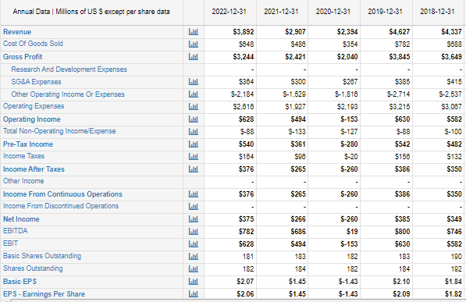

Table 2 Hilton hotel group financial performance (Source: macrotrends.net, 2023)
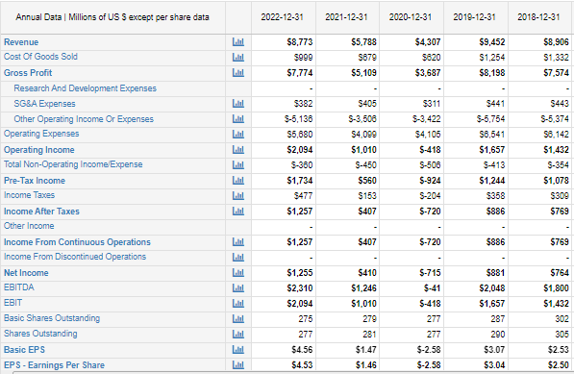

Similarly, it can be observed that the total assets of Intercontinental hotel group in 2022 were around $4.216 billion, with a decline of 10.6% from 2021. In contrast, the Hilton hotel group increased its assets by 0.46% in 2022 to $15.512 billion in 2021. Therefore, it can be determined that Hilton progressed quite well than its major competitor, Intercontinental hotel group.
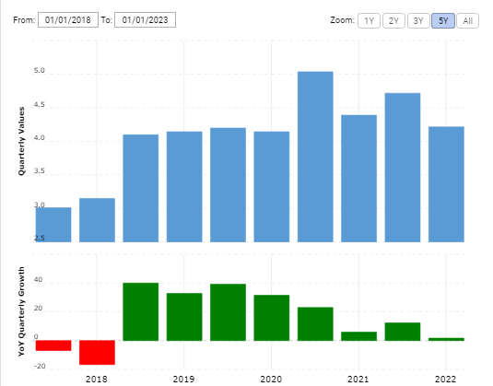
Figure 1 Intercontinental hotel group assets (Source: macrotrends.net, 2023)
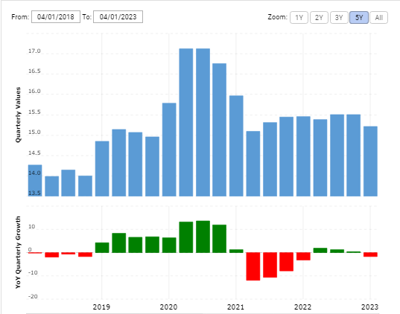
Figure 2 Hilton hotel group assets (Source: macrotrends.net, 2023)
According to Ali and Anwar (2021, p.21-30), in order to increase business performance, it is important that the needs of the employees are addressed and their satisfaction is increased as satisfaction is a significant contributor to motivation in employees due to which employees are influenced to work to achieve the strategies of the organisation. In this regard, Ungureanu et al. (2019, p.742-759) stated that business performance and strategic directions are aligned with the motivation and behaviour of employees.

Recommendations and conclusion
Systems theory and situational theory are useful for understanding collaboration but lack techniques for relationship development. Hilton Hotel Group should identify employees' skills, create leaders based on leadership styles, and use psychologists to address employee challenges.
In conclusion, organizational structure, culture, and people significantly impact performance. Management and leadership play crucial roles in decision-making, resource utilization, and employee satisfaction. Situational leadership theory helps mitigate change consequences as well behavioral management theory helps understand employee behaviour for competitive advantage.

References
Ali, B.J. and Anwar, G., (2021). An empirical study of employees’ motivation and its influence job satisfaction. International Journal of Engineering, Business and Management, 5(2), pp.21-30.
Andersson, T., Cäker, M., Tengblad, S. and Wickelgren, M. (2019) Building traits for organisational resilience through balancing organisational structures. Scandinavian Journal of Management, 35(1), pp.36-45.
Azeem, M., Ahmed, M., Haider, S. and Sajjad, M. (2021) Expanding competitive advantage through organisational culture, knowledge sharing and organisational innovation. Technology in Society, 66, p.101635.
Cortellazzo, L., Bruni, E. and Zampieri, R. (2019) The role of leadership in a digitalised world: A review. Frontiers in psychology, 10, p.1938.
Escortell, R., Baquero, A. and Delgado, B. (2020) The impact of transformational leadership on the job satisfaction of internal employees and outsourced workers. Cogent Business & Management, 7(1), p.1837460.
Hilton Worldwide Holdings Market Cap 2011-(2023) | HLT (2023). Available at: https://www.macrotrends.net/stocks/charts/HLT/hilton-worldwide-holdings/market-cap (Accessed: 9 June (2023).
Hung, Y.C., Su, T.C. and Lou, K.R. (2022) Impact of Organizational Culture on Individual Work Performance with National Culture of Cross-Strait Enterprises as a Moderator. Sustainability, 14(11), p.6897.
Kabeyi, M. (2019) Organisational strategic planning, implementation and evaluation with analysis of challenges and benefits. International Journal of Applied Research and Studies, 5(6), pp.27-32.
Klasmeier, K.N. and Rowold, J. (2020) A multilevel investigation of predictors and outcomes of shared leadership. Journal of Organizational Behavior, 41(9), pp.915-930.
Kreutzer, R.T., Sirrenberg, M., Kreutzer, R.T. and Sirrenberg, M. (2020) What Is Artificial Intelligence and How to Exploit It?. Understanding Artificial Intelligence: Fundamentals, Use Cases and Methods for a Corporate AI Journey, pp.1-57.
Leitão, J., Pereira, D. and Gonçalves, Â. (2019) Quality of work life and organisational performance: Workers’ feelings of contributing, or not, to the organisation’s productivity. International journal of environmental research and public health, 16(20), p.3803.
Lubis, F.R. and Hanum, F. (2020) December. Organisational culture. In 2nd Yogyakarta International Conference on Educational Management/Administration and Pedagogy (YICEMAP (2019) (pp. 88-91). Atlantis Press.
Mulyana, A., Ridaryanthi, M., Faridah, S., Umarella, F.H. and Endri, E. (2022) Socio-emotional leadership style as implementation of situational leadership communication in the face of radical change. management.
Our Approach to ESG | Travel with Purpose | Hilton ESG (2023). Available at: https://esg.hilton.com/our-approach/#:~:text=Chief%20Executive%20Officer-,Our%20ESG%20Strategy,our%20environmental%20footprint%20by%(2020)30. (Accessed: 9 June (2023).
Park, S.O., Choi, S.U., Kim, S.T. and Na, H.J. (2021) The relationship between corporate culture and value at different life cycle stages. Sustainability, 13(4), p.2334.
Plaza‐Úbeda, J.A., Pérez‐Valls, M., Céspedes‐Lorente, J.J. and Payán‐Sánchez, B. (2020) The contribution of systems theory to sustainability in degrowth contexts: The role of subsystems. Systems Research and Behavioral Science, 37(1), pp.68-81.
Pratama, E.N., Suwarni, E. and Handayani, M.A. (2022) The Effect Of Job Satisfaction And Organisational Commitment On Turnover Intention With Person Organization Fit As Moderator Variable. Aptisi Transactions on Management (ATM), 6(1), pp.74-82.
Roscoe, S., Subramanian, N., Jabbour, C.J. and Chong, T. (2019) Green human resource management and the enablers of green organisational culture: Enhancing a firm's environmental performance for sustainable development. Business Strategy and the Environment, 28(5), pp.737-749.
Runtu, T.M., Novieastari, E. and Handayani, H. (2019) How does organisational culture influence care coordination in hospitals? A systematic review. Enfermería Clínica, 29, pp.785-802.
Shamsuddin, S. (2020) Resilience resistance: The challenges and implications of urban resilience implementation. Cities, 103, p.102763.
The Story of Hilton | Stories From Hilton (2023). Available at: https://stories.hilton.com/history# (Accessed: 9 June (2023).
Ungureanu, P., Bertolotti, F. and Pilati, M. (2019) What drives alignment between offered and perceived well-being initiatives in organisations? A cross-case analysis of employer–employee shared strategic intentionality. European Management Journal, 37(6), pp.742-759.
Yin, Y., Wang, Y. and Lu, Y. (2019) Antecedents and outcomes of employee empowerment practices: A theoretical extension with empirical evidence. Human Resource Management Journal, 29(4), pp.564-584.

