

Programme: MSc Public Health and Social Care in Practice
Module: Health Care System Organisation and Leadership
Module code: LCHS7002
Assignment Title: Case Study Analysis Report
Student name: Dhruvi Mukeshbhai Desai
Student ID number:2534275
Table of content
1. Introduction 3
1.1 Background and Purpose of the Case Study 3
1.2 Understanding Leadership in Health and Social Care 3
1.3 Centralisation and Decentralisation with leadership in Healthcare Organisations 3
1.4 Importance of Leadership During Change and Crisis 4
1.5 Structure of the Report 4
2. Main Body and Critical Analysis 5
2.1 Identifying the Problem and Setting the System Context 5
2.1.1 Overview of Patient X Case Study 5
2.1.2 Description of the Clinical Incident 5
2.1.3 Global Perspective on Medication-Related Harm 5
2.1.4 National Perspective 6
2.1.5 Comparison Between National and Global Evidence 7
2.1.6 Systemic Weaknesses Identified 8
2.1.7 Governance Level Influencing the Incident 9
2.1.8 Underlying Organisational Challenges 9
2.1.9 Rich Picture of the Case Study 10
2.2 Centralisation and Decentralisation within the Case Study 11
2.2.1 Understanding Centralisation in Healthcare 11
2.2.2 Understanding Decentralisation in Healthcare 12
2.2.3 Critical Comparison of Both Approaches 12
2.2.4 Statistical Evidence Supporting Evaluation 13
2.3 Leadership Theories and Application to the Case Study 15
2.3.1 Leadership Challenges within Patient X Case 15
2.3.2 Transformational Leadership 16
2.3.3 Transactional Leadership 17
2.3.4 Situational Leadership 18
2.3.5 Selection of appropriate leadership style 18
2.4 Improvement and Lessons Learned 19
2.4.1 Interaction Between Leadership and Governance 19
2.4.2 Missed Opportunities and an Evidence-Based Problem 19
2.4.3 Evidence-Based Improvement Strategies 20
2.4.4 Impact of system structure, leadership style, system feedback interaction 20
2.4.5 Lessons for Other Healthcare Organisations 21
2.4.6 Continuous Improvement Using Data 21
3. Recommendations 22
4. Conclusion 25
4.1 Summary of Key Findings 25
4.2 Leadership and Governance Lessons 25
4.3 Importance of Systems Thinking 25
References 26

1. Introduction

1.1 Background and Purpose of the Case Study
In recent years, medication errors have been a major challenge that leads to potential harm and death of patients. Unsafe practices contribute to medication errors, which are about $42billion annually due to weak medication and staff shortages (WHO, 2026). In this case, "Patient X," aged 87 faced heart failure, atrial fibrillation and hypertension, which led to the patient's death (HSSB, 2025). In this case, delays in identifying the patient's medical issue and operational delays reflect high-risk encounter system failures. The report aims to state operational decisions, clinical governance, and leadership dynamics associated with system failure.

1.2 Understanding Leadership in Health and Social Care
Leadership has played a vital role in the execution of the health and social care activities of an organization. According to Singh et al. (2024), the inclusion of this aspect also provides assistance to the companies in developing a proper understanding regarding the requirements of the patients with an intent to improve the quality of the treatment process. In addition, the availability of flexible leadership has also promoted harmony within the business operations of the organization. Thus, the improvement in the patient care process has assisted healthcare institutions in strengthening its product quality.

1.3 Centralisation and Decentralization with leadership in Healthcare Organisations
Centralisation assists organisations in improving work discipline for ensuring timely completion of its business operations. For instance, the NHS has developed the “NHS Oversight Framework (NOF)” to monitor the progress of the operations and assess the engagement level of its workers (NHS, 2026). On the other hand, decentralisation focuses on developing independent decision-making institutions for reducing the work pressure on organisations and ensuring improvement in operational productivity. Hence, the adoption of the techniques mentioned above has helped healthcare companies in strengthening their service quality.

1.4 Importance of Leadership During Change and Crisis
The healthcare sector responds to crises using transactional, transformational, and situational leadership to address patient safety (Al-Rajoub et al., 2024). The healthcare sector faces staff turnover, procedural delays, and high accuracy rates, which affect the operational efficiency of the healthcare sector. “Proper decision-making” of frontline workers responds with uncertainty, psychological safety and real-time information by relying on rigid protocols for patient safety. Handling medication uncertainty among patients in the healthcare sector is a key crisis based on proper advice from the healthcare professional and strict consent by serving the patient to deal with medical error.

1.5 Structure of the Report
The report provides a critical evaluation regarding the importance of leadership activities in improving the services of healthcare organisations. In addition, the investigation also provides details regarding the impact of the case study issues on the performance of health officials across the globe. Overall, the report has evaluated the availability of leadership activities on the services provided by the healthcare companies to the patients.

2. Main Body and Critical Analysis

2.1 Identifying the Problem and Setting the System Context

2.1.1 Overview of Patient X Case Study
As per the case study, patient X was admitted to the hospital due to loss of breath and nosebleed issues. The patient was not provided apixaban due to excessive bleeding, which also led to the death due to stroke (HSSB, 2025). Thus, the occurrence of delay in the provision of the proper treatment has caused the death of X.

2.1.2 Description of the Clinical Incident
The medical authority was hesitant in providing apixaban to MR X due to nose bleeding that adversely influenced the health status of the patient. Overall, the absence of proper treatment decisions has caused the death of Mr. X.

2.1.3 Global Perspective on Medication-Related Harm
The medical error leads to a rise in health expenditure that hinders progress in “low- and middle-income countries” regarding the prescribing of medicines. In global aspects, patient safety is addressed with the “Global Patient Safety Action Plan” by ability to assess patient harm with reliable medication standard. The prevalence of “medication-related harm” was about 5%, as the majority of the harm is life-threatening (WHO, 2023). On the other hand, the stages of the prevention of “medication error” are 53% at the ordering stage, 36% at reporting, and 80% at the prescribing stage (WHO, 2023). Thus, the rise in medication errors affecting patient X leads to rises in disability among patients and high rates of death due to “ineffective transition care”.
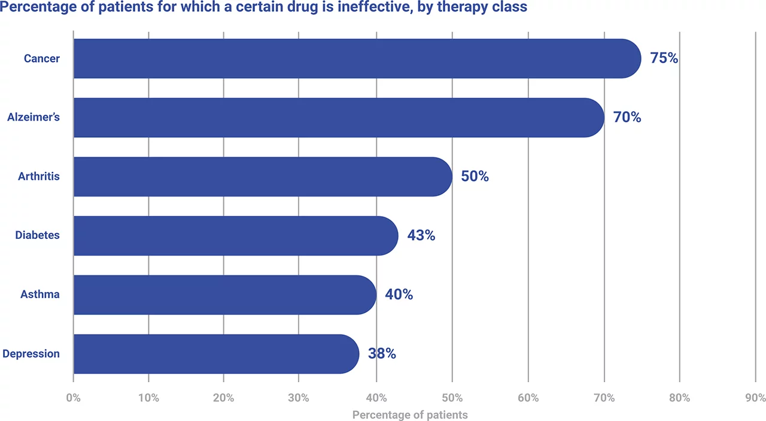
Figure 1: Patient faced with different drug issue
(Source: Incite Health, 2026)

2.1.4 National Perspective
NHS Patient Safety Incident Data
The NHS has focused on strengthening its safety infrastructure to ensure the smooth completion of its business operations. For instance, the organisation recorded no harm to patient privacy in 490351 cases in 2025 (NHS, 2025). Thus, the strengthening of the privacy policy has assisted the NHS in improving its trust level among patients.
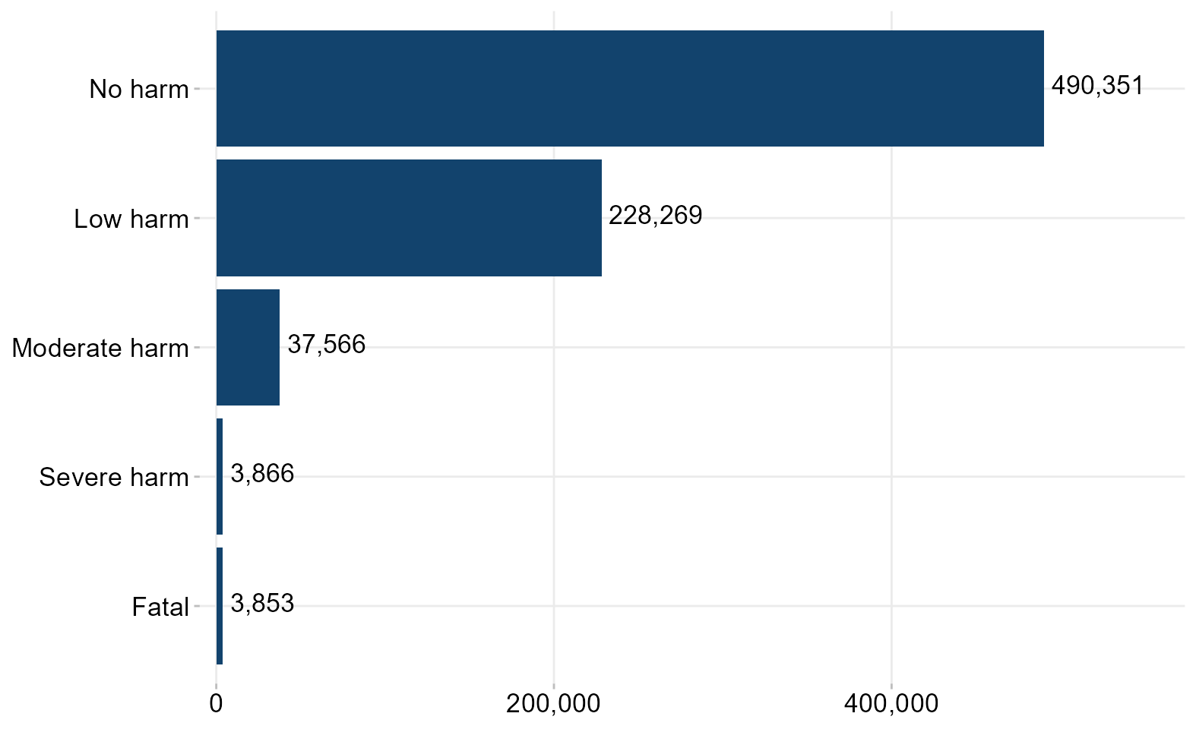
Figure 2: Cases Related to Patient Safety
(Source: NHS, 2025)

Medication Safety Statistics
In the UK, safety issues have been witnessed within its healthcare sector that has hampered the mental and physical well-being of the residents. As an example, the NHS has recorded 10345 cases of patients acquiring infections during the treatment process in 2025 (NHS, 2025). Hence, the decline in the medication quality has lowered the loyalty level of the organisation.
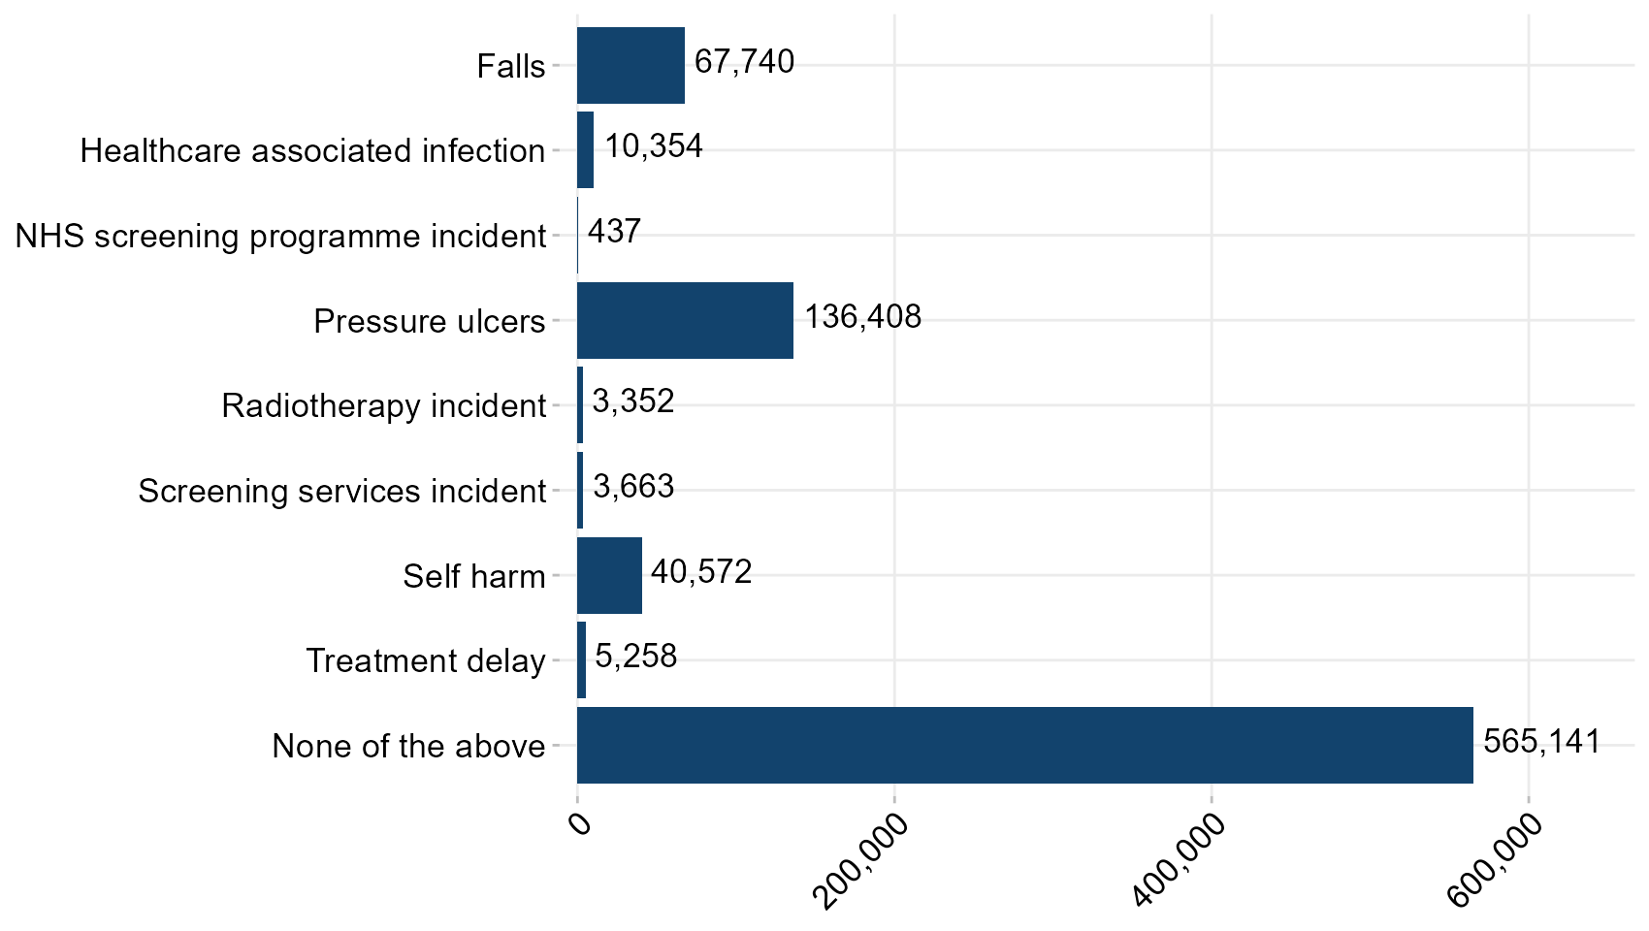
Figure 3: Medication Issues
(Source: NHS, 2025)
Anticoagulation-related incidents
The NHS has reported around 17000 anticoagulation cases and has also reduced the occurrence of brain strokes among patients in 2025 (NHS England, 2025). Thus, the lowering of the blood clotting incidents has assisted the healthcare organisations in the death rate within its work environment significantly.

2.1.5 Comparison Between National and Global Evidence
WHO and NHS data serve as reliable sources of information regarding medical errors that affect patients, resulting in clinical incompetence. IHI reported that 90% of medical errors are unreported due to lack of time constraints, feedback, and ineffective use of "data-driven diagnostic” tools, which leads to measuring patient harm. The selection of “IHI Global Trigger Tool” is designed to measure the medication harm of patients with targeted intervention (IHI, 2026). On the other hand, the NHS has adopted the “Patient Safety Incident Response Framework,” more reliable to raise with the medication errors, which is about 237 million, with a cost of about £98 million (BMJ, 2026). Thus, this is addressed due to significant transition in care by enhancing improvement in clinical outcomes.

2.1.6 Systemic Weaknesses Identified
The occurrence of issues in communication has an adverse impact on the quality of the treatment process provided within the healthcare institutions. As an instance, the lowering of interactions from the medical staff has hampered the mental and physical well-being of 48% young patients in 2025 (Artera, 2025). On the other hand, delay in the execution of the treatment process has also been a critical issue that has reduced the efficiency of the healthcare practitioners. Thus, the decline in the engagement level of the patients has reduced the smooth completion of the treatment process.
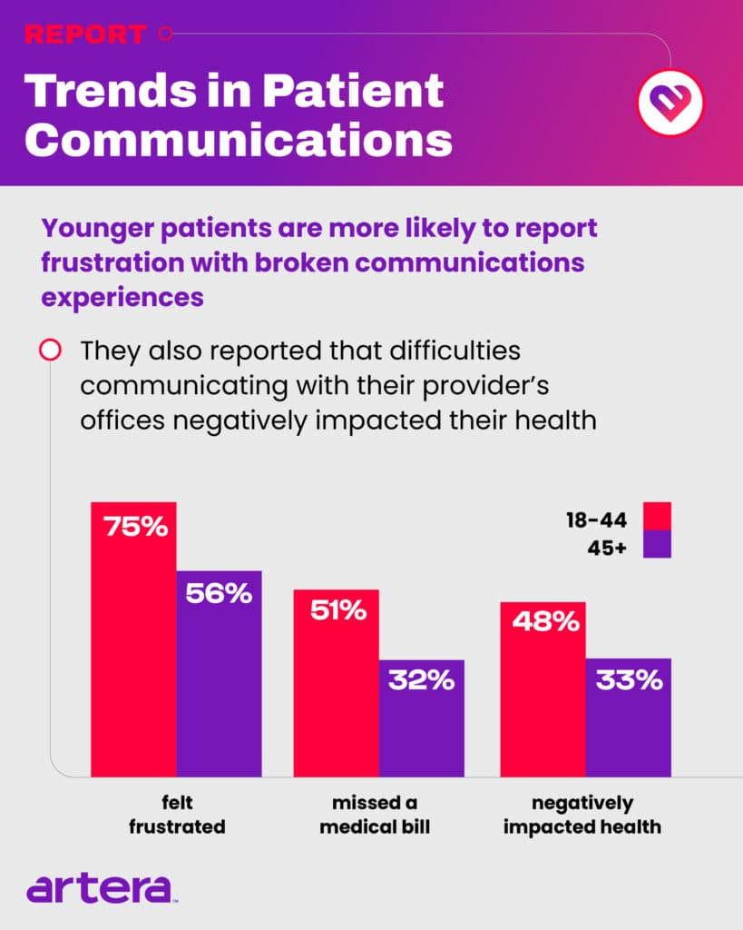
Figure 4: Communication Impact on Patients
(Source: Artera, 2025)

2.1.7 Governance Level Influencing the Incident
WHO follows the “Global Patient Safety Action Plan 2021–2030,” which is designed to reduce medical harm faced by patients and involves key stakeholders, enhancing improvement in “patient outcomes” (World Health Organization, 2023). The leaders of the healthcare sector are prioritizing patient safety by becoming more accountable in managing clinical processes. This showcases safety processes by servicing patients with safety protocols and procedures for managing infection. Adoption of the “Centers for Disease Control and Prevention” protects public safety and the health of patients by controlling diseases and injuries (CDC, 2026). Thus, healthcare governance is directly accountable in addressing equitable services with continuous improvement.

2.1.8 Underlying Organisational Challenges
Staff Shortage
The absence of proper workforce has lowered the service quality provided by healthcare institutions. In the NHS, around 40% of the workforce have resigned due to the presence of limited appraisals and reward schemes in 2025 (Mallorie, 2025). Thus, the decline in the staff volume has reduced the efficiency of the treatment process and resulted in the enhancement of death cases.
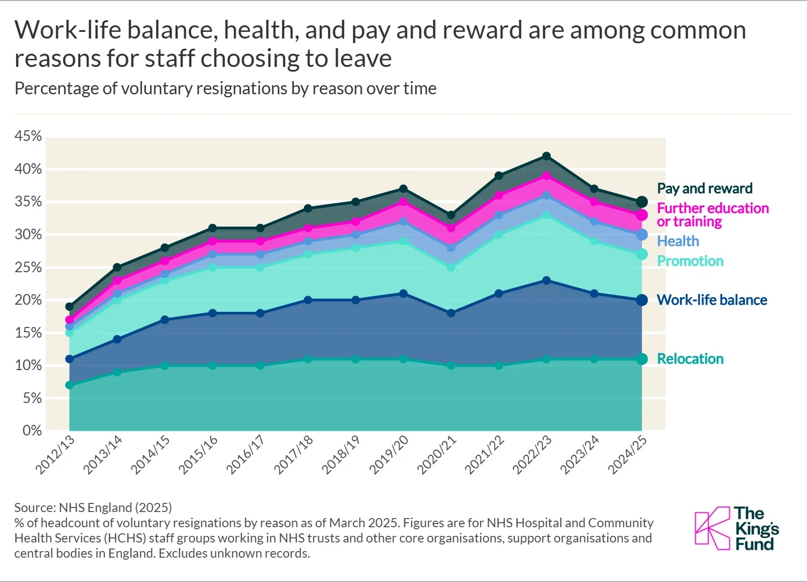
Figure 5: Staff Shortage in NHS
(Source: Mallorie, 2025)
Bed Pressures
The growing demand for healthcare services has also hampered the infrastructure of the organisations. For example, the USA health sector has observed an 85% shortage of hospital beds due to population growth in 2025 (Government of USA, 2025). Hence, the absence of proper infrastructural assistance has caused delays in the provision of proper treatment for the patients.

2.1.9 Rich Picture of the Case Study
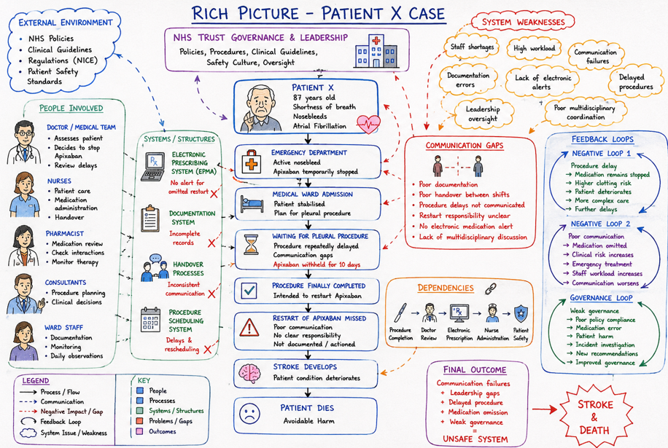
Figure 6: Rich picture
(Source: Self-developed)

2.2 Centralisation and Decentralisation within the Case Study

2.2.1 Understanding Centralisation in Healthcare
Evidence of Centralised Decision-Making in Patient X Case
Centralised decision-making procedure in the healthcare senior administration team is most effective for building effective hierarchical coordination and stable governance of clinical protocols. Thus, in this case, HSSIB investigation also illustrated that medical tea is directly stopping the usage of apixaban for Patient X due to excessive active nosebleeds. Till now further treatment procedures have also been held for a period due to the awaited future procedure. This evidence also be illustrated that procedure was delayed by administration and anticoagulation with consecutive total 10 days that issue to death of person. This demonstrates that reliance on centralised clinical authority without coordination impacts patient safety standards. The adoption of the techniques mentioned above has helped healthcare companies in strengthening its service quality. Hence, the adoption of centralized decision-making activities will help in improving the quality of the critical; care services provided to Patient X and will enhance his health significantly.

Advantages of Centralisation
- Centralised decision is most useful for standardized protocols with maintaining regulatory compliance with healthcare standards.
- This decision is effective for idealised high-risk treatments for complex medication that allows safety protocol for patients.

Disadvantages of Centralisation
- All clinical decisions also are followed late due to approaching medication standards for senior approval enhance patient safety risk.
- The communication issue is associated with multidisciplinary teams associated with documentation errors and weakened accountability of patient care.

2.2.2 Understanding Decentralisation in Healthcare
Evidence of Decentralised Clinical Decision-Making
As per the case study, the decentralisation of the healthcare activities has caused the death of patient X. For instance, the absence of a flexible decision-making authority has caused delays in the provision of adequate steps for controlling the occurrence of nose bleeding for the patient. Thus, the decline in the decision-making activities has lowered the trust level of the health officials among the stakeholders.

Advantages of Decentralisation
- Reduces the work pressure of the healthcare organisations and improves its operational efficiency, that also strengthens the quality of the treatment process.
- Diversify the services of healthcare institutions and improves the quality of the services provided to the patients.
- Provides health specialists to monitor the proper working of the departments that increases trust level among patients.

Disadvantages of Decentralisation
- The decline in decision-making capacity has hampered the operational efficiency of the healthcare organisations and lowered the treatment process for the patients.
- The inability of the companies in taking adequate medications during emergencies has increased the death rate for critical patients.

2.2.3 Critical Comparison of Both Approaches
Effect on Crisis Management
Based on the Patient X case study, the emergency department team assessed the nose bleeds and shortness of breath by adopting “Breathing Control” process and “Hemodynamic Resuscitation” process. The Centralised clinical protocol for nasal bleeding is keeping patients’ formal conditions by preventing swallowing with the right dose. In a decentralised system, Patient X's daily health management is done involving “Acute Medical Unit”, “emergency teams” to serve clinical outcomes analyzing bleeding status. The acute bleeding of Patient X is resolved by assessing the stroke profile and safety protocols to address this issue.
Effect on Accountability
Patient X faced a risk of stroke and nasal bleeding have been monitored by the medical staff, in addressing gaps in medication design due to predicting “real-time needs of patients. The “Electronic Prescribing and Medication Administration (ePMA) system” has the ability to manage the “real-time tracking” of the patient's needs, which has been improved gathering clinical support (NHS, 2026). In decentralised aspects, frontline staff flagged the medication delay address through accessing patient ward conditions. Although 75% of patients affected due to high rises of cancer required therapy class leads to rising economic burden for patients (Incite Health, 2026). On the other hand, delays in the execution of the treatment process have also been a critical issue that has reduced the efficiency of healthcare practitioners.
Effect on Patient Safety Outcomes
In centralized systems, failing to provide immediate responses affects the overall health of patient X by serving them with customized therapies to enhance patient needs. In a decentralized system, immediate response and high flexibility in treatment in analyzing medication decisions.

2.2.4 Statistical Evidence Supporting Evaluation
Staff ratios
The higher fluctuation also is associated with staff ratios that make volatility in standardized decision making of healthcare standards globally. Nursing personal shortages are also the most challenging for better healthcare management that reduce 54.5% from 9.89 million to 4.50 million (Deb, 2026). On the other hand, a shortage of medical doctors of about 1.94 million indicated senior management team ineffectiveness in global healthcare standards. Further, midwifery personnel also make shortages about 0.31 million indicated policy compliance issues navigating front care staff management. Overall, it directly influences key potentiality of patient management and builds strong communication among decentralised teams effectively.
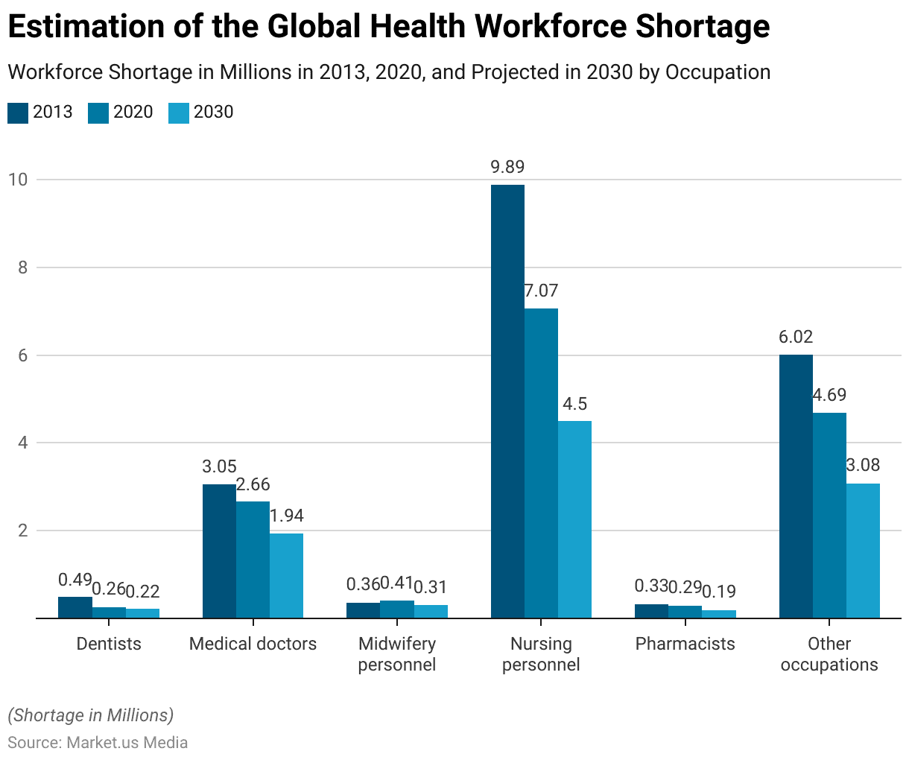
Figure 7: Staff ratios
(Source: Deb, 2026)

Policy compliance and Safety indicators
Patient saft indicator is highly recognisable towards improving educational activity of staff and utilization of better safety tools standard. Tracking of medication error rate tolerance necessary for achieving success rate associated with healthcare standards. Medication errors also are higher in case of injury incidents of outpatient clinics with approximately till now facing 530,000 (Renew Bariatrics, 2024). FDA medication error value also higher than 100,000 indicated major transformation needed in the healthcare segment. Measured appropriate safety indicators are most significant that abruptly improve mediocre standard and prorating policy formulation for drug errors. Overall, found of wrong dose also be associated with 27% that abruptly impacted font case staff management decentralized system inefficacy in healthcare (Caring for Care, 2026).
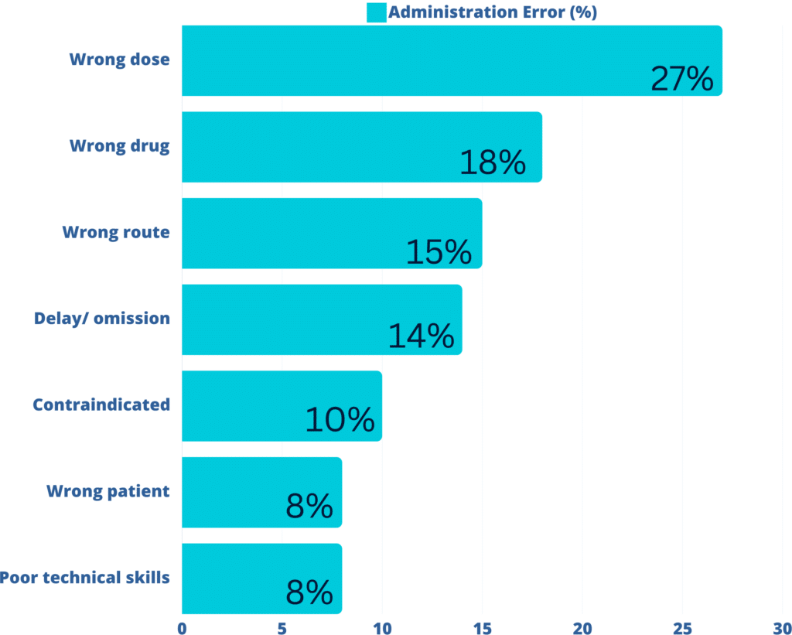
Figure 8: Medication incident data
(Source: Caring for Care, 2026)

2.3 Leadership Theories and Application to the Case Study

2.3.1 Leadership Challenges within Patient X Case
Absence of decision-making authority
The limited involvement of the authorities has been a viable cause that has led to the occurrence of death of the patient. In the case study, the medical staff have been indecisive in applying apixaban for controlling the nose bleeding that resulted in deterioration of the health condition.

Lack of patients consent
The absence of limited conversation with patients also reduces the quality of the medication process provided for overcoming the health issue. As an instance, the decision of delaying the use of apixaban was adopted by the medical staff without informing patient X. Thus, the lowering of the communication standard has caused the death incident.

2.3.2 Transformational Leadership
Theory and its application
The transformational leadership theory has improved the operational efficiency of the organisations. According to Deng et al. (2022), the method has stressed upon enhancing flexibility within the business operations for yielding quality results for the patients. In addition, the framework has also promoted employee participation in healthcare activities through the use of motivation and career growth opportunities. As per the study, the inclusion of the transformational leadership style would have improved the decision-making capacity of the medical practitioners and improved the efficiency of the treatment process. In addition, the method also improved the communication process involving its medication activities with an intent to strengthen the engagement level of the patient. Thus, the inclusion of the framework has improved the service quality of healthcare institutions.

Critical evaluation with evidence
Healthcare institutions have adopted the use of transformational leadership activities for including innovation in its business operations and meeting the changing requirements of the treatment provided to the patients. As an example, the John Hopkins Hospital has developed platforms such as “John Hopkins OnDemand” that has provided opportunities for patients to monitor health checkups and acquire doctor appointments in 2025 (John Hopkins, 2025). The provision of these initiatives has increased the brand loyalty of the institutions. In addition, the companies have also adopted the transformational leadership technique for increasing the engagement level of the workers. Hence, the inclusion of the framework has provided opportunities for the organisations in promoting harmony in its business operations.
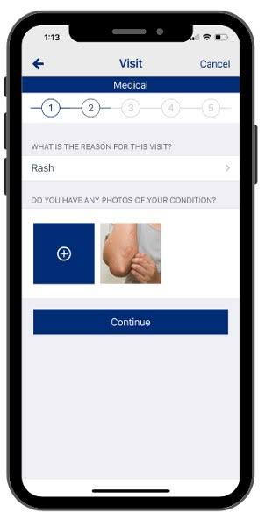
Figure 9: John Hopkins Mobile Applications
(Source: John Hopkins, 2025)

2.3.3 Transactional Leadership
Theory and its application
The application of the “Transactional Leadership” theory drives the performance of the employee rewards in achieving long-term goals. As stated by Jaqua and Jaqua (2021), the element of this theory manages safety by depending on “error-free clinical execution” to address reliable safety among patients. From the cases, Patient X faced high medication errors by highlighting its failure in managing continual care by addressing safety. The healthcare team upholds the transaction mindset by serving Patient X with proper care with the use of “Electronic Prescribing and Medicines Administration (ePMA) system”. The ED team, making informed decisions, has the ability to manage blood clots by addressing improvements in medical procedures by “Acute Ischemic Stroke Management”.

Critical evaluation with evidence
The leaders of the public healthcare sector follow transactional leadership theory and address operational efficiency by relying on higher staff motivation. For instance, the “NHS Patient Safety Strategy” is served to the health care provider in reducing risk faced by patients (NHS England, 2025). The involvement of the “patient safety partners” collaborating with “NHS Trust” enhances the safety of patients. The UK government has confirmed to pay 3.6% to AfC staff, 3.25% for managers and 4% for doctors based on their performance (Moynagh, 2025). Although the UK government has increased its wages by about £12.21, which provides substantial job opportunities and boosts the overall performance of employees. Thus, changes in wages and pay structure enhance the operational efficiency and productivity of the business.

2.3.4 Situational Leadership
Theory and its application
The uses of situational leadership theory (SLT) rely on growth of employees by showcasing individual competence in the market to respond with reliable changes. As stated by (), the element of this theory boosts job satisfaction of employees through skill development by dealing with changes in healthcare. The frontline staff failed to manage the medication required by Patient X for nasal bleeding and stroke, leading to procedural delay. In the case of Patient X, involvement of the junior team serves to provide proper guidance in balancing blood clotting.

Critical evaluation with evidence
In the healthcare sector, SLT serves reliable health outcomes through job satisfaction of employees by the ability to respond to crises. For example, in the NHS, 57.66% of employees are valued based on flexible work by their ability to manage high workloads in the organization by providing them with proper recognition (NHS, 2025).

2.3.5 Selection of appropriate leadership style
The adoption of the transformational leadership style will assist the organisations in reducing the occurrence of death due to staff negligence significantly. In addition, this method will also assist the authorities in strengthening the decision-making activities and ensuring smooth completion of its business operations. According to Eaton, Bridgman and Cummings (2024), the adoption of the transformational leadership framework has also provided opportunities for the companies in enhancing the skills of its workers and improving their production quality. Thus, the adoption of the method will increase the confidence level of the workers involved in the business operations.

2.4 Improvement and Lessons Learned

2.4.1 Interaction Between Leadership and Governance
The leadership and governance activities have played an important role in improving the ethical standard of the business practices carried out by the organisations. According to António Sacavém et al. (2026), the adoption of the method has provided opportunities for the companies in monitoring the progress and participation level of the employees within the medication process provided to the patients. As per the discussion in the case study, the healthcare staff illustrated limited involvement in the treatment activities that caused the death of Mr. X. The healthcare companies need to adopt a proper incentive structure to ensure higher engagement levels of their workers. For instance, the NHS has increased the wages of its nurses and other employees by 3.3% due to the improvement in service quality in 2026 (Triggle, 2026). Thus, the availability of higher financial income and improved working conditions has helped in increasing the workforce productivity of the organisations.

2.4.2 Missed Opportunities and an Evidence-Based Problem
- Failure to review patients daily
In the healthcare sector, failure to address patient review results in delayed diagnosis, burnout, and worsening the health of the patients (Barwise et al., 2021). Patient X is suffering due to stroke and has a risk of nasal bleeding due to ineffective care medical care leads to the death of patients. Impact of patient review is addressed due to clinical deterioration and rising patient complications affecting patient safety.

- Lack of clinical documentation
The lack of clinical documentation slows down patient safety due to duplicate tests and rises of drug reactions (Bocknek et al., 2022). The medical team appointed Patient X pauses to manage nosebleeds by waiting for recovery. This informed decision of the patient leads to the death of Patient X by compromising clinical trials. Thus, this can be addressed through medication review and clinical support enhance safety of patients

2.4.3 Evidence-Based Improvement Strategies
The existence of evidence-based strategy has helped healthcare organisations in improving its operational efficiency and strengthening trust among stakeholders. As stated by Chapman et al. (2025), the adoption of the method has assisted companies in utilising real-world examples for overcoming operational issues effectively. Based on the discussions in the case study, the inclusion of the method will help the healthcare staff in modifying the treatment processes with an intent to improve the health of the patient. In addition, the organisations have also utilised evidence-based methods for improving its product quality. As an instance, the WHO has developed drugs such as “Diuretics” for reducing blood clotting issues within patients in 2024 (Japi, 2025). The provision of blood pressure medicines has also helped the organisations in enhancing the efficacy of the medication provided to the patients. Thus, the adoption of evidence methods has assisted the healthcare companies in strengthening their operational efficiency.

2.4.4 Impact of system structure, leadership style, system feedback interaction
System structure
Patient X faced a medical error, was moved to the emergency department to address high-risk reevaluation in the healthcare sector. The healthcare sector is addressing challenges due to serving personalized drugs and therapies, which leads to rising clinical outcomes for patients. This leads to rise in procedural delay by improving structural capacity through re-evaluation of drugs served to patients.

Leadership style
The selection of “transformational leadership” style enhances accountability by achieving the vision of the company through intrinsic motivation. The investigation into integrating Patient X highlights its difficulties regarding anticoagulation. Ward doctors observe long-term personalized drugs taken by Patient X to respond with challenges with strict decision-making.

Feedback mechanism
The health condition of Patient X is predicted by the “Electronic Health Record” and the ability to analyze prolonged omission through closed-loop feedback. Thus, using a digital survey of staff and accessing health of patients with a digital portal strengthens patient safety outcomes for better healthcare standards.

2.4.5 Lessons for Other Healthcare Organisations
As per the information provided in the case study, the absence of proper medication has caused the death of patient X. The healthcare organisations need to enhance the knowledge of their workers regarding changing market requirements for improving its operational efficiency. As an example, the NHS has developed the “Scientist Training Programme (STP)” for executing research in cancer drugs in 2025 (NHS Careers, 2025). In addition, the initiative also provided courses in robotic surgery for the health officials. On the other hand, the lessons learnt from the case study also include the provision of rewards for increasing the engagement level of the workforce. The University Hospital Heidelberg has developed platforms such as “Department 5.2” that provide opportunities for workers to interact with management and discuss workforce issues in 2025 (Heidelberg University, 2026). Overall, the provision of training and reward initiatives will help health organisations in acquiring a skilled workforce for providing quality treatment to the patients.

2.4.6 Continuous Improvement Using Data
The public healthcare organization, adopting “real-time ePMA” to track medication of patients based on continuous improvement processes. For example, WHO has enhanced patient health and has adopted digital technologies which improve patient outcomes. The NHS uses an “NHS app” to address the growth of patients, about 33 million through digital prescriptions (WHO, 2026). The adoption of “Data-driven protocols” is more reliable to manage workflow by suspending medication. “Acute Care Action Fund” is funded with $ 12.5 million and was launched by WHO to provide basic training to respond to injuries (WHO Foundation, 2025). Continuous improvement in healthcare is based on “Right to Health” equality by sustaining standardized care and universal access to medicine.

3. Recommendations
Recommendations 1: Strengthening Leadership through clinical governance
The healthcare organisations have enhanced leadership operations to ensure the inclusion of sustainability in its business activities. Strengthening healthcare leadership by adopting governance protocols that ensure accountability through long-term collaboration. Clinical governance is more accountable in enhancing safety among patients through quality improvement protocols (Macfarlane, 2019). Clinical justification for “Anticoagulation” is documented by electronic medication management regarding reliable discharge of patients. In the USA, the medical waste management services have achieved a higher CAGR rate of 7.0% from 2024 to 2030 (Grand View Research, 2025). Enhancing medication safety and addressing through reliable anticoagulant management ensures reliable medication for enduring patient safety. Thus, leaders' involvement involves multidisciplinary teams for managing “anticoagulation safety” among patients through reliable decision-making.
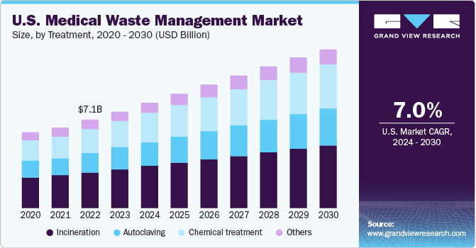
Figure 10: Revenue of the US Medical Waste Management Services
(Source: Grand View Research, 2025)

Recommendations 2: Strengthen Governance, Communication, and Systems Integration Through Digital Systems for Medication Safety
The proper integration of “Electronic Prescribing and Medicines Administration (EPMA)” for clinical approval process is also necessary for tracing digitally about changing scenarios of every patient condition. This systematic digital procedure also raises automatic consolidation alerts for omitted medicines, overdue doses, drug interactions, and mandatory medication reviews. As it is also effective to reduce key error acceptance in healthcare standard operational by human approach. In case of patient X, electronic alert with systematic approach for restart apixaban also be helpful to prevent fatal stroke and unnecessary delays in procedure. It is also ensured to control external expenses of medicare drugs with appetite choice right dose effectively. For instance, the prescription drug adoption trend will also be raised by 8.42% in 2026 indicating a higher fatality rate in healthcare systems (Sarasohn-Kahn, 2025). As it is also enabled, it costs approximately $42 billion each year to meet criteria of medications process. Overall, using digital systems also reduces excess use of dosage and mandates efficiency of the medication process of healthcare standards.
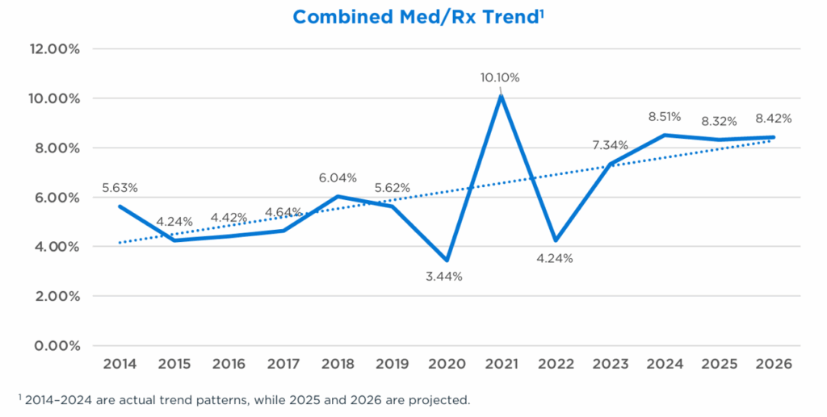
Figure 11: Medication trend
(Source: Sarasohn-Kahn, 2025)

Recommendations 3: Strengthen Technical and Allocative Efficiency
The adoption of digitalisation is also a viable option that has assisted the organisation in strengthening the quality of the healthcare services provided to the community. As an example, WHO has developed the “OpenWHO” digital platform for the healthcare policymakers to acquire knowledge regarding medical guidelines and treatment processes adopted to overcome the impact of fatal diseases (World Health Organization, 2025). In addition, the technique has also provided opportunities for organisations to provide quality care to critical patients. Healthcare companies have also emphasised on adopting digitalisation tools for monitoring employee performance. NHS has developed the “StaySafe” application for providing safety and security to nurses and other female employees in 2025 (EcoOnline, 2025). Thus, the provision of digital techniques has increased the operational efficiency of healthcare organisations.

Recommendations 4: Continuous Learning and Organisational Development
The established continuous learning adaptability and development initiative among staff also be helpful to strengthen the update safety approach regarding patients X with better standards of care. In addition, providing medication standardized processes through multidisciplinary simulation training also ensures evidence based quality programme initiative in working procedure. Recent medicare market adverse activity also enables more employment opportunities for supporting stipulated trends. For instance, a total of 11.4% structural growth of the market enables future requirements of medical staff for better control of progressive healthcare (BRC, 2026). As it ensures development learning for every anticoagulation review and medication standard. Overall, in future it reduces medication related harms and provides better service quality among patients.
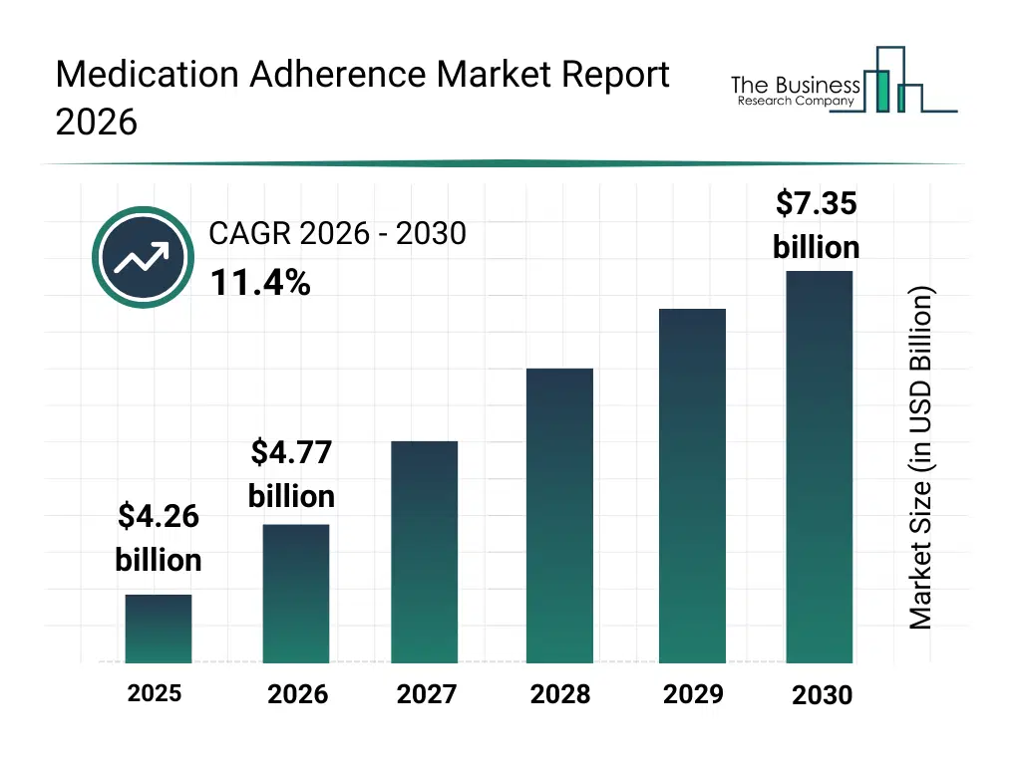
Figure 12: Medication adherences report
(Source: BRC, 2026)

4. Conclusion

4.1 Summary of Key Findings
Based on the overall analysis, medication error is the major problem, by prioritizing more on safety addressed with automated reliable treatment processes. Patient X's death is addressed due to nasal bleeding and stroke, to ensure faster approach of communication and informed decision-making. The impact of this failure is due to procedural inefficiency and incomplete digital safeguards, which affect overall accountability of the treatment process. Significance of the failure addressed with targeted safety by adoption of “EPMA” and long-term medication with standardized clinical review. The impact of this failure is addressed with reliable medication by the ability to respond to uncertainty.

4.2 Leadership and Governance Lessons
The adoption of the transactional, transformational and situational leadership activities has assisted healthcare companies in strengthening its employee relationships and promoting organisational harmony. In addition, the methods have also improved the services and enhanced patient outcomes. On the other hand the inclusion of flexible governance activities has also provided opportunities for the companies to increase the work discipline level in its business operations. The technique has also reduced the occurrence of delay in the completion of the treatment provided to the patients. Thus, the existence of the governance and leadership activities have helped the health organisations in increasing its trust among the community.

4.3 Importance of Systems Thinking
In the healthcare sector, systematic thinking is the holistic approach by connecting with people reliable feedback (Rhoda, 2026). Enhancing patient safety is addressed with systematic thinking, serving clinical governance and innovation in business. The healthcare sector has a massive alignment by relying on innovation and collaboration with interdisciplinary teams in managing healthcare outcomes. The “medication-related harm” has been addressed by enhancing staff shortages for proper prescribing by relying on transitions in the healthcare medicare standard. Although “real-time drug” interaction helps to reduce medication error by serving personalized care, enhancing duplication with a better patient safety approach.

References
Al-Rjoub, S., Alsharawneh, A., Alhawajreh, M. and Othman, E. (2024). Exploring the impact of Transformational and transactional style of Leadership on nursing care performance and patient outcomes. Journal of Healthcare leadership, [online] 16(16), pp.557–568. doi:10.2147/jhl.s496266.
António Sacavém, Bem Machado, A. de, dos Santos, J.R., Palma-Moreira, A. and Au-Yong-Oliveira, M. (2026). Adaptive leadership and governance mechanisms in Sustainability-Oriented Inter-Organizational networks: A systematic review and qualitative narrative synthesis. Sustainability, 18(10), pp.4764–4764. doi:10.3390/su18104764.
Artera (2025). Healthcare communication trends | nearly 70% of Patients prefer conversational messaging over basic texting - artera. [online] artera.io. Available at: https://artera.io/blog/healthcare-communication-trends/.
Barwise, A., Leppin, A., Dong, Y., Huang, C., Pinevich, Y., Herasevich, S., Soleimani, J., Gajic, O., Pickering, B. and Kumbamu, A. (2021). What contributes to diagnostic error or delay? A qualitative exploration across diverse acute care settings in the US. Journal of patient safety, [online] 17(4), pp.239–248. doi:10.1097/PTS.0000000000000817.
BMJ (2026). 237+ Million medication errors made every year in England - BMJ group. [online] BMJ. Available at: https://www.bmj.com/company/%20newsroom/237-million-medication-errors-made-every-year-in-england/
Bocknek, L.S., Kim, T.C., Spaar, P.A., Russell, J.L., Busog, D.-N.C., Howe, J.L., Boxley, C.L., Ratwani, R.M., Krevat, S., Jones, R. and Franklin, E.S. (2022). Duplicate medication order errors: Safety gaps and recommendations for improvement. Patient safety, [online] 4(3), pp.39–47. doi:10.33940/data/2022.9.6.
BRC (2026). Medication adherence global market report 2024. [online] Thebusinessresearchcompany.com. Available at: https://www.thebusinessresearchcompany.com/report/medication-adherence-global-market-report
Caring For Care (2026). Medication errors stats, costs and how to avoid them. [online] Caring For Care. Available at: https://caringforcare.co.uk/what-are-medication-errors/
CDC (2026). Centers for Disease control and prevention. [online] www.cdc.gov. Available at: https://www.cdc.gov/index.html
Chapman, A., Gaskin, C.J., Beks, H., Wright, C., Marshall, S., Johnston, E.A., Bergin, R.J., Riva, S., Crawford-Williams, F., Short, C.E., Kiss, N., Yoong, S.L., Hart, N.H., Wong Shee, A., Rodi, H., Jongebloed, H. and Ugalde, A. (2025). Implementation strategies for evidence-based healthcare interventions in rural and remote settings: A scoping review. The lancet regional health - western pacific, [online] p.101732. doi:10.1016/j.lanwpc.2025.101732.
Deb, T. (2026). Healthcare staffing statistics 2024 by Hospitals, clinics, homes. [online] Market.us Media. Available at: https://media.market.us/healthcare-staffing-statistics/
Deng, C., Gulseren, D., Isola, C., Grocutt, K. and Turner, N. (2022). Transformational leadership effectiveness: An evidence-based primer. Human resource development international, 26(5), pp.627–641. doi:10.1080/13678868.2022.2135938.
Eaton, L., Bridgman, T. and Cummings, S. (2024). Advancing the democratization of Work: A new intellectual history of transformational leadership theory. Leadership, [online] 20(3), pp.125–143. doi:10.1177/17427150241232705.
EcoOnline (2025). Healthcare | StaySafe | EcoOnline. [online] EcoOnline. Available at: https://www.ecoonline.com/ehs-software/lone-worker/staysafe-healthcare/.
Government of USA (2025). The U.S. could experience a critical hospital bed shortage by 2032, new research warns | clinical and translational science institute. [online] Clinical and Translational Science Institute. Available at: https://ctsi.ucla.edu/the-us-could-experience-a-critical-hospital-bed.
Grand View Research (2025). Medical waste management market size, share report, 2025. [online] www.grandviewresearch.com. Available at: https://www.grandviewresearch.com/industry-analysis/medical-waste-management-market.
Heidelberg University (2026). Heidelberg university - zukunft seit 1386. [online] Uni-heidelberg.de. Available at: https://www.uni-heidelberg.de/en/institutions/university-administration/division-5-human-resources/personnel-services-for-employees.
HSSB (2025). [online] Available at: https://www.hssib.org.uk/patient-safety-investigations/medication-related-harm/second- investigation-report/pdf/?utm_source=chatgpt.com.
IHI (2026). Introduction to Trigger tools for identifying adverse events. [online] Ihi.org. Institute for Healthcare Improvement. Available at: https://www.ihi.org/library/tools/introduction-trigger-tools-identifying-adverse-events
Incite Health (2026). Statistics and studies on the impact of Ineffective medications in patients - incite health. [online] Incite Health. Available at: https://www.incitehealth.com/statistics-and-studies-on-the-impact-of-ineffective-medications-in-patients/.
Japi (2025). Loop diuretics: An overview of its history and evolution. [online] Japi.org. Available at: https://japi.org/article/japi-72-9-s1-11.
Jaqua, E. and Jaqua, T. (2021). Transactional leadership. American journal of Biomedical science & research, [online] 14(5), pp.399–400. doi:10.34297/AJBSR.2021.14.002021.
John Hopkins (2025). [online] Available at: https://www.hopkinsmedicine.org/-/media/ondemand/ondemand_visit.pdf.
Mallorie, S. (2025). NHS workforce in a nutshell. [online] The King’s Fund. The King’s Fund. Available at: https://www.kingsfund.org.uk/insight-and-analysis/data-and-charts/nhs-workforce-nutshell.
Moynagh, A. (2025). Pay awards for health workers signed off by minister. [online] 22 May. Available at: https://www.bbc.com/news/articles/c308760zr2go
NHS (2025). NHS staff survey results 2025: What you need to know. [online] The NHS Alliance. Available at: https://thenhsalliance.org/resources/nhs-staff-survey-results-2025-what-you-need-to-know/
NHS (2025). Statistics » quarter 3 2025/26 (October, November, December 2025). [online] England.nhs.uk. Available at: https://www.england.nhs.uk/statistics/statistical-work-areas/patient-safety-data/2025-26/q3/.
NHS (2026). Electronic prescribing and administration (EPMA) data in Secondary care under the covid-19 direction. [online] NHS Digital. Available at: https://digital.nhs.uk/data-and-information/data-collections-and-data-sets/data-collections/electronic-prescribing-and-administration-epma-data-in-secondary-care
NHS (2026). Restoring financial discipline and returning to financial sustainability. [online] The NHS alliance. Available at: https://thenhsalliance.org/resources/nhs-financial-reform-and-the-10-year-health-plan-aligning-vision-with-delivery/restoring-financial-discipline-and-returning-to-financial-sustainability.
NHS Careers (2025). NHS scientist training programme. [online] Health Careers. Available at: https://www.healthcareers.nhs.uk/career-planning/study-and-training/graduate-training-opportunities/nhs-scientist-training-programme.
NHS England (2025). Medication safety management. [online] NHS. Available at: https://www.england.nhs.uk/long-read/medication-safety-management/
NHS England (2025). Statistics » quarter 3 2025/26 (October to December 2025). [online] England.nhs.uk. Available at: https://www.england.nhs.uk/statistics/statistical-work-areas/vte/vte-risk-assessment-2025-26/q3/.
NHS England (2026). Structure of the NHS. [online] www.england.nhs.uk. Available at: https://www.england.nhs.uk/long-read/structure-of-the-nhs/.
Renew Bariatrics (2024). Medication error statistics: How prevalent are medication errors? [online] Renew Bariatrics. Available at: https://renewbariatrics.com/medication-error-statistics/
Rhoda, B. (2026). Systems thinking: Tools for change. [online] Medium. Available at: https://medium.com/@biodunrhoda/systems-thinking-tools-for-change-70fcd2cfcce6
Sarasohn-Kahn, J. (2025). Expect Double-Digit prescription drug trend increases in 2026 – the update from HUB international. [online] HealthPopuli.com. Available at: https://www.healthpopuli.com/2025/09/04/expect-double-digit-prescription-drug-trend-increases-in-2026-the-update-from-hub-international/
Singh, P., Singh, S., Kumari, V. and Tiwari, M. (2024). Navigating healthcare leadership: Theories, challenges, and practical insights for the future. Journal of Postgraduate medicine, [online] 70(4), pp.232–241. doi: 10.4103/jpgm.jpgm_533_24.
Triggle, N. (2026). Nurses and other NHS staff to get 3.3% Pay rise. [online] 12 Feb. Available at: https://www.bbc.com/news/articles/c6274rjr311o.
WHO (2023). Global burden of Preventable medication-related harm in Health care: A systematic review. [online] www.who.int. Available at: https://www.who.int/publications/i/item/9789240088887
WHO (2026a). Digital prescriptions – good for patients, good for prescribers and good for dispensers. [online] Who.int. Available at: https://www.who.int/europe/news/item/02-05-2024-digital-prescriptions---good-for-patients--good-for-prescribers-and-good-for-dispensers
WHO (2026b). Medication without harm. [online] World Health Organization. Available at: https://www.who.int/initiatives/medication-without-harm
WHO Foundation (2025). Who foundation and laerdal global health announce US $12.5 Million to launch massive acute care scale up. [online] Who.foundation. Available at: https://www.who.foundation/post/who-foundation-and-laerdal-global-health-announce-us-12-5-million-to-launch-massive-acute-care-scale-up
World Health Organization (2023). Patient safety. [online] World Health Organization. Available at: https://www.who.int/news-room/fact-sheets/detail/patient-safety
World Health Organization (2025). Digital health. [online] www.who.int. Available at: https://www.who.int/health-topics/digital-health#tab=tab_1.

