I confirm that I have not used any AI tools in the research and creation of my assignment. I confirm that I have not presented any AI generated material as my work. I confirm I have copies of my drafts, notes, and other resources I used, which I may be asked to provide as evidence.

Article Summary
I will summarise the article called ‘how does music make you feel?’ By Zoe Nendick. In this article the author discusses the link between music and emotions. It highlights the importance of music in everyday life and how it can benefit an individual in several ways. Zoe started researching into the article when she started her music degree and kept developing her framework.

Music can heavily impact an individuals mood or the emotions they are experiencing. There are multiple different genres of music to adapt to any mood or emotion that an individual may be experiencing. Many people have a favourite song that can immediately improve their mood, however, many people also have a song that can make their mood drop instantly. Individuals are able to express themselves through music, as some individuals may struggle to express their thoughts and emotions. Music can be a beneficial way to do so. ‘Music can be very powerful’. This quote is included in the article. Individuals react differently to the same piece of music. It brings out different emotions in them. The way a piece of music makes the individual feel depends on the context. We must take into account, the memories or associations with the piece of music. This can impact how an individual feels about the song.

The study of music having an effect on our emotions is at the early stages of research. There are still many years of research left to develop this idea and try to make it apply to each individual. However, the finding that approximately 5% of the general population experience “music anhedonia” meaning they do not gain any pleasure from listening to music, this suggest that the idea of music enchanting a persons mood is subjective and cannot be generalised to everyone. Music is said to have the ability to regulate emotions for some individuals, it can even be used for therapy. Music can be used to help recover from surgery and improve their well-being However, it can also have the opposite affect and have a negative impact on the individual’s mood or emotion. If the music is too loud, or a genre they don’t like, it can upset them. This can cause stress for the individual.

In conclusion, the article highlights the connection between music and human emotions. Music is a tool that can be used to help express emotions. While it can be used to uplift and comfort individuals, it can also evoke sadness and stress depending on personal experiences and the individual’s past. Overall, music has a significant role in human life and shaping how people think, feel and connect with the world around them. Zoe Nendick highlights that people’s reaction to the same piece of music vary widely according to the context, memory’s and association with the piece of music.

Referencing List E-Portfolio Task.

Davis, E. R., & Clarke, M. J. (2022). Modern marketing strategies. Business Books Publishing.

Department for Environment, Food & Rural Affairs. (2020). UK climate change risk assessment 2020. UK Government. https://www.gov.uk/government/publications/uk-climate-change-risk-assessment-2020

Garcia, M. T. (2022, March 5). Climate change impacts on coastal cities. The Global Times. https://globaltimes.com/climate/coastal-impact

Kim, S. H., Patel, R., & Wilson, J. D. (2021). Virtual reality in education: A meta-analysis. Educational Technology Research and Development, 69(2), 1105–1123. https://doi.org/10.1007/s11423-020-09834-7

Lee, A. M. (2020). Cognitive development in early childhood. In P. Brown & L. Green (Eds.), Child development theories (pp. 45–67). Springer.

Martinez, S. L. (2022, October 14). Advances in renewable energy storage. Paper presented at the International Symposium on Sustainable Energy, Berlin, Germany.

Morgan, D. S. (2021). Machine learning applications in healthcare diagnostics (Doctoral dissertation, University of Edinburgh). ProQuest Dissertations & Theses Global. (Accession No. 12345678)

Nguyen, H. P. (2018). Blockchain technology in finance. In R. Singh & A. Cohen (Eds.), Innovations in financial technology (pp. 122–139). Wiley Online Library.

Nguyen, L. T., O’Connell, M. A., Li, S. J., Rivera, P. M., Adams, F. R., Chen, H. Y., Bailey, T. K., Jones, A. R., Walker, C. L., & Ahmed, S. E. (2022). Cognitive flexibility and executive function in early adulthood. Journal of Experimental Psychology: General, 151(4), 789–805. https://doi.org/10.1037/xge0001223

NHS Greater London Trust. (2022). Annual patient satisfaction survey report. London, UK.

Patel, S. R. (2020). The rise of digital therapy. The Psychologist, 33(6), 48–53.

Reynolds, K. M. (2023). How mindfulness improves productivity. Mindful Living. https://mindfulliving.com/how-mindfulness-improves-productivity

Smith, J. A. (2019). Understanding psychology (3rd ed.). Academic Press.

Thompson, R. E. (2018). Social media effects on adolescent mental health. Journal of Adolescent Health, 62(4), 410–417. https://doi.org/10.1016/j.jadohealth.2017.11.290

U.S. Department of Education. (2017). National education technology plan 2017 (Report No. ED-ICT-17-01). https://tech.ed.gov/netp

University of Oxford. (2022). Referencing and citation guide. https://www.ox.ac.uk/students/academic/referencing

Williams, J. L. (2020). Exploring sustainable urban development (Doctoral dissertation, University of California). https://escholarship.org/uc/item/7gp4v2cd

World Health Organization. (2023). Mental health and COVID-19. https://www.who.int/mental_health/covid-19

Zhao, L. (2019). Enhancing user experience in mobile apps. In Proceedings of the International Conference on Human-Computer Interaction (pp. 102–110). ACM Press. https://doi.org/10.1145/3313831.3376310

Essay Planner
Essay Title- How has our understand of melancholia and approaches to treatment have changed.
Introduction
- define what melancholia is.. how the definition has changed over time - what I will be explaining in the essay… look at how people explain melancholia and have treated it from ancient times to today. - explain how people used to think it was from bodily fluids or religion but now it’s seen as a mental health condition

Main body
Paragraph 1.
Greeks and Romans – Hippocrates said melancholia came from too much black bile (one of the humours). The symptoms and the treatments that were recommended.
Philosophers – Aristotle thought melancholia could be linked to creativity and intelligence
Religious views - some people saw melancholia as a spiritual problem – may be caused by sin or demons + Treatments available

Paragraph 2 - 18th and 29th centuries.
New scientific views – doctors started to see it as a mental illness. Moral treatments became more popular like lindens and calm environment to support the individuals mental state.
Emil Kraepelin (late 1800s) – manic depressive illness ( early idea of bipolar disorder) . Treatment focused on rest and early forms of therapy
Paragraph 3 - 20th century to Today.
-Freud’s Theory (1917) - comes from loss and turning anger inward – explored through psychoanalysis (talking therapy)
-Modern medicine – depression liked to brain chemistry and hormones - discovery of antidepressants (SSRIs) changed over time
-seen as a type of major depression now - ‘melancholic depression’

Paragraph 4 – comparison
-what changed; from humours to brain chemistry, sin to science, punishment to therapy.
- What stayed the same; people still debate if it is physical, emotional or both.

Conclusion
Summary – understanding of melancholia had changed from ancient body theories and religion to modern medicine and psychology
-these changed show how the mind, body and emotions have developed over time
-melancholia is seen as both biological and emotional – shows old and new ideas are connected.

Key references
Any websites used for research or quoted within the essay when collecting the research.

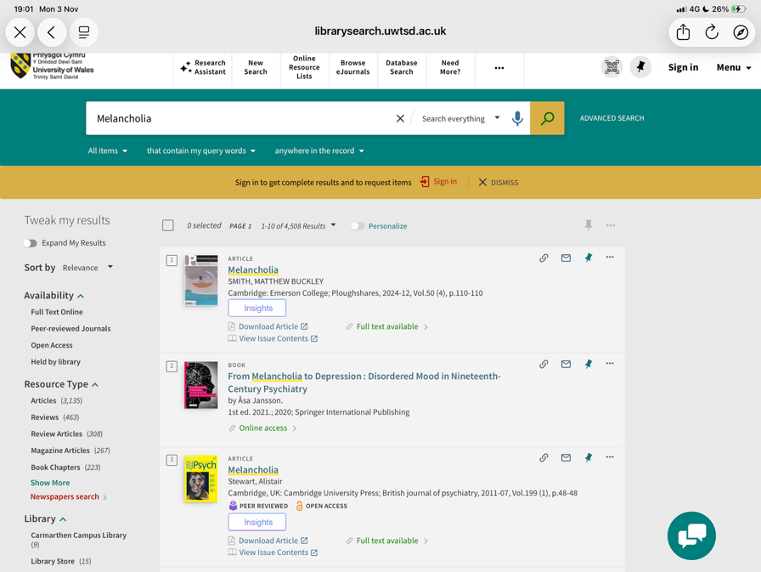
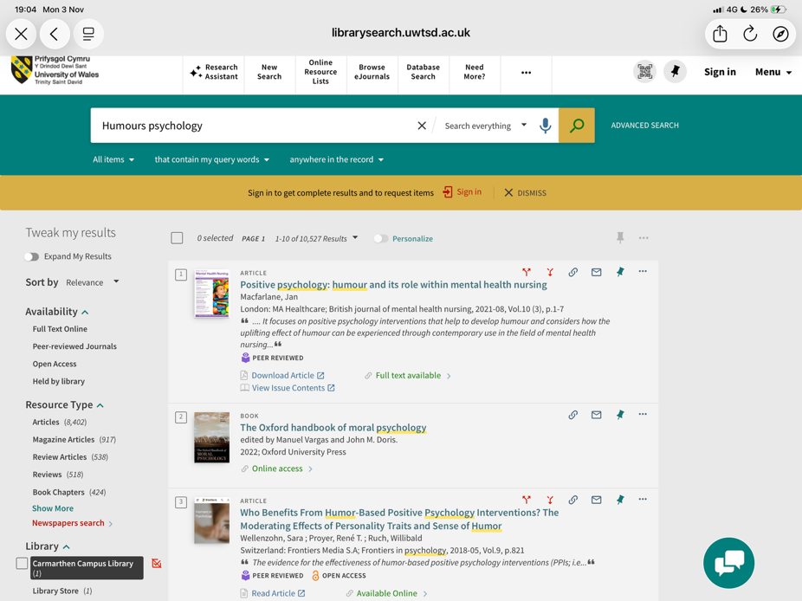
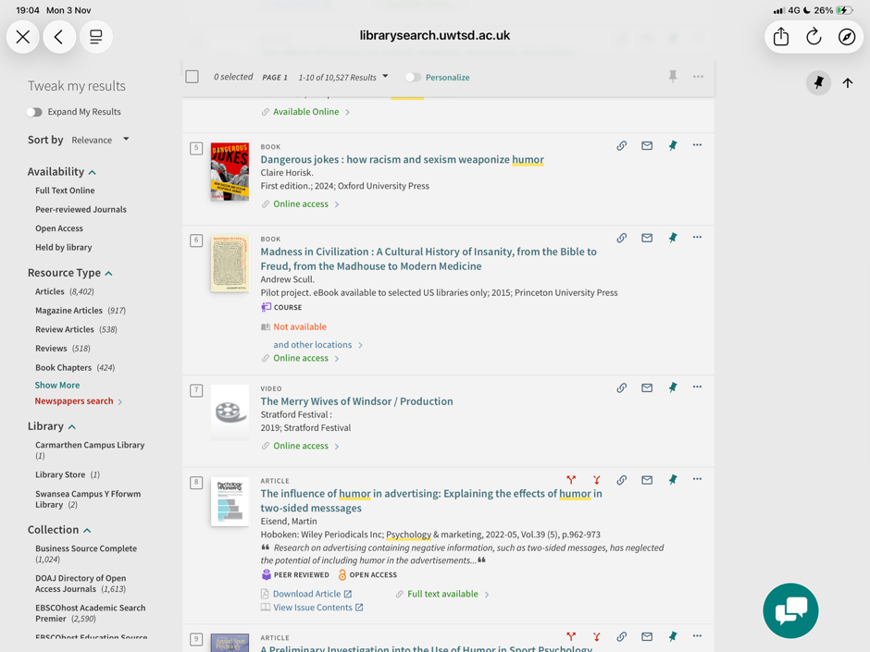
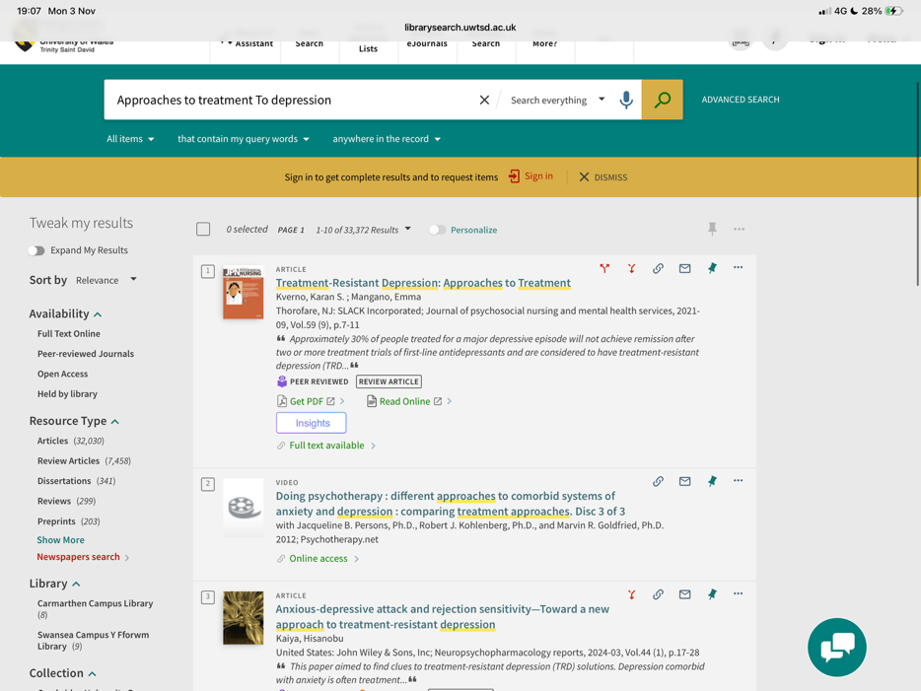
Here are the screenshots of the library searches I have used with university library system.

