Liam Berner
1706870
30/04/19
ACBA4001
Domestic New-build
Tom Duxbury

1.
The image below is a sketch I have done to show the foundation, ground floor plan and junctions with the external walls.
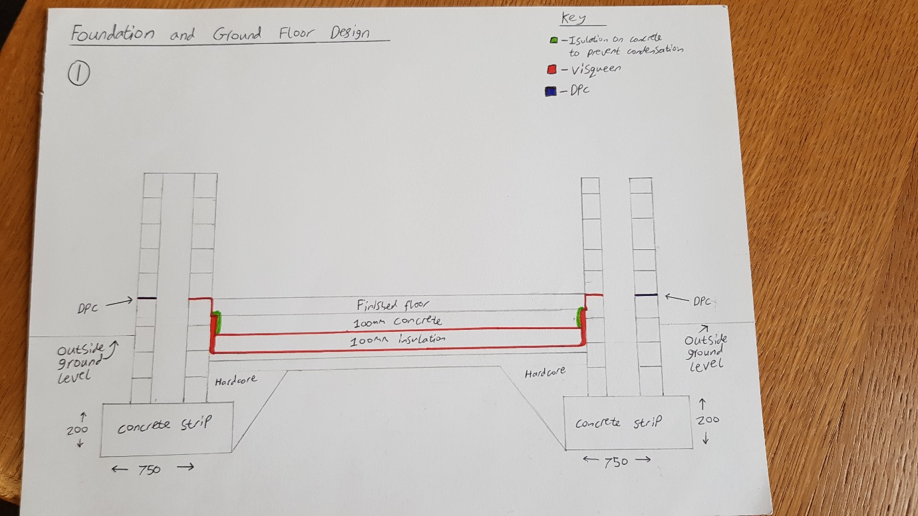
2.
This image shows a sketch I have done showing the first floor construction with the restraint strap.
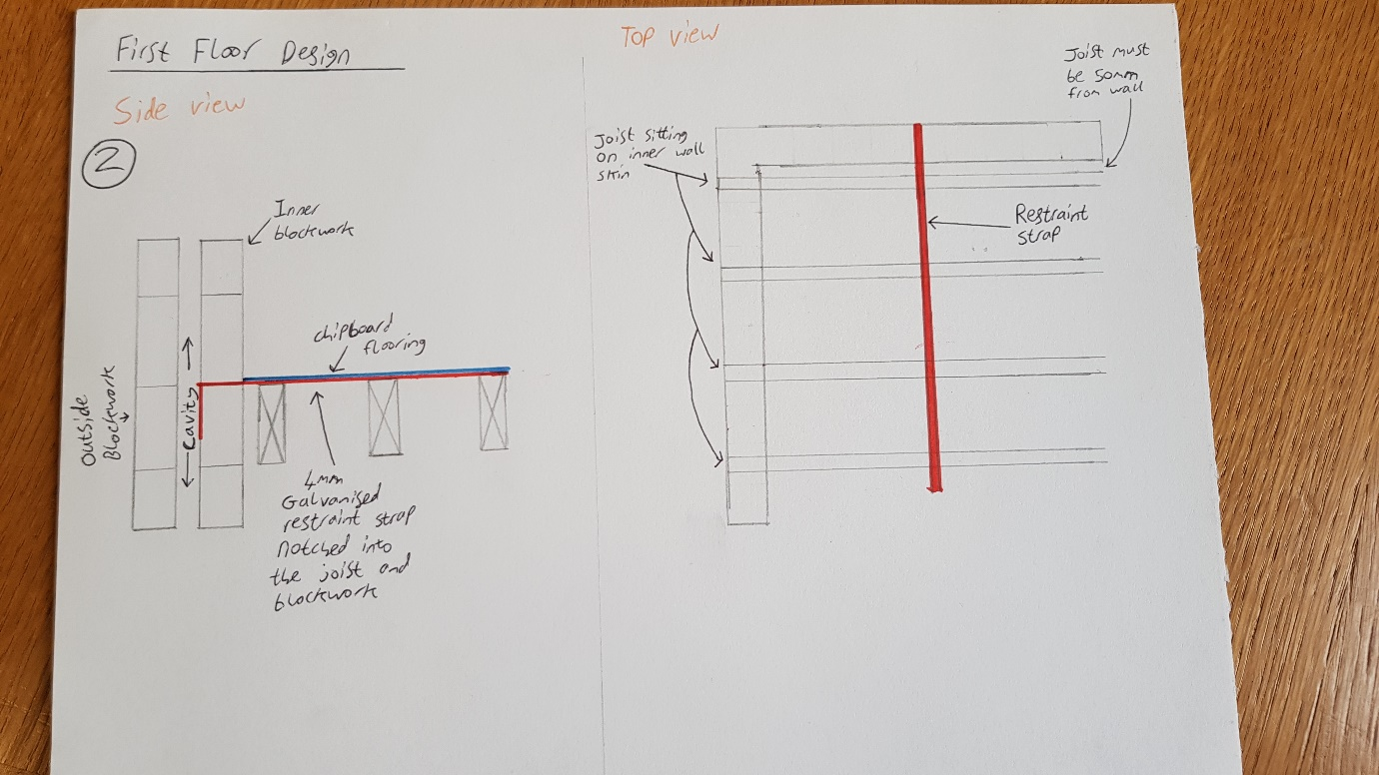

3. The advantages and disadvantages of using a trussed roof design.
A timber trussed roof is made up of one or more triangular units which adds stability to the roof by utilising its triangular shape to spread the weight of the roof away from the exterior walls. A timber trussed roof’s cost is one of its greatest selling points. This is because it is generally cheaper than steel, they also save time and reduce labour costs. The timber used in the truss construction has advantages and disadvantages. A timber roof is an environmentally friendly alternative and a trussed roof uses less timber than a traditional pitched roof. However, the timber in trussed roofs can be known to get rot when it is subjected to exposed environments. The timber can also attract termites and is more likely to suffer damage during storms or bad weather. Timber roofs also have the advantage of allowing personal preference in the design process because they are suitable for many building types such as residential buildings, church’s and cathedrals.
The advantages and disadvantages of using a cut roof design.
A cut roof design has the advantage of using a cu roof design are that the finished structure is very adaptable, and the volume is large enough to convert it into a living space. The structure can also be easily altered. As the timbers for the cut roof and cut and erected one at a time this makes for slow progress and higher labour costs.
The image below shows a sketch I have down showing the eaves detailing and roof covering, also the ventilation.
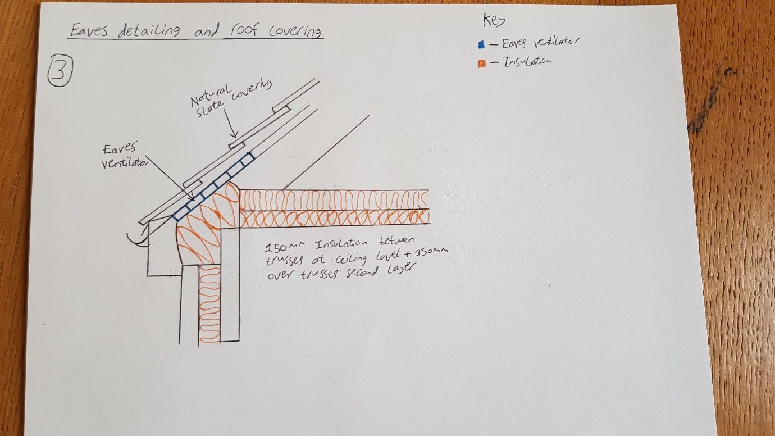

4.
Condensation is where the air cools so that it is no longer able to hold the moisture within it and this creates condensation or ‘dew’. Condensation typically happens in building where the warm moist air comes into contact with a cold surface such as windows, the water then condenses onto the surface creating condensation. Condensation in buildings can cause mould to grow which can cause respiratory damages, mildew, staining, slip hazards, corrosion of the building fabric and it can also cause the insulation to be les effective.
On my drawing ladled number ‘3’ I have shown an ‘Eaves ventilator’. This is a vent which allows free movement of air so that is makes the water vapour in the air disperse. Ventilation is needed in roofs/loft spaces because not having proper ventilation can cause condensation, excess heat and smells. Ventilation is not only needed in the loft space; it is also needed in the bathrooms where the warm moist air from hot water creates condensation so an extractor fan should be placed to take the warm air out of the house.
During my research I found a website that outlines the necessary ventilation needed to keep the air quality of a house high on new and existing buildings. On this page they talk about exhaust, supply, balanced and energy recovery and heat recovery ventilators. They give the pros and cons of these different types of ventilators however for the building that this assignment is specific for I think that balanced and energy + heat recovery ventilators would be the best option for the given building.
This is one of the websites is used during my research - https://www.energy.gov/energysaver/weatherize/ventilation/whole-house-ventilation
To reduce the amount of condensation in the proposed building there needs to be the correct amount of insulation and in the correct places for the specific building. The DPC which is just above the outside ground level needs to also be installed correctly and with high quality workmanship. This is to ensure that no water can enter the building or the cavity wall. By having the correct insulation and the correct ventilation in the building it means that the air quality in the building will be up to standard and also the temperature inside the building will be comfortable for the people living/using it.


