

Title and Module number: Component 2- Developing and Managing Individuals and Teams
LCLM5002
Student Name: Rio-Raquel Dominique Ramsey

Student Number: 2416415

Lecturer: Amer Kareem

Table of contents
Contents
Introduction 3
Factors Related to Societal Changes, Technology Trends and Flexible Working. 4
1.1 Societal Changes 4
1.2 Technological Trends 5
1.3 Flexible working 5
2. Evaluation of contemporary HR practices 6
2.1 Employment Engagement 6
2.2 Learning and development- supported by 6
2.3 Motivation – Supported by Herzberg’s two factor Theory 7
3.Critical Evolution of Managerial Implementation 7
3.1 Leading by example 7
3.2 Increasing and maintaining communication 7
Conclusion 8
Recommendations 8
References 9

Introduction
Having recently joined the HR team at Xhilo London, I have observed multiple organisational challenges connected to wider societal, technological and workplace changes. These factors influence how employees work, managers lead and how HR can aid the team’s employees. This report will analyse three areas affecting Xhilo: Societal changes, Digital Technology Trends and Flexible working arrangements. Within each area this report will also go through challenges and evaluate HR practices that can aid company performance. This report will also evaluate how managers can effectively implement practices moving forward. The goal is to highlight a structured analysis that supports the development, management and leadership of individuals and teams within Xhilo London, draw a conclusion and put forward some recommendations going forward for future improvement.

Factors Related to Societal Changes, Technology Trends and Flexible Working.

Societal Changes
Health Awareness and Globalisation are two fundamental societal factors influencing Xhilo. Due to the devastating recent pandemic known as COVID-19 the Hospitality Industry has changed as employees expect to be provided with safer working environments, better work life balance and assistance with mental health as there was a rise of mental health cases due to the pandemic (World Health Organisation, 2022). Many individuals were ordered to stay home, jobs were lost unless a key worker or working from home figure one below shows a chart of how many people were affected.(Statista, 2024) Due to the Hospitality Industry being physically and mentally demanding where face to face interaction is at its highest as a result employees may start to become stressed, fatigued and anxious, this could lead to poor performance and have a knock-on effect with attendance and consistency. To uphold a healthy and improved workforce moving forward Xhilo should prioritise health and safety, wellbeing support (Insight Workplace Health, 2021) and work with the HR team to help support. Globalisation is another major factor which has had a major impact on exposure to a variety of different cultures, leading to a variety of communication styles, work culture norms which can lead to conflict and inconsistency in work ethic In relation to Xhilo, to ensure a high level of service HR should implement cultural inclusive training alongside keeping clear and open communication.(Toronto School Of Management, 2018)

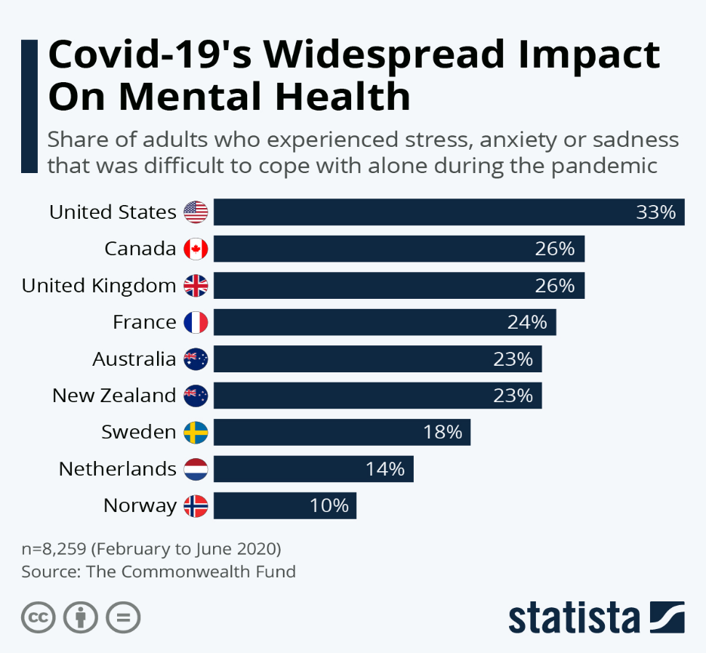
(figure one: source www.statista.com)

Technological Trends
AI and cybersecurity requirements are two trends within this area affecting Xhilo.
In the most recent years the hospitality Industry has relied heavily on Ai for things such as booking systems, personal guest experience, Marketing and customer interaction. (Sahota, 2024). Due to the ever evolving and rapid technological changes some employees may face difficulties in keeping up (Armstrong, 2020), which can lead to inconsistencies, low work morale and lack of confidence. To ensure a high standard of performance, staff engagement and high morale Xhilo should maintain frequent digital training so this is not a future problem.
Cybersecurity is also used in the ever-growing hospitality industry for HR records and customer data. Some employees may find keeping personal data intrusive or may not completely and confidentially know the data protection policies (Statista, 2025), which can lead to organisational problems moving forward. To prevent this Xhilo should maintain up to date cyber and GDPR training, create a framework and systems to limit access sensitive or protected information and data (Coursera, 2025). This will put employees at ease and confidence whilst avoiding conflict.

1.3 Flexible working
Within the hospitality industry flexible working is quite challenging as it’s an industry that require more in person/ face to face work ethic unless doing a more back of house role or face with a way of means of communicating internally and externally via stakeholders some of the Challenges that may be faced are scheduling conflicts which may involve trying to please staff request alongside company needs could create problems, There are different types of flexible working which include remote working where work can be done in any place outside the company work space and shift work which has specific set work timings (e.g. 9am-5pm, 6pm-11pm).Flexible working may cause Inconsistent customer experience quality which is where with various staff working flexible hours and days could affect the standard of service/experience which may become inconsistent. Another factor could be conflict between staff where certain staff members within their job role may be able to work remotely/hybrid and more flexible overall which may cause tension to those who cannot, Xhilo should organise and locate which roles are suitable for flexible working and which are not, so it is made clear when communicating this during interviewing process for the job. Allowing flexible working could heighten staff morale and motivate as it will suit individuals needs to perform better. (khan,1990). Post COVID “the great working from home experiment” (McPhail et al., 2023) showed evidence that this type of working was valued and in demand.

2. Evaluation of contemporary HR practices

2.1 Employment Engagement
When dealing with societal changes such as health issues and Globalisation good employee engagement is crucial. As suggested by Khan’s engagement theory employees engage more effectively and deeply when feeling supported, valued and psychologically safe. If employee engagement is not properly monitored and managed problems could occur and engagement could drop. To good and high employee engagement HR could organise team bonding activities/days, in house incentives, PERK packages which may include mental and physical aid, a motivated work culture where employees feel respected, recognised and know what is expected. As suggested by J.T Odonell “Give them a road map with milestones of what they should know and be capable of doing in the first 30, 60 and 90 days” (Digitalid, 2025).Taking care of the employees well being doing steps such as mindfulness and relaxation sessions (Swift Wellbeing, 2025) will ultimately have a positive outcome as when employees feel cared for, appreciated and recognised it is more likely to get a positive out come back, whereas treating individuals like robots with no compassion is more likely to get an negative outcome.
2.2 Learning and development- supported by Maslow’s Hierarchy of needs.
Continuous training needs to be maintained with Technological trends such as Ai and cybersecurity. Maslow’s Hierarchy of needs model suggests employees needs must have their basic needs satisfied before being able to move on to the next level of higher needs (5 levels, bottom to top) for example their safety and growth needs need to be met in order to work productively. If undertrained employees may feel anxious by the growing technology trends which may jeopardised employees’ sense of security. Xhilo can avoid this by implementing workshops such as refresher courses, digital skill courses, online and in person support and training. Having both online and in person gives the opportunity to do at own pace in own language and in person more confidence to ask questions and get a better understanding if feeling anxious. Doing this will boost confidence, consistency, performance and help with career development.

2.3 Motivation – Supported by Herzberg’s two factor Theory
Having employees being motivated is crucial to good performance, one influence is flexible working. Herzberg refers to two factors (motivators: Satisfiers and Hygiene: Dissatisfiers) For example Motivators such as Recognition and advancement whereas job security and work conditions would fall under hygiene. (Gimpl, 2025) Using clear and open communication whilst implementing flexible working hours could motivate employees as it creates a clear work life balance. It could also be seen as a hygiene factor if inconsistent and not fairly implemented which could lead to dissatisfaction and low motivation. To avoid dissatisfaction Xhilo should make sure communication is open, clear and implemented fairly to the job roles suited for this type of working.

3.Critical Evolution of Managerial Implementation

3.1 Leading by example
The manager role is where an individual is responsible for ensuring the continuous smooth running of a Xhilo, responsible for a team/group of people and making decisions to ensure the smooth running of the organisation to meet end goals. As suggested by (Dykstra, 2025) Managers are crucial for successfully implanting HR policies. They will oversee performance, communicate between higher management, staff and oversee strategic planning. The manager will oversee day to day running of Xhilo but also have an important hand in moulding high morale and work culture by implanting and leading by example (LinkedIn, 2025) showing health work ethic habits which will then goes on to lead to good performance outcomes and strengthens the team for Xhilo’s success moving forward.

3.2 Increasing and maintaining communication
Open and clear communication is vital in any company but especially when implementing flexible working arrangements and keeping staff UpToDate with changing technological trends. Managers should be able to report that employees are able to understand and carry out cybersecurity policies and new systems as well as understand rota changes overall this can prevent tension, anxiety, miscommunication and ensure a consistent and smoothing running of organisation operation.

Conclusion
This report has assessed how societal changes, Technological Trends and Flexible working arrangements impact Xhilo London. Supported by relevant academic Theories the report analysed HR practices such as employee engagement, learning and development and motivation. Also highlighted is how important the manager role is in leading by example and implementing these policies through open and clear communication and good leadership. For Xhilo London to successfully develop, lead and manage individuals and teams moving forward these factors need to focus on these factors.

Recommendations
The recommendations are that Xhilo should provide clear flexible working policies, therefore this is to prevent future conflict and miscommunication, maintain frequent training such as Digital and cyber security, implement employee incentives and wellbeing packages to make sure everyone no one struggling silence and support is on hand if needed. Support diverse culture and maintain clear and open communication whilst aligning with inclusive behaviours managers should upkeep frequent leadership and development training. To monitor performance and progress engagement surveys should also be introduced, by making these changes within the organisation will enhance employee morale, build confidence, enhance motivation, improve customer service quality and have a positive organisational impact moving forward.

References
1.World Health Organisation (2022) COVID-19 Pandemic triggers 25% increase in prevalence of anxiety and depression worldwide. Available at: COVID-19 pandemic triggers 25% increase in prevalence of anxiety and depression worldwide (Accessed: 12 December 2025)

2. Statista (2024) COVID-19 Mental Health- Statistics and Facts. Available at: https://www.statista.com/topics/7106/covid-19-and-mental-health/#topicOverview (Accessed:10 December 2025).
3. Insight Workplace Health (2025) 8 Strategies to promote Wellbeing in the Workplace. [online] Available at: Http://www.insightworkplacehealth.co.uk/post/8-strategies-promote-wellbeing-workplace [Accessed 15 December 2025].
4. Toronto School of Management (2018) The effects of globalisation on the Hospitality industry. Available at: https://www.torontosom.ca/blog/the-effects-of-globalization-on-the-hospitality-industry (Accessed 11 December).
5. Sahota, .N (2024) AI in Hospitality: Elevating the guest experience through innovation. Available at: https://www.forbes.com/sites/neilsahota/2024/03/06/ai-in-hospitality-elevating-the-hotel-guest-experience-through-innovation/ (Accessed: 10 December 2025).
6.Armstrong, M (2020) Armstrongs Handbook of human resources Management Practices.15th edn. London: Kogan Page.
7.statista (2025) Global Workforce Trends in Automation and AI. [online] Available at: https://www.statista.com/statistics/1557405/workforce-strategies-respond-ai/?srsltid=AfmBOorDDnP9E75ljbqKSXYwN19UvdbX1wu8SPKJF4sIAkJb4NwlV3U9 [Accessed 14 December 2025].
8. Coursera (2025) Cyber security in the Hospitality industry: Your 2026 Guide. Available at: Cybersecurity in the Hospitality Industry: Your 2026 Guide | Coursera (Accessed: 13 December 2025).
9. Khan, W.A (1990) Psychological Conditions of Personal Engagement and Disengagement of Work. Academy of Management Journal, 33, 692-724.
10. McPhail, R., Chan, X.W. (Carys), May, R. and Wilkinson, A. (2024) ‘post-COVID remote and its impact on people, productivity and the planet: Exploratory scoping review’, The international journal of Human Resource Management, 35:1, pp154-182. Doi: 10.1080/09585192.2023.2221385
11. Odonnel, J.T. (2025) Digitalid: Information. Available at: https://www.digitalid.co.uk/info/employee-onboarding-tips (Accessed:10 December 2025).
12. Gimpl, N. (2025) Herzberg’s Motivation-hygiene theory revisited in the age, Academy of management proceedings, Published 18 June. Doi:10.5465/AMProc.2025.11129
13. Dykstra, D. (2025) Leadership in Hospitality: Leading by example. Available:
https://www.linkedin.com/pulse/leadership-hospitality-leading-example-dustin-dykstra-gzcnc/ (Accessed: 11 December).
14. Swift wellbeing (2025) March Wellbeing awareness days: How to support your workplace. Available at: March Wellbeing Awareness Days | Wellbeing Ideas for Work (Accessed: 14 December 2025).

