Assignment feedback

Student Name: Broyan Dymond
Student University Email:
Module code: HPAR 6011  Module title: Funerary beliefs in Egypt | Student ID number:  1303350 |  | Educational support needs:  Yes
Assignment title: Object Catalogue Entry

Assignment due date:07/04/2019
Assignment Number: 1
(i.e. 1,2,3)
Marker’s signature: |  | Date:
Provisional.
NB. All marks are provisional until confirmed by the final examination board.

Object Catalogue Entry
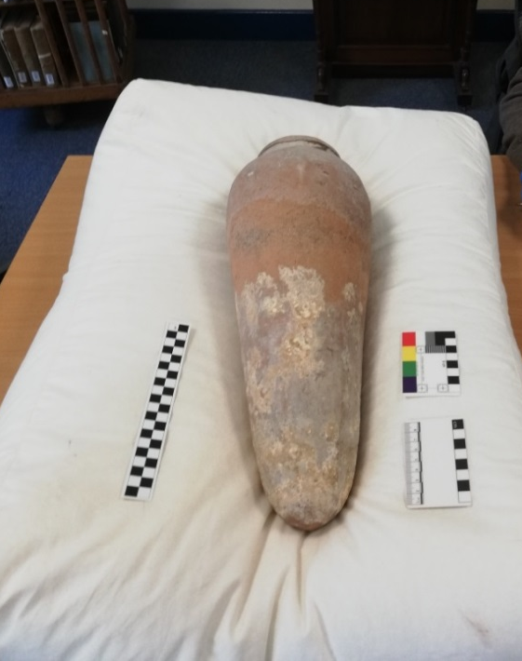
Museum number:
Cyfarthfa Castle, Merthyr Tydfil CCM 326.004
Object type: Pottery: Beer Jar
Material: Clay
Date: Circa First Dynasty (3100 to 2686 BC)
Provenance: Ancient Egypt
Measurements:
Full length: 48cm
Widest point: 17cm
Narrowest point: 4cm
Width at opening: 11cm
Object analysis by Broyan Dymond
Description
This is a large ovoid jar (Wodzińska, 2009, pp. 4,5), well preserved for its estimated age. It is difficult to date the jar from visual inspection alone and therefore comparison with other finds can provide more information about its date.
The top part of the jar has a slight curve and a small lip. According to the typology suggested by Wodzinska (2009:6) this vessel fits with type J7. The base of the jar is rounded as was the usual design at the time (Wodzińska, 2009, p. 5).
A little over half of the jar, at the base, is covered in residue. It is an example of Egyptian clay pottery (Wodzińska, 2009). There are two types, this can tell us where the jars were produced. Nile silt pottery is a darker, reddish colour and it is found on the banks of the Nile. This jar is lighter in colour, therefore it is made from marl clay or desert clay, thought to have originated from somewhere along the valley from Esna to Cairo at the edges of the Nile Delta (Finch**, 2017, p. 2). A similar jar can be seen in the Liverpool Museums collection, dating back to 2181BC-1976BC (Liverpoolmuseums, 2019).
It has been described as a beer jar in the catalogue but there is no evidence of the original contents. It is possible it may have been used to transport liquids, for example, olive oil, water and beer (Finch**, 2017, p. 2). One theory is that it was used to hold beer, as the origin of beer drinking was at around the same time as the possible dates of the jar (Seawright, 2013). One suggestion is that the sediment on the outside of the jar is possibly beer as it is ‘yeasty’ in appearance. However, without scientifically testing (using a mass spectrometer (Finch**, 2017, p. 2)) there is no way to know this, but it may be that this is why it was described as a beer jar.
Beer was important to Ancient Egyptians and enjoyed by both adults and children. It was their staple drink as the water from the Nile was not suitable to drink. There were offerings of beer made to their gods (Mark, 2017). As the Egyptians required food and drink in their present life they also needed provisions for the afterlife as well because of their beliefs (H.Taylor, 2001, p. 92). Funerary goods such as jars of various sizes have been found in tombs in such places as Saqqara tomb 3503, where jars of provisions surrounded the coffin (Grajetzki, 2003, pp. 7-9).

Funerary feasts took place throughout Egyptian history, the example is thought to be traced back to the First Dynasty burial customs (3000BC) (Grajetzki, 2003, p. 7). There was a social importance to the funerary feasts. This was a time when alliances and social relationships were built on and reinforced (Tassie, 2010, p. 65). Illustrations on tombs, such as that of Rameses III, show preparations of bread and staple foods, ready for the passing into the afterlife (Attia, 2017, p. 5).
Ancient Egyptians believed that the body was essential for entry into the afterlife. Preparation of the body went through a number of steps towards mummification. The ka was a non-physical aspect of the person (for example soul or spirit) and was thought to link all the generations of a family (H.Taylor, 2001, pp. 16-19). Another aspect of the body of the Ancient Egyptians is the ba, similar to the ka, but the ba is the process by which the dead could leave the tomb and reach the netherworld. The ba can eat and drink, speak and move, it can visit the world of the living or travel to visit the sun god in the sky (H.Taylor, 2001, pp. 20,21). It is precisely because of their belief in the human-like abilities of the ba that the funerary feasts were so important to the Ancient Egyptians.
In conclusion, there is no real idea what the jar was used for or what the contents were. Was it used for beer, oil or water? There were no contents or evidence of the substance which was contained within. Without testing for the age of the vessel, all that can be deduced is by comparison with similar types of vessels which have been dated, such as the one in Liverpool museum. The location of the production of the jar can be guessed by the type of clay which has been used. This is defined by the colouring of the jar, a lightish shade, suggesting marl or desert clay. It can only be assumed that this jar was found in an assemblage of grave goods. This is possibly a fine example of well-preserved grave goods.

Bibliography
Ancient Egyptian online, 2019. Ancient Egyptian online. [Online]
Available at: file:///F:/Egyptian%20Burial/Ancient%20Egypt%20Society_%20Beer.html
[Accessed 20 03 2019].
Attia, V. I., 2017. Bread in Ancient Egypt Bread in Ancient Egypt. : https://www.researchgate.net/publication/316587464, Volume 1, pp. 1-6.
Boyle, M. C. a. S., 2019. British MuseumBlog. [Online]
Available at: file:///F:/Egyptian%20Burial/A%20sip%20of%20history_%20ancient%20Egyptian%20beer%20%E2%80%93%20The%20British%20Museum%20Blog.html
[Accessed 20 03 2019].
edited by Fred Hocker, 2006. Vasa 1: The Archaeology of a Swedish Warship of 1628. Stockholm: Oxbow Books.
Egyptian Burial/Ancient Egyptian pottery, 2013. file:///F:/Egyptian%20Burial/Ancient%20Egyptian%20pottery.html. [Online]
Available at: file:///F:/Egyptian%20Burial/Ancient%20Egyptian%20pottery.html
[Accessed 20 03 2019].
Finch**, A. H. a. P., 2017. A chemical study of the contents of an Early Dynastic Egyptian storage jar. Pharm Hist (Lond), Volume https://www.ingentaconnect.com/content/bshp/ph/2017/00000047/00000001/art00001?crawler=true, pp. 1-6.
Grajetzki, W., 2003. Burial Customs in Ancient Egypt. London: Duckworth.
H.Taylor, J., 2001. Death & the afterlife in Ancient Egypt. London: British Museum Press.
Liverpoolmuseums, 2019. Liverpoolmuseums.html. [Online]
Available at: file:///F:/Egyptian%20Burial/Beer%20or%20Water%20Jar,%20Ancient%20Egypt%20collection%20-%20World%20Museum,%20Liverpool%20museums.html
[Accessed 20 03 2019].
Mark, J. J., 2017. Beer in Ancient Egypt. [Online]
Available at: https://www.ancient.eu/article/1033/beer-in-ancient-egypt/
[Accessed 24 3 2019].
Seawright, C., 2013. Ancient Egyptian Alcohol: Beer, Wine and the Festival of Drunkenness. [Online]
Available at: file:///F:/Egyptian%20Burial/Ancient%20Egyptian%20Alcohol_%20Beer,%20Wine%20and%20the%20Festival%20of%20Drunkenness.html#.XJe8FiL7TIV
[Accessed 20 03 2019].
Tassie, G., 2010. Funerary feasts and the function of early offering dishes. https://www.academia.edu, pp. 60-72.
Wodzińska, A., 2009. A Manual of Egyptian Pottery. In: Volume 2: Naqada III–Middle Kingdom. New Hampshire,: Puritan Press., pp. 1-245.

