Student Name: CHIRAG ARVING KAPADIA
Student ID: 2521160
Module Name: Marketing Management
Module Code: LCMB7024
Lecturer’s Name: Laila Maazouz & Dian Mayasari

Work Count:2500
Term 1

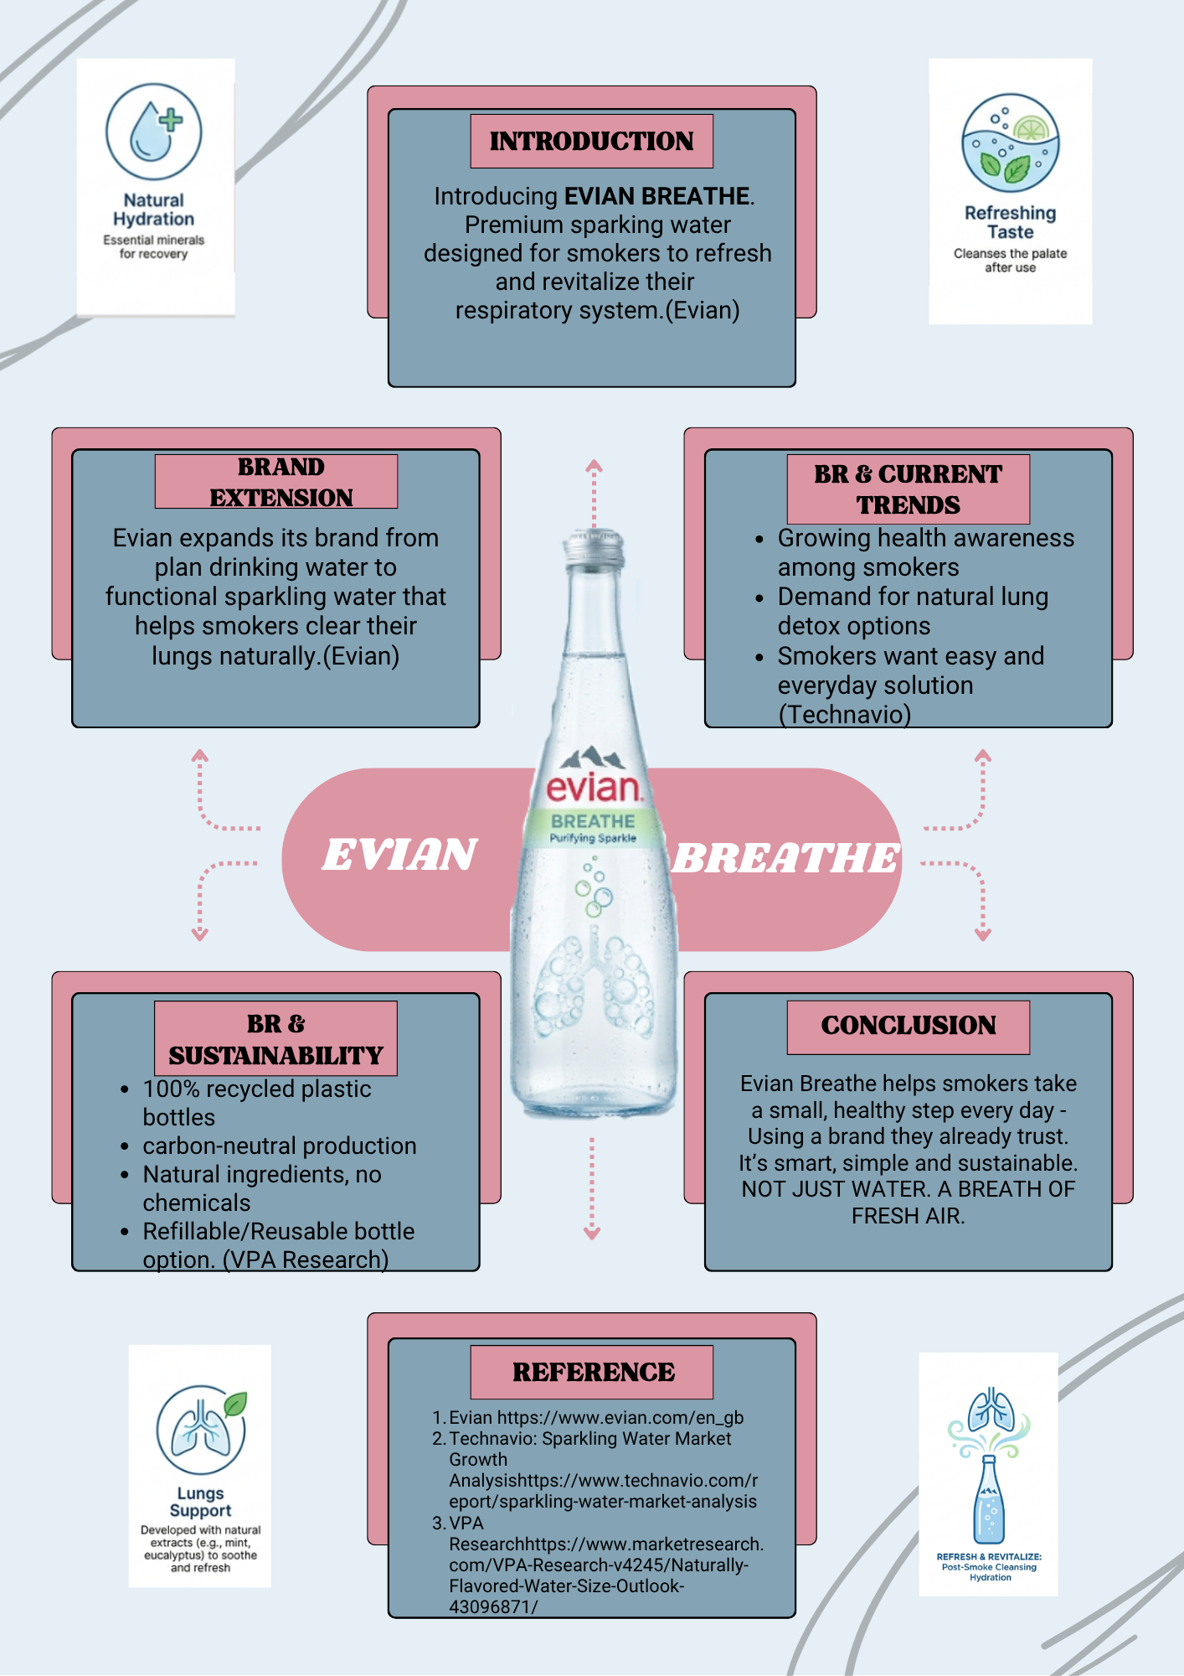

Poster Explanation
Brand Extension Evian, a well-established premium drinking water brand owned by Danone, has extended its product line by launching Evian Breathe — a functional sparkling water specifically designed for smokers. This moves Evian beyond plain hydration into the functional wellness beverage space, targeting a niche audience seeking natural respiratory support. The product incorporates natural extracts such as mint, eucalyptus, and other botanicals to help soothe and refresh the lungs after smoking. Rather than being just water, Evian Breathe positions itself as a daily health companion for smokers looking for an easy, accessible recovery option(Evian)
Market Appeal and Emerging Trends The extension responds directly to three growing market trends. First, there is increasing health consciousness even among smokers, who are actively seeking products that minimise harm. Second, consumers are demanding natural lung detox and cleansing solutions without pharmaceutical intervention. Third, people want simple, everyday solutions that fit seamlessly into their routines. Evian Breathe meets all three needs by offering a familiar, trusted product in a new functional format — making healthy choices feel effortless.( Technavio)
Sustainability Alignment Evian Breathe is designed with strong sustainability commitments. The product uses 100% recycled plastic bottles, supports carbon-neutral production, and is made from natural ingredients with no chemicals. A refillable and reusable bottle option is also available, reducing single-use plastic waste. These efforts align with Danone's broader environmental goals and appeal to eco-conscious consumers.( VPA Research)
STDP Analysis: Evian Breathe

1. Segmentation
Market segmentation divides the broad consumer market into smaller, more defined groups. For Evian Breathe, four key segmentation variables are used.

Geographic Segmentation
Evian Breathe would be targeted primarily in urban and suburban areas across developed markets such as Western Europe, North America, and parts of Asia-Pacific. Cities with high smoking rates and growing wellness cultures — such as London, Paris, Tokyo, and New York — represent the strongest opportunities. Urban consumers tend to have greater access to premium beverage products and are more exposed to health messaging (Kotler and Keller, 2016). Additionally, countries where smoking remains culturally common but health awareness is simultaneously rising, such as Japan and South Korea, present significant geographic opportunities for this functional water product.
- Urban and suburban areas in Western Europe, North America, Asia-Pacific
- High smoking rate cities — London, Paris, Tokyo, New York
- Markets where health awareness is rising alongside smoking culture

Demographic Segmentation
The primary demographic target for Evian Breathe includes adults aged 18–45 who are current or occasional smokers. This age range is significant because younger adult smokers (18–30) are increasingly health-aware and open to wellness products, while older smokers (31–45) are more likely to seek practical, everyday health solutions. The product appeals across both genders, though marketing may lean slightly towards males given higher global smoking rates among men (World Health Organisation, 2023). In terms of income, Evian Breathe targets middle to upper-middle income consumers who are willing to pay a premium for a functional beverage. Education level also plays a role, as more educated consumers tend to be more aware of the health risks of smoking and more motivated to seek supportive products (Armstrong et al., 2020).
- Adults aged 18–45, current or occasional smokers
- Middle to upper-middle income consumers
- Appeals to both genders, slight lean towards males
- More educated consumers aware of smoking health risks

Psychographic Segmentation
Psychographic segmentation focuses on lifestyle, values, and personality. Evian Breathe appeals to smokers who identify as health-conscious but realistic — people who acknowledge their smoking habit but still want to take small, manageable steps toward better health. These consumers value natural ingredients, distrust synthetic or chemical-based health products, and prefer solutions that feel premium and trustworthy. They are likely to follow wellness trends, read health content online, and be influenced by social media health communities. This segment can also include eco-conscious consumers who care about sustainable packaging and responsible production, aligning well with Evian Breathe's use of recycled bottles and carbon-neutral manufacturing (Evian, n.d.).
- Health-conscious but realistic smokers
- Values natural ingredients, distrusts chemicals
- Follows wellness trends and social media health content
- Eco-conscious consumers who care about sustainability

Behavioural Segmentation
From a behavioural perspective, the core user is someone who smokes regularly or semi-regularly and is already in the habit of purchasing bottled water or wellness beverages. These consumers seek functional benefits beyond basic hydration — specifically respiratory refreshment and palate cleansing after smoking. They are brand-loyal consumers, likely already familiar with and trusting of the Evian brand. Occasion-based segmentation is also relevant here: consumption would likely occur after smoking, making it a habitual, daily-use product. Consumers motivated by health benefits and convenience are particularly relevant, as Evian Breathe offers an effortless wellness solution requiring no change in routine (Technavio, n.d.).
- Regular or semi-regular smokers
- Seek functional benefits beyond basic hydration
- Consume after smoking — habitual daily use
- Already brand-loyal Evian customers
- Motivated by health benefits and convenience

2. Targeting
Based on the segmentation analysis, Evian Breathe adopts a concentrated targeting strategy, focusing on one well-defined segment: urban, health-aware adult smokers aged 18–45 in developed markets. This group is large enough to be commercially viable yet specific enough to allow focused and effective marketing. They are already purchasing premium beverages, meaning the barrier to switching or adding Evian Breathe to their routine is relatively low. Their desire for natural, easy health solutions means the product directly meets an existing, unmet need. Targeting this group through digital platforms, gym and wellness spaces, and convenience retail outlets in urban areas ensures maximum reach within the segment (Armstrong et al., 2020).
- Concentrated targeting strategy — one focused segment
- Urban, health-aware adult smokers aged 18–45
- Already purchasing premium beverages
- Reached via digital platforms, wellness spaces, urban retail
- Low barrier to adding product to existing routine

3. Differentiation
Evian Breathe differentiates itself from competitors on three key dimensions. First, product uniqueness — unlike standard sparkling waters or generic functional drinks, Evian Breathe is specifically formulated for smokers, incorporating natural extracts such as mint and eucalyptus to support respiratory refreshment. No major competitor currently occupies this precise niche, giving Evian a first-mover advantage (Evian, n.d.). Second, brand trust — Evian is a globally recognised, premium water brand with decades of consumer trust. Launching a functional extension under this brand immediately transfers credibility, something new entrants cannot replicate easily (Kotler and Keller, 2016). Third, sustainability credentials — with 100% recycled bottles, carbon-neutral production, and natural ingredients, Evian Breathe stands apart from competitors who may not prioritise environmental responsibility. This is an increasingly important differentiator as consumers reward brands that align with their values (VPA Research, n.d.).
- Only sparkling water specifically made for smokers
- Contains mint and eucalyptus for respiratory refreshment
- First-mover advantage — no direct competitor in this niche
- Backed by decades of Evian brand trust
- Strong sustainability credentials — recycled bottles, carbon-neutral
- More accessible and habitual than pharmaceutical alternatives

4. Positioning
Evian Breathe is positioned as a premium, natural, and purposeful functional water — "Not Just Water. A Breath of Fresh Air." It occupies a space between everyday hydration and wellness supplementation, sitting above standard sparkling waters in perceived value but remaining more accessible and habitual than pharmaceutical or supplement-based alternatives. The positioning communicates that smokers do not need to make dramatic lifestyle changes to care for their health — simply replacing or supplementing their water intake with Evian Breathe is a smart, simple, and sustainable step. This positioning leverages Evian's existing premium image while adding a meaningful, functional layer that speaks directly to a growing, underserved consumer need (Technavio, n.d.).
- Positioned as premium, natural, purposeful functional water
- Tagline: "Not Just Water. A Breath of Fresh Air"
- Sits above standard sparkling water in perceived value
- More accessible than supplements or medical products
- Communicates small, easy, daily health steps for smokers
- Leverages Evian's premium image with added functional purpose

Marketing Mix (7Ps) Analysis: Evian Breathe

1. Product
Evian Breathe extends the brand into functional wellness by offering sparkling water specifically made for smokers. It uses natural ingredients to deliver real health value beyond basic hydration (Kotler and Keller, 2016).
- Functional sparkling water infused with mint and eucalyptus for smokers
- Delivers hydration, respiratory refreshment, and brand prestige
- Sleek glass bottle with lung bubble imagery and "Purifying Sparkle" branding
- 100% natural ingredients, no chemicals
- Extends Evian beyond plain water into functional wellness category

2. Price
A premium pricing strategy is chosen to reflect the product's functional benefits, natural ingredients, and trusted brand name. The price must feel justified to health-conscious consumers willing to invest in their wellbeing daily (Armstrong et al., 2020).
- Premium pricing strategy reflecting functional benefits and brand heritage
- Suggested retail price £2.50–£3.50 per bottle
- Sits above standard sparkling waters but below pharmaceutical products
- Value-based pricing — price reflects perceived health value and sustainability
- Multipack options available to encourage daily habitual use

3. Place
Distribution is carefully selected to match where health-conscious urban smokers shop and spend time. Using Danone's existing global network allows fast and efficient market entry across multiple countries (Baines, Fill and Rosengren, 2017).
- Premium supermarkets — Waitrose, Whole Foods, Marks & Spencer
- Gyms, pharmacies, and health stores — reinforcing wellness positioning
- Urban convenience stores — targeting on-the-go city smokers
- Online direct-to-consumer — Evian website and Amazon Fresh
- Uses Danone's global distribution network for international reach

4. Promotion
An integrated marketing communications approach ensures the brand message reaches the target audience consistently across all platforms. Every promotional activity reinforces the same core idea — natural, easy, daily respiratory care (Fill, 2013).
- Social media — Instagram, TikTok, YouTube targeting 18–35 smokers
- Influencer partnerships with authentic wellness advocates
- Sampling campaigns in gyms, urban areas, and entertainment venues
- Point-of-sale displays in pharmacies and premium supermarkets
- Consistent message across all channels — "Not Just Water. A Breath of Fresh Air"

5. People
Although Evian Breathe is a packaged product, the people behind it — from retail staff to brand ambassadors — play a vital role in communicating its benefits and building consumer confidence in the product's wellness claims (Zeithaml, Bitner and Gremler, 2018).
- Retail staff trained to understand and recommend the product
- Brand ambassadors — authentic, wellness-focused influencers
- Danone's sales and marketing teams securing premium shelf placement
- People element critical in building consumer trust and awareness

6. Process
Efficient and sustainable processes are essential for delivering on the brand's promises around quality and environmental responsibility. Consistent production processes protect both product integrity and brand reputation (VPA Research, n.d.).
- Efficient supply chain using Danone's global network
- Carbon-neutral manufacturing and 100% recycled materials
- Seamless online ordering and delivery for direct consumers
- Strict quality control ensuring consistent natural ingredient formulation

7. Physical Evidence
For a premium wellness product, physical appearance matters greatly. The bottle design and packaging are the first things consumers see, and they must instantly communicate quality, purpose, and sustainability to justify the premium price (Kotler and Keller, 2016).
- Premium glass bottle with distinctive lung bubble design
- Clean minimal label — "Breathe — Purifying Sparkle"
- Packaging clearly labelled as 100% recycled and eco-friendly
- In-store displays reflecting premium wellness aesthetic
- Bottle design stands out on shelves and reinforces brand value

Reflection – Evian Breathe Brand Extension

Developing the Brand Extension
Working on the Evian Breathe brand extension was a highly valuable learning experience. At the beginning, I found it challenging to think beyond Evian's traditional identity as a plain water brand and imagine how it could serve a completely new and specific audience. However, through research and applying marketing frameworks, I gradually developed confidence in building a product concept that felt both realistic and innovative.
One of the most important things I learned was how a strong existing brand can be extended meaningfully when it is grounded in genuine consumer needs. Evian Breathe was not created randomly — it was built around a real and growing market gap: health-conscious smokers seeking natural, everyday wellness solutions. This taught me that successful brand extensions must always start with the consumer, not the product. Understanding the target audience deeply — their lifestyle, values, and daily habits — was essential to making the brand extension feel credible and relevant.
Applying the STDP framework helped me structure my thinking clearly. Segmentation taught me to look at consumers from multiple angles — not just age or income, but also their values, behaviours, and motivations. Targeting then helped me focus rather than try to appeal to everyone, which is a common mistake in marketing. Differentiation and positioning made me think critically about what makes Evian Breathe genuinely different and why a consumer would choose it over alternatives (Armstrong et al., 2020).

Preparing and Delivering the Poster Presentation
Preparing the poster presentation was both exciting and challenging. Condensing a complex marketing strategy into a single, visually clear poster required strong communication and design thinking skills. I had to make difficult decisions about what information was most important and how to present it in a way that was easy to understand at a glance. This process improved my ability to communicate complex ideas simply and visually, which is an essential professional skill in marketing and business. I also developed greater attention to detail, ensuring every element of the poster — from the bottle design to the layout of information boxes — communicated the brand's identity consistently.

Skills and Knowledge Gained
- Deeper understanding of brand extension strategy and consumer-led thinking
- Practical application of STDP, SWOT, and 7Ps frameworks
- Improved visual communication and design skills through poster creation
- Stronger ability to research, evaluate, and apply academic sources
- Greater awareness of sustainability in marketing and its growing importance to consumers (VPA Research, n.d.)

Personal and Professional Development
This project pushed me to think like a real marketer — balancing creativity with strategic logic. I became more confident in justifying marketing decisions using evidence and theory rather than just personal opinion. It also highlighted the importance of sustainability and ethical marketing, particularly when targeting a vulnerable consumer group like smokers. Understanding how to market responsibly — offering genuine value rather than exploiting habits — is a lesson I will carry forward professionally

Future Improvements
Reflecting honestly, there are several areas I could improve in future projects. First, I would conduct primary research such as surveys or focus groups with actual smokers to validate my assumptions about the target market. Relying only on secondary sources limits the depth of consumer insight. Second, I would explore competitor analysis more deeply, mapping out existing functional beverage brands more thoroughly to sharpen the differentiation strategy. Third, in terms of presentation delivery, I would practise speaking confidently about each section rather than relying heavily on the poster itself, as strong verbal communication is just as important as visual content in professional settings.
Overall, this project was one of the most complete marketing exercises I have undertaken. It combined creativity, research, strategic thinking, and communication — all core competencies for a future marketing professional. The experience of developing Evian Breathe from a simple concept to a fully justified brand extension has significantly strengthened both my academic understanding and my practical marketing skills.

Reference :
- Evian (n.d.) Evian mineral water. Available at: https://www.evian.com/en_gb
- Technavio (n.d.) Sparkling water market growth analysis. Available at: https://www.technavio.com/report/sparkling-water-market-analysis
- VPA Research (n.d.) Naturally flavoured water size outlook. Available at: https://www.marketresearch.com/VPA-Research-v4245/Naturally-Flavored-Water-Size-Outlook-43096871/
- Kotler, P. and Keller, K.L. (2016) Marketing Management. 15th edn. Harlow: Pearson Education.
- World Health Organisation (2023) Tobacco. Available at: https://www.who.int/news-room/fact-sheets/detail/tobacco
- Evian (n.d.) Evian mineral water. Available at: https://www.evian.com/en_gb
- Technavio (n.d.) Sparkling water market growth analysis. Available at: https://www.technavio.com/report/sparkling-water-market-analysis
- Armstrong, G., Kotler, P., Harker, M. and Brennan, R. (2020) Marketing: An Introduction. 4th edn. Harlow: Pearson Education
- VPA Research (n.d.) Naturally flavoured water size outlook. Available at: https://www.marketresearch.com/VPA-Research-v4245/Naturally-Flavored-Water-Size-Outlook-43096871/
- Technavio (n.d.) Sparkling water market growth analysis. Available at: https://www.technavio.com/report/sparkling-water-market-analysis
- Kotler, P. and Keller, K.L. (2016) Marketing Management. 15th edn. Harlow: Pearson Education.
- Armstrong, G., Kotler, P., Harker, M. and Brennan, R. (2020) Marketing: An Introduction. 4th edn. Harlow: Pearson Education.
- Baines, P., Fill, C. and Rosengren, S. (2017) Marketing. 4th edn. Oxford: Oxford University Press.
- Fill, C. (2013) Marketing Communications: Brands, Experiences and Participation. 6th edn. Harlow: Pearson Education.
- Zeithaml, V.A., Bitner, M.J. and Gremler, D.D. (2018) Services Marketing: Integrating Customer Focus Across the Firm. 7th edn. New York: McGraw-Hill Education.
- VPA Research (n.d.) Naturally flavoured water size outlook. Available at: https://www.marketresearch.com/VPA-Research-v4245/Naturally-Flavored-Water-Size-Outlook-43096871/

