Effective Team Working for Team success
ISKRA TSVETANOVA VALKOVA -2026742

University of Wales Trinity Saint David
Team working and communications
Lector: Dale Clarke

1.Abstract

The main purpose of this report is to outline the developmental stages a team is going through exploring some common developmental models such as Tuckman’s and Wheelan’s. This model will be investigated and compared in order to be found the most appropriate one for developing a productive team, will be discovered what impact an effective team working can have in the health and social settings (visualising the Trinity Social Care home in this particular report). The report will highlight the damages that a dysfunctional team can cause to a company’s reputation. It will be analysed the types of roles that are needed for creating a cohesive and effective team. The importance of a solid and effective leadership.

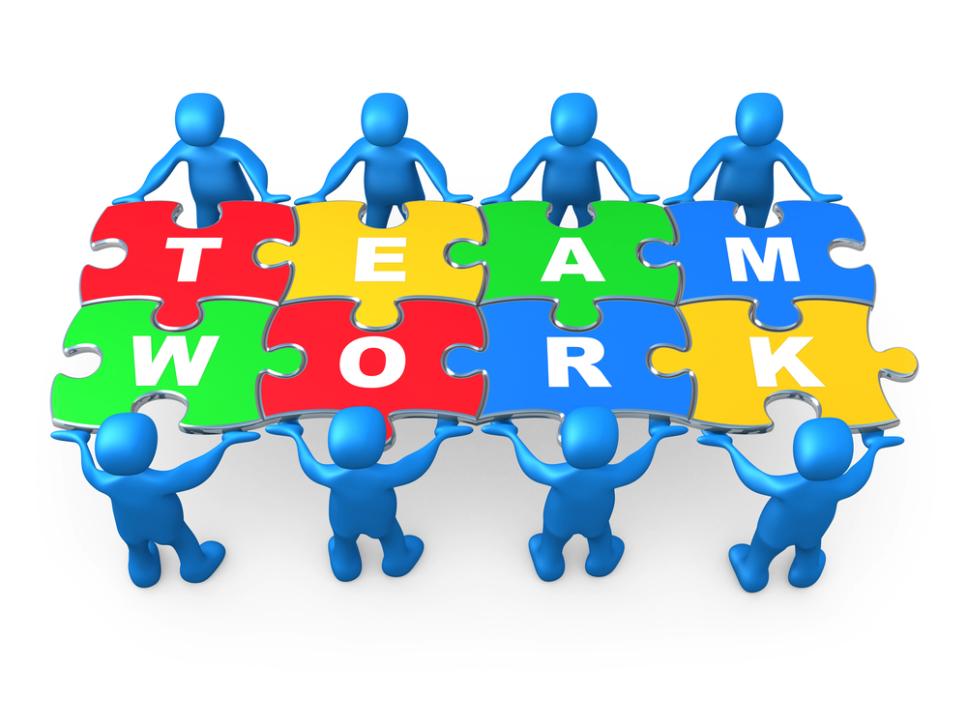

2.Table of contents

1.Abstract 1
2.Table of contents 2
3. Introduction 3
4. Main body 4
4.1 Overview of team working 4
4.2 Models of team development 5
4.2.1 6
4.2.2 6
4.2.3 6
4.2.4 6
4.2.5 6
4.3 6
4.3.1 7
4.3.2 7
4.3.3 7
4.3.4 7
4.3 Team roles 8
4.4 Discussion 10
4.4.1 Advantages of team working 10
4.4.2 11
5. Conclusion 13
6. Reference list 14
7. Appendicies 16

3. Introduction
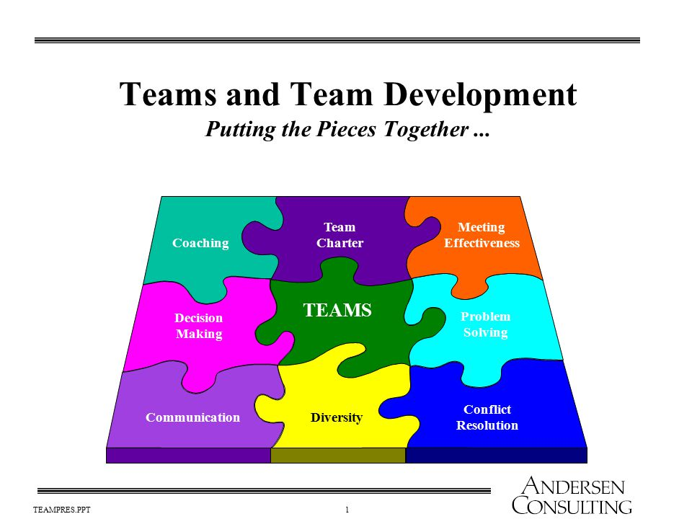

A group evolves in a team facing a lot of difficulties and grate effort of its members and going through a lot of stages in order to be upgraded into a team. “A team is a number of individuals working as one to achieve a particular goal to which they are mutually committed”. (Morgan,2017 , p 204)

(Teams and Team Development
Putting the Pieces Together 2015)

The individuals participating in that group might have differences in terms of their interests, personalities, nationality and abilities, like is the case with the staff of the Trinity Social care home. The staff members in the care home are from different gender, demographics, age, background and experience. This diversity causes a lot of issues between the team members, however there is something that brings them together and this is the mutual aim to accomplish their target to become a successful team to benefit themselves and the residents of that home.

Looking into Tuckman’s and Wheelan’s developmental models will help understand the changes and manage expectations in the evolution of their group into a productive and cohesive team. Tuckman model describes the development team the same way as a society is develop. He uses stages of acceptance to highlight the evolution of a successful team. On the other hand, Wheelan outlines his framework as how a child will develop within a home. Both models are very beneficial to illustrate and describes the growth of a team

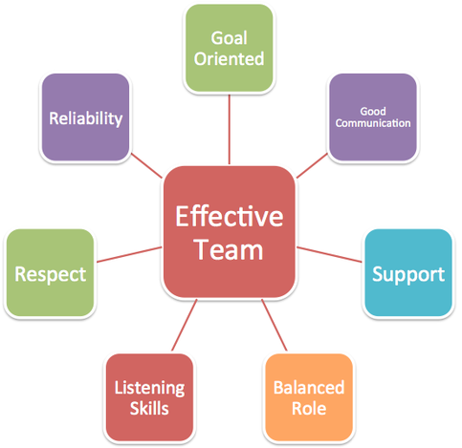
4. Main body

4.1 Overview of team working

Every organisation needs a good team work to function and provide high quality of work. In a care home, for instance, having good team members that can work together and supply good level of care to the residents and their relatives is a necessity.

Team is a group of people with common goal. What defines the team from the group is the mutual commitment and the desire to pursue a certain aim no matter their differing personalities, ethnicity, social background and interests. Each one of them needs to contribute equally and to the best of their abilities to ensure a normal and beneficial work environment be established. The diversity in a Trinity Care home can be quite challenging and it is up to the team leader / management to organise and give the appropriate guidance so that good communications and effective teamwork are structured. However, the team members need to be wiling that change to happen in order to succeed.

The progress from a group to an effective team can be accomplished by giving everyone equally workload and allocating team members according to their strength and skills so the tasks can be done faster and easier. One successful team leader needs to step back from the team at one point and let them find the best way of working together. Good management is when everyone knows what they are doing but there is someone they can rely on if needed, someone easily approachable but not necessarily irreplaceable. In other words, to not depend on the care leader as much. Good partnership between the team will be beneficial to increase patient safety, reduce medical errors, improve patient mortality rate, reduce stress levels and improve job satisfaction.

Employees usually pass-through predictable evolution to become a successful team member, which is clearly presented in several developmental models
that will be used in our report.

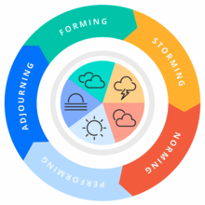
4.2 Models of team development

In this report two developmental models will be used as mentioned above-Tuckman’s and Wheelan’s.

Tuckman’s team model has been proposed by the psychologist Bruce Tuckman in 1965. It represents one of the most famous theories of team developments composed by five stages: Forming, Storming, Norming, Performing and Adjourning.

4.2.1 During the forming phrase the members of the group might feel anxious and hesitant as they are new to each other. They are still getting acquainted and trying to learn their new roles and responsibilities. During that stage the role of the team leader is quite important. The management needs to give directions, explain in detail and provide emotional support as well as guidance.

4.2.2 The storming phase is the second stage of team development. The members of the group feel more competitive and tense, they start disagreeing with each other, are trying to find their place in the group or even form cliques. During that stage it is required the team leader to facilitate conversations and maintain the good atmosphere among the newly formatted team members.

4.2.3 The Norming stage characterises with the now effective work of the team members when they demonstrate mutual respect and agree on the team roles they have already established. They respect each other’s opinion and start making progress on their project. The team members do not rely on the team leader so much, they help each other in order to achieve their goal.

4.2.4 During the performing stage, the team performs at high level. They make decisions and solve problems quickly and effectively and can work independently without any additional support. The team structure now is fully functional and accepted and the team energy has moved from getting to know and understand each other to performing the task at hand. The task is already heading towards its successful ending.

4.2.5 The Adjourning stage represents the team success. The team now celebrates its victory, but this stage might bring some sad feelings as well among its members. Some people might feel depressed over the loss of their friendships as team is breaking down now as the target is completed.

4.3 The other developmental model that will be explored is The Wheelan’s integrated model of team development. It is quite similar to Tuckman’s, however Susan Wheelan also describes the relationship of the group members during four proposed key stages of team development. Her model is built on Tuckman’s but also based on her own research. In other words, she is taking his theory further. According to Wheelan, the groups can mature simply by working together, she links the progress of development with the length of time the members spend together.

4.3.1 The first stage is called dependency and inclusion; it represents the forming of the team. The performance improves as the members start to understand their roles clearer.

4.3.2 The second stage is described as counter dependency and fight. It represents the adulthood of the group. The team members have got certain tasks allocated and are orientated in performing them.

4.3.3 Stage three is the adolescence of the group. Here the members are very well orientated, they even start fighting between each other and challenge the team leader’s authority. Cliques are formed and disagreement is demonstrated. Increased trust is maintained at the end of the stage.

4.3.4 The infancy is the last stage of team development according to Susan Wheelan. It characterises with work and productivity; the team members are dependent on the team leader’s support and are even frightened not to get rejected by the team. The team implement their ideas now and can focus on the goal achievement.

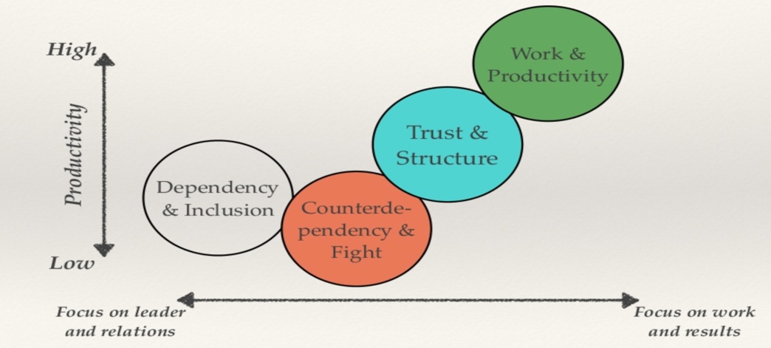
(” Integrated Model of Group Development” by Susan Wheelan)

In other words, Tuckman’s model highlights the importance of a team to be independent as possible and to not rely on leader. Tuckman outlines how a team member will be accepted in a small society and what stages they will go through. Wheelan’s framework is contrasting to Tuckman’s. She beliefs that the team leader/ manager functions as a parent figure and it takes all the decisions for the team. However, this is not always beneficial in decisions making, because it can jeopardise the quality of the outcome.) (. Ian James Wright, 2016,)

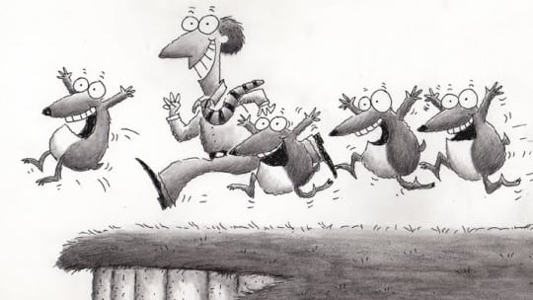

4.3 Team roles

Creating productive and more balanced team can be done observing your employees’ personalities, observing how they interact with one another, finding out how they can contribute into building a successful team and matching their behaviour to Belbin’s model. Meredith Belbin suggests that ‘ by understanding your role within a particular team, you can develop your strengths and manage your weakness as a team member”( Belbin, M. (2016) Team role circle).

Belbin identifies nine team role models, who can be defined by completing Belbin’s Self-Perception Inventory. This can generate and individual report that can be used my managers or team leaders in order to allocate the right person to the right task. The team members then can support each other to overcome their personal weaknesses to ensure the best possible contribution to the team.

The ideal team should be balanced if consisting of all nine types of team roles. Team personalities may mature with experience and develop into one another if monitored and guided by a proper management. Sharing the team roles will benefit the strengths of the team members and will increase their understanding about each role which will lead to a better performance.

Forming a team is very crucial to the success of the company’s goal. The recruitment of individuals plays significant role here. The management needs to consider what individual will benefit the team in order to accomplish the tasks that are given. The management of Trinity Care home can assign different team roles according to the staff’s individuality and experience.

4.4 Discussion

4.4.1 Advantages of team working
Daniel Coyle’s book “The Culture Code “written in 2018 identifies the secrets of successful groups and discusses how this develops into successful teams. He has made studies according to which the more successful are the groups that focus on the outcome, not being distracted by the management factor. For building strong team Coyle presents three skills that are essential:

Build safe environment. This means that the work atmosphere must be appropriate for the team members to be able to share their ideas without being afraid of negative feedback. Regardless of their team roles everyone should feel free to express their opinion and that is equally important.

Share vulnerability. As a team leader you have given individual feedback to every person of your team, point out their strengths and weaknesses and give them guidance of how they can improve themselves, thus creating mutual trust and positivity and making plans how to move forward. For example, in Trinity Care Home the management can have “in the moments” meetings for each individual, where it can be discussed their feedback for each shift.

-Establish Purpose. The team leader/ manager of Trinity Care Home needs to name and rank the team’s priorities, by putting posters on the walls, sending emails, asking the team members questions regarding the team’s mutual purpose and desired goals. “Culture is set of living relationships working towards a shared goal”. To be able to make all of that happen the team leader first needs to be very observant and a good listener. The leader needs to make eye contact with his employees, connect physically with them by giving them hugs, make them feel safe and important, listen to their ideas, support them and offer them alternative paths. Coyle’s analyses provide better understanding of how the people work together and how they can build a productive work environment.

Wheelan(2014) also outlines some key advice for group members. Susan Wheelan covers why teams are important, how they function and what makes them productive. The points out that the organisations play a huge role in helping the groups to become effective. She follows eight principles in accomplishing that mission. According to Wheelan every organisation should define their target and explain it clearly to the group, encourage new ideas, value its employees and believe in their success. Also, make the organisational members value the quality of work, pay attention to every detail and set clear expectations guidelines to increase the team members’ chances of success.

Finally, reward teamwork rather than individual performance. Wheelan also teaches not to blame others for group problems, encourages the establishment of norms that support productivity, innovation and freedom of expression, balancing task communications and supportive communications.

In (page 131, 2016 Wheelan) states that the smaller groups tend to be more productive as everyone is having the chance to participate in the decision making, while in larger groups not all the members would have the opportunity to express their thoughts.

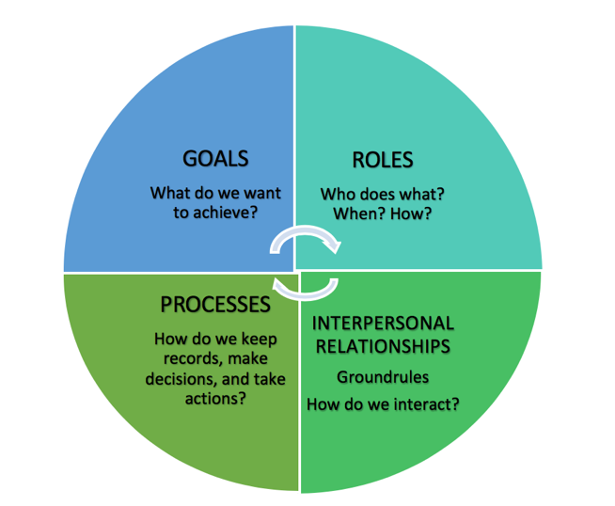

4.4.2 Impact of effective or poor team working

The team working can face some barriers. The failure of a team can start for several reasons. One of them might be when the individuals try to impose solutions that meet their own needs, that might be opposite of what the team might need. Team members need to learn to work and think as one in pursuing their common goal. Team members who have bad attitude towards colleagues also tend to fail their mission. All team members need to learn to support each other, share ideas, brainstorm and compromise. Selfish behaviour, unwillingness to cooperate, poor communication, infighting and conflicts lead towards a negative impact in the teamwork.

On other hand, the collective ability to interact simultaneously to find out the solution of a group problem refers to the group decision making, which helps the task to be completed successfully. There are different group making techniques that can help the team find a solution to a problem.

The Nominal technique is structured and very well organised. Everyone is coming up with a written idea anonymously, later the team leader is collecting them and the whole team is discussing them

The Delphi technique is very similar but here an outsourcing is required, different experts who can be even away from each other participate and share their ideas, while the governor is taking the final decision.

Brainstorming is one of the most common methods, which can be divided into generation of alternatives and evaluation of alternatives. Each method is exploring, and suggestions are brought forward.

The Dialectic inquiry is the second step after choosing one of the other methods. Sometimes the members of the group quickly agree on a proposal, thus the dialectic method comes. That is why we need to keep a record of which alternative options have been considered.

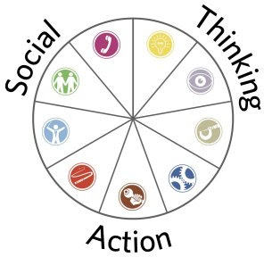
5. Conclusion

Brainstorming is a good opportunity for the team to exchange ideas and come up with creative solutions, working together encourages the members to develop their potential. Everyone in the group finally starts to develop similar ideas about where their team is headed, and they aim towards their mutual goal.

The Trinity Care Home firstly needs to focus on their management skills. That can be accomplish by attending leadership training, so they learn various technics on how to approach different individuals. Also, they need to establish some barriers and set up roles and responsibilities for everyone. In other words, to create an anarchy. For example, to have a group of 3 or 4 people, which form a governance. This will make the workload more effortless to manage between them. That will give an opportunity to the staff to speak with the management and express themselves more. Also, the management can indicate a senior staff that are more experience below them, who will carry out leadership responsibility in order to maintain good team work on each shift. This will allow the carers, residents and relatives to have more support regarding their opinions, feelings and wellbeing.

In conclusion, teamwork is highly important because it enables the team to share ideas and responsibilities, explore different techniques in order to finding solutions which can benefit the whole team. Teamwork helps to reduce the stress, trusting other team members and feeling confident to express your thoughts motivates the individuals and promotes positive results.

6. Reference list

1. Qin, Z., Johnson, D. and Johnson, R. (1995) Cooperative versus Competitive Efforts and Problem Solving. Review of Educational Research, 65, 129-143.

2.Morgan,2017,p 204; Morgan, P. (2017), The Business Student’s guide to study and employability, London, SAGE.

3. Geraghty,A.& Peterson – Brown,S., (2018), Leadership and working in teams, Surgery (Oxford), pp.503-208
Griffith, Brian A., and Ethan B. Dunham. Working in Teams : Moving From High Potential to High Performance, SAGE Publications, 2014.

4. Miller, R. (2016) Integrated Care in Action : A Practical Guide for Health, Social Care and Housing Support London: Jessica Kingsley Publishers.
5. Belbin, M. (2016) Team role circle, Available: https://www.belbin.com/media/2302/belbin-team-role-circle.pdf [accessed: Octomber 2021]
6. Wheelan, S.A., (2016), Creating Effective Teams, 5th edn, London: SAGE
7. Coyle, D. (2018), The Culture Code, London: Random House Business.

8. Human Dimensions, (2019), Groupthink, That’s just the way we do it,[video] Available:https://www.youtube.com/watch?v=jwHfmlbJX5Q (Accessed: Octomber 2021).
Hodson, C., (2001), Psychology and work, Hove, England: Routledge.

9. Pentland, A. (2008), Honest Signals, Cambridge, MA: MIT Press.
10. O’Sullivan, T. (2011) Decision making in social work. Second edition. London: Palgrave Macmillan. (Practical Social Work Series)

11. Jijo's Skill Factory (2020) 10 Barriers to Effective Communication, [video], Available at: https://www.youtube.com/watch?v=f5Tao6KHV5w (Accessed: October 2021)

12. Kanaga, Kim.Kossler, Michael E.Greensboro, N.C. :Center for Creative Leadershipc2001.Total Pages 1 online resource (33 p.)

13. Teams and Team Development Putting the Pieces Together ( 2017) https://slideplayer.com/amp/5906792/ (Access: October 2021)

14. Rubab Sahar, 2018 “ How to resolve Lack of Teamwork Issues” (Available on : https://medium.com/@rubab.sahar88/how-to-resolve-lack-of-team-work-issues-d1c8a159ef22 ) ( Access : October 2021)

15. Kaur, 2018, Advantages of Teamwork ( Available on: https://teamwork681898193.wordpress.com/2018/10/23/advantages/amp/ ) ( Access on : October 2021)

16. Tuckman, Bruce W (1965). "Developmental sequence in small groups". Psychological Bulletin. ( available on : https://en.m.wikipedia.org/wiki/Tuckman%27s_stages_of_group_development ) ( Access on 2021)

17. Ian James Wright, 2016, 6 Ways to Avoid Groupthink ( Available on: https://www.prnewsonline.com/avoid-groupthink) ( Access on: October 2021)

7. Appendicies



