Module title & code
Managing Hotel Administration
BMIH6004

Student Name : Alina Grigore
Student ID: 2127560
Lecture : Jessica Newport

Contents
Introduction 1
Reflection on Experience and Personal Development 2
Critical Analysis of Work-Based Skills and Technical Knowledge 2
Reflection on Organisational Issues 4
Conclusion 6
Action Plan 7
References 8

Introduction
The administrative operation of Cardiff Marriott Hotel requires constant interaction among important departments to have the hotel managed properly (Russell, 2024). Sales, Front Office, Staffing, Human Resources, and Revenue Management interact together for hotel management and provide the best service (O’Fallon and Rutherford, 2020).
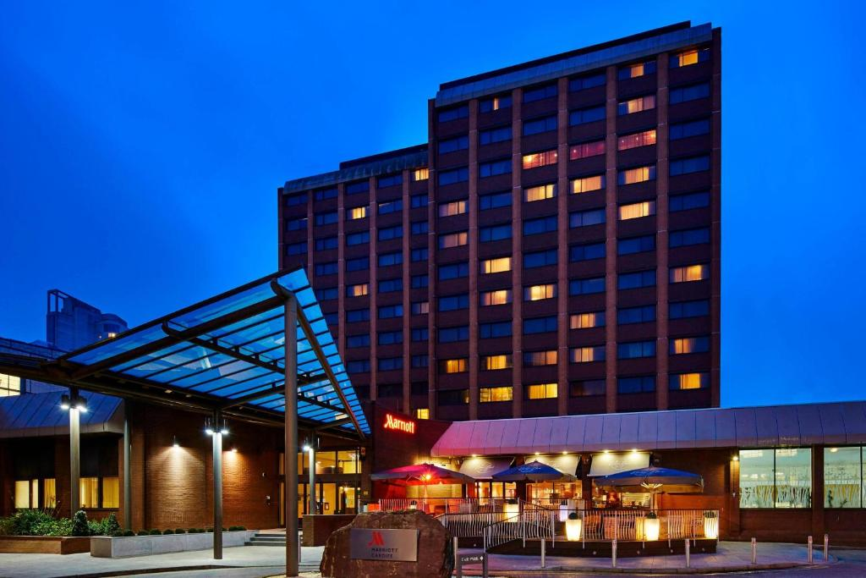
Figure: Marriott Hotel at Cardiff (Marriott, 2024)
There are four key things that I expect to learn from my placement role in the Cardiff Marriott Hotel as an administrative position.
- Knowledge of how departments (e.g., Front Office, Back Office, Sales, HR, Finance) work together to keep the day running smoothly
- Understanding the financial part of hotel management including; forecasting, revenue tracking, cost control and reporting.
- How guest relations work, from responding to customer concerns to keeping customers happy and how different departments can collaborate to deliver on guests’ expectations

Reflection on Experience and Personal Development
A hands-on experience shadowing a supervisor in the Front Office at Cardiff Marriott Hotel was invaluable as it showed me the importance of both technical and work-based skills in delivering exceptional guest service. The importance of technical proficiency in booking systems and operational protocols as well as the importance of seeing how the supervisor's leadership impacted all points of operations from the check-ins to even resolving guests’ issues to timely service, was observed.
Skill sets and my past experience clearly showed the importance of communication, teamwork, and task management in our job to achieve goals, especially in the quick pace of the hotel industry. To interact with the customer effectively terms like clear communication and strong interpersonal skills are very much important, while teamwork is vital for managing more than one task or achieving deadlines.
Reviewing my academic base, I noticed that the theories of organizational behaviour supplemented my practical experience in the improved understanding of the roles of team dynamics in service delivery. Since combining my on-ground experience, my prior knowledge and academic learning, I can say that my foundation has been strengthened in the area of guest services and the requirement of continuous learning has constantly been emphasised to keep up with the changing industry standards.

Critical Analysis of Work-Based Skills and Technical Knowledge
During my placement experience at the Cardiff Marriott Hotel Hotel Front Office, I learnt the significance of both work-based skills and technical knowledge in managing hotel administration. Without these elements, it would seem that smoothly operating, and maintaining high standards of guest service, would be impossible (Johnston and Clark, 2008).
- Work-based Skill
  - Problem Solving: Problem solving in the supervisory role is necessary. Frequently, this required quick, effective solutions to unexpected situations such as guest complaints and room assignment issues (Vallen and Vallen, 2014). When looking at this, for example, during a busy check-in time the supervisor was able to deal with a double booking very quickly by compensating the guest with a free service making sure that the guest and the staff workflow was not too disrupted. Hotel administration requires this skill, where the problem-solving has to happen immediately, or operations will fall into a tailspin.
  - Delegation: Another critical skill we also observed was effective delegation. To keep labour usage efficient at peak times, the supervisor created a workflow where he determined who should be given what tasks based on team members’ strengths and workload (Bardi, 2010). For one, they took care of guest queries, let front desk staff check in and check out, and had those requests for urgent housekeeping as appropriate. Coordinated mission with the supervisor employed strategic delegation to save time and resources, and ensure a window of operations was kept seamless throughout periods of heavy burden (Raghubalan and Raghubalan, 2015).
- Technical Knowledge
  - Property Management System (PMS): Proficiency with the hotel’s Property Management System (PMS) was a very important technical skill handled during the shadowing experience. It was used to track guest reservations, room availability and billing information (Lacalle, 2024). The supervisor showed me how to use the system to make bookings, update guest details and quickly check out guests. Hotel administration revolves around the ability to navigate the PMS and this allows guest data to be accurate, and also to have smooth check-ins, check-outs, billing etc.
  - Point of Sale (POS) System: The second technical skill I saw the supervisor doing was processing payments for additional services, in other words, meals, spa treatments and room service, something that was done via using the Point of Sale (POS) system. Payment handling, receipt generation and confirmation that the system was updated following transactions came easily to the supervisor. However, this technical knowledge is very important to make sure that we are processing guest charges accurately and quickly, and sometimes this will directly affect guest satisfaction and the financial record for the hotel.

Reflection on Organisational Issues
Gibbs’ Reflective Cycle is a framework for reflecting on experiences in a structured way, which includes six stages: Feelings, Description, Evaluation, Action Plan, Analysis, and Conclusion (Potter, 2020).
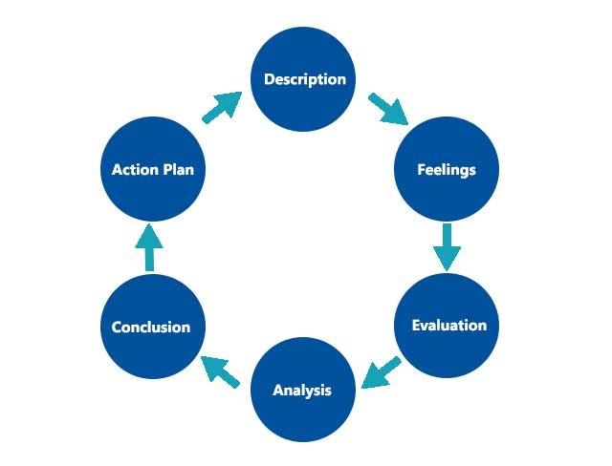
Figure: Gibbs’ Reflective Cycle (The University of Edinburgh, 2024)
Description: When I started my placement at Cardiff Marriott Hotel, I faced a problem in which more people than there are rooms on the system to accommodate them because of system errors and last-minute cancellations. That meant delays at check-in and frustration for staff and guests alike.
Feelings: In the beginning, it did scare me a bit about the guest satisfaction impact of this. The staff seemed to tense as they scrambled for solutions. Yet I think the supervisor did so calmly and professionally on the whole, ignoring the most minor of inconveniences, while still doing all she could to create a good experience for the guests.
Evaluation: An organizational issue with hotel booking and reservation systems was highlighted in that overbooking situation. The immediate consequence was longer check-in time and an increase in guest complaints. Even staff morale was affected because all of us were pressured to sort out the issue quickly.
Analysis: The oversights in room allocation and late cancellations of rooms were blamed on poor use of the Property Management System (PMS). The main problem that resulted from this was a lack of communication and updates between departments since there were no real-time updates. Systems Theory with the idea of interconnected systems (e.g. booking and guest management) creating larger operational problems due to inefficiencies.
Conclusion: Overbooking issues were found to negatively affect guest service and department performance and therefore resulted in an improvement of integration between reservation systems and improved communication protocol.
Action Plan: To solve this, the hotel will need to update the PMS so it always has real-time information, automate cancellations and improve communication between departments. Total Quality Management (TQM) principles can be applied through continuous monitoring and a feedback loop, and the system should get better with time so people do not repeat the same problem (Bilich and Neto, 2021).

Conclusion
I learned from my placement experience at the Cardiff Marriott Hotel how important coordination, communication, and knowledge in technical hotel administration are. A lesson learned through this was that key skills such as task management, problem-solving, and guest service were gained from this experience. At the end of all this, I have created an action plan to further develop my technical skills by mastering hotel management software, looking at getting opportunities to practice conflict resolution and pursuing further training or certifications in hotel administration to help my career in the industry.

Action Plan
Task | Action | Method | Duration
Delegation Skills | Work in a team and communicate with other members. | Enroll in a delegation course, and go through some relevant cases in different journals. | Within 2 months
Property Management System (PMS) | Use different industry-standard software (Christudason, 2018). | Enroll in an online course | Within 2 months
Problem-Solving Skills | Check out how the supervisor deals with such unexpected things and resolve the guests’ complaints. | Go through different cases from well-known journals | Ongoing

References
Bardi, J.A. (2010). Hotel Front Office Management, 5th Edition. Wiley Global Education.
Bilich, F. and Neto, A.A. (2021). Strategic total quality management. Total Quality Management, 8(2-3), pp.88–89. doi:https://doi.org/10.1080/0954412979767.
Christudason, A. (2018). Choice of property management system for residential strata developments in Singapore. Property Management, 26(2), pp.97–111. doi:https://doi.org/10.1108/02637470810866679.
Johnston, R. and Clark, G. (2008). Service operations management : improving service delivery. Harlow, Essex, England ; New York: Financial Times/Prentice Hall.
Lacalle, E. (2024). 8 functions of a property management system | Mews. [online] Mews.com. Available at: https://www.mews.com/en/blog/functions-property-management-system.
Marriott (2024). Family Friendly Hotel in Cardiff | Cardiff Marriott Hotel. [online] www.marriott.com. Available at: https://www.marriott.com/en-gb/hotels/cwldt-cardiff-marriott-hotel/overview/.
O’fallon, M.J. and Rutherford, D.G. (2020). Hotel Management and Operations. Hoboken, N.J.: Wiley.
Potter, C. (2020). Leadership Development: an Applied Comparison of Gibbs’ Reflective Cycle and Scharmer’s Theory U. Industrial and Commercial Training, 47(6), pp.336–342.
Raghubalan, G. and Raghubalan, S. (2015). Hotel Housekeeping : Operations and Management. New Delhi, India: Oxford University Press.
Russell, J. (2024). International Hotel Management graduate developing a career to keep an eye on - Hospitality & Catering News. [online] Hospitality & Catering News. Available at: https://www.hospitalityandcateringnews.com/2024/07/international-hotel-management-graduate-developing-a-career-to-keep-an-eye-on/ [Accessed 12 Nov. 2024].
The University of Edinburgh (2024). Gibbs’ Reflective Cycle. [online] The University of Edinburgh. Available at: https://reflection.ed.ac.uk/reflectors-toolkit/reflecting-on-experience/gibbs-reflective-cycle.
Vallen, G.K. and Vallen, J.J. (2014). Check-in check-out : managing hotel operations. Upper Saddle River, N.J.: Pearson/Prentice Hall.

