Visualisation of IoT data

Student Name: Lloyd Johnson
Student Number: 1802820
Module Code: ACDA5005
Module Name: Smart and Connected Devices I
Lecturer: Gaynor Thomas
Contents
No table of contents entries found.

Introduction
This report will discuss the implementation of a SQL server and database into a web interface using php. The report will show how features were implemented into the web interface by showing annotated screenshots of php code along with screenshots of the working web interface page. Different tests will take place to show the working code, if the code does not work it will be troubleshooted, the troubleshooting will be documented in the report to show what the error was in the code. After the error is documented the code will be corrected and the working code and web interface will be shown.

Login
The First page on the web interface is a login form. The user will have to enter the correct Username and Password to be able to access the rainfall database. The Username and Password is stored in the “users” database in phpMyAdmin.
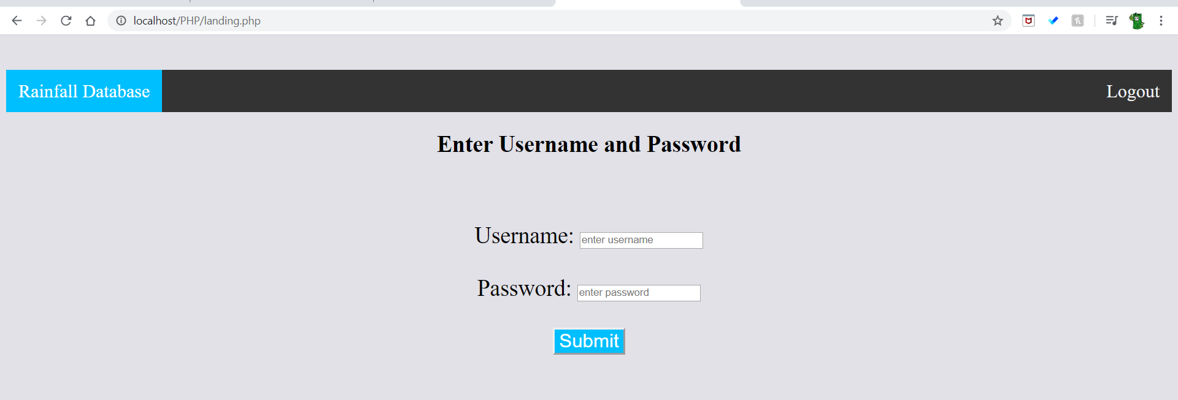
When the username and password is incorrect then the user will be directed to a webpage explaining that the user has gotten the login details wrong.
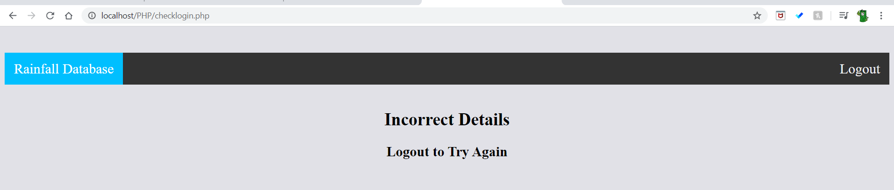
When the user enters the login details correctly then the rainfall database can be accessed by the user. Below is the php code that checks if the user has gotten the login details correct, if incorrect it offers text to allow the user to try again using the logout button. The reason for the login being added is to add security to the database so only authorised personnel with the username and password can access the rainfall database. 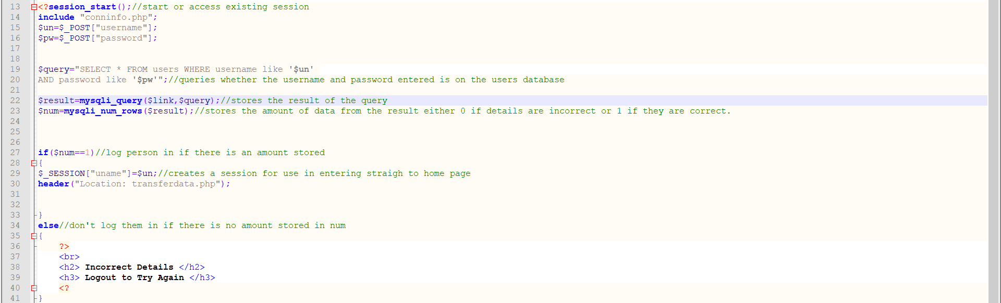
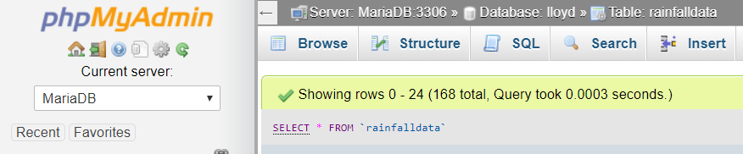
After this page a php file is triggered called “transferdata.php” what this file does is transfer all the data from the sensor text files into the “rainfalldata” database in MySQL. This is where the first problem was found as when a user leaves the site and needs to login again the data is added again to the database creating duplicates.

This is the code with the correction code made highlighted in red.
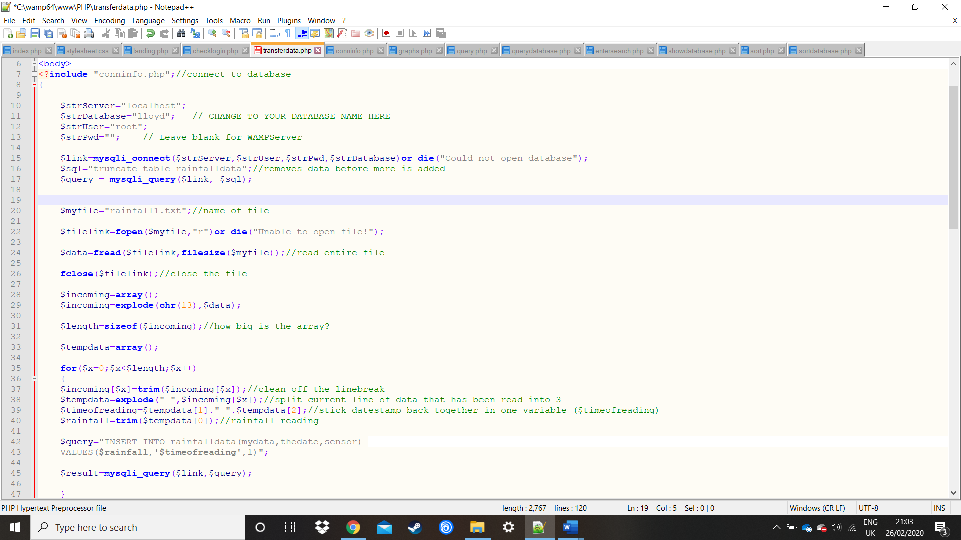
This error needed to be corrected as duplicates of the data would alter the graphs used in the database and make searching the data increasingly difficult the more times the user logs in.
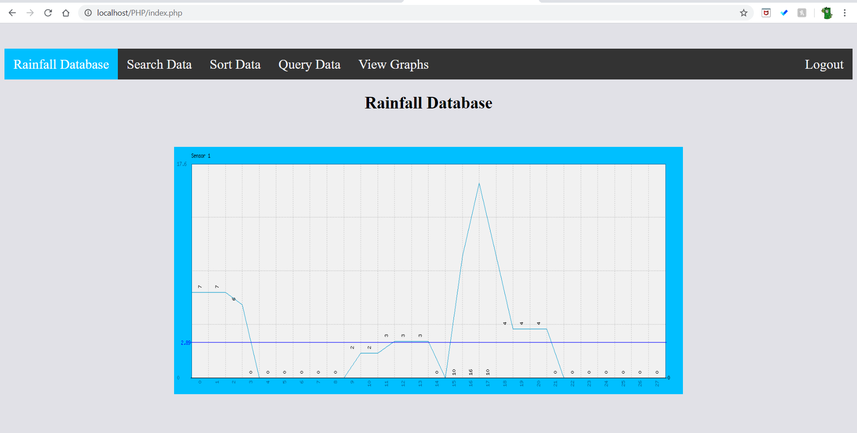
Once the User enters the rainfall database the first webpage is the home or index page. From this page the user can select how to interpret the text files data. Also, at any point in the web interface the user can log out to ensure security is maintained.
The second page allows the user to search the data in the database. The user can select what column they want to search in by using the radio buttons, Once the column has been selected the user can search specific data, by using the search bar.
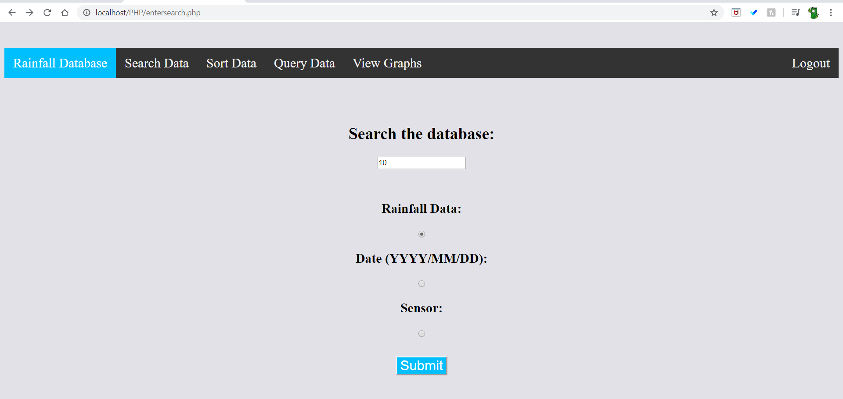
To complete the search the user must press the submit button, for this example the amount of rainfall searched was “10”. 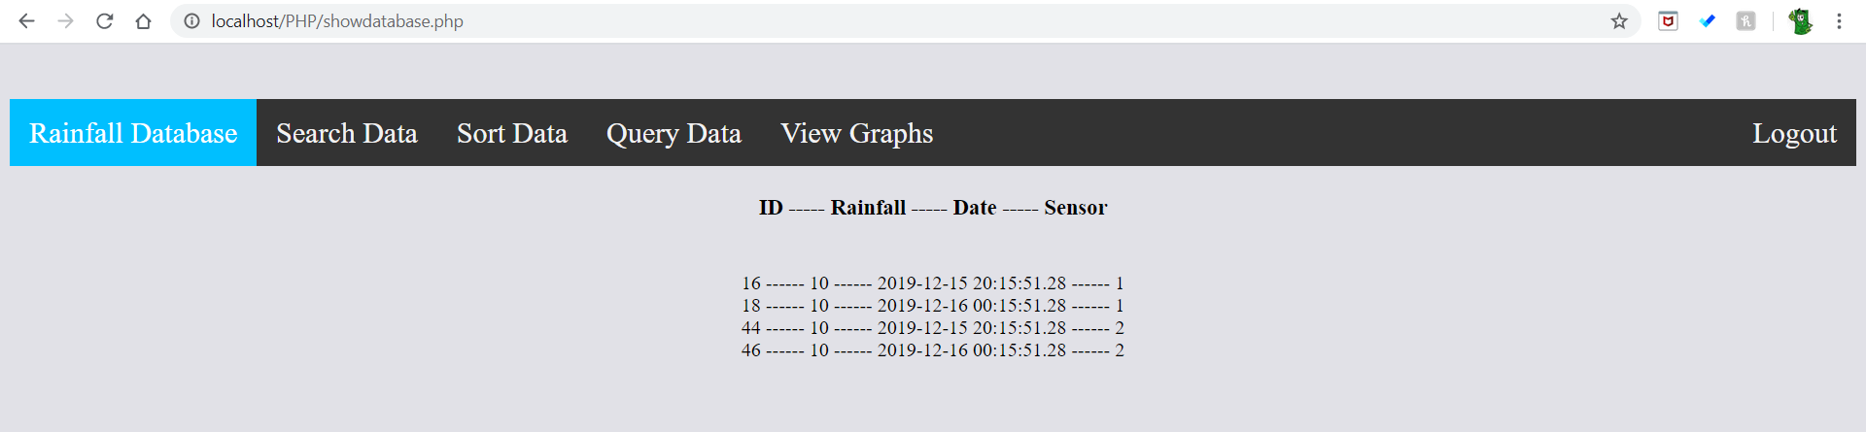
An amount of rainfall that did not exist on the database was then searched to show that when this happens it runs a separate piece of php code to display that the code did not find any data that matched.
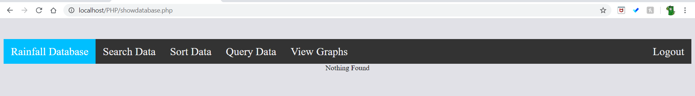
This is the annotated code for the search database php file.
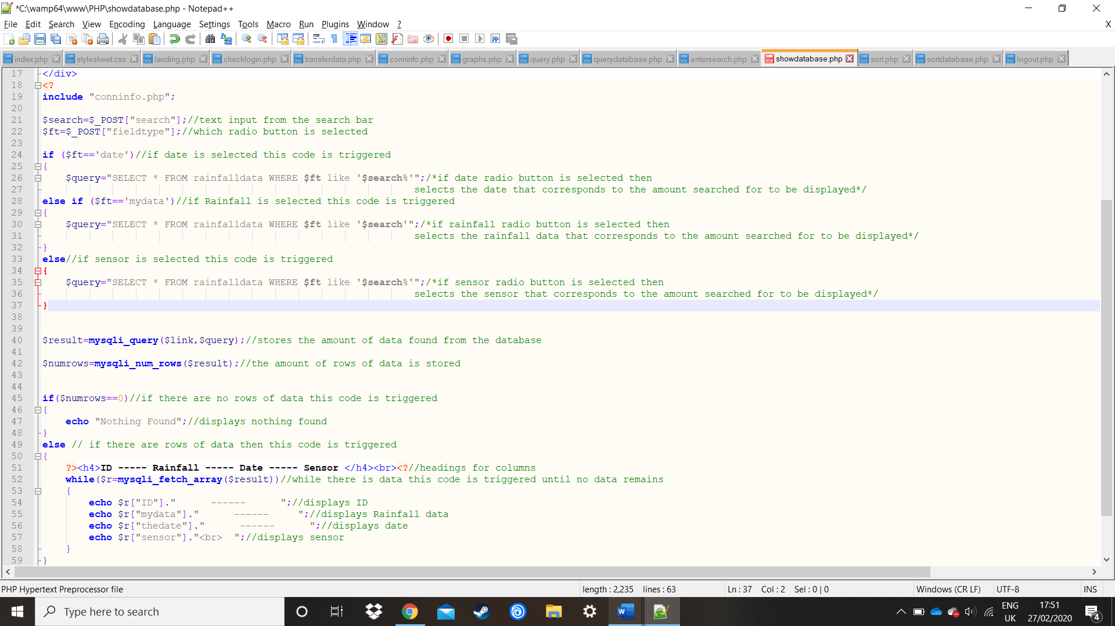
Next the user can sort the database by selecting the radio button linking to which column to sort.
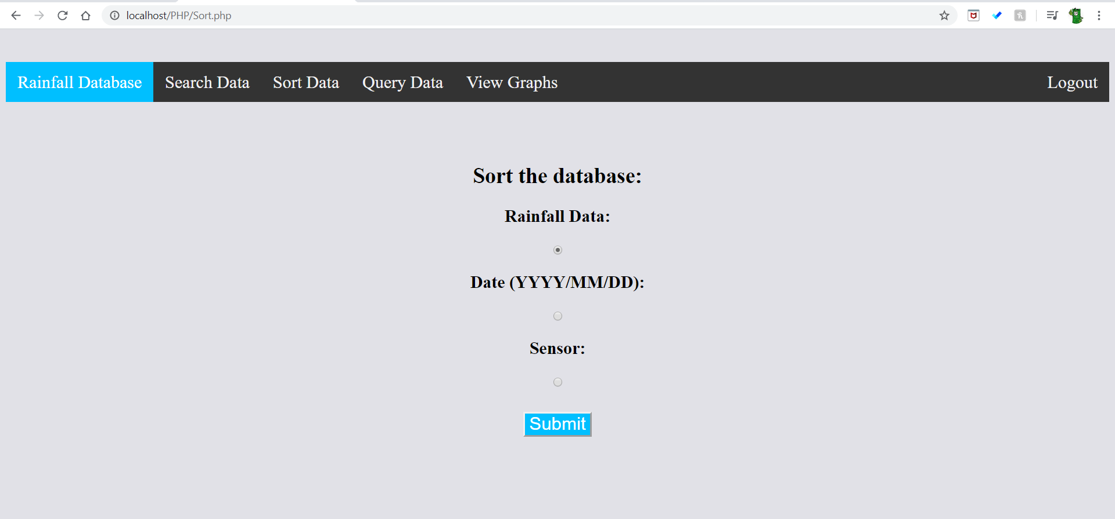
The sort page will then direct the user to another page displaying the sorted date. This is the page displayed when the Date button has been selected to sort. The dates will be sorted in descending order. 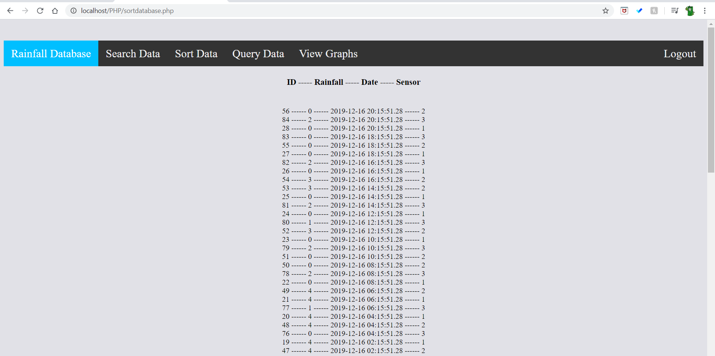
Below is the annotated code to explain how the sort function works in the php file. This includes the query that sorts the data according to which radio button was selected, this is highlighted in red. The PHP code that displays the information is highlighted in green.
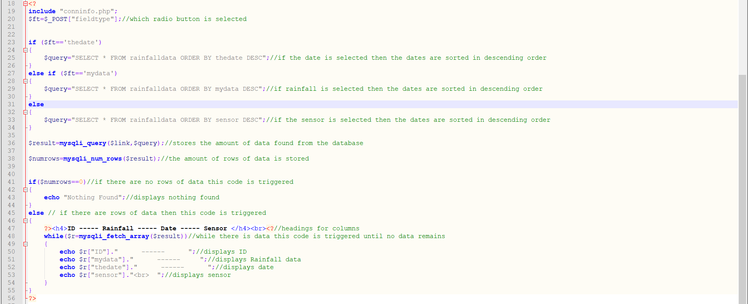
The Next Page that is displayed is the query database this allows the user search for data that is larger than the amount entered into the search bar. The Amount entered is 7 to show all rainfall data that is above 7. Then the Next screenshot shows the data that is displayed after the submit button has been clicked.
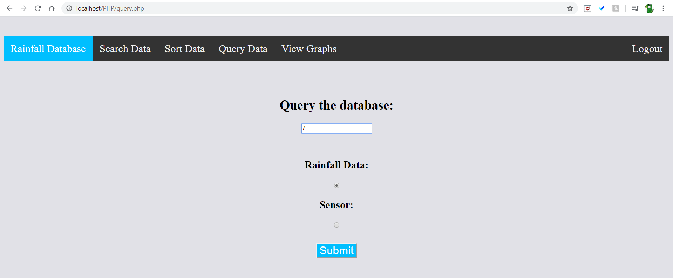
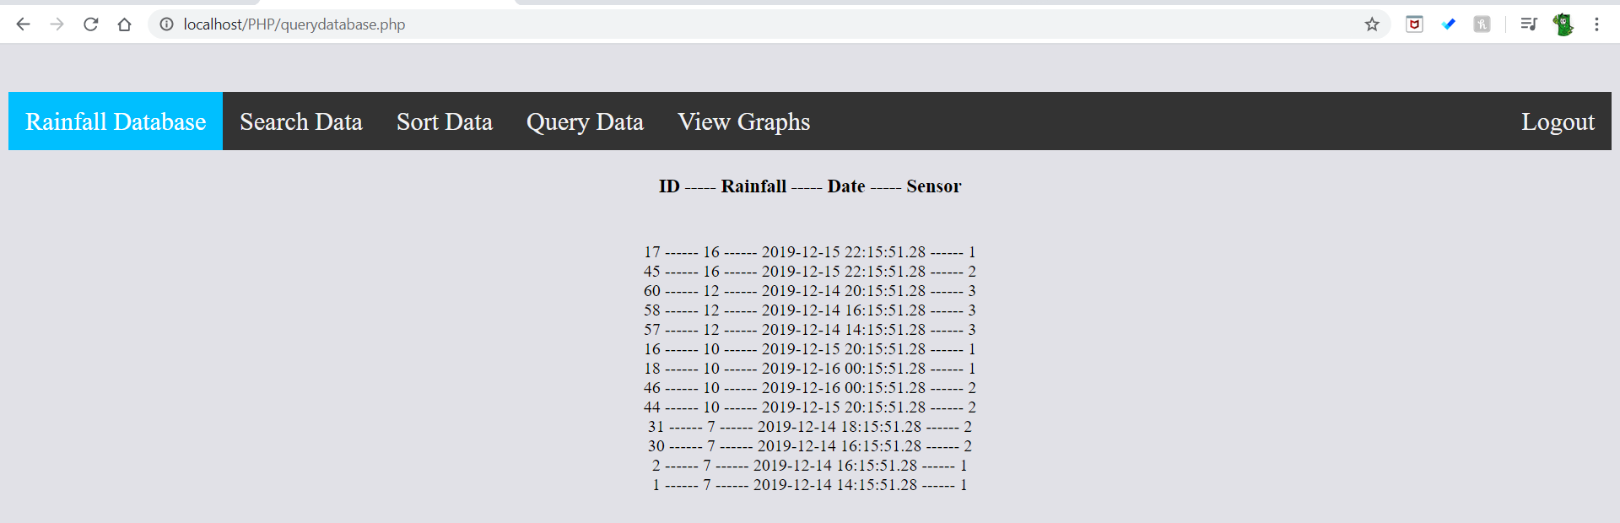
The Next screenshot displays when the 17 is entered into the search bar which is higher than any rainfall data that is stored in the database.
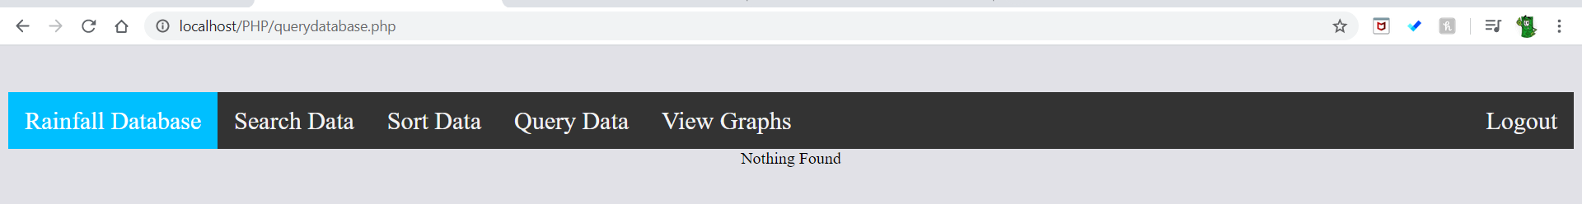
Below is the php code that links to the query database page. Highlighted in red is the query sql code, highlighted in blue is the code that sorts whether any data is found and highlighted in green is the if statement that sorts what will be displayed on the webpage. 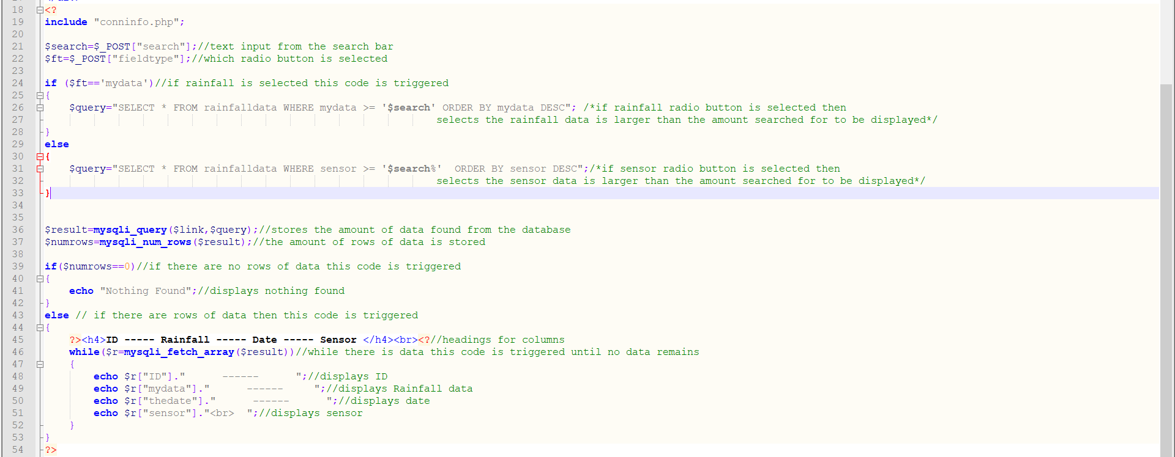
The final page on the web interface displays the graphs. The graphs are each made on a separate php file then they are linked to the graphs.php file using and image tag.
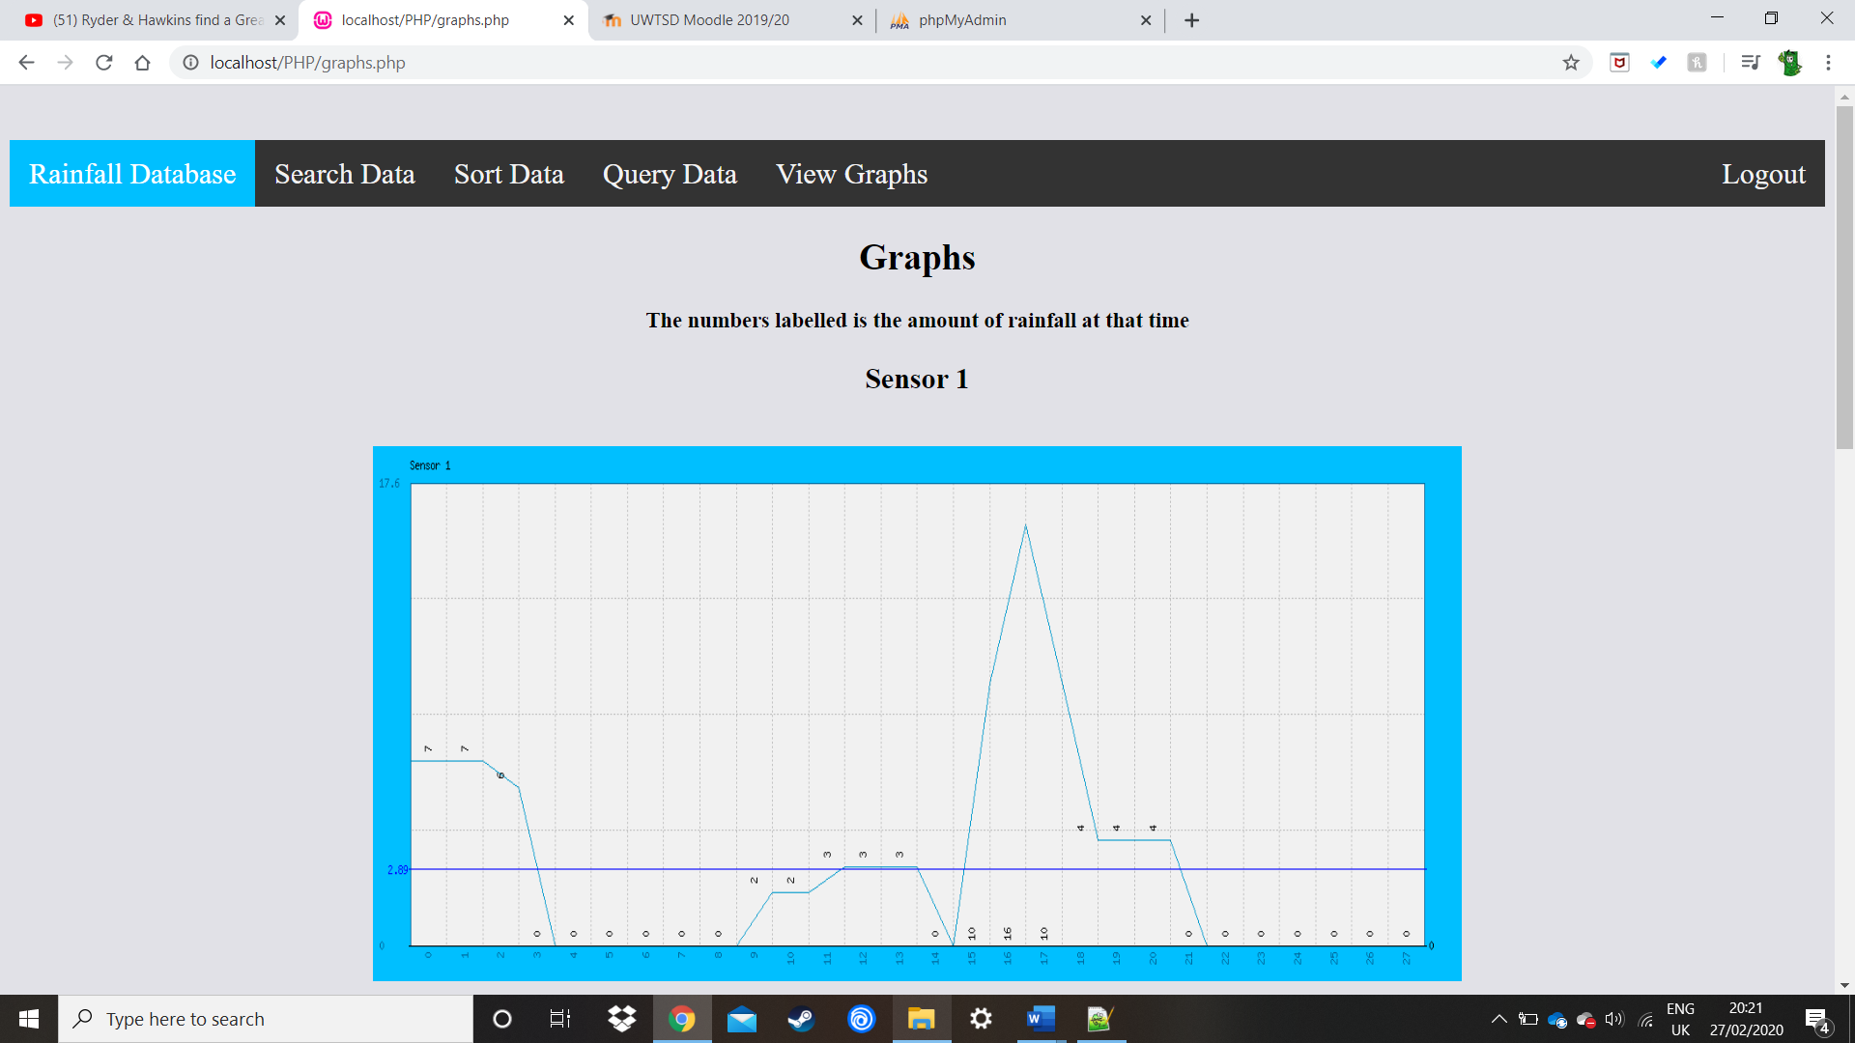
Below is the graphs.php page that shows the code on how the graphs are linked highlighted in red.
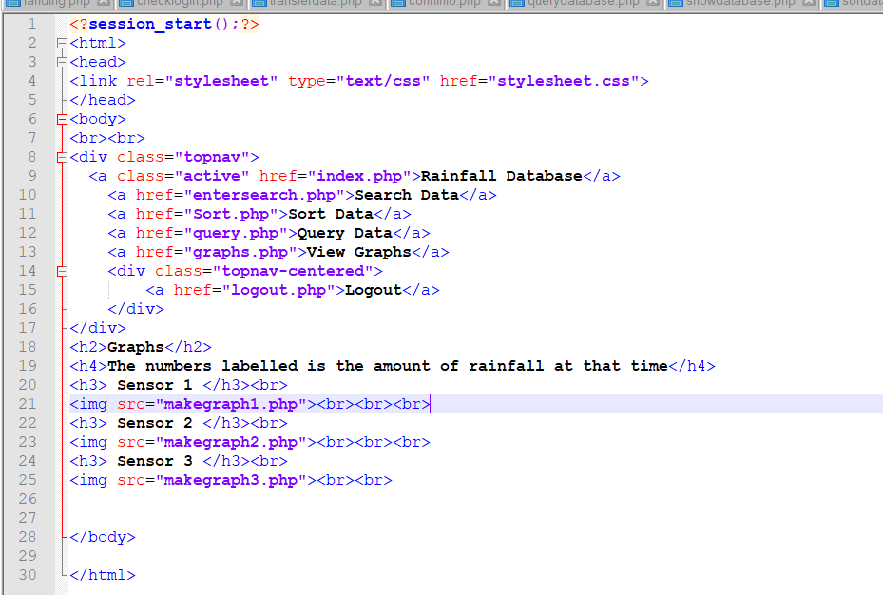
Below is the code that creates the sensor 1 graph. The code uses an existing library called phpMyGraph5.0.php this code has preset variables that a programmer can choose to use, to display a graph using php. The two php files are linked to allow the use of the preset variables.
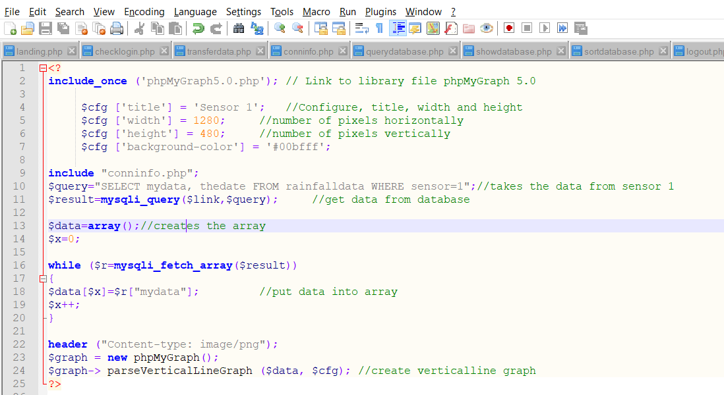
The final piece of code on the landing page allows a user who just exited the web interface to go straight to the home page if they have already logged in.
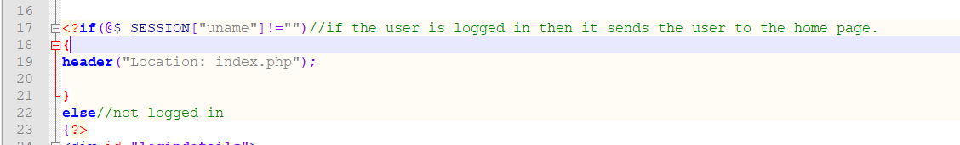
The if statement checks if a session has been created, this will be the case if a user has previously logged in, if there is then the header sends the user straight to the home page. The reason this function has been added is it can become frustrating to have to constantly login to view the database therefore only having to login once will increase the ease of use of the web interface.

Bibliography

[1] | “PHP Tutorial,” w3schools, [Online]. Available: https://www.w3schools.com/php/. [Accessed 26 February 2020].

