Adapting to Change: A Business Environment Analysis of Next
- Introduction (500 words)
Next PLC is a high street department store that sell clothing, homeware and footwear for children and adults. They are renowned for their quality, and this is reflected in their price. They have identified their market segments and offer different ranges and higher branded products for customers seeking these items.
Over the recent years they have relocated a lot of their stores to retail parks rather than being just on the local high streets they have also adapted their opening hours to later times in order to suit customers working longer hours so that they are able to shop instore and online this way they are able to collect their orders or complete their returns. Next has a strong online presence that offers their customers to order to home, store, collection points nearby and also to reserve for collection in store. This would appeal to many busy customers and also gives them a competitive edge by offering quick options to receive orders. Next is a very popular department store in both the uk and internationally.

One of the main factors that contributed to the decision of choosing next for this analysis includes the way in which the company has responded to the challenges that retail industries have faced with the rise of online shopping, closure of many high street shops the ever changing customer expectations and economic inconsistencies.
Next has been able to adapt their prouducts and materials ensuring there are sourced ethically and sustainably. This factor appeals to many customers especially those who have an interest in looking after the planet.
This essay will explore how retail organizations respond to external forces and how they keep their competitive edge.
his essay will explore the following key themes and structure:
- Business Environment Analysis – An exploration of the external factors (economic, political, technological, and social) that influence Next PLC's business environment.
- Application of Business Models and Theories – A deep dive into relevant business theories and models such as PESTEL, SWOT, and Porter’s Five Forces to assess how Next PLC navigates these changes.
- Evaluation of Adaptation Strategies – A critical analysis of how Next PLC has implemented strategies to adapt to changes in its external environment, focusing on innovation, digital transformation, and sustainability.
- Conclusion and Recommendations – A summary of key findings, with insights into how Next can further enhance its adaptability and recommendations for future strategies.

The Goal of this essay is to analyse and understand how Next has been able to adapt to the ever changing business environment whilst also continuing to stay competitive to other major retail industries. This essay will highlight what strategies Next and other businesses will have to use and how each factor will influence this industry.

Business environment refers to the combination of internal and external factors that influence a company's operating situation. These factors include customers, competitors, suppliers, government, socio-cultural and technological trends, and economic conditions. Understanding the business environment is crucial for strategic planning and decision-making as it helps organizations anticipate changes, respond to opportunities, and mitigate risks.
According to Worthington and Britton (2015), the business environment consists of two main components:
- Internal Environment: Elements within the company that affect its operations. These include company culture, employees, management, and internal processes. It is usually within the control of the business.
- External Environment: Elements outside the company that can impact performance, often beyond the organization’s control. It can be further divided into:
  - Microenvironment: Immediate external forces such as customers, suppliers, and competitors.
  - Macroenvironment: Broader forces such as political, economic, social, technological, environmental, and legal factors—commonly analysed using the PESTEL framework.
Understanding these environments enables businesses to align their strategies with external realities and internal capabilities.
Worthington, I. (2006

It is crucial that businesses ensure that they consider and analyse the external factors that would affect the operation of a business. The factors are usually things that are outside of a businesses direct control. Ensuring that businesses plan strategically and consider and manage risks can support companies long term success.

The market is constantly changing, and it is vital businesses regularly examine these changes in order to adapt to change, stay relevant and keep being successful.
The main factors which businesses should consider include Political, Environmental, social, technological, and economical. Often referred to as PESTLE. (Francis J. Aguilar 1967) Using models like PESTLE or SWOT allows business to gain a full picture of their external environment which in turn helps them to make informed decisions.
Companies identifying and evaluating these risks early on they are able to act quickly to lower their chances of failure and avoid losses. This analysis also presents opportunities to enter new markets, create new partnerships and improve or gain a competitive advantage. Keeping up to date with the current economic conditions ensures businesses can adjust pricing or the way in which they market their products. It also gives them knowledge to be able to upgrade their products or services. The way in which businesses operate can vary widely across different industries and regions. Business needs to adapt to new laws and regulations in order to avoid damage to their reputation and large fines. When analysing this factor companies can gain insight into ways to operate ethically, ensure they are using sustainable practices and are up to date with the latest legal compliances. Lastly it is important that businesses understand what other businesses and their competitors are doing and how these market changes can affect them. They should consider where they can offer the best value and create a unique selling point to gain a higher market share.
Businesses that do not analyse these external factors are likely to encounter some of the issues mentioned above and these could have catastrophic consequences for their company.
As briefly introduced above there are range of models that businesses can use to analyse their operation.
PESTLE allows businesses to look at vital factors such as Political, Environmental, Social, Technological, Legal, Ecological.
The analysis was given the name PESTLE in reference to the acronym formed by the initials of the six categories of macroeconomic variables included in the model (Political, Economic, Socio-cultural, Technological, Legal and Environmental). Firstly, the model allows managers to identify the macroeconomic variables to take into consideration for the development of the business (opportunities vs. potential risks) for which realization remains relatively uncertain. Then, the model can initiate the conceptualization of different scenarios based on these uncertain variables to better predict the future and make the right decisions today in the interest of the future (Marmol, 2015)
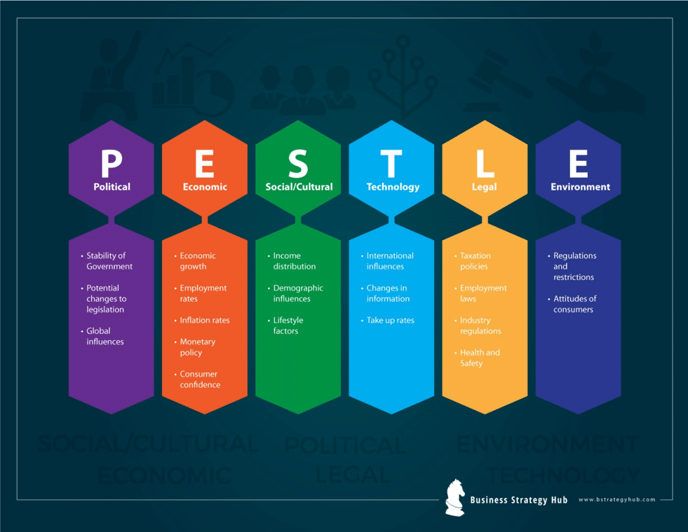
(Grab your Mortar - PESTLE Ana https://bstrategyhub.com/grab-your-mortar-pestle-analysis-explained/lysis Explained | Business Strategy Hub Image Accessed 28/04/2025)

The political factor looks at things such as change of government, government policies, tax policy, global influences.
The Environmental factor highlights issues such as global warming and the increased need to switch to sustainable resources. Ethical sourcing of products or products used for services. Regulations aimed specifically at the environment. Resource scarcity looks at how freely we are able to access the essential resources that are obtained from the environment.
The social factor identifies cultural norms and expectations for example how a food chain would adapt its menu in different countries or a clothing company would adapt its products in order to meet the local customers needs. age distribution, consumer preferences, lifestyles and spending patterns. Consumers career attitudes, populations growth rates and increased consumer awareness of ethical behaviours.
Technological factors assess the ever growing advancement of technology. Social media, access to products and services, emerging technologies like AI.
The legal factors include employment laws, cosumer protection law, health and safety regulations and product bans.
Lastly the economical factors include the current economic growth or decline, interest rates, exchange rates, wage rates and inflation. Working hours and conditions, unemployment, cost of living and credit availability.
Using this model and looking at these factors allows businesses to have a full picture of their current market share and gives them opportunity to improve.

Another model businesses can use is Porters Five Forces which was created by Michael E. Porter in 1979 to analyse the level of competition within an industry and how well they can perform. It's widely used in strategic business planning. The five forces are as follows; Competitive rivalry, Threat of new entrants, Bargaining power of suppliers, Bargaining power of buyers and Threat of substitutes.
The first force is Competitive rivalry businesses will be able to identify how intense the competition is from other companies in the industry. High rivalry from competitors could limit profitability resulting in marketing battles, price wars and the race for the next best thing.
Secondly The threat of new entrants is how easy or difficult it is for new businesses to enter the market and essentially threaten the companies livelihood. It considers the barriers to entry which include; capital requirements, brand loyalty, regulation.
Bargaining power of suppliers; How much power suppliers have over pricing, fewer suppliers for certain products or services give suppliers more power.
Bargaining power of buyers; The power customers have over the industry when It comes to choosing their product or service for example; size of purchase or order, number of customers, price sensitivity, buyers using alternative, switching costs.
Threat of substitutes; Could other businesses in the industry offer alternative products or services for better value, lower price, better quality. The mote substitutes available the higher the threat which adds pressure to a company’s pricing and innovation.
Analysis of External Factors (1,000 words)

o Apply PESTLE Analysis to evaluate the impact of the relevant factors on your chosen organisation/industry.
Political Factors
- Brexit Implications: Post-Brexit, NEXT plc faces challenges related to trade tariffs and customs regulations when exporting to EU countries. The company has responded by establishing Next (Ireland) Ltd to mitigate these issues.​
- Government Regulations: Varying product safety and quality regulations across different countries require NEXT to adapt its compliance strategies accordingly.
- Trade Policies: Changes in global trade policies, influenced by political shifts, can impact NEXT's supply chain and cost structures.​
Economic Factors
- Economic Downturns: Global economic challenges, including recessions, can reduce consumer spending, affecting NEXT's sales and profitability .​
- Interest Rates: Fluctuating interest rates influence NEXT's borrowing costs for expansion and operations .​
- Inflation: Rising inflation can increase operational costs and reduce consumer purchasing power, impacting sales .​
Social Factors
- Consumer Preferences: Shifts towards sustainable and ethical fashion require NEXT to adapt its product offerings and sourcing strategies .​
- Demographic Changes: An aging population in key markets may influence product design and marketing strategies.​
- Diversity and Inclusion: Emphasis on workplace diversity and inclusive practices can enhance NEXT's brand image and employee satisfaction.​
Technological Factors
- E-commerce Growth: Investment in online platforms and digital marketing is crucial as consumer shopping habits shift towards online channels.​
- Supply Chain Technology: Adoption of advanced technologies in supply chain management can improve efficiency and responsiveness.​
- Cybersecurity: As digital operations expand, robust cybersecurity measures are essential to protect customer data and maintain trust.​
Legal Factors
- Employment Laws: Compliance with labor laws, including minimum wage and working conditions, is vital for NEXT's operations.​
- Intellectual Property: Protection of designs and trademarks ensures NEXT's competitive edge in the market.​
- Environmental Regulations: Adherence to environmental laws, especially concerning sustainability practices, is increasingly important.​
Environmental Factors
- Sustainability Initiatives: NEXT is focusing on sustainable sourcing and reducing carbon footprints to align with consumer expectations and regulatory requirements.​
- Climate Change: Adapting to climate-related challenges, such as supply chain disruptions due to extreme weather, is essential for business continuity.​
- Resource Management: Efficient use of resources and waste reduction strategies are being implemented to enhance environmental responsibility.​

o Identify key challenges and opportunities arising from these external factors.
Some of the key challenges that Next Plc have encountered include the economic downturn which meant people were spending a lot less money and had a much less disposable income. This ultimately affected Next’s profits and sales. Another challenge that Next have faced is the increased awareness of sustainability and this has meant adapting their products and how they are sourced to ensure that they are matching the values and beliefs of their customers in that segment of the market.
Science Based Target initiative (SBTi) approval
In July 2021 our scope 1, 2 and 3 carbon reduction targets were approved by the SBTi, with our scope 1 and 2 targets being approved to the most ambitious designation available which was classified as 1.5°C at the time of approval.
NEXT commits to reduce absolute scope 1 and 2 GHG emissions by 55% by FY2030 from a FY2017 base year.
NEXT also commits to reduce scope 3 GHG emissions by 40% per million GBP (British Pounds) of sales and scope 3 GHG emissions from indirect use of sold products by 40% per million GBP (British Pounds) of sales by FY2030 from a FY2020 base year.
Looking Ahead - during the year, we will continue:
- to expand our use of solar and renewable energy
- our work to reduce our impact through our packaging and products
- uptake of EVs within the company car fleet
(NEXT plc, 2025, Challenges and Targets, accessed 28/04/2025)

Due to the rise in wage bills that changed in April 2025 next have had to implement a 1% rise in their prices this year in order to meet this amount. Next have placed the blame of this price increase on the change in National Insurance contributions that took effect in April 2025. (J Sillars, 2025)

Next have committed to continuing to promote their inclusive culture.

We want to provide an environment where our workforce is:
- Safe, supported and respected
- Treated fairly and taken care of
- Listened to
- Motivated to achieve their full potential
Our priorities are in the areas of:
- Health, safety and wellbeing
- Equality, diversity and inclusion
- Training and development
- Reward, fair pay and employee share ownership
(2025 NEXT plc.)
Next Plc has a target to responsibly source 100% of their materials used to make their products.
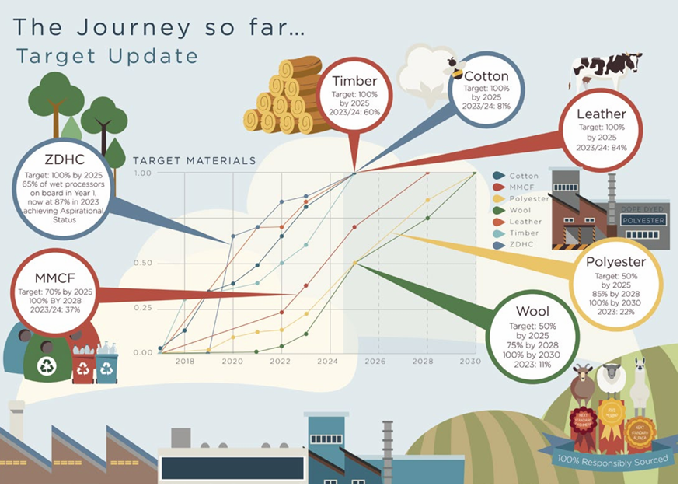
Next have made significant progress since they launched there Responsible Sourcing Approach in 2018, originally set to be achieved by 2025. We have met our Feathers target and are currently on track to meet Cotton and Timber by 2025. (A James, 2024)

Next plc’s have always opted for a centralized and cost-conscious approach, financial discipline and operational efficiency have always been their main strategy for leadership. Focusing of this strategy has allowed them to stay relevant and keep profits high during economic downturns especially during the covid-19 pandemic and navigating through the challenges of Brexit. Next have invested a great deal of money into they online presence, this has allowed customers to be able to have products available for next day delivery or instore click and collect at their finger tips and in in turn allows for a broader customer reach. Next have also introduced high quality fashion and homeware brands to their online platform and with the option to use credit options this will attract more customers from different backgrounds. As mentioned above next have committed to responsibly sourcing 100% of their cotton by 2025. This will include Better cotton, organic, recycled and fairtrade certified cotton. This goal is in line with the retail giants strategy to reduce their environmental impact. Next have also joined the U.S. Cotton trust to make certain that they are sourcing their cotton responsibly and sustainably by following their guidelines. (U.S. Cotton Trust Protocol, 2020)
(White, 2020) (Next PLC, 2023)
Next has shown that they have a strong ability to adapt to external changes beyond their control. Through the strategic relocation of their stores, investment in e-commerce and the way they have responded to the social and economic changes. External changes such as Brexit, economic instability, technological advancements and growing consumer demand for sustainable products have pushed next to reevaluate the way that the business is operated and make the necessary changes and adaptations. The use of analytic tools like PESTLE and Porters Five Forces has helped to identify they key risks and opportunities that will influence the decisions of the business. Lastly Next’s commitments to ethical sourcing, digital innovation and inclusive practices shows the forward-thinking approach the company and its operational team have. Next have ensured to adapt and comply with the regulatory requirements and the customers expectations. Navigating through these changes with such ease has helped the company to maintain profits, operate efficiently and shows how loyal its customers are despite its market disruptions,
Although next is making great progress with its goal of 100% cotton to be sourced by 2025 Next should expand its sustainability targets across all materials and supply chains. Next have a great, fuctional and relatively up to date e-commerce considering further investments in AI-driven personalization, mobile app enhancements and stop webpage glitches during peak end of season discounts could deepen online sales and attract more engagement from loyal customers and new customers. Lastly Next could continue to leverage customer data for innovation taking insights into customer behavior and preferences to effectively improve customers in-store and online experiences and improve the products they have available.



