
An investigation into how Amazon.com has utilised technology for the development of their business and products.
By
Ross Thomas

Supervisor- James Williams
Second Marker- Kevin Palmer

Project submitted as part of the requirements of the award of BSc (Hons) Business Information Technology

April 2017

DECLARATION
I, Ross Thomas declare that I am the sole author of this Project; that all references cited have been consulted; that I have conducted all work of which this is a record, and that the finished work lies within the prescribed word limits.

This work has not previously been accepted as part of any other degree submission.

Signed : .............................................

Date : ...............................................

FORM OF CONSENT
I, Ross Thomas hereby consent that my Project, submitted in candidature for the B.Sc.(Hons) Business information Technology degree, if successful, may be made available for inter-library loan or photocopying (subject to the law of copyright), and that the title and abstract may be made available to outside organisations.

Signed : .............................................

Date : ...............................................

Abstract
This study is based on how Amazon.com has used the ever growing technology to continue to grow and develop their business. The study looks at what Amazon is and what they offer, as well as what competitors are doing to compete in the markets they are in
Amazon has created a full functioning website and mobile app for customers to shop and purchase from them. Amazon has also created a wide range of product and services into different markets to compete and continue their growth as a business. This will look at the products and why they were made, what the products offers, how Amazon are benefiting from the product or services, what competition is on the market for that product or service and finally a product review on the product.
The research is non-biased and totally true to the data which is found. The approach undertaken for this study was deductive as the aim was chosen and the objective followed. The data is collected from secondary research and a questionnaire. The research was competed over a 12 month period.
A questionnaire was created and distributed to the general public, asking for their opinions on products and services they own, as well their feeling towards Amazon shopping methods.
The results were then analysed to get a clear understanding into the study, allowing to identify key findings.
The conclusion will summarise the study and discusses any further work that could be done to give a more in-depth study and wider understanding.
This study could be used for new and existing business to them develop their business and see what the find factors are in regards to having a successful product or service.

Contents
0
Chapter 1 – Introduction 8
1.1 Objectives 8
Chapter 2 – Research & Review of Literature 9
2.1 History of Amazon.com 9
2.1.1 Introduction 9
2.1.2 Amazon 9
2.1.3 SWOT Analysis 9
2.1.4 SWOT Analysis on Amazon 10
2.2. Amazon.com technology 10
2.2.1 Introduction 10
2.3.1 E-Commerce 11
2.3.2 Business benefit 11
2.4 Mobile App 11
2.4.1 Business benefit 11
2.5 Amazon App Store 11
2.6 Amazon Alexa 12
2.7 Kindle 12
2.7.1 Industry analysis 13
2.7.2 Business benefit 13
2.7.3 Product review 13
2.8 Amazon web services 13
2.8.1 Industry analysis 14
3.8.2 Business benefit 14
2.9 Amazon prime 14
2.9.1 Industry analysis 15
2.9.2 Business benefit 15
2.10 Amazon Fire tablet 15
2.10.1 Industry analysis 16
2.10.2 Business benefit 16
2.10.3 Product review 16
2.11 Amazon Fire TV 17
2.11.1 Industry analysis 17
2.11.2 Business benefit 17
2.11.3 Product review 18
2.12 Amazon fire phone 18
2.12.1 Industry analysis 18
2.12.2 Business benefit 19
2.12.3 Product review 19
2.13 Amazon Prime Air 19
2.13.1 Industry analysis 20
2.14 Amazon Echo 20
2.14.1 Industry analysis 21
2.14.2 Business benefit 21
2.14.3 Product review 21
2.15 Boston Matrix 21
2.15.1 Product analysis 22
2.16 Conclusion of Literature Review 22
Chapter 3 – Research Methodology 23
3.1 Introduction 23
3.2 Research method 23
Research Philosophy 23
Research Approach 23
Research Strategy 23
Research Choice 23
Research Time Horizon 23
Research Technique 24
Objectives of survey 24
Valid 24
Reliable 24
Generalizable 24
Creating the questionnaire 25
Distributing the questionnaire 25
Target Group 25
3.3 Questionnaire on Amazon products and services 25
3.4 Conclusion of Research Methodology 29
Chapter 4 – Analysis 30
4.1 Introduction 30
4.2 Questionnaire Analysis 30
Chapter 5 – Evaluation 70
5.1 Introduction 70
5.2 Conclusion from the data 70
5.3 Objectives 72
5.4 Aim 73
5.4 Repeating the research 73
Chapter 6 – Conclusion and Recommendations 74
6.1 Introduction 74
6.2 Conclusion 74
6.3 Recommendation 75
6.4 Suggestion for further work 76
Chapter 7 – Reflection 77
7.1 Introduction 77
7.2 Reflection 77
Bibliography 79
Appendix 0

Figure 1- Kindle Oasis- https://www.engadget.com/2016/04/13/amazon-kindle-oasis/ 1
Figure 2- Nook GlowLight- http://mashable.com/2015/10/21/nook-glowlight-plus-waterproof-e-reader/#tuUZdU5D3Gqh 1
Figure 3- Cybook Ocean- https://www.bookeen.com/en/cybook-ocean 1
Figure 4-Fire 8- https://www.mobipicker.com/amazon-fire-hd-8-tablet-release-date-price-specs/ 1
Figure 5- Apple iPad 9.7 - https://www.bhphotovideo.com/c/product/1241268-REG/apple_mlmy2ll_a_9_7_ipad_pro_256gb.html 1
Figure 6 - Samsung Galaxy Tab - http://www.currys.co.uk/gbuk/computing/tablets-and-ereaders/tablets/samsung-galaxy-tab-s2-9-7-tablet-32-gb-gold-10137667-pdt.html 1
Figure 7-Fire TV- http://forum.xda-developers.com/fire-tv 1
Figure 8- Roku - https://www.amazon.com/Roku-Streaming-Media-Player-2710R/dp/B00F5NB7JK 1
Figure 9 - Google Chromecast - https://www.google.com/chromecast/tv/ 1
Figure 10-Fire Phone- https://vrworld.com/2015/08/28/report-amazon-will-forego-future-phone-development/ 1
Figure 11 - Apple iPhone 6 - http://www.gsmarena.com/apple_iphone_6-pictures-6378.php 1
Figure 12 - Sony xperia z3 - http://www.gsmarena.com/sony_xperia_z3-6539.php 1
Figure 13-Amazon Prime Air- https://www.amazon.com/b?node=8037720011 1
Figure 14- Google Project Wing - http://www.theindustrylondon.com/google-goahead-drones-us/ 1
Figure 15-Amazon Echo- https://www.incontrolha.com/Buy/product/amazon-echo 1
Figure 16 - Google Home - http://thenextweb.com/google/2016/05/18/google-home-official-amazon-echo-worried/ 1
Figure 17 - Q1 Please Select Your Gender 1
Figure 18- Q2 Please Select your Age Range 1
Figure 19- Q3 Amazon product and services you own 1
Figure 20 - Q4 Yes/No to Device/service user owns 1
Figure 21 - Make of service/device 1
Figure 22 - Q5 time on each device 1
Figure 23 - Q6 Rate deivces/Serivces 1
Figure 24 - Q7 Favourite Amazon device RAW 1
Figure 25 - Q7 Favourite Amazon device 1
Figure 26 - Q8 Purpose RAW 1
Figure 27 - Q8 Purpose 1
Figure 28 - Q9 Like about product RAW 1
Figure 29 - Q9 Like about product 1
Figure 30 - Q10 Dislike RAW 1
Figure 31- Q10 Dislike 1
Figure 32 - Q11 Improve RAW 1
Figure 33 - Q11 Improve 1
Figure 34 - Q12 Consider alternative 1
Figure 35 - Q13 Why RAW 1
Figure 36 - Q13 Why 1
Figure 37 - Q14 Shop on Amazon site 1
Figure 38 - Q15 Why to shopping or not shopping on site 1
Figure 39 - Q16 Shop on mobile app 1
Figure 40 - Q17 Why to shopping or not shopping on app 1
Figure 41 – Q18 Use Amazon App store 1
Figure 42 – Q19 Why to using or not using app store 1
Figure 43 - Q20 Use Amazon Alexa 1
Figure 44 - Q21 reasoning for or against using or not using Alexa 1
Figure 45 - Q22 Use alternative to Alexa 1
Figure 46 - Q23 Rate shopping methods of Amazon 1
Figure 47 - Q24 Know about Amazon Air 1
Figure 48 - Q25 Would you use Amazon Air 1
Figure 49 - Q26 Overall happiness with what Amazon offers 1

Chapter 1 – Introduction
The area of research that will follow is “An investigation into how Amazon.com has utilised technology for the development of their business and products”.
The research will look at online retailer Amazon.com and see how they have developed with the growth of technology. The research will look into primary and secondary data and identify how Amazon has taken advantage of the technology available. First the research will identify Amazon and how they have used technology to continue growth. A questionnaire will then be created and disturbed to get a wider understanding into the product, services and methods Amazon has available. Finally it will identify key finding in the research and see how Amazon has utilised technology for good or worse.

1.1 Objectives
- Research the history of Amazon.com Inc.
- Research and evaluate Amazon’s use of technology for the development of their business.
- Design, conduct and evaluate primary research into customer prospective on Amazon.com technology.
- Evaluate primary and secondary research and identify key findings.
These 4 objectives will help give a clear understanding on how Amazon.com has utilised technology and how they continue to do so.

Chapter 2 – Research & Review of Literature
The following section of the report will look at the history of Amazon.com and how they have utilized technology to help them grow and develop as a business. This section will look at what Amazon’s competitors have done to compete and how the technology has benefited Amazon.com. To gain this information, the research will be collected from secondary research.

2.1 History of Amazon.com

2.1.1 Introduction
This section of the report will find out information about Amazon.com

2.1.2 Amazon
In 1994 Amazon was created by Jeff Bezor and was a company which was launched as an e-commerce site in 1995. They started out by selling only books but with the success Amazon has had they branched out and now sell DVD’S, CD’S, software, video games, electronics, clothing and furniture [1]. Jeff Bezor began to see the beginning of the internet and felt he could take advantage of that and start an internet business. He began by selling books, at the time it was the cheapest option as Amazon would buy the books in bulk and then sell them at a cheaper price and there was also a high demand for books [2.] During the years and continuous success Amazon decided they wanted to be different to all their competitors, so they decided to create their new technology and services [3]. In 2015 Amazon.com generated £85 billion through sales of their technology and products [77].

2.1.3 SWOT Analysis
A SWOT analysis is a technique used in businesses to help identity the business’s strengths, weaknesses, opportunities and threats. Business will use this technique to help them understand their business and help them grow. It will identify what their competitors are doing and see how they can be better than them. The strengths section in the analyst will look what advantages the company has and what they do better than anyone else. The weakness’s section will look at what the business needs to improve. The opportunities section in the analyst will look how the business can grow and trends within the business. Finally, the threats section will at obstacles the business faces and what their competitors are doing [85].

2.1.4 SWOT Analysis on Amazon
Strengths | Weakness’s
Profit- Amazon has a high profit margin  Global Brand- Amazon is known all around the world.  Selection- Amazon sell around 353.7 million different products.  Third party sellers- Amazon has high traffic on their sites and allow for third party sellers to sell on the site, giving Amazon a percentage of the fee [86]. | Tax Avoidance issue – Amazon has gained negative reputation with regards to not paying tax or avoiding different taxes.  Product Flops- Not all products have been successful, costing Amazon money.  Dependent on different delivery companies- If a delivery company loses or damages an item, it hurts Amazon image with the customer.  Free shipping- Amazon offers free shipping making them lose money on delivery costs [87].
Opportunities | Threats
Links with other business’s- Amazon could link with other businesses to continue grow and improve themselves.  Expand- Expand their business into more places around the world, epically in places where the competition is low.  Focus on own products- Amazon could focus more on their own products and develop them to reach the potential and not rely on third party’s to sell on their sites.  Opening physical stores - Amazon could open physical stores around the world for their customers [88]. | Competitors lowering price- Other competitors could lower prices and attract Amazon customers.  Security- Customers could lose trust with Amazon if they were hacked and customer data was stolen.  Increase in price with delivery customers- Amazon will have to increase the price of the items or shipping if there was increase in price from the delivery companies [89].

2.2. Amazon.com technology

2.2.1 Introduction
This section of the report will look at how Amazon.com used and innervated their own technology with the resources available. It will look at how the competitors to Amazon.com have competed with Amazon.com and will also evaluate how the technology has benefited Amazon.com.

2.3.1 E-Commerce
In 1995 Amazon.com launched their e-commerce site, which would allow users to browse for books and purchase them online, the features of the site were very limited and would allow the user to only browse for a book, select it and purchase it [78]. Over the years Amazon.com have improved their site with the resources available and in 2015 they offer users many features to enhance their shopping experience, these features include a navigation system, to allow users to find item’s more easily, related item’s displayed, to show item’s like what the user is looking at, recommendations, giving user recommendations to what they’ve previously bought, pricing, compared Amazon prices to other retailers and notifications. These pop up around the site to remind the user about notifications such as offers they have, free shipping and products they may have in their basket [79].

2.3.2 Business benefit
As well as selling their own product’s, Amazon also allow third party sites to sell through them, the sale the third-party site makes, 25% of that sale goes to Amazon.com [80]. By having an E-commerce site it’s allowed Amazon to branch into different countries in the world, therefore expanding their customer base [81].

2.4 Mobile App
In 2011 Amazon.com created a mobile app to allow users to shop on the Amazon site using their phone, the app allows for a quick search method, 1-click ordering, full product description, read product reviews, scan the barcode of a product and the item appears and will allow the user to buy with confidence, the app is free on all app stores [82].

2.4.1 Business benefit
Up to 2016 the Amazon shopping app has generated between 50,000,000 and 100,000,000 downloads on just the Apple app store, making it the 9th most popular free app on the store [83]. In 2015, the Amazon app on Apples app store was number for most popular shopping app on the store [84].

2.5 Amazon App Store
The Amazon app store was launched in 2011, allowing users to access the store then purchase and download app to their Amazon device. Amazon allowed developers to put their app on the store and Amazon would take a fee for this. The Amazon app store was released to over 200 countries around the world. As of 2015 there are 400k app on the Amazon App store, these apps vary [94].

2.6 Amazon Alexa
Alexa is Amazon voice controlled system, which user will speak to and Alexa will follow commands. These commands could be to set reminders, to play music and even control other smart home product at home. Amazon Alexa is mainly used on Amazon Echo however users can download Alexa on their Amazon products using the Amazon app store. Alexa was launched in 2014 [95].

2.7 Kindle
In 2004, Amazon wanted to make their own piece of technology which would bring a bookstore in a technological form [4]. The kindle was created in 2007 with the idea of allowing users to browse and read e-books, newspapers and magazines over an internet connection and then download it to a device where it will be stored and accessed[5]. The original kindle had a price of £300 and had a 7inch screen, weighed 14.6 ounces, had 8GB storage and had 8 hours of battery life [6]. The latest kindle Amazon created was in April 2016 and was called Kindle Oasis, the original price was £270 and offered users a 6inch touch screen, weighed 4.6 ounces, has 4GB of internal storage and has up to two weeks of battery life [7]. Amazon have created many versions of the kindle over the years, these include kindle paperwhite, kindle touch, kindle kobo and kindle voyage which offer all different specifications to their customers [8].
Amazon Kindle Oasis | Barnes & Noble Nook GlowLight Plus | Bookkeen Cybook Ocean
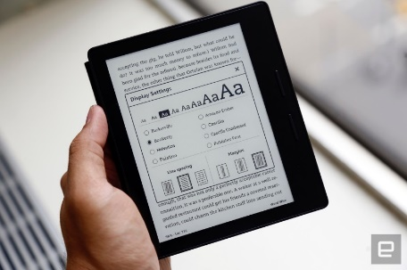  Figure 1- Kindle Oasis- https://www.engadget.com/2016/04/13/amazon-kindle-oasis/ | 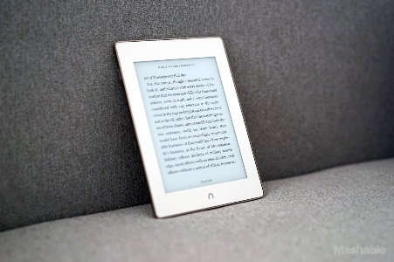  Figure 2- Nook GlowLight- http://mashable.com/2015/10/21/nook-glowlight-plus-waterproof-e-reader/#tuUZdU5D3Gqh | 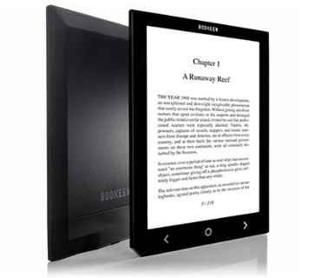  Figure 3- Cybook Ocean- https://www.bookeen.com/en/cybook-ocean

2.7.1 Industry analysis
Before the kindle was created, there was already an e-reader available, called Sony Librie [4]. The Sony Librie offered users a 6inch screen, 100mb storage, weighed around 190g and required 4 AAA batteries [9]. The launch of Amazon Kindle caused Sony to withdraw their e-reader from the market as it couldn’t offer as many books as Amazon could. Sony’s sales started to decrease when the Kindle was launched [10]. Since the launch of the Kindle, many other e-readers became available, the Barnes & Noble Nook GlowLight Plus, which offers their users a water proof device which has a 6inch screen, weighs 6.9 ounces, 4GB storage and 2 weeks of battery life. It was on the market for £100 [11]. Another e-reader which has become available is the Cybook Ocean which is created by Bookkeen. The Cybook Ocean offers their users an 8inch touch screen, weighs 10 ounces, holds around 4000 books and has a battery life of 1 month [12].

2.7.2 Business benefit
The Kindle has had a positive effect on Amazon, the Amazon Kindle is the most popular e-reader on the market, as it offers the most books to choose from [13]. By 2013 the Kindle had sold around 20 million units, bringing in a revenue of £3 billion. The e-books sales would approximately be around £200 million to £400 million a year [14].

2.7.3 Product review
Overall the feedback generated from the users are good but with some flaws, the good things about the latest Amazon Kindle Oasis are that its light, the lighting on it is adjustable allowing the user to choose their own lighting and the battery life can last up to 9 weeks, however users feel the price is high and users are disappointed with the device not being waterproof. [72].

2.8 Amazon web services
In 2006 Amazon launched a new service to businesses and users which would provide them with many online services. The business or user would only pay for what they use in that month. These services include:
- Cloud Drive- Allows users to upload many file types to the Amazon cloud, these files would include images, videos, documents and music if the user is using a web connected device.
- Dynamo Database - Allow users access to a fully-managed NoSQL database service.
- Elastic Compute Cloud- Allows businesses to run application programs.
- Mechanical Turk - Is an API which allows developers to integrate human intelligence into remote procedure calls.
- RedShift - A data warehouse service.
- Simple storage service - a high speed service which allows users and businesses to back up data and application programs online [65].

2.8.1 Industry analysis
Other Cloud based services on the market are Google Cloud Platform and Microsoft’s Azure. They all offer users and business many cloud based services, which users and businesses can access at a fee [66]. Google Cloud Platform offer users and business many different options, these include:
- Cloud drive - Allows users to upload many different file types to the cloud
- Hosting - Allows businesses to host an app on Google servers
- Cloud debugger - Allows developers to debug their code when problems occur with the application [67].
Microsoft’s Azure offers users and business with a whole bunch of cloud services, these include:
- Compute - offers users a virtual machine.
- Data storage - offers users an SQL database.
- Media and CDN - on-demand streaming, encoding and media playback.
- Development – Offers help to users on development of their code [68].

3.8.2 Business benefit
In the period of 2013 to 2015 Amazon received £6 billion through revenue generated by Amazon web based services. In the first quarter of 2015 Amazon generated £1 billion in revenue from AWS [69].

2.9 Amazon prime
In 2007, Amazon created and launched a service which would offer users unlimited access to a wide range of movies, shows, music and e-books for a monthly or yearly fee, this was called Amazon Prime. For £79 a year users have access to free next day delivery on the Amazon site, unlimited streaming of 15,000 movies and TV episodes, access to 800,000 free e-books, borrow one of over 500,000 books per month on the Amazon Kindle and have access to the Amazon music library where they can download and stream as much music as they wish [47]. If users don’t want to pay or can’t afford the yearly fee, Amazon also offer the full Amazon prime subscription on a monthly basis for£8. If the user decides they don’t want the one-day delivery and they only want the media side of it called Amazon Prime Instant, users can pay £7 a month and have access to all the media content, all services are non-contract meaning the user can cancel when they want [48].

2.9.1 Industry analysis
Services already on the market which offer users access to thousands of media content include Netflix and Now TV [49]. Netflix is a movie and TV streaming service which offers users unlimited access to 4,335 movies and 1,197 TV shows in both HD and SD [50]. Users have this service for a non-contract monthly fee from £6 to £9 depending on what resolution the user wants and how many devices the user wants to use it on [51]. Now TV is a non-contract video service which allows users to choose what content they wish to watch, provided by SKY, the user can choose what service they wish to pay for on a monthly basis, these include sports, movie and TV content. The cost of the TV package is £6.99 a month, the sports package is £31.99 a month, £6.99 a day or £10.99 a week depending on how long the user wants to use it and the movie package is £9.99 a month [52].

2.9.2 Business benefit
By 2016 Amazon had 54 million Prime users in the US, with an increase of 14 million Prime users in the US from the following year [53]. In 2015, it’s estimated that Amazon received £ 3 billion in revenue from all Prime memberships in that year [54].

2.10 Amazon Fire tablet
In 2011 Amazon created a device which had a 7-inch touch screen, weighed 14.57 ounces, had internal storage of 8GB and 512 MB of ram, a dual core 1.0 GHZ CPU and ran on the Android operating system. The price of the device was £155 [15]. The device was created to allow users to access email, browse social media, edit documents, listen to music, browse the internet, play games and to read books on the device. Apps can be accessed and downloaded from the Amazon app store [16]. In 2015 Amazon created a newer version of the fire tablet, called Fire 8, it had a 10.1-Inch HD touch screen, weighs 11 ounces, storage of up to 16GB, a quad core 1.5 GHz processor, a front and rear camera and operated on its own Fire 5 operating system. Original price of £170 [17].

Amazon Fire Tablet 8 | Apple iPad 9.7 | Samsung Galaxy Tab
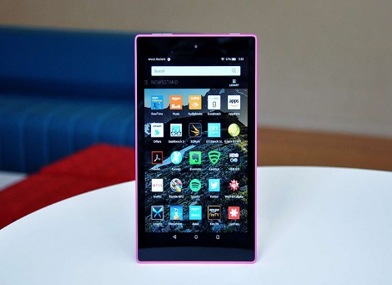  Figure 4-Fire 8- https://www.mobipicker.com/amazon-fire-hd-8-tablet-release-date-price-specs/ | 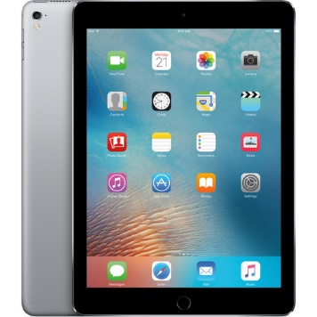  Figure 5- Apple iPad 9.7 - https://www.bhphotovideo.com/c/product/1241268-REG/apple_mlmy2ll_a_9_7_ipad_pro_256gb.html | 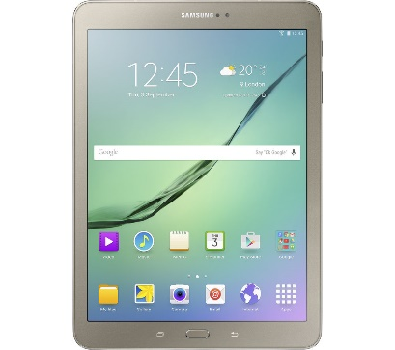  Figure 6 - Samsung Galaxy Tab - http://www.currys.co.uk/gbuk/computing/tablets-and-ereaders/tablets/samsung-galaxy-tab-s2-9-7-tablet-32-gb-gold-10137667-pdt.html

2.10.1 Industry analysis
There are many tablets on the market to date, these include the iPad created by Apple and Galaxy tab created by Samsung [18]. The iPad pro 9.7 offers a 9.7-inch touch screen, weighs 0.96lbs, storage of up to 256 GB, has a 64-bit processors, runs iOS 9.3 and has a front and rear camera, costing £800 [19]. Apple shipped 4 million units within the first half of the year [20]. The Samsung Galaxy offers users a 10.5-Inch touch screen, weighs 467g, storage of 32 GB internal, a 3GB RAM, a quad core 2.3GHz processor, runs on Android and has a front and rear camera, costing £199.99 [21]. Within the first month of launch sales hit 1 million units [22].

2.10.2 Business benefit
Within the first year of selling the original fire tablet, Amazon.com sold close to 5 million units [23]. The original fire tablet was predicted to sell 27.8 million units by 2014 [24]. In 2014 there was 240,000 apps on the Amazon store, which users can download from their tablet, their revenue from the app store in 2014 was £2 million [25].

2.10.3 Product review
Overall the feedback generated by users on the Fire 8 are good however it has its drawbacks. The good points are that it’s cheap, has expandable storage, comes with a free subscription of prime and the speakers are a good quality, the drawbacks are that the display isn’t as sharp as other tablet(s) on the market and the device is slow to charge [73].

2.11 Amazon Fire TV
In 2014 Amazon created a streaming media device called Amazon Fire TV. It takes videos, music, games and apps from the internet which can then be displayed on the TV the device is plugged into. The Fire TV box supports up to 4k ultra HD resolution. On the Fire TV box users can stream videos from services like Amazon prime and Netflix, as long as the user has a subscription with the service [55]. The Fire TV box has 8GB of storage with 2GB of RAM and has a quad core 2GHz processor, price on release was £79.99 [56]. Amazon also created a smaller version of the Fire TV box called Fire TV stick, which plugs directly into a HDMI socket on the user’s TV, it offers all the same features other than the resolution is only 1080p HD [55]. The Fire TV stick has 8GB of storage with a 1GB of RAM and has a quad core 1.3 GHz processor, price on release was £40 [57].
Amazon Fire TV | Roku | Google Chromecast
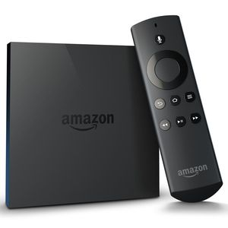  Figure 7-Fire TV- http://forum.xda-developers.com/fire-tv | 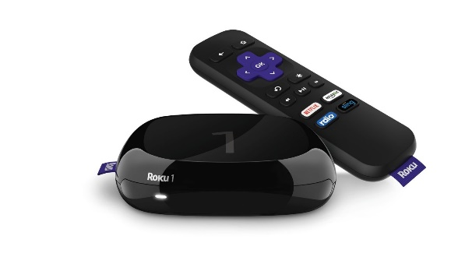  Figure 8- Roku - https://www.amazon.com/Roku-Streaming-Media-Player-2710R/dp/B00F5NB7JK | 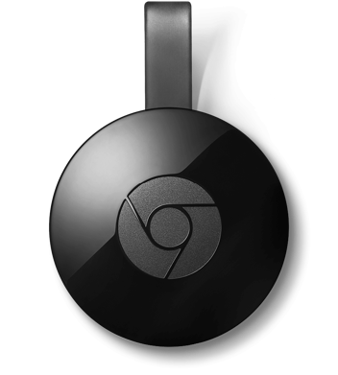  Figure 9 - Google Chromecast - https://www.google.com/chromecast/tv/

2.11.1 Industry analysis
Other streaming media devices on the market include Roku and Google’s Chromecast. All devices have different specification and prices, but all offer the same features and do roughly the same job [58]. The 2016 version of Roku offers users a voice recognition device with 1080p HD resolution, no internal storage, has 512 MB of RAM and a dual core 900 MHz processor, the price on release was £60 [59]. Google’s Chromecast offers users 1080p HD resolution, 2GB of storage, 512MB of RAM and a dual core 1.2 GHz processor, the price on release £30 [60].

2.11.2 Business benefit
By 2015 Amazon had sold 4.5 million Fire TV devices, meaning Amazon were the second best seller in the media streaming market, behind Google’s Chromecast which sold 8.5 million units [61]. At the end of 2015 Amazon Fire TV was the number one bestselling streaming media player in the US [62].

2.11.3 Product review
The 2015 version of Amazon Fire TV has received positive feedback, however it does have some bad points about it. The good being is that it streams in 4K, has expandable storage and allows users to plug in a games controller to play games. However, some users feel Amazon are pushing to much toward their own streaming services and are putting popular services like Netflix into the back and have made it hard to find [74].

2.12 Amazon fire phone
In 2014 Amazon created a new piece of technology, which was their own smartphone, which had a 4.7-inch screen, weighed 5.46 ounces, had up to 64 GB internal storage with 3GB of RAM, a quad core 2.2 GH processor and operated on Amazon Fire v3.5 [26]. Without having the phone on contract, the price of the phone on release was £150 [27]. “Fire Phone puts everything you love about Amazon in the palm of your hand—instant access to Amazon’s vast content ecosystem and exclusive features like the Mayday button, ASAP, Second Screen, X-Ray, free unlimited photo storage, and more,” [28 Jeff Bezos, Amazon.com Founder and CEO].
Amazon Fire Phone | Apple iPhone 6 | Sony’s xperia z3
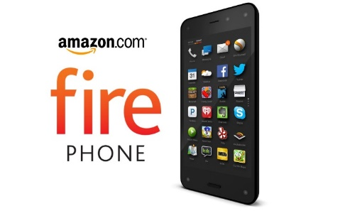  Figure 10-Fire Phone- https://vrworld.com/2015/08/28/report-amazon-will-forego-future-phone-development/ | 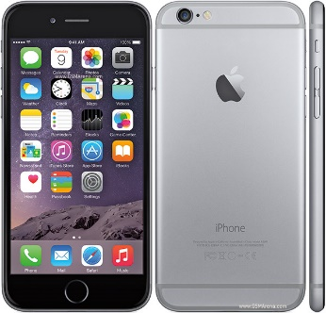  Figure 11 - Apple iPhone 6 - http://www.gsmarena.com/apple_iphone_6-pictures-6378.php | 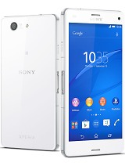  Figure 12 - Sony xperia z3 - http://www.gsmarena.com/sony_xperia_z3-6539.php

2.12.1 Industry analysis
There were many smartphones on the market in 2014, the popular ones being Apples iPhone 6 and Sony’s Xperia Z3 [29]. Apples iPhone 6 offers a 4.7-inch touch screen, weighs 4.55 ounces, has up to 128GB internal storage with a 1GB of RAM, has a dual core 1.4 GHz processor and runs on the iOS operating system [30]. The price on release of the iPhone 6 without a contract was £650 [31]. Sony’s Xperia Z3 offers a 5.2-inch touch screen, weighs 152 g, up to 16GB of storage with a 3GB of RAM, has a 2.5 GHz quad core processors and operates on Android 4.4 [32]. The price of the Sony Xperia Z3 without a contract was £500 [33].

2.12.2 Business benefit
Within the first month of the Fire phone being released, Amazon.com sold 30,000 units [34]. After a year of the Fire phone being on the market and a drop-in price, Amazon sold out their inventory of Fire phone worth £65 million. Amazon decided to stop selling the item due to poor sales [35]. The reason behind the failure of the Fire phone was that the phone was late to market, as there were already many popular phones on the market. The app store was small compared to Apples and Samsung’s and the phone was aimed at people who used Amazon services all time, with the features like scanning a barcode and viewing the item, this would only appeal when someone wanted to use the website [36].

2.12.3 Product review
The Fire phone also received some negative feedback from users as they felt the price they were paying for the phone didn’t match the features the phone had compared to other phones on the market. Users also didn’t like the app store, as it didn’t offer enough apps to compare to others [75].

2.13 Amazon Prime Air
In 2013 Amazon announced a very new idea called Amazon Air, in which a device would deliver your order from the Amazon website within 30 minutes. The drone will pick up the users order from an Amazon warehouse and fly it to the user’s house. The drone can go as high as 400 feet and can fly for 10 miles. Once the package has been dropped at the users address, the drone will then go back to the warehouse and recharge. As of 2016 the device is still in development with no date to when it will be available, however it is being tested heavily in a few select countries [63].

Amazon Prime Air | Google Project Wing
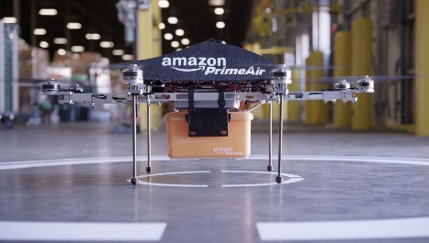  Figure 13-Amazon Prime Air- https://www.amazon.com/b?node=8037720011 | 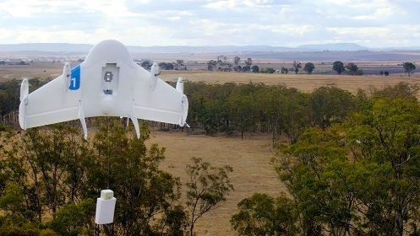  Figure 14- Google Project Wing - http://www.theindustrylondon.com/google-goahead-drones-us/

2.13.1 Industry analysis
The only other delivery drone on the market is Google’s Project wing, which aims to deliver an item across town within a minute or two, again this item is still in development with no date given to when it will become available [64].

2.14 Amazon Echo
In 2015 Amazon created a new device which allowed users to interact with a voice recognition speaker connected over Wi-Fi in which a personal assistant would respond and follow commands, Amazon created the Amazon Echo [37]. The device has built in Wi-Fi and Bluetooth, has one speaker, is 9.25-inches tall, weighs 1.7 lbs. and the price on release was £155 [38]. The Amazon Echo will play music, provide information from the web, deliver news, updates on sports scores, tell the user the weather, control smart home products, update calendars, tell users about event(s) they have on that day and order products of from Amazon. The Amazon Echo also known as Alexa will update through the cloud at all times, to stay up to date with real time events [39]. In late 2015 Amazon created a small version of the Amazon Echo, called the Echo dot. The echo dots does all the same things as the Amazon Echo, the only differences being the size, weight and price. The Echo dot is 1.5-inches tall, weighs 0.6 lbs. and price on release was £70 [40].

Amazon Echo | Google Home
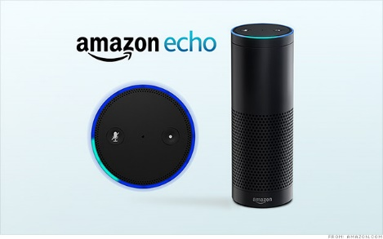  Figure 15-Amazon Echo- https://www.incontrolha.com/Buy/product/amazon-echo | 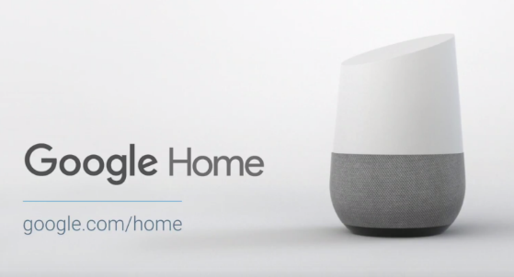  Figure 16 - Google Home - http://thenextweb.com/google/2016/05/18/google-home-official-amazon-echo-worried/

2.14.1 Industry analysis
When the Amazon Echo was released, there was only one other smart home speaker coming on the market, this was Google Home [41]. The device allows users to play music, add calendar appointments, receive data from the internet and ask for real time updates using their voice, the device is connected over Wi-Fi [42]. The Google Home is 6inches tall and the price on release was £100 [43]. It is also believed that Apple are working on a device to compete with the Amazon Echo and Google Home but no other information has been given [44].

2.14.2 Business benefit
Within the first 18 months of the Amazon Echo being released, Amazon sold 5 million units [45]. From the sales of the first year, it’s estimated that in 2020 there will be 41.3 million units sold that year, bringing in a revenue of £ 3 billion, this includes both the Amazon Echo and Echo dot, based from the results and feedback from the first year [46].

2.14.3 Product review
The Amazon echo has been received fantastically by the users, as they are impressed with the response time, the continuation of updates to keep users informed and the users like that it has massive potential, however the user don’t like the sound quality as sometimes it can be hard to hear or understand when at different volumes [76].

2.15 Boston Matrix
This is used as a marketing tool, to examine and understand the success or failure of a product on the market. It will identify where resources should be spent in order to increase the businesses profit [70]. Each quadrant of the matrix is there to identify where each product lies within it, star- product which generated the most sales and have room for growth. Cash cow- products which have a high sales but no growth. Dogs- low sales and low growth. Question marks- low sales but high growth [71].

2.15.1 Product analysis
Market
Growth
Low
High
Star | Question Mark
Kindle – Room for improvement and high sales already
Amazon Prime - Room for improvement and high sales
Fire Tablet – High sales and room for improvement

Cash Cows | Dogs
Echo - High sales, however not room for growth as the item is at its potential.  Fire TV –High sales, item is close to full potential. | Fire Phone – Low sales and item discontinued
Market Share
Low
High

2.16 Conclusion of Literature Review
This section looked at how Amazon started as an e-commerce website which only books at a cost, has grown over the years into worldwide company, which now sell loads of different items on a full functioning website and mobile app. Amazon has also created their own product and services and enter a range of different markets to compete, some product/ services have had great successful others have been discontinued.

Chapter 3 – Research Methodology

3.1 Introduction
This section of the report at what methods were chosen to complete the study and why they were chosen. This section will look at how the questionnaire was created and how it was distributed to the correct audience.

3.2 Research method

Research Philosophy
The research philosophy chosen for this project is realism. This was chosen because the results needed to be non-biased and fair towards the data which was collected. However in order to complete the research and get a wider view, other methods may be needed, this is why realism is the best philosophy. [90]

Research Approach
The research approach chosen for this project is deductive. This approach is when you start with a specific aim which is broken down into objectives, the objectives then become the research in which is needed to complete the aim, once the objectives have been completed it can then be concluded by a yes or no response to see if the aim had been met or not. [90]

Research Strategy
The strategy chosen to complete the project is survey based. This strategy is when surveys and questionnaires are designed and conducted to collect data for the research. This strategy will help massively as the data which is generated will be totally non-biased and will also be rich and statistical data which can be analysed. [90]

Research Choice
The project will use both quantitative and qualitative data to generate the results for the project. All data which is collected will be analysed non-biasedly and completely true to the results, meaning the choice in order to analyse data will be mixed-methods. [90]

Research Time Horizon
The time horizon over the project is cross-sectional, this is because the project is short term based down to the deadline of the project. The project will look at both qualitative and quantitative data at a single point. [90]

Research Technique
Once all the data is collected, the data will then be analysed to produce the results for the project. The results will show a non-biased outcome and a conclusion which will answer the main aim of the project. [90]

Objectives of survey
The main aim of the survey is to find out how Amazon and other companies customers feel towards the products and services Amazon has available. This will be done by sending out questionnaires to the general public to find out the information the research needs.
1 Create a pilot questionnaire, asking about the products and services Amazon has available
2 Send the questionnaire to a select few people for testing
3 Using the feedback from the pilot re-design the questionnaire
4 Send the questionnaire out to the general public using a survey based tool
5 Collect results after a period of time (10 days)
6 Analyse the results to find out information on how customers feel towards Amazon

Valid
The questionnaire is completely valid because customers in the general public will be completing the questionnaire. These are the people who use the devices on a regular basis and understand the devices they use. If the questionnaire was aimed at people who didn’t use technology then they wouldn’t understand and know the technology making the questionnaire invalid.

Reliable
The questionnaire is very reliable, as the questionnaire results is raw data and from the customers without being edited or changed in any way keeping the research true and reliable. Also if the questions were asked by someone else the results would be similar. However, if the research was done again in 10 years’ time, the questionnaire would become un-reliable due to the fact, there will be new devices and technology available.

Generalizable
This research can only be done for Amazon and not used on other business’s. The research looks specifically at Amazon products and service therefore if the research and questionnaire was to be done on another business then it would not work as other businesses have their own product and services.

Creating the questionnaire
The questions which will be used to create the questionnaire will be determined by the information based on the literature review. Once all questions are created, the questionnaire will be posted and created through Survey Monkey, this is an online survey development cloud based service which is one of the world’s leading web-based survey solutions available. They make tools available to the user which can really help researchers with the analysis of the feedback [91]. Factors which were considered when creating the questionnaire were how it should be worded, how many questions it should contain and the layout of the questionnaire. The questionnaire needs to be worded with words that are easy to understand and asked in a polite manner [92]. The questionnaire should have been around 10 questions or less than 5 minutes to complete, however with the data that was needed for the research it difficult to keep to this limit [93]. The questionnaire should be in logical order with questions being related in order, for example questions about a specific product should follow each other [93].

Distributing the questionnaire
Once the questionnaire is complete and uploaded in Survey Monkey, this will generate a web link for participants to take in the questionnaire. The questionnaire will be sent to friends and family, it will also be posted on social media to generate more participants. The questionnaire will be closed after the questionnaire receives 50 participants, this will be a good number of responses and a good analysis.

Target Group
The questionnaire is aimed at the general public. This is because everyone in their day to day life uses some sort of device, these could include a smart phone, a tablet etc. Also with technology becoming such an important part of everyday life, each of the general public would have experienced good and bad parts of the experiences. The general public are ordinary people who live in society.

3.3 Questionnaire on Amazon products and services
Part 1- This part is based more towards Amazon devices and similar devices in a market.
- Please select your gender
This question will identify the gender of the person who is taking the questionnaire. This will be useful when looking at trends or similarities in the data, for example a gender may have a different reason to female when purchasing different products. The user will have a choice of male, female and prefer not say.
- Please select your age range
This question will identify the person’s age range. This question will be useful when looking at trends or similarities in the data, for example a 41+ individual may have a different reason on purchasing than an 18-. The user will have a choice of 16-, 17-21, 22-27, 28-40 and 40+.
- Please state the Amazon products & services you own
This question will identify which Amazon products and services the user owns. The user will have all products and services listed which Amazon have created with an option of yes or no for each one.
- Please specify the devices or services you own and select the make of the device
This question will identify what products the person uses and what brand of device they use. This will be useful as to what product they opted for and how popular that product could be.
- Please state the amount of time on average you spend using each device/service a week
This question will show how long users use on average for each device, this will help identify their favourite and least favourite product.
- Out of the device you own, please rate your overall satisfaction with the devices 1=poor 10=excellent
This question will underline how satisfied the user is with the device they are currently using. 1 being unhappy or poor and 10 being very happy or excellent, this will show the rate they feel the device matches.
- Please specify your favourite Amazon device (If you don't own an Amazon device please go to part 2)
This question will underline the user’s favourite Amazon product. This could be different to the product they spend the most time on as the user may not be able to use much due to other situations, this question will show the favourite devices users pick.
8. Purpose of purchasing
This will help identify the purpose behind buying the product, to get a better understanding on customers reasoning to buying the product.
9. What do you like about the product?
This will help identify what different customers like about the product they are using, it will give a better understanding on what’s good about the product.
10. What do you dislike about the product?
This will help identify what customers feel the product does badly, it will give a better understanding of the product, with the bad features of the product.
11. If you could improve the product, how would you improve it and why?
This is will give a better understanding on how customers feel the product can be improved, it will give a better analysation to the product and how customers feel it can grow.
12. Would you consider an alternative?
This question will tell the research if the user had considered changing devices due to the dislike of certain features. This question could underline the alternatives available which could offer what the user wants added to the Amazon product.
13. Why?
This question will clarify their reasoning behind whether or not the user considers an alternative to their existing product. The user will state why they stayed with the product or why they consider similar products in the market.
Part 2 – This part of the questionnaire is aimed at the shopping experience at Amazon.
14. Do you shop on the Amazon e-commerce site?
This question will identify if the user uses the Amazon e-commerce site at all. The user will select yes if they use the site or no if they do not use the site.
15. Why?
This question will explain the users reasoning behind whether they use the e-commerce site or not. These could include what they like or dislike about the site, or even if they prefer other sites that are similar.
16. Do you shop on the Amazon mobile App?
This question will identify if the user uses the Amazon mobile app at all. The user will select yes if they use the mobile app or no if they do not use the mobile app.
17. Why?
This question will explain the users reasoning behind whether they use the mobile app or not. These could include what they like or dislike about the app.
18. Do you use the Amazon app store?
This question will identify if the user uses the Amazon app store at all. The user will select yes if they use the app store or no if they do not use the app store.
19. Why?
This question will explain the users reasoning behind whether they use the app store or not. These could include what they like or dislike about the store or if they have no purpose to use it due to not having any Amazon products.

20. Do you use Amazon Alexa?
This question will identify if the user uses the Amazon voice recognition service Alexa. The user will select yes if they use Alexa or no if they do not.
21. Why?
This question will explain the users reasoning behind whether they use Alexa or not. These could include what they like or dislike about Alexa and how it is useful to them. The user could also have no purpose to use it or devices with it on.
22. Do you use an alternative? If yes please specify
This question will identify if the user uses an alternative to Alexa. If the user does use an alternative they are asked to specify which alternative it is.
23. Out of the shopping methods for Amazon.com, please rate your experience, 1=poor 10=excellent
This question will identify how users feel towards each of the shopping methods. They will rate their experience, 1 being poor and 10 being excellent.
24. Do you know about Amazon Air?
This question will identify whether the user knows about Amazon’s latest instalment of technology “Amazon Air” or not. The user will select yes if they know about it or no if they don’t know about it.
25. If Amazon Air was available in your area, please specify if you would use the service
This question identifies if the user would use Amazon Air if it was available to them. If the user would use it then they yes select yes, if they wouldn’t use it then the user would select no and if the user isn’t sure what Amazon Air is, then they would select N/A.
26. Overall how happy are you with the services and products Amazon.com has available. 1=poor 10=Very happy
This question will identify how happy or unhappy the user is with what Amazon has to offer their customers. This is aimed at both shopping and products.

3.4 Conclusion of Research Methodology
It was important before starting the research to have the correct approach, this will give a good direction into starting the study. It’s also important to have the correct questions in the questionnaire and explain why these questions are asked. It’s also important the questionnaire is design to get the highest number of responses available to get a better analysis of the data.

Chapter 4 – Analysis

4.1 Introduction
This section of the report will look at the feedback generated from the questionnaire, it will look at the data in a diagram, explain the results and what was the expected outcome, as well any link to the literature review and other questions.
To see full response for questionnaire see appendix 1.

4.2 Questionnaire Analysis
1 – Please select your gender
Graph
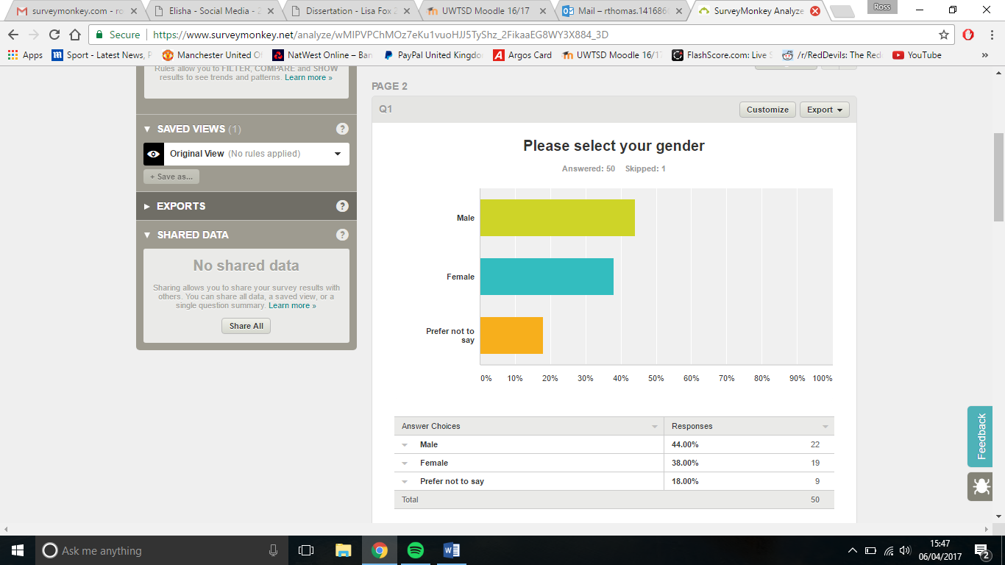
Figure 17 - Q1 Please Select Your Gender
Results
The results show out of the 51 people who took the questionnaire, 50 people answered this question with just over 40% of people were male, just under 40% were female and just under 20% preferred not to state their gender.
Expectation
There was no expectation for this question, this is because the questionnaire was posted online to the general public, and therefore anyone who wanted to could take the questionnaire would take it.
Link to literature review
No links to literature review
Correlations
No correlations in the data
2 – Please select your age range
Graph
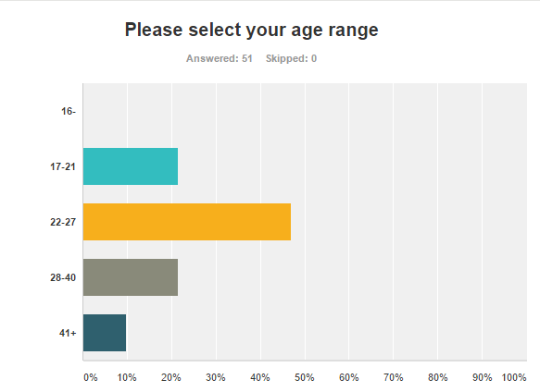
Figure 18- Q2 Please Select your Age Range
Results
The results show out of the 51 people who answered this question, 0 were under the age of 16, just over 20% were 17-21. Just under 50% were 22-27, just over 20% were 28-40 and 10% were over 41.
Expectation
The results were what was expected, this is because mostly people 18-40 use the website, and therefore these are the ones who use the website. This was also expected because people aged 22-27 will understand the technology the most. However, it was expected that more than zero people aged under 16 would have taken the questionnaire, as they could have used the devices for educational purposes.
Link to literature review
No link to literature review.
Correlations
No correlations in the data

3 - Please state the Amazon products & services you own
Graph
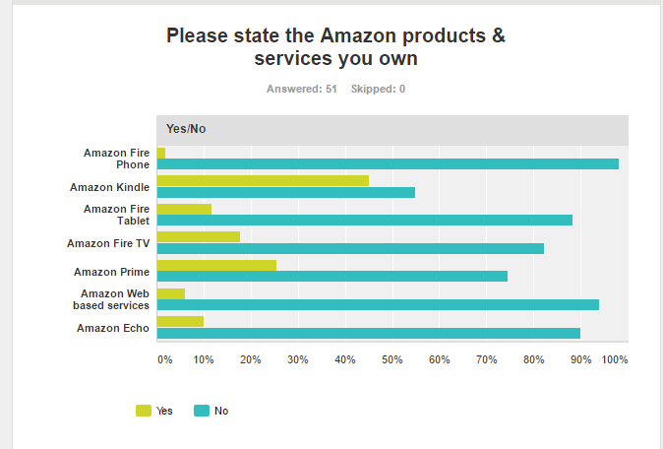
Figure 19- Q3 Amazon product and services you own
Results
The results show that the most popular Amazon product was the Kindle with 45% of people saying they owned the Amazon Kindle. The least popular product was the Amazon Fire Phone with only 2% of people stating they owned the Fire Phone. The Amazon Fire tablet had 12%, Fire TV had 18%, Prime had 25%, AWS had 6% and Echo had 10%.
Expectation
The Amazon Fire phone has been dis-continued so this was expected to have close to zero people stating they own the phone and only one person said they had it so this was expected. The Amazon Kindle is a very popular e-reader and some people don’t even know any other device in that market, it was expected that the Kindle would have been the most popular product. The Amazon Echo is a new product and hasn’t been around for long so therefore not many people are expected to have it. Amazon promote AWS more at businesses than the general public, therefore this was also expected to have a low percentage. The Amazon fire tablet was expected to have a higher number of people using it due to it being one of the cheapest tablets on the market, only 12% stated they owned it and not meeting what was expected of it. Amazon Prime was expected to have a higher number of people stating they owned it, this is because there aren’t a wide variety of choices in the video streaming market to choose from.

Link to literature review
All the products link back to section 2.2 in the literature review, this allowed for a better understanding of the products and to see what else is available within the selected market. It also provided a clearer imagine of what each device offered a user and an overall review of the products. If a product had a very good overall review and not much competition, this product would therefore be expected to have a higher percentage than a product which is unproven and unknown.
Correlations
No correlations in the data
4 - Please specify the devices or services you own and select the make of the device
Graph
Yes or No
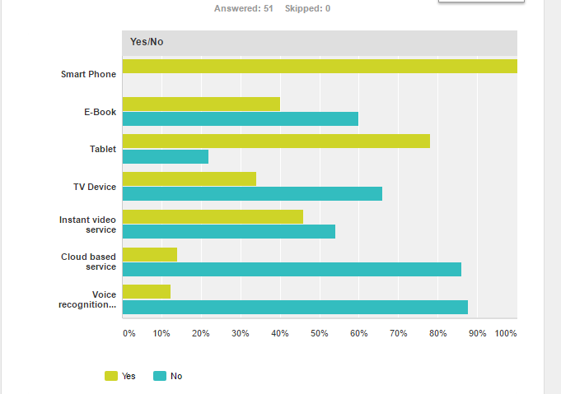
Figure 20 - Q4 Yes/No to Device/service user owns
Make
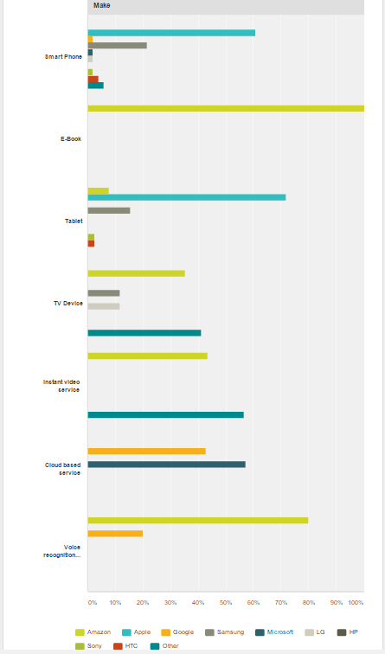
Figure 21 - Make of service/device

Results
The results show that all 51 people owned a smart phone, with 31 of them being manufactured by Apple, 11 by Samsung, 1 by Google, 1 by Microsoft, 1 by LG, 1 by Sony, 2 by HTC, 1 by Motorola and 2 by Huawei.
Out of the 50 people who took the question, 20 of them said they owned an e-reader and all of them selecting it was manufactured by Amazon.
Out of the 50 people who took this question, 39 of them said they owned a tablet, with 28 of them saying it was manufactured by Apple, 3 by Amazon, 6 by Samsung, 1 by Sony and 1 by HTC.
Out of the 50 people who took this question, 17 of them said they owned a TV device, with 6 of them being manufactured by Amazon, 2 by Samsung, 2 by LG, 1 by Sky, 1 by Bush and 5 by Kodi.
Out of the 50 people who took this question, 23 of them said they owned an instant video services, with 10 by Amazon and 13 by Netflix.
Out of the 50 people who took this question, 7 of them said they owned a cloud based service, with 3 of them saying it was owned by Microsoft and 4 of them saying it was owned by Google.
Out of the 50 people who took this question, only 49 completed the voice recognition device, with 6 of them saying they owned a voice recognition device with 4 of them selecting Amazon and 1 with Google.
Expectation
It was expected that Apple and Samsung would have the highest number of users with smartphones. This is because they are most popular in their markets. It was also expected that a high number of user would have an e-reader, likely manufactured by Amazon. This is down to Amazon being popular in that market. Apple are very popular in the tablet market therefore it was expected that most of the people who had a tablet would own an Apple device. It was expected that more people would of have chosen the Amazon fire TV device for the TV device as there aren’t many others to choose from in that market. However, Kodi is very popular in that market so this along with Amazon would have been expected to have the highest number of users.
The results for the instant video service were expected, this is because there are only two main services which offer what Netflix and Prime offer to their users. The results for cloud based services were expected, this is because Microsoft and Google promote their services to more than just business’s, therefore more people will know about the services and therefore more people would use them. There are only 2 main voice recognition devices on the market, these are Amazon Echo and Google Home, therefore the people who had a voice recognition device could only chose between two. Amazon Echo was out first, therefore more people were expected to know about it and own it out of the two.
Link to literature review
This question links to the market analysis within the literature review, this allowed for an understanding of each market and to see what it had available. This also provided an insight into what the competition was like in the market and to understand which products were more popular in that market compared to others.
Correlations
No correlations in the data

5 - Please state the amount of time on average you spend using each device/service a week
Graph
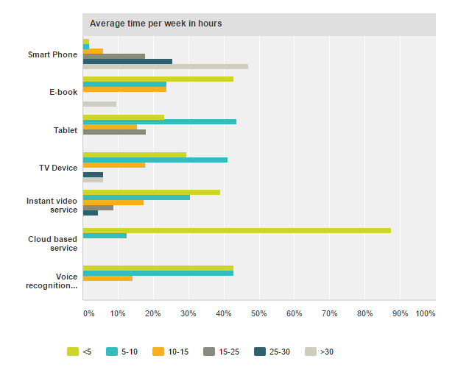
Figure 22 - Q5 time on each device
Results
Out of the 51 people who said they own a smart phone, 24 of them said they used their phone more than 30 hours a week, 13 of them said 25-30 hours, 9 said 15-25 hours, 3 said 10-15 hours, 1 said less than 5 hours and 1 said 5-10 hours.
Out of the 21 people who said they own an e-reader, 9 of them said they use their e-reader less than 5 hours per week, 5 of them said 5-10 hours, 5 of them said 10-15 hours and 2 of them said more than 30 hours a week.
Out of the 39 people who said they own a tablet, 9 of them said they use it for less than 5 hours per week, 17 of them said 5-10 hours, 6 of them said 10-15 hours, 7 of them said 15-25 hours a week.
Out of the 17 people who said they own a TV device, 5 of them said they use the device for less than 5 hours a week, 7 of them said 5-10 hours, 3 said 10-15 hours, 1 said 25-30 hours and 1 said more than 30 hours a week.
Out of the 23 people who said they own an instant video service, 9 of them said they use it for less than 5 hours a week, 7 said 5-10 hours, 4 said 10-15 hours, 2 said 15-25 hours and 1 said 25-30 hours.
Out of the 8 people who said they use a cloud based service, 7 of them said they use it for less than 5 hours a week and 1 between 5-10 hours.
Out of the 7 people who said they own a voice recognition device, 3 of them said they use it for less than 5 hours a week, 3 of them said 5-10 hours and 1 said 10-15 hours.
Expectation
It was expected that most people who own a phone spend a lot of time using it. This is because smart phones can almost do everything and contain everything you need to get through your day. E-readers and tablets were expected to be used between 0-10 hours a week. This is because people use these devices on their way to home and to work and in any free time they may have. TV devices and instant video services was expected to be used between 0-10 hours a week. This is because most people like to watch TV in the night for an hour or 2 while relaxing after work.
It was also expected that most people would use their voice recognition device for less than 5 hours a week. This is because people would mostly use it to set reminders, add items to a shopping list, find out information on the internet, etc. It was expected that people who use a cloud based service would use it for much longer than under 5 hours a week, because people would use it for work, study and to store data etc. To see most people only use it for less than 5 hours wasn’t expected.
Link to literature review
No link to literature review.
Correlations
No correlations in the data.

6 - Out of the devices you own, please rate your overall satisfaction with the devices 1=poor 10=excellent
Graph
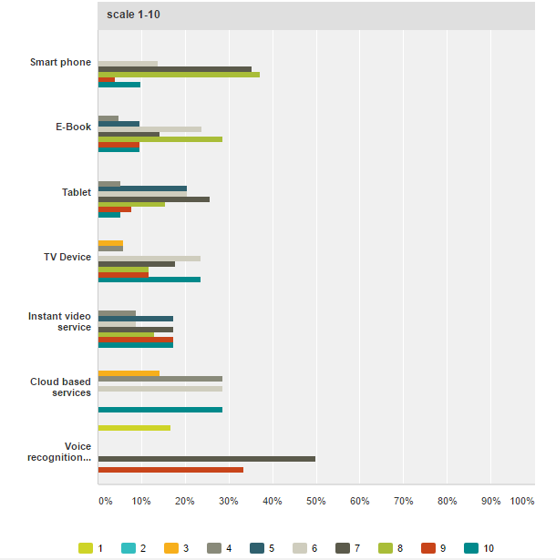
Figure 23 - Q6 Rate devices/Services
Results
The results show that 51 people would rate their satisfaction of their smart phone with a 6 out of 10, 18 people gave it 7 out of 10, 19 people gave it 8 out of 10, 2 people said 9 out of 10 and 5 people gave it 10 out of 10.
Out of the 21 people who said they owned an e-book, 1 person gave it 4 out of 10 for their satisfaction with it, 2 people gave it 5 out of 10, 5 people gave it 6 out of 10, 3 people gave it 7 out of 10, 6 people gave it 8 out of 10, 2 people gave it 9 out of 10 and 2 people gave 10 out of 10.
Out of the 39 people who said they own a tablet, 2 of them gave it 4 out of 10 for their satisfaction with the device, 8 people gave it 5 out of 10, 8 people gave it 6 out of 10, 10 people gave it 7 out of 10, 6 people gave it 8 out of 10, 3 people gave it 9 out of 10 and 2 people gave it 10 out of 10.
Out of the 17 people who said they own a TV device, 1 person gave it 3 out of 10 for their overall satisfaction with the device, 1 person gave it 4 out of 10, 4 people gave it 6 out of 10, 3 people gave it 7 out of 10, 2 people gave it 8 out of 10, 2 people gave it 9 out of 10 and 4 people gave it 10 out of 10.
Out of the 23 people who said they use an instant video services, 2 people gave it 4 out of 10 for their overall satisfaction with the service, 4 people gave 5 out of 10, 2 people gave it 6 out of 10, 4 people gave it 7 out of 10, 3 people gave it 8 out of 10, 4 people gave it 9 out of 10 and 4 people gave it 10 out of 10.
Out of the 7 people who said they use a cloud based service, 1 person gave 3 out of 10 for their overall satisfaction with the service, 2 people gave it 4 out of 10, 2 people gave it 6 out of 10 and 2 people gave it 10 out of 10.
Out of the 6 people who said they own a voice recognition device, 1 of them gave it 1 out of 10 for their overall satisfaction with the device, 3 people gave it 7 out of 10 and people gave it 9 out of 10.
Expectation
It was expected that all responses would choose over 5 out of 10 for their satisfaction with their smart phone because of the amount of time they all selected they use the device per week. If the user wasn’t happy with the device then they wouldn’t use it as it as much as they currently do. Each of the other devices also had their expected results based on the amount of time the device was used per week.
Link to literature review
No link to literature review
Correlations
This question correlates with question 5, this is because in question in 5 the user was asked how long they would spend using each device per week. Therefore, that would give some indication into how the user felt about the device. If the user was on the device all the time this would suggest they enjoy using the device and if the user didn’t spend as much time on the device then this could suggest the user didn’t enjoy it or didn’t have the time to use it.

7 - Please specify your favourite Amazon device (If you don't own an Amazon device please go to part 2)
Graph
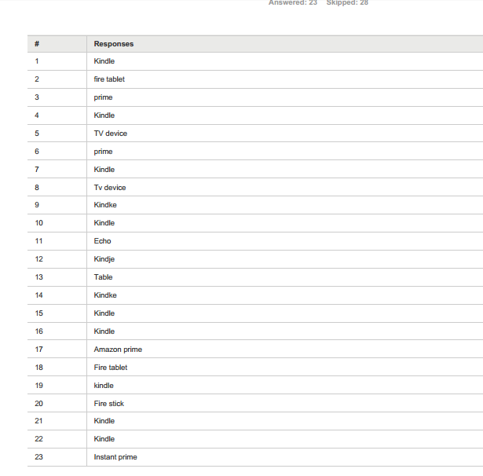
Figure 24 - Q7 Favorite Amazon device RAW

Figure 25 - Q7 Favorite Amazon device

Results
The results show that 12 out of 23 people said their favourite device was the Kindle, 4 said Prime, 3 said TV device, 3 said tablet and 1 said Echo.
Expectation
It was expected that the Kindle would have been the most popular on this question due to the feedback the product received. It was also expected that the other products were less popular here because of how highly rated the Kindle is.
Link to literature review
This question links to the product review in the literature review, this allowed an understanding of how each device would be rated and what the overall reflection of the device was.
Correlations
No correlations in the data.

8 - Purpose of purchasing
Graph
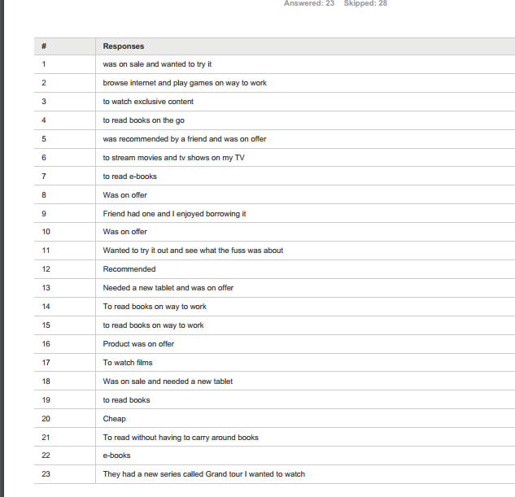
Figure 26 - Q8 Purpose RAW

Figure 27 - Q8 Purpose

Results
The results show that 7 people bought an Amazon product because it was on offer and 7 people also bought so they could read e-books, 4 people were recommended their device and 4 people wanted it to stream media, 1 person wanted their device to browse the internet.
Expectation
It was expected that most people bought their device to buy e-book due the high percentage of people chose Kindle as their favourite device. It was also expected people bought their product due to it being on offer. A small number of people said their favourite Amazon device was Tablet and prime therefore it was expected to have small percentage for browse internet and stream media. It was expected that recommended would have had a higher number due to the Kindle having a good overall review.
Link to literature review
No link to literature review.
Correlations
This question links to question 7, because it was important to find out what the user’s favourite Amazon device was to get a better understanding into what they use it for and why they bought it.

9 - What do you like about the product?
Graph
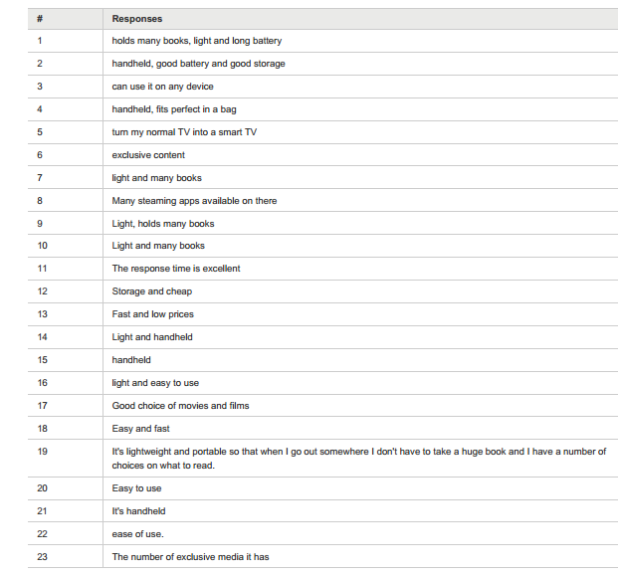
Figure 28 - Q9 Like about product RAW

Figure 29 - Q9 Like about product
Results
The results show that 7 people liked the weight of the product, 6 said they liked the storage provided by the product, 5 said they liked that it was handheld, 4 said the ease of use, 2 said the speed was good, 2 said the price was good, 2 said how compatible it was and 2 said they liked the apps or movie’s that were available.
Expectation
It was expected that the weight was going to be popular based on the research in the literature review. However, it was expected the price was going to be higher due to many people previously saying the reason they bought the product was because it was on offer. Each of the other good features were as expected due to the research in the literature review.
Link to literature review
This question links back to product review on each product in the literature review, this provided a clearer understanding on what was good on the product.
Correlations
No correlations in data
10 - What do you dislike about the product?
Graph
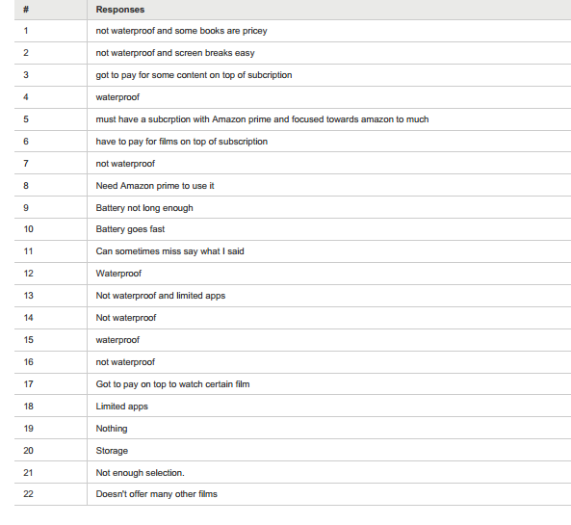
Figure 30 - Q10 Dislike RAW

Figure 31- Q10 Dislike
Results
The results show that 9 people dislike that it wasn’t waterproof, 4 people said they didn’t like the price, 2 people said you needed Amazon Prime, 3 people said they didn’t like that it had limited content available, 2 people said the battery was poor, 1 person said it was easily damaged, 1 person said it focused too much on Amazon, 1 person said it would misinterpret what they were saying and 2 people said they didn’t dislike anything about it.
Expectation
It was expected that not being waterproof was going to be a big reason for disliking the product. This is because in the product review the overall feedback said people didn’t like the fact it wasn’t waterproof. Easily damaged, misinterpretation, battery, limit of content, were expected to be low as this is down to in the product review, these were never mentioned. However focus towards Amazon and needing Amazon services were expected to be higher because these were mentioned previously.
Link to literature review
This question links back to the product review in the literature review, this allowed an understanding of what people felt the product lacked in.
Correlations
No correlations in data

11 - If you could improve the product, please state how you would improve it and why?
Graph
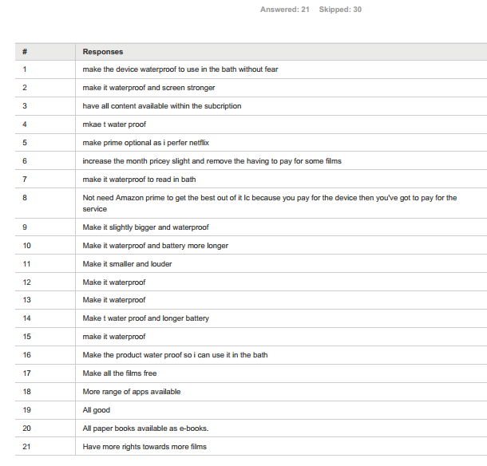
Figure 32 - Q11 Improve RAW

Figure 33 - Q11 Improve
Results
The results show that 10 people would make the device water proof, 3 said they would change the price, 3 wanted more content, 2 would change the size, 2 wanted a longer battery, 2 wanted to have Amazon service optional, 1 person would improve the sound and 1 person would make it harder to damage.
Expectation
It was expected that making the product waterproof was going to be high, this is because many people didn’t like that the device wasn’t waterproof.
Link to literature review
No link to literature review.
Correlations
This question correlates with question number 10, this is because in the previous question, the user was asked what they didn’t like about the product, therefore they would like to see that feature removed or improved.

12 - Would you consider an alternative?
Graph
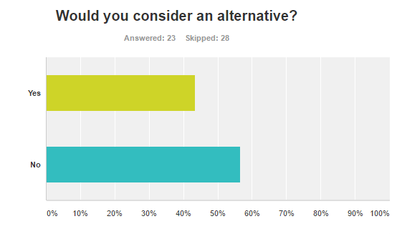
Figure 34 - Q12 Consider alternative
Results
Out of the 23 people who took this question, 10 said they would consider an alternative and 13 said they wouldn’t consider an alternative.
Expectation
It was expected that more people would have considered an alternative due to most people said they didn’t like certain aspects of the current device and wanted to change certain features about it. Therefore. They could have looked in the market to see what alternatives were offered and consider them. To see that more people didn’t consider an alternative wasn’t expected.
Link to literature review
This question links back to the market analysis of the literature review, in the market analysis it shows what alternatives are on the market and what they offer differently to an Amazon product. Some features which Amazon products don’t offer, other products in that market could have offered these features.
Correlations
This question correlates with question 12, this is because in question 11 the user was asked what they would change about the device, therefore an alternative might be available in that market.

13 – Why?
Graph
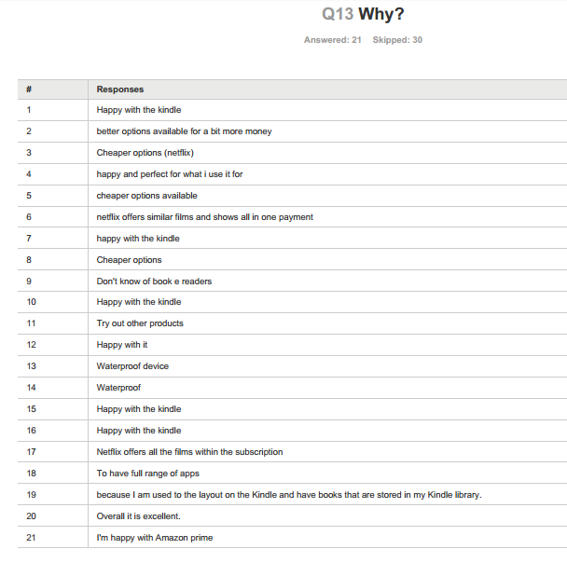
Figure 35 - Q13 Why RAW

Figure 36 - Q13 Why
Results
The results show that 9 people are happy with their current device, 3 people want a device which offers more apps or movies, 2 people want a waterproof device, 2 people want a cheaper option, 1 person doesn’t know what is available in the market and 1 person wants to try a new product.
Expectation
It was expected that most people were going to be happy with their device due to the response in the previous question. However, it was expected that waterproofing would have been higher due to many people saying they disliked that the device wasn’t waterproof. Cheaper options and more apps or movies had expected results due to the previous responses.
Link to literature review
No link to literature review
Correlations
This question correlates with question 13 and 11, this is because people might have considered an alternative due to they wanted to see improved in the current device.

14 - Do you shop on the Amazon e-commerce site?
Graph
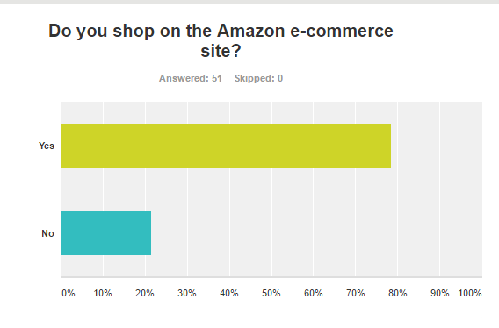
Figure 37 - Q14 Shop on Amazon site
Results
The results show that just under 80% of people said they use the Amazon e-commerce website, with just over 20% of people who said they didn’t use the Amazon e-commerce website.
Expectation
It was expected that most people would use the Amazon website, this was expected because of the amount of traffic the e-commerce website gets compared to others and how many products Amazon sell on there.
Link to literature review
This question links back to the Amazon e-commerce site in the literature review, this allowed for an understanding into what the e-commerce site had to offer users and what alternatives there were available.
Correlations
No correlations in the data

15 - Why?
Graph

Figure 38 - Q15 Why to shopping or not shopping on site
Results
The results show that 25 people use the site because of the wide selection it has available, 12 people said they use the site because it’s cheap, 1 person said they like the site because they can read reviews, 4 people said they liked how easy it was to use, and 2 people said they use the site because of trust. 5 people said they don’t use the site because they prefer other sites and 4 people said they prefer to use the app.
Expectation
It was expected that most people would like the site because of the wide selection it has, due to Amazon selling almost anything the user needs. Cheap and fast delivery were also expected to be higher due to the options it has available on delivery and how competitive they are on prices. However, reading reviews was expected to be higher due to not many sites offering this experience, more people were expected were to say they like the site for the ease of use due to the research in the literature review. Overall feedback said how easy it was to use. Based on the results from the previous question, it was expected that better options and prefer the app was going to have a low percentage.

Link to literature review
This question links back to the Amazon e-commerce site in the literature review, this gave a good understanding on what the site offered and what it didn’t offer.
Correlations
This question correlates with question 14, as in question 14 the user was asked if they use the Amazon e-commerce site. This question explains their reasoning behind using or not using the site.

16 - Do you shop on the Amazon mobile App?
Graph
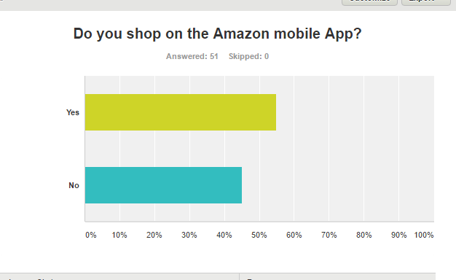
Figure 39 - Q16 Shop on mobile app
Results
The results show that just under 60% of people said they use the Amazon mobile app and just over 40% said they didn’t use the Amazon mobile app.
Expectation
It was expected that more people would use the mobile app, this is because everyone out of the 51 people who took the questionnaire said they owned a smart phone and the amount of downloads the app has got is very high. The results show yes and no being close, this was not expected.
Link to literature review
This question links back to the Amazon mobile app section of the literature review, this allowed for an understanding of what the app offered and provide a clear imagine on how many people use it.
Correlations
No correlation in the data.

17 – Why?
Graph

Figure 40 - Q17 Why to shopping or not shopping on app
Results
The results show that 19 people said they use the mobile app because it’s quick to access on the phone, 11 said they use it because of how easy it is to use, 6 people said they don’t use it because they haven’t download it on their phone, 5 people said they don’t because of the storage, 3 people said they don’t use Amazon and 3 people said they prefer the site.
Expectation
It was expected that ease of use and quick to access were going to be high due to feedback in the literature review and from the response in the previous question. Don’t download, storage and don’t use Amazon were due to be low and spread out due to the previous question.
Link to literature review
This questions links back to the Amazon mobile app in the literature review, this allowed an understanding of what the mobile app offered and what it didn’t offer.
Correlations
This question correlates with question 16, in question 16 the user was asked if they used the mobile app, in this question the user is asked to explain their reasoning behind using or not using the app.
18 - Do you use the Amazon app store?
Graph
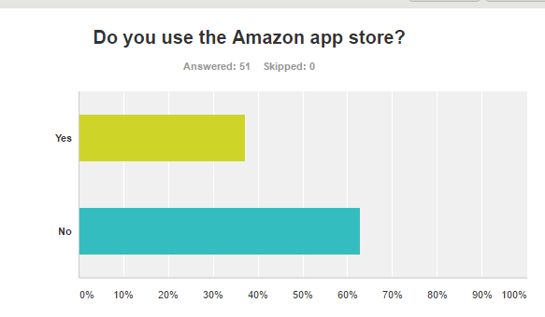
Figure 41 – Q18 Use Amazon App store
Results
The results show that just over 60% of people don’t use the Amazon app store and just under 40% of people use the Amazon App store.
Expectation
Is was expected that less people would use the app store, this is because less than half of the people who took the questionnaire didn’t own an Amazon product and you can only use the Amazon app store on Amazon based products.
Link to literature review
This question links back to the Amazon app store in the literature review, this allowed an understanding of what the app store offered and what user would use the app store for.
Correlations
No correlations in the data.

19 - Why
Graph

Figure 42 – Q19 Why to using or not using app store
Results
The results show that 16 people use the app for purchasing/download apps, books etc. for their Amazon device. 35 people said they don’t use the app store due to not having a purpose for using it, this could be down to not owning an Amazon device or not knowing what the app store is.
Expectation
It was expected that most people wouldn’t use the app store due to the response in the previous question related to what Amazon product they own. It was expected that the results for using it on their Amazon device would be around less than half due the app store only being available on Amazon devices.
Link to literature review
This questions links back to the Amazon app store in the literature review, this allowed an understanding of what the app store offered and what it didn’t offer.
Correlations
This question correlates with question 18, in question 18 the user was asked if they used the app store, in this question the user is asked to explain their reasoning behind using or not using the app store.
20 - Do you use Amazon Alexa?
Graph
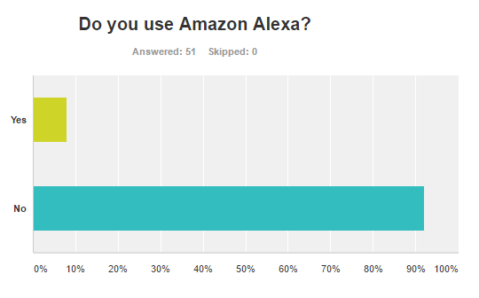
Figure 43 - Q20 Use Amazon Alexa
Results
The results show that less than 10% of people use Amazon Alexa and just over 90% of people don’t use Amazon Alexa.
Expectation
It was expected that most people wouldn’t use Amazon Alexa, this is because Amazon Alexa is still new in the market and not many people would know about it.
Link to literature review
This question links back to Amazon Alexa in the literature review, this allowed an understanding of what Amazon Alexa was and to understand why people would use it.
Correlations
No correlations in the data.

21 – Why?
Graph

Figure 44 - Q21 reasoning for or against using or not using Alexa
Results
The results show that 15 people don’t use Alexa because they don’t know what it is, 21 people said they don’t use it because they don’t have it available, 4 people said they use Alexa on their Echo and 3 people said they use it to set reminders and 3 people said they don’t have a reason to use it.
Expectation
It was expected that a high number of people wouldn’t use Alexa because either they didn’t own it or didn’t know what it is, due to it still being a new service released by Amazon, it was also expected that a small number would use it for either their Echo or to set reminders due to it being new also.
Literature Review
This questions links back to the Amazon Alexa in the literature review, this allowed an understanding of what the Alexa offered and what it didn’t offer.
Correlations
This question correlates with question 20, in question 20 the user was asked if they used Alexa, in this question the user is asked to explain their reasoning behind using or not using Alexa.
22 - Do you use an alternative? If yes please specify
Graph

Figure 45 - Q22 Use alternative to Alexa
Results
The results show that 5 people said they use Alexa and 41 people said they don’t use an alternative, 5 people skipped this question.
Expectation
It was expected that people who didn’t use Alexa used an alternative due to their being other services like Google Home on the market. To see that no people said they didn’t use an alternative so high was not expected, however it’s not a surprise it’s high also due to it being new on the market.
Link to literature review
This question links to the market analysis on Amazon Alexa in the literature review, this allowed an understanding of the market which Alexa was competing in.
Correlations
This question correlates with question 21 and 20, this question identified if the user used Alexa or not and why, this question underlines if they don’t use Alexa because they use an alternative.

23 - Out of the shopping methods for Amazon.com, please rate your experience, 1=poor 10=excellent
Graph
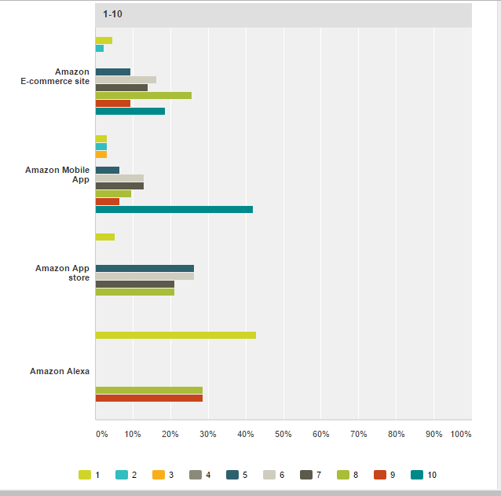
Figure 46 - Q23 Rate shopping methods of Amazon
Results
Out of the 43 who said they used the Amazon e-commerce site, 2 of them gave it 1 out of 10 for the experience with the site, 1 person gave it 2 out of 10, 4 people gave it 5 out of 10, 7 people gave it 6 out of 10, 6 people gave it 7 out of 10, 11 people gave it 8 out of 10, 4 people gave it 9 out of 10 and 8 people gave it 10 out of 10.
Out of the 31 people who said they used the Amazon mobile app, 1 person gave it 1 out of 10 for their experience with the site, 1 person gave 2 out of 10, 1 person gave it 3 out of 10, 2 people gave it 5 out of 10, 4 people gave it 6 out of 10, 4 people gave it 7 out of 10, 3 people gave it 7 out of 10, 3 people gave it 8 out of 10, 2 people gave it 9 out of 10 and 13 people gave it 10 out of 10.
Out of the 19 people who said they used the Amazon app store, 1 person gave it 1 out of 10 for their experience with the app store, 5 people said 5 out of 10, 5 people said 6 out of 10, 4 people said 7 out of 10 and 4 people said 8 out of 10.
Out of the 7 people who said they used Amazon Alexa, 3 people gave it 1 out of 10 for their experience with Alexa, 2 people gave it 8 out of 10 and 2 people gave it 9 out of 10.
Expectation
It was expected that most of the people who used the Amazon website would rate it highly, this was down to the positive feedback it had in question 16 and 17 based on the Amazon e-commerce site, these responses were about how easy the site was to use and the features it had available. All other shopping methods also had their expected results based on the feedback they generated in question 18,19,20,21,22,23,24
Link to literature review
No link to literature review
Correlations
This question correlated to question 16, 17,18,19,20,21,22,23 and 24, these asked the user if they used the services and why, if the user had a positive reason behind using the method then this would show on the rating scale.

24 - Do you know about Amazon air?
Graph
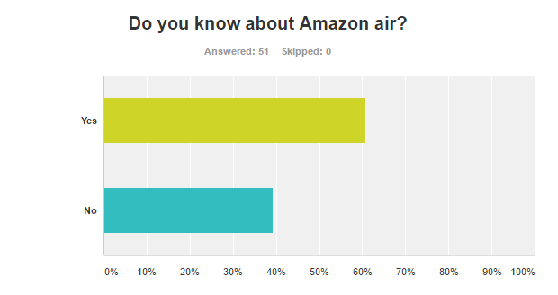
Figure 47 - Q24 Know about Amazon Air
Results
The results show that over 60% of people knew about Amazon Air and just under 40% of people didn’t know about Amazon Air.
Expectation
It was expected that less would know about Amazon Air, this is because the service is still in development and not available to customers.
Link to literature review
This question links back to Amazon Air in the literature review, this allowed an understanding of what Amazon Air was and what it offered customers.
Correlations
No correlations in the data.

25 - If Amazon air was available in your area, please specify if you would use the service.
Graph
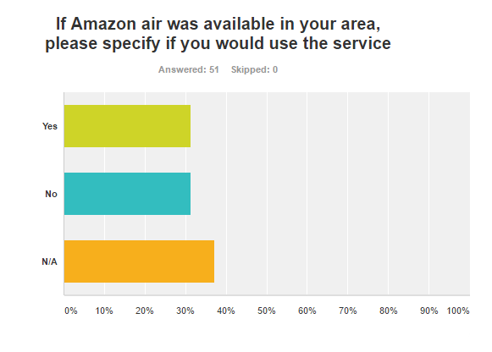
Figure 48 - Q25 Would you use Amazon Air
Results
The results show that both yes and no had 16 each and 19 people selected N/A.
Expectation
The results are what was expected due to the product being unknown and people would be unsure on trying it or not.
Link to literature review
No link to literature review
Correlations
This question correlates to the question 24, it was important to find out how many people knew about Amazon Air before asking them if they would use it or not.

26 - Overall how happy are you with the services and products Amazon.com has available. 1=poor 10=Very happy
Graph

Figure 49 - Q26 Overall happiness with what Amazon offers
Results
The results show that 5 people said they would rate it 1 out of ten with their overall happiness with what Amazon offers, 1 person said 2 out of 10, 4 people said 3 out of 10, 4 people said 4 out of 10, 6 people said 5 out of 10, 8 people said 6 out of 10, 8 people said 7 out of 10, 9 people said 8 out of 10, 3 people said 9 out of 10 and 3 people said 10 out of 10.
Expectation
It was expected that most people would have chosen above 6 due to the many various products, services and shopping methods Amazon has available. It was also expected due to the good feedback the products and services have received and also the continued growth and development with them.
Link to literature review
No link to literature review
Correlations
This question correlates with all previous questions in this questionnaire, this allowed an understanding of what people thought about the different aspects of Amazon and what they offered.

Chapter 5 – Evaluation

5.1 Introduction
This section of the report will evaluate key findings in the data collected from the questionnaire and identify links to the literature review. This section will also look at the aim and objectives to see if they have been met and where they were met. Finally, it will also look if the project was to be done again, what would be done differently.

5.2 Conclusion from the data
Based on the information collected from the literature review and questionnaire, the results show that technology has had a positive impact on Amazon and how they use it. The literature review examined Amazon and the products and services they have created from technology growth, it also looked at the impact it has had on the market they compete in. The questionnaire results backed up the results from the literature review which therefore allowed for a clear conclusion on Amazon.
The literature review was about finding out what Amazon was and what they offered. This included Amazon overall, such as their history, but it also focused more on Amazon products, in what they were, their purpose of being created, what competitors were offering to compete and the feedback which had been generated by people using them. The sales of each product were also looked at to get an understanding into how well each product was doing in the market. Another aspect about the products which was looked at was how much potential that product had using a Boston matrix. The information within the literature review helped get a greater understanding into what was needed to complete the next stages of the research.
The questionnaire results show that out of all the 51 responses, they all owned a piece of technology and used them daily. The results also showed what manufacture was most popular within each market and how important each device was to the owner.
Everyone owned a smartphone and used it for a high number of hours per week, the most popular manufacture was Apple. This shows how important a smart phone is to everyone daily. The feedback score for the smart phone was also high, this shows that the user is happy with their smartphone.
The most popular e-reader was the Amazon Kindle and the majority of people use the device to read e-books. Most of the users who owned a Kindle like that it was handheld and had many books to choose from. However most of them also didn’t like that the Kindle wasn’t waterproof, due to innovative technology within the world, this shows that Amazon has room for growth with the Kindle. If they only change one feature on the Kindle and this feature was making it waterproof then the sales would go up even more.
Whilst looking at the data in the analysis and literature review, you can get an understanding into each market and see what product is the most popular product within that market. Apple is most popular smartphone manufacture in the market. Amazon is the most popular e-reader manufacture in the market. Apple is the most popular tablet manufacture in the market. Amazon and Kodi are the leading manufactures in the TV device market. Amazon and Netflix are the leading manufactures in the instant video service market. Google and Microsoft are the leading manufactures in the cloud based services market. Finally, Amazon and Google are the leading manufactures in the voice recognition market. These results are based on the results from this research and questionnaire, if more people was to take the questionnaire then these results could change, however with the results as they are, it gives a good indication into each market.
Based on the e-reader and smartphone alone, it can be concluded that one of the most important factors into having a successful product in the market is timing. The Amazon e-reader was one of the first e-readers on market and now 10 years later is one of the most popular e-readers on the market. The most popular smartphone was Apples iPhone, this again shows that Apple was one of the first smartphones on the market and now is one of the most popular smartphones available. Amazon did create a smart phone to compete in the market, however as the results show in the questionnaire and the data in the literature review, this is no longer available due the product being late to that market.
Another example of timing is the voice recognition device, with the Amazon device being released before Google’s device, based on the results from the questionnaire, the most popular manufacture for this market being Amazon.
The results show that in the market for tablets, TV devices and instant video services, it is very even between all the leading manufactures for them. This shows that the competition is tight, this is down to all of them offering very similar technology to their customers. This is down to all the manufactures within these markets releasing devices around the same time and therefore all experiencing the same growth of technology. The results show for one of the manufactures to pull a head in each market, they would need to be very innovating and exciting.
Another important aspect of having a successful product or service within the market is promotion, out of all 51 people who took the questionnaire, none of them owned the Amazon cloud based service. However, 7 of them do use either Google or Microsoft’s cloud based service. Amazon promote their cloud based service more at businesses where as Google and Microsoft promote their services to everyone and not narrowing it down to business.
Only 60% of 51 people knew about Amazon’s new piece of technology Amazon Air. This shows for a product or service to be very known is by promoting the service, if this question was asked again when the service was released this number could be higher down to Amazon promoting the service. It’s also important to take many factors into consideration when promoting the service and removing doubt from potential user minds.
Based on the results from the questionnaire and data from the literature review it’s important to offer customers an easy and pleasant experience when using different shopping methods in which the business offers. People say they enjoy using the app or e-commerce site down to the experience being easy and quick, whilst Amazon offering a good range of products to their customers.
Based on the research carried in the literature review, the results were very similar within the questionnaire. This gave a clearer outcome within the research which could be understood. If the questionnaire and literature review were completely different, this would give a very confusing outcome and more research would be needed to clarify the results.

5.3 Objectives
- Research the history of Amazon.com Inc.
This objective was completed in the literature review chapter 1. This included Amazon overall, what they were, how they were created and how they have changed over the years. Also included was a SWOT analysis of Amazon.
- Research and evaluate Amazon’s use of technology for the development of their business.
This objective was also completed in the literature review chapter 1. This included each of the Amazon products which are offered to customers. These included what the device or service was, what sales it had, what competitors were doing to competing in the market and an analysis of the product’s, followed by a Boston matrix.
- Design, conduct and evaluate primary research into customer prospective on Amazon.com technology and services.
This objective was completed in research methodology and analysis chapter 2 and 3. This included a questionnaire asking user’s how they feel about Amazon’s technology and Amazon shopping methods. The questions asked the user what Amazon products they own and how they felt about it or if they used an alternative to Amazon. Other questions also included were how they felt about the shopping experience at Amazon. This gave a very good understanding into how customers felt about the technology and services Amazon offered.
- Evaluate primary and secondary research and identify key findings.
This objective was achieved in Analysis and Evaluation chapter 4 and 5. This included analysing the results from the questionnaire and seeing how it links to the literature review. Also included was a conclusion from the data whilst stating the key findings which were found.

5.4 Aim
The aim for this research was “An investigation into how Amazon.com has utilised technology for the development of their business”. The research shows how Amazon has created all different products and services to enter markets and using the ever-growing technology to continue to grow the products, therefore growing their business. The research also shows Amazon are trying to still create new pieces of technology like the Amazon Air and Amazon echo which are still new in the technology world to continue to grow the business. The research also shows how Amazon shopping methods are looked at by the users and see how they feel about them, this being mostly positive.

5.4 Repeating the research
If this research was re-done, the only aspect which would be done differently is adding Amazon’s prospective. This would include interviewing someone at Amazon to gain more insightful information into Amazon’s products and methods, this would include what they plan to do in the future, what they are happy with or disappointed with and why. This would give the research a different view and give the research more information into Amazon.

Chapter 6 – Conclusion and Recommendations

6.1 Introduction
This section of the report will conclude the research, whilst listing all objectives and stating how they were met. This section will also include how this research can help others and look at any further work which can be done on this research.

6.2 Conclusion
For this research to be concluded, objectives needed to be met and achieved, the objectives of this research were as follows;
1-Research the history of Amazon.com Inc.
2-Research and evaluate Amazon’s use of technology for the development of their business.
3-Design, conduct and evaluate primary research into the customer prospective of Amazon.com technology.
4-Evaluate primary and secondary research and identify key findings.
Objective 1 was achieved in the literature review, this looked at Amazon from the start and through their history. It looked at what they started selling and what they sell now and also what products they have created and when and why they created them. A SWOT analysis was competed to get a better understanding of Amazon.
Objective 2 was achieved in the literature review, this looked at the Amazon products and service in more detail. This included what the product offered, why someone would buy the product, the cost of the product, how well that product was doing in sales, what other companies were doing to compete with Amazon and product analysis using an analysing tool called Boston matrix.
Once the literature review was completed, this gave a clearer understanding on what needed to be added to the questionnaire. Objective 3 was achieved in the research methodology and analysis. Based on the information from the literature review the questionnaire could be designed and created for users to take and give their perspective into Amazon products. Once the questionnaire received a reasonable amount of response (51), it was closed and the evaluation can begin in the analysis chapter. This looked at the responses and analysed the responses, this looked at trends within the data and looked for links back to the literature review and other questions.
Once all questions were analysed, all the results were then evaluated and objective 4 was achieved in evaluation. This would identify what popular products were within the markets, why they were popular and identify the key factors to having a successful product. Also identified was the key points to having a successful shopping method and why.
Completing these objectives gave a very good understanding into how Amazon have used technology to their advantage and how it helped them grow. Amazon originally was only an e-commerce site which sold books. Now many years later and with new technology they sell a very wide range of products on a full functioning e-commerce site, not only have they grown their e-commerce site, they have also become a manufacture with releasing many products and services into different markets and competing with top manufactures. This shows that Amazon has embraced technology and used it to help them grow and develop as a business. Amazon has also learnt along the way, this is down to not all products being successful and realising the potential of a product and making that product grow.
Using different analysis tools like SWOT and Boston, allowed to understand the products and services more clearly and get a better understanding on Amazon as a whole. The SWOT analysis concluded that Amazon have got many advantages but they have also got to wary of their competitors and other issues to stay at the top. The Boston matrix concluded that Amazon have got many high potential and high sales products, but they have also got products that didn’t work for them. They have also got items that have high sales but low growth this could become a concern at a later for Amazon especially if their competitors take advantage of this.
To conclude this research, the literature review and questionnaire data backed up each other and shows that any business not only Amazon use’s technology correctly, it will help grow as a business and become more successful. As this research was aimed at Amazon, it’s important to stress that Amazon have embraced new technology and demands and created something massive in the world from the research it shows that there is still room for growth.

6.3 Recommendation
This research could be helpful to any new business who is looking at creating a new product to add to the market. This research includes how a worldwide company has used technology to their advantage and created different products which most have been successful for them. It shows what the key factors are to have a successful product and what they need to compete with current products, for example, if a new business wanted to create a new smartphone they could use this research to understand what’s on the current market and look at the analysis to see how to make a product successful.

6.4 Suggestion for further work
In 10 years’ time, there be will new technology and products available within the market. It would be interesting to see if Amazon has continued to grow positively with the new technology and see how they have used it to their advantage and see how new or current competitors are competing with Amazon products. It would be interesting to compare this research to the research in 10 years’ time and see what’s different for them then and see if it’s had the same outcome for Amazon with their growth.

Chapter 7 – Reflection

Introduction
This section of the report will include what was learnt during the study. These include what skills were gained and how it’s allowed me to develop.

7.2 Reflection
Looking back at completing the research, it has given me a wider range of skills and helped developed existing skills to help and prepare me for the future.
One of the most important skills which was developed was time management. Over a year, the research had been schedule using different tools available and making sure all deadlines were met. The research had to be broken down into different tasks and each task was given enough time to complete and reach a deadline. The research had to be completed along with my university studies, family and social life. I had to find the right balance for each one and making sure that I didn’t fall behind on any of my aspects of life. Developing and staying on top of my time was the key to completing this research within the deadline, also making sure each objective was met to excellent quality and finally reach the final aim.
Another important skill which was developed was confidence and working alone. As this was an independent study, I had to rely on myself to complete each aspect of the research, but also making sure each aspect was at a high standard. When I needed to complete a SWOT analysis and Boston matrix, I had to learn on how to complete them and then carry it out into the research. This shows that my confidence is higher and I can complete an independent study.
Whilst completing the research, I have developed a good understanding on how to complete secondary and primary research. The literature review shows that I could find secondary research online and in books and making sure out of the data which was found, I selected the right data to add to this research. As time management and a word count was important, I could not include all the data which was found, therefore I had to select the data which would meet my objectives.
During the research, I needed to complete and distribute a questionnaire based from the research in the questionnaire. I had to make sure I asked the correct questions to meet the objective and complete the research. I also had to be wise into selecting how I was going create and distribute the questionnaire with the tools available.
Another skill which was learnt during the process of this study was learning my own analysis tools like the SWOT and Boston. These gave me an understanding into what they were and how they worked, also they helped me understand how businesses can use them to their advantage.
To conclude, this project has given me a wide range of skills to help me grow as a person. These skills together could be developed by completing an independent study within a time period. Going forward these skills will help me in completing my final few weeks at university and carry forward into my career and the rest of my life.

Bibliography
[1] Schneider, Laura. "History Of And Information On Amazon.Com". The Balance. N.p., 2016. Web. 14 Dec. 2016.
[2] "Amazon Startup Story - Fundable". Fundable. N.p., 2016. Web. 14 Dec. 2016.
[3] shah, zarana, "Amazon.Com". Miscasestudy.blogspot.co.uk. N.p., 2012. Web. 14 Dec. 2016.
[4] Denning, S. (2016). Forbes Welcome. [online] Forbes.com. Available at: http://www.forbes.com/sites/stevedenning/2011/09/30/how-amazon-created-the-kindle-fire-part-11/#257a30602a26 [Accessed 2 Dec. 2016].
[5] Schonfeld, E. (2016). The Kindle Fire, What Is It Good For?. [online] TechCrunch. Available at: https://techcrunch.com/2011/11/25/the-kindle-fire-what-is-it-good-for/ [Accessed 2 Dec. 2016].
[6] Amazon.com. (2016). Amazon.com: Kindle Fire (Previous Generation - 1st): Kindle Store. [online] Available at: https://www.amazon.com/Kindle-Fire-Amazon-Tablet/dp/B0051VVOB2 [Accessed 2 Dec. 2016].
[7] Kowalczyk, P. (2016). Kindle Oasis: tech specs, comparisons, reviews, and more. [online] Ebook Friendly. Available at: http://ebookfriendly.com/kindle-oasis-2016/ [Accessed 2 Dec. 2016].
[8] Byrne, K. (2016). Kindle vs Kindle Paperwhite vs Kindle Voyage vs Kindle Oasis - Best for you?. [online] Expert Reviews. Available at: http://www.expertreviews.co.uk/amazon/amazon-kindle [Accessed 2 Dec. 2016].
[9] Pilato, F. (2004). Sony LIBRIe – The first ever E-Ink e-Book Reader. [online] Mobile Magazine. Available at: https://www.mobilemag.com/2004/03/25/sony-librie-the-first-ever-e-ink-e-book-reader/ [Accessed 2 Dec. 2016].
[10] Sparkes, M. (2014). [online] Available at: Pilato, F. (2004). Sony LIBRIe – The first ever E-Ink e-Book Reader. [online] Mobile Magazine. Available at: https://www.mobilemag.com/2004/03/25/sony-librie-the-first-ever-e-ink-e-book-reader/ [Accessed 2 Dec. 2016]. [Accessed 2 Dec. 2016].
[11] KOWALCZYK, P. (2015). Nook GlowLight Plus – tech specs, comparisons, pics, launch details. [online] Ebook Friendly. Available at: http://ebookfriendly.com/nook-glowlight-plus/ [Accessed 2 Dec. 2016].
[12] Bookeen.com. (2016). eReader Cybook Ocean | BOOKEEN. [online] Available at: https://www.bookeen.com/en/cybook-ocean [Accessed 2 Dec. 2016].
[13] Team, T. (2010). Forbes Welcome. [online] Forbes.com. Available at: http://www.forbes.com/sites/greatspeculations/2010/06/28/amazons-plan-for-a-billion-dollar-ebooks-business/#398169660d7f [Accessed 2 Dec. 2016].
[14] Forbes.com. (2016). Forbes Welcome. [online] Available at: http://www.forbes.com/sites/greatspeculations/2014/04/02/estimating-kindle-e-book-sales-for-amazon/#69bff8075bfc [Accessed 5 Dec. 2016].
[15] Gsmarena.com. (2016). Amazon Kindle Fire - Full tablet specifications. [online] Available at: http://www.gsmarena.com/amazon_kindle_fire-4524.php [Accessed 5 Dec. 2016].
[16] Love My Fire. (2016). Everything the Kindle Fire Can Do. [online] Available at: http://www.lovemyfire.com/kindle-fire.html [Accessed 5 Dec. 2016].
[17] Kowalczy, P. (2015). [online] Available at: http://ebookfriendly.com/amazon-fire-tablets-2015/ [Accessed 5 Dec. 2016].
[18] Beavis, G. (2016). The 10 best tablets you can buy in 2016. [online] TechRadar. Available at: http://www.techradar.com/news/mobile-computing/tablets/10-best-tablet-pcs-in-the-world-today-1079603 [Accessed 5 Dec. 2016].
[19] Mitroff, S. (2016). Apple iPad Pro 9.7 specs vs. the original iPad Pro and iPad Air 2 specs. [online] CNET. Available at: https://www.cnet.com/uk/news/ipad-pro-9-7-vs-original-ipad-pro-ipad-air-2/ [Accessed 5 Dec. 2016].
[20] F, A. (2016). Report: Apple to ship 4 million 9.7-inch iPad Pro units in the first half of the year. [online] Phone Arena. Available at: http://www.phonearena.com/news/Report-Apple-to-ship-4-million-9.7-inch-iPad-Pro-units-in-the-first-half-of-the-year_id79560 [Accessed 5 Dec. 2016].
[21] "Samsung Galaxy Tab S 10.5 LTE - Full Tablet Specifications". Gsmarena.com. N.p., 2016. Web. 14 Dec. 2016. [22] Computerworld, M. (2010). Samsung confirm sales of Android Galaxy Tab sales hit 1 million. [online] Techworld. Available at: http://www.techworld.com/news/mobile/samsung-confirm-sales-of-android-galaxy-tab-sales-hit-1-million-3252005/ [Accessed 5 Dec. 2016].
[23] Whitney, L. (2012). How many Kindle Fires did Amazon sell? 5M, maybe. [online] CNET. Available at: https://www.cnet.com/news/how-many-kindle-fires-did-amazon-sell-5m-maybe/ [Accessed 5 Dec. 2016].
[24] Emarketer.com. (2012). Kindle Fire Adds Fuel to Tablet Market Growth - eMarketer. [online] Available at: https://www.emarketer.com/Article/Kindle-Fire-Adds-Fuel-Tablet-Market-Growth/1008780 [Accessed 5 Dec. 2016].
[25] Seekingalpha.com. (2014). Why Amazon's Appstore Could Become As Big As Google Play. [online] Available at: http://seekingalpha.com/article/2471365-why-amazons-appstore-could-become-as-big-as-google-play [Accessed 5 Dec. 2016].
[26] Gsmarena.com. (2016). Amazon Fire Phone - Full phone specifications. [online] Available at: http://www.gsmarena.com/amazon_fire_phone-6453.php [Accessed 7 Dec. 2016].
[27] Flores, M. (2015). Amazon Fire Phone review. [online] TechRadar. Available at: http://www.techradar.com/reviews/phones/amazon-fire-phone-1259146/review [Accessed 7 Dec. 2016].
[28] Phx.corporate-ir.net. (2016). Amazon Media Room: Press Releases. [online] Available at: http://phx.corporate-ir.net/phoenix.zhtml?c=176060&p=irol-newsArticle&ID=1940902 [Accessed 7 Dec. 2016].
[29] Miller, M. (2014). Best 10 smartphones at the close of 2014 | ZDNet. [online] ZDNet. Available at: http://www.zdnet.com/article/best-10-smartphones-at-the-close-of-2014/ [Accessed 7 Dec. 2016].
[30] Gsmarena.com. (2016). Apple iPhone 6 - Full phone specifications. [online] Available at: http://www.gsmarena.com/apple_iphone_6-6378.php [Accessed 7 Dec. 2016].
[31] Inquirer, T., iPhone 6 release date, p., Latest, I. and read, M. (2016). iPhone 6 release date, price and specs | TheINQUIRER. [online] http://www.theinquirer.net. Available at: http://www.theinquirer.net/inquirer/news/2323136/iphone-6-rumours-price-features-and-release-date [Accessed 7 Dec. 2016].
[32] Z3, (2016). Sony Xperia Z3 price, specifications, features, comparison. [online] NDTV Gadgets360.com. Available at: http://gadgets.ndtv.com/sony-xperia-z3-1940 [Accessed 8 Dec. 2016].
[33] Rogerson, J. (2016). Sony Xperia Z3 release date, news and features. [online] TechRadar. Available at: http://www.techradar.com/news/phone-and-communications/mobile-phones/sony-xperia-z3-1251663 [Accessed 8 Dec. 2016].
[34] Arthur, C. (2014). Amazon has sold no more than 35,000 Fire phones, data suggests. [online] the Guardian. Available at: https://www.theguardian.com/technology/2014/aug/26/amazon-fire-phone-sales-data [Accessed 10 Dec. 2016].
[35] Duryee, T. (2015). Amazon finally stops selling the Fire Phone, as company adjusts its hardware strategy. [online] GeekWire. Available at: http://www.geekwire.com/2015/amazon-finally-stops-selling-the-fire-phone/ [Accessed 10 Dec. 2016].
[36] Luckerson, V. (2014). 4 Reasons Amazon's Fire Phone Was a Flop. [online] TIME.com. Available at: http://time.com/3536969/amazon-fire-phone-bust/ [Accessed 10 Dec. 2016].
[37] Ackerman, D. (2015). Why I think Amazon's Echo is the breakthrough product of 2015. [online] CNET. Available at: https://www.cnet.com/news/amazon-echo-and-alexa-the-most-impressive-new-technology-of-2015/ [Accessed 11 Dec. 2016].
[38] Wireless-speakers.specout.com. (2015). Amazon Echo. [online] Available at: http://wireless-speakers.specout.com/l/18/Amazon-Echo [Accessed 11 Dec. 2016].
[39] McGrath, J. (2016). What can’t she do? The best ways to use Amazon’s Alexa around the house. [online] Digitaltrends.com. Available at: http://www.digitaltrends.com/home/amazon-echo-tips-and-tricks/ [Accessed 11 Dec. 2016].
[40] Wireless-speakers.specout.com. (2015). Amazon Echo Dot. [online] Available at: http://wireless-speakers.specout.com/l/1829/Amazon-Echo-Dot [Accessed 11 Dec. 2016].
[41] Gebhart, A. (2016). Google Home vs. Amazon Echo: Alexa takes round 1. [online] CNET. Available at: https://www.cnet.com/uk/news/google-home-vs-amazon-echo/ [Accessed 11 Dec. 2016].
[42] Guide, G. (2016). Amazon Echo Vs Google Home Specs & Features Review: Google Smart Speaker Catches Up. [online] Gamenguide. Available at: http://www.gamenguide.com/articles/67535/20161114/amazon-echo-vs-google-home-specs-features-review-google-smart-speaker-catches-up.htm [Accessed 11 Dec. 2016].
[43] Pierce, D. (2016). Google Home Review: A Smart Speaker That’s Pretty Great—And Crazy Ambitious. [online] WIRED. Available at: https://www.wired.com/2016/11/review-google-home/ [Accessed 11 Dec. 2016].
[44] Keach, S. (2016). Google Home: Your complete guide to Google’s smart speaker. [online] TrustedReviews. Available at: http://www.trustedreviews.com/news/google-home-specs-features-price-uk-release-date [Accessed 11 Dec. 2016].
[45] Roettgers, J. (2016). Amazon Has Sold More Than 5 Million Echo Speakers (Report). [online] Variety. Available at: http://variety.com/2016/digital/news/amazon-5-million-echo-speakers-sold-1201927641/ [Accessed 11 Dec. 2016].
[46] Kim, E. (2016). Amazon's Echo and Alexa could add $11 billion in revenue by 2020. [online] Business Insider. Available at: http://uk.businessinsider.com/amazon-echo-alexa-add-11-billion-in-revenue-by-2020-2016-9?r=US&IR=T [Accessed 11 Dec. 2016].
[47] Munbodh, Emma. "What Is Amazon Prime? All Your Questions Answered". mirror. N.p., 2016. Web. 12 Dec. 2016.
[48] Fung, Brian. "Amazon’S New Strategy To Steal Netflix Customers — And Keep Them". Washington Post. N.p., 2016. Web. 12 Dec. 2016.
[49] Henderson, Rik and Max Langridge. "Which Is The Best Movie Streaming Service In The UK? Netflix Vs Amazon Prime Vs Now TV And More - Pocket-Lint". Pocket-lint.com. N.p., 2016. Web. 12 Dec. 2016.
[50] Luckerson, Victor. "The Number Of Movies On Netflix Is Dropping Fast". TIME.com. N.p., 2015. Web. 12 Dec. 2016.
[51] Grozanick, Rachel. "How Much Does Netflix Cost These Days? Here’S The Lowdown". Digital Trends. N.p., 2015. Web. 12 Dec. 2016.
[52] May, Steve and Marc Chacksfield. "Now TV Review". TechRadar. N.p., 2016. Web. 12 Dec. 2016.
[53] Kline, Daniel. "How Many Prime Members Does Amazon Have (And Why It Matters) -- The Motley Fool". The Motley Fool. N.p., 2016. Web. 12 Dec. 2016.
[54] Levy, Adam. "How Prime Makes Amazon Profitable -- The Motley Fool". The Motley Fool. N.p., 2016. Web. 12 Dec. 2016.
[55] Kricfalusi, Elizabeth. "Amazon Fire TV: What Is It And How Does It Work?". Tech for Luddites. N.p., 2014. Web. 12 Dec. 2016.
[56] Martin, Jim. "A Future-Proof Media Streamer With 4K Support And Both Amazon And Netflix Players, Plus Alexa". PC Advisor. N.p., 2014. Web. 12 Dec. 2016.
[57] Chacksfield, Marc. "Amazon Fire TV Stick Review". TechRadar. N.p., 2014. Web. 12 Dec. 2016.
[58] Katzmaier, David. "Chromecast Vs. Apple TV Vs. Roku Vs. Amazon Fire TV". CNET. N.p., 2016. Web. 12 Dec. 2016.
[59] Grothaus, Michael. "Amazon Fire TV Vs Roku 3: Two Of The Best Chromecast Alternatives". Know Your Mobile. N.p., 2016. Web. 12 Dec. 2016.
[60] Grothaus, Michael. "Chromecast 2 Vs. Chromecast: The Best Just Got EVEN BETTER". Know Your Mobile. N.p., 2016. Web. 12 Dec. 2016.
[61] Terry, Nick. "Amazon Fire TV Takes 30% Of The Streaming Market | Androidheadlines.Com". AndroidHeadlines.com |. N.p., 2015. Web. 12 Dec. 2016.
[62] Roettgers, Janko. "Amazon Clocks $107 Billion In Revenue In 2015". Variety. N.p., 2016. Web. 12 Dec. 2016.
[63] Titcomb, James. "Amazon To Step Up UK Tests Of Delivery Drones". The Telegraph. N.p., 2016. Web. 12 Dec. 2016.
[64] King, Rachel. "Game Of Drones: Google Readies Project Wing Against Amazon's Prime Air | Zdnet". ZDNet. N.p., 2016. Web. 12 Dec. 2016.
[65] "What Is Amazon Web Services (AWS)? - Definition From Whatis.Com". WhatIs.com. N.p., 2012. Web. 13 Dec. 2016.
[66] Aldiab, Motasem. "AWS Vs Azure Vs Google: The Public Cloud War | Cloud Academy". Cloud Academy Blog. N.p., 2015. Web. 13 Dec. 2016.
[67] Forrest, Conner. "The Google Cloud Platform: 10 Things You Need To Know - Techrepublic". TechRepublic. N.p., 2014. Web. 13 Dec. 2016.
[68] "What Is Microsoft Azure (Windows Azure)? - Definition From Whatis.Com". SearchCloudComputing. N.p., 2014. Web. 13 Dec. 2016.
[69] "Amazon Web Services Revenue 2015 | Statistic". Statista. N.p., 2016. Web. 13 Dec. 2016.
[70] "Boston Matrix". Oxlearn.com. Web. 13 Dec. 2016.
[71] Arline, Katherine. "What Is A BCG Matrix?". Business News Daily. N.p., 2016. Web. 13 Dec. 2016.
[72] Carnoy, David. "Amazon Kindle Oasis Review: Best E-Reader Ever, But Sky-High Price Hurts Its Appeal". CNET. N.p., 2016. Web. 14 Dec. 2016.
[73] Carnoy, David. "Amazon's New Fire HD 8 Review: Finally, A Cheap Tablet That's Actually Good". CNET. N.p., 2016. Web. 14 Dec. 2016.
[74] Katzmaier, David. "Amazon Fire TV Review: Awesome For Amazon Addicts But Too Pushy For Everyone Else". CNET. N.p., 2015. Web. 14 Dec. 2016.
[75] Dolcourt, Jessica. "Despite Innovative Spark, Amazon Fire Phone Fails To Fully Ignite (Review)". CNET. N.p., 2016. Web. 14 Dec. 2016.
[76] Crist, Ry and David Carnoy. "Amazon Echo Review: The Connected Home Experience You Didn't Know You Wanted". CNET. N.p., 2016. Web. 14 Dec. 2016.
[77] Roettgers, Janko. "Amazon Clocks $107 Billion In Revenue In 2015". variety. Web. 14 Dec. 2016.
[78] "Amazon.Com Facts, Information, Pictures | Encyclopedia.Com Articles About Amazon.Com". Encyclopedia.com. N.p., 2016. Web. 14 Dec. 2016.
[79] staff, WDD. "An Analysis Of The Amazon Shopping Experience | Webdesigner Depot". Webdesigner Depot. N.p., 2015. Web. 14 Dec. 2016.
[80] LAYTON, JULIA. "How Amazon Works". HowStuffWorks. N.p., 2016. Web. 14 Dec. 2016.
[81] Matthews, Christopher and Christopher Matthews. "Will Amazon Take Over The World?". TIME.com. N.p., 2014. Web. 14 Dec. 2016.
[82] "Amazon Shopping App". Play.google.com. N.p., 2011. Web. 14 Dec. 2016.
[83] "Popular Apps". Play.google.com. N.p., 2016. Web. 14 Dec. 2016.
[84] Menoni, Tanya. "Top 6 Iphone Shopping Apps". Lifewire. N.p., 2015. Web. 14 Dec. 2016.
[85] "SWOT Analysis: Discover New Opportunities, Manage And Eliminate Threats". Mindtools.com. N.p., 2017. Web. 25 Apr. 2017.
[86]"Amazon SWOT". Marketingteacher.com. N.p., 2017. Web. 25 Apr. 2017.
[87] Bhasin, Hitesh. "SWOT Analysis Of Amazon - Amazon SWOT Analysis". Marketing91. N.p., 2017. Web. 25 Apr. 2017.
[88] Frue, Kiesha. "SWOT Analysis Of Amazon". PESTLE Analysis. N.p., 2017. Web. 25 Apr. 2017.
[89]"SWOT Analysis Of Amazon". Managementstudyguide.com. N.p., 2017. Web. 25 Apr. 2017.
[90] https://onion.derby.ac.uk/onion.pdf
[91] https://www.surveymonkey.co.uk/mp/aboutus/
[92] "Survey Tips: How To Write A Good Survey Questionnaire". Accesscable.net. Web. 25 Apr. 2017.
[93] "How Many Questions Should A Good Survey Have? - Benchmark Email". Benchmarkemail.com. Web. 25 Apr. 2017.
[94] "App Store Statistics Roundup". Business of Apps. N.p., 2017. Web. 26 Apr. 2017.

[95] Clauser, Grant. "What Is Alexa? What Is The Amazon Echo, And Should You Get One?". The Wirecutter. Web. 26 Apr. 2017.

Appendix
1 – Full response of Questionnaire. Part 1
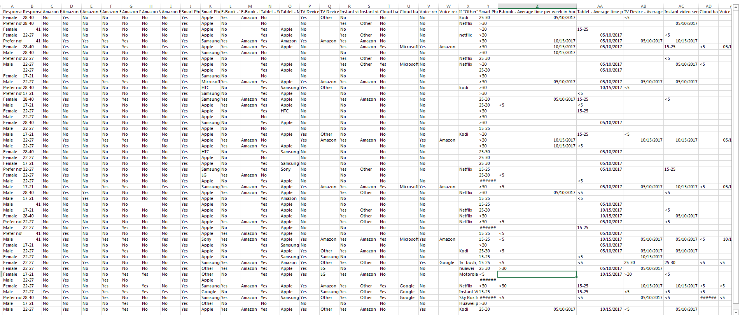

Part 2


