•CLASS TASK: Heritage Development

In small groups - - devise and develop an “Interpretative Heritage Trail” for an area of choice (your home
town? / Swansea / Gower ………..??). Consider what would you need to include / develop to make the
trail a viable and sustainable heritage tourism attraction in the area?

Students are to present 2 slides on the idea -
Slide 1: Overview of the Heritage Trail – Key Features.
Slide 2: What considerations you gave to devising the trail-link to HERITAGE INTERPRETATION Theory.

Some ideas - - see links below:

The Dylan Thomas Trail at New Quay (newquay-westwales.co.uk)
loch-leven-leaflet-230915.pdf (livinglomonds.org.uk)
Pontarddulais Heritage Walking Trail - Visit Swansea Bay
Pontarddulais Heritage Trail bilingual cover (visitswanseabay.com)
Seven Tips to Create a Heritage Trail | National Trust for Historic Preservation (savingplaces.org)

WHAT MAKES A GOOD HERITAGE TRAIL?
Questions to ask:
- What purpose does a heritage trail serve – commercial/tourism, preservation, public awareness, mitigation, or exhibition?
- What role does a trail play in a contributing/participating community?
- How do you define a heritage trail? What stories are included? Excluded?
- What are the advantages and disadvantages of a specific type of organization or institution managing and staffing a trail?
- How do can you generate public support and involvement for a heritage trail?
- How do you facilitate public history projects for a trail?
- Depending on the size or length of a trail, how can public historians successfully weave together shared histories?
- Do heritage trails help to preserve historic resources and/or generate civic engagement?
- What role do digital projects play in heritage trails?

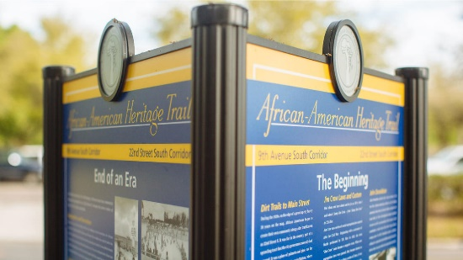 | Seven Tips to Create a Heritage Trail | National Trust for Historic Preservation - @SavingPlaces #TelltheFullStory | National Trust for Historic Preservation  Great heritage trails are more than just a list of stops at historic places along a mapped route. They can be a journey through time. It’s also a journey all its own to create a heritage trail from start to finish—from deciding what story to tell to selecting the sites that illustrate the area’s history.  savingplaces.org

Gwybodaeth Bwysig Important Information
7 5 6 2 4 3 1 9 8 oad owr ppa Rd ago Rd fin Rd B4296 M4 oad A48 A48 t t t oed Rd yn Rd yn Rd Glowr dd ch oed k oughor e Mill Rd errig Rd is Rd edbach Rd Rd Y Heritage ...
www.visitswanseabay.com

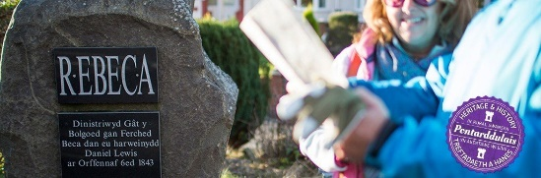 | Pontarddulais Heritage Walking Trail - Visit Swansea Bay  The Pontarddulais Heritage trail guides you through a small Welsh town packed with stories. Book ended by the twin commemorative stones built to mark the Rebecca Riots; it features more about the heroes of that struggle, the effect the town had on famous Welsh poets Dylan and Edward Thomas and, of course, the site of the 7th Century Church of St. Teilo – contemporary of St. David and one ...  www.visitswanseabay.com

