

Module Name: Problem Solving and Innovation

Module Code: BMSW4014

Student Name: Lauren Dalling

Student Number: 2506840

Lecturer: Chris Wilkin
Deadline: 10th July 2026 23:59

AI Acknowledgement

I acknowledge the use of ChatGPT (https://chatgpt.com/) for research purposes: Prompts used are shows in appendices.
I confirm that I have not presented any AI generated text as my own work. I confirm that I have copies of my drafts, notes, and other resources I used before, and after the use of AI tools which I may be asked to provide in evidence.

Contents

AI Acknowledgement 1
1.0 Introduction 4
2.0 Critical Analysis of External Factors Influencing the Creator Economy 5
3.0 Discussion of Findings 9
4.0 Future Lens 9
5.0 Conclusion 10
6.0 Recommendations 11
Reference List 12
Appendices 14

Executive Summary

The creator economy has become a significant part of the digital economy, allowing individuals to generate income through content creation on platforms such as Instagram, TikTok and YouTube. This report analyses the external factors influencing the industry using the STEEPLE framework. Findings indicate that social, technological and legal factors have the greatest influence on creator success. UK examples, including Molly-Mae Hague and Saffron Barker, highlight the importance of transparency, audience trust and regulatory compliance.

1.0 Introduction

The creator economy refers to individuals who earn income by creating and distributing content through digital platforms such as Instagram, TikTok, YouTube and podcasts (Cunningham and Craig, 2019). Influencers, vloggers, streamers and content creators have transformed social media from a communication tool into a business opportunity, generating revenue through sponsorships, affiliate marketing, advertising and product sales (Abidin, 2018).

The growth of social media and increasing consumer trust in influencers have contributed to the rapid expansion of the creator economy. According to Ofcom (2024), social media usage remains particularly high among younger audiences, creating significant opportunities for creators and brands. However, success within the creator economy is influenced by a range of external factors including social trends, technological developments, economic conditions, political intervention, legal requirements, environmental concerns and ethical considerations.

This report critically analyses the external factors influencing the creator economy using the STEEPLE framework. UK examples, including Molly-Mae Hague and Saffron Barker, are used to evaluate how these factors create opportunities and challenges for creators and influence the future development of the industry.

In addition, a DPSIR (Drivers, Pressures, State, Impacts and Responses) analysis is included in Appendix B to further examine the relationships between the key forces influencing the creator economy.

2.0 Critical Analysis of External Factors Influencing the Creator Economy

2.1 Social Factors
Social factors have a significant influence on the creator economy because audience engagement is largely driven by trust, authenticity and personal connection. Many social media users follow influencers because they find them relatable and feel connected to their everyday lives. This has led to the development of parasocial relationships, where followers feel a sense of friendship with creators despite never meeting them (Abidin, 2018).

Influencers such as Molly-Mae Hague and Saffron Barker have built successful careers through lifestyle-focused content and strong audience engagement. Their success demonstrates the importance of authenticity within influencer marketing. Research suggests that trust is one of the most important factors influencing whether consumers act on influencer recommendations (Lou and Yuan, 2019). Similar findings were identified by Freberg et al. (2011), who found that social media influencers are often perceived as credible opinion leaders capable of shaping consumer attitudes and behaviours. Sokolova and Kefi (2020) further suggest that parasocial relationships between influencers and followers can positively influence consumer trust and purchase intentions.

However, changing social attitudes have created new challenges for creators. Audiences are becoming increasingly critical of excessive sponsorships, unrealistic lifestyle portrayals and misleading content (Audrezet et al., 2020). As a result, creators face growing pressure to maintain transparency and behave responsibly. This demonstrates how social factors can directly affect influencer credibility and long-term success.

2.2 Technological Factors
Technology is one of the primary drivers of the creator economy. Platforms such as TikTok, Instagram and YouTube provide creators with opportunities to reach large audiences, build personal brands and generate income. Features such as livestreaming, short-form video content and monetisation programmes have made content creation more accessible than ever before.

However, creators are heavily dependent on platform algorithms, which determine content visibility and audience reach (Bucher, 2018). Changes to algorithms can significantly affect engagement, views and income, creating uncertainty for creators who have limited control over platform decisions.

Artificial intelligence (AI) is also becoming increasingly influential within the creator economy. AI tools can support content creation, editing and audience analysis, allowing creators to work more efficiently. However, AI-generated content may increase competition and raise concerns regarding authenticity and originality (Bleier et al., 2024). Therefore, technological developments create both opportunities and risks for content creators.

2.3 Economic Factors
Economic factors play an important role in determining the success and profitability of the creator economy. Many influencers rely on income generated through sponsorships, affiliate marketing, advertising and product sales. Businesses increasingly invest in influencer marketing because consumers often view influencer recommendations as more trustworthy than traditional advertising (Djafarova and Rushworth, 2017).

Influencers such as Molly-Mae Hague have expanded beyond content creation by launching businesses and collaborating with major brands. However, economic conditions can significantly affect these opportunities. During periods of economic uncertainty, organisations may reduce marketing budgets, resulting in fewer sponsorship opportunities (OECD, 2024).

Furthermore, increased competition within the creator economy means many creators struggle to generate stable incomes. While some influencers achieve substantial financial success, many fail to build sustainable careers. Therefore, economic factors create both opportunities and challenges within the industry.

2.4 Political Factors
Political factors are becoming increasingly important within the creator economy as governments introduce legislation to regulate online platforms and improve user safety. In the UK, policymakers have become more concerned about the impact of social media on young people, misinformation and harmful online content. As a result, governments are increasing their involvement in digital platform governance.

A recent example is the UK Government’s proposal to restrict social media access for individuals under the age of 16 as part of wider online safety reforms (UK Government, 2023). While these measures aim to improve child protection and online wellbeing, they may also affect audience demographics and platform growth. Many creators rely on younger audiences for engagement, meaning such restrictions could reduce reach and advertising opportunities.

The Online Safety Act 2023 further demonstrates increasing government oversight of digital platforms by introducing responsibilities for platforms to protect users from harmful content (UK Government, 2023). Therefore, political decisions can significantly influence how creators operate and how platforms manage content.

2.5 Legal Factors
Legal factors have become increasingly important as influencer marketing continues to grow. In the UK, organisations such as the Advertising Standards Authority (ASA) and Competition and Markets Authority (CMA) regulate influencer advertising to ensure consumers are not misled (CMA, 2023; ASA, 2024). Influencers are required to clearly identify paid partnerships and sponsored content to maintain transparency.

A notable example is Molly-Mae Hague, who has faced scrutiny regarding advertising disclosures on social media. Cases involving influencer marketing have highlighted the importance of clearly labelling promotional content and complying with advertising regulations (ASA, 2022). Failure to do so can result in reputational damage and reduced consumer trust.

Creators must comply with data protection legislation when collecting and processing audience information. As influencer marketing becomes more professionalised, legal compliance is becoming a key requirement for both creators and brands. Consequently, legal compliance is essential for creator credibility and sustainability.

2.6 Environmental Factors
Environmental factors are becoming increasingly relevant as consumers place greater importance on sustainability. Although environmental factors currently have less influence than social or technological factors, their importance is increasing.
Influencers promoting fast-fashion brands have faced criticism due to environmental concerns, encouraging some creators to promote more sustainable products and lifestyles (Sokolova and Kefi, 2020)

2.7 Ethical Factors
Ethical factors are closely linked to influencer credibility and audience trust. Common ethical concerns within the creator economy include misleading advertising, unrealistic beauty standards, misinformation and the promotion of potentially harmful products. These issues can negatively affect audiences, particularly younger social media users.

Many creators earn income through sponsored content, creating potential conflicts between commercial objectives and honest recommendations. If audiences believe influencers are promoting products purely for financial gain, trust and engagement may decline (Audrezet et al., 2020). Ethical behaviour is therefore essential for maintaining long-term audience relationships. Furthermore, Kapitan and Silvera (2016) argue that the effectiveness of influencer endorsements is strongly influenced by perceptions of authenticity and trustworthiness.

3.0 Discussion of Findings

The STEEPLE analysis and SWOT analysis (Appendix A, Figures A1–A3) identify social, technological and legal factors as the most significant influences on the creator economy. The success of influencers such as Molly-Mae Hague and Saffron Barker demonstrates the importance of audience trust, engagement and authenticity. However, increasing regulation, platform dependency and growing competition continue to create challenges for creators. The DPSIR analysis (Appendix B) further highlights the relationship between these external factors and their impact on the long-term sustainability of the creator economy.

4.0 Future Lens

The future of the creator economy is likely to be shaped by technological innovation, increasing regulation and changing consumer expectations. Artificial intelligence is expected to play a significant role in content creation, audience analysis and platform management. While AI may improve efficiency and productivity, it may also create challenges relating to authenticity, originality and audience trust (Bleier et al., 2024).

Regulation is also expected to increase. Governments are becoming more involved in addressing concerns relating to online safety, privacy and advertising transparency. The UK Government’s proposal to restrict social media access for under-16s demonstrates a wider trend towards stronger regulation of digital platforms (UK Government, 2026). These developments may create additional compliance requirements for creators and brands.

Consumer expectations are also evolving. Audiences increasingly value transparency, authenticity and ethical behaviour. As a result, creators who prioritise trust and responsible content creation are likely to achieve greater long-term success. Although the creator economy is expected to continue growing, future success will depend on creators’ ability to adapt to technological developments while maintaining compliance with increasing regulatory requirements.

5.0 Conclusion

The creator economy has become an important part of the digital economy, providing individuals with opportunities to generate income through content creation and influencer marketing. However, the industry is heavily influenced by external factors that create both opportunities and challenges.

This report has demonstrated that social, technological and legal factors currently have the greatest impact on the creator economy. Audience trust remains essential for creator success, while technological developments create opportunities but also increase dependence on platform algorithms. Furthermore, political and legal regulation is playing an increasingly important role in shaping influencer behaviour and platform governance.

Overall, the creator economy is likely to remain a significant and profitable industry. However, future success will depend on creators maintaining authenticity, adapting to technological change and complying with increasing regulatory requirements.

6.0 Recommendations

Recommendation 1
Creators should diversify their income streams through sponsorships, subscriptions, merchandise and product sales to reduce reliance on platform algorithms and advertising revenue.

Recommendation 2
Creators should prioritise transparency, ethical behaviour and compliance with advertising regulations to maintain audience trust and protect their professional reputation.

Reference List

Abidin, C. (2018) Internet Celebrity: Understanding Fame Online.
Advertising Standards Authority (ASA) (2023) Influencers’ guide to making clear that ads are ads. Available at: https://www.asa.org.uk/resource/influencers-guide.html (Accessed: 04 July 2026).
Audrezet, A., de Kerviler, G. and Moulard, J.G. (2020) ‘Authenticity under threat: When social media influencers need to go beyond self-presentation’, Journal of Business Research, 117, pp. 557–569.
Bleier, A., Fossen, B.L. and Shapira, M. (2024) ‘On the role of social media platforms in the creator economy’, International Journal of Research in Marketing, 41(3), pp. 411–426.
Bucher, T. (2018) If… Then: Algorithmic Power and Politics.
Competition and Markets Authority (CMA) (2019) Social media endorsements: guidance for content creators. Available at: https://www.gov.uk/government/publications/social-media-endorsements-guidance-for-content-creators (Accessed: 05 July 2026).
Cunningham, S. and Craig, D. (2019) Social Media Entertainment
Djafarova, E. and Rushworth, C. (2017) ‘Exploring the credibility of online celebrities’ Instagram profiles in influencing the purchase decisions of young female users’, Computers in Human Behavior, 68, pp. 1–7.
Freberg, K., Graham, K., McGaughey, K. and Freberg, L.A. (2011) ‘Who are the social media influencers? A study of public perceptions of personality’, Public Relations Review, 37(1), pp. 90–92.
Kapitan, S. and Silvera, D.H. (2016) ‘From digital media influencers to celebrity endorsers: Attributions drive endorser effectiveness’, Marketing Letters, 27(3), pp. 553–567.
Lou, C. and Yuan, S. (2019) ‘Influencer marketing: How message value and credibility affect consumer trust of branded content on social media’, Journal of Interactive Advertising, 19(1), pp. 58–73.
OECD (2024) OECD Digital Economy Outlook 2024. Available at: https://www.oecd.org/en/publications/2024/05/oecd-digital-economy-outlook-2024-volume-1_d30a04c9.html (Accessed: 05 July 2026).
Ofcom (2024) Online Nation 2024. Available at: https://www.ofcom.org.uk/research-and-data/online-research/online-nation (Accessed: 04 July 2026).
Sokolova, K. and Kefi, H. (2020) ‘Instagram and YouTube bloggers promote it, why should I buy? How credibility and parasocial interaction influence purchase intentions’, Journal of Retailing and Consumer Services, 53, 101742.
UK Government (2023) Online Safety Act 2023. Available at: https://www.legislation.gov.uk/ukpga/2023/50/contents (Accessed: 04 July 2026).

Appendices

Appendix A – Generative AI Research Evidence
Figure A1.
Screenshot of AI-assisted research used to identify key external factors influencing the creator economy.
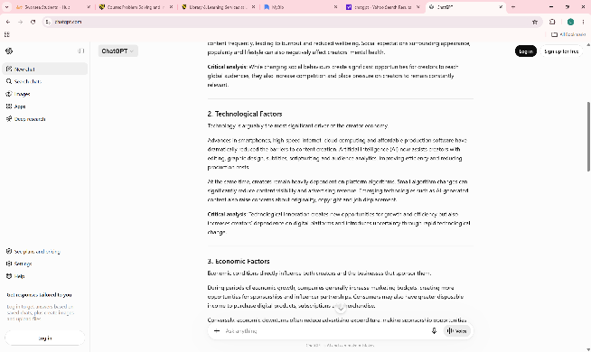
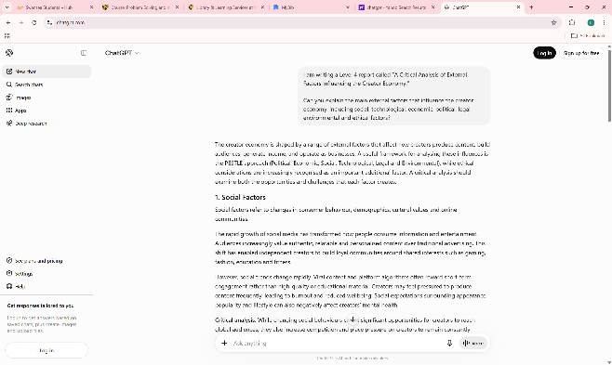

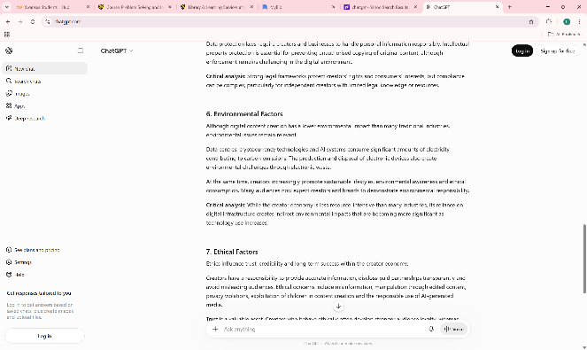
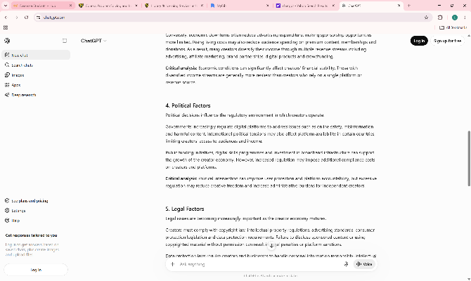
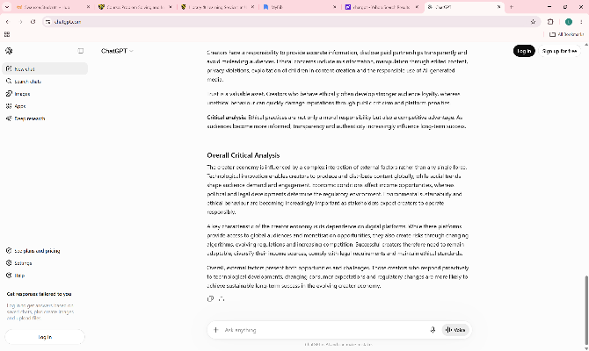

Figure A2 – Steeple Analysis
The STEEPLE analysis demonstrates that social, technological and legal factors have the greatest impact on the creator economy. Social factors influence audience trust and engagement, technological factors affect visibility through platform algorithms, and legal factors influence advertising compliance. The analysis highlights both opportunities and challenges facing creators within a rapidly changing digital environment.
Screenshot of AI-assisted STEEPLE analysis used to organise research findings relating to the creator economy.
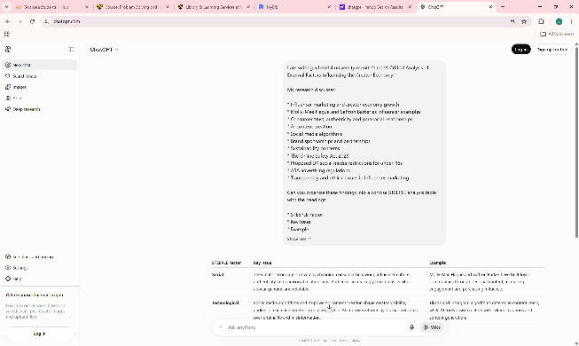
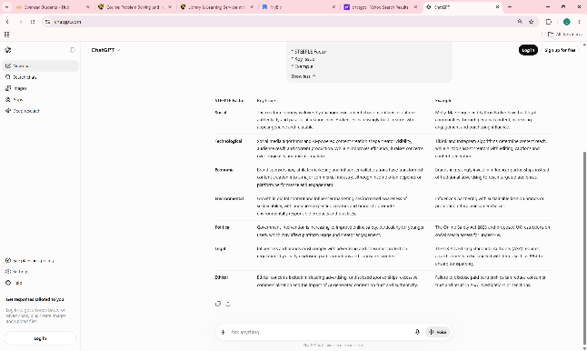

Figure A3 - SWOT Analysis
The SWOT analysis highlights key strengths, weaknesses, opportunities and threats affecting the creator economy. However, weaknesses such as platform dependency and income instability remain significant concerns. Opportunities include AI tools, creator-owned brands and new monetisation methods, while threats include increasing regulation, market saturation and declining audience trust.
Screenshot of AI-assisted SWOT analysis used to identify strengths, weaknesses, opportunities and threats affecting the creator economy.

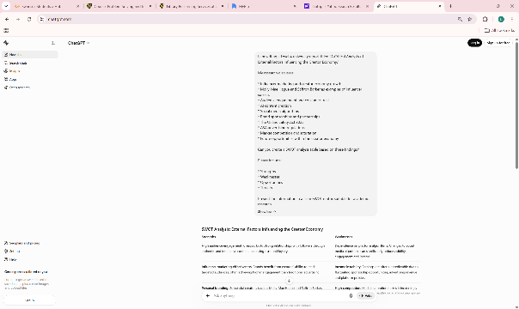
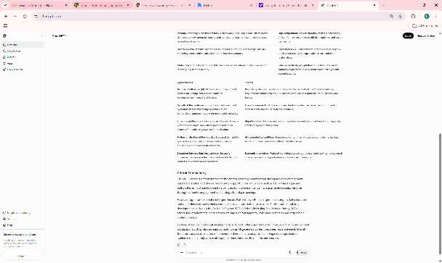
Figure A4 – UK Regulation Research
Screenshot of AI-assisted research into UK regulation affecting influencers and content creators, including the Online Safety Act 2023 and ASA advertising guidance.
This research informed the discussion of the Online Safety Act 2023, ASA advertising regulations and proposed restrictions on social media access for under-16s discussed within the report.
This research informed the discussion of the Online Safety Act 2023, ASA advertising guidance and wider regulatory developments affecting content creators.
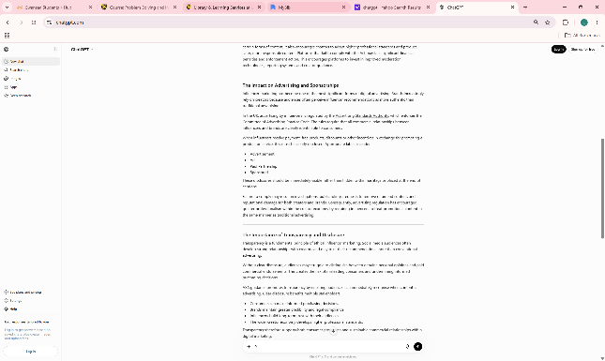
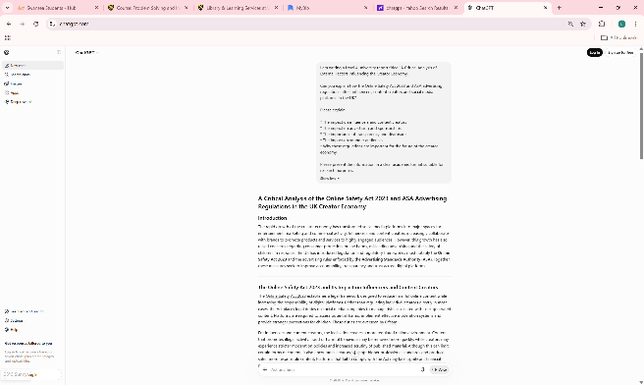
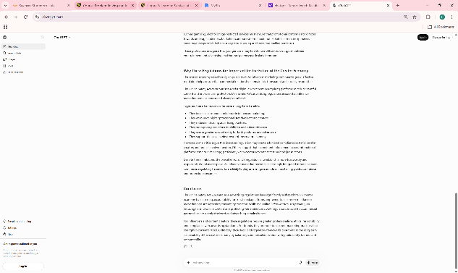
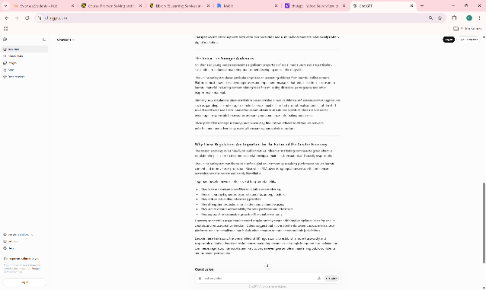
Appendix B – DSPIR Analysis

Figure B1 – DSPIR
The DPSIR analysis identifies social media growth, influencer marketing investment and technological innovation as key drivers of the creator economy. Pressures including competition, algorithm changes, regulation and audience expectations influence the industry’s current state. The framework highlights the need for creators and platforms to respond through adaptation, transparency and regulatory compliance.
Screenshot of AI-assisted DPSIR analysis used to examine the drivers, pressures, state, impacts and responses affecting the creator economy.
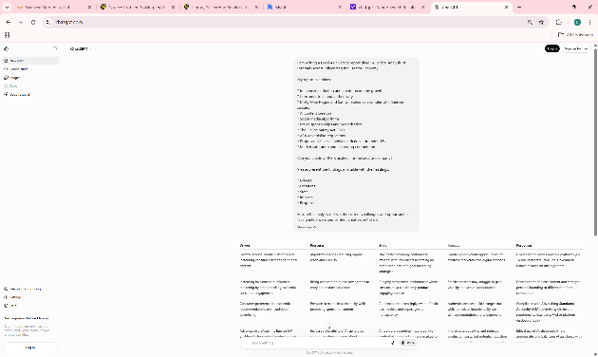
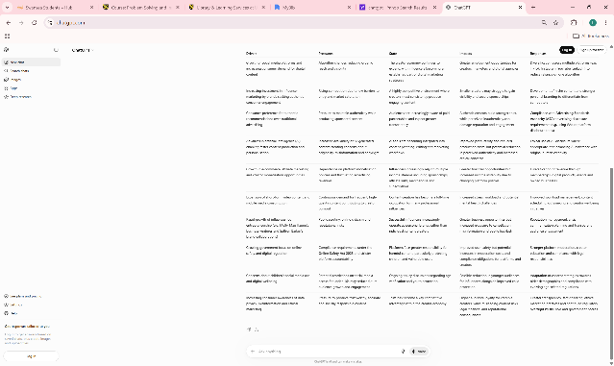
The DPSIR framework demonstrates how growth in social media, influencer marketing and technological innovation act as drivers of the creator economy, while regulation, competition and consumer expectations create pressures that influence industry development and future responses.

